Disclaimer

This eBook has been written for information purposes only. Every effort has been made to make this eBook as complete and accurate as possible. However, there may be mistakes in typography or content. Also, this eBook provides information only up to the publishing date. Therefore, this eBook should be used as a guide - not as the ultimate source.

The purpose of this eBook is to educate. The author and the publisher do not warrant that the information contained in this eBook is fully complete and shall not be responsible for any errors or omissions. The author and publisher shall have neither liability nor responsibility to any person or entity with respect to any loss or damage caused or alleged to be caused directly or indirectly by this ebook.

This eBook offers information and is designed for educational purposes only. You should not rely on this information as a substitute, nor does it replace professional medical advice, diagnosis, or treatment.
Table of Contents

Introduction 5
Chapter 1: Understanding the Metaverse 7
Chapter 2: The Metaverse Today 11
Video games 11
Virtual reality 12
Crypto 12
Chapter 3: Criticisms and Concerns 15
Privacy 15
Addiction 15
User safety 16
Social issues 17
How Much Will The Metaverse Cost? 18
The Metaverse and the Future 18
Chapter 4: Emerging Technology 21
Extended reality technologies 21
Artificial Intelligence 22
Brain-computer interfaces 23
Chapter 5: How the Metaverse Will Transform the Future 25
Work 25
Health and Defense 26
Personal lives 26
How to Use the Metaverse 27
Chapter 6: Enhance personal life 29
Gaming 29
Enhance social lives 29
Chapter 7: Personalize Work and Education 32
Virtual workspaces 32
Online curriculums and virtual classrooms 33
Chapter 8: Investment 36
Metaverse stocks 36
NFT investments 37
Virtual estates 37
Conclusion 39


Introduction

There has been a lot of talk about the Metaverse in recent years, with tech companies, gurus, and business owners all speaking about the limitless power it can give. It's supposed to revolutionize the internet, and that breeds quite a lot of excitement and worry from certain people and groups. With Facebook recently rebranding itself into the company ‘Meta’ and redefining their commitment to building the Metaverse soon, the word is on people’s lips more than ever.

However, the Metaverse is an area that is surrounded in confusion as well. What is it? Who owns it? What can you do with it? These are all questions that people are asking, and asking in much louder voices given the recent news.

Thankfully, this Ebook will help you out, as we are going to lay out step by step what the Metaverse is and why exactly you should care about it. We want to make sure that you are armed with the answers to these hard to answer questions and that our book can cut through the misinformation about the complexities of the Metaverse.

So read on, and by the end of this book, you’ll wonder what there was to be confused about in the first place!


Chapter 1: Understanding the Metaverse

The desire and ability to go into a video game, virtual world, or even into the internet itself hasn’t been anything new. From “Wreck-It-Ralph Breaks The Internet” to “Ready Player One”, we’ve seen this trope in countless fiction mediums. The idea that the internet is a virtual world in itself, one where people can encounter one another, make interactions with themselves and the world, and even affect the real world with their choices in the digital one.

If you think of it like a massively expanded virtual world, where players don’t just control avatars on a screen with a mouse and keyboard, then you’ve got the right idea. Instead, the person accessing the metaverse is their avatar, and they can move around, speak, and travel the virtual world as easily as they can in the real world.

It will also connect the virtual world and the real world to make the pair closer than ever before. For example, have you ever seen in Science Fiction where a character might wear goggles that give them a heads up display of their surroundings? They can look at people and instantly gain access to public information about them, or do the same with buildings or items. With the metaverse, we might have that technology too.

The Metaverse might seem a little confusing, but with a little bit of open mindedness and understanding, you’ll know just what this place is, so let’s start with a simple definition, shall we?

Definition
The Definition that most people can agree on is this one. The Metaverse is a set of virtual spaces where you can create and explore with other people who aren't in the same physical space as you. Think of it like a video game MMO world. In games like Final Fantasy or World of Warcraft, players from all over the world log into servers. Their avatars are visible in game, and they can interact with one another, participate in events, and even drive the game’s economy.

The Metaverse is going to be like that, only instead of going into a video game world, you would be logging into a world similar to our own. The Metaverse will be like one huge shopping mall, where you can log into different servers that are all owned by different companies. Imagine logging into Amazon’s virtual world and ordering all your packages with simple gestures. You won’t need to take out your phone, but instead put on a headset.

Additionally, the Metaverse will be able to support your Avatars. Whether you want to buy real life items to put in your virtual room, or just have an avatar that reacts to your movements and body language, your virtual manifestation of your avatar will be just as important to the metaverse as the worlds you inhabit.

Persistence
Finally, the last major definition (one so important it needed its own subheading) is the word ‘Persistence.’ Persistence in the metaverse refers to the continuity and sense of presence that you will feel in the virtual world.

There will be several ways to connect to and experience the metaverse, from your phone, PC, Ipad, or VR headset, and the creators of the metaverse want to make sure that you feel like you and your Avatar matter in both of them.

Persistence gives connections between the various ‘worlds’ of the metaverse and is primarily experienced by avatars. For example, let’s say your avatar gets a new pair of glasses from a VR shop in the virtual world. Then you hop off the virtual world and get into the metaverse on your phone. Your avatar will have the same glasses on, and no matter how you access the metaverse, the glasses will remain on.

This persistence of a cosmetic item is an example of how persistence as a whole will work in the metaverse. Basically, if your Avatar buys something, makes a change to their look, or makes a change to their own personal world, those changes will show up no matter how you access the metaverse.

Implementation
Well, this all sounds well and cool, but how will it be implemented into the everyday consumer’s life? Much like how you need to buy a VR headset from a certain company (Such as the Oculus Quest or the HP Reverve) to experience certain games and features, you will probably need to buy a headset or a system from the companies that will be getting into the Metaverse, including one from the company Facebook has created, appropriately called: Meta.

Otherwise, it should be like any other online activity. You will need to create an account, customize an avatar, and then you can explore the worlds of your choosing. The theory goes that the metaverse should be quite unlimited, so once you get logged in you won’t have too many limits on where you can go.

Required technology
Despite there being quite a lot of advances in the realm of virtual reality with the rise of headsets, VR gaming, and avatar creations, the technology to create a 100% immersive world in digital just doesn’t exist yet. The technology that we have access to for virtual reality is merely the lightest scratch on the surface of what everyone hopes the Metaverse might become one day.

Mark Zuckerberg has said that he hopes the technology will come out in 5-10 years, while Meta has given their estimate at around 10-15 years. Meta is already placing technological advancements in the pipeline that will help them get to where the Metaverse as we understand it is possible, but that’s still a long way away.

Who knows what type of technology might be required to create this world, or what type of people are aiming to create it? It’s certainly something that will be worth watching, especially if you have any interest in the technological field of study.
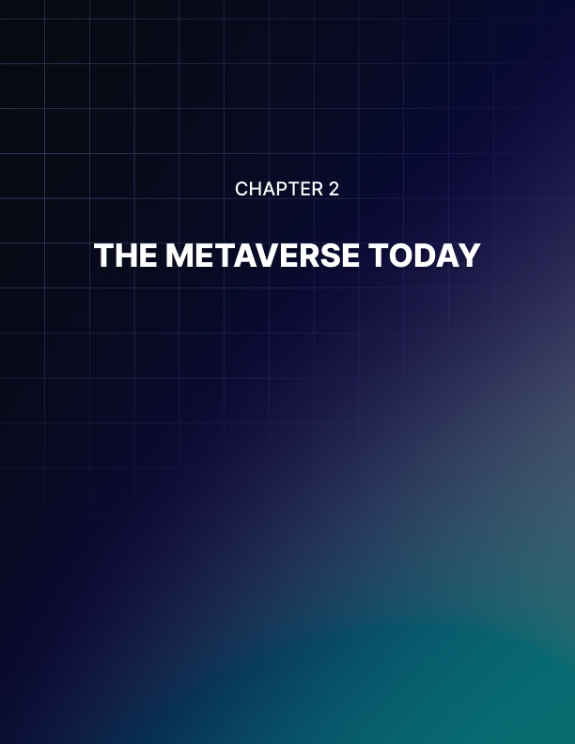

Chapter 2: The Metaverse Today

Since we’ve been comparing the metaverse to video games, that’s a good place to start this chapter by saying that virtual reality gaming is the best way to give us a peek into what the metaverse is going to look like. Video games and VR have always been the pavers and the movers towards the combination of digital and physical worlds. But there are other items too that will help us get a better understanding of, and make predictions towards, what the metaverse of several years into the future would look like.

Video games
Most MMO video games such as Fortnite, Final Fantasy, Roblox, and World of Warcraft are all examples of ‘mini-metaverses.’ They are persistent games where a player controls an avatar and makes them do certain things, and every player can connect and talk to every other player. Players can socialize, join clubs or guilds, attend events, and make in game payments using in game currency.

Additionally, several games allow you to fully customize your character. You can design a completely different character than yourself, make a non-humanoid design, or create a character that looks completely like you. The Metaverse is going to be populated with a similar cast of characters, as while many people might want to create wacky avatars that push the limits, most people will want an avatar that looks like them.

The metaverse might also hold events that can bring thousands or millions of players all to one spot or world, something MMO games are known for. This helps to foster a sense of community for the gamers who play, as well as gives them something to look forward to. Certain worlds in the metaverse might host similar events or sales to bring people together.

But while MMO’s are a great sneak peek into the world that the metaverse hopes to create, there’s something even more tangible on the horizon, and that is virtual reality gaming.

Virtual reality
Before we delve into the metaverse’s uses for VR, let’s focus on the gaming side of things. Virtual reality gaming allows for a much greater level of immersion that we have seen so far in gaming, as we are able to actually move our bodies with our character and in essence ‘see what they see.’ If our character swings a sword, holds a blaster, or throws a bomb, we are making a similar movement with our bodies. It can also be very interesting to see nothing but the virtual land around you. For example, traditional gaming simply has your eyes glued to what is in front of you, but with a virtual reality headset, you can turn around and get a complete 360 view of what the world you are playing in looks like. If you want to be reminded that the world isn’t real, then you need to take the headset off!

Virtual reality is the metaverse in its pre-walking infancy. It allows us to connect with our friends in the virtual world, and also transforms our dull living rooms and offices into places straight out of fantasy and science fiction. We are able to move, interact, and play within the confines of the room we are in and the game we are playing.

The Metaverse will have no limits. You won’t be loading up just one game into your headset and playing only that game, but instead you will have access to every single world and the ability to do whatever you want in each. You can log into a zoom call from your headset but feel like you are sitting in your office, you can go into Amazon’s world and purchase whatever you would like, or you can walk to a virtual park and sit down to watch the world go by. It will be virtual reality on steroids, and it will open up a lot of doors for people.

Crypto
If you’ve ever played an MMO or even a single player video game, you have probably noticed that you don’t pay for things with dollars and cents. Whether you are buying the newest sword for your character or a new shirt for your avatar in the shop, you are paying in gold, or bottle caps, or ore, or something made up specifically for that game’s world.

Sure you can buy the equivalent of the in-game currency with real money, but you are making your payments in the in-game currency.

In the metaverse, while buying things with dollars and cents is a real thing that you will be able to do, you also might be paying for more with cryptocurrency than you might think. Crypto coins are going to be the virtual currency of the metaverse, and you might be able to exchange your dollars and cents for them.

Since the metaverse is going to be the next large step when it comes to the advent of technology, a lot of businesses are already getting in on the ground floor of it. Even more will be getting into it when it is a proven business model, and that’s when more and more cryptocurrencies are going to pop up as a way to pay for the services rendered in the virtual world.

Thankfully, crypto exists today and it’s fairly easy to understand what it is about if you are willing to do some research. It is a form of money that you can’t hold or see, but you can spend it at several stores that will take coins. With the metaverse, the number of vendors that will accept bitcoins and other forms of currency is no doubt going to rise.


Chapter 3: Criticisms and Concerns

Of course, with every new change in the advent of technology, there are a lot of people who have some serious misgivings and questions about the Metaverse. Even though the idea of the metaverse and the technology that would make it possible are still in their infancy, the criticisms and concerns raised by people are not. And they will only get more pronounced with time. In order to make the metaverse simple, we need to analyze these as well.

Privacy
One of the biggest concerns with the metaverse is user privacy. We see data get released from social media sites all the time, and Facebook has had two data breaches where the personal data of their customers was shared all over. With Meta running the show, a lot of people are raising questions about just how private their actions on the metaverse are, or if everything they leave there can be leaked.

With the metaverse, a lot of personal information is going to be placed online for all to see. You’ll even need webcams and sensors to analyze your face and your voice to create an online Avatar that looks and sounds like you as closely as possible.

Additionally, people will be using the metaverse to shop, attend work, read emails, and connect with friends. There’s a growing group of people who are asking: Who can see all that information? And exactly how secure is this metaverse going to be?

Addiction
Screens are addicting, and billions of dollars are spent every single year to make sure that we stay on them as long as possible. They provide little drips of dopamine and other chemicals that ensure we keep scrolling, liking, and being liked, to an extent where it can be extremely hard to put the phone down. Whether you are young or old, we all have some degree of dependence on the internet, and that poses a problem for the metaverse.

Internet addiction is something that affects everyone’s mental health to some degree. You might be hooked on your work email, your Facebook feed, a video game, or stalking your ex every time they post a picture.

However, with the way the internet is now you can always turn it off and get back to the real world.

The metaverse is something that you won’t just browse and scroll through, but also something that you can ‘live’ in. Your avatar will be able to move and interact with others, and it might be much harder to pull yourself away from the fantasy it provides. Especially if that fantasy is better than your reality.

After all, why would you try to go back to a life that isn’t as exciting as the world inside the real world?

Nearly everyone involved in the metaverse has made repeated claims and wants to stress that the Metaverse is not real. At the end of the day, it is a fictional world that attempts to connect to our real one, not go about replacing it.

Still, that’s potentially a line that people who are very addicted to screens and want to scope out an escape aren’t going to be able to see. The internet tends to have both a positive and negative effect on the mental health of the users, and the Metaverse could easily exacerbate the impact the internet has on our brains, as well as the disturbing rise of screen addiction.

User safety
The internet can be nasty, and aside from a few calmer niches you really can’t scroll past anything without seeing someone yelling at one another. Whether it’s political beliefs, social issues, differences of opinions, or celebrity drama, the internet has tons of new ways to make us feel like victims where the entire world is against us.

But while we’ve seen new ways to cyberbully, harass, and demean people on the internet, what we haven’t seen is an effective way to make the internet safe for everyone. Moderators, website owners, and level headed people among us can do their best to ensure that those who cause the most trouble are kicked out or prevented from seriously harming someone, but that really amounts to a slap on the wrist at best.

Being personally attacked on the internet for a belief you hold can hurt, but at the end of the day you can remove the offending comments and walk away.

However, in the Metaverse you might have dozens of avatars screaming at you and shaming you into leaving or changing your belief system. The world that you have in the metaverse suddenly won’t feel as safe as it once did, and that can be a real problem for people.

Since we don’t have safety measures in place for monitoring everything, preventing smaller issues from growing out of control, and also for punishing the people who are spitting hate effectively, this raises some concerns about how all people are going to feel safe and secure on the metaverse. Finally, while governments are welcome in the metaverse, they aren’t in charge. Instead Mark Zuckerberg and his team are.

If the mudslinging gets really bad, there’s not a lot of faith that a team of CEO’s can handle it for some people and they would rather have law enforcement or a government entity take on people who are actively being toxic and spreading hate.

Even though the Metaverse is in its infancy, this is still a very important topic to discuss because everyone should feel safe on the platform, and sometimes the internet is anything but safe.

Social issues
The metaverse could be a massive springboard for social issues, but it could also lead to homogeneous groups creating worlds all their own, where they are free to express views that aren’t the safest for certain

ethnic groups, religions, or other types of people. Additionally, people also see the metaverse as a great way for social issues to be broadcast to the world.

Instead of taking to Twitter or another online media platform to connect, people who have the same opinions about various issues will be able to display it right on their profile.

Then meetups could happen directly inside the metaverse on designated worlds or areas, allowing people who want to raise awareness or protest the ability to ‘meet’ one another without the hassle of actually driving to meet one another. This could connect various worldwide organizations and groups all under one banner, and allow for them to do far more than they could alone.

While the metaverse will allow different groups to find themselves and connect to share mutual interests and bring about social change, the type of people who might find themselves inside the metaverse could have a further issue awaiting them, the issue of wealth.

How Much Will The Metaverse Cost?
With a VR headset running anywhere between $300-$400 dollars, the bar to get into VR can be a little high for some families, and the metaverse could be even more expensive. Even though Meta has stated that they want to sell the electronics at cost and ensure that the

metaverse remains a valid option for everyone to get into, some people just might not have the money needed to make and maintain their connection to the Metaverse.

If only the very wealthy can get into the metaverse, then what will that allow everyone else to do?

Especially if the metaverse is owned and run by companies and billionaires that are seeking to make a profit off of what everyone is purchasing.

This could be a very large use of money for most people, and for those who can’t afford to get into the metaverse, it would be a large opportunity.

The Metaverse and the Future
As this book has stated before, the metaverse is still very very young and while strides are being made towards it becoming a reality, there are a lot of future advancements that need to happen in the technology sector in order to make the metaverse a real possibility. Additionally, the metaverse is going to change every single aspect of the lives of the people who end up using it, so they have that to look forward to as the future grows even closer.

Let’s take a look at what is going to happen as the Metaverse gets even closer and closer to us, and how it will affect the lives of the people involved. As well as what needs to happen before the metaverse is a reality.


Chapter 4: Emerging Technology

As we’ve stated many times throughout this book, the technology for the metaverse is still many years away, but that doesn’t mean that the technology isn’t coming faster than we think. The technology that will make the metaverse possible is already making some massive strides, and this chapter is going to look at some of the trends and advances in our technology that will lead to the foundation of the metaverse.

Extended reality technologies
The definition of extended reality technology is a term that encompasses several aspects of the tech industry. Specifically, it’s the technology that melds the virtual worlds and the physical world. So you might be able to buy a house without ever leaving your couch, while virtually going inside the house and examining everything.

Of course, extended reality technology encompasses augmented reality, virtual reality, and mixed realities. Let’s take a look at each of these technologies in greater detail.

Augmented Reality
Augmented reality is the overlaying of the real world with virtual images to enhance the real world. For example your phone is a way to augment your reality, such as the popular video game Pokemon Go, which takes real world locations and then

populates them with Pokemon that you can catch and interact with. Filters and other items that put digital objects on you are also the same.

In augmented reality, you can see all the real world and aren’t isolated from the people around you. You can look away from the screen, close the application, close the filter, and then get back into the real world and the people around you.

Virtual Reality
Virtual Reality is the typical headset where you are fully immersed in a digital environment, and you can get a 360 degree view of the world around you. This is typically done for gaming, and it is one of the core components of the Metaverse. The entire purpose of a VR system is to fool the user’s brain into thinking that they are someplace else, and the metaverse is going to do the same thing.

Virtual Reality is being adopted into all sorts of industries to help train people in different jobs before letting them go into the real world. VR is relatively new, but there's no doubt that the world is going to grow around it and the technology is going to improve.

Mixed Realities
Finally, another core component of what the metaverse will be is Mixed Reality. In Mixed Realities, digital and real-world items and objects will be able to interact with one another and form a hybrid reality. Mixed realities work with headsets, and they allow you to place objects from the digital world in the physical world and then have the ability to interact with it.

Mixed reality is a younger technology, but it is used in various technologies and businesses. For example some furniture outlets let you use your phone to place objects inside of your home. Some clothing companies will allow you to virtually try on clothes or glasses before making the purchase, and you can do all this from the comfort of your home!

Artificial Intelligence
Bridging the gap between our world and the virtual world is going to take a lot of brainpower, but for everything human inventors and programmers need to do to make the metaverse real, the load will also need to be shouldered by the Artificial intelligence that makes up the metaverse as well.

One of the first issues that will be solved by artificial intelligence is the facial recognition software. In order to make sure that your avatars are like you, and that any other non-human avatars that you meet are as realistic as possible, you need technology. Facial and voice recognition software are going to need to be used to ensure that your avatar is what you need.

If other digital humans (those not controlled by a human… Think of them like NPC’s) exist in the world, then they will be built entirely by AI and will need artificial intelligence to make themselves dynamic in the metaverse.

Additionally, AI will be able to scan different two dimensional and three dimensional items from the real world and then place them inside the metaverse. It will also be able to turn the English language into machine code, which is then turned back into English once the AI has a response. So, with high level artificial intelligence, you will be able to have ‘realistic conversations’ in the metaverse.

The field of Artificial Intelligence is growing even more as many companies and businesses take advantage of the benefits of AI, and the metaverse will have artificial intelligence running everything… both in front of the users and behind the scenes.

Brain-computer interfaces
Finally, one of the largest pieces of technology that will come into the metaverse is the ‘Brain-Computer’ interface. Which is where the electrical data from your brain is attached to a computer and allows you to analyze what should be happening in the game. This is the closest that we are getting to the Metaverse, because the ideas of screens and such are going to be removed with brain computer interfaces.

Some of these are technologies that interlink your brain and body with the virtual world, but others require surgery to implant devices directly into your brain. The technology of brain computer interfaces is something that will be integral to the metaverse, and given the growing field of connecting the digital to our brains, the technology will certainly advance.
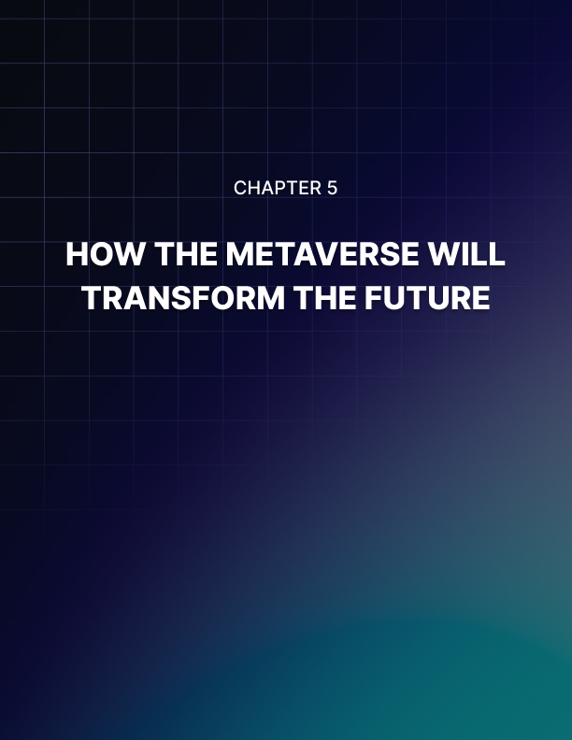

Chapter 5: How the Metaverse Will Transform the Future

The use and implementation of the metaverse is going to transform lives
and the way that our world works. Even with how little we know about the metaverse itself, we know that if it is implemented in even a fraction of the ways that people say it will be, then things aren’t going to be the same. Here’s some of the ways that our future will be transformed once we get into the metaverse.

Work
One of the biggest benefits that the metaverse has for us is the ability of communication and connection. Two people in different areas of the world will be able to get into the same room and feel like they are there, additionally, the room they are in will feel like a room.

For example, instead of all 12 employees of a company getting in one singular room in the real world to have a meeting like many companies do, the metaverse will allow for a completely virtual meeting. Only instead of going on Zoom and staring at one another through screens, they will be able to sit in a virtual meeting room and communicate as their avatars.

Meanwhile, all twelve employees will be in twelve different areas of the world, all logged into the metaverse and sitting in their rooms… while their avatars are in the meeting. This will transform when and how we all go to work, because people won’t need to go to offices and see one another in person. Instead they can simply log in and see one another virtually.

Remote Work
With the metaverse, nearly every single job will have some virtual option, making most jobs location independent and able to be done by freelancers. You might live in Georgia and work in Canada for a company, except you won’t need to move there because all your work is in the Metaverse.

Health and Defense
VR systems are already in use to train active duty soldiers in combat scenarios without the expensive and time consuming ‘live-fire’ exercises. Headsets allow and will allow soldiers in a combat zone to see the terrain from the POV of their enemies or from themselves, rather than having to huddle over a battlemap or inspect a crudely redone combat zone.

This will also allow for soldiers to train in scenarios or run through missions as realistically as possible without having to risk harming themselves by accidents. With the Metaverse, the ability of soldiers to place themselves in the combat zone without harming themselves will be greatly increased.

The medical industry is also using VR technology to train surgeons on complicated medical procedures, and even to perform operations with surgeons who are far away from their patient. If a patient needs open heart surgery in New York and the most qualified doctor is 5 states away, the doctor can use VR to make the surgery, with his actions being mirrored by medical robots that are on site.

How Things Are Built and Tested
Finally, since the metaverse is going to be extremely realistic, it allows manufacturers and companies to test new concepts without the risk of wasting hardware or harming people with faulty technology. They can build and test everything they need, or make plans, and once everything is confirmed in the metaverse, then the item can be built in the real world.

Nearly everything about how we work will either change if not be completely overhauled by the introduction of the metaverse, and it will be very interesting to see what opportunities arise.

Personal lives
You probably remember how the world changed with the introduction of the Smartphone, and then with the introduction of VR. Well, the Metaverse will add another change to how people spend free time. You will be able to climb mountains, swim in lakes, walk cities all around the world, and talk to people from everywhere, and you will be able to feel like you are there.

The Metaverse doesn’t just want you to ‘see’ the world that you are walking in, but it wants to engage your other senses as well. You will be able to smell, hear, touch and even taste the items you want to interact with. You’ll need smart clothing, a haptic bodysuit (the same type of sensor suit worn in most movies), and a headset, but there’s no limit to how real the world of the metaverse can feel.

Additionally, you could even take on different forms. Remember pretending to be a monkey in the backyard when you were a kid, and the backyard was a large jungle in your imagination?

Well, in the metaverse you can take on the form of a monkey and swing through the treetops. Or you could play virtual sports not as yourself, but as your favorite sports star.

Talking and Learning
You could meet up with long lost friends, communicate with experts, and even learn from the greats in the metaverse. It wouldn’t just be about physical experiences, but you could learn a lot from the mental side of things too. From going to great libraries, to attending classes, to joining events in the metaverse about your favorite topic, you could learn whatever you wanted. Also, imagine finding the avatar of someone you never thought you would ever see again in the metaverse? Wouldn’t that be great, because even if you and your friend are halfway around the world from one another physically, the metaverse would allow you to connect as easily as if you were neighbors.

How to Use the Metaverse
Once the metaverse comes into being, then how exactly would you use it? Once you’ve bought all the tech, signed up for all the accounts, and figured out what exactly you want the metaverse to do for you, then how exactly would you use the Metaverse for yourself?

This part of the book is going to let you know about some of the opportunities that the metaverse is going to give you when it comes to advances in your personal life. As well as some of the best ways to ensure that you make the most out of your access inside this advancement of technology.



Chapter 6: Enhance personal life

The internet has vastly improved the quality of life for most of the people who use it. From new jobs, to new friendships, to personal fame, the advent of the internet has changed quite a lot of lives. The metaverse is going to do the exact same thing on a much bigger scale. People will have access to a lot of different things, including new ways to game, learn, travel, and share their viewpoint with the world!

Gaming
One of the biggest uses that most people want to get out of the Metaverse is how gaming works within it. MMO games and VR headsets allow for some idea of what the metaverse would be like, and science fiction movies such as “Ready Player One” also share the idea of thousands of Avatars sharing a game world, fighting one another, participating in events, and stimulating a game’s world and economy.

More than likely the metaverse will make you feel like you are in a video game. For example, if you stand on a mountaintop in a VR game like Skyrim for example, you will be able to see the mountain, but that’s about it. With the Metaverse, you will actually feel the biting cold and smell the smells of the mountain too.

Whenever you die in a VR game or take some damage, your character might react and you will see your health bar drop. However, in the Metaverse, you might feel some type of jolt or impact whenever you get hit.

The name of the game with the Metaverse and gaming within it is going to be immersion. You need to feel like you are in the game world.
Gaming is going to feel like a 2nd way of life and if you love gaming and playing with friends together right now, the metaverse is going to make that even more pronounced and immersive!

Enhance social lives
Social opportunities in the Metaverse will be much more pronounced than in the real world. For example, you will be able to find friends and connect with them no matter where they are. We’ve all got at least one online friend or a group of friends, and while connecting with them over Discord or Zoom or some other platform is fun, you are still looking at your friend through a mobile device.

In the metaverse you will be able to sit in various locations, or even do activities such as playing a game, watching a movie, or skiing down a mountain. You will be able to see and even touch their avatars as well.

Even dating will be heavily enhanced in the metaverse, where you can find your soulmate and take them anywhere to get to know them.

Instead of the standard first dates and awkward pickup lines, you can instead take the object of your affections to walk along the beach or have a quiet conversation in an intimate cafe.

It will allow you to get to know the real person and not just what they are telling you about themselves through a screen.

Additionally, if you’ve got something that you want to share with an audience of people, you will easily find your platform in the metaverse, and can become a teacher for people as well. This could be a second wave, just like social media was, and if you can get into it early, you will be able to build a large following and build a business.

Finally, you will be able to unwind from personal troubles and just unwind in the metaverse. Whether you want to sit on the beach and relax, curl up with a book in a rainy cabin, or relax with a loved one beside a fire, you will be able to get away from the real world a bit. That’s what the majority of the people are probably going to use the metaverse for, just like how most people use video games or social media to get some stress relief and escape from the rough problems of the world.

Technology required
If you want to experience the full experience that the metaverse has to offer, you will need some of the above mentioned pieces of technology. While the things you need aren’t set in stone just yet, you will need haptic suits, headsets, an internet connection, and probably some accounts for the various areas of the metaverse you want to get into.
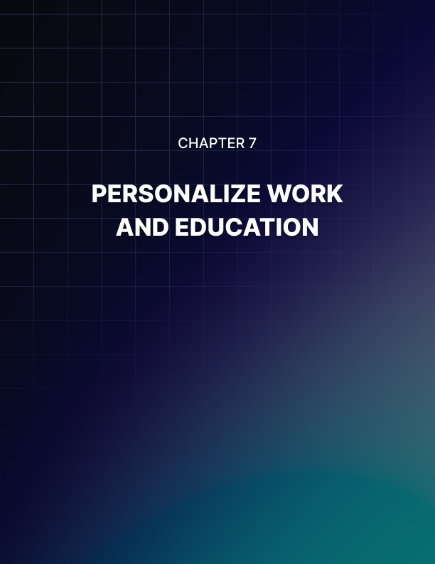

Chapter 7: Personalize Work and Education

Of course, the metaverse isn’t just going to be for fun and games, but it will also be for education and work as well. If you want to focus on building how you work and learn, the extreme customizability of the metaverse will allow you to do so. The sky is going to be the limit for these things, so don’t be afraid to hop in and enjoy all it has to offer!

The internet changed quite a lot of how people work and learn in the world, and the metaverse is going to increase the opportunity that you get!

Virtual workspaces
Have you ever been denied a job because the workplace was on site and it was in a place you didn’t, or couldn’t move to? Have you ever found that your dream job was wrecked by your commute too and from work? Do you spend too much time in the car and not enough in your office? If so, then the Metaverse might hold some answers for you.

The metaverse will allow you to work whenever and wherever you want, and you won’t have to worry about commute times, just your internet connection! If you want to work in Hong Kong while living in New York, then you can. Your avatar will simply be connected to the virtual workplace in Hong Kong while you sit on your couch.

Or you can set up meetings with your co-workers or project managers, but instead of having to carve time out of your busy schedule, you can simply pull their avatars into the metaverse and have a communication. Additionally, you will be sitting in a virtual area that looks exactly like your traditional office, so even though everyone else might be on their couches or in their homes, the virtual environment will be one of work.

This will help keep the productivity of your workers high, because anyone working from home can tell you that working alone can be a pit of distractions! However, if you are sitting in a virtual office, most people will work a lot faster and won’t be as distracted.

You can have any job you want in the metaverse, because every single job is going to be at least influenced by this technology. You won’t be limited by location or by anything else, only the technology that you have access to.

Online curriculums and virtual classrooms
When it comes to education, you might not find that traditional education exists in the Metaverse. Rather than applying for colleges or curriculums in the real world, you might find various ways to educate yourself in the Metaverse. For example, teachers and those who want to teach and share knowledge (either for free or by being paid) will be able to do so.

The reach of education is going to be more generalized and available than ever before, and you might be able to learn more than you could ever want to without paying massive prices.

The idea of online education can be very powerful if done right, and the metaverse could allow people to learn everything they could ever want.

Plus, you might not be learning about the subjects, but also experiencing them. Imagine if you want to learn all about carpentry. A teacher in a virtual classroom could teach and talk to you all about how carpentry works, but after a few minutes every single student would get the same tools and the same piles of wood. Then you will virtually get your hands dirty with some tool work as you try and build.

This won’t just be education that you learn about through lectures and voices, but through actually going back into simulations of the past and seeing what life was really like. It’s a form of educational and virtual time travel, and could be very important for both the young and the old students who want to learn.

After all, this could be a massive form of active learning that also helps to keep the students engaged and also wanting to ensure that they learn more. Using the metaverse for all sorts of education could be very interesting, and also could be very socially active as well, bringing students together to help fully learn.

Technology required
With education and virtual learning being a key component of the metaverse, most companies are more than likely going to try to lower the barrier for entry and ensure that most people are going to be able to access the education that they need. However, you will still more than likely need a headset and some accounts to ensure that you can access the metaverse.


Chapter 8: Investment

Finally, the metaverse is going to have its own economy, as discussed in previous chapters. Much like how video games are run by their own currencies and economies, the metaverse will likely be connected to cryptocurrency once it is fully up and running. However, for those who want to invest in this growing technology while there's still time to do so and the Metaverse is still in its infancy. You have some options.

From investing into cryptocurrency itself to making sure that you are able to buy your share of the metaverse, here are some of the best ways to ensure that you can invest in the Metaverse.

Metaverse stocks
There’s a lot of speculation of what companies will invest in the metaverse and what companies will try to get a shareholder’s position in the metaverse. However, here are some good thoughts for places for you to invest your stock.

For example, the company NIKE already has a Nikeland in the video game ROBLOX, where players can purchase and adorn their avatars with Nike brand shoes, shirts, hats, and other gear. Additionally NIKE is focusing on making sure they are one of the biggest names selling virtual sneakers in the metaverse, so buying stock in them is a good option.

Tech companies are perfect places to invest in and purchase stock for in the Metaverse. Along with technology being a large part of what is sold within the Metaverse, they will also be needed for outside the metaverse as well. The Next-Gen technology that will make sure the metaverse is going to be updated and accessible.

This also says nothing of the cloud which is going to be the thing that is going to provide the computing power for the Metaverse. Companies like Amazon, Microsoft, and other web cloud based companies are going to be very lucrative if people want to buy stocks in their work in the Metaverse.

NFT investments
With the massive focus on NFTs (Non-Fungible Tokens), it’s all but common knowledge that they will be a part of the economy of the Metaverse. NFT markets and the blockchain that they are part of are going to be the backbone of what the Metaverse turns into. The tokens are digital assets that are able to show off ownership and can easily be transformed into your avatars.

Since NFTs are able to go anywhere and can be used for a great many things, NFTs are the perfect way to move assets around the various worlds and devices that will encompass the metaverse. Plus, they focus on ownership. Unlike in a video game where you buy an asset and it remains in the game and can’t be taken away, with NFT’s you own it.

You can buy a hat from an in video game store and then place that hat on your Avatar in your Instagram feed. You might even be able to buy and own your own piece of the Metaverse as well, kinda like how you can buy player homes in video games that belong to your character. Since NFT’s look like the backbone of the metaverse, making an investment in the token could be very lucrative down the line.

Virtual estates
Speaking of owning land in the metaverse, there is already a virtual real estate boom in the four predetermined lands that will exist in the Metaverse. These lands are: Decentraland (an area for governments to interact), The Sandbox (A world for virtual video game development), Crypto Voxels (a virtual world), and Somnium Space (another customizable virtual world).

All of these places are like large plots of land where you can do whatever you want. Think about the video game Minecraft at the start. All you have are some basic tools and an empty world where you can do whatever you want. Well, these virtual real estate plots are like plots of land where consumers and companies can build whatever they would like.

The idea of investing into virtual estates, especially this early in the metaverse, can be either a risk or an opportunity. That does depend on what you think though, and it might be a good investment to consider. After all, it might pay off very handsomely in the long run.


Conclusion

The Metaverse is a very exciting and sometimes confusing area of the world that is going to come no matter what. Hopefully this book has made the idea of the Metaverse a little less confusing and much more applicable to you. While you might not invest in it right away or prepare for its arrival, at least you know the possibilities that this new way of accessing the internet can give you.

The Metaverse probably isn’t going to be here for at least a few decades, even with all the technological advances in the world that might happen. Still, no one can deny that it is coming and we are certainly seeing the birth of the Metaverse in VR systems and other areas of life.

It’s going to be very interesting, even if you don’t care about the Metaverse and want to simply use it as a casual user, we can’t deny that once it comes everything is going to change. From our work lives, to how we learn, to how we gather and communicate about what is important to us, the Metaverse is going to be a massive change in our world.

Whether you want to play in the Metaverse, work in the Metaverse, or be even one of the people who helps to make the Metaverse a reality, we hope this book has given you some direction about how to get started.

Now the hardest part is going to be waiting for the Metaverse to arrive!

