TABLE OF CONTENTS
____
INTRODUCTION 5
FINDING YOUR PERFECT MICROSAAS NICHE 9
Why Niche Markets Matter for Your MicroSaaS 10
Finding Problems Worth Solving 10
Engaging With Your Target Market 12
Evaluating Market Potential 14
FINDING PROBLEMS WORTH SOLVING IN NICHE MARKETS 17
Understanding the Power of Niche Markets 17
Research Methods to Uncover Niche Problems 18
Validation Techniques for Your Ideas 20
Assessing Market Potential 21
Using Your Personal Experience 23
Common Pitfalls to Avoid 23
TESTING YOUR IDEA BEFORE DEVELOPMENT 26
Start with a Simple Landing Page 26
Use Targeted Ads to Drive Traffic 27
Survey Your Target Users 28
Build a Manual MVP 28
Create a Simple Prototype 29
Set Up Customer Interviews 29
Test Different Pricing Models 30
Measure Key Metrics 30
Use Feedback to Refine Your Idea 31
Watch for Warning Signs 32
CREATING A STANDOUT VALUE PROPOSITION 34
What Makes a Great Value Proposition? 34
Understanding Your Audience's Pain Points 35
Building Your Value Proposition Canvas 36
Crafting Your Core Message 37
Testing Your Value Proposition 38
Making It Tangible 38
Common Value Proposition Mistakes 39
Evolving Your Value Proposition 39
Examples of Strong MicroSaaS Value Propositions 40
NO-CODE TOOLS AND SMART OUTSOURCING 43
Getting Started with No-Code Development 43
Planning Your No-Code Development 44
Building Your MVP with No-Code Tools 44
Leveraging AI and Automation 45
Smart Outsourcing Strategies 46
Combining No-Code and Outsourcing 48
Common Challenges and Solutions 48
Testing and Iteration 49
Scaling Your MicroSaaS 49
SETTING THE RIGHT PRICE FOR YOUR MICROSAAS 52
Understanding Different Pricing Models 53
Setting Your Initial Price 55
Testing Your Pricing Strategy 56
Creating Upsell Opportunities 57
Common Pricing Mistakes to Avoid 58
RECAP AND NEXT STEPS 61
Starting with Strong Foundations 61
Building Smart and Lean 62
Creating Value That Stands Out 62
Smart Pricing Strategies 63
Marketing That Works 64
Planning for Growth 64
Avoiding Common Pitfalls 65
Taking Action Now 66
Measuring Success 67
DISCLAIMER
____
The information provided in this ebook is intended solely for educational and informational purposes. The author does not accept any responsibility for the outcomes that may arise from the application of the material within. While efforts have been made to ensure the accuracy and relevance of the content, the author cannot be held accountable for any errors or omissions, or for any consequences resulting from the use or misuse of the information provided. The responsibility for any actions taken based on the information in this ebook lies solely with the reader.


INTRODUCTION
____
Picture this: you're sitting at your desk, grinding through another workday, dreaming of building something that's truly yours. A business that runs smoothly, generates steady income, and doesn't demand every waking hour of your life. That's exactly what a MicroSaaS can offer you. A lean, focused software solution that serves a specific market need while operating almost on autopilot. Unlike complex tech startups that require massive teams and millions in funding, a MicroSaaS venture can start with just you, your laptop, and a clear vision.
This isn't just about building another app,
it's about creating a valuable asset that generates income while you sleep.

You might be thinking, "But I'm not a tech genius!" or "I don't have endless resources to invest." Here's the beautiful truth: you don't need to be the next Mark Zuckerberg or have a Silicon Valley budget to create a successful MicroSaaS. In fact, 47% of profitable MicroSaaS founders started with less than $5,000 in initial investment, and 68% reached profitability within their first year. These aren't just numbers, they're proof that the barrier to entry has never been lower for ambitious individuals like you.
Think about the countless professionals, small business owners, and freelancers who face specific challenges every day. Maybe they're struggling with client management, drowning in repetitive tasks, or searching for better ways to organize their work. Each of these pain points represents an opportunity for you to create a focused solution that makes their lives easier.
In this book, you'll discover the exact steps to identify lucrative market gaps, validate your ideas without wasting time or money, and build a MicroSaaS product that customers love. You won't just learn theory – you'll get practical, actionable strategies that successful founders use right now. From choosing the right no-code tools to setting up automated marketing systems, every chapter provides clear guidance to transform your idea into a reality.
The modern economy craves specialized solutions, and the numbers prove it. The MicroSaaS market has grown by 124% since 2021, with successful founders reporting average monthly recurring revenue of $25,000 to $50,000. This isn't just about building another app, it's about creating a valuable asset that generates income while you sleep. Whether you're a marketing professional, teacher, accountant, or someone with unique industry insights, your experience could be the foundation of a successful MicroSaaS venture.
By the time you finish reading, you'll know exactly how to validate your idea, build your product (even without coding skills), attract your first customers, and scale your business efficiently. The path to creating your own MicroSaaS empire starts here, and every chapter brings you closer to transforming your side hustle into a sustainable source of income.
Are you ready to join the growing community of successful MicroSaaS founders? Let's turn your idea into reality.



FINDING YOUR PERFECT MICROSAAS NICHE
____
The buzzing world of MicroSaaS offers you endless chances to create small, focused software solutions that can generate steady income with minimal overhead. But before you jump in and start building, you need to find the right problem to solve. This chapter will show you practical ways to spot golden opportunities in niche markets that could inspire your next successful MicroSaaS venture.
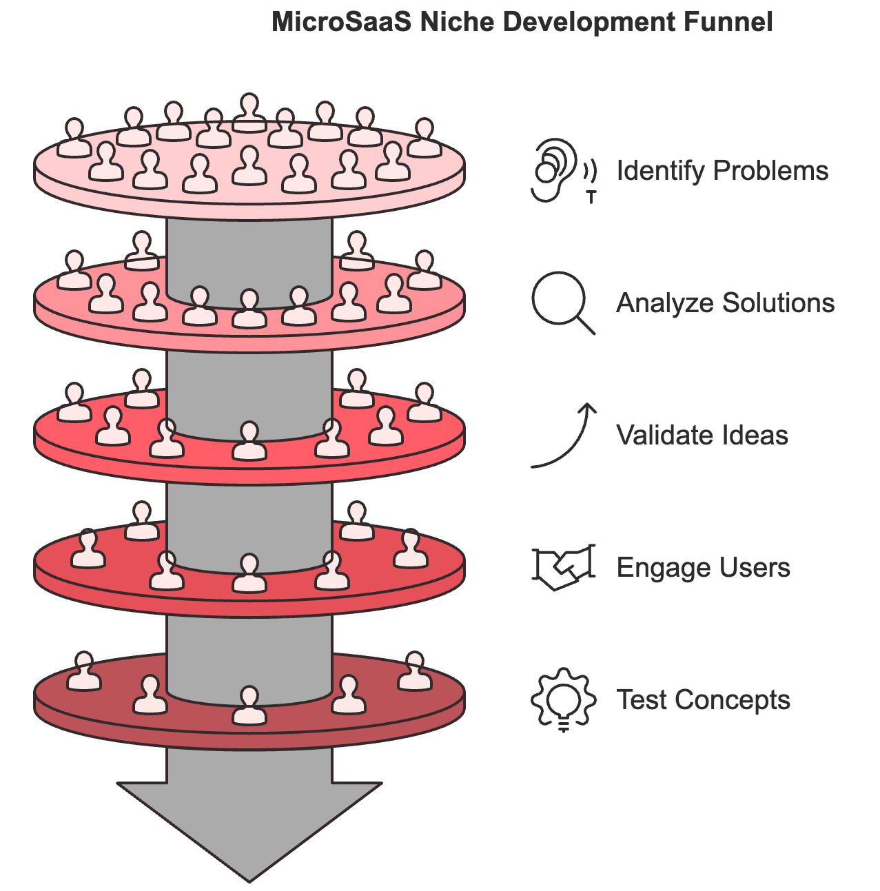

Why Niche Markets Matter for Your MicroSaaS
Picture this: Instead of trying to compete with giant software companies that serve everyone, you focus on solving specific problems for a smaller, well-defined group of customers. That's the power of targeting niche markets. When you zero in on particular needs, you gain several advantages:
First, you face less competition since big SaaS companies often ignore these smaller markets. They're too focused on scale to notice these opportunities, leaving room for you to thrive. Second, when you solve specific problems well, customers become incredibly loyal to your solution. Finally, having a narrow focus lets you move faster, update your product quickly, and stay responsive to your users' needs.
According to research by ClearInsights, businesses that focus on niche markets often see higher customer satisfaction rates and longer-term relationships with their users. This happens because they can truly understand and address their customers' specific challenges.

Finding Problems Worth Solving

Listen to Your Target Audience
The best MicroSaaS ideas often come from real people facing real challenges. Here's how you can tune into their needs: Start by joining online communities where your potential customers hang out. Visit Reddit, Quora, and industry-specific forums. Don't just scroll - actively look for patterns in the questions people ask and the problems they discuss. Write down common complaints and frustrations you notice.
For example, if you notice multiple posts from fitness trainers struggling to manage client schedules and payments, that could signal an opportunity for a specialized scheduling tool. According to WeSoftYou, successful MicroSaaS founders often find their best ideas by spending time in these online spaces where their target users gather.

Study Existing Solutions
Look at the tools people currently use and identify their shortcomings. Sometimes the best opportunities come from making existing solutions better for specific groups. Here's what to look for:
- Features that users frequently complain about
- Missing capabilities that people often request
- Overly complex interfaces that frustrate users
- Pricing that doesn't match the value provided
For instance, Userlist found success by creating a customer messaging tool specifically for SaaS companies, focusing on features that general-purpose tools lacked. This approach helped them carve out their own space in a crowded market.

Use Data to Validate Your Ideas
Don't rely on gut feelings alone. Use tools like Google Trends, SEMrush, and Ahrefs to research potential markets. These tools can show you:
- Search volume for specific problems or solutions
- Growing trends in your target market
- Related keywords that might reveal new opportunities
- Competition levels for different niches
According to Developing for Dummies, successful MicroSaaS founders spend significant time analyzing market data before settling on an idea. This research helps them avoid building solutions that nobody wants.

Engaging With Your Target Market

Create Detailed User Personas
Before you start building anything, develop clear pictures of who you're serving. A good user persona includes:
- Demographics (age, location, job role)
- Daily challenges and frustrations
- Goals and aspirations
- Current solutions they use
- Budget constraints
For example, instead of targeting "small business owners," you might focus on "Alex, a solo consultant who spends 5 hours weekly on invoice management and wants to automate this task."

Conduct Customer Interviews
Nothing beats direct conversations with potential customers. Here's how to make these interviews valuable:
- Find 5-10 people who fit your target persona
- Ask open-ended questions about their challenges
- Listen more than you talk
- Take detailed notes about specific pain points
- Look for emotional responses that signal strong needs
BufferApps suggests recording these conversations (with permission) so you can review them later and catch details you might have missed.

Test Your Ideas Quickly
Before investing months in development, test your ideas with potential customers. You can:
- Create a simple landing page describing your solution
- Share mockups or wireframes with target users
- Build a basic prototype using no-code tools
- Offer a manual service version of your product
According to Altorise Hub, successful MicroSaaS founders often test multiple ideas before finding one worth pursuing fully.

Evaluating Market Potential

Size Matters (But Not How You Think)
In MicroSaaS, you don't need millions of customers to succeed. A small, loyal customer base can support a profitable business. Consider these factors:
- How many potential customers exist in your niche?
- What percentage could you realistically reach?
- How much would they pay for a solution?
- What's the lifetime value of each customer?
For example, a tool that saves personal trainers 5 hours per week might be worth $50/month to them. If there are 10,000 trainers in your target market and you capture just 2%, that's 200 customers generating $10,000 monthly revenue.

Competition Analysis
Study your competitors carefully, but don't let their presence discourage you. Look for:
- Gaps in their offerings
- Poor user experiences you could improve
- Underserved customer segments
- Pricing opportunities
According to Microns.io, successful MicroSaaS businesses often succeed not by being completely unique, but by serving a specific segment better than anyone else.
Your solution to a niche market problem could become your ticket to a sustainable, profitable business. Start by deeply understanding your chosen market, validating your ideas with real users, and testing your concepts before full development. Remember, successful MicroSaaS businesses solve specific problems exceptionally well for a defined group of customers.


FINDING PROBLEMS WORTH SOLVING IN NICHE MARKETS
____
Ideas spark in everyday places. While scrolling through social media, you notice fitness trainers complaining about client scheduling hassles. During lunch with friends, you hear a small business owner struggling with social media management. These moments can inspire your next successful MicroSaaS venture. This chapter shows you proven ways to spot these golden opportunities in niche markets and turn them into viable business ideas.

Understanding the Power of Niche Markets
Niche markets offer unique advantages for MicroSaaS entrepreneurs. Unlike crowded mainstream markets where giant companies dominate, niches provide space for specialized solutions. When you focus on specific customer segments with distinct needs, you face less competition and can build stronger relationships with users.
According to BufferApps research, large SaaS companies often overlook niche markets because they seem too small for their growth targets. This creates perfect opportunities for MicroSaaS businesses to thrive. Users in niche markets also tend to be more loyal when they find a solution that truly understands their specific challenges.

Research Methods to Uncover Niche Problems
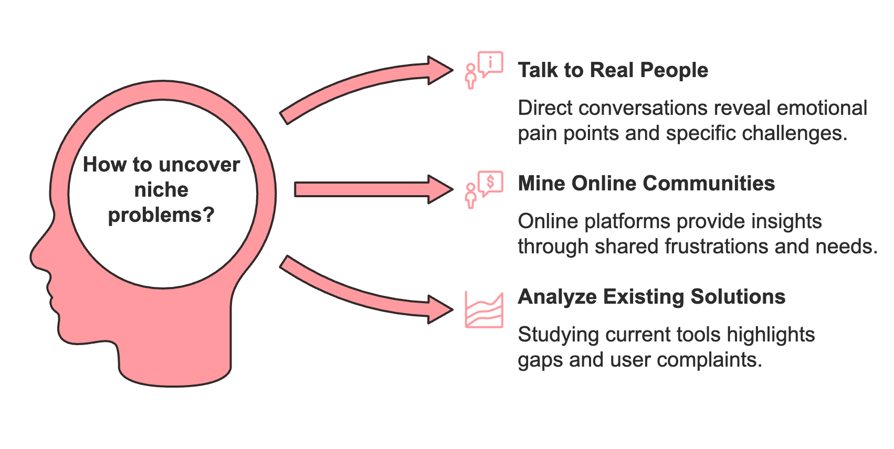

Talk to Real People
Nothing beats direct conversations with potential customers. Here's how to make these discussions productive:
Start by identifying groups that might need your solution. For example, if you're interested in the fitness industry, connect with personal trainers, gym owners, and fitness enthusiasts. According to WeSoftYou, successful MicroSaaS founders often find their best ideas through direct conversations with their target users.
Ask open-ended questions about their daily challenges:
- What tasks take up most of their time?
- Which problems frustrate them the most?
- What solutions have they tried?
- Why didn't those solutions work?
Pay special attention when people show strong emotional reactions while describing problems. These emotional pain points often signal valuable opportunities for solutions.

Mine Online Communities
Online platforms contain treasure troves of potential business ideas. People freely share their frustrations and needs in these spaces. Here's where to look:
Reddit communities specific to your target industry often reveal common challenges. For instance, r/personaltrainers might show recurring complaints about scheduling and payment collection. Industry-specific Facebook groups, LinkedIn discussions, and Quora questions can also provide valuable insights.
According to Developing for Dummies, successful entrepreneurs spend significant time analyzing these online discussions before settling on an idea. Look for patterns in the complaints and questions people ask.

Analyze Existing Solutions
Study current tools and services in your chosen niche. Focus on:
- Features users frequently complain about
- Missing capabilities that people often request
- Pricing that doesn't match user expectations
- Complex interfaces that frustrate users
For example, Userlist found success by creating a customer messaging tool specifically for SaaS companies after noticing that general-purpose tools lacked features these businesses needed.

Validation Techniques for Your Ideas

Create Simple Landing Pages
Before building anything, test market interest with a basic landing page. Describe your proposed solution and include a sign-up form for updates or early access. Drive traffic to this page through:
- Social media posts
- Relevant online communities
- Small ad campaigns
According to Altorise Hub, successful MicroSaaS founders often test multiple ideas this way before finding one worth pursuing fully.

Run Small Surveys
Design targeted surveys to validate specific aspects of your idea. Keep them short and focused. Ask questions about:
- Current solutions people use
- How much they spend on existing tools
- Features they wish existing solutions had
- How much they would pay for your proposed solution
Tools like Google Forms or TypeForm work well for this purpose. ClearInsights research shows that successful MicroSaaS products often evolve based on early survey feedback.

Build Minimum Viable Products (MVPs)
Create the simplest version of your solution that delivers value. This might be:
- A manual service version of your product
- A basic prototype using no-code tools
- A simplified version with core features only
Share this MVP with potential users and gather feedback. Pay attention to how they use it and what features they request most often.

Assessing Market Potential

Evaluate Market Size
While MicroSaaS businesses don't need massive markets, you should ensure there's enough demand to support your business. Consider:
- How many potential customers exist in your niche?
- What percentage could realistically become customers?
- How much would they pay monthly for your solution?
- What's the lifetime value of each customer?
For example, if you build a scheduling tool for personal trainers and there are 10,000 trainers in your target market, capturing just 2% at $50 per month means $10,000 in monthly revenue.

Study Competition
Analyze existing solutions in your market. According to Microns.io, successful MicroSaaS businesses often succeed not by being completely unique, but by serving a specific segment better than anyone else. Look for:
- Gaps in current offerings
- Poor user experiences you could improve
- Underserved customer segments
- Pricing opportunities

Consider Long-term Potential
Think about how your market might evolve:
- Are there trends supporting growth in your niche?
- Could you expand to related markets later?
- What technological changes might affect your solution?
For instance, the rise of remote work created new opportunities for specialized collaboration tools.

Using Your Personal Experience
Your background and skills can help identify valuable opportunities. According to WeSoftYou, many successful MicroSaaS founders built solutions for industries they knew well. Consider:
- Problems you've faced in previous jobs
- Challenges you see in your current work
- Industries where you have expertise
- Skills that give you unique insights
For example, if you have experience in fitness, you might notice specific problems that gym owners face with member management.

Common Pitfalls to Avoid

Solving Non-existent Problems
Make sure the problem you're solving actually exists and people want it solved. According to Medium, many startups fail because they build solutions nobody needs.

Targeting Too Broad a Market
Stay focused on your niche rather than trying to serve everyone. A specialized solution for a specific group often performs better than a general solution for many groups.

Ignoring Feedback
Listen to potential customers and be willing to adjust your idea based on their input. Early feedback can help you avoid building the wrong solution.
Markets constantly change, creating new opportunities for MicroSaaS solutions. By carefully researching niche markets, validating your ideas, and staying focused on specific customer needs, you can identify problems worth solving and build valuable solutions.


TESTING YOUR IDEA BEFORE DEVELOPMENT
____
Starting small lets you build something people actually want. Before pouring months of work and thousands of dollars into developing your MicroSaaS, you need to verify that customers will pay for your solution. This chapter shows you practical, budget-friendly ways to test your idea and get real feedback from potential users.

Start with a Simple Landing Page
Your first step is creating a basic website that explains your product's core benefits. This landing page acts like a digital storefront, helping you gauge interest before building anything. According to Altorise Hub, successful MicroSaaS founders often test multiple ideas this way before finding one worth pursuing fully.
Here's what your landing page needs:
- Your product's main benefit stated clearly at the top.
Instead of "Project Management Software," try "Help Remote Teams Stay Organized and Meet Deadlines." This tells visitors exactly how you'll solve their problem.

- Add 3-4 key features that address specific customer pain points.
For example, if you're building scheduling software for personal trainers, highlight features like "Automated Client Reminders" and "Payment Processing."
- Include a clear call-to-action button.
This could be "Join the Waitlist" or "Get Early Access." Place an email signup form below it to capture interested visitors.
You can build this landing page using tools like Carrd or Webflow without coding knowledge. Keep the design clean and focus on your message.

Use Targeted Ads to Drive Traffic
With your landing page ready, you need to get it in front of potential customers. Small, targeted ad campaigns on platforms like Facebook or LinkedIn can help you reach the right people without spending much money.
For example, if you're building tools for fitness trainers, you might target:
- People who list "Personal Trainer" as their job title
- Those who follow fitness certification organizations
- Members of personal trainer groups
Start with a small daily budget of $10-20. According to BufferApps research, successful founders often test multiple audience segments to find which responds best to their offer.

Survey Your Target Users
Create a short survey to learn more about your potential customers' needs. Tools like Google Forms or Typeform work well for this. Keep it brief - aim for 5-7 questions that help you understand:
- What tools they currently use
- Their biggest challenges with existing solutions
- How much they'd pay for a better option
- Which features matter most to them
Share your survey in online communities where your target users gather. According to WeSoftYou, direct conversations with potential customers often reveal the best ideas for product improvements.

Build a Manual MVP
Before writing any code, consider offering your service manually. This approach, sometimes called a "concierge MVP," lets you test your idea with real customers while learning exactly what they need.
If you're building scheduling software for trainers, you might:
- Find 5-10 trainers willing to test your service
- Handle their scheduling manually using spreadsheets
- Send appointment reminders yourself
- Process payments through existing tools
This hands-on experience helps you understand the real problems your software needs to solve. According to Developing for Dummies, many successful MicroSaaS products started as manual services.

Create a Simple Prototype
Once you've validated basic interest, build a simple prototype using no-code tools. This gives potential customers something tangible to try without requiring full development.
Tools like Bubble or Adalo let you create functional apps without coding. Focus on building just enough features to solve the core problem. For example, if you're making client management software, start with:
- Basic client profiles
- Appointment scheduling
- Simple payment processing
According to ClearInsights, successful entrepreneurs often release basic versions of their products to get real user feedback before adding more features.

Set Up Customer Interviews
Schedule video calls with potential customers who sign up through your landing page. These conversations provide valuable insights about their needs and willingness to pay.
During these calls:
- Ask open-ended questions about their current challenges
- Show them your prototype and get feedback
- Discuss pricing expectations
- Note feature requests and suggestions
Record these conversations (with permission) to review later. According to Microns.io, successful MicroSaaS businesses often adjust their plans based on early customer interviews.

Test Different Pricing Models
Before settling on a final price, experiment with different options. Create multiple landing pages with different pricing tiers to see which attracts more interest.
For example, you might test monthly vs. annual subscriptions, different price points ($27/month vs. $47/month), and various feature combinations in each tier.
Track sign-ups and feedback for each option. This data helps you find the sweet spot between what customers will pay and what generates enough revenue for your business.

Measure Key Metrics
Pay attention to these numbers as you test your idea:
- Landing Page Metrics:
- Visitor-to-signup ratio
- Time spent on page
- Bounce rate
- Survey and Interview Data:
- Percentage who say they'd pay for your solution
- Most requested features
- Common pain points mentioned
- Ad Campaign Results:
- Click-through rates (CTR)
- Cost per lead
- Which audiences respond best
According to WeSoftYou, successful founders often adjust their product plans based on these early metrics.

Use Feedback to Refine Your Idea
As you gather data from these tests, use it to improve your concept. You might discover that:
- Your target market is different than expected
- Certain features matter more than others
- Your pricing needs adjustment
- The problem you're solving isn't urgent enough
Be ready to pivot based on what you learn. According to Altorise Hub, many successful MicroSaaS products look very different from their original concepts.

Watch for Warning Signs
Pay attention to red flags during testing:
- Low signup rates despite targeted traffic
- People like the idea but won't pay for it
- Similar features already exist in popular tools
- The problem isn't painful enough to justify a solution
These signs might mean you need to rethink your approach or explore different ideas.
Testing your MicroSaaS idea doesn't require huge investments. Start small, gather real feedback, and let customer needs guide your development. Remember, it's better to find out early if an idea won't work than after months of development. Use these testing methods to validate your concept and build something people truly want.


CREATING A STANDOUT VALUE PROPOSITION
____
Your MicroSaaS needs more than just cool features, it needs a message that grabs attention and shows why it's worth buying. Building a strong value proposition helps potential customers quickly understand how your product solves their problems better than any other option. Let's explore how to craft a value proposition that makes your MicroSaaS impossible to ignore.
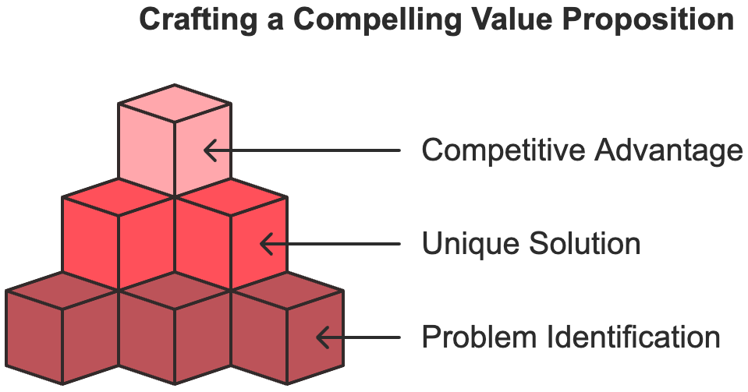

What Makes a Great Value Proposition?
Think of your value proposition as your product's elevator pitch. It needs to quickly explain three key things:
- The specific problem you solve.
- How you solve it uniquely.
- Why customers should choose you over competitors.
According to Gripped, successful value propositions focus on customer benefits rather than just listing features. Your message should resonate with your target audience's needs and aspirations.

Understanding Your Audience's Pain Points
Before writing your value proposition, you need to deeply understand who you're serving. Take time to research your target customers.
Talk directly with potential users about their challenges. What frustrates them most? What solutions have they tried? Why didn't those solutions work? These conversations reveal the emotional triggers that will make your value proposition compelling.
Join online communities where your target users gather. Read through discussions to spot common complaints and wishes. Look for patterns in the problems people mention repeatedly. According to Selling-SaaS.io, successful MicroSaaS founders often find their best insights by spending time in these online spaces.
Study competing products' reviews and forums. Pay attention to both positive and negative comments. What do users love? What makes them frustrated? These insights help you position your solution effectively.

Building Your Value Proposition Canvas
The value proposition canvas helps align your product's features with customer needs. It has two main parts:
- Customer Profile:
- Jobs they need to do
- Problems they face
- Gains they want to achieve
- Value Map:
- How your features solve problems
- How you deliver desired gains
- What makes your solution unique
For example, if you're building scheduling software for personal trainers, your canvas might look like this:
Customer Profile:
Jobs: Managing client appointments, tracking payments, sending reminders
Pains: Double bookings, missed appointments, late payments
Gains: More organized schedule, reliable income, professional image
Value Map:
Features: Automated scheduling, payment processing, reminder system
Pain Relievers: Prevents double bookings, reduces no-shows, ensures timely payments
Gain Creators: Saves 5+ hours weekly, increases revenue by reducing missed appointments

Crafting Your Core Message
With deep customer understanding, you can create a message that resonates.
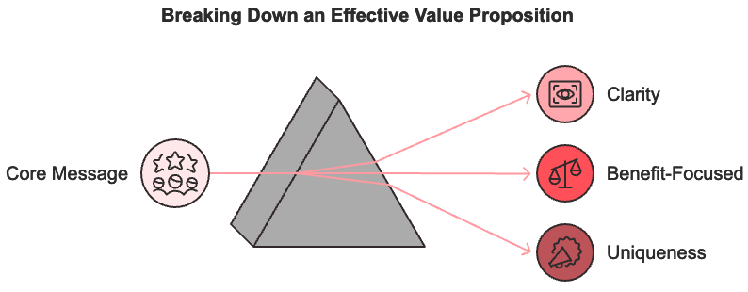
Your value proposition should be:
- Clear and Direct
Avoid jargon and complex language. According to NPWS, the best value propositions use simple words that anyone can understand. For example, Zoom's value proposition "Meet happy" perfectly captures their benefit without unnecessary complexity.
- Benefit-Focused
Highlight outcomes, not features. Instead of "AI-powered scheduling system," try "Never double-book clients again." Show how you improve their life or business.
- Unique
Explain what makes you different from competitors. This could be your specialized focus, unique features, or superior user experience. According to Froged, standing out in crowded markets requires clear differentiation.

Testing Your Value Proposition
Create multiple versions of your value proposition and test them with real users. Here's how:
- A/B Testing
Create different landing pages with various value propositions. Track which version gets more sign-ups or engagement. Use tools like Google Optimize for free testing.
- User Interviews
Show potential customers different versions of your message. Ask which one resonates most and why. Their feedback helps refine your proposition.
- Social Proof
Include customer testimonials or case studies that support your claims. According to Selling-SaaS.io, real user stories make your value proposition more credible and compelling.

Making It Tangible
Turn abstract benefits into concrete outcomes. Instead of saying "saves time," specify "saves 20 hours monthly." Use numbers, percentages, or time frames when possible.
Compare before and after scenarios:"Stop spending hours on manual scheduling. Our automated system handles everything in minutes."
Show ROI clearly: "Reduce missed appointments by 80% and recover $1,000+ monthly in lost revenue."
According to Trainual, specific, measurable benefits make value propositions more persuasive.

Common Value Proposition Mistakes
Being Too General: "We help businesses grow" could describe thousands of products. Be specific about exactly how you help.
Focusing on Features: Lists of features don't excite customers. Focus on how those features improve their lives or businesses.
Copying Competitors: Your value proposition should highlight what makes you unique. According to Gripped, standing out requires more than just matching competitor offerings.
Using Industry Jargon: Write like you're explaining to a friend. Technical language can confuse and alienate potential customers.

Evolving Your Value Proposition
Your value proposition isn't set in stone. As your product and market evolve, your message should too. Keep gathering feedback and testing new versions.
Monitor these signals that might indicate need for change:
- Declining conversion rates
- Customer feedback suggesting misaligned expectations
- New competitor offerings
- Changes in market needs or technology
According to NPWS, successful SaaS companies regularly update their value propositions to stay relevant and competitive.

Examples of Strong MicroSaaS Value Propositions
Look at how these companies communicate their value:
Slack: "Be more productive at work with less effort."
Why it works: Focuses on clear benefit (productivity) while acknowledging pain point (effort).
Mailchimp: "Get your business online."
Why it works: Simple, clear promise that speaks to small business owners' needs.
HubSpot: "There's a better way to grow."
Why it works: Suggests improvement over current methods without being technically complex.
According to Gripped, these companies succeed by focusing on customer outcomes rather than technical features.
Your value proposition serves as the foundation for all your marketing efforts. It should clearly show why your MicroSaaS is the best solution for your target customers' problems. Keep testing and refining your message based on customer feedback and market changes. Remember, the best value propositions focus on benefits over features and speak directly to customer needs.
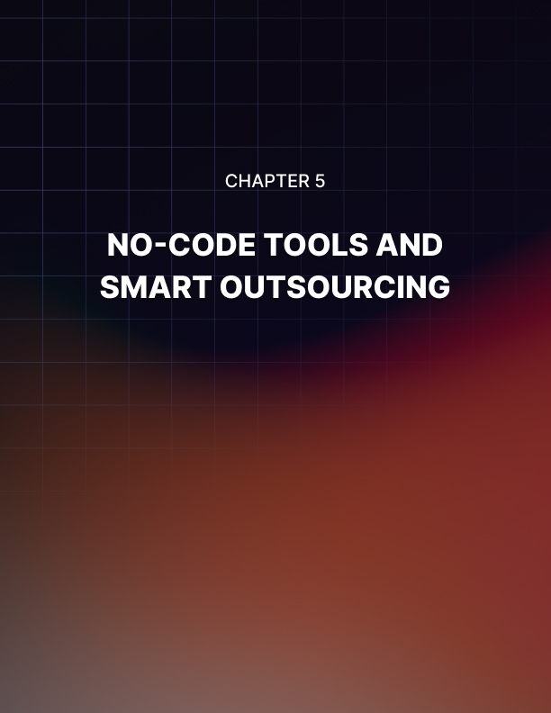

NO-CODE TOOLS AND SMART OUTSOURCING
____
Ready to turn your MicroSaaS idea into reality without breaking the bank? No-code platforms and strategic outsourcing offer you affordable ways to build your product fast. Let's explore how you can launch your MicroSaaS using these modern tools and techniques.

Getting Started with No-Code Development
No-code platforms let you create software without writing code. Think of them like building blocks - you arrange pre-made pieces to construct your application. According to NoCode.MBA, entrepreneurs now build and launch MicroSaaS products in weeks instead of months using these tools.
Your first step is picking the right no-code platform for your needs. Popular options include:
- Bubble: Perfect for web applications with complex workflows
- Adalo: Great for mobile-first applications
- Webflow: Strong choice for content-heavy platforms
- Glide Apps: Ideal for turning spreadsheets into apps
When choosing your platform, consider:
- How many users you expect
- What features you need
- Your budget
- Integration requirements
WeAreNoCode reports that successful MicroSaaS founders often test multiple platforms before settling on one that fits their needs best.

Planning Your No-Code Development
Before diving into building, map out your product's core features. Start with the essential functions that solve your users' main problems. For example, if you're creating scheduling software for personal trainers, focus first on:
- Basic calendar management
- Client booking system
- Payment processing
- Automated reminders
According to Knack, successful MicroSaaS products often start with a limited feature set and expand based on user feedback.

Building Your MVP with No-Code Tools
Your Minimum Viable Product (MVP) should solve the core problem for your users without extra bells and whistles. Here's how to build it:
- Design Your Interface
Start with basic screens that users need most. Use your platform's drag-and-drop tools to create:
- Sign-up/login pages
- Main dashboard
- Core feature screens
- Settings page
- Set Up Your Database
Most no-code platforms include database functionality. Structure your data to track:
- User information
- Customer interactions
- Transaction records
- Usage statistics
- Create Basic Workflows
Build the essential processes your users need:
- User registration
- Payment processing
- Core feature operations
- Basic reporting
JustReply.AI suggests testing each workflow thoroughly before moving to the next feature.

Leveraging AI and Automation
Modern no-code platforms often include AI capabilities. You can enhance your MicroSaaS by adding:
- Chatbots for customer support
- Automated data analysis
- Smart recommendations
- Content generation
SaaSPedia reports that integrating AI features can give your product a competitive edge without requiring technical expertise.

Smart Outsourcing Strategies
Sometimes you'll need help with specific tasks. Outsourcing lets you access expertise without hiring full-time employees.

Identifying What to Outsource
Focus on tasks that:
- Require specialized skills
- Are time-consuming
- Don't need constant attention
- Can be clearly defined
According to LinkedIn, companies save up to 30% on operational costs through strategic outsourcing.

Finding the Right Talent
Use platforms like Upwork or Toptal to find freelancers for:
- Custom design work
- Complex integrations
- Marketing content
- Customer support
Look for contractors who:
- Have experience in your industry
- Show strong communication skills
- Provide clear portfolios
- Offer reasonable rates

Managing Outsourced Work
Create clear processes for:
- Project briefs
- Milestone tracking
- Quality checks
- Payment schedules
Use tools like Trello or Asana to track progress and communicate with your team.
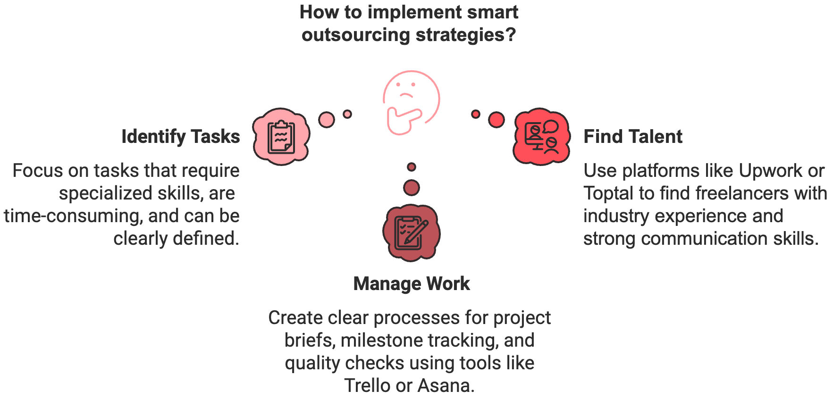

Combining No-Code and Outsourcing
The magic happens when you blend no-code development with strategic outsourcing. For example:
- Build your core product using no-code tools
- Outsource custom design work for a professional look
- Use freelancers for marketing and content
- Hire customer support as needed
This approach gives you flexibility while keeping costs low. According to Knack, successful MicroSaaS founders often start with no-code tools and gradually add outsourced talent as they grow.

Common Challenges and Solutions

Technical Limitations
Challenge: No-code platforms might not support all features you want.
Solution: Focus on core features first. Add complexity through integrations or custom code only when necessary.

Quality Control
Challenge: Maintaining consistent quality across outsourced work.
Solution: Create detailed guidelines and review processes. Start with small projects to test new contractors.

Cost Management
Challenge: Balancing platform fees and outsourcing costs.
Solution: Start with basic plans and upgrade as needed. Set clear budgets for outsourced work.

Testing and Iteration
Your first version won't be perfect - and that's okay. Set up processes to:
- Gather user feedback
- Track usage patterns
- Monitor performance
- Identify bottlenecks
Use this information to improve your product continuously. WeAreNoCode suggests making small, frequent updates based on user feedback rather than large, infrequent changes.

Scaling Your MicroSaaS
As your user base grows, you'll need to scale. Plan for:
- Upgrading platform plans
- Adding more automation
- Expanding support team
- Improving performance
Keep watching your metrics to know when to scale each aspect of your business.
Building a MicroSaaS doesn't require deep technical knowledge or huge investments anymore. By combining no-code tools with smart outsourcing, you can create a profitable product that serves your niche market well. Start small, focus on solving core problems, and grow based on real user feedback.
Remember, successful MicroSaaS businesses aren't built overnight. Take your time to build quality features, test thoroughly, and listen to your users. With patience and the right tools, you can create a valuable product that generates steady income while solving real problems for your customers.


SETTING THE RIGHT PRICE FOR YOUR MICROSAAS
____
Money talks when it comes to pricing your MicroSaaS. Choose the wrong pricing model, and you'll struggle to attract customers or make enough profit to sustain your business. Pick the right one, and you'll create a steady income stream that grows over time. Let's explore how to find that sweet spot for your MicroSaaS pricing and build a solid monetization strategy.
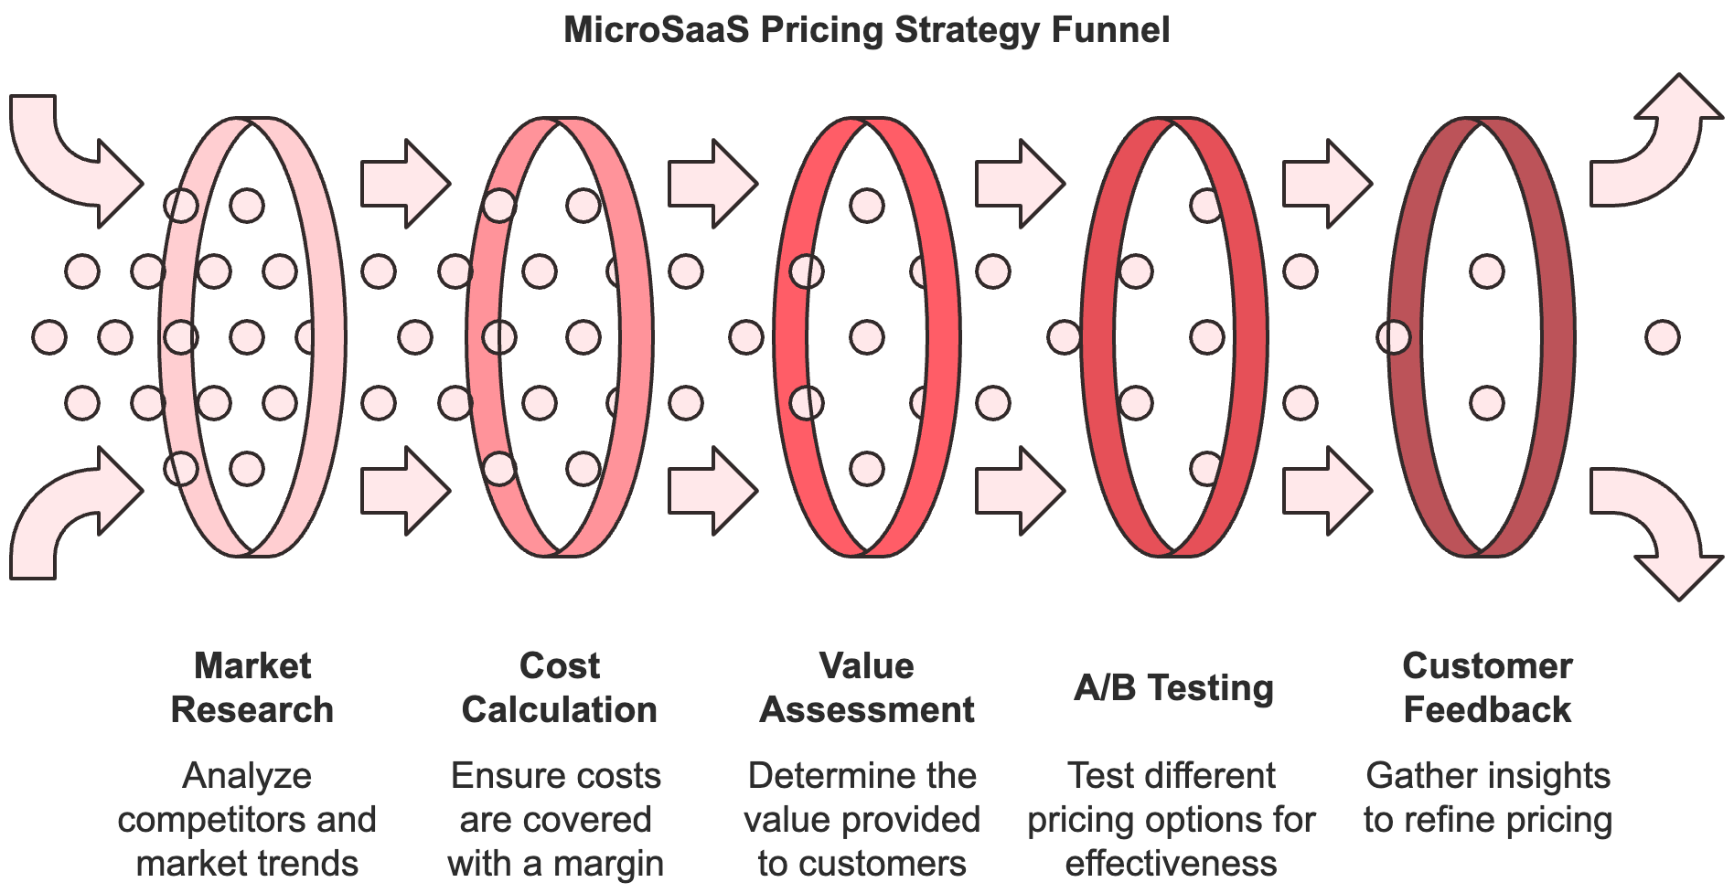
Your MicroSaaS needs more than just a price tag, it needs a complete plan for making money that matches what customers want and expect. According to Maxio, businesses that take time to develop strategic pricing models see higher customer retention and more predictable revenue growth.

Understanding Different Pricing Models
Think of pricing models like building blocks for your business. Each type serves different needs and customer expectations. Here are the most effective models for MicroSaaS.

Subscription-Based Pricing
Monthly or yearly subscriptions work well for most MicroSaaS products. They give you steady, predictable income while making it easy for customers to budget their expenses. Take Dropbox - they use subscriptions to provide ongoing storage and file-sharing services, creating reliable revenue streams.
The key benefits of subscription pricing include:
- Steady monthly income
- Higher customer lifetime value
- Easier financial planning
- Natural opportunities for upgrades

Freemium Model
Freemium lets users try basic features for free while charging for premium capabilities. Spotify shows how powerful this model can be - their free tier attracts users while premium features encourage upgrades. According to Medium, successful freemium models convert 2-5% of free users to paid customers.

To make freemium work:
- Offer enough value in the free tier to hook users
- Keep your best features for paid plans
- Make the upgrade path clear and compelling
- Balance free and paid features carefully

Tiered Pricing
With tiered pricing, you create different levels of service at different price points. This works especially well for MicroSaaS because it lets you serve various customer segments. HubSpot uses tiered pricing effectively by matching feature sets to different business sizes and needs.
Tips for creating effective tiers:
- Start with 3-4 clear options
- Make each tier's value obvious
- Include your target price in the middle tier
- Highlight your recommended option

Usage-Based Pricing
Some MicroSaaS products work better when you charge based on usage. AWS made this model famous by charging for actual resource consumption. According to WeAreNoCode, usage-based pricing works well for tools where value directly relates to usage volume.
Consider usage-based pricing if:
- Your costs scale with usage
- Users have varying needs
- You can measure usage accurately
- Customers prefer paying for what they use

Setting Your Initial Price
Picking your starting price means balancing several factors. You want to charge enough to make money but not so much that customers run away. Here's how to find that balance:

Research Your Market
Look at similar products in your niche. While you shouldn't just copy their prices, understanding the market helps you position your product. According to ProductLed, successful MicroSaaS businesses often price within 20% of their main competitors.
Study these aspects:
- Competitor pricing strategies
- Feature comparisons
- Target customer budgets
- Market positioning

Calculate Your Costs
Know your numbers before setting prices. Include all costs, such as platform fees, payment processing, customer support, marketing expenses and development costs. Add at least a 40% margin to these costs to ensure profitability. According to Maxio, healthy MicroSaaS businesses maintain gross margins of 70-80%.

Consider Value-Based Pricing
Instead of focusing only on costs, think about the value you provide. If your tool saves customers 10 hours monthly, what's that worth to them? According to Paddle, value-based pricing often leads to higher profitability than cost-plus pricing.
Ask yourself:
- How much money does your product save customers?
- What problems does it solve?
- How much do alternative solutions cost?
- What's unique about your offering?

Testing Your Pricing Strategy
Don't just set your price and forget it. Test different approaches to find what works best. Here's how:

A/B Testing
Create different landing pages with various pricing options. Track which ones get more signups. According to Selling-SaaS.io, even small price differences can significantly impact conversion rates.
Test these elements:
- Monthly vs. annual billing
- Different price points
- Various feature combinations
- Special offer messaging

Customer Feedback
Talk to your users about pricing. You might find they're willing to pay more than you thought, or that certain features matter more than others. Use surveys and interviews to gather insights.

Monitor Metrics
Watch these numbers closely:
- Conversion rates
- Customer lifetime value
- Churn rates
- Revenue per user

Creating Upsell Opportunities
Your initial price point isn't your only chance to make money. According to Launchpod, successful MicroSaaS businesses often make 30% or more of their revenue from upsells.
Consider these upsell strategies:
- Premium features
- Additional storage
- Advanced support options
- Team collaboration tools

Common Pricing Mistakes to Avoid
Learn from others' mistakes to price your MicroSaaS right:

Starting Too Low
Many founders underprice their products, making it hard to raise prices later. According to Medium, it's better to start slightly higher and offer occasional discounts than to start too low.

Complex Pricing
Keep your pricing simple and clear. If customers can't understand your pricing quickly, they'll look elsewhere. According to Maxio, companies with simple pricing models often see higher conversion rates.

Ignoring Customer Feedback
Your customers will tell you if your pricing works. Listen when they say it's too high, too low, or doesn't match their needs. Be ready to adjust based on feedback.

Not Testing Different Options
Many founders stick with their first pricing model too long. According to ProductLed, regular testing and adjusting of pricing strategies leads to better results.
Finding the right price for your MicroSaaS takes time and testing. Start with solid research, choose a model that fits your product and market, and be ready to adjust based on what you learn. Remember, your pricing strategy can grow and change with your business - the key is staying focused on providing value that matches what customers pay.


RECAP AND NEXT STEPS
____
The tools and knowledge you now have can transform your MicroSaaS idea into reality. From finding the perfect niche to building and marketing your product, you've learned essential strategies that work in today's software market. Let's bring it all together and map out your next moves.

Starting with Strong Foundations
Your MicroSaaS journey begins with identifying real problems worth solving. Remember that successful products often come from listening to potential customers and spotting gaps in existing solutions. According to BufferApps research, many thriving MicroSaaS businesses started when founders noticed specific challenges in their own industries.
Think about problems you've faced or witnessed:
- Tasks that take too much time
- Processes that could be simpler
- Tools that don't quite fit specific needs
- Common frustrations in your field
Use online communities, surveys, and direct conversations to validate these problems. Pay attention to how people describe their challenges - their words often reveal the emotional weight of the problems they face.

Building Smart and Lean
You don't need huge investments or technical expertise to create your MicroSaaS. No-code platforms have changed the game, letting you build functional products quickly and affordably. According to WeAreNoCode, entrepreneurs now launch MicroSaaS products in weeks instead of months using these tools.
Focus on your core features first:
- What's the main problem you're solving?
- Which features are absolutely necessary?
- What can wait for later versions?
Remember that perfectionism can be your enemy. Launch with a solid basic product and improve based on real user feedback. This approach saves time and money while ensuring you build something people actually want.

Creating Value That Stands Out
Your value proposition acts as the bridge between your product and your customers' needs. Make it clear, specific, and focused on benefits rather than features. According to Gripped, successful MicroSaaS businesses often succeed by solving one problem exceptionally well for a specific group of users.

When crafting your message:
- Speak directly to your target users' pain points
- Highlight specific outcomes they'll achieve
- Show why your solution is unique
- Keep it simple and memorable
Test different versions of your value proposition with potential customers. Their reactions will tell you what resonates and what needs adjustment.

Smart Pricing Strategies
Pricing isn't just about covering costs - it's about capturing the value you create. According to Maxio, businesses that take time to develop strategic pricing models see higher customer retention and more predictable revenue growth.
Consider these factors when setting prices:
- What value does your solution provide?
- How much do competitors charge?
- What can your target market afford?
- How will you grow revenue over time?
Start with a simple pricing structure and adjust based on customer feedback and usage patterns. Many successful MicroSaaS products begin with one or two tiers and add options as they grow.

Marketing That Works
You don't need a big marketing budget to reach customers. Focus on where your target users already spend time. According to Dharana Digital, many MicroSaaS founders find their first customers through focused efforts in online communities and social media.
Effective low-cost marketing tactics include:
- Creating helpful content that addresses user problems
- Building relationships in industry forums
- Using targeted social media posts
- Offering free trials or limited versions
- Encouraging word-of-mouth through excellent service
Track which channels bring the best results and double down on what works. Quality always beats quantity in MicroSaaS marketing.

Planning for Growth
While MicroSaaS businesses stay intentionally small, you still need to plan for sustainable growth. According to ProductLed, successful MicroSaaS companies often follow a steady expansion pattern, adding features and capacity as customer needs evolve.
Think about:
- How will you handle increasing customer numbers?
- What features might you add later?
- When might you need to upgrade your tools or platforms?
- How will you maintain quality as you grow?
Keep your focus narrow but leave room for strategic expansion when opportunities arise.

Avoiding Common Pitfalls
Learn from others' mistakes to smooth your journey. Common challenges include:
- Trying to Do Too Much
Stay focused on your core solution. Adding too many features too quickly can confuse users and stretch your resources thin.
- Ignoring Customer Feedback
Your users are your best source of product insights. Make it easy for them to share feedback and take their input seriously.
- Pricing Too Low
According to Medium, many founders underprice their products at launch. Starting too low makes it hard to raise prices later and can limit your growth potential.
- Neglecting Documentation
Good documentation saves time and improves the user experience. Create clear guides and FAQs from the start.

Taking Action Now
Your next steps depend on where you are in your journey, but here's a basic roadmap:
- If you're still searching for ideas:
- List problems you've noticed in your field
- Talk to potential users about their challenges
- Research existing solutions and their gaps
- If you have an idea:
- Create a simple landing page to test interest
- Build a basic prototype using no-code tools
- Gather feedback from potential users
- If you're ready to build:
- Choose your development approach (no-code or outsourcing)
- Set up your basic infrastructure
- Create your MVP with core features
- If you're close to launch:
- Test your product thoroughly
- Set up customer support systems
- Plan your marketing approach

Measuring Success
Track these key metrics to gauge your progress:
- Customer acquisition numbers
- User engagement rates
- Churn rates
- Revenue per user
- Customer feedback scores
Use this data to make informed decisions about product updates, marketing efforts, and growth strategies.
Building a successful MicroSaaS business takes time, effort, and persistence. Focus on solving real problems, listen to your users, and stay nimble enough to adapt when needed. Start small, learn continuously, and keep improving based on what works. Your journey might have challenges, but with the right approach and mindset, you can build something valuable that serves your users well and provides sustainable income.

