Table of Contents

Introduction 3
Chapter 1: Why Podcasting? 5
Benefits of Podcasting 6
Chapter 2: Choosing The Right Niche For Podcasting 10
Listeners Trust Experts 10
Chapter 3: Planning for Great Podcasts 14
What is the Mission and Vision of your Podcast? 14
What kind of Personality and Voice? 15
Chapter 4: The Equipment You Need For Podcasting 18
The Simple Podcast Recording Setup 18
The Advanced Podcast Recording Setup 21
Chapter 5: Planning Great Podcasts 23
Organize your Podcasts 23
Recording Online Interviews 25
Chapter 6: How To Record Professional Podcasts 28
Start by Recording properly 28
Creating your Final Podcast File 30
Chapter 7: Podcast Hosting And Distribution 32
Distributing Your Podcasts and Getting the Word Out 33
Chapter 8: How To Promote Offers Through Podcasts 37
Use Subtlety 37
Providing Value is your top Priority 38
Provide Alternative Offers to your Listeners 38
Chapter 9: Growing Your Podcast Listener Numbers 40
You need good Reviews and Ratings 41
Promote your Podcasts 42
Chapter 10: Monetizing Your Podcasts 44
Conclusion 47

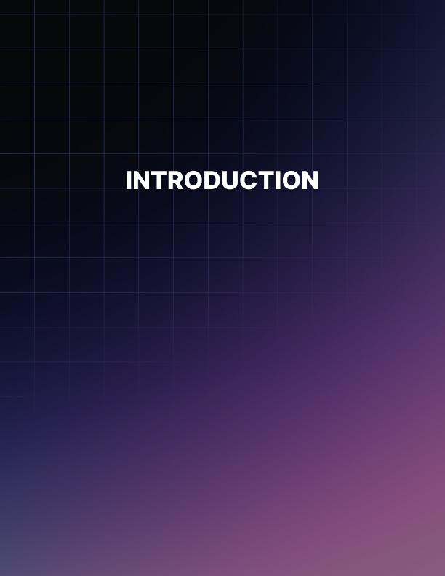

Introduction

There has never been a better time to start your own podcast. Sales of smartphones over recent years have fueled more interest in podcasts and now there are more podcast listeners than ever before.

And the numbers are growing every year.

A number of marketers have tried to create a successful podcast and failed. This is because they tried to use outdated methods to get their podcasts noticed, or because they just didn’t know what they were doing. Well now you can learn from a podcast expert on how to create the best podcasts and build a significant following.

In this guide we will take you by the hand and guide you step by step through the process of creating a successful podcast. You will learn how to create high quality and high value podcasts that listeners crave and how you can get the word out to your target audience.

Planning your podcasts is a very important step in the process and many marketers make the mistake of trying to wing it. This is not the right approach and you will learn how to spend a small amount of time planning to create the very best podcasts for your audience.

There are many ways that you can monetize your podcasts and earn a significant income from them every month. After all it is going to take time and effort to produce your podcasts so why not be rewarded for it?

Use the techniques in this guide to create really successful podcasts. Provide your listeners with the content that they want and they will be hungry for more. It is a lot easier to stand out from the crowd with podcasting rather than blogging and video marketing if you know the right techniques to use.
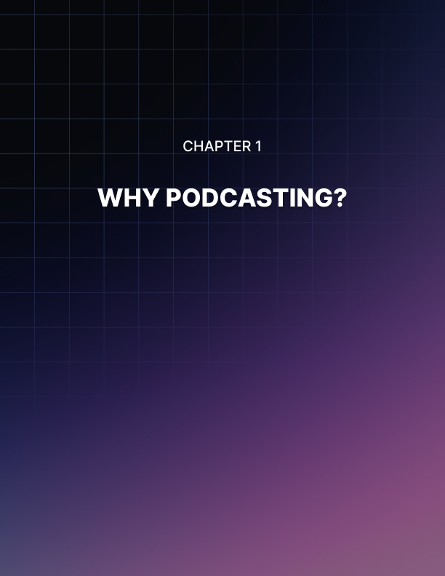

Chapter 1: Why Podcasting?

A lot of marketers dismiss podcasting because they don’t believe that it has the impact of videos for example. But they are wrong to think this because a lot of people like to listen to podcasts especially when they are on the go.

There are many successful podcasters out there that have a huge following. People enjoy their podcasts so much that they can’t wait for the next one. How good would it feel to be in this position? Well you can be an in demand podcaster and you can make a profit from it as well which is what this guide is all about.

What is a Podcast?
A podcast is an audio recording that is usually a series of episodes. It is in MP3 format which means that you can download it and play it on any device that will play MP3 audio such as:

- An MP3 player
- A smartphone
- A tablet
- A laptop

You can listen to a podcast while you are driving but you cannot watch a video. You can think of a podcast a bit like talk radio but it is on demand rather than a continuous program. There are podcasts available on all kinds of subjects and in a number of different niches.

Are Podcasts always Audios?
No, not always. There are video podcasts that you can watch on websites like YouTube. They tend to show the podcast live with all of the people involved speaking into microphones. There are also videos on YouTube and other video sharing sites that are just audios and they will have a static image (or sometimes a number of images) to look at.

Even if a podcast is in video format you can use a converter service online to change it to MP3 which is the audio only part of the video. Then you can listen to the MP3 in the gym, on the way to work, in the supermarket or wherever you happen to be.

What is a Podcast normally like?
A podcast really is like listening to a show on the radio. They will normally have a specific theme, for example dog training or making money online. Most of the time a podcast will be part of a series where it talks about different aspects of the topic. So one podcast could be about dog obedience training, and another about stopping your dog from barking excessively.

A lot of podcasts feature more than one person. The interview podcast is very popular. Here the presenter will interview an expert on a particular subject. This is great for the listener as they have the opportunity to learn from someone that really knows their stuff.

You will find some podcasts that have intro and outro music and even sound effects in them. This is not difficult to do as you will discover later on in this guide. We would always encourage you to make your podcasts as professional as possible so that your audience will take you more seriously.

Benefits of Podcasting
The growth in the number of MP3 enabled mobile phones has really fuelled interest in podcasts. People now have a very easy and convenient way to listen to what you have to say. There are a number of other benefits to podcasting for the marketer and business owner:

A good alternative to Video
Most online marketers would agree that video marketing is essential these days. The problem with videos is that they take a lot of planning and time to shoot. Also not everyone is comfortable about appearing in videos. If you create poor videos and it is obvious that you don’t want to appear in them then this will do your business more harm than good.

There are so many videos available these days that it is a real challenge to make yours stand out from the crowd. You may need to invest in really expensive equipment and software to achieve this. Many things can go wrong when you shoot videos such as the background, sound, lighting etc.

Podcasts are a lot easier to create and the space is less crowded so you can stand out much more easily. All you need to create a good podcast is a high quality microphone and a good audio editing software suite which we will discuss later.

Generate Traffic with your Podcasts
When you create and publish podcasts you will be able to reach out to new audiences. You can use podcasts to build likeability and trust with a wide range of audiences. When a listener subscribes to a podcast series they are very likely to listen to every episode.

If the listeners like your podcast then they are likely to recommend it to other people who share the same interests. When this word of mouth kicks in you can really extend your reach. You can generate a lot of targeted traffic to your website through podcasts.

You can Build a Great Relationship with your Audience
It is possible to build great relationships with your audience through podcasting. The listeners will get the feeling that they really know you after listening to a few of your podcasts. Your listeners will feel that they have something in common with you.

All of this is a great way to build trust. Your listeners will form a strong association with your brand or business and this will definitely help you to sell more of your products or services. Your listeners will consider you a friend and they will be a lot happier to make a purchase from a friend than a stranger.

Podcasts are easy to create
There are not a lot of steps involved in creating a good quality podcast. Nowadays you can purchase the small amount of equipment that you need at a very reasonable price. You need to invest in a good quality microphone for sure, and some good quality headphones will also help.

You will also need an audio editing suite which you can download for free. This will enable you to cut out any errors and also add in any jingles, intro and outro music and so on. After you have completed your edits you can create your podcast in MP3 format very easily so that you can distribute it.

Podcasts have High Engagement levels
The Internet is a great resource for any subject but sometimes there is just too much information. There is always tons of written content and providing a podcast to explain something really breaks up the monotony.

It is a lot easier to get a point across with a podcast than it is with text. There was a survey conducted of 300,000 listeners and this revealed that 63% had purchased what the podcaster had recommended. This supports the fact that podcasts really do engage an audience and will have a strong influence on their buying decisions.
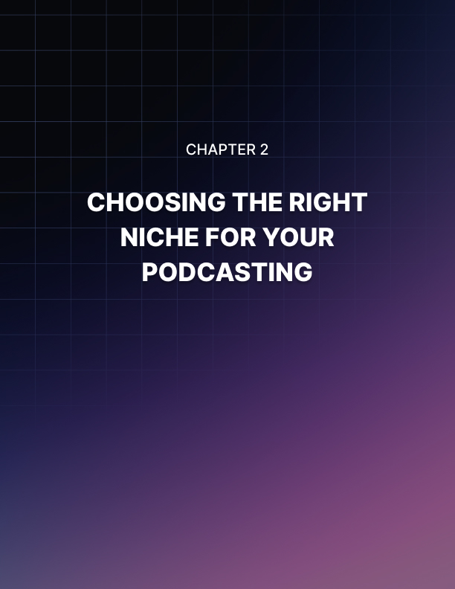

Chapter 2: Choosing The Right Niche For Podcasting

One of the biggest mistakes that people make with podcasting is that they don’t choose the right niche. Because it is relatively easy to create a podcast there is a temptation just to jump right in without thinking about the long term possibilities of what you are doing.

But if you are serious about making money through podcasting then you need to choose a niche that you are comfortable with that will also provide you with money making opportunities.

A lot of “experts” will tell you that you should always choose a niche that you are passionate about. This is particularly important with podcasting as the listeners will hear the passion in your voice.

But the problem here is that not all “passions” are profitable. While there are a ton of potential money making opportunities with a niche like dog training, there are a lot less with stamp collecting and model railways.

So when you are considering a niche for your podcasts you need to think about two important factors:

Is there demand and is there commercial opportunity?
You may be thinking at this stage that if you know nothing about a niche that is in demand and has good commercial opportunities, how can you be passionate about it? Well the answer is that you can certainly become really interested in a niche like this and when this happens your passion will rise to the surface.

Listeners Trust Experts
When you choose a niche that is in demand you will get a lot more followers with your podcasts. People who are interested in the niche will automatically believe you to be an authority even if you are not. Now we are not recommending that you try to create podcasts when you know nothing about a niche – that’s just dumb!
But these days you can learn a lot about a niche in a very short time. There are plenty of resources online and you can obtain high quality training courses for a lot of different niches. You will need to put in some effort initially to get up to speed and you will want to get to the point where you know more about your niche than most people interested in it will know.

This does not have to take you a long time. Just immerse yourself into the niche for a few days and you will learn a great deal. What you are doing here is “faking it till you make it” which you might not feel that comfortable with right now, but after immersing yourself into your chosen niche for a while you will feel a whole lot better about everything.

The best way to establish yourself as an expert with your listeners is to provide them with valuable tips and advice in your podcasts. Even if you are not well known it will not take long for most of your listeners to warm to you and trust you as an authority. Once you have achieved this then you can start recommending related products and services.

So choose an in demand niche with good commercial opportunities and stick with it. Whatever you do, don't go dancing around from one niche to another. You will lose your listeners very quickly if you do this.

How to choose the right Niche
The best way to start to identify your niche for podcasting is to write down a list of your interests and passions. Also include niches that you know a lot about even if you do not consider that you are passionate about this.

Have a look at different podcasting websites to see which niches are the most popular. Also you can use the Google Keyword Planner and see how many searches are happening each month for niche ideas that you have. If there are thousands then you are on the right track.

For each of your niche ideas use Google to see if there are products and services available that you can become an affiliate for and make money. Just search for “niche name” + affiliate programs. The more affiliate opportunities that you can find for a niche the better. You can also head over to Clickbank.com and see if there are any digital products on offer there for your niche ideas. Clickbank is the world leader in digital products and they sell products in tons of different niches. You can also check out physical product opportunities on Amazon.com where you can become an affiliate and make money.

Eliminate any niche ideas that do not have the demand (tested with the Google Keyword Planner) or not enough commercial opportunities in the form of affiliate offers that you can promote. Once you have done that you can move on to the next step.

How can you help people?
With the remaining niche ideas on your list write down how you can help people in each one. In every niche there are problems and at this stage just identify these and don’t worry if you can solve them for people or not.

So for example if one of your niche ideas was making money online then there are a ton of problems that you can come up with here including:

- Which is the best online business model?
- How do I stay motivated with my online business?
- What is the best web hosting?
- What is the best autoresponder?

These are the kinds of questions that people interested in the niche ask every day. You can find the answers later online. Having a number of problems to solve and the ability to provide solutions for them is a strong indicator of a good niche.

Who are your Competitors?
For the niche ideas that remain on your list check out the competition. Having competition in a niche is a good thing as it tends to show that there is demand and also commercial opportunity. Other podcasters want to make money as well as you do so never be concerned about competition.

Take a look at what kind of podcasts your competitors are putting out and think about how you can find another angle or do it better. Your aim is to stand out from the crowd. How many followers do your competitors have? What subjects are they creating podcasts about?

If you really like a niche idea but are concerned that it doesn’t have the right level of commercial opportunity then don’t worry because there are a number of different ways that you can monetize the podcasts you create which we will cover in a later chapter.
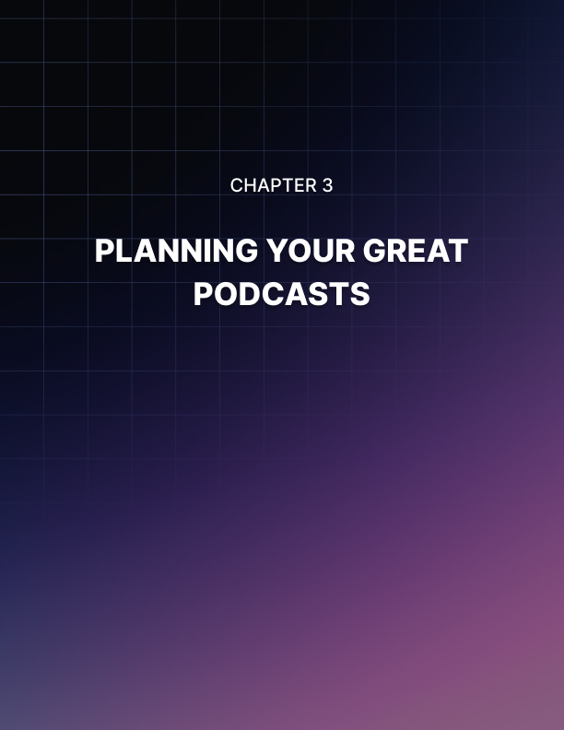

Chapter 3: Planning for Great Podcasts

OK so you have chosen your niche and you have identified a number of problems that people in the niche have and know how to answer them. Surely it is time to start recording your podcasts now? Well not quite…

You need to plan your podcasts first. What does this mean? Well how will you brand yourself in the world of podcasting? This is more than just selecting a great name for your podcast or getting great cover art designed. It is about how you want your listeners to know your podcast. You need to get this right as it will set you up for success.

What is the Mission and Vision of your Podcast?
Before you start to record anything you need to establish a mission and vision for your podcasts. When you have done this then you are sure to create the right kind of content. To be sure we are on the same page here let’s define what we mean by a mission and vision.

Your mission is your goal for your podcast and how you intend to achieve this goal. A vision is how you want your podcasts to look in the future. Both of these are really important so you need to spend time on this. Once you have defined your mission and vision you can ensure that every published podcast aligns with them both.

Create a Community around your Brand
People love communities as it provides them with a sense of belonging. The best podcasters always foster a sense of community with their listeners. As an example of this there is a popular podcast series called “Entrepreneurs on Fire” by John Lee Dumas. He calls his listeners the “Fire Nation” to instill a sense of community.

So if you are going to create a podcast about online marketing you could call your audience the “Digital Marketing Geniuses” or something like that. If you are already “well known” on other channels and have a specific branding then keep this going on your podcasts. Be sure to set up all of your other channels if you don’t have them.
You want to do everything that you can to make all of your listeners feel very special. When they tune into your podcasts they feel great because they are part of the “Digital Marketing Genius” community or whatever you have called it.

So you need to put in a bit of time planning for your podcasts. This is time well spent as your listening audience will appreciate what you are trying to do for them. A strong community will always be on your side (unless you break your own rules) and they will want you to keep producing your great podcasts for a long time.

What kind of Personality and Voice?
Your podcasts are going to be a reflection of you. They will be unique because you are unique. You don’t want to sound like anybody else do you? So how can you make sure that you avoid that?

The best thing to do is to act naturally when recording your podcasts. Speak normally as you do in real life. There are no censors and nobody is there judging you. You may want to avoid using certain words if you think that they are not going to resonate well with your audience though!

You should always come up with a catchy tagline for your podcast. Add something about your niche in your tagline and make it unique and inspiring. Take your time over this as you want a tagline that is going to persuade new listeners to try out your podcasts.

Be Consistent
Your personal branding is not just limited to your podcasts. It is best to be consistent with all of the platforms that you use. Use the same branding on your website or blog, your Facebook page, your YouTube channel and any other platforms you use.

Get some good looking cover art created for your brand. If you don’t have any graphic design skills then head over to Fiverr.com and pay a few bucks to someone good to do this for you. Use this cover art on all of your platforms so that your audience will instantly recognize it no matter which one they are on.

If you don’t do this then you are going to confuse people. With different branding for your podcast and your social media channels for example, your audience will not be sure that they are on the right page for your stuff.

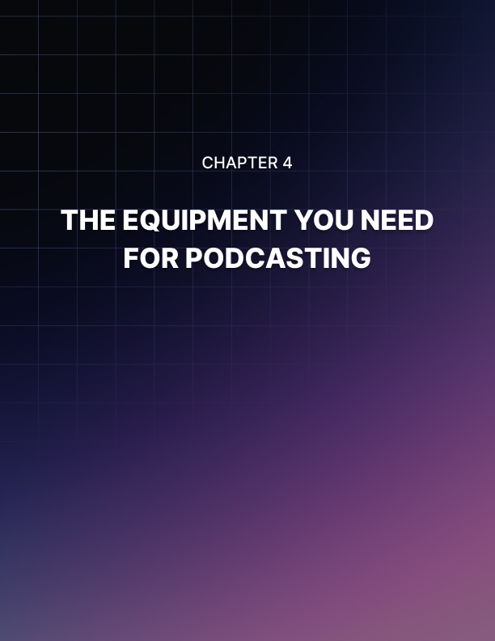

Chapter 4: The Equipment You Need For Podcasting

Before you create any podcasts you need the right equipment. The worst thing that you can do is to produce podcasts where the audio quality is poor. Nobody will want to listen to them. A podcast is all about audio and trying to record using the microphone in your laptop or the one attached to a pair of cheap headphones is out of the question.

You need to think about the type of podcasting you plan to do. If you are going to have a setup where guests will appear on your podcasts by dropping into your home studio then you will need a mixer and some other gear. We do not suggest that you start this way. It can cost you a lot of money to create a mini studio like this.

We recommend that you start by creating the podcasts yourself and conducting interviews over an app like Skype. The advantage of doing this is that you can interview people anywhere in the world. The disadvantage is that sometimes the quality of Skype recordings vary and the person being interviewed will need a good microphone.

So we will take a look in this chapter at a home setup where you will use a computer for the recordings and then we will discuss the options for setting up a mini studio where guests can come and record a podcast with you.

The Simple Podcast Recording Setup
This is the simplest form of podcast recording setup that you can do at home. You will need a computer (which you probably already have), a high quality microphone with a pop guard, good quality headphones and audio editing software.

Most Computers will be fine
You do not need a high end computer to record good quality podcasts. Audio files are a lot smaller than video files and if you have a reasonably modern desktop or laptop computer at the moment this should be more than sufficient.

Podcast Recording with Mobile Devices
What about mobile devices? Well you can record a podcast on your smartphone or tablet but you will need a higher quality microphone than the one included in your device. There are a number of recording apps available for audio for both Android and iOS devices. So mobile device recording is certainly a possibility.

What Microphone?
If you are just going to use your computer for solo podcasts and Skype interviews (more on this later) then we recommend that you get a good quality USB microphone. A USB microphone will work very well with your computer. There are two different types of microphone which are:

- Condenser
- Dynamic

A condenser microphone is all that you need for solo recordings. If you intend to have two people on a podcast recording into your computer then dynamic microphones are best. You can find good quality USB microphones available on Amazon.com for a reasonable price. A couple of good examples are:

- The Blue Yeti (there are some great accessories for this) which is a condenser microphone
- The Audio Technica ATR2100 which is a dynamic USB/XLR microphone

If you want to record using your smartphone or tablet device then you will need a better microphone than the one that comes with the device. You can use a lavalier microphone here such as the Rode smartLav+ which is an omnidirectional microphone that you can clip on to a lapel or a tie for good quality recordings.

The Rode smartLav+ plugs straight into your smartphone or tablet jack. This is a good option if you plan to travel around to make podcast recordings. It will work on most Android and iOS mobile devices.

Get a Pop Guard (or Pop Filter)
Some microphones come with a pop guard (or pop filter) already supplied. If your chosen microphone does not have a pop filter then we strongly recommend that you get one as it will improve the sound quality of your podcasts significantly.
Microphone Stand
You will need some form of microphone stand otherwise you will have to hold your microphone when you are recording your podcasts which is far from ideal. You can get a small desk stand for your microphone so that it sits upright on your desk. This is sufficient in most home recording situations.
Another way to hold a microphone in place is to use a boom arm. These are available separately or you can purchase them in a bundle with the microphone – the Blue Yeti microphone certainly has this option. You clamp the boom arm to a desk and then you can move it around so that it is in the perfect position for your recordings.

Good Quality Headphones
Although you can record a solo podcast into your computer without headphones we recommend that you use a pair of good quality headphones for all of your recording so that you get live feedback on the quality.

You can choose between “in ear” or “earbud” headphones or the conventional “over the ear” headphones. One of the best value for money earbuds is the Panasonic Ergo Fit. If you want to go up a notch in quality then we recommend the 1 MORE Triple Driver in ear solution.

If you prefer the over the ear headphones then the AKG Pro Audio AKG K92 closed back headphones provide great quality sound at a very good price. Of course there are higher quality over the ear headphones available and if you want the best then the Grado SR352e are really up there.

Audio Editing Software
When you record your podcasts it is very unlikely that you will not want to make some edits to it. You may have made some mistakes that you want to cut for the final production and you can make your podcasts sound really professional by adding intro and outro music and sound effects.

Well we have some good news for you here. After spending money on a good microphone and other accessories there is no need for you to pay for audio editing software.

There are two free audio editing suites which will provide all of the tools that you need to produce high quality podcasts:
- Windows computers – Audacity
- Mac computers – Garageband

There are other audio editing suites some of which are free and others where you will need to pay for them. In all honesty Audacity and Garageband are all you need so why pay for an editing suite when you don’t need to?

We are not going to explain how to use these audio editing suites here as it is beyond the scope of this guide. There are plenty of videos on YouTube that will show you how to use the basic and advanced features of these two audio editing suites. With both of these apps you can produce your final podcast in MP3 format.

If you want to do your audio editing on your smartphone or tablet device then there are a number of free and paid apps available for this. For Android devices there is WaveEditor for example and for iOS devices you can use Garageband or TonePad. It is not the easiest thing to do to edit your recordings on a smartphone with these apps. So a better option would be to save your initial recording in MP3 format on your phone using an app and then copy it onto your computer and use Audacity or Garageband.

The Advanced Podcast Recording Setup
If you want to create a podcast recording studio then you will need some additional gear. You will need to use dynamic microphones with an XLR connector for plugging into a mixer. You will also need the mixer, maybe a preamp, a digital recorder and a number of boom arms to hold the microphones in place.

The idea here is that you will create your podcasts using the mixer and digital recorder and then transfer the recording onto your computer so that you can perform your edits with Audacity or Garageband.

To create a podcasting studio like this is going to take some serious investment so you need to be sure that this is the way that you want to go. This is an ideal setup if you are in a good location where guests can easily drop in and participate in podcasts with you.
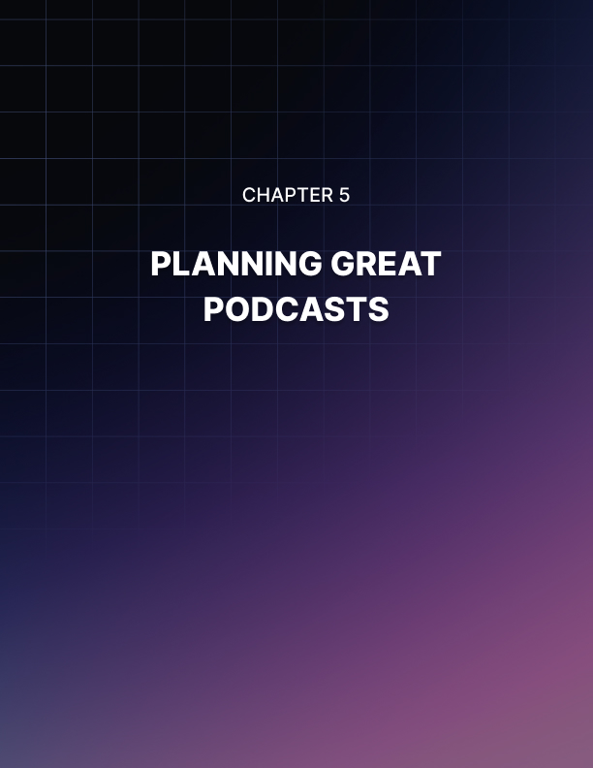

Chapter 5: Planning Great Podcasts

Before you start to record your first podcast you need a plan for it. Podcasts recorded “on the fly” rarely turn out that well. You need to prepare for each podcast to ensure that things go as smoothly as possible.

You don’t need to spend hours on a podcast plan. Investing a small amount of time into a plan will make a huge difference to the quality of each of your podcasts. So let’s get started shall we?

Organize your Podcasts
You are not going to record just one podcast so it is a good idea to get organized so that you can plan and record your podcasts on a regular basis. There are no strict rules for how many podcasts you should create a month but always remember that it is not a good idea to keep your listeners waiting too long or they will find another person’s podcast to listen to!

We recommend that you have a content calendar for your podcasting activities. You have the option of good old fashioned pen and paper here or you can use technology. If you prefer technology then we recommend that you use Google Calendar. There are paid options available but the free Google Calendar will do everything that you need.

With Google Calendar you can add a description to the entries that you make. So you can add the topic of each podcast for the next few weeks for example. You can even attach files to your calendar event if you want to. Just do whatever you need to do to be organized with your podcast planning and recording.

What will you talk about?
You need to spend the most time planning what you are going to talk about on your podcast. If you get this wrong then it doesn’t matter how much fancy equipment you have your podcast will be a disaster.

Always bear in mind that your podcasts are for your listeners. So you need to provide recordings that your target audience will really care about. Do your homework here and find out what your audience wants. You can ask yourself the following questions to help you here:

- What questions do your listeners have?
- What problems do your listeners have?
- What things are your listeners struggling with now?

Use an answer to one of these questions in your podcasts. One way that you can easily find out what your audience is looking for is to do some keyword research. Using the free Google Keyword Planner you can discover the search terms that people in your niche are using to find answers to their questions and problems.

Keyword research is a really good idea because you can create a list of relevant keywords for your niche that you not only use for podcast episodes but also for optimizing your listings when you distribute your recordings. We will talk about this more later in this guide.

Another way that you can come up with content for your podcasts is by brainstorming. If you are going to record a podcast with other people then ask them for their ideas as well. You will get a better result if you use their ideas as well as yours.

Use a mind map if you are going to record solo. This will help you to think through all of the relationships with your initial podcast idea and can even help you with coming up with themes for future podcasts.

Create a Script for your Podcast
Some of you might not like the idea of creating a script for your podcast but it really will help you. If you are an expert in your niche then you may not need a full script to follow. Just write down the important points that you want to cover and then use these as prompts. You will need to be pretty confident to record a good podcast using prompts.

When you write a detailed script it provides you with a really tight way to create a podcast that is packed with value. Reading a full script will prevent you from rambling on and will also ensure that you cover everything in your podcast.

There are a couple of problems with a detailed script though. First is the amount of time and effort that it will take you to write it. Second is that a detailed script can stop you from being spontaneous and prevent you from adding your personality into the recording.

We recommend that you create a couple of test podcasts by using a “prompt” script and a detailed script and see which one suits you the best. Listen critically to the two test recordings and check for coverage of points and ramblings. In the end practice is the best solution. After a while you will find the best form of script for you to create the best podcasts.

It is better that you have some form of script than no script. Even if you have a great memory, the pressure of making the podcast recording can lead you to forget certain points that you really wanted to cover. Start off by using a detailed script and then see if you can get by with a prompt script as you gain more podcasting experience.

Recording Online Interviews
Your listeners will usually look forward to interviews that you have agreed with experts in your niche. If your expert lives far away then the best solution is to record your conversation using an online app.

There are a few good apps out there that you can use for this:

Skype
Skype is an extremely popular online call app that has improved significantly over the years. A lot of people have Skype accounts so check with your interviewee ahead of time so that they can quickly set up a Skype account for free if they don’t have one.

There are a number of apps available for recording Skype calls and creating MP3 files from these. There is actually a feature now in Skype to record calls. Once you have started your call you can start recording and both parties are notified that recording has begun. You can stop the recording at any time or it will automatically stop at the end of the call.

When the recording has finished Skype creates an MP4 file and adds it to the chat window where you can download it. You will then have to convert this into an MP3 file for audio editing. At the time of writing this guide all recordings are in mono format only. This is not great for balancing recording levels in your audio editor.

The next level up for Skype call recording is either TalkHelper for Windows computers or Call Recorder for Mac computers. You will have to pay a small premium for these apps but it is worth it. They will record both parties in separate channels so that you can volume balance. You also get the recording as an audio file.

Zoom
Zoom is more sophisticated than Skype as it is more like a video conferencing tool. All you need to do is use Zoom to set up a room and send the generated link to the other person so that they can sign into the call.

All calls using Zoom are automatically recorded and you will receive an audio file when the call has ended. You can set up the recording so that it will record the two parties on different channels which is great for editing. If you are only recording with one other person then a Zoom call is free.

Whenever you are going to record an interview using a call over Skype, Zoom or any other method you should plan the questions that you are going to ask and agree to this with the interviewee prior to recording the interview.
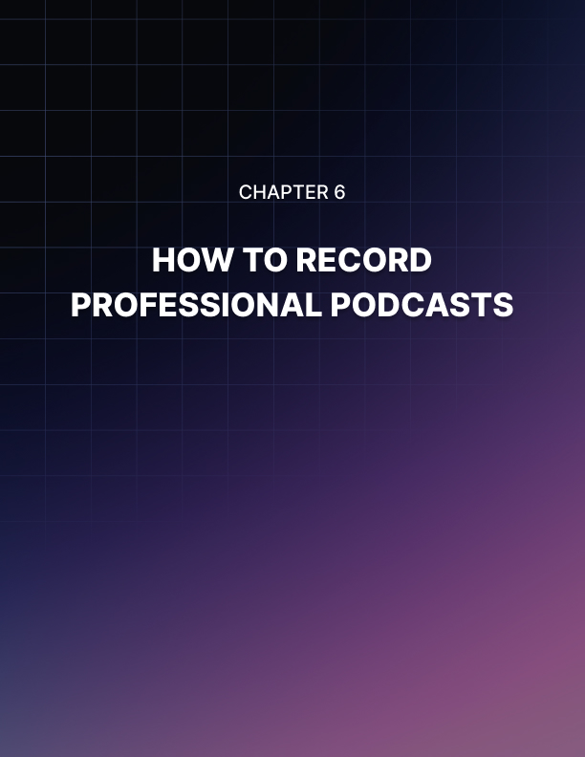

Chapter 6: How To Record Professional Podcasts

Listeners to your podcast are going to judge it on two things:

- The quality of the content you provide
- The quality of the recording

We are going to assume that you followed our advice on planning your podcast and will create valuable content for your audience. So that leaves the quality of the recording itself. In this chapter we will look at how you can create podcasts like a pro.

Start by Recording properly
If you record your podcast correctly then this will prevent you from spending a lot of time editing it. There is not much fun in fixing a lot of mistakes that you have made in a recording. If there are many errors in your recording it might even be quicker for you to record the whole thing again.

OK it is unlikely that you are going to create recordings without any mistakes in them, especially when you are just starting out. But you can do quite a lot to minimize the number of mistakes in a podcast recording by following these steps:

Choose a Quiet place to Record
You would think that this would be obvious but a lot of people make the mistake of recording their podcasts in a noisy environment. Then they have to spend a great deal of time trying to edit out distracting background sounds (sometimes this is not even possible).

Choose a quiet location for your recording and be sure to close windows and doors. Turn off your phone or at least put it in silent mode. Tell other people in your home that you are going to be recording and not to disturb you unless there is an emergency.

Speak Clearly
We said before that we would always recommend the use of headphones when you are recording your podcasts. If you don’t use any headphones then you won’t know exactly how you are sounding. You may be talking too loudly or too softly.

Use headphones and speak directly into your microphone. If you are reading a script then make sure that you can do this without turning your head away from the microphone. Listen in your headphones and see if you need to make some adjustments to your recording software such as the volume, the cadence, the tone and so on.

Provide each person with their own Microphone
If there are two or more people involved in your podcast then provide each of them with their own microphone. You may think that you can get away with sharing a microphone but the result is not going to be great and you will spend a lot of time editing again.

Placing a single microphone in the middle of two people participating in a podcast recording rarely turns out well. People speak at different volumes and one can easily drown out the other.

Create a Test Recording
It is always a good idea to perform some testing first before you attempt to record your podcast. There are a number of things that can go wrong such as you haven’t plugged in the microphone properly or you have it on mute!

Can you imagine recording a 30 minute podcast only to discover that you hadn’t recorded anything at all? These things happen so do a test first. With your test you can check your recording levels are right, there is no background noise, you have your recording software setup correctly etc.

Professional Editing
You must aim to provide your listener’s with the very best experience with every podcast that you publish. It is very likely that your listener’s will be doing something else when they are listening to your podcast. This means that you need to minimize any distractions.

Your listener’s are going to be annoyed if they have to listen to your heavy breathing, loud noises in the background or anything else that is going to distract them from the value you are providing in your podcast. If you don’t take care of these things then you will end up with bad reviews and listener’s leaving your podcast in droves.

Once you have recorded your podcast you need to listen to it all the way through. You need to know how to make edits in your audio editing suite so learn about this on YouTube or through tutorials on their website.

Perform the necessary edits as you go along. If you cough or sneeze while you are speaking then you definitely want to cut these out. Here is a good tip – you will know when you have made a mistake during recording. So directly after the mistake leave a couple of seconds of silence so that you can perform seamless edits later.

After performing all of the necessary edits, listen to the audio right the way through again. It is possible that you may have missed something. Put yourself in the shoes of a listener and honestly assess whether you have created a great listening experience or not.

Creating your Final Podcast File
When you are happy with all of the editing and the podcast sounds really good then it is time to add your intro and outro music and any other effects that you planned to use. You can add these on different tracks in your audio editor. Make sure that you listen to the whole thing again before you create your final file.

In most audio editors you will then perform a “mix down” where all of the different tracks of your audio are converted into a single track. You can then save this in MP3 format so that it is ready for you to publish to the world.

Before you are ready to upload your file add metadata or your ID3 tags. Here you will provide the necessary information so that your listeners can see important details about your podcast. This will be things like the name of the podcast, the number, the summary and so on.

Adding your ID3 tags in editing applications such as Audacity and Garageband (using iTunes) is really easy and there are a number of videos on YouTube that will show you exactly how to do this.
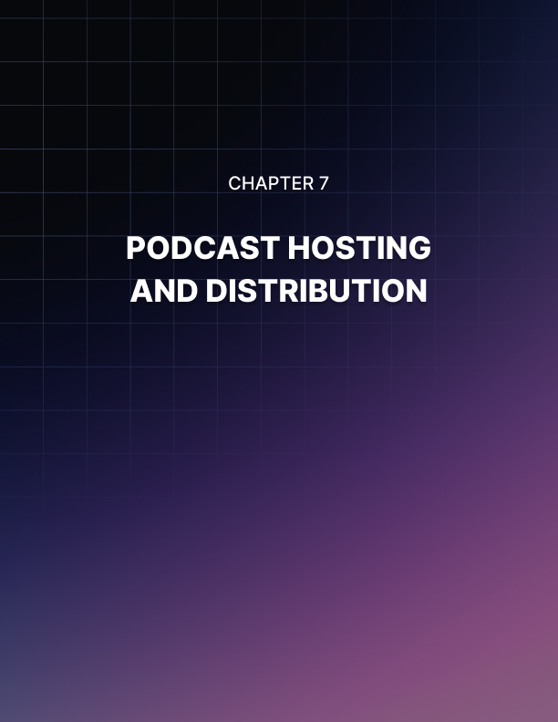

Chapter 7: Podcast Hosting And Distribution

You will need to host your podcast files so that your listeners can access them. They will either stream your podcast or download it. If you have web hosting with unlimited disk space then you may think that you can just upload your files there. But you can run into trouble if you do this.

Unlimited disk space is usually for web files only. Audio or MP3 files are not classed as web files. So the best thing to do is to use a podcast hosting service. These services are optimized for the storage and serving of audio files of different file sizes.

One of the benefits of using a podcast hosting service is that they have built in and validated RSS feeds. These RSS feeds are compliant with the podcasting directories which makes the submission process easy for you and access to your podcasts easy for your listeners.

You can use your RSS feed link when you make submissions to the podcast directories (more on this later). Each time you upload a new podcast file to your podcasting host then the directories where you have submitted your RSS feed will all automatically receive the update. Your listeners will also automatically receive your new podcasts on the device of their choice.

Another good reason for using a podcast hosting company is that you will be able to access statistics about your podcasts. Depending on the podcast company that you use you will be able to see some useful data about your listeners such as:

- Number of downloads
- Apps used to listen to the podcast
- Traffic sources
- Listener locations

You will also be able to create a podcast page with your podcasting host. Here you can provide information about your podcasts and include banners, your social media channels, notes about your podcasts and more. You can link to your website or blog from this page too.

This podcast page will also include a media player where people can stream your podcasts using their web browser. They will also be able to download your podcasts, share them and subscribe to them from this page.

While there are free accounts available with a number of podcast hosts we would always recommend that you go for the paid option as the costs are usually low. Two popular podcast hosting services are PodBean and LibSyn which have plans starting from $3 a month.

Distributing Your Podcasts and Getting the Word Out
We recommend that you record a few podcasts first before you start to distribute them. It looks a lot better if you have a few different podcasts available rather than just one. Once you have done this you are ready to get the word out and tell the world about your awesome podcasts.

Podcasting Directories
You will want to submit your podcasts to a number of podcasting directories. The major ones are going to have the most traffic (iTunes gets the most by far) so we suggest that you submit your podcasts to the following:

- iTunes
- Google Play
- Spotify
- Stitcher
- TuneIn
- SoundCloud

There is no reason why you shouldn’t look for more podcasting directories to make submissions to. The more directories that you use the more people you can reach. Remember that when you use a podcast RSS feed link you will only have to make a single submission.

What about YouTube.com? You absolutely must add your podcasts to YouTube. You will have to convert the MP3 files to MP4 format but this is easy to do with a free online convertor. YouTube will not accept a podcast RSS feed so you will need to upload one at a time. Be sure to optimize properly so your podcasts will be found.

Use your Personal Network
Don’t just leave it to podcast directory submissions to get the word out about your podcasts. Take a look at your personal network including your family members, friends, colleagues and acquaintances.

Don’t be shy about your podcasts, be proud! You have put a lot of effort into creating really valuable podcasts so ask your personal network to help you out in promoting them. Even if they are not interested in your podcast niche they will know people that you don’t that may be interested.

Ask the people that you know to listen to the podcasts and then leave a positive review for you on iTunes or the other podcasting directories. Reviews are essential for your success so do everything that you can to get them. When others see your reviews they will be a lot more likely to listen to your podcasts.

Promote using your Website and Social Channels
If you have your own website or blog then promote your podcasts there. If you have an email list then send out a broadcast email to everyone telling them where they can find your podcasts and requesting that they leave you a review.

Write a post specifically about your new podcasts and publish this on your site. You can add banners to your site as well promoting your podcasts. When you upload your podcasts to YouTube you can embed these into your blog as individual posts.

If you have existing social media channels then be sure to make posts about your podcasts here. You can use your personal Facebook account to make a post and then direct people to your Facebook page to find out more for example.

Use Influencer Marketing
These days it is a good idea to use influencer marketing. The idea here is that you will leverage individuals or brands that have large followings on their social media channels, blogs, podcasts and so on.

Whenever these people endorse something their followers will usually go and check it out. So try and find influencers where you can work together for mutual benefit. Do your homework here to find influencers that really do have a high level of engagement and not a load of fake followers. Contact them and negotiate a deal.

Interview some Experts
We touched on this in earlier chapters. People love to be seen as experts in their niche so find people that you believe can add value to your podcasts and reach out to them and request an interview.
It is best to interview experts that have a large following initially. You want these experts to promote your show to their fan base. Once you have built up a good following of your own you can interview experts that don’t have a large following too.

When an expert agrees to be interviewed for a podcast make sure that you send them a link so that they can access the final recording. You can create a customized swipe file to help your expert promote your podcasts for you including emails, social media posts and other ways that they can tell their following about your joint podcast.

Always thank any experts that you interview for their time and sharing their insight with your listeners. Also thank them for promoting the podcast with their following. If they want to interview you then always accept this. This is a great opportunity for you to distinguish yourself as an expert too and promote your podcasts as well of course.

Paid Ads
There is no reason why you shouldn’t use paid ads to get the word out about your podcasts. We would recommend that you use Facebook Ads to do this as you can identify your target audience precisely.

At the time of writing it is still pretty inexpensive to use Facebook Ads to reach your target audience.

Of course Facebook isn’t the only game in town and there are other platforms that will happily take your money in exchange for promoting your podcasts. Do your homework here so that you get the best bang for your buck and set yourself a budget so that you do not overspend on advertising.

You will get the most out of paid advertising when you really know your audience!
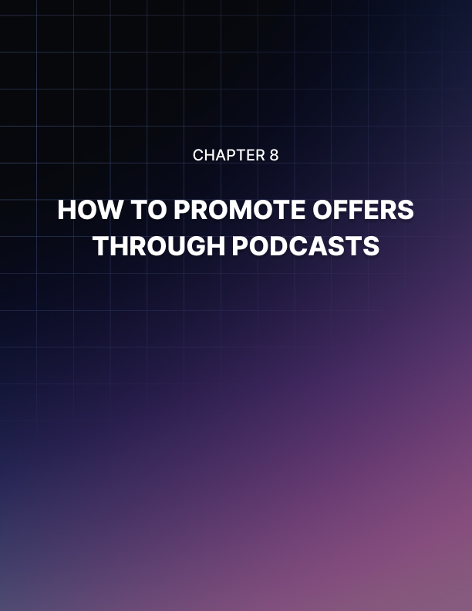

Chapter 8: How To Promote Offers Through Podcasts

There is absolutely no reason why you shouldn’t promote related offers in your podcasts. They are your podcasts so you can do what you want. Nobody is going to try and persecute you for promoting your own podcasts.

It is a lot easier to stand out with podcasting than with other forms of media. The competition in podcasting is a lot lower than video and if you have had the courage to record your voice and make it public then you should get something in return for your efforts. Just follow these steps to promote offers in the best way:

Use Subtlety
We would always recommend that you get a few podcasts under your belt and build up a following before you start to promote offers. When you do start the promotion of offers don’t make it too sales orientated as your listeners will not be happy with this.

In the beginning it will take a while for your listeners to get to know you so don’t hit them with offers right out of the gate. This is very unlikely to work and you will probably lose a lot of listeners if you do this. You need to be more subtle.

We understand that you have put in a great deal of time and effort (and probably money) to create your podcasts. You want to get a return as soon as possible. But you have to be patient with podcasting and your promotional messages must be subtle.

One of the best ways of making a promotion is to mention it in the intro and outro of your podcast. So at the beginning of the podcast tell the listeners who you are and provide a bit of background. Then announce your offer and tell your listener’s that there is more information in the podcast notes if they are interested. Start the podcast normally after this. When your podcast ends just gently remind your listeners about your offer and tell them to check out the notes and description for more details. All you are doing here is sharing the information with your audience – there is no hard selling involved.

Providing Value is your top Priority
All of your podcasts need to add value and you need to think of a good way to interleave your offer into this subtlety. A good way to do this is to discuss pain points with your listeners and tell them that you have the answer to their problems and can relieve their pain. The answer of course is your offer.

Tell your listeners about the benefits they will receive by taking up your offer today. Explain that the product will provide the solutions to their problems. Help them by guiding them through how to use the product so that they can benefit.

This approach is a helpful one rather than a sales orientated one. You are teaching your listeners how they can solve some of their problems which will be appreciated. Of course they will need to purchase your offer to find out exactly what they need to do but that is fine.

People do not like to be sold to but they will always appreciate it if you are trying to help them. This is the promotion strategy that you need to use with your podcasts. Other successful podcasters have been doing this for a long time because it works so well.

Provide Alternative Offers to your Listeners
The same offer is probably not going to fit well with all of your podcasts so you should have some alternative offers lined up that will help your listeners. Never be shy when it comes to promoting another offer – if you don’t have a product of your own that is a good fit you can promote someone else’s product for an affiliate commission.

Your aim with any offers that you make needs to be to help your listeners. If an affiliate product is the best way to do that then go for this. Your listeners will respect you for letting them know that these products exist to help solve their problems.

Always promote quality products and services. If you are going to promote an affiliate offer then check it out yourself first. If you promote something of poor quality then your reputation will take a nosedive and you could undo all of the hard work that you have put in.
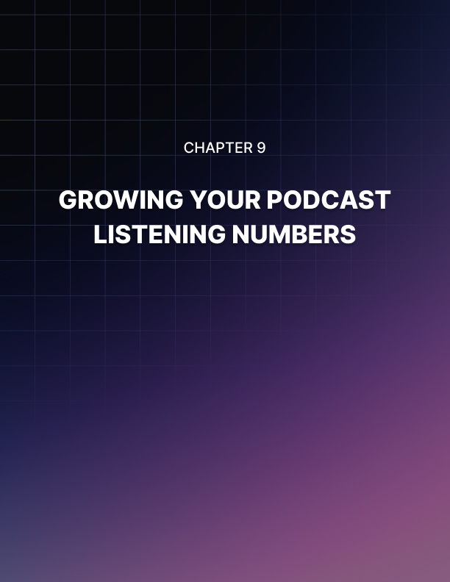

Chapter 9: Growing Your Podcast Listener Numbers

You need to do everything you can to grow your podcast listener numbers. We will discuss some of the best methods to do this in this chapter. It is not going to be easy, but with the right amount of determination you can grow your podcast audience significantly.

It is essential that you are consistent with your podcasting. This means that you must always provide value to your listeners and that you publish a new podcast on a regular basis. The frequency of publishing is up to you – it can be weekly, fortnightly or even every day if you have the time and content to do this. Just be consistent.

As you grow your listener base they will get used to your podcast publishing schedule. They will be very disappointed if you miss a week for example. So you need to get organized for podcast creation as we discussed in an earlier chapter and give your listeners what they want when they expect it.

Let’s assume that you are going to publish a new podcast once a week. Choose the same day to publish. So if you launch a new podcast every Friday then your listeners will get into the habit of tuning into your podcast channel every Friday and expect a new podcast to be there for them.

Some listeners will arrange their lives around your podcast day. They will download your podcast and listen to it while they are doing something else such as driving to work. So don’t let them down! If you start missing Friday’s then they will soon give up on your channel and look elsewhere.

We strongly recommend that you record a number of podcasts in advance so that publishing every week is a lot easier for you. So for example you could record 4 podcasts over a weekend and that is you covered for the upcoming month ahead.

You need good Reviews and Ratings
You are not going to encourage new listeners if you don’t have any good reviews or ratings for your podcasts. Even worse than this is to have a number of negative reviews on your podcast channel. People have become accustomed to look for reviews before they act. They do not want to be the first to try something even when it is free.

You have to provide sufficient evidence to a new listener that listening to your podcasts is going to be a good use of their time. Positive reviews and ratings are the best way to do this. So ask your listeners to provide a review and rating for your podcasts at every opportunity.

What happens if you receive a negative review? Well the first thing to do is to see if the review is justified. If it is then you need to learn from it and thank the reviewer for their comments and explain that you will take their suggestions on board.

Sometimes negative reviews are part of a smear campaign from competitors. If you suspect this then contact the podcast directory administrator and ask for the comments to be removed. Unfortunately some people will go to any lengths to try and sabotage their competitors.

When you have a really large listener base there is always a chance that you will receive some negative reviews. You need to be strong when this happens and respond swiftly to the comments. It is impossible to please all of the people all of the time.

If your reviews are mainly positive then nobody is going to mind a few negative reviews. Take a look at your podcast statistics and if you see that your podcasts are being streamed and downloaded in significant numbers then remind yourself that you are on the right track. Don’t be disheartened by the minority.

Ask your friends and family to leave the first few positive reviews to get you started. You need something for potential listeners to see.

Promote your Podcasts
Most successful marketers spend about 20% of their time on creating content and the remaining 80% on promotion. You need to do this as well. Just because you built it doesn’t mean that they will come. Consistent promotion of your podcasts is the best strategy.

The first step is to really know who your target audience is. When you know this you can find out where they hang out. If your audience is younger then they will probably use Instagram, Snapchat, Reddit etc and if they are older then try Facebook, Pinterest and forums for example. So if your audience are going to be on Facebook you can use Facebook Ads to reach out to them. Facebook has a great retargeting system which means that if a person shows an initial interest they get “cooked” and then you can retarget them again.

A retargeted individual is warm. They have already discovered you and your brand and it is much easier to convert them than it is with cold leads. You can use an incentive to convert both cold and warm leads and get them onto your email list. Once they have subscribed, tell them about your podcasts.

Podcast Contests
Once you have a good number of listeners to your podcasts you can hold a contest. Some examples could be:

- The best post about your podcasts on Facebook
- The best review left
- The best tagline idea for your podcast show

Think about what you want to achieve here. Do you want more people to leave a post on Facebook about your podcast so that you can increase your reach? Or do you want to get more good reviews on your channel?

Always give the contest winner a good prize for participating. If you have created your own products then you could give the winner access to this for free. You can get some branded items that are useful (e.g. USB sticks) and give these away to the runners up for example. Always name the winner on one of your podcasts and reach out to them and ask if they want to be interviewed. Tell them that they can have a 60 second slot to promote their business if they want to.
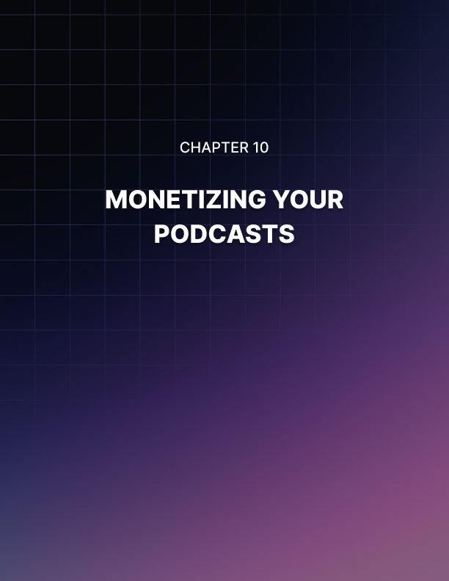

Chapter 10: Monetizing Your Podcasts

We have already discussed that you can make offers during your podcasts for people to purchase your products or services or an affiliate offer where you make a commission. But it doesn’t have to stop there. There are a number of other ways that you can monetize your podcasts.

- Request Donations
A lot of successful podcasters use a donation service like Patreon.com as a way to collect donations from their listeners. You can announce this on all of your podcasts and tell your listeners that it is a great way for them to support you to create more podcasts in the future.

- Find Sponsorship and Advertising Partners
One of the most common ways to monetize a podcast is through sponsorship. This is great for you as you don’t have to do any selling. Usually a sponsor will ask you to add a specific line at the beginning and maybe the end of your podcast such as “this podcast is brought to you by [company name]. If you want …”

There are a number of places that you can look for sponsors including:

- AdResultsMedia.com
- Adopter.media
- AdvertiseCast.com
- TrueNativeMedia.com

Of course a broker will want a cut of the sponsorship or ad money but they are worth using because they are in contact with a lot of companies that are looking to sponsor podcasts. It is much easier than trying to find sponsors yourself.

- Create Premium Content Podcasts
Once you have an established listener base you can create premium podcasts which your listeners have to pay to access. Some ideas for premium podcasts are:

  - Live streamed podcast episodes
  - Q & A sessions with special guests
  - Interviews with esteemed experts

- Sell Consulting or Coaching Services
Your listeners see you as an expert and a total authority in your niche. They would love to know what you know. So you can offer your listeners a series of high priced consulting or coaching sessions that you perform online over Skype.

- Make Money from YouTube
You can earn additional income by syndicating your podcasts on YouTube and signing up for a Google Adsense account. When people are listening to your podcasts on YouTube they will be presented with relevant ads. Because you are not using video, these ads will seem a lot less intrusive. You will receive a commission for the ads that are clicked.

- Experiment with Different Monetization Strategies
Test to see which monetization strategies work the best with your podcasts. There are other strategies that you can use as well to make some money. Sponsorship and donations are the most common form of monetization. They bring in regular income without you having to do much for it.


Conclusion

You now have everything that you need to plan for and create a successful and profitable podcast. We strongly recommend that you create goals for your podcast and are consistent with value, audio quality and the publishing schedule for your podcasts.

Podcasting offers a tremendous opportunity for businesses and individual marketers alike. If someone tells you that podcasting doesn’t work then they simply don’t know what they are talking about.

With a successful podcast you have the opportunity to generate leads and sales of your products and affiliate offers. After a while you can look for sponsors who will pay you a regular monthly income for a shout out in your podcasts.

It is vital that you are consistent with your podcasts. Make a commitment to publishing once a week for example and be sure that your new podcasts appear on the same day each week. Your listeners will get into the habit of looking for your podcast each week with great anticipation.

So now it is over to you. You need to take action and follow the advice in this guide. Don’t skip any steps in the process. Plan all of your podcasts and check them thoroughly before publishing. Spend most of your time promoting your podcast.

We hope that you found Modern Podcasting informative and helpful. Get started today on your podcasting. We wish you every success with your podcasting and making a profit from this very overlooked form of marketing!

