TABLE OF CONTENTS
____
INTRODUCTION 5
HIDDEN FORCES BEHIND YOUR FINANCIAL DECISIONS 8
How Your Mind Influences Financial Choices 9
How Culture Shapes Your Financial Decisions 10
External Forces That Shape Your Financial Choices 11
MINDSET MASTERY: SHAPING FINANCIAL SUCCESS 14
Building Growth-Oriented Financial Strategies 14
Navigating Implementation Challenges 16
BUILDING DAILY FINANCIAL HABITS THAT MATTER 19
Essential Daily Financial Practices 19
Tools and Systems for Success 20
NAVIGATING THE FINANCIAL FEELINGS 24
The Brain-Money Connection 24
Making Better Decisions Through Emotional Awareness 25
OVERCOMING COGNITIVE BIASES IN BUSINESS DECISIONS 29
Understanding Your Brain's Financial Shortcuts 29
Creating a Bias-Resistant Decision Process 31
RISK PERCEPTION AND FINANCIAL CHOICES 34
Understanding Business Risk Through Your Lens 34
Making Better Risk Decisions in Your Industry 35
CULTIVATING A WEALTH-BUILDING MINDSET 38
Understanding the Wealth Mindset 39
Creating Your Growth Framework 39
Building Your Support System 40
USING PSYCHOLOGY FOR FINANCIAL GROWTH 43
Measuring Financial Decision-Making Success 43
Building Implementation Systems That Work 44
Future-Proofing Your Financial Psychology 45

DISCLAIMER
____
The information provided in this ebook is intended solely for educational and informational purposes. The author does not accept any responsibility for the outcomes that may arise from the application of the material within. While efforts have been made to ensure the accuracy and relevance of the content, the author cannot be held accountable for any errors or omissions, or for any consequences resulting from the use or misuse of the information provided. The responsibility for any actions taken based on the information in this ebook lies solely with the reader.


INTRODUCTION
____
Why do some entrepreneurs consistently make smart financial decisions while others struggle, even when they have similar skills and resources? The difference often lies in their mindset and the unseen psychological forces influencing their choices.
As an entrepreneur, every day brings financial decisions that shape the future of your business. From small expenses to large investments, these choices create the foundation for growth—or lead to costly mistakes. What many overlook is that emotions, habits, and mental biases often drive these decisions more than logic or data.
Entrepreneurs who actively work on their relationship with money are far more likely to achieve their financial goals.

Consider the case of Emily, a tech startup founder who missed growth opportunities because of her cautious approach to risk, shaped by her experiences during the 2008 financial crisis. Once she identified her unconscious bias and learned to manage it, her business grew by 300% in just two years. Her story highlights the powerful impact of understanding the psychology behind financial decisions.
Financial success isn’t just about numbers and spreadsheets—it’s about understanding the emotional and behavioral patterns that influence every choice. Fear, excitement, and deeply ingrained habits often play a larger role than we realize, and learning to recognize and manage these forces is essential for long-term success.
Mastering the psychological side of financial decision-making gives you a unique edge. It helps you make confident, balanced choices that align with both your business goals and personal values. This means spotting and avoiding cognitive biases, using emotions like fear as signals instead of obstacles, and developing habits that naturally lead to better outcomes.
Entrepreneurs who actively work on their relationship with money are far more likely to achieve their financial goals. Yet few business owners invest in this kind of self-awareness and growth. By diving into these principles, you’re taking a critical step toward mastering an often-overlooked aspect of entrepreneurial success.
This guide is designed to help you build a mindset for financial growth—not through empty promises, but with proven strategies and actionable insights. Whether you’re launching a new venture or scaling an existing one, you’ll learn how to improve decision-making, avoid common traps, and create systems that foster sustainable success.
Let’s explore how understanding the psychology of financial decisions can unlock your full potential as an entrepreneur. Turn the page, and let’s get started.


HIDDEN FORCES BEHIND YOUR FINANCIAL DECISIONS
____
When you make financial decisions in your business, you might think you're being purely rational. However, behind every investment choice, budget allocation, or strategic move lies a web of hidden influences that shape your decision-making process.
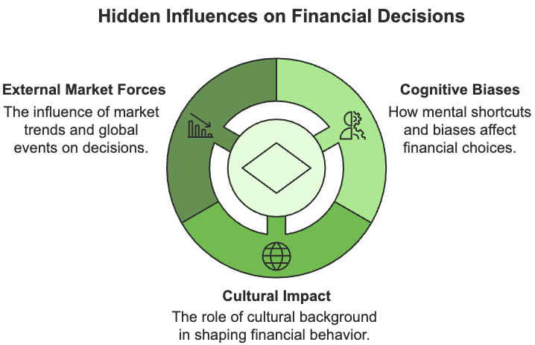
Understanding these forces can help you make better financial choices and avoid common pitfalls.

How Your Mind Influences Financial Choices
Your brain processes financial decisions in ways that often surprise you. While traditional financial theories assumed business leaders made choices based purely on logic, modern research tells a different story:
The way you think about money and risk can significantly impact your business decisions.

Observe how you react to potential losses versus gains. You're probably more likely to feel the pain of losing $1,000 more intensely than the pleasure of gaining the same amount. This natural tendency explains why you might hesitate to pursue profitable opportunities when they involve some risk, even when the potential rewards clearly outweigh the possible downsides.
Your mind also uses mental shortcuts that can affect your financial judgment. For example, when you're negotiating, the first number mentioned often becomes an anchor point that influences the outcome, regardless of whether that initial number makes sense. This anchoring effect can lead you to make decisions based on arbitrary reference points rather than actual value.
Time also plays tricks on your financial thinking. You might find yourself choosing immediate financial rewards over potentially larger long-term benefits. This temporal bias can lead you to sacrifice sustainable growth for quick wins, a common challenge many business leaders face.

How Culture Shapes Your Financial Decisions
Your cultural background influences your financial choices more than you might realize. From the way you save and invest to your attitudes toward debt and spending, culture plays a subtle yet powerful role in shaping your financial behavior.
The values, traditions, and social norms that you inherit from your community or family can create a framework through which you interpret financial decisions, often without conscious awareness.
However, it's not just your personal or family culture that impacts your financial behavior. It also extends to the culture of your workplace or company environment. How your organization handles compensation, benefits, and even financial communication can significantly affect your financial decisions.
Understanding how company culture influences financial decisions is especially crucial in organizations with varying power dynamics, where the approach to decision-making can significantly impact the opportunities and risks perceived by employees at different levels. In cultures where hierarchy is important (high power distance), financial decisions tend to be made at the top with little input from lower-level employees. This centralized approach can lead to missed opportunities and overlooked risks that frontline workers might spot.
The contrast between individualistic and collectivist cultures also affects financial behavior. If you're operating in an individualistic culture, you're more likely to take risks and focus on short-term gains. In collectivist cultures, you'll find a stronger emphasis on stability and group harmony, leading to more conservative financial approaches.
Your organization's culture matters too. Companies with strong innovation cultures tend to invest more in new technologies and encourage calculated risk-taking at all levels. This cultural orientation can significantly impact how you evaluate and pursue new opportunities.

External Forces That Shape Your Financial Choices
The world around you constantly influences your financial decisions in subtle ways. Technological disruption forces you to reassess traditional business models and consider new digital initiatives. Additionally, global events can dramatically shift your perception of risk and influence your investment timing.
Market sentiment acts like an invisible current pulling your decisions in certain directions. Emotions can spread through markets, leading to herd behavior and overreactions to news. When everyone around you is excited about a particular investment or worried about a market trend, it becomes harder to maintain an objective perspective.
The overwhelming amount of information available today presents its own challenges. The Investments & Wealth Institute (2020) found that when you're under pressure to process complex information quickly, you're more likely to rely on gut feelings rather than careful analysis. This tendency becomes even stronger when you're dealing with information overload or facing competitive pressures that demand quick decisions.
To make better financial decisions, you need to recognize these hidden influences and develop strategies to manage them. Create structured decision-making processes that account for your natural biases. Build your cultural awareness to better understand how background and context affect your choices. Most importantly, remember that awareness of these hidden forces is your first step toward making more objective and effective financial decisions.
By understanding and actively managing these invisible influences, you can make more informed choices that lead to better outcomes for your business. The key lies not in eliminating these forces (that's impossible), but in learning to work with them consciously and strategically.
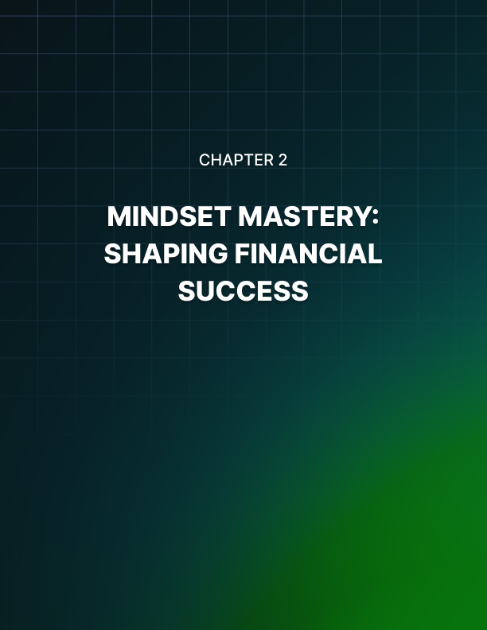

MINDSET MASTERY: SHAPING FINANCIAL SUCCESS
____
When you're building a successful business, your mindset shapes every financial decision you make. Entrepreneurs who embrace experimentation and continuous learning consistently outperform those stuck in traditional thinking patterns. By developing the right mental approach, you can unlock new opportunities and drive sustainable growth for your business.

Building Growth-Oriented Financial Strategies
Your approach to growth needs to balance ambition with practical implementation. Successful entrepreneurs recognize that strategic resource allocation goes beyond basic budgeting—it's about investing in your future. According to Forbes, you should prioritize investments in areas that drive long-term value: digital transformation, market expansion, research and development, and talent retention.
To make your growth strategy work, you need a systematic approach to financial decisions. Start by identifying opportunities in your market, then assess potential risks and available resources before creating an implementation plan. Regular performance monitoring helps you stay on track and adjust your strategy as needed. Remember to maintain a dedicated innovation budget and gather competitive intelligence to inform your decisions.
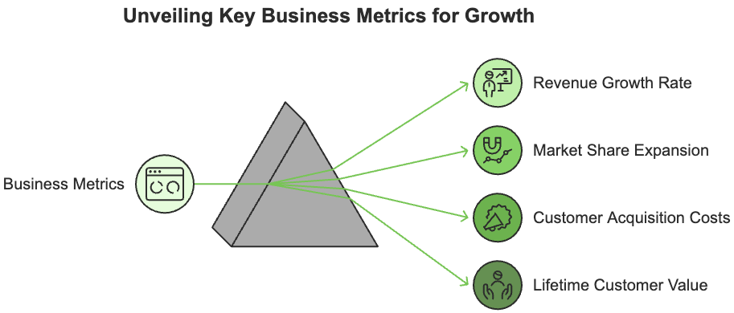
When measuring your progress, focus on metrics that truly matter. Revenue growth rate, for example, shows how quickly your business is expanding and can signal the effectiveness of your overall strategy.
Another crucial metric is market share expansion, which highlights your position in the industry and how well you're competing against others in your field. Customer acquisition costs, on the other hand, help assess the efficiency of your marketing and sales efforts, ensuring you're not overspending to acquire new customers.
Finally, lifetime customer value measures the total revenue a customer generates over the entire duration of their relationship with your business, providing insight into long-term profitability and customer retention strategies. Together, these metrics offer a panoramic view of your business's performance and guide data-driven decisions for sustained growth.
These indicators specifically help you understand whether your strategy is working and where you need to make adjustments. Research from LinkedIn shows that entrepreneurs who consistently invest in innovation, even during challenging times, experience higher revenue growth and improved market positioning.

Navigating Implementation Challenges
You'll inevitably face obstacles when putting your growth strategy into action. Resource constraints often present the first challenge. Combat this by prioritizing high-impact investments and exploring strategic partnerships.
During periods of market uncertainty, maintain flexible strategies and build strong contingency plans. When facing competitive pressures, focus on differentiation and strengthening customer relationships.
To future-proof your business, commit to continuous learning and adaptability. Stay updated on market trends, study emerging technologies, and analyze competitor strategies.
Successful entrepreneurs remain flexible in their approach and view change as an opportunity rather than a threat. This mindset helps you build resilient systems that can withstand market fluctuations and evolving business conditions.
Foster innovation throughout your organization by encouraging creative thinking and supporting calculated risk-taking. Create an environment where teams feel empowered to experiment and learn from both successes and failures. This approach helps you identify unique market opportunities and develop sustainable competitive advantages that set your business apart.
Success in modern business requires more than traditional financial knowledge—it demands an entrepreneurial mindset that combines strategic thinking with practical action. By implementing these strategies and maintaining a growth-oriented perspective, you'll be better equipped to navigate challenges and seize opportunities in today's complex business environment.


BUILDING DAILY FINANCIAL HABITS THAT MATTER
____
Your daily actions determine your financial success more than any grand strategy or ambitious plan. While understanding psychology and mindset matters, it's the small, consistent steps you take each day that transform knowledge into tangible results. Let's explore the practical habits that successful entrepreneurs use to build lasting wealth.

Essential Daily Financial Practices
Start your day by reviewing your business's vital signs. This morning ritual sets the tone for informed decision-making and helps you spot potential issues before they become problems.
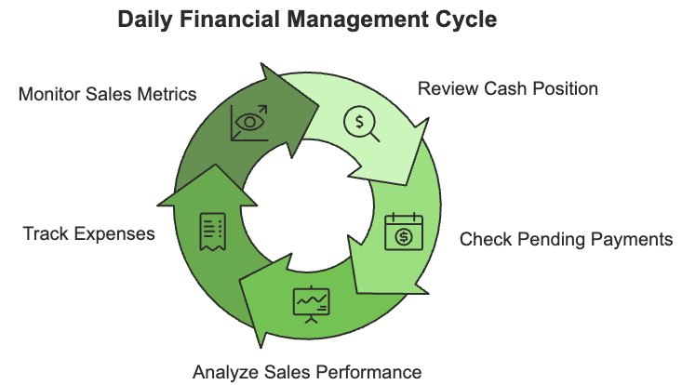
Dedicate 30 minutes each morning to check your cash position, review pending payments, and analyze your daily sales performance. Entrepreneurs who maintain this practice are more likely to consistently outperform those who don't.
Create a simple but effective tracking system for your expenses. Record everything, no matter how small: those $10 monthly subscriptions can add up to thousands over time.
Use your phone to snap pictures of receipts immediately and categorize them daily. This habit prevents the end-of-month scramble and gives you real-time insight into your spending patterns.
Monitor your sales performance with focused attention. Review your previous day's figures and compare them against your targets. Pay special attention to your customer acquisition costs and retention rates. These metrics often reveal opportunities for improvement before they show up in your bottom line. You are more likely to achieve your growth targets if you track these metrics every day.

Tools and Systems for Success
Technology can transform these daily habits from burdensome tasks into smooth, automated routines. Choose accounting software that offers real-time reporting and automated reconciliation.
You can also look for expense-tracking apps that automatically categorize your spending and integrate with your accounting system. The IT Supply Chain recommends selecting tools that provide predictive analytics and scenario planning capabilities to help you make better financial decisions.
Set up your digital dashboard to display key metrics at a glance. Include:
- Daily cash position
- Pending payments
- Sales performance
- Customer retention rates
- Expense categories
Integrate these tools into your daily workflow. Schedule specific times for financial reviews and stick to them. Set up automated alerts for unusual spending patterns or dips in cash flow. Implementing steps like these is crucial because entrepreneurs who leverage technology for financial monitoring spend less time on administrative tasks while maintaining better financial oversight.
Create standard operating procedures for your financial tasks and document them clearly. Train your team on these procedures and regularly review their effectiveness. As your business grows, these systems should evolve, but the core habits of daily monitoring and proactive management remain constant.
Your path to financial success begins with these daily practices. Start small. Choose one crucial habit and master it before adding more. And track your progress using simple metrics and adjust your approach based on what works for you.
Consistency matters more than perfection. These daily disciplines, practiced faithfully, will compound over time to create a significant financial impact on your business.


NAVIGATING THE FINANCIAL FEELINGS
____
As you navigate your business journey, you'll experience a rollercoaster of emotions that influence your financial decisions. Understanding and managing these emotions isn't just helpful—it's essential for making better choices that drive your business forward.

The Brain-Money Connection
Your brain processes financial decisions through both emotional and logical channels, with emotions often taking the lead.
When you face a financial choice, your emotional response kicks in within milliseconds, before your analytical thinking begins. This quick emotional reaction helped our ancestors avoid danger, but in today's complex business environment, it can lead to rushed decisions.
Think about the last time you faced a major investment decision. Your immediate reaction—whether excitement or fear—shaped how you viewed the opportunity. Research from SpringerLink (2024) shows that these emotional responses create "tags" in your brain that influence your final choice, even after careful analysis.
Your emotions serve as both allies and potential obstacles in decision-making. They can sharpen your intuition, helping you spot opportunities and dangers before conscious analysis catches up.
For instance, that uneasy feeling about a potential business partner might reflect subtle warning signs your conscious mind hasn't processed yet. However, emotions can also cloud your judgment, leading to impulsive choices or decision paralysis when feelings become overwhelming.
To navigate this balance effectively, it's crucial to recognize when emotions are signaling important insights while also ensuring they don’t overpower rational thinking.

Making Better Decisions Through Emotional Awareness
The CLEAR decision model offers a practical framework for balancing emotions with logic:
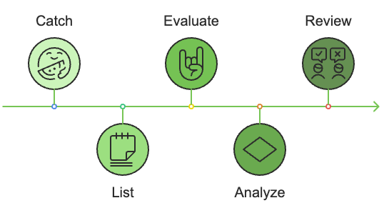
- Catch your emotional state - Take a moment to identify what you're feeling.
- List objective facts - Write down the concrete information you have.
- Evaluate emotional influences - Consider how your feelings might affect your choice.
- Analyze alternatives - Look at different options without emotional attachment.
- Review and decide - Make your final decision with both emotion and logic in mind.
To put this model into practice, create space between your initial emotional response and your final decision. When facing important choices, take a short walk or schedule the decision for the next day. This "cooling off" period helps you process emotions and think more clearly.
Building emotional awareness in your organization matters, too. Leaders who create emotionally intelligent environments see better team performance and decision quality. Encourage open discussion about the emotional aspects of business decisions. Create an atmosphere where team members feel safe expressing concerns and sharing different perspectives.
Supporting your emotional intelligence growth requires a strong network. Connect with mentors who can share their emotional management experiences. Join peer groups where you can discuss the emotional challenges of entrepreneurship. Consider working with business coaches who understand both the practical and emotional aspects of running a company.
Managing emotions in business isn't about suppressing them—it's about understanding their influence and using them wisely. By developing your emotional awareness and applying structured decision-making approaches, you transform your emotions from potential roadblocks into valuable tools for business success.
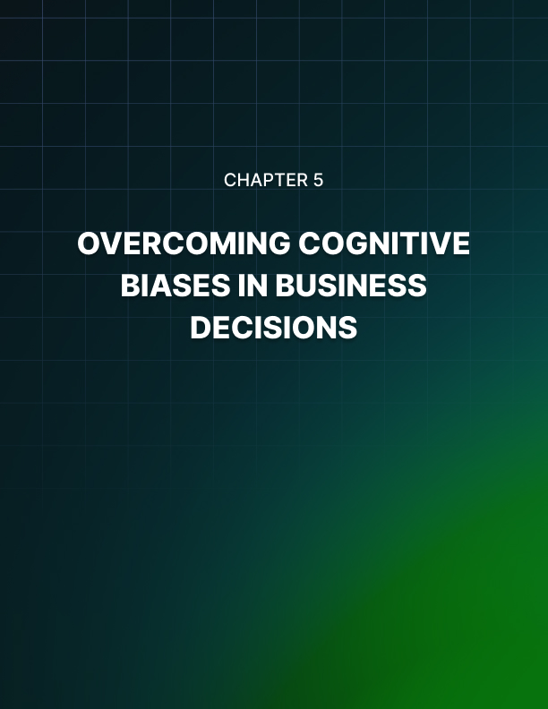

OVERCOMING COGNITIVE BIASES IN BUSINESS DECISIONS
____
Every day, you make countless financial choices for your business. While you might think you're being completely logical, your brain often takes mental shortcuts that can lead you down the wrong path.
These shortcuts, known as cognitive biases, can significantly impact your business success. Understanding how they work—and learning to manage them—can dramatically improve your decision-making.

Understanding Your Brain's Financial Shortcuts
Your brain processes thousands of decisions daily, from small purchases to major investments. To handle this load, it develops shortcuts that usually serve you well but can sometimes lead to costly mistakes. As an entrepreneur, you're especially vulnerable to these thinking traps because you often need to make quick decisions under pressure.
The most dangerous bias you'll face is overconfidence. You might think you know more than you actually do or that you can predict outcomes more accurately than what facts reveal.
This overconfidence can lead to unnecessary risks or ignoring warning signs. For example, you might launch a new product without adequate market research, convinced that your gut feeling is enough. Research from SpringerLink reveals that overconfident entrepreneurs often pursue high-risk ventures without proper preparation, leading to higher failure rates.
Confirmation bias presents another significant challenge. When you've invested time and energy into a business idea, you naturally want to prove it's good. This desire makes you more likely to seek out information that supports your existing beliefs while dismissing contrary evidence.
Think about the last time you researched a business decision. Did you genuinely look for opposing viewpoints, or did you mainly search for information that confirmed what you already thought?
Your brain also processes losses differently than gains, typically feeling losses about twice as strongly as equivalent gains. This bias persists regardless of your experience level or financial status. This fear of loss might keep you from taking calculated risks that could benefit your business. You might find yourself holding onto failing investments for too long or avoiding necessary but risky opportunities for growth.

Creating a Bias-Resistant Decision Process
To protect yourself from these mental traps, you need a systematic approach to decision-making.
The goal isn't to eliminate biases, but to create systems that help you work with them effectively.

Start by implementing a simple but effective framework. Before making any significant financial decision, write down your assumptions and actively seek evidence that contradicts them. This practice helps counter your natural tendency to look for confirming evidence.
Build a diverse network of advisors who can challenge your thinking. Include financial advisors, industry experts, mentors, and experienced entrepreneurs. Each brings a different perspective that can help you spot blind spots in your reasoning. Organizations that regularly consult with diverse advisors make better decisions and avoid common thinking traps.
Use technology and data to support more objective decision-making. Track key metrics like decision accuracy rates, comparing your predictions against actual outcomes. And don’t forget to monitor resource allocation efficiency and document opportunity costs. These concrete measurements help you identify patterns in your decision-making and areas where biases might be affecting your judgment.
Create regular review processes within your organization. Encourage team members to question assumptions and reward evidence-based thinking.
Another thing you can do with your team is assign someone to play devil's advocate when evaluating major decisions. Someone challenging the team's assumptions to teach critical thinking, or so no one becomes complacent with their ideas. Document decisions and their outcomes, then review them regularly to learn from both successes and failures.
Improving your decision-making is an ongoing process. Each time you face a major business choice, pause to consider how cognitive biases might be influencing your thinking.
Challenge your own stance. Look for contrary evidence, consult your advisory network, and rely on data when possible. By building these practices into your daily routine, you'll make better decisions and create a stronger, more resilient business.
Building a bias-resistant organization doesn't happen overnight, but each step you take to recognize and manage these mental shortcuts brings you closer to better business decisions.
Keep in mind that the goal isn't to eliminate biases, but to create systems that help you work with them effectively.


RISK PERCEPTION AND FINANCIAL CHOICES
____
In business, risk is an inevitable part of decision-making, and how you perceive it plays a critical role in shaping your financial choices. Let’s explore the complexities of risk perception and how it influences your decisions.

Understanding Business Risk Through Your Lens
Every time you face a business decision, your perception of risks guides your choices.
Think about two entrepreneurs evaluating the same investment opportunity. One might see it as a calculated step forward, while the other views it as a dangerous gamble. Despite having access to identical information, their different risk perceptions lead them down entirely different paths.
Your brain processes risk information through two channels: analytical thinking that weighs data and probabilities, and gut feelings that rely on intuition and emotional responses. Research from Scientific Reports shows that these systems often compete, with your instincts frequently winning out when you face uncertainty. Understanding this dual processing helps you make better-balanced decisions.
When you assess risk, you naturally consider multiple factors: the likelihood of success or failure, potential gains and losses, and how long you'll be exposed to uncertainty. You also weigh known factors against unknowns, like market shifts, competitor moves, or economic changes that could impact your business. Successful entrepreneurs learn to balance these elements rather than focusing too heavily on any single aspect.

Making Better Risk Decisions in Your Industry
Different industries face unique risk patterns that shape how you should approach decision-making. If you're in the tech sector, research shows you'll likely have higher risk tolerance due to the innovative nature of your business. Traditional manufacturing companies, on the other hand, typically display more conservative risk perceptions.
To improve your risk assessment capabilities, follow these practical steps:
- Start with data-driven analysis using concrete metrics and industry benchmarks.
- Gather diverse perspectives from your team and trusted advisors.
- Map out different scenarios and their potential impacts.
- Review and update your assessments regularly.
Modern technology offers powerful tools to enhance your risk assessment process. Advanced analytics can help you spot potential issues before they become problems. Real-time monitoring systems track risk factors continuously, while scenario modeling lets you test different outcomes safely. According to Coventry University's research, combining these tools with human judgment leads to more accurate risk assessment.
The business environment around you constantly influences how you perceive risk. Market conditions, competitive pressures, and regulatory changes all affect your risk assessment. Build a structured approach that includes:
- Regular review of market conditions and industry trends.
- Monitoring of regulatory requirements and policy changes.
- Assessment of technological disruption potential.
- Analysis of competitor movements and industry shifts.
As you build your risk assessment capabilities, remember that effective risk management isn't about eliminating uncertainty—it's about understanding and working with it productively. Combining careful analysis with practical tools and diverse perspectives allows you to make more confident decisions even in uncertain situations.
Understanding and managing risk effectively helps you spot opportunities others might miss while protecting your business from potential threats. Keep learning, stay adaptable, and remember that every risk you evaluate makes you better equipped to handle the next one.


CULTIVATING A WEALTH-BUILDING MINDSET
____
Your journey to entrepreneurial success begins with your mindset. While technical skills matter, your approach to wealth creation determines your long-term outcomes. Entrepreneurs who develop their financial knowledge are more likely to achieve their business goals compared to those relying solely on intuition.
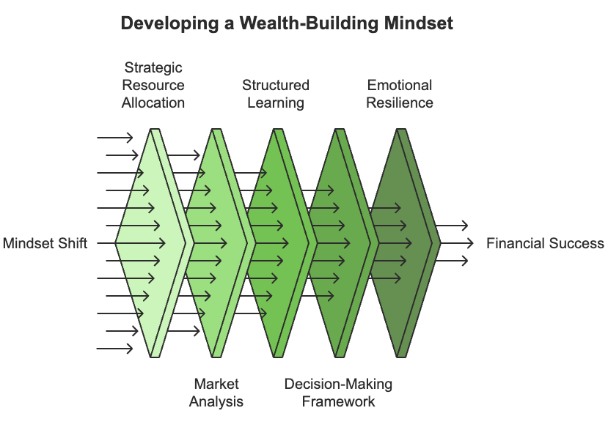

Understanding the Wealth Mindset
Building wealth requires more than making money; it demands understanding how financial systems work and developing the right mental approach. You must shift from thinking about immediate gains to sustainable growth and long-term value creation.
Your wealth mindset development starts with mastering key knowledge areas. Focus first on strategic resource allocation, or understanding how to optimize your investments and prioritize growth opportunities while managing costs effectively. Market analysis comes next, as you learn to identify trends and evaluate competitive landscapes that affect your business decisions.
The Swedish Wealth Institute's research shows that entrepreneurs who adopt a structured learning approach achieve twice the business growth compared to those who learn reactively. To build your financial intelligence, set clear learning objectives based on your specific knowledge gaps. Create a personal curriculum that combines professional courses, industry publications, and peer learning groups. Remember to track your progress regularly and adjust your learning path as needed.

Creating Your Growth Framework
Successful wealth building requires a systematic approach to financial decisions. Start by gathering relevant data and analyzing market conditions before making any significant moves. Consider not just the immediate impact but also long-term consequences of your choices.
Your decision-making process should follow a clear pattern:
- Assess the situation using concrete data and market analysis.
- Plan your approach with specific objectives and resource allocation.
- Implement your strategy while monitoring progress.
- Review outcomes and document lessons learned.
According to an article published in the Frontiers of Psychology, entrepreneurs with high emotional intelligence in financial matters are 65% more likely to survive economic downturns. Build your emotional resilience by recognizing your triggers in financial decisions and understanding your personal risk tolerance. Practice self-regulation by implementing cooling-off periods for major decisions and creating decision-making checklists that help you maintain objectivity.

Building Your Support System
You can't build significant wealth alone. Entrepreneurs with strong support networks are logically more likely to achieve their financial goals. Surround yourself with professionals who complement your skills, like financial planners, tax specialists, and legal counsel who can guide your decisions.
Engage regularly with your network through monthly advisor meetings and industry events. Share experiences and insights with peer groups while remaining open to learning from others' experiences. Create accountability partnerships that help you stay focused on your goals and celebrate achievements together.
Transform these practices into daily habits. Start each morning with a financial review of your key performance indicators. Dedicate time each week to analyzing your progress and adjusting your strategies. Most importantly, maintain consistent learning habits that keep you growing and adapting to changing market conditions.
Developing your wealth-building mindset is an ongoing journey. Start with one or two practices that resonate most strongly with your current situation, then gradually expand as you build confidence. Your commitment to continuous improvement will create the foundation for lasting financial success.


USING PSYCHOLOGY FOR FINANCIAL GROWTH
____
You already understand how psychology influences your financial decisions. Now it's time to transform that knowledge into practical strategies that drive real business results. By measuring, implementing, and adapting psychological insights, you can create lasting positive change in your organization.

Measuring Financial Decision-Making Success
Your journey to better financial decisions starts with understanding where you are now. Organizations that actively measure their emotional intelligence in financial processes will see an improvement in decision quality. This improvement comes from making better risk assessments, negotiating more effectively, and building stronger relationships with stakeholders.
Begin by conducting an emotional awareness audit of your organization. Look at how emotions influence your team's financial decisions and identify specific triggers that affect judgment. Track key metrics like decision quality, team collaboration scores, and client satisfaction ratings to establish your baseline.
Create a structured system for monitoring progress. You might track how often your team meets financial targets, how well they handle unexpected challenges, or how effectively they communicate during financial discussions. The Swedish Wealth Institute found that organizations using systematic measurement approaches achieve 45% better retention of key financial talent and 38% improved client relationships.
Don't forget to measure the cultural impact of your initiatives. Look at indicators like innovation rates in financial processes, risk-taking effectiveness, and team collaboration quality. These metrics help you understand how well your organization adapts to new approaches and where you need to focus improvement efforts.

Building Implementation Systems That Work
Taking action on psychological insights requires a systematic approach. Start by implementing emotional awareness checkpoints in your financial procedures. These brief pauses help your team recognize emotional influences before making important decisions.
Create a structured decision-making process using the IMPACT framework:
- Identify your current emotional state.
- Map out potential cognitive biases.
- Process objective data carefully.
- Analyze multiple alternatives.
- Consider cultural factors.
- Track your outcomes and learn.
Teams using this framework will notice a dramatic improvement in decision quality. The key is consistency. Make these steps part of your regular routine rather than occasional exercises.
Build psychological safety in your financial discussions. Encourage open dialogue about concerns and create space for team members to express doubts without fear. Organizations with high psychological safety will achieve higher innovation rates and better risk management outcomes.
Develop your team's emotional intelligence through regular training and mentorship. Pair experienced leaders with emerging talent to share insights about handling emotional aspects of financial decisions. Create opportunities for cross-functional learning, where team members can gain different perspectives on financial challenges.

Future-Proofing Your Financial Psychology
The intersection of psychology and finance continues to evolve with technology. AI-enhanced tools now help track emotional patterns in decision-making and detect potential biases in real time. These advances offer new ways to improve your financial choices while maintaining the human element that drives success.
Focus on building systems that can adapt to change. Create flexible frameworks that incorporate new insights while maintaining core psychological principles. Stay current with emerging trends in cultural analytics and integrated performance measurement to keep your organization competitive.
When you apply psychological insights systematically and measure their impact carefully, you create a stronger foundation for financial success. Remember to balance data-driven decisions with emotional awareness, and keep evolving your approach as new tools and insights emerge.

