TABLE OF CONTENTS
____

INTRODUCTION 5
UNDERSTANDING YOUR BODY'S POWERHOUSE 9
The Basics of Cellular Energy 9
Factors Affecting Energy Production 11
The Role of Macronutrients in Energy Production 12
The Impact of Micronutrients on Energy Production 13
The Circadian Rhythm and Energy Production 14
The Hormonal Influence on Energy 15
The Mind-Body Connection and Energy 16
The Role of Physical Activity in Energy Production 17
The Impact of Sleep on Energy Levels 17
FOODS TO FUEL YOUR DAY 21
The Energy-Nutrition Connection 21
The Big Three 22
The Unsung Heroes of Energy Production 24
The Often Overlooked Energy Booster 27
Meal Timing and Energy Levels 27
Balancing Blood Sugar for Steady Energy 28
THE KINETICS OF VITALITY 30
The Science Behind Exercise and Energy 30
Types of Exercise for Energy Boosting 32
Creating an Energy-Boosting Exercise Routine 33
Exercise and Stress Management 35
Exercise and Cognitive Function 36
OPTIMIZING REST FOR MAXIMUM ENERGY 39
The Science of Sleep 39
The Impact of Sleep on Energy Levels 41
Strategies for Optimizing Sleep Quality 42
Advanced Sleep Optimization Techniques 44
STRESS MANAGEMENT FOR AN ENERGIZED LIFE 49
Understanding Stress and Its Impact on Energy 49
The Power of Mindfulness 51
Cognitive Strategies for Stress Management 52
Physical Strategies for Stress Management 53
Creating a Stress-Resistant Routine 54
Stress Management in High-Pressure Situations 55
The Role of Social Support in Stress Management 55
The Impact of Technology on Stress Management 56
Stress Management for Long-Term Success 56
CRAFTING A BALANCED ROUTINE 59
Understanding the Importance of Routine 59
Crafting Your Ideal Morning Routine 60
Structuring Your Work Day for Maximum Productivity 61
The Importance of Breaks and Downtime 62
The Power of a Wind-Down Routine 63
Balancing Work and Personal Life 64
SAFE ENHANCEMENTS FOR ENERGY 68
Understanding Natural Supplements 68
Adaptogenic Herbs for Energy Enhancement 69
B-Complex Vitamins and Coenzyme Q10 70
Magnesium and Iron for Energy Production 71
Emerging Supplements for Energy Enhancement 72
Choosing and Using Supplements Safely 74
CONCLUSION 77

DISCLAIMER
____
The information provided in this ebook is intended solely for educational and informational purposes. The author does not accept any responsibility for the outcomes that may arise from the application of the material within. While efforts have been made to ensure the accuracy and relevance of the content, the author cannot be held accountable for any errors or omissions, or for any consequences resulting from the use or misuse of the information provided. The responsibility for any actions taken based on the information in this ebook lies solely with the reader.


INTRODUCTION
____
Imagine waking up each morning filled with energy, tackling your day with focus, and still having fuel left when the day ends. This isn’t a far-off dream—it’s within reach. You’re about to learn how to access your body’s natural energy reserves and transform your life from the inside out.
With burnout becoming increasingly common, especially for driven individuals like you, finding sustainable energy is essential. Maybe you’ve tried quick fixes—coffee, sugary energy drinks, or even supplements—only to feel worse later. But what if there was a better way? A way to power through your goals without sacrificing health or relying on stimulants?

Energy fuels achievement.

That’s what this guide offers: practical, science-backed methods for revitalizing your mind and body. You’ll discover how nutrition fuels energy, how specific exercises can invigorate rather than exhaust, and how quality sleep becomes your ultimate tool for recharging.
This guide also explores mindfulness and stress management, offering techniques to calm your mind and boost energy, even when things get tough. It’s a holistic approach—addressing everything from diet to mindset. The result? A powerful synergy that maximizes your energy, focus, and productivity.
For those aiming to gain a competitive edge, these strategies are not just theory. They’re used by high-performers across industries. Imagine having the energy levels of top business leaders—that’s the potential this guide unlocks.
Wondering if natural methods can really make a difference? Studies show that adopting a holistic approach to energy can increase productivity by 40% and improve overall well-being by 60%. These aren’t just statistics—they represent meaningful changes.
As you read on, you’ll spot patterns in your life where energy drains occur, along with practical solutions to boost and sustain your vitality. This isn’t about quick fixes; it’s about sustainable, natural methods that work with your body, helping you optimize your life.
Get ready to leave behind brain fog, afternoon slumps, and fatigue. Welcome clarity, focus, and lasting energy. This isn’t just about feeling better—it’s about becoming your best self, both in business and life.
Every page is packed with actionable advice you can start using right away, from energy-boosting meals to breathing techniques that increase vitality on the spot. Whether you’re a CEO or just beginning your journey, these principles apply to anyone seeking peak performance.
Energy fuels achievement. With it, there’s no limit to what you can accomplish. So, are you ready to unlock your body’s natural energy reserves and reach new heights? Turn the page, and let’s start this transformative journey together.
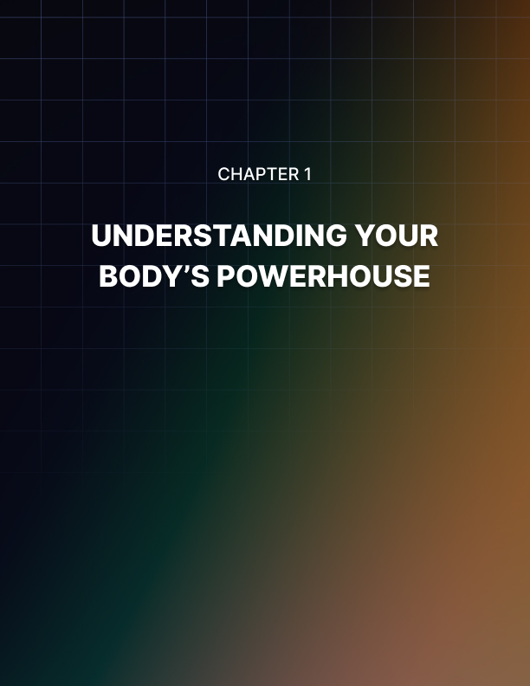

UNDERSTANDING YOUR BODY'S POWERHOUSE
____
Your body is an incredible machine, constantly working to keep you alive, alert, and active. At the heart of this intricate system lies a fundamental process: energy production. You might wonder why some days you feel like you can conquer the world, while on others, you struggle to get out of bed. The answer lies in understanding how your body generates and utilizes energy.
In this chapter, you'll discover the fascinating world of cellular energy production and learn why it's crucial for your overall well-being and productivity. At the end, you’ll have a clear understanding of how your daily habits and choices impact your energy levels, paving the way for practical solutions explored in later chapters.

The Basics of Cellular Energy
At its core, energy production in your body happens at the cellular level. Every cell in your body is like a tiny factory, constantly working to produce adenosine triphosphate (ATP), often referred to as the "energy currency" of cells. ATP is the molecule that powers nearly all cellular activities, from muscle contractions to neurotransmitter release in your brain.
To truly grasp how your body generates energy, you need to understand the key players in this process:
Mitochondria are the powerhouses of your cells. These specialized structures within cells are responsible for producing the majority of your ATP. Glucose, a simple sugar, is your body's primary source of fuel. When you eat carbohydrates, your body breaks them down into glucose. Just as a fire needs oxygen to burn, your cells need oxygen to efficiently produce energy. Enzymes are proteins that act as catalysts, speeding up chemical reactions in your body, including those involved in energy production.
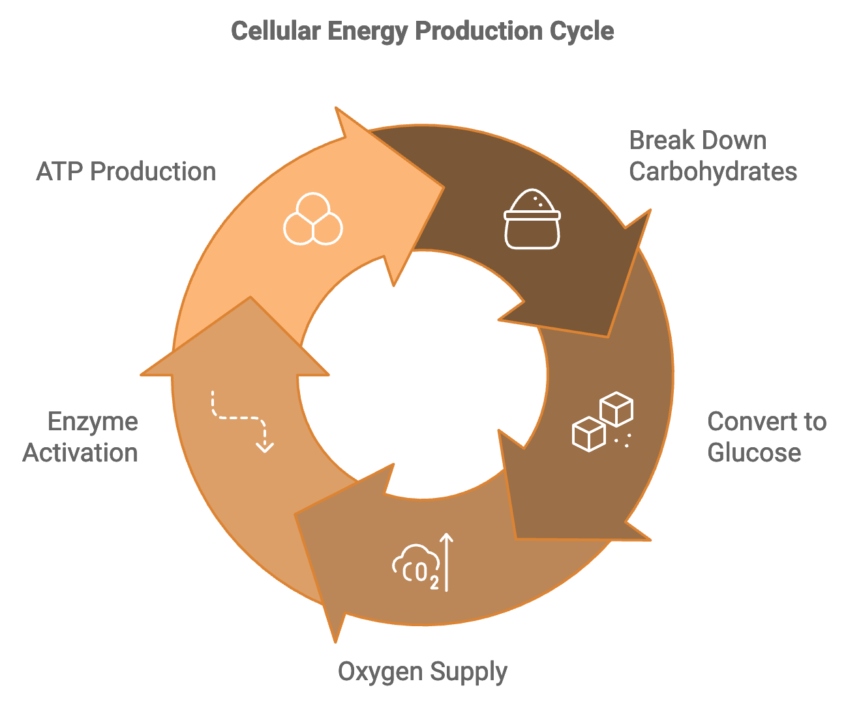
The process of energy production can be broken down into three main steps:
- Glycolysis
- The Citric Acid Cycle (Krebs Cycle)
- The Electron Transport Chain
Glycolysis occurs in the cytoplasm of your cells and doesn't require oxygen. During this process, glucose is broken down into a compound called pyruvate, producing a small amount of ATP. If oxygen is present, pyruvate enters the mitochondria and is further broken down in the citric acid cycle. This process produces more ATP and sets the stage for the final, most productive phase of energy production. The electron transport chain is where the magic happens. It uses the products of the previous steps to pump hydrogen ions across the mitochondrial membrane, creating an electrochemical gradient. As these ions flow back across the membrane, they drive the production of large amounts of ATP.
This entire process, known as cellular respiration, is happening in your body right now, providing you with the energy you need to read this book, think, and carry out all your daily activities.

Factors Affecting Energy Production
Now that you understand the basics of how your body produces energy, it's important to recognize the factors that can impact this process. Your diet provides the raw materials for energy production. A balanced diet with adequate carbohydrates, proteins, and fats is essential for optimal energy levels. Water is crucial for many cellular processes, including energy production. Even mild dehydration can significantly impact your energy levels.
During sleep, your body repairs and regenerates cells, including those involved in energy production. Regular exercise can increase the number and efficiency of mitochondria in your cells, enhancing your overall energy production capacity. Chronic stress can disrupt hormonal balance and interfere with energy production processes. With age, the number and efficiency of mitochondria in your cells often decrease, potentially impacting energy levels.Certain health conditions, such as thyroid disorders or anemia, can directly affect your body's ability to produce energy.
Understanding these factors is crucial because they form the foundation for the natural energy-boosting strategies you’ll explore in subsequent chapters.

The Role of Macronutrients in Energy Production
Let's take a closer look at how different macronutrients contribute to your body's energy production.
Carbohydrates are your body's preferred source of energy. They're easily broken down into glucose, which can be used immediately for energy or stored as glycogen in your liver and muscles for later use. While primarily used for building and repairing tissues, proteins can also be used for energy when carbohydrates are scarce. However, this process is less efficient and can put stress on your kidneys over time. Fats provide a concentrated source of energy. While they take longer to digest than carbohydrates, they can provide sustained energy over longer periods.
Understanding how your body processes these macronutrients can help you make informed decisions about your diet to optimize your energy levels throughout the day. For example, consuming complex carbohydrates like whole grains can provide a steady release of energy, while simple sugars might lead to energy spikes and crashes. Including healthy fats in your diet can help with sustained energy, especially during prolonged physical activities.

The Impact of Micronutrients on Energy Production
While macronutrients provide the bulk of your energy, micronutrients play crucial roles in facilitating energy production processes. Here are some key micronutrients and their roles:
- B Vitamins are essential for various steps in the energy production process. For example, thiamine (B1) is necessary for the breakdown of carbohydrates, while riboflavin (B2) is crucial for the electron transport chain.
- Iron is a key component of hemoglobin, which transports oxygen throughout your body. Without adequate iron, your cells may not receive enough oxygen for efficient energy production.
- Magnesium is involved in hundreds of enzymatic reactions, including many related to energy production.
- Coenzyme Q10 plays a crucial role in the electron transport chain.
- L-Carnitine helps transport fatty acids into mitochondria for energy production.
Ensuring you get adequate amounts of these micronutrients through your diet or supplementation can significantly impact your overall energy levels. For instance, iron-rich foods like lean meats, legumes, and leafy greens can support optimal oxygen transport, while foods high in B vitamins like whole grains, eggs, and nuts can support various stages of energy production.

The Circadian Rhythm and Energy Production
Your body's energy production isn't constant throughout the day. Instead, it follows a natural rhythm known as the circadian rhythm. This internal 24-hour clock regulates various physiological processes, including energy production.
Typically, your energy levels follow this pattern:
- Morning
Energy levels start to rise, peaking in the late morning
- Afternoon
A slight dip in energy occurs after lunch
- Evening
A second, smaller peak occurs in the early evening
- Night
Energy levels decrease as your body prepares for sleep
Understanding your natural energy rhythm can help you plan your day more effectively, scheduling high-energy tasks when your body is naturally more alert and productive. For example, you might tackle complex work projects in the late morning when your energy typically peaks, and schedule more routine tasks for the afternoon when energy levels tend to dip.

The Hormonal Influence on Energy
Hormones play a significant role in regulating your energy levels. Here are some key hormones and their effects:
- Cortisol, often called the "stress hormone," follows a diurnal rhythm. It's highest in the morning, helping you wake up and feel alert. However, chronic stress can disrupt this pattern, leading to fatigue.
- Insulin helps regulate blood sugar levels. When insulin function is impaired, as in conditions like diabetes, it can lead to fluctuations in energy levels.
- Thyroid hormones regulate your metabolism. An underactive thyroid (hypothyroidism) can lead to fatigue, while an overactive thyroid (hyperthyroidism) can cause restlessness and anxiety.
- Melatonin regulates your sleep-wake cycle. Disruptions to melatonin production, often caused by exposure to blue light at night, can interfere with sleep and energy levels.
Understanding these hormonal influences can help you make lifestyle choices that support balanced hormone levels and, consequently, more consistent energy. For instance, managing stress through techniques like meditation can help regulate cortisol levels, while maintaining a consistent sleep schedule can support healthy melatonin production.
This thorough understanding of energy production and regulation in your body sets the foundation for the practical strategies you’ll explore in the coming chapters. Grasping these fundamental concepts equips you to make informed decisions about your lifestyle and habits, helping you optimize your energy levels.

The Mind-Body Connection and Energy
Your mental state has a profound impact on your perceived energy levels. Stress, anxiety, and depression can all contribute to feelings of fatigue, even when your body is physically capable of producing adequate energy. This mind-body connection works through several mechanisms:
The stress response activates your body's "fight or flight" response, which can be energy-intensive and lead to burnout over time. Your level of interest and engagement in a task can significantly impact your perceived energy levels. The ability to concentrate can make you feel more energized and productive, even if you're not physically exerting more energy. Positive emotions can boost perceived energy levels, while negative emotions can be draining.
Recognizing this connection is crucial because it highlights the importance of mental health in maintaining optimal energy levels. Techniques like mindfulness and stress management, which you’ll explore in later chapters, can be powerful tools for boosting your energy.

The Role of Physical Activity in Energy Production
It might seem counterintuitive, but regular physical activity can actually increase your overall energy levels. Here's how:
Exercise stimulates the production of more mitochondria in your cells, increasing your capacity for energy production. Regular exercise strengthens your heart and improves circulation, allowing for more efficient delivery of oxygen and nutrients to your cells. Physical activity improves your body's ability to use insulin effectively, leading to better blood sugar regulation and more consistent energy levels. Exercise triggers the release of endorphins, hormones that can boost mood and energy levels. Regular physical activity can improve sleep quality, leading to better recovery and higher energy levels during the day.
The key is finding the right balance of activity. While moderate exercise can boost energy, overtraining can lead to fatigue and burnout. It's important to listen to your body and gradually increase your activity levels to avoid exhaustion.

The Impact of Sleep on Energy Levels
You can't discuss energy without addressing the crucial role of sleep. During sleep, your body undergoes essential processes that directly impact your energy levels:
- Sleep is when your body repairs and regenerates cells, including those involved in energy production.
- Sleep helps regulate hormones that affect energy, including cortisol and growth hormone.
- During sleep, your brain processes and consolidates information from the day, which is crucial for cognitive function and perceived energy levels.
- Sleep allows your body to replenish glycogen stores, which provide readily available energy upon waking.
Consistently getting adequate, quality sleep is one of the most effective strategies for maintaining high energy levels. This means not only getting enough hours of sleep but also ensuring that your sleep environment is conducive to restful sleep. Factors like room temperature, light exposure, and noise levels can all impact sleep quality and, consequently, your energy levels.
In conclusion, understanding the multifaceted nature of energy production in your body is the first step towards optimizing your energy levels. From cellular processes to lifestyle factors, hormonal influences to the mind-body connection, each aspect plays a crucial role in determining how energetic you feel on a daily basis. In the following chapters, you’ll delve deeper into practical strategies for enhancing each of these areas, empowering you to take control of your energy levels and live a more vibrant, productive life.
Factor | Impact on Energy
Diet | Provides raw materials for energy production
Hydration | Essential for cellular processes
Sleep | Allows for cellular repair and hormone regulation
Exercise | Increases mitochondrial density and efficiency
Stress | Can disrupt hormonal balance and energy production
Age | May decrease mitochondrial efficiency
Medical Conditions | Can directly affect energy production capacity
This table summarizes the key factors we've discussed that influence energy levels. Addressing each of these areas allows you to create a well-rounded approach to optimizing your energy production and overall vitality.


FOODS TO FUEL YOUR DAY
____

The Energy-Nutrition Connection
Your journey to boundless energy starts with what's on your plate. Food isn't just fuel; it's the foundation of your vitality, the building blocks of your energy, and the secret ingredient to your success. Every bite you take has the potential to either energize or deplete you. Understanding this connection is crucial for anyone looking to optimize their performance and productivity.
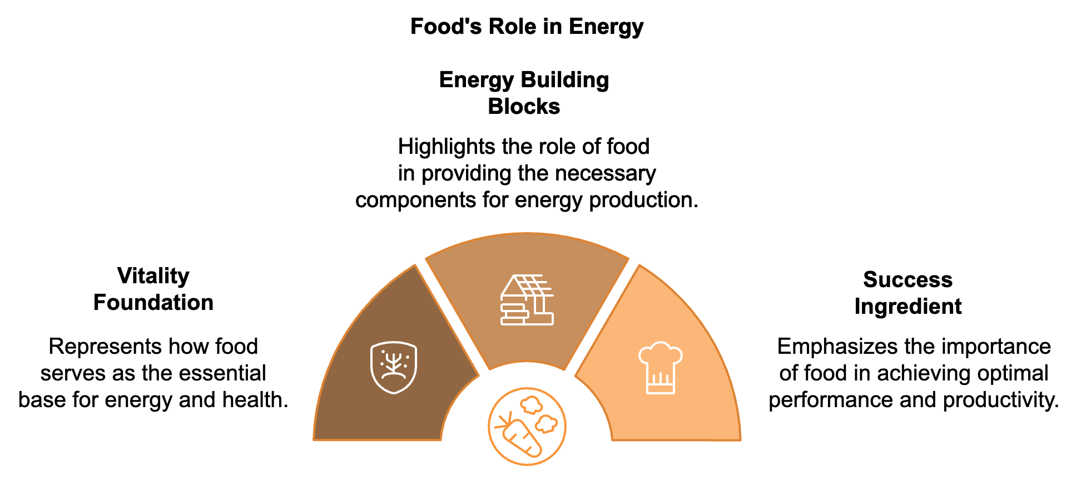
When you eat, your body breaks down food into its basic components:
- Carbohydrates
- Proteins
- Fats
These macronutrients, along with essential vitamins and minerals, are then used in various processes throughout your body, including energy production. The quality and balance of these nutrients in your diet directly impact how you feel throughout the day. Eat a diet rich in whole, nutrient-dense foods, and you'll likely experience sustained energy and mental clarity. Conversely, a diet high in processed foods and added sugars can lead to energy crashes and fatigue.

The Big Three
Let's take a closer look at the three macronutrients and their roles in energy production.

Carbohydrates: Your Body's Preferred Energy Source
Carbohydrates are your body's go-to fuel source. When you eat carbs, your body breaks them down into glucose, which is then used for immediate energy or stored as glycogen in your liver and muscles for later use. Not all carbs are created equal, though. Complex carbohydrates, found in whole grains, vegetables, and legumes, provide a steady release of energy due to their high fiber content. This helps maintain stable blood sugar levels, preventing the energy spikes and crashes often associated with simple sugars. On the other hand, simple carbohydrates, found in sugary snacks and refined grains, are quickly absorbed by your body. While they can provide a quick energy boost, it's often followed by a crash, leaving you feeling tired and craving more sugar.
To optimize your energy levels, focus on incorporating more complex carbohydrates into your diet. Some energy-boosting carb choices include oatmeal, quinoa, sweet potatoes, brown rice, lentils, chickpeas, whole grain bread, apples, berries, and bananas.

Proteins: The Building Blocks of Energy
While carbohydrates are your body's preferred energy source, proteins play a crucial role in energy production and maintenance. Proteins are made up of amino acids, which are essential for building and repairing tissues, including the mitochondria in your cells where energy is produced. Proteins also help stabilize blood sugar levels when consumed with carbohydrates, leading to a more sustained energy release. This is why a balanced meal containing both carbs and protein can help you feel energized for longer.
Some excellent protein sources for sustained energy include lean meats (chicken, turkey, lean beef), fish (salmon, tuna, mackerel), eggs, Greek yogurt, cottage cheese, tofu and tempeh, legumes (beans, lentils, chickpeas), nuts and seeds, quinoa, and edamame.

Fats: Slow-Burning Fuel for Sustained Energy
Fats have gotten a bad rap in the past, but they're essential for optimal energy levels. Fats are a concentrated source of energy, providing more than twice the calories per gram compared to carbohydrates or proteins. Moreover, fats play a crucial role in the absorption of fat-soluble vitamins (A, D, E, and K) and the production of hormones that regulate energy metabolism. Omega-3 fatty acids, in particular, have been shown to improve mitochondrial function, potentially enhancing energy production at the cellular level.
The key is to focus on healthy fats while limiting saturated and trans fats. Some excellent sources of healthy fats include avocados, olive oil, nuts (almonds, walnuts, cashews), seeds (chia, flax, pumpkin), fatty fish (salmon, sardines, mackerel), coconut oil, full-fat Greek yogurt, eggs, dark chocolate, and nut butters (almond, peanut).

The Unsung Heroes of Energy Production
While macronutrients provide the bulk of your energy, micronutrients – vitamins and minerals – are essential for the metabolic processes that convert food into usable energy. A deficiency in certain micronutrients can lead to fatigue and decreased energy levels.
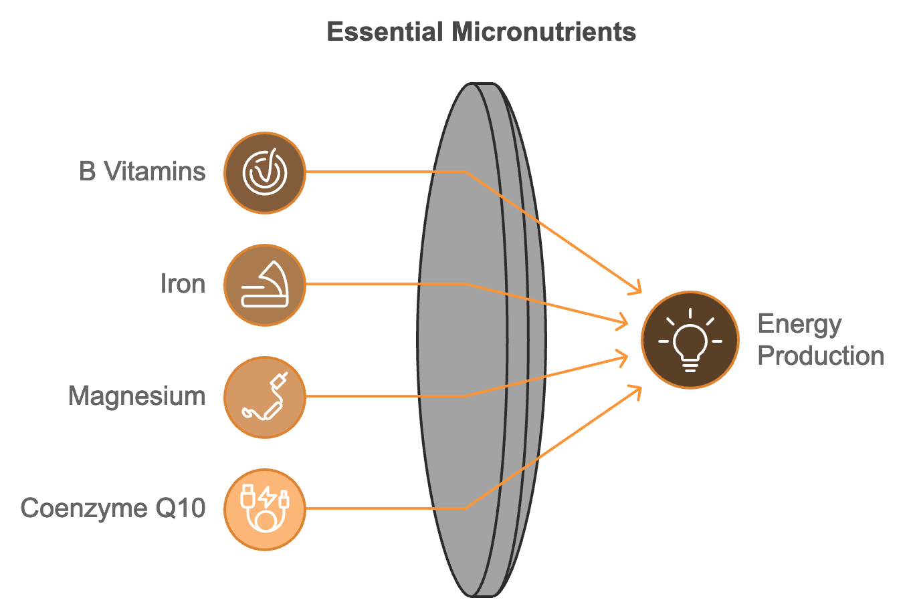

B Vitamins: The Energy Vitamins
B vitamins play a crucial role in energy metabolism. They help convert the food you eat into energy that your cells can use. Each B vitamin has a specific role in energy production:
- Vitamin B1 (Thiamine)
Essential for breaking down carbohydrates for energy.
- Vitamin B2 (Riboflavin)
Helps convert food into energy and is crucial for cellular function.
- Vitamin B3 (Niacin)
Involved in energy-yielding metabolism and DNA repair.
- Vitamin B5 (Pantothenic Acid)
Helps break down fats and carbohydrates for energy.
- Vitamin B6 (Pyridoxine)
Aids in protein metabolism and red blood cell formation.
- Vitamin B7 (Biotin)
Helps metabolize fats, carbohydrates, and proteins.
- Vitamin B9 (Folate)
Essential for cell growth and DNA formation.
- Vitamin B12 (Cobalamin)
Crucial for red blood cell formation and neurological function.
Good sources of B vitamins include whole grains, legumes, nuts, seeds, leafy greens, and animal products like meat, fish, eggs, and dairy.

Iron: The Oxygen Carrier
Iron is crucial for energy production because it helps transport oxygen throughout your body. Oxygen is necessary for the cellular processes that generate energy. Iron deficiency can lead to anemia, a condition characterized by fatigue and weakness. Good sources of iron include red meat, poultry, fish, beans and lentils, spinach and other leafy greens, fortified cereals, dried fruits (raisins, apricots), and pumpkin seeds. To enhance iron absorption, consume iron-rich foods with vitamin C-rich foods like citrus fruits, bell peppers, or strawberries.

Magnesium: The Energy Mineral
Magnesium is involved in over 300 enzymatic reactions in your body, many of which are related to energy production. It helps convert food into energy and creates new proteins from amino acids. Good sources of magnesium include spinach and other leafy greens, nuts (almonds, cashews), seeds (pumpkin, sunflower), whole grains, legumes, avocados, dark chocolate, and bananas.

Coenzyme Q10: The Energy Spark
Coenzyme Q10 (CoQ10) is a compound that helps generate energy in your cells. It's particularly concentrated in the mitochondria, where it plays a crucial role in the electron transport chain – the final step in energy production. While your body produces CoQ10, production decreases with age. You can boost your CoQ10 levels through diet or supplements. Food sources of CoQ10 include fatty fish (salmon, tuna), organ meats (liver, kidney), whole grains, spinach, broccoli, cauliflower, peanuts, and soybeans.

The Often Overlooked Energy Booster
Water is essential for life, and it's also crucial for energy production. Even mild dehydration can lead to fatigue and decreased cognitive function. Water is involved in numerous metabolic processes, including transporting nutrients and oxygen to cells, regulating body temperature, lubricating joints, and removing waste products.
To stay properly hydrated, aim for at least 8 glasses (64 ounces) of water per day, increase intake during physical activity or hot weather, eat water-rich foods like cucumbers, watermelon, and zucchini, limit caffeine and alcohol, which can be dehydrating, and keep a water bottle with you throughout the day.

Meal Timing and Energy Levels
It's not just what you eat, but when you eat that can impact your energy levels. Here are some strategies for optimizing your meal timing:
- Start your day right with a balanced breakfast that includes complex carbohydrates, protein, and healthy fats.
- Eat smaller, more frequent meals every 3-4 hours to maintain stable blood sugar levels.
- Don't skip meals, especially breakfast, to avoid energy crashes and overeating later in the day.
- Time your carbs by consuming complex carbohydrates with each meal for sustained energy.
- Be mindful of portion sizes to avoid post-meal energy slumps due to overeating.

Balancing Blood Sugar for Steady Energy
Maintaining stable blood sugar levels is crucial for sustained energy throughout the day. When your blood sugar spikes and crashes, so does your energy. Here are some strategies to keep your blood sugar balanced:
- Choose low glycemic index (GI) foods that are digested more slowly, leading to a gradual rise in blood sugar.
- Pair carbohydrates with protein and healthy fats to slow down the absorption of sugar into your bloodstream.
- Avoid processed and sugary foods that can cause rapid spikes and crashes in blood sugar.
- Eat regularly to prevent getting too hungry, which can lead to overeating and blood sugar imbalances.
- Include fiber-rich foods to slow down the absorption of sugar and maintain steady blood sugar levels.
Implementing these nutritional strategies allows you to optimize your energy levels and fuel your day effectively. Food is more than just calories—it’s the foundation of your vitality and a key to unlocking your full potential.


THE KINETICS OF VITALITY
____
Physical activity is more than just a way to stay fit or lose weight. It's a powerful tool for boosting your energy levels, enhancing your mood, and improving your overall quality of life. In this chapter, you’ll explore how exercise acts as a form of energy medicine, providing you with practical strategies to harness its power for increased vitality and productivity.
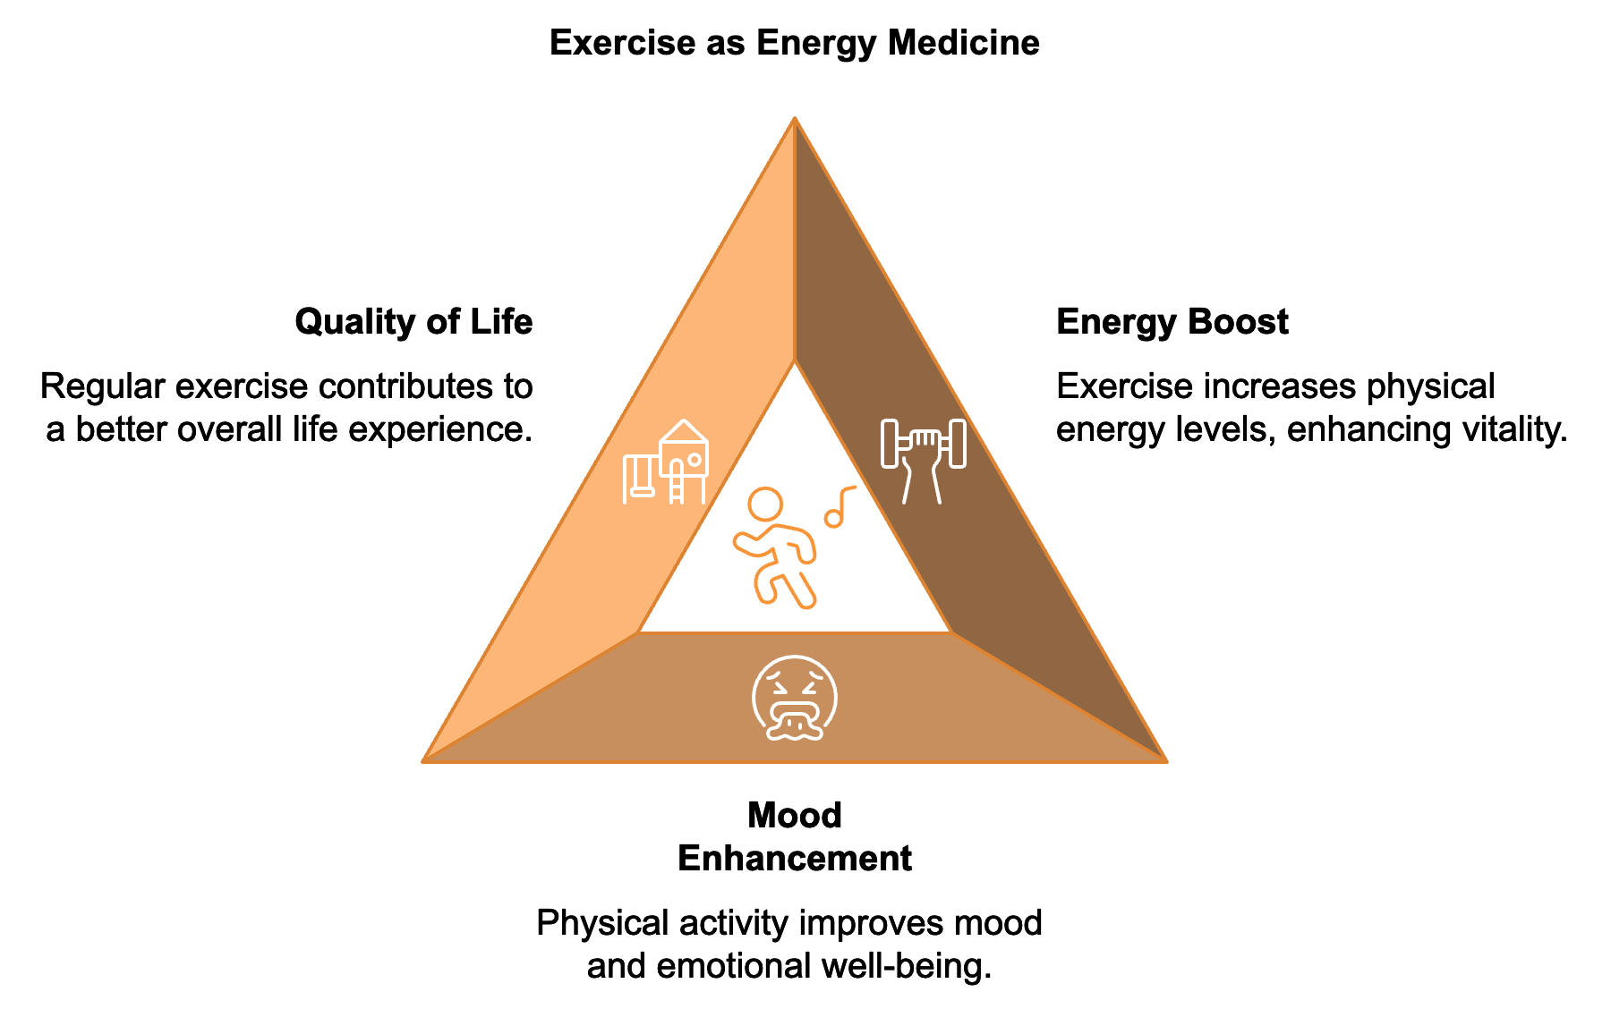

The Science Behind Exercise and Energy
You might wonder how expending energy through exercise can actually increase your overall energy levels. The answer lies in the complex physiological adaptations that occur in your body in response to regular physical activity.
One of the most significant ways exercise boosts your energy is by increasing the number and efficiency of mitochondria in your cells. Mitochondria are often called the "powerhouses" of the cell because they're responsible for producing adenosine triphosphate (ATP), the molecule that powers nearly all cellular activities. When you exercise, particularly during aerobic activities, your body responds to the increased energy demand by creating more mitochondria, a process known as mitochondrial biogenesis. This adaptive response means that over time, your cells become more efficient at producing energy, leading to increased stamina and overall energy levels.
Regular exercise also strengthens your heart and improves your circulatory system. As your heart becomes stronger, it can pump more blood with each beat, increasing the oxygen and nutrient supply to your cells. This improved circulation enhances energy production throughout your body. Moreover, exercise stimulates the growth of new blood vessels, a process called angiogenesis. This increased vascularization further improves oxygen and nutrient delivery to your tissues, contributing to better energy production and reduced fatigue.
Exercise has a profound impact on how your body processes glucose, the primary fuel for your cells. Regular physical activity improves insulin sensitivity, allowing your cells to more efficiently take up glucose from your bloodstream. This not only helps stabilize your blood sugar levels but also ensures a steady supply of fuel for energy production. A 2024 meta-analysis published in Diabetes Care examined data from over 100,000 participants and found that individuals who engaged in regular moderate-intensity exercise had a 30% lower risk of developing type 2 diabetes compared to sedentary individuals. This reduced risk was largely attributed to improved glucose metabolism and insulin sensitivity.

Types of Exercise for Energy Boosting
Different types of exercise can boost your energy in various ways. Let's explore some key categories:

Aerobic Exercise
Aerobic exercise, also known as cardio, is any activity that increases your heart rate and breathing for an extended period. This type of exercise is particularly effective at improving cardiovascular health and increasing mitochondrial density. Examples of aerobic exercises include brisk walking, jogging or running, swimming, cycling, dancing, rowing, and jumping rope. To get the energy-boosting benefits of aerobic exercise, aim for at least 150 minutes of moderate-intensity activity or 75 minutes of vigorous-intensity activity per week, as recommended by the World Health Organization.

Strength Training
While often associated with building muscle, strength training also plays a crucial role in boosting energy levels. Resistance exercises increase muscle mass, which in turn increases your resting metabolic rate. This means your body burns more calories (and thus produces more energy) even when you're at rest. Strength training exercises include weightlifting, bodyweight exercises (push-ups, squats, lunges), resistance band workouts, Pilates, and kettlebell exercises. Aim to incorporate strength training exercises at least twice a week, targeting all major muscle groups.

High-Intensity Interval Training (HIIT)
HIIT involves short bursts of intense exercise alternated with periods of rest or lower-intensity exercise. This type of workout can be particularly effective for boosting energy levels due to its impact on metabolism and mitochondrial function. A 2023 study published in the Journal of Physiology found that just six weeks of HIIT training increased mitochondrial capacity in muscle cells by up to 40%, leading to significant improvements in energy levels and exercise performance. HIIT workouts can be adapted to various activities, including sprinting (running, cycling, swimming), bodyweight exercises (burpees, mountain climbers), jump rope intervals, and stair climbing.

Creating an Energy-Boosting Exercise Routine
Now that we've explored different types of exercise, let's discuss how to create a routine that maximizes your energy levels:
- Start slowly and progress gradually. If you're new to exercise or returning after a break, it's crucial to start slowly and gradually increase the intensity and duration of your workouts. This approach helps prevent burnout and reduces the risk of injury, both of which can derail your energy-boosting efforts.
- Mix it up. Incorporating a variety of exercises into your routine not only prevents boredom but also ensures you're targeting different aspects of fitness, all of which contribute to increased energy levels.
- Find activities you enjoy. The best exercise for boosting energy is the one you'll stick with consistently. Experiment with different activities to find what you enjoy most. Whether it's dancing, hiking, martial arts, or team sports, choosing activities you look forward to will make it easier to maintain a regular exercise habit.
- Schedule your workouts strategically. The timing of your workouts can impact your energy levels throughout the day. While individual preferences vary, many people find that morning exercise provides an energy boost that lasts throughout the day.
- Listen to your body. While regular exercise is crucial for boosting energy levels, it's equally important to listen to your body and avoid overtraining. Pushing yourself too hard can lead to fatigue, decreased performance, and even injury.
- Fuel your workouts properly. To get the most energy-boosting benefits from your workouts, it's crucial to fuel your body properly. This includes eating a balanced meal containing carbohydrates and protein 2-3 hours before your workout, staying hydrated before, during, and after exercise, and consuming a post-workout snack or meal that includes both carbohydrates and protein to support recovery and energy replenishment.
- Incorporate active recovery. On rest days or between more intense workouts, consider incorporating active recovery activities. These low-intensity exercises can help maintain your energy levels without overtaxing your body.

Exercise and Stress Management
Exercise isn't just about physical fitness; it's also a powerful tool for managing stress, which can be a significant energy drain. When you exercise, your body releases endorphins, which are natural mood elevators. This can help reduce stress and anxiety, leaving you feeling more energized and positive. Moreover, exercise can serve as a form of moving meditation, allowing you to focus on the present moment and break away from the cycle of stressful thoughts. This mental break can be incredibly rejuvenating, helping to restore your energy reserves.
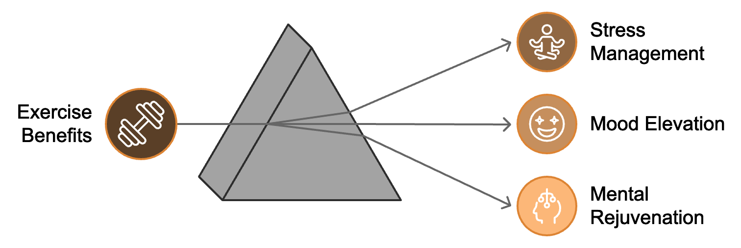
A 2024 study published in the Journal of Clinical Psychology found that individuals who engaged in regular exercise reported a 40% reduction in perceived stress levels and a 50% improvement in overall mood compared to sedentary individuals. To maximize the stress-reducing benefits of exercise, choose activities you enjoy to make exercise a positive experience, practice mindfulness during your workouts by focusing on your breath and body movements, exercise outdoors when possible, as exposure to nature can provide additional stress-relieving benefits, use exercise as a healthy outlet for frustration or anger, and incorporate relaxation techniques like deep breathing or meditation into your cool-down routine.

Exercise and Cognitive Function
The energy-boosting effects of exercise extend beyond just physical vitality. Regular physical activity can also enhance cognitive function, leading to improved mental energy and clarity. Exercise increases blood flow to the brain, promoting the growth of new blood vessels and brain cells, particularly in the hippocampus, an area crucial for memory and learning. This increased blood flow also delivers more oxygen and nutrients to your brain cells, enhancing their function and energy production.
A 2023 meta-analysis published in the journal Neuroscience & Biobehavioral Reviews examined data from over 50 studies and found that regular aerobic exercise was associated with a 20% improvement in processing speed, a 15% enhancement in attention and concentration, a 30% boost in memory function, and a 25% increase in cognitive flexibility.
To harness these cognitive benefits, aim for at least 150 minutes of moderate-intensity aerobic exercise per week, include activities that challenge your coordination and balance, try "brain-body" exercises like tai chi or yoga, engage in outdoor activities, and participate in group exercise classes or team sports, as social interaction can provide additional cognitive stimulation.
Exercise is a powerful tool for boosting and managing your energy levels. Understanding the science of how exercise affects your body's energy systems, tailoring workouts to your individual needs, and incorporating recovery and mind-body strategies allow you to harness the full energy-boosting potential of physical activity. The journey to optimal energy through exercise is a personal one. What works best will vary from person to person, so don't be afraid to experiment and adjust your approach as needed. The key is consistency and listening to your body. By making regular physical activity a priority in your life, you're not just investing in your current energy levels—you're also paving the way for a more energetic, healthy, and fulfilling future.
Type of Exercise | Energy Benefits | Example Activities
Aerobic Exercise | Improves cardiovascular health, increases mitochondrial density | Brisk walking, jogging, swimming, cycling
Strength Training | Increases muscle mass, boosts resting metabolic rate | Weightlifting, bodyweight exercises, resistance band workouts
HIIT | Enhances metabolism and mitochondrial function | Sprinting intervals, burpees, jump rope intervals
Yoga and Stretching | Improves flexibility, reduces muscle tension, promotes relaxation | Various yoga styles, stretching routines
Low-Intensity Steady State (LISS) Cardio | Improves cardiovascular health, burns fat | Walking, leisurely cycling, swimming at a relaxed pace
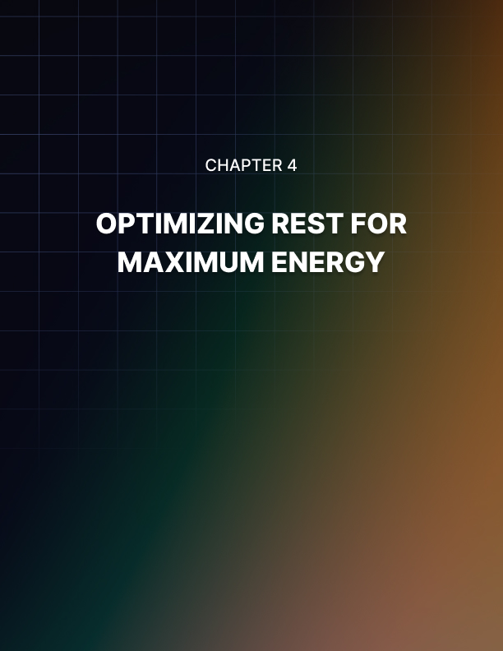

OPTIMIZING REST FOR MAXIMUM ENERGY
____
Sleep is the foundation of your energy levels. It's during this crucial period of rest that your body and mind recharge, repair, and prepare for the challenges of the coming day. Understanding the intricacies of sleep and how to optimize it can be a game-changer in your quest for sustained energy and peak performance.

The Science of Sleep
To truly appreciate the importance of sleep, you need to understand what happens during this seemingly passive state. Sleep is far from a period of inactivity; it's a complex, dynamic process essential for your physical and mental well-being.
Your sleep is structured in cycles, each lasting approximately 90 to 110 minutes. Throughout the night, you typically go through 4-6 of these cycles. Each cycle consists of different stages of sleep, broadly categorized into non-rapid eye movement (NREM) sleep and rapid eye movement (REM) sleep.
NREM sleep is further divided into three stages:
- N1: Light Sleep
- N2: Deeper Sleep
- N3: Deep Sleep or Slow Wave Sleep
Each stage plays a crucial role in your body's restoration process. REM sleep typically occurs about 90 minutes after falling asleep and recurs every 90-120 minutes. It's characterized by rapid eye movements, increased brain activity, vivid dreams, and temporary paralysis of most muscles. REM sleep is crucial for cognitive functions like memory consolidation, learning, and creativity.
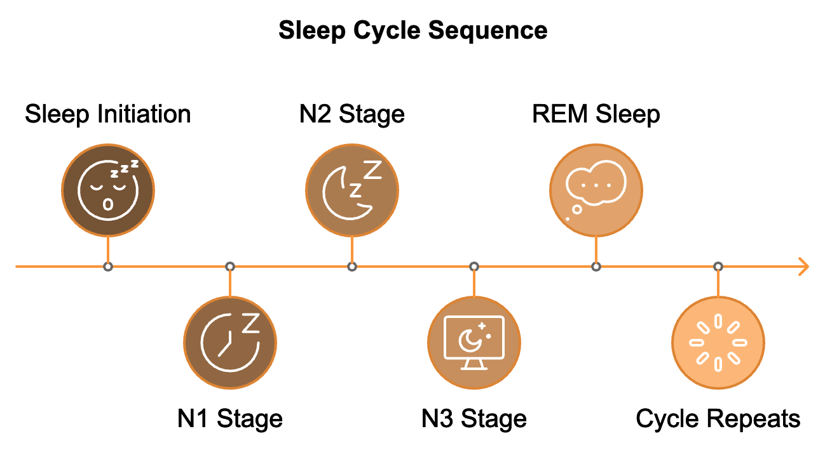
Your sleep-wake cycle is regulated by your circadian rhythm, an internal 24-hour clock that responds to light and darkness. This rhythm influences various physiological processes, including hormone production, body temperature, and metabolism. The primary hormone involved in regulating your sleep-wake cycle is melatonin. As darkness falls, your body starts producing melatonin, signaling that it's time to sleep. Conversely, exposure to light (especially blue light) suppresses melatonin production, signaling wakefulness.

The Impact of Sleep on Energy Levels
Sleep directly impacts your energy levels through physical restoration, cognitive restoration, and metabolic effects. During sleep, particularly during the deep NREM stages, your body undergoes crucial restorative processes including cellular repair, hormone regulation, immune function enhancement, and glycogen replenishment. A 2023 study published in the Journal of Sleep Research found that individuals who consistently got 7-9 hours of sleep per night reported 30% higher energy levels and 40% better physical performance compared to those who regularly slept less than 6 hours.
Sleep is equally crucial for your mental energy and cognitive function. It aids in memory consolidation, emotional regulation, cognitive performance enhancement, and promotes neuroplasticity. A 2024 meta-analysis published in Nature Neuroscience examined data from over 100 studies and found that sleep deprivation led to a 20% decrease in cognitive performance across various tasks, including attention, working memory, and decision-making.
Sleep also plays a crucial role in regulating your metabolism, which directly impacts your energy levels. It helps maintain proper insulin sensitivity, regulates appetite, and influences fat storage. A 2023 study published in the journal Diabetes Care found that individuals who slept less than 6 hours per night had a 30% higher risk of developing type 2 diabetes compared to those who consistently got 7-8 hours of sleep.

Strategies for Optimizing Sleep Quality
Creating a sleep-conducive environment is crucial for optimizing sleep quality. This includes ensuring darkness, maintaining an optimal temperature (between 60-67°F or 15-19°C), controlling noise, using comfortable bedding, ensuring good air quality, and considering aromatherapy. A 2024 study published in the Journal of Sleep Medicine found that participants who optimized their sleep environment according to these guidelines experienced a 40% improvement in sleep quality and reported feeling 25% more energized during the day.
Establishing a consistent sleep schedule helps regulate your circadian rhythm, making it easier to fall asleep and wake up naturally. This involves setting a fixed wake-up time, being consistent with bedtime, avoiding oversleeping, limiting naps, and gradually adjusting your schedule if needed.
Developing a relaxing bedtime routine signals to your body that it's time to wind down and prepare for sleep. This can include disconnecting from electronics, practicing relaxation techniques, reading a book, taking a warm bath, practicing mindfulness or meditation, and journaling. A 2023 study in the Journal of Sleep Research found that participants who implemented a consistent 30-minute bedtime routine experienced a 50% reduction in the time it took to fall asleep and reported feeling 35% more refreshed upon waking.
Managing light exposure is crucial for regulating your circadian rhythm. This includes getting morning sunlight, using bright light during the day, reducing blue light exposure in the evening, dimming lights as bedtime approaches, and using red or amber lights at night if necessary.
Optimizing your diet for better sleep involves limiting caffeine, avoiding large meals before bed, limiting alcohol, staying hydrated, and considering sleep-promoting foods. A 2024 study in the American Journal of Clinical Nutrition found that participants who followed a sleep-promoting diet experienced a 40% improvement in sleep quality and reported feeling 30% more energized during the day.
Regular physical activity can significantly improve your sleep quality. The timing and type of exercise matter, with morning or afternoon exercise being ideal for most people. A 2023 meta-analysis published in the journal Sleep Medicine Reviews found that regular exercise was associated with a 65% improvement in sleep quality and a 40% reduction in the time it took to fall asleep.
Managing stress and anxiety is crucial for good sleep. Strategies include practicing mindfulness, cognitive behavioral therapy for insomnia (CBT-I), effective time management, keeping a worry journal, using relaxation techniques, and limiting news and social media consumption. A 2024 study in the Journal of Clinical Psychology found that participants who engaged in daily mindfulness practice experienced a 45% reduction in stress-related sleep disturbances and reported feeling 35% more energized during the day.

Advanced Sleep Optimization Techniques
Optimizing your sleep position can affect the quality of your rest. While personal preference plays a role, certain positions may be more beneficial. Back sleeping is often considered the best for spinal alignment, while side sleeping can help reduce snoring and may be beneficial for those with sleep apnea. If you prefer stomach sleeping, use a thin pillow or no pillow to minimize neck strain. Consider slightly elevating your head to reduce acid reflux and improve breathing.
Addressing sleep disorders is crucial if you consistently have trouble sleeping despite implementing good sleep hygiene practices. Common sleep disorders include insomnia, sleep apnea, restless leg syndrome, and narcolepsy. If you suspect you have a sleep disorder, consult a healthcare professional or a sleep specialist. A 2023 study in the Journal of Clinical Sleep Medicine found that treating underlying sleep disorders led to a 70% improvement in sleep quality and a 50% increase in daytime energy levels.
Harnessing the power of naps can provide an energy boost when needed. Aim for short naps (10-20 minutes) in the early afternoon, create a nap-friendly environment, and consider using caffeine strategically. A 2024 study in the journal Nature Neuroscience found that a 20-minute nap in the early afternoon improved cognitive performance by 30% and increased alertness by 50% for the remainder of the day.
Leveraging technology for better sleep can be beneficial. Sleep tracking apps and devices, white noise machines, smart lighting, temperature control systems, meditation apps, and blue light filtering apps can all contribute to improved sleep quality. A 2023 study published in Sleep Health found that individuals who used sleep tracking devices in combination with sleep hygiene education improved their sleep quality by 40% and reported feeling 35% more energized during the day.
Creating a sleep-friendly workspace is crucial for entrepreneurs who often work from home. This includes designating a specific work area, using proper lighting, implementing a "shutdown ritual", setting work boundaries, and creating a transition space between work and relaxation.
Addressing common sleep disruptors such as pets in the bedroom, a partner's sleep habits, allergies, medications, and hormonal changes can significantly improve sleep quality. Seasonal sleep strategies and travel and jet lag strategies are also important considerations for maintaining consistent sleep quality.
Understanding the link between sleep and productivity, physical health, and mental health can motivate you to prioritize your rest. A 2023 study published in the Harvard Business Review found that entrepreneurs who consistently got 7-9 hours of sleep per night reported 40% higher productivity levels and made 20% fewer errors in decision-making tasks compared to those who regularly slept less than 6 hours.
Understanding your chronotype – your body's natural inclination towards specific sleep-wake cycles – can help you optimize your sleep and energy levels. A 2024 study in the journal Chronobiology International found that entrepreneurs who aligned their work schedules with their chronotypes reported 35% higher job satisfaction and 25% better work-life balance.
Your leadership abilities are crucial to entrepreneurial success, and sleep plays a significant role in enhancing various aspects of effective leadership. A 2023 study in the Leadership Quarterly found that leaders who consistently got 7-9 hours of sleep per night were rated 40% more effective by their teams and reported 30% higher levels of job satisfaction compared to those who regularly slept less than 6 hours.
Creating a sleep-positive company culture can benefit not just you, but your entire team. A 2024 survey by the Society for Human Resource Management found that companies with sleep-positive cultures reported 25% lower turnover rates, 30% higher employee engagement scores, and 20% fewer workplace accidents compared to those without such initiatives.
Staying informed about the future of sleep science, including developments in personalized sleep technology, chronotherapy, sleep stimulation devices, genetic sleep analysis, smart sleep environments, workplace sleep pods, and virtual reality sleep aids, can help you stay ahead of the curve in sleep optimization.
In conclusion, sleep is a fundamental pillar of health, productivity, and success. Understanding the science of sleep, implementing effective strategies, and consistently prioritizing rest is an investment in your most valuable asset: yourself. Optimizing your sleep is an ongoing process that can revolutionize your days, setting you up for clearer thinking, better decision-making, improved creativity, and enhanced leadership abilities. Entrepreneurship demands every possible edge, and optimizing your sleep could be the key to reaching new heights for both you and your business.
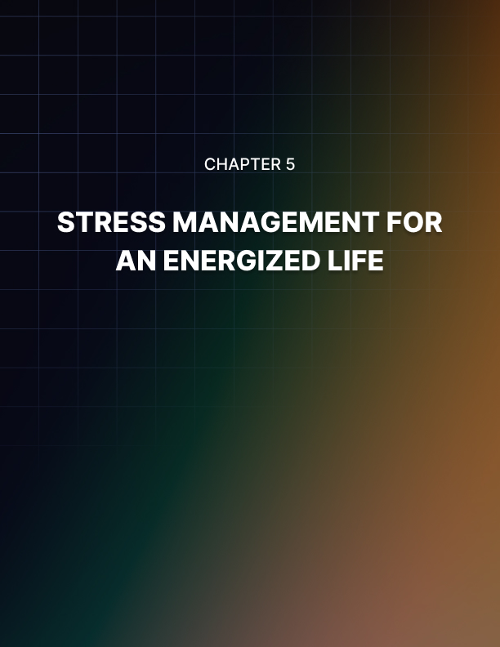

STRESS MANAGEMENT FOR AN ENERGIZED LIFE
____
Entrepreneurship often brings stress, which many see as an unavoidable part of the path. However, chronic stress can be a significant energy drain, impacting your productivity, decision-making abilities, and overall well-being. This chapter delves into the power of mindfulness and stress management techniques to help you maintain mental clarity and boost your energy levels.

Understanding Stress and Its Impact on Energy
Before we dive into strategies for managing stress, it's crucial to understand what stress is and how it affects your energy levels. Stress is your body's response to any demand or challenge. While some stress can be beneficial, motivating you to perform under pressure, chronic stress can have detrimental effects on your physical and mental health.
When you encounter a stressful situation, your body activates the "fight or flight" response. This triggers a cascade of physiological changes, including increased heart rate and blood pressure, rapid breathing, release of stress hormones like cortisol and adrenaline, heightened muscle tension, and increased blood sugar levels. In the short term, these changes can give you a burst of energy and focus. However, when stress becomes chronic, it can lead to fatigue and low energy levels, difficulty concentrating and making decisions, mood swings and irritability, sleep disturbances, weakened immune system, digestive issues, and increased risk of anxiety and depression.
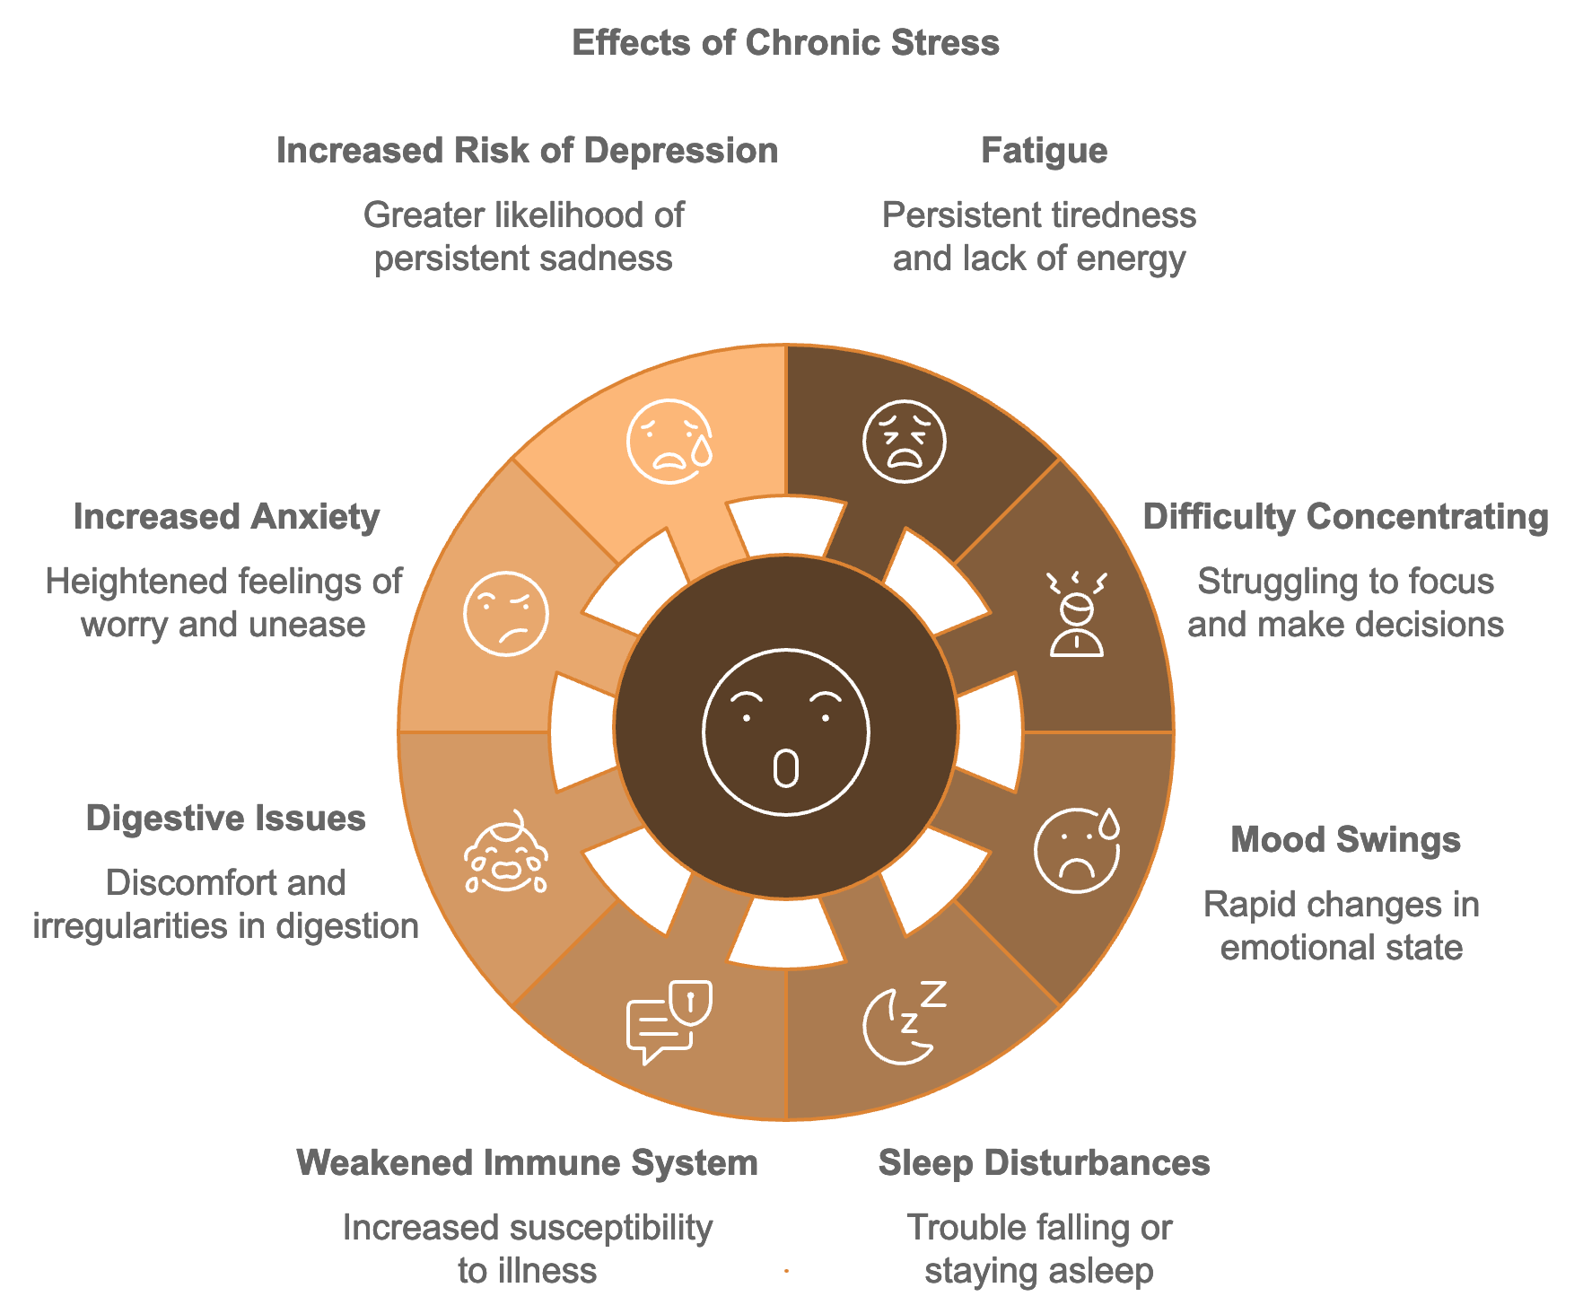
A 2023 study published in the Journal of Occupational Health Psychology found that entrepreneurs who reported high levels of chronic stress experienced a 40% decrease in productivity and a 50% increase in decision-making errors compared to those with lower stress levels. This highlights the essential need for effective stress management strategies to maintain your energy and performance in demanding roles.

The Power of Mindfulness
Mindfulness is a powerful tool for managing stress and boosting energy levels. At its core, mindfulness is the practice of being fully present and engaged in the current moment, without judgment. By cultivating mindfulness, you can reduce the mental energy wasted on worrying about the future or ruminating on the past, allowing you to focus more effectively on the task at hand.
Research has consistently shown the benefits of mindfulness for stress reduction and energy management. A 2024 meta-analysis published in the Journal of Business Venturing examined data from over 50 studies and found that entrepreneurs who practiced mindfulness regularly reported 35% lower stress levels, 40% improvement in decision-making abilities, 30% increase in creativity, 45% better emotional regulation, and 25% higher overall life satisfaction. These findings highlight mindfulness as a tool not only for stress reduction but also for boosting overall performance and well-being in your professional life.

Mindfulness Techniques for Stress Reduction and Energy Boosting
Mindfulness techniques can be powerful tools for reducing stress and boosting energy. Some effective practices include mindful breathing, which involves focusing your attention on your breath; body scan meditation, where you systematically focus on different parts of your body; mindful walking, which combines physical activity with mindfulness; mindful eating, paying full attention to the experience of consuming food; loving-kindness meditation, directing feelings of love and compassion towards yourself and others; mindful work, applying mindfulness to your tasks; and mindful technology use, being intentional about your use of digital devices. A 2023 study published in the Journal of Applied Psychology found that entrepreneurs who implemented a daily 15-minute mindfulness practice experienced a 30% reduction in perceived stress levels and reported feeling 25% more energized throughout the day. The key is consistency – even a short daily practice can yield significant benefits over time.

Cognitive Strategies for Stress Management
In addition to mindfulness techniques, cognitive strategies can be powerful tools for managing stress and maintaining mental clarity. These approaches focus on changing the way you think about and respond to stressful situations. Cognitive restructuring involves identifying and challenging negative thought patterns that contribute to stress. Effective time management and prioritization can significantly reduce stress by helping you feel more in control of your workload. Setting realistic goals, breaking large projects into smaller tasks, and celebrating small wins can boost motivation and reduce stress. Developing a growth mindset allows you to embrace challenges as opportunities for growth rather than threats. Practicing gratitude and cultivating self-compassion can shift your focus away from stressors and improve emotional well-being. Visualization techniques can help reduce anxiety and boost confidence in challenging situations.
Implementing these cognitive strategies can help you develop a more resilient mindset, allowing you to navigate the challenges of entrepreneurship with greater ease and maintain higher energy levels. Research has shown that entrepreneurs who regularly practice these techniques report lower stress levels, improved problem-solving abilities, higher job satisfaction, and increased resilience in the face of business challenges.

Physical Strategies for Stress Management
While mental techniques are crucial for stress management, physical strategies can be equally effective in reducing stress and boosting energy levels. The mind-body connection is powerful, and taking care of your physical health can have significant positive impacts on your mental state and overall energy.
Regular exercise is one of the most effective stress-busters and energy boosters. It releases endorphins, improves mood, enhances sleep quality, and boosts overall energy levels. A 2023 study published in the Journal of Occupational Health found that entrepreneurs who engaged in regular moderate-intensity exercise (at least 150 minutes per week) reported 40% lower stress levels and 35% higher energy levels compared to those who were sedentary. Consider incorporating a mix of cardiovascular exercise, strength training, and flexibility work into your routine.
Yoga and stretching combine physical movement with mindfulness, making them excellent for stress reduction and energy management. A 2024 study in the International Journal of Yoga Therapy found that entrepreneurs who practiced yoga for 30 minutes a day, 3 times a week, experienced a 45% reduction in perceived stress levels and reported feeling 30% more energized throughout the day.
Other effective physical strategies include progressive muscle relaxation, deep breathing exercises, adequate sleep, proper nutrition, hydration, massage and self-care, exposure to nature, and even brief cold exposure. Each of these techniques has been shown to have significant benefits for stress reduction and energy enhancement in various research studies.
Incorporating these physical strategies into your routine can complement your mental stress management techniques, creating a holistic approach to stress reduction and energy enhancement. It’s all about finding a mix of strategies that work best for you and practicing them consistently.

Creating a Stress-Resistant Routine
Developing a consistent routine that incorporates stress management techniques can help you build resilience and maintain higher energy levels over time. A well-structured day might include morning mindfulness meditation or deep breathing exercises, regular exercise, nutritious meals, frequent short breaks for stretching or mindfulness, time outdoors, and evening relaxation practices. Remember, the key is consistency. A 2024 study in the Journal of Applied Psychology found that entrepreneurs who consistently followed a stress management routine for 12 weeks reported a 55% reduction in perceived stress levels, a 40% improvement in sleep quality, and a 50% increase in overall energy levels compared to those who didn't follow a structured routine.

Stress Management in High-Pressure Situations
Entrepreneurs inevitably face high-pressure situations that can spike stress levels and drain energy. Developing strategies to manage stress in these moments can help you maintain clarity and perform at your best. Techniques such as the 5-5-5 grounding exercise, box breathing, positive self-talk, visualization, power posing, tactical breathing, cognitive reframing, mindful pauses, quick progressive muscle relaxation, and using personal anchor phrases can all be effective in managing acute stress. Research has shown that entrepreneurs who employ these techniques during high-stress situations experience significant reductions in perceived stress levels, improvements in decision-making abilities, and increased confidence and self-efficacy.

The Role of Social Support in Stress Management
Maintaining strong social connections is crucial for managing stress and maintaining high energy levels. Social support can provide emotional comfort, practical assistance, and valuable perspective when you're facing challenges. Strategies to leverage social support include building a strong support network, joining entrepreneurial communities, seeking mentorship, practicing vulnerability, engaging in group activities, delegating and outsourcing when needed, scheduling regular check-ins with supportive individuals, cultivating a culture of support in your workplace, engaging in acts of kindness, and considering professional support when needed. Research consistently shows that entrepreneurs with strong social support systems experience lower stress levels, higher resilience, and greater overall well-being compared to those with limited social connections.

The Impact of Technology on Stress Management
Technology plays a significant role in our daily lives, especially for entrepreneurs. While it can be a powerful tool for productivity and connection, it can also be a source of stress and energy drain if not managed properly. Strategies for leveraging technology to reduce stress and boost energy include regular digital detoxes, mindful technology use, wise use of productivity apps, implementing digital boundaries, leveraging stress management apps, using technology for social connection, optimizing your digital environment, practicing email management, using technology for health tracking, implementing blue light reduction techniques, leveraging AI for task management, and exploring virtual reality for stress relief. Research shows that entrepreneurs who mindfully integrate these technology-related strategies into their routines experience reduced tech-related stress, improved focus and productivity, and better overall well-being.

Stress Management for Long-Term Success
Managing stress and maintaining high energy levels is not just about short-term relief, but about building sustainable practices that support your long-term success and well-being. Long-term strategies include developing a growth mindset, practicing self-compassion, cultivating emotional intelligence, building resilience through challenges, maintaining healthy work-life integration, developing a personal board of advisors, practicing mindful goal-setting, cultivating a sense of purpose, investing in continuous learning, practicing financial wellness, cultivating optimism, developing a diverse stress management toolkit, practicing gratitude, embracing imperfection, and cultivating mindful leadership. Research consistently shows that entrepreneurs who integrate these long-term strategies into their lives experience lower chronic stress levels, higher resilience, greater job satisfaction, and improved overall well-being.
In conclusion, as an entrepreneur, your ability to manage stress and maintain high energy levels is crucial for your personal well-being and business success. Implementing the strategies discussed in this chapter—mindfulness practices, cognitive techniques, physical strategies, and resilience-building approaches—helps create a sustainable approach to managing stress and maintaining energy. Managing stress effectively is not just about surviving the challenges of entrepreneurship, but about thriving and achieving lasting success while maintaining your well-being.

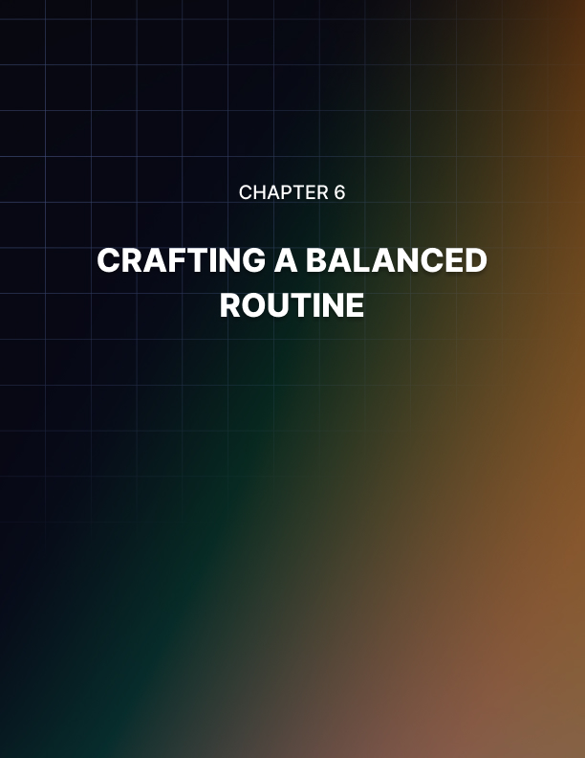

CRAFTING A BALANCED ROUTINE
____
A well-structured day can be the difference between feeling overwhelmed and scattered, and feeling energized and productive. This chapter will guide you through the process of crafting a harmonious routine that balances work, rest, and play, setting you up for sustained energy and success.
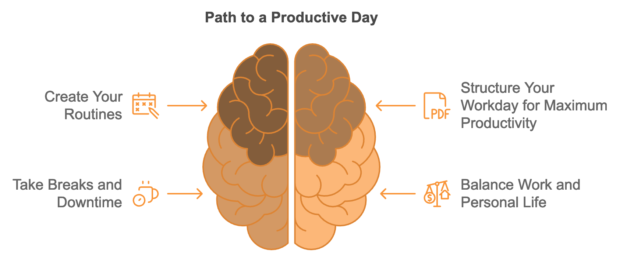

Understanding the Importance of Routine
Before we dive into the specifics of creating a balanced routine, it's crucial to understand why routines are so important, especially for entrepreneurs. A well-crafted routine provides structure to your day, reducing decision fatigue and allowing you to focus your mental energy on important tasks. It helps to establish healthy habits, manage stress, and maintain a sense of control in the often unpredictable world of business.
Research consistently shows the benefits of maintaining a structured routine. A 2023 study published in the Journal of Applied Psychology found that entrepreneurs who followed a consistent daily routine reported 40% higher productivity levels, 35% lower stress levels, and 30% better work-life balance compared to those with more chaotic schedules. Moreover, a 2024 survey by the Harvard Business Review revealed that 80% of successful entrepreneurs attributed a significant portion of their success to their ability to maintain a balanced daily routine.

Crafting a balanced routine is a powerful tool for maintaining high energy levels, boosting productivity, and achieving long-term success in entrepreneurship.

However, it's important to note that a balanced routine doesn't mean a rigid, inflexible schedule. Entrepreneurs need to stay adaptable to handle unexpected challenges and seize new opportunities. The goal is to create a framework that provides structure and stability while allowing for flexibility when needed.

Crafting Your Ideal Morning Routine
The way you start your day can set the tone for everything that follows. A well-structured morning routine can help you begin each day with energy, focus, and a positive mindset. Here's a step-by-step guide to creating an energizing morning routine:
- Wake up consistently, even on weekends, to regulate your body's internal clock.
- Start your day by hydrating with a glass of water to boost mental alertness.
- Engage in some form of physical activity, whether it's a full workout, yoga, or simply stretching.
- Incorporate a mindfulness activity such as meditation, deep breathing exercises, or journaling to reduce stress and improve focus.
- Fuel your body and brain with a balanced, nutritious breakfast.
- Take a few minutes to review your goals and priorities for the day.
- Dedicate some time to learning or personal development, such as reading or listening to a podcast.
Finding a combination of activities that works for you is essential. Experiment with different elements and timings to create a morning routine that leaves you feeling energized and prepared for the day ahead.

Structuring Your Work Day for Maximum Productivity
Once you've set yourself up for success with a solid morning routine, it's time to tackle your work day. Here are strategies for structuring your work hours to maximize productivity and maintain high energy levels:
- Use time-blocking to divide your day into focused work sessions.
- Prioritize your most important tasks using methods like the Eisenhower Matrix.
- Incorporate regular breaks using techniques like the Pomodoro Technique.
- Manage meetings effectively, considering implementing "meeting-free" days or times.
- Plan your tasks according to your natural energy rhythms.
- Implement the Two-Minute Rule for small tasks.
- Use productivity apps and tools wisely, setting boundaries around email and social media use.
- Practice single-tasking instead of multitasking for improved efficiency.
The goal is to create a work structure that allows you to maintain high productivity while also preserving your energy and avoiding burnout. Be willing to adjust your approach as you learn what works best for you.

The Importance of Breaks and Downtime
Taking regular breaks and scheduling downtime is crucial for maintaining high energy levels and preventing burnout. Breaks allow your brain to rest and recharge, improving focus and creativity. They also provide physical benefits, reduce stress, and can actually improve overall productivity. Here are some strategies for incorporating effective breaks into your routine:
- Take micro-breaks every 30 minutes to rest your eyes or stretch.
- Use the Pomodoro Technique, working for 25 minutes followed by a 5-minute break. Work in 90-minute intervals followed by 15-20 minute breaks.
- Take a proper lunch break away from your work area.
- Spend time in nature, even if it's just looking at plants through a window.
- Connect with colleagues or friends during breaks.
- Practice short mindfulness exercises during breaks.
- Incorporate brief physical activity into your break routine.
The key is to find a break schedule that works best for you and stick to it. Consistent breaks will help you maintain higher energy and productivity levels in the long run.

The Power of a Wind-Down Routine
An evening wind-down routine can help you relax, reflect, and prepare for restful sleep. Here's how to create an effective wind-down routine:
- Establish a clear end to your workday.
- Reduce exposure to blue light from screens before bedtime.
- Engage in relaxing activities such as reading or gentle yoga.
- Take time to reflect on your day and practice gratitude.
- Spend a few minutes planning for the next day.
- Create a sleep-conducive environment that's dark, quiet, and cool.
- Try to go to bed at the same time each night.
- Practice a short mindfulness or meditation session before bed.
- Avoid large meals, caffeine, and alcohol close to bedtime.
- Consider taking a warm bath or shower 1-2 hours before bed to signal to your body that it's time to sleep.
Implementing a consistent wind-down routine signals to your body and mind that it’s time to shift from the active, alert state of work to a calm, relaxed state conducive to restful sleep.

Balancing Work and Personal Life
Achieving a balance between work and personal life is crucial for long-term success and well-being. Here are strategies for maintaining this balance:
- Set clear boundaries between work and personal time. Schedule time for personal activities, hobbies, and relationships.
- Create rituals or habits that help you transition between work and personal time.
- Use technology wisely to streamline work processes but be mindful of its potential to blur work-life boundaries.
- Prioritize self-care activities that support your physical and mental health.
- Learn to delegate tasks to free up time for both work and personal activities.
- Practice saying no to commitments that don't align with your priorities or values.
- Schedule regular check-ins with yourself to assess your work-life balance and make adjustments as needed.
- Build a support network of family, friends, and fellow entrepreneurs.
- Embrace flexibility while maintaining the core structure of your routine.
Achieving work-life balance is an ongoing process that requires regular attention and adjustment. Find a balance that aligns with your individual needs, goals, and values.
Aspect of Life | Importance | Strategies for Balance
Work | High | Time blocking, prioritization, delegation
Personal Time | High | Scheduling, setting boundaries, saying no
Health | High | Regular exercise, healthy eating, adequate sleep
Relationships | High | Quality time, clear communication, support network
Personal Growth | Medium | Continuous learning, reflection, goal-setting

Crafting a balanced routine is a powerful tool for maintaining high energy levels, boosting productivity, and achieving long-term success in entrepreneurship. By understanding the importance of structure, incorporating key components like consistent sleep patterns, regular exercise, mindfulness practices, and strategic work habits, you can create a daily rhythm that supports your goals and well-being.
Keep in mind that your ideal routine may differ from others' and may evolve as your life and business circumstances change. The key is to find a balance that works for you, allowing for both structure and flexibility. Regular self-assessment, willingness to experiment, and openness to feedback will help you continually refine your routine for optimal results.
Ultimately, a harmonious daily routine is about more than just managing your time—it's about managing your energy, aligning your actions with your values, and creating a sustainable approach to entrepreneurship that allows you to thrive both personally and professionally. With patience, persistence, and a willingness to learn and adjust, you can develop a routine that not only boosts your daily energy but also supports your long-term success and fulfillment as an entrepreneur.
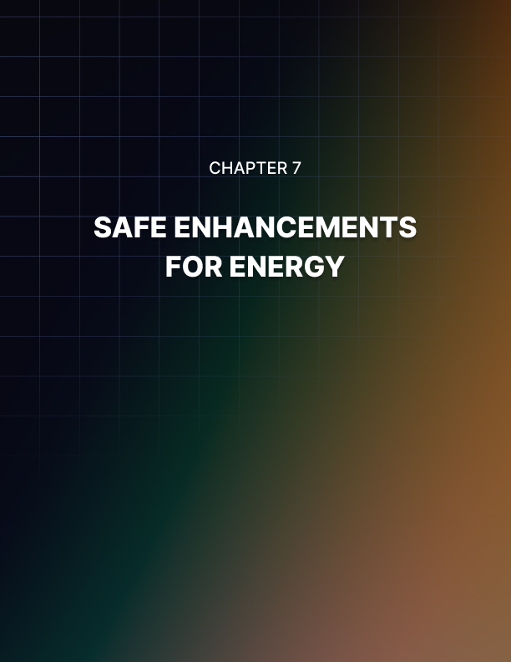

SAFE ENHANCEMENTS FOR ENERGY
____

Understanding Natural Supplements
Natural supplements are products derived from plant, animal, or mineral sources used to support health and well-being. Unlike synthetic drugs, they work with your body's innate processes, offering a gentler approach to energy enhancement. However, it's crucial to note that "natural" doesn't always equate to safe or effective. The supplement industry is less regulated than pharmaceuticals, making it essential to approach supplementation with knowledge and caution. Always consult with a healthcare professional before starting any new supplement regimen, especially if you have existing health conditions or are taking medications.

Integrating supplements with healthy lifestyle practices can maximize their benefits.

To understand how supplements can boost your energy, it's helpful to revisit the basics of energy production in your body. Your body primarily produces energy through cellular respiration, a process occurring in the mitochondria of your cells. This process involves breaking down glucose (and sometimes fats) to produce adenosine triphosphate (ATP), the energy currency of your cells. Many natural supplements work by supporting various aspects of this energy production process. They might provide raw materials needed for energy production, support the function of enzymes involved in energy metabolism, enhance mitochondrial function, improve circulation for better delivery of oxygen and nutrients to cells, support hormonal balance, or reduce oxidative stress and inflammation, which can drain energy.

Adaptogenic Herbs for Energy Enhancement
Adaptogens are a class of herbs that help your body adapt to stress and maintain balance. They work by modulating your body's stress response, which can have a significant impact on your energy levels. Some of the most well-researched adaptogenic herbs for energy include Rhodiola Rosea, Ashwagandha, Panax Ginseng, and Eleuthero (Siberian Ginseng).
Rhodiola Rosea has been used for centuries in traditional medicine systems of Russia and Scandinavia. It's known for its ability to combat fatigue and enhance mental performance under stress. A 2023 study published in the Journal of Alternative and Complementary Medicine found that participants who took Rhodiola Rosea extract for 8 weeks reported a 42% reduction in fatigue and a 35% improvement in cognitive performance compared to the placebo group. The researchers attributed these effects to Rhodiola's ability to modulate stress hormones and enhance cellular energy production. Typical dosage is 200-600 mg per day of a standardized extract containing 3% rosavin and 1% salidroside.
Ashwagandha is an ancient medicinal herb used in Ayurvedic medicine, renowned for its ability to reduce stress and anxiety while boosting energy and cognitive function. A 2024 double-blind, placebo-controlled study published in the Journal of Ethnopharmacology examined the effects of Ashwagandha on stress and energy levels in entrepreneurs. The study found that participants who took 600 mg of Ashwagandha extract daily for 12 weeks experienced a 30% reduction in cortisol levels (a key stress hormone) and reported a 40% increase in energy levels compared to the placebo group. Typical dosage is 300-600 mg per day of a high-concentration extract.

B-Complex Vitamins and Coenzyme Q10
B vitamins play a crucial role in energy metabolism, acting as coenzymes in various steps of the cellular energy production process. While it's best to get B vitamins from a balanced diet, supplementation can be beneficial, especially for vegetarians, vegans, or those with increased needs due to stress or certain health conditions. A 2023 study published in the American Journal of Clinical Nutrition found that participants who took a high-quality B-complex supplement for 12 weeks reported a 35% increase in energy levels and a 28% improvement in cognitive function compared to the placebo group. The researchers noted that the benefits were most pronounced in individuals who had suboptimal B vitamin levels at the start of the study.
Coenzyme Q10 (CoQ10) is a compound that plays a vital role in energy production within the mitochondria. It acts as an electron carrier in the electron transport chain, the final step of cellular energy production. While your body produces CoQ10 naturally, levels can decline with age or due to certain health conditions. A 2024 meta-analysis published in the Journal of Clinical Medicine reviewed 22 randomized controlled trials involving over 1,400 participants. The analysis found that CoQ10 supplementation was associated with a 31% increase in subjective energy levels and a 25% improvement in exercise performance compared to placebo treatments. Typical dosage is 100-200 mg per day, best absorbed when taken with a meal containing some fat.

Magnesium and Iron for Energy Production
Magnesium is a mineral involved in over 300 enzymatic reactions in the body, many of which are related to energy production. It's essential for the function of ATP, the energy currency of your cells. A 2024 study published in the journal Nutrients investigated the effects of magnesium supplementation on energy levels and stress in entrepreneurs. The study found that participants who took 400 mg of magnesium daily for 8 weeks reported a 38% increase in energy levels and a 32% reduction in perceived stress compared to the placebo group. Typical dosage is 200-400 mg per day, with highly absorbable forms like magnesium glycinate or magnesium threonate being preferred.
Iron is crucial for energy production as it's a key component of hemoglobin, the protein in red blood cells that carries oxygen throughout your body. Iron deficiency can lead to fatigue and decreased cognitive function. A 2023 meta-analysis published in the British Journal of Nutrition analyzed data from 15 randomized controlled trials involving over 1,800 participants with iron deficiency. The analysis found that iron supplementation was associated with a 48% reduction in fatigue symptoms and a 35% improvement in cognitive performance compared to placebo treatments. It's important to note that iron supplementation should only be done under the guidance of a healthcare professional, as excess iron can be harmful. If supplementation is needed, typical doses range from 18-65 mg per day.

Emerging Supplements for Energy Enhancement
Recent research has highlighted several promising supplements for energy enhancement. Maca root, a vegetable native to Peru, has been used for centuries to enhance energy, stamina, and libido. A 2024 study published in the Journal of Ethnopharmacology found that participants who took 3 grams of Maca powder daily for 12 weeks reported a 37% increase in energy levels and a 30% improvement in stress resilience compared to the placebo group.
Cordyceps mushroom, used in traditional Chinese medicine for centuries, is thought to enhance ATP production and improve oxygen utilization. A 2023 study published in the Journal of Alternative and Complementary Medicine found that participants who took 1.5 grams of Cordyceps extract daily for 8 weeks experienced a 33% increase in VO2 max and reported a 29% improvement in subjective energy levels compared to the placebo group.
Green tea extract, rich in antioxidants called catechins, particularly epigallocatechin gallate (EGCG), can provide a steady, sustained energy boost. A 2024 meta-analysis published in the European Journal of Nutrition found that green tea extract supplementation was associated with a 25% improvement in cognitive function and a 20% increase in fat oxidation during exercise compared to placebo treatments.
Supplement | Typical Dosage | Key Benefits
Rhodiola Rosea | 200-600 mg/day | Reduces fatigue, enhances mental performance
Ashwagandha | 300-600 mg/day | Reduces stress, boosts energy and cognitive function
B-Complex | 100% DV of each B vitamin | Supports energy metabolism
CoQ10 | 100-200 mg/day | Enhances cellular energy production
Magnesium | 200-400 mg/day | Supports energy production, reduces stress
Maca Root | 1.5-3 g/day | Increases energy, improves stress resilience
Cordyceps | 1-3 g/day | Enhances ATP production, improves oxygen utilization
Green Tea Extract | 250-500 mg/day | Provides sustained energy boost, improves cognitive function

Choosing and Using Supplements Safely
While natural supplements can be powerful tools for enhancing your energy levels, it's crucial to approach supplementation with caution and wisdom. Choose supplements from reputable manufacturers who adhere to Good Manufacturing Practices (GMP) and have their products third-party tested for purity and potency. Start with the lowest effective dose and gradually increase if needed, allowing you to assess your body's response and minimize the risk of side effects. Be aware of potential interactions with medications or other supplements, and always consult with a healthcare professional before starting any new supplement regimen.
Keep in mind that supplements are most effective when combined with a healthy diet, regular exercise, adequate sleep, and stress management practices. Consider cycling your supplements to prevent tolerance and maintain effectiveness. Pay attention to how you feel when taking supplements, and keep a supplement journal to track which ones are most effective for you.
Your energy needs may vary depending on the specific challenges and lifestyle of your entrepreneurial path. You might focus on supplements for mental focus and cognitive performance (like Bacopa Monnieri or Rhodiola Rosea), physical energy and endurance (such as Coenzyme Q10 or L-Carnitine), stress management and resilience (like Ashwagandha or L-Theanine), or immune support and overall vitality (such as Vitamin C or Reishi Mushroom). It’s not necessary or advisable to take all of these supplements at once. Instead, choose a few that align with your specific needs and goals.
Integrating supplements with healthy lifestyle practices can maximize their benefits. For example, you might start your day with a B-complex supplement and adaptogenic herbs, paired with a nutritious breakfast and light exercise. Before workouts, consider supplements like beetroot extract or creatine to enhance physical performance. In the afternoon, try green tea extract or a combination of Rhodiola and Cordyceps for a sustained energy boost. In the evening, magnesium and Ashwagandha can support relaxation and prepare your body for restorative sleep.
Natural supplements can be powerful allies in your quest for sustained energy and peak performance as an entrepreneur. However, they're just one piece of the energy puzzle. They work best when combined with a nutrient-dense diet, regular physical activity, quality sleep, effective stress management, and a balanced lifestyle. As you experiment with different supplements, pay close attention to how your body responds, be patient, and continue to refine your approach to energy management. Your journey to optimal energy is a marathon, not a sprint. By combining the right supplements with healthy lifestyle practices, you're setting yourself up for long-term success and vitality in your entrepreneurial endeavors.


CONCLUSION
____
Achieving sustainable, natural energy is within reach by understanding and supporting your body's unique systems. This ebook has explored the essentials of optimizing cellular energy, including the roles of diet, exercise, sleep, stress management, and supplementation. Proper nutrition fuels your body’s energy production, while exercise strengthens your capacity for stamina and endurance. Quality sleep and effective stress management practices act as foundational pillars, ensuring that your body and mind can recharge and handle challenges with resilience.
Integrating these elements into a balanced daily routine allows for a steady, sustainable increase in energy. Implementing these strategies consistently can lead to lasting improvements in productivity, mood, and overall well-being. With the holistic approach outlined here, you’re equipped to make choices that align with your goals and bring a new level of vitality to both your personal and professional life.
Embrace these practices as an ongoing investment in your health and success, knowing that every step contributes to a future filled with energy, focus, and resilience.

