Introduction

There are myriads of online tools out there for marketers, but that doesn't mean that they are all worth using. In order to figure out what tools would be the best to include in a short report, it's important to understand what kinds of tools marketers want, what features work best online and why, how expensive a tool is, and how well it works to accomplish a marketing goal. Going by these conditions, we've included some online marketing tools that we think every online marketer should include in their toolbox, and we've offered you an evaluation of that tool to convince you to add it. But, first let's discuss the criteria more in depth, to give you an idea of what we think makes a useful and worthwhile marketing tool.

What Kind of Tools Internet Marketers Want?

If you are an Internet marketer, you know that what you are looking for is something to reduce your workload to help you create the following to your website and Internet offerings:

Traffic
The number one thing any Internet marketer wants to achieve online is a good traffic count. Without traffic, there are no customers. Without customers, there are no sales. So, traffic has to be generated and any tool that helps a marketer automate that process is helpful. However, some go way beyond the “helpful” criteria to be actually POWERFUL traffic drivers. Those are the ones that you want to make sure to include in your tool kit. Some of these help you target demographics like a laser, others just get distributed in a fashion that drives traffic back to your site, regardless of demographic.

Income
Another thing that marketers want are tools that help them generate income, manage income streams, or reduce expenses. Along with these tools are things that can produce products online that can be sold, shopping cart tools, and any other sort of revenue specific tool.

Contact Management
So, you have the traffic and you got some sources of income out, but you don't know who is visiting your site? That's because you need tools that help you harvest contacts and then market them via email or subscription campaigns. This is the mouth of your sales funnel and without these tools, you can end up doing a lot of marketing and never getting off the starting block to sales.

Promotion
Tools that promote an Internet marketers business are essential to good online marketing. The Internet may be filled with millions of people, but that doesn't mean your online exposure is sufficient to get the word out. Using tools that help you boost your exposure is one way that you can start creating an online image and brand yourself or your business.

Sounds good? Obviously, even limiting the toolbox to these criteria there are still plenty of other tools out there that can be fun to use and/or stimulate interest in your business.

But, we'll also offer you some locations to check out tools being developed as they come off the assembly line, for those that want to move even further in adopting technologies for their websites.

What Features Work Best Online?

Since tools will be either online services or scripts, the best tools have the following features:

Easy To Use
No one wants to spend a ton of time trying to get the tool to work.

Solves A Customer's Problem
Any tool that gives better customer service, or provides a value-added feature to your customers is valuable to your business model.

Consistent Performance
Adopting a tool that works great one time and bombs another is a sure way to lose customers. Stick with established tools that have the bugs worked out of them already.

Simple Registration
A good online tool will either have a very curt registration opt-in, like an email, or none at all, if it's free.

Manages Multiple Users Efficiently
The idea is to attract tons of traffic, convert it to contacts, and start marketing it. If your tool does this, but performance drops off or you cannot keep up with multiple users efficiently, as an online marketer you might as well not use it.

Great Customer Support
Sometimes technical glitches can happen, even with the best of tools. You want to have a phone number, an AIM contact, or an email you can go to and send in a help support ticket to get your problems resolved.

Creates Excitement/Interest
A tool that creates buzz, excitement, fun and gets your users to participate in your website or offering is a great way to get noticed.

Cost

Obviously, you don't want to spend a whole lot on tools and there are plenty of free tools out there. But, sometimes a little expense can be worth it if the benefits outweigh the costs.

Goal Metrics

If you are like most Internet marketers, you start out without a plan, and quickly realize that if you start setting goals that you are more likely to achieve them. So, you start to set goals, and then you realize that tools would be a good idea to help you achieve those goals. Some of these tools, you will be able to tell how it helps you to achieve your marketing goals, and others will have an impact that may be hard to measure.

However, tools that do let you see right away how they impact your goals of traffic, income, contact management, and advertising are preferable to those that may or may not be having any impact. That way you know that the time, effort, and money you devote to implementing and using a tool is going to give you a sound return on your investment. But, that doesn't mean we've excluded tools that don't have clear metrics, as some things can be hard to quantify on the Internet. It just means it's always better to have some way to measure your success than just a gut feeling.

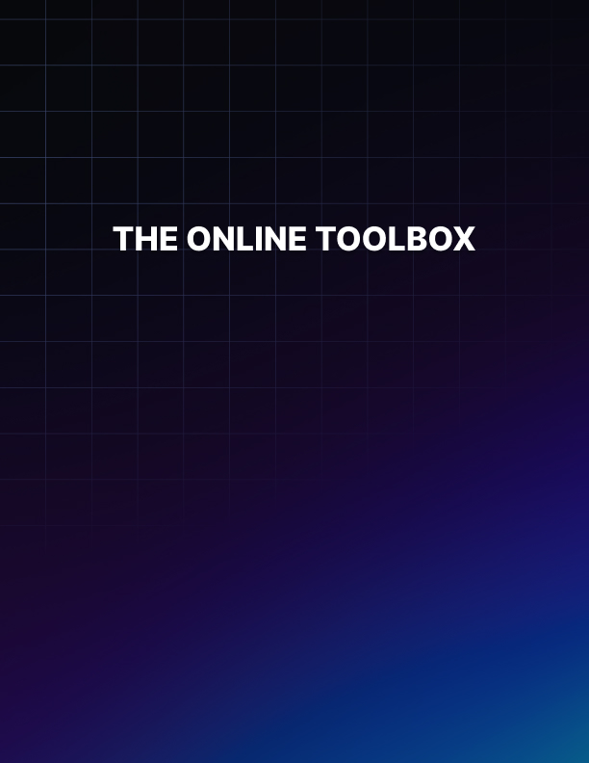

THE ONLINE TOOLBOX

In the interests of this short report, we're going to start listing the tools, evaluating them on our criteria, and giving you a link where you can go to access or buy them. We may not be able to put up your favorite tools, but it's a good start for anyone who is thinking about seriously competing online with other online vendors.

WEBCEO
This is a great all-around tool for webmasters and people who market online. It helps you to find keywords, see what your competitors are doing, and more importantly for this category, it helps you to automatically submit your pages to multiple search engines.

TOOL CATEGORY: TRAFFIC

Features:

- Easy To Use: There is some learning that you have to do with the interface. And it's not highly intuitive, but easy enough to learn. It's not a simple point-and-click tool. It's very feature rich, and well worth spending time learning it.

- Solves A Customer's Problem: It helps to grab traffic from specific demographics by helping you generate keywords that will attract that traffic.

- Consistent Performance: Very solid performance.

- Simple Registration: Email signup.

- Manages Multiple Users Efficiently: Not Applicable.

- Great Customer Support: They do have customer support that you can count on.

- Creates Excitement/Interest: This tool is more for the background, and can generate interest through keywords, but it won't be obvious to the customers. It will be obvious to you when your traffic surges in the right demographics.

Cost
There is a free and a paid version. Download the free version and give it a go. Make use of the web page submission service to help you get better search engine ranking and exposure. This will increase traffic. Then, see if you want to plunk some money down for the paid version.

Metrics
Comparison to your competitors stats and keywords is also available, making it easy to measure metrics to see how the tool is working for you.

Download at http://www.webceo.com

AWEBER
This is an online service that starts at $19.99/month, but comes with multiple tools to free up your time and help you market yourself better. It can help you generate and manage contacts and then go on to market them further with tools ranging from autoresponders to newsletters.

TOOL CATEGORY: CONTACT MANAGEMENT

Features:

- Easy To Use: Since it's a service, the people you hire do most of the work for you. They will walk you through things you need to do to optimize your direct email campaigns too.

- Solves A Customer's Problem: It solves the problem of communication between you and the customer, without taking an inordinate amount of time out of your day.

- Consistent Performance: It is highly rated by Internet marketers.

- Simple Registration: Yes.

- Manages Multiple Users Efficiently: It excels at managing multiple subscribers, readers, fans, contacts, etc. They do charge more for managing more people, but that's what they do best.

- Great Customer Support: You are a valued client and thus they do try to keep you happy.

- Creates Excitement/Interest: A good newsletter, sales promotion, email campaign with good attractive templates, all create excitement and interest from the people who want to stay in contact with you.

Cost
First 500 subscribers that they manage is $19.99. After that, the service charges more.

Metrics
The service comes with testing tools and reports that help you see what's working in your campaigns and what isn't. With metrics like this, it can really help you fine tune your campaigns to get the most sales out of them.

Download at http://www.aweber.com

OPENOFFICE
This is a desktop publishing suite that is free to download. If you don't want to pay for Microsoft Office and you don't do much other than create content for online websites, then OpenOffice takes up less room on your personal computer, and it has enough features to make it sufficient for most Internet Marketers.

TOOL CATEGORY: INCOME

Features:

- Easy To Use: Installing OpenOffice takes less time than Microsoft Office. It is very easy to use if you know how to use Microsoft Office too, as it has many of the same features.

- Solves A Customer's Problem: It has a built-in PDF converter so that you can generate ebooks and reports easily, without having to save the file first, download a converter, and then convert the file. There is an option to save as a PDF file instead.

- Consistent Performance: Very stable and gives consistent performance. However, some functions aren't as elegant as those within Microsoft Office.

- Simple Registration: You don't have to register if you don't want to.

- Manages Multiple Users Efficiently: Even if some of you use OpenOffice and others use Microsoft Office or some other product, there are multiple ways to save in various formats, so you can still share files.

- Great Customer Support: Not a whole lot of technical support available as it is an Open Source product.

- Creates Excitement/Interest: It's not a flashy product and isn't meant to create magazine style documents. For higher level desktop publishing you would have to buy a commercial product.

Cost
Free, and that's why it's very appealing. No more upgrades, no more license fees. If you have several people on your team, you can save quite a bit of money using OpenOffice.

Metrics
It does come with a free spreadsheet, database, presentation, and drawing functionality. If you want to create metric spreadsheets for other things you can, but there's nothing inherently that measures the metric of saving money with this product, other than the difference you pay with MS Office and OpenOffice.

Download at http://www.openoffice.org

TWITTER (X)
This social networking site can be used as a tool to promote your websites, offerings, and yourself. It is a micro-blogging site that allows you to send out “tweets” of 140 character bytes that tell people about what you are doing and what your interests are online. People sign up to follow you and they can end up “retweeting” your tweets, making it viral.

You can even tweet from your mobile phone. The more followers you get, the more likely that you'll end up getting loads of traffic and generate interest and excitement for your activities online.

TOOL CATEGORY: PROMOTION

Features:

- Easy To Use: Extremely easy to use since you just provide an online username and password and start sending out status updates.

- Solves A Customer's Problem: Nanosecond blogging can get you hooked up in minutes, without having to read an entire blog post to find interesting news and links.

- Consistent Performance: Performance has been so consistent that it has climbed up to the number three spot of social networking sites.

- Simple Registration: Email verification.

- Manages Multiple Users Efficiently: You can generate enormous interest with your tweets and get followers very fast. However, managing those users is not that easy! It can be hard to really get to know each user and interact with them. But, the next tool we discuss will help with that.

- Great Customer Support: Good customer service.

- Creates Excitement/Interest: This is the strength of Twitter. Since it's very easy to get followers, you can start to generate a very large network, very quickly, reaching all areas of the Internet.

Cost
Free signup for individuals, but they are implementing a cost model for businesses.

Metrics
It's easy to figure out how popular you are by the number of followers you've attracted. Whether that actually gets you traffic to your sites and offers depends entirely on how diligent you are at tweeting new activities on Twitter. And, it's not that easy to measure what the impact is, but Internet marketers are convinced it has a huge impact.

Sign up at http://www.twitter.com.

SOCIALOOMPH
Who has time to sit and tweet all day? And, yet, that's the way you maintain interest on twitter and get followers. And, who wants to send replies to followers who sign up, especially if you're not on all day? It seems impossible until you find out about Socialoomph. This tool helps you organize your Twitter accounts so that you can automate tweets to go up several times a day. It will also let you automate replies for people who follow you and automatically follow them too, as a courtesy. This way, you don't have to be stuck to your pc to use the power of Twitter all day.

TOOL CATEGORY: PROMOTION

Features:

- Easy To Use: This online service is very easy to use. It comes with an instructional video that shows you the two parts to getting started: setting up your account and then automating it.

- Solves A Customer's Problem: Keeps you in front of the customer, other Twitter users, even when you're not around.

- Consistent Performance: It goes down at times, but nothing too dramatic so far.

- Simple Registration: Easy to register, just need a Twitter account.

- Manages Multiple Users Efficiently: This is the strength of this tool. It lets you manage tons of followers who may sign up, adding a personal touch even when you're not online.

- Great Customer Support: Good customer service.

- Creates Excitement/Interest: If you use this right, it can create great excitement. There are numerous ways you could use Socialoomph to keep people glued to your feed.

Cost
Free.

Metrics
Under automation, it keeps track of the number of followers and replies sent out to followers since you last checked.

Sign up at http://socialoomph.com

GOOGLE KEYWORD TOOL
This tool lets you research keywords to help you develop niches, pay-per-click campaigns, and online strategies to get better traffic. You can see search volume, the average CPC payout, and competition for different keywords. It will suggest other keywords too, as synonyms, by checking that box, helping you to brainstorm potential profitable niches and keywords.

TOOL CATEGORY: INCOME

Features:

- Easy To Use: Very easy to use. You just load a keyword or phrase and hit the button to return a list.

- Solves A Customer's Problem: You have some actual values of how that keyword phrase is performing online.

- Consistent Performance: Extremely consistent tool.

- Simple Registration: No registration necessary.

- Manages Multiple Users Efficiently: N/A

- Great Customer Support: Not really necessary since it's been used consistently for quite some time with no problems.

- Creates Excitement/Interest: Can create interest from targeted streams of traffic if used correctly.

Cost
Free.

Metrics
Gives you detailed metrics on how keywords or potential niches might perform based on past performance and the level of competition in the marketplace. It's one tool that all Internet marketers should get to know in depth.

Check out Google Adwords Keyword Tool here:
https://adwords.google.com/select/KeywordToolExternal

