TABLE OF CONTENTS
____
INTRODUCTION 5
THE POWER OF A MINIMUM VIABLE PRODUCT 9
The Foundation of MVP Development 9
Building and Measuring Success 11
Implementing Effective Measurement Systems 11
Strategic Implementation and Iteration 12
BUZZ BEFORE THE STORM 15
The Foundation of Community Building 15
Strategic Platform Selection and Content Creation 16
Building Authentic Connections and Scaling Growth 17
TRANSPARENCY WINS 21
The Foundation of Public Building 21
Strategic Platform Selection and Content Creation 22
Building Engagement Through Authentic Storytelling 23
Managing Information and Community Engagement 24
FROM CRITIQUE TO CATALYST 27
Building Your Feedback Foundation 27
Real-Time Insights and Analytics 28
From Insight to Implementation 29
OFFERING PRE-LAUNCH ACCESS 33
Building Your Elite Testing Community 33
Structuring an Effective Program 34
Managing Communication and Expectations 35
INFLUENCE WITH STRATEGY 38
Finding Your Perfect Match 39
Cultivating Authentic Partnerships 40
Maximizing Campaign Impact 41
AUTHORITY THROUGH EDUCATION 44
Building Your Educational Foundation 45
Creating High-Impact Educational Materials 46
Maximizing Distribution and Impact 47
DEFINE, MEASURE, ACHIEVE 50
Strategic Goal Setting for Product Success 50
Performance Indicators and Measurement Systems 51
Data-Driven Optimization and Strategic Evolution 52
DELIVERING EXCEPTIONAL CUSTOMER EXPERIENCE 56
The Evolution of Modern Customer Support 56
Building Robust Support Infrastructure 57
Empowering Support Teams 58
STAY AHEAD OF THE CURVE 62
Strategic Intelligence Gathering 62
Digital Footprint Analysis and Response 63
Building Sustainable Competitive Advantages 64
RECAP AND ENCOURAGEMENT 68
Strategic Integration for Launch Success 68
Building Sustainable Growth Engines 69
Mastering Post-Launch Momentum 70

DISCLAIMER
____
The information provided in this ebook is intended solely for educational and informational purposes. The author does not accept any responsibility for the outcomes that may arise from the application of the material within. While efforts have been made to ensure the accuracy and relevance of the content, the author cannot be held accountable for any errors or omissions, or for any consequences resulting from the use or misuse of the information provided. The responsibility for any actions taken based on the information in this ebook lies solely with the reader.


INTRODUCTION
____
Picture this: you have an incredible online product idea that keeps you up at night. Your mind races with possibilities, imagining the impact it could have on people's lives. But launching it successfully feels like solving a complex puzzle with missing pieces. You’re not alone.
In 2023, over 65% of product launches failed to meet their targets, not because the products were bad, but because their creators missed crucial steps in the launch process.

Let’s change that. This isn’t just another business book full of ideas you never use. It’s a practical guide with proven strategies that have helped thousands of entrepreneurs turn their product ideas into successful online businesses. From tech startups that scaled to million-dollar valuations in their first year to solo entrepreneurs building sustainable six-figure businesses from their living rooms, these strategies have proven their value.
Most resources tell you what to do. We will show you how to do it. Through real-world examples, like Sarah Chen's journey from a simple prototype to a $2.5 million product launch in eight months, you’ll see these strategies in action. You’ll learn how Tyler Martinez built a pre-launch community that secured 10,000 paying customers before going live, and how Amy Rodriguez used strategic influencer partnerships to reach 1.5 million potential customers with a marketing budget under $5,000.
You’ll uncover how to validate your idea without overspending, build a loyal following eager for your launch, and create marketing momentum that makes your product a must-have solution. We’ll cover techniques for gathering and implementing user feedback, crafting compelling messages, and turning first-time buyers into loyal advocates.
Think of this book as your personal launch advisor, available 24/7. Every strategy is free of jargon and ready for immediate implementation. Whether you’re launching an online course, a revolutionary app, or a groundbreaking SaaS platform, these principles adapt to your needs. By the end, you’ll have a clear roadmap to take your product from concept to successful launch, complete with checkpoints to keep you on track.
And this isn’t just about launching a product. It’s about launching it the right way. You’ll learn to build scalable systems, foster lasting connections, and develop marketing strategies that drive sales long after launch day. This is about creating a foundation for lasting success in the online marketplace.
Are you ready to transform your product launch from overwhelming to strategic? Let’s start this journey together and turn your vision into a reality that surpasses your boldest expectations.
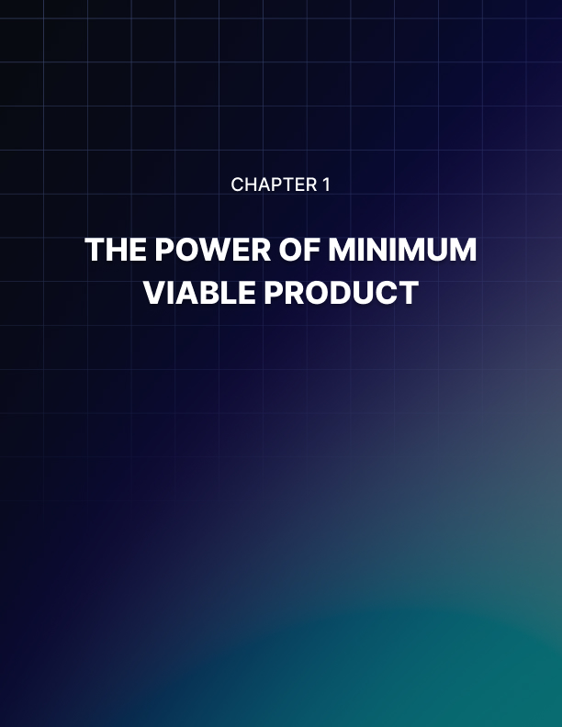

THE POWER OF A MINIMUM VIABLE PRODUCT
____
Your race to build the perfect product can blind you to a fundamental truth: Your vision might not match what customers actually need.
This is where a Minimum Viable Product (MVP) becomes your greatest asset. Launching a simplified version of your product helps you determine whether your idea resonates with your target market before investing excessive time and resources.

The Foundation of MVP Development
An MVP serves as your product's skeleton, containing only the essential features needed to solve your customers' core problems. Rather than building a Ferrari when a bicycle might suffice, you create something functional that allows you to test your main assumptions about the market.
LinkedIn's first MVP in 2003 exemplifies this approach, offering just profile creation and connections - nothing more. They didn't launch with messaging, job boards, or company pages. This focused approach helped them validate their core concept: “Professionals wanted a dedicated platform to showcase their expertise and connect with others”. The success of this streamlined approach demonstrates the power of starting with the basics and expanding based on user feedback and market demands.
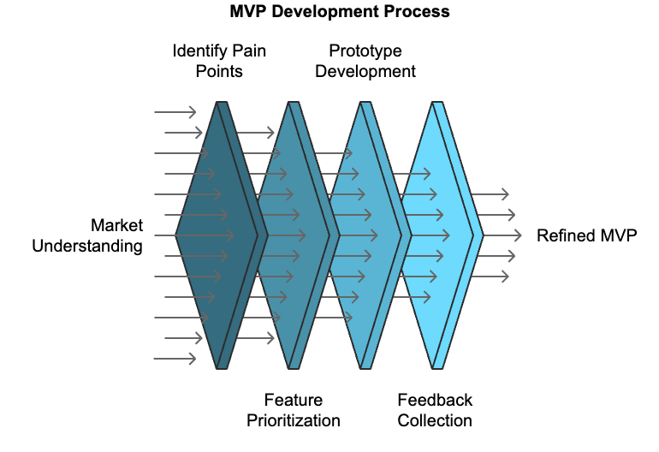
Creating an effective MVP requires careful consideration of your product's essential elements. To identify which features belong in your MVP, you must deeply understand your target market's primary pain points and the minimum functionality required to address them. This process involves extensive market research, competitor analysis, and honest assessment of what constitutes a truly essential feature versus what might be considered a "nice-to-have" addition for future iterations. The goal is to find the perfect balance between functionality and simplicity, ensuring your product provides value while remaining lean enough to launch quickly and gather meaningful feedback.

Building and Measuring Success
The Build-Measure-Learn cycle forms the cornerstone of successful MVP implementation. This iterative process begins with creating the simplest version of your product that can still deliver value to users. Buffer's remarkable story illustrates this perfectly: They started with just a two-page website describing their product and showing pricing options, without having built anything yet. This bold approach helped them validate market interest before investing in development. The measurement phase involves collecting detailed user behavior data and feedback through various channels, while the learning phase focuses on analyzing this information to make informed decisions about future development directions.
MVP Development Phase | Key Activities | Expected Outcomes
Build | Create core features, Establish basic functionality, Set up user interface | Working prototype ready for testing
Measure | Track user behavior, Collect feedback, Monitor key metrics | Quantitative and qualitative data
Learn | Analyze data, Identify patterns, Make informed decisions | Strategic insights for iteration

Implementing Effective Measurement Systems
Success in MVP development relies heavily on your ability to gather and interpret user data effectively. A robust measurement system combines multiple data collection methods to provide a complete view of user behavior and satisfaction. The implementation of these systems should focus on capturing both quantitative metrics and qualitative feedback to inform future development decisions.
Today's digital analytics tools offer unprecedented insight into user behavior. Google Analytics 4 provides essential data about user interactions, while specialized tools can track specific events and user flows through your product. Combining these technical measurements with direct user feedback through surveys, interviews, and support tickets creates a complete picture of your MVP's performance. Important metrics to monitor include user activation rate, core feature usage, time spent on key functions, return visitor rate, and customer satisfaction scores. This thorough approach to measurement ensures you're making decisions based on real user behavior rather than assumptions.

Strategic Implementation and Iteration
The path from MVP to successful product requires careful strategic planning and execution. Your launch strategy should align with your measurement capabilities and resource constraints. Consider implementing a phased approach, starting with a soft launch to a controlled group of users. This method allows you to identify and address major issues before expanding to a wider audience. Facebook's strategic growth from Harvard to other colleges before going global exemplifies this approach's effectiveness.
Effective iteration based on MVP results requires a balanced approach to prioritizing improvements. Quick wins, such as fixing obvious usability issues or implementing frequently requested small features, should be balanced with major iterations that involve significant feature additions or even pivot points. Instagram's evolution from Burbn to a focused photo-sharing platform demonstrates the importance of being willing to make major changes based on user behavior data. Maintaining detailed documentation of user feedback, experimental results, and feature requests is essential for informing future development decisions.
Feature Priority Level | Characteristics | Implementation Timing
Must-have | Core functionality, Essential for problem-solving | Immediate (MVP)
Nice-to-have | Enhancement features, Improved user experience | Post-MVP validation
Future considerations | Advanced features, Market expansion capabilities | Long-term roadmap



BUZZ BEFORE THE STORM
____
Building excitement before your product launch creates momentum that propels your success. Like a snowball rolling downhill, a well-cultivated pre-launch community grows exponentially, creating an unstoppable force of engaged supporters eager to see your product succeed.

The Foundation of Community Building
The pre-launch community serves as the bedrock of your product's initial success. Before diving into tactics, you need to establish clear community guidelines and values that align with your product's mission.
Community engagement starts with understanding your audience and creating an environment where they can thrive. Tesla masterfully executed this approach before launching the Model 3, creating a community of passionate advocates who placed 325,000 reservations within the first week of announcement. Their success wasn't accidental, it stemmed from cultivating a dedicated community that shared their vision for sustainable transportation.Building a strong foundation involves selecting the right platforms, crafting a compelling value proposition, establishing clear engagement rules, developing a robust content strategy, and creating effective feedback channels. These elements work together to create a sustainable ecosystem where your community can flourish and grow organically, supporting your product's journey from pre-launch through to market success.

Strategic Platform Selection and Content Creation
Your community needs the right home to thrive, and choosing the appropriate platform is crucial for success. The online environment offers various options, each with unique advantages for different audience types and engagement styles.
Platform | Engagement Rate | Best Content Type | Community Features
Discord | 32% | Real-time discussions | Voice channels, roles
LinkedIn | 2.2% | Professional content | Groups, articles
Instagram | 4.7% | Visual storytelling | Stories, Reels
Twitter | 1.6% | Quick updates | Spaces, Communities

Content strategy forms the backbone of community engagement, requiring a mix of behind-the-scenes updates, educational content, and interactive elements. Companies that publish content consistently see 67% more leads than those who don't, according to HubSpot's 2024 Content Marketing Report. The most successful pre-launch communities maintain a balance between providing value through educational content and building excitement through exclusive previews and updates. This approach keeps members engaged while establishing your brand as an authority in your space.

Building Authentic Connections and Scaling Growth
The true power of a pre-launch community lies in its ability to foster genuine connections between members and your brand. Creating authentic relationships within your community transforms casual observers into loyal advocates for your product. This transformation occurs through consistent personal outreach, meaningful recognition programs, and collaborative decision-making processes that make community members feel valued and heard. The most successful brands understand that community building is a two-way street, requiring both giving and receiving feedback, support, and engagement.
User-generated content (UGC) becomes a powerful tool in your community-building arsenal. According to recent studies, 79% of people say UGC highly impacts their purchasing decisions. Encouraging and leveraging member-created content through challenges, reward systems, and dedicated platforms creates a self-sustaining ecosystem of engagement and promotion. Success comes from making content creation accessible and rewarding for community members while upholding quality standards that align with your brand values.
As your community grows, the challenge shifts from building engagement to managing scale effectively. Implementing robust moderation frameworks, tracking engagement metrics, and creating specialized experiences for different member segments becomes crucial. Successful communities often develop tiered engagement programs that provide increasing levels of access and benefits based on member participation and contribution levels. This approach maintains exclusivity while providing clear pathways for deeper engagement.
Growth Stage | Focus Areas | Key Metrics | Management Tools
Early Stage | Core engagement | Member activity | Manual outreach
Mid Growth | Content quality | Participation rate | Automation tools
Scaling | Community culture | Retention rate | Team expansion
Maturity | Value delivery | ROI metrics | Enterprise systems

Your pre-launch community becomes the foundation for sustainable product success through consistent engagement, valuable content, and authentic connections. Focusing on creating lasting relationships that extend beyond your launch date helps you build a group of dedicated supporters who champion your product even before its release. Community building is a marathon, not a sprint, and the small actions you take today lay the foundation for the strong communities of tomorrow.

The success of your pre-launch community depends on your ability to balance growth with engagement, exclusivity with accessibility, and structure with flexibility. Maintaining this balance while staying true to your core values and mission creates a powerful foundation that drives your product toward a successful launch and sustained growth.


TRANSPARENCY WINS
____
The internet has transformed how businesses launch products, creating unprecedented opportunities for authentic connection. Building in public represents a revolutionary approach where you share your entrepreneurial journey openly, fostering trust and engagement with your audience before your product hits the market.

The Foundation of Public Building
Building in public means sharing your product development journey, including victories, setbacks, and lessons learned, with your audience in real-time. This transparency creates deeper connections than traditional marketing ever could. Buffer's founder Joel Gascoigne demonstrated this power by sharing everything from revenue numbers to salary formulas, leading to remarkable growth and customer loyalty.
According to a 2024 Trust Barometer report, an overwhelming 81% of consumers indicate they need to trust a brand before making a purchase.

This profound insight underscores why transparency has become not just a nice-to-have feature but a fundamental requirement for modern business success. When entrepreneurs share their journey openly, they naturally establish this essential trust through authentic, consistent communication that resonates with their audience on a deeper level than traditional marketing approaches ever could.
Trust Factor | Impact on Business | Customer Response
Transparency | Higher engagement | Increased loyalty
Regular Updates | Community building | Active participation
Authentic Communication | Brand credibility | Word-of-mouth growth
Open Feedback | Product improvement | Customer satisfaction

Strategic Platform Selection and Content Creation
The choice of platforms for building in public should align with your target audience's preferences and behaviors. Content strategy must balance transparency with value, creating a meaningful narrative that engages and informs. Your development updates should focus on meaningful progress, sharing not just what you've accomplished but the reasoning and learning behind each decision. This approach transforms routine updates into valuable learning opportunities for your audience.
Business metrics transparency requires careful consideration. While sharing success metrics can build credibility, it's essential to provide context and learning opportunities rather than just broadcasting numbers. Learning moments become particularly powerful when shared authentically, demonstrating both successes and failures with equal openness and reflection.
Platform | Best For | Content Type | Engagement Style
Twitter | Quick updates | Short-form, threads | Real-time interaction
LinkedIn | Professional insights | Long-form articles | Industry networking
Instagram | Visual progress | Stories, Reels | Behind-the-scenes
YouTube | In-depth content | Video tutorials | Detailed explanations

Building Engagement Through Authentic Storytelling
The art of storytelling plays a crucial role in building in public effectively. Your journey should be presented as a compelling narrative that audiences can connect with emotionally and intellectually. This involves sharing your product's vision, documenting daily progress, celebrating small wins, and most importantly, including your audience in the story as active participants rather than passive observers. The most successful builders in public create a sense of shared ownership and investment in their project's success.
Marketing research shows that stories are 22 times more memorable than facts alone. When building in public, every update becomes an opportunity to reinforce your narrative and strengthen community bonds. Maintaining consistency while ensuring each piece of content adds value to your overall story is essential. This means carefully balancing technical updates with personal insights, business metrics with behind-the-scenes glimpses, and professional achievements with honest reflections on challenges and setbacks.

Managing Information and Community Engagement
While transparency is fundamental to building in public, it's crucial to establish clear boundaries around sensitive information. Create robust guidelines for what information to share publicly while protecting proprietary data and personal privacy. Successful builders in public maintain this balance by focusing on sharing insights and learnings rather than raw data or sensitive details.
Information Type | Sharing Approach | Examples
Product Development | Regular updates | Feature progress, design iterations
Business Metrics | Contextual sharing | Growth trends, key milestones
Team Culture | Authentic glimpses | Work processes, values in action
Customer Stories | Anonymous insights | Use cases, success stories

The practice of building in public extends beyond mere transparency to create a dynamic ecosystem of engagement and growth. Carefully balancing openness with strategic content creation, maintaining consistent communication while respecting boundaries, and fostering genuine community involvement enables entrepreneurs to build more than just products. They create movements that resonate with their audience on a deeper level. Success comes from not just sharing information but crafting a narrative that invites participation, encourages feedback, and builds lasting relationships with your community.
Remember that building in public is a marathon, not a sprint. Success comes from maintaining consistency while adapting to feedback and evolving your approach based on what resonates with your audience. Stay focused on providing value through your transparency, and let authentic connection guide your sharing strategy.



FROM CRITIQUE TO CATALYST
____
Valuable customer insights can transform your product from good to extraordinary. Setting up effective feedback loops isn't just about collecting opinions. It's about creating a systematic approach to gather, analyze, and implement user insights that drive meaningful improvements.

Building Your Feedback Foundation
The foundation of successful product development lies in establishing organized feedback collection methods. Think of feedback loops as your product's nervous system. They help you sense, react, and adapt to your users' needs. According to McKinsey's 2024 Product Development Report, companies that implement structured feedback systems see a 43% higher success rate in product launches compared to those that don't. The process requires careful consideration of multiple channels and their effectiveness in gathering meaningful insights.
Feedback Channel | Best Used For | Response Rate | Implementation Difficulty
In-app surveys | Quick user reactions | 15-25% | Low
Email feedback forms | Detailed responses | 5-10% | Medium
User interviews | Deep insights | 80-90% | High
Social media monitoring | Real-time feedback | Varies | Medium
Customer support tickets | Issue identification | 100% | Low

Creating effective feedback loops involves integrating multiple touchpoints throughout the user journey. Modern products demand a sophisticated approach to data collection, combining both quantitative metrics and qualitative insights. The most successful companies in the market have demonstrated that a multi-channel approach yields the most complete understanding of user needs and preferences. This complex approach ensures that no valuable insight goes unnoticed, whether it comes from direct user interaction, social media sentiment, or support ticket patterns.

Real-Time Insights and Analytics
The ability to gather and respond to feedback in real-time has become crucial for product success in the modern digital world. Live feedback channels have emerged as essential tools for maintaining strong user relationships and quickly addressing concerns. According to HubSpot's 2024 Customer Experience Report, 73% of customers expect companies to understand their needs and expectations in real-time. This makes implementing immediate feedback mechanisms not just beneficial but necessary for staying competitive in the market.
The integration of analytics with feedback systems creates a powerful combination for understanding user behavior and satisfaction. Modern analytics platforms can help correlate feedback with actual user behavior, providing deeper insights into the validity of user suggestions and the impact of implemented changes.
Analytics Type | Key Metrics | Integration Level | Action Items
Behavioral | User flows, Time on task | High | Feature optimization
Sentiment | Satisfaction scores, Comments | Medium | Experience improvement
Performance | Error rates, Load times | High | Technical enhancement
Engagement | Active users, Return rate | Medium | Content strategy

From Insight to Implementation
The true value of feedback lies not in its collection but in its implementation. Creating a systematic approach to prioritize and implement feedback requires careful consideration of multiple factors, including resource allocation, impact assessment, and implementation timeline.
The RICE Scoring System has emerged as a powerful framework for evaluating and prioritizing feedback-driven improvements. This system helps teams make informed decisions about which improvements to tackle first, ensuring that resources are allocated effectively and that the most impactful changes receive appropriate attention.
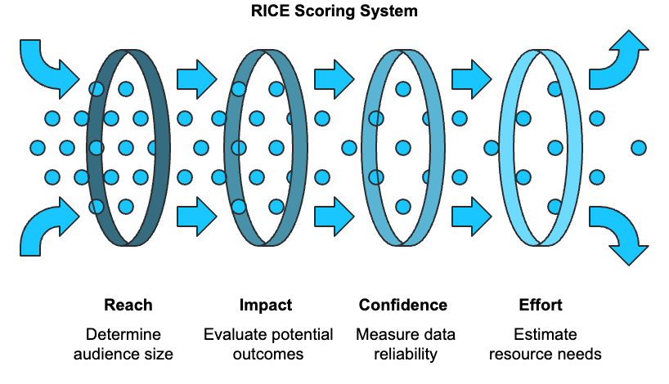
Managing negative feedback presents unique challenges but also valuable opportunities for improvement. According to Gartner's 2024 Customer Experience Report, companies that effectively address negative feedback see a 41% increase in customer retention rates. Handling negative feedback effectively requires a structured approach that emphasizes quick acknowledgment, thorough analysis, and transparent communication about solutions and timelines.
The process of implementing feedback must be transparent and communicative. Successful companies like Notion excel at this by regularly publishing "What's New" updates that directly reference user feedback, creating a strong connection between user input and product improvements. This approach not only validates the importance of user feedback but also encourages continued engagement with the feedback process.
The implementation phase requires careful balance between quick wins and long-term strategic improvements. While some feedback can be addressed immediately through simple fixes or feature adjustments, other suggestions might require more substantial development work or strategic consideration. Maintaining clear communication about implementation timelines and progress ensures users understand that their feedback is valued and being acted upon, even if changes take time to implement.
Feedback implementation is not a one-time event but an ongoing process of improvement and refinement.Each implementation cycle should include thorough testing, user validation, and performance monitoring to ensure that the changes truly address the original feedback and create positive impact for users. This iterative approach helps build a stronger product while maintaining strong user engagement and satisfaction.
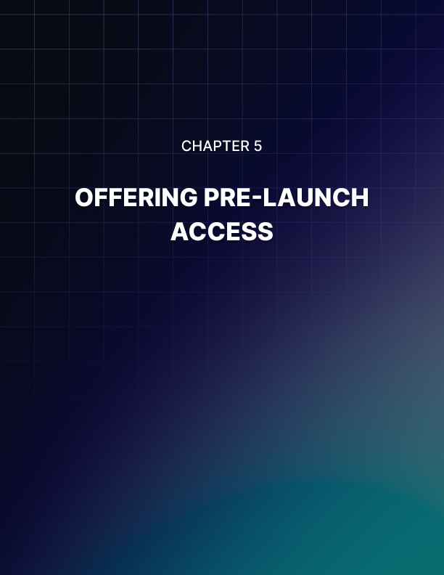

OFFERING PRE-LAUNCH ACCESS
____
Your most valuable asset before launch isn't your product's features. It's the select group of users who'll shape your product's future. Pre-launch access creates an exclusive environment where dedicated users become your product's first champions and most honest critics.

Building Your Elite Testing Community
The journey to a successful product launch begins with assembling the right testing team. Think of these early users as your product's special forces, a carefully chosen group with specific skills and perspectives that can transform your offering. Recent studies show that products with structured beta testing programs see a remarkable 67% higher success rate at launch compared to those without such programs. The selection process demands careful consideration of multiple factors, from technical expertise to industry knowledge, ensuring a balanced and productive testing group.
Consider Airbnb's early success story: Their strategic selection of initial users in New York City, primarily photographers and design enthusiasts, provided both quality listings and invaluable feedback about the platform's visual elements. This careful curation of early users laid the foundation for their explosive growth and market dominance.
Tester Category | Primary Value | Key Requirements | Engagement Level Expected
Power Users | Deep feature insights | Strong domain expertise | High participation
Industry Veterans | Strategic direction | Proven track record | Regular consultation
Target Audience | Usage patterns | Demographic alignment | Consistent feedback
Tech Specialists | Bug identification | Technical background | Detailed reporting

Structuring an Effective Program
A well-organized pre-launch access program requires clear structure and guidelines to maximize its effectiveness. The program should balance exclusive access with clear expectations and responsibilities for participants. Modern successful pre-launch programs incorporate multiple components working in harmony to create a complete testing environment. The onboarding process must include detailed welcome documentation, clear guidelines, and proper security protocols. Feedback mechanisms need to be diverse yet structured, incorporating everything from formal surveys to casual discussion forums. Recent data indicates that structured programs show 3.5 times more effective feedback collection compared to unstructured approaches.
The key to maintaining momentum lies in creating engaging activities that keep testers invested in the process. Weekly challenges provide focused testing objectives, while group discussions foster community building and idea sharing. One-on-one sessions offer deeper insights into individual user experiences, and progress tracking dashboards help maintain motivation through visible achievements. This combination of structure and engagement creates a dynamic testing environment that produces actionable results.

Managing Communication and Expectations
Clear communication forms the backbone of successful pre-launch testing. Your testers need to understand both their role and the product's current limitations. Consider how Stripe mastered this during their pre-launch phase: They provided detailed documentation and regular updates to their beta testers, resulting in highly focused and actionable feedback. Maintaining consistent communication across multiple channels while adapting the message and frequency to different tester groups is essential.
Communication Channel | Update Frequency | Primary Purpose | Target Audience
Email Newsletter | Weekly | Progress updates | All testers
Technical Briefings | Bi-weekly | Feature deep dives | Technical users
Community Forum | Daily | Ongoing discussion | Active participants
Direct Messages | As needed | Critical updates | Key stakeholders

The success of your pre-launch testing program ultimately depends on the quality of feedback received and the relationships built with your testers. These early users become more than testers. They transform into product champions who drive your initial market success. Implementing a structured approach to pre-launch access, maintaining clear communication channels, and fostering strong relationships with your testing community creates a better product and builds a foundation for sustainable growth and market success. Prioritize quality over quantity, clarity over complexity, and relationship building over quick results. Your pre-launch period is not just a testing phase; it is the start of your product's community and the cornerstone of its future success.
These early adopters often become your most valuable long-term customers and advocates. Companies that successfully nurture these relationships during the pre-launch phase see significantly higher user retention rates and more organic growth through word-of-mouth marketing. Treating your pre-launch testers not just as users, but as partners in your product's development journey, is essential.
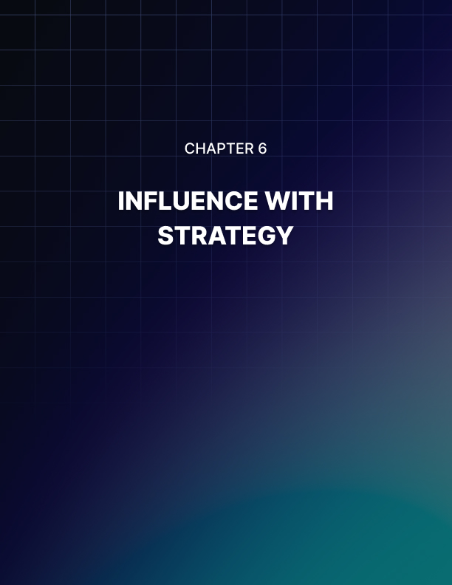

INFLUENCE WITH STRATEGY
____
Social proof powers purchase decisions more than ever before. Partnering with the right influencers can accelerate your product's market entry and establish immediate credibility. However, success requires more than just finding someone with a large following. It demands strategic alignment and authentic collaboration.
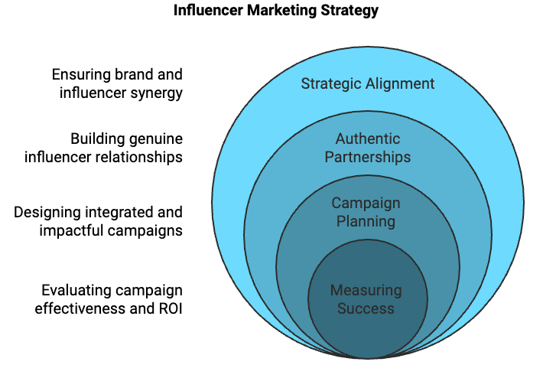

Finding Your Perfect Match
The art of influencer selection goes far beyond surface metrics and follower counts. Recent data from the 2024 Influencer Marketing Hub report reveals that 61% of consumers trust influencer recommendations, but only when they perceive the partnership as genuine and relevant. Success in influencer partnerships emerges from understanding that true influence isn't measured in followers alone, but in the depth of connection between creator and audience.
Take Gymshark's approach: They built their billion-dollar brand by partnering with fitness influencers who genuinely used and loved their products, resulting in authentic promotions that resonated with their target audience.
Alignment Factor | Key Considerations | Impact on Success
Values | Brand principles match | High authenticity
Audience | Demographic overlap | Better conversion
Content Style | Natural product fit | Seamless integration
Engagement Quality | Active community | Stronger results
Past Collaborations | Track record | Reliability indicator

Cultivating Authentic Partnerships
The foundation of successful influencer marketing lies in building genuine relationships that transcend traditional advertising. According to the 2024 Creator Economy Report, 73% of consumers can detect inauthentic endorsements, making authentic partnerships crucial for success. Creating meaningful collaborations requires a deep understanding of both the influencer's creative vision and your brand's objectives. The most successful partnerships develop organically, starting with genuine appreciation and engagement before any business propositions are made.
Modern influencer marketing demands a shift from transactional relationships to strategic partnerships where both parties contribute to content creation and campaign direction. This collaborative approach not only produces more authentic content but also leads to higher engagement rates and better conversion metrics. Finding the balance between maintaining brand guidelines and allowing creative freedom ensures that content stays genuine while meeting marketing objectives.
Partnership Element | Strategic Approach | Expected Outcome
Initial Connection | Organic engagement | Trust building
Creative Freedom | Balanced guidelines | Authentic content
Long-term Vision | Multi-campaign planning | Sustained growth
Value Exchange | Mutual benefits | Lasting partnership

Maximizing Campaign Impact
The success of influencer campaigns hinges on careful planning, execution, and measurement. Effective campaigns combine multiple content formats and platforms to create complete coverage that connects with diverse audience segments. This integrated approach ensures maximum impact while maintaining authenticity across all touchpoints.
A well-structured campaign considers the entire customer journey, from initial awareness through to conversion and advocacy. The most successful brands understand that influencer content serves multiple purposes: it educates, entertains, and persuades, all while building brand credibility. Consider how Tesla maximizes influencer impact by providing early access to new features, allowing tech reviewers to create in-depth content that educates potential customers while generating excitement. This strategy demonstrates the power of giving influencers the tools and freedom to create content that serves both their audience's interests and the brand's objectives.
When it comes to measuring success, modern analytics tools provide detailed insights into campaign effectiveness across multiple metrics. Smart brands focus on a combination of quantitative and qualitative metrics to gauge true campaign impact. While engagement rates and conversion metrics are important, factors like sentiment analysis and brand perception changes often provide deeper insights into campaign effectiveness.
Metric Category | Key Indicators | Target Benchmarks
Engagement | Likes, Comments, Shares | 3-8% rate
Conversion | Clicks, Sales, Sign-ups | 1-5% rate
Brand Impact | Sentiment, Awareness | Positive growth
Community Growth | Followers, Subscribers | Steady increase

The most successful influencer partnerships extend beyond single campaigns to create lasting value. According to the 2024 Creator Economy Trends Report, brands that maintain long-term influencer relationships see 3.5x higher ROI compared to one-off collaborations. This underscores the importance of viewing influencer partnerships as strategic relationships rather than tactical marketing moves.
Effective influencer marketing is not about quick wins but about building lasting partnerships that benefit your brand, the influencer, and most importantly, your target audience. Stay flexible, monitor results carefully, and be ready to adjust your approach based on performance data and changing market conditions. The most successful brands view influencer partnerships as a key component of their overall marketing strategy rather than isolated campaigns.


AUTHORITY THROUGH EDUCATION
____
Knowledge drives decisions in today's market. Your expertise, shared through strategic content marketing, positions you as an industry leader while building trust with potential customers. Creating valuable educational content transforms casual observers into loyal followers who trust your product before it launches.
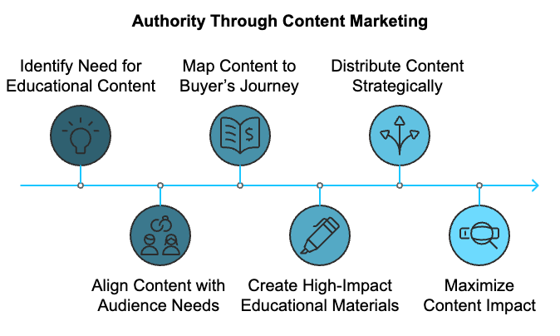

Building Your Educational Foundation
The power of knowledge-driven marketing cannot be understated in the modern world. Recent studies from HubSpot's 2024 State of Marketing Report show that 82% of consumers feel more positive about a brand after reading custom content. This remarkable statistic underscores a fundamental truth about modern marketing: educational content isn't merely about promotion—it's about establishing yourself as a trusted advisor in your field. Consider how industry giants like Canva built their empires not just through their tools, but through extensive libraries of tutorials, tips, and resources that democratized design knowledge. Your content strategy must seamlessly align with your audience's needs while showcasing your product's unique value proposition. The most successful content marketers follow the 80/20 rule: 80% educational content that helps solve problems, and 20% product-related information. This balanced approach ensures your audience receives genuine value while maintaining awareness of your solutions.
Content Type | Educational Value | Engagement Level | Resource Investment
Blog Posts | High | Medium | Medium
Video Tutorials | Very High | High | High
Podcasts | Medium | Medium-High | Medium
Webinars | Very High | High | High
Case Studies | High | Medium | Medium

Creating High-Impact Educational Materials
The development of compelling educational content requires a deep understanding of your audience's journey and pain points. According to Content Marketing Institute's 2024 report, companies that map content to specific stages of the buyer's journey achieve 73% higher conversion rates. This strategic approach ensures every piece of content serves a specific purpose in moving your audience closer to product adoption while building trust and authority in your space. Creating content that educates, engages, and inspires action is essential. This means developing materials that address real-world challenges while demonstrating your expertise and thought leadership in the field. Consider how industry leaders like HubSpot have built entire educational ecosystems around their products, creating detailed resources that serve their audience at every stage of their journey.
The most effective educational content combines practical insights with actionable steps, allowing your audience to implement solutions immediately while recognizing the value of your expertise. This approach builds credibility while demonstrating your understanding of their challenges and your ability to help them overcome obstacles. Focus on creating content that solves specific problems, answers common questions, and provides clear pathways to improvement. This might include step-by-step guides, detailed case studies, expert interviews, or detailed tutorials that showcase your deep understanding of your field.

Maximizing Distribution and Impact
Creating exceptional content is only the beginning—strategic distribution ensures your educational materials reach and resonate with your target audience. Recent data from LinkedIn's 2024 B2B Content Marketing Report reveals that successful brands utilize an average of 6 different channels to distribute their content. This multi-channel approach maximizes reach while catering to diverse audience preferences and consumption habits. Understanding where your audience seeks information and ensuring your content appears in those spaces consistently and meaningfully is crucial.
Distribution Strategy | Primary Benefits | Audience Reach | Implementation Priority
Email Marketing | Direct engagement | High | Essential
Social Media | Brand awareness | Very High | High
Industry Forums | Targeted reach | Medium | Medium
Partner Networks | Extended reach | High | Medium
Content Syndication | Broader exposure | Medium | Optional

A complete distribution strategy ensures your educational content reaches its intended audience effectively while maintaining consistent messaging across all channels. This approach should include a mix of owned, earned, and paid media channels, each serving specific purposes in your overall content strategy. Consider how different platforms can complement each other, creating a cohesive ecosystem that guides your audience through their educational journey while maintaining engagement and building lasting relationships.
Successful content distribution requires more than just posting across multiple channels. It involves understanding the unique characteristics and best practices of each platform. Tailor your content format, tone, and delivery to match the expectations of each channel's audience while maintaining your brand's core message and educational value. This thoughtful approach to distribution ensures your content not only reaches but truly resonates with your target audience, establishing your authority and driving meaningful engagement across all platforms.
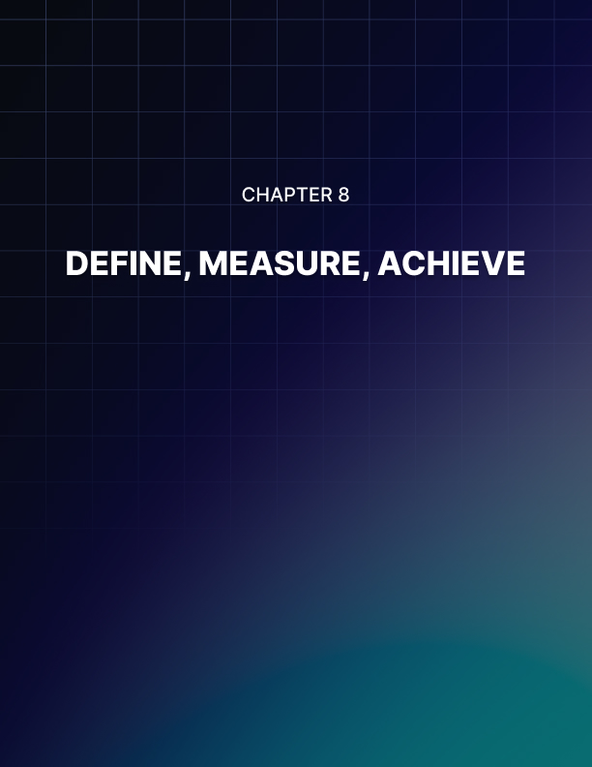

DEFINE, MEASURE, ACHIEVE
____
Measuring success without clear goals is like sailing without a compass. Your product launch demands specific, measurable objectives that guide every decision and action. Understanding which metrics truly matter separates thriving products from those that fade into obscurity.
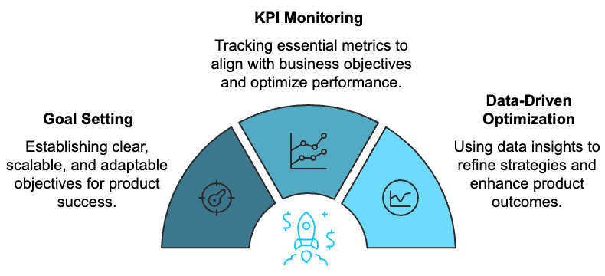

Strategic Goal Setting for Product Success
Setting meaningful goals for your product launch transcends basic target-setting. Research shows that companies with clearly defined, measurable goals are 3.2 times more likely to achieve successful launches than those with vague objectives. This dramatic difference stems from the power of clarity, when you know exactly what success looks like, you can make informed decisions that drive progress toward your goals. The modern approach extends beyond the traditional SMART framework (Specific, Measurable, Achievable, Relevant, Time-bound) to include Scalability and Adjustability, creating SMARTA goals that account for rapid market changes and growth potential. The ability to adapt and scale your objectives is just as crucial as setting them in the first place in a dynamic marketplace. Product teams must develop goals that not only guide immediate actions but also accommodate future growth and market evolution.
Goal Category | Strategic Focus | Short-term Metrics | Long-term Metrics
Growth | Market Expansion | Weekly User Growth | Market Share
Revenue | Financial Health | Monthly Revenue | Annual Profitability
Engagement | User Value | Daily Active Users | Customer Lifetime
Innovation | Product Evolution | Feature Adoption | Industry Position

Performance Indicators and Measurement Systems
The foundation of successful product launches lies in tracking the right metrics at the right time. Modern product teams must focus on a core set of Key Performance Indicators (KPIs) that directly align with business objectives while providing actionable insights for optimization. According to recent industry research, successful companies typically monitor between 7-10 core KPIs during the launch phase, striking a balance between thorough oversight and focused execution. These indicators span multiple dimensions of product success, from user acquisition and engagement to revenue generation and technical performance.
The implementation of robust tracking systems proves crucial for effective KPI monitoring. A well-structured analytics stack should incorporate tools for product analytics, user behavior tracking, performance monitoring, and customer feedback collection. This complex approach ensures no critical aspects of product performance go unmonitored while maintaining the ability to drill down into specific areas when needed. Selecting tools that effectively capture data while integrating seamlessly with existing workflows and decision-making processes is crucial.

Data-Driven Optimization and Strategic Evolution
Converting raw data into actionable insights requires a structured approach to analysis and decision-making. Companies embracing data-driven decision making consistently outperform their peers, achieving 23% higher revenue growth compared to those relying primarily on intuition. This success stems from the ability to identify and act upon clear signals within the noise of daily operations. The optimization process must follow regular cycles of review and adjustment, ensuring that both immediate issues and long-term trends receive appropriate attention and response.
Analysis Level | Review Frequency | Key Focus Areas | Action Types
Operational | Daily | Performance Metrics | Quick Fixes
Tactical | Weekly | Usage Patterns | Feature Updates
Strategic | Monthly | Market Position | Direction Shifts
Executive | Quarterly | Business Goals | Strategic Pivots

Success in product launches often comes through continuous optimization based on real-time data. Teams must establish regular review cycles that enable quick responses to emerging trends while maintaining focus on long-term strategic objectives. This balance between immediate responsiveness and strategic consistency creates a framework for sustainable growth and market success.
Understanding the relationships between different metrics provides deeper insights into product performance. Advanced analytics can reveal powerful correlations between seemingly unrelated metrics, leading to more effective optimization strategies. For instance, patterns in feature adoption might predict future revenue potential, while support ticket themes could signal upcoming retention challenges. These insights enable proactive management of product development and user experience.
The process of measurement and optimization remains ongoing throughout the product lifecycle. Regular review and adjustment of metrics ensure they remain relevant and actionable as market conditions evolve. Teams must focus on metrics that drive real business value rather than vanity metrics that might look impressive but don't correlate with success. This commitment to meaningful measurement, combined with systematic optimization processes, creates a foundation for sustainable product growth and market leadership.
Your goals and KPIs should evolve as your product matures and market conditions change. Successful goal setting and measurement rely on balancing detailed tracking with focused action. While data offers insights, success comes from taking decisive steps based on clear signals from your metrics.
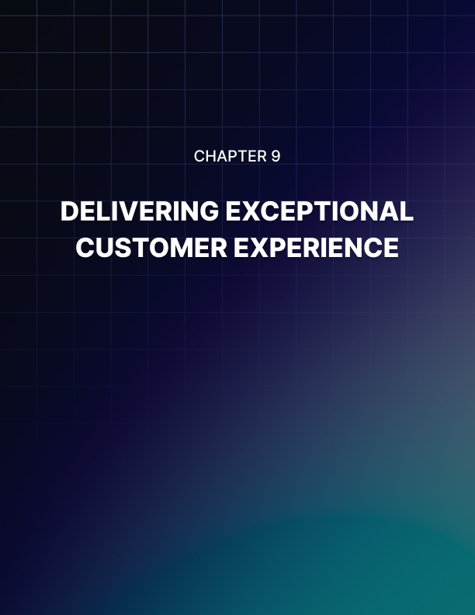

DELIVERING EXCEPTIONAL CUSTOMER EXPERIENCE
____
Success depends on more than just product features. It relies heavily on the quality of your customer experience. Exceptional support fosters brand advocates who drive growth through word-of-mouth and sustained loyalty.

The Evolution of Modern Customer Support
The landscape of customer support has undergone a dramatic transformation in recent years. According to Salesforce's 2024 State of Customer Service Report, 89% of customers expect companies to anticipate their needs before they reach out for help. This fundamental shift demands businesses to move beyond traditional reactive support models towards a more sophisticated, proactive approach.
Companies like Zappos have revolutionized customer service by implementing preemptive support strategies, resulting in an impressive 75% repeat customer rate. Their success stems from a deep understanding that modern customer experience is not about waiting for problems to arise but anticipating and addressing potential issues before they materialize.
Support Evolution Stage | Key Features | Business Impact
Traditional Support | Reactive problem-solving | Basic customer satisfaction
Modern Support | Proactive engagement | Enhanced loyalty
Future Support | AI-powered prediction | Maximum retention

Building Robust Support Infrastructure
Creating exceptional customer experiences requires a sophisticated blend of technology, processes, and human expertise. Recent studies demonstrate that companies offering omnichannel support achieve 89% higher customer retention rates compared to those with limited support options.
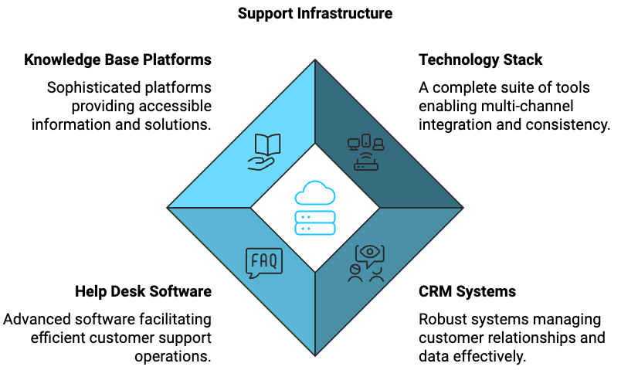
The foundation of effective support lies in implementing a complete technology stack that seamlessly integrates multiple channels while maintaining consistency across all touchpoints. This infrastructure must be built on robust Customer Relationship Management (CRM) systems, advanced help desk software, and sophisticated knowledge base platforms that work in harmony to deliver seamless customer experiences.
The implementation of modern support infrastructure represents a significant investment, but one that pays dividends through improved efficiency and customer satisfaction. Organizations must carefully evaluate their specific needs and choose solutions that align with their customer service philosophy while maintaining scalability for future growth. The key lies in selecting tools that not only solve current challenges but also adapt to evolving customer expectations and technological advancements.

Empowering Support Teams
The human element remains the cornerstone of exceptional customer experience, with McKinsey's 2024 Customer Experience Report revealing that 70% of buying experiences are based on how customers feel they're being treated. This emphasizes the critical importance of building and maintaining highly skilled, empathetic support teams. Support team empowerment goes beyond basic training, encompassing thorough development programs, clear decision-making authority, and robust career advancement opportunities. Companies like Ritz-Carlton demonstrate the power of team empowerment through their famous $2,000 discretionary spending policy, allowing employees to make immediate decisions to resolve customer issues without seeking management approval.
Training Focus Area | Impact Level | Implementation Priority
Technical Skills | High | Immediate
Emotional Intelligence | Critical | Ongoing
Problem Resolution | Essential | Continuous
Leadership Development | High | Phased

Success in modern customer support requires a delicate balance between technological efficiency and human touch. The most effective support organizations create environments where team members feel valued, supported, and equipped with the tools and authority needed to deliver exceptional customer experiences. This approach not only leads to higher customer satisfaction but also results in improved employee retention and overall operational excellence.
A deep understanding of customer needs, coupled with the right tools and empowered teams, forms the foundation of exceptional customer experience. Organizations must continuously evolve their support strategies, embracing new technologies while maintaining the human element that builds lasting customer relationships. The future of customer support lies in creating seamless, proactive experiences that anticipate and exceed customer expectations while building long-term loyalty and advocacy.
Through strategic implementation of these support elements, businesses can create sustainable competitive advantages that drive growth and market leadership. Success comes not just from resolving problems but from creating memorable experiences that turn customers into passionate brand advocates. Achieving this transformation requires ongoing commitment to excellence, continuous improvement, and a strong focus on customer needs.
Success Metric | Target Range | Action Threshold
CSAT Score | 90-95% | Below 85%
NPS Rating | 50-70 | Below 40
Resolution Time | < 24 hours | > 48 hours

Exceptional customer experience is not a destination but an ongoing journey of continuous improvement and adaptation. Organizations that excel in this area consistently invest in their people, processes, and technologies while keeping a strong focus on customer needs and expectations.


STAY AHEAD OF THE CURVE
____
Your market position depends on understanding not just your customers, but your competition. Competitive intelligence transforms market threats into opportunities for innovation and growth. Systematically tracking and analyzing competitor moves positions your product for sustained success.

Strategic Intelligence Gathering
The modern competitive landscape requires sophisticated monitoring approaches that go far beyond casual observation. According to a 2024 Harvard Business Review study, companies with structured competitor monitoring programs show 47% higher revenue growth compared to those without such systems. This striking difference highlights how critical competitive intelligence has become in driving business success. The competitive environment extends beyond direct competitors to include potential market entrants and indirect alternatives. Consider how Netflix monitors not just other streaming services but also gaming platforms, social media, and entertainment alternatives that compete for viewers' attention. This complete view helps identify emerging threats and opportunities before they become obvious to the broader market.
Competitor Category | Intelligence Focus | Key Monitoring Areas
Direct Competitors | High Priority | Product features, pricing, marketing campaigns
Indirect Competition | Medium Priority | Market overlap,  user behavior patterns
Emerging Players | Medium-High Priority | Market signals,  funding activities
Industry Partners | Medium Priority | Partnership opportunities

Digital Footprint Analysis and Response
Tracking competitors' online presence provides invaluable strategic insights in the modern online landscape. Effective competitor analysis requires a sophisticated understanding of digital strategies, market positioning, and customer perception patterns. Digital intelligence tools like SimilarWeb and SEMrush offer detailed data about traffic patterns, keyword strategies, and audience engagement metrics. Recent data shows that 76% of successful companies regularly monitor competitors' digital activities across multiple channels, using this information to shape their own market approaches and strategic decisions. Understanding how competitors evolve their products reveals valuable insights about market direction and customer needs. According to the 2024 Product Management Trends Report, companies that actively track competitor product updates are 2.3 times more likely to successfully innovate in their market.
The most effective organizations employ a structured approach to analyzing and acting on competitive insights. This process involves regular review cycles and clear decision-making frameworks that transform raw data into actionable strategies. The 2024 Market Strategy Report indicates that companies conducting quarterly position analyses achieve 31% higher market share growth than those performing annual reviews. This significant performance difference underscores the importance of regular, systematic competitive analysis in maintaining market leadership.
Analysis Component | Review Frequency | Strategic Value
Market Position | Quarterly | High
Product Features | Monthly | Critical
Pricing Strategy | Bi-monthly | High
Customer Sentiment | Weekly | Medium-High

Building Sustainable Competitive Advantages
Creating lasting market advantages requires a holistic approach that goes beyond simple monitoring. Sustainable competitive advantage emerges from the consistent application of strategic insights combined with innovative thinking and operational excellence. According to McKinsey's 2024 Competition Analysis, companies that consistently monitor and respond to competitive changes maintain market leadership positions 2.8 times longer than reactive organizations. This remarkable statistic demonstrates the crucial importance of proactive competitive strategy in maintaining long-term market success.
Successful organizations have learned to balance immediate competitive responses with long-term strategic planning. They understand that sustainable advantages come from building strong foundations in multiple areas: product innovation, customer relationships, operational excellence, and brand differentiation. Research shows that 67% of successful product launches stem from insights gained through competitive analysis, highlighting the critical role of competitive intelligence in product development and innovation strategies.
The most effective competitive monitoring programs maintain clear ethical guidelines while gathering complete market intelligence. Organizations must carefully balance the need for detailed competitor information with ethical considerations and resource constraints. This balance requires establishing clear protocols for information gathering, documentation, and sharing, ensuring that competitive intelligence activities remain both effective and appropriate.
Strategic Area | Development Priority | Success Metrics
Innovation | Critical | New feature adoption rates
Customer Relations | High | Retention metrics, NPS
Brand Value | Medium-High | Market perception scores
Operational Excellence | High | Efficiency indicators

To maintain a competitive edge in the current market, organizations must develop systematic approaches to gathering, analyzing, and acting on competitive intelligence. Success comes from balancing competitive response with innovation and customer focus, while maintaining strong ethical standards in intelligence gathering activities. Remember that competitive analysis should inform strategy rather than dictate it, serving as one of many inputs into strategic decision-making processes.
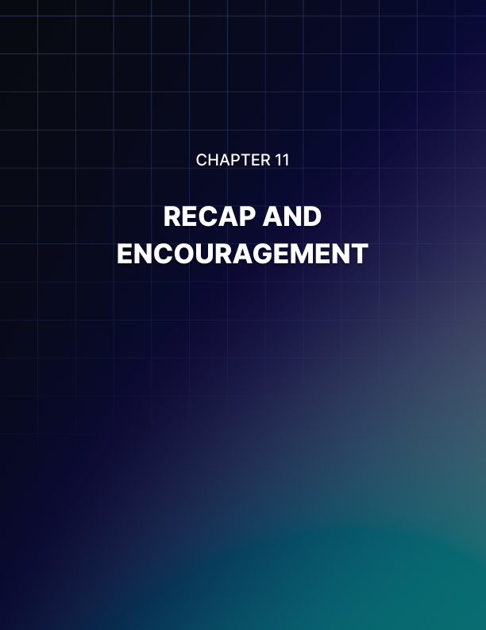

RECAP AND ENCOURAGEMENT
____
Taking your product from concept to successful launch transforms both your business and your entrepreneurial journey. Strong product launches emerge from careful planning, strategic execution, and continuous adaptation. Let's explore how the strategies we've discussed interconnect to create lasting success.

Strategic Integration for Launch Success
The path to a successful product launch requires weaving multiple strategies into a unified approach. The 2024 Product Launch Success Report reveals an extraordinary insight: companies implementing integrated launch strategies demonstrate 3.7 times higher success rates compared to those using isolated tactics. This compelling data reinforces the critical importance of viewing your launch elements as an interconnected ecosystem rather than separate components. Your Minimum Viable Product (MVP) forms the cornerstone of this ecosystem, but its effectiveness is significantly amplified by the pre-launch community you cultivate and the feedback loops you establish. The synergy between these elements creates a powerful foundation for success, with recent studies showing that products backed by strong pre-launch communities achieve 82% higher adoption rates in their first month. This remarkable difference highlights how early community building can dramatically enhance your MVP strategy's impact and create a self-reinforcing cycle of growth and improvement.
Strategy Component | Impact Metric | Success Factor
MVP Development | Feature Validation | 75% reduction in pivot needs
Community Building | User Adoption | 82% higher first-month rates
Feedback Systems | Product Improvement | 63% faster iteration cycles
Analytics Integration | Decision Making | 58% better resource allocation

Building Sustainable Growth Engines
The creation of sustainable growth requires a sophisticated approach to channel development and optimization. Modern product success stories consistently demonstrate that relying on a single growth channel severely limits potential success. Companies implementing diversified growth strategies achieve 2.8 times higher long-term success rates compared to single-channel approaches. This multiplier effect becomes particularly powerful when considering the compound impact of multiple well-executed channels working in concert. Content marketing emerges as a foundational element in this growth ecosystem, with companies producing consistent, high-quality content generating 67% more qualified leads than their competitors. However, the true power lies in the strategic combination of multiple channels, including influencer partnerships, community building, and targeted advertising, creating a comprehensive growth machine that can sustain long-term success.

Mastering Post-Launch Momentum
The critical period immediately following your launch often determines your product's long-term trajectory. Research consistently shows that 64% of successful products achieve their critical metrics within the first three months post-launch, making this period absolutely crucial for establishing momentum. Success during this phase requires an intricate balance of customer experience enhancement, community engagement, and market position strengthening. The most successful companies maintain this momentum through a carefully orchestrated combination of regular feedback collection, swift issue resolution, and proactive support initiatives, while simultaneously building their brand authority and expanding their market presence through strategic partnerships and community-driven growth initiatives.
Focus Area | Key Activities | Success Metrics
Customer Experience | Feedback loops, Support systems | NPS, Customer satisfaction
Community Growth | Events, User spotlights | Engagement rates, Active users
Market Position | Partnerships, Authority building | Market share, Brand recognition

The ability to adapt quickly often determines the difference between success and failure in the modern market.Recent studies indicate that companies with flexible launch strategies are 2.4 times more likely to achieve sustained growth compared to those with rigid plans. This adaptability becomes particularly crucial when considering the pace of technological change and shifting customer expectations. Successful companies maintain their competitive edge through continuous market analysis, regular strategy refinement, and swift decision-making processes that allow them to capitalize on emerging opportunities while mitigating potential threats.
The journey toward product success requires a delicate balance between innovation and stability, growth and sustainability, ambition and pragmatism. Companies that master this balance achieve 3.2 times higher five-year survival rates compared to those focusing solely on rapid growth. This success stems from their ability to maintain strong operational foundations while continuously pushing the boundaries of innovation and market leadership. "Success is not final, failure is not fatal: it is the courage to continue that counts," and this principle perfectly encapsulates the mindset required for long-term product success. Stay committed to your vision while remaining flexible in your approach, and remember that every challenge presents an opportunity for growth and improvement.
Your journey has only begun. Armed with these strategies and insights, you're well-equipped to navigate the challenges and opportunities ahead. Keep learning, stay adaptable, and maintain your unwavering focus on creating genuine value for your users. Your success story starts with your launch, but it continues through your dedication to growth, innovation, and excellence in everything you do.

