TABLE OF CONTENTS
____
INTRODUCTION 5
ORGANIC SOCIAL MEDIA GROWTH BASICS 8
The Power of Organic Growth Mindset 8
The Four Pillars Framework 9
Building Authentic Engagement 11
Value-First Strategy Implementation 12
Mastering Consistency and Measurement 15
CHOOSING THE RIGHT PLATFORMS 22
Platform Ecosystems and User Behavior 22
Strategic Platform Selection and Resource Allocation 26
Building Platform-Specific Growth Strategies 29
CRAFTING CONTENT THAT ENGAGES AND CONVERTS 32
The Psychology Behind High-Performing Content 32
Strategic Content Formats and Platform Optimization 34
Creating Content That Converts 36
BUILDING AND NURTURING AN ENGAGED COMMUNITY 40
The Psychology of Community Engagement 40
Strategic Community Development and Leadership 42
Creating Self-Sustaining Engagement Systems 44
Measuring and Optimizing Community Health 46
LEVERAGING SEO AND SOCIAL MEDIA ALGORITHMS 52
Decoding Modern Social Algorithms 52
Optimizing for Algorithm Success 55
Future-Proofing Your Algorithm Strategy 57
SUSTAINING GROWTH AND MEASURING SUCCESS 61
The Growth Sustainability Framework 61
Advanced Analytics and Performance Measurement 64
Future-Proofing Your Strategy 66

DISCLAIMER
____
The information provided in this ebook is intended solely for educational and informational purposes. The author does not accept any responsibility for the outcomes that may arise from the application of the material within. While efforts have been made to ensure the accuracy and relevance of the content, the author cannot be held accountable for any errors or omissions, or for any consequences resulting from the use or misuse of the information provided. The responsibility for any actions taken based on the information in this ebook lies solely with the reader.


INTRODUCTION
____
Social media has evolved far beyond its initial role as a platform for personal connections. For businesses and creators, it now represents an invaluable opportunity to reach audiences, build relationships, and drive meaningful growth. Yet, many struggle with the challenge of standing out in increasingly crowded spaces without relying on expensive advertising campaigns.
The reality is that organic social media marketing remains one of the most powerful and cost-effective ways to build a genuine following and create a lasting impact online. When done right, it allows you to attract your ideal audience, establish authentic connections, and generate sustainable results—all without spending money on ads. But success requires more than just posting regularly or following trending hashtags; it demands a strategic approach built on proven principles and adaptable techniques.
This book cuts through the noise and misconceptions surrounding organic social media growth to deliver practical, actionable strategies that work across platforms. You'll discover how to create content that naturally draws engagement, build communities that support your goals, and leverage platform algorithms to amplify your reach. Whether you're starting from zero followers or looking to scale your existing presence, you'll find valuable insights to help you achieve meaningful results without relying on paid promotion.
Social media success isn't about luck or gaming the system, but about understanding fundamental principles and applying them consistently. Through real-world examples and step-by-step guidance, you'll learn how to develop content that resonates with your target audience, foster genuine engagement, and build a loyal following that supports your business objectives. You'll also discover how to measure what matters and adjust your approach based on concrete data, ensuring your efforts translate into tangible results.
This book is different because it focuses on sustainable, long-term growth strategies rather than quick fixes or temporary solutions. You'll gain insights into creating systems that scale with your business, adapting to platform changes, and maintaining momentum even as social media continues to evolve. Most importantly, you'll learn how to build an authentic presence that attracts the right audience and converts followers into customers, all through organic methods that stand the test of time.
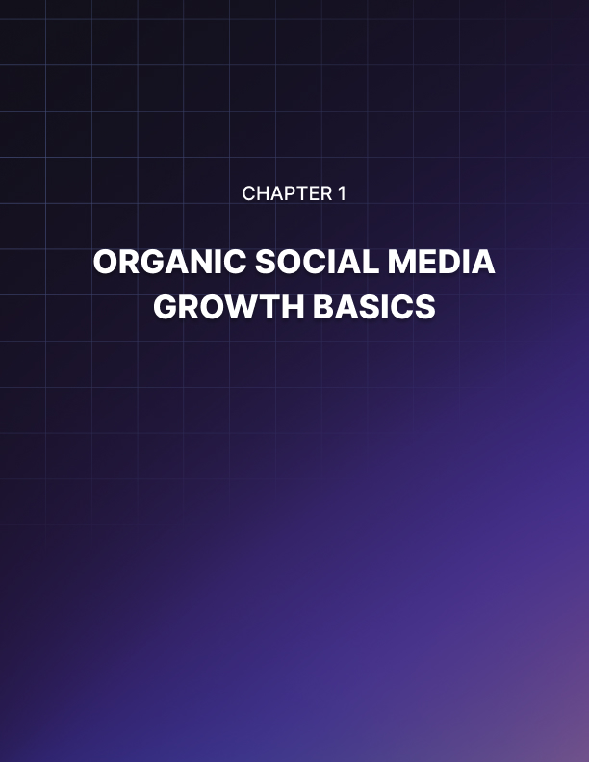

ORGANIC SOCIAL MEDIA GROWTH BASICS
____
Social networks have revolutionized how brands connect with their audiences, transforming simple communication platforms into powerful engines of business growth. Organic social media content often drives deeper engagement than paid advertising, making it the cornerstone of sustainable online success. As you navigate the world of social media marketing, understanding the principles of organic growth will become your competitive advantage.

The Power of Organic Growth Mindset
Organic social media growth represents more than just posting content without paid promotion. It's a strategic approach that builds lasting relationships through authentic engagement and valuable content. Unlike paid advertising, which delivers temporary spikes in visibility, organic growth compounds over time, creating an ever-expanding network of engaged followers who genuinely care about your brand.
Think of organic growth as planting and nurturing a garden. While paid advertising is like buying fully grown plants for instant results, organic growth involves carefully sowing seeds, providing the right conditions, and patiently tending to your garden as it flourishes. This process might take longer, but it creates deeper roots and sustainable results that continue bearing fruit long after your initial efforts.
The compound effect of organic growth becomes evident when you consider how content spreads naturally through social networks. When you share valuable content that resonates with your audience, they're more likely to engage with it, share it with their networks, and become advocates for your brand. This natural multiplication of reach creates a snowball effect that can dramatically amplify your message without additional investment.
Let’s say you just posted an insightful piece of content that reaches 100 followers. If just 10% of those followers share it with their networks (each having an average of 100 followers), your content could potentially reach 1,000 new people. If just 1% of those new viewers become followers and repeat the process, your reach continues to expand exponentially. This organic multiplication demonstrates why focusing on quality content and genuine engagement creates sustainable growth.

The Four Pillars Framework
Success in organic social media marketing rests on four fundamental pillars that work together to create a self-sustaining ecosystem of growth. Understanding and implementing these pillars will help you build a strong foundation for your social media presence.
Pillar | Description | Key Benefits | Implementation Tips
Engagement | Two-way communication with your audience | Builds relationships and trust | Respond promptly, ask questions, create interactive content
Consistency | Regular, reliable presence and voice | Establishes expectations and reliability | Develop a content calendar, maintain brand voice, post regularly
Content value | Information that serves audience’s needs | Attracts and retains followers | Focus on solving problems, educate, entertain
Audience Connection | Authentic relationship building | Creates brand advocates | Show personality, share stories, celebrate community
Each pillar reinforces the others, creating a robust framework for organic growth. When you consistently provide valuable content, engagement naturally increases. As engagement grows, you build stronger connections with your audience, which in turn helps maintain consistency through feedback and motivation.
The success of this framework depends on understanding your audience deeply. You must know their:
- Pain points and challenges
- Goals and aspirations
- Preferred content formats
- Peak activity times
- Communication style preferences

Building Authentic Engagement
Engagement is the lifeblood of organic social media growth. It transforms passive followers into active participants in your brand's story. True engagement goes beyond simple likes and shares—it creates meaningful conversations that build lasting relationships with your audience.
Understanding the psychology behind social media engagement helps you create content that naturally encourages participation. People engage with content that:
- Reflects their values and beliefs
- Helps them solve problems
- Makes them feel understood
- Provides entertainment or emotional value
- Gives them a sense of belonging
To foster authentic engagement, focus on creating opportunities for meaningful interaction. Instead of asking closed questions like "Do you like our new product?" try open-ended prompts such as "What creative ways have you found to use our product in your daily routine?" This approach invites detailed responses and starts conversations that can evolve naturally.
Behind-the-scenes content offers another powerful way to generate authentic engagement. When you share glimpses of your process, team, or workplace, you humanize your brand and create opportunities for genuine connection. This might include:
- Team member spotlights
- Product development updates
- Office culture snapshots
- Creative process insights
- Customer success stories
Remember that engagement is a two-way street. When followers take the time to comment or share their thoughts, acknowledge their contribution with thoughtful responses. Generic replies like "Thanks!" add little value. Instead, craft personalized responses that advance the conversation and show genuine interest in their perspective.

Value-First Strategy Implementation
Creating value for your audience forms the foundation of sustainable organic growth. This approach requires a deep understanding of what your followers consider valuable and a commitment to delivering content that consistently meets their needs. The key lies in viewing value through your audience's eyes rather than your own.
To determine what constitutes value for your audience, implement a systematic approach to gathering and analyzing feedback. This involves observing how your audience interacts with your content, what they communicate directly, and what broader insights can be drawn from ongoing research.
Monitor engagement patterns by tracking:
- Most-shared content types
- Posts that generate meaningful comments
- Content that gets saved for future reference
- Time spent engaging with different formats
Analyze direct communication through:
- Direct message themes
- Common questions in comments
- Customer service interactions
- Community discussions
Regular audience research using:
- Surveys and polls
- Focus groups
- Social listening tools
- Analytics data
The insight gained from this research should inform your content strategy. Apply the 80/20 rule as your foundation: 80% of your content should provide clear value to your audience, while only 20% should be promotional. This ratio ensures you maintain audience interest while still meeting your marketing objectives.
Value-focused content can take many forms, such as:
Educational Content
- How-to guides and tutorials
- Industry insights and analysis
- Expert interviews and perspectives
- Problem-solving tips
- Resource collections
Entertainment Content
- Behind-the-scenes stories
- User-generated content features
- Industry-related humor
- Interactive challenges
- Creative interpretations of trends
Inspirational Content
- Success stories
- Transformation showcases
- Motivational messages
- Goal-setting frameworks
- Community highlights
When creating content, always ask yourself: "How does this benefit my audience?" Every post should have a clear purpose and deliver tangible value. This might mean sharing expert insights that help followers solve common problems, creating step-by-step guides that simplify complex processes, or offering exclusive information that gives your audience an advantage in their field.

Mastering Consistency and Measurement
Consistency extends far beyond just maintaining a regular posting schedule—it encompasses every aspect of your social media presence. Your success depends on creating a cohesive experience that builds trust and recognition with your audience.

The Comprehensive Consistency Framework
Think of consistency as a three-dimensional concept that includes:
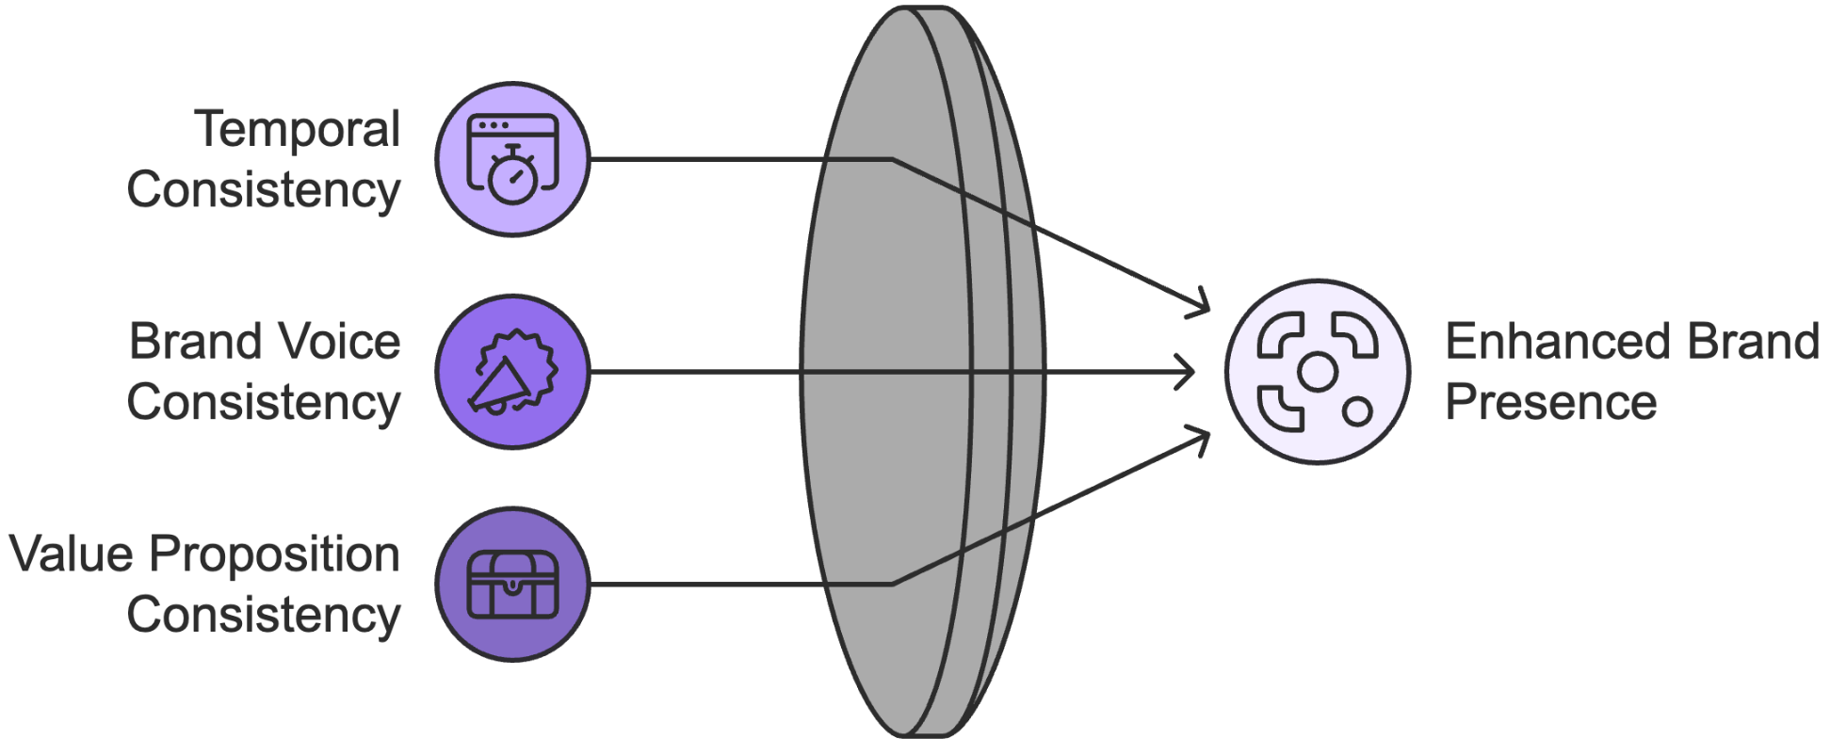
Temporal Consistency
Your posting rhythm must align with your audience's expectations and platform dynamics. According to findings from Popular Pays, accounts posting 4–7 times per week see 2–3x more engagement than those posting sporadically. However, quality should never be sacrificed for frequency.
Create a sustainable posting schedule by:
- Identifying your audience's peak activity times
- Mapping content types to optimal posting slots
- Building buffer time for engagement and community management
- Planning content themes around key dates and events
Brand Voice Consistency
Your brand's personality should shine through in every interaction. This includes:
- Writing style and tone
- Response patterns to comments
- Use of humor and emotion
- Visual elements and design
- Story themes and messaging

Value Proposition Consistency
Every piece of content should reinforce your core value proposition and brand promises. This means:
- Aligning content with audience needs
- Maintaining quality standards
- Delivering on stated benefits
- Supporting brand positioning
- Reinforcing key messages

Measurement and Analytics
Effective measurement helps you understand what's working and what needs adjustment. Focus on these key metrics:
- Engagement Metrics
- Engagement rate per post
- Comment quality and sentiment
- Share and save rates
- Click-through rates
- Story completion rates
- Growth Metrics
- Follower growth rate
- Reach and impressions
- Profile visits
- Website referral traffic
- Mention volume
- Community Health Metrics
- Response time
- Resolution rate
- Community participation
- User-generated content volume
- Brand sentiment
Create a measurement framework that tracks these metrics weekly and monthly. Use tools like platform analytics, social listening software, and engagement tracking tools to gather comprehensive data. This information should inform your content strategy and help you make data-driven decisions about what's working and what needs adjustment.

Advanced Community Building Strategies
Building a thriving community requires more than just consistent posting. It demands strategic approaches to fostering connection and participation. Here's how you can develop a strong community:
1) Create Exclusive Spaces
Develop dedicated spaces for your most engaged followers. This might include:
- Private Facebook groups
- Instagram Close Friends stories
- Twitter communities
- LinkedIn groups
- Discord servers
2) Implement Community Programs
Launch initiatives that encourage participation and reward engagement:
- Ambassador programs
- User-generated content campaigns
- Community challenges
- Mentorship opportunities
- Expert Q&A sessions
3) Foster Peer-to-Peer Connections
Encourage community members to connect with each other through:
- Discussion threads
- Member spotlights
- Collaboration opportunities
- Networking events
- Knowledge sharing
4) Celebrate Community Achievements
Recognize and amplify community success through:
- Success story features
- Achievement announcements
- Community milestones
- Member interviews
- Collective goal celebrations
The key to successful community building lies in creating value that extends beyond your brand. When community members find genuine connection and support from their peers, they're more likely to remain engaged and become brand advocates.
Remember, organic social media growth isn't just about increasing numbers—it's about building a sustainable ecosystem where your brand and community thrive together. By focusing on these foundational elements, measuring your progress, and continuously adapting your approach, you'll create lasting success that grows stronger over time.

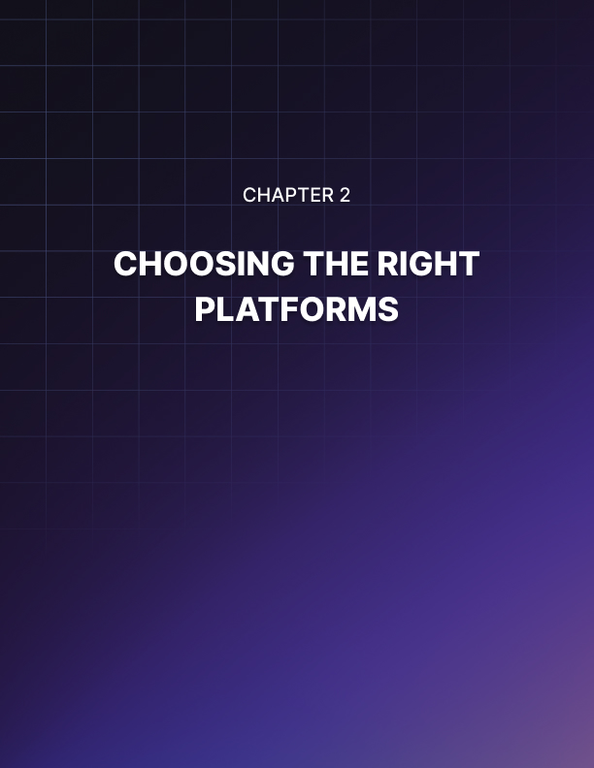

CHOOSING THE RIGHT PLATFORMS
____
Every hour, businesses waste thousands of dollars maintaining ineffective social media presences across platforms that don't serve their goals. Many companies struggle to generate meaningful results from their social media efforts, largely because they're active on the wrong platforms. With 5.24 billion social media users spread across various networks based on the data analysis conducted by advisory firm Kepios, success doesn't come from being everywhere—it comes from being exactly where your audience needs you to be.

Platform Ecosystems and User Behavior
Each social network functions as a unique ecosystem, complete with its own unwritten rules, communication styles, and user expectations. Understanding these distinct characteristics helps you make informed decisions about where to focus your organic growth efforts.
Platform | Monthly Active Users | Primary Demographics | Best Content Types | Engagement Style
Instagram | 2B | 18–34, urban, lifestyle-focused | Visual, Stories, Reels | Interactive, aspirational
LinkedIn | 930M | 25–54, professionals, B2B | Long-form, industry insights | Professional networking
Twitter | 450M | 25–45, news-focused, tech-savvy | Short-form, real-time | Quick interactions
TikTok | 1.59B | 16–24, entertainment-seekers | Short video, trending | Creative, entertaining
Facebook | 3.07B | 25–54, community-focused | Mixed media, groups | Community building
Pinterest | 537M | 25–44, primarily female | Visual inspiration | Discovery, planning
Facebook stands as the largest social media platform globally, thriving on mixed media content and group interactions, thereby making it ideal for community-building strategies. Its scale and user behavior patterns offer valuable insights into how people connect, share, and consume information in a digitally social environment.
Facebook's ecosystem differs significantly from other platforms in its emphasis on existing connections rather than discovery. Users typically visit multiple times daily with average session times of 33 minutes, engaging most actively with content that generates meaningful interactions. Businesses find particular success with group-based strategies and mixed media approaches that combine compelling visuals with substantive text, as branded communities generate 5-7x more engagement than standard business page content.
Instagram has evolved beyond its initial photo-sharing roots to become a multi-format engagement platform. Users spend an average of 30 minutes per day on the platform, primarily engaging with Stories, Reels, and feed content.
The platform's visual nature makes it particularly effective for businesses that can showcase their products or services through compelling imagery or video. Fashion retailers leveraging Instagram's shopping features tend to have higher conversion rates than traditional e-commerce channels, while service-based businesses find success through educational carousel posts and behind-the-scenes content that humanizes their brand.
LinkedIn's professional environment creates unique opportunities for B2B companies and thought leaders. Users typically visit the platform during business hours, with peak engagement occurring Tuesday through Thursday between 9 AM and 2 PM.
The platform's algorithm favors detailed, long-form content that sparks professional discussions. Companies sharing weekly insights about industry trends see an average of 2x more engagement than those posting generic business updates. LinkedIn's professional focus means users are more likely to engage with content that helps them solve business challenges or advance their careers.
Twitter (X) thrives on real-time conversation and quick-hit information sharing. The platform's users check their feeds an average of 15 times per day, making it ideal for businesses that can maintain an active presence and respond quickly to trending topics.
Success on Twitter often comes from mastering the art of conversation rather than broadcasting messages. Brands that engage in genuine discussions and add value to trending conversations see more organic reach than those who simply push promotional content.
TikTok has redefined how users consume content, with its algorithm-driven discovery system delivering personalized content feeds that keep users engaged for an average of 89 minutes per day. The platform's success lies in its ability to make complex topics accessible through entertaining, short-form video content. Businesses that adapt their messaging to fit TikTok's creative, authentic style see significantly higher engagement rates than those who attempt to repurpose traditional marketing content.
Pinterest functions as a visual discovery platform, which excels with visual inspiration content types. This makes it particularly effective for businesses that can showcase ideas through compelling imagery related to planning, projects, and aspirations.
Unlike conversation-focused platforms, Pinterest users approach the site with intent-driven discovery, spending an average of 14.2 minutes per session actively searching for specific inspiration. The platform's unique "saving" behavior differs from traditional social media engagement, with users curating personal collections for future reference rather than seeking immediate interaction. Businesses that align their content with popular search categories and seasonal planning cycles typically see higher engagement, as the platform serves as both a visual search engine and personal idea board for users planning everything from home renovations to special events.

Strategic Platform Selection and Resource Allocation
Choosing the right platforms requires a systematic evaluation of your business goals, audience preferences, and available resources. The platform-business alignment framework helps you make informed decisions about where to focus your efforts:
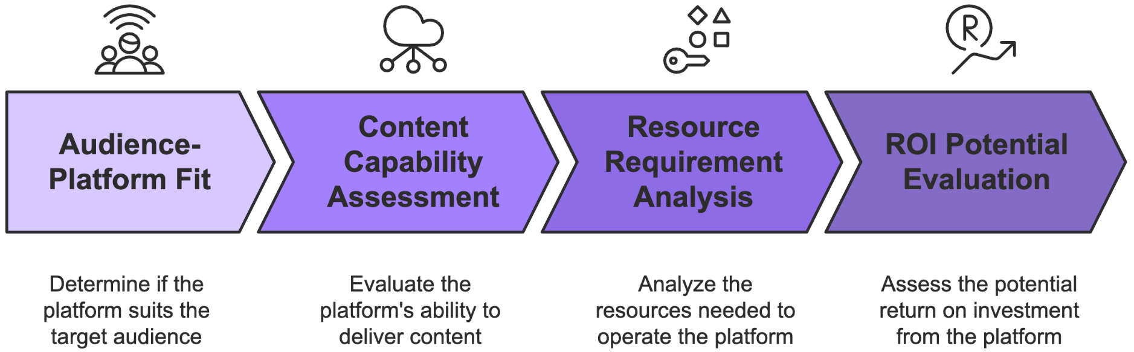
- Audience-Platform Fit
- Research where your target audience spends their time.
- Analyze engagement patterns during different times of day.
- Study how your audience interacts with similar brands.
- Identify platform-specific behavior patterns.
- Content Capability Assessment
- Evaluate your ability to create platform-specific content.
- Consider your team's technical skills and creativity.
- Assess your content production resources.
- Determine sustainable posting frequencies.
- Resource Requirement Analysis
- Calculate the time needed for content creation.
- Consider community management requirements.
- Evaluate technical tool needs.
- Assess training and skill development needs.
- ROI Potential Evaluation
- Analyze platform conversion rates.
- Study competitor success patterns.
- Consider platform-specific marketing features.
- Evaluate organic reach potential.
This systematic approach helps you avoid the common pitfall of spreading resources too thin across multiple platforms. Take the case of a small wellness coaching business that initially maintained active profiles on six different platforms. After applying the platform-business alignment framework, they identified Instagram and LinkedIn as their primary platforms, with Pinterest as a secondary focus. This concentrated approach led to a 300% increase in qualified leads within four months, while actually reducing their total social media management time by 60%.
When evaluating platforms, consider these key factors that influence organic growth potential:
- Algorithm Dynamics
Each platform's algorithm prioritizes different types of content and engagement patterns. Instagram's algorithm favors content that generates quick engagement and saves, while LinkedIn's algorithm rewards thoughtful discussions and industry insights. Understanding these dynamics helps you create content that naturally gains visibility.
- Content Lifespan
The longevity of content varies significantly across platforms. A tweet might have a lifespan of just 15–20 minutes, while Pinterest pins can continue driving traffic for months or even years. This impacts your content strategy and resource allocation decisions.
- Engagement Patterns
User behavior varies dramatically between platforms. LinkedIn users might engage deeply with long-form content during business hours, while TikTok users prefer quick, entertaining videos throughout the day. Your content strategy must align with these patterns to maximize organic reach.

Building Platform-Specific Growth Strategies
Success on each platform requires tailored approaches that leverage its unique characteristics while maintaining your brand's core message. Here's how to develop effective platform-specific strategies:
Your Instagram presence should focus on visual storytelling that builds emotional connections with your audience. Create content that showcases your brand's personality while providing clear value to followers. Use Stories for time-sensitive content and behind-the-scenes glimpses, Reels for educational or entertaining short-form video, and feed posts for high-quality visual content that reflects your brand's aesthetic.
LinkedIn requires a more professional, thought-leadership-focused approach. Share industry insights, company culture highlights, and educational content that helps your audience solve professional challenges. Focus on building meaningful connections through thoughtful comments and discussions rather than purely promotional content.
Twitter success comes from maintaining an active presence and engaging in relevant conversations. Monitor trending topics in your industry, share quick insights, and respond promptly to mentions and direct messages. Use threads to break down complex topics into digestible pieces, and incorporate relevant hashtags to increase discoverability.
TikTok demands authenticity and creativity. Focus on creating entertaining or educational content that fits naturally within the platform's style. Participate in relevant trends while maintaining your brand voice, and use popular sounds or music to increase visibility. Polished, commercial-looking content often performs poorly compared to authentic, relatable posts.
Successful platform selection isn't about being everywhere—it's about being exactly where you can provide the most value to your audience while achieving your business objectives. As you move forward, focus on mastering one or two platforms before expanding your presence. This focused approach will yield better results than trying to maintain a presence everywhere at once.

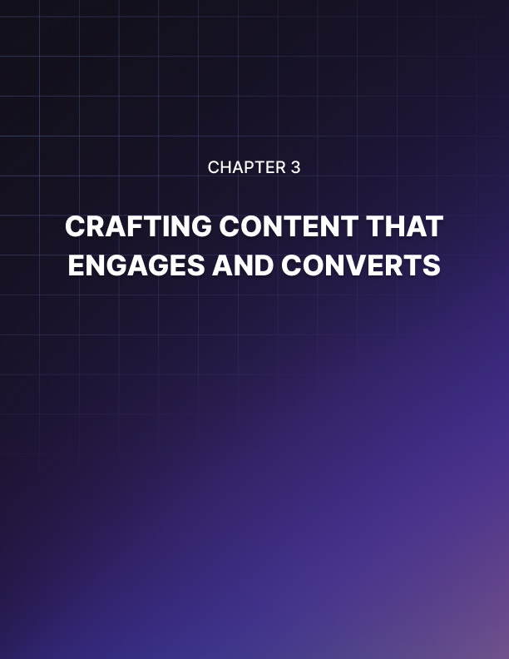

CRAFTING CONTENT THAT ENGAGES AND CONVERTS
____
Social media is overflowing with content, but only a small fraction truly resonates with audiences. The key to cutting through the noise lies in understanding the intricate psychology that drives people to engage, share, and ultimately convert. Successful content isn't about following trends or copying competitors, but about creating authentic, value-driven experiences that speak directly to your audience’s interests and motivations.

The Psychology Behind High-Performing Content
At its core, social media sharing represents a deeply personal act of self-expression. When someone shares your content, they're not merely passing along information—they're making a deliberate statement about their identity, values, and aspirations.
Research from The New York Times Insider Group reveals that people share content primarily when it helps them build and maintain relationships, define their identity to others, feel part of something larger than themselves, support causes they believe in, or gain social currency through unique or valuable information. Understanding these motivations is the secret to creating content that not only captures attention but inspires meaningful action.
The emotional component of sharing proves particularly fascinating. Content that triggers high-arousal emotions—whether positive (awe, excitement, amusement) or negative (anger, anxiety)—receives significantly more engagement than content that evokes low-arousal or neutral responses.
This psychological insight explains why a small coffee roastery's sharing rate increased by 312% after shifting from generic product photos to compelling stories about their sustainable farming partnerships. The content transcended simple product promotion to give followers a meaningful narrative worth sharing, one that made them feel like active participants in positive social change.
Social currency (the perceived value of sharing specific information) plays a pivotal role in content virality. People naturally gravitate toward sharing content that enhances their social standing or demonstrates their expertise. This explains why industry insights consistently outperform promotional content, and why behind-the-scenes glimpses often generate more engagement than polished marketing materials.
When crafting content, successful creators consider how sharing their material might benefit their audience's social position. Will it make them appear knowledgeable? Helpful? Forward-thinking? The more social currency your content offers, the more likely it is to spread organically through social networks.
Understanding these psychological triggers allows you to create content that naturally resonates with your audience's deeper motivations. For instance, when a fitness brand shifted from posting standard workout videos to sharing client transformation stories that emphasized personal growth and emotional journey, their engagement rates tripled. The content connected with viewers' aspirations and desires, making it significantly more shareable than purely instructional material.

Strategic Content Formats and Platform Optimization
Different content formats serve distinct psychological needs and engagement purposes. Video content has emerged as the dominant format for organic engagement, particularly short-form video, but this doesn't mean other formats have become obsolete. Each format plays a crucial role in a comprehensive content strategy, and understanding their unique strengths allows you to choose the right medium for your message.
Short-form video succeeds because it combines multiple engagement triggers: visual interest, emotional connection, and quick value delivery. When creating video content, the first three seconds prove critical—they determine whether viewers will continue watching or scroll past. Successful video content starts with immediate movement or action, focuses on one clear message, and uses captions or text overlay since 85% of social media video is watched without sound, according to Facebook’s internal data.
Static images remain powerful tools for organic growth, particularly when they tell a story or convey complex information simply. The most successful static images combine strong visual hierarchy, clear focal points, brand-consistent design elements, text overlay that adds context, and human elements that create an emotional connection. A fitness coach's transformation from simple before-and-after photos to journey collages that included progress milestones, emotional quotes, and achievement metrics led to a 267% increase in engagement while maintaining the basic image format.
Platform-specific optimization proves crucial for content success. Content that performs well on LinkedIn might fall flat on Instagram, not because of quality issues, but because of platform misalignment.
Instagram users expect high-quality imagery that stops the scroll, stories that feel personal and immediate, and carousel posts that deliver multiple value points. LinkedIn users value professional insights and industry knowledge, while Twitter thrives on brevity and immediacy. TikTok demands creativity and authenticity, with success requiring trend awareness, quick-paced editing, and genuine personality.
Rather than creating entirely new content for each platform, develop a smart adaptation strategy. Start with a core piece of content, then modify it to suit each platform's unique characteristics. A detailed case study could become a carousel post on Instagram, a thread on Twitter, a video summary on TikTok, and an article on LinkedIn. This approach maximizes efficiency while ensuring content performs optimally on each platform.

Creating Content That Converts
While engagement metrics provide valuable feedback, the ultimate goal of social media marketing is to drive specific actions. The AIDA model (Attention, Interest, Desire, Action) provides a proven framework for creating converting content, but its application requires careful consideration of platform-specific dynamics and user behavior patterns.
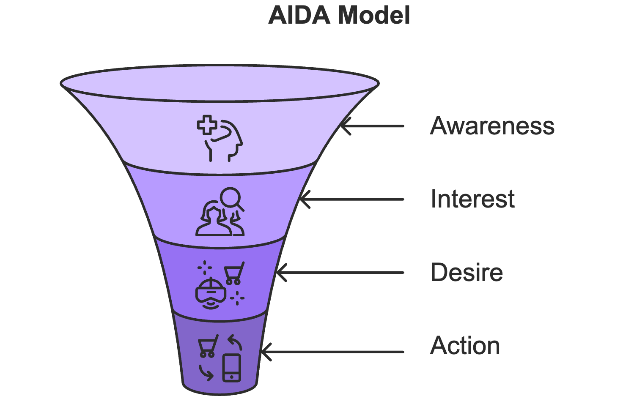
The attention phase requires stopping the scroll, a challenging task in today's content-saturated environment. Successful attention-grabbers combine unexpected elements with clear value propositions. For example, instead of stating "5 tips for better social media marketing," you might lead with "The psychological trigger that doubled our engagement overnight." This approach creates curiosity while promising specific value.
Interest develops through strategic storytelling and relevance. Rather than presenting dry facts or features, successful content creators weave information into compelling narratives that resonate with their audience's experiences and aspirations. Share specific examples, use storytelling techniques, and create emotional connections that keep viewers engaged beyond the initial hook.
Desire builds through a combination of social proof, future pacing, and clear benefit statements. Show your audience not just what your product or service does, but how it transforms lives or solves problems. Use customer testimonials, case studies, and before-and-after comparisons to demonstrate real-world impact. Then, drive action with clear, simple instructions and compelling reasons to act now.
Testing and optimization remain crucial elements of content success. Develop a systematic testing framework that examines variables like headlines, visual styles, post timing, caption length, and call-to-action placement. Track both engagement metrics (likes, shares, saves) and conversion metrics (click-through rates, lead generation, sales) to understand your content's true impact.
Creating engaging social media content that drives conversions requires a delicate balance of art and science. Use these frameworks and guidelines as your foundation, but don't be afraid to experiment and develop your unique approach based on your audience's responses and needs. Remember that the most successful social media presences combine proven principles with authentic brand expression, creating content that not only captures attention but inspires action.
See social media content creation as an ongoing experiment in human psychology and behavior. Each post serves as an opportunity to better understand your audience, refine your approach, and build stronger connections that drive meaningful business results.
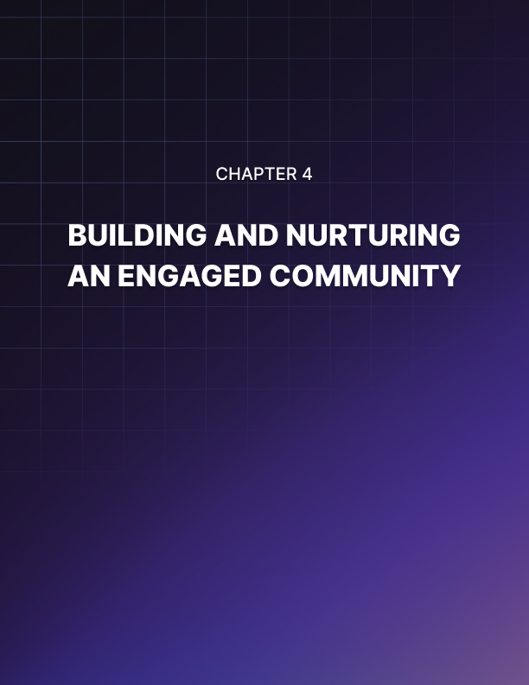

BUILDING AND NURTURING AN ENGAGED COMMUNITY
____
Scrolling through Instagram in the 2010s, beauty brand Glossier made a revolutionary decision that would transform the company's future. Instead of flooding their feed with product promotions, they chose to build something more meaningful: a community.
Within three years, their organic engagement rates soared way above industry averages as more than a million passionate advocates rallied around their brand. Today, Glossier's success demonstrates how authentic community building outperforms traditional social media marketing in creating sustainable growth and brand loyalty.

The Psychology of Community Engagement
Building a thriving online community requires understanding the deep psychological needs that drive people to participate. Social identity theory explains that people join and engage with communities that help them express or enhance their desired self-image. When you create spaces that align with members' aspirations and values, you tap into this fundamental human desire for belonging and self-expression.
Consider how Ryder Carroll transformed the simple concept of bullet journaling into a global movement. Rather than focusing solely on selling his productivity system, Carroll fostered a community of practice where members could share their journaling experiences, modifications, and creative interpretations.
This approach sparked the organic creation of the #bulletjournal movement, generating millions of posts on Instagram—all without paid promotion. The success stems from understanding that people aren't just looking for productivity tools; they're seeking connection with others who share their passion for organization and creativity.
Your community's foundation must rest on clear values and guidelines that bridge your brand's mission with members' aspirations. When an athletic wear brand shifted their social media strategy to focus on women's empowerment and inclusive fitness, their engagement rates doubled. Members began generating authentic conversations about body positivity and wellness because the brand's values resonated with their personal journeys and beliefs.
Creating psychological safety becomes paramount in fostering genuine engagement. Members need to feel secure sharing thoughts, asking questions, and even making mistakes. This safety emerges through consistent enforcement of community guidelines, prompt addressing of negative behavior, and public appreciation of vulnerable sharing. When members see others being supported and respected, they become more likely to contribute meaningfully to discussions.

Strategic Community Development and Leadership
Successful communities evolve through five distinct stages, each requiring different leadership approaches and engagement strategies. Understanding these stages helps you provide appropriate support and opportunities for growth at each phase of community development.
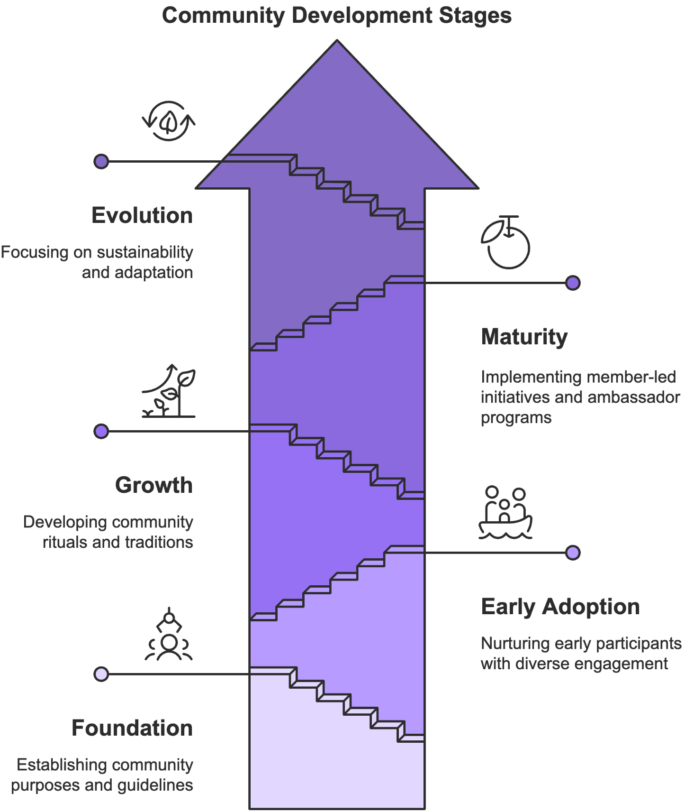
In the foundation stage, focus on establishing clear community purposes and guidelines while actively welcoming early members. Create opportunities for meaningful interaction through targeted discussion prompts and personal introductions. During this phase, your leadership style should be highly visible and engaged, modeling the behavior you want to see from members.
The early adoption stage sees your first wave of active participants testing the waters. Nurture these early adopters by providing multiple pathways for participation that cater to different comfort levels. Some members might feel comfortable sharing detailed stories and advice, while others prefer to participate through likes and simple comments. Design engagement triggers that accommodate this diversity while gradually encouraging deeper participation.
As you enter the growth stage, focus on developing community rituals and traditions that create a sense of belonging. These might include:
- Weekly welcome threads for new members
- Monthly celebration posts for achievements
- Regular expert Q&A sessions
- Seasonal challenges or events
- Annual community awards or recognition ceremonies
The maturity stage brings opportunities for member-led initiatives and content co-creation. Implement ambassador programs that formalize relationships with highly engaged members. Successful ambassador programs provide clear roles and responsibilities while offering valuable benefits.
Ambassador Responsibilities | Program Benefits
Content creation | Early access to features
Community support | Professional development
Brand representation | Networking opportunities
Engagement facilitation | Recognition and exposure
Feedback collection | Exclusive perks
During the evolution stage, focus on sustainability and adaptation. Implement systems for continuous learning and feedback while preparing for leadership succession and long-term growth. This might include developing content creation systems, engagement automation tools, and crisis response protocols.

Creating Self-Sustaining Engagement Systems
Long-term community success hinges on building self-sustaining engagement systems that generate ongoing participation without constant intervention from community managers. This requires understanding and leveraging the natural motivations that drive member participation.
Recognition plays a crucial role in sustaining engagement. Members who feel valued and appreciated are more likely to continue contributing to the community. Acknowledgment doesn't have to be elaborate; consistently spotlighting members’ efforts, even in small ways, can significantly boost motivation. This sense of appreciation often inspires members to take a more active role, including contributing content that fuels further engagement.
User-generated content (UGC) becomes a powerful tool for both engagement and content creation when properly structured. Successful UGC initiatives provide clear parameters while offering meaningful incentives for participation. Rather than simply asking for contributions, create themed challenges or collaborative projects that align with community interests and values.
Community-driven content creation represents one of the most powerful aspects of engaged communities. When members contribute to content creation, they develop a deeper connection to the community and help create more authentic, relatable material. Leverage member expertise by creating opportunities for knowledge sharing through expert Q&A sessions, member-led workshops, and mentorship programs.
Your role shifts from content creator to content curator and facilitator. Focus on highlighting exceptional member contributions, connecting complementary expertise, and ensuring discussions remain productive and aligned with community values. This approach creates a virtuous cycle where engaged members inspire others to participate more actively.
Building a thriving community takes time and consistent effort. Focus on creating genuine value for members, fostering meaningful connections, and maintaining a supportive environment. The investment in community building pays dividends through increased brand loyalty, organic growth, and sustainable engagement that traditional marketing approaches simply cannot match.
The real power of community lies not in the number of followers but in the depth of connections formed between members. When you successfully nurture these connections, your community becomes a self-sustaining engine of growth that continues generating value long after your initial investment.

Measuring and Optimizing Community Health
Successfully managing a thriving community requires both quantitative metrics and qualitative indicators to assess engagement quality and overall health. While follower counts provide surface-level insights, deeper metrics reveal the true strength of your community connections.
Engagement quality supersedes quantity in importance. A single thoughtful comment that sparks meaningful discussion holds more value than dozens of surface-level reactions. Track conversation depth by monitoring:
- Average replies per discussion thread
- Percentage of comments generating additional responses
- Quality and depth of member interactions
- Time spent engaging with community content
- Member-initiated discussion frequency
Create a comprehensive health assessment framework that combines multiple indicators, such as:
Metric Category | Key Indicators | Target Benchmarks
Core engagement | Active daily participants | 5–10% of total membership
Content generation | Member-created content | 40% of the total content
Growth patterns | New member retention | 65% after 30 days
Community sentiment | Positive interaction ratio | 80% positive/neutral
Beyond numbers, healthy communities display distinct qualitative characteristics that indicate genuine engagement. Look for signs of emotional investment, such as members defending community values, offering unprompted support to others, and initiating collaborative projects. These behaviors signal that your community has developed its own self-sustaining culture.
Regular member surveys provide crucial insights into community satisfaction and needs. Structure your surveys to gather feedback on:
- Overall community experience
- Value received from participation
- Barriers to deeper engagement
- Desired features or programs
- Future participation intentions
Use this feedback to refine your community strategy and identify opportunities for improvement. Pay particular attention to patterns in member behavior and engagement preferences. Understanding these patterns helps you optimize your community management approach and create more effective engagement opportunities.
When analyzing community health, study the entire member journey from initial discovery through active participation. Map out typical progression paths and identify potential drop-off points where members might disengage. This analysis helps you implement targeted interventions to maintain engagement throughout the member lifecycle.
A particularly insightful case comes from a fitness community, which discovered that members who joined small accountability groups within their first month were 3x more likely to remain active after six months. This finding led them to implement automated group matching for new members, significantly improving long-term retention rates.
Your role as a community leader includes anticipating and removing barriers to participation. Common obstacles include:
- Unclear participation guidelines
- Limited engagement opportunities
- Technical difficulties
- Time zone challenges
- Language barriers
Address these challenges proactively by creating inclusive systems that accommodate diverse members’ needs. This might involve offering multiple participation formats, translating key content, or implementing 24/7 moderation coverage for global communities.
Implement a tiered engagement model that provides clear pathways for increasing involvement. Start with simple, low-commitment activities and gradually introduce opportunities for deeper participation as members become more comfortable within the community. This approach helps prevent overwhelming new members while providing growth opportunities for established participants.
Success in community building comes from consistent application of these principles combined with genuine care for member experience. Focus on creating value, fostering connections, and maintaining a supportive environment where members feel empowered to contribute meaningfully. The resulting engagement creates a self-sustaining cycle of growth that continues generating value for both your brand and community members.
Most importantly, remember that your community exists to serve its members, not just your brand objectives. When you prioritize member value and authentic connection, the marketing benefits flow naturally through increased loyalty, word-of-mouth promotion, and organic growth. This member-first approach builds sustainable communities that thrive long-term while delivering meaningful business results.
Build your community gradually with intention and authenticity. Focus on quality over quantity, meaningful engagement over vanity metrics, and genuine connection over superficial growth. The time and effort invested in thoughtful community building returns exponential value through lasting relationships and sustainable brand growth.
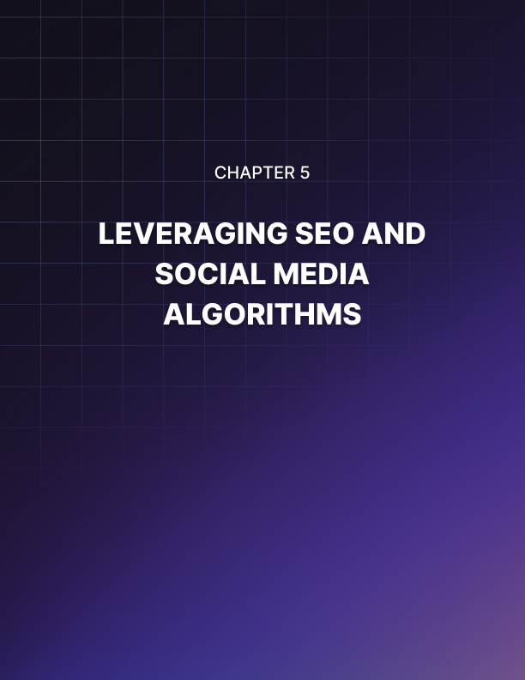

LEVERAGING SEO AND SOCIAL MEDIA ALGORITHMS
____
A sustainable fashion brand's organic reach plummeted 78% overnight after a major algorithm update in 2023, while their competitor's visibility soared 315%. This stark contrast wasn't about luck; it demonstrated how understanding social platform algorithms determines success in modern organic marketing. A very low percentage of organic social media content actually reaches its intended audience, making algorithmic knowledge more crucial than ever for sustained growth.
Think of social media algorithms as sophisticated matchmakers, constantly evaluating billions of content pieces to connect the right posts with the right users at the perfect moment. While many marketers view algorithms as obstacles, those who learn to work with these systems rather than against them unlock unprecedented opportunities for organic growth.

Decoding Modern Social Algorithms
Today's social media algorithms have evolved far beyond simple chronological feeds into sophisticated AI-driven systems analyzing hundreds of signals simultaneously. Using advanced machine learning, these algorithms evaluate content quality, predict user preferences, and optimize engagement across vast networks of users and content. Your success depends on understanding how these systems think.
When you post content, algorithms immediately begin evaluating multiple factors:
- Initial engagement velocity and patterns
- Content relevance to user interests
- Creator authority and consistency
- Format-specific quality signals
- User response indicators
Each platform's algorithm has unique priorities and evaluation methods. Instagram's algorithm heavily weights "saves" above likes, viewing them as stronger indicators of content value. When users save your post, it signals intent to return to it later, which is a more meaningful action than a quick double-tap. On the other hand, LinkedIn's algorithm focuses intensely on "dwell time," measuring how long users engage with content rather than just counting surface interactions.
TikTok's algorithm operates differently, making rapid distribution decisions based on viewer behavior within the first few seconds. This explains why unknown creators can suddenly reach millions, because the algorithm prioritizes content quality over account size. The platform analyzes factors like video completion rates, rewatch patterns, and sharing velocity to determine content value.
Twitter's evaluation heavily weights conversation quality through metrics like reply-to-tweet ratios, quote tweet context, and conversation depth. A post generating thoughtful discussion will often outperform one with higher surface-level engagement. The platform particularly values authentic conversations that build over time rather than brief engagement spikes.
Understanding these platform-specific priorities becomes crucial for content optimization. A post performing well on Instagram might fail on LinkedIn because it doesn't align with that platform's algorithmic preferences. Your strategy must adapt to each platform's unique value signals while maintaining an authentic audience connection.
Here's how algorithms evaluate social proof signals beyond basic engagement metrics:
Primary Social Proof Indicators
- Content sharing patterns and velocities
- Save-to-share ratios across time
- Comment quality and conversation depth
- Cross-platform citation frequency
- Profile authority and consistency metrics
Modern algorithms employ sophisticated analysis to identify natural versus artificial engagement patterns. Sudden engagement spikes from unusual sources often trigger distribution limitations rather than amplification. The key lies in generating authentic engagement that builds organically over time.

Optimizing for Algorithm Success
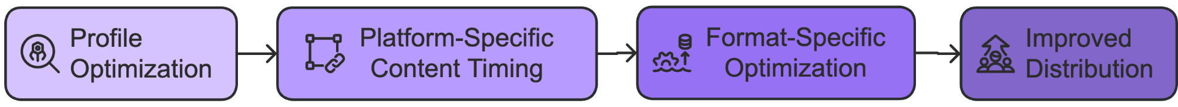
Your path to algorithmic success starts with profile optimization - the foundation that helps platforms understand and categorize your content. Every profile element contributes to how algorithms evaluate your posts and determine distribution:
- Profile Name Optimization
Balance branding with searchability by incorporating relevant keywords naturally. For example, "sustainable_fashion_studio" provides more algorithmic context than just "studiostyle," provided it accurately reflects your content focus.
- Bio Section Strategy
Strategically place keywords while maintaining readability and a clear value proposition. Algorithms scan these sections to understand account themes and relevance to specific queries. However, natural integration matters; forced keyword placement can trigger spam filters and limit distribution.

- Visual Elements
Profile images, cover photos, and highlighted content should maintain consistent themes that reinforce your topical authority. Algorithms increasingly consider visual consistency when evaluating account credibility.
- Link Optimization
Platforms track link click-through rates and subsequent user behavior as quality signals. Regular updates to linked content and maintaining consistent themes between social content and linked destinations improve algorithmic evaluation.
Beyond profile optimization, success requires understanding platform-specific content timing strategies. Each platform has unique windows where engagement carries more algorithmic weight.
Instagram's algorithm particularly values engagement received within the first 30 minutes, using this as a primary signal for broader distribution. However, sustained engagement over the following hours can trigger secondary distribution waves. You'll get the best results posting when your core audience is most likely to engage immediately while ensuring content maintains value for extended interaction.
LinkedIn's algorithm evaluates content performance over a longer initial window, typically 2–3 hours. The platform weighs engagement quality more heavily than quantity, preferring thoughtful comments over quick reactions. Focus on posting when your professional network has time for meaningful engagement rather than just high-traffic periods.
TikTok makes rapid distribution decisions, often within minutes of posting. This makes your content's first few seconds crucial for capturing attention and triggering positive algorithm signals. However, the platform also values sustained engagement, using metrics like save rates and share velocities to determine ongoing distribution.
Understanding format-specific optimization becomes crucial as algorithms grow more sophisticated in evaluating different content types. Modern algorithms analyze video content for:
- Viewer retention patterns across duration
- Engagement distribution throughout the content
- Audio engagement through unmute rates
- Interactive element usage patterns
- Share timing and velocity metrics
These factors help algorithms determine not just content quality but optimal distribution strategies. Videos maintaining high viewer retention throughout their duration often receive broader distribution than those with high initial views but poor retention.

Future-Proofing Your Algorithm Strategy
As social media algorithms continue evolving, maintaining sustainable organic reach requires building adaptable strategies focused on genuine value creation. Rather than chasing temporary tactics, focus on understanding underlying patterns that drive algorithmic distribution, including:
Value-First Content Creation - Algorithms increasingly prioritize content that generates meaningful user value over promotional material. Focus on creating content that solves problems, answers questions, or provides unique insights your audience can't find elsewhere.
Engagement Quality Over Quantity - Build strategies encouraging thoughtful discussion and genuine community interaction rather than superficial engagement. High-quality conversations signal greater content value to algorithms than large numbers of basic reactions.
Platform-Specific Expertise - While maintaining a consistent brand presence across platforms remains important, success requires understanding and optimizing for each platform's unique algorithmic preferences and distribution patterns.
Content Retention Focus - Create content designed for both immediate impact and lasting value. Algorithms increasingly weight content that maintains engagement over time versus posts generating quick but temporary interest.
Regular Testing and Adaptation - Implement systematic testing to understand how algorithm updates affect your content performance. Track key metrics like:
- Engagement rate changes
- Distribution pattern shifts
- Audience response variations
- Content format effectiveness
This data helps you adapt strategies proactively rather than reacting to sudden algorithmic changes.
Success in modern organic social media marketing requires balancing algorithmic optimization with authentic engagement and value creation. By understanding how algorithms evaluate and distribute content while maintaining focus on audience value, you'll build sustainable organic reach strategies that evolve with platform changes rather than falling victim to them.
Algorithms exist to connect valuable content with interested users, so focus on creating genuine value, and algorithmic success will follow naturally.
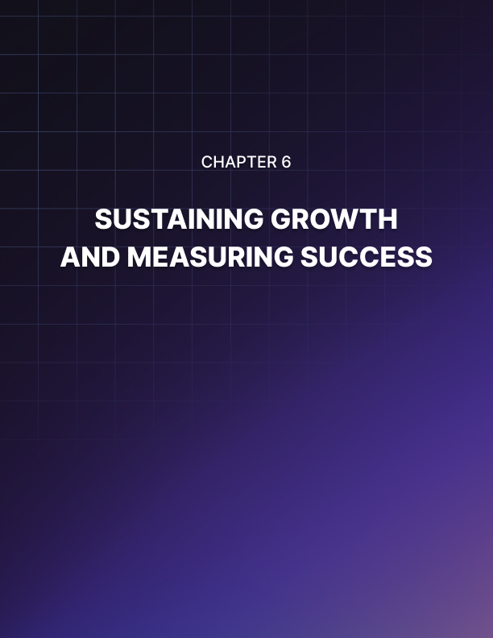

SUSTAINING GROWTH AND MEASURING SUCCESS
____
In times of uncertainty and rapid change, businesses that thrive are those equipped with adaptable systems and a clear understanding of what drives results. Organic social media growth is not a one-time effort—it’s a continuous process that requires intentional strategy, consistent evaluation, and the ability to pivot based on real-time insights.
Success on social media isn’t about occasional viral moments. It’s about building sustainable systems for growth, tracking what truly matters, and refining your approach through ongoing measurement. With the right tools and mindset, social media becomes more than a marketing channel. It becomes a reliable engine for long-term business success.

The Growth Sustainability Framework
Sustainable social media growth requires moving beyond ad-hoc posting to build systematic approaches that scale. Think of your social media presence as a garden that needs consistent care rather than a campaign that ends. This mindset shift transforms how you approach content creation, community management, and measurement.
The foundation of sustainability lies in creating systems that maintain consistency while maximizing resource efficiency. Examine how National Geographic transformed their social media approach by implementing a sustainable growth framework. Rather than chasing viral moments, they developed systematic processes for content creation, curation, and community engagement. This approach helped them maintain consistent growth even as platforms evolved and team members changed.
Your sustainable growth framework must address four key areas: content creation, community engagement, performance measurement, and resource allocation. Each area requires specific systems and protocols that work together to create a self-sustaining ecosystem of growth. Let's examine how these components interact and support each other in creating lasting success.
Content sustainability begins with developing clear workflows that maintain quality while improving efficiency. You need to document your content creation process, from ideation through publication and measurement. This documentation serves multiple purposes, including ensuring consistency across team members, reducing decision fatigue, streamlining onboarding of new team members, creating accountability and clear expectations, and enabling process optimization over time. That’s why it’s so important to build systems that are easy to replicate and scale without compromising quality or authenticity.
When building your content sustainability system, focus on creating templates and frameworks that guide content creation while allowing for creativity and adaptation. This might include content calendars that align with business objectives, template libraries for different content types, and clear guidelines for maintaining brand voice and visual consistency. The goal is to remove unnecessary decision-making from the process while preserving the creative elements that make your content unique and engaging.
Community engagement sustainability demands establishing clear protocols for interaction, response times, and crisis management. Document how different types of engagement should be handled, who's responsible for what, and what tone and voice should be maintained across all interactions. This systematic approach ensures that your community receives consistent support and attention, regardless of who's managing the engagement.
Performance measurement sustainability depends on creating systems that automatically track and report key metrics. This includes setting up automated tracking tools, creating custom dashboards for different stakeholders, establishing regular review cycles, and developing response protocols for different performance scenarios. The key is to make measurement an integral part of your daily operations rather than an afterthought.
Resource allocation sustainability involves careful planning of both human and technical resources. This encompasses team structure and responsibilities, tool selection and integration, budget allocation and optimization, time management and scheduling, and training and skill development. Success requires finding the right balance between automation and human touch, ensuring that resources are used efficiently while maintaining the authentic connections your audience values.

Advanced Analytics and Performance Measurement
While many social media managers focus on surface-level metrics like follower counts and likes, true success requires a deeper understanding of performance measurement. Advanced analytics go beyond vanity metrics to reveal insights that drive meaningful business outcomes.
Starting with engagement quality metrics, you need to examine not just how many people interact with your content, but how they interact. This means analyzing metrics like:
- Comment sentiment and quality
- Share-to-impression ratios
- Content save rates
- Discussion thread depth
- Time spent engaging with content
These metrics provide deeper insights into content effectiveness than simple engagement counts. For example, a post with fewer likes but higher save rates and meaningful comments might actually deliver more value than a highly liked post with shallow engagement.
Creating a balanced scorecard helps maintain focus on metrics that matter while avoiding the trap of optimizing for easy-to-measure but less meaningful indicators. Your scorecard should encompass growth metrics, engagement quality metrics, conversion metrics, and community health metrics. Each category provides unique insights into your social media performance and helps guide strategic decisions.
When implementing advanced analytics, start by establishing clear baselines across all key metrics. This baseline provides context for future improvements and helps identify seasonal patterns or external factors affecting performance. Document current performance levels and set realistic targets for improvement based on historical data and industry benchmarks.
Predictive analytics represents the next frontier in social media measurement. By analyzing historical performance data, platform trends, and audience behavior patterns, you can begin to forecast content performance and optimize your strategy proactively. This might include:
- Content timing optimization
- Topic trend prediction
- Engagement pattern analysis
- Audience growth forecasting
- Resource requirement planning
The secret to successful predictive analytics lies in collecting comprehensive data and applying sophisticated analysis techniques. Use tools that can track and analyze multiple data points simultaneously, looking for patterns and correlations that might not be immediately apparent.

Future-Proofing Your Strategy
Social media's rapid evolution demands strategies that can adapt to change while maintaining consistent growth. Future-proofing isn't about predicting specific changes but building flexibility and resilience into your approach. This requires systematic monitoring of industry trends, regular strategy reviews, and continuous optimization of your processes.
Platform evolution monitoring forms the foundation of future-proofing efforts. Track platform update announcements, monitor industry news sources, participate in beta programs, network with platform representatives, and study successful early adopters. This proactive approach helps you anticipate and adapt to changes before they impact your performance.
Innovation requires systematic approaches to identify and test new opportunities. Develop frameworks for evaluating emerging trends based on relevance to business objectives, resource requirements, implementation complexity, potential impact, and risk assessment. Create structured approaches to testing new ideas through pilot programs with clear success criteria and evaluation processes.
Risk management plays a crucial role in future-proofing your strategy. Strong foundations make it easier to adapt, recover, and maintain momentum when unexpected challenges arise.
Implement platform diversification strategies to reduce dependence on any single platform. Maintain robust content backup protocols to protect your assets. Develop comprehensive crisis response plans that address various scenarios. Regular security audits and compliance monitoring help identify and address potential vulnerabilities before they become problems.
Your journey in organic social media marketing continues evolving as platforms change and new opportunities emerge. Focus on building strong foundations through systematic measurement and optimization while maintaining flexibility to adapt as needed. Success comes not from perfect prediction but from creating sustainable systems that support continuous improvement and adaptation.
The principles and strategies outlined in this chapter provide your roadmap to sustainable organic social media success. Remember that every major brand started somewhere—what matters isn't where you begin but how systematically you approach growth and measurement. Start building your sustainable growth framework today, measure what matters, and keep adapting as you grow.

