TABLE OF CONTENTS
____
INTRODUCTION 5
PERSONAL BRANDING FOR ENTREPRENEURS 8
Why Personal Branding Matters 8
Building Your Personal Brand 11
The Impact of Personal Branding 12
CRAFTING YOUR UNIQUE VALUE PROPOSITION 16
Understanding Your Core Strengths 16
Identifying Your Target Audience 17
Crafting Your Unique Value Proposition 18
Communicating Your Unique Value 19
Overcoming Challenges in Crafting Your UVP 20
Personal Branding in Entrepreneurship 21
CONTENT STRATEGY FOR THOUGHT LEADERSHIP 24
Developing Your Content Strategy 25
Creating High-Quality, Engaging Content 26
Leveraging Different Content Platforms 28
Measuring the Impact of Your Content 29
Overcoming Common Challenges 30
BUILDING CREDIBILITY AND TRUST 33
The Power of Social Proof in Personal Branding 33
Building a Powerful Network for Credibility 36
Maintaining and Evolving Your Credibility 37
STRENGTHENING AND EVOLVING YOUR BRAND 41
The Dynamic Nature of Personal Branding 41
Staying Ahead of Industry Trends 43
Expanding Your Brand's Reach 44
Balancing Personal and Professional 45
Future-Proofing Your Personal Brand 47
CONCLUSION 50

DISCLAIMER
____
The information provided in this ebook is intended solely for educational and informational purposes. The author does not accept any responsibility for the outcomes that may arise from the application of the material within. While efforts have been made to ensure the accuracy and relevance of the content, the author cannot be held accountable for any errors or omissions, or for any consequences resulting from the use or misuse of the information provided. The responsibility for any actions taken based on the information in this ebook lies solely with the reader.

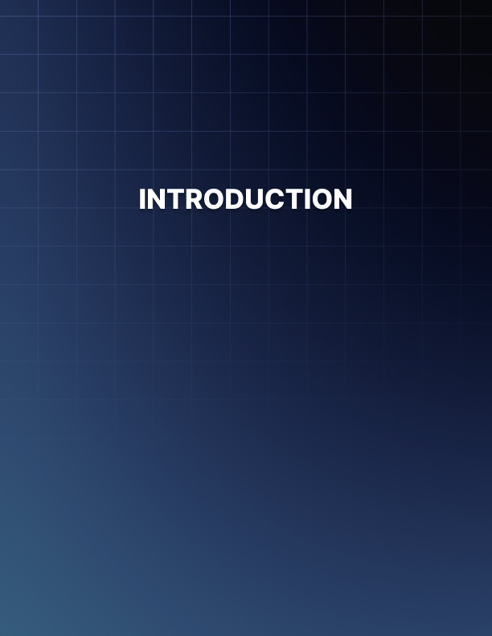

INTRODUCTION
____
In a crowded marketplace filled with ambitious entrepreneurs and innovative startups, how do you stand out? How do you ensure your voice rises above the competition? The answer lies in personal branding—a powerful tool that can turn you from just another business owner into a respected thought leader.
This book is more than a typical guide; it’s a roadmap designed to transform your business and career. By the end, you’ll have the insights to build a personal brand that sets you apart and propels you to the forefront of your field.
Imagine clients, partners, and investors seeking you out, drawn to your expertise and reputation.

Picture yourself confidently sharing your knowledge through speeches, podcasts, or written content, knowing that your words carry weight.

This isn’t just a vision—it’s a reality that awaits you as you dive into this guide. Inside, you’ll discover the strategies that have taken entrepreneurs from obscurity to stardom. With practical advice, real-world examples, and actionable steps, you'll learn how to craft a value proposition, leverage social proof, and network to build credibility.
This book is not just about theory—it’s filled with proven techniques you can apply immediately. You'll learn to create content that highlights your expertise, choose the right platforms to amplify your message, and build relationships that open doors to new opportunities.
As you read, your path will become clear. You'll start seeing yourself as more than an entrepreneur—you’ll become a thought leader whose opinions shape industry trends. Personal branding is about adding value, building trust, and making a lasting impact.
Get ready to level up your personal brand and, in turn, boost your business. Your journey to becoming a respected thought leader starts here. Let’s begin.

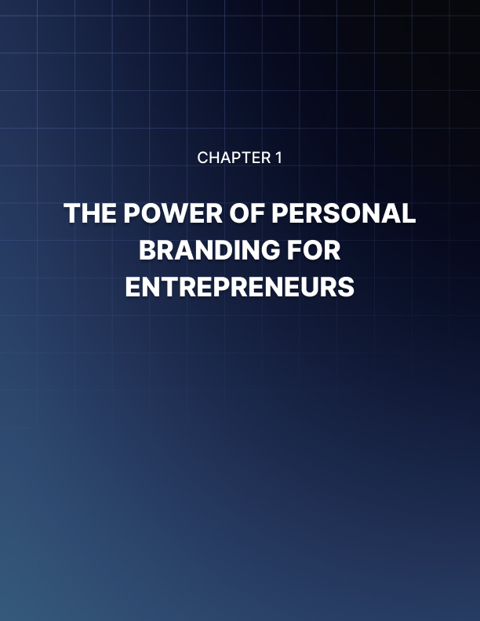

PERSONAL BRANDING FOR ENTREPRENEURS
____
Your personal brand is your secret weapon in the fiercely competitive business world. It's the intangible asset that sets you apart from the crowd, attracts opportunities, and opens doors you never thought possible. As an entrepreneur, you're not just selling a product or service; you're selling yourself. Your personal brand is the story you tell, the values you embody, and the unique perspective you bring to your industry.

Why Personal Branding Matters
A strong personal brand isn't just a luxury; it's a necessity in today's interconnected, information-rich world. It's what helps you stand out in a sea of competitors, build trust with your audience, and create lasting connections that drive your business forward. Think about the most successful entrepreneurs you know. Chances are, they have a strong personal brand that precedes them. They're not just known for their products or services, but for who they are as individuals. Their values, expertise, and unique perspectives are instantly recognizable. This is the power of personal branding, and it's a power you can harness to propel your own entrepreneurial journey.
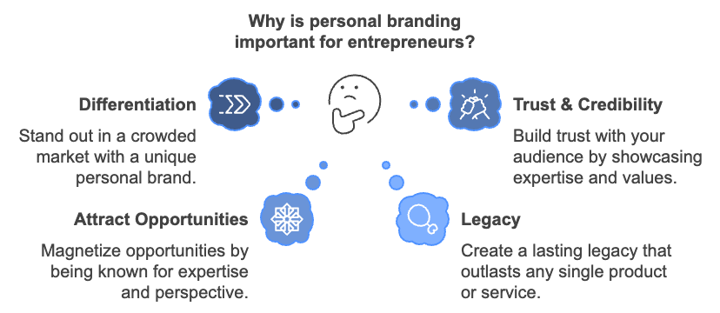

Let's take a closer look at why personal branding matters so much for entrepreneurs like you:
Differentiation in a Crowded Market
In today's saturated market, standing out is more challenging than ever. Your personal brand is what sets you apart from the competition. It's not just about what you offer, but how you offer it and why. Your unique experiences, perspectives, and values shape your brand and make it impossible for others to replicate. Consider the case of Gary Vaynerchuk, better known as Gary Vee. His personal brand is built on authenticity, hustle, and a no-nonsense approach to business. This distinct personality has helped him stand out in the crowded digital marketing space and build a loyal following of millions.
Building Trust and Credibility
Trust is the currency of business, and your personal brand is the bank that stores it. When you have a strong personal brand, you're not just another faceless entity; you're a real person with real expertise and values. This human element is crucial in building trust with your audience. Look at how Brené Brown has built her personal brand around vulnerability and courage. By sharing her own experiences and research, she's established herself as a trusted voice in leadership and personal development. Her authenticity has resonated with millions, leading to bestselling books, viral TED talks, and a thriving business.
Attracting Opportunities and Creating a Lasting Legacy
A strong personal brand acts like a magnet, attracting opportunities to you rather than you having to chase them. When you're known for your expertise and unique perspective, people come to you. This could mean new clients, speaking engagements, media appearances, or partnerships. Take Marie Forleo, for example. Her personal brand, centered around helping entrepreneurs build businesses and lives they love, has attracted numerous opportunities. From hosting web TV shows to writing bestselling books and creating online courses, her brand has opened doors far beyond her initial business coaching services. Your personal brand outlasts any single product or service you might offer. It's the legacy you leave in your industry and the world. By building a strong personal brand, you're creating something that can endure and evolve throughout your career and beyond. Consider the legacy of Steve Jobs. His personal brand, synonymous with innovation and design excellence, continues to influence Apple and the tech industry years after his passing. Your personal brand can have a similar lasting impact in your field.

Building Your Personal Brand
Now that you understand the importance of personal branding, you might be wondering how to start building your own. Here are some actionable steps you can take right now:
- Define Your Unique Value Proposition
Start by identifying what makes you unique. What experiences, skills, or perspectives do you have that others don't? What problems can you solve better than anyone else? Your unique value proposition is the foundation of your personal brand.
- Know Your Audience
Understand who you're trying to reach. What are their pain points? What do they value? Tailor your brand message to resonate with this specific audience.
- Craft Your Story
Your personal brand is essentially your story. Craft a narrative that highlights your journey, your values, and your vision. Make it authentic and relatable.
- Consistency is Key
Ensure your brand message is consistent across all platforms and interactions. From your website to your social media profiles to your in-person meetings, your brand should be immediately recognizable.
- Showcase Your Expertise
Share your knowledge generously. Write articles, create videos, speak at events. The more you share your expertise, the stronger your brand becomes.
- Network Strategically
Build relationships with others in your industry. Collaborate, share ideas, and support each other. Your network can significantly amplify your personal brand.
- Be Authentic
Above all, be genuine. Your personal brand should be a true reflection of who you are. Authenticity resonates with people and builds trust.
Building a personal brand is not about creating a false persona or bragging about your achievements. It's about strategically and authentically communicating your value to the world. It's about letting your unique light shine and using it to illuminate the path for others.

The Impact of Personal Branding
To illustrate the power of personal branding, let's look at a hypothetical case study:

Entrepreneur | Personal Brand Focus | Results
Sarah | Sustainable Innovation | 300% increase in client inquiries
John | Tech Simplification | 5 speaking engagements per month
Maria | Inclusive Leadership | 2 book deals and a TED talk

As you can see, a well-defined personal brand can lead to significant opportunities and growth in various aspects of an entrepreneur's career.
Your personal brand is the story you tell the world about who you are and what you stand for. It's the impression you leave on everyone you meet, both online and offline. It's the value you bring to your industry and the unique perspective you offer. In the chapters that follow, we'll dive deeper into the nuts and bolts of building and maintaining a strong personal brand. You'll learn how to craft your unique value proposition, create content that positions you as a thought leader, build credibility through social proof and networking, and evolve your brand over time.
Your personal brand is not set in stone. It will grow and evolve as you do. Embrace this journey of self-discovery and self-expression. Your personal brand is your most valuable asset as an entrepreneur. Nurture it, refine it, and watch as it opens doors to opportunities you never thought possible.
Take a moment to reflect on your current personal brand as you close this chapter.

What message are you sending to the world? How do others perceive you?
What aspects of your brand do you want to strengthen or change?

These questions will guide you as you continue reading and implementing the strategies in this book. Your personal brand journey starts now. Own it, take it on, and use it to fuel your entrepreneurial success. The world is waiting to hear your unique voice and experience your unique value. Are you ready to show them what you've got?
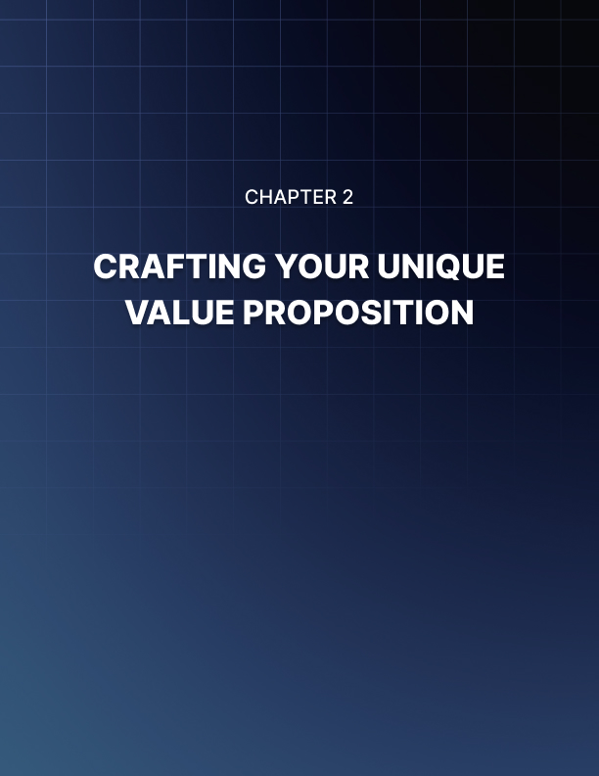

CRAFTING YOUR UNIQUE VALUE PROPOSITION
____
Your personal brand is the cornerstone of your entrepreneurial success. It's the unique blend of skills, experiences, and values that make you stand out in a crowded marketplace. At the heart of your personal brand lies your Unique Value Proposition (UVP) – a clear statement that describes the benefit you offer, how you solve your customers' needs, and what distinguishes you from the competition.
Crafting your UVP is not just about listing your skills or achievements. It's about understanding your core strengths, identifying your target audience, and communicating your value in a way that resonates with them. In this chapter, you'll learn how to create a compelling UVP that will serve as the foundation of your personal brand.

Understanding Your Core Strengths
The first step in crafting your UVP is to gain a deep understanding of your core strengths. These are the unique abilities, experiences, and perspectives that set you apart from others in your field. To identify your core strengths, reflect on what skills come naturally to you, what experiences have shaped your perspective, what others consistently praise you for, and what problems you solve better than anyone else. Take time to reflect on these questions. Don't rush this process – self-awareness is crucial for developing an authentic and powerful personal brand. Consider using assessment tools like the CliftonStrengths assessment or the VIA Character Strengths survey to gain deeper insights into your natural talents and strengths. These tools can provide objective data to compliment your self-reflection.

Identifying Your Target Audience
Your UVP isn't just about you – it's about how you can serve others. To craft an effective UVP, you need to understand who your target audience is and what they need. Ask yourself who can benefit most from your skills and experiences, what their pain points and challenges are, what their goals and aspirations are, and where they seek information and solutions. Conduct market research to gain deeper insights into your target audience. This could involve surveys or interviews with potential clients, analysis of industry trends and reports, studying successful competitors in your niche, and engaging in online forums or social media groups where your target audience gathers. The more you understand your audience, the better you can tailor your UVP to address their specific needs and desires.

Aligning Your Brand with Business Goals
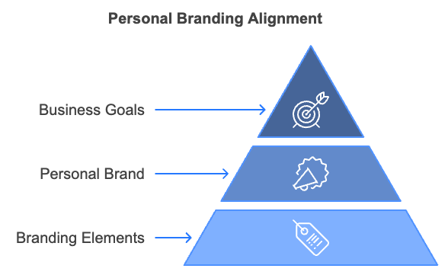
Your personal brand should not exist in isolation from your business goals. Instead, it should be a powerful tool that helps you achieve those goals. Consider what your short-term and long-term business objectives are, how your personal brand can support these objectives, and what aspects of your personal brand need to be emphasized to align with your business goals. For example, if your goal is to position your business as an innovative leader in your industry, your personal brand might emphasize your forward-thinking approach and track record of implementing cutting-edge solutions.

Crafting Your Unique Value Proposition
Now that you've identified your core strengths, understood your target audience, and aligned your brand with your business goals, it's time to craft your UVP. A strong UVP typically includes the specific benefit you offer, how you solve your customers' problems or meet their needs, and what makes you different from competitors.
Here's a simple formula you can use:
"I help [target audience] to [solve problems/achieve goal] through [your unique approach/skill]."
For example: "I help small business owners increase their online visibility and sales through personalized, data-driven digital marketing strategies."
Your UVP should be clear and concise, focused on benefits, not features, specific to your target audience, and distinctive from your competitors.

Communicating Your Unique Value
Once you've crafted your UVP, you need to communicate it effectively across all your brand touchpoints. This includes your website and social media profiles, your elevator pitch, your marketing materials, and your networking interactions. Consistency is key.
Your UVP should be reflected in everything you do and say, from the content you create to the way you interact with clients. Consider creating a brand style guide that outlines how your UVP should be communicated visually and verbally. This might include guidelines on language and tone of voice, visual elements like colors and fonts, and key messages and talking points.
Brand Element | Guidelines
Tone of Voice | Professional, approachable, confident
Color Palette | Primary: #003366 (Navy Blue),  Secondary: #FF9900 (Orange)
Typography | Headings: Montserrat, Body: Open Sans
Key Messages | "Innovative solutions for sustainable growth"
Key Messages | "Data-driven strategies for measurable results"
Key Messages | "Personalized approach for unique business needs"

Testing and Refining Your Value Proposition
Your UVP isn't set in stone. Growing as an entrepreneur and adapting to changing market conditions may require you to refine your UVP. Regularly test and evaluate your UVP by seeking feedback from clients and peers, analyzing the performance of your marketing efforts, and staying attuned to changes in your industry and target audience. Be open to making adjustments, but avoid frequent, drastic changes that could confuse your audience and dilute your brand.

Overcoming Challenges in Crafting Your UVP
As you work on your UVP, you might encounter some challenges. If you're not sure what makes you unique, seek feedback from colleagues, clients, and mentors. Often, others can see our unique strengths more clearly than we can ourselves. If your UVP sounds generic, be specific about your approach and the results you deliver. Use concrete examples or data points to illustrate your value. If you're afraid of limiting your opportunities, remember that a focused UVP doesn't limit you – it makes you more memorable and helps you attract the right opportunities. If your industry is saturated and you're wondering how to stand out, focus on your unique approach or perspective, not just your skills or services. Your personal story and values can be powerful differentiators.

Personal Branding in Entrepreneurship
Your UVP and personal brand are not just marketing tools – they're integral parts of your entrepreneurial journey. They influence the opportunities you attract, the partnerships you form, the pricing you can command, and the impact you can make in your industry. By investing time and effort in crafting a strong UVP and building a powerful personal brand, you're laying the foundation for long-term success and fulfillment in your entrepreneurial career.
Remember, building a strong personal brand is an ongoing process. It requires consistent effort, authenticity, and a willingness to adapt. But the rewards – increased visibility, stronger professional relationships, and greater career opportunities – make it well worth the investment. Moving forward in your entrepreneurial journey, let your UVP serve as your guiding star. It should inform your decisions, shape your offerings, and inspire your growth. Your unique value is your greatest asset – embrace it, communicate it, and let it propel you towards your goals.
In the next chapter, we'll explore how to leverage your UVP and personal brand through strategic content creation, positioning yourself as a thought leader in your industry. Get ready to amplify your voice and extend your influence!
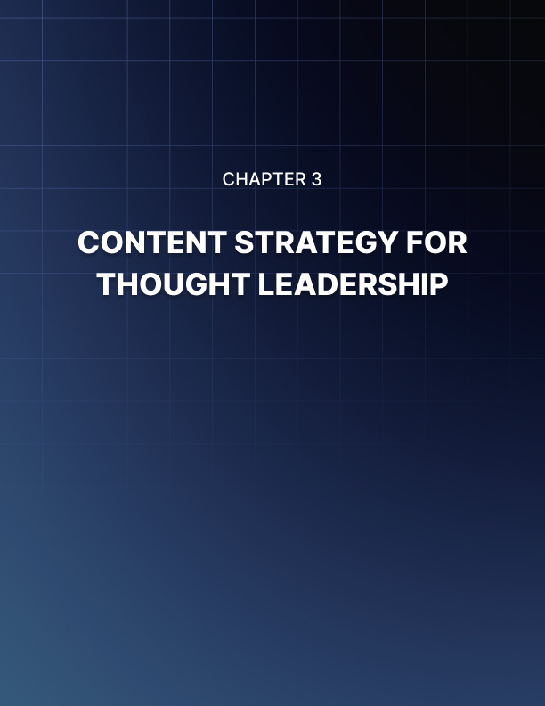

CONTENT STRATEGY FOR THOUGHT LEADERSHIP
____
Thought leadership is the pinnacle of personal branding. It's the point where your expertise becomes so recognized and valued that you're not just part of the conversation in your industry - you're leading it. As an entrepreneur, positioning yourself as a thought leader can open doors to unparalleled opportunities, from lucrative speaking engagements to game-changing partnerships.

Power of Content in Thought Leadership
Content is the vehicle that carries your ideas, insights, and expertise to your audience. It's how you demonstrate your knowledge, share your unique perspective, and provide value to your followers. High-quality, strategic content can establish your credibility and authority in your field, attract and engage your target audience, showcase your unique insights and approaches, build trust and loyalty among your followers, create opportunities for collaboration and partnerships, and drive traffic to your website and generate leads for your business. Remember, thought leadership isn't about being the loudest voice in the room. It's about consistently providing valuable, insightful content that helps your audience solve problems, gain new perspectives, or achieve their goals.

Developing Your Content Strategy
A successful content strategy aligns your expertise with your audience's needs and the goals of your personal brand. Start by clearly defining your niche. What specific area of your industry do you want to be known for? What unique insights or approaches can you offer? Your content should focus on this area, demonstrating your deep knowledge and innovative thinking. Understanding your audience is crucial. Who are you trying to reach with your content? What are their pain points, challenges, and aspirations? What kind of content do they consume, and where do they look for it? Use tools like Google Analytics, social media insights, and customer surveys to gain a deeper understanding of your audience. Setting clear goals is essential. What do you want to achieve with your content? Are you looking to increase brand awareness, generate leads, or establish yourself as a go-to expert in your field? Your goals will shape the type of content you create and how you distribute it.
Choose your content types wisely. Different types of content serve different purposes and appeal to different audience segments. Consider a mix of blog posts, articles for industry publications, videos, podcasts, infographics, whitepapers or ebooks, social media posts, and webinars or live streams. Choose the types that align best with your expertise, your audience's preferences, and your goals. Planning your content calendar is crucial for consistency, which is key in building thought leadership. Create a content calendar that outlines what you'll publish, when, and where. Aim for a mix of timely, topical content and evergreen pieces that provide lasting value.
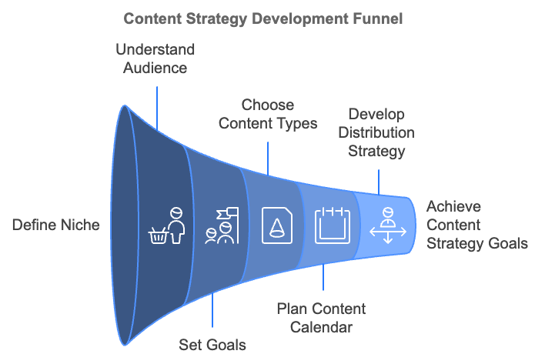
Developing a distribution strategy is just as important as creating great content. You need to get it in front of your target audience. Your distribution strategy should include sharing on your own platforms (website, blog, social media), guest posting on relevant industry sites, collaborating with other thought leaders, leveraging email marketing, participating in industry forums and discussion groups, and using paid promotion for high-value content.

Creating High-Quality, Engaging Content
Now that you have a strategy in place, focus on creating content that truly showcases your expertise and engages your audience. Every piece of content you create should provide tangible value to your audience. This could be practical advice, new insights, or a fresh perspective on industry trends. Ask yourself: "What will my audience gain from this content?" Be original in your approach. Thought leadership is about bringing new ideas to the table. Don't just rehash what others have already said. Offer unique insights based on your experience and expertise. Share original research or data when possible.
Storytelling is a powerful tool in content creation. Humans are wired to respond to stories. Use anecdotes from your own experience or case studies from your work to illustrate your points. Stories make your content more engaging and memorable. Always backup your claims with data, research, and expert opinions to support your arguments. This adds credibility to your content and demonstrates that your insights are grounded in fact.
Stay on top of industry trends and current events. Offering your perspective on recent developments can help establish you as a go-to source for insights on your industry. Consistency in both quality and frequency is crucial for building thought leadership. Set a publishing schedule you can maintain, and stick to it. Engage with your audience by encouraging discussion around your content. Respond to comments, ask for feedback, and be open to dialogue. This interaction can provide valuable insights and help build a community around your brand.

Leveraging Different Content Platforms
Different platforms offer different opportunities for showcasing your expertise. Your blog is your home base for thought leadership content. It's where you can dive deep into topics, share detailed insights, and build a library of valuable content. To maximize the impact of your blog, optimize your posts for SEO to increase visibility, use compelling headlines that grab attention and convey value, structure your posts with clear headings and subheadings for easy reading, and include calls-to-action to engage readers further.
Social media platforms allow you to share bite-sized insights, engage in real-time discussions, and reach a wider audience. Each platform has its own strengths: LinkedIn is ideal for professional content and B2B thought leadership, Twitter is great for sharing quick insights and participating in industry conversations, and Instagram and TikTok can be effective for visual content and reaching younger audiences. Tailor your content to each platform's strengths and audience expectations.
Podcasts offer a personal, intimate way to share your expertise. They allow you to dive deep into topics and showcase your personality. To succeed with podcasting, choose a specific focus for your podcast that aligns with your expertise, invite interesting guests to provide diverse perspectives, be consistent with your publishing schedule, and promote your podcast across your other platforms.
Video content is increasingly popular and can be a powerful tool for thought leadership. Whether it's short-form content for social media or longer YouTube videos, video allows you to connect with your audience in a more personal way. Consider creating how-to videos that showcase your expertise, offering video commentary on industry news and trends, and hosting live Q&A sessions to engage directly with your audience.
Guest content, such as writing for other publications or appearing on others' podcasts, can help you reach new audiences and build credibility. Look for opportunities to contribute to respected industry publications or collaborate with other thought leaders in your field.

Measuring the Impact of Your Content
To refine your content strategy and demonstrate the value of your thought leadership efforts, you need to measure their impact. Key metrics to track include website traffic and engagement (time on page, bounce rate), social media engagement (likes, shares, comments), email list growth and engagement rates, lead generation from content, media mentions and backlinks, and speaking or collaboration opportunities resulting from your content. Use tools like Google Analytics, social media insights, and email marketing metrics to track these KPIs. Regularly review your metrics and adjust your strategy based on what's working best.
Metric | Description | Importance
Website Traffic | Number of visitors to your site | Indicates reach and visibility
Engagement Rate | How users interact with your content | Shows content relevance and quality
Lead Generation | New potential customers acquired | Measures business impact
Media Mentions | References in other publications | Reflects industry influence
Speaking Opportunities | Invitations to present at events | Indicates thought leadership status

Overcoming Common Challenges
Building thought leadership through content isn't without its challenges. Time constraints can be a significant obstacle. Creating high-quality content consistently can be time-consuming. Consider batching your content creation, repurposing content across different formats (e.g., turning a blog post into a video), and outsourcing some aspects of content creation or promotion. When facing writer's block, keep a running list of content ideas, stay updated on industry news for inspiration, and ask your audience what they want to learn about. Staying consistent can be challenging, but it's crucial. Try creating a content calendar and sticking to it, setting realistic goals for content creation, and building a support system or accountability partner.
Building thought leadership is a marathon, not a sprint. It takes time, consistency, and persistence to establish yourself as a recognized expert in your field. But with a strategic approach to content creation and distribution, you can showcase your expertise, provide value to your audience, and position yourself as a thought leader in your industry. When implementing your content strategy, stay true to your unique voice and perspective. Your authenticity is what will ultimately set you apart and resonate with your audience.
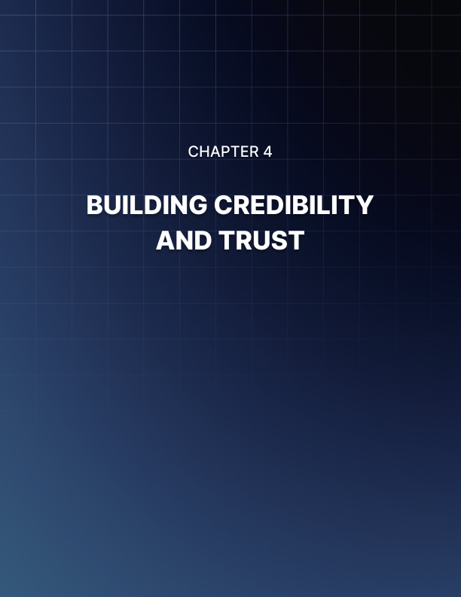

BUILDING CREDIBILITY AND TRUST
____
Trust forms the bedrock of any successful personal brand. In today's interconnected world, where information is abundant but attention is scarce, credibility has become a precious commodity. As an entrepreneur, your ability to build and maintain trust with your audience can make or break your success. This chapter will guide you through advanced strategies for establishing and reinforcing your credibility, leveraging social proof, and building a powerful network that amplifies your personal brand.

The Power of Social Proof in Personal Branding
Social proof is a psychological phenomenon where people assume the actions of others in an attempt to reflect correct behavior for a given situation. In the context of personal branding, social proof can be a powerful tool for building credibility.
Testimonials from satisfied clients or customers are one of the most potent forms of social proof. They provide tangible evidence of your expertise and the value you deliver.
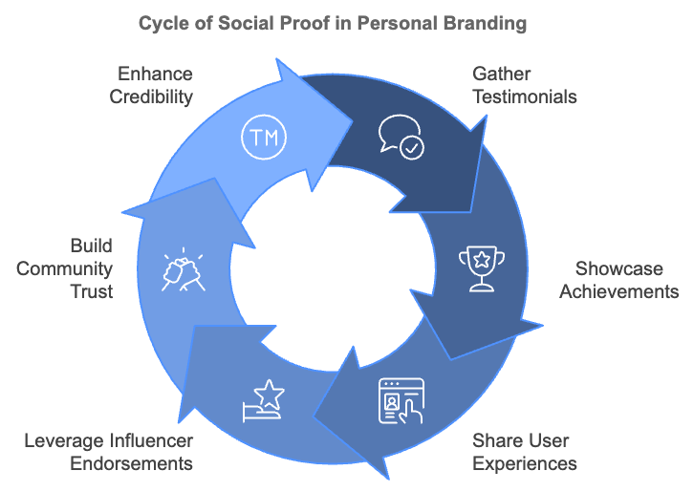

To maximize the impact of testimonials, seek detailed, specific testimonials that highlight concrete results, include the full name and, if possible, a photo of the person providing the testimonial, feature testimonials prominently on your website and marketing materials, and consider video testimonials for even greater impact. Case studies take testimonials a step further by providing an in-depth look at how you helped a client achieve their goals. A well-crafted case study should clearly define the initial problem or challenge, outline the solution you provided, detail the results achieved, and include quotes from the client throughout.
Endorsements from respected figures in your industry can significantly boost your credibility. These could come in the form of forewords or quotes for your book, testimonials on your website, or social media mentions and collaborations. To secure such endorsements, build relationships with industry leaders before asking for endorsements, offer value to them first, perhaps by promoting their work or providing insights, make specific, reasonable requests that align with their expertise and audience, and provide them with all the necessary information and make the process as easy as possible.
Industry awards and professional certifications serve as third-party validation of your expertise. They demonstrate your commitment to excellence and ongoing professional development. Some strategies for leveraging awards and certifications include displaying logos or badges on your website and marketing materials, mentioning relevant awards or certifications in your bio and introductions, sharing the news when you win an award or obtain a new certification, and explaining the significance of the award or certification to your audience.
Being featured in reputable media outlets or publishing in respected industry journals can significantly enhance your credibility. It positions you as an expert whose insights are valued by established platforms. To increase your media presence, develop relationships with journalists and editors in your industry, create a compelling media kit that showcases your expertise and unique insights, use services like HARO (Help a Reporter Out) to find media opportunities, and consider hiring a PR professional to help secure high-profile media placements.

Building a Powerful Network for Credibility
Your network can be one of your most valuable assets in building credibility and expanding your influence. A strong network can provide opportunities, offer support, and amplify your message. Strategic networking involves being intentional about who you connect with and how you nurture those relationships. Some tips for strategic networking include identifying key players in your industry and adjacent fields, attending industry events and conferences, engaging meaningfully on professional social media platforms like LinkedIn, offering value before asking for anything in return, and following up and maintaining relationships over time. Quality is more important than quantity when it comes to professional networking.
Collaborating with other respected professionals or brands can expand your reach and enhance your credibility. Potential collaborations might include co-authoring articles or books, co-hosting webinars or podcasts, creating joint products or services, and cross-promoting each other's work. When seeking collaborations, look for partners whose expertise complements yours, ensure there's mutual benefit in the collaboration, start with smaller projects to build trust before committing to larger ventures, and set clear expectations and agreements from the outset.
Joining or creating thought leadership communities can position you at the center of important industry conversations. These communities might take the form of professional associations, online forums or discussion groups, mastermind groups, or industry-specific social media groups. To leverage these communities effectively, contribute valuable insights regularly, engage with others' contributions, share relevant resources, and organize or participate in community events.
Taking on mentorship or advisory roles can significantly boost your credibility while allowing you to give back to your industry. These roles demonstrate that your expertise is valued not just by clients, but by other professionals and organizations in your field. To find mentorship or advisory opportunities, reach out to your alma mater or professional associations, offer to speak at or mentor in startup incubators, look for board positions at relevant non-profits or startups, or create your own mentorship program.

Maintaining and Evolving Your Credibility
Building credibility is not a one-time effort; it requires ongoing maintenance and evolution. Consistently delivering high-quality work and valuable insights is crucial for maintaining credibility. This might involve regularly updating your skills and knowledge, staying abreast of industry trends and developments, continually refining your processes and methodologies, and regularly seeking and acting on feedback from clients and peers.
In an age where information is readily available, transparency and authenticity are more important than ever. Be open about your processes, admit when you don't know something, and be willing to show the human side of your brand. This honesty builds trust and makes your successes more credible. No one is perfect, and how you handle mistakes or criticism can significantly impact your credibility. When faced with a mistake or criticism, acknowledge it promptly, take responsibility without making excuses, explain how you're addressing the issue, and share what you've learned from the experience. Handling challenges with grace and professionalism can actually enhance your credibility in the long run.
As your expertise grows and industry trends change, your personal brand should evolve too. Regularly reassess your brand positioning, messaging, and offerings to ensure they still align with your goals and resonate with your audience. While credibility can seem intangible, there are ways to measure its growth. Some metrics to consider include increase in inbound inquiries or referrals, growth in your professional network, invitations to speak at industry events, requests for media interviews or comments, increase in social media followers and engagement, growth in website traffic and time on site, and improvement in conversion rates for your offerings. Regularly tracking these metrics can help you gauge the effectiveness of your credibility-building efforts and identify areas for improvement.
Credibility Building Strategy | Key Actions
Leverage Social Proof | Collect testimonials, create case studies, secure endorsements
Build a Powerful Network | Strategic networking, collaborations, join thought leadership communities
Maintain and Evolve | Consistent value delivery, transparency, address mistakes, evolve brand
Measure Credibility | Track inbound inquiries, network growth, speaking invitations, media requests

Building credibility and trust is a critical component of a strong personal brand. Leveraging social proof, building a powerful network, and consistently delivering value helps establish you as a trusted authority in your field. Credibility is not built overnight; it's the result of consistent effort over time. But with patience and persistence, you can create a personal brand that commands respect, attracts opportunities, and makes a lasting impact in your industry.
When implementing these strategies, stay true to your values and authentic self. Your unique perspective and experiences are what make your brand truly valuable. By combining your authenticity with strategic credibility-building efforts, you'll create a personal brand that not only stands out but also stands the test of time.
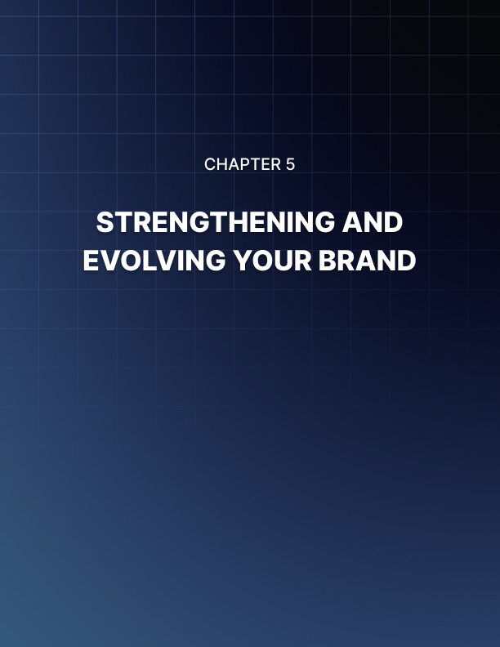

STRENGTHENING AND EVOLVING YOUR BRAND
____
Your journey to build a powerful personal brand has brought you to this pivotal moment. You've learned the importance of personal branding, crafted your unique value proposition, developed a content strategy for thought leadership, and built credibility through social proof and networking. Now, it's time to solidify your efforts and prepare for the ongoing evolution of your personal brand.

The Dynamic Nature of Personal Branding
Personal branding isn't a "set it and forget it" endeavor. It's a living, breathing entity that grows and changes as you do. The business world is in constant flux, with new technologies, market shifts, and changing consumer behaviors emerging regularly. Your personal brand must be agile enough to adapt to these changes while remaining true to your core values and unique strengths.
Think of your personal brand as a tree. The roots represent your core values, experiences, and skills - the foundation of who you are. The trunk symbolizes your unique value proposition, the central message of your brand. The branches and leaves represent the various ways you express and share your brand - your content, your networking efforts, your products or services. Just as a tree continues to grow and adapt to its environment, your personal brand should be in a constant state of growth and refinement.
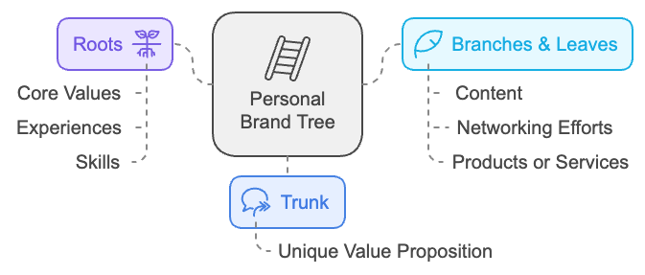

To ensure your personal brand remains relevant and impactful, it's crucial to conduct regular brand audits. These audits help you assess the current state of your brand, identify areas for improvement, and align your brand with your evolving goals and market demands. Start by revisiting your unique value proposition. Does it still accurately reflect what you offer and what sets you apart? Has your expertise expanded into new areas that should be highlighted? Consider seeking feedback from trusted colleagues, mentors, or even clients to get an outside perspective on how your brand is perceived.
Next, assess your online presence. Review your website, social media profiles, and any other digital platforms where your brand is represented. Are they consistent in messaging and visual identity? Do they effectively communicate your current offerings and expertise? Are you active on the platforms most relevant to your target audience? Evaluate your content strategy. Are you consistently producing high-quality content that resonates with your audience? Are you leveraging the most effective formats and channels for your message? Analyze engagement metrics to understand what types of content are performing best and adjust your strategy accordingly.
Finally, examine your network and partnerships. Are your current connections still aligned with your brand and business goals? Are there new relationships you should be cultivating? Consider how you can strengthen existing partnerships and forge new ones that will help elevate your brand.

Staying Ahead of Industry Trends
To maintain a strong personal brand, you must position yourself at the forefront of your industry. This requires a commitment to continuous learning and adaptation. Dedicate time for regular industry research, setting aside time each week to read industry publications, follow thought leaders on social media, and explore new developments in your field. Attend conferences and workshops, which not only provide valuable learning opportunities but also offer chances to network with other professionals and stay updated on industry trends. Engage in continuous professional development by considering additional certifications, taking online courses, or even returning to formal education to expand your knowledge and skills. Experiment with new technologies and platforms, being open to trying new tools that could enhance your brand or help you reach your audience more effectively. Seek out diverse perspectives by engaging with professionals from different backgrounds and industries to gain fresh insights and broaden your understanding of various business challenges.
With the growth of your expertise and the evolution of your industry, your brand voice and messaging may require refinement. Your brand voice should mature along with your professional growth, reflecting your increased knowledge and experience while maintaining the authentic personality that sets you apart. Consider how you can elevate your messaging to address more complex industry challenges or speak to a higher-level audience if that aligns with your goals. At the same time, ensure your language remains accessible and relatable to your target audience. Regularly review your key brand messages. Are they still compelling and relevant? Do they accurately reflect your current offerings and expertise? Don't be afraid to update your taglines, elevator pitch, or brand story as needed to better align with your evolving brand.

Expanding Your Brand's Reach
When your personal brand solidifies, seek opportunities to expand its reach and impact. This might involve seeking speaking engagements at industry conferences or events, writing a book or e-book that showcases your expertise, launching a podcast or YouTube channel to share your insights in a new format, developing online courses or workshops to share your knowledge with a wider audience, or collaborating with other brands or influencers to tap into new markets. Remember, expansion should be strategic and aligned with your overall brand goals. Don't spread yourself too thin by pursuing every opportunity that comes your way. Focus on initiatives that truly resonate with your brand and offer significant value to your audience.
Even the strongest personal brands face challenges. Perhaps a project doesn't go as planned, you receive negative feedback, or you face a public relations issue. How you handle these situations can significantly impact your brand's credibility and longevity. Transparency is key when facing brand challenges. Be honest about the situation, take responsibility where appropriate, and communicate clearly about how you're addressing the issue. View setbacks as opportunities to demonstrate your problem-solving skills and commitment to excellence. Use challenges as learning experiences to strengthen your brand. Analyze what went wrong, identify lessons learned, and share these insights with your audience. This vulnerability can actually enhance your credibility and deepen your connection with your followers.

Balancing Personal and Professional
As an entrepreneur, the line between your personal and professional brand can often blur. While this can be advantageous in many ways, it's important to strike a balance that feels comfortable for you and aligns with your overall goals. Consider what aspects of your personal life you're comfortable sharing as part of your brand. Sharing some personal details can help humanize your brand and build stronger connections with your audience. However, be mindful of maintaining appropriate boundaries. If you're building a business brand alongside your personal brand, think carefully about how the two intersect. Your personal brand can be a powerful asset for your business, but ensure that your business can also stand on its own merits.
Measuring the success of your personal brand goes beyond short-term metrics like social media followers or website traffic. While these are important indicators, long-term brand success is often reflected in less tangible outcomes. Consider tracking metrics such as the quality of opportunities (are you being approached for higher-level partnerships, speaking engagements, or business opportunities?), audience engagement (is your audience becoming more engaged over time, asking deeper questions, and showing a stronger connection to your brand?), industry recognition (are you being recognized as a thought leader in your field through awards, media mentions, or peer recognition?), financial impact (how is your personal brand contributing to your business success or career advancement?), and personal fulfillment (does your brand align with your personal values and long-term goals? Are you finding fulfillment in the work you're doing?).
Metric | Description | Example
Quality of Opportunities | Higher-level partnerships or engagements | Keynote speaking at major industry conference
Audience Engagement | Deeper interaction and connection | Increased comments and shares on thought leadership posts
Industry Recognition | Awards, media mentions, peer acknowledgment | Featured in Forbes "30 Under 30" list
Financial Impact | Brand contribution to business success | 20% increase in client acquisition attributed to personal brand
Personal Fulfillment | Alignment with values and goals | Sense of purpose and satisfaction in daily work

Future-Proofing Your Personal Brand
The only constant in business is change. To ensure your personal brand stands the test of time, you must build adaptability and resilience into its very foundation. Focus on timeless principles like providing value, maintaining integrity, and prioritizing relationships. Develop a growth mindset, embracing challenges and viewing them as opportunities for learning and growth. Build a diverse skill set, developing a range of skills that can be applied across various scenarios and industries. Cultivate a strong network that can be a source of support, opportunities, and insights to help you navigate changes in your industry. Stay curious about your industry and the world at large, driving continuous learning and helping you spot new opportunities. Regularly reassess and realign your brand, periodically stepping back to ensure it's still aligned with your long-term goals and values, and be willing to make bold changes if necessary.
Concluding this chapter, keep in mind that personal branding is an ongoing journey, not a destination. It's a continuous process of self-discovery, growth, and refinement. Each day presents new opportunities to strengthen your brand, connect with your audience, and make a meaningful impact in your industry. Embrace this journey with enthusiasm and patience. Celebrate your successes, learn from your setbacks, and always keep pushing forward. Your personal brand is a powerful tool for achieving your professional goals and creating the career and life you desire. Trust in your unique strengths, stay true to your values, and let your genuine passion shine through in everything you do. As you move forward, continue to invest in your personal brand. Stay curious, remain open to new opportunities, and never stop evolving. The effort you put into building and maintaining your personal brand will pay dividends in ways you may not even imagine. Your personal brand is your legacy. It's the mark you'll leave on your industry and the world. Make it count. Make it meaningful. Make it unmistakably you.



CONCLUSION
____
Throughout this book, you've explored the power of personal branding and its transformative impact on your entrepreneurial journey. Personal branding is more than just an asset—it’s your unique value, reputation, and the way you communicate with your audience. It sets you apart in a crowded market and opens doors to new opportunities.
You’ve learned how to craft your Unique Value Proposition (UVP), aligning it with your core strengths and target audience, ensuring that your brand resonates and stands out. Content strategy has been highlighted as a key component for establishing thought leadership, with insights on creating high-quality, engaging content that amplifies your message.
The importance of social proof, networking, and building credibility was also discussed. These elements are crucial for gaining trust and expanding your influence. By leveraging testimonials, endorsements, and partnerships, you can enhance your authority and visibility.
Your personal brand is dynamic—it grows as you do. The process doesn’t end once your brand is established; it requires continuous refinement and adaptation to stay relevant in a changing landscape. Staying ahead of industry trends, regularly auditing your brand, and expanding your reach through new platforms will be essential as you maintain and evolve your brand.
Moving forward, keep in mind that personal branding is not just about promoting yourself—it’s about creating value, fostering trust, and making a lasting impact in your industry. Continue to invest in your personal brand, stay true to your values, and let your authenticity shine through.
Your journey toward building a powerful and influential personal brand begins now. Keep evolving, remain adaptable, and never stop pushing the boundaries of what you can achieve. Your personal brand is your legacy—make it count.

