Disclaimer

This ebook has been written for information purposes only. Every effort has been made to make this ebook as complete and accurate as possible. However, there may be mistakes in typography or content. Also, this e- book provides information only up to the publishing date. Therefore, this ebook should be used as a guide - not as the ultimate source.

The purpose of this ebook is to educate. The author and the publisher do not warrant that the information contained in this e-book is fully complete and shall not be responsible for any errors or omissions. The author and publisher shall have neither liability nor responsibility to any person or entity with respect to any loss or damage caused or alleged to be caused directly or indirectly by this ebook.

Table of Contents

Introduction 6
Chapter 1: How To Choose A Podcast Niche That Fits You 8
People trust authority 8
Picking the right niche 9
Chapter 2: Branding Yourself For Success From The Start 13
What’s your podcast’s mission and vision? 13
Establish your podcast’s voice and personality 13
Consistency matters 14
Build a community around your brand 14
Chapter 3: Get Your Podcasting Equipment In Order 17
The most essential podcasting tools 17
Chapter 4: Plan Your Podcast Episodes With A Purpose 21
Commitment is key 21
Organizing your content 22
Chapter 5: Record And Edit Your Podcast Audio Like A Pro 26
Recording done correctly 26
Editing audio like a pro 27
Stitching your final audio file 28
Chapter 6: Finding A Suitable Host For Your Podcast 30
Using a web hosting service 30
Using a podcast or media hosting service 31
Chapter 7: Launch Your Podcast Like A Rocket Ship 34
Chapter 8: How To Plug Your Products And Services 38
Be subtle 38
Always give value 39
Give alternatives 39
Chapter 9: Growing Your Audience Like A Chia Pet 42
Reviews and ratings matter 42
Hold contests 43
Promote, promote, promote 44
Chapter 10: Getting Advertisers And Sponsors For Your Podcast 47
A solid following 47
Listener engagement 47
Your integrity 48
Customer service 49
Conclusion 51

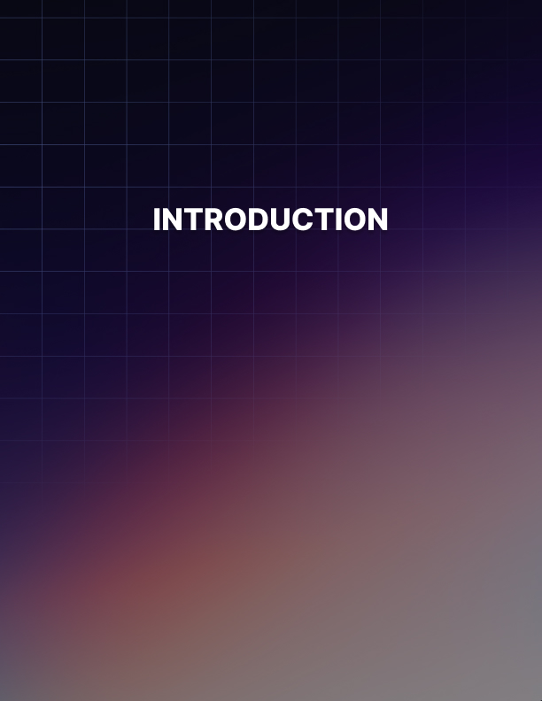

Introduction

Not too long ago, not a lot of people knew what podcasting was. But today, everyone’s talking about their favorite podcasts and sharing their thoughts on social media.

Unless you’ve been living under a rock, then you’ve probably listened to a few podcasts yourself. If you have, then you very well know podcasts make for great companions!

The beauty of podcasting is you may be busy with something else, but you’d still be learning something new. You could be driving to work or running the treadmill at the gym, and you’d be getting some useful tips from your favorite podcast show hosts. You’re not limited to sitting in front of your computer or staring at your phone’s tiny screen.

With podcasting, you have the freedom to listen to what you want, where you want, when you want, and how you want to listen! These are but a few benefits of listening to podcasts.

But what does podcasting mean to you as a business owner? Or as a content creator? And why should you put some serious thought into starting your own podcast?

Well, that’s what you’re going to find out in this in-depth guide!

Be ready to take down notes because I’m going to walk you through the
entire process of creating a successful and highly profitable podcast!

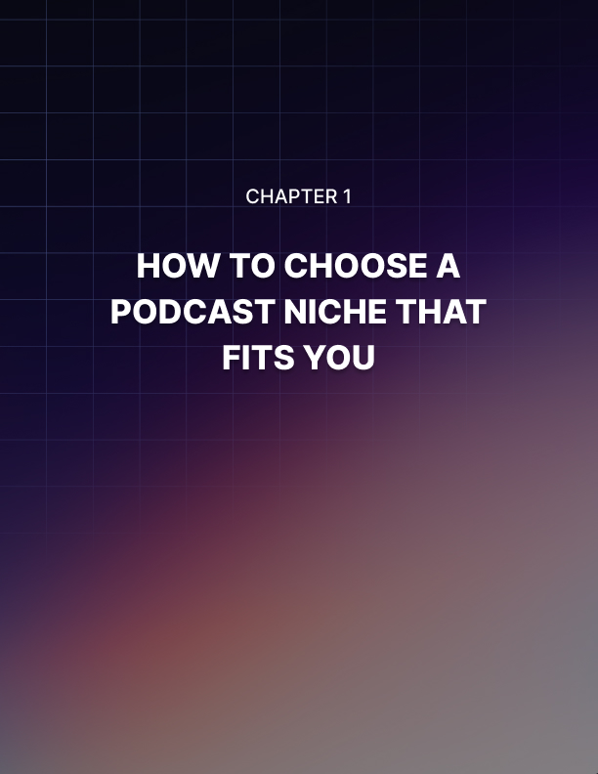

Chapter 1: How To Choose A Podcast Niche That Fits You

If you want to maximize your chances of success, then you need to find the perfect niche for your podcast. It might sound weird and counterproductive right now, but that’s really what you need to do.

You’re probably thinking, ’Why should I niche down when I can practically reach anyone, anywhere in the world with my podcast?’

Well, you see, there are hundreds of thousands of podcasts listed in various directories. How do you think you’re going to stand out? By being a jack-of-all-trades podcaster?

I don’t think so. In fact, I’m a hundred percent sure you’re not going to achieve success by publishing a podcast that talks about everything under the sun!

People trust authority
Niche-focused podcasts will ultimately get a lot more followers than those that don’t. This is because when you cover a specific niche, you’re able to present yourself or your brand as an authority.

For instance, if you want to be known as an email marketing genius, then you can start an email marketing podcast. If you know a lot about social media marketing, then you may want to start a podcast in this niche. If you love digital marketing and you want to create a digital marketing podcast, then you can publish episodes on various topics in this niche.

Whatever niche you eventually decide on, you can easily position yourself as an expert by sharing highly valuable tips and techniques with your listeners.

The point is that people love to listen to authority figures. When you select a niche, you need to stick to that niche. You create content that fits within your niche. Over time, people will come to realize that you’re true to your word and you really are an expert in your niche.

You can’t ever prove you’re an expert if you jump from one niche to another! You’re just going to end up confusing your listeners. For instance, they may have followed you because you gave out a lot of good advice in your social media episodes. However, over the next 10 episodes, you talk about auto-detailing or crocheting or fishing!

If you do this, then I guarantee you’ll have people unfollowing you and leaving bad reviews on your podcast. You’re literally going to throw your reputation and your brand under the bus. So, if you want to be recognized as an expert and as a trustworthy authority, then you need to pick the right niche.

Picking the right niche
Niche selection can either be straightforward or difficult. It all boils down to your needs and your preferences. If you want to take the easy way, then just pick a niche you love, something you know you can create tons of content on, and stick to that.

But if your life’s a bit more complicated, like for instance, you have a lot of different interests, then here’s a technique you can use to figure out the right niche for your podcast.

Step 1: Write down your interests and passions
What are you passionate about? What topics interest you the most? What industry are you most knowledgeable about?

Come up with a list of 5-10 potential niches. This step is extremely important because if you choose the wrong niche, then sooner or later, you’re going to lose interest in continuing your podcast. You’d run out of ideas to keep your show going.

Your disinterest and lack of passion are going to be evident in your show. People are astute listeners – most of us can tell when someone is passionate about a topic or not. So, if you want your podcast to succeed, then you need to get this step right.

Step 2: What problems can you solve?
Write down the problems you can solve in each of the potential niches you’ve identified in Step 1.

You can come up with possible problems off the top of your head (should be easy if you know the topic). But if you need more ideas, then there are
tons of resources you can check online.

You can go on Quora or Yahoo Answers and check out what kind of questions people are asking in your potential niches. Visit forums and social media groups as well.

These places provide lots of free information for anyone willing to look! You can even use Google Suggest and other keyword tools to determine if people are searching for solutions to specific problems.

Step 3: Figure out your competition
Whatever niche you decide on, you’ll most likely have some competition. Now, there’s no need to be afraid if you want to go after ’saturated’ or high- competition niches.

Figure out what everyone else is doing and see if you can come up with your own angle! That ’angle’ will be your edge, it will help you stand out from the crowd.

Check your competitor’s podcast. How many followers do they have? What topics are they covering? Do you think you can one-up them and do a much better job?

Step 4: Choose the right niche
Some people may say Step 4 should be devoted to checking if a niche is profitable. However, in most cases, this is unnecessary. Because with podcasting, there are many different ways you can monetize your podcast.

We’ll cover monetization later, but for now, you should know that selecting your niche and growing your audience are two of the most important things you should work on first. In short, monetization is something you shouldn’t worry about when you’re just starting a podcast.

With that said, the information you collected in Steps 1-3 should now give you an idea of your perfect niche. You probably have your gut telling you which niche is right for you.

Whatever it is, the important thing to note is that you MUST enjoy talking about your topic. Otherwise, you run the risk of losing your motivation to continue with your podcast a few weeks or months from now.

To sum up this chapter, take the time to figure out the right niche for your podcast, and you’ll be increasing your chances of success later on.

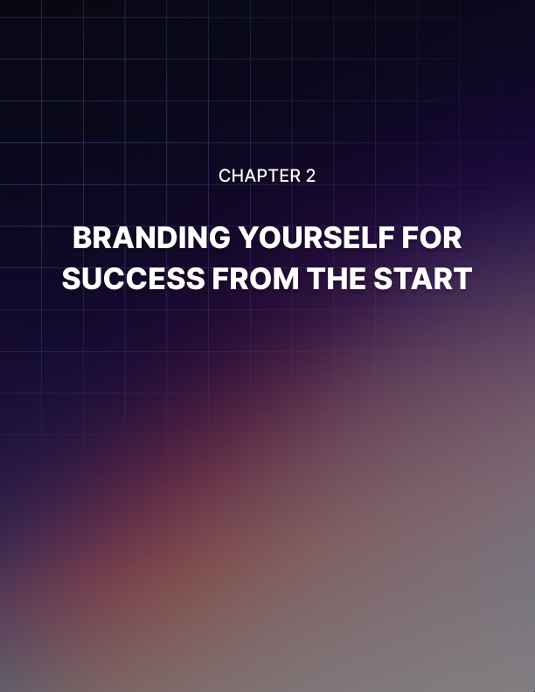

Chapter 2: Branding Yourself For Success From The Start

Branding is so much more than just choosing an awesome name for your podcast or designing the perfect podcast cover art. Branding is essentially how you want people to know your podcast. Build your brand just right, and you’ll reap the benefits for a long time to come.

What’s your podcast’s mission and vision?
It’s important to identify your podcast’s mission and vision when you’re just starting out. Knowing these will allow you to create the right kind of content. Before we go any further, let’s define what mission and vision statements mean.

Your mission statement outlines your podcast’s goals and how you intend to achieve those goals. Your vision statement, on the other hand, is what you want your podcast to become in the future. In short, your mission statement is all about the present while your vision statement is all about your podcast’s future.

With that said, you need to make sure every episode you publish is aligned with your mission and vision. This is how you build your brand, this is what you want to be known for.

Establish your podcast’s voice and personality
You’re unique and there’s no one else like you. You don’t want to sound like anybody else, but yourself. You’re your own special brand. So, how do you do that?

Well, you can start by acting as naturally as possible. When you’re recording your episodes, speak like how you would in real life. No one’s going to censor you, though, depending on your audience, you may wish to exclude some choice words from your vocabulary.
Unless, of course, you want your show to be known as the profanity- filled podcast on craft making or drop shipping or whatever your niche is!

You can also come up with a catchy tagline for your show. Think of a tagline that will represent your show well. Be unique. Be creative. Bring your voice and your personality to each of your episodes!

Consistency matters
Your branding activities shouldn’t be limited to your podcast. In fact, your brand should be consistent across all platforms you use. Whether it be your blog, your YouTube channel, or your Facebook fan page, your branding should remain consistent.

You can use your podcast cover art as a banner on your website, or you can use it as your profile picture on social media. The point is that you don’t want people to feel a certain disconnect when they find you on other platforms. You want people to recognize your brand wherever they go!

For example, you’re promoting your podcast on your blog. But when people visit Apple Podcast or Spotify or TuneIn, they don’t recognize your brand right away.

When they go on social media, you use a different name which leaves people even more confused. For best results, be consistent in your branding activities, and you’ll have people following you on multiple platforms!

Build a community around your brand
People love the feeling of belonging to a community. If you’ve ever listened to John Lee Dumas’ podcast ’Entrepreneurs On Fire,’ you’ll notice that he addresses his listeners as ’Fire Nation.’ That’s branding in action right there!

You can follow the same strategy once you’ve built a nice following for your podcast. If you’ve already got an established brand elsewhere, then you can simply call your listeners what you already call them on your other channels (if you’re not on other platforms, then you really should set up your profiles ASAP).

Building a community around your brand allows your listeners to feel like they ’belong.’ You build a relationship with your audience, you make them feel special.

Now, this is made possible when you do your homework up front, that is, you take the time to know who your listeners are. When you do this, you’re able to provide the right solutions to the right people!

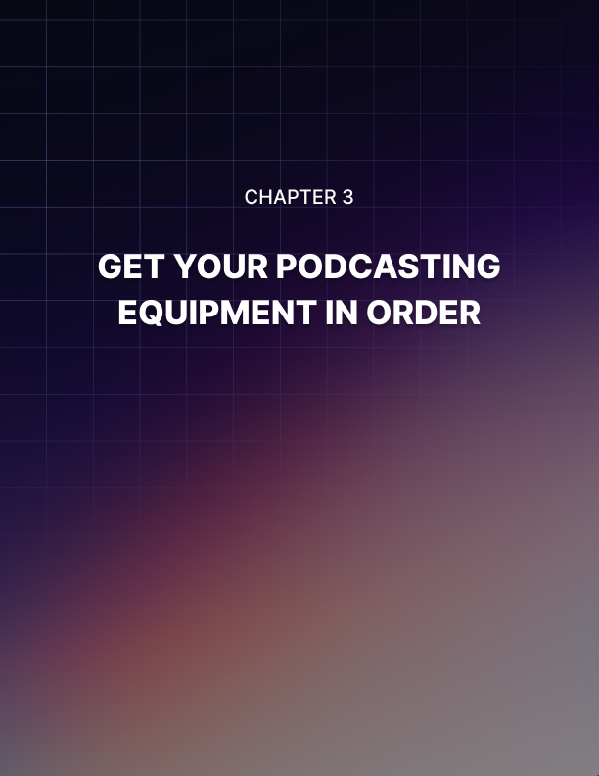

Chapter 3: Get Your Podcasting Equipment In Order

Your podcasting journey won’t be complete without getting the right equipment in order. And when I say equipment, I mean the kind of equipment you need to spend some money on. If you thought you could get away with spending nothing to start up your podcast, then you have another thing coming.

The truth is that while you don’t need to spend a small fortune on podcasting equipment, you’ll still need to spend some cash to get the ball rolling. When you’re just starting out, you don’t necessarily need the best tools that money can buy. In fact, many podcasters have managed to get by on less than $100 for their new shows!

The most essential podcasting tools
Here are some of the most important tools that you need to acquire or purchase. You don’t need to buy any of these brand new, you can go on Craigslist or eBay and get a huge discount on used podcasting equipment.

Don’t get me wrong though, a thousand-dollar setup will sound much different than a hundred-dollar podcast setup. There’s a reason why many podcasts sound good – that’s because they use the right kind of (expensive) tools!

- Microphone
You’re probably wondering, ’Why do I need to spend money on a microphone when my laptop’s got a built-in microphone?’ Or, you’re probably thinking you can use your phone’s microphone. You know what, you’re absolutely right!

If you’re really strapped for cash, you can use your computer or your phone’s built-in microphone. However, just don’t expect professional quality audio. That will be too much to ask honestly. Try it now, and check how it sounds.

What do you think? Do you think you sounded good? I bet not! Even if you recorded your voice in a quiet location, you'd still find your audio lacking.

So, really if you want your podcast to sound professional, consider buying a good microphone. Here are some affordable, but good quality, microphones:

Audio-Technica ATR2100 USB Microphone
>>https://www.amazon.com/Audio-Technica-ATR2100-USB-Cardioid-Dynamic-Microphone/dp/B004QJOZS4

Samson Q2U USB Microphone
>>https://www.amazon.com/Samson-Handheld-Microphone-Recording-Podcasting/dp/B001R747SG

You can’t go wrong with either of these Amazon’s Choice microphones. Both are priced well below $100 with hundreds of positive customer reviews!

The good thing with USB microphones is that you can just plug them directly into your computer and you’ll be able to record right away. No need to install any software. It’s as simple as that!

- Pop filter
Another thing that can make your audio sound good is a pop filter. Basically, what it does is it filters out the plosive sounds from consonants like d, p, g, and b. Without a pop filter, your audio will have popping sounds which can annoy your listeners pretty fast.

So, if you want to avoid that at all cost, get a pop filter. The good news is you can grab one off Amazon for under 10 bucks!

- Audio software
You need software that can record the input from your microphone. The good thing is you don’t need to spend hundreds of dollars for top-of-the- line digital audio workstations. There are a couple of excellent, free options you can use whether you’re on Windows, Mac or Linux.

Here are the top, free choices for many podcasters:

Audacity - http://www.audacityteam.org
Audacity is a full-featured, open source and cross-platform audio editing software. It may look intimidating at first, but as the saying goes, don’t judge a book by its cover.

It’s not as pretty as other software, but I promise it works exactly as advertised. You can record your entire show on Audacity, and then edit it later. If you want to add your intro and outro, you can also do that on the software.

You can add various effects to your recording as well. If you want to uncover everything that Audacity has to offer, you can check out their site. Browse YouTube as well because there are tons of tutorial videos from people who use Audacity on a regular basis!

Garage Band - https://www.apple.com/mac/garageband
If you’re on a Mac, then you don’t need to look any further than Garage Band. This awesome software comes pre-installed on Mac computers, so you shouldn’t need to download this anymore. However, if for any reason, you lost your copy, then simply click on the link above and download the software.

As with most things Apple, Garage Band is a looker. Audacity doesn’t come anywhere near its looks, but then again Audacity isn’t marketed as eye candy.

Garage Band, on the other hand, doesn’t just have a beautiful interface, but it’s also fully functional. You can easily create your intros and your outros on this software. To sum up, Garage Band is user-friendly, intuitive, and best of all, it’s free.

- Graphics software
You want your podcast to stand out from a sea of other podcasts. The best way to do this is by uploading an eye-catching podcast cover art. It’s what’s going to catch people’s attention.

If you upload a meh looking artwork, no one’s going to pay any attention to it. Instead, people are going to skip your podcast and check out other, more interesting-looking podcasts.

If you don’t know anything about art, then perhaps you may want to consider outsourcing your podcast cover art to a designer. Someone who actually knows their way around design, colors, typography, and so on. But if you don’t have the budget, then you can use software like Canva (https://www.canva.com) to create your own design.

There are tons of places you can use for design inspiration. Check out what podcast covers in your niche look like. Then think of a way to stand out.

For instance, if most of the podcast cover art in your niche is mostly in a shade of blue, then you may want to think about creating a cover in another color. That way, when you upload your art, you know people’s eyes are going to be gravitating towards your art simply because it stands out!

- Headphones
You may or may not opt to use headphones when recording your first episode. However, after listening to your recording, you’ll soon realize that you sound funny and different.

Well, if you want to hear what you sound like while you’re recording, then you better put on a good pair of headphones. You’ll be able to control your voice, volume, speed, etc. when you’re fully aware of how you sound and how your audience is going to perceive your voice.

It’s up to you if you want to use over-the-ear headphones or those in-ear ones. Whatever floats your boat. However, if you have guests over at your studio, then you may want to have some spare over-the-ear headphones as these are obviously more hygienic. And obviously, not everyone’s going to be comfortable putting on earphones that have been on somebody’s else’s ears!

Another benefit to owning a good pair of headphones is that you’ll be able to edit your own recording much faster. You’ll be able to hear everything; thus, you can easily remove unnecessary parts. You can cut out dead air, you can remove coughing noises, etc. In short, your headphones will be instrumental in achieving high-quality podcast audio!
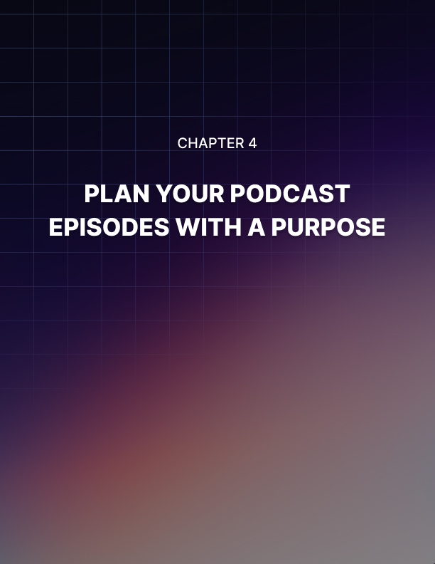

Chapter 4: Plan Your Podcast Episodes With A Purpose

If you don’t want your podcast to run out of steam, then you need to take the time to plan your podcast episodes for the weeks and months ahead. In fact, you can plan your episodes a full year in advance if you’re up for the job!

There are a ton of benefits to good planning. When you don’t think that far ahead because you think coming up with podcast topics is easy, then you seriously need to rethink your strategy.

Sooner or later, I guarantee, you’re going to run out of things to say, or you’ll be recycling the same ideas over and over again. When you get to that point, your audience is going to unfollow you in droves! Why? Because you’re no longer providing anything of value.

When you plan in advance, you’re able to basically get a bird’s eye view of your entire podcast’s content strategy. You can easily check if you’re still on the right path to fulfilling your mission and vision, or if you’ve somehow gone off the road. If it’s the latter, then you can make the necessary adjustments so that your next episodes fall within your show’s niche.

Commitment is key
No matter how well you plan out your podcast’s content strategy, if you don’t have the discipline or the commitment to stick to your plans, then you might as well just skip this part!

Seriously, one of the major roadblocks to many a podcast’s success is the lack of commitment. You don’t want to be one of those who lose hope and motivation the moment they come across some obstacles.

As you read this guide right now, I want you to promise yourself you’re going to stay committed to your goals, whatever they may be. If you don’t have a specific goal in mind for your podcast, well, there’s no better time to come up with one than now!
What are you hoping to achieve? Do you want to use your podcast as a marketing vehicle to get the word out about your brand? Or are you looking to turn it into an extra income stream? Perhaps you want to use it as a platform to generate highly qualified leads for your business?

Settle on a goal for your podcast and commit to it. Without commitment, your plans will be all for naught. So, get your head around it because podcasting is no easy thing. There’s a lot of work - and planning - involved. Without the right mindset, your podcast is not going to last very long.

Organizing your content
When it comes to content organization, there are many different ways you can go about it. If you’re the old-fashioned type, then you may be comfortable with the old pen and paper method. If you’re a bit techier, then there’s no shortage of apps that can help you out.

Here are some tried and tested techniques to get your content organized:

Content or editorial calendar
There’s a reason why editorial calendars have been around for ages - they work. For content creators like podcasters, bloggers, copywriters, social media managers, publishers, etc., a content calendar can literally mean the difference between success and failure. Whether you work alone or with a team, a calendar will help organize not just your content, but your life as well!

Now, there are plenty of different calendar apps you can use, both free and premium. However, one of the best ones you can possibly use to organize your new show’s content is Google Calendar (https://calendar.google.com). All you need is a Google account (and who doesn’t have one of those, eh?) and you’re good to go!

The awesome thing about Google Calendar is you’re not limited to using only one calendar. You can add as many calendars as you need and assign different colors to each calendar. So, for example, in your Google Calendar, you can add calendars for your podcast, your blog, your social media, your personal calendar, etc.

If you only want to view your podcast calendar, then simply untick all the other calendars you don’t want to see. If you want to invite guests over to your show, you can send them an invitation directly from your calendar!

Another great thing about Google Calendar is you can add a description to your calendar entry. Say, for episode no. 10, you want to talk about the importance of podcasting. You can write your notes, create an outline, or even attach files to support your notes for this particular episode.

As you can see, a content or editorial calendar is a very powerful tool. Use it to your advantage by planning your episodes in advance, and giving your followers the incentive to keep on listening to your shows!

Brainstorm episode topics
For brainstorming, you’re going to need to set aside a good amount of time (and preferably some quiet) to get your brain working. You can brainstorm alone, or you can ask your co-host(s), your team, even your guests to help you out!

There are several brainstorming techniques you can use. For group brainstorming, you can ask each person in the group to come up with ideas regarding a specific topic. You can have them verbally say it, and have someone write it down, or you can ask everyone to write their thoughts down, say, within 5 minutes. Usually, with group brainstorms, you may need to consider having an incentive in place to motivate everyone to think really hard.

For solo brainstorming sessions, you’d need to get creative, so you can think outside the box. There’s the associative brainstorming technique wherein you write down everything you associate with a particular topic.

Then there’s the word storm technique where you write down all the words you think of when you see another word.

If you’re a visual type, then mind mapping may be the right technique for you. You can show relationships between various ideas, and you can then come up with themes which you can discuss in a number of episodes.

Again, these are just some ideas to help get the ball rolling. Research your topic in-depth, ask questions on Quora and online forums, go out on the street and talk to people, and so much more!

Write an outline or script for each episode
Some people use outlines, while others prefer scripts. You can’t go wrong with either method. Having a structure in place for your episodes will help you get into the groove of things. It will be easy for you to flow from one point to another, one question to the next, and so on.

You’ll lessen the instances of needing to put your microphone on mute so you can think of the next thing to say. While you’re certainly free to edit your recording, just know that by working off of a structured outline or script, you’ll be saving a ton of time in the editing process.

If you’re not sure which method is good for you, then why don’t you try both? Work with an outline first, and then record an episode. See how long it takes you from writing the outline to the finished and edited audio. Then do the same thing with a script. See which one helps you work more efficiently. You don’t want to spend too much time editing, so it’s better to organize your episode’s content in advance.

It might take you a few episodes until you finally find the system that works for you. Don’t be afraid to experiment and try out new processes. We all work at different speeds. Figure out the perfect process and system that will help you crank out high-quality content on your show!

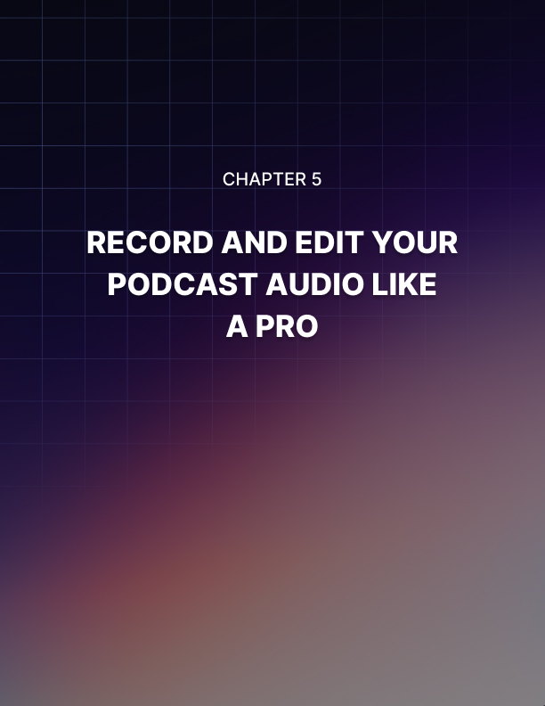

Chapter 5: Record And Edit Your Podcast Audio Like A Pro

Your podcast is going to be judged by the quality of your audio recording and your content. Assuming you’ve done your homework and researched your topic thoroughly, then the next thing for you to do is to record and edit your podcast audio like a pro. You want to make a good impression on your listeners. You don’t want to scare them away with an obviously sub- par and poorly edited podcast!

Recording done correctly
If you want to avoid hours upon hours of editing, then you need to record your audio correctly. Fixing recording mistakes is every podcaster’s nightmare, especially if there’s a lot to edit out! Sometimes, it may even be easier to just record the entire episode from scratch!

While an error-free recording may not be possible in your first few episodes, you can certainly minimize your editing time by following these techniques:

Record someplace quiet
Find a quiet place to record your episode. Close all doors and windows, put your phone on silent mode. Remember, you don’t need a lot of tools to record a show.

You can simply plug in your microphone (with a pop filter) to your laptop, put on a pair of headphones or earphones, hit Record, and start talking. That’s it!

But if you set up someplace noisy, you’ll have a tough time editing out all
that background noise later on.

Speak clearly into your microphone
Here’s where having a good headset will come in handy. Without it, you won’t know exactly how you sound. Are you speaking too softly? Too loudly? Can you hear yourself breathing and is it distracting you?

If you can’t hear yourself on your headphones, then you may need to tweak your recording software’s settings. The point is, with headphones, you’ll be able to adjust your tone, cadence, volume, etc. as you speak into your microphone.

Don’t share microphones
If you have a co-host or a guest over to record an interview, then make sure you use separate microphones. You may think it’s harmless to share a microphone, but editing the audio is going to be a huge time-drag! It’s going to be tough trying to level all the voices down to the same volume.

You’re probably thinking of a workaround even as you read this section. You’re thinking, ’How about if I put the microphone in the middle? That will help even out the voices.’

Well, you may want to put your theory into practice then, and see how much time you waste editing the file!

Do a test recording
You don’t want to launch into a 30-minute recording without doing some basic testing first. It’s very easy, in your nervousness, to forget to plug in the microphone to your laptop or audio mixer, or unmute the microphone!

You want to avoid these kinds of errors at all costs, so make sure you check everything - the microphones, the room’s acoustics, your recording software, your headphones, etc.

Editing audio like a pro
You want your listeners to have a good experience listening to your podcast. Often, your listeners will be busy doing something else while listening to your show.

If you annoy them with your heavy breathing, loud background noises, or a myriad of other annoying factors, then chances are they’re not going to follow your show. They’ll probably leave a bad review and then head on over to your competitor’s podcast.

Don’t just look at the audio’s waveform on your screen, it’s important to listen to the entire audio file, too. Obviously, the editing process will differ from one software to another, so go through your preferred software’s manual, if any, or check out tutorials on YouTube.

Editing your audio shouldn’t be too time-consuming provided you followed the tips I outlined above for top-notch quality recording sessions. Even if you followed everything to a T, it’s best to listen to the recording and make sure your audience is going to love listening to your voice (or at least, not hate it)!

Stitching your final audio file
When you’re finally happy with your (edited) recording, then it’s time to proceed to the next task – stitching your intro, outro, and main episode audio into a single audio file.

This audio file is what you’re going to upload to your podcast hosting service. This is the file that your followers are going to be listening to when they tune in to your show. So, make sure everything sounds good before you hit that Upload button!

The last thing you need to do before you upload your audio file anywhere is to add the metadata or ID3 tags. These details are necessary so that people can see important information about your show. They’ll see things like episode number, episode title, podcast name, summary, etc.

You can use free programs like EasyTag (https://wiki.gnome.org/Apps/EasyTAG) and MP3Tag (https://www.mp3tag.de/en) to add your podcast file’s metadata.

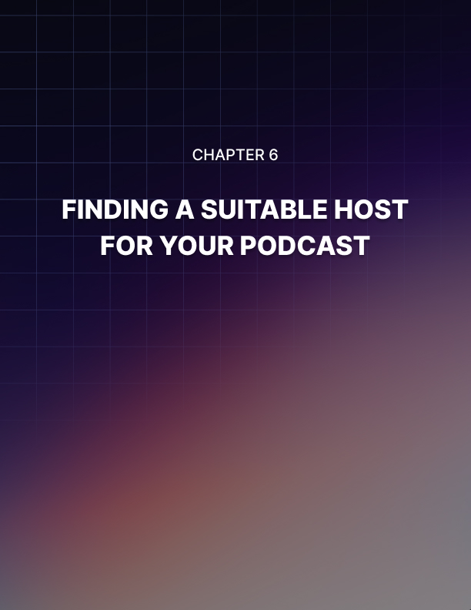

Chapter 6: Finding A Suitable Host For Your Podcast

Your podcast audio files need to be hosted with a suitable host so that your listeners can tune in and listen to your show. By ’listen,’ I mean stream or download your audio file. Now, the thing is that audio files can get quite big, depending on the quality of your recording and its length. So, you need a host that can accommodate your podcasting needs.

Using a web hosting service
Many web hosting services advertise ’unlimited’ storage space. However, if you read the fine print, you’ll notice that this space is supposed to be used for website files only.

Your podcast audio files are media files, they’re not website files. As such, uploading these to your web hosting server (especially if you’re on a shared hosting plan) can incur severe penalties or even possibly, termination of service.

The exception to this rule is if you’re on an expensive, dedicated web hosting plan, that is, you’re basically renting out an entire server from your web host. If this is the case, then you most likely will be able to upload your podcast files to your web server. However, each hosting company has their own Terms and Conditions, so it’s better to get in touch with them first than get in trouble later.

Another downside to using a web hosting service is that when your server goes down, then both your website and podcast are going to go down. So, people who are listening to you on iTunes or Spotify or wherever are going to get cut off.

Getting a 404 error on a website is annoying enough, not being able to stream your favorite podcast when you’ve been looking forward to it all day long is another thing entirely!

With that said, there’s a lot of wisdom to not keeping all your eggs in one basket. Keep your website and podcast files hosted separately, so if one service goes down, the other won’t be affected.

Using a podcast or media hosting service
There’s a reason why podcast or media hosting services exist. They’re not exactly competing with web hosting companies because they offer an entirely different service, one that’s optimized for hosting and serving large media files.

So, here are some of the benefits of hosting your show on a media hosting service.

Podcast RSS feed
Podcast hosting services are made for hosting audio files. In fact, they are optimized specifically for podcasts! This means they have built-in, validated RSS feeds and are
compliant with all major podcast directories, making the submission process extremely easy for their customers.

All you need to do is grab your RSS feed’s link and paste it into the podcast submission form on Apple Podcast, Google Music, Spotify, Stitcher, TuneIn, PodBean, SoundCloud, etc.

When you upload a new episode to your hosting account, then all directories where you’ve submitted your RSS feed will automatically receive the update. Your followers will also automatically receive your new episodes on their favorite devices!

Podcast statistics
Another important benefit of hosting your podcast with a media/podcast hosting company is you get access to your show’s statistics. This is something that’s missing from web hosting companies.

Depending on the company, you’ll gain useful data about your podcast audience. You’ll get info like total and unique downloads, the apps your listeners are using to tune in to your show, your traffic sources, the geographical location of your listeners, and so much more!

You don’t get detailed information like this from your web host. So, if you’re planning to get brands or businesses to sponsor your show and they ask you questions about your audience’s demographics, you won’t know what to say. But with a dedicated podcast hosting service, you’ll know the answers with just a few clicks!

Podcast page
If you don’t have an existing blog or website, then don’t worry. Many podcast hosting companies include a free podcast page. This is the place where information about your podcast lives – you can add your banners, your show notes, your social media channels, etc. The good news is, if you already have an existing blog, then you can link from your podcast page to your blog – this is great for your blog’s SEO!

Your podcast page will also include a free media player. People who visit your site from social media or Google can easily stream your show in their browsers. They also have the option to download, subscribe, and share your podcast.

Affordable plans
Of course, pricing is an important factor when it comes to choosing a suitable host for your podcast. The good thing is some hosts offer a free plan to those wanting to get their feet wet with podcasting.

A good example would be BuzzSprout (https://www.buzzsprout.com) which allows you to upload up to 2 hours of audio each month. Now the caveat is that a free plan can seriously limit your podcast’s growth and they’d only be hosted for a short period of time.

If you’re serious about growing your podcast, then it’s best to subscribe to a paid service. Basic plans can go as low as $3 on PodBean (https://www.podbean.com) and $5 on Libsyn (https://www.libsyn.com). If you need more storage or bandwidth, then you can simply move up to the next pricing tier with no downtime in hosting.

To sum up, the right hosting will save you from a ton of headaches and will help propel your podcast to success!

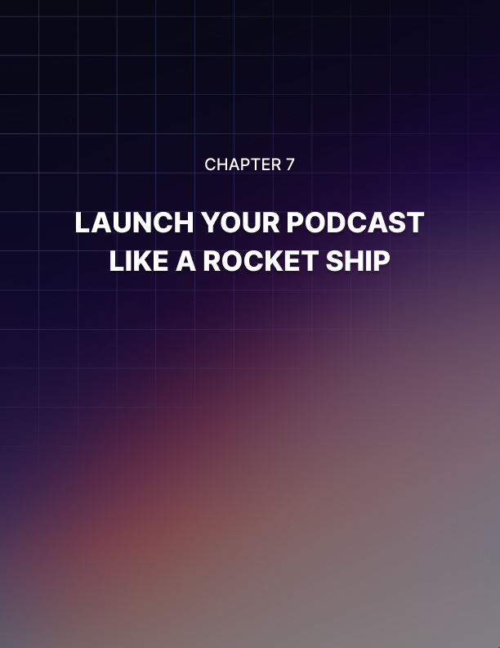

Chapter 7: Launch Your Podcast Like A Rocket Ship

At this point, you’ve recorded a few episodes for your show and uploaded it to your host. Now, it’s time to let the world know your awesome podcast exists and that they’re missing out on a lot by not following your show.

So, here are some tips you can follow to launch your podcast like a rocket ship:

Podcast directories
The first thing you need to do is submit your podcast to various directories. Some people may say you only need to be on iTunes or Apple Podcast and Google Play, but the truth is that if you want to reach as many people as possible, then you need to be where your listeners are.

That means submitting your show to Spotify, Stitcher, TuneIn, SoundCloud, and more. It’s not like you’re going to spend an entire week doing this! It's just a few hours’ work, and the potential ROI could be immense later on.

Your personal network
There are many different ways you can promote your podcast, but in the beginning, you don’t need to look very far. Look at your network of family, friends, colleagues, and acquaintances.

If you’re truly proud of the work you’ve created and you know you’ve given out a lot of value, then don’t be shy. I’m sure they’d love to help you out, so give them the opportunity to do so! They’d probably feel a bit hurt if you left them in the dark about your latest project and heard about it from somebody else.

Your personal network is important, not only to help get the word out about your podcast but also because they can be the first ones to leave reviews on iTunes. And as you know, we live in a review-driven world where people are more likely to follow a brand if they see positive reviews about that business.

So, take a deep breath and start reaching out to everyone in your network and ask them to leave an honest review or rating on your show.

Your blog
If you have an existing blog, then this should be relatively easy. Send out an email to your subscribers and let them know about your new show (Don’t have a list? Start building one!).

Write a blog post about your new podcast, put up banners on your site and link it to where people can listen or download your new episodes!

If you don’t have a blog, and you’re thinking you’ve already got a free podcast page included with your hosting, then that’s fine as well. However, just know that if you have problems with your host, then your podcast and your ’site’ will both be down! Likewise, if you decide to move your podcast somewhere else, then you’re going to lose that ’site,’ too.

Besides, there are a lot of benefits to having your own blog or website. It’s your very own web property so you can do pretty much whatever you want with it. You can write a lengthy blog post about each podcast episode, you can upload your show notes or even the entire transcript!

If you upload your podcast video to YouTube, then you can also embed that in your blog post, so your site visitors now have multiple options to consume the same content – they can read it, they can listen to it, or they can watch it! The fact of the matter is, your blog is your online home so you can design and present your content any way you like!

Get an influencer to promote you
Another popular option nowadays is called influencer marketing. These are basically people or brands who have a considerable following on their social media channels, podcasts, blogs, etc.

When they promote or endorse something, their followers will usually go check out and follow their advice.

However, sometimes, some scammers will attempt to inflate their follower numbers by using bots or fake accounts to ’follow’ them. In that case, you’re not going to get a ton of engagement on your ad. So, do your research and steer clear of ’influencers’ who get low engagement from their posts and shout-outs!

Interview experts
People love being recognized as ’experts.’ So, if you know of anyone you think can add value to your show, then reach out to them and ask if they’d be willing to be interviewed.

Now, there are all sorts of ’experts.’ Some experts have a lot of followers, while others are just getting started. At this point in your podcast, you should ideally want to interview experts with an established and loyal fan base. Why? Because if those experts promote your show to their followers, then chances are, they’re going to check you out, too! A number of them may even decide to follow your show if they like your content.

Don’t forget to send your experts the link to where they can listen to their episode. To make it easy for them to promote your show, send them a customized swipe file of social media posts, emails, scripts, etc. they can use to send to their followers.

You want them to feel special, so make sure their names are mentioned on the swipe file. Don’t forget to thank them for guesting on your show and for helping you spread awareness about your new show.

If they want to return the favor and interview you, then let them. That’s one quick way you can establish your expertise in your niche, and of course, you’ll most likely be given a chance to promote your own show!

Pay for ads
Facebook Ads is often touted as a cost-effective way to reach audiences. And if you know what you’re doing, it’s certainly true. You can get clicks, comments, likes, and engagement from your audience for cents on the dollar. But, if you don’t know your way around Facebook Ads, then that’s okay.

There are other platforms out there that will be more than happy to promote your show – for a fee, of course. Just remember that if you don’t want to burn through your cash, then you MUST go after the people who are most likely to listen to your show. Knowing who your audience is is key to succeeding in paid ads!

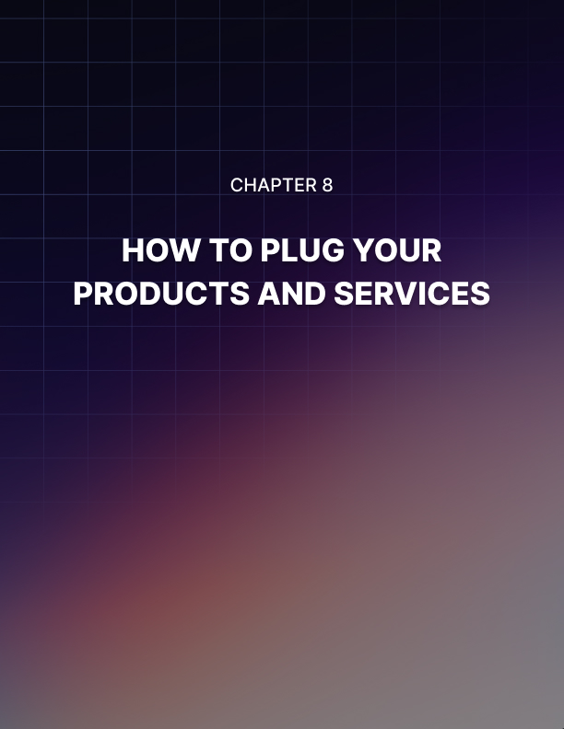

Chapter 8: How To Plug Your Products And Services

Plugging your products and services on your show is perfectly acceptable. It is your own show, after all. No one’s going to come after you and penalize you if you do a bit of self-promotion. The barrier to entry to podcasting is low, so basically, anyone with the guts to record themselves speaking and upload it to the Internet can become a podcaster. However, there are certain tips you need to observe if you want to get the most out of your podcast and get a good conversion rate.

Be subtle
In the beginning, when you’re just fresh off your podcast launch, and you’ve only got a few episodes to your name, then I don’t recommend getting too salesy right away. In fact, it’s a big no-no. Your listeners are only starting to get to know you. If you try to make a sale right away, then you’re going to lose out big time.

You’re probably thinking, ’But my time is valuable. The information I’m sharing is valuable. I don’t want to give it away for free.’

Well, guess what. In the podcasting world, this isn’t how it works. If you want people to trust you, then you’re going to have to be subtle about selling.

Here’s an example:
If you’re selling a course or book on your blog, Amazon, Udemy or wherever, then you can add that information to your podcast’s intro and outro. In the introduction, you can welcome your listeners to the show and give a bit of background about yourself.

Tell them you’re the author of a bestselling course on Amazon and Udemy, and that people can check the show notes for more information about it. Then go straight to your show’s topic.

When you conclude your show, again remind your audience that you’re the author of so-and-so and to check out the link in the show’s description or notes.

See, that wasn’t so salesy, was it? You’re basically just letting your audience know you’ve written a course, but you’re not being pushy about it. Use the right tone, and you’ll get people curious enough to check out the link to your awesome course. That’s it!

Always give value
Used car salesmen often get a negative reputation for being too aggressive and too pushy. All they care about is making the sale and meeting their quota, they don’t particularly care if the car is a good fit for your needs or not.

If you don’t want to be identified as such – and lose all your followers in the process – then you need to always put your audience’s needs before yours.

If you were in their shoes, you’d hate to be sold to, too. So, you need to do it in a subtle manner. How? By addressing your audience’s pain points and solving their problems. And by offering your products and services as the right solution.

Don’t just say, ’Buy my product today!’ Why should they listen to you and do as you say?

Explain the benefits they’re going to get if they buy your product today.
Tell them how your product can potentially solve their problems. Give them a step by step guide to using your product or service so they can achieve your promised benefits.

If you follow this strategy, you’ll notice that you’re not actually selling anything to your audience. Rather, you’re teaching them how your products or service can make their lives better and how it will make their problems go away. In the long run, this strategy is going to help you increase conversions and get even more people to buy from you.

Give alternatives
Now, if you’re only selling a single product or service, then there may be certain episodes where the topic may not be a good fit for your product or service. In this case, don’t be afraid to promote something else – you can promote affiliate products or even your competitor’s products!

You want to help people, right? So, if your competitor’s products make sense, then don’t be afraid to promote it! You’ll get a ton of respect from your audience because it will show that you truly care about them, and aren’t just after getting more sales for your own products!

You can also reach out to your competition and tell them about your show and how you helped promote their product. Don’t expect anything back, just a friendly message will do. Who knows, they may even promote your show to their customers and fans!

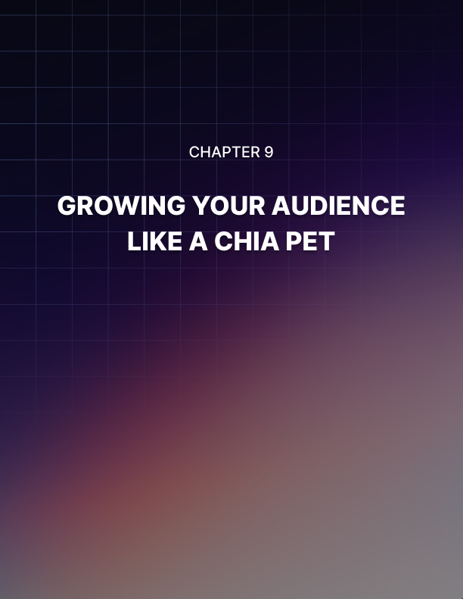

Chapter 9: Growing Your Audience Like A Chia Pet

If you’ve ever tried growing a chia pet, then you’d know how fast the seedlings sprout and grow. Now, the thing is, you want your podcast audience to grow the same way. However, this is easier said than done.

Similar to caring for a chia pet, you also need to be consistent with your podcast if you want to achieve success. Whether you publish episodes weekly, bi-weekly, or even daily, you need to be consistent about it.

The more people listen to your show, the hungrier they’ll be to consume your value-laden content! They’ll expect your new episodes on days you promise to publish, and they’d incorporate listening to your show into
their routines.

For instance, if you publish a new episode every Monday, then your followers are going to be expecting a new one to appear on their favorite app on Mondays. They’ll be tuning in to your show every Monday on their way to work or while they’re taking their dog out for a walk.

Sooner or later, it’s going to become their habit. And that’s a good thing because it means you’ve got a loyal following! So, whether you like it or not, you need to always have something published on Mondays.

This is why recording your episodes in advance is so important, it will give you some buffer time and some room. If you need to go on holiday or there’s an emergency, you can simply upload a pre-recorded episode!
You’re not going to be held hostage by your podcast so your life can go on like normal.

Reviews and ratings matter
Trying to get people to follow a podcast with no ratings or reviews – or worse, negative reviews! – will be a bit like pulling teeth. It’s going to be difficult. This is because nowadays we’ve become so dependent on other people’s reviews that whenever we see something that hasn’t been reviewed yet, we become hesitant even to try it out.

The same thing goes for new podcasts. You’ll rarely come across people who are going to willingly listen and follow a new podcast without any evidence of it being good.

So, do make it a point to ask your listeners to rate or review your show. If, for any reason, you get a negative review, then you’ve got a few options. You can respond respectfully, or you can flag the review and ask iTunes (or wherever the review was left) to remove it. This is especially useful if you suspect it’s a smear campaign and someone’s trying to sabotage your show (yes, unscrupulous people do this to their competitors).

For valid, negative feedback, do your best to learn from it. Try and see how you can improve the quality of your show and your content. If someone gave you a 1-star rating and said your audio sucks, then take that as constructive criticism and make sure your future episodes sound great!

Also, it’s important to mention that the bigger your audience and the more popular your show, the more likely it will be that you’re going to get negative reviews. The sad truth is that you just can’t please everyone, no matter how hard you try.

So, just do your best and take your 5-star reviews to heart. Use these as inspiration to keep on going. Look at your podcast statistics. If you consistently get a good number of streams and downloads per episode, then it means you’re doing something right!

Hold contests
One of the easiest ways to grow your audience is by holding a contest among your listeners. The contest can be for a number of things – you can hold a contest for the best review, the most creative post on Facebook, the best tagline for your show, etc.

Your contest should be designed according to what you want to achieve. If you want to get more reviews on iTunes, then let that be your goal. Think of ways you can get your listeners to actually take the time to review your show.

Your giveaway or prize should be something valuable to your listeners to make it worth their while. For example, if you’re selling an online course, then you could give the winner free access to your course!

You’re not even limited to choosing only one winner. To make the contest even more fun, you can give away 10 t-shirts with your podcast’s logo on it, or you can take them out to lunch or dinner for that personal touch (if they live near you).

Whatever prize you choose, you can say that the winner will be named on your show. You can even say they’d also get a chance to be interviewed if they want, or they can have 60 seconds to promote their own business, or something along those lines.

Promote, promote, promote
According to experts, you should only spend 20 to 30% of your time on content creation, and the rest needs to be spent on content promotion. Whether you agree or disagree with this statement, you can’t deny the fact that without consistent promotion, your audience is not going to grow.

As a content creator, you want your voice to be heard. You want your target audience to benefit from your podcast, you want to help them. If you’re not getting through to the people you want to help, then you need to rethink your marketing strategy.

But, how do you seek out your target audience?

Well, first of all, you need to know who your target audience is so you’d have an idea of where they usually hang out. For instance, if you’re targeting the younger generation, then you’ll most probably find them on social platforms like Facebook, Instagram, Snapchat, Reddit, etc. But if you’re targeting the older generation, then they may be hanging out elsewhere. They could be on Facebook, on Pinterest, forums, etc.

Once you’ve identified where your audience mainly hangs out, then you need to find ways to reach them and put your content in front of them.

Here’s a tip:
If you have a website, then you can install the Facebook Pixel on your site. Every time someone lands on your site, they get ’cooked’ which means that you can retarget them later with Facebook Ads. These people are ’warm’ leads, that is, they’re already familiar with your brand. So, it will be relatively easier to convince them to follow your Facebook Ads call to action. This is great if you’re running campaigns to get people to check out your new podcast episodes, or if you’re selling something on your site.

Just take note that marketing to ’warm’ leads is not the same as targeting ’cold’ leads or people who’ve no idea who you are or what it is you do. Either way, provide these two types of audiences an incentive they can’t refuse, and you’d soon see some significant growth in your podcast following!

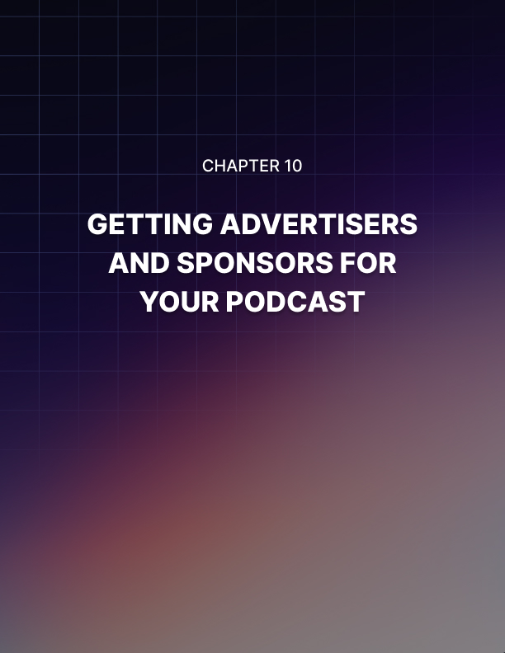

Chapter 10: Getting Advertisers And Sponsors For Your Podcast

Creating a new podcast with money on your mind is probably not going to bode well for you or your show. You don’t want to be motivated by money or greed. Instead, the right approach is to build a loyal community of people who will love your show as much as you do.

Your show is for your target audience, it’s about helping them out with their problems and their issues. Don’t put a price tag on their heads because that can seriously backfire on you.

So, here are some tips to help you attract the right advertisers and sponsors for your podcast:

A solid following
When you’ve grown your podcast audience to a respectable number, say 5,000 to 10,000, then you may now start thinking about getting advertisers and sponsors on your show. The more followers you have, the more opportunities and possibilities you have at your disposal.

In the beginning, you may need to reach out to sponsors, but when your show starts to become popular, you’ll have them begging you to take them on as sponsors. This is a nice ’problem’ to have, right?

So, do your best to grow your audience to a good number, and you’ll be
rewarded with a problem your competitors are going to be jealous of!

Listener engagement
What are people saying about you? How engaged are your listeners? These are but some of the questions your sponsors are going to ask about your show. They do want to make sure they’re going to get their money’s worth, after all.

They’ll check your reviews on iTunes and any other place you’ve submitted your podcast to. If you have social media pages for your podcast, then your potential sponsors are most likely going to check it out. If you have a blog, they’ll most likely check your blog comments, too.

Depending on the niche, some sponsors may even contact you and ask to sponsor your show even if you’ve got a relatively small audience size.
This may be because they believe your audience is perfect for their brand, or they think your listeners are engaged enough to give their brand some of their attention. But this is the exception, not the rule.

In most cases, sponsorship is a numbers game. The more followers and the higher the ratings, the more likely it is that sponsors are going to want to advertise with you.

Your integrity
No matter how popular your show is, if you don’t have a lot of integrity to your name, then it’s going to be a major red flag for potential sponsors. No one’s going to give you their money if they think you can’t be trusted with it.

Honesty and integrity can’t ever be underestimated. When your reputation is on the line, your integrity can spell the difference between success and failure, so make sure you protect your name, your brand and your show.

When you live your life with integrity, building lasting relationships with sponsors is possible. You’re not just out to get their money. If, for any reason, you don’t think they’re a good fit for your audience, then say so.

Perhaps you can even give them suggestions to develop a product or service that will benefit your audience. That will certainly tell your sponsors you care more about your listeners than money. That speaks volumes about the kind of person, podcaster, and business person you are!

You may ’lose out’ on some sponsorship money, but you won’t be alienating your listeners by entertaining sponsors that don’t add any value to your show. This is a very common mistake among podcasters who are far too focused on the amount of revenue their show generates.

In the long run, everyone will win. You win because you didn’t sell out your integrity for money. Your audience wins because they continue to get a ton of value from your show. Your sponsors win because they’re getting their money’s worth.

Customer service
Whether you like it or not, when you take on a sponsor for your show, you need to do some customer service. If you’ve ever been on the receiving end of good customer service, then you know how good you feel when you receive excellent service. You feel valued, you feel special. And that’s the kind of feeling you want your sponsors to have when doing business with you.

When you’re an up-and-coming podcaster, you may not have a lot of negotiating power yet. So, one thing you can do to make your sponsor happy is by under promising and over delivering! The opposite (over promising and under delivering) will only disappoint and probably anger your sponsors, so it’s best to always try to exceed your sponsor’s expectations.



Conclusion

Profiting with your podcast is certainly possible, but it’s going to take some time. Podcasting is far from being a get rich quick scheme. If you want to succeed, you need to take the time to know the ins and outs of this medium.

You need to commit yourself to create a podcast that your target audience will love. Grow and nurture your audience, and you’ll soon see significant profits with podcasting.

