TABLE OF CONTENTS
____
INTRODUCTION 5
UNDERSTANDING SMS MARKETING 8
The Power of SMS Marketing 8
Types of SMS Campaigns 9
Addressing Common Concerns 10
Key Statistics and Best Practices 11
Success Stories and Future Potential 11
CRAFTING COMPELLING MESSAGES 14
The Power of Words in 160 Characters 14
The Anatomy of an Effective SMS 14
Techniques for Attention-Grabbing Texts 15
The Art of Persuasion in SMS 16
Personalizing Your Messages 16
Crafting Effective CTAs 17
SEGMENTING YOUR AUDIENCE FOR MAXIMUM IMPACT 21
The Power of Audience Segmentation 21
Effective Segmentation Techniques 22
Data Collection and Analysis 23
Dynamic Segmentation and Real-Time Adaptation 24
Case Study: The Power of Segmentation in Action 25
Implementing Your Segmentation Strategy 26
ENSURING COMPLIANCE IN SMS MARKETING 28
The Critical Importance of Legal Compliance 28
Understanding Key Regulations 29
Obtaining Proper Consent 30
Providing Clear Opt-Out Options 31
Maintaining a Compliant Contact List 32
BOOSTING ENGAGEMENT, SALES, AND CUSTOMER RELATIONSHIPS 38
Integrating SMS Marketing with Your Overall Strategy 38
Advanced SMS Marketing Tactics 39
Key Performance Indicators and Analytics 41
Experimenting and Refining Your Approach 42
Overcoming Common Challenges 43
CONCLUSION 46

DISCLAIMER
____
The information provided in this ebook is intended solely for educational and informational purposes. The author does not accept any responsibility for the outcomes that may arise from the application of the material within. While efforts have been made to ensure the accuracy and relevance of the content, the author cannot be held accountable for any errors or omissions, or for any consequences resulting from the use or misuse of the information provided. The responsibility for any actions taken based on the information in this ebook lies solely with the reader.



INTRODUCTION
____
Welcome to the world of SMS marketing, where your message reaches customers instantly and directly in the palm of their hand. You're about to discover how this powerful tool can transform your business, drive sales, and build lasting connections with your audience. This guide isn’t just another marketing book; it’s your roadmap to mastering text message campaigns that resonate deeply with your customers.
Imagine reaching your customers anytime, anywhere, with messages that capture their attention and prompt immediate action.
Picture your sales increasing as your texts hit the right note, building a loyal customer base that feels personally connected to your brand.

SMS marketing can make this a reality, and you’re about to learn exactly how to make it happen.
SMS marketing isn't about sending bland promotional texts. In this book, you'll learn how to craft messages that spark curiosity, evoke emotion, and drive engagement. You'll uncover the psychology behind why some messages work while others don't and gain the tools to create compelling, action-driven content.
More than just theory, this book offers practical strategies you can implement right away. You’ll learn how to segment your audience for targeted campaigns and navigate SMS regulations to ensure your messages are both effective and compliant.
SMS marketing is about creating meaningful, timely interactions that add value to your customers’ lives. Through real-world examples, you'll see the potential to transform your marketing approach, and with every text you send, you’ll recognize opportunities for deeper connection and conversion.
Ready to take your marketing strategy up a notch and connect with your audience in a more direct, personal way? Let’s dive into the world of SMS marketing! Your customers—and your business—are just a text away.
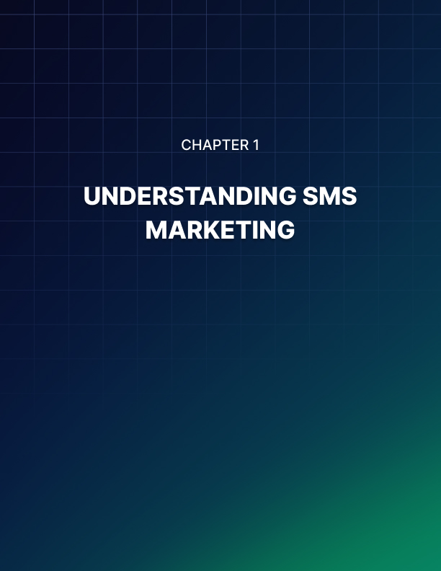

UNDERSTANDING SMS MARKETING
____

The Power of SMS Marketing
SMS marketing, often overlooked in favor of flashier digital strategies, is a potent weapon in your entrepreneurial arsenal. This direct, personal, and incredibly effective method involves sending promotional messages via text to customers who have opted in to receive them.
As of 2024, there are over 7 billion mobile phone users worldwide, representing 91% of the global population. More importantly, text messages boast an open rate of 98%, dwarfing email's average of 20%. These aren't just numbers; they represent an unprecedented opportunity to connect with your audience.
Text messages are typically read within three minutes of receipt, making them ideal for time-sensitive offers or urgent communications. This immediacy can be a game-changer for your business, allowing you to capitalize on spontaneous purchasing decisions or provide crucial updates in real-time.
While platforms like social media and instant messaging apps have their place, SMS remains uniquely positioned due to its universality and simplicity. Unlike apps that require downloads or social media platforms that rely on algorithms, SMS is native to every mobile phone and doesn't require an internet connection.
A real-world example illustrates the power of SMS marketing: In 2023, a small boutique clothing store in Austin, Texas, implemented an SMS campaign for their seasonal sale. They sent a text to their opt-in list with a unique discount code and a link to their online store. The result? A 35% increase in sales compared to their previous email-only campaign, with 60% of purchases made within an hour of the text being sent. This success story underscores the immediacy and effectiveness of SMS marketing.

Types of SMS Campaigns
Understanding the types of SMS campaigns is crucial to leveraging this tool effectively.
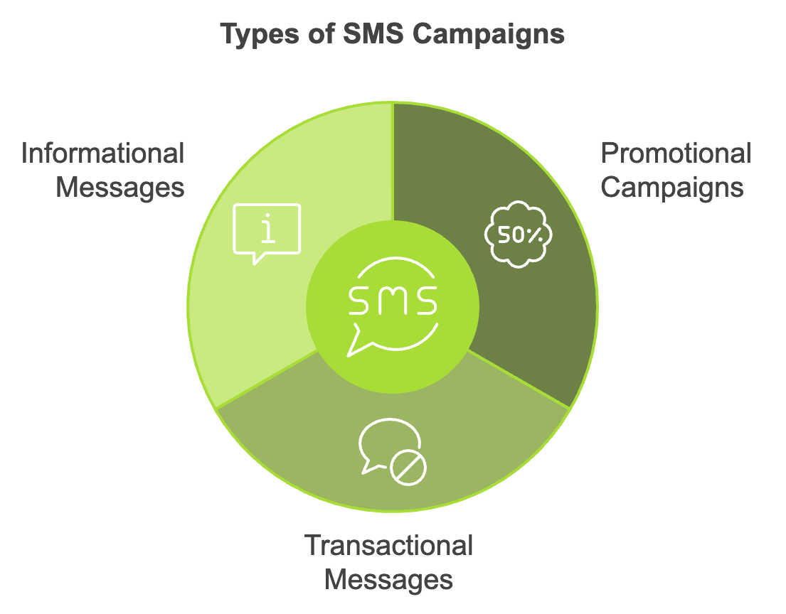
Promotional Campaigns are designed to drive sales or encourage specific actions. They often include special offers, discount codes, or limited-time promotions.
Transactional Messages provide important information related to a customer's interaction with your business, such as order confirmations, shipping updates, or appointment reminders.
Informational Messages keep your customers informed about relevant news, updates, or events, including new product launches, changes in business hours, or upcoming sales.
Each type of campaign serves a different purpose and can be strategically deployed to achieve specific business goals. The key is to strike a balance, ensuring that your messages provide value without overwhelming your audience.

Addressing Common Concerns
Entrepreneurs often have concerns about SMS marketing, such as intrusiveness, cost-effectiveness, and comparison to email marketing. To address these concerns, it's important to follow best practices like obtaining explicit consent, providing clear opt-out instructions, and limiting the frequency of texts. When done respectfully, customers often appreciate the convenience and immediacy of SMS communications.
SMS marketing can be surprisingly affordable, especially when compared to traditional advertising methods, with many platforms offering scalable pricing based on the number of messages sent. While email marketing remains valuable, SMS offers unique advantages such as higher open rates, faster response times, and less likelihood of being filtered as spam.

Key Statistics and Best Practices
Consider these key statistics from 2024:
Statistic | Value
Consumers comfortable receiving SMS from brands | 75%
Average SMS click-through rate | 19%
Customers reading texts within 5 minutes | 60%
SMS engagement rate compared to other channels | 25x higher

To maximize the effectiveness of your SMS marketing efforts, consider these best practices: timing your messages appropriately, keeping content concise, personalizing when possible, including a clear call-to-action, providing value, and monitoring and analyzing key metrics. Remember that SMS marketing works best when integrated with your broader marketing efforts, complementing strategies like email campaigns or e-commerce initiatives.

Success Stories and Future Potential
A local gym in Chicago used SMS to combat the typical post-holiday membership slump in late 2023. They sent personalized text messages to inactive members, offering a free personal training session if they returned within the week. The campaign resulted in a 40% reactivation rate, significantly higher than their previous email-based efforts. This example showcases how SMS can be used not just for acquisition, but also for retention and reengagement. It's a powerful tool for nurturing customer relationships throughout the entire lifecycle.
Wrapping up this chapter, it's clear that SMS marketing offers a unique mix of reach, immediacy, and effectiveness that can have a major impact on your business. Understanding the fundamentals, recognizing its strengths, and implementing best practices will position you to effectively leverage this powerful tool. The key to successful SMS marketing lies in respecting your audience, providing value, and constantly refining your approach based on results. As you move forward, keep experimenting, testing, and learning. The world of SMS marketing is rich with opportunities for innovative entrepreneurs willing to embrace its potential.
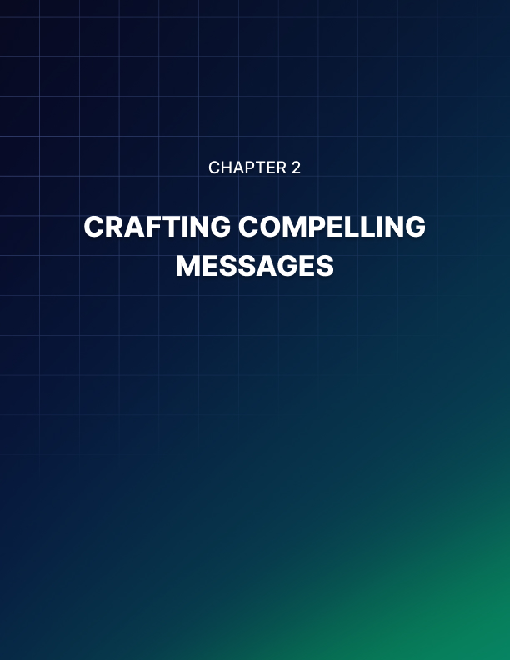

CRAFTING COMPELLING MESSAGES
____

The Power of Words in 160 Characters
When it comes to mobile marketing, strong SMS copywriting can really make a big difference for your marketing efforts. With a direct line to your customers' attention, SMS offers a unique opportunity to distill your message to its most impactful essence. A well-crafted SMS can spark action, evoke emotion, and drive sales in just a few seconds. It's a high-wire act of communication, balancing brevity with persuasion, and when done right, it's incredibly effective. In 2024, businesses that mastered SMS copywriting saw an average increase in click-through rates of 23% compared to their previous campaigns.

The Anatomy of an Effective SMS
An effective SMS marketing message consists of several key elements. First, you need an attention-grabbing opening that hooks your reader immediately. Your first few words should pique curiosity or offer clear value. Next, focus on clear and concise content, as every word counts in the limited space. Cut the fluff and concentrate on your core message. A compelling call-to-action (CTA) is crucial, telling your readers exactly what you want them to do next. Create a sense of urgency to encourage immediate action without resorting to pushy tactics. Finally, personalization can make the message feel tailored to the recipient, using their name or other relevant details.
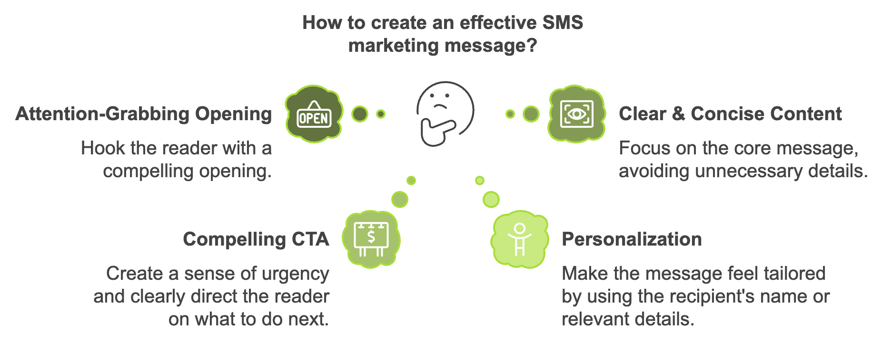
Here's an example that incorporates these elements: "Hey Sarah! 🎉 Your favorite shoes are back in stock, but they're selling fast. Tap here to grab yours before they're gone: [link]"

Techniques for Attention-Grabbing Texts
To create attention-grabbing texts, consider using power words that trigger emotional or psychological responses. Words like "exclusive," "limited," "secret," or "now" can create excitement or urgency. Engaging your audience by posing intriguing questions can also be effective. Creating curiosity gaps by teasing information without revealing everything can pique interest. Using specific numbers can catch the eye and add credibility, while emojis can add personality and visual appeal when used judiciously.

The Art of Persuasion in SMS
Persuasion in SMS copywriting isn't about manipulation; it's about presenting your offer in a way that resonates with your audience's needs and desires. Some effective persuasion techniques include highlighting scarcity, leveraging social proof, offering reciprocity, establishing authority, and reminding customers of their past interactions or preferences. For example, you might emphasize limited availability or time constraints, showcase the opinions of satisfied customers, offer something valuable to encourage action, establish credibility through expert endorsements, or remind loyal members of their exclusive benefits.

Personalizing Your Messages
Personalization can significantly boost the effectiveness of your SMS campaigns. In 2024, personalized SMS messages saw a 30% higher conversion rate compared to generic ones.
To personalize effectively, use names instead of generic greetings, reference past purchases, offer location-based promotions, use behavioral triggers, and acknowledge special dates like birthdays. This level of personalization can make your messages feel more relevant and engaging to the recipient.
Personalization Technique | Example
Use Names | "Hi Alex," instead of "Dear Customer,"
Reference Past Purchases | "Loved your last purchase? Here's something similar you might enjoy"
Location-Based Offers | "Visiting New York? Stop by our Broadway store for an exclusive discount"
Behavioral Triggers | "We noticed you left items in your cart. Here's a 10% off code to complete your purchase"
Special Dates | "Happy Birthday, Lisa! Enjoy 20% off your next order as our gift to you"

Crafting Effective CTAs
Your call-to-action is where you convert interest into action. To create powerful CTAs, be specific in your instructions, create a sense of urgency, use action words, keep it short, and make it stand out visually.
Instead of generic phrases like "Click here," use specific actions like "Shop now" or "Book your appointment." Create urgency with phrases like "Get 50% off - today only!" or "Last chance to register!" Use action words like "Grab," "Discover," "Unlock," or "Join" to make your CTA more compelling. Aim for 2-4 words for maximum impact, and consider using caps or special characters to make your CTA pop.
When crafting your SMS messages, watch out for common pitfalls like overusing slang or abbreviations, being overly salesy, sending messages too often, neglecting proofreading, and forgetting to include opt-out instructions. Focus on providing value rather than just pushing for a sale, respect your audience's time and attention, and always double-check your messages before sending.
To refine your SMS copywriting skills, it's crucial to track the right metrics. Key performance indicators (KPIs) for SMS marketing include open rates, click-through rates (CTR), conversion rates, opt-out rates, and ROI. These metrics can help you understand the effectiveness of your messages and guide your optimization efforts.
While SMS is powerful on its own, it's most effective when integrated with your broader marketing efforts. Consider cross-channel promotion, using complementary content across different channels, mapping the customer journey to identify where SMS fits best, synchronizing data with your CRM, and maintaining consistent branding across all channels.
In conclusion, effective SMS copywriting is both an art and a science. It requires creativity to craft compelling messages, analytical skills to interpret data and refine your approach, and a deep understanding of your audience. By mastering these skills, you're opening a direct line of communication with your customers, building relationships, and driving real business results. The power of SMS marketing lies in its simplicity and directness, allowing you to cut through the noise and speak directly to your customer's needs and desires. As you move forward, keep experimenting, learning, and listening to your audience to guide you towards SMS marketing success.
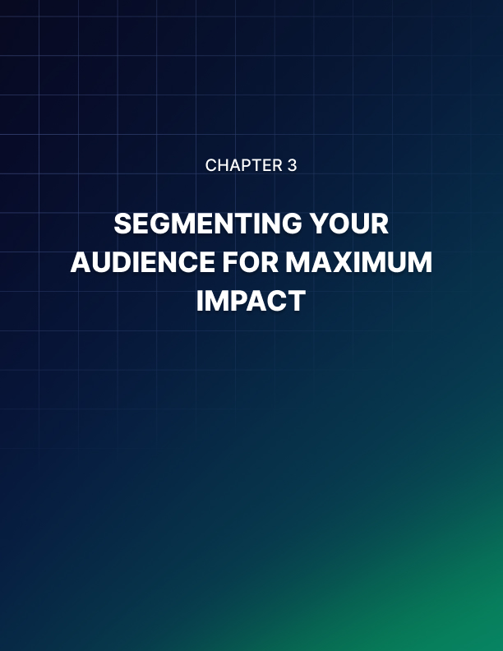

SEGMENTING YOUR AUDIENCE FOR MAXIMUM IMPACT
____

The Power of Audience Segmentation
A one-size-fits-all approach is no longer effective in the fast-moving world of mobile marketing. Your customers are unique individuals with distinct preferences, behaviors, and needs. Recognizing and catering to these differences can significantly enhance the impact of your SMS campaigns, making audience segmentation crucial.
Audience segmentation is the process of dividing your customer base into distinct groups based on shared characteristics. It's about understanding who your customers are and tailoring your messages to resonate with each group. In 2024, businesses that implemented advanced segmentation strategies saw a 34% increase in customer engagement and a 22% boost in conversion rates compared to those using basic or no segmentation. Segmenting your audience allows you to deliver more relevant content, increase engagement, improve customer satisfaction, boost conversion rates, reduce opt-out rates, and enhance overall campaign performance.

Effective Segmentation Techniques
Demographic and Behavioral Segmentation
Demographic segmentation is often the starting point for many businesses. It involves categorizing your audience based on characteristics such as age, gender, income, education level, occupation, marital status, and family size. While demographic segmentation is relatively easy to implement, it's important to remember that it's just the tip of the iceberg. For example, knowing that a customer is a 35-year-old married woman with two children provides some insight, but it doesn't tell you about her interests, shopping habits, or brand preferences.
Behavioral segmentation, on the other hand, focuses on how customers interact with your business. This can include purchase history, product usage, brand interactions, loyalty program status, and customer lifecycle stage. This type of segmentation can be incredibly powerful. For instance, you might create separate segments for first-time buyers, frequent purchasers, and customers who haven't bought in a while. Each of these groups would benefit from different types of messages.
Psychographic and Geographic Segmentation
Psychographic segmentation digs deeper into the psychological characteristics of your customers, including lifestyle, interests, values, attitudes, and personality traits. This type of segmentation can help you craft messages that truly resonate with your audience on an emotional level. For example, if you know a segment of your customers values sustainability, you could highlight your eco-friendly products or initiatives in messages to this group.
Geographic segmentation involves grouping customers based on their location. This can be as broad as country or as specific as zip code. It's particularly useful for businesses with physical locations or those offering location-specific products or services.
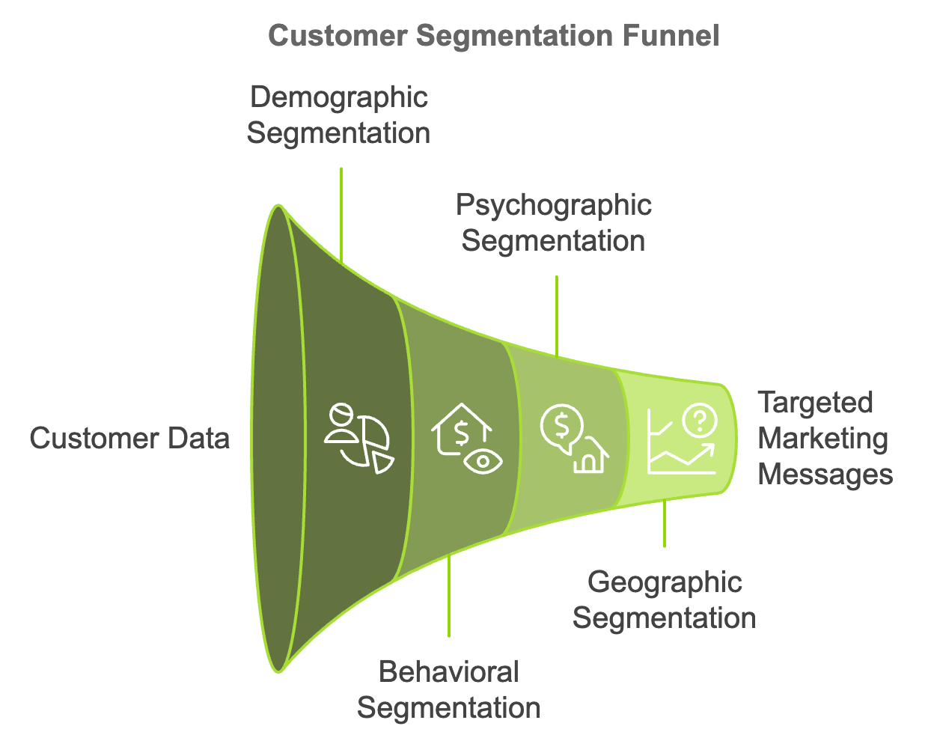

Data Collection and Analysis
To implement effective segmentation, you need to collect and analyze customer data. Strategies to gather this valuable information include using sign-up forms, surveys, analyzing purchase history, tracking website and app behavior, utilizing social media insights, gathering data from customer service interactions, and leveraging loyalty program data. Once you've collected this data, you'll need to analyze it to identify meaningful patterns and segments. This is where Customer Relationship Management (CRM) systems and analytics tools come in handy. They can help you organize your data and uncover insights that might not be immediately apparent.
Creating meaningful segments involves defining your goals, identifying key characteristics, creating segment profiles, validating your segments, and naming them clearly. The key is to create segments that are large enough to be worth targeting, distinct from each other, accessible through your marketing channels, and relevant to your business goals.

Dynamic Segmentation and Real-Time Adaptation
Static segmentation is a good start, but to truly maximize the impact of your SMS marketing, consider implementing dynamic segmentation. This approach involves adjusting your segments based on real-time customer behaviors and responses. For example, if a customer who typically buys men's clothing suddenly purchases a women's item, they might be moved into a different segment. Or if a customer who usually opens your messages immediately starts leaving them unread, they might be shifted to a "re-engagement" segment.
Dynamic segmentation allows you to respond quickly to changing customer behaviors, provide more timely and relevant offers, improve customer experience by anticipating needs, and increase the overall effectiveness of your campaigns. To implement dynamic segmentation, you'll need real-time data collection, automated segmentation tools, trigger-based messaging, and regular analysis and optimization.

Case Study: The Power of Segmentation in Action
Let's look at a real-world example of how segmentation can drive results. In 2024, a mid-sized online retailer specializing in outdoor gear implemented an advanced segmentation strategy for their SMS marketing. They created segments based on purchase history, geographic location, customer lifecycle stage, and engagement level with previous SMS campaigns. They crafted tailored messages for each segment, such as welcome series for new customers, early access to new products for regular buyers, special "we miss you" offers for customers at risk of churn, and location-specific promotions.
The results were impressive:
Metric | Improvement
Click-through rates | 42% increase
Conversion rates | 28% boost
Opt-out rates | 15% reduction
Overall revenue from SMS | 37% increase

This case study demonstrates the power of thoughtful segmentation combined with tailored messaging.

Implementing Your Segmentation Strategy
Implementing your segmentation strategy involves starting small, testing and learning, personalizing your messages, monitoring performance, being flexible, integrating across channels, and respecting privacy. It's important to address common challenges such as data quality, over-segmentation, resource constraints, maintaining relevance, and measuring impact.
Concluding this chapter, it's important to note that effective segmentation is an ongoing process requiring continuous learning, testing, and refinement. Delivering more relevant, personalized messages to your audience will not only improve your marketing performance but also enhance your customers' experience with your brand. In the world of SMS marketing, where every character counts, targeting the right message to the right person at the right time is the key to success.

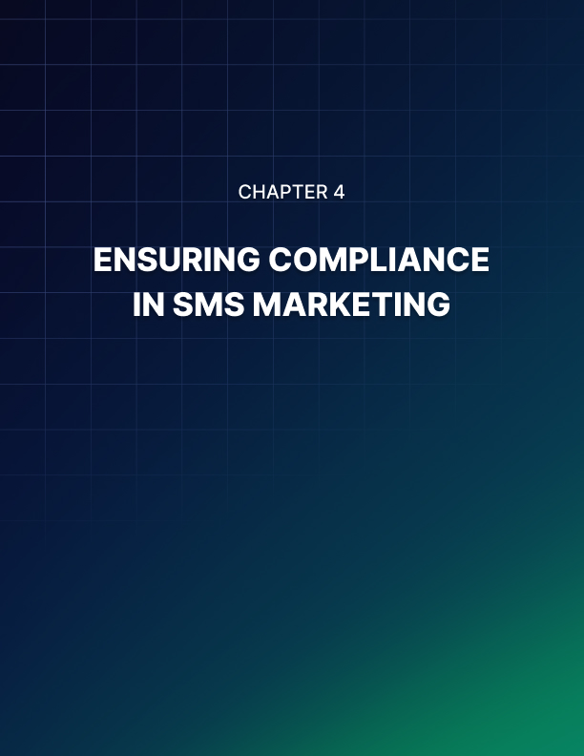

ENSURING COMPLIANCE IN SMS MARKETING
____

The Critical Importance of Legal Compliance
Success in SMS marketing isn't just about crafting compelling messages or segmenting your audience effectively. It's also about navigating the complex web of laws and regulations that govern this powerful marketing channel. As an entrepreneur, you must prioritize legal compliance to protect your business and maintain the trust of your customers.
Ignoring or overlooking the legal aspects of SMS marketing can lead to severe consequences.
In 2024, the Federal Communications Commission (FCC) imposed fines totaling over $200 million on companies that violated SMS marketing regulations.

These penalties ranged from $10,000 to $50 million per violation, depending on the severity and frequency of the infractions. Beyond financial repercussions, non-compliance can damage your brand reputation, erode customer trust, and even result in legal action against your business.

Understanding Key Regulations
To effectively navigate the legal landscape of SMS marketing, you need to familiarize yourself with the key regulations that impact your campaigns. While specific laws may vary depending on your location and target audience, there are several fundamental regulations that apply to most SMS marketing efforts.
The Telephone Consumer Protection Act (TCPA) sets the foundation for regulations surrounding telemarketing practices, including SMS marketing. It requires businesses to obtain explicit consent from consumers before sending them marketing messages and mandates that companies provide clear opt-out instructions in their messages.
The CAN-SPAM Act, although primarily focused on email marketing, also applies to mobile commercial messages. It requires marketers to identify messages as advertisements, include valid physical postal addresses, and honor opt-out requests promptly.
If you're targeting customers in the European Union, you must comply with the General Data Protection Regulation (GDPR), which requires explicit consent for data collection and processing, including for SMS marketing purposes.
The California Consumer Privacy Act (CCPA) gives California residents more control over their personal information and how businesses use it.
While not legally binding, the Cellular Telecommunications Industry Association (CTIA) Guidelines set best practices for mobile marketing and are often used as a standard by mobile carriers.

Obtaining Proper Consent
At the heart of SMS marketing compliance is obtaining proper consent from your audience. This isn't just a legal requirement; it's also a best practice that respects your customers' preferences and builds trust.
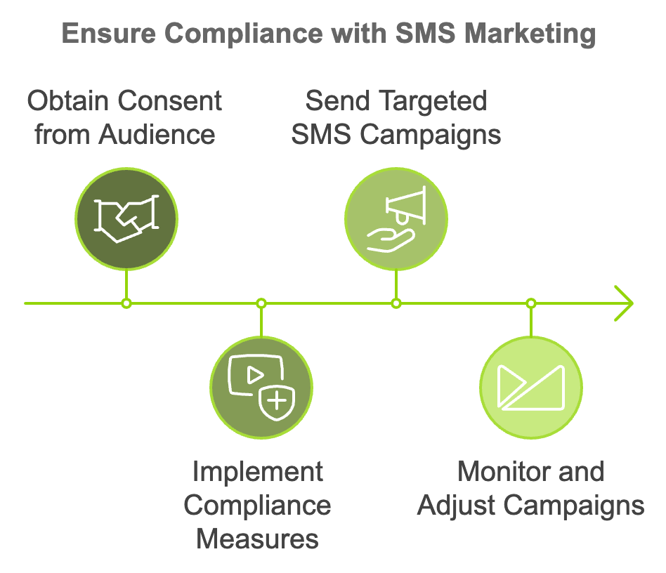
You must obtain explicit, affirmative consent from individuals before sending them marketing messages. This means they must take a clear, affirmative action to opt in to your SMS communications. Pre-checked boxes or assumed consent based on prior business relationships are not sufficient. When asking for consent, provide clear information about what the individual is signing up for. This should include the type of messages they'll receive, the frequency, and any associated costs. Consider implementing a double opt-in process where users confirm their subscription after initially signing up. This extra step can help prevent mistakes and demonstrate your commitment to obtaining genuine consent. Maintain accurate records of when and how each individual gave consent. This documentation can be crucial if you ever need to prove compliance. Be aware that consent can expire. If a user hasn't engaged with your messages for an extended period, you may need to re-confirm their consent.

Providing Clear Opt-Out Options
Just as important as obtaining consent is providing clear and easy ways for recipients to opt out of your SMS communications. This is not only a legal requirement but also a way to maintain a positive relationship with your audience. Include clear opt-out instructions in every message. Common methods include replying with "STOP" or "UNSUBSCRIBE". Honor opt-out requests immediately. Set up automated systems to process these requests in real-time. Send a confirmation message when someone opts out to acknowledge their request. Ensure that opting out is free for the user and doesn't require any special steps beyond sending a simple message. Keep your opt-out list up to date and cross-reference it before sending campaigns to ensure you're not messaging those who have opted out.

Maintaining a Compliant Contact List
Your SMS marketing list is a valuable asset, but it requires careful management to stay compliant. Periodically review and clean your list to remove invalid numbers, bounces, and long-term non-responders. Use segmentation to ensure you're sending relevant messages to the right people, which can help reduce opt-outs and complaints. Implement a preference center where subscribers can update their contact information and messaging preferences. For subscribers who haven't engaged in a while, consider running a re-engagement campaign to confirm their interest before removing them from your list. Implement robust security measures to protect your subscribers' personal information. This includes encryption, access controls, and regular security audits.
Compliance Aspect | Best Practice
Consent | Obtain explicit, affirmative consent
Opt-Out | Provide clear instructions in every message
List Management | Regularly clean and update your contact list
Data Security | Implement encryption and access controls
Re-engagement | Run campaigns for inactive subscribers

Compliance isn't just about who you're messaging; it's also about what you're sending and when.
- Ensure your messages are clear, truthful, and not misleading.
- Avoid making false claims or promises.
- Clearly identify your business as the sender of the message.
- Respect quiet hours.
In the U.S., for example, the TCPA prohibits sending messages before 8 am or after 9 pm in the recipient's local time zone. While there's no strict legal limit on message frequency, sending too many messages can lead to increased opt-outs and potential complaints. Ensure your messages are relevant to the consent given. If a user signed up for promotional messages, don't send them unrelated content.
If your business operates internationally or targets customers in multiple countries, you need to be aware of varying regulations across different jurisdictions. Many countries have their own specific laws governing SMS marketing. Research and comply with local regulations in each market you target. Some countries may have stricter consent requirements.
For example, under GDPR, consent must be "freely given, specific, informed, and unambiguous." Be aware of regulations regarding the transfer of personal data across borders, particularly when dealing with EU residents' data. Some countries require marketing messages to be in the local language or to include specific disclosures.
Consider partnering with local legal experts or compliance consultants when entering new markets to ensure you're meeting all requirements.
To illustrate the importance of compliance, let's look at a real-world example. In 2024, a mid-sized e-commerce company faced severe penalties for SMS marketing violations.
The company had been sending promotional texts to a list of phone numbers they had purchased from a third-party data broker, assuming that these individuals had given consent. However, many recipients complained that they had never agreed to receive these messages. The FCC investigated and found that the company had failed to obtain proper consent, didn't provide clear opt-out instructions, and continued to message individuals who had opted out.
The consequences were severe: a $5 million fine from the FCC, legal fees and settlement costs for a class-action lawsuit brought by affected consumers, significant damage to the company's reputation leading to a 30% drop in sales over the following quarter, and the need to completely overhaul their marketing practices and rebuild their SMS list from scratch.
This case underscores the critical importance of compliance in SMS marketing. The short-term gains of using a non-compliant list were far outweighed by the long-term costs and damage to the business.
Best Practices in SMS Marketing
To help you stay on the right side of the law, here are some best practices to implement in your SMS marketing efforts.
- Keep up-to-date with changes in regulations.
Subscribe to industry newsletters, follow relevant regulatory bodies on social media, and consider joining industry associations that provide compliance updates.
- Conduct regular audits of your SMS marketing practices to ensure ongoing compliance.
This should include reviewing your consent collection processes, opt-out procedures, and message content.
- Ensure that all team members involved in your SMS marketing efforts are trained on compliance requirements.
This includes not just your marketing team, but also customer service representatives who may handle opt-out requests or complaints.
- Maintain detailed records of consent, opt-outs, and your compliance efforts.
This documentation can be crucial if you ever face a compliance audit or legal challenge.
- Consider using SMS marketing platforms that have built-in compliance features.
These can help automate many aspects of compliance, such as managing opt-outs and maintaining consent records.
- Develop and publish clear privacy policies and terms of service.
These should outline how you collect, use, and protect customer data.
- If you receive complaints or inquiries about your SMS marketing practices, respond promptly.
Take appropriate action to address the issue.
- When in doubt, consult with legal professionals who specialize in marketing compliance.
The cost of legal advice is often far less than the potential cost of non-compliance.
Navigating the legal landscape of SMS marketing clearly requires diligence, attention to detail, and a commitment to ethical practices. While the regulations may seem daunting, they ultimately serve to protect consumers and maintain the integrity of SMS as a marketing channel. Prioritizing compliance helps you avoid potential penalties while also building trust with your audience and establishing a foundation for sustainable, long-term success in your SMS marketing efforts. Remember, in the world of SMS marketing, compliance isn't just a legal obligation—it's a competitive advantage.

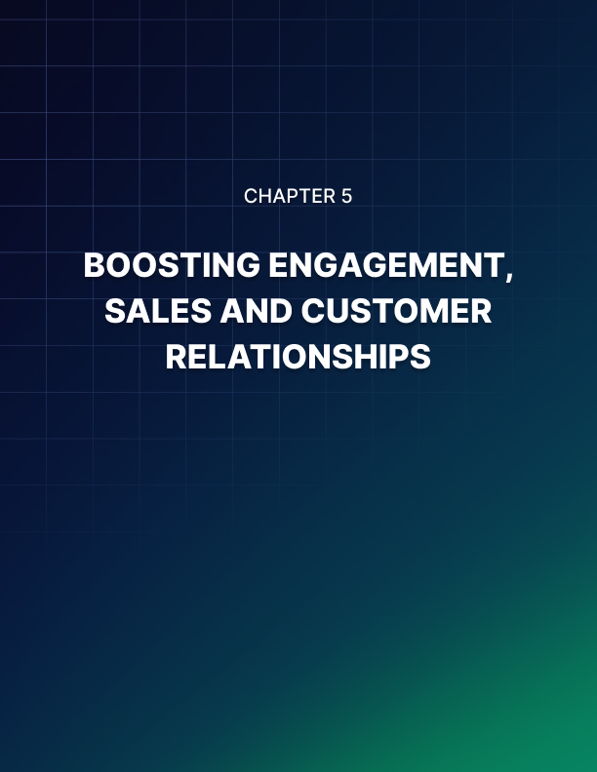

BOOSTING ENGAGEMENT, SALES, AND CUSTOMER RELATIONSHIPS
____

Integrating SMS Marketing with Your Overall Strategy
SMS marketing doesn't exist in isolation within the digital landscape. To maximize its impact, you need to seamlessly integrate it with your broader marketing efforts. This integration allows you to create a cohesive customer experience across all touchpoints, reinforcing your brand message and driving better results.
Start by mapping out your customer journey and identifying key touchpoints where SMS can complement or enhance other marketing channels. For example, you might use SMS to follow up on an abandoned cart email, provide shipping updates after an online purchase, or remind customers about an upcoming event they registered for via your website.
Consider using SMS as part of a multi-channel approach. For instance, you could tease a new product launch on social media, send an exclusive pre-order link via SMS, and follow up with detailed information in an email. This coordinated approach can create a sense of anticipation and exclusivity, driving engagement across channels.
Ensure consistency in your messaging across all platforms. While the specific content may vary due to the constraints of each channel, your brand voice, key messages, and overall campaign themes should remain consistent. This consistency helps reinforce your brand identity and prevents confusion among your audience.
Leverage data from other channels to inform your SMS strategy. For example, use website browsing behavior to trigger relevant SMS offers, or use email engagement data to segment your SMS list. Conversely, use insights from your SMS campaigns to refine your strategies on other channels.

Advanced SMS Marketing Tactics
To take your SMS marketing to the next level, consider implementing these advanced tactics:
Automated Messaging Sequences
Set up automated SMS sequences triggered by specific customer actions or events. For example, create a welcome series when a new customer signs up, sending a series of messages introducing your brand, offering a first-purchase discount, and highlighting key products or services. Implement a post-purchase follow-up sequence, sending messages thanking customers, providing usage tips, asking for feedback, and suggesting complementary products. For customers who haven't engaged in a while, set up a re-engagement series to rekindle their interest, perhaps offering a special "we miss you" discount.
Drip Campaigns
Drip campaigns involve sending a pre-planned series of messages over time. These can be highly effective for nurturing leads, onboarding new customers, or promoting long-term engagement. For example, create a product education campaign that sends a series of messages over several weeks, each highlighting a different feature or benefit of your product.
Develop a loyalty program drip campaign that guides customers through your program, explaining benefits, encouraging participation, and celebrating milestones. Plan a series of messages leading up to major shopping events like Black Friday, gradually building anticipation and highlighting different offers.
Exclusive Offers and VIP Programs
Use SMS to create a sense of exclusivity and reward your most loyal customers. Send time-limited, exclusive offers only to your SMS subscribers. Give SMS subscribers first access to new products or services before they're available to the general public. Create a special SMS list for your top customers, providing them with unique perks, personalized offers, or behind-the-scenes content.

Key Performance Indicators and Analytics
To truly drive results, you need to consistently measure and analyze the performance of your SMS campaigns. Here are some key metrics to track:
Metric | Description
Delivery Rate | Percentage of messages successfully delivered
Open Rate | Percentage of messages opened (if trackable)
Click-Through Rate (CTR) | Percentage of recipients who click on links
Conversion Rate | Percentage of recipients who take the desired action
Opt-out Rate | Percentage of recipients who unsubscribe
Return on Investment (ROI) | Revenue generated compared to campaign cost

Use these metrics to continually refine your SMS strategy. For example, if you notice a high CTR but low conversion rate, you might need to optimize your landing pages. If you see a spike in opt-outs after increasing message frequency, you might need to dial it back. Many SMS marketing platforms offer built-in analytics tools. Take advantage of these to track your performance over time, compare different campaigns, and gain insights into your audience's behavior.

Experimenting and Refining Your Approach
The key to long-term success in SMS marketing is continuous experimentation and refinement.
- Regularly conduct A/B tests on different elements of your SMS campaigns, such as message timing, length, tone, call-to-action phrasing, and offer types.
- Continuously refine your audience segments based on engagement data, creating specialized segments like "high engagement" for subscribers who frequently interact with your messages.
- Experiment with different levels of personalization to find the sweet spot for your audience, ranging from simply using the recipient's name to crafting messages based on their purchase history or browsing behavior.
- Test various ways of coordinating your SMS campaigns with other marketing channels, such as sending an SMS reminder shortly after an email campaign versus sending it a day later.
- Stay abreast of new SMS marketing features and technologies, and experiment with incorporating them into your strategy, including rich media messaging, chatbots, or advanced automation tools.
Remember, what works for one business or audience segment might not work for another. The key is to consistently test, measure, and refine your approach based on your specific results and audience responses. By doing so, you'll be able to optimize your SMS marketing efforts and drive better results over time.

Overcoming Common Challenges
As you work to drive results through SMS marketing, you're likely to encounter some common challenges. Here's how to address them:
- If you notice declining engagement rates, it could be a sign of message fatigue. Combat this by varying your content, personalizing messages, and potentially reducing frequency for less engaged segments.
- For deliverability issues, review your contact list for invalid numbers and consider using a dedicated short code for improved deliverability.
- Stay up-to-date with regulations and best practices to address compliance concerns. Regularly audit your processes to ensure ongoing compliance.
- If you're struggling to measure ROI, consider implementing unique tracking links or promo codes for each campaign.
- To overcome the limited character count of SMS, get creative with your messaging. Use concise language and consider breaking longer messages into a series of shorter ones.
- If you're having trouble integrating SMS with your other systems, consider working with a marketing technology consultant or looking for platforms with pre-built integrations.
Driving results through SMS marketing is an ongoing process that requires continuous effort and optimization. It requires a strategic approach, careful integration with your broader marketing efforts, continuous measurement and refinement, and a willingness to experiment and adapt. Leveraging the power of SMS allows you to create more engaging, personalized, and effective marketing campaigns that drive real business results. Keep testing, keep learning, and keep refining your approach. With persistence and creativity, SMS marketing can become one of your most powerful tools for boosting engagement, driving sales, and building lasting customer relationships.


CONCLUSION
____
Throughout this ebook, you’ve explored the power of SMS marketing and how it can transform your business by building lasting connections, driving sales, and boosting engagement. You’ve learned the importance of crafting compelling messages that grab attention, evoke emotion, and prompt action—all within 160 characters. By mastering the art of SMS copywriting, you can create messages that resonate with your audience and drive real results.
Audience segmentation plays a critical role in ensuring your SMS campaigns are personalized and relevant, helping to increase engagement and satisfaction. You’ve seen how dynamic segmentation and real-time adaptation can significantly enhance the effectiveness of your campaigns.
The importance of compliance in SMS marketing was also highlighted. Adhering to regulations, obtaining proper consent, and providing clear opt-out options are essential for maintaining trust and avoiding legal pitfalls.
Finally, advanced SMS marketing tactics such as automated messaging sequences, drip campaigns, and exclusive offers were covered. By tracking key performance indicators and continuously refining your approach through A/B testing and personalization, you can optimize your campaigns for long-term success.
As you move forward, remember that SMS marketing is a powerful tool that, when used thoughtfully and strategically, can help you foster deeper connections with your customers and drive meaningful results for your business. Keep experimenting, learning, and refining your strategy to unlock the ultimate potential of SMS marketing.

