Disclaimer
This ebook has been written for information purposes only. Every effort has been made to make this e-book as complete and accurate as possible.
However, there may be mistakes in typography or content. Also, this e-book provides information only up to the publishing date. Therefore, this e-book should be used as a guide - not as the ultimate source. The purpose of this e-book is to educate. The author and the publisher do not warrant that the information contained in this ebook is fully complete and shall not be responsible for any errors or omissions.
The author and publisher shall have neither liability nor responsibility to any person or entity with respect to any loss or damage caused or alleged to be caused directly or indirectly by this e-book.
Table of Contents
Introduction 8
The Risk Bearers 9
The Organizers 10
Chapter 1: Traits of a Successful Entrepreneur 12
Things to Do to Reduce Stress as an Entrepreneur 14
Chapter 2: Starting a Home-Based Business 18
The Advantages of a Home-Based Business for Entrepreneurs 20
Chapter 3: Entrepreneurial Failure: Get Used To It 24
You Might Want To Drop Out Of College 25
Secret to Making the Decision 27
Chapter 4: Entrepreneur Opportunities: Finding the Right Business to Start 30
Popular Entrepreneurial Ideas that Does Not Work 32
The Greatest Difficulty Though Is The Starting 32
What Could Be Done Then? 34
Chapter 5: How Entrepreneurs Take Business Opportunities 37
Entrepreneur Opportunities: Finding the Right Business to Start 39
Finding the Right Entrepreneur Opportunity 40
Chapter 6: Facing Your Fears As An Entrepreneur 43
Dare To Be Different! 44
Chapter 7: Start Up Business Plan: The Benefits 48
The Benefits of a Start Up Business Plan 48
Starting A Business – The Three 'Ps' 49
Chapter 8: The Keys To Success In Business 52
What Does It Take To Be An Entrepreneur? 54
Conclusion 57



Introduction
The word Entrepreneur has been associated in many fields and is defined and has been defined by a variety of people in many ways.
Well, the word itself was of French origin which evolved into meanings that pertain to people who take the risks, founders of businesses and or someone who is accountable in case of failure or success in a business venture.
Being a person who founded a new enterprise, it is also understood that entrepreneurs take the largest part when it comes to risks inherent to businesses. After all, they are normally the owners of the company or the business unit.
The common perception with entrepreneurs is that they are the establishments of new entities that aim to offer innovative or existing services or products in the market.
The talk of profit or non-profit issues also vary, depending on the type of business management being referred to.
They are, of course, one of the main components of the capitalistic world. They take the largest losses or gains since they are the manipulators of the funds. Central to this is the belief of opportunities in a specific area that require the filling of the demands.
They are like the providers for the needs and thus, they take the gain in exchange for the provision. They are basically service- or product oriented devices that create the fillers for the two said demands. The main focus of their acts is towards the gain of profit.
There are many types of typical entrepreneurs. And because of this evolution from the simple merchants to the more sophisticated corporate men, entrepreneurship has also matured in ways unimaginable when men first thought of selling their own produce.

The Risk Bearers
Risks are incalculable and rather undefined. They come as problems arise and they develop as more problems sprout. There are no specific ways by which risks come out. They just do and they seem to be the eternal parts of any business ventures.
Entrepreneurs are not only risk bearers, they also take all the disadvantages of uncertainties.
While both may appeal the same, it is an undeniable fact that they may offer different horizons for individual business people.
Risks can be subjected to insurance principles. Meaning, there are methods by which their intensity or frequency can be measured. Thus, we can provide options in decreasing one's susceptibility over risks.
However, uncertainties may be considered to be more on the subjective side. Since they can't be calculated and their very nature can't be estimated. These two combined, it is easier to assume that entrepreneurs can be characterized both as decision-makers and improvisers.
They provide solutions to immediate and long-term demands, which are unachievable, even when business routines are carefully studied.
Entrepreneurs certainly are great risk takers. Without this element of uncertainty, no business could have evolved in ways that lead to the growth of certain industries.
There surely are things that must be met with responses that are either detrimental to a business unit or would create changes for its betterment.

The Organizers
Entrepreneurs are typically the founders. It is only proper that they are equipped with facilities that make leaders lead. Founders are the leaders of the pack, they are the builders. They too are planners and the organizers of schemes for giving birth and growth to a business organization.
They are the planners for maximizing the resources. They combine specific factors like land resources, the capital from a partner, the labor of his employees or the resources that came from him to create products that would meet certain demands.
He will then create organizational tactics to come out with the earnings of his profit after everything is settled.
Being the organizer, it is understood that he also is the leader. Organizers always have the authority to set things in their proper places.
But being a leader is a matter of having a good combination of values and abilities that will support the group. And because we are not all born leaders nor were, we all made leaders, too few really achieve successes in business. However, leadership is not at the core of entrepreneurship.
It is the will. The will to start with uncertainty and keep believing that it would in the end, turn out well.


Chapter 1: Traits of a Successful Entrepreneur
Have you ever wondered why some entrepreneurs succeed and why some do not?
Have you ever thought of the things that would make one the best entrepreneurs in a chosen field?
For the lucky few, owning a business might run in their veins but for most who are just common people with a high desire to start a business of their own, then, careful evaluation and extra time on studying the nature and principles of entrepreneurship is a must. However, this doesn’t mean that an individual who wants to become an entrepreneur should have a thorough background on these qualities and principles.
Whether you are conscious about it or not, success and failure always depend on the entrepreneur. You want to know what those are?
Here are the traits of a successful entrepreneur:
Goal Oriented
Whether short term or long term, a successful entrepreneur never misses to set his goal.
This trait can be developed at a very young age. For instance, a child sets academic goals for himself or sets a specific timeframe to achieve something. Say, for example, the child’s parents cannot afford to buy him a toy he wanted.
He will try to get this toy by saving money or making money for himself. When he grows up, he carries this trait in doing business. This same child is more likely to become successful because he knows how to get certain things he wants to.
But it does not stop there. A successful entrepreneur knows how to revise or rewrite his goals whenever he thinks that there is something that needs to be changed.
Opportunity Seeker
An entrepreneur knows how to search for opportunities. It may be an opportunity to earn more or to learn further. He will not settle on the things that exist around him. He knows how to find opportunities that may not be visible for most people.
Taking Advantage Of These Opportunities
Once he has found opportunities, he knows how to take advantage of them. But it does not mean that he will become impulsive for he knows how to identify what type of opportunity will give him benefits.
He will ask himself these questions: Will it bring better than harm? Is it worth the time and money? Will it be able to help me reach my set goals?
Knows His Strengths And Weakness
Another good trait of a successful entrepreneur is knowing his strengths and weaknesses. This type of trait will enable him to define his limits and know how to extend his limits. He knows the borderlines but knows how to keep the borderlines expanding.
An individual who does not know his strengths and weaknesses is like a person facing a mirror without clearly seeing his face. A successful entrepreneur sees his face clearly in the mirror and recognizes his imperfection.
He would then polish his imperfections and convert them to something that would benefit him because a successful entrepreneur does not only know his strengths and weaknesses, he also recognizes these as parts of his personhood.
Always Wants To Be The Best
A successful entrepreneur does not settle for the second best. He always finds ways to be the best in his craft. With the help of his recognition of his strengths and weaknesses, he will achieve what others might not achieve. He has a certain attention to detail and quality. He would as much as possible treat all customers the same.
Enjoys What He Does And Knows How To Enjoy As Well
A successful entrepreneur loves his work and enjoys what he is doing. He would not be successful if he does not enjoy his business. On the other hand, he does not make his business his life. He knows how to rest once in a while to enjoy life itself.
Knows When To Get Help
A successful entrepreneur recognizes that he could not do some things alone. He knows that he needs a hand in order to get things right. He knows and respects others' views on matters regarding his business.
They do this to minimize the risk of committing mistakes. He knows what type of person that is right for the job.

Things to Do to Reduce Stress as an Entrepreneur
Running your own business can be both rewarding and fun. But it does not end there. Alongside all the joys and the rewards are pressures that make doing business very stressful.
For many entrepreneurs, the most common source of stress is the workload. As people would say, “If you want to become successful, you have to work extra hours”.
This is particularly what is happening to many entrepreneurs. They work harder and longer. And the pressure is different if you are running your own business than working 40 hours a week.
Stress also mounts up because of several tasks related to work added by the responsibilities at home. Usually, moms have tasks at work, and at the same time, have to do chores at home. Further tasks are contributed by the responsibilities to her kids.
Another stressor is the financial aspect of the business. Seldom do we see businesses without debt. Most of them have a certain amount of loan somewhere that needs to be paid.
This causes great stress on the part of the entrepreneur; balancing of funds and converting all the expenses into income. Getting back the investment quickly adds stress to entrepreneurs as well.
Entrepreneur has to make decisions correctly and quickly. And for those who are only beginning to introduce themselves to this kind of environment, it may be very stressful.
All these contribute to the problem of an entrepreneur.
To reduce the stress from these, here are some things you can do:
Start at your desk – Clutters can contribute to the present stress you are experiencing. So before doing something today, make sure that you clean up all the mess and put away the things that do not have to be on your desk.
A clean desk will be more pleasant to work on.
Device a system – Daily planners will make things easier for you. If you have lots of things to do, do not intend to finish them all at the same time. Make a schedule when to do this and when to do that.
Thinking about all the tasks that need to be done will not solve your problem. Do them one at a time. In this way, you will certainly accomplish one thing after another.
Multiply yourself – If you think you cannot do an enormous task on your own, hire people who can help you. Remember that one good trait of a successful entrepreneur is he knows when to seek help. Two heads are better than one and four hands are better than two, right?
Make a business plan – Everyday, you are tasked with several things to do. In order to get things organized, it would be better to make a plan and stick to that plan.
This will keep you on track and prevent you from doing things that you don’t need to do. Remember that time is crucial in running your own business.
Time means money so better make the most out of every second that passes. Make sure that you know where you are heading at with the plan you have devised.
Designate tasks – You cannot do everything. But even if you do, you cannot make it efficiently. Why? Because you are too occupied with the thought that you have so many things to do.
Make sure that you designate tasks to the right person. In this way, things would not be so hard and things will be done fast.
Learn the business everyday – As days progresses, you will surely have some rises and falls. These are called experiences. Learn something from these experiences so that the next time you encounter the same thing, you would know what to do.
In this way, you will avoid the same mistake you have made before.
And finally, relax – Stressing too much will not do any good to you. What you should do is to relax. This will let you think properly.
Remember that you are making crucial decisions every now and then and you cannot make the correct decision if you are always tense.
Take time to breathe and take time to clear your mind from all the worries in front of you. Soon enough, you are back on track better and livelier.


Chapter 2: Starting a Home-Based Business
Home-based works are becoming more and more popular these days.
Moms who want to spend more time attending their children and taking care of the house enter this type of business. Dads who can give up the time they spend at the office are starting to convert their home as a workplace.
And of course, many companies are starting to welcome out-based employees on their payroll. But then you ask: How do you start a home-based business on your own?
This article aims to answer this single and most important question.
When starting something, you should know what it is that something you should start. In the case of home-based business, you should start with identifying what type of business that fits you.
In doing this, you need to know your interest. Since you will be spending most of your time at home, your lifestyle would change with a great tendency that you will live in monotony. And this is the dangerous part of home-based business.
What you should do is to know what are the things you are good at and what are the things you would love to do over and over again. This will lay the ground on deciding what type of home-based business is right for you.
Weigh on your interest, skill, and talent. Obviously, these are 3 different things. Talents are inert while skill is something you know how to do. Interest on the other hand is that thing you want to do.
To put it in other terms, talent is passive, skill is active, and interest is both active and passive. If you work out that these 3 will compensate one another, then you are one step ahead in realizing your home based business.
How to put all these 3 together is completely up to you. As a tip, you can create a short list of the things you love to do. Make sure you make plenty of them so that you can arrive at something you really want. Same thing goes with your talents and your skills.
If you have a particular business in mind, you can still make lists of your interests, skills, and talents. This will give you better chances of arriving a he best type of home-based business for you and not on the thing that first popped-out of your mind.
Putting them together is like this: You have a great interest in reading while you have the talent in writing and your skill is putting ideas on paper.
All these would become one if you decide to become a writer or translator. This will also apply to other home-based jobs such as catering services, home renovation services, cleaning services, consultancy and more.
Be reminded that coming up with a particular type of business does not mean you have already created one. You should still have to evaluate further if you are up to the nature of the business. In other words: put your idea to the test.
For example, if the type of business involves staying in front of the computer for more than 8 hours a day or speaking to a lot of people every day, then you have to determine if you can carry the task.
Study the profitability of the business you are venturing in. Draw up a business plan to determine this. Assess the outcome of the plan and make sure you redraw another one if you find things you need to change.
Make sure that you run smoothly on the early stage of your business. Committing mistakes would cost you too much both on time and money invested. If all the day’s work will prove nothing, then you might have to change not the business, but the plan.
If you happen to fail on your initial try, never think of starting all over again. This is the worst mistake an entrepreneur would commit. Sadly, this is the most common thing that would happen in case the business fails.
Just learn to move on and start where you have left off. Experience is the best teacher, right? So, all you have to do is to make sure that you will never have to repeat the same mistake you have committed.

The Advantages of a Home-Based Business for Entrepreneurs
Trials and hardships are what the budding entrepreneur always expects to encounter. No entrepreneur really expects to begin at the top, right?
Anyway, even those lucky enough to be born rich face a lot of challenges when they decide to become entrepreneurs. For one thing, being born rich doesn't really equal being born with the talents of an entrepreneur of the year.
How do entrepreneurs get started? Well, there are a number of ways that you can get a business off the ground. There are a number of opportunities out there for people to use their entrepreneurial skills.
Actually, more and more people are finding that the market is really hard to penetrate if you are competing against a major corporation.
But have no fear; all you need to do is contact the right people in order to succeed in the world of entrepreneurship. Contacting other people means you have to get your resources in a manner that would make using them effectively easier for you.
Definitely, more and more people are finding out that home-based businesses are the best way for an entrepreneur to go. Funding is not really a problem since lots of financing companies would be happy to lend you the money you need in order to get your business rolling. Exactly how do you get funding?
Going to financial companies, you might want to bring along a business plan and projected financial statements to show that your business is something worth investing in.
Home based businesses of entrepreneurs often attract financiers if they have a good solid plan that can get them back their money quickly.
In that light, you can say that a solid business plan (and some collateral) is all you need to get your venture off the ground. Just remember not to be tricked by financing companies with too high interest rates and too much service charges.
Knowing about how entrepreneurs run home based businesses is essential to your success. Learning about entrepreneurial techniques with your business in the line can prove costly.
Most people research on different things that can help them before they actually start a venture. Naturally, ventures can face a lot of problems in the first year of operation and it helps to be prepared.
Of course, home based businesses of entrepreneurs have to face the problem of gaining a customer base. Popularity at this stage is easy to get through word-of- mouth. Quitting can be a very tempting option if you face problems.
Rest assured, you will get through this stage if you find the will within yourself. Several people actually find that the first year of operating an entrepreneur's home-based business can be the true test of your skills.
Time will come when you realize that the hardest part of your business actually proved to be the most satisfying for you.
Understanding the way people think is a crucial part of success. Ventures succeed not because of their products, but the way people react to those selling the products. What you need to do is to study the community around you and understand what makes them tick.
X-ray vision, of course, is out of the question. You need to get inside their shoes and see what they need for an entrepreneur's home base.
Zen-like calmness of the mind can definitely help you with making decisions without giving in to the panic you will experience when running your own home-based business.
Another thing you might want to think about is whether or not you can compete in the market. Basically, it's hard to introduce a home-based business if the entrepreneur has no connections. Competing with the big names in the business should not be your priority yet.
Don't take your defeats too hard. Far too many businesses have gone down because the owners can't get up when they fall down. Greatness comes from inside.
Home based businesses are preferred by entrepreneurs because they require the least capital. In most cases of home-based businesses, you require very little capital as you don't really have to rent office space. Just think about all of the money you will be able to save by bringing your business home.
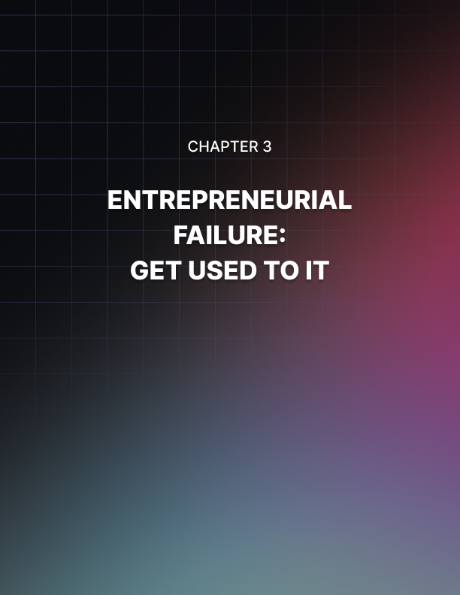

Chapter 3: Entrepreneurial Failure: Get Used To It
To be a successful entrepreneur you are going to have to learn to deal with failure.
There is no way around it. Thomas Edison tried over ten thousand different experiments before he finally demonstrated the first incandescent light bulb on October 21, 1879.
Bill Gates' first company, Traf-O-Data, was a failure. Michael Jordan was once quoted as saying: "I've missed more than 9,000 shots in my career. I've lost almost 300 games. 26 times I've been trusted to take the game winning shot; And missed. I've failed over and over again in my life. And that is why I succeed."
In my short stint as an entrepreneur I've failed more times than I can count. I have also had my share of success, but it’s not even close to equal. The failures far outweigh the successes, and I’m sure I have a lot more failures ahead of me.
I’m OK with that because I know that as soon as I stop failing, I have stopped trying to innovate. It's the nature of the business of being an entrepreneur, and of success in general.
If it were easy, everyone would do it. It is naive to think that every good idea that you have will result in a successful business venture. I have yet to hear an entrepreneur say "every single idea I come up with seems to work." More likely, you hear something like "I failed at my first five businesses before this one took off."
Think about that for a second. Five businesses. Sometimes the number is three, sometimes it's 20, but the important point is that most entrepreneurs don't hit a home-run with their first company. It really does amaze me - how many people have the stones to fail five times and still start a sixth business?
You have to be supremely confident and treat those previous five times as a learning experience for the sixth. And if number six fails, you have to do the same and move on to number seven.
In my opinion, the most important thing is how you deal with failure. Once you accept that it's inevitable, you are able to learn from your mistakes and move on.
It's easy to let failure consume you - not so much because you are pessimistic, but more so because it is hard to see something that you poured your heart and soul into to be ignored or rejected.
As soon as possible you need to come to the realization that your business is what they are ignoring or rejecting, NOT you. The sooner you do that, the sooner you can objectively analyze why you failed and learn the things necessary for improvement in the future.
Failure isn't easy and is extremely frustrating, but it's a necessary part of success. Don't believe me? Ask Thomas Edison, Bill Gates or Michael Jordan! Ok, asking Thomas Edison might be a little tough, but you get the idea.

You Might Want To Drop Out Of College
Young entrepreneurs and business owners are oftentimes faced with the choice of which road to take. On one hand, there is the more conservative route of staying in college and getting a degree.
On the other hand, many have thriving businesses that are making more money than their degree will ever get for them. Is college simply a hindrance? Or is it a valuable resource that should be continued at all costs.
Many college business owners don't even realize they have the choice of dropping out. Knowing this option could be vital to the success of their future business.
If you are in college and are an entrepreneur or business owner you must ask yourself this question: should I drop out of college?
The answer to this question often comes in many forms from many different people. I was recently at an entrepreneurial conference and had the opportunity to discuss this matter with many rich entrepreneurs.
The answers I was getting from them were vastly different from those that my family had given me. On the one hand I was being told that college is only useful if you are getting something out of it, and that if I was serious my businesses should take priority over schooling.
From the family side I was being told to stay in school no matter what, put schooling at the forefront - there will always be time for business and it will be good to have a safe backup.
Both of these answers have their merits, but which one is right? It became clear to me that it was my decision- not the other wealthy entrepreneurs, and not your family.
Why Are You In College?
This question is the fundamental element in the decision to drop out of college. Entrepreneurs must figure out the reality of why they are in college before making a decision to drop out. Some business owners are in college because their parents told them to go there, or because they didn't realize they had the choice.
Other young entrepreneurs are in college because they find the information valuable and want to continue learning while they expand their business. Even more still had childhood dreams of one day being an engineer or architect and want to follow through with their early ideals.
You must answer this question truthfully and honestly if you are going to make a choice about running your business full time or staying in college.
Why Do You Want to Drop Out?
It is very important to understand exactly why you want to drop out. Many business owners and entrepreneurs have vastly different reasons for dropping out of college and it is key that you understand yours.
I have often fielded this question in conversation, and many times a young entrepreneur will want to drop out of college on pure speculation. This is never a good idea without a solid business plan.
I recommend having a solid business plan and some backups in the least, as well as some plans for continued learning of business skills. Dropping out is a risky decision - entrepreneurs will understand and easily accept this fact. Understanding and accepting risk is part of being an entrepreneur and starting new businesses.
I have also talked with many entrepreneurs who already have million dollars plus income, and are thinking about dropping out in order to focus more on their business. This instance presents an entirely new set of questions.
Whatever your reasoning makes sure that you understand and research your position.

Secret to Making the Decision
It all comes down to balancing the two sides of the argument. If you've figured out both your reasons for being in college and your reasons for dropping out and starting a business, then you can easily make a decision.
The trick is to look at a list of both sides: your reasons for being in college and your reasons for going out and becoming an entrepreneur.
If either side has reasons that aren't your own, or that have doubts in them, then you will most likely pick the other side. Here is an example situation, look at the two lists and decide what the student should do.
Student A - Reasons to Stay in College:
- My parents are paying for it, and they would flip if I left.
- Everyone I know is in college, it would be weird to leave.
- A degree might give me some security later on.
Student A - Reasons to Drop Out and Pursue Business
- I have a solid business plan and have been working on it for months
- My income is almost half of my parents already
- Having more time to work on business would let me expand faster
I think it is fairly clear in this setup that we have an entrepreneur at heart. There is doubt in the reasoning behind college, and he also doubts that he will even need the security of a degree. The second list is much more profound and certain.
This student knows he will be successful as an entrepreneur and he only want to build his business more. There is certainty and understanding in his tone. With this situation it seems very likely that the student would be far better off dropping out of college and pursuing his business goals.
The case is almost never as cut and dry as the situation above, most young businessmen have far more complicated setups. Even with the complications, the end result is always the same.
Follow the path that you are sure of in your heart. If you are an entrepreneur in the right position then you will know exactly why you want to drop out and that it will be better for you.
Or, you will know that staying in college will teach you more about business and let you grow faster out of college. I will leave you with one last thing.
Listen to your own thoughts, and pick the path that you know is better for you.


Chapter 4: Entrepreneur Opportunities: Finding the Right Business to Start
Do you want to be a successful entrepreneur?
You probably have an excellent idea and you’re thinking over whether it is doable or not, whether it will bring in revenues, and whether it has the potential to expand into a more profitable business venture. Now that you find yourself with the desire to start your own business, there are still a lot of things you have to consider and think about.
First you have to ask yourself if you have what it takes to own and maintain a business. You should know that the world of entrepreneurship is not for everyone. Yes, the opportunities for profit and self-fulfillment are great, but so are the risks involved.
Being an entrepreneur can be a life-changing endeavor, thus, you really have to be prepared for anything that may happen. There are some specific character traits that every entrepreneur must possess or develop. These include perseverance, hard work, independence, self confidence, commitment to quality and success, honesty and many more.
If you think you really have what it takes to be an entrepreneur then you are ready to proceed to the next step, and that is to find the type of business you want to establish and own.
Finding the right Entrepreneur Opportunity
As you know by now, there are literally thousands of business opportunities available for the budding entrepreneur. With all these choices, what type of business are you going to pursue?
There are actually two approaches to finding the right entrepreneur opportunity for you. There’s the traditional approach and the “follow your passion” approach. The traditional approach to finding the right business opportunity involves a systematic and methodical process.
It involves careful planning, thorough research of the market, recognizing a need and creating the product or service to fulfill that need.
First, you have to choose the field of business that you are most interested in. Then, you can now embark on researching the ins and outs of that industry and the different businesses that can be found within it.
Afterwards, you can do market research to find out if there is an unmet need in the form of products, services, prices, etc. Then you can proceed to analyzing the competition and checking out how their business models work.
You can now start on making your preliminary business plan. Make sure to do market research to see the market potential for your chosen business. Re-evaluate and reassess your business plan and determine how much capital you are going to need.
Then, you can start seeking out investors and lenders who can help you finance your business. The traditional approach to entrepreneur opportunities is obviously labor-intensive and time-consuming, as well as potentially expensive, but careful planning before actually starting the business will also reduce the risk of failure as time goes by.
Another approach in finding the right entrepreneur opportunity is the “follow your passion” philosophy. This approach involves following and doing what you love and the money will start coming in.
This can be an excellent way to start your own business but you should understand that many people have also followed and did what they love and still did not succeed well enough. This approach encourages you to find out what type of business you should pursue through self-discovery and observation.
Reflect on what you are truly interested in and passionate about and look for ways to make a business out of it. Observe your surroundings to see If there is an unmet need. You can then create a product or service to fulfill that need.
Inspiration is also an important aspect of this approach to identifying an entrepreneur opportunity. Who knows that idea that simply popped into your mind while driving your kids to school may actually be an excellent business idea that can eventually lead to success? Another aspect of this approach is imitation.
You can simply find a tried-and-tested business model and copy it in another market. You can also consider getting a franchise. Franchises are already proven business models, and you also get support from the company to help you start out your business.
These two approaches are both effective in helping you find out what entrepreneur opportunity you must pursue. Although these approaches are not failure-proof, they can really help you increase your chances of success in the highly-competitive world of business.

Popular Entrepreneurial Ideas that Does Not Work
There are so many reasons why people want to start out a business as there are as many reasons why people are afraid to get into it. For some, it is because of the perceived enormous risks, especially to the uninitiated, although to many it is the lure of a changed lifestyle, a feeling of independence and let’s face it, the opportunity of better income and when done right, even wealth.

The Greatest Difficulty Though Is The Starting
Although at the outset, most potential entrepreneurs would never dream of failing, the facts though would eventually seep in.
We have often been told that 90% of businesses fail during the first year of operation and only a small percentage of the remaining 10% really make it.
There are many reasons for these failures. It would then be smart to look closely into these failed entrepreneurial ideas and take lessons as to why businesses fail if one is to increase the chances at succeeding.
Some examples of failed entrepreneurial ideas are:
Discover Your Passions And Make A Business Out Of It
Nothing worthwhile in this world has really been achieved without passion and this is very true. However, there have been a lot of businesses built on a passionate desire to sell what one truly believes in that did not make it.
Why? Because for all the passion built into it, the market is not primed for it. Another thing is…
Over Projection
Enthusiasm is required if one is to succeed at any endeavor. It is the fuel that fires a person up. It is the motivation that serves as the driving force to start out into a direction and the energy that could supply the individual as the direction is taken. It is also the source, sadly, of frustration.
Getting Into A Business That Has Been Proven To Succeed
Let me cite an example. When the Internet was just starting, someone in my neighborhood started an internet shop. It did very well and so as with anything that goes well, someone started picking the idea up and opened a shop. It did okay and the idea caught fire. Soon another opened up.
As could be expected, the shops started competing for the customers and prices were driven down. Soon afterwards, everyone has access to the Internet and most of the shops eventually closed. Get the idea?
Another example of an entrepreneurial idea that could seriously go wrong is getting into a similar business that someone has done successfully.
Make a careful study because unbeknownst to you, you could be getting into a business that has better resources, is better funded, is a niche market that could produce goods faster, cheaper and of better quality.
When you get into these niche businesses, you are already on an uphill climb the moment you start.
Even granting that the business that you are getting into is at par with what you have, you could be drawn to a constant head to head battle and when that is done, margins will be the first to suffer.
Getting Into A Business For Very Strong Profit Motive
Now, what could be wrong with that? Ask any seasoned businessman and he’ll say everything. For one, marketing, merchandising and communication and other goodwill support that is so vital in making your goods compete in the marketplace could already suffer even at the start.

What Could Be Done Then?
Take stock of what you have and of what you are. There are things and characteristics unique in each of us that could be trimmed and tapered to the needs of the marketplace. This may be too simplistic but introspection is the first step. You are as different as the person sitting next to you.
Surely there is something that only you could do best and in a unique manner that could be offered. Yes. This is another way of saying being passionate about what you do but take it a step farther. What is it that will rub your passion on other people?
Said another way, will other people really want to buy it? Or how would you make the market want what you are offering? How would you make them react favorably?
Study, study and study some more. Know your competition and your market well. Do not underestimate the cost nor over project the sales. Nothing is really that new in today’s marketplace.
Only the approaches and the processes could differ which could spell a marked difference when you put your personality into it and not someone else who has succeeded before you.
There is a sufficient supply of good books that are immediate for practical business application out there. Many times, when potentially good ideas fail, it could be because the person did not take that much time in discussing the ideas with someone else who is in the know and could be downright honest.
It could also result from not coming out with a good business plan or has not taken that much investment at self-discovery and a myriad of other little things.
Finally, do not do things if the only reason that tempts you to do it is the profit motive. You could end up doing things you do not want to do which will not give you the energy required to stick to it.
For other things, there are online schools that could help you gain a better head start and help increase your chances at executing your entrepreneurial ideas.
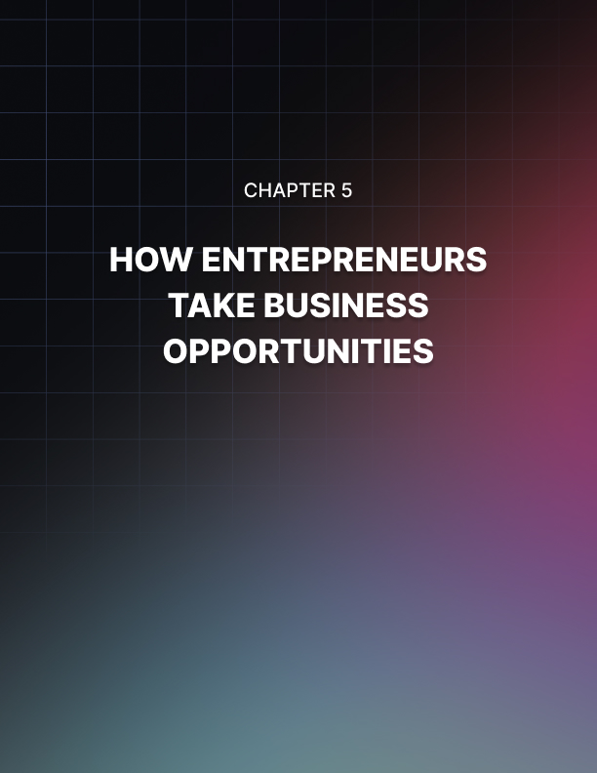

Chapter 5: How Entrepreneurs Take Business Opportunities
They say that opportunity only knocks twice. In the business world, however, opportunities do not get the chance to knock before they are shoved through the door.
You see, entrepreneurs take business opportunities very seriously.
Serious entrepreneurs do not wait for opportunities to come to them. They study their environment and find the opportunity.
Opportunity counts for so much in the business world. Whenever you encounter an opportunity, you need to grasp it and submit it to your will. Entrepreneurs treat business opportunities differently.
Here are some views of entrepreneurs on how to take advantage of business opportunities:
Seduction – some entrepreneurs find business opportunities to be like a woman. You need to properly seduce a business opportunity.
You see, with one wrong move, a business opportunity can fly out of your grasp.
Thus, you need to study for the opportunity. Is she mysterious? If so, what can she be hiding? What can help you pull that opportunity towards you?
Seduction of the business opportunity is a game of balance. You cannot be too eager or the opportunity will get suspicious and pull away. You cannot be too aloof, or the business opportunity will go to other entrepreneurs.
You have to show that you are the proper person to get that opportunity. You have to treat it with the proper respect. After all, you are the entrepreneur who needs that opportunity.
Prey – some entrepreneurs think business opportunities are like prey. They enjoy the thrill of hunting for a perfect business opportunity and take them down for the kill. For these entrepreneurs, business opportunities should be watched out for.
These people watch their environment, hoping for any sign of business opportunities. Constant vigilance is their creed, and nothing can stand in the way of their success.
By taking this mindset, you gain the instinct of the hunter. You become very competitive in terms of taking business opportunities. Sometimes, this is a good thing, leading you to your success.
There are times, however, when this mindset can lead to your downfall. Hunters often love the thrill of the hunt, but neglect to take care of the opportunity once they have them in their hands. You know that you need to take care of every opportunity in order for it to be of any use to you.
A Plant – smart entrepreneurs view business opportunities as plants. They plant the seeds of opportunity and nourish it to make it grow into a successful business venture.
This view of business opportunities is probably the best considering the fact that opportunities really do need to be taken care of in order for an entrepreneur to achieve success.
Getting the opportunity is just the start of being an entrepreneur. In order to gather the fruits of success, an entrepreneur should be able to not only get the opportunity, but expand it.
Luck – Some entrepreneurs see business opportunities as lucky coincidences or even a work of fate. They, of course, keep a lookout for business opportunities. However, they do not actively work to find some.
This Entrepreneur's view of business opportunity is probably the most naïve in today's world of business. As was mentioned earlier, opportunities nowadays have very little chance of falling into someone's lap. By waiting for the business opportunity to come to you, you are probably wasting your time.
What you need to do is get up off that chair and start looking at your environment and make the opportunity for yourself. What are the advantages to this?
Well, if you create your own opportunity, then you'll have direct access to it and have intimate knowledge of how to shape it into a great business venture.
Another plus to creating your own business opportunity is that you will be getting a head start. This means that you can forget about the competition, taking your opportunity and beating you to the success that you so anticipated.
So how should entrepreneurs view business opportunities? Well, the best thing you can do is take all of the different views and try to balance them into your own view.
Remember that different things work for different people. Try not to conform yourself to other entrepreneurs' views of business opportunities. This way, you can be at your most effective.

Entrepreneur Opportunities: Finding the Right Business to Start
Do you want to be a successful entrepreneur? You probably have an excellent idea and you’re thinking over whether it is doable or not, whether it will bring in revenues, and whether it has the potential to expand into a more profitable business venture.
Now that you find yourself with the desire to start your own business, there are still a lot of things you have to consider and think about. First you have to ask yourself if you have what it takes to own and maintain a business.
You should know that the world of entrepreneurship is not for everyone. Yes, the opportunities for profit and self-fulfillment are great, but so are the risks involved.
Being an entrepreneur can be a life-changing endeavor, thus, you really have to be prepared for anything that may happen. There are some specific character traits that every entrepreneur must possess or develop.
These include perseverance, hard work, independence, self confidence, commitment to quality and success, honesty and many more. If you think you really have what it takes to be an entrepreneur then you are ready to proceed to the next step, and that is to find the type of business you want to establish and own.

Finding the Right Entrepreneur Opportunity
As you know by now, there are literally thousands of business opportunities available for the budding entrepreneur. With all these choices, what type of business are you going to pursue? There are actually two approaches to finding the right entrepreneur opportunity for you. There’s the traditional approach and the “follow your passion” approach.
The traditional approach to finding the right business opportunity involves a systematic and methodical process. It involves careful planning, thorough research of the market, recognizing a need and creating the product or service to fulfill that need.
First, you have to choose the field of business that you are most interested in. Then, you can now embark on researching the ins and outs of that industry and the different businesses that can be found within it.
Afterwards, you can do market research to find out if there is an unmet need in the form of products, services, prices, etc. Then you can proceed to analyzing the competition and checking out how their business models work.
You can now start on making your preliminary business plan. Make sure to do market research to see the market potential for your chosen business. Re-evaluate and reassess your business plan and determine how much capital you are going to need.
Then, you can start seeking out investors and lenders who can help you finance your business. The traditional approach to entrepreneur opportunities is obviously labor-intensive and time-consuming, as well as potentially expensive, but careful planning before actually starting the business will also reduce the risk of failure as time goes by.
Another approach in finding the right entrepreneur opportunity is the “follow your passion” philosophy. This approach involves following and doing what you love and the money will start coming in.
This can be an excellent way to start your own business but you should understand that many people have also followed and did what they love and still did not succeed well enough.
This approach encourages you to find out what type of business you should pursue through self-discovery and observation. Reflect on what you are truly interested in and passionate about and look for ways to make a business out of it. Observe your surroundings to see If there is an unmet need. You can then create a product or service to fulfill that need.
Inspiration is also an important aspect of this approach to identifying an entrepreneur opportunity. Who knows that idea that simply popped into your mind while driving your kids to school may actually be an excellent business idea that can eventually lead to success?
Another aspect of this approach is imitation. You can simply find a tried-and-tested business model and copy it in another market. You can also consider getting a franchise.
Franchises are already proven business models, and you also get support from the company to help you start out your business.
These two approaches are both effective in helping you find out what entrepreneur opportunity you must pursue. Although these approaches are not failure-proof, they can really help you increase your chances of success in the highly-competitive world of business.


Chapter 6: Facing Your Fears As An Entrepreneur
Everyone I have ever talked to that is an entrepreneur has had to come face to face with their fears. I have had to as well.
I want to share with you some of the techniques that I have used to face them. The first step is not to be in denial. You have fears even if you don’t readily acknowledge them. They sometimes take the form of that chatter in the back of your head that says you can’t do it.
Fear is such a huge issue preventing people from becoming entrepreneurs. I have heard from the CEO of a real-estate based network marketing company that even though he has people packing out company seminars, that maybe 2-5% of people will actually go out and apply the knowledge by putting offers on real estate. He is convinced that the rest are paralyzed by fear.
Here are some of the techniques I have used as I learned them from the entrepreneurs I know:
Think about what you do want. When you find yourself spinning the wheels in your mind over and again about your worst-case scenario, turn it around and focus on what you DO want. Visualize yourself getting what you do want. See the new house. See yourself talking to the interested person as they become a part of your business. You get what you focus on.
Change the voice. When you hear yourself telling you that you’re not good enough – you’re going to fail. Just change the voice from yours to that of Mickey Mouse or Jim Cary or something that would hold little weight with you anyway! Who cares if Mickey Mouse thinks you’re not good enough? Is Mickey Mouse an entrepreneur?
Voice them to a trusted friend or associate. Hopefully you have been able to find some level of support from at least one other entrepreneur. Ideally, you have a significant other that supports you.
If not, then you should have some kind of support network from your team, upline, or corporate that you can talk to. Some people may tell you that it is silly you could even believe that you’re not good enough. For me, my wife has been a constant source of support.
However, don’t go looking for support to all those people who doubted you and told you it was crazy to go out on your own. They will never understand the entrepreneur.
Have a personal development library. I draw tremendous support from my library. It is not just filled with how to resources, but also stories of others who conquered their fears. I couldn’t begin to list the many sources I have.
Sometimes just making the smallest step will help get you going enough that the fear of not doing something can go away. An example would be neglecting to write an article such as this one out of fear of failure. Just starting it can create enough momentum to see it through.
Visualize the result, but make the action the goal. There is a subtle difference here for the entrepreneur. Of course, you want the result, but maybe that’s not in your direct control. Visualize the result in your mind, but make your goal the consistent and persistent action of the entrepreneur. The action will eventually produce the result and you can certainly achieve that goal.
Never, ever quit. I hate to even use that q word. If you do quit, you cease to be an entrepreneur – otherwise you’re not beaten, you are moving ahead!

Dare To Be Different!
Adding value to your site, service, or product is one of the most overlooked and underrated strategies for improving your internet business.
The internet and modern technology make it possible for anyone to offer that little something extra that nobody else does, and usually at no additional cost.
Why: First, let’s look at why this is a good business practice. It’s a good thing to do because you will make more money! What: Now let’s look at what value adding is!
Value adding is giving surprise high quality and useful gifts. It’s giving something that your competitors aren’t offering. It’s promising the world and delivering the universe.
It’s taking care of your clients and always providing something that your clients need and want, when and where they want it.
How: Now let’s look at the different ways we can do this.
If you receive a free gift from someone when you don’t expect it, do you remember that person?
- Answer; yes usually.
- How can we do this?
Look at the example below for an idea!
- If you subscribe to a newsletter or ezine, what do you expect?
- You expect to get what you subscribed for, right?
Now imagine that you subscribed for a newsletter that distributes information about Poodle breeding in France, and when you open the confirmation email you find you’ve also received a free ebook containing 20 poodle grooming tips and Grandma's secret poodle pampering techniques. (a book that normally sells for $29)
Wouldn’t that make you more likely to open and read the next issue and the next etc?
That’s one simple example, but where do you get the ebook from? You make it! If you are distributing a poodle breeding newsletter, you might know something about grooming, or know some people that could help you put together the necessary information.
Then you can wrap that up in an ebook cover and then send it around to a variety of sites that will post it for you for free and you can sell it on your own site, if you have one. (I can see that there are several more articles just on making e-books, posting them on other people’s sites, and setting up a shop front.)
Back to the Poodles! So, you can see that by offering this free gift you have achieved several things.
- You have developed a product (at no cost to you) that you can sell and make a profit on.
- You have used that product to increase the chances of your new subscriber opening your next email.
- You have promoted your site/service to other internet marketers that you may wish to do a joint venture with at some time. (see my article on Joint ventures)
Another way to add value for less effort is to offer a 110 percent guarantee instead of a 100 percent.
Another is to make your 20 tips into 30 or more etc., get the idea? It’s all just a matter of finding ways that you can give more.
The more you give the more you will receive.
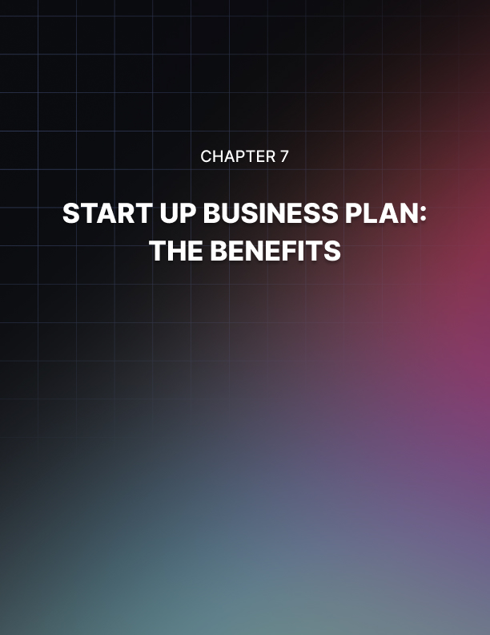

Chapter 7: Start Up Business Plan: The Benefits
Startup business plans are developed because the process of writing them creates huge benefits.
A lot of people resist writing a startup business plan. They are under the false notion that start up business plans are an academic exercise that people are made to do in college or business school.
Another common misconception is that start up business plans are only needed if you are going to raise capital through public share offerings, taking on private investors, or looking for angel investors.
The fact is, there are a tremendous number of benefits to putting together a simple startup business plan regardless of the type of business you intend to launch.
Even if the startup business plan will only be read by you or your spouse, the benefits are undeniable. The things you will learn about your business by going through the process of writing a startup business plan far outweigh the time you will spend writing it.

The Benefits of a Start Up Business Plan
Motivation: your start up business plan can help you get back on track with your original business concept giving you wisdom and guidance. It helps you see your original vision.
Planning: your start up business plan is a map showing where you are today and where you want to end up. Following it gives you confidence that you know where you're going.
Analysis: your start up business plan helps you to think about things you wouldn't normally consider. It forces you to analyze the relationships among different parts of your business. How sales ties together with lead generation, how that ties into services, delivery, profit margins, cash flow forecasting, etc...
Strategy: your start up business plan highlights the relationship between your business and the local competitive marketplace. By writing it you will have tapped into the primary sources of information about the competition; sources that will be invaluable in the future.
Overall, the act of writing a startup business plan puts your ideas and concepts down on paper. When things are in black and white like that you can see the inconsistencies and weaknesses much easier. Then you have time to address these issues and resolve them before you enter the marketplace.
Having a startup business plan is extremely valuable. The process of researching and compiling the information about your business provides motivational, organizational, analytical, and strategic advantages. These advantages will continue to accrue long after your start up business plan is written.

Starting A Business – The Three 'Ps'
There are a lot of factors to consider when starting a business. Primary among these are the three “P”s – Plan, Prepare and Persist.
- Plan
After you have selected some ideas from your brainstorming to base your business around, create a plan of attack. List what you'll need before your business starts.
What will your ongoing expenses be?
Factors include rent, utilities, permits, licensing, legal fees, inventory, staff, design, marketing collateral, mailing lists, software, advertising and more. Get as much as you can out on paper and set deadlines to get things accomplished. This will allow you to evaluate your pace.
- Prepare
Once you have a plan, carry it out. Preparing to start a business can be a lot of work. Tasks include getting an identity designed, creating business cards, brochures, web sites and other marketing material, consulting with CPA's, lawyers, and HR professionals, in some cases finding and renting or buying a storefront or office, furnishing the business space, getting utilities in place, receiving and organizing inventory, getting a database for your customers and leads and any number of other tasks.
By running a home business, some of these steps will already be taken care of, yet opening a business of any kind can be an enormous task. While planning your business make sure to leave plenty of time to get up and running.
Better to plan your setup time too long than too short and finding yourself running out of money.
- Persist
This is the most important step of running a business. Without persistence, you won't even be able to finish your business plan. Hang on like a pit-bull. When the going gets tough, get tougher. Have worst case scenario plans to fall back on, as well as best case scenario plans.
Some businesses become overnight successes, while others take years to develop. If you plan, prepare and persist, you’ve got a very good chance of making it.
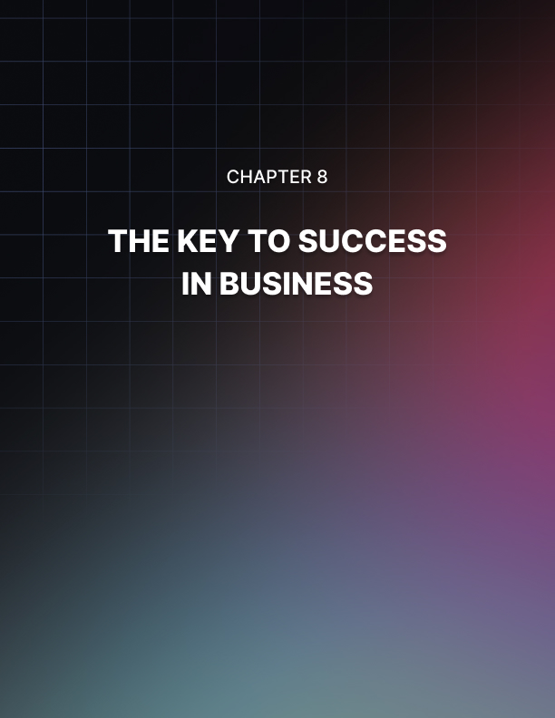

Chapter 8: The Keys To Success In Business
Success in business has nothing whatsoever to do with salesmanship, little to do with a knowledge of your company’s products or services.
It is owing to some far more basic fundamental principles which will determine your success or failure at anything you do in life.
They are your A,B,C’s, Attitude, Belief and Consistency. Taking them in reverse order.
Consistency
We get up every morning, we brush our teeth, get dressed and have breakfast. We are consistent in our actions. We do it every day. We need to do the same in being consistent with our tasks associated with our business for the days that we have chosen we are going to work, be it 1 or 7 days a week.
We need the 6 marbles in our left pocket or left side of our bag and transfer 1 marble to the other side every time we have carried out a positive action i.e. seeing a customer, talking to someone about the business, etc. etc.
We need to do it consistently. We need to have transferred all 6 marbles (better still 10) by the end of the day. We need to concentrate on the actions, not on the result. I’ll repeat that, we need to concentrate on the actions not on the results.
When we go mountain climbing, if we continually look at the summit we would soon trip up and fall. We need to concentrate on every step at a time, one after the other and as surely as the sun goes down, we will reach our summit.
Belief
An absolute and genuine belief in our business, it’s products and services and what it can give its customers.
Attitude
Possibly the most important of these three but useless on its own. It’s no good having the best attitude in the world if one’s sitting on one’s own in a closed room not talking to anyone. So, what is an attitude apart from how one feels about oneself and others. I describe it like this.
Your face is transparent, totally transparent and your attitude shines through whether it’s positive or negative. The first second that a prospective customer sees you, maybe even before you see him, your attitude comes through.
The customer sees it, maybe only subconsciously and will react accordingly. We all know that the first thing any salesperson has to sell is themselves even before they open their mouth. If they can’t sell themselves, they might as well turn around and go home and go back to bed. If they can’t sell themselves, they wouldn’t be able to sell packets of peanuts or a Mars bar.
Another description of attitude, when I took my 14-year-old daughter recently to Disneyland Paris we went one evening to an aquatic circus.
Very unusual, people diving, dancing and somersaulting on water. It was a spectacular show. What made it even more enjoyable (we were sitting in the front row) was the fact that all the performers without exception were obviously really enjoying themselves.
They were loving every minute of it and gave it their all. Their attitude really shone through like a beacon and this made our enjoyment total.
So, when we get up in the morning and do our consistent things, let's get a really big warm smile from within feeling good about ourselves and keep that all day.
When we go about our business, we need to keep a good attitude. If we can’t also be in the place where we are physically there’s no point being there in the first place. It’s easier to ride a horse in the direction that it’s going.
So those are my 3 all-important ingredients that determine one’s success or failure at anything in life.

What Does It Take To Be An Entrepreneur?
Over the years countless institutes and individuals have asked the million-dollar question. What makes an entrepreneur an entrepreneur? What traits or characteristics are inherent to a successful entrepreneur and is one born with those traits? There’s great news! Successful entrepreneurs are born every day!
Some people believe an entrepreneur is born while others believe an entrepreneur can be taught. Some believe an entrepreneur is like an artist - either you have it or you don’t.
Some see entrepreneurs as leaders that are focused, disciplined, competitive, and charismatic, while others see them as huge risk takers. And all of these analogies are right to some degree.
It’s true all successful entrepreneurs share a few qualities and skills that allow them to be successful. These inherent qualities can be taught; but they often seem to be an inherent driving force that sends individuals down the path of being in business or formally training for a career in business.
Entrepreneurs see the world differently. They have the ability to see the world as a system. They have the ability to see something in its entirety and as an integrated unit, and they seem to possess the ability to see opportunity within the global picture. They are what is called a system thinker.
There are other characteristics they possess. Entrepreneurs possess an overpowering need to achieve and tend to be very competitive against themselves.
They are continuously trying to outthink themselves and others and they are constantly looking for the edge. This is a process that occurs as naturally as breathing and is a driving force behind most entrepreneurs.
They have the determination and dedication to follow through with commitments and they always appear confident and in control. You’ll notice they also possess a positive atmosphere.
They are of the mindset “I can,” and “I will.” They are not afraid of failure because failure is not in their vocabulary nor is it an option.
They are objective but have the ability to weigh risks realistically within the big picture. They have an uncanny ability to anticipate developments which gives them the edge on many competitive situations.
Entrepreneurs seem to feel right from their gut, call it instinct. They are a resourceful group that possess excellent problem-solving skills and are able to diligently work through obstacles as they occur.
Entrepreneurs are excellent communicators and recognize how important clear and concise communication is to their success. They also possess a sound working knowledge of the business they are involved in.
When it comes to successful entrepreneurs it’s a question of what came first, the chicken or the egg. Are its inherent qualities that we are born with that lead us to be entrepreneurs or is it when we choose to become an entrepreneur that we develop the skills and qualities of success? That’s a question we shall leave to the great debaters to resolve.
What is for certain is that successful entrepreneurs are born every day and that you too can be a successful entrepreneur by developing the skills of success.


Conclusion
In discussing entrepreneurship and writing articles on the subject, I have found that it aids understanding when we begin by agreeing on exactly what the word means to us.
Entrepreneurship is the process of creating or seizing an opportunity, and pursuing it regardless of the resources currently controlled. The American Heritage Dictionary defines an entrepreneur to be “a person who organizes, operates, and assumes the risk for business ventures.
These are rather abstract concepts for a person just beginning to consider whether they ought to start a business rather than take a job, or leave a secure job for a chance at greater self-fulfillment. Let us try to refine our understanding of entrepreneurship by asking some more specific questions.
Is everyone who runs a business an entrepreneur? Many would not consider the newspaper carrier, shoeshine person, and grass cutter entrepreneurs, though these are often the youthful pursuits of those with an entrepreneurial bent.
Does it matter whether the business is merely part-time? Whereas some part-time activities are basically hobbies, or undertaken to supplement income, some entrepreneurial ventures can be tested in the marketplace on a part-time basis.
The path to an entrepreneurial venture might begin by earning a salary in the business one expects to enter, while learning more about it, and waiting for the opportune time to go out on one's own. This time can be used to develop a support network, professional and personal, and generate ideas to “bounce off” people whose opinion one respects.
At what scope does self-employment become a venture? The primary objective of many self-employed people is merely to employ themselves (and others if necessary) at a moderate to good salary; some are even willing to eke out a living to do what they enjoy. This approach is often referred to as a “lifestyle” business, and is generally accompanied by little, if any, plan for growth.
These questions are intended, not to develop a precise definition of entrepreneurship, but to help us understand our attitude toward its many forms of expression. We may each answer these questions differently, yet all answer appropriately within our own frame of reference.
Entrepreneurship is more an attitude than a skill or a profession. Some of us may prefer a corporate or public service career path, but many would choose an entrepreneurial opportunity that “feels right.”
Would you consider a person who inherits a business an entrepreneur? From the point of inheritance on, it is their own money and financial security at risk.
They could possibly sell the business, invest the proceeds in blue-chip stocks, and live off dividends. Some might consider managing a personal stock portfolio for a living as an entrepreneurial venture.
Would a person who inherited a small or marginal business, then took it to new dimensions be considered an entrepreneur? The inheritor could have tried merely to keep it going, or even to pace the business’ decline to just carry them to retirement. In a family-held business, long-term success is often a central goal.
Are franchise owners’ entrepreneurs? Many feel that, for those who have access to the large up-front investment, franchises are sure things. For many, operating a franchise is similar to investing in “blue chips,” a relatively sure thing with generally unexciting returns.

