TABLE OF CONTENTS
____
INTRODUCTION 4
DECODING ADHD 7
Understanding Executive Function 7
Managing Time and Memory 8
Harnessing ADHD Strengths 9
TRANSFORMING YOUR SPACE FOR SUCCESS 13
The Foundation of Organized Spaces 14
Strategic Zone Management 14
Digital Organization Systems 15
TIME MANAGEMENT TACTICS THAT WORK 18
Understanding Your Time Dynamics 19
Creating Your Productivity Framework 20
Implementing Strategic Time Blocks 21
CRAFTING HABITS THAT STICK 24
Understanding the Neuroscience of Habits 24
Engineering Your Environment for Success 25
Building Resilient Habit Systems 26
SELF-CARE STRATEGIES FOR SUSTAINED MOMENTUM 30
The Brain-Body Connection 30
Energy Management Mastery 31
The Wellness Foundation 32
SUMMING UP AND MOVING AHEAD 36
Building Your Success Framework 36
Implementing Personalized Strategies 37
Maintaining Momentum and Growth 38

DISCLAIMER
____
The information provided in this ebook is intended solely for educational and informational purposes. The author does not accept any responsibility for the outcomes that may arise from the application of the material within. While efforts have been made to ensure the accuracy and relevance of the content, the author cannot be held accountable for any errors or omissions, or for any consequences resulting from the use or misuse of the information provided. The responsibility for any actions taken based on the information in this ebook lies solely with the reader.



INTRODUCTION
____
Your mind is full of amazing ideas. Sometimes even simple tasks feel impossible to finish. Maybe you’ve tried different productivity systems, but they never seem to work for you. You might feel frustrated and wonder if something is wrong with you. The truth is, your brain isn’t broken. It’s just wired differently, and that’s a good thing.
Think of your ADHD brain like a high-speed sports car. It has incredible power. You just need the right tools to control it. This book will help you learn how to use your brain’s unique strengths to turn challenges into opportunities for success.
The ADHD mind isn't less than; it's different. And different can be better when you know how to use it.

Most productivity guides assume one solution works for everyone. But this book is designed specifically for people like you, with tips that match how your brain naturally works. You’ll find simple tools to help you handle tasks, manage time, and stay organized. Imagine walking into a workspace that helps you focus instead of stressing you out. Picture checking off items on your to-do list with confidence because you know how to break projects into steps that make sense to your brain. These results are possible and proven.
This book isn’t just about giving advice. It’s a guide to understanding how your brain works. Dr. Russell Barkley, a leading ADHD researcher, notes: “The ADHD mind isn’t less than; it’s different. And different can be better when you know how to use it.”
You’ll learn how to turn distractions into tools for focus. You will find ways to use procrastination to your advantage and organize your ideas into action plans. You won’t have to force yourself to follow systems that don’t fit. Instead, you’ll create your own systems that play to your strengths. Whether you’re building your career, growing a business, or just trying to stay on top of daily tasks, the strategies in this book will work for you.
The solutions in these pages are simple, proven, and designed for people with ADHD. From organizing your space to learning time management tricks that stick, every tip helps you succeed on your terms. You're about to join a community of successful individuals who've learned to embrace their ADHD traits as advantages rather than limitations.
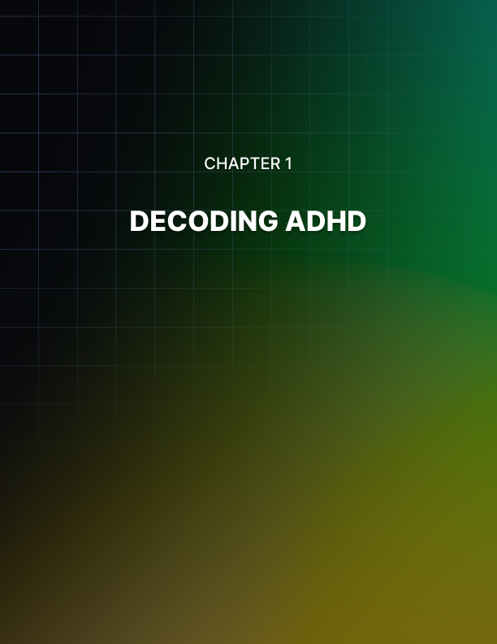

DECODING ADHD
____

Understanding Executive Function
Your brain works like a powerful engine with a unique operating system. Living with ADHD means your mental processing differs from others - not better or worse, just different. Think of executive function as your brain's control center. It manages critical tasks like planning your day, organizing your workspace, controlling impulses, and keeping important information ready for use. When you have ADHD, this control center operates differently, creating both obstacles and opportunities in your daily life.
According to Dr. Russell Barkley, a leading ADHD researcher, people with ADHD often experience a 30-40% delay in executive function development. This means your brain's organizational abilities might work differently from your actual age, requiring unique approaches to planning and organization. The impact extends across multiple areas of daily functioning, from managing simple tasks to handling complex projects. Understanding this delay helps explain why traditional organizational methods might not work effectively for someone with ADHD, and why developing personalized strategies becomes crucial for success.
Executive Function Component | Common Challenges | Practical Solutions
Planning & Organization | Task breakdown difficulties, Time estimation issues | Use visual planners, Break tasks into smaller steps
Working Memory | Forgetting details, Losing track of items | Implement "Touch It Once" rule, Use digital reminders
Impulse Control | Quick reactions, Distraction susceptibility | Practice "pause and breathe", Create buffer zones
Emotional Regulation | Intense feelings, Rapid mood changes | Apply STOP method, Develop mindfulness practices

Managing Time and Memory
Working memory acts as your brain's temporary sticky note, holding information you need while performing tasks. With ADHD, your working memory might drop important details during conversations, forget instructions halfway through tasks, lose track of items you just put down, or struggle to hold multiple thoughts simultaneously. The "Touch It Once" rule becomes particularly valuable here - when you receive information, immediately process it by either writing it down, setting a reminder, taking immediate action, or scheduling it for later.
Time management presents unique challenges for individuals with ADHD due to time blindness - a difficulty in estimating time passage. This can manifest in various ways, from getting lost in hyperfocus to struggling with deadline management. Using external time management tools and building structured systems that align with your natural tendencies can make managing your time more effective and sustainable.
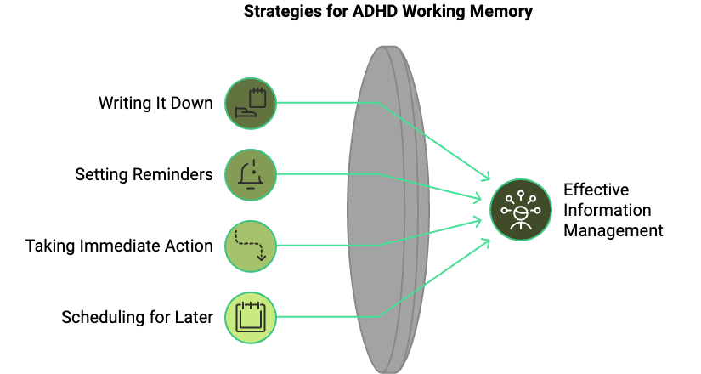

Harnessing ADHD Strengths
Your ADHD brain comes packed with unique advantages that can become powerful assets when properly understood and utilized. Research consistently shows that people with ADHD often excel in areas of creativity, innovation, and dynamic thinking.
The ability to make unexpected connections and see patterns others might miss can lead to breakthrough solutions and original approaches to problems. Famous entrepreneurs like Richard Branson have attributed their success to their ADHD thinking style, demonstrating how different cognitive processing can become a competitive advantage in business and life.
The phenomenon of hyperfocus, while sometimes challenging to control, can become a superpower when properly channeled. During periods of intense focus, people with ADHD often demonstrate exceptional productivity and creative output. Success comes from learning to direct this focus toward meaningful goals while maintaining healthy boundaries and work-life balance. Understanding your unique energy cycles and attention patterns allows you to optimize your environment and schedule for peak performance.
ADHD Strength | Potential Applications | Optimization Strategies
Creativity | Problem-solving, Innovation | Create dedicated brainstorming time
Hyperfocus | Deep work,  Project completion | Schedule around peak focus periods
Adaptability | Crisis management,  Change leadership | Build flexible systems
Energy | Dynamic presentations,  Active leadership | Channel energy productively

The path to success with ADHD involves working with your brain's natural tendencies rather than against them. This means developing personalized strategies that align with your unique cognitive style, reframing challenges as opportunities, and leveraging your inherent strengths. Understanding how your executive functions work and embracing your unique attributes is the first step toward transforming your ADHD into a powerful force for success. Don't forget that your brain is not broken. It is simply wired differently, and that difference can be your greatest advantage.
"In the end, success with ADHD isn't about forcing yourself to fit into a neurotypical mold. It's about discovering and embracing your unique way of processing the world."


TRANSFORMING YOUR SPACE FOR SUCCESS
____
Your environment shapes your mind's ability to process information and maintain attention. For someone with ADHD, creating an organized space isn't just about aesthetics. It's about building a foundation for success. Research consistently shows that our physical surroundings directly impact cognitive function, productivity, and overall well-being. Understanding and implementing effective organizational systems can transform your daily experience and enhance your ability to manage ADHD symptoms effectively.
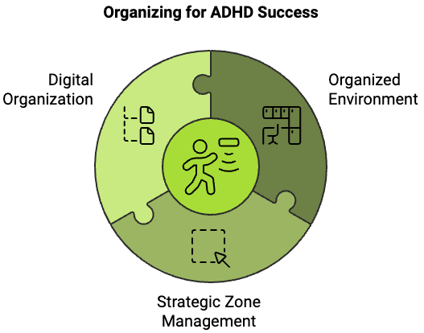

The Foundation of Organized Spaces
Creating an organized environment requires understanding the fundamental principles that drive successful space management. The human brain processes thousands of visual inputs every second, and in a cluttered environment, each item becomes a potential distraction. Research from the Princeton University Neuroscience Institute demonstrates that working in a cluttered space significantly restricts your brain's ability to focus and process information efficiently. When your surroundings are organized, your cognitive resources are freed to focus on important tasks rather than being drained by environmental chaos. This neurological response makes organizing your space not just a practical step, but an essential part of managing ADHD. Creating systems that align with your natural tendencies, building habits that last, and using strategies to ease the mental load of daily tasks are crucial components of effective ADHD management.

Strategic Zone Management
The implementation of strategic zones transforms chaotic spaces into functional environments that support productivity and focus. The concept of activity-based zoning divides your space into purposeful areas, each designed to support specific types of tasks and behaviors. This systematic approach reduces decision fatigue and creates clear boundaries between different activities, making it easier to maintain focus and transition between tasks.
Zone Configuration Table:
Zone Type | Purpose | Key Elements | Maintenance Requirements
Focus Zone | Deep work and concentration | Minimal decoration, good lighting, ergonomic setup | Daily reset, weekly deep clean
Quick-Task Zone | Brief activities and transitions | Essential supplies, clear workspace | Twice-daily organization
Reference Zone | Information storage and retrieval | Labeled containers, accessible filing system | Weekly review and update
Storage Zone | Long-term item storage | Categorized boxes, inventory system | Monthly assessment

The effectiveness of zone management relies heavily on consistent maintenance and clear boundaries between areas. Each zone should be equipped with the necessary tools and supplies specific to its purpose, while maintaining minimal visual clutter. This strategic approach to space organization creates a natural flow that supports productive behavior patterns and reduces the cognitive burden of transitioning between different types of tasks.

Digital Organization Systems
Digital clutter can be just as overwhelming as physical disarray. Establishing effective digital organization systems is essential for maintaining productivity and reducing mental stress.Effective digital organization comes from creating intuitive structures that align with your natural thought processes while setting clear boundaries to avoid information overload.
A well-rounded digital organization strategy must address three critical areas: file management, communication systems, and task tracking. The implementation of a hierarchical file structure creates clear pathways for information storage and retrieval, while established protocols for email and message management prevent communication overload. Additionally, utilizing task management software with clearly defined categories and priority levels ensures that important responsibilities don't fall through the cracks.
The success of any organization system, whether physical or digital, depends on consistent maintenance and regular review. Implementing these strategies creates a framework for success, but the real transformation comes from daily practice and commitment to maintaining these systems over time. Perfection is not the goal. Progress and functionality are what matter most in creating an environment that supports your success with ADHD.
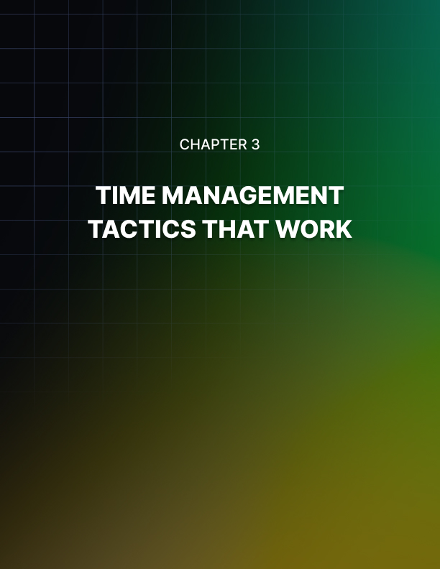

TIME MANAGEMENT TACTICS THAT WORK
____
Time flows differently when you have ADHD. Minutes can stretch like hours during tedious tasks, while hours vanish in moments of intense focus. Your unique relationship with time requires specialized strategies that match your brain's natural rhythms.
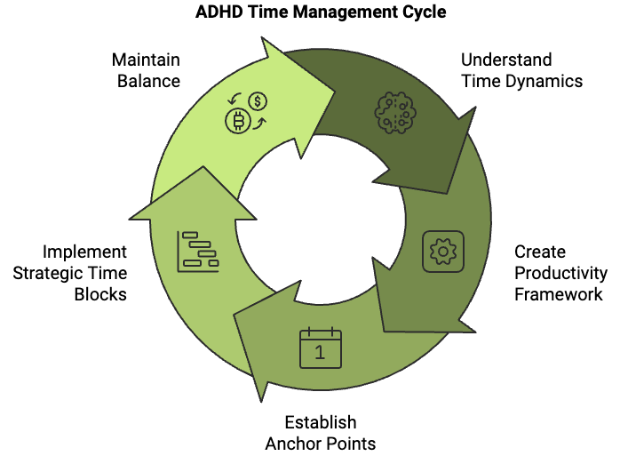

Understanding Your Time Dynamics
Your perception of time with ADHD is fundamentally different from neurotypical individuals. This isn't a flaw - it's simply how your brain processes temporal information. Effective time management comes from working with these differences instead of fighting against them.
Managing time with ADHD requires understanding that traditional time management advice often fails because it doesn't account for the unique way your brain processes temporal information. The time blindness many people with ADHD experience isn't a character flaw, it's a neurological difference that requires specialized approaches.
A thorough analysis of how ADHD affects time perception shows these common patterns:
Time Perception Challenge | Impact | Adaptive Strategy
Time Blindness | Difficulty estimating task duration | External timing tools
Hyperfocus | Lost track of time during engaging tasks | Set clear boundaries and alarms
Variable Processing | Inconsistent task completion times | Buffer zones in scheduling
Future Projection | Struggle to plan ahead effectively | Visual planning systems

Creating Your Productivity Framework
The foundation of effective time management with ADHD lies in building a framework that accommodates your brain's natural patterns while providing necessary structure. This framework must be both robust enough to keep you on track and flexible enough to prevent frustration when things don't go as planned.
Start by establishing your anchor points. Anchor points are the non-negotiable elements of your day that create structure. These might include morning medication, regular meals, or specific work hours. Around these anchors, build flexible zones that allow for both focused work and the natural variability that comes with ADHD.
Your framework should include:
- Morning launch sequence
A consistent routine that sets up your day for success.
- Energy-matched task blocks
Aligning complex tasks with your peak focus periods.
- Buffer zones
Built-in flexibility for transitions and unexpected events.
- Recovery periods
Scheduled breaks to maintain optimal brain function.
- Evening wind-down
Structured transition from work to rest.

Implementing Strategic Time Blocks
Time blocking becomes particularly powerful when adapted specifically for the ADHD brain. Rather than rigid hourly schedules, create flexible blocks that account for your natural rhythm and energy fluctuations. This approach provides structure while maintaining the adaptability necessary for success.
A dynamic and sustainable approach to time management requires understanding that productivity isn't about working longer hours - it's about working smarter within your natural rhythms and capabilities. The most effective time management system is one that you can consistently maintain, even if it looks different from traditional advice or others' methods. Success is not measured by adhering to a perfect schedule, but by consistently moving forward toward your goals while maintaining your well-being.
Research has consistently shown that individuals with ADHD perform best when they have clear external structures combined with internal flexibility. This means creating systems that provide guidance without becoming restrictive straightjackets that trigger resistance or overwhelm. Finding the right balance between structure and flexibility is essential to support your unique brain wiring.

Consider this expanded time-blocking template:
Time Block Type | Duration | Purpose | Energy Level Required
Power Block | 90-120 mins | Deep focus work | High
Admin Block | 30-45 mins | Routine tasks | Medium
Creative Block | 60-90 mins | Innovation/brainstorming | Variable
Buffer Block | 15-30 mins | Transitions/unexpected | Low
Recovery Block | 20-30 mins | Reset/recharge | Minimal

Effective time management is not about controlling every minute of your day. It is about creating a framework that supports your natural strengths while providing structure where needed. The goal is to work with your ADHD brain rather than against it, allowing you to harness your unique abilities while managing potential challenges.
Your time management system should be as dynamic as your thinking patterns. Regular review and adjustment of your strategies ensures they continue to serve your needs as circumstances change. This flexibility, combined with consistent core practices, creates a sustainable approach to managing time with ADHD.


CRAFTING HABITS THAT STICK
____

Understanding the Neuroscience of Habits
Lasting change comes from understanding how our brains, especially those with ADHD, process and establish habits.Your brain's neural pathways are like well-worn trails that become deeper and more defined with each repetition.
For individuals with ADHD, the process of habit formation is uniquely challenging due to differences in dopamine regulation. Dopamine is the neurotransmitter responsible for motivation and reward processing. The traditional habit loop consists of three essential components: the cue that triggers behavior, the routine or action itself, and the reward that reinforces the behavior. This mechanism works differently in the ADHD brain, requiring specific adaptations to create lasting change.
Recent neuroscience research has revealed that approximately 40% of our daily actions are guided by habits rather than conscious decisions. For someone with ADHD, this presents both a challenge and an opportunity. While initial habit formation may require more effort and intentional design, successfully established habits can significantly reduce the cognitive load that often overwhelms the ADHD mind. Understanding these neurological differences allows us to design habit-forming strategies that work with, rather than against, the unique characteristics of the ADHD brain.
Brain Region | Role in Habit Formation | ADHD Considerations | Adaptation Strategies
Prefrontal Cortex | Executive Function | Reduced Activity | External Structure
Basal Ganglia | Habit Storage | Variable Processing | Consistent Cues
Reward System | Motivation | Irregular Response | Immediate Rewards
Working Memory | Routine Maintenance | Limited Capacity | Simple Steps

Engineering Your Environment for Success
Creating an environment that supports habit formation is crucial for individuals with ADHD. The physical and digital spaces we inhabit can either facilitate or hinder our progress toward establishing lasting habits. Environmental design is more than just keeping things organized. It means setting up your space in a way that makes it easier to build good habits and harder to stick to bad ones. This strategic approach to environmental design can significantly impact your success rate in forming and maintaining new habits.
Consider how your current environment either supports or sabotages your desired habits. The most effective habit-supporting environments incorporate clear visual cues, minimize distractions, and make desired behaviors the path of least resistance. For instance, if your goal is to exercise more regularly, placing your workout clothes and shoes in a visible location the night before creates both a visual reminder and reduces morning friction. Similarly, setting up a dedicated workspace with all necessary tools readily available can significantly improve focus and productivity habits.
Key Environmental Modifications:
- Create clear visual reminders and cues
- Establish dedicated spaces for specific activities
- Remove or reduce potential distractions
- Position tools and resources for easy access
- Design physical barriers for unwanted behaviors

Building Resilient Habit Systems
The development of resilient habit systems requires an inclusive approach that accounts for the natural variations in ADHD symptoms and energy levels. Rather than relying on rigid routines that can easily break down, successful habit formation for individuals with ADHD depends on creating flexible systems that can adapt to changing circumstances while maintaining core behaviors. This approach acknowledges that some days will be more challenging than others and builds in contingency plans to maintain momentum even during difficult periods.
A resilient habit system incorporates multiple layers of accountability, tracking mechanisms, and reward structures. Developing what we call habit scaffolding is important. It’s a supporting framework that helps maintain behaviors even when motivation is low or external circumstances are challenging. This scaffolding includes backup plans, modified versions of habits for different energy levels, and clear recovery protocols for when habits temporarily derail. For example, if your primary habit is a 30-minute morning workout, your habit scaffolding might include a 10-minute version for low-energy days and a simple stretching routine as a minimal viable option.
Energy Level | Primary Habit | Modified Version | Minimal Version
High | 30min full workout | 15min core routine | 5min stretching
Medium | 60min deep work | 25min focused task | 10min planning
Low | Complete meal prep | Simplified cooking | Healthy snacking
Recovery | Daily meditation | Guided breathing | 2min mindfulness

The success of your habit-building efforts ultimately depends on creating systems that acknowledge and work with your ADHD brain rather than against it. This means incorporating enough flexibility to maintain momentum through varying energy levels and external circumstances while providing sufficient structure to support consistent progress. Keep in mind that perfection is not the target but rather sustainable progress over time.Building resilient systems that adapt to your needs while maintaining core behaviors creates a strong foundation for lasting positive change. This approach helps you navigate the challenges and setbacks that often come with any significant behavioral modification.
"The key is not to prioritize what's on your schedule, but to schedule your priorities." This fundamental principle becomes even more critical when designing habit systems for the ADHD brain. By focusing on creating flexible, resilient systems rather than rigid routines, you set yourself up for long-term success in establishing and maintaining beneficial habits that truly stick.


SELF-CARE STRATEGIES FOR SUSTAINED MOMENTUM
____
Living with ADHD demands extra energy from your brain, making self-care not just helpful but essential for sustainable success. The foundation of exceptional productivity rests on caring for your physical, mental, and emotional well-being.

The Brain-Body Connection
Your brain operates like a high-performance sports car – it needs premium fuel and regular maintenance to function at its best. Research shows that individuals with ADHD who practice consistent self-care experience a 40% reduction in symptom severity and report higher life satisfaction levels. When you're running on empty, even the best organizational systems and time management strategies can't compensate for depleted mental resources.
The intricate relationship between physical wellness and cognitive function creates a powerful feedback loop. Understanding this connection helps explain why traditional productivity advice often falls short for people with ADHD. Consider how sleep quality directly impacts executive function, or how proper nutrition influences neurotransmitter production. These aren't just nice-to-have additions to your routine; they're fundamental requirements for optimal brain function.
Wellness Factor | Impact on ADHD | Optimization Strategy
Sleep Quality | Executive Function | 7-9 hours consistent schedule
Nutrition | Neurotransmitter Balance | Regular, balanced meals
Physical Activity | Dopamine Regulation | Daily movement practice
Stress Management | Emotional Control | Regular relaxation techniques

Energy Management Mastery
Think of your energy like a bank account. Every activity either deposits or withdraws energy. People with ADHD often experience more rapid energy depletion due to the extra mental effort required for daily tasks. Creating a sustainable energy management system helps prevent burnout and maintains consistent productivity.
Effective energy management depends on understanding your personal patterns and creating strategies that align with your natural rhythms. This means tracking your energy levels throughout the day and identifying both energy-draining and energy-boosting activities. With this information, you can strategically plan your day to maximize productivity while maintaining sustainable energy levels.

Energy optimization involves several key components:
- Strategic task scheduling based on energy patterns
- Regular energy restoration breaks
- Activity batching to reduce cognitive load
- Environmental optimization for focus and flow

The Wellness Foundation
Physical wellness serves as the cornerstone of effective ADHD management. Research indicates that regular exercise can improve executive function by up to 30%, while proper nutrition and sleep hygiene directly impact symptom management and overall functioning.
A holistic wellness approach must address multiple dimensions of health, including physical activity, nutrition, sleep, and stress management. This isn't about pursuing perfection but rather about creating sustainable habits that support your brain's optimal functioning.
The most effective wellness strategies combine structured routines with flexibility to accommodate the natural variability in ADHD symptoms. This might mean having a consistent morning routine while allowing for adjustments based on energy levels and daily demands. Regular movement practices, whether through formal exercise or informal activity breaks, help regulate dopamine levels and improve focus.

Consider these foundational elements:
Wellness Component | Daily Practice | Weekly Goal | Benefits
Movement | 10-minute breaks | 150 minutes total | Improved focus, mood
Nutrition | 3 balanced meals | Meal prep Sunday | Stable energy levels
Sleep | Consistent bedtime | 49-63 hours total | Better executive function
Stress Management | 5-minute meditation | 3 longer sessions | Reduced anxiety

Creating a sustainable self-care practice requires understanding that small, consistent actions often yield better results than dramatic but unsustainable changes. Start with one area of focus and gradually build upon your successes, always remembering that self-care isn't selfish. It's essential for managing ADHD effectively.
Implementing these strategies and refining your approach over time helps you build a strong foundation for managing ADHD effectively while achieving your goals and maintaining well-being. Progress may not always follow a straight path, and what works best for you to change as you grow. Staying flexible and responsive to your needs while maintaining consistency in your core self-care practices is essential.
Your journey with ADHD requires understanding that self-care is not optional. It is essential for optimal functioning and sustained success. Consistently applying these strategies helps create the conditions for lasting productivity and personal fulfillment. This approach allows you to build a life that works with your unique brain wiring rather than against it.


SUMMING UP AND MOVING AHEAD
____
Success with ADHD isn't about following a rigid blueprint – it's about discovering and implementing strategies that resonate with your unique brain wiring. Throughout this journey, you've gained valuable insights and practical tools to transform challenges into opportunities. Now, let's bring these elements together into a cohesive approach for continued growth and achievement.

Building Your Success Framework
Managing ADHD effectively requires weaving together multiple strategies into a unified system. When these pieces come together, they create a powerful framework for sustained success. Your executive function understanding, organizational systems, time management techniques, habit-building strategies, and self-care practices work synergistically to support your goals. Lasting success depends on understanding how these various elements interact and support each other to create a sustainable system tailored to your needs and challenges.
Consider this essential framework that outlines how different components work together to create a complete support system.
Core Component | Supporting Elements | Integration Benefits
Executive Function | Time Management + Organization | Enhanced decision-making and planning
Physical Environment | Habit Building + Self-Care | Improved focus and productivity
Time Management | Executive Function + Energy | Better task completion and reduced stress
Habit Formation | Environment + Self-Care | Lasting behavioral changes
Wellness Practices | All Components | Increased resilience and performance

Creating a sustainable system requires understanding that success with ADHD isn't about perfection – it's about progress and adaptation. Your unique brain wiring brings both challenges and remarkable strengths. The key lies in leveraging these strengths while developing strategies to manage challenges effectively. This means being willing to experiment, adjust, and refine your approach as you learn more about what works best for you.

Implementing Personalized Strategies
Your ADHD experience is uniquely yours, and the strategies that work brilliantly for others might need significant adjustment to fit your needs. This isn't a failure – it's an opportunity for innovation. The process of personalizing strategies involves careful observation, experimentation, and refinement. It's essential to understand that what works in one situation or energy state might need modification in another.
Successful strategy implementation involves creating systems that are structured enough to provide support while remaining flexible enough to adjust to the natural variations in ADHD symptoms.This means developing multiple approaches for different scenarios and energy levels. For instance, having a high-energy protocol that maximizes productivity during peak focus periods, while also maintaining a low-energy protocol that ensures essential tasks are completed during challenging times.
When implementing new strategies, it's crucial to start small and build gradually. This approach allows you to:
- Test the effectiveness of each component individually
- Make adjustments based on real-world experience
- Build confidence through small successes
- Create sustainable habits that stick
- Identify potential obstacles before they become major issues
- Develop backup plans for challenging days

Maintaining Momentum and Growth
Progress with ADHD isn't always linear, and understanding this is crucial for long-term success. There will be days when everything flows smoothly and others when challenges seem overwhelming. Maintaining momentum requires building resilience by responding flexibly to natural variations. This means having systems in place that can adapt to different energy levels and circumstances while still moving you forward toward your goals.
Building momentum requires a combination of consistent action and strategic planning. Here's a balanced approach to maintaining progress:
- Daily Foundations
- Morning routine optimization
- Energy management strategies
- Task prioritization systems
- Environmental adjustments
- Weekly Review and Planning
- Progress assessment
- Strategy refinement
- Goal alignment
- Support system check-ins
- Monthly Growth Focus
- Skill development
- System optimization
- Habit evaluation
- Long-term planning
Creating sustainable progress means understanding that setbacks are not failures but opportunities for learning and adjustment. Each challenge provides valuable information about what works and what needs modification in your personal ADHD management strategy. Maintaining a growth mindset and viewing each experience as valuable information for your development is essential.
Remember that success with ADHD isn't about achieving perfection. It's about progress and adaptation. Your unique brain wiring brings both challenges and remarkable strengths. By continuing to refine and implement these strategies while maintaining self-compassion, you create a foundation for lasting success and fulfillment. Keep moving forward, celebrate your progress, and trust in your ability to create positive change in your life.
"Success is not final, failure is not fatal: it is the courage to continue that counts." Your ADHD journey is ongoing, and each step forward builds momentum for continued growth and achievement.

