Disclaimer

This eBook has been written for information purposes only. Every effort has been made to make this eBook as complete and accurate as possible. However, there may be mistakes in typography or content. Also, this eBook provides information only up to the publishing date. Therefore, this eBook should be used as a guide - not as the ultimate source.

The purpose of this eBook is to educate. The author and the publisher do not warrant that the information contained in this eBook is fully complete and shall not be responsible for any errors or omissions. The author and publisher shall have neither liability nor responsibility to any person or entity with respect to any loss or damage caused or alleged to be caused directly or indirectly by this ebook.

This eBook offers information and is designed for educational purposes only. You should not rely on this information as a substitute, nor does it replace professional medical advice, diagnosis, or treatment.
Table of Contents

Introduction 5
Chapter 1: The Power of Your Story 8
Understanding How Your Story Has Been Shaped by Your Beliefs. 8
Recognizing the Impact of Your Story on Your Life. 9
Chapter 2: Identifying Limiting Beliefs 14
Recognizing Common Limiting Beliefs 14
Identifying Your Own Limiting Beliefs 15
Chapter 3: The Origins of Limiting Beliefs 18
Understanding How Limiting Beliefs are Formed. 18
Examining the Influence of Past Experiences on Your Beliefs. 19
Chapter 4: Challenging Your Limiting Beliefs 25
Learning to Question Your Beliefs 25
Examining the Evidence for and Against Your Beliefs 26
Chapter 5: Creating a New Narrative 30
Understanding the Importance of Reframing Your Beliefs 30
Learning to Create a New Narrative for Yourself. 31
Chapter 6: Practicing Self-Compassion 36
Understanding the Role of Self-Compassion in Overcoming Limiting Beliefs 36
Learning to Practice Self-Compassion in Your Daily Life. 37
Chapter 7: Cultivating a Growth Mindset 40
Understanding the Difference Between a Fixed and Growth Mindset 40
Learning to Cultivate a Growth Mindset 41
Chapter 8: Taking Action and Making Lasting Changes 47
Setting Goals That Align With Your New Beliefs. 47
Overcoming Obstacles and Resistance to Change 48
Celebrating Your Progress and Maintaining Momentum 48
Conclusion 53



Introduction

When you think about your story, what often comes to mind is the series of events that make up your past; the things that have happened to you. It’s a powerful moment when you understand that your story is, in fact, not just a series of events that happened to you. Your story is what shaped your life, your beliefs, attitudes, and perceptions. Among these, limiting beliefs are more influential than many others. These beliefs are the assumptions and convictions you hold, not about the world around you, but about yourself. It’s what you believe that sets constraints for you in some way.

Recognizing and understanding what your limiting beliefs are is the first step in rewriting your story.

Limiting beliefs are often created from your past experiences, the norms created by your culture/society, and the influence of those around you the most. You can identify them with thoughts like “I’m not good enough,” “I can’t change my future,” or “I don’t deserve success.” While they seem like fleeting thoughts, they can be insidious. Thoughts like this creep into your decision-making processes and will impact your life without you realizing it.

But here’s the truth: You have the power to rewrite your story. In order to accomplish this, you first have to identify and challenge your limiting beliefs. This process isn’t as simple as positive thinking; it’s about fundamentally altering the story you tell yourself about who you are and what you’re capable of achieving.

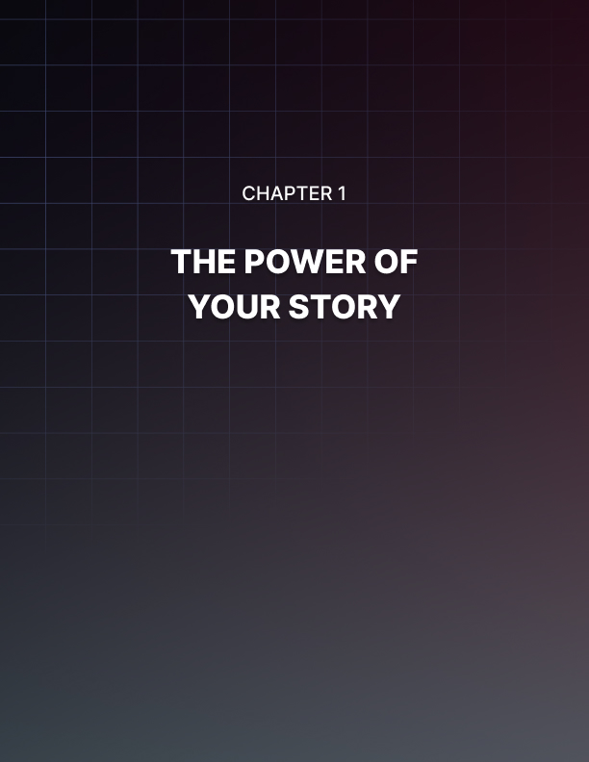

Chapter 1: The Power of Your Story

You might consider your story to be a simple narrative of the events that happened in your life so far, but that’s overly simple. Your story isn’t a simple recounting; it’s a deep narrative that includes your beliefs, experiences, and your perceptions of events. At the heart of your story is a powerful force—your beliefs. Your beliefs play a pivotal role in shaping your story and also your personal identity and your actions.

Understanding How Your Story Has Been Shaped by Your Beliefs.
Beliefs are those convictions that we hold to be true. Often these beliefs are deeply ingrained and don’t require tangible proof for us to believe. Your beliefs arise from a complex process that includes your upbringing, culture, personal experiences, and the influence of significant people in your life.

These beliefs act as a lens through which you view and interpret the world around you whether that’s about yourself, others, or the world.

Just how strong are these beliefs? Strong. For instance, if you believe that you’re not good at public speaking, this belief will color your experiences. Because of this belief, you may actively or subconsciously avoid situations where you need to speak in front of others. When you have to speak, you might be more nervous or even less effective. This experience when you have to speak only serves to solidify your belief that you’re not good at public speaking. You end up creating a self-fulfilling prophecy. This type of cycle allows your beliefs to shape your actions, and your actions, then in turn, reinforce your beliefs.

Some beliefs can be empowering. They can propel you toward growth and success. Others are limiting and holding you back from realizing your true potential. Your limiting beliefs are particularly dangerous as they can become so ingrained in your psyche that you believe them to not only be true but unchangeable. Limiting beliefs tend to come from negative experiences, failures, rejections, or societal messages. For example, if you’ve been repeatedly told that you’re not a good leader, if it happens often enough, you might internalize this view. This limiting belief would then shape your professional trajectory and personal self-esteem.

Therefore, your story is not simply what happened to you; it’s how you’ve interpreted and internalized these events. Two people can experience the same events in two vastly different ways, ending in two different stories.

For instance, after a failed business venture, one person might believe they’re destined for failure, while another might see it as a learning opportunity, they believe that they can improve their abilities and succeed in the future.
In order to understand your beliefs and how they shaped your story you need to adopt a practice of introspection and self-awareness. You need to trace back your actions and reactions to their roots and the beliefs that fuel them. This process involves asking yourself why your thoughts progress the way that they do and whether the beliefs that fuel them are based on facts or assumptions created by experiences.

By understanding the role your beliefs play in your story you’re opening the door to rewriting your story. By following this process you gain the incredible power to question and change your beliefs, and by doing so, alter the course of your personal story. This doesn’t mean you deny your past but you choose to view your past through a new lens. This new lens should be designed to empower you and support your growth.

Recognizing the Impact of Your Story on Your Life.
Every aspect of your life is affected by the story that you tell about who you are and what you can achieve. This story that you create for yourself is constructed from your beliefs and experiences and shapes your reality. It influences your thoughts, emotions, and actions. Recognizing this impact is a critical part of the process of understanding the role your personal narratives play in your life and the potential it has for change.

Your story affects your self-identity. The story you have written for yourself forms the solid foundation of how you see yourself and your place in the world around you. If your narrative is filled with limiting beliefs like “I’m not capable” or “I don’t deserve success or happiness,” these thoughts can undermine your self-esteem and confidence. A story, on the other hand, that emphasizes your strengths and potential can boost your self-worth and confidence. Research in the field of psychology regularly shows that self-perception is a strong influence when it comes to your behavior and attitudes. A study published in the Journal of Personality and Social Psychology found that individuals with a positive concept of self were more likely to engage in healthy and productive behaviors.

It's also about your emotional well-being. The story we hold as our own often comes with emotional baggage. It’s hard to avoid. If your story is one of overcoming adversity, you might feel pride or resilience as a survivor.

The opposite of this narrative is one of perpetual victimhood or failure. This can lead to feelings of helplessness or depression. Psychologists emphasize the link between our stories and our emotional health. There’s an entire field of therapy dedicated to reframing your stories in a more positive light to improve your well-being.

The story you have written for yourself also influences your relationships. If you see yourself as unlovable or unworthy, it can affect how you interact with others, leading to difficulties in forming and maintaining relationships. Conversely, if your story is about self-respect and openness, your beliefs can foster healthier and more fulfilling relationships. Research in social psychology suggests that our personal stories play a meaningful role in how we relate to those around us. Much like our behaviors, our relationships can be transformed by more positive self-narratives.

Your professional life is equally impacted by your personal narrative. This makes sense when you think about it. If your story is one where you see yourself as a competent, capable individual, then you’re more likely to pursue more ambitious career goals and take on more challenges. If your story is riddled with self-doubt and feelings of being inadequate, it may hinder your professional growth and satisfaction. This correlation is heavily supported by research. Your self-perception can have a great effect on your job performance, leadership ability, and career development.

When it comes to overall life satisfaction and happiness, your personal story affects those too. When you focus on gratitude, strength, and optimism you can lead yourself into a life that’s more fulfilling and happier. If you focus on negativity, regret, and pessimism, you can find the opposite effect with diminished satisfaction. Much like the other facets of life, a positive outlook or focus on your beliefs can lead to higher levels of happiness and satisfaction with your life.
Recognizing the impact of your story on your life isn’t only about acknowledging the existence of your beliefs; it’s about understanding that you have the power to change them. If you reevaluate and rewrite your story that you hold about yourself, you can transform your identity, emotions, relationships, professional life, and overall happiness. This process begins with an honest assessment of your current story. You need to commit to writing a new story that aligns with who you want to be and the life you want to live.

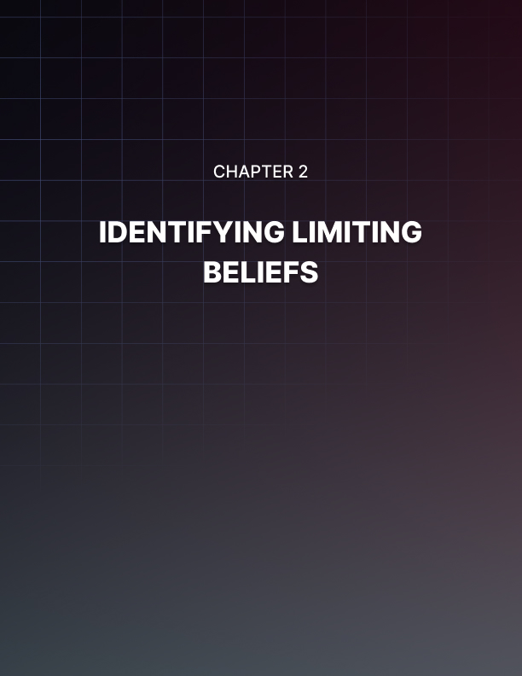

Chapter 2: Identifying Limiting Beliefs

Limited beliefs are often what hold you back from reaching your full potential. These unconscious beliefs serve as barriers to our goals and desires. They subtly influence your decisions and shape your life experiences. By identifying and understanding these beliefs, you can begin the process of rewriting your story.

Recognizing Common Limiting Beliefs
These beliefs come in many forms but they often revolve around themes of self-worth, capability, and possibility. Below you’ll find some of the most common limiting beliefs to help you recognize them in your own life.

Self-Worth Limiting Beliefs: As you can probably tell from the name, these limiting beliefs are centered around your perceived value and worthiness. Common examples are “I’m not good enough,” “I don’t deserve happiness or success,” or “I am unworthy of love.” These types of negative beliefs usually stem from past experiences of rejection, failure, or criticism. Experiences like this lead individuals to internalize negative perceptions of themselves as truths.

Capability Limiting Beliefs: These beliefs revolve around your abilities and skills. Capability limiting beliefs resemble phrases like “I can’t do this,” “I’m not smart enough,” or “I don’t have the talent to succeed.” Beliefs like this can result from previous failures, negative feedback, or through comparing yourself to others in a negative frame. Beliefs like this create a self-imposed ceiling on your potential and can prevent the pursuit of your goals and dreams.

Possibility Limiting Beliefs: These beliefs are about what is possible in the world and in your life. This can include thoughts like “Change is impossible,” “Life is unfair,” or “Success is for others, not for me.” Beliefs like this usually come from many past disappointments, from societal conditioning, or even a lack of positive role models. They are usually accompanied by feelings of helplessness and resignation. Beliefs like this often make it less likely that you’ll strive for change or improvement. They can make your life stagnant.

Fear-based Limiting Beliefs: As their name suggests, these limiting beliefs are rooted in fear. They’re about avoiding negative outcomes. These are beliefs like “If I try, I’ll just fail,” or “If I show my true self, I’ll be rejected”. These limiting beliefs can be paralyzing as they are rooted in your deep-seated fears and anxieties.

Scarcity Limiting Beliefs: These beliefs are linked to the lack of resources or opportunities. The most common examples would be “There’s not enough to go around,” “I can’t lose what I already have,” or “Opportunities are limited.” Beliefs like this can lead to a mindset deep in competition, jealousy, and insecurity. Thoughts being guided like this can hinder your cooperation and growth.

Identifying Your Own Limiting Beliefs
After exploring the common limiting beliefs, the next step in the process of rewriting your story is uncovering the specific beliefs that are holding you back. Through introspection and honesty can reveal these to you as many of these beliefs operate below the surface in your subconscious. Starting to identify your personal limiting beliefs is one of the first steps on the journey of self-discovery; a vital step in rewriting your story.

Start by examining your past. When doing this self-searching focus on moments you felt like a failure, you felt disappointment, or criticism. After finding these moments that stick out in your mind, ask yourself what beliefs these moments may have instilled in you. A harsh critique in your past may have led you to believe that you’re not talented or capable. It’s a good idea to start a journal during this phase of self-reflection. Write down these experiences as they come to mind.

Your self-talk can also reveal a lot for you. How you talk to yourself through internal dialogue is a peek into your subconscious mind. Pay particular attention to the things you say to yourself frequently, especially what you say when times get tough. Again, journaling can be very helpful. If you write in a journal a little bit every day, you can soon see patterns and phrases that may provide clues to the beliefs that limit you.

Your behaviors can be another manifestation of your internal beliefs. Look at your life and identify areas where you see recurring patterns, especially those that don’t serve you well. For instance, if you consistently avoid taking leadership roles. This may indicate that you hold a belief that you’re not a natural leader.

Sometimes, it’s helpful to ask others close to you when on this journey. Others can see things that you can’t identify yourself with. Take a look at feedback you’ve received from family and friends, or even colleagues. Make sure these are people you trust and respect. Not all feedback is going to be helpful or accurate but some of it may provide insights you hadn’t considered.
Once you identify your limiting beliefs, it’s time to trace their origin. It’s important to try and understand where a belief comes from so you can see it for what it is—a subjective interpretation of an experience. They are not objective truths.



Chapter 3: The Origins of Limiting Beliefs

Understanding where your limiting beliefs come from is imperative on your journey to effectively address them and rewrite your story. Limiting beliefs are the product of the interplay between your personal experiences, cultural influences, and environmental factors. By finding the origins of your limiting beliefs you can begin to navigate the parts of your story that may be holding you back.

Understanding How Limiting Beliefs are Formed.
Limiting beliefs aren’t only created in your youth but can also develop in adulthood. However, many of our core beliefs do take root during our childhood. Your parents, siblings, and other family members play a big role in this process. Our self-image and worldview are shaped during these formative years and the message we receive during this time can have a huge impact. When it comes to limiting beliefs, someone who suffers from constant criticism from family members can grow into an individual who thinks themselves to be incompetent. Someone who grows up in an overprotective home might believe that the world is a dangerous place.

It may amaze you how much the culture and society that you grow up in will also shape your beliefs. Your culture provides you with your worldview. Cultural norms, societal expectations, and stereotypes can all instill limiting beliefs about what you can and cannot do. This is especially true when it comes to gender roles, racial identities, and social class. For example, societal stereotypes about gender can influence your ideas about what professions and roles are open to you.
The positive and negative experiences in school will shape your beliefs. Academic success and failure, feedback from teachers, and your interactions with your peers will all reinforce beliefs about your intelligence, social skills, and even worthiness.

The most obvious events are the traumatic ones. Accidents, loss, and abuse, all can lead to deeply ingrained limiting beliefs. The trauma you experience often results in beliefs that are related to safety, trust, and self-worth. A person who has experienced betrayal may start to believe that they can’t trust anyone.

The media is a powerful source in society. TV, movies, advertisements, and social media can all shape our beliefs. The media often portrayed idealized images that can create unrealistic standards and expectations. If you believe you can meet these standards you can create beliefs that you’re inadequate.

Your personal experiences are key to understanding the origins of limiting beliefs. Those experiences that revolve around feelings of failure or disappointment can easily lead to ideas that you’re incapable or unworthy. Remember, the goal is not to blame or dwell in the past but to understand its influence so that you can move forward with greater self-awareness and more freedom.

Examining the Influence of Past Experiences on Your Beliefs.
Now that we’ve established that our past experiences take a role in shaping our beliefs and perspectives, you have to ask yourself how influential are these experiences. While every experience, no matter how small, acts as a building block for the foundation of your belief system, some have more power than others.

Formative Years: As we addressed earlier, the experiences during your formative years are especially influential. The way you were treated by your parents, teachers, and peers and the events you witnessed or experienced all contribute to your concept of self. It can be something as simple as being regularly told you’re clumsy. A child who grows up being consistently called clumsy may grow up believing they are inherently uncoordinated. This belief could steer them away from physical activities and sports.

Reinforcement through Repetition: If you experienced repetition of an event or statement then the belief that instills becomes that much stronger. If you repeatedly face rejection in your social life, you may believe that you’re socially inept. This limiting belief can change your future behavior leading to social withdrawal and then reinforcing the original belief in a self - perpetuating cycle.

The Emotional Intensity of Experiences: The emotional involvement in an experience can also affect how deeply you believe. Traumatic or highly emotional experiences often leave a lasting imprint. This leads to deeply held beliefs. Surviving a serious accident might lead you to believe that the world is not a safe place. This can lead to your hesitance to take any risks in life.

Interpretation of Experiences: The beliefs you form are dependent on how you interpret the experience. As we said before, two individuals
can have the same experience and emerge on the other side with different beliefs.

The Role of Memory: Our memories can be reshaped into something that supports a limiting belief. They aren’t always accurate reflections of what really happened. The way we recall an event can be influenced by our current emotional state and our limiting beliefs. This selective memory serves to reinforce existing beliefs or can even distort them further.

External Influences and Validation: Your beliefs can be validated and reinforced by the feedback and reactions of the people around you. If your environment regularly reinforces one of your limiting beliefs, it becomes stronger and more deeply seated in your mind.

Understanding the influence of your past on your beliefs is crucial when it comes to challenging and rewriting them. It involves re-examining these experiences and considering alternative interpretations. This process can help in loosening the grip of limiting beliefs and paving the way for the adoption of more empowering and positive beliefs. It's important to approach this examination with compassion and understanding, acknowledging that your past experiences have shaped you but do not define you. By reassessing the past, you open the door to a future where your beliefs support and enhance your life, rather than limit it.

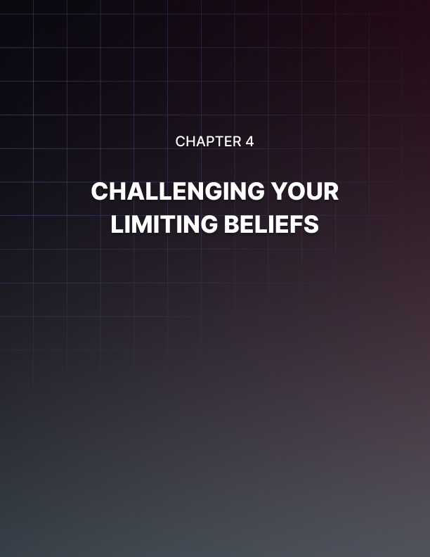

Chapter 4: Challenging Your Limiting Beliefs

Once you’ve identified and understood the origins of your limiting beliefs, it’s time to challenge them. It’s one thing to recognize these limiting beliefs; it’s another to confront them and transform them. If you’re determined to rewrite your story, this part of the process is crucial. This is how you unlock your full potential. Challenging your beliefs requires a combination of self- reflection, critical thinking, and a willingness and strength to embrace change.

Learning to Question Your Beliefs
Step one when it comes to challenging your beliefs is learning to question them. You need to develop a healthy skepticism towards the beliefs that may have been holding you back. Here’s how you can start this process:

- Enhance Your Awareness: You need to become more aware of your thoughts and beliefs. Most especially those thoughts and beliefs that come to the forefront during challenges and/or setbacks. If you catch yourself thinking something that you know limits you, pause and take note. This awareness and acknowledgment of your limiting beliefs is the first step in questioning their validity.

- Practice Self-Inquiry: Ask yourself critical questions about your beliefs. When a limiting belief arises, ask yourself, “Why do I believe this?” and “What evidence do I have that supports this belief?” This will help you to understand the root of your beliefs and assess their validity.

- Understand the Origin: Trace the origin of the beliefs you’ve identified. Pinning down where a belief may have originated gives you the ammunition you need to release its hold on you. You’ll often find that these beliefs are based on old and misinterpreted experiences.

- Adopt a Growth Mindset: We’ll address a growth mindset deeper in Chapter 7 but start believing that your abilities and intelligence can be developed over time. Begin to view challenges as opportunities to learn and grow. They are not reflections of your worth or ability.

- Challenge any All-or-Nothing Thinking: Many limiting beliefs are rooted in all-or-nothing attitudes. You view the world in black or white, without any middle ground. Challenge this attitude by introducing shades of grey into your thinking. Instead of thinking “I always fail,” consider “I have had failures but also successes.”

- Seek Alternative Perspectives: Seek out people who may have different viewpoints or who have overcome similar experiences to your own. Gaining some understanding of how others have navigated similar beliefs can provide you with new perspectives you may not have considered and provide you with a path to challenge your own belief system.

Examining the Evidence for and Against Your Beliefs
Now that you’ve started questioning your beliefs, it’s time to examine the evidence that supports or contradicts these beliefs to break them down. You have to move from a subjective viewpoint that is often clouded by emotions and past experiences to a more objective stance.

Start by listing the reasons and experiences that you believe support your limiting belief. As an example, if your belief is “I’m not good at public speaking,” note the instances that reinforce this belief. List out times that you felt nervous and received negative feedback.

Next, you need to look critically at this list. Are these moments actually reflective of your abilities? Could they have been isolated instances?

Were they influenced by external factors or your state of mind at the time? We are hardwired to give more weight to negative experiences and we overlook the circumstances and the progress we’ve made since then.

Once you’ve completed and analyzed your list in support, it’s time to look for experiences that contradict your limiting belief. Continuing with our example of public speaking, recall moments where you effectively communicate your ideas, even in informal settings. List out moments where you felt confident, got some positive feedback, or simply got your point across.

Now, go back and reevaluate your past experiences through this new lens. An event you once viewed as a failure may be actually one of your learning opportunities and a stepping stone to your later success.

Reframing your focus from what went wrong to what you gained from the experiences challenges the belief.

Open up your mind to different interpretations of your past experiences. If you struggled in relationships, instead of finding yourself unworthy of love, consider that you might have been learning valuable lessons about compatibility and self-worth.

Through this process, you'll likely find that the evidence supporting your limiting beliefs is not as solid as you thought. You'll also uncover a wealth of experiences and facts that contradict these beliefs. This realization is empowering, as it lays the groundwork for building new, more positive beliefs.

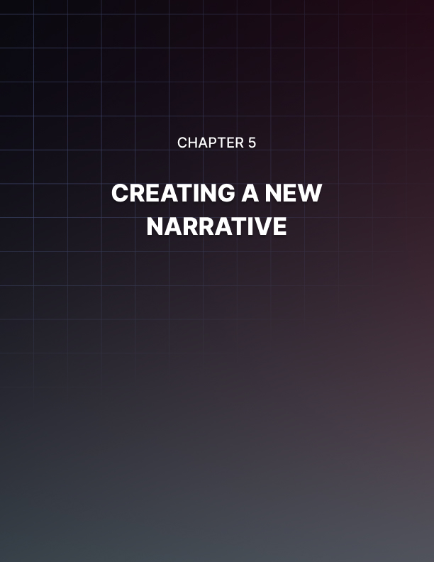

Chapter 5: Creating a New Narrative

Having identified and challenged your limiting beliefs, it’s time to construct a more empowering and positive story. You need to reframe your beliefs and perspectives to support your goals, dreams, and true potential. A new story can change how you perceive yourself and the world. This opens up possibilities and opportunities that were previously obscured by your negative mindset.

Understanding the Importance of Reframing Your Beliefs
Reframing your beliefs is about changing the way you interpret experiences and you view yourself. This can be a powerful tool. It can shift your mindset from one of limitations to one of possibility and growth. Your beliefs shape your perceptions, your perceptions then create your reality.

By changing your beliefs, you are changing the way you not only interpret situations but how you respond to them. For example, viewing a failed project not as a confirmation of your incompetence but as a learning experience. This can transform how you approach future challenges.

Limiting beliefs often trap you in a negative cycle. You need to break the cycle by reframing these beliefs. This will allow you to respond differently to situations that would have previously triggered negative thoughts and behaviors. This can lead to more positive outcomes in life and subsequently reinforce your new and more empowering beliefs.

Your beliefs have a major impact on your emotional health. Negative beliefs can lead to negative feelings like inadequacy, anxiety, and depression. By working to reframe these into more positive beliefs, you can improve your emotional well-being. Reframing your beliefs can lead to greater overall happiness and strength.

Your beliefs drive your behavior. When you change your limiting beliefs to empowering, positive ones, your actions and behaviors will align with your new story. Aligning your beliefs with your goals and ambitions can lead to more effective actions, better decision-making, and more success in life.

It’s about self-efficacy. Self-efficacy is your belief in your ability to influence events and outcomes. High self-efficacy has been linked to greater motivation, perseverance, and resilience. All of these are essential in achieving your personal and professional goals.

Just as your limiting beliefs can be a self-fulfilling prophecy, your new reframed beliefs are the same. By creating positive beliefs, you set in motion a more positive prophecy for your future. Your beliefs about yourself influence how you interact with others. Believing in your ability to succeed can lead to more confident and open interactions, not only improving your professional life but also your relationships and social experiences.

Learning to Create a New Narrative for Yourself.
Creating a new narrative for yourself is a choice. It’s intentional. You have to work at constructing a new set of beliefs and perspectives that will guide your thoughts, emotions, and actions. It’s about taking control back of your story and making it better. But there is a process.

- Define Your Desired Narrative: You need to start by clearly defining what you want in life. Consider the aspects of your life where you’d like to see the most change. Ask yourself questions like “What would I like to believe about myself?” and “How do I want to feel and act in these areas?”. Be specific when making this plan and be positive. When designating your goals, instead of saying something like “I don’t want to be scared of failure,” say, “I want to view failures as opportunities to learn and grow.”

- Craft Affirmations that Align with this New Narrative: If you recall, we suggested using affirmations to help challenge your limiting beliefs. Now, create affirmations that reflect this new story you’re writing. Your affirmations should be positive and present tense statements that reinforce what you desire to change. For example, “I am capable and confident in my abilities to succeed.” Repeat these affirmations daily, not only when you’re struggling.

- Visualize Your New Narrative: Visualization can be a powerful tool when working on accepting and internalizing your new story. Spend time visualizing yourself living out your new story. Imagine how you would feel, act, and respond in situations as the person who embodies these new beliefs.
- Take Action Consistent with Your New Story: Your beliefs are reinforced by your actions. Start taking small steps that reinforce your new story. If your new belief is about being a good communicator, practice speaking up in meetings or starting a conversation with a stranger. Small actions reinforce your beliefs as much as large ones. Don’t try to change too much at once and overwhelm yourself.

- Record and Reflect on Successes: This is a big change to your world and can get overwhelming, fast. Keep a journal or record of instances where you live out your new story. Reflecting on these successes, no matter how small, can reinforce your belief in the new story. It will help encourage you to keep going.

- Surround Yourself with Supportive Influences: Your environment and the people around you can significantly change your story, for better or worse. Work on surrounding yourself with people who support this journey and who believe in your new story. Look for books, listen to podcasts, and other resources that reinforce the beliefs and attitudes you want to adopt.

- Learn from Setbacks: You’re going to experience setbacks. These are potentially big changes you’re trying to make. Changing your entire mindset doesn’t happen overnight. Instead of viewing setbacks as failures, use them to learn. Analyze what happened and why. Work on adjusting your approach in the future.

- Be Patient and Persistent: You’re talking about changing deeply ingrained beliefs. This takes time and consistent effort. Be patient with yourself and persistent in your efforts. Remember you are rewriting a story that has been written over years and even decades. You are the author of your story, and every day is an opportunity to write a new page.

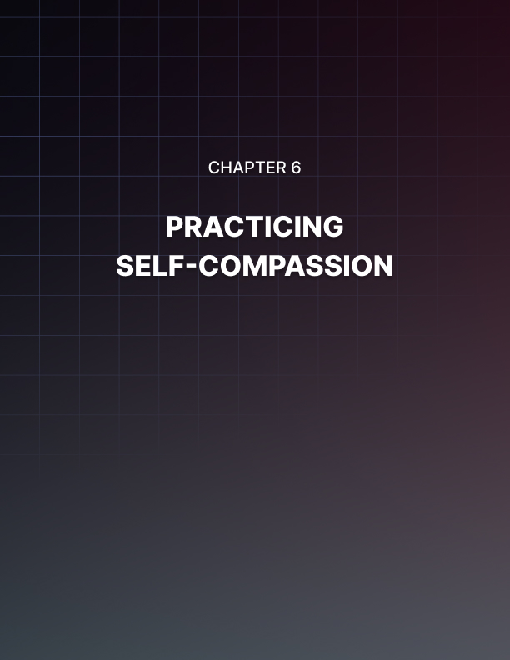

Chapter 6: Practicing Self-Compassion

While self-compassion is a feel-good concept, it’s also a practical and essential tool when it comes to personal growth. You need to treat yourself with the same kindness, concern, and support that you would readily offer to a good friend. Working through your limiting beliefs is not an easy task. Self-compassion provides the emotional grounding and understanding needed to navigate this process.

Understanding the Role of Self-Compassion in Overcoming Limiting Beliefs
Addressing your limiting beliefs can be an uncomfortable and sometimes painful process. Practicing self-compassion gives you a safe emotional space to explore your beliefs without harsh self-judgment. You can acknowledge your feelings and experiences without being overwhelmed by them. Self-compassion is part of a growth mindset. You can view your mistakes and setbacks, not as reflections of your worth, but as moments to learn and grow. This is how you challenge and change your limiting beliefs. It encourages a more open and curious approach to your personal development instead of one of fear.

Fear of failure is a common barrier when it comes to challenging and rewriting your limiting beliefs. Self-compassion reduces this fear as it changes your relationship with failure. This perspective helps you see failure as something that’s completely normal in the human experience. Failure is something to learn from instead of something that defines you.

Building resilience is key when it comes to changing your beliefs. Practicing self-compassion strengthens your resilience by promoting a more balanced perspective on your experiences. It helps you bounce back from difficulties because you’re easier on yourself. It fosters a sense of common humanity and reminds you that you’re not alone in these struggles. Perfection is not necessary.

As many limiting beliefs stem from past hurts and traumas, self- compassion is needed for emotional healing. To change your underlying beliefs, you need to acknowledge and validate your pain. Show yourself kindness and recognize that suffering is part of the shared human experience and nothing to be ashamed of. Acceptance is necessary.

Accept yourself as you are, even as you work to change certain aspects of your life. This kind of acceptance is empowering. It comes from a place of love and understanding rather than criticism and dissatisfaction. Approach your transformation with kindness, understanding, and strength. Practicing self-compassion means you become your own supportive friend throughout the process.

Learning to Practice Self-Compassion in Your Daily Life.
There are several practical ways you can start showing yourself compassion in your everyday life:

- Mindfulness: Mindfulness in the foundation of self-compassion. It’s a great place to start. The practice of mindfulness involves being present in the moment and fully accepting your thoughts and feelings without judgment. You can start practicing mindfulness throughout the day. Pay attention to your senses and notice your surroundings. Take a few moments to observe your thoughts and feelings. You may become more aware of negative self-talk or critical thoughts. Acknowledge them but don’t get caught up in them.

- Take Breaks: Whenever you notice that you’re feeling stressed, overwhelmed, or critical of yourself, take a moment to press pause. Place your hand on your heart or another soothing place on your body and say some kind words to yourself. Say the same things you would say to a friend who’s struggling but say them to yourself.

- Write a Letter: Take on a compassionate and understanding perspective and write a letter to yourself as you would a friend. Address an area where you’re currently feeling inadequate or a mistake you’ve made. Write with empathy, understanding, and kindness. Focus on the fact that you’re human and everyone has challenges and mistakes.

- Self-Kindness: Actively practice self-kindness. A simple way to do this is taking care of your physical needs. Allow time for relaxation or go out and do something that you enjoy. Treat yourself with care like a loved one.
- Change Your Critical Self-Talk: Start paying attention to how you talk to yourself. When you catch yourself being critical, try to actively reframe these thoughts to be more compassionate and realistic.

- Journaling: Keep a self-compassion journal. This can be as simple as regularly writing what you’re grateful for, what you forgive yourself for, and what you appreciate about yourself. This can help shift your focus to self-acceptance rather than self-critique.

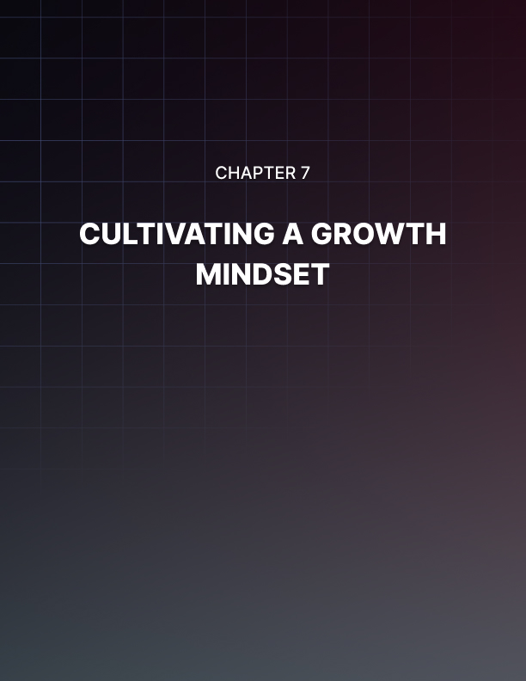

Chapter 7: Cultivating a Growth Mindset

A growth mindset is essential when it comes to personal development and overcoming limiting beliefs. The term growth mindset was coined by Psychologist Carol Dweck and refers to the belief that abilities and intelligence can be developed through dedication and hard work.

Embracing a growth mindset is about believing in your potential which is vital to overcoming challenges and achieving success.

Understanding the Difference Between a Fixed and Growth Mindset
In a fixed mindset, you believe that your talents, abilities, and intelligence are fixed traits. Your talent is an inherent ability that you’re born with and it cannot be developed. People with this type of mindset often avoid challenges, give up easily, see effort as fruitless, ignore useful negative feedback, and feel threatened by the success of others. This type of mindset often leads to stagnation and the urge to not engage in activities that challenge your own self-perception.

On the other hand, a growth mindset is fully based on the belief that you can always learn and grow. Your talents and abilities can always advance and change. Effort, good teaching, and persistence are what lead you there. Those who follow the growth mindset aren’t put off by challenges, they embrace them. They remain persistent in the face of setbacks and they see their efforts as the path to mastery. They learn from criticism and find inspiration in the success of others. If you follow this mindset it leads to a love of learning and an inner strength that lends itself to success and accomplishment.

The mindset that you choose to adopt affects how you lead your life.

When it comes to education, students with a growth mindset are more likely to take challenging tasks head on and view any failures as a way to learn to improve. In the workplace, employees who follow a growth mindset are the same: more likely to face challenges and overcome them and are open to feedback to improve.

The brain’s ability to change and adapt, or brain plasticity, suggests that our intellectual abilities are not fixed but developed over time. This neuroscience conclusion supports the concept that your efforts, practice, and perseverance do increase your neural growth and enhance your abilities and intelligence.

Engaging in a growth mindset sets you up for success when it comes to challenging your limiting beliefs. By viewing challenges and setbacks as a way to learn and grow, you automatically change how you approach more difficult situations. Instead of letting failure hinder you, you can use it as a stepping stone for growth. The growth mindset focuses on progress rather than perfection. It fosters a more flexible approach to life’s challenges where you adapt and learn.

Learning to Cultivate a Growth Mindset
Shifting to a growth mindset can be a challenging feat. Considering this way of thinking will automatically challenge many people’s limiting beliefs, it’s part of the whole process but also imperative to success. It’s about shifting your belief that your abilities are fixed to understanding the phrase “not yet”. Here’s how you can start working on shifting over to a growth mindset:

- Embrace Challenges: This may be the most obvious path but seeing challenges as opportunities for growth rather than obstacles is the foundation of this mindset. People with this mindset thrive on challenges. They automatically recognize them as chances to expand their abilities. When faced with a difficult task, instead of thinking, “I can’t do this,” try out, “I can’t do this yet, but I can learn how.”

- Persistence even with Setbacks: Start to work on understanding that setbacks and failures are just a part of the learning process. They do not define you or your worth. Don’t give up when things get hard, instead, view these moments as part of your path to mastery. Take a moment to ask yourself what you can learn from the moment and how it will give you strength in the future.

- Value Effort: It’s time to value effort over perfection. Effort is the path to mastery. When you embrace the growth mindset you learn to understand that effort is what leads to improvement. As long as the effort is there, you’re on the path to success. Start to celebrate the effort rather than the results, even if they’re negative. Take credit for the hard work instead of focusing on the ending.

- Learn from Criticism: While this only applies to constructive criticism, it can be a valuable tool. Don’t take constructive criticism personally or ignore it. Analyze what’s been said and learn from it. Start asking yourself what you can do differently next time and how this feedback can help you improve and grow.

- Let the Success of Others Inspire You: Don’t let yourself feel threatened by the achievements of others. These are opportunities to learn and be inspired. When someone else succeeds, you can learn from their process and apply it to your own efforts. This can transform what could be feelings of jealousy into your own motivation.

- Become Self-Aware: Start analyzing your mindset in different situations. Try to notice when you fall into fixed mindset patterns like avoiding challenges or feeling discouraged. Being able to recognize these patterns is the first step to adjusting to a growth mindset.

- Develop a Curious Attitude: Start engaging in learning new things. Approach your tasks by asking the question, “What can I learn from this?” instead of worrying about your performance.

- Seek Out New Learning Opportunities: Actively look for new ways to learn and grow. Start a new project, a course, or learn a new skill.

This mindset shift is not a one-time event but an ongoing process that requires conscious effort and practice. As you foster a growth mindset, you'll find that not only do your skills and abilities grow, but your overall sense of fulfillment and achievement in life also expands. Remember, the growth mindset is about enjoying the journey of learning and becoming, rather than simply focusing on the destination.

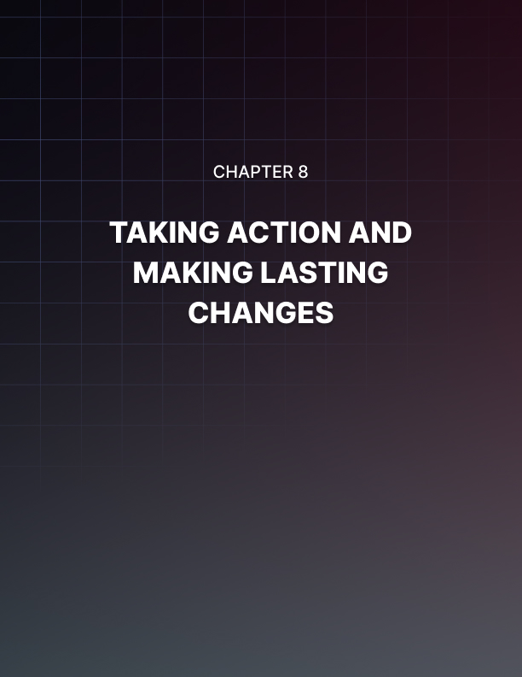

Chapter 8: Taking Action and Making Lasting Changes

It’s time to take your efforts and turn them into concrete actions and lasting
changes. This is where your transformation happens. You’re now moving from self-awareness and mindset shifts to taking the steps that reflect these new beliefs and your new story. Setting goals that are in harmony with these new beliefs goes a long way.

Setting Goals That Align With Your New Beliefs.
Goal setting is a powerful tool that can help propel you into the new life that you desire. The key is to set goals that are backed by the new beliefs you have created. Start by clearly understanding your new beliefs. Identify where the shifts in the mindset you’ve created. How do these beliefs shape what you think is possible for yourself? Your goals need to be a natural extension of your beliefs.

Set SMART Goals. Your goals should follow these parameters: be Specific, Measurable, Achievable, Relevant, and Time-bound. By using this framework you can clarify your goals and focus your efforts easily. This allows you to use your time and resources more productively. To give an example, instead of a vague goal like “become a better communicator,” a SMART goal would be “enroll in a public speaking course by next month and give a presentation by the end of the quarter.”

Your goals should also be about inner achievements, not only external achievements. If one of your new beliefs involves living a balanced and healthy life, you need to set goals that reflect this. These could be something like regular exercise or practicing mindfulness.

Making large goals can easily overwhelm you. Break down your larger goals into smaller, more manageable steps. That way each small step you complete will not only allow you to make progress but build your confidence and reinforce your beliefs. This is part of a plan of action.

Outline what steps you need to take, what resources you might need, and a timeline for achievements. This will help you stay focused and organized.

Overcoming Obstacles and Resistance to Change
An inevitable part of your journey is going to be learning how to deal with obstacles and resistance. Change, even positive change, can be challenging. You’ll find that fears, doubts, and resistance frequently rear their heads. These can come from your inner voice and sometimes from those around you. You can learn to navigate these issues. Resistance is a natural part of the process of change. As long as you enter the journey expecting to face doubts, fears, and setbacks you’re already set up to succeed. Accepting that these are normal reduces your frustration when they come and can help you stay committed to your goals.

When you feel resistance, take a moment to identify what’s causing it. Is it fear of failure, fear of the unknown, or comfort with the status quo? When you start to change, resistance can often come from family, friends, or colleagues who are more familiar with your old ways. Identifying the source is the first step in effectively addressing the problem. This is why it’s important to surround yourself with people who support and believe in your journey. Being surrounded by a support network makes it much easier to find the strength to continue despite the obstacles.

Reframe your approach to obstacles and decide they aren’t barriers but opportunities to learn, grow, and strengthen your commitment to your goals. This is part of equipping yourself with coping strategies for dealing with setbacks. Adapting the right mindset, or returning to it, combined with options like seeking support from mentors or peers, reminding yourself about your achievements, or reducing stress with meditation or exercise are all part of an approach to overcoming obstacles. You need to stay flexible. If one approach isn’t working then try something different. Don’t forget to remind yourself regularly why you decided to make these changes.

Celebrating Your Progress and Maintaining Momentum
The long-term success of your personal growth depends on you recognizing your progress, celebrating it, and keeping going. By not only recognizing but also appreciating all your achievements, big and small, you’re reinforcing your commitment to your new story. This helps keep you motivated. Here are a few ways you can celebrate your progress and keep up the momentum on your journey:

- Acknowledge Every Achievement: Every step forward deserves recognition. It doesn’t matter if it’s sticking to a new habit for a week, speaking up in a meeting, or completing a big project. Every achievement is a success when it comes to your effort and growth. Celebrating all milestones helps to reinforce your new beliefs and behaviors.

- Reflect on Your Journey Often: Self-reflection helps you see how far you’ve come. Look back at where you started and see where you are now. This isn’t about only what you achieved but how you’ve grown as a person, the challenges you’ve overcome, and the many lessons that you learned along the way.

- Share Your Successes: Tell your family and friends about what you’ve accomplished. This celebrates your successes but may also encourage others to do the same. Their feedback and encouragement can be a powerful motivator.

- Set New Goals: When you cross off one completed goal, add another. Keep moving forward by adding more avenues for growth and development. New goals should build on what you’ve already achieved.

- Practice Gratitude: Start practicing gratitude. Being grateful for what you’ve accomplished and the opportunities you haven’t yet enhances your well-being and keeps you grounded and focused.

- Keep Learning and Growing: Your personal growth is an ongoing process. Keep open to learning new things and expanding your horizons. This can be as simple as reading a book, attending workshops, or checking out new interests.

- Adjust Your Strategies When Needed: Not every strategy is going to work for you. You need to be willing and flexible and adjust your strategies and approach if you mind yourself losing momentum. Sometimes a small change in routine can make all the difference.



Conclusion

This is a profound transformation you’ve decided to make. Rewriting your story takes dedication and a great sense of self. Recognizing the problem is the first big step along the way. You’ve now explored the depths of your limiting beliefs, understood their origins, learned to challenge and reframe them, and begun to write as a new, empowered author of your life. This journey isn’t only about your personal growth. This journey is about moving forward with confidence, maybe confidence that’s new to you, in your ability to shape your destiny.

As you move forward, remember that this is an ongoing process. You’re going to encounter setbacks and challenges but that’s okay. You have new tools and insights to face these challenges head on. You’ve learned the importance of self-compassion, the power of a growth mindset, and how effective it is to set and pursue goals that align with your new beliefs.

These are strategies but also life skills that will serve you in all aspects of your life.

- Embrace Continuous Learning: Every experience is an opportunity to learn and grow. Stay open-minded and curious. Always look for ways to expand your knowledge and understanding.

- Practice Resilience: Challenging your limiting beliefs and overcoming obstacles has already given you a strength you may not have felt before. Continue to nurture this resilience. When you face difficulties, remind yourself of the challenges you’ve already overcome.

- Stay True to Your New Story: You’ve rewritten your story and you are its biggest supporter. Stay true to what you’ve created and the beliefs that make its foundation. This is your story so let it guide your decisions, actions, and interactions with others.

- Celebrate Your Progress: Take the time to acknowledge your progress and do it often. Recognition of your achievements, no matter how small, is the fuel that motivates you to continue.

Carry with you the confidence that comes from knowing that you have the power to change your story. You are not defined by those limiting beliefs. Your story can be one of growth, of possibility, and strength. The journey of self-improvement is a lifelong path and you are well on your way. Move forward with the thought that each day is another opportunity to grow, learn, and become a more empowered version of yourself. You are the author of your story, with every step you take you write a new chapter, one filled with potential and promise.

