TABLE OF CONTENTS
____

INTRODUCTION 4
THE POWER OF SOPS 7
The Foundation of Operational Excellence 7
Transforming Business Operations Through SOPs 12
Measuring and Maintaining SOP Excellence 13
CRAFTING YOUR FIRST SOP 16
Identifying Essential Processes for Documentation 17
Creating Clear and Actionable Documentation 18
Testing and Refining Your Documentation 21
OPTIMIZING AND UPDATING SOPS FOR MAXIMUM EFFICIENCY 24
Building a Systematic Review Framework 25
Leveraging Data for Strategic Optimization 27
Creating a Culture of Continuous Improvement 29
TRAINING TEAMS AND ENSURING SOP ADOPTION 32
Creating an Effective SOP Training Framework 33
Building a Culture of SOP Excellence 35
Measuring and Sustaining SOP Success 36
AUTOMATING AND SCALING YOUR BUSINESS USING SOPS 41
Building the Foundation for Automation 42
Implementing Smart Automation Solutions 44
Scaling Through Integrated Systems 45
MAKING SOPS A LONG-TERM SUCCESS STRATEGY 48
Building a Sustainable SOP Framework 49
Driving Excellence Through Advanced Analytics 51
Future-Proofing Your Operations 53
Embracing the SOP Evolution 54

DISCLAIMER
____

The information provided in this ebook is intended solely for educational and informational purposes. The author does not accept any responsibility for the outcomes that may arise from the application of the material within. While efforts have been made to ensure the accuracy and relevance of the content, the author cannot be held accountable for any errors or omissions, or for any consequences resulting from the use or misuse of the information provided. The responsibility for any actions taken based on the information in this ebook lies solely with the reader.
Foreword

INTRODUCTION
____

Growing a successful business requires more than just a great idea and hard work. Behind every thriving company lies a foundation of well-structured processes that enable consistent delivery, efficient operations, and sustainable growth. These processes, known as standard operating procedures (SOPs), are the invisible force that transforms chaos into order and turns sporadic success into repeatable excellence.
You've likely experienced the frustration of explaining the same task multiple times, watching quality slip when key team members are absent, or struggling to maintain consistency as your business grows. These challenges aren't just occasional hiccups—they're symptoms of a deeper need for systematic approaches to running your operations.
Whether you're a solo entrepreneur preparing for expansion or a business owner managing a growing team, the ability to create and implement effective SOPs will determine how smoothly your business can scale. In the current increasingly competitive marketplace, the businesses that thrive are not necessarily those with the most innovative products or the largest marketing budgets, but rather those that have mastered the art of operational consistency through well-documented and religiously followed procedures.
Think of SOPs as your business's operation manual—a clear, documented set of instructions that ensure tasks are performed consistently, regardless of who's doing them. They're not just bureaucratic paperwork or rigid rules that stifle creativity. Instead, they're powerful tools that free up your mental energy, reduce decision fatigue, and create a framework for innovation. When properly developed and implemented, SOPs become the backbone of your business, supporting everything from daily operations to strategic growth initiatives.
This book goes beyond theoretical concepts to provide practical, actionable guidance on creating and optimizing SOPs that work in real-world business scenarios. You'll learn how to identify which processes need documentation, write clear and effective procedures, and ensure your team actually follows them. More importantly, you'll discover how to make SOPs a living part of your business culture rather than documents that gather dust on a shelf.
The principles and strategies shared in these pages come from years of hands-on experience helping businesses transform their operations through systematic processes. Whether you're looking to improve efficiency, maintain quality standards, or prepare your business for scaling, you'll find the tools and frameworks needed to build a stronger, more systematic approach to business operations. Let's begin this journey toward creating a more organized, efficient, and scalable business through the power of well-crafted SOPs.
Part One

THE POWER OF SOPS
____

In any business, consistency is key. Employees must deliver the same level of quality and service day after day, regardless of staffing changes, training gaps, or unexpected challenges.
Standard operating procedures provide a clear roadmap, ensuring tasks are completed efficiently and to the highest standard. With well-documented processes in place, businesses can reduce errors, improve productivity, and maintain seamless operations—even in the face of disruption.

The Foundation of Operational Excellence
Standard operating procedures represent more than instruction manuals or checklists. They embody your business's operational DNA, defining how tasks are executed, ensuring consistency, and enabling teams to perform at their best—no matter the circumstances.
SOPs are your organization's blueprint, guiding every action and decision with precision and purpose. They convert individual expertise into institutional knowledge, ensuring your business thrives regardless of who's on duty.
When you implement SOPs effectively, you're not just creating guidelines; you're building a framework that supports growth, consistency, and excellence. Have you ever seen a symphony orchestra perform? Each musician knows their part, understands their cues, and contributes to a harmonious whole. Similarly, SOPs orchestrate your business operations, ensuring every team member plays their role perfectly.
The true power of SOPs lies in their ability to standardize excellence. They capture your best practices, turning them into repeatable processes that anyone can follow. This standardization doesn't stifle creativity or innovation; instead, it provides a stable foundation from which your team can excel and improve.
Modern SOPs come in various forms, each suited to different operational needs:
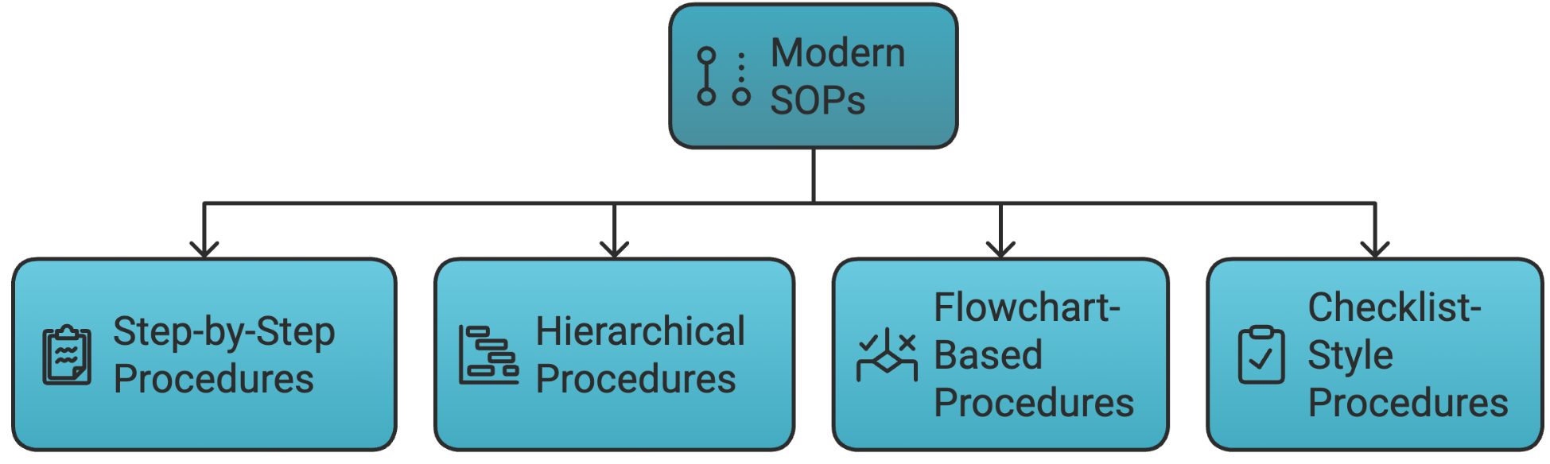

Step-by-Step Procedures
Detailed instructions for linear processes.
Example:
- Fill in kitchen assistant log for your shift.
- Fill dish pan with soapy, hot water, and place on cart.
- Move cart next to buffet.
- Ensure that buffet has enough napkins and cutlery for guests.

Hierarchical Procedures
Complex operations broken down into manageable sub-tasks.
Example:
- Fill in kitchen assistant log for your shift.
- Add date and arrival time.
- Note weather and temperature.
- Include number of guests.
- Fill dish pan with soapy, hot water, and place on cart.

Flowchart-Based Procedures
Visual guides for decision-making processes.
Example:
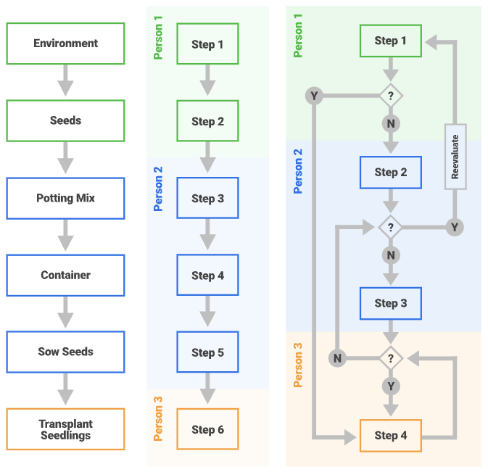
Source: Kate Eby in smartsheets

Checklist-Style Procedures
Quick reference guides for routine tasks.
Examples:
- Simple Checklist
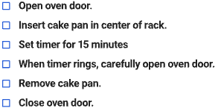
- Detailed Checklist
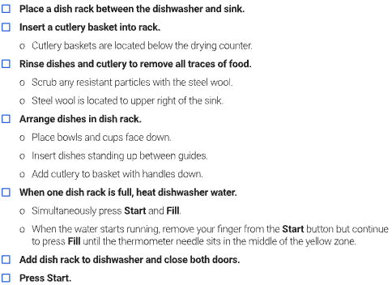
To truly grasp the impact of SOPs, consider their essential components. Every effective SOP contains:
- Clear purpose and scope statements
- Detailed procedural steps
- Role assignments and responsibilities
- Required resources and tools
- Quality control measures
- Troubleshooting guidelines
- Review and update protocols
- Safety and compliance considerations

Transforming Business Operations Through SOPs
When you implement SOPs effectively, they touch every aspect of your business operations. The impact extends far beyond simple task completion, creating a ripple effect that enhances every facet of your organization.
Quality and consistency become ingrained in your operational fabric. Take a manufacturing company that implemented SOPs across their production line. Their defect rate dropped by 67% within three months, while employee confidence soared. This improvement didn't happen by chance—it resulted from clear, actionable procedures that left no room for guesswork.
Your training processes transform when backed by solid SOPs. New employees learn faster and retain information better when they have clear, documented procedures to follow. One retail chain reduced their new hire training time from two weeks to just four days after implementing comprehensive SOPs. More importantly, these employees reached full productivity faster and made fewer mistakes during their initial weeks.
Risk management takes on new dimensions with proper SOPs in place. They act as your first line of defense against operational errors, compliance issues, and safety incidents. A healthcare facility reported a 78% reduction in medication errors after implementing detailed SOPs for their dispensary operations. This improvement not only enhanced patient safety but also reduced their insurance premiums and liability exposure.

Measuring and Maintaining SOP Excellence
The success of your SOP implementation depends on your ability to measure its impact and maintain its relevance. Successful businesses track specific metrics to gauge SOP effectiveness:
- Quality Metrics
- Error rates and defect percentages
- Customer satisfaction scores
- Consistency in product or service delivery
- Number of quality-related incidents
- Efficiency Metrics
- Time to complete standard tasks
- Resource utilization rates
- Training completion times
- Productivity per employee
- Compliance and Safety Metrics
- Number of safety incidents
- Audit findings and observations
- Regulatory compliance scores
- Risk assessment results
Maintaining SOP excellence requires ongoing attention and refinement. You must establish regular review cycles, gather feedback from users, and update procedures as your business evolves.
Technology plays a crucial role in modern SOP management. Digital platforms offer features like version control, mobile access, and multimedia integration that make SOPs more accessible and engaging. Cloud-based systems ensure your team always has access to the latest procedures, while analytics help you track usage and identify areas for improvement.
Consider implementing a feedback loop that allows your team to suggest improvements and report issues with existing procedures. This approach keeps your SOPs relevant and ensures they evolve with your business needs—because the best SOPs are living documents that grow and adapt alongside your organization.
The power of SOPs extends beyond daily operations. They become a cornerstone of your business's value. When it's time to scale, sell, or franchise your operation, well-documented SOPs represent a significant asset. They provide the roadmap for replicating your success and maintaining quality across multiple locations or operations.
Part Two

CRAFTING YOUR FIRST SOP
____

A CEO's cursor blinked steadily on her computer screen as she contemplated how to document her digital marketing agency's complex workflows. With a growing team and increasingly intricate client projects, she knew standardizing processes was crucial. Yet, like many business owners, the task of creating her first standard operating procedure felt overwhelming. "Where do I even start?" she wondered, staring at the blank document before her.
This moment of uncertainty is familiar to countless business owners and managers. You might recognize the challenge: translating your expert knowledge and daily operations into clear, actionable procedures that anyone can follow.
The good news? By breaking down the process into manageable steps and following proven methodologies, you can transform this daunting task into an achievable goal that yields remarkable results.

Identifying Essential Processes for Documentation
Before you write your first procedure, you need to identify which processes deserve immediate attention. See your business as a complex machine with multiple gears working together. Some gears are more critical than others, and these should be your primary focus when beginning your SOP journey.
Start by analyzing your operations through these critical lenses:
- Impact on Core Business Functions - Which processes directly affect your product or service quality?
- Frequency of Use - What tasks do your team members perform most often?
- Error Rates - Which processes consistently lead to mistakes or quality issues?
- Training Requirements - What takes the longest to teach new employees?
- Compliance Needs - Which processes must meet regulatory standards?
Take Sarah's bakery as an example. When she began documenting her procedures, she first tackled custom order processing, a frequent task with high error potential and a significant impact on customer satisfaction. Within weeks of implementing this SOP, order mistakes dropped by 85%, and customer complaints virtually disappeared. This success motivated her team to embrace the documentation process for other procedures.
The key to effective process identification lies in your ability to break down complex operations into distinct, manageable components. For instance, if you're documenting a sales process, you might separate it into lead generation, qualification, presentation, negotiation, and closing. Each component becomes its own SOP, creating a library of interconnected procedures that support your overall operation.

Creating Clear and Actionable Documentation
Once you've identified your priority processes, the next challenge is creating documentation that transforms complex procedures into clear, actionable steps. This requires a deliberate approach that combines strategic thinking with practical application.
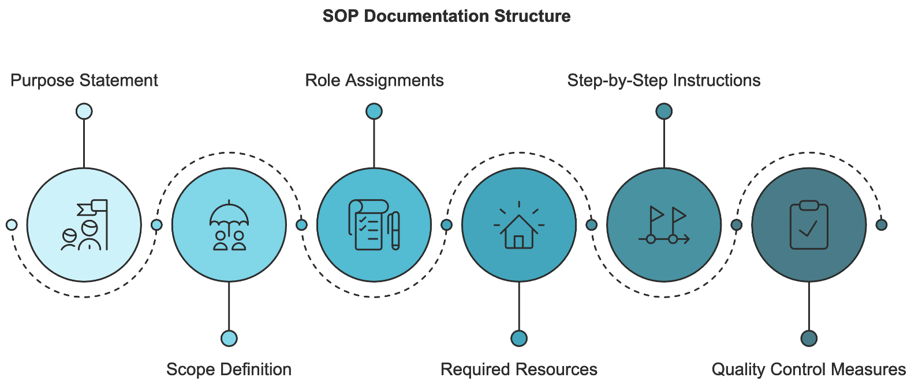
Your SOP documentation should follow a consistent structure that includes:
- Purpose Statement
Begin with a clear explanation of why this procedure exists and what it aims to achieve. For example, instead of simply stating "Customer Service Protocol," write "This procedure ensures consistent, high-quality customer interactions that maintain our 98% satisfaction rating."
- Scope Definition
Clearly outline what the procedure covers and, equally important, what it doesn't. This prevents confusion and helps users understand when to apply this particular SOP.
- Role Assignments
Define who performs each task and who's responsible for oversight. This clarity prevents the "someone else's job" syndrome that often leads to missed steps.
- Required Resources
List all tools, materials, software, or access permissions needed to complete the procedure. Include specific versions or models where relevant.
- Step-by-Step Instructions
Break down the process into clear, sequential steps. Each step should be action-oriented and specific. Instead of "Process the order," write "Enter the customer's shipping information into the order management system using the standard format: Street Address, City, State, Zip Code."
- Quality Control Measures
Include checkpoints and verification steps throughout the procedure. This helps users ensure they're executing tasks correctly before moving forward.
The most effective SOPs combine different documentation methods to accommodate various learning styles and process complexities. For example, a software implementation procedure might include written instructions supported by screenshots and screen recordings. A manufacturing process might combine written steps with photos and diagrams showing correct assembly techniques.
When documenting complex processes, resist the urge to capture every possible scenario in a single procedure. Instead, create a main procedure for standard operations and separate procedures for handling exceptions or special cases. This approach keeps your SOPs clear and manageable while still providing guidance for unusual situations.

Testing and Refining Your Documentation
Creating an effective SOP is an iterative process that requires careful testing and continuous refinement. Your first draft is exactly that—a draft. The real value emerges through systematic testing and improvement based on real-world application.
Begin your testing phase with a small group of users who weren't involved in creating the SOP. This fresh perspective helps identify assumptions or missing steps that might be obvious to the procedure's author but unclear to others. Observe these users as they follow the procedure, noting:
- Where do they hesitate or show confusion?
- Which steps require clarification or additional detail?
- What questions do they ask during execution?
- How long does each step take?
- What mistakes or deviations occur?
Use this observational data to refine your documentation. Pay particular attention to areas where users consistently struggle or make mistakes. These trouble spots often indicate a need for additional detail, clearer explanations, or visual aids.
Try implementing a structured feedback system that includes:
- Regular user surveys
- Performance metrics tracking
- Error rate monitoring
- Time-to-completion measurements
- Quality control assessments
This data helps you measure the effectiveness of your SOPs and identify areas for improvement. For instance, if completion times vary significantly between users, you might need to provide more detailed guidance for complex steps. If error rates spike at certain points, consider adding additional quality control measures or clarifying instructions.
As you refine your SOPs, maintain version control and keep detailed records of changes. This documentation helps track improvements over time and ensures all users have access to the most current procedures. Using digital tools that automatically track versions and notify users of updates helps ensure consistency, minimize confusion, and keep everyone aligned with the latest best practices.
Your journey to creating effective SOPs starts with a single procedure. Choose one critical process, apply these principles, and begin building your operational foundation for success. Remember, the goal isn't perfection from the start, but rather continuous improvement through systematic documentation and refinement.
Part Three

OPTIMIZING AND UPDATING SOPS FOR MAXIMUM EFFICIENCY
____

Standard operating procedures are not set-and-forget documents. As businesses grow, introduce new products or services, and refine their operations, SOPs must evolve to keep pace. Failing to update them can lead to inefficiencies, inconsistencies, and costly mistakes.
Regular reviews and improvements ensure that procedures remain relevant, effective, and aligned with current business needs. When properly maintained, SOPs serve as dynamic tools that drive efficiency, reduce errors, and support long-term success.

Building a Systematic Review Framework
A robust SOP review system forms the cornerstone of operational excellence. Your SOPs are like living organisms requiring regular health checks to maintain their vitality and relevance. So these reviews shouldn't merely react to problems, but proactively prevent issues before they surface and impact your business.
Your review framework should operate on multiple interconnected levels, each serving a distinct purpose in maintaining and improving your procedures. A structured approach ensures that SOPs remain effective, adaptable, and aligned with operational demands.
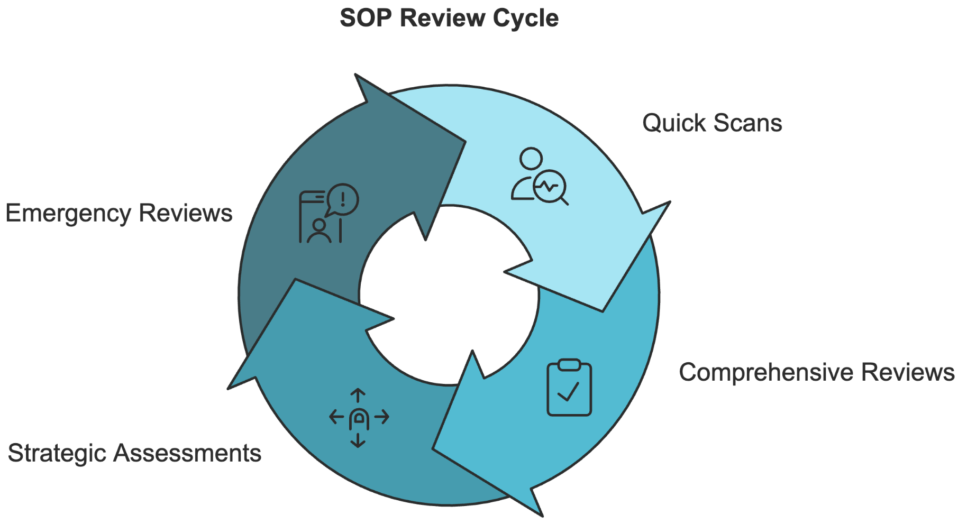
Quick scans occur monthly, focusing on basic functionality and immediate issues that team leaders can identify and address promptly. Comprehensive reviews take place quarterly, with department managers examining efficiency, accuracy, and relevance across their areas of responsibility. Strategic assessments happen annually, where executive teams evaluate how SOPs align with broader business goals and competitive advantages. Finally, emergency reviews occur as needed, triggered by critical issues or compliance changes that demand immediate attention.
Beyond scheduled reviews, certain triggers should automatically initiate SOP evaluation. These triggers act as early warning systems, alerting you to potential gaps or inefficiencies in your procedures before they escalate into serious problems.
Common triggers include implementing new technology, discovering process bottlenecks, receiving consistent employee feedback about specific procedures, noticing patterns in customer complaints, adapting to regulatory changes, or detecting increases in error rates. Addressing these signals promptly helps maintain efficiency and prevent operational setbacks.
A manufacturing company successfully implemented this approach by establishing automatic review triggers based on quality metrics. When defect rates in any product line exceeded 1.5% for three consecutive days, it automatically triggered an SOP review for that production line. This proactive stance helped them identify and correct procedural issues before they could significantly impact their operations. Within six months of implementing this system, their overall defect rate dropped by 43%, and they saved over $200,000 in prevented quality issues.

Leveraging Data for Strategic Optimization
In our current measurement-driven business environment, relying on intuition or casual observations to guide SOP optimization no longer suffices. You need concrete data to make informed decisions about procedure improvements. This approach requires establishing clear performance metrics and reliable methods for data collection and analysis.
When assessing SOP effectiveness, focus on metrics that directly connect to operational success. Track time to completion for specific tasks, error rates, resource utilization efficiency, cost per unit or transaction, customer satisfaction scores, employee feedback, compliance adherence rates, and training completion times. Modern technology offers numerous tools for gathering and analyzing this data, from digital process management systems that automatically track task completion times to quality control software that monitors error rates in real-time.
A regional healthcare provider revolutionized their SOP assessment by implementing digital tracking systems across their facilities. Their data revealed that certain administrative procedures took 40% longer during shift changes, a pattern that wasn't apparent through casual observation.
This discovery led to targeted improvements in their handover procedures, reducing processing times and improving patient care continuity. More importantly, it highlighted the value of data-driven decision-making in SOP optimization.
The optimization process itself should follow a structured approach that prioritizes improvements based on their potential impact and implementation difficulty. By categorizing improvements effectively, you can allocate resources wisely and focus on changes that yield the greatest returns.
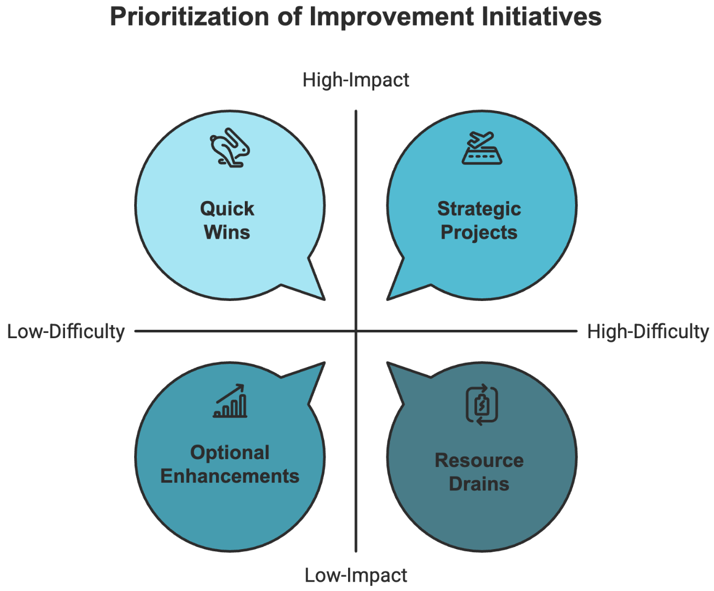
Quick wins represent high-impact, low-difficulty changes that you can implement rapidly. Strategic projects involve more complex changes that require careful planning but promise significant benefits. Optional enhancements offer minor improvements with minimal implementation challenges, while resource drains represent low-impact changes that require substantial effort.
A retail chain exemplified this approach when they discovered their inventory counting SOP contained unnecessary duplicate steps. Eliminating these redundancies (a quick win) immediately saved 45 minutes per day per location. Meanwhile, they carefully planned implementing a new digital inventory system (a strategic project) over several months, ensuring proper integration with existing procedures and thorough staff training.

Creating a Culture of Continuous Improvement
The most successful organizations view SOP optimization not as a periodic project but as an integral part of their operational DNA. This approach requires building systems that encourage continuous feedback and improvement while maintaining necessary structure and standardization.
Establish multiple channels for collecting and acting on feedback. A digital suggestion box allows employees to submit quick improvement ideas that can be reviewed and implemented weekly. Regular team meetings provide opportunities to discuss process issues and develop solutions collectively. Formal proposal systems enable employees to present more substantial improvement projects that require careful evaluation and planning.
A technology services company successfully implemented this approach through a points-based reward system for SOP improvements. Employees earned points for suggesting improvements, participating in implementation, and achieving measurable results through process changes. These points could be redeemed for various rewards, from extra time off to professional development opportunities. The system generated over 200 actionable improvement suggestions in its first year, leading to significant efficiency gains across the organization.
Innovation within structured processes presents a unique challenge. Many worry that SOPs might stifle creativity and prevent adaptation to new challenges.
However, well-designed procedures actually provide the foundation for sustainable innovation by establishing clear baselines from which improvements can be measured and verified. This is because SOPs are more like the canvas upon which innovation can be painted, providing necessary structure while leaving room for creative problem-solving and process improvement.
A software development company maintains this balance by designating certain "innovation zones" within their SOPs—specific points in their processes where teams are encouraged to experiment with new approaches while maintaining core quality and security requirements. This structured approach to innovation has led to numerous process improvements while maintaining highly reliable standards.
Technology plays a crucial role in modern SOP optimization. Digital platforms can automate review schedules, track performance metrics, facilitate feedback collection, and streamline update implementation. However, remember that technology should support your optimization process, not drive it. Focus on solutions that enhance your existing procedures rather than forcing changes to accommodate new tools.
Your journey to SOP optimization evolves alongside your business, creating new opportunities for enhancement with each challenge you face. By establishing robust review systems, embracing data-driven assessment, managing changes effectively, and fostering a culture of continuous improvement, you ensure your SOPs remain valuable assets that drive operational excellence and sustainable growth.
Part Four

TRAINING TEAMS AND ENSURING SOP ADOPTION
____

Creating well-documented SOPs is only the first step—ensuring employees understand, accept, and consistently follow them is the real challenge.
Even the most detailed SOPs are ineffective if they are ignored, misunderstood, or seen as unnecessary. Successful adoption requires clear communication, hands-on training, and a culture that values adherence to standardized processes. When teams actively engage with SOPs and integrate them into their daily workflows, businesses can improve efficiency, reduce errors, and maintain consistency across operations.
The gap between documentation and implementation often determines whether your SOPs become valuable tools for growth or expensive shelf decorations. Even the most meticulously crafted procedures hold little value if your team doesn't understand, accept, and consistently apply them in their daily work.

Creating an Effective SOP Training Framework
The journey from SOP documentation to successful implementation begins with a robust training framework—the bridge connecting your carefully crafted procedures to their practical application in daily operations. Just as a master chef doesn't simply hand recipes to new cooks and expect perfect dishes, you can't simply distribute SOPs and expect flawless execution.
Your training approach must recognize that every employee learns differently and brings unique experiences to their role. A semiconductor manufacturer revolutionized their training approach by implementing a multi-modal learning system. Instead of relying solely on written procedures, they developed a detailed program incorporating visual demonstrations, hands-on practice sessions, and interactive digital modules. Within six months, their error rates dropped by 45%, and employee confidence scores increased by 73%.
The foundation of an effective SOP training program rests on several key components that work together to ensure complete understanding and adoption. You must begin with a broad introduction that helps employees understand not just the "how" but the "why" behind your procedures. This context-setting phase explains how individual SOPs fit into the larger organizational picture and contribute to business success. When your team understands the purpose and value of procedures, they're more likely to embrace them.
Creating structured opportunities for hands-on practice represents another crucial element of your training framework. These sessions should simulate real-world conditions while allowing for mistakes and learning opportunities without operational consequences.
For customer service procedures, implement role-playing exercises that mirror common scenarios. In manufacturing processes, set up mock assembly stations where teams can practice without risking product quality. For software procedures, establish test environments that allow risk-free experimentation.
You need comprehensive evaluation methods beyond simple checkboxes to truly assess understanding and competence. A well-rounded approach ensures that employees don’t just memorize procedures but can apply them effectively in real-world scenarios.
Include practical demonstrations where employees must show mastery of procedures under observation. Develop scenario-based assessments that test their ability to apply SOPs in various situations. Implement periodic reviews to ensure lasting comprehension and proper application. These assessments should identify areas where additional training or clarification might be needed, allowing you to address gaps before they impact operations.

Building a Culture of SOP Excellence
Creating a culture where SOPs are valued and followed consistently requires more than just training programs. It demands a fundamental shift in how procedures are perceived and integrated into daily operations. This cultural transformation begins with employee involvement and extends through every level of your organization.
Start by involving your team in the SOP refinement process. When employees contribute to procedure development and improvement, they develop a sense of ownership that naturally increases adoption rates.
Your accountability systems play a crucial role in maintaining SOP compliance, but you must implement them thoughtfully to avoid creating a culture of fear or micromanagement. A balanced approach fosters engagement, making employees more likely to embrace SOPs rather than resist them.
Focus on positive reinforcement and constructive feedback rather than punitive measures. Create clear expectations around procedure adherence while maintaining open communication channels for questions and concerns. Consider implementing recognition programs that celebrate consistent adherence and improvement suggestions. Develop team-based incentives that encourage collective compliance and collaboration.
To combat resistance to change, you must understand and address its root causes proactively. If you identify these challenges early, you can implement strategies that ease transitions and foster acceptance.
Common sources of resistance include fear of job loss through standardization, comfort with existing methods, lack of confidence in new procedures, insufficient training or support, and perceived inefficiency of new processes. Address these concerns through open dialogue, demonstration of benefits, and adequate support systems. Share success stories from early adopters and create opportunities for skeptical employees to witness the positive impacts of SOP implementation firsthand.

Measuring and Sustaining SOP Success
Successfully implementing SOPs requires ongoing monitoring and maintenance to ensure consistent adoption and identify areas for improvement. This process should be systematic yet flexible enough to accommodate operational realities and changing business needs. You need clear tracking mechanisms that measure both quantitative and qualitative aspects of SOP adoption.
Start by establishing key performance indicators (KPIs) that provide insight into adoption success. Track completion rates for training modules, measure time-to-competency for new procedures, monitor error rates in execution, and analyze customer satisfaction scores related to standardized processes. Implement regular audits to ensure compliance and identify potential improvements. Create feedback loops that allow for continuous refinement based on practical implementation experience.
Modern technology offers powerful tools for managing and monitoring SOP adoption. Digital platforms can track completion rates for training modules, monitor procedure access and usage patterns, collect and analyze performance data, facilitate communication and feedback, provide instant access to updated procedures, and generate compliance reports automatically.
A healthcare company transformed their operations by implementing a digital SOP management system that reduced training time by 40% while improving compliance rates by 28%. The system provided real-time access to procedures through mobile devices, tracked usage patterns, and automatically notified staff of updates or changes.
Leadership plays a vital role in sustaining SOP adoption over time. You must demonstrate consistent commitment to procedures, provide necessary resources for training and implementation, recognize and reward compliance, address challenges promptly, maintain open communication channels, and support continuous improvement efforts. Create opportunities for advanced training and specialization within your SOP framework through certification programs, train-the-trainer initiatives, process improvement workshops, and leadership development programs.
To justify continued investment in SOP training and adoption initiatives, establish clear metrics for measuring return on investment. Track both direct and indirect benefits, including reduced error rates and associated costs, improved productivity and efficiency, decreased training time for new employees, lower turnover rates, enhanced customer satisfaction, reduced liability exposure, and improved regulatory compliance. Document success stories and specific examples of how proper SOP implementation has benefited your organization.
The transformation of your SOP training and adoption strategy requires attention to the human elements that drive success. A logistics company tackled this challenge by creating immersive learning experiences for their warehouse staff. They developed virtual reality simulations that allowed employees to practice complex loading procedures without risking equipment or inventory. This innovative approach reduced training time by 60% while improving safety compliance rates by 85%.
A key aspect of sustaining SOP success involves creating multiple pathways for advancement and specialization. Your training framework should include opportunities for employees to become subject matter experts and trainers themselves.
A retail giant implemented a three-tier certification program for their inventory management procedures. Entry-level staff began with basic compliance training, advanced to procedure optimization roles, and ultimately could achieve master trainer status. This career advancement pathway increased retention rates by 45% and created a self-sustaining culture of excellence.
Your training methods must adapt to different learning styles and operational needs. Visual learners benefit from flowcharts, videos, and demonstration sessions. Auditory learners excel with verbal explanations and group discussions. Kinesthetic learners need hands-on practice and simulation opportunities. By incorporating all these elements into your training approach, you create an inclusive learning environment that supports every team member's success.
Remember that successful SOP adoption relies on consistent reinforcement and support. Regular refresher sessions, performance coaching, and peer mentoring programs help maintain high standards while preventing skill decay. These ongoing support systems ensure that your investment in training continues to deliver value long after the initial implementation phase.
As your business grows and evolves, your SOP training framework must adapt accordingly. Stay attuned to emerging technologies and training methodologies that could enhance your program's effectiveness. The future of SOP excellence lies in your ability to balance standardization with innovation, creating procedures that guide your team while embracing opportunities for improvement and growth.
Part Five

AUTOMATING AND SCALING YOUR BUSINESS USING SOPS
____

SOPs are the backbone of efficient and scalable operations. By clearly defining workflows, businesses can identify opportunities for automation, streamline repetitive tasks, and eliminate bottlenecks that hinder growth.
Automation isn’t just about adopting new technology—it’s about creating structured, repeatable processes that allow systems to function smoothly with minimal manual intervention. When SOPs are designed with scalability in mind, businesses can expand without compromising quality, ensuring consistency, efficiency, and seamless integration of new tools and technologies.
The transformation from manual to automated operations represents the ultimate potential of well-designed SOPs. When properly developed and implemented, your procedures create the perfect foundation for automation and scaling, turning your business into a sophisticated system that can grow without sacrificing quality or consistency. The journey requires careful planning, strategic implementation, and a deep understanding of how SOPs can drive technological innovation while maintaining human oversight.

Building the Foundation for Automation
Before diving into automation tools and scaling strategies, you must ensure your SOPs are ready for technological enhancement. This preparation phase often determines the success or failure of your automation initiatives.
A tech solution provider learned this lesson the hard way. Their initial attempt to automate their ticket routing system failed spectacularly because their existing SOPs didn't account for all possible scenarios and decision points. After investing three months in revising their procedures to include clear decision trees and standardized input requirements, their second automation attempt succeeded beyond expectations, reducing response times by 62% and improving customer satisfaction scores by 45%.
The key to successful automation lies in creating SOPs that think like machines while remaining accessible to humans. Your procedures must evolve from simple step-by-step instructions into comprehensive process maps that capture both standard operations and exception handling. This transformation requires a methodical approach to documentation and standardization.
Begin by evaluating your current SOPs through the lens of automation potential. High-volume, repetitive tasks with clear rules and standardized inputs offer the best starting points. These "quick wins" build confidence in automation while delivering immediate efficiency gains. For example, data entry processes, document routing, and basic customer communications often present excellent opportunities for initial automation efforts.
When preparing SOPs for automation, focus on standardizing your data formats and creating clear validation rules. A freight company exemplifies this approach in their transformation of shipping documentation processes. Their original SOP contained vague instructions like "verify shipping details." The automation-ready version specified exact validation rules: checking address format against postal databases, verifying weight against carrier limitations, and confirming restricted item compliance. This precision enabled them to automate 85% of their document processing while maintaining perfect accuracy.
Your automation preparation must also include thorough error-handling procedures and quality control checkpoints. Document every potential failure point and create clear protocols for managing exceptions. This detailed planning helps prevent costly disruptions once automation is implemented and ensures your team knows how to handle situations that require human intervention.

Implementing Smart Automation Solutions
The implementation phase requires a balanced approach that combines technological sophistication with practical operational considerations. Your goal isn't to automate everything possible, but to create intelligent systems that enhance human capabilities while maintaining operational flexibility. This means selecting tools and platforms that align with your specific needs and existing infrastructure while providing room for growth and adaptation.
Start by mapping your SOPs to potential automation tools, considering factors like integration capabilities, scalability potential, and total cost of ownership. Create a detailed evaluation matrix that helps you compare different solutions based on your specific requirements. This systematic approach helped an electronics company select and implement an automated quality control system that reduced inspection times by 40% while improving accuracy by 25%.
The implementation process should follow a structured approach:
- Begin with pilot programs in controlled environments where you can test and refine automated processes.
- Create comprehensive testing procedures that verify both technical functionality and practical usability.
- Develop detailed documentation explaining both the automated process and underlying business logic.
- Establish clear metrics for measuring success and monitoring system performance.
- Create training programs that help your team understand both normal operations and exception handling.
Testing becomes particularly crucial when implementing automated systems. Design test scenarios that cover standard operations, edge cases, and potential failure points. Document expected outcomes and establish clear success criteria for each automated process. This rigorous testing helped a delivery service identify and resolve potential issues before their automated dispatch system went live, preventing costly disruptions to their operations.

Scaling Through Integrated Systems
Well-documented SOPs provide the foundation for sustainable business scaling, whether you're expanding to new locations, entering different markets, or growing your service offerings. They enable consistent operations across multiple sites while maintaining the flexibility to adapt to local requirements. This scalability becomes particularly powerful when combined with automated systems that can grow alongside your business.
A fast food company leveraged SOP-driven automation to expand from 5 to 50 locations in three years. Their operations manual included core procedures that remained consistent across all locations, plus customizable sections for local market adaptations. This structure allowed them to maintain brand consistency while accommodating regional preferences and regulations. More importantly, their automated systems scaled effortlessly to support the increased operational complexity.
Creating scalable workflows requires thinking beyond current operations to envision future growth scenarios. Your automated SOPs should include provisions for multiple location management, team structure variations, and market-specific adaptations. Build flexibility into your systems while maintaining core standardization that ensures quality and consistency.
Technology infrastructure plays a crucial role in supporting scaled operations. Your tech stack should grow with your business, considering both immediate needs and future requirements. This might include process automation platforms, document management systems, communication tools, and analytics capabilities. The key is selecting solutions that integrate seamlessly while providing the flexibility to adapt to changing business needs.
A cloud computing company built their technology infrastructure to support global expansion. They created a modular system where new locations could be added without disrupting existing operations. Their automated SOPs included clear protocols for technology deployment, ensuring new sites could be operational within days rather than weeks or months.
Your ability to maintain consistent quality across expanding operations depends heavily on automated monitoring and control systems. Implement robust analytics that track key performance indicators and identify potential issues before they impact operations. Create standardized reporting procedures that provide clear visibility into performance across all business units.
Remember, the most successful automated systems enhance human capabilities rather than replace them entirely. Continue investing in your team's development, ensuring they have the skills needed to work effectively with evolving automated systems. Your SOPs provide the bridge between human expertise and automated efficiency, enabling you to build operations that are both highly efficient and adaptably human.
Part Six

MAKING SOPS A LONG-TERM SUCCESS STRATEGY
____

Standard operating procedures are more than just documentation. They’re the foundation of a business’s long-term efficiency, consistency, and scalability.
When properly maintained and continuously improved, SOPs evolve alongside an organization, ensuring that operations remain streamlined even as challenges and opportunities arise. The secret to long-term success lies in treating SOPs as dynamic assets rather than static guidelines. By fostering a culture of continuous refinement, businesses can transform their procedures into a sustainable framework that drives growth, innovation, and operational excellence.
The journey from implementing basic procedures to creating a self-sustaining ecosystem of operational excellence requires strategic vision, consistent effort, and a deep commitment to continuous improvement. Your challenge lies in transforming these procedures into a permanent cornerstone of your business success while maintaining their relevance and effectiveness over time.

Building a Sustainable SOP Framework
Creating a sustainable SOP framework demands more than periodic updates and reviews—it requires establishing a living system that naturally evolves with your business.
Think of your SOPs as a thriving garden that needs the right combination of nutrients, care, and attention to flourish. This environment consists of interconnected elements that work together to maintain, improve, and evolve your procedures naturally over time.
Your governance structure must balance stability with flexibility. While clear protocols ensure consistency, they shouldn't create bureaucratic barriers that stifle improvement.
Successful organizations establish multi-level oversight systems that distribute responsibility across the organization while maintaining central coordination. This approach ensures that everyone from front-line workers to executive leadership plays a role in maintaining and improving your SOPs.
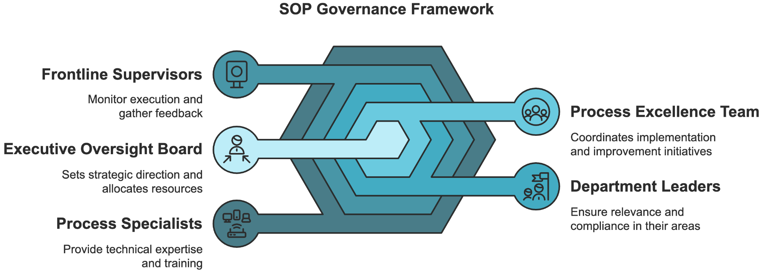
The most effective governance frameworks incorporate several key elements working in harmony. Your executive oversight board sets strategic direction and allocates resources, ensuring your SOP initiatives align with broader business objectives. A dedicated process excellence team coordinates implementation and improvement initiatives, acting as the central hub for all SOP-related activities. Department leaders ensure relevance and compliance within their areas while providing valuable insights into operational needs and challenges.
Frontline supervisors play a crucial role by monitoring daily execution and gathering feedback from those who use the procedures most frequently. They serve as the first line of defense against procedural inefficiencies and provide valuable insights into practical implementation challenges. Process specialists provide technical expertise and training support, ensuring your SOPs remain technically accurate and practically applicable.
To create self-sustaining improvement, you must establish effective feedback loops between different levels of your organization. These loops should capture both structured feedback through formal reviews and assessments and informal insights from daily operations. Technology plays a crucial role here, providing platforms for real-time communication and collaboration between teams and departments.

Driving Excellence Through Advanced Analytics
The long-term success of your SOP strategy depends heavily on your ability to measure and analyze its impact across multiple dimensions. While traditional metrics like error rates and completion times remain important, modern organizations need more sophisticated analysis tools to drive continuous improvement and anticipate future needs.
Predictive analytics represents a game-changing advancement in SOP management. By analyzing patterns in historical data, these tools can identify potential issues before they impact operations.
A financial services firm implemented predictive analytics to monitor their transaction processing SOPs. The system identified patterns indicating potential errors or bottlenecks, allowing them to proactively adjust procedures and prevent issues. This proactive approach reduced processing errors by 42% and improved customer satisfaction scores by 31%.
Your analytics strategy should focus on both leading and lagging indicators of SOP effectiveness. While lagging indicators like error rates and customer complaints provide important feedback about past performance, leading indicators help you identify potential issues before they impact operations. This dual approach allows you to both measure current effectiveness and predict future challenges.
Modern analytics platforms can integrate data from multiple sources to provide comprehensive insights into SOP performance. For example, an electronics manufacturing company combines data from their production systems, quality control checks, employee feedback, and customer satisfaction surveys to create a holistic view of their procedure effectiveness. This integrated approach helped them identify and address subtle inefficiencies that traditional metrics might have missed.
When implementing advanced analytics, focus on metrics that provide actionable insights rather than just data points. Track procedure access patterns and usage statistics to understand how your team interacts with SOPs in real time. Analyze time spent on specific steps or sections to identify areas that might need clarification or simplification. Monitor the frequency of exception handling to understand where your procedures might need updating or expansion.

Future-Proofing Your Operations
As technology evolves and business environments change, your SOP strategy must adapt while maintaining operational stability. This requires building flexibility into your procedures while establishing clear protocols for managing change. The goal isn't to predict every possible future scenario but to create systems that can adapt to whatever challenges arise.
An e-commerce platform offers an excellent example of future-proofing in action. Their SOPs include specific sections for technology dependencies and alternative procedures, making it easier to adapt when systems change. They maintain a "technology roadmap" that aligns SOP evolution with planned system upgrades, ensuring smooth transitions during digital transformation initiatives. This forward-thinking approach has allowed them to maintain operational excellence even during periods of significant technological change.
Your future-proofing strategy should incorporate several key elements. Start with modular design principles that break procedures into components that can be updated independently. This approach allows you to modify specific elements without disrupting the entire system. Focus on technology independence by emphasizing business logic rather than specific tools, enabling easier adaptation as technology evolves.
Build scalability provisions into your procedures from the start, anticipating future growth and expansion needs. Create clear adaptability frameworks that specify how procedures can be modified in response to changing conditions. Establish processes for innovation integration that allow you to incorporate new technologies and methodologies without disrupting existing operations.

Embracing the SOP Evolution
Implementing SOPs is not a destination but a continuous journey that transforms alongside your organization. As your business navigates changing markets, technologies, and customer expectations, your procedural framework must serve as both anchor and sail, providing stability while capturing the winds of innovation.
Leaders who truly excel in operational excellence understand that SOPs are living entities—breathing, growing, and adapting with each challenge encountered and each milestone achieved. They recognize that the most powerful procedures are those that become so deeply embedded in organizational culture that they inspire rather than constrain, empower rather than control.
The organizations that thrive in tomorrow's marketplace will be those that view their SOPs not as static documents but as dynamic expressions of their operational philosophy. These companies cultivate procedural ecosystems where improvement is not a scheduled activity but a natural outcome of daily operations—where every team member feels both the responsibility and the ability to contribute to operational excellence.
Your SOP journey does not end with implementation or even with refinement. It continues with each new employee who brings fresh perspectives, each technological advancement that opens new possibilities, and each market shift that demands new approaches. The procedures you establish today will evolve into something different tomorrow, perhaps unrecognizable in form but unwavering in their fundamental purpose of driving exceptional performance.
The true measure of your SOP strategy's success lies not in perfect compliance or flawless documentation, but in how seamlessly it enables your organization to adapt, innovate, and excel in an ever-changing business environment. Your procedures should be more than instructions—they should be the embodiment of your commitment to operational excellence and the foundation upon which your organization builds its future.

