Table of Contents

Introduction 3
Chapter 1: Provide Online Training 5
Chapter 2: Provide Freelance Services 8
Chapter 3: Create “How To” Videos 11
Chapter 4: Become an Affiliate Marketer 15
Chapter 5: Become a Merchandise Seller 19
Chapter 6: Use the Dropshipping Model 21
Chapter 7: Become Self-Publisher 24
Conclusion 27



Introduction

In this special report, we will reveal some profitable side hustles that you can undertake on a part-time basis. This means that you can continue to work at your job and earn more money for the things that you want.

With all of the side hustles in this report, you can make additional income without having to spend too much time on them. A lot of people find that their side hustle has the potential to earn them more than they do from their regular job. They can then quit their job and focus on the side hustle to make it their main hustle.

We encourage you to explore all of the side hustle ideas in this report carefully. Decide which of them is right for you and create a plan to get started and make regular income.

You can use a side hustle to pay off your debts or save for something important. With the additional income that you will earn from your chosen side hustle you will not have to worry about money again.

Most of the side hustles revealed in this report can be expanded so that you can replace your current income and make much more money than you ever did before. You decide how much time you want to dedicate to your side hustle when you are getting started.

Let’s get started on this exciting side hustle journey.
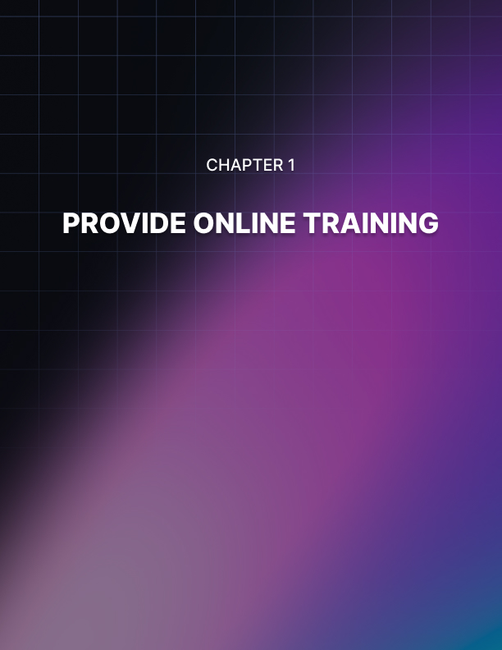

Chapter 1: Provide Online Training

You can use the knowledge and the skills that you have to create online training courses and programs. People will pay to access your training and you can use established platforms such as Udemy and Teachable to make your training available.

Decide on the Format of your Course
We would recommend that you provide your online training courses in video format but you can also include text-based resources such as PDF documents, spreadsheets, slide presentations and more. Find out what your market wants before deciding on the format of your training. You can research existing courses in your niche to see how they present their training.

Right now, there are people earning huge amounts of money by providing online training. They provide courses that show people how to learn a new skill or solve a specific problem. Think about it – you create your training course once and you sell it over and over to people that want it.

Anyone can Create a Good Online Training Course
You may be thinking that you do not have the knowledge, skills or experience to create a quality online training course. But this is not the case. There are people looking to learn all kinds of things online and all you need to do is to learn more than they do and you can create a course.

The online course that you create does not have to be very extensive. Less is often more with online training as people do not want to spend too much time learning. You could develop a basic course and then more advanced courses to make even more money.

Knowing what your target audience wants is the secret to success. In every niche, there are problems that people have and you can identify these and solve them with your online training. Do your research and uncover these pain points. Then create your courses around them.

Make an Assessment of your Current Skills
The first step to creating successful online training courses is to make an assessment of the skills that you currently have. Identify your interests as well as it will be a lot easier for you to create a course around something that you are interested in.

You want to come up with a list of possibilities and then choose the best one to get started. Perhaps you have some experience of digital marketing and generating traffic to a website for example. Or maybe you are an accountant and can teach people valuable business accounting skills?

There is value in these skills and many others. If you don’t think that you have valuable skills and experience to offer then you can learn a new skill, master it, and then create a course around it. The most important thing is that you create courses that people want.

The Sky's the Limit with Online Training
The provision of online training has the potential to make you a lot of money and can be one of the most profitable side hustles around. There are many options for you to take this further to make more money. For example, you could decide to provide personal one-on-one coaching to your students. You can charge a lot more money for this. If your online training is high-quality (which it needs to be) and people perceive you to be an expert, some of them will want more from you and will be willing to pay for it.

If you like the online coaching idea then you could offer your students a 30 day or 60 day series of calls. Another idea is to create a membership website where your students pay you a monthly subscription for additional training and resources.
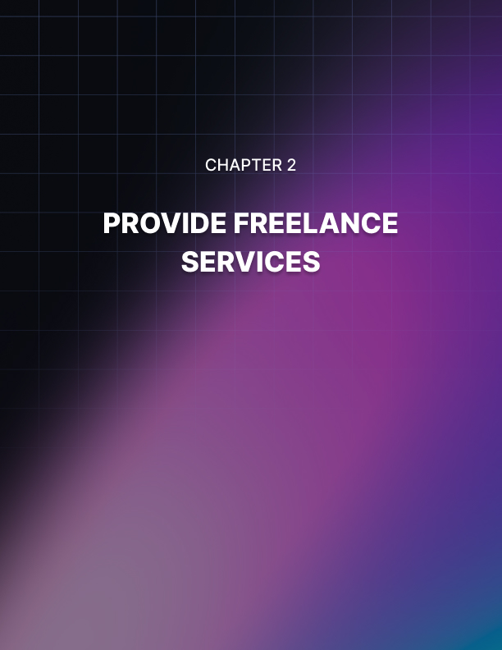

Chapter 2: Provide Freelance Services

When you offer freelance services, you should be able to make good money without having to spend a lot of time. All you need to do is to decide what services you want to offer, decide what you will charge for your services and then only accept the number of gigs that you have time to complete comfortably.

There are many different freelancing services that you can provide. Your aim is to develop a client base who will come back to you with more work on a regular basis. Today, there are several freelancing websites where you can find freelancing work. Fiverr.com is a very popular “gig- based” site where you can advertise your services for free. If you prefer to respond to project requests from clients then you can join a website like Freelancer.com.

Choose your Freelancing Services
You need to decide which freelancing services that you are going to provide. Choose a service that is in demand so you will get a steady stream of work. Here are some examples of in-demand freelancing services:

- Content writing
- Copywriting
- Translation
- WordPress set up and maintenance
- Search Engine Optimization (SEO)
- Web design and development
- Graphic design
- Social media marketing

You need to be confident that you can complete any job that you accept. If you don’t feel that you have the right skills to offer you can learn them first. It is better to do this than to just accept jobs that you do not know how to complete.

Customer Service is everything
When you are providing freelancing services, you need to develop a good reputation with your customers. Ask your customers to leave you a review on websites like Fiverr and Freelancer as this will help you to obtain work from other customers. If your profile has many testimonials then customers are more likely to choose you for their work than your competitors that have few reviews.

Commit to delivering your services to specific deadlines. Your customers will really appreciate this. If you need to clarify anything then contact the customer right away so that you can fully understand what they need. Regular communication with your customers will help you to obtain even more glowing testimonials.

Research your Pricing
Identify who your competitors are in the freelancing world and compare the prices that they are charging. If you set your prices too high when you start out then you will probably find it difficult to get work. You do not want to set your prices too low either as you could end up working like a slave for little reward.

Find out what other freelancers are charging for similar services. You want to give the impression that your services are high-quality so don’t settle for the lowest price. Go for a reasonable price to begin with. As you build up your profile with positive testimonials from customers you can increase your prices with confidence.

Here are some freelancing websites that you can consider for offering your services:

- Fiverr.com
- PeoplePerHour.com
- Upwork.com
- Freelancer.com
- Guru.com

Please note that the first 2 sites (Fiverr and PeoplePerHour) are “gig based” where you can create your own gigs (ads) for your services and customers will choose the one that they want. The remaining 3 sites are “project based” which means that you need to respond to client projects with your bid.


Chapter 3: Create “How To” Videos

These days, people prefer to watch a video to learn how to do something rather than read a lot of text. YouTube is the second largest website in the world and receives around 35 billion visitors each month. It is also the second largest search engine after Google. A lot of people search YouTube for “how to” videos.

If you create popular “how to” videos then you can quickly generate a lot of views and make a lot of money. Once you get used to creating these videos it will be easy for you to make more of them. Creating a YouTube channel for your videos is very easy.

What Videos will you create?
Creating the right type of “how to” videos is critical to your success. You want to upload videos that people want to watch. A good place to start is to assess your current skills, knowledge and experience. Can you turn any of this into popular how-to video content?

Spend some time going through YouTube looking for how-to videos in your chosen niche. Look at the average number of views that the videos receive. Also take note of the number of subscribers that the channel has.

Play some of the most popular videos to see how they are structured. Do not copy what others are doing but use their videos for inspiration. How are they answering the questions that their audience has? What kind of style do the videos have? Are they showing their faces on camera or using a slideshow approach?

Take the time out to fully research your market. The more that you know about what your audience wants, the more likely you are to create the right videos. What problems do your audience have? Can you provide solutions to these problems in your videos?

Creating High-Quality How-To Videos
We recommend that you show your face on camera. A lot of people don’t like this idea but it will help to build trust with your audience. Although the cameras in smartphones are improving all of the time, we also recommend that you invest in a good quality webcam and microphone.

YouTube users are not expecting you to create Hollywood style videos. But they do expect your videos to be good quality. Using an inferior Camera or microphone will drive your audience away. You can find good quality webcams (HD) and USB microphones on Amazon for a very reasonable price these days.

Video editing software and screen recording software are available for free. You can use iMovie for a Mac computer and Movie Maker for a Windows computer. There are also other free video editing suites available. For screen recordings you can use the open-source OBS Studio.

Create a storyboard for your video. You can write a script for your video as well but if you are reading from a script then this may come across as unnatural. Plan your videos and write some notes instead. This will ensure that you cover all of the main points that you need to and don’t forget anything.

YouTube Shorts are very popular now. Can you create a good how-to video in 60 seconds or less? The shorter you can make your videos the better. People do not want to spend any longer watching a how-to video than they have to.

A good opening clip and ending clip will add a good touch of professionalism to your videos. It will also help to promote your brand. There are gigs on Fiverr for a reasonable price for this. We also recommend that you add high-quality graphics to your YouTube channel. Again, you can outsource this on Fiverr.

Monetizing your How-To Videos
There are different ways that you can monetize your how-to videos. If you have a product or service, you can promote this in your videos. Tell your audience that it will reveal secrets to greater success in your niche.

Alternatively, you can promote related affiliate offers in your videos. Find affiliate offers that complement the subject of your videos and explain to your viewers how the product or service will help them.

YouTube has a Partner Program where you can show ads on your videos once you surpass their requirements for this. You will need at least 1,000 subscribers and over 4,000 watch hours. We need to tell you that ad revenue from YouTube is unlikely to make you rich. A lot of views are needed to make decent money with this.

Another monetization strategy that you can consider is sponsorship. You can find a company to sponsor your videos. Finding a company that operates in the same niche is probably best but you can look for other companies as well. Agree a deal with them and how you will promote them in your videos.

You can make a lot of Money with How-To Videos
There are people making thousands each month by creating and uploading useful videos. YouTube users are always searching for solutions to the problems that they have and if you can get in front of these people, you will maximize your chances of success.

Choosing the right niche and creating the right videos is critical. You need to be patient with this strategy as you are unlikely to make a lot of money from it right away. Growing your channel is very important as you want as many subscribers as possible. When your videos are good your audience will share them on their social media profiles.

Creating engaging videos is your number one priority. You want to encourage your audience to like and share your videos and leave comments. Be sure to respond to any comments quickly and professionally.



Chapter 4: Become an Affiliate Marketer

Being an affiliate marketer can be very profitable for you if you do it right. It is a very popular side hustle as you can start for free. There are thousands of affiliate offers available in just about every niche. It is easy for you to get started with affiliate marketing. People are earning thousands of dollars a month in passive income from this and there is no reason why you cannot do it as well.

What is affiliate marketing? It is the promotion of someone else’s products and services in exchange for a commission. You do not need your own product and you will not be responsible for customer service issues either. All you need to do is to drive traffic to the affiliate offers and each time a sale is made you make a commission.

Decide on the Affiliate Offers to Promote
The best way for you to promote affiliate offers is through content marketing. This means that you will have a website or blog, a YouTube video channel, a social media channel such as a Facebook Page and so on.

If you like the idea of content marketing then we recommend that you choose a niche that is in demand and where products are already selling. The three most popular niches are health and fitness e.g. weight loss, wealth creation e.g. make money online, and self-help e.g. relationship advice.

Once you have chosen your niche you need to find related affiliate offers. There are thousands of affiliate offers for the top 3 niches, but you need to understand that these niches are all highly competitive.

You need to decide if you are going to promote physical products, digital products or both. A physical product is something that you can touch such as a TV or a pair of shoes. It is easier to make sales with physical products as people know what to expect. The problem with physical products is that the commissions tend to be low.

A digital product could be an e-book or video training. The customer does not receive anything in the mail when they order a digital product. They will either need to download the product or access a special website where the training videos are located for example. Commissions with digital products are usually much higher. It is not uncommon to make a 50% commission or more on a digital product.

Never promote low quality affiliate offers. If you can purchase the product or obtain it from the vendor then go through it and make sure that it provides good value. People will quickly lose faith in you if you promote poor quality affiliate offers.

Affiliate Networks
The best way to find affiliate offers is to join an affiliate network. There are many affiliate networks available that you can join for free. Some of these specialize in digital products while others only deal with physical products. Some have both.
You should never have to pay to join an affiliate network. If you are asked to pay then we recommend you look elsewhere. When you join an affiliate network you can search through the offers that they have and find those that are best suited to your chosen niche.

Here are some examples of well-known and respected affiliate networks: Physical Products:

- Amazon Associates
- Commission Junction
- Digital Products Clickbank
- Digistore 24

Please note that you may require approval from some vendors to promote some products. Always check the commission levels to see if it is worth your while promoting the offer. Affiliate networks often provide other useful information such as earnings per click, gravity, conversion levels, and more.

Using Paid Traffic for Affiliate Offers
The fastest way to make affiliate commissions is to use paid traffic. It can take a while for content marketing to work, but with paid traffic you can start to get results in minutes. Pay per click (PPC) ads are offered by Google and Microsoft and it is sometimes called search marketing. Your ads will appear for specific keywords that users type in.

Social media ads and native ads are other alternatives. Facebook and Instagram offer ads as do Pinterest and other major social networks. Native ads are offered by companies like Taboola and they appear on high traffic websites like CNN.com.



Chapter 5: Become a Merchandise Seller

There is a huge demand for printed t-shirts and you can make money from this without having to process any payments and ship any inventory. All that you need to do is to use a website such as Printify or Red Bubble and you only have to upload a design and they will deal with everything else.

Every time that one of your t-shirt designs is sold you will receive a percentage of the sale. You have the choice of several different types of merchandise that your design can appear on. Examples of these products include handbags, mouse pads, coffee mugs and of course, t- shirts.

You Focus on the Design
This is a really good side hustle as you just need to focus on your designs and you will not have to spend time on anything else. We recommend that you perform solid research to see what kind of designs are selling well so that you can maximize your chances of success.

Spend quality time on this research and look at websites such as Etsy and Amazon for inspiration. Make a note of the slogans, phrases, colors and other factors that are involved for the most sold designs. This will all help you to come up with winning designs of your own.

You do not have to be a Designer
Don’t worry if you are not a graphic designer or have no Photoshop skills. There is a free website called Canva where anyone can create awesome designs using their range of templates. You do not require any design experience to create a great looking design using Canva.

Alternatively, you can find a talented designer on Fiverr that will create the designs for you based on your ideas for a few dollars. There are some very talented people on Fiverr that will be happy to create your designs and get them to you quickly. Be sure to check out the reviews that the sellers have from other customers before you choose a designer. When you are uploading your designs to Printify or Red Bubble you need to ensure that the resolution is 300 dpi and the file dimensions are 4,500 by 4,500 pixels. Make sure that your image is a PNG file and not a JPG.
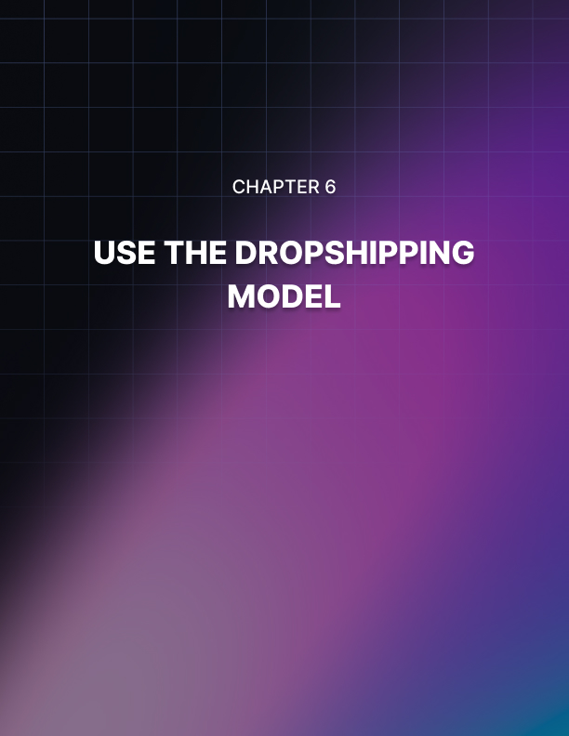

Chapter 6: Use the Dropshipping Model

If you are not aware of dropshipping, it is where you can sell physical products on your website (online store) and you do not have to purchase any inventory or deal with delivering the orders to the customers. This is one of the best side hustles for passive income. Once you have set everything up, you will not have to spend a lot of time on this side hustle.

Dropshipping is a low-risk side hustle. You do not have to purchase any inventory and then hope that you will sell it all quickly. This requires significant investment and if you choose the wrong products, you can make a loss. With dropshipping, no products are shipped by the company until sales are made.

Decide on your Niche
The most important thing for you to do when you are getting started with dropshipping is to choose the right niche. Once you know who your target audience is and what you want to sell to them, you can then look for a good dropshipping company to work with.

You want to avoid the mistake of trying to promote too many different products. Narrow your focus to a specific niche and then investigate the products that will be the best fit for the niche.

Some people use current trends to make money from dropshipping. They identify what is popular right now and then jump on this by promoting related products. We would not recommend basing your entire dropshipping business on this method but you can make good short-term profits with trends. Choose an evergreen niche for your business so that you can be confident of consistent sales. If you have the time and opportunity to jump on a hot trend and make some good profits as well then do that.

Find the Right Company and Market your Business
To be successful with the dropshipping side hustle you need to work with the right dropshipping companies and promote your business properly. Go over to Oberlo to start a dropshipping business in an evergreen niche. You can always search for other good suppliers as well as Oberlo by searching on Google. When you have found a good dropshipping supplier, you will need to create an online store so that you can integrate the inventory of the supplier.

It is never a case of “build it and they will come” with dropshipping. You need to promote the products offered by the dropshipping company and you can use eBay and Amazon as part of your marketing strategy.

Find out where your target audience hangs out and let them know about your store. Spend all of the available time that you have promoting your dropshipping business after you have set it up.


Chapter 7: Become Self-Publisher

Before the launch of the Amazon Kindle Direct Publishing Platform (KDP), if you wanted to write a book and get it published you were at the mercy of publishing houses. You would first need to convince the publisher that your book idea was a good one and would sell well. Then you would enter into a contract where they would take a sizable part of your book sale income.

Now anyone can use the Amazon KDP platform self-publish. Millions of self-published books are sold on Amazon every day and you can turn this into a very profitable side hustle. With KDP you can publish a fiction or non-fiction book immediately and start selling to your audience.

Decide on the Books that you want to Publish
Think about what you are interested in and knowledgeable about to come up with ideas for books that you can self-publish. It is tougher to come up with successful fictional books than it is with non-fiction. But if you create a winner in fiction then you can really make a lot of money.

For non-fiction books, what skills and experience do you have that will help others? Write a list of the things that you have done and assess these for marketable ideas. Is there sufficient demand for your ideas?

For example, do you have experience in niches such as finance, digital marketing, copywriting or personal development? These are a few of the bestselling genres on Amazon.

Writing your Books
How do you feel about writing your own books? If you enjoy writing then you can do this yourself. All you need is a word processing application such as Microsoft Word or the free Google Docs or Libreoffice suite.

If you are not a fan of writing or do not have the time to write your own books, you can still profit from the self-publishing side hustle. You will need to find a competent writer to create your books for you. These people are called “ghostwriters” and have experience of writing books for others. There are freelance marketplaces where you can find good ghostwriters and these include Upwork and Reedsy.

Whether you decide to write the book yourself or outsource it to a ghostwriter you need to create an outline for your book. Your outline needs to be clear and specific especially if you are going to outsource the writing task. When you are looking for a ghostwriter, check their credentials thoroughly. What kind of track record do they have? Do they have glowing testimonials from other customers? Can they write the book in the style that you want?

As you start to profit with your self-publishing side hustle you can reinvest some of your profits into the creation of a writing and editing team. The more high-quality books that you can publish, the more income you should generate from self-publishing.

Market your Books
There is a lot of visitor traffic for books on Amazon but we recommend that you do not leave it at that. Do everything that you can to market your book(s). You need a solid marketing plan for all of your self-published books so that you can tell your audience when you publish a new book.

Another approach that you can take with self-publishing is to create “low-content” books. These are popular on Amazon and examples are notebooks, calendars, planners, and more. Low-content books are much easier to create than full books. You can purchase templates for your low-content books which come with full commercial rights on a site like Niche Raiders.


Conclusion

In this special report, we have provided you with 7 proven side hustle ideas that are all online based. All that you need with any of these side hustles is laptop or desktop computer and a connection to the Internet.

We recommend that you go through each of the side hustle ideas in this special report and choose the one that suits you best. Focus on this side hustle until you achieve your goals with it before moving onto another. Trying to do more than one side hustle at a time is not likely to work especially if your time is limited.

Please bear in mind that all of these proven side hustle ideas are going to take patience and determination. It may be a while before you start to see any income from them. Probably the fastest way to make money from a side hustle is to become a freelancer.

We wish you every success with your side hustle!

Essential Resources
Use these essential resources to maximize your chances of side hustle success:

11 Best Side Hustles To Make an Extra $1,000 Monthly
>> https://www.oberlo.com/blog/side-hustle

The Ultimate Guide to Freelancing
>> https://blog.hubspot.com/marketing/freelancing

The Ultimate Guide to Affiliate Marketing
>> https://impact.com/partnerships/ultimate-guide-to-affiliate-marketing/

The Complete Guide to YouTube Marketing in 2022
>> https://blog.hootsuite.com/youtube-marketing/

