Disclaimer

This ebook has been written for information purposes only. Every effort has been made to make this ebook as complete and accurate as possible. However, there may be mistakes in typography or content. Also, this e- book provides information only up to the publishing date. Therefore, this ebook should be used as a guide - not as the ultimate source.

The purpose of this ebook is to educate. The author and the publisher do not warrant that the information contained in this ebook is fully complete and shall not be responsible for any errors or omissions. The author and publisher shall have neither liability nor responsibility to any person or entity with respect to any loss or damage caused or alleged to be caused directly or indirectly by this ebook.
Table of Contents

Chapter 1: Get In The Right Mindset To Start A Side Hustle 5
The Right Mindset 5
Chapter 2: Take Inventory Of Your Special Skills And Talents 9
Low-level vs. High-level Skills 9
Money vs. Satisfaction 10
Chapter 3: Build On Your Strengths, Outsource Your Weaknesses 13
Make good use of your time 13
Is outsourcing the right thing to do? 14
Chapter 4: Map Out Your Hustle Idea And Strategy 17
Lists vs. Mind Maps 17
Branding your side hustle 18
Chapter 5: Analyze And Validate Your New Hustle Idea 21
Chapter 6: Implement A Solid Marketing Strategy 25
Chapter 7: Set Realistic Goals And Timelines With Your Hustle 29
Chapter 8: Keep Your Side Hustle Separate From Your Day Job 33
Chapter 9: Create And Follow A Strict Side Hustle Schedule 37
Chapter 10: Focus Your Time On What Generates Revenue 41
Chapter 11: How To Avoid The Side Hustle Burnout 45
Chapter 12: When It’s Safe To Quit Your Day Job 49



Chapter 1: Get In The Right Mindset To Start A Side Hustle

Many people start off so excited when they see a side hustle opportunity they think will be a good fit for them. They make plans and think about how they’re going to spend their extra cash, or how they’re going to quit their jobs the moment their side hustle takes off.

But before they even get halfway to success, they give up all of a sudden. They make excuses as to why their side hustle isn’t working. They’ll tell themselves that their day job is easier because they get a steady paycheck every month. They’ll try to convince themselves that they’re happier at their day jobs anyway.

The Right Mindset
Many people have what it takes to succeed. They have the skills and the talent to do so. But the moment life throws curveballs their way, they give up and quit chasing their dreams.

Why is that? Did they not want their dreams badly enough? Do they really like their lives the way it is right now? Maybe, maybe not.

The answer actually lies in people’s mindsets. Not everyone’s cut out to hustle and take actual charge of their lives. When you hustle, you’re taking control of your life and you’re stepping out of your comfort zone.

The thing is some people are content with whatever they have going for them at the moment. They don’t have that drive, that burning passion to see their dreams come to life. And that’s okay, that’s their prerogative, their choice.

Perhaps they’ve become jaded and cynical. They’ve seen far too many people fail, and only a very small minority succeed, so they think they just don’t have what it takes to beat the odds. In their minds, they’ve already failed.

But you don’t have to follow in their footsteps. You don’t need to feel the same way. You don’t need to feel discouraged every time you hear about someone who’s failed at their side hustles.

You control your mind
The human mind is amazing. It can either push you to go after your dreams no matter what it takes or bury it long before you even do anything about it. But your mind and your thoughts aren’t independent of who you are as a person. The truth is, YOU control your mind. Your mind doesn’t control you!

With that said, if you want to change your life for the better, then you need to get out of your comfort zone. You’ll never see success if you keep on doing the same things over and over again.

When you enter the world of side hustling and entrepreneurship, you need to change the way you think. If you’ve got a negative mindset, then you absolutely must change it to a positive one.

If you don’t, then you’re never going to get anywhere, you’ll be stuck doing the same kind of jobs until you die. The same jobs that give you an uncomfortable, mediocre, and ultimately, unhappy life.

Know your “why”
If you want to succeed in your side hustle, then you need to, first of all, understand your “why.” Why do you want to succeed? Who are you doing it for? What are you hoping to achieve with your side hustle? More money? Freedom from the rat race?

Whatever the reason, you need to always remember your “why” because it’s going to be an uphill battle to success. There will be times when you’ll feel so tired, when you’ll feel like the world is conspiring against you to fail. You’ll feel like your side hustle is not bringing you any closer to your goals. When that time comes, remember your “why” and you’ll feel your motivation come back.

Chase the right goals
Your mindset plays a critical role in your side hustle success. If you don’t want your dreams badly enough, then perhaps you’re chasing after the wrong goals?

You need to get your mindset right before you attempt to do anything. If you don’t, you’re going to be suffering for months and years, wondering why you can’t muster the motivation to do what needs to be done. You’ll only be delaying your success, and every step of the way, you’ll feel like your feet weigh a ton and is dragging you down!

However, if you’re chasing after goals that you’re passionate about and you’ve got the right mindset for it, then you can expect different results.
This powerful combination is what separates successful side hustlers and entrepreneurs from failures and wannabes.

So, take the time to get to know yourself, prepare your mindset, and ask yourself if you’re ready to take on one of the biggest challenges in your life.


Chapter 2: Take Inventory Of Your Special Skills And Talents

You’ve probably got a lot of skills and talents that you can put to good use. But since you’ve got a limited amount of free time (provided you work full time at your day job), then you need to choose a profitable side hustle that will help maximize your time.

How do you do that?

Well, for starters, you can take an inventory of your special skills and talents. You can start by writing down your work experiences (paid or not), and then write the skills you used to do those jobs. If you picked up any random skills along the way, write them down as well.

This process is important so you can identify which opportunities are going to be a good fit for you. You can then further analyze the marketability and demand of your skills because as you probably know, not all skills are created equal.

Low-level vs. High-level Skills
General and low-level skills probably aren’t going to get you an extra thousand bucks right away. You’ll have a ton of competition since there is a relatively lower barrier to entry, meaning a lot of people can do these easy side jobs.

On the other hand, if you choose a side hustle which requires higher-level and more technical skills, then chances are, you’ll have less competition. Depending on the demand for those skills, you’ll be able to bring in more extra cash each month than a low-skill side hustle.

For instance, let’s say you’re pretty skilled at babysitting, copywriting and designing websites. Which of these side hustles do you think are going to be most profitable?

With babysitting, you don’t really need special skills. If you love babies and you’ve got a way with them, then you can easily become a babysitter. With this logic, anyone looking for a babysitter can theoretically find one quickly, provided, of course, they pay competitive rates.

When it comes to writing and web design, not everyone has these skills. This means that the pool of good copywriters or web designers is going to be much smaller than the pool of possible babysitters. The thing is, good copywriters and web designers are very much in demand, which is why they can command higher-than-average prices for their services.

Going by the example above, which side hustle are you going to choose? Do you want to become a babysitter, a copywriter or a web designer?

I bet most of you will choose either a copywriting or web designing side hustle. After all, if you’ve only got 20 free hours each week to work on your side hustle, then you want to make the most of it. Why work on a low-paying hustle (say $10/hour) when you can work on something that pays $30-$100 an hour? Think about how much extra money you’ll be making for the same amount of time worked!

Money vs. Satisfaction
If you’re looking to eventually quit your day job, then having a good paying side hustle is a must. This is why you must know your skills and your strengths, so you can put it to good use and make some good money in the process!

You think you’re a pretty capable writer and/or web designer, but you don’t want to spend all your free time getting stressed out about client work. You already have enough of that at your day job, so you just want to do a side hustle where you can chill out. Well, that’s your call.

To be honest, there’s no right or wrong answer here. We all have different goals. For some of you, you want a side hustle that can provide you with extra cash. For others, you want something that will eventually replace your day job. And for some, you want to do something you really enjoy and still make a few dollars out of it.

If you find babysitting more fulfilling as a side hustle than copywriting or web design, then that’s perfectly alright. If that’s your passion, then follow what your heart says. There’s no point working on a side hustle you’re going to dislike or hate eventually!

It’s better to do what you really want to do. When you’re passionate about something, it’s easier for you to find ways to make it grow. Who knows, maybe you can turn your babysitting side hustle into something bigger!

For instance, you can probably use babysitting as a foot in the door to bigger opportunities later on. You can offer your writing and web designing services to the kids’ parents. So, you’ll essentially be hitting two birds with one stone!

In the end, the success of your side hustle will depend on your commitment. You’ll find it hard to commit to something you don’t enjoy, no matter how talented or skilled you may be.

If you believe in what you’re doing and you’re happy doing it, then good for you. Stick with a side hustle that feels right for you. Listen to what your heart is saying. Otherwise, you’re going to regret it later on.
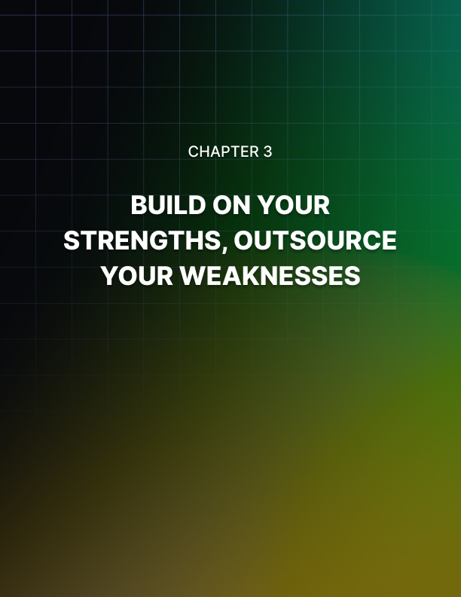

Chapter 3: Build On Your Strengths, Outsource Your Weaknesses

Do you believe in the saying “time is money?” If you do, then you know that your time is better spent doing things you’re good at. You can then leave the rest (meaning, the things you’re bad or mediocre at) to people who are way better than you.

In the beginning, it may be perfectly okay to do everything in your side hustle business all by yourself. However, once your business starts growing, then you need to consider outsourcing those tasks which slow you down or those which you don’t particularly enjoy.

This is especially useful if you still hold a day job – you can only do so much! If you insist on doing everything yourself, then you’re only going to slow down your progress.

Make good use of your time
If you’ve got the money even before you go into your side hustle, then right away, it will be easier for you to scale your business from the get-go! This means you can invest in the tools and resources you need to succeed.

You can simply focus on doing what you know best and outsource the rest. You don’t need to go through the process of working on your side business all by your lonesome self.

Unfortunately, however, not too many people are going to be this lucky. If you belong to the majority of people who don’t have huge trust funds or a healthy savings account, then don’t worry.

You can still succeed at your side hustle, it’s just going to take you a bit longer because you’re going to do everything from scratch. Don’t compare your progress to others. You’re just going to end up pitying yourself, and your self-esteem and your motivation will probably take a nosedive.

Let me give you an example. If you choose blogging as your side hustle, then you may need to do everything yourself in the beginning. You’ll write all the content, design your site, promote your content on various social media channels, etc.

Doing all these things will cost you many hours, maybe hundreds! But, you’d be willing to do it anyway because you’re passionate about blogging. You don’t mind doing all the grunt work. In fact, you treasure the learning experience.

When you finally succeed, you’ll get hundreds or thousands of people reading your blog posts. If you monetize your site properly, then you could earn a good amount of money from your blog.

You know that if you add more high-quality content to the site, then there’s a very good possibility your earnings are going to go up. So, now you need to decide. Do you outsource the content creation or do you continue to do everything yourself?

If you decide to outsource, you’ll publish more articles on your site than if you continue writing alone. You’ll be able to grow your social media presence much faster. With outsourcing, you’re essentially replicating yourself, so you get more work done in less time!

Is outsourcing the right thing to do?
The thing is outsourcing part of your side hustle will mean money. But, don’t view it negatively. Instead, consider it an investment in your business. You need to spend money so you can make money.

Now, hiring the right people to help you out with your business isn’t exactly easy. If you go to a workplace site like Upwork (https://www.upwork.com), you’ll probably receive tons of applicants. You’d need to shortlist the ones you think are going to be a good fit, and then you have to spend some time interviewing them.

Doing all these is going to take some time. And by the end of it all, the freelancer you hired may end up being only good on paper, but won’t be a good match for your needs. So, you need to do everything all over again.

Outsourcing comes with its own share of headache-inducing problems.
Once you find a good contractor, you’ll need to train them up on your systems and your processes. They’re probably not going to get the hang of it right away. That means a few weeks of back and forths until you’re finally satisfied, and you feel comfortable enough to give them some leeway on how to do their jobs.

Whether you’re hiring freelancers or employees, keep in mind that it’s important to build healthy relationships with everyone. If you respect the people working for you, then they’ll respect you back. They’ll be more committed to helping you grow your business.
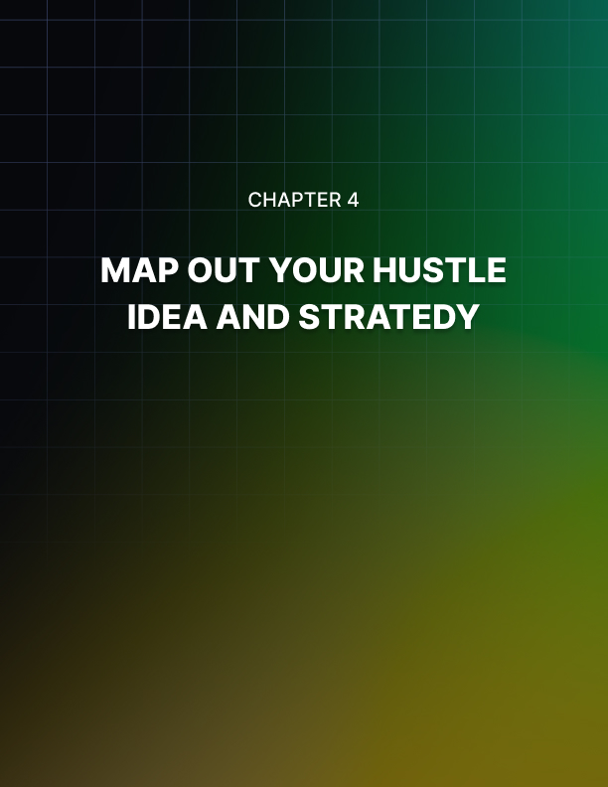

Chapter 4: Map Out Your Hustle Idea And Strategy

Planning is key to your side hustle success. Without a good plan, you may just as well be playing in the dark. You’re almost guaranteed to fail. If you want to increase your chances of success (and who wouldn’t?), then it’s a must that you plan out your side hustle idea and lay down a solid strategy.

You know your strengths and your weaknesses better than anyone. If you say you’re not good at planning, then you better think of a way to move ‘planning’ to your strengths column. If you feel like you can’t do it alone, then don’t be afraid to ask for help from family and friends.

Ask them to help you brainstorm your side hustle strategy. As the saying goes, two (or more) heads are better than one. Do a brain dump and write down everything you can think of, even those you think are absurd. You’ll have the opportunity to edit your ideas later on.

Lists vs. Mind Maps
To organize your ideas, you can use either a simple linear list or you can use a mind map.

With linear lists, it can be hard to make sense of if you’ve got a very, very long list. You’d need to scroll down, and it can be disorienting and overwhelming at the same time. If you’ve got ideas that are similar to each other, it’s hard to show that on a linear list.

Mind maps, on the other hand, provide a more logical and more organized way to view your ideas. Its free and non-linear format allows you to easily move ideas around, connect similar ideas and group them together. It’s also so much easier to get a bird’s eye view of your strategy on a mind map.

To sum up, mind maps are much better tools for the planning process than an old-fashioned linear list. There’s plenty of mind-mapping software out there. You can try out an app like Bubble (https://bubbl.us) or Mindomo (https://www.mindomo.com). Their free-forever versions allow you to create up to 3 mind maps.

Your edge
One very important thing you need to consider when you plan out your side hustle strategy is your competitive advantage.

What is your unique selling proposition? What do you have that your competitors don’t have? Why should anyone do business with you instead of your competitors?

Find out the answers to these questions, and you can use that as your selling point when you go out into the world and start reaching out to potential clients. They’re going to ask those tough questions, so you need to plan your answers beforehand. And it’s super important to believe in those answers!

You can’t just say you’re better than the competition because that’s what your parents or your spouse told you. No, you need to do better than that. Think outside the box if you need to, but you need to give a solid and foolproof reason why people should give you the time of day.

Branding your side hustle
Another thing you should consider is your branding. Now, you may think this isn’t all that important. You may think you’re just starting a “little” side hustle, and you don’t need to think about this branding stuff. Well, that’s what you think!

If you want to see your side hustle succeed and you want people coming to you instead of you going to them, then you need to learn how to brand yourself as someone your target audience is going to want to do business with.

If you manage to do branding right, then your marketing efforts will be so much easier. People will come to know and trust your brand. In the overall scheme of things, branding just may be the secret ingredient to your side hustle’s success!

It’s all about the details
There’s a popular saying that goes, the devil is in the details. At this point, you may think you can skimp on the details and just figure things out as you go along. However, if you decide to follow this route, then you may be in for some nasty “surprises” along the way. Surprises that could have been avoided if you’ve only taken the time to plan things out.

You want to minimize obstacles and challenges. You want to be prepared when they do happen, that’s why you plan things in advance. If you don’t, you’re just going to end up derailing your path to success. And that’s not what you want, right? You’re reading this guide because you want to succeed, not fail.

It’s all quite simple really – you can either be proactive or reactive. As you probably know, prevention is better than cure. So, it’s better to be proactive and to prepare for whatever may occur than to react as and when things happen.


Chapter 5: Analyze And Validate Your New Hustle Idea

Breaking away from the comfort of your day job is a scary thought, especially if you’ve never once attempted to do something so radical before. Or, perhaps you have, but you failed.

Well, there’s a way you can minimize failure, and that is by analyzing and validating your side hustle idea. This technique will help you cross out the side hustles which aren’t going to be worth spending your time on simply because they aren’t going to be profitable.

Depending on the side hustle you choose, you may need to spend some money to validate your idea and see if it will work out or not. This means you may need to buy (or rent or borrow) some tools and resources so you can do your testing.

Keep your expenses to a minimum for now. You don’t want to go all in and spend thousands of dollars on equipment that you’re not going to have any use for later on!

Analyze your competitors
What are your competitors’ doing? What are their products? Their marketing strategies? Why are people buying their products or using their services? What can you do better? Can you beat them at their game, especially if they’ve been around for years?

Ask yourself this question, if you were a customer, would you buy your products? Or would you go over to the competition and buy from them? Why or why not? Based on your answer, you should have a pretty good idea on where you stand.

If your competitors are active on social media, don’t be afraid to follow them. It’s not illegal. After all, they’re pretty much posting on public domain. Research which types of content get the most engagement from their followers. Then create a list of what you need to do so you can do better.

At this point, you may feel like David going up against Goliath. Don’t worry, just take it all in stride. You’re doing this analysis because you don’t want to waste your time competing against other businesses when you never stood a chance. You’re doing this because you want to increase your odds for success. You don’t want to spend months and years working on a side hustle only to find out that you just don’t have what it takes to succeed!

Get feedback from your target audience
You should clearly identify who your target audience or clients are. You want to maximize your efforts. You can’t afford to waste your time and money trying to put your offer in front of people who simply aren’t interested. Instead, you want to get your offer in front of the right people, those who will actually invest and do business with you!

So, to make sure your target audience is going to like what you bring to the table, then you need to get feedback from the people who fit your target demographics.

Say, for instance, your target clients are small businesses in California with 1-2 employees. You can try looking for people in your personal network who fit that profile. You can also post your question on social media and/or relevant forums.

Present your offer and ask them if it’s something they would be interested in. If yes, why? If no, why not? Getting detailed answers is going to help you improve your offer and increase your chances of success.

Don’t forget to thank people for their time. You’re trying to build a brand, and you should always look for opportunities to put your brand at the top of people’s minds.

Do a ‘soft’ launch
You don’t want to go all out at this point since you’re still in the process of validating your idea. So, if you’re selling a physical product in your store, then you may not want to order or create hundreds or thousands of items.

What’s going to happen to those if your target audience doesn’t bite? That will literally translate to money down the drain if you don’t get to sell your inventory.

This is especially true if you’re doing eCommerce as a side hustle. You want to make sure there’s a real and sustainable demand for your product. Otherwise, you could be wasting your energy on something that’s never going to pan out.

Now, if your launch turns out to be successful, then you’ve most probably got a profitable side hustle on your hands. However, if not, then don’t be afraid to go back to the drawing board. Don’t think of it as a failure – you’re doing these tests to find the most suitable and most profitable side hustle for you!

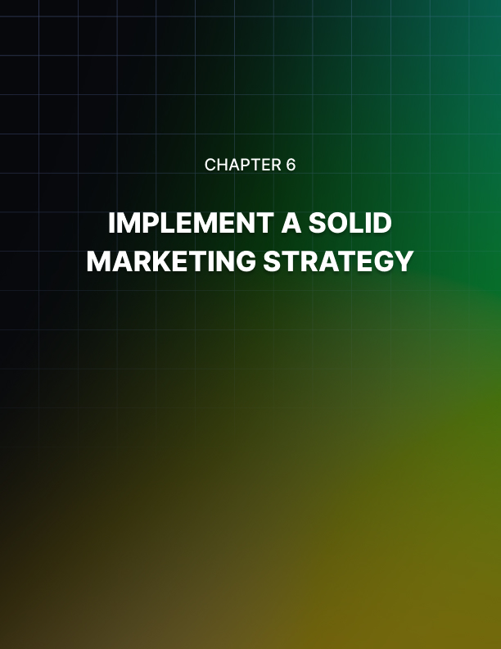

Chapter 6: Implement A Solid Marketing Strategy

If you’re shy and timid and you’re scared at the thought of talking to random people and businesses, then you’re in for a shock. Your side hustle is never going to take off if you don’t go out there and let people know you’re open for business.

So, before you even think about which marketing strategy to employ, you need to figure out how you can toughen up ASAP. You need to build the confidence so you can market and ‘sell’ yourself to potential clients.

Put yourself in the shoes of your prospects: would you want to do business with someone who exudes confidence or someone who doesn’t? I’m sure you’ll choose the former.

Once you’ve built your confidence in your skills and believe you can deliver what your side hustle promises to deliver, then it’s time to market yourself to your audience.

Now, the kicker is that there are many different types of marketing techniques you can use. Look around you, how are your competitors marketing their brand? Is it working for them? Should you do the same or should you look for another strategy, so you can tap into a different and less saturated market?

What you ultimately decide on will depend on your industry. But, for starters, let me give you an idea of the most common marketing strategies that can work for many side hustles:

- Word of mouth marketing
Word of mouth is probably the simplest form of marketing there is, yet it’s also one of the most effective. How many times have you bought a product or subscribed to a service your family and friends have recommended? Or, how often do you ask them for recommendations?

The reason why word of mouth works so well is that we tend to trust the judgment of people we personally know. So, when they say you should check out this new business on 8th Street, then you’ll go check it out as soon as you get some free time.

For your side hustle, it’s important you use your existing network of friends. Ask them to help you get the word out about your service. If anyone asks them why they should do business with you, they can easily vouch for your skills, your talent or your integrity.

Once you start getting some clients, make sure you go above and beyond what’s expected of you. Give them a lot of value and make sure they have a very positive experience. If you do this, you won’t even need to ask your clients to help spread the word about you, they’ll be happy to do it of their own accord!

- Door to door marketing
This kind of marketing strategy will only work well for side hustles that target the local population. If you’ve got an online side hustle, then this may not be the right marketing tactic for you.

For this marketing strategy to succeed, you need to make a personal connection with the people you’re going to be talking to. You’re going to be knocking on their doors and talking to them personally, so talk to them like people. Don’t be pushy and aggressive because you’re just going to get the door slammed in your face, or worse, have security called on you!

For door to door marketing to succeed, you need to think outside the box. Don’t just knock on people’s doors, give your card, and leave abruptly. Instead, what you should do is introduce yourself and tell them you’ve started a new business. Say something like, “If you need my help, here’s my card. Please don’t hesitate to reach out.”

For instance, if your side hustle is painting people’s walls, then you may want to say something along the lines of “When your paint starts to fade, just give me a call and I’ll be happy to offer my introductory price even if you call me a few years from now.”

See, you’re not pushing them to use your service right away. You’re just sharing what it is you do and how you can help them. That’s all there is to it really.

- Social media marketing
Everyone’s on social media nowadays. Whether you’ve got an online or offline side hustle, you can benefit from the power of social media marketing.

First, you simply need to know where your target clients are hanging out.
Are they on Facebook, LinkedIn, Instagram, Twitter, or some other social networking site?

Then build a strong profile and make sure it matches your branding. Post content that shows your expertise. Don’t post anything silly that will make you look thoroughly unprofessional.

Start reaching out to your target clients. Follow them and/or write thoughtful comments on their posts. You can also send them private messages, but don’t be aggressive and pushy. You want to gain their trust so they’ll do business with you, you don’t want to scare them off. If you send them a private message, make sure it’s going to be worth their while.

Social media marketing has the power to grow your side business exponentially. But be very careful in how you go about doing it. If you annoy too many people, you can quickly lose your reputation, and you may need to start again from scratch!


Chapter 7: Set Realistic Goals And Timelines With Your Hustle

At this point, your side hustle is exactly what the label says, you work on it on the side, meaning it’s not your full-time job or your day job. You’re basically working on your hustle on days when you don’t have regular work or even before/after you go to work. Obviously, your schedule will depend on you and how busy you are at the office.

When you’re just starting out at your side hustle, you need to be realistic with your goals. Sure, you may think your hustle’s got real potential, and you think you can make it grow to earn 10x your salary or something like that.

But, really, do you think you have that much time to devote to your business? Think about it thoroughly, or else you’d end up disappointing yourself big time.

Goal setting
You can aim for ambitious and lofty goals. You can also aim for extremely easy goals. Or you can aim for the middle-of-the-road goals, not too hard and not too easy, just right.

When you aim for ambitious goals, you may end up stressing yourself to death. You’ll take on more work than you can handle, you’ll start missing deadlines, you’ll have clients complaining of poor quality work, etc. You don’t want that. When you pressure yourself to achieve something you simply cannot physically do, then you’re literally killing yourself.

At the opposite end of the spectrum, if you aim for goals that are way too easy for you, then you may end up procrastinating. You’ll think, “I can do that project in one day. I’ll do it tomorrow. I’ll just go play on my computer today.” So, you end up not doing anything, and waste a lot of time in the process.

The right goals would be something that will push you or challenge you to use your time wisely. You’re not going to procrastinate, and at the same time, you’re not going to drive yourself up the wall. This way, you’re highly productive, and you ultimately bring yourself closer to your goals.

Your goal timelines
There are 3 different timelines for goals. When it comes to your side hustles, you can set short-term goals, long-term goals or life goals.

For short-term goals, think of what you want to happen to your side hustle over the next few weeks or months. Ask yourself how much you want to earn in the next month or so, and how you plan to achieve that goal. Having a daily, weekly and monthly to-do list or checklist would be beneficial as well. It will help keep you on track and make sure you stick to what you’ve planned.

For your long-term goals, think of where you want your side hustle to be in say, 1 to 5 years. Do you think you’ll still be working solo? Or do you think your little business will have grown by then and you’ve got a team to help you out? Or do you think you’ll still be employed at your day job?

For your life goals, obviously, this is THE goal. What do you want to achieve with your side hustle? Where do you eventually see yourself several years from now? You’d probably be the CEO of your own company, the one that started from your side hustle. Or maybe your goal is to see your local enterprise become a global one. Whatever your life goal may be, make sure your short-term and long-term goals align with it.

Constantly re-evaluate your goals
Your goals aren’t set in stone. Over time, you may realize that some of your goals may not be feasible. So, you need to adapt and adjust as necessary.

There’s no need to fret if you don’t achieve your goals as planned.

Simply re-evaluate your goals and try to come up with something more achievable.

For example, if you find that one of your goals was too difficult or too complicated to achieve within the timeframe you chose, then perhaps you may want to adjust the timeframe or scrap that goal altogether.

No one’s going to tell you off. If you need to change your goals, then so be it. You’re probably just a one-person show at this point in your side hustle journey. There’s no need to be so hard on yourself.

Enjoying the process and the journey is important. You have a big goal you want to achieve someday. You’re not going to be able to do that if you criticize yourself every time you make a wrong move. Learn from your mistakes and your failures. It’s the only way you’re going to grow as a hustler, as an entrepreneur, and as a person.
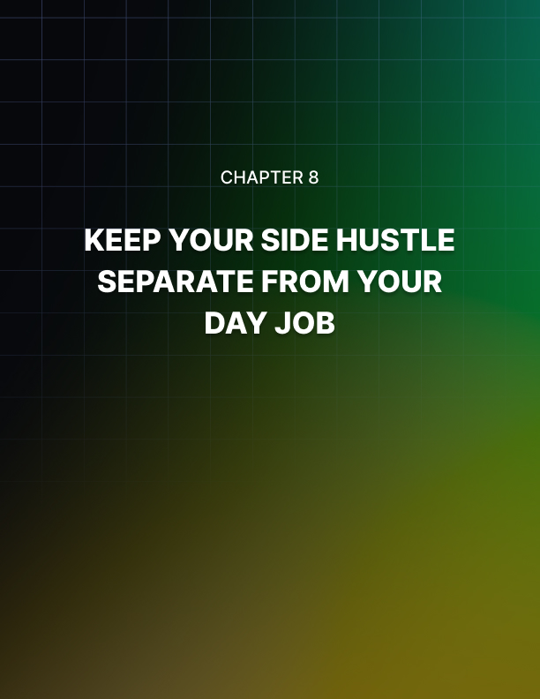

Chapter 8: Keep Your Side Hustle Separate From Your Day Job

If you value your day job, then you wouldn’t want to lose it, especially not when your side hustle has barely even started. Even when your side hustle reaches the point where you’re making more money than at your day job, you may still want to keep your job.

If you work at a job you really like and enjoy and you find it very fulfilling, then, by all means, stay in it. Some jobs are worth staying for even if it doesn’t pay nearly as well as your side hustle. If this sounds like you, then good for you. Not everyone is as lucky as you.

So, here are some tips to help keep your side hustle separate from your day job:

Don’t cheat at your job
One of the biggest no-no’s of having a side hustle is working on it while you’re on paid company time. Even if you’ve got the most boring job in the world, if your time is paid for by someone else, then you shouldn’t be disrespecting them by working on your side hustle secretly. If you get caught, you could lose your job.

Likewise, if your side hustle is also somewhat related to the things you do at work, then you should take measures not to get tempted to offer your services to your work clients. That’s called poaching. Your employer can sue you for breach of contract, and that’s something you should want to avoid at all cost.

You need to respect boundaries between work and your hustle. For as long as you’re employed, then you need to play by your employer’s rules.

Manage your time well
Time management is very important when it comes to side hustling.
Since you’ve only got a limited amount of time each day, and you need to divide that with work and other personal commitments, then make sure that every single minute you allot to your side hustle is actually spent working on it!

But doing this can be very hard, especially if your side hustle is at home.
There’re just far too many distractions – you’ve got TV, Netflix, kids, pets, etc. It’s so hard to say “no” to friends inviting you to go for a night out during weekends. But you need to build up the courage to say “no.” You may sound like a killjoy, but really, it’s all for the best.

You have to minimize random ‘play’ times as that can seriously disrupt your concentration and will literally ruin your plans. Plan your to-do list and your schedule in advance and make sure you stick to it.

Having a routine is key to side hustle success. If you have random things disrupting your schedule all the time, you’ll find it hard to find a rhythm so you can work in peace.

For side hustles that require creativity and concentration, you often need to get into a ‘zone’ before you can do anything. If you let yourself be distracted by the tiniest things, then you’re really not going to accomplish much.

Set boundaries
You need to set physical boundaries when you work on your side hustle. For instance, if you write or create designs, you probably need some peace and quiet so you can get your creative juices flowing.

If you don’t live alone, then you need to find some space all to yourself. If you’ve got a spare bedroom (or any other room for that matter), then use that as your office.

Tell the people you live with that when you’re in your special room, a.k.a. your office, you’re not to be disturbed unless there’s an emergency. You can put up a sign on the door handle that says something to that effect to deter anyone from inadvertently disturbing you.

When it comes to clients, you also need to set boundaries. Depending on your side hustle, it might be important to mention that you do have a full- time job, so they don’t call you anytime they feel like it.

Some clients may panic when they don’t hear from you within the hour, so they call you up. It’s better to be upfront about your schedule than have them think you’re at their beck and call.

If they really, really need something done urgently, like it’s a matter of life or death, then you may need to make an exception (just make sure it’s actually an emergency). You can perhaps take an early lunch break at work to go do the urgent task from your side hustle client.

Just remember not to be a pushover because it can be really easy for people to take you for granted. Stand your ground and follow the rules you’ve set. Your boundaries can literally save your sanity!
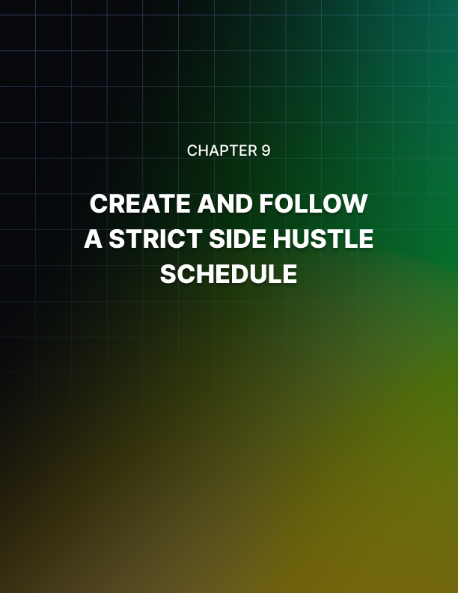

Chapter 9: Create And Follow A Strict Side Hustle Schedule

How many free hours do you have on a workday? And how many free hours do you have on your days off? How many hours do you need for your personal routines? For sleep? For family time?

There are plenty of reasons why you need to create and follow a strict side hustle schedule. For one, you’ve only got 24 hours in a day. That’s fixed, non-negotiable. Whether you like it or not, you’ve got to squeeze in your day job, your side hustle, and everything else within this timeframe.

If you don’t want to die young, then you need to take measures not to stress yourself to death. You need to spend time taking care of your body. You need to assess your physical, mental and emotional health from time to time. The reason for this is because if you get sick, then you don’t get to work, it’s as simple as that.

Plan your day
Planning your schedule every single day will help ensure you avoid taking on more than you can realistically handle. You can only do so much in one day.

For example, if you’ve got a blog as a side hustle, then plan out how many words you should be writing each day. If that doesn’t work for you, then think about how many posts you can realistically write and upload in a week.

Remember that consistency is key to succeed in almost anything in life, and it’s especially important for side hustles! Because you’re your own boss, you need to structure your day so you don’t go about procrastinating and doing things you really shouldn’t be doing!

Maximize your time
Strictly following your schedule will help maximize your time. You do want your side hustle to be profitable, right? So, figure out a way to do tasks that will help maximize your time and your profitability. Have a system in place or a process that will help you get from landing a client to submitting their deliverables in the most efficient way possible.

You may start out with a prototype of your system (let’s call it system A), but somewhere along the way, you’ll find it’s not nearly as effective as system B. If this happens, then you need to adjust. You need to do whatever it takes to be as efficient as possible.

You can’t just say you’ll stick with system A because that’s what you thought of first, or that’s what’s written on your whiteboard or wherever. Don’t be afraid to change plans, you’ve got to do what it takes to maximize your time!

Focus on one thing at a time
Multitasking is a valuable skill, but in many cases, it can slow you down. It’s so easy to lose focus when you multitask. It’s easy to get overwhelmed by the different things you need to do.

For example, if you’re doing some client work, watching TV and checking out social media at the same time, you’re probably not going to get much work done. When it’s time to work on your side hustle, turn off the distractions.

Put your phone on silent mode if it’s not going to be used in your side work. Turn off the TV. Take the necessary steps to make sure you give your full attention to what you’re working on.

Trust me, you’re going to get so many things done when you’ve removed the distractions (they’re called distractions for a reason!). You might even be able to finish your tasks ahead of your schedule. When you do this, then you can reward yourself by watching some TV until it’s time for you to work on the next task on your to-do list.

Don’t forget to reward yourself
It’s an incredibly satisfying feeling when you cross off things on your to- do list. When you’re on a schedule, it’s sometimes hard to think about rewarding yourself when your scheduled downtime is 5 days away. Now, the thing is, you don’t need to splurge, but don’t shy away from treating yourself either.

For instance, if you managed to do everything on your to-do list for today, then you can reward yourself with an extra hour in front of the TV. Or perhaps you have your favorite Chinese food delivered so you can make TV time even more enjoyable. If you finish your to-do list for the week, then reward yourself with a movie ticket to watch the latest blockbuster movie.

Strictly following a schedule – and for a side hustle at that – requires commitment and discipline. If you succeed, then you certainly deserve whatever reward you’ve got planned!
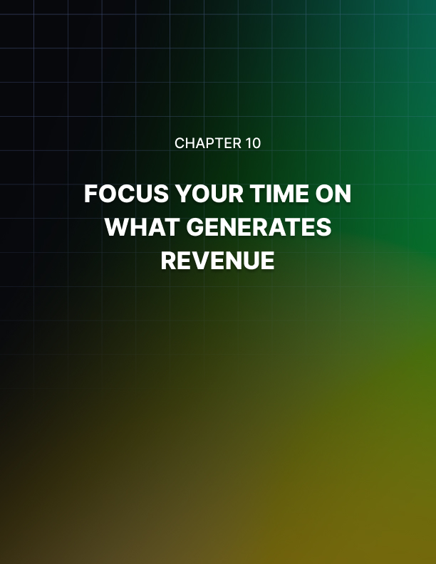

Chapter 10: Focus Your Time On What Generates Revenue

As much as possible, you want to generate some revenue every time you work on your side hustle. So, you’ve got to figure out how you can streamline your processes and your systems to come up with the most profitable ‘formula.’

As you already know, not all side hustles are created equal. Some side hustles are straightforward, while some are a bit more complicated and require thorough planning. If you’re engaged in a ‘simpler’ side hustle, then generating revenue is as simple as offering your service to your neighbors.

Now, when it comes to generating revenues for more complex side hustles, then you would want to focus your time on activities that actually will make you money.

Here are some ideas:

Focus on your target audience
Before you started your side hustle, you should already have had at least an idea of who your ideal clients and customers are.

Say, for instance, you want to tutor kids. Before you go around promoting your business, you should already know what kind of subjects you’re going to tutor, what grade levels you’re going to handle, etc.

If you’re babysitting, then you may want to only care for kids at certain ages. If you’re not comfortable being left alone with a baby or a toddler, then that’s fine. You can just choose to babysit kids 4 years old and above.

In many cases, creating a buyer persona of your target audience is helpful. It’s easier for you to create offers that they’ll find interesting.

For instance, if you have a dropshipping business on the side, you’d probably be advertising your business on various social media channels (you need to spend both time and money to do this). If you’re going after the wrong people, then you’re not going to get much in the way of sales. However, if you focus your attention (and your ads) on people who will actually benefit from buying your products, then you may make a lot of money!

So, that’s what you want to happen. You want to maximize your return on investment. And the best way to do that is by putting your brand and your offer in front of the right audience. If you don’t, then your money’s literally going to go down the drain.

Focus on generating and nurturing leads
The importance of lead generation can’t ever be understated. Without a pipeline full of leads, you’ll be struggling to stay afloat. Without good leads, how are you going to generate revenue for your side hustle?

A sound marketing strategy will help you fill up your pipeline with quality leads. But you can’t just leave it at that. Instead, you have to nurture your leads, so they eventually become paying clients.

With lead generation, you can either do it manually or you can automate the entire process. For manual lead generation, you can ask for referrals from your existing network, like your friends and even your clients. You can try offering discounts to anyone who sends some new customers your way.

For automated lead generation, this is mostly used by online businesses. You can set up a landing page with a very enticing offer. When people download or check out your offer, they enter their contact details on the page. All you have to do then is to contact them and then do your best to convert them into paying clients.

Focus on customer service
Some people underestimate customer service. They think there’s no money to be had in providing good customer service. But, of course, this is not only true, but it can kill your side hustle entirely!

Unsatisfied clients can easily go online and post about their bad experience with your business. Word can quickly spread about you. People who haven’t heard of you will Google you. When they read your negative reviews, they’re going to go elsewhere. They’re not going to risk their money on you.

However, if you treat your customers right, if you deliver your promise, then they’ll be happy campers. They’ll be loyal to your brand, they’ll be repeat customers, and best of all, they’ll tell their friends all about you. As you know, word of mouth is one of the most effective forms of marketing. Pretty soon, you’ll have more leads in your sales pipeline than you know what to do with!
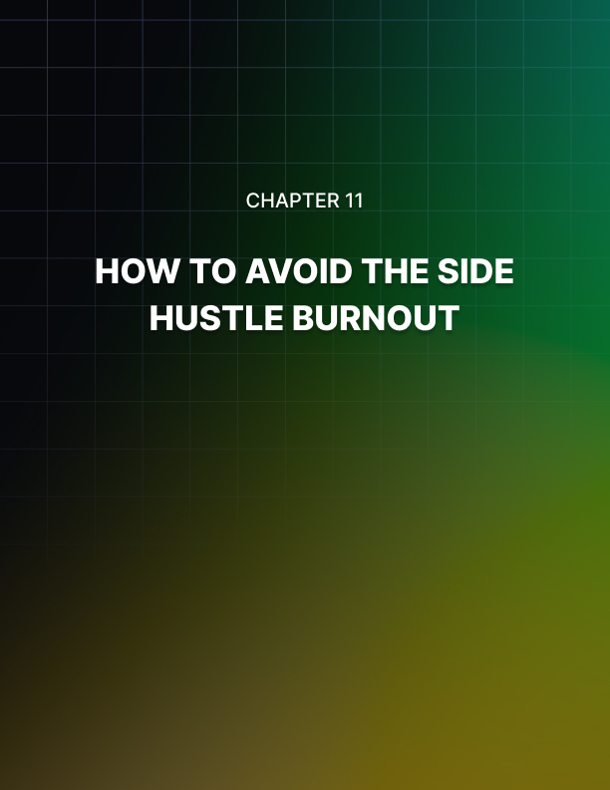

Chapter 11: How To Avoid The Side Hustle Burnout

Working full-time can be hard and stressful enough. Working on a side hustle can take your stress levels to the next level. No matter how passionate you are about your side hustle, even if it’s your favorite thing to do in the world, there will come a time when you’ll start feeling burnt out.

So, how can you avoid the side hustle burnout? Here are a few ideas:

Delegate or outsource
You don’t have to be a one-person business forever. Sure, being hands- on with your business is great, but you’ve only got one body. And that body still has a full-time job to attend to.

When you start feeling the heat, and you feel like the walls are closing in around you, then perhaps it’s high time you delegate or outsource some of the less important tasks in your side hustle.

Of course, finding someone to help you out will mean investing both time and money on them. You’ll spend time training them and getting them up to speed on your needs, and you’ll be paying them for their time.

The question would be, should you give all your trade secrets away? Do you tell them everything about your business, the ins and outs? You probably can if you trust your contractor or employee enough, but for the most part, it’s probably better not to.

Stop comparing yourself to others
No matter how hard you try, someone else will always be more successful, more attractive, more talented, more popular, etc. than you. If you’re using your side hustle as a means to compete with someone else, then you’re never going to win.

For instance, let’s say you have a childhood friend who somehow managed to rise through the ranks and now owns a million-dollar home and drives nice cars. You want to be successful like your friend.

So, you start a side hustle where you hope to eventually become a millionaire. You do everything you can to succeed. But 5 years later, you’re nowhere near your friend’s socioeconomic class. Maybe you now drive a nice car, but you still live in the same house. You’ve done everything and you’re still a few million dollars poorer than your friend. You become disillusioned, you become depressed, and eventually, you give up.

Instead of being jealous at your friend’s success, how about you focus on how far you’ve come? For example, let’s say that in the 5 years you’ve worked on your side hustle, your income has more than doubled or tripled, your quality of life has improved, and you’re now in a position to leave your day job for good.

This is why you need to be mindful and thankful of what you do have.

Comparing yourself to others is one quick way to burn yourself out, so don’t do it. Learn to appreciate yourself and your accomplishments, no matter how small they may seem to you right now.

Set reasonable deadlines
One of the quickest ways to side with hustle burnout is to set unreasonable deadlines for yourself. With your side hustle, you’re your own boss. You need to work hard, but you also need to work smart if you want your side hustle to last more than a week.

Don’t take more work than you can afford to handle. Or else you’ll be forced to say “yes” to deadlines that are literally going to drive you crazy. You may need the money, but it doesn’t mean you’re going to kill yourself for it.

If you’ve got a couple of clients offering you a lot of money in exchange for doing some urgent work over the weekend, then you may need to turn down either one of them, or perhaps even both of them!

You can try to negotiate the deadline, and maybe one of them will agree to move their deadline to a later date. There’s no harm in trying, right?

However, if you really need to, then don’t be afraid to just say “no.”

Take breaks and vacations
Can you imagine how tired you must feel if you worked for 12 months straight without taking a single day off? Sure, you may get a day or couple days off at your day job, but technically you’re still working on your side hustle. So, you’re not really “off,” you’re just doing something else. Still busy, still hustling.

When you’re just starting your side hustle, there may be stretches where you’ll work for weeks at a time without taking a break. But as soon as you’re able to, as soon as you finish your first project, you should reward yourself by taking a short break.

You don’t need to buy a plane ticket to some exotic location abroad (though you could if you really wanted to). You can just chill at your house for an entire day without checking your emails or thinking about your day job or your side hustle. Just enjoy your “me time.”

Every time you achieve a major milestone, treat yourself to something nice. Get a body massage or buy yourself that nice bag or jacket you’ve been thinking of buying for months now!

Variety is the spice of life
If you become stuck doing the same things over and over again, you’re going to get bored eventually. If you want to find out how you can regain your excitement for both your day job and your side hustle, then you need to do something different.

You can’t probably do much about your job, but as for your side hustle, maybe instead of designing some graphics this week, you may want to do a different side job instead.

How about you try dog walking or babysitting? Or maybe go drive an Uber for a few hours? Do something you don’t normally do, something that will bring you loads of fun!

You don’t even need to switch up your side hustle. You can go hike up in the mountains or drive to the beach or go clubbing at night. This just may give you the boost you need to amp up your motivation at work and at your side hustle!
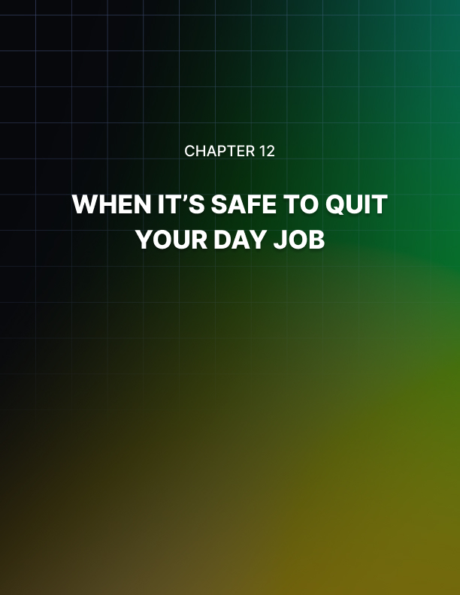

Chapter 12: When It’s Safe To Quit Your Day Job

So, your side hustle is finally starting to take off and your future has never looked so bright. You’re excited at the prospect of working full-time on what was once your little side project. You probably feel the way Bill Gates and Steve Jobs did when they were finally ready to move out of their garages to launch their brilliant products to the world!

But how do you know when it’s safe to quit your day job? Do you just make that decision when you feel like it? Or just because you say so? Well, the truth is, you can quit anytime you like. But don’t blame anybody else if your side hustle crashes and burns to the ground.

So, here are a few telltale signs you’re finally ready to quit your day
job and pursue your side hustle full-time:

You make way more money at your side hustle
This is actually a good tipping point for most side hustlers. The moment their side hustle brings in more money than their day jobs, they just up and quit. But is it really a smart decision?

The answer is “yes” and “no.” “Yes,” if the side income is stable enough, that is, your hustle has been consistently generating more money than your main job for several months now. “No,” if it’s not stable enough, that is, your side income ebbs and flows, and there’s no guarantee that the next several months’ earnings are going to be good enough.

But, what exactly does “way more money” mean exactly? Well, that really depends on you and your living expenses. Some people may be happy with a side income 2x their salary, while some will only be happy if it’s 5x or 10x their salaries. Figure out your tipping point and use it as a benchmark to figure out if you’re ready to take the leap.

You’ve saved up enough money if your side gig doesn’t work out
Just in case your side hustle doesn’t work out, what are you going to do for money? How are you going to be able to sustain your lifestyle if you lose both your salary and your side income?

Having an emergency fund is of utmost importance. Many financial experts recommend having at least 6 months of your monthly income in a savings account. It has to be liquid, so when an emergency strikes, you can easily get the money out.

You can’t invest it into financial instruments like stocks where the risk is far too high. Sure, if you’re lucky enough and you “time” the market perfectly, you could end up with a reasonably significant amount. However, the opposite could also be true. You can just as quickly lose a huge amount of your hard-earned cash in the blink of an eye!

So, it’s best to play on the side of caution and just leave your emergency fund in a high-interest savings account, so inflation doesn’t ‘eat’ it too much. If your side hustle doesn’t pan out, you’ll have something to fall back on while you attempt to get back on your feet.

You’re ready to scale your side hustle
You’ve got the data and the bank account to prove your side hustle is ready to move forward and upward. You’re ready to take it to the next level. But you can’t do that if you’re still tied to your day job. And you know that the longer you stay at your job, the longer you’re delaying your success. So, you do the only rational thing left to do – you quit your job.

Of course, before you do that, you should assess and make sure you’re not looking at your side hustle through rose-colored glasses. Get someone else’s opinion, someone who can look at things from a neutral angle.

Maybe someone who’s been there in your position, a mentor perhaps. They can give you some valuable advice on whether or not your business is ready for the limelight, and if it’s not, what you can do to make it ready.

You’re committed to seeing your side hustle succeed
Sometimes, you just know deep in your heart that you’re doing the right thing. When you’re really passionate about your side hustle, and it’s what you’ve always wanted to do, then quitting your day job is probably a good idea.

Spend some time going over the pros and cons of leaving your job and focusing on your side business. If you think the pros more than outweigh the cons, then, by all means, go for it. There’s no one stopping you from taking the bulls by the horn. Just make sure you have a backup plan, a Plan B, in case things don’t go as planned.

You’re missing out on opportunities
You’ve probably got so many leads and prospects, and the only thing stopping you from taking them all as clients is because you don’t have the time. If each client you sign on pays you a few hundred or a few thousand dollars each month, that’s a significant chunk of money you’re missing out on.

At some point, you’re going to have to ask yourself if staying at your job is still worth it. For some, they’re not in it for the money, and so they stick to their day jobs even though they’ve got a bustling and highly profitable side hustle.

For others who are motivated by money, then it’s a no-brainer really. If you’re earning $100/hour at your side hustle as compared to a measly $10/hour at your day job, then you’re literally leaving a lot of money on the table. When the math adds up like this, then you can safely say you’re ready to quit your job for good.

With that said, there's no reason why anyone would shy away from starting a side hustle. After all, millions of people have thriving side businesses in addition to their day jobs. With the right mindset and the right goals, you too can have a profitable side hustle that has the potential to out-earn your salary!

