Table of Contents
Introduction 5
The ABCs of Financial Budgeting 8
Essential Financial Terminology 8
Types of Budgets 9
Aligning Your Budget with Business Objectives 10
Advanced Budgeting Techniques 12
Crafting the Perfect Budget 15
Step 1: Gather Your Financial Data 16
Step 2: Determine Your Budget Period 16
Step 3: Project Your Revenue 16
Step 4: List All Income Sources 16
Step 5: Categorize Your Expenses 17
Step 6: Estimate Your Expenses 17
Step 7: Calculate Your Profit Margin 17
Step 8: Create Your Cash Flow Forecast 18
Step 9: Review and Adjust 18
Step 10: Implement Budget Control Measures 18
Step 11: Plan for Contingencies 19
Step 12: Seek Professional Advice 19
Advanced Cost Control Techniques 23
Negotiating with Suppliers 23
Lean Management Principles 23
Cost-Benefit Analysis 24
Break-Even Analysis 25
Innovative Cost Control Strategies 26
Mastering Revenue Forecasting 29
Qualitative vs. Quantitative Forecasting Methods 29
Practical Application of Forecasting Methods 30
Enhancing Forecast Accuracy 31
Utilizing Financial Tools and Software 34
The Evolution of Financial Software 34
Advanced Accounting Software 34
Integrating Financial Tools 35
Best Practices for Financial Tool Implementation 37

Disclaimer
The information provided in this ebook is intended solely for educational and informational purposes. The author does not accept any responsibility for the outcomes that may arise from the application of the material within. While efforts have been made to ensure the accuracy and relevance of the content, the author cannot be held accountable for any errors or omissions, or for any consequences resulting from the use or misuse of the information provided. The responsibility for any actions taken based on the information in this ebook lies solely with the reader.



Introduction
As a small business owner, you’re juggling countless responsibilities, and sometimes, the numbers can feel overwhelming. Mastering your finances could be the key to unlocking the growth you’ve been searching for.
Waking up each morning with a clear picture of your business’s financial health and making informed decisions that drive growth is within your reach. Effortlessly forecasting revenue, controlling costs, and building a robust financial foundation that withstands market fluctuations is not just a dream—it’s achievable.
This isn’t just another dry finance book destined to gather dust on your shelf. It’s your personal guide to financial empowerment, tailored specifically for the unique challenges and opportunities that small business owners face. From the moment you crack open this book, you’ll begin a transformative journey that will revolutionize the way you approach your business finances.
Did you know that according to a 2024 study by the Small Business Administration, 82% of small businesses that fail cite poor financial management as a primary factor? This sobering statistic underscores a critical truth: in today’s competitive landscape, financial acumen isn’t just an asset—it’s a necessity. But here’s the good news: you don’t need an MBA or years of accounting experience to take control of your business finances. All you need is the right guidance, and that’s exactly what this book provides.
As you dive into these pages, you’ll discover practical, actionable advice that cuts through the financial jargon and gets straight to the heart of what matters for your business. We’ll start by demystifying the ABCs of financial budgeting, breaking down complex concepts into bite-sized, easily digestible pieces. You’ll learn how to craft the perfect budget, step-by-step, ensuring that every dollar works as hard as you do.
But we won’t stop there. This book goes beyond the basics, equipping you with advanced cost control techniques that will streamline your operations and boost your bottom line. You’ll master the art of revenue forecasting, gaining the ability to anticipate market trends and position your business for success. In this age of digital innovation, we’ll show you how to leverage cutting-edge financial tools and software to automate tedious tasks and gain unprecedented insights into your business’s financial health.
It's an invitation to own your power as a business owner. Take control of your financial future. By the end, you'll have all the tools to build a lasting financial legacy for your business.
So, are you ready to unlock your business’s full potential? Are you prepared to transform financial uncertainty into rock-solid confidence? If so, then you’re in the right place. This book isn't just about crunching numbers. It's about empowering you to achieve your dreams, one budget line at a time.



The ABCs of Financial Budgeting
Financial budgeting forms the backbone of any successful small business. As you navigate the complexities of entrepreneurship, you’ll quickly realize that a well-crafted budget is your compass, guiding you through both calm seas and stormy waters. This chapter will equip you with the essential knowledge and tools to create a robust financial foundation for your business.
A budget is your financial roadmap, providing clarity on where your money is coming from and where it’s going. With this insight, you can make informed decisions, allocate resources effectively, and steer your business towards profitability and growth. Budgeting isn’t just about restricting spending; it’s about empowering you to invest strategically in your business’s future. A well-planned budget allows you to set clear financial goals and track progress, identify potential cash flow issues before they become critical, make data-driven decisions about expansion, hiring, or new product lines, secure funding from investors or lenders by demonstrating financial acumen, and prepare for unexpected expenses or economic downturns.

Essential Financial Terminology
Before delving deeper into budgeting strategies, let’s break down some essential financial terminology you’ll encounter in your budgeting journey. Revenue is the total amount of money your business earns from sales of goods or services before any expenses are deducted. Expenses are the costs associated with running your business, which can be further categorized into fixed expenses (costs that remain constant regardless of your business’s performance, such as rent and salaries) and variable expenses (costs that fluctuate based on your business activity, like raw materials and shipping costs). Profit is the amount left over after subtracting all expenses from your revenue. Cash flow refers to the movement of money in and out of your business over a specific period.Assets are resources owned by your business that have economic value, such as inventory, equipment, and cash. Liabilities are debts or financial obligations your business owes to others.

Types of Budgets
With these terms in mind, let’s explore the different types of budgets you might use in your small business. The operating budget is your day-to-day budget, encompassing expected revenues and expenses for a specific period, typically a year. A cash flow budget focuses on the timing of cash inflows and outflows, helping you ensure you have enough liquidity to meet your obligations. The capital budget is used for planning large, long-term investments in assets like equipment or property. A project budget is a specialized budget for specific initiatives or projects within your business. Lastly, a flexible budget adjusts based on changes in activity levels, allowing for more accurate performance evaluation.
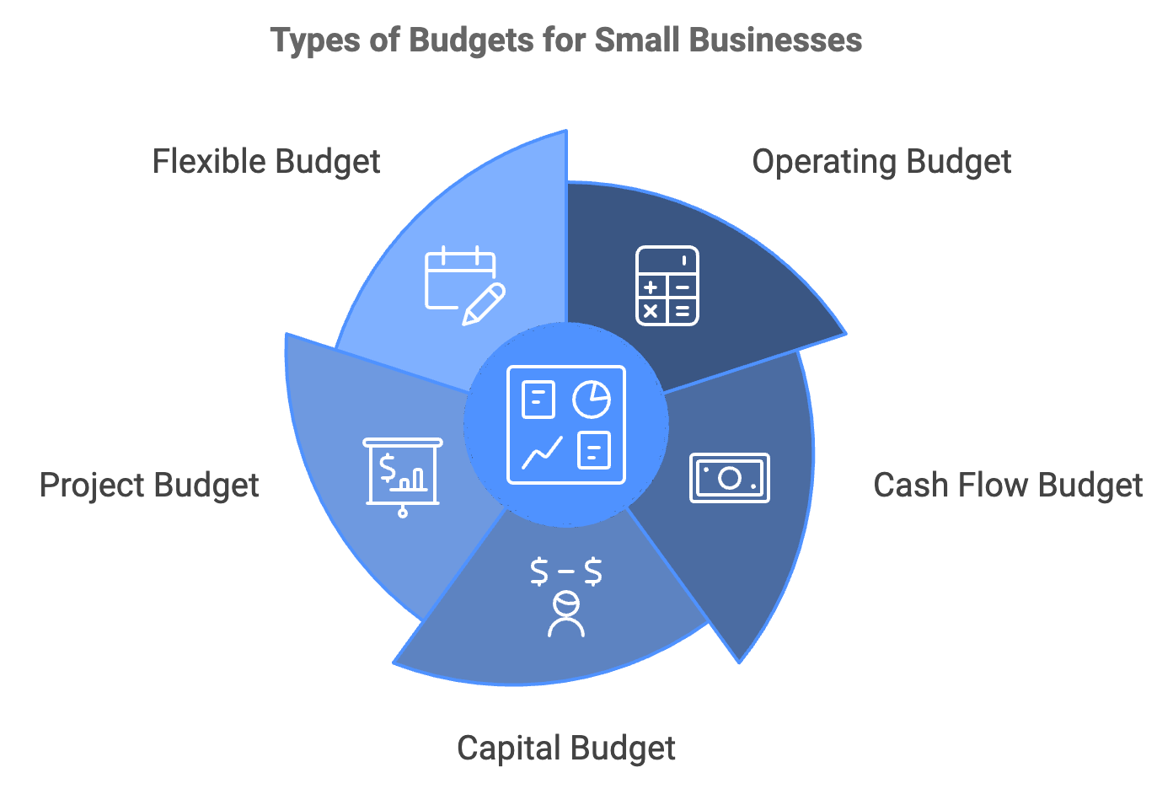
Choosing the right type of budget depends on your business’s specific needs and goals, and many small business owners find that a combination of these budgets provides the most comprehensive financial overview.

Aligning Your Budget with Business Objectives
Aligning your budgeting efforts with your broader business objectives is crucial for ensuring that your financial planning supports your company’s growth and success. Start by clearly defining your business goals, which might include increasing revenue by a certain percentage, expanding into new markets, launching new products or services, improving profit margins, or reducing debt. Once you’ve identified your goals, you can structure your budget to support these objectives. For example, if your goal is to launch a new product line, your budget should allocate funds for research and development, marketing, and potentially new equipment or staff.

Business Goal | Budget Alignment
Increase revenue by 20% | - Allocate 15% more to marketing budget  - Invest in sales training  - Set aside funds for market research  - Plan for increased inventory
Launch new product line | - Allocate funds for R&D  - Increase marketing budget  - Plan for new equipment or staff  - Budget for initial production costs
Expand into new market | - Allocate funds for market research  - Budget for legal and regulatory costs  - Plan for new distribution channels  - Increase marketing budget for new region

Setting clear, actionable financial objectives within your budget is essential. The SMART criteria (Specific, Measurable, Achievable, Relevant, Time-bound) provide an excellent framework for this. For instance, instead of a vague goal like “increase profits,” aim for “increase net profit by 10% within the next fiscal year.” This approach ensures your objectives are well-defined and trackable.
As you create your budget, it’s essential to consider both internal and external factors that might impact your financial planning. Internal factors include your business’s operational efficiency, staff productivity, and current resources. External factors encompass market trends, economic conditions, and competitive landscape. For instance, if market research indicates a potential economic downturn in your industry, you might want to create a more conservative budget with higher cash reserves. Conversely, if you’re seeing strong growth signals, your budget might reflect increased investments in expansion.
Remember, budgeting is not a one-time event but an ongoing process. Regular review and adjustment of your budget are crucial for maintaining its relevance and effectiveness. Consider implementing a monthly or quarterly budget review process to compare actual performance against budgeted figures, identify any significant variances and their causes, adjust future projections based on current trends, and reallocate resources as needed to meet changing priorities. This iterative approach ensures your budget remains a dynamic tool that evolves with your business.

Advanced Budgeting Techniques
As you become more comfortable with budgeting, you can start to leverage more advanced techniques to enhance your financial planning. One such technique is scenario planning, where you create multiple budget versions based on different potential outcomes. For example, you might create three budget scenarios: conservative (assuming slower growth or challenging market conditions), moderate (based on your most likely projections), and optimistic (reflecting potential upsides or unexpectedly favorable conditions). By preparing for various scenarios, you’ll be better equipped to adapt quickly to changing circumstances.
Another advanced technique is zero-based budgeting. In this approach, you start each budget period from scratch, justifying every expense rather than basing it on previous years. While more time-consuming, zero-based budgeting can be particularly effective for identifying unnecessary costs and optimizing resource allocation. This method forces you to critically examine each expense and its contribution to your business goals, potentially uncovering significant savings opportunities.
As you implement these budgeting practices, you’ll likely encounter some common challenges. Overestimating revenue is a frequent pitfall, especially for new businesses or those in volatile markets. To combat this, be conservative in your projections and base them on solid market research and historical data when available. Underestimating expenses is another common issue. Always factor in a contingency for unexpected costs and be thorough in identifying all potential expenses, including often-overlooked items like maintenance, software subscriptions, or professional development.
Lack of detail in your budget can limit its usefulness. The more specific your budget, the more valuable it will be as a management tool. Break down broad categories into smaller, manageable line items. For instance, instead of a general “marketing” category, break it down into subcategories like “social media advertising,” “print materials,” and “event sponsorships.” This level of detail provides greater control and insight into your spending.
Inflexibility can also hinder effective budgeting. While it’s important to stick to your budget, be prepared to make adjustments when necessary. Market conditions, unexpected opportunities, or unforeseen challenges may require you to revisit and revise your budget. Regular reviews and a willingness to adapt will help you maintain a relevant and effective budget throughout the year.
Neglecting cash flow is another critical mistake. Remember that timing is crucial in financial management. A positive bottom line doesn’t always mean you’ll have cash when you need it. Pay close attention to the timing of your income and expenses, and use cash flow forecasting to anticipate and prepare for periods when cash might be tight.
By anticipating these challenges and implementing strategies to overcome them, you can create a more robust and realistic budget that serves as a powerful tool for guiding your business towards financial success.
Mastering the ABCs of financial budgeting is a critical step in your journey as a small business owner. A well-crafted budget serves as your financial compass, guiding your decision-making and supporting your business goals. By understanding key financial terms, aligning your budget with your objectives, and setting SMART financial targets, you’re laying a solid foundation for your business’s financial health. Budgeting is an ongoing process that requires regular attention and adjustment.
As you become more proficient, you can explore advanced techniques like scenario planning and zero-based budgeting to further optimize your financial management. Your journey to financial mastery has just begun, and the skills you’re developing will serve as invaluable assets in your entrepreneurial toolkit.



Crafting the Perfect Budget
Money flows through your business like a river, nourishing growth and sustaining operations. Your budget is the dam that harnesses this flow, directing it purposefully to maximize its impact. In this chapter, you’ll learn how to construct a budget that not only controls your finances but also propels your business forward.
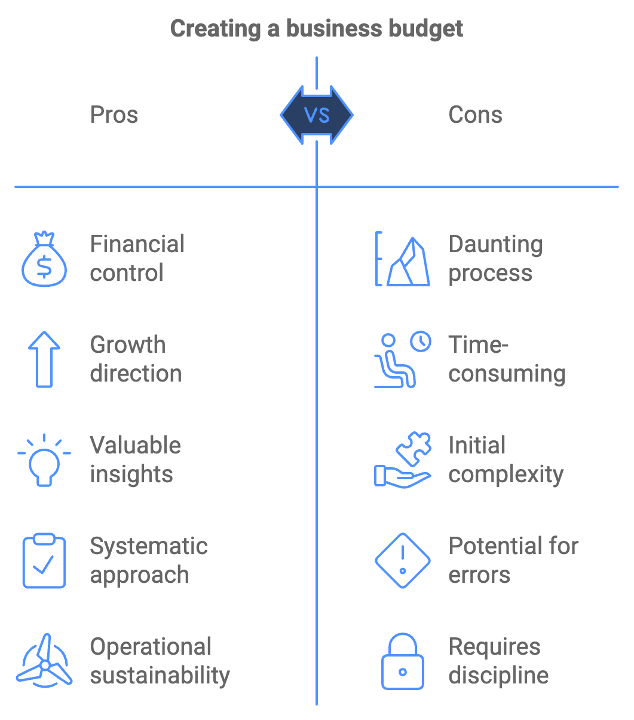
Creating a budget from scratch might seem daunting, but with a systematic approach, you’ll find it’s an enlightening process that offers invaluable insights into your business. Let’s break down this process into manageable steps, each building upon the last to create a comprehensive financial plan.

Step 1: Gather Your Financial Data
Your journey begins with collecting all relevant financial information. This includes past income statements, bank statements, tax returns, sales records, expense receipts, payroll data, and any other financial documents specific to your business. If you’re a new business owner, you’ll need to research industry standards and make educated estimates. The Small Business Administration (SBA) offers resources and benchmarks for various industries that can serve as a starting point.

Step 2: Determine Your Budget Period
Most small businesses operate on a monthly budget within an annual framework. This allows for detailed short-term planning while keeping sight of long-term goals. However, your ideal budget period may vary depending on your business cycle. Seasonal businesses, for example, might benefit from quarterly budgeting.

Step 3: Project Your Revenue
Revenue forecasting is both an art and a science. Start by analyzing your historical sales data, if available. Look for patterns and trends. Are there certain months when sales consistently peak or dip? Factor in any known changes, such as new product launches or expanded service offerings. For a more accurate projection, consider market trends, economic indicators, competitive landscape, pricing changes, and marketing efforts. Be conservative in your estimates. It’s better to exceed your projections than to fall short.

Step 4: List All Income Sources
Detail every source of income for your business. This might include product sales, service fees, rental income, interest from investments, royalties, grants or subsidies. Break these down as specifically as possible. For example, instead of just “Product Sales,” list individual product categories or even specific high-value products.

Step 5: Categorize Your Expenses
Now, it’s time to turn your attention to outgoing money. Start by categorizing your expenses into fixed and variable costs. Fixed costs remain relatively constant regardless of your business activity. These might include rent or mortgage payments, insurance premiums, salaries for permanent staff, loan repayments, and subscriptions and regular service fees. Variable costs fluctuate based on your business activity. Examples include raw materials or inventory, shipping and packaging costs, utilities, commissions, and temporary staff wages. Some expenses, known as semi-variable costs, have both fixed and variable components. For instance, your phone bill might have a fixed monthly fee plus variable charges based on usage.

Step 6: Estimate Your Expenses
For each expense category, estimate the amount you expect to spend. Use historical data as a guide, but also consider any anticipated changes. Are you planning to move to a larger office? Will you need to hire additional staff? Are raw material costs expected to rise? Don’t forget to include less frequent expenses, such as annual software license renewals or equipment maintenance. Divide these by 12 to account for them in your monthly budget.

Step 7: Calculate Your Profit Margin
Subtract your total estimated expenses from your projected revenue. This gives you your estimated profit (or loss). Calculate your profit margin by dividing your profit by your revenue and multiplying by 100. This percentage is a key indicator of your business’s financial health. If your projected profit margin is lower than you’d like, or if you’re projecting a loss, it’s time to look for areas where you can increase revenue or cut costs.

Step 8: Create Your Cash Flow Forecast
Your profit calculations assume all your revenue comes in and all your expenses go out at the same time. In reality, there’s often a lag between when you make a sale and when you receive payment, or between when you incur an expense and when you pay for it. A cash flow forecast accounts for these timing differences. It shows when you expect money to come in and go out of your business. This helps you anticipate potential cash shortages and plan accordingly.
To create a cash flow forecast, start with your opening bank balance, add your expected cash inflows (when you expect to receive payments), subtract your expected cash outflows (when you expect to pay expenses), and this gives you your closing balance for the period. Repeat this process for each month of your budget period.

Step 9: Review and Adjust
Once you’ve completed your initial budget, step back and review it critically. Does it align with your business goals? Are your projections realistic? Have you accounted for all potential expenses? Make adjustments as necessary. Remember, your budget is a tool to help you achieve your business objectives. If it doesn’t support those objectives, it needs refinement.

Step 10: Implement Budget Control Measures
A budget is only effective if you stick to it. Implement systems to track your actual income and expenses against your budgeted figures. This might involve regular financial reviews (weekly or monthly), use of accounting software to automate tracking, assigning budget responsibilities to team members, and setting up alerts for significant variances.

Step 11: Plan for Contingencies
No matter how carefully you plan, unexpected events can throw your budget off course. Build in a contingency fund to cover unforeseen expenses or revenue shortfalls. A common rule of thumb is to set aside 5-10% of your revenue for this purpose.

Step 12: Seek Professional Advice
If you’re unsure about any aspect of your budgeting process, don’t hesitate to consult with a financial advisor or accountant. Their expertise can help you create a more accurate and effective budget.
Now that we’ve outlined the steps, let’s look at some practical tips for optimizing your budget:
- Cut unnecessary expenses: Scrutinize every expense. Are there subscriptions you’re not fully utilizing? Can you negotiate better rates with suppliers? Could you reduce energy costs with more efficient equipment?
- Prioritize spending: Allocate your resources to areas that provide the most value to your business. This might mean investing more in high-performing marketing channels or in training for your staff.
- Use technology: Take advantage of budgeting tools and software. These can automate much of the tracking and reporting process, saving you time and reducing errors.
- Stay flexible: While it’s important to stick to your budget, be prepared to make adjustments as circumstances change. Regular reviews will help you stay agile.

Let’s look at a simplified example of how these steps might come together for a small retail business:

Monthly Budget for XYZ Boutique

Revenue:
Product Sales: $50,000
Online Sales: $10,000
Total Revenue: $60,000

Expenses:
Fixed Costs:
Rent: $3,000
Insurance: $500
Salaries: $15,000
Loan Repayment: $1,000

Variable Costs:
Inventory: $20,000
Utilities: $800
Marketing: $2,000
Shipping: $1,500

Total Expenses: $43,800

Projected Profit: $16,200
Profit Margin: 27%

Cash Flow Forecast:
Opening Balance: $10,000
Cash Inflows: $58,000 (assuming 90% of sales collected)
Cash Outflows: $43,800
Closing Balance: $24,200

This simplified budget provides a clear overview of the business’s financial situation. It shows that the business is profitable, with a healthy profit margin of 27%. The cash flow forecast indicates that the business should have sufficient cash to cover its expenses, with a growing bank balance.
Remember, your budget is not set in stone. It’s a living document that should evolve as your business grows and changes. Regular reviews and adjustments will ensure it remains a relevant and useful tool for guiding your business decisions. Crafting the perfect budget is an iterative process. Each cycle of creating, implementing, and reviewing your budget will provide new insights and opportunities for improvement. Over time, you’ll develop a deeper understanding of your business’s financial dynamics, enabling you to make more accurate projections and more informed decisions.
Your budget is more than just a financial document; it’s a powerful tool for achieving your business goals. By following these steps and continuously refining your approach, you’re not just creating a budget - you’re creating a roadmap for your business’s financial success.



Advanced Cost Control Techniques
In the world of small business, every dollar counts. Your ability to manage and minimize costs can mean the difference between thriving and merely surviving. This chapter will arm you with sophisticated strategies to control and reduce costs without compromising the quality of your goods or services.
Cost control is not about penny-pinching or sacrificing quality. Instead, it’s about making smart, strategic decisions that maximize the value of every dollar spent. By implementing advanced cost control techniques, you’ll be able to streamline your operations, boost your profit margins, and create a more resilient business.

Negotiating with Suppliers
Let’s start by exploring some key strategies for negotiating with suppliers. Your suppliers are essential partners in your business, and cultivating strong relationships with them can lead to significant cost savings. Consider negotiating volume discounts, early payment discounts, and long-term contracts. Don’t be afraid to shop around and solicit bids from multiple suppliers to ensure you’re getting the best possible prices. Look for suppliers who offer value-added services like free shipping, inventory management, or technical support. Work collaboratively with your suppliers to identify ways to reduce costs throughout the supply chain, such as streamlining ordering processes, optimizing packaging, or finding more efficient shipping methods.
Remember, successful negotiation is about creating win-win situations. Approach these conversations with a spirit of partnership, focusing on how both parties can benefit from the relationship.

Lean Management Principles
Now, let’s turn our attention to lean management principles. Lean management is a systematic approach to eliminating waste and maximizing efficiency in your business processes. Originally developed in the manufacturing sector, these principles can be applied to businesses of all types. Key lean management concepts include Value Stream Mapping, which involves creating a visual representation of all the steps in your business processes to identify areas of waste and inefficiency. The 5S System focuses on organizing your workspace for maximum efficiency, with the five S’s standing for Sort, Set in order, Shine, Standardize, and Sustain. Encourage a culture of continuous improvement (Kaizen) where all employees are empowered to suggest and implement small, incremental changes.
Consider implementing Just-In-Time (JIT) Inventory to minimize inventory costs by ordering materials only as they are needed in the production process. Develop and document best practices for routine tasks to ensure consistency and efficiency. When problems arise, dig deep to identify and address the root cause rather than just treating symptoms. Implementing these lean principles can lead to significant cost savings by reducing waste, improving efficiency, and minimizing errors.

Cost-Benefit Analysis
Another powerful tool in your cost control arsenal is cost-benefit analysis. This technique helps you make informed decisions by weighing the potential benefits of an action against its costs. To conduct a basic cost-benefit analysis, start by identifying all costs associated with the action, including direct costs like materials and labor, as well as indirect costs like opportunity costs. Then, identify all potential benefits, both tangible (like increased revenue or cost savings) and intangible (like improved customer satisfaction or employee morale). Assign a monetary value to each cost and benefit, even for intangible factors. Calculate the net benefit by subtracting total costs from total benefits.
Consider the time value of money by using discounted cash flow analysis if costs and benefits occur over time. Finally, conduct sensitivity analysis by varying your assumptions to see how they affect the outcome. Cost-benefit analysis can be particularly useful when deciding whether to invest in new equipment, launch a new product line, or implement a new business process.

Cost-Benefit Analysis Example
Costs | Benefits | Net Benefit
Equipment: $10,000 | Revenue: $25,000
Training: $2,000 | Cost Savings: $5,000
Maintenance: $1,000/year
Total: $13,000 + $1,000/year | Total: $30,000 | $17,000 - $1,000/year

Break-Even Analysis
Break-even analysis is another valuable technique for cost control. This analysis helps you determine the point at which your total revenue equals your total costs - in other words, the point at which you start making a profit. To conduct a break-even analysis, follow these steps:
- Identify your fixed costs (costs that don’t change with production volume, like rent or salaries)
- Identify your variable costs per unit (costs that change with production volume, like materials or direct labor)
- Determine your selling price per unit
- Calculate your contribution margin per unit by subtracting variable costs per unit from the selling price per unit
- Calculate your break-even point in units by dividing fixed costs by contribution margin per unit
- Calculate your break-even point in dollars by multiplying the break-even point in units by the selling price per unit

Understanding your break-even point can help you make informed decisions about pricing, production volume, and cost control efforts.

Innovative Cost Control Strategies
Let’s now explore some innovative cost control strategies that leverage technology and modern business practices. Consider moving your IT infrastructure to the cloud, which can significantly reduce hardware and maintenance costs while offering scalability. Identify repetitive tasks in your business that could be automated, such as inventory management, customer service chatbots, or social media scheduling. Invest in energy-efficient equipment and practices, like LED lighting, smart thermostats, or energy-efficient appliances. While there may be upfront costs, the long-term savings can be substantial. Consider allowing employees to work remotely, either full-time or part-time, to reduce office space requirements and associated costs like rent and utilities. For non-core business functions, consider outsourcing to specialized service providers, which can be more cost-effective than maintaining in-house staff.
Use data and analytics for predictive maintenance to reduce downtime and extend the life of your equipment. Implement zero-based budgeting, starting from zero each year and justifying every expense, to help eliminate unnecessary costs that have crept in over time. While implementing these strategies requires careful planning and often involves upfront investment, the long-term cost savings can be significant.
To effectively monitor and manage your cost control efforts, track key performance indicators (KPIs) such as Gross Profit Margin, Operating Expense Ratio, Cost of Customer Acquisition, Employee Productivity, Inventory Turnover, Energy Consumption, and Waste Reduction. Regularly reviewing these KPIs will help you identify areas where your cost control efforts are succeeding and where there’s room for improvement.
It’s crucial to note that cost control should not come at the expense of quality or customer satisfaction. In fact, many cost control measures can actually improve quality by reducing errors and inefficiencies. Always consider the impact on your customers and product quality when implementing cost control measures.
Employee engagement is vital for successful cost control. Your employees are on the front lines of your business and often have valuable insights into where costs can be reduced. Encourage a culture of cost-consciousness by educating employees about the financial realities of the business, soliciting ideas for cost savings and efficiency improvements, recognizing and rewarding cost-saving initiatives, and implementing a profit-sharing program to align employee incentives with business profitability.
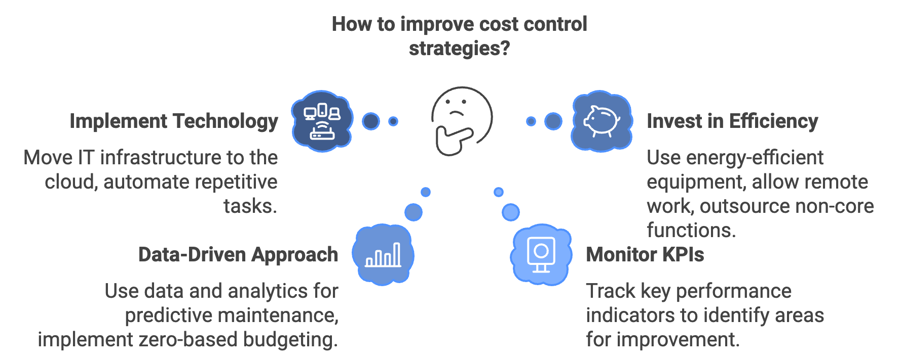
Remember, cost control is an ongoing process, not a one-time event. Markets change, technologies evolve, and new opportunities and challenges arise. Regularly reassess your cost structure and be prepared to adapt your strategies as needed.
Advanced cost control techniques can significantly improve your business’s profitability and resilience. By negotiating effectively with suppliers, implementing lean management principles, utilizing analytical tools like cost-benefit and break-even analysis, and leveraging innovative strategies, you can create a lean, efficient operation that maximizes the value of every dollar spent. With these techniques in your toolkit, you’ll be well-equipped to navigate the financial challenges of small business ownership and set your company on a path to long-term success.

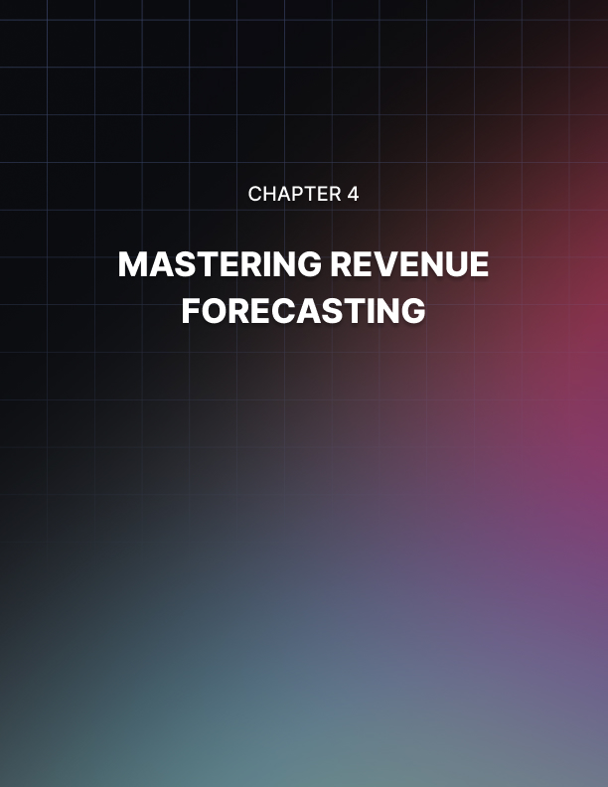

Mastering Revenue Forecasting
Revenue forecasting is a critical skill for small business owners, enabling informed decision-making and steering companies towards success. This chapter will equip you with the knowledge and tools to become a master of revenue forecasting, allowing you to anticipate cash flow issues, plan for growth, and make confident decisions about your business’s future.

Qualitative vs. Quantitative Forecasting Methods
There are two main approaches to revenue forecasting: qualitative and quantitative methods. Qualitative methods rely on expert opinions, market research, and intuition, particularly useful when historical data is limited or when entering new markets. Quantitative methods use historical data and statistical techniques to project future revenue, providing more objective and accurate forecasts when reliable historical data is available.
Qualitative forecasting methods include expert opinion, market research, the Delphi method, and scenario planning. These approaches can provide valuable insights, especially when combined with other forecasting methods. Expert opinion involves consulting with industry experts, experienced staff members, or business advisors to get their insights on future revenue trends. Market research entails conducting surveys, focus groups, or analyzing industry reports to gain insights into market trends and consumer behavior. The Delphi method gathers a panel of experts who anonymously provide their forecasts, with results compiled and shared for revision until a consensus is reached. Scenario planning involves creating multiple potential future scenarios and estimating revenue for each, helping prepare for various outcomes and develop contingency plans.
Quantitative methods often form the backbone of revenue forecasting, especially for established businesses with historical data. Key quantitative forecasting techniques include time series analysis, regression analysis, and sales pipeline analysis. Time series analysis uses historical data to identify trends, seasonal patterns, and cycles in revenue. Common time series techniques include moving average, exponential smoothing, and trend projection. Regression analysis examines the relationship between revenue and various influencing factors, such as marketing spend, economic indicators, or seasonality. Sales pipeline analysis involves analyzing the sales process, from lead generation to closing deals, to forecast future revenue based on conversion rates and average sale values.

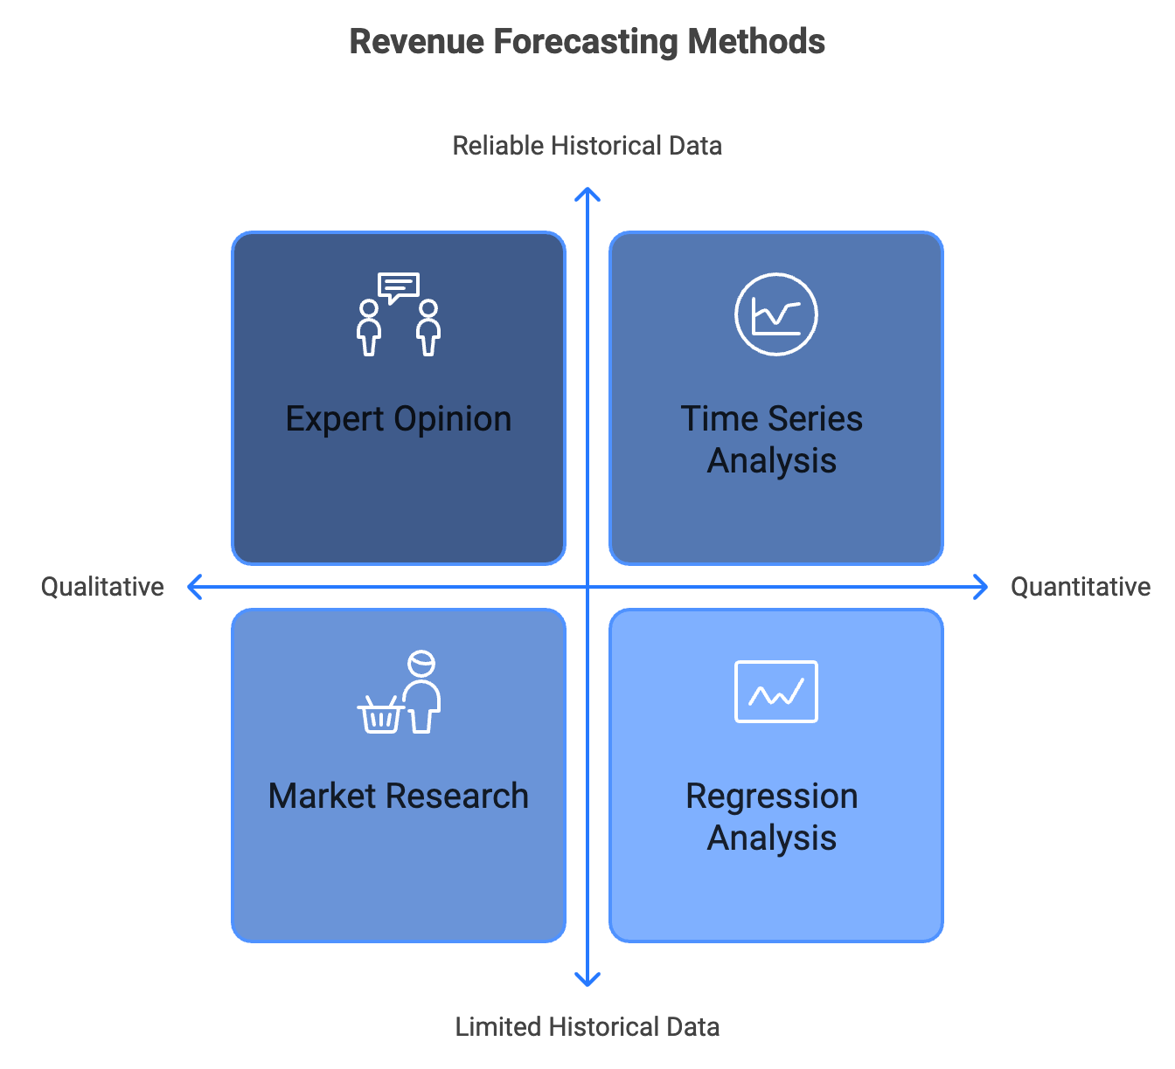

Practical Application of Forecasting Methods
To illustrate these methods in practice, consider a hypothetical small business, “TechGadgets,” an online retailer of electronic accessories. TechGadgets could use time series analysis to identify trends and patterns in their historical data, noting a 15% year-over-year growth rate and a significant sales spike during the holiday season. Using regression analysis, they might find that every $1,000 increase in marketing spend results in a $5,000 increase in revenue, and new product launches typically boost monthly revenue by 10% for the first three months. Analyzing their sales pipeline, TechGadgets might discover a 5% lead-to-customer conversion rate with an average purchase value of $100. By combining these forecasting methods, TechGadgets can create a comprehensive revenue forecast, predicting base revenue using time series analysis, adjusting it based on planned marketing spend and product launches, and adding potential revenue from their current sales pipeline.

Forecasting Method | Key Insights
Time Series Analysis | 15% year-over-year growth, holiday season spike
Regression Analysis | $1,000 marketing spend increase = $5,000 revenue increase
 | New product launch = 10% monthly revenue boost for 3 months
Sales Pipeline Analysis | 5% lead-to-customer conversion rate
 | $100 average purchase value

Enhancing Forecast Accuracy
While quantitative methods provide valuable insights, it’s crucial to remember that all forecasts are based on assumptions. External factors like economic conditions, competitive actions, or unexpected events can significantly impact actual revenue. Regularly reviewing and updating forecasts as new information becomes available is essential.
To enhance the accuracy of revenue forecasts, consider using multiple methods, creating forecasts for different time horizons, accounting for seasonality, factoring in known future events, using conservative estimates, regularly updating forecasts, learning from past forecasts, and considering external factors. These practical tips can help create more robust and reliable revenue projections.
Building flexibility into forecasts is crucial to handle uncertainties and accommodate market fluctuations. Strategies to achieve this include using ranges instead of single point estimates, creating multiple scenarios (base case, upside case, and downside case), performing sensitivity analysis, utilizing Monte Carlo simulation, and implementing rolling forecasts. These approaches allow businesses to adapt to changing conditions and make informed decisions based on a range of potential outcomes.
Case studies of successful small businesses demonstrate the practical application of these forecasting strategies. For instance, craft brewery “HopHaven” used a combination of time series analysis and market research to create three revenue scenarios, allowing them to adjust their spending based on which scenario was unfolding. Online education platform “SkillBoost” utilized sales pipeline analysis and regression modeling to create a dynamic forecasting model, resulting in a 25% increase in revenue compared to the previous year.
Developing strong revenue forecasting skills is essential for small business owners. By combining qualitative insights with quantitative analysis, using a mix of forecasting techniques, and building flexibility into projections, you can create more accurate and useful revenue forecasts. The goal of forecasting isn’t to predict the future with perfect accuracy but to make informed decisions based on the best available information and to be prepared for a range of potential outcomes. With practice and persistence, forecasting skills improve over time, providing a powerful tool to guide businesses toward success.



Utilizing Financial Tools and Software
In a fast-paced business environment, staying on top of your finances is more crucial than ever. Fortunately, a plethora of financial tools and software are available to simplify your budgeting tasks and enhance your financial oversight. This chapter will guide you through the landscape of modern financial technology, helping you select and implement the right tools for your small business needs.

The Evolution of Financial Software
The evolution of financial software has transformed the way small businesses manage their finances. Gone are the days of manual ledgers and cumbersome spreadsheets. Today’s financial tools offer real-time insights, automation, and integration capabilities that can save you time, reduce errors, and provide deeper financial understanding. Let’s start with the basics: spreadsheet templates. While more advanced solutions exist, spreadsheets remain a versatile and accessible option for many small business owners. Microsoft Excel and Google Sheets offer a range of pre-built templates for budgeting, cash flow forecasting, and financial reporting. These templates can be customized to fit your specific needs and provide a solid foundation for financial management.
For example, a basic budget template in Excel might include columns for budgeted amounts, actual amounts, and variances, with rows for different income and expense categories. Formulas can automatically calculate totals and variances, giving you a quick overview of your financial performance. While spreadsheets require manual data entry, they offer flexibility and are an excellent starting point for businesses just beginning to formalize their financial processes.

Advanced Accounting Software
Moving beyond spreadsheets, dedicated accounting software provides more robust features and automation. Popular options for small businesses include QuickBooks, Xero, and FreshBooks. These platforms offer features like automated bank feeds, invoicing, expense tracking, and financial reporting. They can significantly reduce the time spent on bookkeeping tasks and provide more accurate financial data. Let’s take a closer look at some key features of modern accounting software:
- Automated bank reconciliation: This feature connects directly to your business bank accounts and credit cards, automatically importing and categorizing transactions. This not only saves time but also reduces errors from manual data entry.
- Invoicing and accounts receivable: Create professional invoices, send them directly to clients, and track payments. Many systems can automatically send reminders for overdue invoices, helping improve cash flow.
- Expense tracking: Capture and categorize expenses easily, often with the ability to snap photos of receipts using a mobile app.
- Financial reporting: Generate a variety of financial reports, from profit and loss statements to balance sheets and cash flow forecasts, with just a few clicks.

Integrating Financial Tools
When selecting accounting software, consider factors such as ease of use, scalability, integration capabilities with other business tools, mobile access, and cost. Many providers offer free trials, allowing you to test-drive the software before committing.
For businesses with more complex financial needs, Enterprise Resource Planning (ERP) systems offer comprehensive solutions that integrate financial management with other business processes like inventory management, customer relationship management, and human resources. While typically more expensive and complex to implement, ERP systems can provide a holistic view of your business operations and financials. Beyond general accounting software, specialized tools can help with specific financial tasks. For budgeting and forecasting, consider tools like PlanGuru, Prophix, or Adaptive Insights. These platforms offer advanced forecasting capabilities, scenario planning, and financial modeling features that go beyond what’s available in standard accounting software.
For cash flow management, dedicated tools like Float or Pulse can provide more detailed cash flow forecasting and scenario planning. These tools can integrate with your accounting software to provide real-time cash flow projections based on your accounts receivable, accounts payable, and recurring expenses. Expense management software like Expensify or Concur can streamline the process of tracking and approving employee expenses. These tools allow employees to submit expense reports easily, often by simply taking a photo of a receipt with their smartphone. Managers can then review and approve expenses quickly, and the data can be automatically synced with your accounting software.
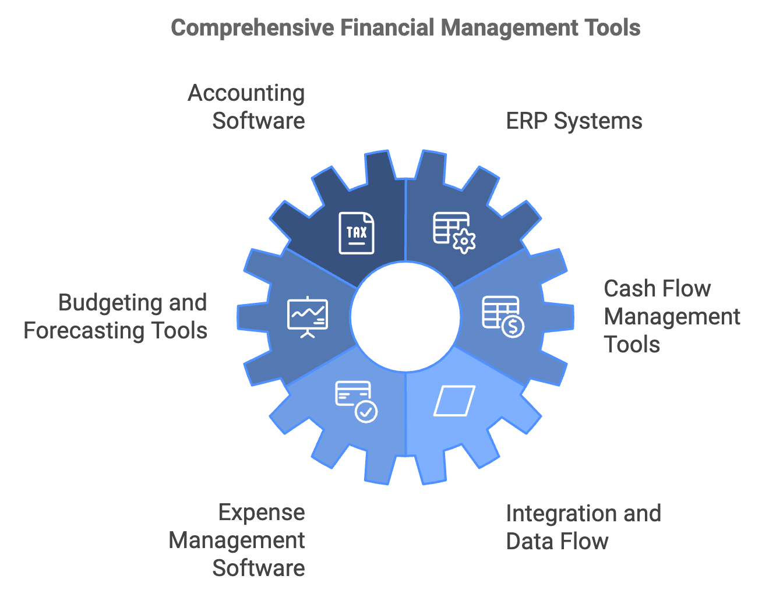
As you implement these financial tools, it’s crucial to focus on integration and data flow between different systems. Many modern financial tools offer API (Application Programming Interface) connections, allowing different software to communicate and share data automatically. This integration can prevent data silos and provide a more comprehensive view of your financial situation. For example, your e-commerce platform could automatically push sales data to your accounting software, which in turn updates your inventory management system and cash flow forecasting tool. This seamless data flow reduces manual data entry, minimizes errors, and provides real-time financial insights.

Best Practices for Financial Tool Implementation
While these tools can greatly enhance your financial management capabilities, it’s important to remember that they are just that – tools. They require proper setup, consistent use, and regular maintenance to be effective. Here are some best practices for implementing and using financial software: Invest time in proper setup, train your team, regularly reconcile accounts, keep your data clean, stay up to date, leverage support resources, and regularly review and adjust. As your business grows and changes, your financial management needs may evolve. Regularly review your processes and tools to ensure they still meet your needs.
While financial software can automate many tasks, it’s crucial to maintain a good understanding of your financial data and processes. Don’t fall into the trap of “set it and forget it.” Regularly review your financial reports, question any unusual figures, and use the insights provided by your tools to make informed business decisions. As you become more comfortable with your financial tools, you can start to leverage more advanced features and analytics. Many accounting and ERP systems offer customizable dashboards that can provide at-a-glance insights into key financial metrics. These might include cash flow projections, accounts receivable aging, gross profit margins by product or service, or customer acquisition costs.
Data visualization tools like Tableau or Microsoft Power BI can connect to your financial data to create more advanced visualizations and reports. These tools can help you identify trends, spot anomalies, and communicate financial information more effectively to stakeholders. Artificial Intelligence (AI) and Machine Learning (ML) are increasingly being incorporated into financial software, offering exciting possibilities for small businesses. These technologies can help with tasks like anomaly detection, predictive analytics, automated categorization, and intelligent cash flow forecasting. As you explore these advanced features, remember to maintain a balance between leveraging technology and maintaining human oversight. While AI and ML can provide valuable insights, they should complement, not replace, human judgment in financial decision-making.
Security is a critical consideration when implementing financial tools and software. Your financial data is sensitive and valuable, making it a potential target for cybercriminals. When selecting financial software, prioritize providers that offer robust security features such as end-to-end encryption for data transmission and storage, multi-factor authentication, regular security audits and compliance with relevant standards (e.g., SOC 2, GDPR), and backup and disaster recovery capabilities. In addition to choosing secure software, implement good security practices within your organization. This includes using strong, unique passwords for all financial accounts, regularly updating software, and training employees on cybersecurity best practices.
While financial tools and software can greatly enhance your financial management capabilities, they’re not a substitute for financial expertise. Consider working with a professional accountant or financial advisor who can help you interpret your financial data, ensure compliance with accounting standards and tax regulations, and provide strategic financial advice. Many accountants and financial advisors are well-versed in modern financial software and can help you set up and optimize your systems. They can also provide valuable insights into which tools and features will be most beneficial for your specific business needs.
In conclusion, leveraging financial tools and software can transform your approach to financial management, providing deeper insights, saving time, and enabling more informed decision-making. From basic spreadsheet templates to advanced AI-powered analytics, there’s a wide range of options available to suit businesses of all sizes and complexities. Remember, the goal of implementing these tools is not just to automate tasks, but to gain a deeper understanding of your financial situation and use that knowledge to drive business growth. By carefully selecting the right tools, properly implementing them, and consistently using the insights they provide, you can take your financial management to the next level and position your business for long-term success. As you continue your journey in financial management, stay curious and open to new technologies and methodologies. The field of financial technology is rapidly evolving, and staying informed about new developments can help you identify opportunities to further optimize your financial processes and gain a competitive edge.

Financial Tool Category | Examples | Key Features
Spreadsheet Templates | Microsoft Excel, Google Sheets | Customizable, flexible, good for basic budgeting
Accounting Software | QuickBooks, Xero, FreshBooks | Automated bank feeds, invoicing, expense tracking
ERP Systems | SAP, Oracle, NetSuite | Comprehensive business management, integrates multiple functions
Budgeting & Forecasting | PlanGuru, Prophix, Adaptive Insights | Advanced forecasting, scenario planning
Cash Flow Management | Float, Pulse | Detailed cash flow projections, scenario planning
Expense Management | Expensify, Concur | Easy expense submission, approval workflows
Data Visualization | Tableau, Microsoft Power BI | Advanced reporting, trend analysis

