Disclaimer

This eBook has been written for information purposes only. Every effort has been made to make this eBook as complete and accurate as possible. However, there may be mistakes in typography or content. Also, this eBook provides information only up to the publishing date. Therefore, these eBooks should be used as a guide - not as the ultimate source.

The purpose of these eBooks is to educate. The author and the publisher do not warrant that the information contained in this eBook is fully complete and shall not be responsible for any errors or omissions. The author and publisher shall have neither liability nor responsibility to any person or entity concerning any loss or damage caused or alleged to be caused directly or indirectly by this eBook.
Table of Contents

Introduction 5
Chapter 1: The Beginning: What Is Social Media Marketing? 9
Chapter 2: Key Elements Of Social Media Marketing 12
The content 12
The conversation 13
The “social” of social media 13
Chapter 3: How To Implement A Social Media Marketing Strategy 15
Set goals 15
Research 17
Audience 17
Chapter 4: Using Social Media Marketing To Develop A Brand 21
Aesthetics 21
Voice and personality 22
Chapter 5: The Importance Of Analytics 25
Engagement 26
Chapter 6: The Crucial Difference: Advertising Vs Marketing 31
Psychology of Social Media 31
Chapter 7: Pros And Cons Of Different Social Media Platforms For Marketing 35
Demographics 35
Profiles 36
Chapter 8: Unique Content Creation 43
Conclusion 46



Introduction

Weirdly, if you were to search for “social media marketing” on your favorite search engine, you will likely receive results from the same couple of websites, as well as an assortment of targeted ads. This is a prime example of social media marketing in action. Search ranking, recognition, and branding are essential elements of your future marketing strategy,

Throughout this book we will be referring to the concept of brand loyalty; it is an appropriate goal of many businesses, and with it will come sales and engagement. To reach brand loyalty: you must first have brand awareness and recognition: this is where social media marketing comes in.

Social media marketing involves consistently using appropriate strategies to engage your audience and raise awareness of your brand. Simply posting is not enough. Your posts need to be relevant and strategic.

This eBook will make social media marketing simple. The concept of social media marketing can seem challenging and convoluted. And, with a haphazard attempt towards it, social media marketing can be. You will need to have a clear strategy, that will help you reach your clearly defined goals. When it comes to the results of marketing, ignorance is not bliss. You would never implement a traditional marketing campaign without first clearly planning it and outlining several specific goals; so why would you do it online? One of the biggest mistakes people make in implementing social media marketing is not acknowledging the stark difference between regular marketing and online marketing. Many of the foundational principles are the same, yet new skills and elements exist and will be necessary to comprehend.

Before beginning, it is important to note that this eBook is not directed towards one specific business type, it is for everyone who is using social media to market. The eBook may include phrases like “your product”, “your service” or “your business.” What is meant, is whatever you have to offer! Use the elements that apply to your business, do not falsify a business to fit with anything other than your goals.

We will begin by discussing what social media marketing is. It is important to have a complete understanding first so that you can do a better job of working through the remainder of the book. It may be prudent to answer all the rhetorical questions posed within the coming pages to truly outline your overall business goals and how you can use social media marketing to achieve them.

The eBook will then go on to discuss the key elements of social media marketing; this section will provide you with a list of ideas and questions that you can include in a strategy. It is important to remember that not every part of social media marketing will be relevant to you and your business. You need to find and focus on the elements that are most applicable to you and your goals, while also taking into account your audience and their media usage. We will then go on to discuss how you can implement a media marketing strategy; it will provide you with some tips and hints of the top things that you should be considering in creating a strategy and provide you with ideas for some goals that you could set. The book will then discuss branding which is in itself a kind of marketing. Having a brand would be a central aspect of building a loyal audience.

This eBook will then run through the importance of analytics. Tracking analytics and data is some of the most essential skills for someone who is trying to run a business online. Without them, you will not be able to tell your progress, nor will you know if your marketing is effective. We will discuss how you can use tools to do so as well as simple metrics to track.

Following this, this book will discuss the benefits of some of the different social media platforms. However, it will not go into detail into which demographics use which platform. It simply will provide an overview of the types of content that will be created on them.

Throughout all this, however, it is important to remember that each business and each audience is different; for this reason, there is not a one size fits all approach to marketing. Rather than giving you a strategy, this book will give you the tools and understanding that you need in order to produce your own. This will allow you to build a tailored strategy to your goals, skills, and abilities in order to make the most out of your strategy.
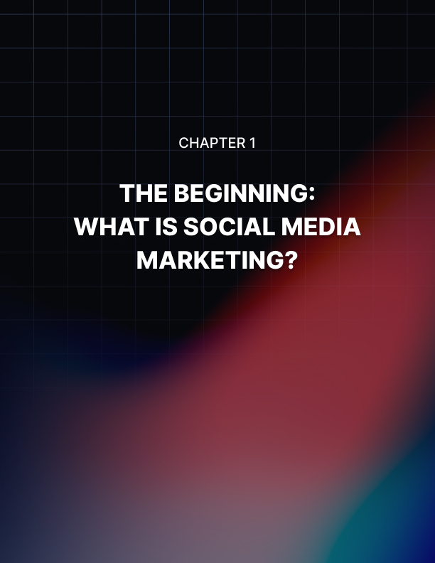

Chapter 1: The Beginning: What Is Social Media Marketing?

You may be asking, is it not enough to simply have active profiles on social media? Unfortunately, no, it is not.

In this day and age, almost every person, and, even, many pets(!) are on social media. For this reason, there is an undeniable need for the existence of an enhanced and consistent social media presence to be able to run a business on social media. There is an abundance of content that you will need to compete with, so, above all, you need to try to have a high-quality brand.

But, people do not only use social media to be social with their friends and family—as it was originally intended. Social media is used to build connections and make business decisions and, of course, learn about new and exciting products.

Social media was designed with the intention of keeping us on our phones and to constantly refresh our feeds to see what new and exciting content is available for us. And it certainly worked. Social media usage is constantly increasing, with platforms finding new ways to keep us posting and most importantly buying.

When social media was first introduced, it was ad-less and free. But, as sites grew, so did the ability of it to be used for marketing. Now, in amongst pictures of our family and friends, are sponsored posts and ads that the algorithms think that we might enjoy. The videos we watch are often paused momentarily to make way for a quick ad. Advertising has been seamlessly integrated into our feeds; but how do you compete with all that content? Theanswer comes in creating a social media marketing strategy.

In essence, social media marketing is defined as efforts made on social media to connect with audiences and achieve business goals, such as increased sales, increased followers, more traffic, and building a brand.

Through social media marketing, you will want your audience to develop brand awareness, then brand recognition, and finally, brand loyalty. We will discuss “branding” more specifically later, but it is important to keep in mind that as branding is how your audience perceives you, you want them to have a good impression.

Social media marketing is the combination of all your online activities that aim to drive user engagement and overall sales.

As with regular marketing, it can be proactive or reactive. Preferably of course you want proactive marketing to head off anything bad—ideally, you want your marketing strategy to seem effortless, not staged PR.

While it can seem like a challenge, the ideal social media marketing strategy does not seem like one at all to the audience. It should come across as natural, organic content.

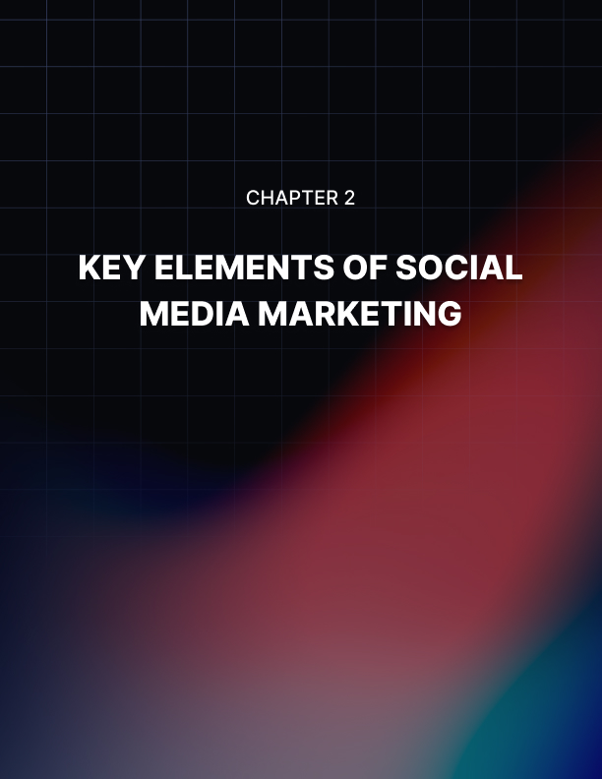

Chapter 2: Key Elements Of Social Media Marketing

Social media marketing is not the same as traditional marketing. Depending on one's industry and business goals, it may require traditional marketing as well as social media marketing to grow their business. There are elements of social media marketing that are inspired by traditional marketing, but one would be foolish not to have a solid understanding of social media marketing specifically to maximize the possible gains from it.

Whether you, yourself, are your brand or you are trying to run a business from social media you will still need to use social media marketing. Basically, you will not succeed on social media, irrespective of your endeavor, without a good social media marketing strategy.

If you have already started your business, it could be helpful for you to conduct an audit of the kinds of posts you have been doing and the success of these posts. Doing so will also help you learn the skills that we are discussing throughout this book. The sooner you learn to apply the skills, the better; so if you can do an audit of any content currently, it would be an advantage.

The content
One element of social media marketing is the content that you will be producing. While we will discuss this in more detail later in the eBook, it is something that you must keep in mind. Content can be your every day or more casual posting style as well as specific campaigns that you run.

While marketing is how you do it, ultimately the content is what you are selling. You will be using analytics to understand the success of your content.

You can have the best marketing strategy in the world but if your content is not good, then your account will not be as successful as it could be.

The conversation
You can monitor the conversation about what people are already saying about you and steer the conversation in new ways. Listening to the buzz about you and the feedback you are receiving is an important part of marketing and growing your business. For example, check in the comment sections, checking reviews, and checking message boards. It is not just enough to look on your own channels, you need to see how you are appearing in other places as well that you personally have less control over.

Checking your own notifications for mentions is one thing, but you also want to know what people are saying about you and not tagging you in. Sometimes when people air their grievances, they do not actually want to tag the brand itself, for fear of backlash or an uncomfortable conversation. This is why you just need to monitor things that include your name as well—just in case.

The “social” of social media
It is right there in the name, there is no use just posting blindly into the void or shouting into an echo chamber: engagement is everything. It should be one of the primary goals of your marketing strategy. And do not forget, engagement goes both ways. Not only do you want your audience to engage with you, but you need to engage back. An element of this is your brand persona, but it also involves putting the time into replying and commenting and also creating a conversation and space for your audience where they feel valued, appreciated and, also have fun!
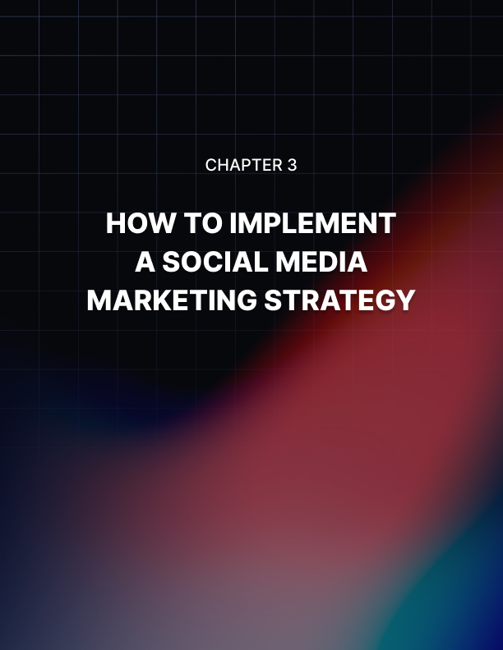

Chapter 3: How To Implement A Social Media Marketing Strategy

Social media marketing can be divided into five categories:

- Strategy
- Planning
- Publishing
- Listening and engagement
- Analytics and reporting
- Advertising

In essence, you must first come up with your strategy including your goals plan and publish your posts, listen to feedback and view your engagement, and check the analytics to see whether the data backs up your goals.

Basically, your social media marketing strategy is a plan. You need to start at the beginning with planning, obviously, and as with most things, the better foundation that you build for yourself in the beginning, the better the understanding you have of the things that you want to achieve and who your brand is going to be: the better your strategy would be and, therefore, the better your chance of success is.

While it can seem tedious, it is worth taking the time to put in the effort to create a comprehensive strategy to have a successful business eventually.

Set goals
The important thing to begin with is what your goals are. What do you want to achieve from your business and how can you use your marketing strategy to do so? This will be what you are striving to meet with your strategy. There are more examples of specific and smart goals later on, but these could give you a hint about some things that you should be thinking about achieving.

Possible overall goals to set for your social media profiles include:

- Increase brand awareness
- Grow revenue
- Get new traffic to your website/or other platforms
- Increase the clickthrough rate
- Increase mentions
- Build a community with your audience

But how will you achieve such things? Although they are overall goals, they are not specific, nor do they provide any real incentive. They may give you an indication, but they do not give any real inspiration for what you explicitly are aiming for. Instead, your goals should have specific numbers and timelines. Below are some ideas for sub-goals you can create, they are listed without timelines, but you should endeavor to create them.

Possible sub-goals include:

- Increasing your overall follower count
- Increasing reach
  - Reaching x people per month
- Increasing comments
- Increasing mentions
- Increasing overall likes
- Improving your follower to like ratio
- Driving traffic to your website
  - How many people click the links to your website?
  - Where do these people come from?
  - How long do they stay on your website?
- Growing revenue
  - Revenue from social media
  - Revenue from ads
  - Revenue from people buying your products or service
- Growing leads
- People using your hashtags or contests

Goals will obviously differ for everyone and each business will have different goals. Try to make them as specific and time-sensitive as possible, this will ensure that you are on track to meet them.

Research
The research phase of your business strategy will be incredibly important. It will be the foundation of your business, in conjunction with your marketing, which is why you need to spend adequate time getting to the bottom of your goals and how are you going to achieve them.

First, you need to research your industry. While it is likely that you have already done this— you can never be too prepared. It would be valuable to check marketing trends within your industry. This includes things like popular kinds of campaigns, hashtags, and locations to post.

You will also need to research your audience. We will discuss this more below (and throughout this eBook), but you need to have a very clear understanding of who your audience is and how they use social media in order for you to be able to market to them effectively.

Additionally, you should be researching your competition. Figure out who your main competition is (both direct and indirect) and analyze their successes and their failures, and it may even be prudent and valuable to analyze their data, too. This will give you some hints of things to avoid and things that you should (and should not) be focusing on. Any advantage that you can give yourself will be invaluable; do not waste time doing things that have been proven not to work before. This does not mean that you should not take risks, but simply that you should be careful about the ones that you do take.

Audience
While it almost goes without saying, it is imperative that you understand your target audience. If you are lacking an understanding of where your target audience is spending their time online, what kind of content they enjoy, and what kind of businesses they like, your marketing strategy will not be successful.

You need to be able to paint an incredibly detailed picture of your target audience in order to be able to reach them effectively. You need to understand them from a demographic perspective, but your understanding will also need to include things like their income, their propensity to comment, and share posts, and their geographical location. As well as understanding the times of day that they use social media. For example,e there is no use posting a competition on Instagram at 10:00 am that closes a few hours later requiring them to share and comment, tagging a friend on a post if your audience typically does not share posts or does know how to and works regular business hours and may not be online during that time and aren't typically tag people all know how to. While that was a convoluted explanation, often, social media usage patterns are convoluted too! These are the smaller things that you need to take into consideration.

You also need to use the social media platforms that your audience is using. It may seem obvious, but looking into the data that shows where your audience is most online and how they use social media is the best way to enjoy a successful marketing strategy. After all, what is the point of posting if your audience does not see it? In addition to this, you also need to fill out your profiles completely; even on social media sites you may not be using. As it is better to have claimed the username and have a basic profile with consistent branding than to not. Not only does this open you to more possible searches, but it also looks professional.

The next chapter will discuss developing a brand, and how that, too, will add a layer of professionalism to your business.
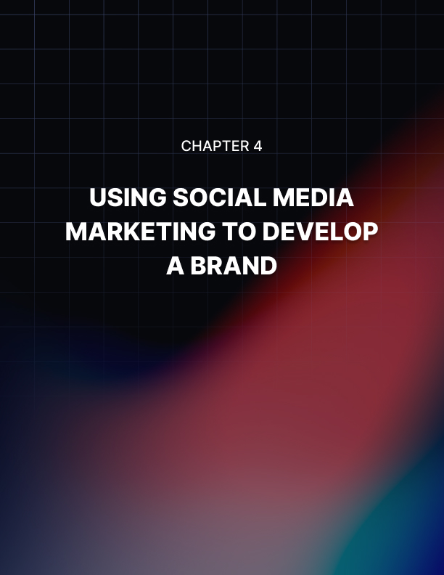

Chapter 4: Using Social Media Marketing To Develop A Brand

Having a brand is one of the most important parts of success. It is not enough to simply have an account, in order for true success you will need to have a brand.

In essence, a brand is how your audience perceives you. It is how you are portraying yourself and how they are receiving it. This brand will be based on who your audience is; taking into account their demographic features, including but not limited to age, location, education, interests, beliefs, needs,and values.

Throughout the business process, you want your audience to develop brand awareness, brand recognition, and ultimately brand loyalty. Building a good relationship with your audience is one way to achieve this.

Developing your brand will mean that your audience has something to associate with you. It will allow them to build a connection with your business and, ultimately, become a loyal customer. And, as we all know, loyal customers are a fantastic way to build a successful business.

Aesthetics
Social media can be a very visual medium. Having bad aesthetic and visual elements is a number one sign of unprofessionalism and can easily bring down a brand-- especially with how easy it is but these little things to be consistent.

You need to have cohesive aesthetics. This means having logos, colors, and fonts that all match each other and are consistent across your profiles. If you have not updated your visuals in a while it may be a good thing to start doing. It is an easy way to update your marketing strategy. Any profile pictures and cover photos should also be the same. A potential consumer should be able to open any of your social media profiles and know immediately that they belong to the same person.

This is imperative because brand recognition is one of the most important pillars of the marketing strategy, and aesthetics is one simple way to encourage this to occur. One way to think about this could be to look into your favorite brands, and think about the associations that popped into mind when you see them: is it colors of type, a certain style of post, whatever it is, you need to have your own image of what you want people to think about you. Developing a brand vision board could help you with this and ensure that it all stays cohesive

Voice and personality
A big part of the marketing strategy should be determining the personality and the persona of your brand. This then informs the tone of your interactions with your audience.

Some things you can think about in order to flesh this out specifically include:

- If the brand was a person, what is their personality?
- What is not a personality?
  - Make a list of adjectives of the things you do want and the things you do not want to be associated with the brand
- What kind of relationship are you trying to build with your audience?
  - For example, a friend, authority figure, teacher, expert, etc.
- What kind of associations do you want people to have with your business?
- Look at other examples of brands (perhaps ones that you like!), as well as brands that are similar to yours and see how they interact with the audience and what sort of person they are trying to be.

Your brand will be incorporated into many phases and areas of your business as a whole, not just the marketing strategy. For this reason, your brand is pivotal to your success.


Chapter 5: The Importance Of Analytics

Perhaps the biggest part of social media marketing will be checking your analytics. To begin with, it can seem like a huge task that you will never fully comprehend, but as you develop your skills you will learn that it is easy and, honestly, kind of fun! Checking your analytics is, in effect, also a way to chart the growth of your business. Dedicating time to understanding and analyzing the data will soon spark joy--especially if your strategy is working effectively!

There are many kinds of analytics and they are often the results of your goals. For example, three of the most common kinds of analytics will be reach, clicks, and engagement. You will also want to look into your conversion rate. This is the number of people who are seeing your content in contrast to the amount of people who are engaging with and giving you revenue.

It cannot be stressed enough that the only way to know if your social media marketing is successful is to check the analytics. Analytics can seem very complicated but once you learn how they work it will become second nature

Some social media platforms have built-in analytics however there are other platforms and tools that you can use in order to have a more detailed in- depth analysis. Do not feel compelled to immediately enlist the assistance of a complicated analytics tracker. You can start by using the inbuilt tracker to get the hang of analytics. You should first get familiar with the concept and things you will be looking for by using the ones that are built into each social media site. There is no use getting too overwhelmed and neglecting to fully understand it. The benefits of using the built-in ones are that all the information is there for you already, you do not have to go anywhere else and the information is the same regardless of where you find it.

If you have already begun to post on your accounts, it is recommended that you see your progress so far—so, then you know where you need to go. In particular, pay attention to your successful posts as well as your levels of engagement--try and see how many ghost followers you have. Ghost followers are followers who do not like or interact with your content, you want a few of these as possible

Analytics include such a wide range of things and there are numerous questions that you can ask yourself, and then discover the answers to through viewing analytics. For example:

- Has your reach grown since last month?
- How was your reach been compared to last week?
- How many mentions do you get a month?
- How many uses of your unique hashtags occur?
- How many shares of your content?
- How does campaign content compare to other things you post?
- If you collaborate, how does that affect your interaction?
- If you share a post from another brand does that other post get more interactions than your own content?
- What are your average likes?
- How many unique profile or page views?
- What is your click-through rate?
- What is your conversion rate?
  - And how does it change over time?
- What time of day are your followers active?

These are just some examples of information that you can discover through analytics, and you should change and develop them over time. Additionally, you should also try to set different goals for different platforms.

Additionally, the goals that you create should be SMART. That is; Specific, Measurable, Attainable, Relevant and Time-Bound. Do not just write “increase engagement”, strive for “increase engagement by 3% in two months.” As well as making them motivating, this makes it clear as to whether or not you are on track whether you need to update a strategy.

Engagement
Engagement is something that has popped up multiple times in our discussion of social media marketing; and that is because it is one of the most important things.

Engagement should be two ways. It should be your audience commenting and sharing your posts replying to your polls liking, retweeting, repining, resharing, or whatever it is that you want your audience to be doing! However, you also need to be engaging back with them. This means you should reply to comments like them, ask questions of your audience and reply, as well as responding promptly to messages and emails.

It is also necessary for you to have a cohesive persona that you use to reply to these with. While calling it a persona makes it sound like it is fake, it should not be. It should seem authentic and real. Your audience wants to feel like they are interacting with the person, not just a random online brand. Basically, just have a consistent voice that is in line with your brand.

Inbuilt tools
Many social media platforms have their own inbuilt tools to allow you to check your insights. This is a very valuable way to begin to understand analytics, they are simple, easy and you do not have to use another tool, because all the information is right there in front of you. Inbuilt analytics are easily accessible, and, while simple, is a fantastic introduction to the principles.

Take insights on Instagram, for example, you will be able to see a breakdown of the demographic of your followers which includes age, gender, location, and their most active hours. Knowing their active hours is key to being able to post when they are online. You can also get specific insights into your posts and by doing so you can see which posts are successful and how users are engaging with them you can then apply these to your other posts.

Third-party analytics
There are many third-party analytics checkers. It can be a valuable idea to learn how to use one. Often, they run on a subscription basis or have a one-time fee, but they usually offer a free trial period first. One of the benefits to some of these tools is that they put all the analytics in one place for all of your social media sites, so you do not need to keep running individual checks. This will also make it easy to check your data over time and easily visualize your progress. Not only will such tools give you the analytics for the social media sites you use, but they can also give insight into relevant hashtags and wider industry trends.

Testing
Try new things and test them. Once you are familiar with the tools, trying new things and experimenting with how you post is a fantastic way to try and improve your analytics. The analytics will make it clear which type of days are best to post on and what time of day, and also what kind of engagement you are generating.

Being able to run data-driven campaigns in a central part of business, and the only way you know if something is going to work is to try it out.Nevertheless, using data will at very least give you an educated guess as to what might work.
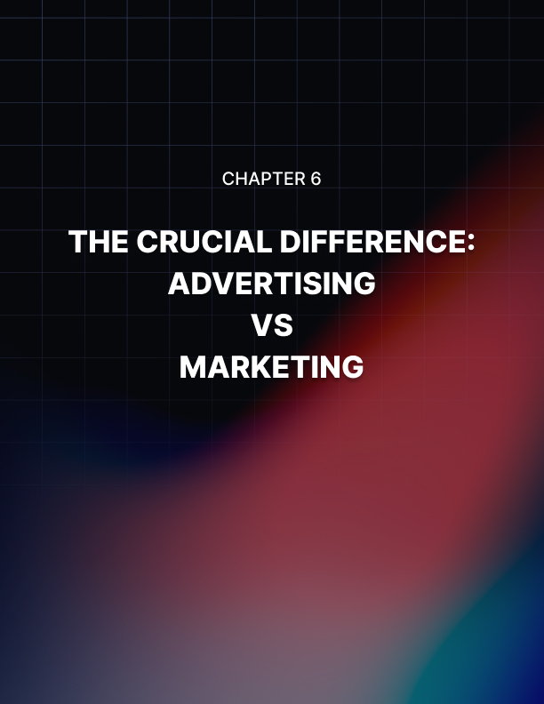

Chapter 6: The Crucial Difference: Advertising Vs Marketing

As anyone who has worked in the area will tell you, there are explicit differences between advertising and marketing, however, the lines often get blurred. Advertising is a kind of marketing; but that is not all there is to it.

Advertising comes under the umbrella term of marketing. Marketing is much broader and is the combination of all relevant elements in the area.

Definitions also vary and there is no one fixed answer, however, marketing is more inclusive and comprehensive of different areas of business. Whereas advertising may refer specifically to campaigns.

While the difference is not necessarily important in all circumstances it is still something that it should be aware of. Something that is more explicitly “advertising” may be more likely to be ignored or suppressed by your audience, as opposed to something that comes across as more natural. Often this has to do with branding.

When scrolling through your social media feeds, chances are, you have seen posts labeled with #ad, or #sponsored. This is a kind of advertising that falls under the broader marketing strategy. These things are very obviously labeled as advertising, and therefore consumers view them differently from other posts in their feeds. That is, they know that it is clearly trying to sell them on the product. Which, of course, is an important part of marketing, but it should not be the only kind. Although many influencers have been able to build brands and lifestyles from advertising products, their power truly comes from their brand. Posting sponsored post after sponsored post would be nothing if they had not built up an audience and brand.

Psychology of Social Media
As many people know a big part of marketing is understanding the psychological patterns of consumers and determining what makes them act.To complement this, social media was designed with the intent of making us spend as much time as possible on the platform. Social media is something that is addictive to many people, and many of us love refreshing our pages to see what new content is waiting for us. This means that your content needs to be of high quality in order to light up a consumer’s eyes (and screens!), cause them to double-tap and engage meaningfully with your content

In essence, a good social marketing strategy will understand consumers psychologically and compare this with the psychological underpinnings of each social media platform in order to create a powerful marketing strategy that uses consumers’ patterns and thoughts to get them to act.

Reach
Organic reach and algorithms can challenge brands and businesses. The algorithms are ever-changing and sometimes seem to prefer or block posts for no real reason. Often, you are at the mercy of the algorithms. A way to beat this is having good engagement. Different kinds of engagement and interactions will post rank differently. For example, saving or sharing is better than liking. To combat this, try and include competitions or posts that require a direct call to action that people are likely to send the post on.

Search engine optimization (SEO)
Optimizing your content for search engines is another fantastic way to assist with your audience and reach new people. It will rank your post higher compared to others. A fun example is whenever you look up the phrase “social media marketing” regardless of the other search words afterward you will likely still get results from the same few websites because they have excellent SEO.

Paid content
You may have to add paid posts to your marketing strategy. While these are obviously marketing, there are benefits to doing so. It will place your business in front of new future customers and provide new opportunities for your brand. Checking the analytics, and return on your investment is essential totracking how productive your paid content is.
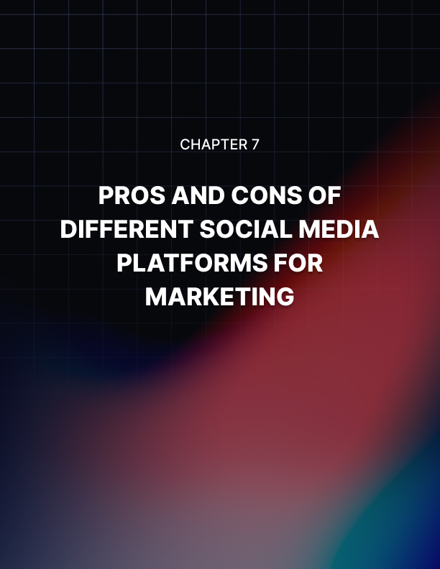

Chapter 7: Pros And Cons Of Different Social Media Platforms For Marketing

You will also need to determine which social media sites you will be using. In essence, it depends on your target audience. Different audiences and demographics use social media in different ways, and therefore, marketing strategies will be different.

Rather than overwhelming yourself with trying to create unique content for each social media site, you should elect to base your platform on a few of them. It may be worth creating profiles on them all, filling them out consistently and in line with your brand, but you do not have to create unique content for all of them—at least right away. It is far better to focus your attention than to overwhelm yourself and have subpar content. Again, you need to be aiming for quality over quantity.

It is important to remember that something that characterizes the success of content going “viral” is when it gets re-shared across different platforms. We have all seen viral tweets screenshot and shared on Instagram or Facebook. While it does not happen to everyone, the cross-posting success of an idea is still something that you can consider.

Demographics
First, before deciding which social media platforms to use; you need to determine which platforms your audience uses. Different platforms have higher usage and different effectiveness with different target audiences. So, naturally, you want to take your media strategy to the platforms that will maximize your engagement and impact on your audience.

Remember to base your platform use on your audience, not the other way around.

Choose the social media sites that best reflect the content you will be creating, but more importantly, best reflects the places where your audience would be. Your audience should dictate your content type, not the other way around. You cannot force people to engage with something that they do not like; because they will not: they will unfollow or simply ignore you.

Profiles
Not specific to any one platform, it is important to have a well-curated profile. Your profile should make it clear who you are.

Visually, and aesthetically, your profiles encapsulate your brand and are of the highest possible caliber—it will likely be the first impression that your audience has of you, so it needs to be a good one. Usernames should be appropriate and catchy, bios should be clear and simple, and profile pictures should be eye-catching. All of this should be tailored to your audience.

Across platforms, as well, your visual branding should be consistent.

Instagram
Instagram is a popular photo and video sharing site. To begin, you need to make sure that you are on a business profile: this will give you access to all the business and insight tools. It gives you a contact button and the ability to create ads from your posts.

Popular kinds of posts include product teasers, product posts, behind the scenes shots, reposts from followers or employees, educational content, influencer posts, and typography, just to name a few!

Instagram will also allow you to create sponsored ads, too. These show up on the feeds of people who are not following you but meet the demographic requirements of your audience.

Instagram stories are also incredibly useful. Posting stories is a beneficial way to remind your audiences that you exist, without creating a new post for your feed. Additionally, stories can be a great way to share your followers’ content about you or any features that you have.

While people like to follow their favorite brands, more importantly, perhaps, people want to follow people they care about. Having a personal brand is very important on Instagram, and you want to be perceived as a person with a business, not just a business.

Facebook
Facebook is one of the most popular social media platforms, for many people, in fact, Facebook is the internet. Setting up a Facebook business page (even if Facebook will not be your primary social media avenue) is a good way to create a hub for your business. Instagram posts can be easily shared, but other content may have to be reformatted. Make sure you fill out the profile information to include links to your other social media, as well as your contact information. Naturally, you need on-brand titles, profile pictures, and header images.

Depending on your kind of business, you could always create a Facebook group to interact with your audience and create a community hub. While this will not be an effective strategy for everyone, if you are branding yourself as yourself and offering some kind of service that is very persona-heavy, this is a creative way to break down barriers and build a connection and community with your audience.

Many popular posts on Facebook are links to content posted elsewhere. For Example, if you have a blog or other website, posting links to your Facebook page is a great way to drive traffic.

Videos are another popular form of content on Facebook. As well as graphics and other photos. Update your content, especially ad content, frequently! Audiences get bored with seeing the same things over and over, so you need to be able to keep it fresh.

Twitter
Twitter is another major social media website; however, it is characterized by its use of short-form content. There is a character limit on Twitter, meaning that tweets posted can only be 280 characters long.

Once again, you need to create your profile in line with your branding. Make It recognizable as you. Your audience needs to be able to instantly recognize it as you—being recognizable is a key part of growing your business. Having cohesive profile pictures, usernames, bios, and headers is a fantastic way to aid with this.

You should make sure that your content is shareable; creating exciting, new content that is unique to you and is something that people will want to share.To gain exposure, use unique hashtags, as well as interacting with your audience. Commenting and retweeting your followers, or goal followers will make them more likely to do the same for you. As well as making sure that you jump on trends and use trending, yet appropriate hashtags to grow your audience.

Go through your mentions, and indirect mentions and like, retweet, and comment on tweets that are about you! Additionally, make your direct messages open and monitor them regularly. Keyword sharing and hashtags are prime ways to increase the views of your tweets.

LinkedIn
Even if you are not using LinkedIn as a part of your business to gain customers, you should, at the very least, set up an individual profile (and, then perhaps, one for your brand, depending on whether it will be appropriate). But, to use LinkedIn as a marketing tool, make sure that you find your audience on there. At the very least, you can probably use LinkedIn to make broader industry connections, if not to reach an audience.

Company pages are a great feature of LinkedIn. And you can share unique content or cross-share content from other platforms. Use hashtags, as well as keywords to ensure that you stand out.

Build connections with other professionals, as well as find ways to build exposure. Other professionals on LinkedIn may be looking for collaborations; so updating your profile with your achievements, as well as any professional features you have is a great way to show off your business—to other people who may be able to elevate it.

Connect with as many people as possible in order to expand your reach. LinkedIn has effective search and recommendation tools that will allow you to find new people to connect with who are in a similar industry to you. Posting content to LinkedIn is a great way to set yourself up as a leader in the industry. You can use it to share your knowledge and present yourself as an authority in your field.

Pinterest
Pinterest is an incredibly popular social media platform around the world, and people use it for inspiration. It is a very visual medium, so your content will need to be of a high quality to stand out. Pinterest is very popular for DIYideas, recipes, clothing, and other design posts. It is aesthetically oriented,so your branding will need to be consistent and visually lovely.

Remaining on-brand is important with Pinterest—as it is so dependent on visual elements you need to ensure that your branding and graphic design are consistent so that your audience immediately recognizes your content as yours.

Good quality pins are usually vertically oriented, including text and tasteful branding. They often link to a blog or other post for the remainder of the content—so it is good to analyze your click-through rate. Make sure you include descriptions and detail. Pinning regularly is essential on Pinterest, but you can schedule them, so you do not have to do it every day. Additionally, make sure you plan for seasons—people on Pinterest often search for inspiration in advance.

YouTube
YouTube is the biggest video sharing social media platform. There are a lot of videos on YouTube, but that should not mean that you should not try to gain the attention of your audience. If your content features you, you will need to have a distinct and likable personality. Editing is something that can make or break your YouTube channel, so make sure that your videos are unique and well-edited. Have captions on your videos and descriptions on the upload.

Do not forget to utilize cards, end screens, bumper ads, and watermarks. Create content that is unique and of a quality that viewers cannot resist the urge to “like, comment, and subscribe!”

Snapchat
Snapchat is a social media platform that, used mostly by younger people privately, has a huge portion of it dedicated to advertising. In order to stand out from the bright and playful content on Snapchat, you will need to be unique and fun.

You can set up ads and build filters in order to reach new users. Share yourSnapcode on other social media platforms for your audience to add you.

TikTok
TikTok is a new social media platform, mostly used by younger people. It features videos that are shorter than one minute and tend to be attention- grabbing. Despite primarily being shot on mobile phones, TikTok are characterized by high production value in areas such as; transactions between shots, typography, and their sound effects.

Popular kinds of TikTok content include: undertaking challenges or popular variations (check the discover page for trending hashtags), dances, reenactments of scenes using audio tracks, art, tutorials, daily life videos and so many more! Trends change quickly, but if your target audience uses Tik Tok, keeping up with them can be a great way to reach your audience.


Chapter 8: Unique Content Creation

Once you have decided on your social media platforms you will need to create your own content. The content that you create needs to be appropriate, both in order to meet your overall goals, and also for your audience; this will ensure that your branding is appropriate and your business messages.

The type of content and the tone of the content should be appropriate, and it should go without saying that it needs to be of a high-quality: do not use pixelated images and do not do bad editing.

Content scheduling and a content calendar
A content calendar is a valuable way to organize your business, there is no one template, but whatever works for you and your needs. Have different sections or color codes for different media and edit until it fits your needs. Do not forget to set aside time to analyze data and reply to comments.

You can schedule posts in advance once you have completed the content to post at a time that is appropriate for your audience to encourage maximum engagement. Plan your content in advance, including, and especially, seasonal posts. Planning in advance means you can dedicate your time to more important things rather than stressing out about the post or campaign. It would lead to higher quality content and subsequently better results. It will also help you better strategize and determine which posts are more successful.

Creating a content calendar is not only a way to plan, it is also a way to measure and track your progress so that you are able to optimize and improve in the future.

Video content
Videos of one of the biggest forms of social media content. Growth continues to grow in videos. Of course, you want the first seconds of your video to be entertaining and informative as well as exciting so that your audience stays involved and engaged and what is the rest of your video.

Editing is something that you could consider, as well as subtitles. Having built-in closed captions is a great way to be an inclusive brand--as well as making it easier for people who do not have the volume on their phone being able to read along to videos. This helps a lot of people and will make your message clearer.

Patterns
Eventually, you will be getting into a posting pattern. You will have a kind of content that your audience will begin to expect from you. You should break it up every few posts to try something a little different but definitely try to have a pattern. This will also help with your analytics because it will be easy to see which kind of posts are the most effective, your regular tried and tested content, or newer more experimental things.

Frequency
You need to decide how often to post: because it depends. Different platforms will require different times of posting and different frequencies. However, you should always make it seem as if you are online and available even if you are not. You do not want to come across as a brand that only checks your post once a week and is not available to deal with consumer needs.

Replying
But replying is not content creation, I hear you ask? Perhaps not but it is a huge value add to a business and needs to be something that is prioritized.

People expect fast replies from businesses. A lot of people would be more willing to leave a bad review over a bad customer service experience over a suboptimal product. People would rather have an easy way to reply to comments or get in touch with businesses, rather than having to write an emailer ring a number—it is often considered outdated. Having live chats or a social media page that people can contact and get a quick reply is an essential part. You could include an FAQ page or a robot preprogrammed with questions.

Collaboration
Electing to collaborate with another brand is another fantastic way to grow your audience. There are different kinds of collaborations: including partnerships, cross-promotions, content placements, and general collaborations. The time frame on these vary, and some will be more of an investment than others. Collaborating is a way to create new and exciting content, as well as grow your audience.


Conclusion

In conclusion, social media marketing is an essential tool of business in the twenty-first century. Being on social media is not enough; you must evolve and strategize your social media content into a marketing approach.

As we have discussed, social media marketing is not as complicated as it might seem to begin with; it merely requires a good quality plan. The better you plan, the better your strategy will be, and, overall, the better your chance of success will be.

You should make a regular effort to check in with your analytics and your data in order to ensure that your strategy is working and if it is not updated. Do not be afraid to readjust your strategy and try something new—it is the only way you will learn and grow. Using analytics to determine where your strategy is, and is not working means that you can make educated guesses and try to meet your goals.

