Table of Contents

Introduction 4
Chapter 1: Why Start an Online Business? 6
Work your Online Business Part Time 6
There are no Push Button Miracles 7
Get started with a Domain Name and Hosting 8
Chapter 2: Choose The Right Online Business Model 10
What Niche do you want to be in? 10
Affiliate Marketing 11
Chapter 3: CPA Marketing 14
Creating your own Product or Service 14
Ecommerce 15
Dropshipping 15
Drop-servicing 15
Freelance Services 16
Amazon FBA 17
Self Publishing 17
Chapter 4: Setting Up Your 6-Figure Online Business 20
Domain Name 20
Web Hosting 21
WordPress 23
Logo 24
Payment Processor 24
Email Autoresponder 24
Chapter 5: Setting Goals For Your Online Business 27
Set Goals for your Online Business 27
How does your Goal make you feel? 28
Why do you want to achieve your Goal? 28
Daily Routine 29
Chapter 6: Traffic Generation 31
Chapter 7: Marketing Your Online Business 34
Free Traffic Methods 34
Paid Traffic Methods 37
Chapter 8: Your 30-Day Plan 41
Chapter 9: Scaling Your Online Business 45
Chapter 10: Best Practices For Your 6-Figure Online Business 48
Conclusion 51



Introduction

It is the dream of many people to set up and run a successful online business and live the Internet lifestyle. But most people that start online businesses fail. They do not use the right approach to setting up their online business and making it a success.

To create a successful online business you have to know what works and what doesn’t. It is much tougher to start and maintain a successful online business than most people think. This guide will explain the right approach to use to maximize your chances of success.

We have worked hard to provide you with everything that you need to know about starting an online business and making it a success. You will find it an easy and engaging read and we encourage you to read it from start to finish and then start to implement the tips and advice you find here.

You will learn what successful online business owners do to ensure their success. Avoid the mistakes that the majority of new online business owners make by following the methods outlined in this guide.
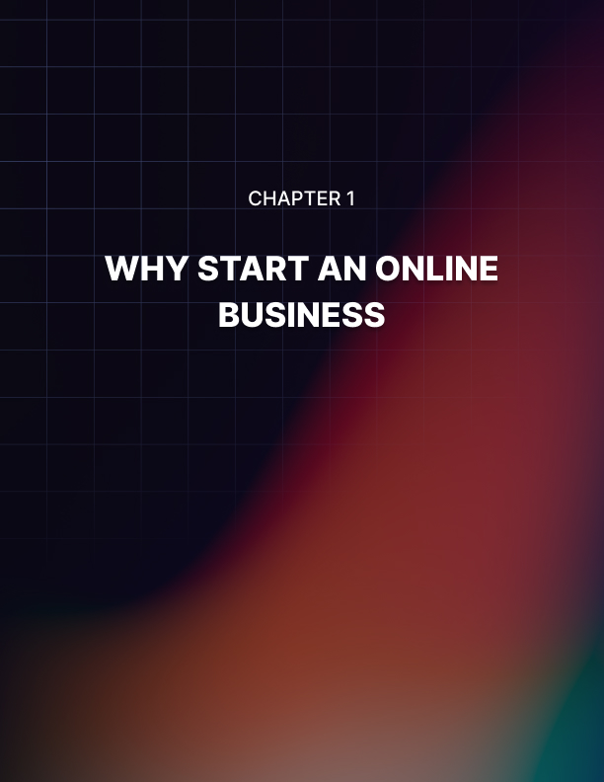

Chapter 1: Why Start an Online Business?

Why should you start an online business as opposed to a conventional brick and mortar business? There are a few good reasons for doing this:

- It costs a lot less to start an online business
- You do not need to hire any staff
- You do not need an office or other commercial premises
- You can start an online business today
- You just need a computer or mobile device and a connection to the Internet
- Work from anywhere
- Set your own hours
- People are used to making purchases online these days
- You do not need any technical skills
- You can outsource different tasks to freelancers

If you wanted to open a shop in a mall then you would need a lot of money to do this. You have to provide stock for your shop and pay commercial rent. Someone has to take care of the shop and if this is not going to be you then you will have to hire people.

You will also need to advertise your shop. If you are in a busy mall then you will get some potential customers to walk in out of curiosity. But to do really well you need to do a lot of marketing to get people to your shop.

Of course you will need to advertise your online business as well and we will cover this in a later section in this guide. But it is easier to market an online business than it is a brick and mortar business and your reach is much larger. You can literally sell your products and services to the world with an online business.

Work your Online Business Part Time
You can start your online business from home. There are many owners of 6 figure online businesses that work from home. They do not need an office and they are able to work the hours that they choose.

If you have a job that pays the bills at the moment then we recommend that you keep this and develop your online business in your spare time. This can be tough if you have a family but talk to them and explain that things will be better in the near future. You need your family onboard with what you are doing.

It is not easy working a full time job and then switching on your computer to start working on your online business. You need a great deal of commitment and motivation to do this and in a later section we will discuss setting goals for your online business and ways that you can drive yourself to take action.

Unfortunately, a lot of people that start online businesses fail. There are no published statistics on the reasons for this but one of the main ones is very likely to be that they did not take their online business seriously.

Because there is a low barrier to entry from a financial point of view, many people will give up if they do not get the results that they are looking for. They put in the time and effort initially to get everything set up, and then lose interest quickly after that. We do not want this to happen to you.

There are no Push Button Miracles
There is a great deal of hype around making money online and running an online business. New products launch all of the time claiming that they will show you how to make a fortune overnight with a few clicks of your mouse.

This is totally untrue. It takes time and effort to create a 6 figure online business. Some of these products rely on loopholes that are eventually closed which means that your income will cease. You want to build a sustainable online business.

Don’t be fooled by the hype. You cannot generate buyer traffic to your offers in less than a minute. This is ridiculous. There is no software out there that is going to magically turn your computer into an ATM. It is amazing that these product vendors get away with these wild claims.

A few years ago there were a number of scams on the Internet where people lost a lot of money and received nothing, or next to nothing in return. Over the years these have disappeared but you can never be too careful. If you are thinking of buying a product or service to help you with your online business then check it out thoroughly first.

Get started with a Domain Name and Hosting
If you are serious about your online business (which you need to be) then you need your own domain name. There are free services out there that you can use to create a website such as Blogger.com, WordPress.com and Weebly.com. Unless you are really strapped for cash we advise you not to use these services.

The reason for this is that people are a lot more Internet savvy than they used to be. They know that Blogger is a free website service and if you launch your business on a free platform like this then you are just going to look cheap.

You have to sell things to create a 6 figure online business. Trying to sell products and services from a free website is not going to work well. It is very important that you invest in a domain name and some web hosting.

You can get a .com domain name from Namecheap.com for less than $10 a year. There are many web hosting companies out there and you need a web host to make your website live on the Internet. You can get web hosting starting from $5 a month. It is important that the web-host you choose offers you a number of different features that we will explain in the section about setting up your website.

For now we just want you to accept that having your own domain name is the best way to go. If you were setting up a conventional business it would cost you thousands. For an online business you can start with a $10 a year domain name and $5 – $15 a month web hosting. Make the right impression from the start.

In the next chapter we will discuss the different online business models that you can choose from…
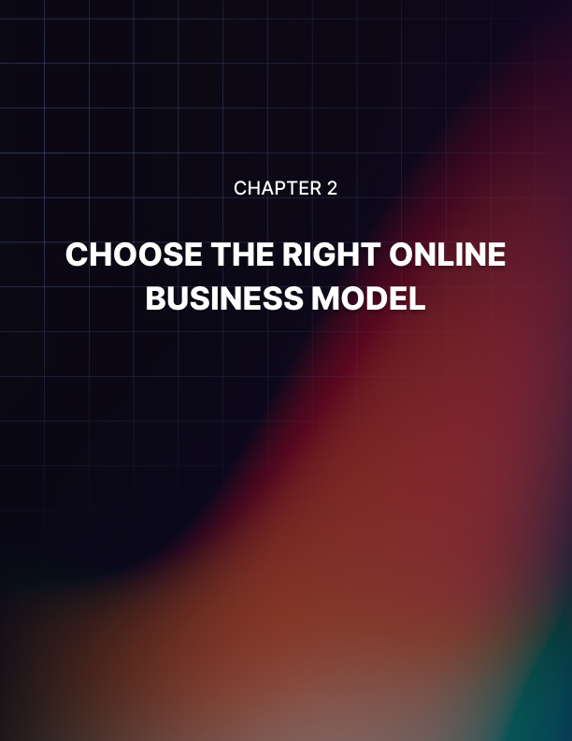

Chapter 2: Choose The Right Online Business Model

What kind of online business do you want to start? There are several ways that you can go with an online business. All of the models we cover in this section have the potential to provide a 6 figure business. You need to choose the one that you are most comfortable with.

A word of warning here – flitting around from one model to another is never going to turn out well. Many newcomers to online business start with one model and because they are not getting the results that they want they shift to another. There is always going to be someone that tells you that the grass is greener over here.

Once you have chosen your online business model you need to master it. There are always new things to learn about online business and it will be virtually impossible for you to keep up with all of the changes if you are dabbling with more than one model. So make your choice and stick to it.

What Niche do you want to be in?
There are literally thousands of niches where you can create a 6 figure online business. If you are an expert in a particular niche then this is always a good place to start. It doesn’t matter if you are not an expert in a chosen niche because you can always learn. When choosing a niche you need to consider two things:

- Is there a big demand?
- Is there money in the niche?

Both of these are very important. You do not want to enter a niche where there is little demand. You may be interested in a particular topic, but if nobody else is then your online business will fail. We suggest that you choose an evergreen niche. This is a niche where the demand is always there 365 a year, every year.

As far as we are concerned, these are the top 3 evergreen niches where there is always demand and the potential to make a lot of money:

- Wealth creation (making money)
- Health and fitness (weight loss is a classic niche)
- Personal development – relationships, self improvement, spirituality, Law of Attraction etc

There are other large evergreen niches as well and we are not saying that these are the only ones you should consider. But these are tried and tested and there will always be demand for them and money making opportunities.

If there is high demand for a niche but it is difficult to make money then you should avoid this. These days there are opportunities in most niches but you need to be sure that you can make good money from the niche that you choose.

Affiliate Marketing
If you are not familiar with affiliate marketing the concept is pretty simple. There are many vendors of products and services out there that will happily pay you a commission for bringing them new customers.

Your only job as an affiliate marketer is to promote the products and services of other vendors. You do not have to concern yourself with product delivery or customer service. All you have to do is drive targeted traffic to the affiliate offers.

You can promote physical products or digital products or both. Amazon has an affiliate program where you can make commissions by recommending physical products that they offer. The problem with this is that the commissions are low in the 3% to 5% range. If you choose the wrong products to promote you will only make pennies on each sale.

Digital products tend to offer much higher commissions. Typically a digital product will offer a 50% commission and this can go as high as 100%. The reason for this is that once a digital product is created it costs next to nothing to deliver it. So the vendors can pass on higher commission rates to you.

Some affiliate marketers promote both physical and digital products. Let’s say that you had a website providing health tips. There are so many products that you could offer to your visitors. You could promote exercise equipment or supplements as physical products, and guides and training for losing weight and getting healthy for digital products.

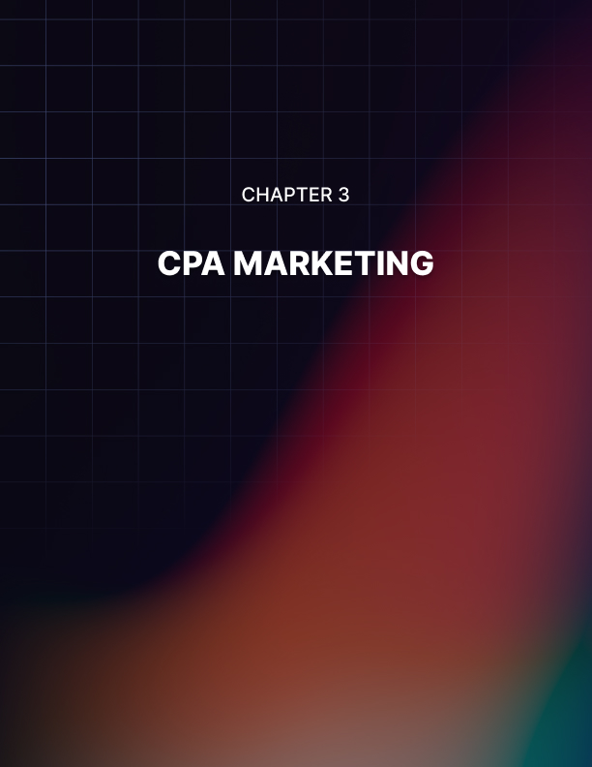

Chapter 3: CPA Marketing

CPA stands for “cost per action”. There are a number of CPA networks that have clients who will pay you for promoting their offers. The difference between CPA marketing and affiliate marketing is that you do not need to make a sale to earn commissions with CPA marketing.

Some CPA offers only require the visitor to provide their email address or phone number for example. Other CPA offers are based on free trials of products. This is all lead generation for the businesses that are behind the CPA offers.

The biggest problem with CPA offers is that most of them pay low commissions. This means that you have to drive a great deal of traffic to the offers to make good money. But you are not relying on a sale so the conversion rates are a lot higher than they are with affiliate marketing.

Creating your own Product or Service
Creating the right products and services in your niche that answer the questions that the target market has is a great way to build a 6 figure business online. It does take time, effort and usually money to create your own products and services. But the advantage that you have over affiliate marketing is that you own the customer.

Do you have an idea for a great product or service? Maybe you have expertise in a specific niche and you know what people in this niche are looking for? Your product will fix the pain that they have.

Your product can be physical or digital. What is most important is that there will be demand for it. You do not want to spend time and money developing a product that nobody wants. There are online businesses that make millions of dollars each year through providing products and services that people need and will gladly pay for.

Ecommerce
Do you like the idea of selling physical products from your own online store? Amazon makes gazillions doing this each year so why not you? As you are unlikely to have the same level of resources as Amazon, gazillions will be out of the question. But you can certainly create a 6 figure online business with e-commerce.

Setting up your own ecommerce store is now easier than it has ever been. There are solutions that you can use where you pay a monthly subscription such as Shopify. There are also themes and plugins for the WordPress blog platform that you can use which we will discuss in a later section.

Making your e-commerce store successful depends on being in the right niche and selling the right products. You will need to get the marketing right as well as there is a lot of competition these days. E-commerce is not for the faint hearted. You have to deal with customer service, returns, sourcing products, stock outs and more.

Dropshipping
The difference between drop-shipping and a conventional e-commerce store is that you do not need to acquire any stock with drop-shipping. There are drop-shipping websites that will provide the product range and take care of the delivery to the customer as well.

Sounds perfect right? Well it can be good but you need to check the commission levels first. Most drop-shipping websites are not too generous with their commissions so you will need to shift a high level of stock to make good income.

Drop-servicing
This is a relatively new term in online business but the concept has been around for a long time. You can make a great deal of money from this if you do it right. The old term for this was “service arbitrage”.

The concept of drop-servicing is that you find the customers and charge them a high price for a service that they need and then you get a freelancer with the skills to provide the service at a lower cost.

Let’s look at logo design for example. If a business went to a fancy agency to have a logo design it would probably cost hundreds of dollars. You can sell them a logo design service for $200 and then get someone on Fiverr.com to design the logo for your customer for around $20.

If everything goes well (which it should) then you make $180 on the deal. The good thing is that the customer pays you upfront for the service and then you pay the freelancer. SO your only cost is to find the customers and take care of them.

You can use PPC ads or social media ads to find customers. With such a good markup you can afford to spend money on advertising. The customer is yours so you can promote more services to them and make even more money.

To be successful at drop-servicing you must choose the right services to promote and find reliable freelancers that will do a great job for your customers. Here are some ideas for services you can promote:

- Design services – logos, website headers etc
- Writing services – SEO optimized posts and articles
- Copywriting services – sales pages, sales video scripts, email sequences etc
- Web development
- Search Engine Optimization (SEO)
- Programming
- App development

Freelance Services
Do you have a skill that is in demand? Are you a good content writer or copywriter? Are you an SEO expert that can rank websites and videos on YouTube? Do you have programming skills that are in demand?

There are lots of people providing freelance services to customers and creating 6 figure online businesses out of this. If you do not have any specific skills then you can either develop these or just go for drop-servicing.

You can use a number of different techniques to market your services. There are freelancer websites such as Upwork.com and Freelancer.com where you can set up a profile and bid for jobs or projects that they have in their system.

There are also gig based sites such as Fiverr.com and PeoplePerHour.com where you can post gigs related to your skills and then customers can purchase them. Some freelancers make thousands a month from Fiverr.

Amazon FBA
You can use the power of Amazon to sell physical products. They have an FBA (fulfilled by Amazon) service where you can list products on their sites and they will fulfill the customer orders and deal with any customer service issues. You will have to pay a fee per product sold to do this but this model does have the potential to make you a lot of money.

Amazon receives a huge amount of traffic every month. If you can provide a product or products that people want then you can be very successful with the FBA model. It is down to you to source the products and deliver them to Amazon warehouses for shipping to customers.

A lot of people involved in FBA turn to China for low priced products that they can sell at a higher price in the United States, the United Kingdom, Western Europe, Australia and New Zealand and so on.

The Amazon FBA model does require you to make an investment in product acquisition. Unlike other online business models you will need to spend a few thousand on products before you can start to see a return. But if your products are popular on Amazon they will sell fast and it will not be long before you start to see a return on your investment.

There are a number of pitfalls with Amazon FBA. If you don’t know what you are doing then you can lose a lot of money. Amazon has a lot of rules and regulations that you have to comply with for example. But if you get it right you can easily create a 6 figure online business.

Self Publishing
Are you a good writer? Do you have the next best selling fiction book whirring around in your head? Or maybe you are good at writing nonfiction books about business, personal development and other niches?

These days you can write a book and publish it yourself on Amazon Kindle and a lot of other self publishing websites. You do not need the websites to approve your book other than check that it does not violate their terms and conditions (they will have a list of book subjects that you cannot publish for example).

Once you have your book on Amazon Kindle or wherever it is all about marketing. You need to get as many people to check out your book as you can. If you get self publishing right then you can make 6 figures a year online and more.

This has been a long chapter and we make no apology for this. We have covered the main online business models here and you need to decide which of these is right for you. The easiest one to get started with is probably affiliate marketing.

In the next chapter we will talk about getting your 6 figure online business setup…
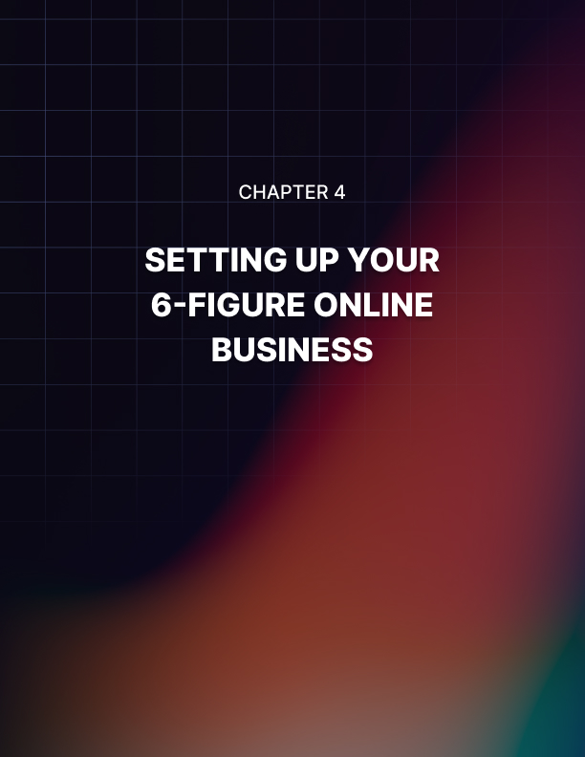

Chapter 4: Setting Up Your 6-Figure Online Business

No matter which of the online business models you choose to go for we would always recommend that you set up your own website. This is all about credibility. Even if you are using the Amazon FBA model it is still a good idea to have a website. People expect all businesses to have a website these days.

Domain Name
You need a good domain name for your 6 figure online business. The best domain name extension to use is .com but many names have gone for this extension. A good alternative is a .net r a .org and there are lots of other extensions available today such as .co, .club, .news, .review and so on.

If you are going to market in a specific country then choose a domain extension for that country. In the United Kingdom you can go for a .co.uk and even a .uk and in Australia there is .com.au etc.

For marketing your business worldwide you are better off with a .com, .net or a .org. These are generally accepted to be global domains. If you want to rank your web pages in search engines such as Google then these extensions are much better than those with a longer name like .review for example.

You can either go for a name that makes sense or a branding name. If you are going to open an ecommerce store then you could choose something like clothesforall.com which tells the visitor what to expect. Some ecommerce stores use branded domain names which don’t make any sense.

For example asos.com is a well known online clothing store. But if you didn’t know that then their domain name would not make sense to you. There is nothing wrong with going for a branding domain but you will need to work hard with your marketing to get the right amount of brand recognition.

A .com domain name will cost you less than $10 a year from Namecheap.com. Namecheap is a domain registrar which means they are authorized to sell domain names. There are many others such as GoDaddy.com. All of these registrars have a feature where you can search to see if your chosen domain name is available.

We recommend that you steer clear of domain names with hyphens in them. Clothes-for-all.com is nowhere near as good as clothesforall.com. Also you shouldn’t go for .info domains. These are cheaper to register but unfortunately they have a cheap feel about them. You only need to pay for your domain name once a year so make it a good one.

Web Hosting
In order for your website to be live on the Internet you will need a web hosting account. There are thousands of web hosting companies out there that have different plans and pricing. When you are just starting out you can go for shared hosting. As your traffic increases you can upgrade to VPS hosting and even rent your own server.

With web hosting you want the servers to be as fast as possible. People do not have any patience and they will be very frustrated if your website takes a lot of time to load. The search engines don’t like this either and you will have difficulty ranking a slow website.

Look for hosting companies that use the latest SSD (solid state drive) servers. You may pay a little extra each month for this but it is certainly worth it. It is essential that your website provides the best possible experience for your visitors and a fast loading site is an essential part of this.

Web hosting companies will have different shared hosting plans. They will list what these plans offer in terms of resources. When you are checking out web hosts look for the following:

- Unlimited disk space
- Unlimited bandwidth
- Fast SSD servers
- Free SSL certificates
- One click WordPress install
- cPanel Access
- Free malware monitoring and removal

You need to think about whether you will stick with one domain name or are likely to register more than one. If you choose the product creation model then you will probably need hosting that supports more than domain name for example as you may want to create new domains for all of your products.

Going for a shared hosting plan that allows you to add more than one domain name (some have unlimited domain names) makes sense as it usually does not cost a lot more and you tend to get better resources.

Another thing to look out for with web hosting is the support that they offer. Are there video tutorials available to show you how to perform specific tasks? Is there a good knowledge-base (where you can search for answers to questions)? Do they offer live support using a messenger app?

There are web hosting forums where you can investigate the support performance of a lot of web hosts. If you are new to all of this then it is really important that you have good support available. Sometimes things go wrong and you need to be confident that your web host will help you.

The cost of web hosting varies considerably. If you only want to host a single domain then it should not be difficult for you to find a quality web host that will take care of this for between $5 and $10 a month. Be careful with the advertised pricing as this is often yearly or 3 yearly deals where you have to pay a large amount upfront.

Unless you know and trust a web host then we would advise not going for yearly or more than one year deals. If you sign up for a 3 year deal and then find that the web host is not very supportive then you will lose a lot of money migrating to a new host. Go for the slightly more expensive monthly deals to begin with.

It is really important that your web host provides a one click WordPress installation service. We recommend that you use WordPress to set up your website as it is so easy and you don’t need any technical skills to do this.

Malware is a growing problem for web hosts. This can disable your website and if you have to hire someone to get rid of the malware to make your site live again this can be expensive. Some web hosts are offering malware monitoring and removal as part of the deal. Again you will pay a bit more for this, but your website being unavailable is a disaster.

WordPress
There are different ways to create a website. If you know HTML code you can use an editor to create your own pages. For an e-commerce store there are many different solutions available. We believe that the best website (blogging) platform available is WordPress. You can do so much with it and do not need any technical skills to use it.

Once you have linked your domain name to your web hosting account you will need to install WordPress next. Just go to the one click installer within cPanel and fill in a few details. Then tell the installer which domain name you want WordPress installed on. Click the install button and a few seconds later your website will be available.

WordPress is a content management system. It makes it easy for anyone to create pages and posts on their website. A page is something that will not change much such as your homepage, about us page, terms and conditions, privacy, contact us etc. Posts are for new content that you want to publish on your website.

When you install WordPress you can choose what theme you want for it. This is the look and feel of your website or the design.

There are thousands of free WordPress themes available as well as premium themes that cost a few dollars. It shouldn’t be too difficult for you to find a theme that you like. You can then easily install it. You can add plugins to WordPress as well. These provide enhancements to your WordPress website. For example there are a lot of plugins that will help you optimize your website for SEO, protect your site from spam, add fancy features such as countdown timers and much more.

There are many free plugins available for WordPress and there are some premium plugins available for a few dollars as well. Using the right plugins can really enhance the look and feel of your WordPress website.

There are plugins available that will turn your WordPress website into an e-commerce store for example. You can also find specific ecommerce themes for WordPress. The bottom line is that WordPress is very easy to use and adds content too. You don’t have to know anything about website design and development to create a great looking and functional site.

Logo
If you want to create a 6 figure business online then you need to have a professional logo on your website. Don’t even think about wasting your time trying to create your own logo if you don’t have any design skills. Just head over to Fiverr.com and find a good logo designer that will create a stunning logo for you for around $25.

Payment Processor
You will need a way to collect money for the purchases that your customers make. This applies if you are selling your own products and services or opening an e-commerce store. It is easy to find a payment processor who will collect payments for you (for a fee of course) and then allow you to transfer funds into a bank account.

One of the most well known and trusted payment processors is PayPal. They have millions of customers that use their services and their transaction fees are reasonable. You can create payment buttons from within your PayPal account to add to your website. The only problem with PayPal is that it is not available in all countries.

An alternative to PayPal is 2Checkout.com. They cover most countries in the world and they will also let customers pay using a PayPal account as well. Another popular payment processor is Stripe. Do your homework here and make sure that your payment processor works in your country and that you can make easy withdrawals.

Email Autoresponder
Email marketing is a very powerful way of keeping in touch with your customers and getting them to purchase your products and services later. Not everyone who visits your website is going to make a purchase straight away.

If you are able to capture their email address then you can send them email updates. Send them more information about the benefits of purchasing your products so that they will buy later on. You can also tell them about new products that are coming up.

You will need an email autoresponder service to capture email addresses and send emails out. With an autoresponder service you can setup sequences of emails that go out automatically whenever someone joins your email list. There is also a broadcast facility where you can send emails to your list whenever you want.

There are several companies offering auto responder services. Probably the two most popular services are from Aweber.com and GetResponse.com. Others include Mailchimp, Sendlane, Constant Contact and more.

In the next chapter we will discuss setting goals for your 6 figure online business…
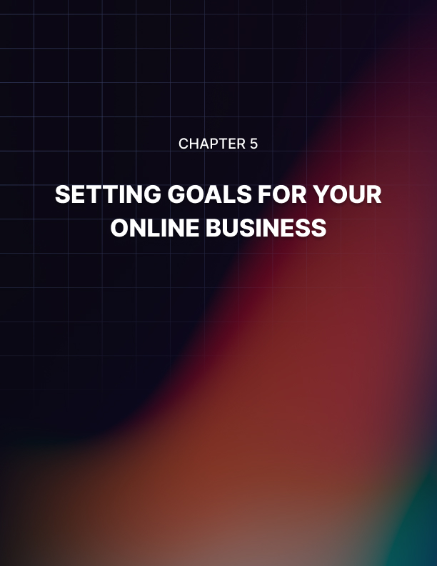

Chapter 5: Setting Goals For Your Online Business

If you want your new online business to fail then skip this chapter! That may sound harsh but it is true. Most people that start online businesses and fail had no plan or goals for their business. They just poked around and then got disheartened when they didn’t make the money that they wanted.

One of the major drawbacks of an online business is also one of its biggest advantages – you can start for a very small investment. Around $10 for a domain name and $10 a month for web hosting and you are good to go. So if things don’t work out as you wanted them too it is not much of a loss to give up.

You need to be persistent and work at your online business every day. If something is not working you need to figure out why and change your approach. Just because a method worked for someone else does not mean that it will work for you. The best way to muster the drive to carry on is by setting goals and having a plan.

Set Goals for your Online Business
How much money do you want your online business to generate in the first year? Most newbie online business owners don’t think about this. But you must think about it and then develop this into a goal for your online business.

This guide is all about creating a 6 figure online business so let’s say that your goal for the first year is to generate $100,000. Can that really be done? Yes it can. Many have generated more than this.

These people all had goals and plans and a WHY statement.

We never promised that you would make 6 figures in your first year so if $100,000 is a bit rich for you then go for $50,000. Just decide on a figure and then stick with it. Create your goal by using the SMART goal setting process which stands for:

- Specific - $50,000 in 12 months is specific
- Measurable – you can measure what you earn each month to see how well you are doing
- Achievable – you are not going to make thousands overnight as some of these product vendors claim so make sure that your goal is achievable
- Realistic – is it realistic to make $50,000 a year with an online business? Yes it is!
- Timed – you have set the goal for 12 months which is good. Adding a time frame for achieving your goal is essential.

Write your goal down. You can create a document on your computer as well, but when you write something down it is more powerful. Nobody really knows why this works but it does.

How does your Goal make you feel?
Think about how achieving your goal for your online business will make you feel. Visualize the money in your account. Think about how proud you will feel – you created this online business out of nothing. Feel the emotions of achieving your goal and make them strong.

Add these feelings to your goal. Describe how you will feel once you have achieved your goal. Write it down as part of your goal. Carry your written goal around with you wherever you go.

Why do you want to achieve your Goal?
Just having a goal, no matter how good, is never enough. You need to ask yourself why you really want to start an online business and make it a success. Don’t just write down that you are doing it for the money. Money is just something useful – what will you do with the money?

Who are you doing this for? Is it for your partner so that you can buy them something special? Think emotions here. You want to create a WHY statement for your goal that will drive you every single day. Once you have your reason(s) write them down in your WHY statement and carry it with you everywhere.

Daily Routine
When you get up in the morning, be sure to read your goal and your WHY statement. This is a great way to start the day. If you are working on your online business and something is stopping you from moving forward and you feel your motivation waning you can read your goal and WHY statement to reignite your motivation.

You are going to have some tough days ahead. Running a successful online business is not easy and there will be times when you feel very frustrated and may even question why you started the business. Get out your WHY statement and goal and find a new level of inspiration.

In the next chapter we will look at the importance of traffic generation…


Chapter 6: Traffic Generation

Traffic is the most important thing if you want to succeed with your online business. You can have a poor offer, but if you send enough visitors to it you will make sales. If you have the very best offer in the world and nobody is looking at it then you will not make a cent.

It is not difficult to generate Traffic
This will be a short chapter but a very important one. People that fail with online businesses do so because they didn’t generate enough traffic to their website.

No traffic = No Online Business
The thing is that there are many ways that you can generate traffic to your online business. There is no reason that you should fail here because there are free methods of traffic generation and paid methods.

The free methods will take more time than the paid methods, but if you are on a budget then you just need to accept this and get on with it. You can test with paid traffic and tweak your offers and landing pages to get better results.

Broad Traffic
You may have seen people advertising services to send you tens of thousands of visitors for a few dollars. This is general or broad traffic. If you are marketing a product or service that will appeal to a wide range of people – e.g. weight loss, then you may find a very small percentage will be interested to learn more. The majority will not be interested.

Broad traffic is basically anyone and everyone. They may be in the market to buy something but you have no idea what this is. Rarely is it worth going after broad traffic. So resist the temptation to purchase thousands of broad traffic visitors because it doesn’t work.

Targeted Traffic
Now think about getting visitors to your website that are actually interested in what you have to offer. Do you think that some of these visitors might convert? Yes they will! For example, if you have a website that teaches people how to make money online then you need to find visitors that are interested in doing this.

So the bottom line here is that you need to generate as much targeted traffic as you can. Once you have setup your website then you should spend 80% of your time on traffic generation. The more visitors you can get to your website the more successful your online business will be.

This is not rocket science. If you had a shop in the mall and nobody came in to it then you would not make any money. Well the same thing applies to an online business. If you have no visitors then you will not make any money let alone 6 figures. That is how important traffic generation is.

In the next chapter we will continue this theme by discussing the marketing of your online business…
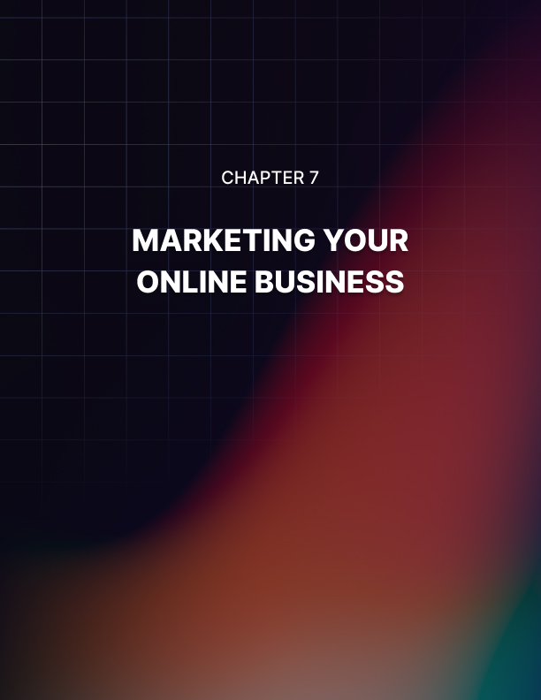

Chapter 7: Marketing Your Online Business

Now that you know the importance of traffic generation it’s time to go and get that targeted traffic for your new online business. See we will look at some free and paid traffic methods that you can use to market your online business.

Free Traffic Methods
There are many free traffic methods that you can use to drive visitors to your website. Most of these are going to take work but you can outsource some of this if you want to. We recommend that you use a combination of these methods to drive traffic on a regular basis.

Content Marketing
The principle here is that you create useful content that provides value to those who consume it and they will want to visit your website for more great content. Content can be written text, videos, podcasts (audio files) and images. We will discuss written text in this section.

When you create your website you want to add content to it on a regular basis. This is good for your visitors as well as the search engines like Google. If you do not consider yourself to be a good writer then you can always outsource this to a freelance writer.

You also want to post content on external websites. We highly recommend that you have a Facebook profile for your online business and create a Facebook page. Adding valuable content to this page will help to increase your following and engage with people that are interested in your niche.

It is also a good idea to set up an account on Medium.com. You can publish relevant and valuable content here and use it to drive targeted visitors to your website.

There are lots of other places where you can syndicate content, but you should focus on those that have the highest traffic. Medium.com gets around 200 million visitors a month.

Video Marketing
If you do not have videos on YouTube promoting your business then you are missing out on some serious targeted traffic. YouTube is the second biggest website in the world and gets billions of views every day.

Some people don’t like the idea of making videos and they do not want to appear on camera. If you think like this then you need to get over it. Showing your face is important as it helps to build trust with your visitors.

Again you want to provide value here. How to videos are very popular and perhaps you can show your viewers how to solve a particular problem in your niche. Make sure that you do some keyword research and optimize your videos for search. You want your videos to appear high up in any searches in YouTube for your keywords.

Podcasts
Another great way to drive targeted traffic is to create podcasts for your niche. If you are an expert in your niche you can talk about solving problems and changes in the niche. You can interview niche experts to increase the number of followers to your podcast channel. Upload your podcasts to the popular podcasting sites and add it to YouTube as well.

Search Engine Optimization (SEO)
SEO is a great free traffic method but it will take time. You will need to undertake keyword research (or outsource this) and then optimize your website for the keywords that you want to target. You need to know how competitive keywords are as it is not worth wasting your time trying to rank for those near impossible terms like “make money online” and “weight loss”.

What you want are keywords that have a reasonable amount of search volume that are not too competitive. You can publish posts on your website related to these keyword terms and make sure that they are all SEO optimized.

SEO is about internal and external optimization. You need to build backlinks (links from other websites) to your pages as this will help with your external optimization. These need to be high quality links – if they are from related websites then these will be the most powerful.

Social Media
We have already mentioned the value of having a Facebook profile and creating a Facebook page for your business. You do not need a social media profile on all of the networks.

If you sell to businesses then you need a LinkedIn profile because that is where your customers hang out. You can make relevant posts on LinkedIn to drive traffic.

Social media marketing is going to take time and effort. You need to develop a following of your target audience and keep providing them with value. It is certainly worth doing this as you can generate a lot of quality targeted traffic from social media. It is important to be realistic about the time you can dedicate to social media marketing.

Email Marketing
You can argue that email marketing is not really free because you have to pay a monthly fee for an autoresponder service. Let’s split the difference here and say that it is almost free. It is essential that you build an email list for your online business.

Very few visitors to your website are going to make a purchase on their first visit. The harsh reality is that you may never see that visitor again. So in order to minimize this loss you need to entice them to join your email list. Use a good incentive as visitors will be reluctant to give you their email address because they know you are going to market to them.

You could create a special guide or report that helps people solve a specific problem in your niche. It can be effective for online e-commerce stores to offer a discount to people that join their email list. Whatever you offer makes it enticing.

When you have potential customers on your email list you can send them an automated sequence of emails or broadcast emails. Each time someone new joins your email list they will receive your automated sequence of emails. You can use broadcast emails any time that you wish.

Don’t just send offers to your email list. Provide them with value as well. You want people to stay on your email list as long as possible so give them a good reason to stay. Email marketing works but you need to be smart about it.

Guest Blogging
Website owners are always looking for new and unique content to add to their sites. Some high traffic websites and blogs in your niche will probably accept a guest blog post from you as long as it meets their quality standards.

With a guest blog post you can add a link back to your website to drive more traffic. This is good for SEO as well. You need to check the rules of the blog that you want to make a post for. Some high traffic blog owners charge for guest posts so do your homework here.

Paid Traffic Methods
There are several paid traffic methods that you can use to send targeted visitors to your website. Most of these are not as expensive as you might think.

You are in control here and you can monitor what you spend on a daily basis. One of the good things about paid traffic is that you get results fast so you can test your landing pages.

Pay Per Click (PPC)
Another name for this is search marketing. You place ads with Google or Microsoft (Bing, Yahoo etc) and they appear on the first page of the search results for keywords that you determine. It is possible to generate a lot of traffic very quickly with PPC and it is a great way to test the different pages on your website.

Keyword research is essential here. You want your PPC ads to show up when people are searching for your target keywords. When you add keywords to your PPC campaigns Google and Microsoft will recommend the price that you should pay per click. Some keywords can be very expensive so be careful with this.

If you are an affiliate marketer then don’t send the traffic directly to the offer. Google will not accept an ad like this and you may have an ad rejected by Microsoft as well. Use a landing page as a bridge.

Capture the email address of the visitor on this page and add them to your email list.

Social Media Ads
If you don’t have a large following on your social media profiles then you can use social media ads to increase your number of followers. With Facebook and Instagram you can specifically target the people that you want to see your ads.

Knowing your target audience is very important. What kind of people do you want to visit your website? How old are they and what are their interests? Where is your audience in the world? What income levels do they have? You can specify all of this when you choose Facebook or Instagram ads.

Most of the social platforms provide the opportunity to create ads for your online business. For example, on Facebook you can boost the posts that you make on your Facebook page to a wider audience. Social media ads are not usually that expensive and they can help you to reach your target market effectively.

YouTube Ads
More and more online business owners are using YouTube ads these days. The idea here is that you specify the keywords for your niche and then choose existing videos that have a lot of views to run your ads. A YouTube ad is a video that you will need to create but it can be very effective.

Native Ads
The reason that native ads work so well is that they really blend in with a website and they look like natural links. Native ads can work really well in niches like weight loss, make money online and personal development.

In a recent survey it was stated that visitors to a site would look at native ads 52% more frequently than they would conventional banner ads. Native ads also get shared on social media a lot more. Around 32% of those surveyed said that they would share native ads on their social media accounts. Another surprising fact was that more people looked at the native ads than the original content. This was 26% for the native ads compared to 24% for the original content. It was also discovered that people looked at the native ad content for around the same amount of time that they looked at the original editorial content.

You can get a lot of traffic to your website with a native ad that is placed on another website that receives a lot of traffic. Some of the world’s most famous websites use native ads for monetization. These include Yahoo, Huffington Post and BuzzFeed.

There are other paid traffic methods that we have not discussed in this section that can produce good results. You can place banners on related websites and pay by the number of impressions. You can advertise on niche related forums and if you are in the make money online niche then solo ads can be effective.

You must monitor how much you are spending and the conversion rates that you achieve with paid advertising. Always be in control and never let your ad spend exceed your budget. Track everything so that you know where your traffic is coming from.

Marketing Plan: We strongly advise that you create a marketing plan for your online business. You can include a mixture of free and paid traffic methods in your plan. Think about the amount of money that you are prepared to spend on paid advertising and the time that you have available for the free traffic methods.

In the next chapter we will recommend a 30 day plan for your 6 figure online business…


Chapter 8: Your 30-Day Plan

If you fail to plan then you plan to fail. The first 30 days of your online business are critical as they define the way that you will approach things that you can repeat in the months ahead. Here are our ideas for the first 30 days of your new 6 figure online business:

- Decide on your Niche
You need to do this on day one. Choosing the right niche is critical to your success. It is essential that there is demand and that you can make money in your niche. If you are passionate about a particular subject then research this first. Always remember that you need to go where the money is so if your passion does not work out then find something else.

- Keyword Research
On day two we recommend that you perform keyword research for your chosen niche. This is a very important step that a lot of new online business owners ignore. You can do this yourself using the free Google Keyword Planner or you can outsource the task. Identifying the right keywords to target with your website and your promotional efforts is critical.

- Create your Goal and WHY statement
Decide on your goal for your online business and write this down. Create a corresponding WHY statement to provide you with the motivation to work on your business each day. Do this early, say day 2.

- Choose your Domain Name
On day 3 you need to choose your domain name and register it. It is your choice to go for a name that is related to your niche or a brand-able domain name. If your target market is worldwide then choose a .com, .net or .org domain extension.

- Choose a Good Web Host
This is another activity for day 3. Find a web host that will give you the best deal on a shared hosting package. Once you have chosen your web host you need to point your domain name to it. This is easy and there are plenty of videos on YouTube about this.

- Install WordPress
This can be a day 3 or 4 activity depending on the amount of time you have available. You need to have your domain name and web hosting set up first. Use the one click feature of your web hosting to install the WordPress blogging platform on your domain name.

- Customize your WordPress site
Again this can be day 3 or 4. Choose a theme for your new website that you like. Add the necessary plugins to enhance your website. Learn how to add content to your new WordPress site. There are lots of videos to show you how to do this. Get a logo created from a good freelancer on Fiverr.com and add this to your website.

- Add your Initial Pages
We will assume that you do this on day 5. You will need the following pages on your new website:

- Home page – this is the first page that your visitors will see so make it enticing.
- About Us page – this is very important as people want to know who you are and what you stand for
- Contact Us page – you need a way for your visitors to contact you and there are plenty of free plugins available to create a good contact page
- Terms and Conditions page – again you can find a free plugin to create this
- Privacy page – use a free plugin to create this

- Add post
This is where you add niche related content to your website. You can use text, videos and images here. Write these posts yourself or outsource the writing. Start adding content from day 6 and do this at least once a week.

- Create your Marketing Plan
From day 7 onwards just focus your effort on promoting your online business. Decide on your marketing plan and follow it. Add tracking to all of your promotional efforts to see what is working and what isn’t.

In the next chapter we will discuss scaling your online business…
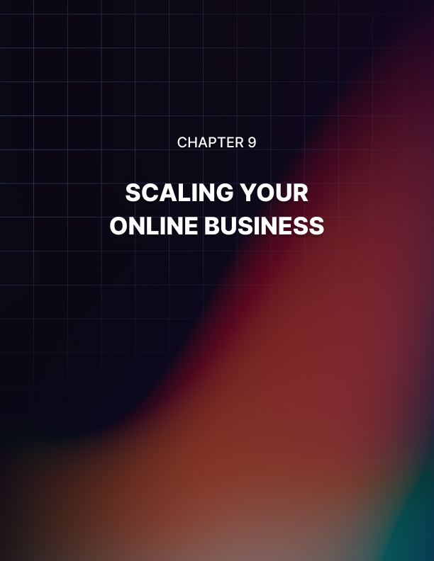

Chapter 9: Scaling Your Online Business

Once you have got your online business to a certain level you will want to scale it up so that you can drive more traffic and make more money. If you are working your online business on your own then you need to get help from others to scale it.

Outsource Specific Tasks
Once your online business is generating revenue on a regular basis you can pay others to perform specific tasks for you. Your focus needs to be on marketing so you can outsource the following:

- Written content creation
- Video content creation
- Making regular posts to your website
- Making regular posts to your social media profiles
- Optimization of your web pages for SEO
- The provision of quality backlinks for SEO
- Copywriting for your product offer pages and sales videos

Finding good outsources is not always easy but it is essential to grow your online business. You need the right team to support you as you scale up. There is only so much that you can do on your own even if you are working on your online business full time.

Analyze and Grow
You need to know what is working and what isn’t with your online business. Install Google Analytics on your site to see where your visitors are coming from.

Use the analytics from social media sites to see which of your posts are the most popular. With your paid advertising, find out what ads perform the best.

The idea here is that you use your analytics to do more of what is working and less of what isn’t. If you are not measuring how well your promotional activities are working then you will never scale your online business successfully.

Ramp up your Content Marketing
Use your virtual team to increase the amount of content marketing that you do. This includes new content for your website and posts to your social profiles. Add more videos to your YouTube channel as well. Your analytics will guide you as to what type of content you need to provide.

Ramp up your Paid Advertising
Once you know which of your paid advertising channels are working the best you can ramp these up by increasing your ad spend and eliminate the channels that are not performing. Be prepared to invest some of your profits in paid advertising that works.

In the final chapter we will discuss the best practices for a 6 figure online business that you need to follow…
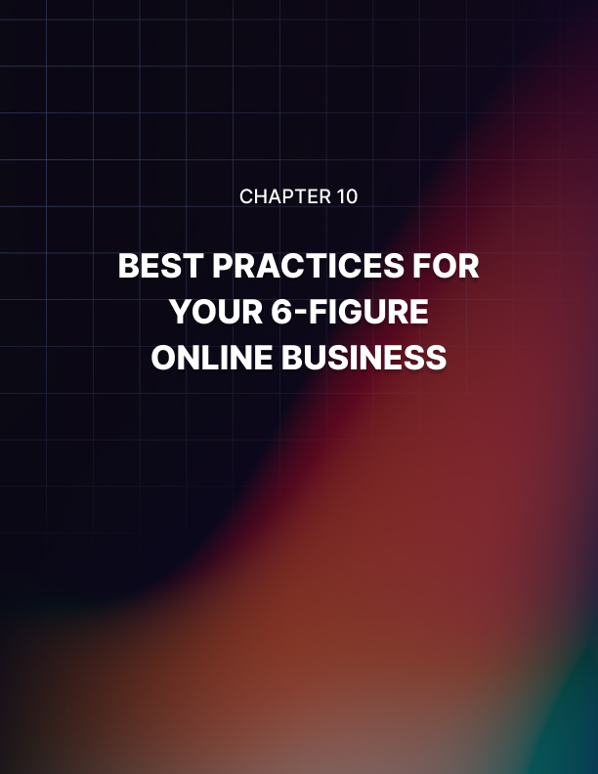

Chapter 10: Best Practices For Your 6-Figure Online Business

Here are the 8 best practices that we strongly recommend you follow to create a successful 6 figure business. It is not easy to develop a successful online business and we believe that if you follow these best practices you will have the maximum chance of success.

- Know the Advantages of an Online Business
There are several advantages to starting and running an online business. You do not require a great deal of money to get started and you can work from anywhere and at any time. Use these advantages to drive you to succeed with your online business.

- Choose the Right Online Business Model
You have a choice of several online business models and it is essential that you choose the right one. Think about the amount of money that you are prepared to invest in your online business, the skills that you have and the time you have available. Choosing the wrong online business model can be a disaster.

- Setup your Online Business properly
Make sure that you set up your online business properly. Don’t use a free website service and register a domain name and get some good web hosting. Install the WordPress blogging platform on your domain so adding content is easy.

- Set Goals for your Online Business
Set at least one goal and create a strong WHY statement for your online business. Some days the going will get tough and you can use your goal and WHY statement to motivate you and drive you forward.

Create a plan to make your online business a success.

- Traffic Generation
Once you have set up your online business you must spend the majority of your time, effort and money on generating traffic. Nothing is more important than this. If you don’t get enough traffic your online business will never be a success.

- Promote your Online Business
Do everything that you can to get the word out about your online business. There are several free traffic and paid traffic methods that you can use. Free methods tend to take more time to show results. Control your spending with paid methods.

- Create a 30 Day Plan
The first 30 days of your online business are critical so create a plan that defines the way that you will approach things right from the start. Make sure that you cover all of the important tasks and provide a focus on promotion and traffic generation.

- Scale your Online Business
Once you have got your online business to a certain level you can scale it up to drive more traffic and make more money. Find reliable freelancers that you can outsource specific tasks too. Work on ranking your web pages higher in the search results. Reinvest some of your profits by increasing ad spend.



Conclusion

If you have read this guide from start to finish you will have a good understanding of how you can set up and run a successful online business that has the potential to earn 6 figures and more.

Now it is over to you. While reading this guide will make you a bit smarter, only by taking action will you be able to choose the right online business model and drive all the targeted traffic that you need to make your online business a success.

We hope that you found this guide to be informative and useful. Get started today with your online business. We wish you every success with starting your online business and growing it to 6 figures and beyond!

