Table of Contents
____

Introduction 4
Understanding the Foundation 7
From Japanese Innovation to Global Excellence 8
Building Blocks of Organizational Excellence 9
Making 5S Work in Your Organization 12
Sort Your Space with Strategic Elimination 14
Understanding Value vs. Waste in Your Environment 15
The Red Tag Strategy 17
Measuring and Maintaining Your Sort Success 19
Set in Order and Shine for Efficiency 21
Creating a Place for Everything 21
The Science of Spatial Organization 23
Visual Management and Storage Solutions 24
Strategic Maintenance and Care 26
Integration of Physical and Digital Workspaces 29
Standardize Your Business Systems 34
Creating Visual Standards That Drive Performance 35
Developing SOPs That Drive Real Results 37
Implementing Control Systems for Sustainable Excellence 39
Building Organizational Capability Through Training 40
Sustain 5S in Your Business Culture 44
Creating a Culture Where Excellence Becomes Natural 45
Leadership's Role in Driving Sustainable Excellence 46
Building Systems That Sustain Excellence 48
Transform Your Business with 5S 53
The Compounding Power of 5S Implementation 54
Strategic Implementation: Your Path to 5S Success 55
Building Your 5S Support System 57

Disclaimer
____

The information provided in this ebook is intended solely for educational and informational purposes. The author does not accept any responsibility for the outcomes that may arise from the application of the material within. While efforts have been made to ensure the accuracy and relevance of the content, the author cannot be held accountable for any errors or omissions, or for any consequences resulting from the use or misuse of the information provided. The responsibility for any actions taken based on the information in this ebook lies solely with the reader.



Introduction
____
E
very business faces the same fundamental challenges: staying organized, maintaining efficiency, and maximizing productivity. Whether you run a small retail shop, manage a manufacturing facility, or operate a service-based company, your success depends on how well you handle these core aspects. The Japanese 5S methodology offers a proven solution that has transformed countless businesses worldwide, and it can do the same for yours.
Think about your current workspace. Do you waste precious minutes searching for important documents? Are your tools and supplies scattered across different locations? Does clutter slow down your team's performance?
These common problems drain resources, reduce productivity, and ultimately impact your bottom line. The 5S methodology addresses these challenges through a systematic approach that brings order, efficiency, and continuous improvement to your business operations.
The beauty of 5S lies in its simplicity and universal applicability. While it originated in Japanese manufacturing, its principles work equally well for businesses of all sizes and types. From organizing your office space to streamlining your production processes, 5S provides a clear framework that helps you eliminate waste, reduce errors, and create a more professional work environment. You'll discover how small changes in organization and standardization can lead to significant improvements in productivity and employee satisfaction.
Your journey with 5S will transform more than just your physical workspace. It will reshape how you and your team think about efficiency, organization, and continuous improvement. The methodology's five steps (Sort, Set in Order, Shine, Standardize, and Sustain) work together to create lasting change in your business operations. As you implement these principles, you'll notice fewer delays, reduced costs, improved quality, and a more engaged workforce.
This book serves as your practical guide to understanding and implementing 5S in your business. You'll learn not just the theory behind each step, but also specific strategies and techniques you can apply immediately. Through real-world examples and actionable advice, you'll gain the knowledge needed to make 5S work for your unique situation. Most importantly, you'll discover how to maintain these improvements over time, ensuring that the benefits of 5S become a permanent part of your business culture.
Successful businesses don't just happen by chance. They result from systematic approaches to organization, efficiency, and continuous improvement. The 5S methodology provides exactly that—a proven system that has stood the test of time and continues to help businesses thrive in competitive markets.



Understanding the Foundation
____
P
icture a manufacturing floor where workers waste 30 minutes daily searching for tools, or an office where employees navigate through endless stacks of papers to find important documents. These scenarios represent the costly chaos that the 5S methodology was designed to eliminate. By emphasizing principles like organization, visual management, and cleanliness, 5S helps teams streamline workflows, reduce errors, and foster a culture of continuous improvement—benefits that have made it a cornerstone of lean manufacturing practices worldwide.

From Japanese Innovation to Global Excellence
In the aftermath of World War II, Japanese manufacturers faced an unprecedented challenge: rebuilding their industrial capacity with limited resources. From this necessity, Toyota pioneered revolutionary management practices that would transform global business operations. The 5S methodology emerged as a cornerstone of this transformation, initially designed to maximize efficiency in manufacturing environments where every square foot and every second counted.
The methodology draws its name from five Japanese words: seiri, seiton, seiso, seiketsu, and shitsuke. These translate to “sort,” “set in order,” “shine,” “standardize,” and “sustain” in English. Consider the success story of Kawasaki Heavy Industries, which implemented the 5S in their motorcycle assembly plant. Within six months, they reduced production time by 23%, workplace accidents by 35%, and increased employee satisfaction scores by 40%.
The beauty of the 5S lies in its versatility. What started in manufacturing has proven equally valuable in healthcare, where organized supply rooms save critical minutes during emergencies, and in office environments, where structured workflows boost productivity. Companies like Google and Amazon have adapted these principles to their unique environments, proving that 5S transcends cultural and industrial boundaries.

Building Blocks of Organizational Excellence
Understanding each pillar of 5S reveals why this methodology creates such dramatic improvements in workplace efficiency and employee engagement:
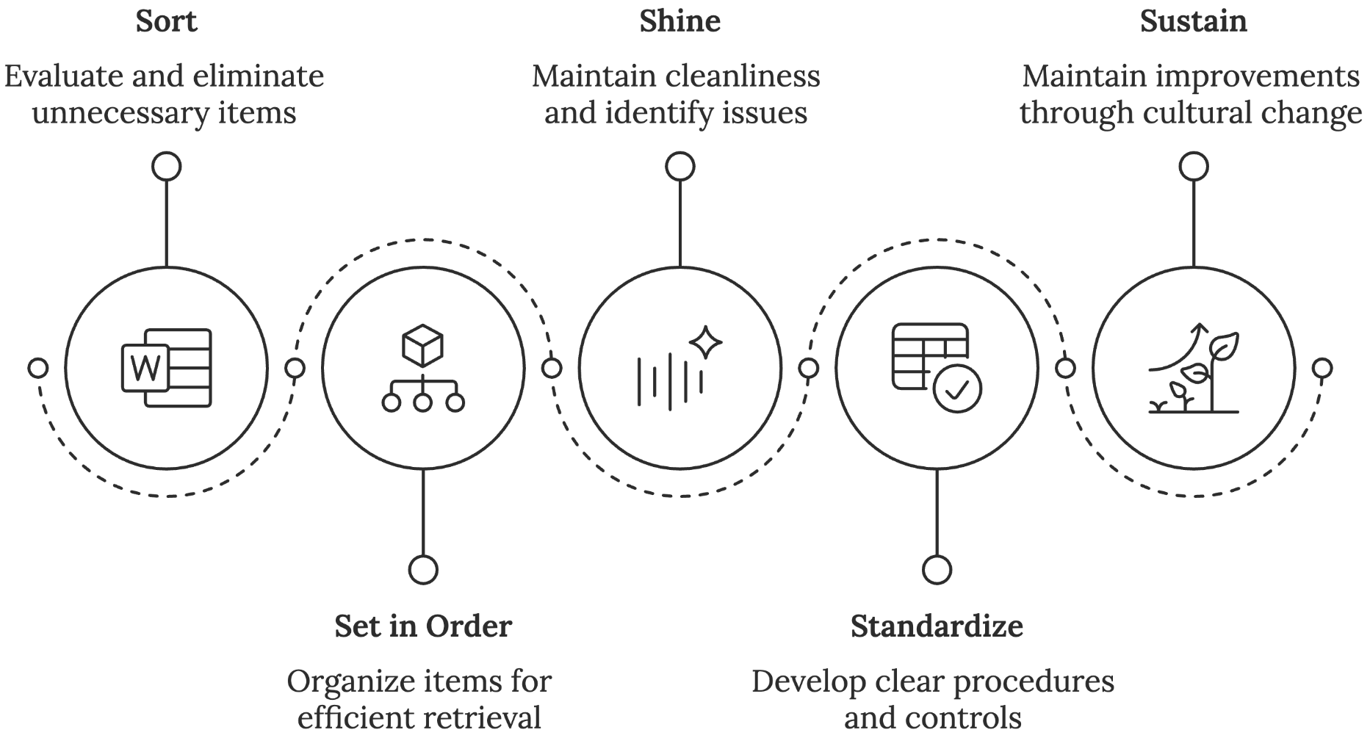

1. Sort (Seiri)
You begin by evaluating every item in your workspace through a critical lens. This isn't just cleaning; it's strategically eliminating waste. Imagine your workspace as a precision instrument where every element must earn its place. Items fall into three categories:
- Essential (used daily or weekly)
- Occasional (used monthly)
- Unnecessary (hasn't been used in 3+ months)
During a Sort initiative at Toyota's Kentucky plant, teams discovered that 40% of tools and materials in workstations were unnecessary. Their removal created space for more efficient workflows and reduced the time workers spent searching for essential items by 75%.

2. Set in Order (Seiton)
Once you've eliminated the unnecessary, you'll organize remaining items based on usage frequency and workflow requirements. This pillar transforms your workspace into a highly efficient system where everything has a designated home. Japanese manufacturers use the concept of "30-second retrieval," which means any tool or document should be locatable within 30 seconds.
Emergency rooms apply this principle, where critical supplies are arranged in standardized locations across all rooms, enabling medical staff to work efficiently even under intense pressure. This standardization has reduced treatment response times by up to 50% in hospitals that have implemented 5S.

3. Shine (Seiso)
This pillar extends beyond simple cleanliness to create a culture of proactive maintenance and inspection. When you maintain clean, well-organized spaces, problems become immediately visible. A clean workspace acts as an early warning system for equipment issues, safety hazards, and process inefficiencies.
For example, a manufacturing plant in Wisconsin implemented daily cleaning protocols as part of their Shine initiative. Workers discovered small oil leaks in equipment that would have eventually led to major breakdowns. This preventive identification saved an estimated $200,000 in potential repair costs and downtime.

4. Standardize (Seiketsu)
Standardization transforms individual best practices into systematic improvements. You'll develop clear procedures, visual controls, and checklists that make it impossible to regress to old habits. This pillar ensures that improvements become permanent through:
- Visual workplace controls
- Standard operating procedures
- Regular audits and assessments
- Clear responsibility assignments

5. Sustain (Shitsuke)
The final pillar focuses on maintaining improvements through cultural change and continuous reinforcement. This is where many 5S initiatives falter, but success stories show that sustaining improvements requires:
- Regular training and education
- Leadership commitment and visibility
- Recognition and reward systems
- Performance metrics and feedback
- Employee engagement programs

Making 5S Work in Your Organization
Successful 5S implementation requires careful planning and a clear understanding of your organization's unique challenges. Before you begin, study these essential preparations:
- Leadership Engagement
Your leadership team must visibly support and participate in 5S activities. When leaders at Harley-Davidson implemented 5S, they spent time each week on the shop floor, participating in Sort activities and Shine inspections. This visible commitment resulted in 90% employee participation rates.
- Training and Education
Develop a thorough training program that explains not just the what, but the why of 5S. Successful programs typically include:
- Initial awareness training for all employees
- Detailed implementation training for team leaders
- Hands-on practice sessions
- Regular refresher courses
- Pilot Programs
Start with a single area or department to demonstrate success and learn from challenges. When Boeing implemented 5S in their assembly operations, they began with one production line. The successful pilot program provided valuable lessons that smoothed implementation across the entire facility.
- Measurement Systems
Establish clear metrics to track progress and demonstrate value, such as:
- Time savings in material retrieval
- Space utilization improvements
- Accident reduction rates
- Productivity increases
- Quality improvements
- Employee satisfaction scores
Through proper implementation and sustained effort, 5S transforms chaotic workspaces into models of efficiency and productivity. The methodology's proven track record across industries and cultures testifies to its fundamental value in creating organized, productive workplaces that benefit both employees and organizations.
When you master the principles of 5S, you'll possess a powerful tool for workplace transformation that has stood the test of time. Its simplicity belies its effectiveness, and its results speak for themselves through improved efficiency, reduced waste, and enhanced employee satisfaction.



Sort Your Space with Strategic Elimination
____
Y
our desk overflows with stacks of papers, drawers burst with files you haven't touched in months, and unused equipment gathers dust in the corner. Sound familiar?
This workplace chaos isn't just an eyesore—it's bleeding your business dry. A survey by Huddle found that inefficiencies in document retrieval and approval processes cost professional services firms an average of $3,747 per employee per month in lost billable time. The first pillar of 5S methodology, Sort (Seiri), offers a systematic solution to eliminate this costly inefficiency and transform your workspace into a model of productivity.

Understanding Value vs. Waste in Your Environment
When you begin the Sort journey, you're doing more than just tidying up; you're making strategic decisions that directly impact your bottom line. Think of your workspace as a precision instrument where every component must justify its existence. This mindset shift transforms Sort from a simple cleaning exercise into a powerful business optimization tool.
The concept of "visual noise" lies at the heart of Sort's effectiveness. Japanese manufacturing experts discovered that excessive items in a workspace create cognitive interference that extends far beyond physical clutter. Cluttered environments tend to reduce focus and significantly increase stress levels among workers. This mental burden affects decision-making, creativity, and overall performance.
To implement Sort effectively, you must first understand the four distinct categories that every item in your workspace falls into:
Critical Items (Used Daily) - These are the tools, materials, and resources that directly contribute to your core operations. Think of the software you use every hour, the reference materials you constantly consult, or the equipment that keeps your production line moving.
Important Items (Used Weekly) - These items play a regular but not constant role in your operations. They might include meeting materials, weekly report templates, or maintenance tools used for regular upkeep.
Occasional Items (Used Monthly) - These are the resources you need periodically but not frequently. Seasonal equipment, quarterly reporting tools, or backup supplies typically fall into this category.
Unnecessary Items (Not Used in 3+ Months) - This category represents the greatest opportunity for improvement. These items often linger due to the "just in case" mentality, consuming valuable space and mental bandwidth while providing no real value.
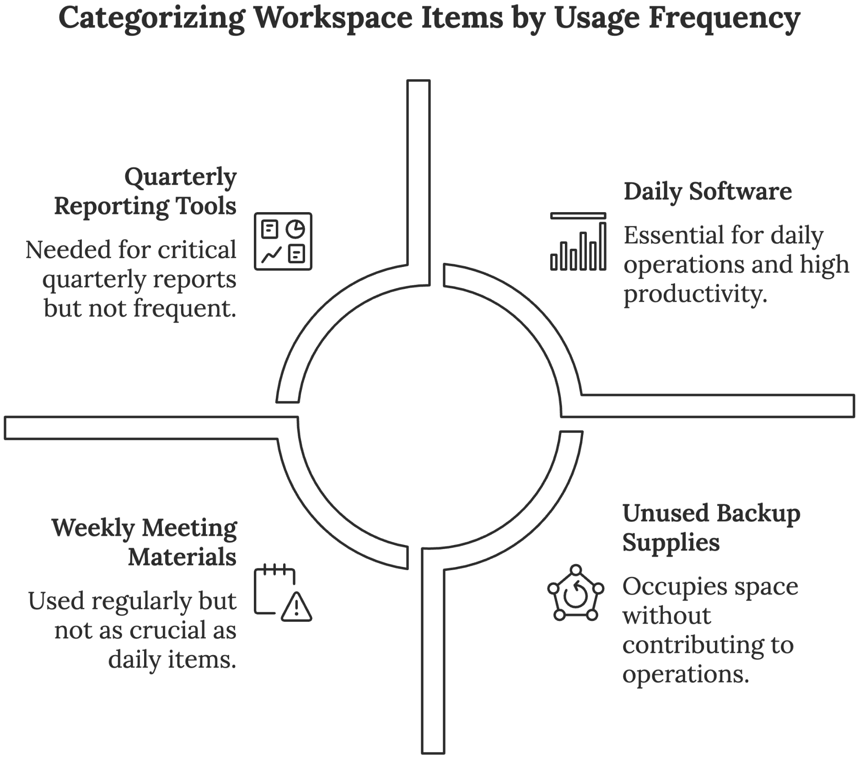

The Red Tag Strategy
The red tag strategy serves as your practical framework for implementing Sort decisions. This systematic approach removes emotion from the equation, replacing gut feelings with objective criteria. Here's how to make it work in your organization:
Start by creating a dedicated red tag holding area, a temporary storage space where questioned items can be evaluated without disrupting daily operations. Each red tag should include critical information, such as item description, date tagged, department origin, reason for tagging, and suggested action.
When implementing the red tag strategy, you'll categorize items based on urgency and evaluation needs:
Category A (Urgent) - Items requiring immediate decision-making. These might include safety hazards, expired materials, or broken equipment taking up valuable space. Give your team 48 hours to make final disposition decisions.
Category B (Standard) - The majority of your items will fall here. Allow two weeks for evaluation, during which team members can "claim" items they genuinely need. Track usage patterns during this period to inform final decisions.
Category C (Extended) - Complex items requiring longer evaluation periods. These might include seasonal equipment or specialized tools. Set a 30-day maximum evaluation period to prevent analysis paralysis.
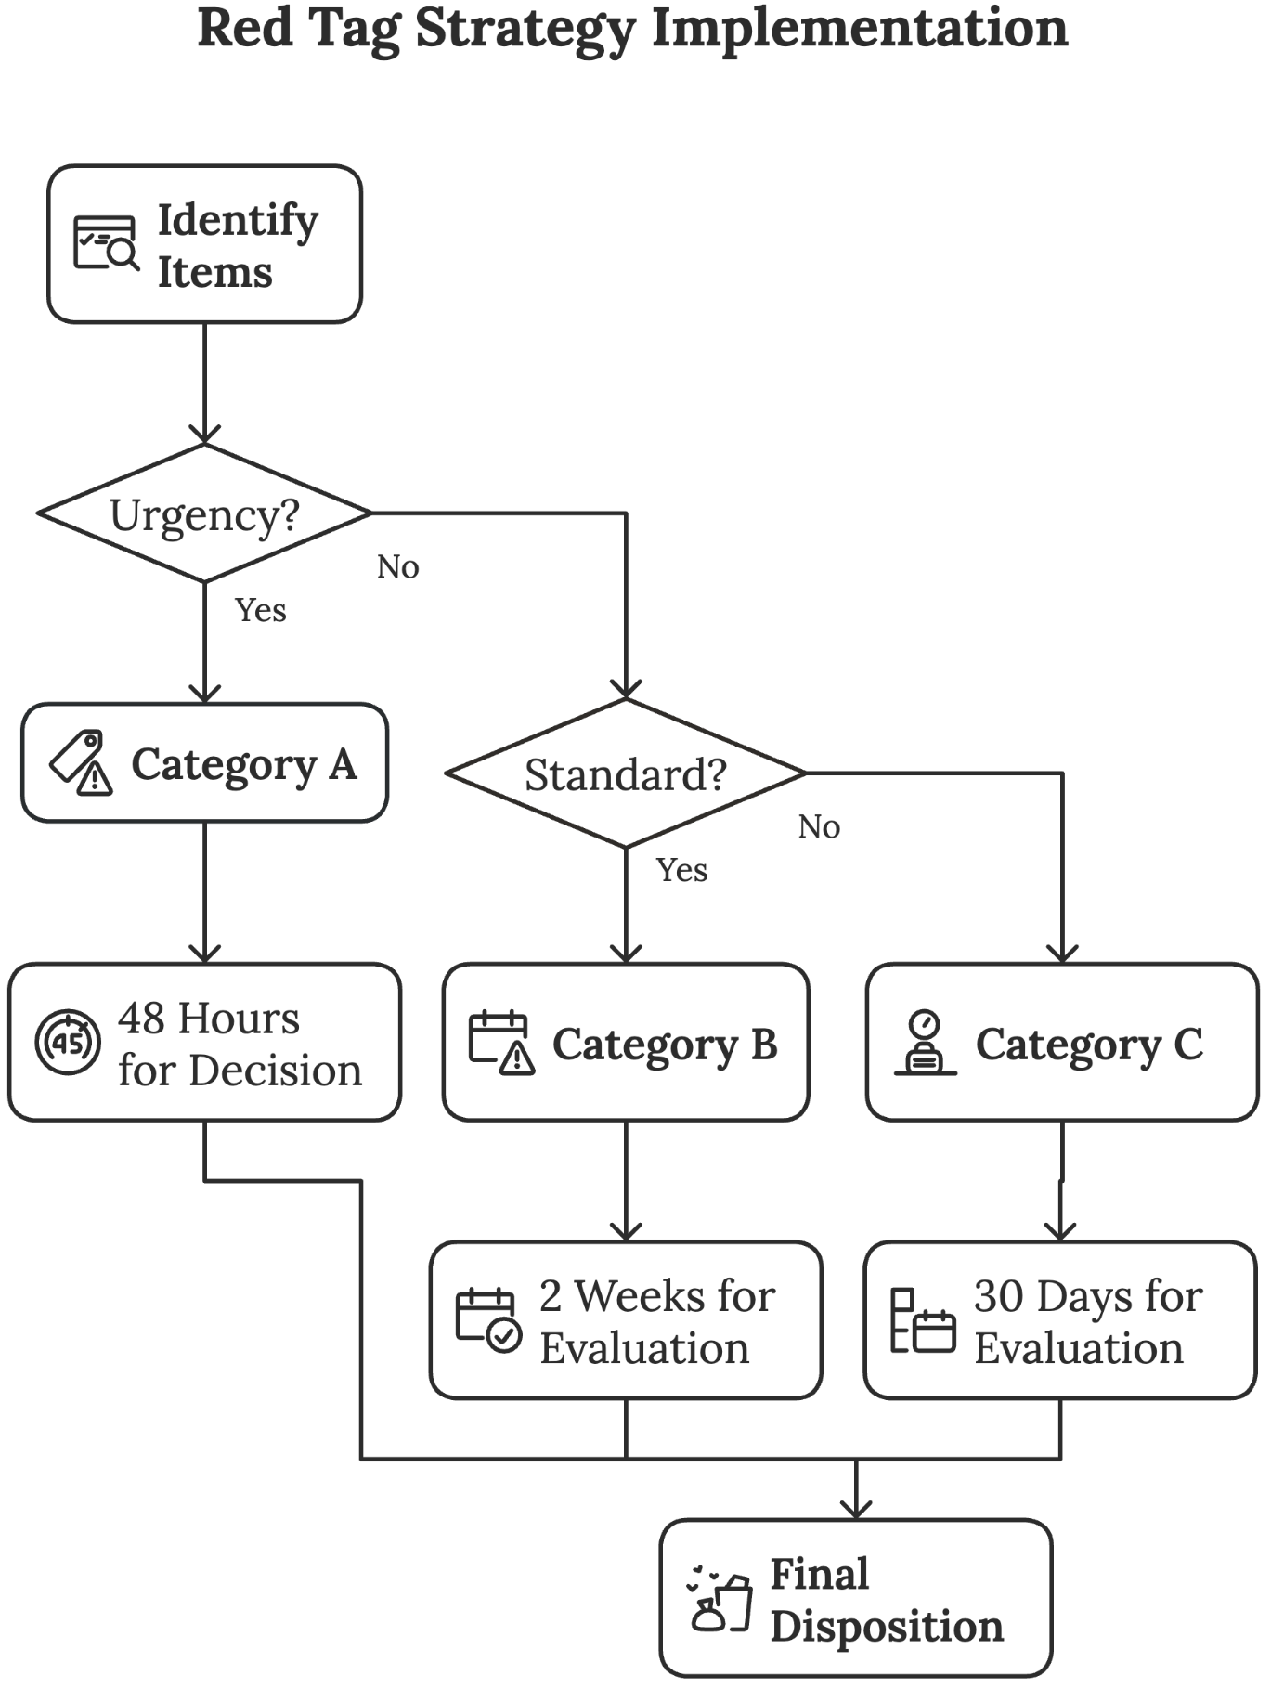
A manufacturing client implemented this strategy and discovered 30% of their stored inventory hadn't moved in over a year. By clearing this dead stock, they reduced storage costs by $50,000 annually and improved inventory turnover by 40%.
The real power of the red tag strategy lies in its ability to create sustainable change. When you systematically evaluate every item in your workspace, you develop new habits and decision-making skills that prevent future clutter accumulation. Team members learn to question the necessity of items before they enter the workspace, creating a natural filter against unnecessary accumulation.

Measuring and Maintaining Your Sort Success
Implementation is just the beginning. The true value of Sort emerges through consistent measurement and maintenance. You need concrete metrics to justify the investment and identify areas for ongoing improvement.
Create a measurement framework that captures both quantitative and qualitative improvements:
Time Metrics - Track the minutes saved in daily operations. Calculate the reduction in search time for tools and documents. Measure improvements in setup and changeover times.
Space Utilization - Document square footage recovered through the elimination of unnecessary items. Calculate storage space optimization percentages. Measure improvements in workplace density and equipment accessibility.
Financial Impact - Calculate direct cost savings from reduced inventory carrying costs. Measure productivity improvements in dollar terms. Track maintenance cost reductions related to better organization.
Employee Satisfaction - Conduct regular surveys to measure workplace organization satisfaction. Track stress level reductions and improvements in job satisfaction. Gather feedback on process efficiency improvements.
A manufacturing company implementing these measurements discovered their Sort initiative led to a 15% reduction in production setup times and a 25% improvement in workplace satisfaction scores within the first three months.
The psychological aspects of Sort often present the biggest challenge to successful implementation. People naturally resist letting go of items, fearing they might need them in the future. Address this by creating a positive association with the Sort process. Celebrate small wins, share improvement metrics, and recognize team efforts publicly.
When you succeed with Sort, you create a foundation for all other 5S pillars. A properly sorted workspace enables efficient organization, simplifies cleaning processes, supports standardization efforts, and makes sustainable improvements possible. By mastering Sort, you're not just clearing space – you're creating the conditions for operational excellence.



Set in Order and Shine for Efficiency
____
Y
our hands brush against a well-worn workbench, its surface gleaming under bright lights. Every tool rests in a custom-fitted shadow outline, materials flow naturally between stations, and the workspace hums with the quiet efficiency of a master craftsman's studio.
This isn't just organization. It's orchestration, where Set in Order and Shine transform cluttered chaos into a performance of peak productivity.

Creating a Place for Everything
The second S, Set in Order, focuses on arranging necessary items so they are easy to find, use, and return. While Sort (the first S) eliminates unnecessary items, Set in Order creates efficient, intuitive systems for the items you actually need. The guiding principle is simple yet powerful: "A place for everything, and everything in its place."
Effective Set in Order implementation follows these key principles:
- Proximity - Place items closest to where they will be used.
- Frequency - Position most frequently used items within easiest reach.
- Sequence - Arrange items in the order they will be used in common processes.
- Ergonomics - Design storage to minimize physical strain and wasted movement.
When properly implemented, Set in Order creates workspaces where anyone can quickly find what they need, use it effectively, and return it promptly. This dramatically reduces time wasted searching for tools and materials while preventing the accumulation of clutter that naturally occurs when return locations are unclear.
The benefits extend beyond simple efficiency. Well-ordered workspaces reduce cognitive load by eliminating constant decision-making about where items should go. This mental clarity allows workers to focus on value-adding activities rather than organizational housekeeping.

The Science of Spatial Organization
Creating an efficient workspace isn't about aesthetics, but about applying proven principles of motion economy and workflow optimization. Think of a surgeon's operating room, where every instrument has its precise location, arranged in sequence of use, within easy reach. While your business may not deal with life-or-death situations, the principles remain identical: thoughtful organization leads to better outcomes.
Well-organized environments typically experience productivity boosts and reductions in work-related stress. These improvements stem not just from better organization, but from the psychological benefits of working in a space where everything has its place and maintains a professional standard of cleanliness.
Your brain processes every visual input in your environment, whether you realize it or not. In a well-organized space, this processing power can focus on productive work rather than filtering through chaos.
Motion economy focuses on minimizing unnecessary movements and maximizing efficiency in every action. Contemplate how a professional chef moves through their kitchen during service. Every ingredient, tool, and surface is positioned to support natural movement patterns, reducing wasted motion and mental energy. This same principle applies to any workspace, from manufacturing floors to creative studios.
To implement motion economy effectively, start by analyzing your current workflows. Map the typical movement patterns of your team during different tasks. Look for opportunities to reduce unnecessary movement and reorganize spaces to support natural flow. Common inefficiencies often include:
- Frequently used items stored too far from their point of use
- Workflow bottlenecks caused by poorly placed equipment
- Unnecessary reaching, bending, or stretching for routine tasks
- Crossed movement patterns creating congestion
Your organization system should follow the principle of first-touch accessibility. Most frequently used items belong within arm's reach, secondary items within walking distance, and rarely used items in designated storage areas. This creates natural zones that support efficient work patterns while maintaining clear organization.

Visual Management and Storage Solutions
Visual management transforms abstract organizational systems into concrete, visible realities. This approach leverages your brain's ability to process visual information quickly and effectively. When implemented properly, visual management creates an environment where anyone can understand the organizational system at a glance, reducing training time and minimizing errors.
Observe how professional kitchens organize their knife storage. Magnetic strips mounted at eye level keep knives visible, accessible, and protected. This system makes it immediately apparent if a knife is missing and ensures proper storage is as easy as placing the knife against the magnetic strip. The same principle applies to any workspace, so make the right way the easy way.
Color coding serves as a powerful tool in visual management, but its effectiveness depends on consistent application and clear meaning. Develop a simple color system that serves multiple purposes:
- Department or category identification
- Priority levels and urgency indicators
- Process flow and directional guidance
- Safety zones and hazard warnings
Shadow boards represent one of the most effective visual management tools, using outlines or silhouettes to show exactly where each tool belongs. The visual nature of these boards makes proper organization intuitive and immediately shows when items are missing or out of place.
Floor marking and zoning create clear boundaries and movement paths throughout your workspace. Use consistent colors and patterns to designate:
- Primary walkways and material flow paths
- Equipment and storage zones
- Safety areas and emergency routes
- Work cell boundaries and buffer zones

Strategic Maintenance and Care
Shine extends far beyond simple cleanliness; it represents a proactive approach to workplace maintenance and equipment care. This step creates an environment where problems become immediately visible and where regular maintenance prevents costly breakdowns. Think of Shine as your early warning system, detecting small issues before they evolve into major problems.
A methodical approach to Shine yields multiple benefits:
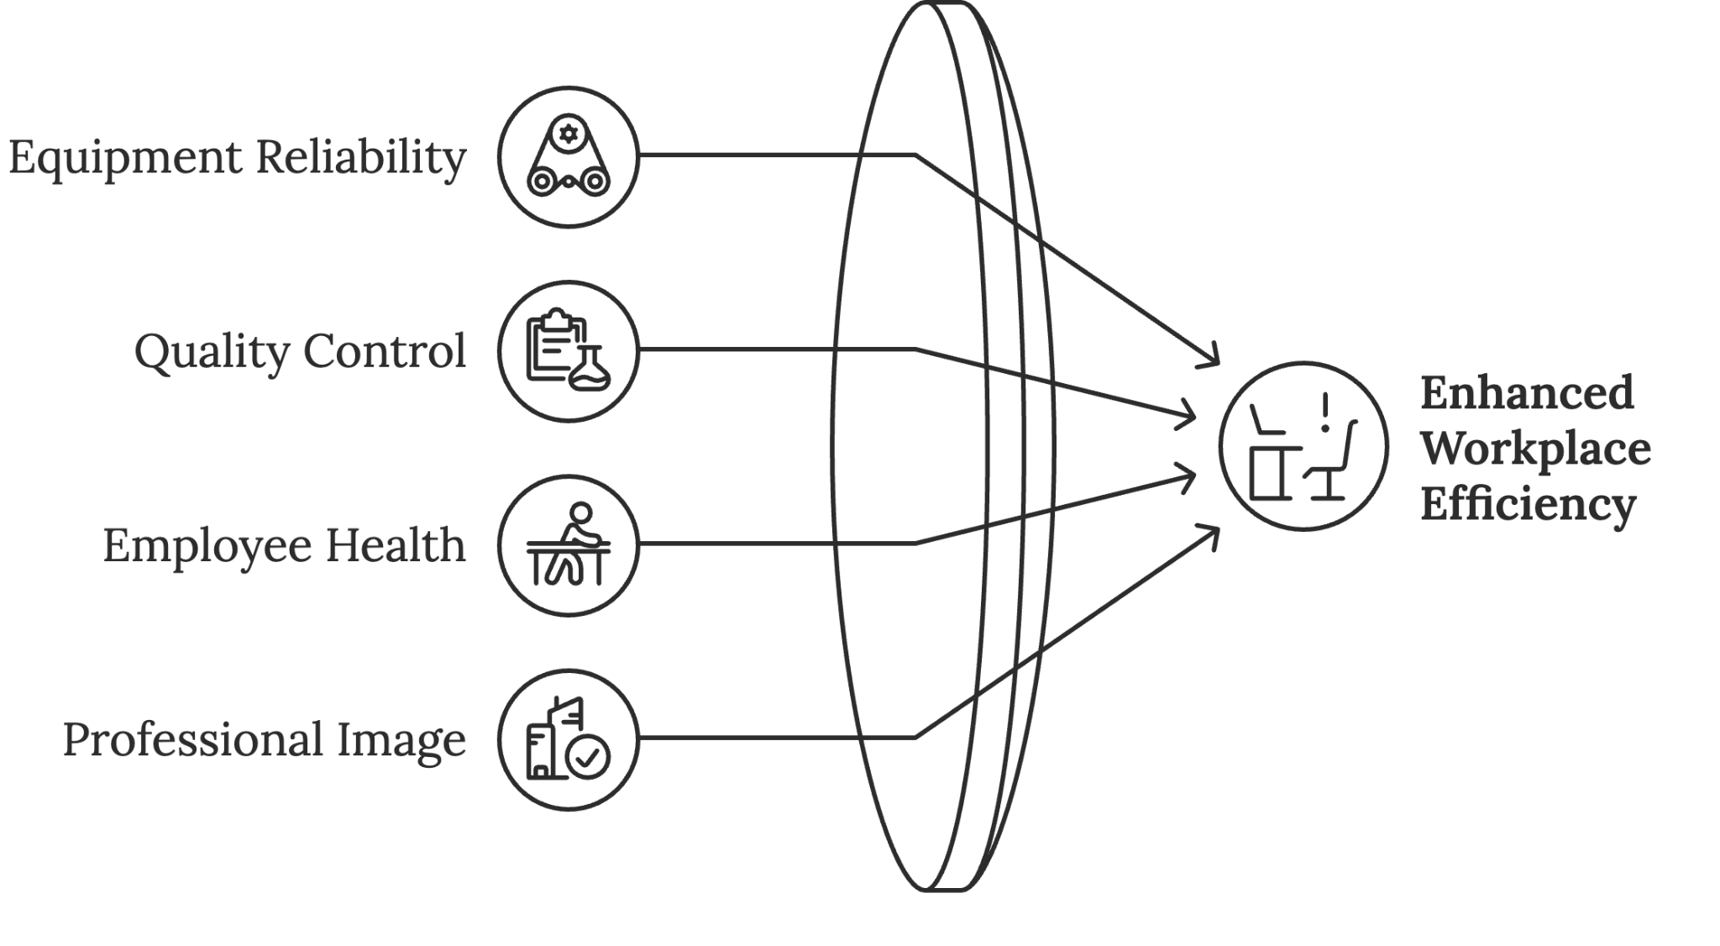
Equipment Reliability - Regular cleaning reveals potential maintenance issues early, reducing unexpected breakdowns in manufacturing environments. When surfaces and equipment are clean, unusual wear patterns, leaks, or vibrations become immediately apparent.
Quality Control - Clean environments significantly reduce contamination risks and error rates. In precision manufacturing, cleanliness directly correlates with product quality. Even in office environments, organized and clean spaces lead to fewer mistakes in document processing and data entry.
Employee Health - Well-maintained workspaces show measurable improvements in air quality and reduced sick days. Regular cleaning and maintenance help create a healthier environment, reducing the spread of germs and allergens that can lead to workplace-related illness.
Professional Image - A clean, well-maintained workspace builds confidence among customers and pride among employees. This psychological benefit translates into measurable improvements in customer satisfaction and employee retention.
Implementing effective Shine protocols requires clear standards and consistent execution. Your cleaning and maintenance schedules should account for different time horizons.
Daily tasks focus on basic cleanliness and inspection, such as:
- Workspace cleanup before and after shifts
- Equipment wiping and basic maintenance
- Quick safety and function checks
- Immediate reporting of any issues
Weekly deep cleaning addresses accumulated wear, including:
- Thorough equipment cleaning
- Detailed inspection of wear points
- Preventive maintenance tasks
- Organization system audit
Monthly maintenance provides complete care, such as:
- Complete system checkups
- Preventive repairs and updates
- Deep cleaning of all areas
- Performance analysis and adjustment
The key to successful Shine implementation lies in making it a natural part of daily operations rather than an additional burden. Create cleaning stations at strategic points throughout your workspace, equipped with necessary supplies and clear instructions. Develop simple checklists that guide workers through required maintenance tasks while documenting completion.
Your Shine protocols must be specific to each area while maintaining consistency across the organization. Document standards for:
- Cleaning methods and materials
- Inspection points and criteria
- Maintenance procedures
- Problem reporting processes
- Response time requirements
Shine serves as your first line of defense against equipment failure and quality issues. When implemented effectively, it reduces maintenance costs while extending equipment life and improving overall operational efficiency.
Through careful implementation of Set in Order and Shine, you transform your workspace from a potential obstacle into a powerful asset that drives success and supports growth. The journey to organizational excellence continues with standardization, but the foundation you build through these steps will support every future improvement initiative.
In the next chapter, we'll explore how to standardize these practices across your organization, ensuring consistent excellence in every area of operation. The systems you've created through Set in Order and Shine will serve as the building blocks for comprehensive standardization.

Integration of Physical and Digital Workspaces
Modern workplaces require seamless integration between physical and digital organization systems. The principles of Set in Order and Shine apply equally to your computer files, digital communication, and cloud storage. A disorganized digital workspace can be just as costly as a cluttered physical environment.
Start by applying the same zoning principles to your digital assets:
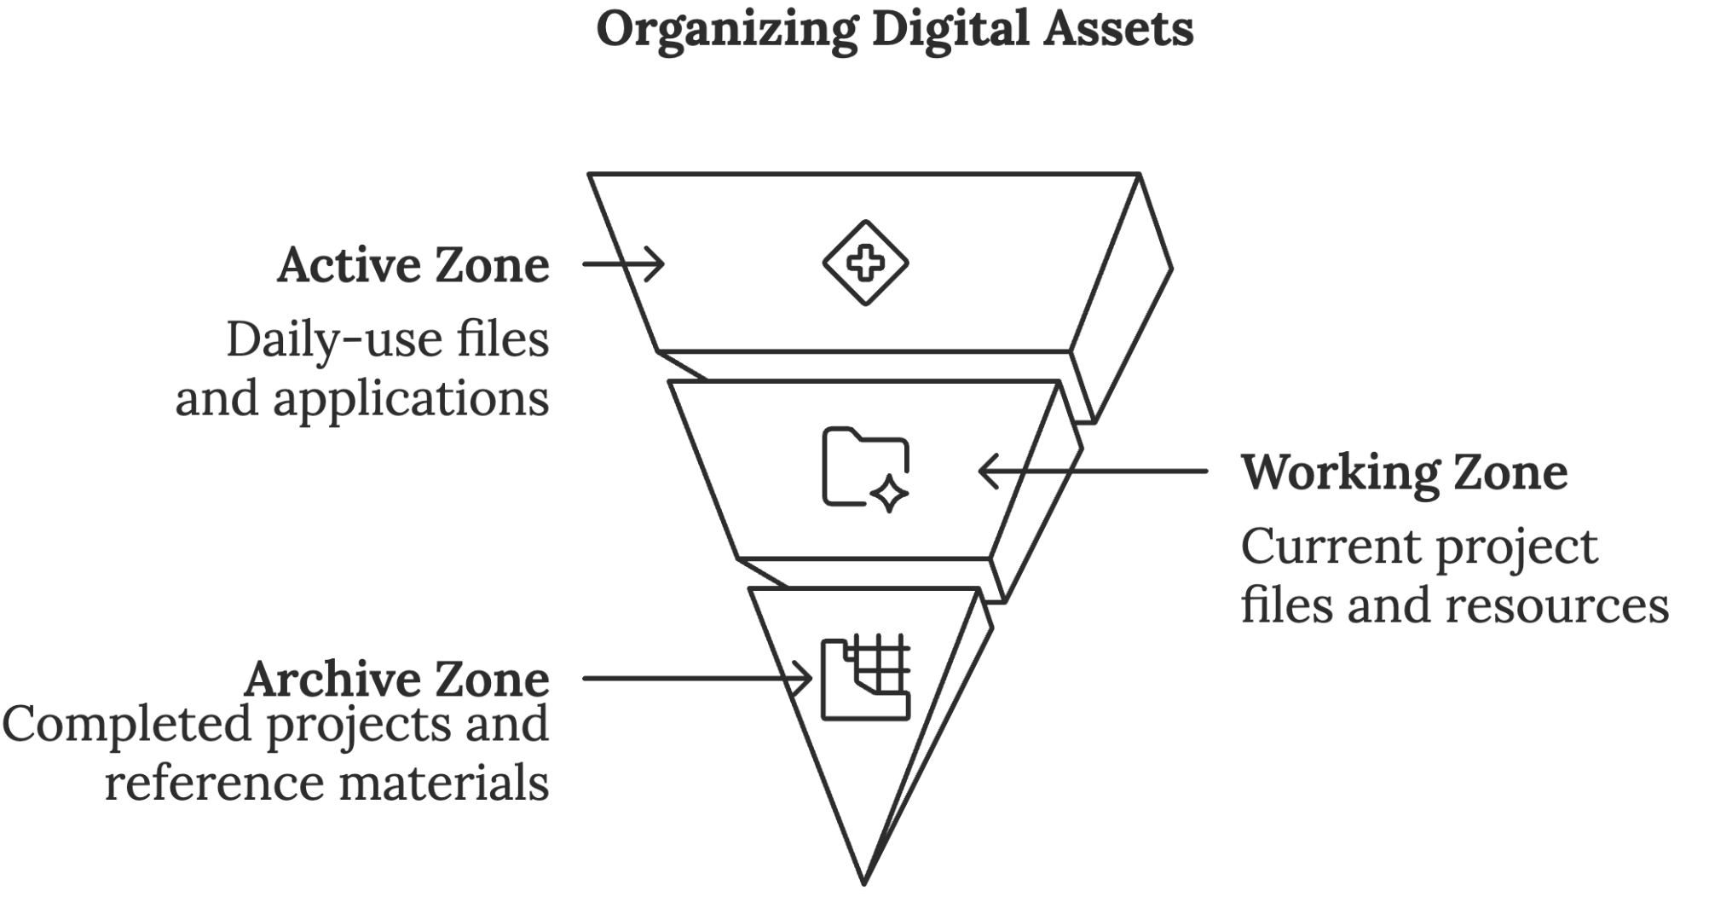
Active Zone - Files and applications used daily should be immediately accessible through shortcuts or bookmarks. Create a standardized desktop layout that mirrors your most frequent workflows. Adobe found that over 1 in 10 employees spend more than four hours each week searching for digital documents, highlighting the significant time savings possible with better organizational systems.
Working Zone - Current project files and regularly accessed resources belong in clearly named folders with logical hierarchies. Implement a consistent file naming convention that includes:
- Project or client identifier
- Date or version number
- Document type or category
- Status indicator
Archive Zone - Completed projects and reference materials should move to long-term storage with clear archival procedures. Regular digital cleanup, following the same principles as physical Sort, prevents digital clutter from accumulating.
Digital Shine involves regular maintenance of your electronic systems. including:
- Weekly cleanup of temporary files
- Monthly archive reviews
- Quarterly backup verification
- Regular software updates and security checks
A marketing agency transformed their digital workspace using these principles. By implementing standardized folder structures and file naming conventions, they reduced project handoff times by 60% and eliminated version control confusion that had previously caused costly mistakes.
Your digital organization system must support collaboration while maintaining security. Cloud storage solutions should follow the same organizational principles as local storage, with clear access controls and version tracking. Regular digital maintenance prevents system slowdowns and reduces the risk of data loss or security breaches.
Creating effective digital workflows requires understanding how information moves through your organization. Map these flows just as you would physical movement patterns by answering the following questions:
- How do files move from creation to approval?
- Where are bottlenecks in digital processes?
- What redundant steps can be eliminated?
- How can automation improve efficiency?
A case study of a medium-sized accounting firm revealed that implementing digital Set in Order principles reduced document processing time by 35% and virtually eliminated misfiled documents. Their system included:
- Standardized folder structures across all client accounts
- Automated file naming and versioning
- Digital shadow boards for common document types
- Regular maintenance schedules for digital assets
Your workspace transformation succeeds when physical and digital systems work in harmony, supporting rather than hindering your team's productivity. Through careful implementation of Set in Order and Shine across both domains, you create an environment where efficiency becomes the natural state rather than a constant struggle.
Organization isn't a destination but a continuing journey. Monitor your systems' effectiveness through regular audits and feedback sessions. Adjust and refine based on real-world usage patterns and changing business needs. Most importantly, celebrate the small victories as your workspace evolves from chaos to coordinated efficiency.
These foundational improvements prepare your organization for the next level of operational excellence through standardization and sustained practice. Your investment in proper organization and maintenance pays dividends through increased productivity, reduced errors, and improved employee satisfaction.



Standardize Your Business Systems
____
T
he assembly line at a manufacturing company used to resemble a game of chance rather than a precision operation. Workers developed their own methods, quality varied wildly between shifts, and new employees struggled through months of confusion before becoming productive.
Today, visitors marvel at the transformation. Every workstation displays identical tool layouts, visual guides direct material flow with GPS-like precision, and employees confidently follow standardized procedures that eliminate guesswork. This dramatic shift didn't emerge from random improvement efforts, but is the direct result of masterful standardization, the fourth pillar of 5S methodology that transforms sporadic success into systematic excellence.
When the company implemented standardization, their metrics told a compelling story: defect rates plummeted by 67%, employee training time decreased by 45%, and productivity surged by 28%. These improvements illustrate why standardization isn't just another business buzzword. It's the critical bridge between isolated improvements and consistent excellence.

Creating Visual Standards That Drive Performance
Your brain processes visual information much faster than text, making visual management your most powerful tool for maintaining organizational standards. Visual standards are like the silent teachers in your workplace, constantly guiding behavior and reinforcing best practices without saying a word.
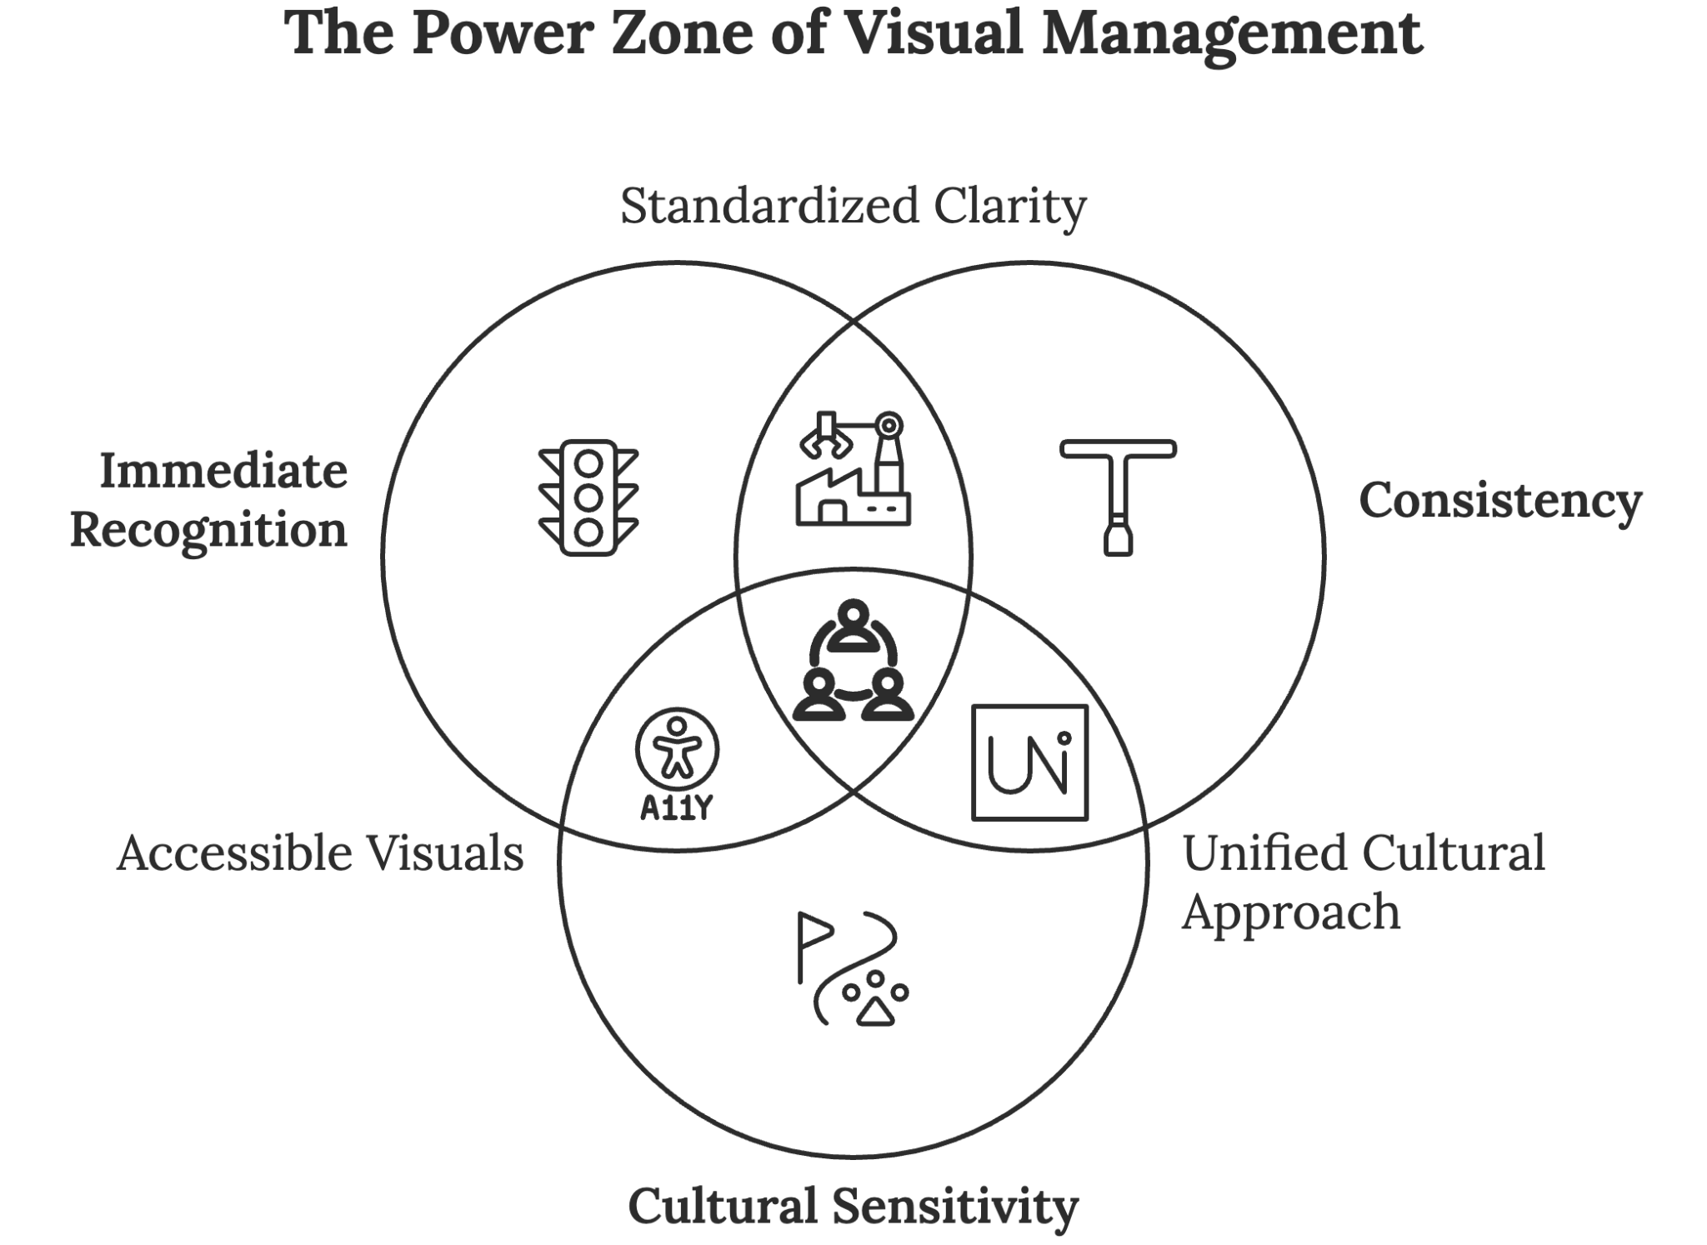
Visual management succeeds by tapping into the brain's natural preference for visual processing. Note how quickly you understand traffic signals compared to written driving instructions. Your workplace needs this same level of instant comprehension. Successful visual management systems incorporate three critical elements: immediate recognition, consistency, and cultural sensitivity.
Immediate recognition demands that every visual element communicate its message within three seconds. The 3-second rule in visual management emphasizes that anyone should be able to understand the status of a process or operation within three seconds, crucial for clear communication and quick decision-making in fast-paced environments. When implementing visual standards, test each element with this three-second challenge. If workers can't grasp the meaning instantly, simplify the design until they can.
Consistency across your facility amplifies the power of visual management. When an electronics manufacturer standardized their color-coding system across all departments, they discovered an unexpected benefit: cross-training time decreased by 28% because workers already understood the visual language of each new area. This consistency principle extends beyond color coding to all visual elements, from shadow boards to workflow indicators.
Cultural sensitivity becomes increasingly crucial in global operations. A manufacturing company learned this lesson the hard way when their red "safety first" signs caused confusion in Asian facilities, where red traditionally symbolizes good fortune rather than warning. Successful visual management considers how different cultures interpret colors, symbols, and even directional indicators.
Creating effective visual documentation requires a systematic approach that combines process photography, annotated diagrams, and digital integration. Process photos should capture key steps with clear, well-lit images that highlight critical details. Include both correct and incorrect examples to illustrate quality standards. This before-and-after approach proved particularly effective at a pharmaceutical packaging company, where inspection errors dropped significantly after implementing visual documentation.

Developing SOPs That Drive Real Results
Standard operating procedures (SOPs) form the backbone of your standardization efforts, but traditional text-heavy manuals often gather dust while workers develop their own methods. Effective SOPs must bridge the gap between theoretical perfection and practical application. This requires a fundamental shift in how you approach procedure development.
A leading automotive parts manufacturer revolutionized their operations by reimagining their SOP development process. Instead of managers writing procedures in isolation, they created collaborative teams where operators documented their best practices while engineers and quality specialists refined these methods. This approach improved procedure compliance by 85% and reduced quality issues by 47% within six months.
The success of modern SOPs depends on three critical factors: clarity over comprehensiveness, user perspective, and regular updates. Take, for example, how a medical device manufacturer applies these principles:
Their procedures focus on critical steps and key decision points rather than exhaustive detail. Each procedure includes clear photographs or diagrams showing correct technique, with annotations highlighting crucial details. The "why" behind each step appears prominently, helping workers understand the purpose of their actions rather than just following instructions blindly.
Digital integration transforms static SOPs into dynamic resources that evolve with your operation. Modern standardization extends beyond physical spaces into digital workflows, ensuring consistency across virtual and physical operations while providing real-time access to current procedures. A regional insurance company demonstrated the power of this approach by implementing standardized digital workflows with built-in compliance checks, reducing processing time by 40% while improving accuracy rates to 99.2%.
This digital transformation requires careful attention to several key elements:
- Creating a single point of entry for all digital standards and procedures
- Optimizing access for mobile devices to enable on-the-spot reference
- Implementing automatic update systems that push procedure changes to all users simultaneously
- Using analytics to track procedure access and compliance patterns

Implementing Control Systems for Sustainable Excellence
Creating standards represents only half the journey. Maintaining them requires robust control systems that balance oversight with empowerment. Effective control mechanisms prevent standards from eroding while encouraging continuous improvement. This balance proves crucial for long-term success.
Layered auditing provides multiple perspectives on standards compliance and effectiveness. Examine how a manufacturing facility implements this approach:
Daily operator self-checks focus on basic compliance and immediate issues. Weekly supervisor reviews examine patterns and systemic challenges. Monthly management audits assess broader implementation effectiveness, while quarterly external assessments provide objective evaluation. This layered approach identified 23% more improvement opportunities compared to traditional single-layer auditing.
Metric-based monitoring transforms subjective observations into quantifiable data, enabling precise tracking of standardization effectiveness. Your monitoring system should capture both leading and lagging indicators, including:
- Procedure compliance rates that reveal how consistently standards are followed
- Error frequency and type analysis to identify patterns and opportunities
- Training completion rates and effectiveness measures
- Productivity improvements linked to standardization efforts
- Cost reduction achievements tied to standardized processes
A chemical processing plant implemented this detailed monitoring approach and discovered that certain procedures, while technically correct, created unnecessary complexity. By simplifying these procedures based on metric analysis, they reduced processing time by 15% while maintaining quality standards.

Building Organizational Capability Through Training
Effective standardization requires more than documented procedures; it demands developing organizational capability to maintain and improve standards. A comprehensive training program builds this capability through structured learning paths and practical application.
A medical device manufacturer transformed their operation through role-based training. They developed specific learning tracks for different positions:
Operators receive detailed procedure training focused on hands-on application. This includes practice sessions with experienced mentors, video demonstrations of correct techniques, and regular skill assessments. Supervisors learn audit procedures, coaching methods, and problem-solving techniques. Managers study system design principles, improvement methodologies, and change management strategies.
Their certification program validates competency through progressive levels:
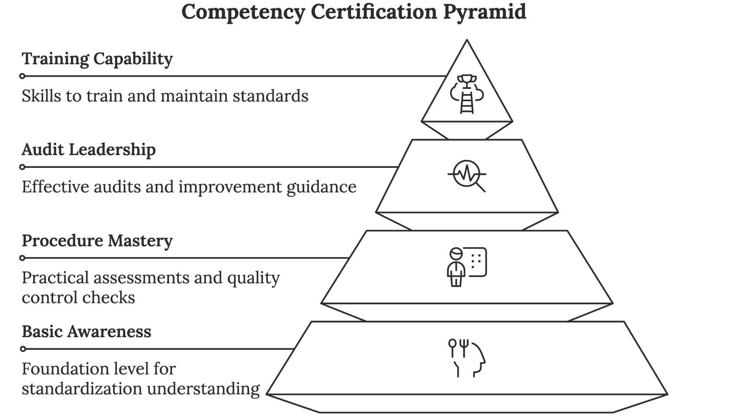
Basic Standards Awareness - All employees complete this foundation level, ensuring everyone understands the principles behind standardization and their role in maintaining standards. This initial training reduced basic errors by 35% across all departments.
Procedure-Specific Qualification - Workers demonstrate mastery of specific procedures through practical assessments and knowledge tests. This level includes troubleshooting scenarios and quality control checks.
Audit and Improvement Certification - Supervisors and team leaders learn to conduct effective audits, analyze results, and guide improvement efforts. This certification improved audit effectiveness by 47%.
Training and Mentoring Capability - Senior staff develop skills to train others and maintain standards of knowledge within the organization. This program created a self-sustaining culture of excellence.
The impact proved remarkable: their first-time quality rate improved from 92% to 99.7% within six months of completing their certification program. More importantly, these improvements held steady even as new employees joined the organization, demonstrating the program's sustainability.
A retail chain adapted this training approach to their service environment, creating role-specific standards for customer interaction, problem resolution, and operational procedures. Their comprehensive training program reduced customer complaints by 43% while improving employee satisfaction scores by 25%.
Through careful attention to these aspects of standardization, you transform sporadic improvements into systematic excellence. Remember that standardization isn't about creating rigid rules, but about building a foundation for consistent performance and continuous improvement. When implemented thoughtfully, standardization becomes your competitive advantage, driving efficiency, quality, and innovation throughout your organization.

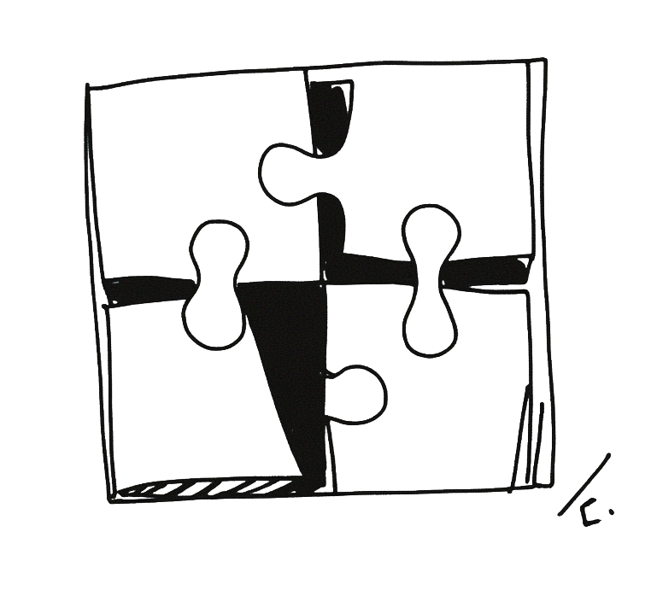

Sustain 5S in Your Business Culture
____
Y
ou gaze at two photographs hanging in your facility's break room. The first, taken three years ago after your initial 5S implementation, shows perfectly organized workstations with clear visual controls. The second, captured yesterday, mirrors that same excellence.
While many organizations watch their 5S efforts crumble within the first year, your company stands among the elite 30% that transform temporary improvements into lasting excellence. Your success isn't accidental—it stems from a deliberate strategy that turns isolated wins into systematic victories.

Creating a Culture Where Excellence Becomes Natural
Sustaining 5S demands more than periodic clean-up campaigns or motivational posters. It requires building an environment where maintaining and improving standards becomes as natural as breathing.
A privately owned hospital exemplifies this transformation. Their operating rooms evolved from chaotic spaces into models of consistency through a systematic approach that addresses three fundamental human needs: purpose, autonomy, and mastery. When your team understands why standards matter (purpose), gains authority to improve them (autonomy), and receives support to excel (mastery), maintaining 5S shifts from an external requirement to an internal drive. This psychological foundation creates lasting change that survives leadership transitions and market fluctuations.
The hospital's "zone ownership" program illustrates this principle in action. Rather than assigning generic cleaning duties, teams received complete responsibility for specific areas. This authority extended beyond maintenance to include improvement suggestions and implementation power. The results proved remarkable: employee-initiated improvements soared 300% within six months, while 5S compliance consistently exceeded 95%.
Internal champions serve as the cultural backbone of sustainable 5S programs. These individuals bridge the gap between management vision and front-line reality, transforming abstract standards into concrete actions.
A Michigan manufacturing facility discovered that areas supported by trained champions maintained standards 40% more effectively than those without. Their success stemmed from a champion development program that included:
- Advanced 5S technique training
- Leadership and coaching skill development
- Regular certification updates
- Peer networking sessions
- Public recognition of improvements
The power of integration into daily operations cannot be overstated. Rather than treating 5S as a separate initiative, successful organizations weave it into their operational fabric. Start-of-shift meetings incorporate quick 5S checks, performance reviews include standardization metrics, and improvement suggestions become part of regular team discussions.

Leadership's Role in Driving Sustainable Excellence
Your leadership team's commitment determines whether 5S becomes a lasting transformation or another failed initiative. This commitment extends far beyond occasional walkthrough tours or motivational speeches. It demands daily engagement and visible demonstration of 5S principles.
A medium-sized manufacturing company's CEO transformed their struggling 5S program through personal engagement. Every morning, she spent 30 minutes on the production floor, engaging with employees about their 5S efforts and participating in improvement activities. This visible commitment catalyzed a 45% increase in employee engagement within three months.
Effective leadership support encompasses several critical elements that reinforce sustainable excellence:
- Resource Allocation
Your commitment becomes tangible through consistent resource provision, such as:
- Dedicated time for maintenance activities
- Budget allocation for improvement projects
- Investment in training and development
- Technology and tools for monitoring
- Recognition and reward programs
- Leading by Example
Actions speak louder than words, particularly in leadership roles. Successful leaders:
- Maintain exemplary personal workspaces
- Participate actively in 5S activities
- Follow established standards without exception
- Acknowledge their own mistakes and improvements
- Share personal success stories

- Strategic Communication
Clear, consistent communication reinforces the importance of 5S sustainability through:
- Regular updates on program status
- Connection of 5S achievements to business results
- Open dialogue about challenges
- Recognition of team and individual successes
- Clear expectations and accountability measures
A healthcare organization's "Leadership in Action" program transformed their 5S sustainability. Department heads spent two hours weekly working alongside their teams on 5S activities. This visible commitment not only improved standard adherence but led to a 30% increase in employee satisfaction scores and a 25% reduction in patient complaints.

Building Systems That Sustain Excellence
Sustainable improvement requires robust measurement and feedback systems that provide accurate, timely information about program effectiveness. These systems should balance thorough monitoring with practical implementation, focusing on metrics that drive behavior rather than just track compliance.
A manufacturing company learned this lesson after realizing their detailed checklist system actually discouraged improvement by making perfect scores the goal rather than continuous enhancement. They revamped their approach to incorporate both leading and lagging indicators:
Leading Indicators
- Daily 5S audit completion rates
- Employee improvement suggestions
- Training participation levels
- Resource utilization metrics
- Near-miss incident reports
Lagging Indicators
- Workplace accident rates
- Quality metrics
- Productivity measures
- Customer satisfaction scores
- Employee retention rates
Modern technology enables sophisticated measurement and feedback systems that provide real-time insights. A distribution center implemented a digital audit system that reduced documentation time by 60% while improving data accuracy by 35%. Their system included:
- Mobile app-based audits
- Automated trend analysis
- Real-time feedback distribution
- Performance visualization dashboards
- Predictive analytics for potential issues
Visual management transforms abstract standards into concrete, visible realities that guide behavior and reinforce expectations. Successful organizations leverage multiple visual management techniques, including:
Digital Dashboards
Real-time displays showing:
- Current performance metrics
- Trending data and analysis
- Recognition and achievements
- Upcoming activities and deadlines
- Problem areas requiring attention
Team Communication Centers
Dedicated spaces serving as focal points for 5S activities, showing:
- Daily performance updates
- Problem-solving initiatives
- Success stories and photos
- Team responsibilities and schedules
- Best practice sharing
A retail chain implemented digital visual management screens in their stockrooms, displaying real-time 5S compliance data and team performance metrics. This immediate feedback loop improved sustained compliance by 40% compared to traditional monthly reporting methods.
Training and development form the foundation of sustainable excellence. Your program should build organizational capability for continuous improvement through:
New Employee Onboarding
First impressions shape long-term behavior:
- Hands-on 5S principle introduction
- Connection to business success
- Mentorship pairing
- Clear expectations and resources
- Early wins recognition
Ongoing Skill Development
Regular opportunities keep skills sharp:
- Monthly technique refreshers
- Advanced problem-solving workshops
- Cross-functional learning sessions
- External benchmark visits
- Leadership development paths
Your journey toward sustainable 5S excellence begins with a single step. Select one area from this chapter, whether strengthening leadership engagement, enhancing visual management, or improving training programs. Start small, stay consistent, and don’t underestimate the impact of steady progress.
Remember that lasting excellence grows from consistent, focused effort over time. Each small improvement builds momentum toward creating an organization where 5S isn't just a program but a fundamental part of how you achieve success.
Through careful attention to these principles and persistent application of proven practices, you transform temporary gains into permanent excellence. The path ahead requires dedication, but the rewards (increased productivity, improved safety, enhanced quality, and engaged employees) justify every effort invested in sustaining your 5S journey.



Transform Your Business with 5S
____
T
he scent of fresh paint and polished metal signals more than a clean space—it marks a complete cultural shift. What was once a chaotic, inefficient workplace has become a model of clarity, control, and continuous improvement.
Workstations are orderly, tools are exactly where they should be, and performance is tracked in real-time. Most importantly, employees move with confidence and purpose, fully aligned with the systems that support their success.
This is the true power of 5S: not just cleaner spaces or higher productivity, but a lasting transformation in how work is done, problems are solved, and improvements are sustained.

The Compounding Power of 5S Implementation
When you implement 5S effectively, each pillar reinforces the others, creating a multiplier effect that transforms your entire operation. This synergy explains why organizations that fully commit to 5S methodology consistently outperform those making partial attempts.
A global software company proves that 5S principles work as powerfully in digital spaces as they do in physical ones. By applying Sort, Set in Order, and Shine to their code repositories and digital assets, they were able to cut project handoff times by 65% and eliminate version control errors that previously wasted hundreds of development hours monthly.
Their standardization efforts created clear protocols for file naming, storage hierarchies, and documentation requirements. Most importantly, their sustained commitment ensured these improvements became permanent through regular audits and continuous refinement.
The multiplicative impact of 5S appears most dramatically in manufacturing environments, where small improvements compound into significant competitive advantages. A grocery chain’s distribution network showcases this effect through remarkable metrics achieved after their comprehensive implementation:
- Picking accuracy improved from 92% to 99.8%
- Workplace accidents decreased by 65%
- New employee training time dropped by 30%
- Inventory carrying costs reduced by 28%
- Product damage during handling fell by 45%
But perhaps the most compelling evidence comes from smaller businesses, where resource constraints often present the greatest challenges. A family-owned business competing against digital giants transformed their operation through systematic 5S implementation. Starting with simple workspace organization, they progressively built a culture of excellence that yielded extraordinary results.
Within two years, setup times dropped by 50%, material waste decreased by 35%, and profit margins grew by 25%. Most importantly, customer satisfaction scores rose by 40%, proving that internal improvements directly impact external relationships.

Strategic Implementation: Your Path to 5S Success
Transforming your business through 5S requires strategic implementation tailored to your unique environment. Success grows from starting small but thinking big, building momentum through quick wins, and systematically expanding your efforts across the organization.
This approach served an insurance company well when they began their journey. Rather than attempting company-wide implementation, they chose their claims processing department as a pilot location. Within three months, they reduced processing times by 40% and eliminated a longstanding backlog. This visible success created natural momentum for expanding 5S across other departments.
Your implementation strategy should follow a natural progression that allows for learning and adjustment. The first 30 days focus on foundation building through basic organization and quick wins that demonstrate value. An auto repair shop achieved dramatic results during this phase by simply organizing their tool cribs, reducing tool search time from 15 minutes to under 2 minutes.
Days 31–60 concentrate on system development, creating standardized procedures and visual management protocols. During this phase, a healthcare provider standardized supply organization across their clinic network, reducing inventory costs by 23%. They created clear visual controls, implemented standard operating procedures, and developed tracking systems that made deviations immediately apparent.
The critical period between days 61–90 focuses on culture creation, embedding 5S practices into daily operations and establishing metrics for sustained success. A technology firm implemented daily team huddles focused on 5S maintenance, resulting in 95% sustained compliance rates. They created recognition programs that celebrated improvements and developed internal champions who drove continued progress.
Beyond the initial 90 days, successful organizations continuously evolve their 5S implementation, finding new opportunities for improvement and adapting to changing business conditions. This ongoing refinement distinguishes organizations that achieve lasting transformation from those that experience temporary gains.

Building Your 5S Support System
Creating lasting change requires robust support systems that reinforce desired behaviors and make improvement natural rather than forced. A global manufacturer demonstrates this principle through their detailed approach to sustaining 5S excellence. Their executives spend two hours weekly participating in 5S activities alongside their teams, showing commitment through action rather than words. This visible leadership engagement resulted in an 85% increase in employee-initiated improvements.
Training evolves from basic instruction to comprehensive skill development that creates internal experts capable of driving continued improvement. An electronic parts manufacturer developed a multi-tier certification program that reduced their dependence on external consultants by 75% while improving implementation effectiveness. Their program includes:
- Foundational 5S principles and practices
- Advanced problem-solving techniques
- Leadership development for area champions
- Train-the-trainer certification
- Continuous improvement methodologies
Modern technology enhances 5S effectiveness through digital tools that support implementation and maintenance. Cloud-based audit systems provide real-time visibility into compliance, while mobile apps enable immediate reporting of issues or improvement opportunities. Digital visual management boards transform how organizations monitor and maintain their 5S programs, making information accessible and actionable across all levels of the organization.
The journey toward operational excellence through 5S offers remarkable rewards for organizations willing to commit to the process. Whether you lead a manufacturing facility, service organization, or digital enterprise, these principles provide a proven path toward sustainable success. It’s not about perfection from the start, but about building habits that drive long-term change.
Your transformation begins with a single step. Take that step today, knowing that thousands of successful organizations have walked this path before you, proving its value across industries and cultures. The potential awaiting your organization through 5S implementation promises not just improved efficiency and reduced costs, but a fundamental shift in how your team approaches their work and contributes to organizational excellence.

