Table of Contents

Introduction 3
How Does This All Work? 4
Chapter 1: Do a Mental Detox Before You Seek to Adopt a Success Mindset 6
Chapter 2: Assume That You Can Change 15
Chapter 3: Failure is Not to Be Feared, But Prepared For 18
Chapter 4: Goals Reveal Your Objectives and Empower You To Achieve Them 22
The Big Problem with Goals 22
Chapter 5: Actively Take Control 28
Chapter 6: Decide After Enough Deliberation and Stick to It 32
The Toxic Effect of Analysis Paralysis 32
Chapter 7: Believe that You Don’t Know Everything About Your Goals and Must Learn More 36
Assume a Growth Mindset 36
Chapter 8: Believe and Act Like There Is Always a Way Through Any Problem 39
Chapter 9: Successful People Relish Calculated Risks 42
Chapter 10: Best Practices When Adopting a Success Mindset 45
Mindsets are Like Muscles 45
Conclusion 49



Introduction

Success is a habit, sure. But to pick up this habit, you have to have the right mindset. You can't force things and hang on to your old mindset while adopting new habits, but these eventually wear off.

Successful people do certain things consistently, and that's why they achieve a higher degree of success than most other people. But there's more to it than that. It's not just a matter of doing certain things over and over again given certain circumstances.

When you adopt these success habits without changing your mindset, you eventually end up where you began. How come? You built your new habits on a faulty mental foundation.

You had the wrong mindset. Your success habits eventually fall apart. You have to make sure that you adopt the right mental foundation from the onset. Your mindset is a combination of your assumptions, expectations and definitions.

Most successful people share a range of mindsets that enable them to maintain their success habits. In fact, they scale these up over time.

Don't for a second think that these people were somehow born with these mindsets. They weren't. In fact, many did not even have a clue when they began. Through trial and error and the hard knocks of life, many arrived at their winning mindset.

Thankfully, you don't have to go through those heartbreaks and frustrations. You don't have to go through trial and error. You can get a head start by identifying and adopting the mindsets that can lead you to consistent victory.

This training teaches you to reprogram yourself for success by adopting 8 key mindsets. Each of these mindsets have their own subset of beliefs. You need to go through these and incorporate them into your life for them to change your results.

How Does This All Work?
Mindset changes your beliefs. If you don't have the right mindset, you're going to have certain beliefs that are not going to help you all that much on your road to success. In fact, in many cases, certain limiting beliefs can hold you back and drag you down from the success that you could have otherwise achieved.

Your mindset has to lead to the right belief. These beliefs shape your emotional response to the things that are happening around you, your priorities, your values, and your life's direction. That's how important they are. Be mindful of what you choose to believe.

The good news? Belief is always a choice.

It may seem like people were just born believers in the right things. It may appear that some people just have the right belief system as far as success is concerned. These have to come from somewhere. They were chosen.

In this training, I'm going to step you through the process of clearing your mind of toxic beliefs and helping you identify and adopt the right mindsets which can lead you to greater personal success.

These mindsets lay the foundation for the success habits you're going to have to adopt to achieve consistent victory in all areas of your life.
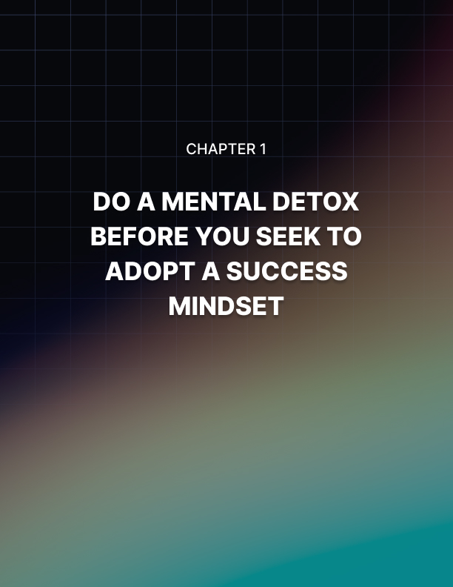

Chapter 1: Do a Mental Detox Before You Seek to Adopt a Success Mindset

I know you're excited. If you're going through this training, you are looking to achieve greater success in at least one part of your life. You can't wait to adopt the right mindset, so you can get better results. I understand that.

The problem is, you're having a tough time achieving the kind of success you want because you are probably hanging on to a few ’toxic’ mindsets that undermine you.

You have to clear these out first before you adopt positive mindsets. Otherwise, these toxic mindsets will degrade, impede, or otherwise negatively affect the new mindset that you're trying to adopt, and you end up nowhere.

Get rid of these toxic mindsets so you can be in a better position to reprogram yourself for better success. I call these mental roadblocks.

Mental Roadblock #1: Others are to Blame for Your Failure
One of the most common games people play with themselves is to think that the reason why they're facing setbacks is because others have it in for them.

Maybe these other people were sabotaging them, maybe they were just negligent. Whatever the case may be, the reason why you're failing is because of other people. This also applies to situations beyond your control.

This is very comforting for many people. After all, this thinking reduces people into victims. Victims are sympathetic. People have a natural tendency to favor the underdog. Who doesn’t want to be the underdog? Who doesn’t want to have the natural sympathy of the crowd? The problem is that playing the victim comes at a very high price.

You have to get rid of this mental roadblock because the moment you blame other people for your failure, you're giving them the power to fix your situation.

If somebody or a situation is to blame, then it necessarily follows that they have to fix your situation because they caused the problem in the first place. They broke your life, so they must contain the solution to whatever it is you’re suffering from. Do you see how this leaves you powerless?

You can't control those people or situations. Since you can’t control these people
and your past, you aren’t going to be handed the solution to your situation.

That’s just not going to happen. Everybody’s got enough problems of their own.
They can’t be bothered with yours.

This is why you have to let go of blaming others for your disappointments. Otherwise, you’ll continue to fight battles of the past. You’ll continue to re-enact certain situations in your mind and engage in all sorts of ’could have, would have, should have’ games with yourself.

You end up feeling stuck. Sure, you want to move on. You understand that it’s important. But the more you dwell on the past, moving on becomes nearly impossible.

Mental Roadblock #2: Real Change is Impossible
This toxic mindset is not as absolute as you think. People who suffer from this mindset actually phrase it in many different ways depending on the circumstances, but it still all leads to the same disappointing result.

Either you say that something is flat out impossible, or things are not right. You're just waiting for the right set of circumstances, and then maybe you'll take action.

At other times, you say to yourself, ’This is not the right time to take the opportunity.’ Alternatively, you convince yourself that you don't have enough resources right now.

Whatever the case may be, they all lead to the same place: you do not change. You have all the justification you need to continue to do things the exact same way you’ve always done them. You understand that change can truly improve your life. That’s not the problem.

Willingness is not the issue. Instead, you just feel that you can’t change because
of so many things going on in your life as well as how the past played out. You have to get rid of this idea.

Please understand that real change is possible, but it is chosen. It is something that you decide on. It is something that you commit to.

You're not waiting for the right circumstances, the right time, the right resources or the right people to come about. They don't have to. You just have to believe that real change is possible, and things will present themselves because your mind is open to change.

But the more you wait for the proper factors to appear; the less likely change will happen. You just doomed change because you believed, at some level or another, that it's impossible. If you think something is simply not going to happen you subconsciously won’t put much effort into it.

Mental Roadblock #3: Your Past Mistakes Define You
A lot of people striving for success end up sabotaging themselves because they feel that they really can't achieve any great success in the future because of their past.

They think that they have screwed up enough so often and so severely in the past that future victories are really not going to happen.

They're shooting for second or third prize. In fact, in many cases, they're just going through the motions. They've given up on the race before they even started.

An alternate version of this is the ridiculous idea that you have to somehow start with a completely clean slate to make real changes in your life. In other words, you're going to have to be perfect.

Because you've already made mistakes, you've already screwed up, either way, both versions lead you to the same place: you don't even bother making a change. You discourage yourself from even trying. In your mind, it’s a foregone conclusion before you even start.

Well, the good news is that the past does not define you. You may have failed an infinite number of times before, but that does not prevent you from getting it right this time.

The only way you will fail is when you read your long record of failures as something so discouraging and so debilitating that you don't even try.
That's how you fail. You fail when you quit.

Mental Roadblock #4: I Can't Be Helped
This mindset assumes that you have to figure things out on your own. You get this idea in your head that for you to achieve success, things have to be revealed to you. You have to dig deep within. You’re the only one that can fix things in your life. Well, at least this is what you believe.

You feel that for whatever reason, the only person you can truly rely on is yourself.

Thankfully, this isn't true. Thankfully, a lot of the challenges that you are facing, believe it or not, have been faced by other people. Maybe they handled these at a different time, at a different place, under different circumstances. Regardless, these people can help you if you ask. They can help you personally on a one to one or some sort of mentorship arrangement. On the other hand, they can also help you through books they may have written or video courses they recorded. You can even be helped by simply reading blog posts or articles they have written.

No matter how you get the help, get it!

Your situation is not unique, nor is it special. Whatever challenge you're facing, others have faced it before and overcame it. You just need to find their experience. Either you reach out to them or you read stuff that they wrote.

A variation of this toxic mindset is the assumption that others won't help. Maybe they don't want their secret sauce coming out. Maybe they don't want new competitors. Well, those are just excuses you're giving yourself.

You really won't know for sure until you ask. And just because one person is stingy with information, it doesn't give you an excuse to stop. You can ask another person, and then another, and then another. Surely, not everybody will turn you down.

Mental Roadblock #5: I Don't Deserve Success
This is a very common toxic mindset. People, of course, would not admit to it, but deep down inside, they're thinking it.

Maybe they have failed a lot in the past. In fact, they think that they've screwed up so badly that they really do not deserve a break. They really do not deserve success. They end up defining themselves through the prism of their frustrations. They personalized their failures and setbacks in the rawest emotional terms.

For people with this mindset, failure is not just something that happens when people strive for greatness or goals, instead failure is some sort of cosmic punishment. It comes at the end of some sort of moral judgment and it burns deep. It cuts to the bones and cannot be escaped. Permanent. Final. Relentless in condemnation. Talk about stifling. Talk about paralyzing.

Others come from traumatic backgrounds. Their self-esteem is so low that they feel that they are not worth changing. They feel that others' needs come before theirs. They look at themselves as some sort of emotional doormat.

Please understand that the only person who can decide whether you deserve success or not is you. You call the shots. Nobody can judge you and say, ’You don't deserve success. Somebody else does.’

You have to claim that success and say that you deserve it because ultimately, this is self-judgment. You've been declaring yourself guilty all this time. Isn't it time to decide otherwise? You know how harsh it feels. You know the kind of lousy results you get when you do this. Why not change things up? Start today.

Mental Roadblock #6: I'm Perfect the Way I Am
Just as toxic is the mindset that you're perfect. You're the smartest person in the room, you're definitely the best looking, the whole nine yards.

While it's great to have a positive self-image and a healthy self-esteem, you should not let this trick you into thinking that you don't need help or that you don't need to make changes.

Make no mistake, on the road to success, you need to change. You're obviously not as successful as you would like now. You’re not as capable as you think. It’s hard to believe but it turns out that you haven’t quite figured everything out like you believe.

Change is required. This means having to let go of whatever inflated impressions of yourself you may have.

The antidote to this is very simple: admit that there is always room for improvement. This doesn’t make you a lesser person. This doesn’t have to mean some sort of defeat.

Mental Roadblock #7: I Need to Change... Tomorrow
Don't play this game with yourself. Don't, on the one hand, say to yourself that you need to change, and you are ready to do it and you're willing to do it, but you're going to wait until tomorrow.

You have to understand that if you're waiting to have time, you'll never have time. There will always be some sort of duty or responsibility or obligation that will pop up out of nowhere and you never get to make the changes that you need to make.

Similarly, tomorrow will never come. The moment you say that, ’I'm going to do something, but I'll do it tomorrow,’ you set yourself up to lose because there will always be something of higher priority. There will be certain unexpected things that will show up that will knock you off track.

So, stop playing this game. Do it now. Make the changes now. Commit today. Take action in the here and now.

The great thing about starting now is pretty soon you get used to the challenges. By starting as soon as possible, you learn the lessons you need to learn and go through the hoops you need to go through sooner. If you’re going to go through this process anyway at some point in the future, why not get it over with now?

Mental Roadblock #8: Success and Money Aren't Everything
Isn't it interesting that the people who say that money isn't everything are usually people who want a lot of money? The same applies for people who tried and failed to achieve great success in their lives.

When you say these things to yourself, you're basically just engaging in sour graping. That's what you're doing.

You're saying, ’Oh, it wasn't worth the hassle anyway. I'll focus on something else. There are higher values in life.’

Well, if they were so valuable, why weren't you pursuing them in the first place? Why are you treating them now as some sort of consolation prize?

Stop playing this game with yourself. You're basically just giving yourself an excuse not to improve or shoot for greatness.

Mental Roadblock #9: Success is Just Not Worth It
This is a very tricky toxic mindset because it actually has many moving parts. Some people end with this conclusion because they feel that they don't want to sell out their real values.

Others would say, ’I just want to preserve my soul, and I feel like I'm going to lose my soul in this wild dash for success.’ Others say that they don't want to lose their identity. ’I just want to remain true to myself.’ ’I want to remain myself.’ How common are these sayings to you? Chances are, you’ve heard these many times. In fact, you might be saying this to yourself at some level or other or in some form or other.

Regardless of how you phrase it or how often you say these things, just because you repeat this thinking, it doesn’t make it go away. The bottom line? These are all excuses!

These are all excuses because success can be part of your identity. It can be part of your soul. It can be part of your core intrinsic values that you would never give up for anything. You're just giving yourself an excuse for not trying or for not trying again.
Maybe you got burned in the past. Maybe you got disappointed badly. Whatever the case may be, you can’t use the past as an excuse to keep you from doing something about your situation in the here and now.

Success is worth it because it improves you. It pushes you to be a more excellent person. It teaches you the value of sacrifice. It enables you to gain a sense of meaning in your day to day life. Living a life of purpose is one of the most important gifts you can ever give yourself.

When you take action every day, it is very empowering to realize that it leads somewhere big.

Mental Roadblock #10: I Don't Want to Turn Into Someone I Will Hate
This mindset is really rooted in a zero-sum mindset. What you're saying is, ’I don't want to turn into someone I hate because when I achieve success, I necessarily rob it from somebody else.’ There are many ways to phrase this thinking but it all goes back to that same zero-sum game.

Let me tell you, there is no giant pie of success anywhere in the world. Just because your slice of the pie gets bigger, it doesn't necessarily mean that somebody else's slice gets smaller.

There are tremendous amounts of opportunities out there. Opportunities come and go at the blink of an eye, moment by moment. They are created and destroyed all the time.

Indeed, by striving for success and excellence, you can inspire others to do the same. Don't think that they will just envy you.

Because people who envy have a zero-sum game mindset. They envy others because they feel that the slice of the success pie that was otherwise due them is shrinking. There's no such thing. That's nonsense.

Understand that when you choose to inspire others, you spread success because they can be motivated to achieve success. This is the precise opposite of the shrinking pie analogy.
If anything, you increase the size of the pie and ensure more slices for others if they want to. You do this because you inspire them.


Chapter 2: Assume That You Can Change

The first step that you need to take is to pay attention to your assumptions.
Assumptions are crucial. You may not be aware of your assumptions, but they have a tremendous impact on your life.

An assumption is a belief regarding the reality of your life, your capabilities, your identity, where you are in the world, and what your rightful place is. These assumptions are choices. Seriously.

You choose to interpret reality. They are not hardwired into you. They don't dictate that you have to interpret reality only in one certain way. You always have control over your assumptions. They might not be top of mind, they may not be obvious, but you can control them.

Another thing you have going for you is the fact that change is the only constant in life. In fact, as you take this training, you're already changing.

You're definitely getting older. There might be ideas that you run into that change certain things that you believe about yourself. It may change some of the things that you do. Regardless, understand that change is part of who you are.

Change happens on two key levels: you can change from within, and/or you change from outside. You have to believe that your ability to change is the key to your mindset transformation.

This is foundational. If you cannot bring yourself to this, then it's almost impossible for you to adopt the right success mindset. You're just not making it happen.

This is crucial. It is not an option. It is non-negotiable. Here's an exercise to help you strengthen your belief muscles. First, think about three examples from your past where you needed to change, and you did.

Maybe one day you did not really feel excited about jogging in the morning, but you know you're gaining weight and you need to run every morning. After a couple of weeks, you finally got to the point where you are jogging every morning.

Look for examples like this. It doesn't have to be big, it doesn't have to be dramatic. Regardless, all of us have at least three examples from our past where we needed to change, and we did.

Next, analyze what happened. Pay attention to what prompted the change.

Why do you feel like you had to do it? What circumstances were present? What was your situation like? What was the trigger or the straw that broke the camel's back?

Next, focus on how you were before and how you were doing after the change. Look at the contrast. Again, most people should be able to find situations like this in their life. It doesn't have to be big. It doesn't have to be grandiose. It just has to be real.

Look at the contrast. Now, ask yourself, ’What do these experiences teach me about myself? Am I the person who waits until the last minute and disaster is only around the corner for me to make a bold move?’

Maybe you stopped being lazy and got a job because you're about to get kicked out of your parents' house. Maybe your company announced a layoff program, but they gave people a test that they should take if they want to be retained.

Whatever the specific experience may be, pay attention to how you responded to those challenges. Did you wait until your back was against the wall before fear pushed you to make a decision? Or did you want certain changes all along and situations just pushed you? This is the difference between being a reactive and a proactive person.

There is no right or wrong answer. Either you're born reactive, which means you are motivated primarily by fear or loss, or you are a proactive person, one who is motivated generally by gain.

Regardless, if you are a reactive person, dwell on what you can lose in your life if you don't push yourself to change. If you are proactive, focus on how much better your life would be and how awesome it would be to experience your dreams if only you allowed yourself to change.
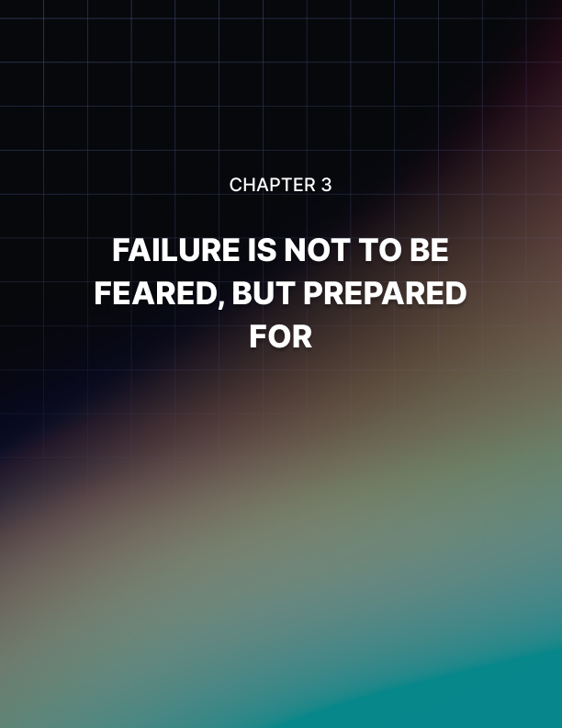

Chapter 3: Failure is Not to Be Feared, But Prepared For

It's really important to make sure that you understand that setbacks happen. People fail all the time.

If you think about it, it's not that big of a deal. It may seem like a crushing setback, it might even appear like some sort of humiliation, but in the big scheme of things, failure is part of the human condition because it happens all the time.

Believe that setbacks happen. Instead of fearing it or wishing it away or constantly asking yourself, ’why me?’ expect it and prepare for it.

According to Thomas Stanley's book ’The Millionaire Next Door,’ the average American millionaire has gone bankrupt at least three and a half times.

Let that sink in for a second. You know how crushing bankruptcy is? You know how humiliating it is at a personal level? Sure, a lot of the stigma has worn off bankruptcy, but it's still a severe personal setback.

Still, it didn't hold these millionaires back. They peaked, they crashed, then they rose back up. Stop fearing failure. Instead, focus on what comes next. Failure does not have to be the final point of your journey. It does not have to end there.

Please don't get the idea in your head that if you're expecting failure, you want it to happen or you're wishing for it. No. These are two totally different things.

When you expect failure, you understand that the probability of failure is always there. By expecting that the worst can happen, you then allow yourself to respond in such a way that you can bounce back up.

Measure Your Success the Right Way
Oftentimes, we think that we fail. Oftentimes, we think that we just crashed and burned. But what actually happened was that we measured our success the wrong way.
For example, if you are starting a business and you know that normally the return on capital in your industry happens after five years, it would be ridiculous of you to assume that you will get all your money back after one year. You're just going to be beating yourself up needlessly if you did that.

Measure your success the right way. It may well turn out that you did not fail. You're just waiting.

Fail Quickly
In addition to measuring your success the right way, another way to prepare for failure is to resolve to fail quickly. I know this sounds kind of crazy, but a lot of successful people do this.

They know that achieving success involves a lot of trial and error, so they experiment a lot. It's like throwing spaghetti on the wall. Eventually, one piece sticks.

But before that happens, you have to be as quick as possible in throwing spaghetti at the wall and getting that pasta to bounce off. When you do this, you're figuring out a map to get to success, and you're doing it quickly and cheaply.

The secret to this, of course, is to fail quickly and cheaply. It must not leave any scars. It must not bankrupt you.

Learn to Let Go Emotionally
Do not let your setbacks define you. This is the number one reason why a lot of people fail.

You see, just because your business venture did not produce the intended result, it doesn't mean that you have to stop. It may mean that you'd have to experiment or do certain things.

If you can't get through the front door, try the back, try the roof, try the basement, try the side. If you can't get in today, try tomorrow, then the week after that, then the week after that. You get the point.
But if you somehow think that this is the end of the world and this means that you are just a loser, you have allowed this setback to define you.

It burns emotionally. It's very hard to move on. So when the next opportunity presents itself, you hesitate or you simply ignore it.

Learn to let go of setbacks emotionally. They don't have to define you. They don't necessarily mean that you are a screw up and can't ever get it together.

Document Everything
When you keep a journal of your efforts, you're doing yourself a big favor as far as achieving ultimate success is concerned. You will figure out why things didn't pan out in a very focused way. You will get to clearly identify what you did before, during and after the disappointment.

Now that you know this information, you can choose to do things differently. You can connect the dots. You can see patterns and conduct experiments to see if you get better results. Throughout all of this, you focus on your end goal.

Just how important is documentation or keeping a journal? Well, people who are looking to lose weight report better results if they only recorded what they ate. Even if they continued to eat the same kinds of food before and in the same amounts, these test participants still enjoyed weight loss.

That’s right, by simply logging what you eat, you trigger a chain reaction in your mind that leads to you eating less. The same process plays out when it comes to success.

The Key to Success Despite Failure
Failure is a part of life. Get used to it. Prepare for it. But the good news is that if you only build grit, you will eventually make it.

According to a research study published by Professor Angela Duckworth, grit is the secret of success.

It's not being the smartest person in the room. It's not being the most dedicated and motivated person. Instead, it's all about the ability to get knocked down, but still keep on pushing forward.

Regardless of how many times you get knocked down, get rerouted or get postponed, you still keep pushing forward until you go all the way to the end.
Grit is a choice. This is the ultimate coping mechanism to setback.



Chapter 4: Goals Reveal Your Objectives and Empower You To Achieve Them

A lot of people striving for success look at goals as afterthoughts. They think that they are just things that they need to set up on their way to ultimate success. They kind of look at them as necessary evils.

If given a choice, they'd rather not set goals. They would just rather follow their passion or just do what excites them and eventually achieve success. At least this is what they think. Talk about getting it wrong.

Goals are crucial for success. In fact, they're so crucial that even unsuccessful people know this. How come? Goals provide you with a map. At the very least, you can see what happens before, during, and after you achieve your goal.

For you to achieve an ultimate goal, there are sub-goals that you need to achieve. You get to see the process that you have to go through, the decisions that you have to make, the results that you have to produce along the way.

You can also see potential dead ends and potential detours.

Goals can also be broken down into small parts which provide milestones. And once you have everything broken down, you can then apply a timeline. This pushes you to take action so that you get to a certain part of your success journey by a certain time.

The Big Problem with Goals
Goals are fairly easy to explain. They're fairly easy to understand. But the problem is, most people still don't manage to achieve them.

Why? Well, setting up goals is one thing, achieving them is another.

This is due to the fact that most people view goals as something that they should work for. They are optional. We can pursue them only when the time is right or when we feel we have the right resources.
Most of the time, people have no sense of urgency when it comes to their goals. They don't put themselves in a position where they feel they have to do or die.

In fact, given most people's attitudes towards goals, it would be safe to say that they essentially function like some sort of large scale ’to do list.’ This is a far cry from how successful people deal with goals.

Successful People Let Their Goals Define Them
Successful people look at goals in a completely different way. First of all, they first start with their passions, and then they craft goals around them.

For example, you are passionate about writing for a living, so your goal is to become a professional freelance writer. You start with a passion, and then you transform it into a goal that is tightly linked to your core passions.

When you work towards these goals, you validate your personal values. You feel that you are expressing your true personal character.

Best of all, you end up tapping your core competencies when you let your goals motivate you. There’s actually an upward spiral that forms the more you work towards your goals: the more you achieve, the more competent you feel, the more motivated you become, the more you try, and the more you achieve. This spiral can go up. Or it can go down.

Also, when you achieve your goals, you get a tremendous amount of pride. Plus, you get the tremendous satisfaction that your goals are what you are about.

So when you achieve them, you get an enhanced sense of personal meaning. You get the impression that this is what you're supposed to be doing. This is what you're about. This is your destiny.

When you operate from this core of passion, goals are no longer things that you should be doing. Instead, they're the things that you were born to do. They're things that you must do. See the difference?

Recast Your Goals Until They Push You Up and Out
If your goals don't give you the energy you need to push yourself and expect more from yourself, you need to change your goals.

You really do. Don’t think that you have to stick to your goals just the way they are.

Your goals are not set in stone. They are simply tools. Treat them like tools.

First, you need to redefine your goals. What truly is at stake? Is this just a simple matter of getting certain things done by a certain date, or is this a matter of you living up to your highest potential? Is this goal all about you pursuing your life's destiny?

Recast the goal by asking yourself, ’What would success mean to me as a person? How does achieving this goal relate to my highest values and my value as a person?’

When you redefine and recast, you can then refocus. Because if you look at your goal as essentially linked to the values that mean so much to you on a personal level, you can get a lot more energy.

This is not just one set of things that you do on a day to day basis. This is what actually gives your life meaning. This is what actually gives you purpose to get up day after day.

Recap
Goals must do the following, otherwise, you need to redefine, recast and refocus them. First, they must energize you. To do this, your goals must give you a sense of why.

When you go about your goals, you gain a sense of purpose. Your life is no longer random. You're no longer doing things by accident. You're no longer doing things based on how you feel.

Instead, you're doing something because this gives you meaning. This gives you purpose.

Next, goals must direct you to action. They give you something to aim for. They give you something to focus on.

Goals must, at the very least, instruct you. This means that you are focused on how to do things and what to do.

Finally, your goals must be capable of being broken down. This is crucial. Because if your goal is something that is amorphous and distant or symbolic, they're not going to help you make changes.

You're not going to achieve success because it's too theoretical.

Finally, your goals must be capable of being broken down. This is crucial. Because if your goal is something that is amorphous and distant or symbolic, they're not going to help you make changes.

You're not going to achieve success.

At the very least, your goals must be capable of being broken down into the following: you can turn them into sub goals and daily to-do lists. That's the bare minimum.

Also, make sure that when you look at your sub goals and daily to-do lists that there are repeatable parts, so you can do them day after day, week after week, month after month, year after year.

Look at each of these sub goals and to-do lists and ask yourself if they're scalable. You must be able to scale them up so that improvements on one level leads to easier improvements or greater improvements at other levels.

Another dimension of the right goals is the fact that they are measurable. You have to know whether you have actually achieved a goal. There has to be certain quality standards.

And finally, when you're crafting your goals, you must be able to associate them with emotional states. You must be able to associate them with a sense of victory, a sense of purpose, and a sense of destiny.

If that's not possible or if that's not happening, then you're doing something wrong. You're not really setting up goals. Instead, you're giving yourself a list of advisory things that you should be doing.
Remember, people feel that they don't have the time, energy or attention for things they should be doing. Instead, they focus on the things they must be doing.

So your goals must be at that level. It must be one that you have to do day after day. It's as if you have no choice in the matter.

The Good News
The good news is that the more you achieve sub goals, the more they become habits. Success is a habit, but for you to keep doing these things over and over, make sure all the elements I described above are present.
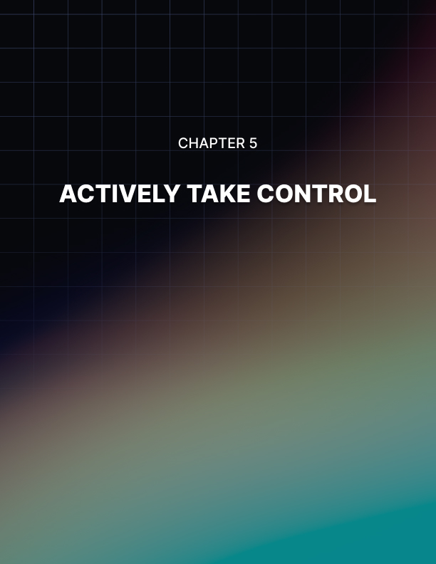

Chapter 5: Actively Take Control

Did you know that success is an act of faith? It really is.

When you believe in certain things, you take action. You don't wait around for a random chance to deliver results. You don’t wait for things to ’feel right.’ You don’t stick around for ’everything to fall into place.’ They almost never do. Last time I checked, most people don't plan on getting lucky.

They have to have some sort of plan. For this plan to come to life and to actively change their lives, they have to take action on these plans.

The key here is to believe in your goals and take control. This means commitment.

You take control because you don't just want to act once and hope for the best. Instead, when you commit, you take control because this means you keep taking action, day after day, week after week.

You take action regardless of what you're feeling, regardless of whether things seem right, regardless of what other people are doing or saying. None of that other stuff matters. Instead, you commit. You take action.

Ultimately, this takes faith. Real active faith takes action again and again and again.

This is the kind of belief that you need because otherwise, it's not going to pan out. There are many challenges out there. It's easy to get hit with one setback after another.

As I've mentioned earlier, if you cannot get through the front door, try the side. If that doesn't work, try the roof. If that's blocked, go to the back. If that's walled off, try the basement.

If it's not happening today, try tomorrow, next week, the week after that. If you can't do this alone, get the help of others.

When You Take Action, Celebrate the Fact that You Are Taking Action
One commonly overlooked fact about successful people is that most of them celebrate the fact that they're taking action. They actually take a step back and they realize what they are doing at that point in time. They allow themselves to become fully aware that they are taking action, and this is leading to a particular goal.

You have to do the same. Because when you do this, you realize that you're not hoping, wishing and fantasizing. In other words, you're not doing the usual stuff that you do, which robs you of victory.

I can't even begin to tell you how many people spend their days fantasizing about the kind of lives they would be living. They're hoping and wishing that somehow, some way, the best things in life will happen to them. But they don't have a plan. They don't put in the work.

Still, a lot of people end up wasting a tremendous amount of time daydreaming. They know whatever they are fantasizing about won’t pan out. Forget about it. Still, they keep on daydreaming. They keep on hoping and wishing for things to be better.

Why do it? Well, people daydream because they get an emotional release. Regardless of how frustrating their current situation may be, when they imagine themselves at some point in the future, a future where they are free of their current problems, they get a nice emotional rush. It’s very easy to get addicted to this emotional rush.

Sadly, the more people daydream, the worse they make things for themselves. They aren’t taking the real action they need to improve their lives.

The good news? You can shift your attention to the action you are taking in certain areas of your life.

When you take a step back and realize that you are taking action, you remind yourself that you're not just waiting for things to fall into place. Instead, you celebrate your ability to actively shape your reality and establish your destiny.

The More You Practice Your Ability to Take Action, the More Effective You Become
I know at first it seems kind of weird. You're basically saying to yourself that you're taking some sort of mental snapshot of what you're doing at a particular point in time. It's off, it's unusual, it's abnormal, it's awkward.

Regardless, the more you become aware that you're practicing your ability to take action, you get to start a chain reaction. You become more proactive. You get used to working towards your goals. Significantly, you learn how to fail faster, which leads to faster learning.

All this activity then increases the chances that you encounter new opportunities, which lead, of course, to the possibility of greater success.

All these are bound up together, and all it takes is the commitment to take action. Success is an act of faith.



Chapter 6: Decide After Enough Deliberation and Stick to It

You cannot be ’wishy-washy’ and become truly successful. That's just not going to happen.

Why? Well, opportunities flash into existence all the time, but they disappear just as quickly.

You can't waste a tremendous amount of time analyzing what could be, what could possibly happen, and other contingencies. You have to study your options, figure out what's at stake, but you have to decide. You have to make a decision.

The Toxic Effect of Analysis Paralysis
Have you ever found yourself in a situation where you're looking for more data to decide on a problem or an opportunity? You think that if you get enough information, your decision will be the right one.

What you're doing is you're just giving yourself an excuse to hold off on making a call.

There will never be a point where knowing ’everything’ will make all the risks disappear. Forget it. That's just not going to happen. You have to decide. Now.

Similarly, you will not stumble upon that ’magic bullet’ piece of data that will clarify everything for you. There’s no data that will make sure your next move will be a slam dunk. It would be great if such information existed but there isn’t.

The key here is to not freak yourself out when deciding. Set a deadline, but make sure that it's not too close so that you end up intimidating yourself.

On the other extreme, make sure that it's not too distant. Because if you hold off on deciding by setting up a date too far into the future, you're probably going to be as unprepared when that day comes as you are now. You end up attending to all sorts of things. Pick the right date.
Decision Means Action
When you decide, you're not just going through some sort of mental exercise. When you decide, you commit to taking action. That's the bottom line.

You haven't really decided if you do not take action or take on risk.

You know you've decided when you are ready to make a move and face the consequences.

It also means that you're prepared to say no to things that throw you off or distract you from your new goal.

In other words, making a decision means making a commitment. This is not an easy thing.

When you commit, you prepare for setbacks. You know that things can and do fall apart, so you're going to go into this situation prepared for all sorts of contingencies. At the very least, you're going to come in prepared to improvise, innovate or negotiate.

Regardless of what you do, please understand that deciding or making a decision doesn't mean expecting things to be smooth sailing. That's not commitment.

Making a Decision also Means Knowing When to Stop
While deciding means you're going to be taking action and you're committing to the long haul, it also means that you are committing to know when to stop.

There has to be a limit to your actions if things are not panning out.

This prevents you from sticking to an impossible situation that robs you of opportunity costs.

Opportunity costs are real. You can't continue to do something that has an eventual payoff of $2 when you could have stopped and chose to do something else that pays $100.

Understand that when you decide, this includes committing to knowing when to stop.

Key Points to Remember
When you commit, please understand that your commitment speaks volumes about your character. What kind of person do you want to be?

What kind of person do you imagine yourself to be?

Understand that this image that you would like for yourself is in danger if you do not know how to commit. If you keep changing your mind or if you quit too easily, you're never going to establish this character that you would like for yourself. It's personal.

People might think you're great, they might compliment you, but deep down inside, you know that you suck because you can't commit. You know there's something wrong with you because you can't go all the way.

Make it personal. There has to be some sort of personal ’sting’ from within to make you stick to what you committed to.


Chapter 7: Believe that You Don’t Know Everything About Your Goals and Must Learn More

Even if you've done extensive research about your goal, please understand that you cannot know everything. There will always be a blind spot. There will always be room for improvement.

Most people are able to handle this. But the problem is, the older you get, the more you assume.

It's very easy to think that you know everything about your goals, so you assume that you've got it figured out. You admit that you don't fully see the whole picture, but you assume that if you see enough of the pieces of the puzzle that you'll be okay.

This is a problem because assumptions short circuit and undermine learning. You're not looking at your problem set with a fully open mind.

Instead, you think that if you see certain patterns, you will just use solutions that you did in the past because this is familiar enough to you. You can't do that.

Assume a Growth Mindset
When you assume a growth mindset, you know that you begin from the initial proposition that you don't know everything. You may have done this at some level before, but you haven't done this exact project before.

When you assume that there are limitations to your knowledge, you are more likely to grow. You're more likely to ask for help. You're more likely to access resources to give you the information you need to make progress.

How does this work? When you operate with a growth mindset, you first focus on your core competency.

We're not jacks of all trades. We all have certain core competencies. Find yours. Once you've identified these, work outward from it.

Here's how I do it. I look at my goal and I break it down based on my core competency. I list down the things that I know like the back of my hand, and then everything else. These are called non-core elements.

What do you do with these? You can delegate, outsource, postpone, ignore or forget them. It all depends on how important they are, what their effects are on your ultimate goal, and how pressing they are.

Regardless, if they fall outside of your core competency, do not hesitate to delegate, outsource, postpone, ignore or forget.

By doing so, you increase your mastery over your project. You focus on what's important and you leave less important stuff to the hands of experienced specialists, people you work with, people you respect, or you just postpone, ignore or forget. This leads you to become a more effective goal manager.


Chapter 8: Believe and Act Like There Is Always a Way Through Any Problem

People are overcome by problems not because they are dumb or unlucky.
This is not a simple matter of IQ.

Most of the time, they're just not prepared. They did not have a system coming in. It comes as no surprise that when the unexpected happens or a setback appears, they have a tough time.

Now, this doesn't mean that you have to know exactly what will happen in the future. This doesn't mean that you have to look at your goal and anticipate each and every potential setback in minute detail.

You don't have to do that. You don't have to go that far. Instead, you just need to employ the following system.

Identify
The first thing that you need to do when you come across a problem or setback is to identify the opportunity in that situation. Oftentimes, opportunities come disguised as challenges.

So ask yourself, where's the opportunity in this situation? What can I learn from this situation? How can this situation make me better?

Use the fact that there's an opportunity there, regardless of how small, as motivation or inspiration to come up with a solution.

If anything, it's a learning experience. It's yet another opportunity to solve a problem and come out on top instead of letting it defeat you or frustrate you.

Optimize
Now that you have come up with a solution, try it out again and again. See if you can make it more efficient.

Figure out ways to get faster results. Look into making it more comprehensive. Run test after test.

Come up with the very best solution you can come up with for your particular situation.

Dominate
Once you've optimized your solution, master the problem. Not just right here, right now, but into the future. Do you see your solution applying to different types of challenges? Do you see it leading to more solutions in the future?

Whatever the case may be, crush the problem. Don't just feel relief that you dodged the bullet this time. You have to stare the challenge right in the eyes and dominate. This is not just a simple matter of coming up with a hack or a quick solution. No. You're looking to dominate the problem.

Scale Up
Now that you have dominated the problem by using an optimized solution, use it extensively. Try to use it as often as possible or come up with a bigger version of this solution.

For example, if you've always had a tough time meeting deadlines, you can optimize the solution that helps you meet deadlines. You then dominate the situation by setting up a system where your on-time delivery always produces the very best quality.

You can then apply this solution to other areas of your life like your relationship. This means that you're never late for a date or you never forget anniversaries or other important events.

Know When to Cut Your Losses
While learning how to identify, optimize, dominate and scale are important, there are certain problems that are just insurmountable. If that's your situation, know when to cut your losses.

You hit a wall, and it's impossible, at least at this point in time, so cut your losses and backtrack.


Chapter 9: Successful People Relish Calculated Risks

One of the most interesting finance shows I watch features interviews with financial managers. These people manage multibillion dollar hedge funds, mutual funds, and other financial instruments.

One particular fund manager blew my mind. The interviewer asked him, ’What do you do to avoid risk?’

The fund manager said, ’I don't run away from risk. Instead, I run to the risk that meets the reward that I'm looking for.’

This floored the interviewer. ’You actually assume risk?’

Well, it was kind of an ironic moment because I assumed that if this financial advice show host really knew his stuff, he would not have been surprised at all.

One of the long-standing rules of the finance world is: no risk means no reward. Put another way, if you are looking for a high reward, you have to take on a lot of risk.

Risk is always part of the package. Successful people know this. Accordingly, they take calculated risks because they know that the greater the risk, the greater the reward.

Unfortunately, people trying to copy successful people often get it wrong. They end up gambling.

They end up taking shots in the dark, hoping to get lucky.

There is a big difference between risk taking and gambling. Risk-taking only happens when you're properly educated about what you stand to gain and what you stand to lose, and the probability of that loss.

When gambling, you're just focusing on odds, and that's all you pay attention to. When you take calculated risks, you look at what's currently happening, what could possibly happen, and make strategic decisions.

The good news is that the more educated you are about the move that you are about to make, the lower your risk. You can't entirely make it go away, but you can manage your risk.

Successful people always find ways to assume more risk while managing it. They actively seek risk. They run to it. They don't run away from it.

Eventually, they keep repeating this over and over to achieve impressive results and they begin to control risk.

They always have a Plan B. Maybe this takes the form of insurance, maybe they hedged their bets buying different types of companies in different industries, or they buy different asset classes.

For example, you can be buying risky stocks, but offsetting it by buying government bonds or investing in local real estate. In the same portfolio, if they're buying stocks, they would buy blue chip, fairly stable stocks, and balance it out with more aggressive tech stocks.

Regardless, successful people relish calculated risks. Risks do not stop them in their tracks. Instead, they seek calculated risks.
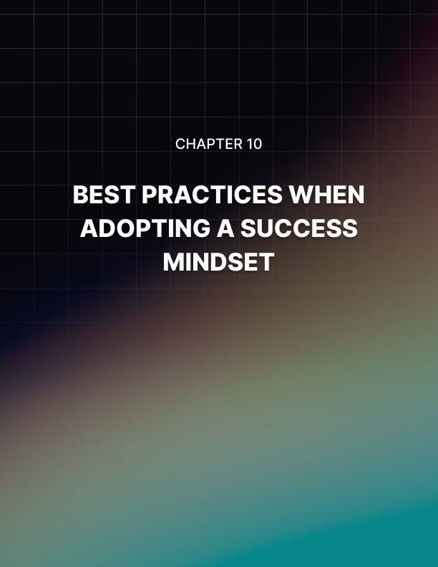

Chapter 10: Best Practices When Adopting a Success Mindset

Congratulations! You've reached the end of this training.

Please note that as empowering as the information shared in this training may seem to you, it's not going to change your life or lead you to success if you don't take action.

You can't just treat it like mental candy. That's not going to work.

You have to carry it out. You have to implement them. You have to tweak them. You have to customize them to your set of circumstances.

In other words, you have to take action. Once you've carried these out, here are some best practices that will help boost your results.

Mindsets are Like Muscles
When you adopt these mindsets, please understand that you have to test them. You have to use them and challenge them. In other words, they're like muscles.

Remember the first time you went to the gym and you tried on some weights at the bench press? It probably was not a pretty sight. It probably wasn't that positive of an experience.

But the more you did it, the more you got used to it. You were able to lift heavier and heavier weights.

What you're doing is you're challenging your muscles. Plus, you're also getting them used to repetitive patterns.

The same applies to mindsets. It's not enough for you to use these mindsets once or even twice. You have to use them over and over. They have to become part of you.

Also, you have to grow them by challenging them. Use them in different situations. Scale up the challenge. Whatever the case, you have to apply pressure on them for them to get stronger and for them to produce better results.

There is No Better Time than Now to Start
Don't trick yourself into thinking that there is always tomorrow. You have to start now. You don't have to do much, but you have to take action now.

Stop waiting for tomorrow. Stop waiting for things to be just right for things to feel
right. You're just giving yourself excuses when you do that. Instead, you have to commit.

Every Setback is an Opportunity to Learn
Make no mistake, you're going to run into problems adopting the success mindsets I have described in this training. For whatever reason, there will be an obstacle or two.

Instead of crumpling like a paper bag the next time you are challenged or experience a setback, look at them as opportunities.

Don't get all emotionally worked up. Instead, focus on the sense that you've seen this before. Focus on the sense that this is not all that unexpected.

Because when you're in that emotional state or frame of mind, you're more likely to look at the setback as an opportunity to learn. What could you have done differently? What could your attitude have been? How can you anticipate this issue and prevent it from happening again? Regardless, be ready to learn.

One of the best attitudes you can assume when trying to adopt these mindsets is to assume the attitude of a student. When you're a student, mistakes are not the end of the world. They're definitely not a source of humiliation or embarrassment. Instead, you often chuckle or laugh, and then you figure it out, then you try again and again, and things get smoother.

If You Have a System, You Will Not Fail
Finally, you should get a system going. I've already discussed one possible way to deal with setbacks, which is to identify, optimize, dominate and scale.

Come up with your own variation. Come up with something that better fits your particular set of circumstances. Whatever the case may be, come up with a system that is truly yours.

Please note that the information that I shared with you here are just starting points. That's all they are. They lay out a basic foundation. But it's up to you to tweak, adapt and configure them so they produce the best results in your life.

That is your responsibility. That's how you take control over this whole process.


Conclusion

Thank you for buying this training. This training can change your life.

You have to understand that the results that you get in life flow directly from your mindset.

If you change your mindset, you change your results.

Everything flows from your mindset because your mindset dictates how you interpret the world. It also influences your emotional response. Change your mindset and you will change the results you get.

Whatever frustrations you have right now, whatever setbacks you're dealing with, are due to your current mindset. If you're not happy with your situation, then the most powerful and effective and permanent way to deal with frustrations is to change your mindset.

I wish you nothing but the greatest success.

