TABLE OF CONTENTS
____

INTRODUCTION 4
MAPPING THE JOURNEY 7
The Role of Ad Funnels in the Buyer Conversion Process 7
The Evolution of Customer Communication 8
Understanding the Modern Purchase Journey 9
Creating an Effective Customer Journey 12
FILLING THE FUNNEL 16
Creating Your Foundation for Awareness 16
The Art of Value Communication 18
Mastering Multi-Channel Messaging 20
THE MOMENT OF CONSIDERATION 23
Building Trust Through Strategic Content 24
Personalizing the Consideration Journey 26
Converting Interest into Action 28
CONVERTING CLICKS INTO CUSTOMERS 30
The Psychology of Purchase Decisions 30
Creating Personalized Purchase Pathways 32
Building Unshakeable Trust 34
MEASURING SUCCESS AND OPTIMIZING FOR ROI 37
Building Your Measurement Foundation 37
Understanding Performance Across Your Funnel 39
Implementing Advanced Optimization Strategies 41
MASTERING THE FUNNEL MINDSET 44
The Strategic Mindset Revolution 44
Building Cross-Functional Alignment 46
Mental Models for Funnel Success 48

DISCLAIMER
____

The information provided in this ebook is intended solely for educational and informational purposes. The author does not accept any responsibility for the outcomes that may arise from the application of the material within. While efforts have been made to ensure the accuracy and relevance of the content, the author cannot be held accountable for any errors or omissions, or for any consequences resulting from the use or misuse of the information provided. The responsibility for any actions taken based on the information in this ebook lies solely with the reader.
Foreword

INTRODUCTION
____

Picture your ideal customer discovering your brand for the first time. They see your ad, feel intrigued, and click through to learn more.
As they explore your content, their interest grows. Soon, they're convinced your product or service is exactly what they need. Finally, they make a purchase, becoming not just a customer but an advocate for your brand.
This seamless progression from stranger to loyal customer isn't magic—it's the result of a well-designed advertising funnel.
You've likely heard countless promises about advertising strategies that deliver overnight success. The reality is that building an effective ad funnel requires more than following a simple formula or copying what worked for others. It demands a deep understanding of your audience, careful planning, and continuous refinement based on real data.
This book offers you a practical roadmap to creating and optimizing ad funnels that consistently convert prospects into customers. Whether you're running an e-commerce store, offering professional services, or building a subscription-based business, you'll discover how to craft messages that resonate with your target audience at every stage of their journey.
Through proven frameworks and examples, you'll learn to identify the critical touchpoints where prospects make decisions and how to influence those decisions in your favor. You won't just understand the theory behind successful ad funnels—you'll gain actionable strategies you can implement immediately to improve your results.
The strategies and techniques shared in these pages come from years of testing, analysis, and optimization across various industries and platforms. You'll learn how to measure what matters, interpret the data correctly, and make informed decisions that drive better results.
From selecting the right targeting options to crafting compelling ad copy, from building trust through content to optimizing for conversions, this book covers every crucial element of a successful ad funnel strategy. By the end, you'll be equipped with the tools and insights to transform your advertising efforts, ensuring your business thrives in an increasingly competitive digital marketplace.
Each strategy, tactic, and technique in this book is presented with clear examples and step-by-step instructions you can adapt to your specific situation. You'll find practical advice on avoiding common pitfalls, maximizing your advertising budget, and scaling your success. You'll have the knowledge and tools needed to build and optimize ad funnels that consistently deliver results by the time you’re done reading.
Let's transform your advertising approach from hoping for results to knowing how to achieve them. Your journey to mastering ad funnels starts here.
Part One

MAPPING THE JOURNEY
____

Every marketing professional knows the challenge: websites teem with visitors, yet only a tiny fraction are ready to make a purchase. While ad funnels can help guide prospects through their journey, the path to conversion isn't always straightforward.
Recent research by Outbrain reveals that 96% of first-time website visitors aren't prepared to buy. This reality underscores why understanding and mastering the art of guiding potential customers through their buying journey—from awareness campaigns to conversion funnels—has become essential for business success.

The Role of Ad Funnels in the Buyer Conversion Process
Ad funnels, also known as “marketing funnels” and “conversion funnels,” represent the strategic pathway that transforms casual browsers into loyal customers. Unlike traditional advertising that hopes for immediate conversion, funnels acknowledge that purchasing decisions happen in stages. These stages mirror the customer's psychological progression: from becoming aware of a problem, through considering solutions, to ultimately making a purchase decision.
Think of an ad funnel as a carefully crafted series of touchpoints. At the top, wide-reaching awareness campaigns capture attention. The middle of the funnel nurtures interest through targeted content and engagement. Finally, the bottom of the funnel focuses on conversion through compelling offers and clear calls to action. Each stage uses specific ad types and messaging designed to move prospects closer to a purchase.
Modern ad funnels leverage sophisticated targeting and retargeting capabilities across multiple platforms. This multi-channel approach ensures your message reaches potential customers at the right time with the right content, gradually building trust and demonstrating value until they're ready to convert.

The Evolution of Customer Communication
The way businesses connect with customers has transformed dramatically. The old model of pushing customers through a rigid, linear sales process has given way to something far more dynamic and responsive. Today's customers move fluidly between different stages of their buying journey, often revisiting steps multiple times before making a decision.
Modern customer communication recognizes that people interact with brands across numerous channels simultaneously. You might spot a product on Instagram, research it on YouTube, read reviews on Amazon, and finally purchase it through a company's website. This interconnected web of interactions has revolutionized how businesses must think about attracting and converting customers.
Several key factors have shaped this transformation. The explosive growth of social media platforms has created new ways for customers to discover and evaluate products. The widespread adoption of smartphones means your customers can engage with your brand anywhere, anytime. Advanced analytics tools now provide unprecedented insights into customer behavior, enabling you to create more targeted and effective marketing campaigns.

Understanding the Modern Purchase Journey
The traditional AIDA model (awareness, interest, desire, action) remains relevant but has evolved significantly to match current consumer behavior patterns.
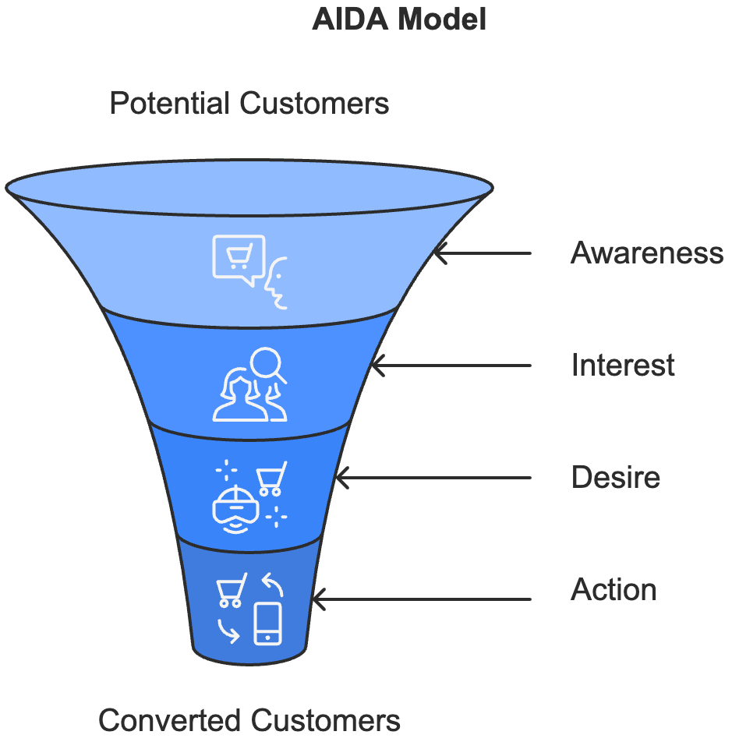
Let's explore how each stage works in today's environment:

Awareness stage
Your potential customers first learn about your product or service. This might happen through social media posts, search engine results, or content marketing efforts. For example, a fitness enthusiast might discover your protein supplement brand through an Instagram influencer's post or a YouTube video about nutrition.

Interest stage
Once aware, people begin actively seeking information about your offering. They might read blog posts, watch product demonstrations, or compare features with competitors. This stage is crucial for establishing your expertise and building trust. Consider how a potential customer might spend hours reading your blog posts about protein supplementation, watching your explanation videos, or comparing your product's amino acid profile with competitors.

Desire stage
At this point, your prospects start visualizing themselves using your product or service. They're emotionally invested but might need an extra push to commit. Social proof becomes particularly powerful here. Customer testimonials, reviews, and case studies can transform interest into a genuine desire to purchase.

Action stage
This is the final step where prospects become customers. Today, this stage must be seamless across all devices and platforms. Whether someone's checking out on their smartphone during their commute or making a considered purchase on their desktop at home, the experience needs to be smooth and trustworthy.
Here's how the modern AIDA model differs from its traditional counterpart:
Stage | Traditional Approach | Modern Application
Awareness | TV ads, billboards | SEO, social media content, targeted ads
Interest | Product catalogs | Interactive content, video tutorials
Desire | In-person demos | User reviews, comparison tools
Action | Store visits | One-click purchasing, mobile payments

Creating an Effective Customer Journey
The key to success lies in creating seamless transitions between different stages of the customer journey. This requires careful attention to three critical elements: content alignment, timing, and personalization.
Content alignment ensures that the message you deliver at each stage of the journey directly addresses your customer's needs and questions, guiding them smoothly toward the next step. Your content strategy should provide value at every stage of the journey. Think about creating a rich collection of information that answers questions before customers even ask them.
For instance, if you're selling running shoes, your content might progress from basic articles about choosing the right running shoe type, to detailed comparisons of different models, to specific product features, and finally to purchase guidance.
Timing is also crucial. You need to deliver the right message at the perfect moment. This means understanding behavioral triggers that indicate when a customer is ready to move to the next stage. For example, someone who has viewed your pricing page three times in the past week might be ready for a special offer to trigger their purchase decision.
Personalization transforms a generic customer journey into a unique experience for each individual. By leveraging data about your customers' preferences, behaviors, and past interactions, you can create highly targeted communications that resonate on a personal level. This might mean adjusting email content based on previous purchases, recommending products based on browsing history, or modifying website content based on visitor location.
Think of your customer journey as a conversation that evolves naturally over time. Each interaction should build upon previous ones, creating a coherent narrative that guides prospects toward making an informed purchase decision. This approach requires careful coordination across all your marketing channels, from social media and email to your website and customer service team.
The most effective customer journeys anticipate and address potential obstacles before they become barriers to purchase.

This might involve providing detailed product information, addressing common concerns in FAQ sections, offering live chat support at crucial decision points, or creating clear, hassle-free return policies to reduce purchase anxiety.
The future of customer journey mapping is being shaped by technological advances in artificial intelligence and machine learning. These tools enable you to predict customer needs more accurately and automate personalized experiences at scale.
However, it's crucial to balance this automation with authentic human connection. Your customers should feel understood and valued, not just targeted by algorithms.
Understanding and optimizing your customer journey isn't a one-time task. It's an ongoing process of refinement based on customer feedback, behavioral data, and market changes. By continuously monitoring and adjusting your approach, you can create more effective, engaging experiences that turn prospects into loyal customers.
Your success in mapping and optimizing customer journeys depends on your ability to blend data-driven insights with human understanding. While analytics tools can reveal what customers do, your expertise and empathy help you understand why they do it. This combination of quantitative and qualitative insights enables you to create truly effective customer journeys that drive business growth.
Part Two

FILLING THE FUNNEL
____

Every second, millions of marketing messages compete for your audience's attention. Success in this crowded space isn't about shouting louder; it's about speaking more intelligently. As a marketer, your challenge is to create messages that not only capture attention but also resonate deeply with your target audience.

Creating Your Foundation for Awareness
The psychology behind capturing attention online operates on different principles than traditional marketing. According to research from the Statistic Brain Research Institute, you have 3 seconds or less to make an impact before a potential customer scrolls past your content. This compressed timeframe means every element of your awareness campaign must work harmoniously to convey value instantly.
Building effective awareness requires understanding how your audience processes information across different platforms. For example, when someone encounters your brand on Instagram, their mindset and expectations differ significantly from when they're browsing LinkedIn. This is why your messaging needs to adapt accordingly while maintaining its core essence.
Research by Defined Digital Academy reveals that successful awareness campaigns increasingly rely on dynamic content adaptation, where your message automatically adjusts based on real-time user signals and platform context. This approach has been shown to increase engagement rates by up to 47% compared to static campaigns. For instance, if data shows your audience engages more with video content during evening hours, your campaign could automatically prioritize video delivery during these peak times.
Consider how different elements work together to create a memorable first impression:
Element | Purpose | Example
Visual impact | Immediate attention grab | Bold colors, striking imagery
Message clarity | Quick value communication | Clear, benefit-focused headlines
Emotional appeal | Creating connection | Storytelling elements
Call to action | Guiding next steps | Clear, low-commitment options
When you're developing your awareness strategy, think about balancing reach with precision. While reaching a broad audience might seem appealing, targeting everyone effectively means targeting no one. Instead, focus on creating multiple touchpoints that maintain consistency while adapting to different contexts.
Your Instagram story might showcase your product in action, while your LinkedIn post explores the business case behind it. This illustrates two different approaches telling the same brand story.

The Art of Value Communication
Your unique value proposition (USP) forms the foundation of all awareness-stage messaging. However, creating a truly effective USP requires more than listing product features. It demands deep insight into your audience's psychological drivers and unmet needs.
Start by asking yourself: what keeps your potential customers awake at night? What aspirations drive their decisions? Your USP should address both the practical and emotional aspects of these questions.
For instance, if you're marketing a productivity app, don't just focus on features like task management or calendar integration. Instead, connect these features to deeper benefits: "Transform chaos into clarity. Reclaim 2 hours every day for what truly matters."
Testing different value propositions requires systematic experimentation. Here's a proven framework for refining your message:
- Create multiple versions of your value proposition, each emphasizing different benefits.
- Test these versions across various channels and audience segments.
- Measure not just click-through rates but also time spent engaging with your content.
- Analyze patterns in which messages resonate with specific audience segments.
- Refine and repeat the process with new variations.
The most powerful value propositions emerge from understanding both expressed and unexpressed needs. For example, Apple's success doesn't come from selling phones with better specifications; they sell a vision of how technology can enhance and simplify life. This deeper understanding comes from extensive market research, customer interviews, and behavioral analysis.
A particularly effective method for developing your value proposition is the story-benefit mapping technique. This involves creating a matrix that connects features to benefits, and benefits to emotional outcomes. For instance:
Feature → Benefit → Emotional Outcome
Cloud Backup → Never Lose Important Files → Peace of Mind
One-Click Sharing → Faster Team Collaboration → Recognition as an Efficient Leader
This mapping helps you craft messages that resonate on multiple levels, addressing both rational and emotional decision-making factors.

Mastering Multi-Channel Messaging
Modern consumers move fluidly between platforms, expecting seamless experiences wherever they encounter your brand. This reality demands a sophisticated approach to multi-channel messaging that maintains consistency while adapting to platform-specific norms.
Here’s an example of how your message might evolve across different platforms while maintaining its core essence:
On Instagram, your message might take the form of visually striking carousel posts that tell a story through images, each slide revealing a new aspect of your value proposition. The same message on LinkedIn could become a detailed case study, backed by data and professional insights. On TikTok, it might transform into an entertaining challenge that demonstrates your product's benefits in an engaging way.
The key to successful multi-channel messaging lies in understanding the unique characteristics of each platform:
Instagram favors visually rich, lifestyle-focused content that showcases your brand's personality. Here, focus on creating thumb-stopping visuals that communicate value instantly. Stories and Reels offer opportunities for behind-the-scenes glimpses and quick tutorials.
LinkedIn demands a more professional approach, emphasizing industry expertise and business value. Your content here should demonstrate thought leadership while maintaining accessibility. Long-form articles and data-driven insights perform particularly well.
Facebook combines community engagement with detailed targeting capabilities. Focus on creating content that sparks conversation and encourages sharing. Mix educational content with entertaining elements to keep your audience engaged.
TikTok requires an authentic, entertainment-first approach. Even promotional content should feel native to the platform. Think of how you can transform your message into trending formats or challenges.
YouTube serves as both a search engine and entertainment platform. Create content that educates while entertaining, using storytelling techniques to maintain engagement throughout longer videos.
The success of your multi-channel strategy depends on maintaining what's called message hierarchy, a clear structure of primary, secondary, and supporting messages that can flex across platforms while maintaining consistency. Think of it as a tree: your core value proposition is the trunk, major benefits are the branches, and platform-specific content represents the leaves.
Creating a seamless brand experience requires not just adapting to each platform’s format, but also maintaining a consistent brand voice that resonates with your audience, no matter where they engage with you. By strategically tailoring your message to fit each channel’s unique characteristics while staying true to your core value proposition, you can create a cohesive, impactful brand experience that drives customer engagement and loyalty across all touchpoints.
Part Three

THE MOMENT OF CONSIDERATION
____

In the bustling marketplace of ideas and products, turning interest into action remains one of marketing's greatest challenges.
Recent analysis from Pathmonk reveals that 47% of all content consumption happens during the consideration phase—a critical juncture where potential buyers actively evaluate solutions to their problems.
This statistic highlights an essential truth: mastering the consideration stage isn't just about presenting information; it's about building relationships that convert curiosity into commitment.

Building Trust Through Strategic Content
Trust forms the bedrock of every successful customer relationship.
Unlike traditional face-to-face interactions, where a firm handshake and direct eye contact build confidence, online trust develops through a complex web of signals and experiences. You must understand these trust signals to effectively guide potential customers through their decision-making process.
Your prospects evaluate multiple factors simultaneously when considering your offering. Each interaction either strengthens or weakens their trust in your brand. These trust-building elements include your content quality, brand consistency, social proof, and how you handle customer communications. Think of trust as a bank account, where every positive interaction inspires making a deposit, while missteps result in withdrawals.
B2B and B2C customers build trust differently. B2B buyers often prioritize detailed technical specifications, comprehensive case studies, and clear ROI demonstrations. They need evidence that your solution will solve specific business problems and deliver measurable results.
In contrast, B2C customers typically respond more strongly to emotional connections, user testimonials, and visual demonstrations of your product in action. Understanding these distinctions helps you tailor your trust-building approach to your specific audience.
For example, if you're selling enterprise software, your B2B trust-building strategy might include detailed white papers analyzing industry challenges, case studies featuring recognized brands, and technical documentation that speaks to IT decision-makers. For a consumer product, you might focus on authentic user stories, lifestyle-focused content, and emotional appeal through compelling visuals and relatable scenarios.
Your content strategy must reflect this understanding of trust-building dynamics. Try creating a balanced mix of content that addresses both rational and emotional decision-making factors. This might include:
Content Type | Trust-Building Purpose | Best Use
Case studies | Demonstrate proven results | Show real-world impact
Expert guides | Establish authority | Address specific challenges
Behind-the-scenes | Build emotional connection | Humanize your brand
Comparison tools | Aid decision-making | Help evaluation process
Customer stories | Create social proof | Share authentic experiences

The timing of your content delivery plays a crucial role in building trust. You need to provide the right information at the right moment; being too promotional too early can damage trust, while waiting too long to present key information might result in missed opportunities. This requires a deep understanding of your audience's consideration process and careful content mapping.

Personalizing the Consideration Journey
Modern personalization goes far beyond adding someone's name to an email. Smart content adjustment uses behavioral data and real-time signals to create truly individualized experiences that resonate with each prospect's specific needs and interests.
Your website should adapt dynamically based on visitor behavior. When someone from a large enterprise spends time reviewing enterprise-focused case studies, your site should automatically prioritize related content in subsequent visits. This level of personalization creates more relevant experiences that accelerate trust-building and decision-making.
Watch for these key behavioral signals that indicate where prospects are in their consideration journey:
A prospect who repeatedly visits your pricing pages likely needs help in understanding the value proposition or comparing options. Someone downloading technical documentation might be ready for a deeper conversation about implementation. Multiple views of customer success stories could indicate a need for more social proof or specific use cases.
Use these insights to create custom content paths that guide prospects through their unique consideration journey. This might mean:
- Recommending relevant resources based on previous interactions: By tracking past behavior, you can suggest content that aligns with the prospect’s demonstrated interests, making their journey more relevant and efficient.
- Adjusting email sequences to match engagement patterns: Tailoring your email follow-ups based on how prospects engage with your previous emails (e.g., opening, clicking) ensures that your messages remain timely and personalized.
- Creating targeted retargeting campaigns that address specific concerns: Using data about a prospect’s interactions, you can create ads that directly address any doubts or unanswered questions, nudging them closer to a purchase.
- Presenting industry-specific case studies at optimal moments: Sharing case studies that are specific to the prospect's industry can build trust and show them how your solution applies to their unique challenges, increasing the likelihood of conversion.
- Offering role-based solution presentations that speak to individual needs: Personalizing content to address the specific needs and challenges of a prospect’s role within their company can create a more compelling, targeted experience that speaks directly to their responsibilities and pain points.
Remember that effective personalization balances automation with authentic human connection. While technology enables sophisticated personalization at scale, maintaining genuine relationships remains crucial for building lasting trust.

Converting Interest into Action
Moving prospects from passive observation to active engagement represents a critical shift in the consideration stage. This transition requires creating meaningful interaction opportunities while maintaining the trust you've carefully built through your content strategy.
Interactive content serves as a powerful catalyst for this transition. When you provide tools like assessment quizzes, ROI calculators, or product configurators, you transform passive readers into active participants. These interactive elements not only provide immediate value but also generate valuable data about prospect needs and preferences.
For example, a marketing automation company might offer an interactive assessment tool that helps prospects evaluate their current processes and identify improvement opportunities. This provides immediate value while generating insights about the prospect's specific challenges and needs.
Two-way communication channels deepen engagement and build stronger relationships. Live chat support, community forums, and expert consultation calls create opportunities for prospects to ask questions and receive personalized guidance. These interactions provide valuable insights into prospect needs while demonstrating your commitment to customer success.
Part Four

CONVERTING CLICKS INTO CUSTOMERS
____

Every time a potential customer reaches for their wallet, a battle wages in their mind. Research from Bloomreach shows that 97% of website visitors leave without purchasing, with average e-commerce conversion rates stuck at 2.86%. These numbers reveal an uncomfortable truth: attracting visitors means little without the ability to turn their interest into action.

The Psychology of Purchase Decisions
When prospects stand at the threshold of buying, they're not just evaluating your product—they're wrestling with deep-seated emotions, weighing alternatives, and seeking validation. Understanding the psychology behind the decision process gives you the power to guide potential customers through their final decision-making moments with confidence and clarity.
Research from WebFX demonstrates that reducing mental effort during checkout can dramatically impact success rates. When they decreased form fields from 11 to 4, conversion rates soared by 120%. This striking improvement highlights a fundamental truth about human behavior:
The easier you make it for people to say yes, the more likely they are to follow through.

Picture your customer's mind as a scale, constantly balancing perceived value against perceived risk. Every additional step you require, every moment of uncertainty, and every unexpected cost adds weight to the risk side of this scale. Your job is to systematically remove these barriers while amplifying the value proposition until the scale tips decisively toward purchase.
Shopping cart abandonments occur because of unexpected costs, with shipping fees leading the pack. This insight points to a crucial principle: transparency builds trust.
When you present all costs upfront, you prevent the jarring disconnect between expectation and reality that sends prospects running. See if you can incorporate shipping into product prices or clearly display delivery costs on product pages to let customers make fully informed decisions from the start.
The way you structure payment options can make or break your conversion rates. Offering multiple payment methods can increase conversions significantly. This improvement stems from both practical convenience and psychological comfort—seeing familiar payment options helps customers feel secure in their decision.
Today's buyers expect everything from traditional credit cards to digital wallets and buy-now-pay-later services. Each additional payment option removes another potential obstacle between hesitation and purchase.

Creating Personalized Purchase Pathways
Modern consumers demand experiences that feel tailored to their specific needs and preferences. By leveraging behavioral data and real-time signals, you can create highly targeted experiences that address individual concerns and motivations at the crucial moment of decision.
A visitor's behavior telegraphs their priorities and concerns. Someone who repeatedly views technical specifications needs different reassurance than someone focused on user reviews. Your content should adapt automatically to these signals, presenting the most relevant information at each touchpoint.
For instance, when a prospect from Minnesota browses winter coats in October, your site might emphasize extreme weather protection and showcase reviews from other cold-climate customers. Meanwhile, a visitor from Florida seeing the same product might encounter messaging about style versatility and lightweight warmth.
The timing of your personalization efforts matters as much as their content. Progressive engagement means adjusting your approach based on where prospects are in their decision journey. A first-time visitor might see educational content and gentle calls-to-action, while a returning prospect who's viewed multiple products might encounter more direct purchase incentives and comparison tools.
This sophisticated targeting requires robust analytics and interpretation. Simple metrics like page views provide basic insights, but understanding genuine purchase intent demands deeper analysis.
Track interaction patterns, hover behavior, and scroll depth to reveal nuanced signals about customer interests and concerns. When someone repeatedly views shipping information, they're likely concerned about delivery times or costs. This pattern allows you to proactively address these concerns through targeted messaging or special offers.

Building Unshakeable Trust
Trust becomes the deciding factor in the final moments before purchase.
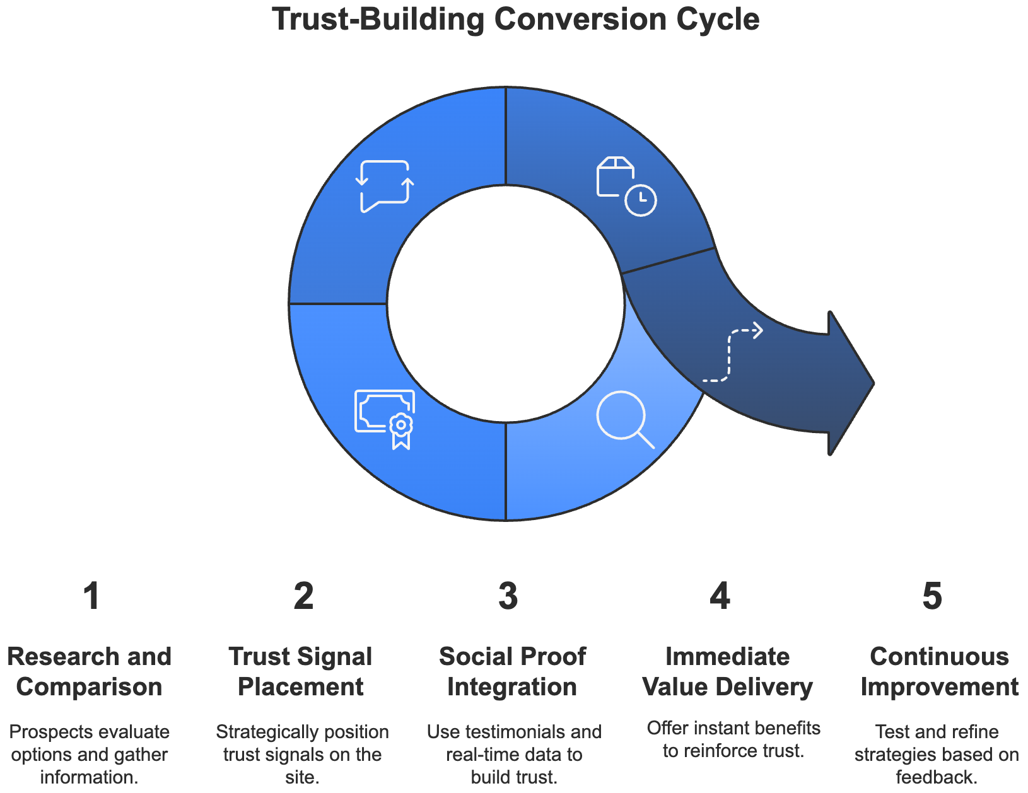
Your prospects have done their research, compared options, and narrowed their choices. Now they need absolute confidence in their decision. This requires a coordinated approach to trust-building that addresses both emotional and rational concerns.
Strategic placement of trust signals can increase conversion rates dramatically during checkout. However, simply plastering security badges across your site isn't enough.
You need to think carefully about where and when these signals appear. Security certificates make the most impact during payment processes, while industry awards and certifications carry more weight on product pages where customers evaluate your expertise.
Social proof takes on special significance during the final decision stages. Video testimonials tend to considerably outperform text reviews in driving conversions. This difference stems from the authenticity and emotional connection that video content provides. When prospects see real customers describing their experiences, it creates a powerful sense of validation and reduces purchase anxiety.
Consider implementing real-time social proof elements that create a sense of community around your product. Showing recent purchases, current visitor counts, or live chat availability adds dynamic energy to the purchase process. These elements transform a solitary decision into a shared experience, leveraging the psychological principle of social validation.
The final moments before purchase present unique opportunities to reinforce trust through immediate value delivery. Offer instant access to digital products, provide detailed order tracking capabilities, or showcase your customer support responsiveness. Each of these elements demonstrates your commitment to customer success beyond the initial transaction.
Your success in converting clicks to customers depends on your ability to understand and address both the practical and psychological aspects of purchase decisions. By focusing on reducing mental effort, building trust, and creating personalized experiences, you create a clear path from interest to action.
Lastly, keep testing, measuring, and refining your approach based on customer behavior and feedback. You will create an ever-strengthening relationship with your audience if you do so, ensuring long-term loyalty and repeat business.
Part Five

MEASURING SUCCESS AND OPTIMIZING FOR ROI
____
Numbers tell stories about your marketing success, but most marketers struggle to understand what those stories mean.
Recent research reveals a striking truth: while 97% of marketers recognize the importance of measuring performance, only 23% feel confident in their ability to extract meaningful insights from their data. Your challenge isn't just collecting numbers; it's transforming those numbers into actionable strategies that drive real business growth.

Building Your Measurement Foundation
Success in marketing measurement starts with understanding the relationship between your business objectives and the metrics that matter. Think of your measurement strategy as a pyramid, with your core business goals at the top and supporting metrics forming the foundation. When WebFX analyzed high-performing marketing teams, they discovered that organizations taking this structured approach achieved 43% better returns on their marketing investments.
Your measurement framework needs to answer three critical questions: what drives revenue growth? How do customers move through your funnel? Where do opportunities for optimization exist? By focusing on these fundamental questions, you avoid the common trap of collecting data without purpose.
Creating this alignment requires more than selecting random metrics. Start by mapping each business objective to specific, measurable indicators. For example, if your goal is increasing customer lifetime value, you'll need to track not just initial purchase amounts but also repeat purchase rates, customer satisfaction scores, and product usage patterns.
Successful organizations typically focus on three layers of metrics:
- Primary metrics directly tie to revenue and business growth. These include conversion rates, customer acquisition costs, and return on ad spend. Think of these as your north star metrics—the numbers that ultimately determine success or failure.
- Supporting metrics help explain performance and identify optimization opportunities. Examples include engagement rates, time on site, and cart abandonment rates. These metrics provide context and insight into why your primary metrics move in certain directions.
- Diagnostic metrics offer detailed insights into specific aspects of your marketing efforts. These might include page load times, email open rates, or social media engagement metrics. While less directly tied to revenue, they help you identify and fix problems before they impact your primary metrics.
Your success in measurement depends on collecting clean, accurate data across all these layers. Organizations with integrated data collection systems achieve better results from their optimization efforts compared to those working with fragmented data. Try implementing proper tracking codes, maintaining consistent naming conventions, and regularly auditing your data collection systems.

Understanding Performance Across Your Funnel
The complexity of modern customer journeys demands sophisticated measurement approaches at each funnel stage. Organizations tracking advanced engagement metrics often see higher conversion rates from initial contact to qualified leads. Let's explore how to effectively measure and optimize each stage of your marketing funnel.
At the top of your funnel, look beyond basic awareness metrics like impressions and reach. Modern awareness measurement requires understanding the quality of initial interactions.
When someone encounters your brand for the first time, what actions do they take? Do they engage deeply with your content or quickly bounce away? These behavioral signals tell you much more about the effectiveness of your awareness efforts than raw exposure numbers.
For example, rather than celebrating reaching 100,000 people with your latest campaign, focus on metrics that indicate genuine interest:
- Average engagement time with your content
- Depth of content consumption (how far people scroll or how many pages they visit)
- Return visitor rates and frequency
- Social sharing and earned media mentions
The middle of your funnel presents unique measurement challenges because prospects often move non-linearly through their decision journey. Prospects typically interact with 8 pieces of content before showing strong purchase intent. This means you need sophisticated tracking systems that can follow prospects across multiple touchpoints and channels.

Focus on metrics that indicate increasing purchase intent:
- Content consumption patterns across different topics and formats
- Interaction with product-specific information
- Engagement with decision support tools like calculators or configurators
- Questions asked through chat or support channels
Bottom-of-funnel measurement ties everything together, connecting marketing efforts directly to revenue. Organizations tracking post-conversion metrics will see a higher customer lifetime value. This broader view helps you optimize not just for immediate sales but for long-term customer value.

Implementing Advanced Optimization Strategies
Modern optimization requires combining sophisticated technology with human insight. Organizations using advanced optimization algorithms alongside human strategic oversight will achieve better returns than those relying solely on automated solutions.
Start by establishing a systematic testing framework. This means moving beyond simple A/B tests to implement multi-variate testing programs that consider multiple variables simultaneously. Create a hypothesis bank, or a collection of test ideas based on data analysis, customer feedback, and competitive research. Prioritize these tests based on potential impact and ease of implementation.
When implementing tests, consider the full customer journey. A change that improves immediate conversion rates might harm long-term customer value. For example, aggressive discounting might boost short-term sales but attract price-sensitive customers who are less likely to become loyal, high-value clients.
Focus your optimization efforts on these key areas:
- Budget allocation
Use algorithmic optimization tools to distribute spending across channels and campaigns, but maintain strategic control through clear constraints and regular performance reviews. Modern platforms offer sophisticated algorithms for budget optimization, but they require human oversight to ensure alignment with business objectives.
- Creative performance
Implement structured creative testing programs beyond the basic headline or image tests. Organizations using systematic creative optimization typically achieve higher engagement rates than those that don’t. This means testing different creative approaches, messaging frameworks, and emotional appeals to understand what resonates with different audience segments.
- Customer journey optimization
Take a holistic view of your funnel, identifying and addressing friction points that prevent prospects from moving forward. This might involve analyzing drop-off points, conducting user testing, and implementing fixes across multiple channels simultaneously.
Your measurement and optimization success ultimately depends on building systems that combine technological sophistication with strategic thinking. Focus on collecting clean, actionable data, implementing structured testing programs, and maintaining a balance between automation and human oversight.
Part Six

MASTERING THE FUNNEL MINDSET
____

Picture two marketing teams facing identical challenges. The first frantically responds to every metric fluctuation, celebrating short-lived victories while struggling to maintain momentum. The second approaches their funnel with calculated precision, combining rapid testing with patient analysis.
Both teams possess similar tools and talent, yet their results differ dramatically. The key distinction? Their fundamental approach to funnel management—their mindset.

The Strategic Mindset Revolution
Success in funnel management requires more than mastering tools or tracking metrics. You need to develop what successful marketers call a strategic mindset, or the ability to see beyond immediate results and understand the broader patterns shaping customer behavior. This mindset transforms how you approach every aspect of funnel management, from daily optimization decisions to long-term strategic planning.
Think of your funnel as an ecosystem rather than a linear path. Each element influences the others, creating complex relationships that simple metrics can't fully capture.
When you adjust your Facebook ad targeting, you're not just affecting top-of-funnel metrics—you're potentially changing the quality of conversations your sales team will have weeks later. This interconnected perspective helps you make better decisions about resource allocation and optimization priorities.
Developing this strategic mindset requires understanding three core principles: context awareness, pattern recognition, and strategic patience. Context awareness means considering how external factors, from seasonal trends to competitive actions, influence your funnel's performance. Pattern recognition involves distinguishing meaningful trends from random fluctuations in your data. Strategic patience, perhaps the most challenging principle, means resisting the urge to react to every short-term change in favor of focusing on sustainable growth.
See how these principles might apply to a common scenario: Your conversion rate drops 20% over a week. A tactical response might involve immediately adjusting ad spend or changing landing page elements.
A strategic mindset first asks deeper questions: is this part of a normal seasonal pattern? Have we recently changed our traffic sources? Are competitors running aggressive promotions? Understanding these contexts helps you respond more effectively and avoid knee-jerk reactions that might harm long-term performance.

Building Cross-Functional Alignment
The most sophisticated funnel strategy falls apart without proper team alignment. This misalignment not only hampers efficiency but also creates friction that can negatively impact the customer experience.
Traditional organizational structures often create unnecessary divisions between teams that should work in seamless coordination. Marketing generates leads without understanding sales processes, while sales teams critique lead quality without providing feedback that could improve targeting. Meanwhile, customer service holds valuable insights about client needs that never reach either team.
Creating what marketing experts call a funnel ecosystem requires fundamentally rethinking how your teams interact. Instead of treating departments as separate entities with distinct goals, consider them interconnected components of a single customer experience system. This shift in perspective changes everything from how you structure meetings to how you measure success.
Your approach to team integration should follow these core principles:
- Shared metrics
Develop KPIs that encourage collaboration rather than competition. For example, instead of measuring marketing purely on lead volume, consider metrics that reflect lead quality and sales team feedback.
- Information flow
Create systems for regular, structured communication between teams. This might include daily standup meetings, weekly cross-functional reviews, and monthly strategic planning sessions.
- Unified technology
Implement tools that provide a single source of truth for customer data across all departments. Modern CRM systems can track interactions across every touchpoint, but only if teams actively share and update information.
- Cultural alignment
Foster an environment where teams naturally collaborate rather than compete. This often requires rethinking incentive structures and recognition programs to reward cross-functional success.
Here's how successful organizations structure their funnel teams:
Team | Traditional Role | Evolved Role | Key Integration Points
Marketing | Lead generation | Journey orchestration | Sales feedback loops, customer insights
Sales | Conversion | Relationship building | Marketing intelligence, support coordination
Support | Issue resolution | Experience enhancement | Product feedback, marketing insights

Mental Models for Funnel Success
Your success in funnel management largely depends on developing effective mental models—frameworks that help you understand and respond to complex situations. These models should guide your decision-making while remaining flexible enough to adapt as circumstances change.
The portfolio approach represents one of the most valuable mental models for funnel management. Think of your marketing activities as an investment portfolio, where you balance different levels of risk and reward.
Successful organizations typically allocate their resources following a 70/20/10 framework:
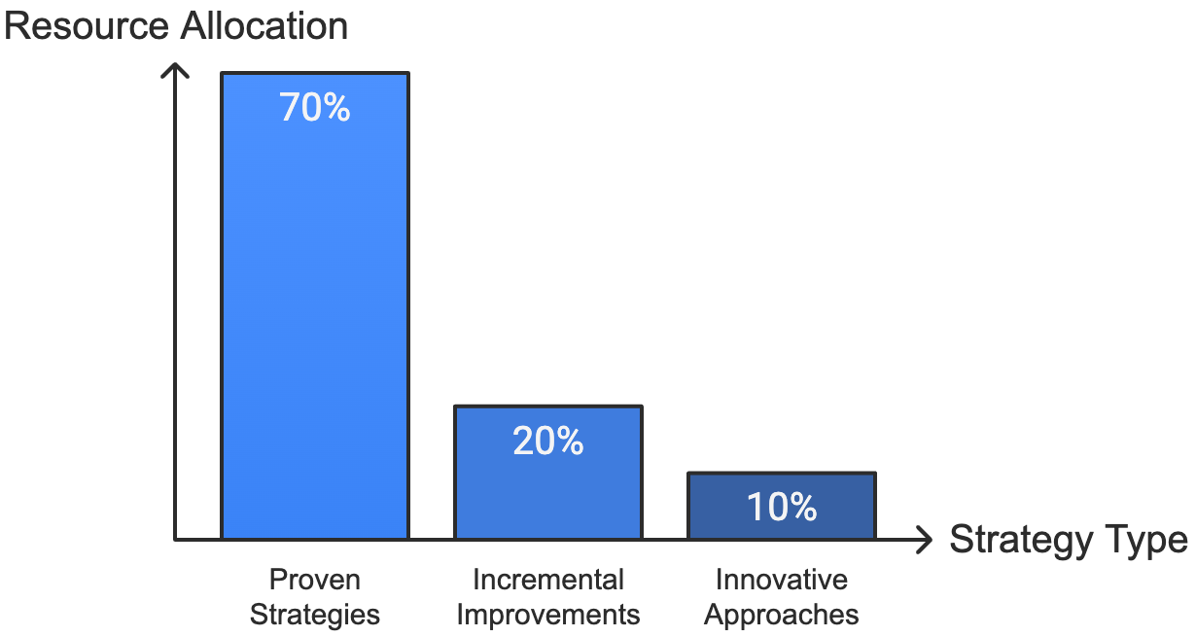
- 70% to proven strategies that consistently deliver results
- 20% to testing incremental improvements
- 10% to experimenting with innovative approaches
This balanced approach ensures stability while creating opportunities for breakthrough improvements. For example, if you're managing a SaaS company's funnel, you might dedicate 70% of your budget to optimizing your core email nurture sequences and content marketing, 20% to testing new ad platforms or messaging approaches, and 10% to exploring emerging channels like voice search or virtual events.
Another crucial mental model is the feedback loop framework. This model helps you understand how different parts of your funnel influence each other. For instance, changes in your lead qualification criteria might reduce your apparent lead volume but improve sales efficiency and customer lifetime value. Understanding these relationships helps you make better decisions about where to focus your optimization efforts.
Your mastery of funnel management ultimately depends on developing both the right mindset and the practical skills to execute effectively. By combining strategic thinking with tactical excellence, you create sustainable systems that drive consistent growth while adapting to changing market conditions.
Remember that building an effective funnel isn't about finding perfect solutions. It's about creating flexible frameworks that evolve with your business and your customers' needs.

