Disclaimer

This eBook has been written for information purposes only. Every effort has been made to make this eBook as complete and accurate as possible. However, there may be mistakes in typography or content. Also, this eBook provides information only up to the publishing date. Therefore, this eBook should be used as a guide - not as the ultimate source.

The purpose of this eBook is to educate. The author and the publisher do not warrant that the information contained in this eBook is fully complete and shall not be responsible for any errors or omissions. The author and publisher shall have neither liability nor responsibility to any person or entity with respect to any loss or damage caused or alleged to be caused directly or indirectly by this ebook.

This eBook offers information and is designed for educational purposes only. You should not rely on this information as a substitute, nor does it replace professional medical advice, diagnosis, or treatment.
Table of Contents

Introduction 6
Chapter 1: What Is Consistency? 12
Give Consistency Its Credit 12
Stay Steady 13
Chapter 2: Why Does Consistency Matter? 18
Consistency In Life And Business 18
All Consistency Can Bring You 19
Self Control is Key 20
Chapter 3: Why You Shouldn’t Treat Consistency As All Or Nothing 26
Always & Never 26
It Is A Challenge 27
Chapter 4: How Small Steps Lead To Big Results 33
Take Your Time 33
Compile The Small Things 34
Chapter 5: How To Not Quit Being Consistent 38
Take Care of Yourself 40
Chapter 6: Consistency And Habits: How They Link 45
How To Change Habits 45
Chapter 7: What Can Consistency Give You? 50
Change Your “YOU” View 50
Chapter 8: How To Be Consistent No Matter Who You Are 55
Conclusion 60



Introduction

When you think about consistency, what is the first word or the first emotions that come to mind? What do you first feel when you think of someone who is consistent?

If you think of a business that is reliable and trustworthy, what feelings does that evoke? Is this a place of business that you want to visit again and again? Is this somewhere that you feel comfortable spending your money as often? Is it a place that feels actually rewarding and fun to shop at?

The answers to those questions are probably yes because consistency is a big reason why people bring their business back to the same companies again and again. When they are spending money, they are voting with their wallets. They are saying that they feel like they can count on this company and their products, their sales people, their entire vision and culture.

The same is true with people. Consistency can go a long way to forge strong friendships, get good jobs, create communities, and manufacture a personal environment that is peaceful and rewarding and strong.

If you want to have real relationships and real success at work and a future that is bright and promising, you need to be a consistent person and do consistent work and regularly show others that you can be trusted.

But before you can do that, before you can really start to live a consistent life and be a consistent person, you need to know what consistency is and why it is so important. Why do so many people look for it in business and in personal life? Why does this facet of someone or some company rise above all others?

Consistency is the act of regularly doing something well without being reminded. It’s being reliable, it’s being trustworthy, it’s delivering on your promises without being prompted and doing it again and again.

The post office is consistent. The nightly news is consistent. Unfortunately, the IRS is consistent. These are all entities that get their jobs done without being told to and they have acted correctly for generations now. They don’t need to be guided, they don’t need to be told what to do. They know their purpose and the task at hand and they complete it on their own, free of mentorship and usually assistance.

Throughout your life, you have met with and worked with plenty of people and business entities that have and have not been consistent. You have experienced the good and bad of consistency. You have people who are always late and you have people who are always on time, sometimes even early. You have companies that deliver their goods and services on time without any issues and you have others who have to be called and hounded to accomplish a very simple task that they promised to you weeks ago.

You know that a life with consistency is much calmer and easier because there are no surprises. You know what is promised and you know that you can expect that promise to be done without any hassle.

You also know that a life without consistency is the opposite. You are always on your toes, you are always a bit anxious, you are always feeling like the other shoe is going to drop and you are going to have to do extra work because you cannot count on people.

As you can imagine, all of this can have both a positive and negative impact on the relationships in your life. Building connections with people who are and are not consistent can be both rewarding and very challenging. And you might find that you’re the type of person who cannot have a meaningful friendship or relationship without someone who will not deliver on promises and cannot keep up their end of any deals.

This is why consistency is so important. On the surface, some people don’t see it as a very important characteristic and value in life but, in reality, it’s crucial. It can make or break relationships and personal lives but it can also make or break businesses and your financial future and wellbeing.

In the chapters ahead, we will take a deeper dive into what consistency is. By doing so, we will examine the ways you see it - and the ways you don’t - in the real world and the influence it has had on you and your money and your life at home and at work.

They say that trust is the most important thing you can earn with other people and that is definitely the truth. Trust is a major component of consistency. Therefore, consistency is one of the most important things you can give someone else. Let’s explore why - and let’s help you become the consistent person you can be.

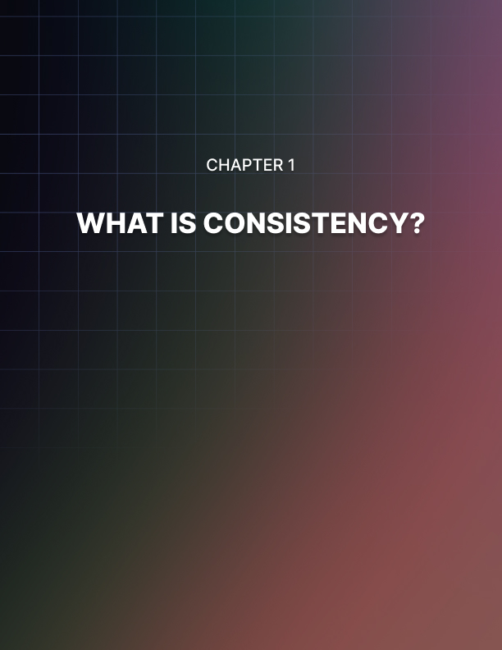

Chapter 1: What Is Consistency?

Consistency: “conformity in the application of something, typically that which is necessary for the sake of logic, accuracy, or fairness.”

That right there is the most definitive definition of consistency. When you look at it that way, it all feels rather simple and easy to put into your own life. It seems like it would be easy to be consistent and only rely upon and grow close with consistent people, right?

Well, not so fast. It’s not nearly as easy as you might think.

There are far too many people who think that truly being consistent will be a breeze. It’ll be so easy to practice this concept and make it a regular part of my life, they think. I can be a consistent person with ease and once I start doing it, I’ll never stop, they tell themselves. But that is simply not the truth.

Give Consistency Its Credit
The truth is that not enough people give consistency enough credit. But although it is sometimes disregarded and underestimated as an important life strategy, consistency has helped many people succeed and can do the same for you.

So, what is consistency, precisely? Not the definition or the vague description that we gave earlier. What does real consistency in a real life look and feel like? And what does it result in? What are some honest instances of consistency?

Let's start with what consistency isn't. Being consistent does not entail giving in or continuing with a situation that is not beneficial to you, your relationship, your profession, or more. It doesn't imply that you have to adhere to customs or principles that are obsolete in the modern age. Because, things are changing in the globe considerably more quickly than they have in the past.

No, maintaining continuity does not imply refusing to adapt to the times. There are far too many people in the world who are consistent in all the wrong ways. Being consistent doesn’t mean you get to be hateful or hurting to others, even if you don’t know them or understand them. That is not being consistent or “true to yourself”, that is just being cruel.

To do what always works requires consistency in principle and practice. It entails continuing with time-tested methods that get the job done, no matter what that job is. When what you're doing is effective, there's no need to change it solely because the newest politician, business tycoon, or life coach says you should. It’s about cutting through all the noise and temptations of get-it- done-quick schemes and methods and doing only what will really work and deliver the best results, again and again.

When you see the success of someone in the world of business, it’s not always because they were trying to shake up the world, think outside the box, and do something brand spanking new.

Most times, you will find that these billionaires and world class experts find their success because they do what works. They keep it simple, they keep their eyes on the prize, they find a method to get what they want and they stick to it. That is consistency. And it has helped many people find great success throughout history.

Stay Steady
Staying steady and dependable is another aspect of consistency. To see results, you must consistently put in the effort. This holds true for all aspects of your life, including your career, personal, and social lives. For instance, consistently hitting the gym three times per week is far preferable to working out hard every single day and eventually wearing out if you're trying to get in shape.

You must put in the effort, and outcomes will come. There is simply no getting around that.

This is an important part of being consistent: you are not always doing it for other people. Sometimes, you are being consistent only for yourself. Being consistent to yourself relates to multiple things. For example, it has to do with sticking to a diet and treating your body well, going to bed at a reasonable hour, keeping up with your hobbies, continuing to contact and be close to the people you love, and treating yourself every now and again.

When you start to be consistent in this part of your life and are consistent to not only others but yourself, you will start to live a happier, more rewarding life.

What are some effective strategies you may use to introduce consistency into your life? Think about losing weight. Do you believe it is preferable to continuously eat healthily with sweet snacks from time to time in moderation, resulting in slower but more lasting weight loss, or to engage in a series of dramatic crash diets followed by binges?

Becoming consistent is about knowing what consistency is and then taking a step back and figuring out how to practice it in the real world, both to yourself and to others. Now that we know what consistency is, let’s talk about what is so important and what it matters and then how you can do little things, again and again, to make yourself consistent.

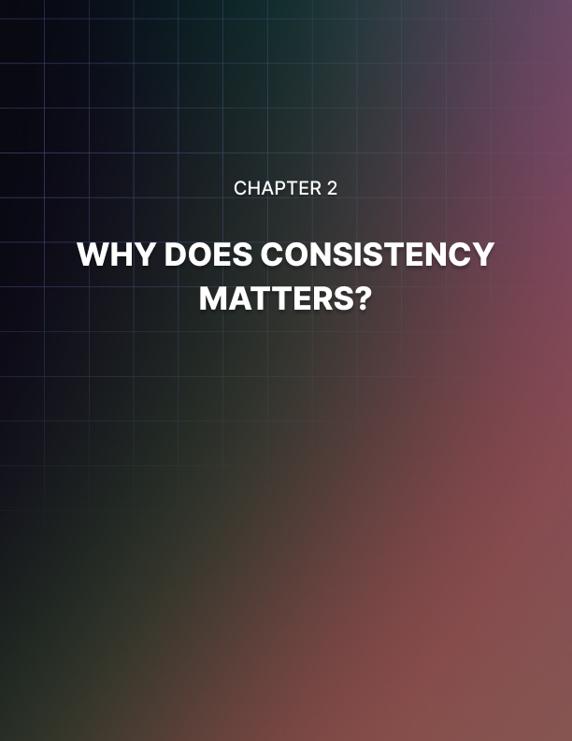

Chapter 2: Why Does Consistency Matter?

What is it about consistency that makes it so vital in both your life and your business? For a number of reasons, actually. When you take a good, long, hard look at consistency you will see how it can help you in many facets of your life.

Consistency can help us cut through the noise in a world where we require self-control and self-discipline to concentrate on the things that are important to us. But you must use discipline if you wish to develop a truly planned habit. And this discipline prevents you from deviating from your course. This is the prime reason why consistency matters so much.

Consistency In Life And Business
Let’s say you are attempting to start a new business or presence online. If that is the case, you must exercise self-discipline if you wish to start something that will flourish and last for a long time. Establish a strategy that will help you maintain focus, find new information, compose the article's outline and body, edit it, and then publish it. And you must repeat this the following week. This is good for yourself, your writing, your skills, and the audience you wish to find.

Would you watch a TV show that doesn’t come out on a normal schedule? Would you subscribe to a newspaper that isn’t delivered everyday? Of course not.

This won't be simple. However, nothing that calls for self-control, self-discipline, and a lot of effort is simple. You will see the outcomes in the end.

And you will feel better about yourself with some consistency too. This is yet another reason why you need to add into your life. With consistency, you will have more confidence in yourself and others will have more faith in you if you consistently follow through on your commitments.

Building the particular project you're focusing on every day can help you feel more confident and proud of the goals you're pursuing. And this will, in turn, cause you to keep working hard, keep creating more, keep finding more success.
It is not about the outcome or the finish line to be consistent. The advancement you make each time you construct that unique project is what consistency is all about.

You can look back and check how you performed this morning, two weeks ago, or three weeks before that. It is about the process and the development, not the outcomes. You can change your speed, get a general sense of your resources, and maintain a clear and precise approach by analyzing your improvement.

By keeping track of your progress, you can boost your self- confidence and become more at ease with goal-setting.

All Consistency Can Bring You
Do you desire to be noticed within the crowd? Be dependable. Do you desire attention? Be dependable. Show up every single time and every single day. If you can establish yourself as a person or writer or business person who is reliable and consistent, you will surely create a following and connections with the people who matter.

Make something that will be worth speaking about or promoting. Not every piece of material you publish will go viral. Not every business endeavor will attract the attention and followers you desire. Not every relationship will become something long-lasting. However, being present each day will earn people's trust and keep their interest. Because over time, these little, straightforward activities will add up to significant outcomes for yourself, for the friends and family you hold close, to the businesses you begin, and for the way you see yourself and the way the world sees you.

There are a number of reasons why keeping our commitment to hard effort might help us achieve great success in life.

When you act regularly, you perform the same tasks practically daily. When we neglect to perform things for a day or even two and then our goal is unsuccessful, it is simple to understand why this occurred. Consistency makes us responsible for every action we take.

If you are the one carrying out the tasks necessary to achieve goals, then no one else is at fault. We may need to modify our activities and habits in order to complete our plans since we will be missing one or two workdays.

Consistency in daily life helps us become more trustworthy in other's eyes. Preaching to others is simple, but actually living our beliefs could be more difficult. Individuals who "walk the talk" are seen as very trustworthy and dependable by others. When the other people believe in you, it gives you confidence in what you're doing and confirms that it's worthwhile. Other people's trust in us fosters our own confidence and gives us the will to continue working for all of our aspirations and objectives.

In terms of trust, acting consistently can increase our relevance and improve our reputation, particularly if you work in a company or are a leader in some capacity. People want to work with people who have a track record of success because consistent hard work yields lasting results. This may result in more client opportunities in business. Working hard and regularly can have a huge impact on whether you get promoted or remain a rank-and- file worker in the workplace.

Self Control is Key
Being consistent can be difficult because it takes a lot of self control, and if one is not accustomed to staying constant in one's actions, it may become an entirely new habit. Consistency in practice reinforces discipline, sharpens our attention, and increases our awareness of what needs to be done. It can be quite difficult to break old habits, yet consistency in all that we do is necessary if we want to do better things and experience personal progress.

If you constantly practice a new skill for a while, you can assess whether it will be a success or a failure. If getting results quickly is your thing, you might stop doing something or give it up if you don't get results right away. You can push through doing things and determine if they will be successful or not if you have the drive to perform them regularly.

For all you know, a project may simply require minor adjustments to the procedure in order to succeed, and you won't know unless you stick with it before choosing to give up.

Consistency in all we do in life can mean the difference between success and failure. It can be challenging to act consistently, especially if you have to perform the same things each day because it can seem monotonous and repetitious. Expecting rapid results is unrealistic since practicing consistency entails playing the long game. People can be reluctant to change when daily habits need to be formed. It is rarely too late to put consistency into practice, particularly if we desire to better ourselves and achieve our objectives years from now. To help you become more effective, seek advice from others, such as a life coach, as doing it alone might be challenging.

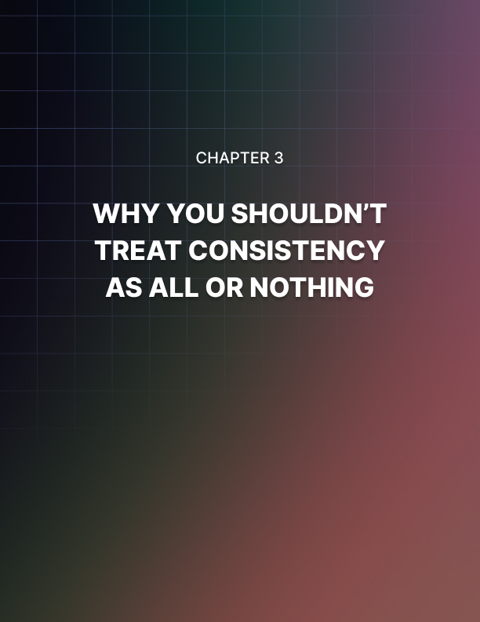

Chapter 3: Why You Shouldn’t Treat Consistency As All Or Nothing

There are so many people who think they are either great successes or horrible failures, despite what the evidence and facts say. There are plenty of people who don’t see what they have accomplished, even if what they have done is huge and monumental and worthy of fame and praise.

And then there are also people who think that they have done more than enough and don’t need to keep at it or try hard anymore or accomplish anything else.

This is all or nothing thinking. It’s the idea that it’s either this or that, A or B, and nothing else. When you live a life that is all black and white thinking without any gray, you are doing yourself a great disservice and completely limiting what you can accomplish.

There are many people who follow black and white, all or nothing thinking when they are trying to become consistent. Why is it such a common feature of people who are attempting to add more consistency into their lives? It’s not totally clear but it has to do with the fact that it hurts to see yourself set goals and fall short.

Always & Never
There is a great deal of harm that can result from this kind of thinking especially when you are trying to be a consistent and reliable person. All or nothing thinking will impact how you perceive both yourself and other people. This mode of thinking frequently employs absolute phrases like "always" or "never." “I can never be consistent all the time so I should never try!” This is a common thing that many tell themselves as they try to be more consistent in their personal and business lives. Additionally, many people are unable to recognize other possibilities since there is only good or bad, with nothing in between. It could make it challenging or even impossible to see solutions.

When you follow all or nothing thinking you will feel like a failure more often and you will also tend to have lower self-esteem because when you are either a success or a failure - and nothing else - the chances of looking like a complete failure are much higher.

You will also be less willing to take risks when you are an all or nothing thinker and this simply will not allow you to be consistent regularly. You need to take some risks to change your life and the way that you do things, including the ways that you can be consistent and reliable and dependable. You might need to think outside of the box, try new things, push yourself, and shake things up. But you cannot do that regularly with all or nothing thinking.

Also, you will not be able to forgive yourself often and this is a huge reason why all or nothing thinking cannot be employed when you are becoming a consistent person. You need to give yourself grace when you don’t reach the new standards you are setting for yourself. You need to tell yourself that you didn’t do all that you wanted, you didn’t reach your goals 100%, but at least you tried and that is something to be proud of. That is something to celebrate. If you cannot forgive yourself, you cannot get back on the horse and try again. And that is an important part of becoming consistent or really doing anything else.

Yes, you need grace and self-forgiveness and self-compassion when you are trying to transform yourself and become a compassionate person. And all or nothing thinking will not allow you to do that.

When someone thinks in this way, they may think of themselves as successful or unsuccessful in their endeavors in life and nothing else. It's all black and white, it's one or the other. That is the essence of all or nothing thinking and it can lead you down a path you can't come back from.

It Is A Challenge
Let’s be honest: becoming consistent can be a challenge. It will require that you set a goal for yourself and create a vision of a version of yourself that you want to be. And then it’s about following through and creating the steps necessary to become that person. That is a big undertaking! That means that chances are you will not always be 100% perfect.

You will make mistakes, you will fall short, you will have to reevaluate and try again and tweak your approach to being consistent. And if you are an all or nothing, black and white thinker, you will constantly hold yourself back.

This type of thinking is bad when you’re trying to be consistent but it’s also bad if you are attempting to create relationships with other people too. You judge your own worthiness as either being good or bad. But with this binary thought pattern, you might begin to perceive other people as well. As a result, you could judge yourself and other individuals harshly and unfairly. When you're so pessimistic, the world can seem like a very gloomy place, which can reinforce your sentiments of cynicism, sadness, and anxiety.

You might not want consistency just from you in life but from other people too. That means that you’ll demand a lot of others in your life. You will require that they are dependable and can be counted on. But, as mentioned, it’s not always easy to do that all of the time. You’re not the only one who will probably make mistakes and fall short at times. Other people will not always be able to become consistent over night. It will take time, it will take false starts, adjustments, and moments of frustration.

If you remain all or nothing thicker then you will not allow those people close to you to try, fail, try again, and eventually succeed. As you can imagine, this will not permit consistency from you or from other people close to you.

The bottom line is that you will not gain anything from suffering from all or nothing thinking. All it will do is set unfair standards for yourself and for other people. It is a surefire way to limit yourself and ensure that you will never make changes and the changes that others make will not be good enough for you.

As you can see, it needs to be avoided - especially if you are attempting to make a big change in your life, like becoming a dependable and reliable person.



Chapter 4: How Small Steps Lead To Big Results

As with most things, becoming a consistent person is not a sprint, it’s a marathon.
You have likely heard people say that before about other things but it remains true for being consistent. If you are looking to become a dependable person or run a dependable business, you cannot expect to do it all over night and suddenly change the way that you see the world, the way that you do business, the way that you carry yourself and live your life.

That is, of course, a method of all or nothing thinking. And, as we said, that is a horrible headspace to be in and will only slow you down or completely stop you from being consistent.

The truth is that becoming a consistent person might feel overwhelming at first. You might tell yourself that you have been a certain way your entire life so it will take a monumental amount of change to alter that now.

Take Your Time
Yes, it will take a lot of work but here is the thing: this work doesn’t have to all be done at once. It can be done over time, slowly but surely. In fact, becoming consistent is actually an act of consistency, as confusing as they might sound.

Instead of trying to undergo a sea change and radically altering your life all at once, turn to the marathon analogy and start changing little things, here and there, over time. Before you know it, your entire life and the way that you run your business and your personal affairs will be different and you will see that you really have become the sort of person you knew you could - you just didn’t do it all at once in the blink of an eye.

Small steps, that is what you need. What are some small steps that can make you consistent and keep you that way?

It’s smart to find an evening ritual that you can do every single day. That’s always a good start. Why at night? Because putting the pressure on yourself to do something in the morning might be too much. You already have so much to do in the morning so instead, you should focus on the evening.

Maybe you have a book that you’re trying to read. Here’s a good small step you can follow: read three pages before bed. Set aside 15 minutes for yourself to read those three pages, no matter what. It doesn’t matter what you have done in the day or when you need to wake up or how tired you are, you will read your three pages. It’s just three! You can do that quickly! And you will, every night.

It doesn’t even need to be something as substantial as that. Maybe it’s something as simple as applying lotion to your feet before you go to bed. That is a small step that you can follow every night, right? It only takes seconds.

No matter what it is, you need to do it every night. This is building consistency. It is actively being consistent and it is proving to yourself that you can do it. You are showing yourself evidence that you can achieve consistency, even when it’s with something small. This will help you in the future when you might feel like you have bitten off more than you can chew. You will look back at these small steps and remind yourself that you can get it done.

Why? Because you have and this will be the proof of that.

Compile The Small Things
The key to becoming consistent is looking at all the small things you do regularly and compiling them together into a narrative that you tell yourself. When you put all of these little things together, you will see that you really are consistent now. You haven’t said to yourself “I want to be at work 15 minutes early everyday without exception.” Instead, you have said “I want to wake up five minutes earlier everyday” and then “I want to take a snack with me to work every day” and then “I want to start my car ten minutes early.”

These are all smaller steps and small goals that you can achieve. When you put them all together, you have an overarching success.

As you can see, small steps will lead to big results. You just have to figure out the ultimate results that you want and then find the small steps that you can take on the way to those results. You can never have too many small steps. And when you put them all together, they show you a pathway that ultimately led to the person you want to be and the consistency you want to show.

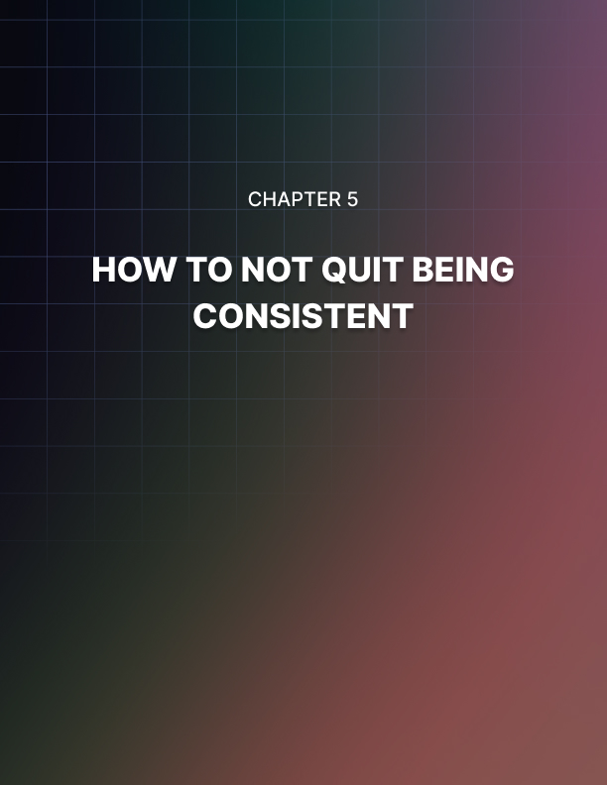

Chapter 5: How To Not Quit Being Consistent

You have now learned how to be consistent but the most important part of being consistent is staying consistent. And that might not be as easy as you would assume.

In fact, if you start to be consistent but then drop the ball and stop, you will really be wasting your time - and the time for others. The whole goal of consistency is staying consistent.

But how do you do that? How do you keep it up? How do you not drop the ball? Well, it’s actually quite easy but it does take some planning and some hard work. But it is well worth it in the end.

Here are a few things to do and keep in mind when you want to keep up with the great progress that you have made.

Be Practical in Your Goals: If you do not know what you must do, it will stay tough for you to be steady. Make easy, straightforward objectives that are simple to monitor as a result. You may begin by outlining your definition of consistency. Next, you must think of smaller steps you must take to accomplish that goal. As we have discussed, this will keep you consistent and will not make your task at hand seem so big, overwhelming, and unattainable.

Maintain Consistency: Consistency requires knowing what needs to be done each day. Consequently, you want to make a plan for yourself. This will assist you in staying organized, whether it be an organizer, a notebook, or a list of notifications on your phone. You can then determine the obligations for which you have time and those for which you do not.

Use Reminders: Since this is a new routine, it is worth reminding oneself to do it. Try to put reminders on your clothing, in your house, at work, and in your school. New commitments and conversations are simple to forget, particularly when you're attempting to switch up your routine. Post reminders where they will be seen so you will remember them throughout the day.

You will occasionally make mistakes, no matter how hard you strive to be consistent. So, if you make mistakes, strive to keep going. Even if you are really well-organized, you will occasionally make a mistake. As a result, you should make plans based on your blunders. Try not to berate yourself if you make a mistake. Periodically, things like these take place.

You are not necessarily losing consistency if you violate a promise, fail to make a date, or have to reschedule on someone. It is true that other circumstances may interfere. Even while it's crucial to prepare for these outside influences and work to avoid having them derail us, it will occasionally happen.

You should have the ability to be more regular if you want to. You must therefore obtain enough sleep at night. The typical adult needs seven to eight hours of sleep per night. Even more is required of those who are still in school. Giving your body time to recover will make it simpler for you to maintain consistency the following day.

It will take time although you desire to see immediate results. It might be challenging to alter your way of thinking, and you might not experience immediate effects. Uprooting your entire life and introducing a lot of new practices all at once might be challenging. You should therefore give yourself time to determine what functions best for you.

You should also be persistent while remaining realistic. Generally speaking, becoming a habit requires doing something consistently for around a month. Set minor goals along the road, don't forget. Avoid taking on too much at once. Over time, minor adjustments will add up.

You'll also need to establish limits for your intimate connections and commitments. Due to your expectations of others, these boundaries may make it simpler for you to keep your end of the bargain. Setting these limits will ensure that you never take on too much. For instance, let your employer know that you don't want to work on the weekends or at odd hours. To let your coworkers know that you are not available on evenings, weekends, or holidays, you can even turn your phone off completely.

You will be more consistent if you alter your way of thinking. When you are attempting to alter such a significant aspect of your life, keep this in mind.

There will be days when we are not feeling like accomplishing anything because we are not machines. We should all use motivational tools for this reason. What should you do if you need some motivation to complete your work? There are steps we can take to solve this issue, despite the fact that it can be simple to let our goals go for a day. There are a few methods you might find more motivation if you're feeling down, lethargic, exhausted, or depressed.

Take Care of Yourself
Making only commitments you can keep is another crucial habit you must cultivate if you want to be more consistent. People enjoy being liked by others. As a result, if someone begs for our assistance, we all have a propensity to say yes. Even while it is nice to have others support us, it is crucial to avoid making promises we can't meet. You must honor your commitments if you wish to live a more consistent life. On the other side, it is simple to become overburdened, which leads to some responsibilities slipping through the gaps.

Make an effort to treat yourself if you want to be more consistent. After all, forming a new habit is difficult. Set time-based objectives for yourself. Then, as you accomplish those objectives, treat yourself. You can congratulate yourself on a job well done in a variety of ways.

It's crucial to reward oneself or practice consistency because doing so strengthens good habits. Everybody rewards oneself in different ways. Never be afraid to come up with new ideas, and remember to treat yourself when you succeed.

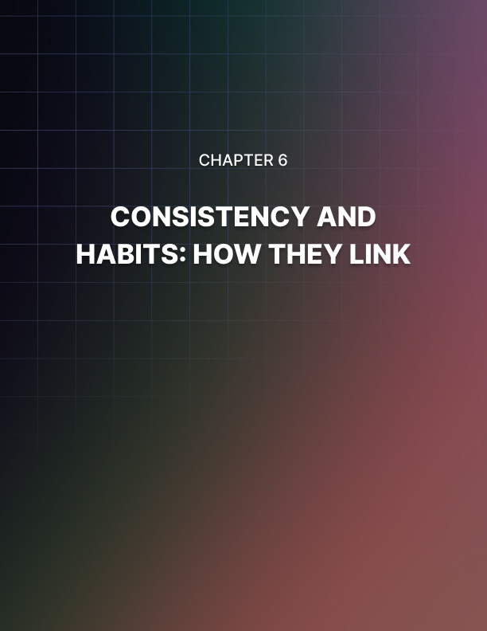

Chapter 6: Consistency And Habits: How They Link

Becoming consistent is really just a matter of changing your habits, one at a time, little by little.

When you put it that way, it sounds far too simple and like it’s not doing the people who changed enough justice. But that really is the main goal when you are trying to become consistent. All you need to truly be doing is look at the habits that you want to change or instill in your routine and then pursue them.

Habits are only habits so long before they become second-nature to you. Once you start to force yourself to pursue these habits, you will teach yourself to consistently do them and make them a part of your personality and your life and your routine.

That is truly a key part of becoming consistent but it’s also a tough part. Making new habits isn’t easy and keeping yourself honest and steadfast about repeating them is hard too. But it’s a crucial step if you wish to be a consistent and reliable person.

How To Change Habits
So, how do you make new habits and how do you turn them into part of your nature?

It’s really quite simple. Firstly, you want to make a list of all the ways you want to act and the many ways in which you can be a consistent person. Maybe you want to be better about returning phone calls or emails. Maybe you want to show up at work earlier. Maybe you want to go to the gym regularly. Maybe you want to cook at home instead of ordering out.

Okay, now you know your goals and you know how you want your life to look. The second part of this process is to lay out the habits that will make you get to that point and reach those goals. You will start small, like we said, and you will form the habits for yourself.
If you want to be better about returning phone calls, you will make an effort to reach out to a friend or family member via the phone at least once a week, every week. If you want to show up at work earlier, you will start by doing it just once a week but, again, you will do it every week. The same is true for the gym or eating at home.

Habits are often things that are naturally developed inside of us without the use of external factors. So it may sound weird to force yourself to make some. But you have to remember what you will accomplish when you insert these habits into your life. This is the best way to “teach” yourself how to do these things and how to do them regularly.

As you can see, this will create new parts of your personality. This can transform you into someone who returns calls and emails, gets to work on time, cooks at home, and so much more. But it won’t be easy. You may discover that you have some inner resistance to doing these things. You might not feel like doing this is natural or normal, it might feel forced or awkward.

But it won’t always feel that way. This is you building habits which will soon become second nature. Yes, it might not feel completely comfortable at first but the more you do it, the more you practice these new habits, the more you kick your own butt to do these things, the easier it’ll become.

It’s really all a matter of just getting started and initially pushing yourself to do these things. Once you make that first move, once you get going, it’ll all become easier.

You need to remember that being inconsistent is a habit too, and it’s one you need to break. If you are reading this book then you are likely ready to become a dependable and reliable person. You are tired of letting people down and that’s not a person you want to be. That is why you are trying to break the old habits that have led you to this point, the ones that have made you unreliable and inconsistent.

It is possible, it just takes time and it takes hard work. But hard work is almost always worth it, especially when it makes you the type of person you want to be, the type of person you know you can be.



Chapter 7: What Can Consistency Give You?

The best way for you to figure out what consistency can give you is to ask yourself this: how do you feel about consistent people and consistent businesses?

When you think of someone reliable and trustworthy, someone who is always on time and always delivering what they promise and never reminded or forced to do things - what do you think? What is your view of this person or this company? Is it good or bad? Is this someone you want to work with often or someone you want to avoid?

We can assume that you’re very favorable to someone who is good at their job, consistent, and reliable. And that is the sort of view people can have of you if you work hard to become consistent.

You can create a life that is full of healthy, strong relationships, good business connections, possibilities, fun events, and a peaceful and laid back feeling in all things if you strive hard to be consistent.

Change Your “YOU” View
The biggest thing that consistency can give you is the way that people view you, the opinions they have of you, and their desire to be with you and work beside you.

No one wants to work with someone or be close to someone who will only drop the ball and let them down. How often do you hear people speak fondly of others who are flaky and unreliable? Not often at all. It’s one of the worst traits that someone can have and it can ultimately ruin relationships. It can leave you without many friends and no business prospects for your future.

When you are consistent and reliable, you are saying something. You are essentially saying that you care. You are saying that you listen to others, you understand their feelings, and you respect them. You are saying their time is worth something and you are not taking them or their time or their availability for granted. And that says a lot! That shows that you are a caring and genuine and compassionate person. That is the sort of individual that others want to be close with.

When you are not consistent, you are saying just the opposite. You are saying that you know someone is busy or they are asking something of you and you simply don’t care. You’ll do it when you get to it, you’ll arrive when you want to, you’ll do everything at the pace that you choose. This is not someone who compromises or listens to others or truly cares about their feelings.

You say a lot by your actions. Your actions show the world the type of person you are and the values you hold close. If you work on being consistent, you will be given close friendships and high esteem with other people.

But it is important to keep one thing in mind: it is not consistency that will give you these things. It is you that will. You will be giving these gifts to yourself through the hard work, planning, and dedication you have shown. The rewards of being consistent are plentiful and they can be life-changing. They could be the difference between making a friend and not making one, getting a job and not getting it. But they are not given to you. They are earned by you.

You should always remember that you are the one who is fighting hard to win these prizes and reap the benefits of being consistent. You have worked hard and you deserve the rewards.



Chapter 8: How To Be Consistent No Matter Who You Are

You may hear some people say that they’re just always late or they never get something done on time or they only work at their own pace and can’t be told what to do.

They can’t be boxed in, they say. They can’t do things someone else’s way, they claim.

These people are essentially saying that they cannot be consistent, no matter how hard they try. It’s just not in their DNA, it’s not who they are. It is not something that comes naturally to them.

These people are, quite frankly, full of it. They shouldn’t be listened to and they should be believed.

And if you are one of those people, you need to seriously reevaluate how you view yourself and give yourself more faith because, no matter what you think or who you are, you are capable of being consistent and reliable and dependable. You can be the person who shows up on time, returns phone calls, finishes homework promptly, and delivers on their promises. No matter your background, your experiences, and your personality you can do this.

It’s all a matter of pushing yourself. Yes, some people find it easier to be consistent. That is because of the way they were raised or the jobs that they’ve had or just some personality traits that don’t feel taught or learned. But to say that you can’t be consistent is just silly and not truthful at all.

The truth is that anyone can be consistent, they just have to figure out what is holding them back and what the best approach is to changing that and avoiding the potholes and roadblocks that can slow them down to being dependable.

That is why we stressed the importance of avoiding all or nothing thinking and the implementation of making a plan and building new habits. It takes work! It isn’t always easy! You can’t just wake up one morning and tell yourself that you’re going to be consistent from now on. Instead, you will have to sit down, formulate a plan, and really observe and think about the things that have stopped you from doing this before in the past.

You can be consistent no matter who you are. Just like you can learn the piano, no matter who you are. Now, it might be hard for you to learn how to play the piano. You might have played a single instrument in your life and you might have a hard time memorizing things and maybe you have no natural sense of rhythm. There might be a lot of things stacked against you and you may feel overwhelmed just thinking of playing the piano. But it can be done, it will just take more work for you than it does for someone who has played other instruments all their lives.

If someone - even yourself - says consistency is too hard, they are lying. Or, rather, they are selling themselves short. They are accepting less than they are capable of.

You should believe in yourself. You should have faith in yourself. You should tell yourself that, yes, being consistent might be hard but it will be so worth it when you see all it can do for you, your life, your relationships, your job, your future. It will be well worth it.

Doing hard things shouldn’t be scary. And doing hard things shouldn't be avoided. Instead, doing hard things should be welcomed and accepted because it will show your strength and your determination and your drive.

No, it might not be easy to become consistent but you can do it by creating a plan, changing your thinking, and pushing yourself to create new habits and turn them into second nature. The last thing you should do is give up hope and sell yourself short.

You are capable of great things. Everyone is. You just have to get started and believe in yourself and not give up.



Conclusion

When you think of all the great things that can happen in your life when you are consistent, you will see how it is worth it.

You will soon have friends who call you regularly, want to hang out with you often, and have a genuinely good time with you.

You will soon begin working your way up at your place of work and will see that you are treated well by your coworkers, respected by your peers, and trusted by your superiors at work.

You will soon feel better about yourself. You will believe in yourself and know you are capable of so much. No matter the task at hand and how large and scary it might seem, you will be able to look inside yourself, look at the evidence of your strength and ability, and tell yourself that you can do it. You can do anything. And you’ll be right.

Being consistent is a great way to change the way that others think of you and it also is a great way of changing the way you think about yourself. It will give you wonderful confidence and belief and inner strength.

What is consistency? It’s being reliable, it’s being dependable. It’s being that person that others can count on, the person who can be called upon no matter what’s going on and what the hour of need is. It’s being compassionate and caring and understanding.

Who doesn’t want to be that? It’s not always easy to be consistent. Some people didn’t grow up with an emphasis on consistency. They may feel that changing their ways and becoming consistent is all but impossible but it’s not. It’s really not. You can achieve all of this and you can enjoy all that it will bring.

You need to create a plan, you need to follow it, you need to believe in yourself, you need to not give up.

All of this will get you on the path to consistency - and that is a path that can truly change your life.

