TABLE OF CONTENTS
____

INTRODUCTION 5
IDENTIFYING YOUR BRAND'S CORE STORY 9
The Foundation of Your Brand 9
Unearthing Your Story 10
Identifying Core Values 12
Crafting Your Core Story 13
CRAFTING A COMPELLING NARRATIVE 17
The Art of Narrative Construction 17
Developing Relatable Characters 17
Articulating Conflicts and Resolutions 18
Emotional Triggers and Storytelling Frameworks 19
Crafting Your Brand's Narrative Arc 20
LEVERAGING MULTI-PLATFORM STORYTELLING 24
The Power of Omnichannel Narratives 24
Tailoring Your Tale: Platform-Specific Strategies 24
Maintaining Consistency Across Channels 26
Repurposing Content Without Losing Spark 27
Measuring Success and Iterating 27
THE AUTHENTIC ECHO 32
The Power of Customer Stories 32
Curating Authentic Customer Stories 32
Crafting Compelling Customer Stories 33
Integrating Testimonials into Your Brand Narrative 35
Overcoming Skepticism and Building Trust 35
REFLECT AND INSPIRE 39
The Journey So Far 39
The Power of Continuous Reflection 40
Adapting to Market Dynamics 41
Learning from Your Audience 42
Cultivating Authenticity in a Digital Age 43
Inspiring Action Through Your Brand Story 44
The Future of Brand Storytelling 45
Your Story Continues 46

DISCLAIMER
____
The information provided in this ebook is intended solely for educational and informational purposes. The author does not accept any responsibility for the outcomes that may arise from the application of the material within. While efforts have been made to ensure the accuracy and relevance of the content, the author cannot be held accountable for any errors or omissions, or for any consequences resulting from the use or misuse of the information provided. The responsibility for any actions taken based on the information in this ebook lies solely with the reader.


INTRODUCTION
____
Have you ever wondered why some personal brands captivate audiences while others fade into the background? The key lies in storytelling—a powerful tool that can transform your brand into something truly memorable.
In a world where attention is precious, the ability to tell a compelling story can mean the difference between blending in and standing out. This book is more than a guide to personal branding; it’s your pathway to mastering storytelling and building a brand that resonates deeply with your audience.
Imagine yourself at a networking event, surrounded by professionals competing for attention. As you start sharing your story, you notice the shift: people lean in, their expressions change, and suddenly you’re not just another face—you’re the one they want to hear more from. This is the magic of storytelling, and it’s exactly what you’ll learn to harness in these pages.
You might feel uncertain about your storytelling skills. Don’t worry—this is a craft you can learn. This book will guide you in tapping into your unique experiences, values, and vision to create narratives that engage and convert. You’ll uncover the core elements of your story, shape them into compelling narratives, and share them across various platforms to build trust and authenticity with your audience.

This isn’t about telling any story. It’s about discovering the narratives that make your brand truly unique.

Through practical exercises and techniques, you’ll learn how to transform your experiences into stories that resonate on a deep level with your audience.
With these strategies, even the simplest parts of your journey can become captivating. You’ll master creating narratives that showcase your expertise and form emotional connections, turning casual followers into loyal brand advocates.
Your story must resonate across various platforms, ensuring it stays consistent and engaging whether shared on social media, blogs, podcasts, or video. You’ll learn to adapt your narratives for social media, blogs, podcasts, and videos, ensuring consistency and engagement across all channels.
One of your strongest tools will be the authentic voices of those you’ve impacted. You’ll discover how to transform testimonials into powerful elements of your brand story, building credibility and appeal. By the end of this book, you’ll weave these real-life stories into your brand narrative, creating a foundation of trust that your audience won’t resist.
As you work through these pages, your brand will come to life with stories that attract, engage, and inspire. Your personal brand will shift from a mere presence to a powerful force that endures.
Are you ready to embrace storytelling and transform your brand? This book will guide you in crafting, refining, and sharing stories that set your brand apart. Let’s make your story one that captivates, inspires, and leaves a lasting impact.

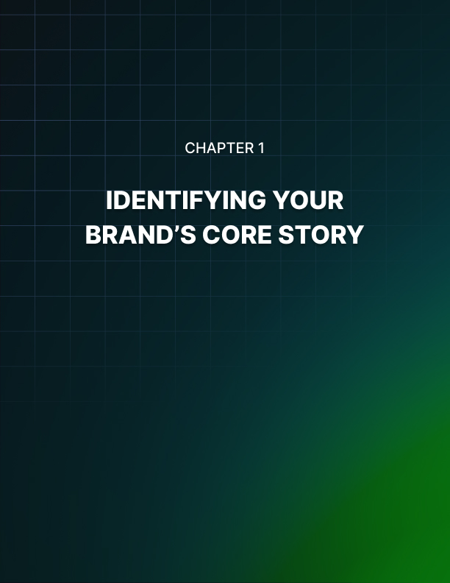

IDENTIFYING YOUR BRAND'S CORE STORY
____

The Foundation of Your Brand
Your brand's core story is the beating heart of your business, pulsing with authenticity and resonating with your audience. It's the unshakeable foundation supporting every aspect of your business and giving it the strength to reach new heights. To uncover this hidden gem, you need to dig deep into your experiences, values, and passions to extract the narrative that will captivate your customers.
Avoid the pitfall of superficial storytelling, which is like building a skyscraper on sand – it won't stand the test of time. Your audience craves authenticity, and they can spot a disingenuous story from a mile away. Instead, tap into your genuine experiences and emotions. Think back to the moment you decided to start your business. What drove you? Was it a personal struggle you overcame? A gap in the market you identified? Or perhaps a burning desire to make a difference in people's lives? These pivotal moments are the raw material for your core story.
Consider the example of Blake Mycoskie, founder of TOMS Shoes. His core story began during a trip to Argentina, where he witnessed children without shoes facing health and education challenges. This experience sparked the idea for his one-for-one business model, where for every pair of shoes sold, another pair is donated to a child in need. Mycoskie's authentic story resonated with consumers and became the cornerstone of TOMS' brand identity.

Unearthing Your Story
To unearth your story, create a timeline of your entrepreneurial journey. Start with the earliest inklings of your business idea and plot the significant events, challenges, and triumphs along the way. Pay attention to the emotions associated with each event. Did you feel exhilarated when you made your first sale? Overwhelmed when facing a major setback? Proud when you received positive customer feedback? These emotional touchpoints will add depth and relatability to your story. Identify the key players in your journey. Who supported you? Who challenged you? How did these interactions shape your business and your personal growth? Your core story isn't just about you – it's about the network of relationships that contributed to your success.
Now that you have this raw material, structure it using the powerful storytelling framework: The Hero's Journey. This ancient narrative pattern, popularized by Joseph Campbell, appears in myths and stories across cultures and resonates deeply with human psychology. In The Hero's Journey, you are the protagonist of your brand's story.
Here's how you can adapt this framework to your entrepreneurial narrative:
- The Ordinary World
Describe your life before you started your business.
- The Call to Adventure
Identify the moment that sparked your entrepreneurial journey.
- Refusal of the Call
Describe any initial hesitations or doubts.
- Meeting the Mentor
Who or what provided guidance and inspiration?
- Crossing the Threshold
The moment you fully committed to your business idea.
- Tests, Allies, and Enemies
Challenges faced and support received.
- Approach to the Inmost Cave
Your darkest moment or biggest obstacle.
- The Ordeal
How you overcame this major challenge.
- Reward
What you gained from overcoming this obstacle.
- The Road Back
Applying lessons learned to improve your business.
- Resurrection
A final test you faced and emerged victorious.
- Return with the Elixir
How your journey allows you to give back or make a difference.
Framing your story within this structure helps create a narrative that is both compelling and deeply relatable. Your audience will see themselves in your journey, rooting for you as the hero and, by extension, connecting with your brand.
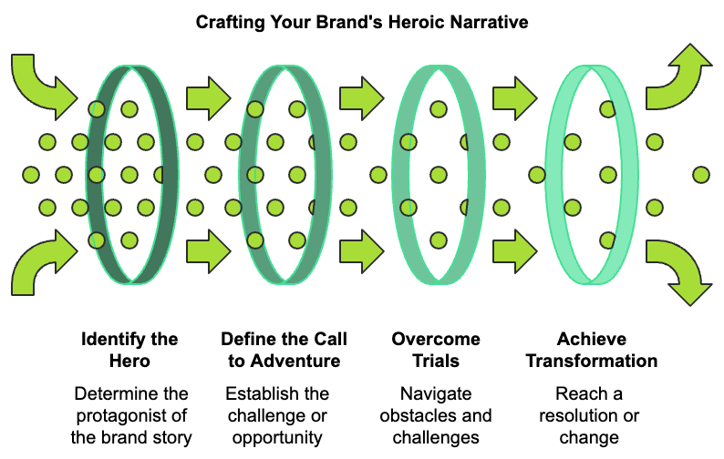

Identifying Core Values
Core values are the guiding principles that inform every decision you make in your business. They're an essential part of your core story because they explain why you do what you do. To uncover your core values, ask yourself these questions:
- What principles do you refuse to compromise on, even if it means losing business?
- What do you want your brand to be known for, beyond your products or services?
- What behaviors do you consistently reward or celebrate in your team?
- What makes you proudest about your business?
Your answers to these questions will reveal the values that are truly important to you. Maybe it's innovation, sustainability, customer empowerment, or social responsibility. Whatever they are, these values should be woven into your core story.
For example, Patagonia's core story is deeply intertwined with its value of environmental responsibility. Founder Yvon Chouinard's passion for outdoor activities led him to create climbing gear that wouldn't damage rock faces. This commitment to minimizing environmental impact became a core part of Patagonia's brand story and continues to guide their business decisions today.

Crafting Your Core Story
Now that you've identified your journey and your values, distill this information into a concise core story. Focus on the most impactful moments and the clearest expressions of your values. Start with a strong opening that hooks your audience. For instance:
"I never set out to revolutionize the coffee industry. I just wanted a cup that tasted like the ones I remembered from my grandmother's kitchen."
Then, weave in the key elements of your journey, highlighting the challenges you faced and overcame. Show how your values guided your decisions and shaped your business. End with a statement that connects your past to your present and future:
"Today, every cup we serve is a tribute to my grandmother's legacy and a step towards a more sustainable coffee industry."
Your core story isn't set in stone. As your business grows and evolves, so too will your narrative. The key is to stay true to your authentic experiences and values while allowing room for growth and new chapters. To keep your story fresh and relevant, set aside time each quarter to reflect on recent experiences and achievements. Ask yourself: How do these new developments fit into our larger narrative? Do they reinforce our existing story, or do they suggest a new direction?
Encourage feedback from your team and customers. Their perspectives can offer valuable insights into how your story is perceived and where it might be enhanced. Consider conducting surveys or hosting focus groups to gather this input. When refining your core story, ensure consistency across all your brand touchpoints. This alignment helps build a cohesive and memorable brand identity. Your website, social media profiles, marketing materials, and even your product packaging should all reflect elements of your core story. This consistency reinforces your brand identity and helps build trust with your audience.
Element | Description | Example
Hook | A captivating opening line | "I never set out to revolutionize the coffee industry."
Challenge | A major obstacle faced | "Our first batch of ethically sourced beans was rejected by every roaster in town."
Value | A core principle of your brand | "We believe that great coffee shouldn't come at the expense of farmers or the environment."
Transformation | How overcoming challenges changed you or your business | "That rejection forced us to learn roasting ourselves, giving us complete control over quality and ethics."
Legacy | The ongoing impact of your story | "Today, we're partnering with 50 small-scale farmers, ensuring fair wages and sustainable practices."

Lastly, don't underestimate the power of vulnerability in your storytelling. Sharing your struggles and moments of doubt makes your journey more relatable and human. It shows that success isn't a straight line but a series of ups and downs, lessons learned, and obstacles overcome.
Your core story is more than just a marketing tool – it's the essence of your brand's identity. It's what sets you apart in a crowded marketplace and creates an emotional connection with your audience. Taking the time to uncover and articulate your story lays the groundwork for a brand that resonates deeply with your target market. Moving forward, keep your core story central to everything you do. Let it guide your decision-making, inspire your team, and connect you with your customers. Your authentic narrative has the power to transform your business from just another company into a brand that people believe in and want to be a part of. Remember, every great brand has a story worth telling. Yours is waiting to be shared with the world. Embrace the process of discovery, be honest in your storytelling, and watch as your core story becomes the catalyst for your brand's success.
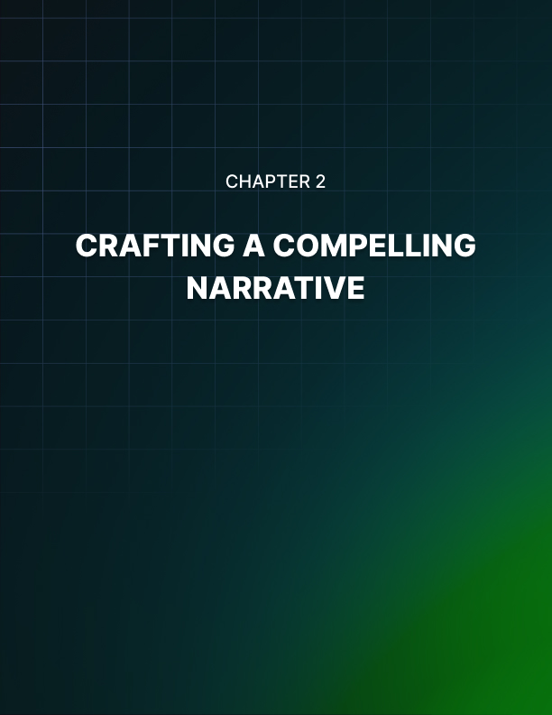

CRAFTING A COMPELLING NARRATIVE
____

The Art of Narrative Construction
Crafting a compelling brand narrative is like weaving a tapestry – each thread must be carefully chosen and placed to create a beautiful, cohesive whole. Your narrative isn't just a recitation of facts; it's an emotional journey that invites your audience to connect with your brand on a deeper level. At its core, every engaging story has three main components: a protagonist (your brand or customer), a conflict or challenge, and a resolution or transformation. This structure provides a framework for your brand's story, allowing you to create tension, evoke emotion, and ultimately deliver a satisfying conclusion that resonates with your audience.
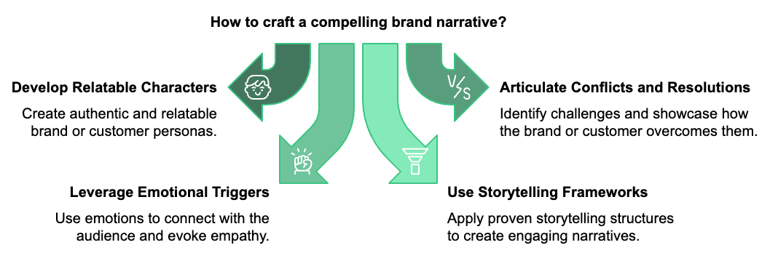

Developing Relatable Characters
In your brand's narrative, you're not just telling your own story – you're telling the story of your customers and how your brand fits into their lives. To do this effectively, you need to develop relatable characters that your audience can see themselves in. Start by creating detailed customer personas. These aren't just demographic profiles; they're rich, multidimensional characters with hopes, fears, and dreams. Consider what keeps your ideal customer up at night, their biggest aspirations, the obstacles they face in achieving their goals, and how your brand helps them overcome these obstacles. For example, if you're a fitness app targeting busy professionals, your protagonist might be Sarah, a 35-year-old marketing executive who struggles to find time for exercise between her demanding job and family commitments. By creating a character like Sarah, you give your audience someone to root for and relate to, making your brand's story more personal and impactful.

Articulating Conflicts and Resolutions
Conflict is the engine that drives your narrative forward. Without it, your story lacks tension and fails to engage your audience. In brand storytelling, conflicts often take the form of customer pain points or market gaps that your product or service addresses. Using our fitness app example, the main conflict might be Sarah's struggle to maintain a healthy lifestyle amidst her hectic schedule. Secondary conflicts could include her lack of confidence in gym settings and her confusion about effective workout strategies. When articulating these conflicts, be specific and emotive. Don't just say, "Sarah was busy." Instead, paint a vivid picture:
"Sarah's days were a whirlwind of client meetings, school pickups, and late-night email sessions. The thought of squeezing in a workout felt as impossible as adding a 25th hour to the day."
The resolution is where your brand enters the story as the hero. Show how your product or service helps the protagonist overcome their challenges. For Sarah, the fitness app could provide quick, effective workouts she can do at home, personalized meal plans, and a supportive community of users with similar goals.
The resolution isn't just about features – it's about transformation. How does your brand change your customer's life for the better? In Sarah's case, the app doesn't just help her exercise more; it gives her confidence, energy, and precious time back with her family.
To elevate your brand narrative from good to great, you can employ several advanced storytelling techniques. Use metaphors and analogies to make complex ideas more accessible and memorable. Engage your audience's senses with vivid descriptions to make your story more immersive. Utilize flashbacks and flash-forwards to show your protagonist's journey over time, and consider weaving together multiple character journeys to showcase the diverse ways your brand impacts lives.

Emotional Triggers and Storytelling Frameworks
Emotions are the secret sauce that makes your narrative stick in your audience's mind. Tapping into specific emotional triggers allows you to craft a story that both engages and motivates action. Some powerful emotional triggers include hope, fear, pride, and belonging. In Sarah's story, you might trigger hope by showing her progress towards her fitness goals, fear by highlighting the health risks of a sedentary lifestyle, pride in her ability to stick to a routine, and belonging through the app's community features.
To structure these emotional elements effectively, you can use storytelling frameworks like the "Before-After-Bridge" (BAB) or the "Problem-Agitate-Solve" (PAS) method.
- The BAB framework describes the problem or pain point, paints a picture of life after the problem is solved, and shows how your brand bridges the gap between these two states.
- The PAS method clearly states the issue, emphasizes the negative consequences of the problem, and presents your brand as the solution.
Even the most compelling narrative can lose its impact if it doesn't keep the audience engaged throughout. Vary the rhythm of your story by mixing short, punchy sentences with longer, more descriptive ones. End sections or episodes of your brand story with mini-cliffhangers that make the audience eager to know what happens next. If you're telling your story across digital platforms, include interactive elements like quizzes, polls, or choose-your-own-adventure style narratives. Use images, infographics, and videos to complement your written narrative, and incorporate real stories from your customers to add authenticity and allow your audience to see themselves in your story.

Crafting Your Brand's Narrative Arc
Now that you understand the elements of a compelling brand narrative, it's time to put it all together. Here's a step-by-step guide to crafting your brand's narrative arc:
- Identify Your Protagonist
- Who is your story about?
- Is it your brand, your customers, or both?
- Define the Conflict
- What problem or challenge does your protagonist face?
- Introduce Your Brand
- How does your brand enter the story?
- What unique solution do you offer?
- Show the Journey
Describe the process of transformation:
- What obstacles are overcome?
- What victories are celebrated?
- Highlight the Resolution
- How has your brand improved the protagonist's life?
- What's different now?
- Look to the Future
- Where does the story go from here?
- How will your brand continue to impact lives?
Remember, your brand narrative isn't static. It should evolve as your company grows and your customers' needs change. Regularly revisit and refine your story to ensure it remains relevant and engaging.
Narrative Element | Example
Protagonist | Sarah, 35-year-old marketing executive
Conflict | Struggle to maintain healthy lifestyle amidst hectic schedule
Brand Introduction | Fitness app offering quick, effective home workouts
Journey | Overcoming time constraints, building confidence
Resolution | Sarah feels energized, confident, and has more family time
Future Impact | Continued health improvements, inspiring others

Crafting a compelling brand narrative is both an art and a science. It requires creativity to weave an engaging story, and strategic thinking to ensure that story aligns with your brand goals and resonates with your target audience. When developing your narrative, focus on building an emotional connection, create relatable characters, use conflict and resolution for added depth, apply storytelling frameworks, maintain engagement with varied pacing and interactive elements, and always stay true to your brand's values. Your brand narrative is more than just a marketing tool – it's the story that defines who you are as a company, what you stand for, and why your customers should care. When crafted thoughtfully and told consistently, it has the power to transform your brand from a mere product or service provider into a meaningful part of your customers' lives.
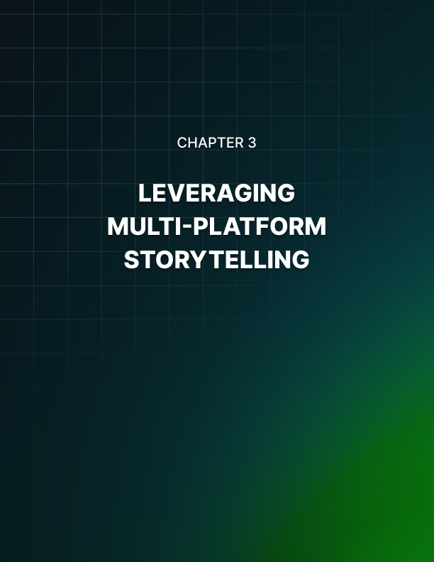

LEVERAGING MULTI-PLATFORM STORYTELLING
____

The Power of Omnichannel Narratives
Your brand's story doesn’t exist in isolation. It lives and breathes across a multitude of platforms, each with its unique characteristics and audience expectations. Mastering the art of multi-platform storytelling allows you to create a rich, immersive narrative that meets your audience wherever they are. Think of your brand story as a sprawling novel. Each platform represents a different chapter, offering a new perspective or diving deeper into a particular aspect of your narrative. When done right, this approach creates a cohesive, yet diverse storytelling experience that keeps your audience engaged and coming back for more.

Tailoring Your Tale: Platform-Specific Strategies
Every storytelling medium has its own strengths and limitations. Understanding these nuances is crucial for effectively adapting your brand narrative across platforms. Let's explore some key channels and how to optimize your storytelling for each:
- Social Media: The fast-paced nature of social platforms demands bite-sized, visually appealing content. On Instagram, you might share behind-the-scenes glimpses of your brand in action, using Stories to create a sense of immediacy and exclusivity. On Twitter, craft punchy, memorable statements that encapsulate your brand's values or mission. Facebook allows for longer-form content, ideal for sharing customer testimonials or more detailed brand stories.
- Blog Posts: Your blog is where you can flex your long-form storytelling muscles. Use this space to dive deep into your brand's history, showcase detailed case studies, or explore industry trends through the lens of your brand's expertise. Incorporate visual elements like infographics or embedded videos to break up text and enhance engagement.
- Podcasts: Audio storytelling offers a unique intimacy. Use podcasts to have in-depth conversations with team members, industry experts, or satisfied customers. This format allows you to showcase the human side of your brand and build a more personal connection with your audience.
- Video Content: Whether it's YouTube, TikTok, or your website, video offers powerful visual storytelling opportunities. Create product demos, customer testimonials, or mini-documentaries about your brand's journey. Remember, different video platforms have different ideal lengths and styles – a 30-second TikTok requires a different approach than a 10-minute YouTube video.
- Email Newsletters: This direct line to your audience is perfect for serialized storytelling. Break your brand story into digestible chunks, ending each newsletter with a cliffhanger that encourages opens for the next installment.

Maintaining Consistency Across Channels
While adapting your story for different platforms is crucial, it's equally important to maintain a consistent core narrative. Your audience should recognize your brand voice and key messages regardless of where they encounter your content. Here are some strategies to ensure consistency:
- Create a Brand Story Bible
- Use a Content Calendar
- Cross-Platform Promotion
- Consistent Visual Branding
Develop a comprehensive document that outlines your brand's core story, key messages, voice, and visual identity. This serves as a reference point for all content creation, ensuring consistency across platforms and team members. Plan your storytelling across platforms in advance. This allows you to create thematic consistency, with different channels supporting and amplifying each other's messages. Use each platform to drive traffic to your other channels. For example, tease a longer YouTube video with short clips on Instagram, or promote your latest podcast episode across all your social media accounts. While content may vary, your visual branding should remain consistent. Use the same color schemes, fonts, and logo treatments across all platforms to create a cohesive brand identity.

Repurposing Content Without Losing Spark
Creating unique content for every platform can be resource-intensive. The key is to repurpose content strategically, adapting it to suit each platform's strengths without losing its original impact. Here's how: Take a long-form piece of content, like a blog post or video, and break it down into smaller, platform-specific pieces. A single blog post could become multiple social media posts, an infographic, and a series of email newsletter tips. Transform written content into visual or audio formats. Turn a how-to article into a step-by-step video tutorial or an infographic. Conversely, transcribe a podcast episode into a blog post for those who prefer reading.
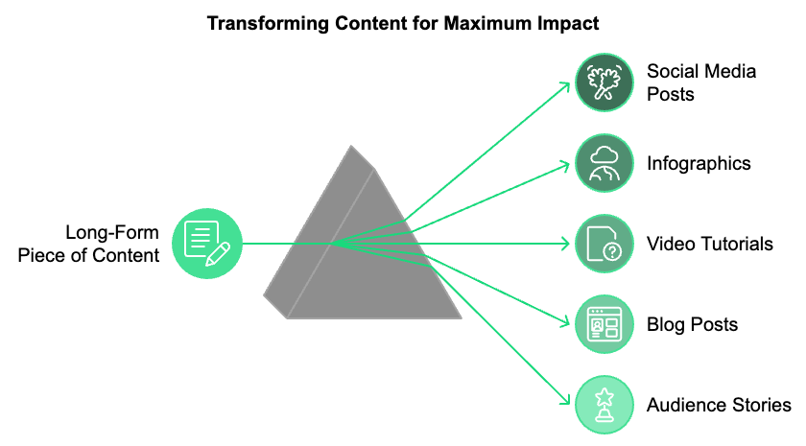
Don't be afraid to revisit old content. Update statistics, add new insights, or reframe the content to align with current trends or events. This keeps your content fresh and relevant. Encourage your audience to share their stories related to your brand. Repost or feature this content across your platforms, adding your own commentary or context.

Measuring Success and Iterating
To ensure your multi-platform storytelling efforts are effective, you need to measure their impact and be willing to adjust your strategy based on the results. Here are some key metrics to track:
Metric | Description
Engagement Rates | Likes, comments, shares, and click-throughs across platforms
Reach and Impressions | Number of people your content is reaching
Conversion Rates | How storytelling translates into desired actions
Sentiment Analysis | Emotional response to your brand story
Platform-Specific Metrics | Unique metrics for each platform (e.g., watch time on YouTube)

Use these insights to refine your storytelling approach. If certain types of content or platforms are performing particularly well, consider doubling down on those efforts. Conversely, if some aspects of your strategy aren't resonating, don't be afraid to pivot.
Airbnb provides an excellent example of effective multi-platform storytelling. Their core narrative of "Belong Anywhere" is consistently woven throughout their various channels: Website features personal stories from hosts and travelers, bringing their experiences to life. Instagram showcases stunning photos of unique listings, often with captions telling the story behind the property or the host. YouTube hosts a series called "Made Possible by Hosts," featuring emotional stories of connections made through Airbnb stays. Their blog offers in-depth articles about travel trends, host tips, and company initiatives, all tying back to their core mission. Email sends personalized recommendations based on user preferences, each suggesting a unique story waiting to be experienced. Across all these platforms, Airbnb maintains a consistent voice and visual identity, while tailoring the content to suit each medium's strengths. This cohesive yet varied approach helps reinforce their brand story at every touchpoint.
With evolving technology, new storytelling opportunities continuously arise. Stay open to experimenting with new platforms and formats. Create choose-your-own-adventure style web stories that allow users to navigate your brand narrative in a personalized way. Platforms like Twitch aren't just for gamers. Consider how live streaming could add an element of real-time engagement to your brand storytelling.
Your brand's story is a living, breathing entity that will continue to evolve as your business grows and changes. Embracing a multi-platform approach establishes numerous touchpoints for your audience to engage with your narrative, each offering a unique view of your brand's journey. Effective multi-platform storytelling isn't about being everywhere at once. It's about choosing the right platforms for your brand and your audience, and crafting content that plays to each platform's strengths while maintaining a consistent core message. Moving forward, keep listening to your audience, stay aware of new platforms and technologies, and remain flexible in adapting your storytelling approach. Your brand's narrative is never finished – it's an ongoing conversation with your audience, one that has the power to build lasting connections and drive real business results. By mastering the art of multi-platform storytelling, you're not just sharing your brand's story – you're inviting your audience to become a part of it. This is how you transform customers into brand advocates, and how you build a brand that resonates deeply in today's complex, interconnected world.


THE AUTHENTIC ECHO
____

The Power of Customer Stories
Your customers' voices are the most potent force in your marketing arsenal. Their stories, experiences, and transformations breathe life into your brand narrative, lending it authenticity and credibility that no amount of self-promotion can match.
Customer testimonials are more than just endorsements; they're windows into the real-world impact of your product or service. When you harness these stories effectively, you create a powerful echo chamber where your brand's promises are amplified and validated by the very people you aim to serve.
Think about the last time you made a significant purchase. Did you rely solely on the company's marketing materials, or did you seek out reviews and experiences from other customers? Most likely, it was the latter. This is the power of social proof in action, and it's why customer testimonials are so crucial to your brand storytelling efforts.
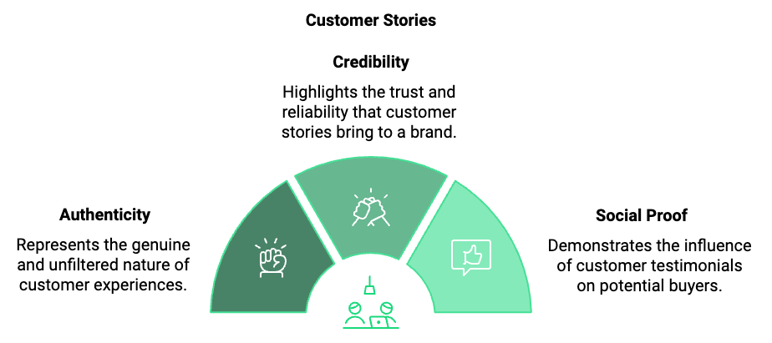

Curating Authentic Customer Stories
The key to leveraging testimonials effectively is authenticity. Your audience can spot a manufactured or overly polished testimonial from a mile away. To curate genuine customer stories, start by creating multiple touchpoints for feedback throughout the customer journey. This could include post-purchase surveys, social media listening, customer support interactions, user-generated content campaigns, and in-depth interviews with long-term customers.
When reaching out for testimonials, ask open-ended questions that encourage detailed, story-driven responses. Instead of "Did you like our product?", try "How has our product changed your daily routine?" or "What specific challenge did our service help you overcome?" These types of questions elicit more meaningful, narrative-rich responses that you can weave into your brand story.
Not all customer stories will fit neatly into your brand narrative, and that's okay. Look for testimonials that align with your core values and messaging, but don't shy away from sharing stories that highlight areas for improvement. This transparency can actually boost your credibility and show that you're committed to growth and customer satisfaction.

Crafting Compelling Customer Stories
Once you've gathered a wealth of customer feedback, it's time to transform these raw materials into compelling narratives. Here's a process to help you craft powerful customer stories: Identify the arc by looking for a clear beginning (the customer's challenge), middle (their discovery of your product/service), and end (the positive outcome). Highlight the transformation by focusing on the change in the customer's life or business. Include specific details using concrete numbers, time frames, and results to make the story more tangible and believable. Incorporate emotion by including the customer's feelings throughout their journey. Use the customer's own words with direct quotes to add authenticity and personality to the story. Finally, tie it back to your brand by showing how your product or service was instrumental in the customer's success without overshadowing their story.
Let's look at an example of how this might play out for a productivity app:
"As a freelance graphic designer, I was drowning in projects and missing deadlines. I felt constantly overwhelmed and was considering giving up my dream career. That's when I discovered [Your App]. Within a month, I had cleared my backlog and was taking on new clients with confidence. The app's intuitive interface and customizable workflow tools felt like they were designed just for me. Now, six months later, I've doubled my income and have a waitlist of clients. But the best part? I finish work by 6 PM every day and have rediscovered my passion for design. [Your App] didn't just save my business; it gave me my life back." - Sarah T., Graphic Designer
This testimonial hits all the key points: it shows a clear transformation, includes specific results, incorporates emotion, uses the customer's own words, and ties directly back to the product's features and benefits.

Integrating Testimonials into Your Brand Narrative
Now that you have a collection of powerful customer stories, it's time to integrate them seamlessly into your brand narrative. Here are some effective ways to do this:
- Feature testimonials prominently on your website by creating a dedicated testimonials page and sprinkling relevant quotes throughout your site, especially on product pages and near call-to-action buttons.
- Create in-depth case studies that dive deep into a customer's experience, showcasing the problem-solving journey and tangible results.
- Incorporate testimonials into your content marketing by using customer quotes to support key points in your blog posts, white papers, and ebooks.
- Leverage video testimonials by capturing customers telling their stories on camera for a more personal and engaging format.
- Share customer success stories regularly on social media to boost engagement and provide social proof.
- Include relevant testimonials in your email campaigns to reinforce your message and build trust.
- Use customer quotes in your print, digital, and video ads to add credibility to your claims.
The key is to use testimonials strategically, placing them where they'll have the most impact on your audience's decision-making process.

Overcoming Skepticism and Building Trust
In an era of fake reviews and paid influencers, audiences have become increasingly skeptical of testimonials. To overcome this skepticism and build genuine trust, consider these strategies: Provide context by including details about the customer, such as their full name, job title, and company (with permission, of course). This adds credibility and allows potential customers to relate to the testimonial giver. Use diverse testimonials to showcase a range of customers from different industries, demographics, and use cases to demonstrate your product's broad appeal and effectiveness. Include negative feedback, as counterintuitively, this can actually boost credibility by showing that you're not cherry-picking only the most glowing reviews. Encourage user-generated content by creating hashtags or campaigns that prompt customers to share their experiences with your product on social media. Respond to testimonials by engaging with customers who leave reviews or share their stories, showing that you value their input and are actively listening to your audience. Update your testimonials regularly to show that you have a steady stream of satisfied customers, not just a handful from years ago. Provide proof by including verifiable data or results alongside testimonials to back up claims.
Testimonial Strategy | Benefits
Provide Context | Adds credibility, allows relatability
Use Diverse Testimonials | Demonstrates broad appeal
Include Negative Feedback | Boosts authenticity
Encourage User-Generated Content | Creates organic, unsolicited proof
Respond to Testimonials | Shows active engagement
Update Regularly | Demonstrates ongoing satisfaction
Provide Proof | Supports claims with data

Implementing these strategies allows you to craft a testimonial-driven narrative that resonates with your audience and builds lasting trust in your brand.


REFLECT AND INSPIRE
____

The Journey So Far
You've navigated the winding path of brand storytelling, uncovering the essence of your narrative, crafting compelling stories, and leveraging diverse platforms to share your message. Now, it's time to pause and reflect on this journey, synthesizing the key lessons and preparing for the road ahead. Your brand story isn't just a marketing tool; it's the lifeblood of your business, pulsing through every interaction, decision, and customer experience.
At this juncture, take a moment to appreciate the progress you've made. You've dug deep into your experiences, values, and passions to extract the core of your brand's identity. You've learned to weave these elements into narratives that captivate and inspire your audience. You've mastered the art of adapting your story to various platforms, creating a symphony of touchpoints that resonate with your target market. And you've harnessed the authentic voices of your customers, amplifying their experiences to build trust and credibility.
But this isn't the end of your journey. It's merely a milestone in the ongoing evolution of your brand. The world of business is dynamic, constantly shifting beneath your feet. To thrive in this environment, your brand story must be equally dynamic, adapting to new challenges, opportunities, and audience needs.

The Power of Continuous Reflection
Reflection isn't a one-time event; it's an ongoing practice that keeps your brand story fresh, relevant, and aligned with your evolving business goals. Set aside time regularly – perhaps quarterly or biannually – to step back and evaluate your brand narrative. Ask yourself these critical questions: How has our business changed since we last revisited our brand story? Are there new customer segments we're reaching? How does our current narrative resonate with them? What feedback have we received from our audience about our brand messaging? Have there been any significant industry shifts that our story should address? Are there new achievements or milestones we should incorporate into our narrative? How well does our current story align with our long-term vision for the company?
This process of continuous reflection allows you to identify gaps in your narrative, spot new storytelling opportunities, and ensure your brand remains authentic and relevant. Remember, your brand story isn't set in stone. It's a living, breathing entity that grows and changes with your business.
Consider the example of Nike. Their core story of empowering athletes has remained consistent for decades, but the way they tell this story has evolved dramatically. From print ads featuring star athletes to inspiring viral videos celebrating everyday heroes, to their recent focus on sustainability and social justice, Nike continually refreshes their narrative to stay relevant and resonate with new generations of consumers.

Adapting to Market Dynamics
The business landscape is in constant flux, shaped by technological advancements, societal shifts, and global events. Your brand story must be flexible enough to adapt to these changes while staying true to your core values. Here are some strategies to help you navigate market dynamics: Stay Informed, Embrace Agility, Listen to Your Audience, Experiment with New Platforms, and Collaborate and Co-create.
Stay informed by keeping a pulse on industry trends, consumer behavior shifts, and technological advancements. Use tools like Google Trends, industry reports, and social listening platforms to stay ahead of the curve. Embrace agility by building flexibility into your brand narrative. While your core story should remain consistent, be prepared to pivot your messaging or emphasize different aspects of your story as market conditions change. Listen to your audience, as they are your best source of insight into changing market dynamics. Regularly engage with them through surveys, social media interactions, and customer service channels to understand their evolving needs and perceptions.
Experiment with new platforms as new communication channels emerge. Be willing to try out how you tell your brand story on emerging platforms. Early adoption of platforms like TikTok or emerging technologies like AR can give you a competitive edge. Lastly, collaborate and co-create by partnering with other brands, influencers, or even your customers to create fresh perspectives on your brand story. These collaborations can inject new energy into your narrative and help you reach new audiences.

Learning from Your Audience
Your audience isn't just the recipient of your brand story; they're active participants in shaping it. Every interaction, comment, review, and shared experience contributes to the ongoing narrative of your brand. To truly resonate with your audience, you must become an expert listener.
Implement a robust system for collecting and analyzing customer feedback. This could include regular surveys and Net Promoter Score (NPS) tracking, social media monitoring and engagement, customer service interaction analysis, user testing and focus groups, and analysis of user-generated content. But collecting data is only half the battle. The real value comes from synthesizing this information and using it to refine your brand story. Look for patterns in the feedback. Are there consistent themes in how customers describe their experience with your brand? Do these align with the story you're trying to tell?
For instance, you might find that while you've been focusing your story on the innovative features of your product, customers consistently praise the exceptional customer service they receive. This insight could prompt you to shift your narrative to highlight the human touch behind your brand, weaving in stories of your customer service team going above and beyond.

Cultivating Authenticity in a Digital Age
With carefully curated social media personas and AI-generated content on the rise, authenticity has become more valuable than ever. Your audience craves genuine connections and real stories. But how do you maintain authenticity as your brand grows and evolves?
Stay true to your roots by never losing sight of why you started your business in the first place. Regularly revisit your origin story and ensure it remains a central part of your brand narrative. Be transparent and don't shy away from sharing the challenges you face. Vulnerability can be a powerful tool in building genuine connections with your audience. Showcase the people behind the brand by putting faces to your company name. Share stories of your team members, their passions, and how they contribute to your brand's mission.
Admit mistakes when things go wrong (and they inevitably will). Own up to it, share what you've learned, and how you're improving. This level of honesty builds trust and respect. Use real customer stories as we discussed in the previous chapter. Authentic customer testimonials are incredibly powerful. Continue to prioritize these real voices in your brand storytelling. Be consistent across channels, as authenticity isn't just about what you say, but how consistently you say it. Ensure your brand voice and message are cohesive across all platforms and touchpoints.
Authenticity Strategy | Description
Stay True to Roots | Regularly revisit and incorporate your origin story
Be Transparent | Share challenges and vulnerabilities
Showcase People | Highlight team members and their contributions
Admit Mistakes | Own up to errors and share learnings
Use Customer Stories | Prioritize authentic testimonials
Consistency | Maintain cohesive voice across all platforms

Inspiring Action Through Your Brand Story
A truly resonant brand story doesn't just inform or entertain; it inspires action. Whether you want your audience to make a purchase, sign up for a newsletter, or join a movement, your story should be the catalyst that moves them from passive observers to active participants in your brand journey. To inspire action, your brand story should create an emotional connection, paint a vivid picture of success, provide clear, actionable steps, create a sense of urgency, and foster community.
Tap into the emotions that drive decision-making to create an emotional connection. Whether it's hope, aspiration, fear, or belonging, make your audience feel something. Paint a vivid picture of success by showing your audience what their life could look like after engaging with your brand. Make this vision so compelling that they can't help but want to be a part of it. Provide clear, actionable steps and don't leave your audience wondering what to do next. Guide them with clear calls-to-action that are seamlessly integrated into your story.
Create a sense of urgency by using time-sensitive elements in your story to encourage immediate action. This could be limited-time offers, exclusive early access, or stories of others who have already benefited from your product or service. Foster community by making your audience feel like they're joining a movement, not just buying a product. Share stories of other customers and create opportunities for your audience to connect with each other.

Your Story Continues
Concluding this exploration of brand storytelling, keep in mind that your story is far from over. In fact, it's just beginning. Every day brings new opportunities to refine, expand, and share your narrative with the world. Your brand story is more than just a marketing tool; it's the heart and soul of your business. It's what sets you apart in a crowded marketplace, what connects you with your audience on a deep, emotional level, and what drives your business forward.
Keep these final thoughts in mind as you progress: Stay curious, continually learn about your industry, your audience, and the evolving art of storytelling. Be courageous and don't be afraid to take risks with your storytelling. The most memorable brands are often those that dare to be different. Remain authentic, as in a world of filtered realities, your genuine voice is your most powerful asset. Embrace evolution and welcome it as a sign of progress. Keep listening to your audience, as they have a wealth of insights to offer. Inspire action and remember that the ultimate goal of your brand story is to move your audience to act. Always include a clear next step. Stay true to your core and never lose sight of the core values and mission that drive your brand.
Your brand story is a powerful tool for connection, growth, and inspiration. Use it wisely, nurture it carefully, and watch as it transforms not just your business, but the lives of those you serve. The next chapter of your brand's story starts now. Make it count.

