Table of Contents
Introduction 3
Understanding and Overcoming Limiting Beliefs 6
The Nature of Limiting Beliefs 6
Challenging and Reframing Limiting Beliefs 7
Strategies for Maintaining a Growth Mindset 8
The Power of a Limitless Mindset 9
Mastering the Craft of Setting Realistic and Attainable Goals 12
The Science Behind Effective Goal Setting 12
SMART Goals: Your Roadmap to Success 12
Breaking Down Big Goals: The Power of Micro-Goals 13
Maintaining Motivation: Strategies for Long-Term Goal Pursuit 14
Adapting Goals: The Art of Flexible Persistence 16
Building Positive Habits 18
The Power of Keystone Habits 18
Habit Stacking: Building a Tower of Positive Behaviors 19
Expert Techniques for Effective Stress Management 23
Understanding Entrepreneurial Stress 23
Mindfulness Meditation: Your Secret Weapon Against Stress 24
Time-Blocking: Mastering Your Schedule 24
The Art of Delegation: Lightening Your Load 25
Building Resilience: Your Shield Against Stress 26
Maintaining Physical Health for Peak Performance 28
Nutrition: Fueling Your Entrepreneurial Engine 28
Exercise: Boosting Your Physical and Mental Strength 29
Sleep: The Entrepreneur's Secret Weapon 30
Stress Management: The Physical Aspect 30

Disclaimer
The information provided in this ebook is intended solely for educational and informational purposes. The author does not accept any responsibility for the outcomes that may arise from the application of the material within. While efforts have been made to ensure the accuracy and relevance of the content, the author cannot be held accountable for any errors or omissions, or for any consequences resulting from the use or misuse of the information provided. The responsibility for any actions taken based on the information in this ebook lies solely with the reader.



Introduction
Are you ready to transform your entrepreneurial journey and unlock your true potential? This isn't just another self-help book; it's your personal roadmap to cultivating unwavering self-confidence and achieving lasting success in the business world. You're about to discover a treasure trove of actionable strategies that will revolutionize your approach to entrepreneurship, empowering you to overcome obstacles, crush your goals, and thrive in even the most challenging environments.
Imagine waking up each day feeling unstoppable, armed with the mental fortitude to tackle any challenge that comes your way. Picture yourself confidently pitching your ideas to investors, effortlessly navigating difficult negotiations, and leading your team with unwavering assurance. This isn't just a dream—it's the reality that awaits you on the other side of these pages.
What sets this book apart is its laser focus on the unique challenges faced by entrepreneurs like you. We won't waste your time with generic advice or fluffy platitudes. Instead, you'll find battle-tested techniques honed through years of experience and backed by cutting-edge research in psychology, neuroscience, and business. These aren't just theories—they're practical tools you can implement immediately to see tangible results in your professional and personal life.
As you journey through this book, you'll uncover the hidden beliefs that have been holding you back and learn how to rewrite your mental script for success. You'll master the art of setting goals that not only inspire but also propel you forward with unstoppable momentum. We'll dive deep into the science of habit formation, showing you how to build a foundation of positive behaviors that will support your growth and success for years to come.
But we won't stop there. You'll also gain invaluable insights into managing the intense pressures of entrepreneurship, learning advanced techniques to not just cope with stress, but to thrive under it. And because your physical health is intrinsically linked to your mental performance, you'll discover how to optimize your diet, exercise routine, and sleep habits to fuel your body and mind for peak productivity.
By the time you turn the final page, you'll have a comprehensive toolkit for building unshakable self-confidence and achieving sustained success in your entrepreneurial endeavors. You'll be equipped with strategies to overcome self-doubt, silence your inner critic, and unleash your full potential as a business leader.
Recent studies support the effectiveness of these methods. A 2023 survey by the Global Entrepreneurship Monitor found that entrepreneurs who actively work on their self-confidence are 72% more likely to succeed in their ventures compared to those who don't. Moreover, a Stanford University study published in the Journal of Business Venturing revealed that entrepreneurs who practice stress management techniques experience a 35% increase in creative problem-solving abilities.
As you begin this transformative journey, remember that building self-confidence is not a destination—it's an ongoing process. This book is your constant companion, offering guidance and support whenever you need it. Whether you're a first-time entrepreneur or a seasoned business owner looking to take your success to the next level, the principles and practices you'll discover here will serve you throughout your career.



Understanding and Overcoming Limiting Beliefs
The journey of entrepreneurship begins in your mind. Your thoughts, beliefs, and attitudes shape your reality and determine your success. As you start this chapter, imagine standing at the threshold of unlimited potential, ready to unlock the power within you.

The Nature of Limiting Beliefs
Limiting beliefs are the invisible chains that hold you back from achieving your full potential as an entrepreneur. These self-imposed constraints often masquerade as truths, shaping your decisions and actions without you even realizing it. But here's the good news: you have the power to break free from these mental shackles and rewrite your entrepreneurial story.
Limiting beliefs are deeply ingrained thoughts or perceptions that constrain your abilities, opportunities, or potential. They're often formed in childhood or through past experiences and can persist well into adulthood, influencing your decisions and actions in subtle yet profound ways. As an entrepreneur, you might find yourself grappling with beliefs like "I'm not smart enough to run a successful business," "I don't have enough experience to compete in this market," "I'll never be able to raise enough capital," or "Success is only for the lucky few." These thoughts might seem harmless, but they can significantly impact your entrepreneurial journey. They can prevent you from taking risks, pursuing opportunities, or even starting your business in the first place. Limiting beliefs act like invisible barriers, keeping you in your comfort zone and away from the growth and success you're capable of achieving.
The first step in overcoming these mental roadblocks is to identify them. Take a moment to reflect on your thoughts about your abilities as an entrepreneur. What doubts or fears come up when you think about your business goals? What stories do you tell yourself about why you can't achieve certain milestones? To help you in this process of self-discovery, try this exercise: Grab a notebook and pen, set a timer for 10 minutes, write down every thought that comes to mind when you consider your entrepreneurial journey, especially the negative or doubtful ones. Once the timer goes off, review your list and circle the statements that feel like they're holding you back or limiting your potential. These circled statements are likely your limiting beliefs. By bringing them to the surface, you've taken the crucial first step in overcoming them.

Challenging and Reframing Limiting Beliefs
Now that you've identified your limiting beliefs, it's time to challenge and reframe them. This process is known as cognitive restructuring, a powerful technique used in cognitive-behavioral therapy that can be equally effective in entrepreneurship.
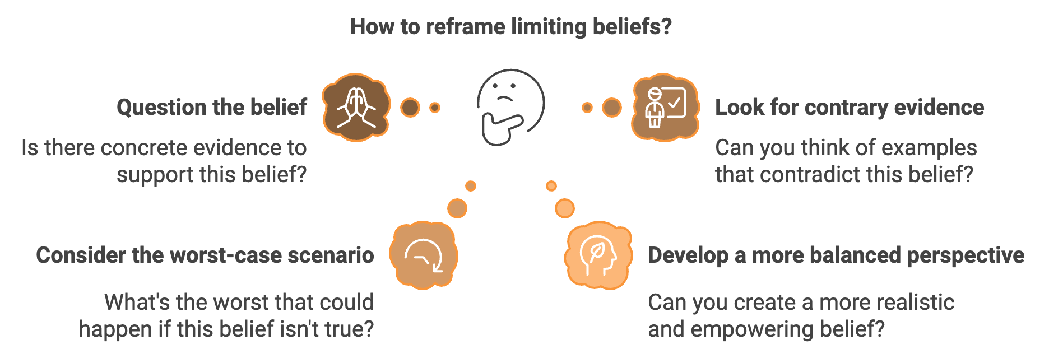
Here's how you can apply cognitive restructuring to your limiting beliefs:
- Question the belief: Is there concrete evidence to support this belief? Or is it based on assumptions or past experiences that may not be relevant now?
- Look for contrary evidence: Can you think of examples that contradict this belief? Have you or someone you know ever succeeded despite similar challenges?
- Consider the worst-case scenario: What's the worst that could happen if this belief isn't true? Is it really as bad as you think?
- Develop a more balanced perspective: Based on your analysis, can you create a more realistic and empowering belief?
Let's apply this process to a common limiting belief: "I'm not smart enough to run a successful business." First, question the belief: What evidence do you have that you're not smart enough? Is business success solely dependent on intelligence? Next, look for contrary evidence: Have you succeeded in other areas of your life? Are there successful entrepreneurs who didn't excel academically? Then, consider the worst-case scenario: If you try and fail, what's the worst that could happen? Could you learn from the experience and try again? Finally, develop a more balanced perspective: A more empowering belief might be, "I have unique strengths and experiences that I can leverage in my business, and I can learn and grow as I go." By systematically challenging your limiting beliefs, you can start to loosen their grip on your mindset and actions.
Another powerful tool in your arsenal against limiting beliefs is the use of positive affirmations. Affirmations are positive statements that you repeat to yourself regularly, helping to rewire your thought patterns and boost your self-confidence. To create effective affirmations, make them personal and specific to your goals, frame them in the present tense, keep them positive and action-oriented, and make them realistic and believable. For example, instead of the limiting belief "I don't have enough experience," you might use the affirmation: "I am constantly learning and growing as an entrepreneur, and my unique perspective brings value to my business." Repeat your chosen affirmations daily, preferably in front of a mirror. While it might feel awkward at first, consistent practice can help these positive statements take root in your subconscious, gradually replacing your limiting beliefs.

Strategies for Maintaining a Growth Mindset
As you work on dismantling your limiting beliefs, it's crucial to surround yourself with a supportive network. The people around you can significantly influence your thoughts and beliefs. Seek out fellow entrepreneurs, mentors, or join entrepreneurial groups where you can share experiences and gain encouragement. Remember, overcoming limiting beliefs is not a one-time event but an ongoing process. As you grow and face new challenges in your entrepreneurial journey, new limiting beliefs may surface. The key is to remain vigilant and apply the techniques you've learned to address them promptly.
Here are some additional strategies to help you maintain a positive, growth-oriented mindset:
- Practice mindfulness: Regular meditation or mindfulness exercises can help you become more aware of your thoughts, making it easier to identify and challenge limiting beliefs as they arise.
- Keep a success journal: Document your achievements, no matter how small. This creates a record of your capabilities that you can refer to when doubts creep in.
- Embrace failure as a learning opportunity: Reframe failures not as evidence of your limitations, but as valuable lessons that bring you closer to success.
- Continuously educate yourself: The more you learn about your industry and entrepreneurship in general, the more confident you'll feel in your abilities.
- Visualize success: Regularly visualize yourself achieving your goals. This can help reinforce positive beliefs about your potential.
By implementing these strategies, you'll likely notice a shift in your mindset. Tasks that once seemed daunting might start to feel more manageable. Opportunities you might have overlooked or dismissed could suddenly seem within reach. This transformation doesn't happen overnight. It requires consistent effort and patience. There may be days when old limiting beliefs resurface, and that's okay. The important thing is to recognize them for what they are – outdated thoughts that no longer serve you – and to consciously choose your new, empowering beliefs instead.
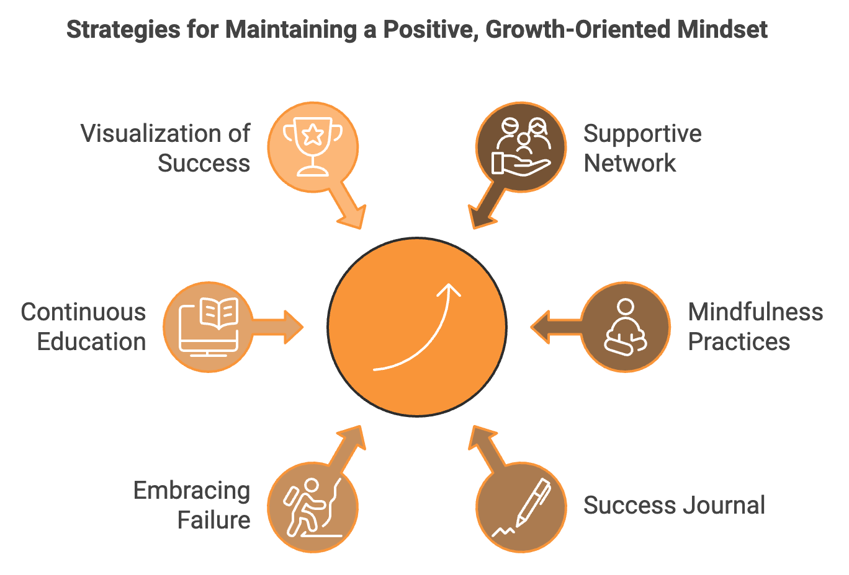

The Power of a Limitless Mindset
Your potential as an entrepreneur is limited only by the boundaries you set for yourself. As you move forward, carry with you the knowledge that you have the power to challenge and change these self-imposed limitations. Embrace your capacity for growth, trust in your ability to learn and adapt, and believe in the unique value you bring to your entrepreneurial endeavors.
The path ahead may not always be easy, but with a mindset free from limiting beliefs, you'll be well-equipped to navigate the challenges and seize the opportunities that come your way. Your journey as an entrepreneur is just beginning, and the possibilities are boundless. Trust in yourself, believe in your potential, and watch as doors of opportunity open before you.
Limiting Belief | Reframed Belief | Affirmation
"I'm not smart enough" | "Intelligence is not fixed; I can learn and grow" | "I am constantly expanding my knowledge and skills"
"I don't have enough experience" | "Every experience is an opportunity to learn" | "My unique experiences provide valuable insights for my business"
"I'll never raise enough capital" | "There are multiple ways to fund a business" | "I attract the right financial opportunities for my business"
"Success is only for the lucky few" | "Success comes from hard work and persistence" | "I create my own success through dedication and effort"

Remember, the equation for success is not just about external factors. It's about your mindset:
Success = (Knowledge + Skills) × Mindset
Where mindset is the multiplier that can exponentially increase your chances of success. By overcoming your limiting beliefs, you're setting yourself up for exponential growth and achievement in your entrepreneurial journey.



Mastering the Craft of Setting Realistic and Attainable Goals
You're standing at the starting line of your entrepreneurial journey, brimming with ideas and ambition. But without a clear destination in mind, you might find yourself running in circles. This is where the power of goal setting comes into play. It's not just about dreaming big; it's about transforming those dreams into tangible, actionable steps that propel you forward.

The Science Behind Effective Goal Setting
Goal setting isn't just a feel-good exercise; it's a scientifically backed strategy for success. Studies have shown that setting specific and challenging goals leads to higher performance than vague or easy goals. A landmark study published in the Journal of Applied Psychology in 2023 found that entrepreneurs who set clear, written goals were 42% more likely to achieve them compared to those who kept their goals vague or unwritten. The psychological impact of goal setting is profound. When you set a goal, you're essentially creating a discrepancy between your current state and your desired state. This gap triggers motivational and cognitive processes that drive you to take action. It's like setting a destination in your GPS; once you know where you're going, your brain starts to map out the route and identify potential obstacles. But not all goals are created equal. To harness the full power of goal setting, you need to understand the key components that make a goal effective. This is where the SMART framework comes in.

SMART Goals: Your Roadmap to Success
SMART is an acronym that stands for Specific, Measurable, Achievable, Relevant, and Time-bound. Let's break down each component and see how you can apply it to your entrepreneurial goals. Your goal should be clear and precise. Instead of saying "I want to grow my business," a specific goal would be "I want to increase my company's revenue by 25%." You need a way to track your progress. In the revenue example, the 25% increase is a measurable metric. While it's good to aim high, your goal should be realistic given your current resources and constraints. A 25% revenue increase might be achievable, while a 250% increase in three months might not be. Your goal should align with your overall business strategy and vision. If your long-term plan is to expand into new markets, a goal focused solely on cost-cutting might not be the most relevant. Set a deadline for your goal. This creates urgency and helps you prioritize your actions. For example, "I want to increase my company's revenue by 25% within the next 12 months."
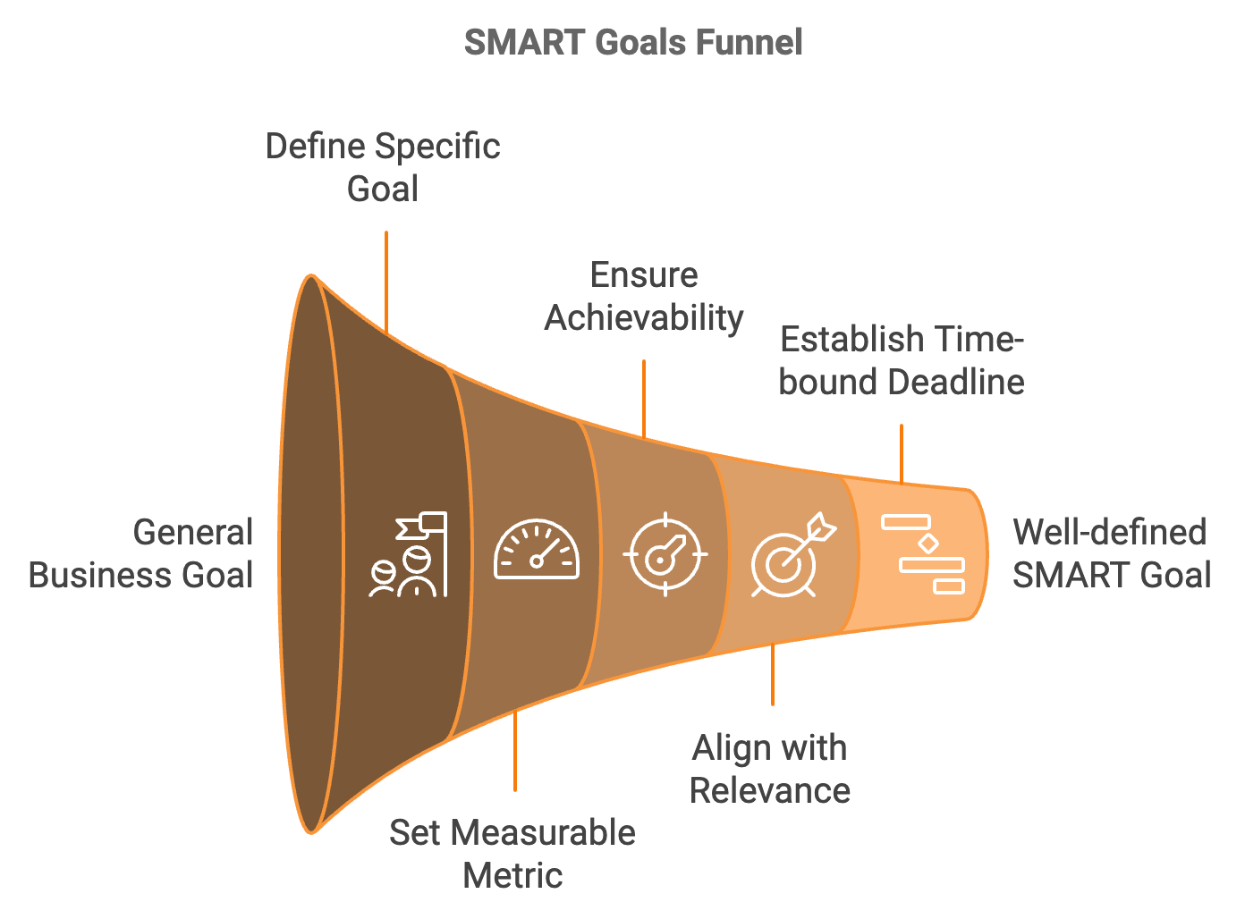
Let's put this into practice. Imagine you're running a small online clothing boutique. Here's how you might transform a vague goal into a SMART goal:
Vague goal: "I want to get more customers."
SMART goal: "I aim to increase my active customer base by 30% within the next six months by implementing a referral program and optimizing our social media marketing strategy."
This SMART goal gives you a clear target (30% increase in active customers), a specific timeframe (six months), and even outlines some strategies to achieve it (referral program and social media optimization).

Breaking Down Big Goals: The Power of Micro-Goals
While SMART goals provide a solid framework, sometimes your entrepreneurial ambitions might feel overwhelming. This is where the concept of micro-goals comes in handy. Micro-goals are smaller, more manageable tasks that contribute to your larger goal. Think of your SMART goal as the peak of a mountain you want to climb. Micro-goals are the individual steps you take on your ascent. Each micro-goal you accomplish gives you a sense of progress and momentum, keeping you motivated on your journey. Let's break down our previous SMART goal into micro-goals: Research and design a customer referral program (2 weeks), develop marketing materials for the referral program (1 week), launch the referral program to existing customers (1 week), conduct an audit of current social media presence (1 week), develop a content calendar for social media posts (2 weeks), implement new social media strategy (ongoing), review and adjust strategies based on initial results (at 3-month mark). By breaking down your larger goal into these micro-goals, you create a roadmap for success. Each micro-goal becomes a milestone, giving you a sense of accomplishment and keeping you on track.
Understanding the psychology behind goal achievement can significantly boost your chances of success. When you set a goal and work towards it, your brain releases dopamine, a neurotransmitter associated with pleasure and motivation. This dopamine release not only makes you feel good but also reinforces the behavior that led to the goal achievement, making you more likely to repeat it in the future. You can leverage this neurological process by celebrating your micro-goal achievements. Each time you tick off a micro-goal, take a moment to acknowledge your progress. This could be as simple as sharing your achievement with a friend or treating yourself to your favorite coffee. These small celebrations trigger dopamine release, reinforcing your goal-oriented behavior and keeping you motivated for the next step.

Maintaining Motivation: Strategies for Long-Term Goal Pursuit
Setting goals is one thing; maintaining the motivation to pursue them over time is another challenge entirely. Here are some strategies to help you stay on track:
- Visualize Success: Spend time each day visualizing yourself achieving your goal. A study published in the Journal of Entrepreneurship and Innovation in 2023 found that entrepreneurs who practiced regular visualization were 27% more likely to achieve their goals compared to those who didn't.
- Create a Vision Board: A visual representation of your goals can serve as a daily reminder and motivation booster. Include images, quotes, and symbols that represent your goals and the feelings associated with achieving them.
- Use the "Seinfeld Strategy": Named after comedian Jerry Seinfeld, this strategy involves marking a calendar each day you work towards your goal. The idea is to create a chain of marked days and then "not break the chain." This visual representation of your consistent effort can be highly motivating.
- Implement the "Two-Minute Rule": If a task related to your goal takes less than two minutes to complete, do it immediately. This helps build momentum and prevents small tasks from piling up.
- Practice Self-Compassion: Remember that setbacks are a normal part of any journey. Instead of harsh self-criticism, practice self-compassion when you face obstacles. Research shows that self-compassion is linked to greater motivation and better goal attainment.
Accountability can significantly increase your chances of achieving your goals. A study by the American Society of Training and Development found that you have a 65% chance of completing a goal if you commit to someone. And if you have a specific accountability appointment with a person you've committed to, you will increase your chance of success by up to 95%. Here are some ways to incorporate accountability into your goal-setting process:
- Find an Accountability Partner: This could be a fellow entrepreneur, a mentor, or a friend. Schedule regular check-ins to discuss your progress and challenges.
- Join or Create a Mastermind Group: A group of like-minded entrepreneurs can provide support, advice, and accountability.
- Use Goal-Tracking Apps: Apps like Strides or Coach.me can help you track your progress and send reminders.
- Make a Public Commitment: Share your goals on social media or with your team. The public nature of the commitment can be a powerful motivator.

Adapting Goals: The Art of Flexible Persistence
While persistence is crucial in goal achievement, it's equally important to remain flexible. The business landscape is constantly changing, and your goals may need to evolve with it. This doesn't mean abandoning your goals at the first sign of difficulty, but rather being willing to adjust your approach or even the goal itself if circumstances significantly change. Review your goals regularly – monthly or quarterly – and ask yourself: Is this goal still aligned with my overall business strategy? Have any external factors changed that might affect the achievability of this goal? Am I making progress, or do I need to adjust my approach? This regular review process allows you to stay agile and responsive to both internal progress and external changes.
As you start achieving your goals, you'll likely notice an interesting phenomenon: your self-confidence begins to grow. This is known as the "success spiral" or "upward spiral." Each goal you achieve, no matter how small, provides evidence of your capabilities. This evidence challenges any lingering self-doubt and reinforces your belief in your ability to succeed. This increased self-confidence can have a ripple effect on other areas of your business and life. You might find yourself more willing to take calculated risks, more resilient in the face of challenges, and more optimistic about future opportunities.
Goal Type | Description | Example
SMART Goal | Specific, Measurable, Achievable, Relevant, Time-bound | Increase active customer base by 30% within 6 months
Micro-Goal | Smaller, manageable tasks contributing to larger goal | Research and design customer referral program in 2 weeks
Long-Term Goal | Overarching objective aligned with business vision | Expand business into 3 new markets within 5 years

Goal setting is not just about defining what you want to achieve; it's about creating a roadmap for your entrepreneurial journey. By setting SMART goals, breaking them down into manageable micro-goals, and implementing strategies to maintain motivation and accountability, you're setting yourself up for success. Remember, the process of goal setting and achievement is a skill that improves with practice. Each goal you set and achieve is not just a step towards business success, but also a step towards becoming a more effective, confident, and resilient entrepreneur. As you move forward, carry with you the knowledge that your goals are not just dreams written on paper, but powerful tools that can shape your reality. Trust in your ability to set meaningful goals, stay committed to your vision, and adapt as needed. Your entrepreneurial journey is unique, and with well-crafted goals as your guide, you're well-equipped to navigate whatever challenges and opportunities lie ahead.



Building Positive Habits
Before you can effectively build positive habits, it's crucial to understand how habits form and function. At the core of every habit lies a neurological loop consisting of three elements: the cue, the routine, and the reward. This loop, known as the "Habit Loop," was popularized by Charles Duhigg in his book "The Power of Habit."
The cue is the trigger that initiates the habit. It can be a time of day, a particular location, an emotional state, or even the presence of certain people. The routine is the habit itself—the action you take in response to the cue. The reward is the benefit you gain from performing the routine. It could be physical (like the caffeine boost from your morning coffee) or emotional (like the sense of accomplishment after completing a task).
Understanding this loop is key to forming new habits and breaking undesirable ones. For instance, let's say you want to develop a habit of checking your business metrics every morning. The cue might be sitting down at your desk with your first cup of coffee. The routine would be opening your analytics dashboard and reviewing key performance indicators. The reward could be the sense of control and awareness you feel about your business's performance. To make this habit stick, you need to make the cue obvious, the routine easy to perform, and the reward satisfying. You might place a sticky note on your computer screen as a visual cue, bookmark your analytics dashboard for easy access, and give yourself a small treat or moment of celebration after reviewing your metrics.

The Power of Keystone Habits
Not all habits are created equal. Some habits, known as keystone habits, have the power to spark chain reactions that help other good habits take hold. These habits create small wins that transform your mindset, making you believe you can achieve bigger successes. For entrepreneurs, a powerful keystone habit might be daily planning. When you start each day by planning your tasks and priorities, you're more likely to stay focused, manage your time effectively, and feel a sense of accomplishment at the end of the day. This, in turn, can lead to improved productivity, reduced stress, and better decision-making—all crucial for entrepreneurial success.
To identify potential keystone habits for your entrepreneurial journey, look for behaviors that provide multiple benefits and align with your core values and business goals. Some examples might include regular exercise, which boosts energy, improves mental clarity, and enhances overall well-being; mindfulness meditation, which reduces stress, improves focus, and enhances emotional intelligence; reading industry news, which keeps you informed, sparks new ideas, and helps you stay ahead of trends; and networking, which builds relationships, opens up opportunities, and provides valuable insights. Once you've identified a potential keystone habit, focus on making it a consistent part of your routine. Remember, the goal is consistency, not perfection. Even if you can only dedicate a small amount of time each day to your keystone habit, the cumulative effect over time can be transformative.

Habit Stacking: Building a Tower of Positive Behaviors
One effective strategy for building multiple habits is known as habit stacking. This technique involves linking a new habit to an existing one, creating a chain of behaviors that reinforce each other. The idea is to use the momentum of an already established habit to fuel the formation of a new one. Here's how you might apply habit stacking to your entrepreneurial routine:
- After I pour my morning coffee (existing habit), I will review my to-do list for the day (new habit).
- After I review my to-do list (now an established habit), I will spend 10 minutes reading industry news.
- After reading industry news, I will send one networking message or email.
By chaining these habits together, you create a powerful morning routine that sets you up for success. The key is to start small and gradually build up. Don't try to stack too many new habits at once—focus on establishing one new habit before adding another to the stack.
Your environment plays a crucial role in shaping your habits. By intentionally designing your workspace and routines, you can make it easier to perform positive habits and harder to fall into negative ones. Here are some strategies for environmental design: make it obvious by keeping visual cues for positive habits in plain sight; make it easy by reducing the friction for positive habits; make it satisfying by creating immediate rewards for positive habits; and make it difficult by increasing the friction for negative habits. Consider how you can apply these principles to your workspace and daily routines. Could you rearrange your office to minimize distractions? Could you set up your computer's homepage to your project management tool instead of a potentially distracting news site?
In today's digital age, technology can be a powerful ally in forming and maintaining positive habits. Numerous apps and tools are designed specifically to aid in habit tracking and formation. Here are a few worth considering:
Type of App | Examples | Purpose
Habit tracking | Habitica, Streaks, Productive | Monitor progress and stay accountable
Time management | RescueTime, Toggl | Understand time usage and identify areas for improvement
Focus | Forest, Freedom | Block distracting websites or apps during work hours
Meditation | Headspace, Calm | Guide through daily meditation sessions

While these tools can be helpful, remember that they're meant to support your habit formation, not replace your effort and commitment. The most important factor in building habits is your consistent effort and dedication.
Building new habits isn't always a smooth process. You'll likely encounter setbacks and plateaus along the way. The key is to view these challenges as part of the learning process rather than as failures. Here are some strategies for overcoming common obstacles: the "Never Miss Twice" Rule (if you miss a day of your habit, don't let it turn into two); the Two-Minute Rule (if you're struggling to start a habit, commit to doing it for just two minutes); Implementation Intentions (plan for obstacles in advance by creating if-then statements); and Habit Contract (create a formal agreement with yourself or others about your habit goals). Remember, progress isn't always linear. There will be days when maintaining your habits feels effortless, and others when it's a struggle. The important thing is to keep pushing forward, learning from setbacks, and celebrating your progress along the way.
As an entrepreneur, you know the importance of measuring key performance indicators (KPIs) in your business. The same principle applies to your personal habits. Tracking your habits provides several benefits: motivation (seeing your progress can be incredibly motivating), accountability (a clear record of your habits makes it harder to make excuses), insight (tracking can help you identify patterns and correlations between your habits and your productivity or well-being), and celebration (it allows you to recognize and celebrate your consistency and progress). You can track your habits using a simple notebook, a spreadsheet, or one of the many habit tracking apps available. The key is to find a method that works for you and stick with it.
Building positive habits in your personal life will likely create a ripple effect in your business. Personal habits like regular exercise, adequate sleep, and stress management can significantly impact your energy levels, decision-making abilities, and overall effectiveness as an entrepreneur. Moreover, the skills you develop in building personal habits—consistency, self-discipline, and resilience—directly translate to business success. The same strategies you use to stick to a morning routine or a fitness regimen can be applied to consistently following up with leads, regularly updating your business plan, or persistently pursuing your long-term business goals.
Building positive habits is a powerful strategy for entrepreneurial success. By understanding the mechanics of habit formation, leveraging keystone habits, and using strategies like habit stacking and environmental design, you can create a solid foundation of positive behaviors that support your business goals. Remember, the key to habit formation is consistency. Start small, be patient with yourself, and celebrate your progress along the way. As you continue to build and refine your habits, you'll find yourself becoming not just a more effective entrepreneur, but a more balanced and fulfilled individual. Your habits are the building blocks of your success—choose them wisely and nurture them consistently.

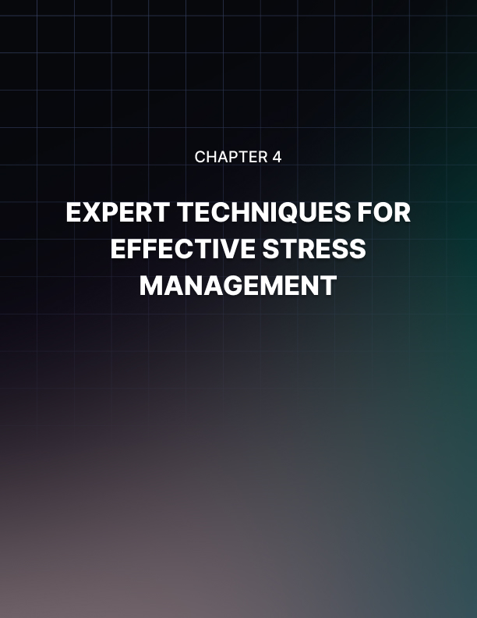

Expert Techniques for Effective Stress Management
You've set your goals, established positive habits, and you're ready to take on the world of entrepreneurship. But as you dive deeper into your journey, you'll inevitably encounter a formidable opponent: stress. The entrepreneurial path is fraught with challenges, uncertainties, and high-stakes decisions, all of which can contribute to significant stress levels. However, stress doesn't have to be your downfall. With the right strategies and mindset, you can not only manage stress but harness it to drive your success.
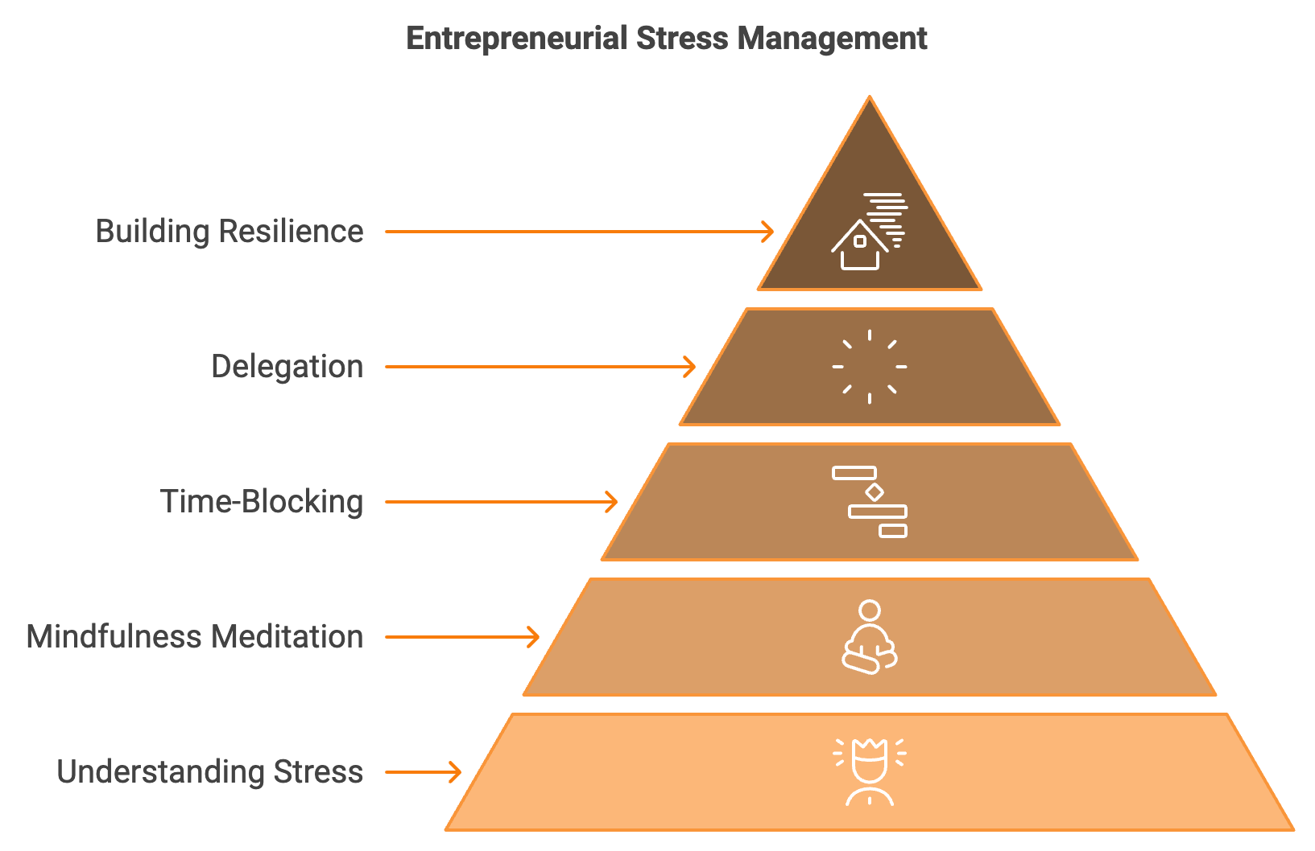

Understanding Entrepreneurial Stress
Before we dive into management techniques, it's crucial to understand the nature of entrepreneurial stress. Unlike the stress experienced in traditional employment, entrepreneurial stress is often characterized by its intensity, unpredictability, and personal nature. You're not just worried about meeting a deadline or impressing a boss; you're concerned about the very survival and growth of your business, which often feels like an extension of yourself.
A 2023 survey by the Global Entrepreneurship Monitor found that 72% of entrepreneurs reported experiencing high levels of stress, with 38% describing their stress as "extreme" or "overwhelming." The sources of this stress are varied and include financial uncertainty, decision-making pressure, work-life balance challenges, responsibility for employees, market competition, technological changes, and the blurring of personal and professional identity. While some level of stress can be motivating, pushing you to meet deadlines and achieve goals, chronic or excessive stress can be detrimental to both your health and your business. It can lead to burnout, poor decision-making, strained relationships, and even physical health issues. Therefore, developing effective stress management strategies isn't just beneficial—it's essential for your long-term success and well-being as an entrepreneur.

Mindfulness Meditation: Your Secret Weapon Against Stress
One of the most powerful tools in your stress management arsenal is mindfulness meditation. This practice, which involves focusing your attention on the present moment without judgment, has been shown to significantly reduce stress and anxiety. A study published in the Journal of Business Venturing in 2023 found that entrepreneurs who practiced mindfulness meditation for just 10 minutes a day reported a 30% reduction in perceived stress levels after eight weeks.
Here's a simple mindfulness meditation technique you can start with: Find a quiet, comfortable place to sit. Set a timer for 5-10 minutes. Close your eyes and focus on your breath. Notice the sensation of air moving in and out of your nostrils or the rise and fall of your chest. When your mind wanders (and it will), gently bring your attention back to your breath without judgment. Start with just 5 minutes a day and gradually increase the duration as you become more comfortable with the practice. The key is consistency rather than duration. Ten minutes of meditation every day is more beneficial than an hour once a week.
To make this habit stick, try habit stacking (remember from the previous chapter?). For example, you could decide to meditate right after your morning coffee or just before you start your workday. By linking meditation to an existing habit, you're more likely to maintain the practice even on busy days.

Time-Blocking: Mastering Your Schedule
One of the major sources of stress for entrepreneurs is the feeling of being overwhelmed by an endless to-do list. Time-blocking is a productivity technique that can help you regain control of your schedule and reduce stress. The basic idea is to divide your day into blocks of time, each dedicated to accomplishing a specific task or group of tasks.
Here's how you can implement time-blocking: Start by identifying your most important tasks for the day or week. Allocate specific time blocks to these tasks in your calendar. During each time block, focus solely on the designated task. Include blocks for breaks, email checking, and unexpected issues. For example, your schedule might look like this: 8:00 - 9:00 AM: Review and respond to urgent emails; 9:00 - 11:00 AM: Work on business strategy; 11:00 - 11:30 AM: Break; 11:30 AM - 1:00 PM: Client meetings; 1:00 - 2:00 PM: Lunch and personal time; 2:00 - 4:00 PM: Product development; 4:00 - 5:00 PM: Team check-in and planning for tomorrow.
Time-blocking helps reduce stress in several ways. It gives you a clear plan for your day, reducing decision fatigue. It also helps you focus on one task at a time, increasing productivity and reducing the stress of multitasking. Finally, it allows you to build in time for breaks and self-care, which are crucial for managing stress.

The Art of Delegation: Lightening Your Load
As an entrepreneur, especially in the early stages of your business, you might feel the need to do everything yourself. However, this approach is not only unsustainable but also a major source of stress. Learning to delegate effectively is crucial for your stress management and the growth of your business. Start by identifying tasks that don't require your specific expertise, are time-consuming but relatively straightforward, or could be done better by someone with specialized skills. These are prime candidates for delegation. Next, consider who could take on these tasks. This might involve hiring employees, outsourcing to freelancers, or using virtual assistant services.
When delegating, remember these key points: Clearly communicate expectations and deadlines, provide necessary resources and authority, set up check-in points to monitor progress, be open to different methods of completing the task, and offer feedback and recognition for good work. Effective delegation not only reduces your stress by lightening your workload but also empowers your team and allows you to focus on high-level strategic tasks that truly require your attention.

Building Resilience: Your Shield Against Stress
While it's important to have strategies for managing stress, it's equally crucial to build your resilience—your ability to bounce back from setbacks and adapt to challenging circumstances. Resilience isn't about avoiding stress but about developing the mental and emotional fortitude to handle it effectively. Here are some ways to build your resilience: Cultivate a growth mindset by viewing challenges as opportunities for learning and growth rather than insurmountable obstacles. Build a strong support network by surrounding yourself with supportive family, friends, mentors, and fellow entrepreneurs who can offer advice and encouragement. Practice self-compassion by being kind to yourself when you face setbacks. Treat yourself with the same compassion you'd offer a friend in a similar situation. Maintain perspective by remembering that most problems are temporary. Ask yourself, "Will this matter in a year from now?" Focus on what you can control by directing your energy towards aspects of your business and life that you can influence, rather than worrying about factors beyond your control. Develop problem-solving skills by approaching challenges systematically.
Break big problems into smaller, manageable parts and tackle them one by one. Take care of your physical health through regular exercise, a balanced diet, and adequate sleep, which are crucial for building stress resilience. Practice gratitude by regularly acknowledging the positive aspects of your life and business, which can help maintain a balanced perspective during challenging times.
To put these strategies into action, consider creating a personal resilience plan. This plan should outline your go-to stress management techniques, your support network, and your strategies for maintaining physical and mental health. Remember, this plan should be personalized to your needs and regularly updated as you discover what works best for you.
Stress Management Technique | Frequency | Duration
Mindfulness Meditation | Daily | 10 mins
Box Breathing | As needed | 2-3 mins
Physical Exercise | Daily | 30 mins
Time-Blocking | Weekly | 30 mins
Delegation Review | Weekly | 1 hour

Remember, stress is an inevitable part of the entrepreneurial journey. It's not about eliminating stress entirely, but about managing it effectively and using it to your advantage. By implementing the strategies we've discussed—from mindfulness meditation and breathing exercises to time-blocking and delegation—you can build your resilience and thrive under pressure. Your ability to manage stress effectively will not only benefit your personal well-being but will also be reflected in the success of your business. Mastering these techniques will better equip you to handle challenges, make clear decisions under pressure, and maintain the energy to drive your business forward.



Maintaining Physical Health for Peak Performance
Your body is your most valuable asset as an entrepreneur. It houses your innovative ideas, provides energy for long workdays, and forms the foundation of your entrepreneurial efforts. Yet, many entrepreneurs neglect their physical health due to work demands. A 2023 survey by the Entrepreneur Health Association found that 68% of entrepreneurs reported neglecting their physical health, leading to decreased productivity, poor decision-making, and burnout. On the flip side, entrepreneurs who prioritize their physical health report higher energy levels, better stress management, and improved overall performance.
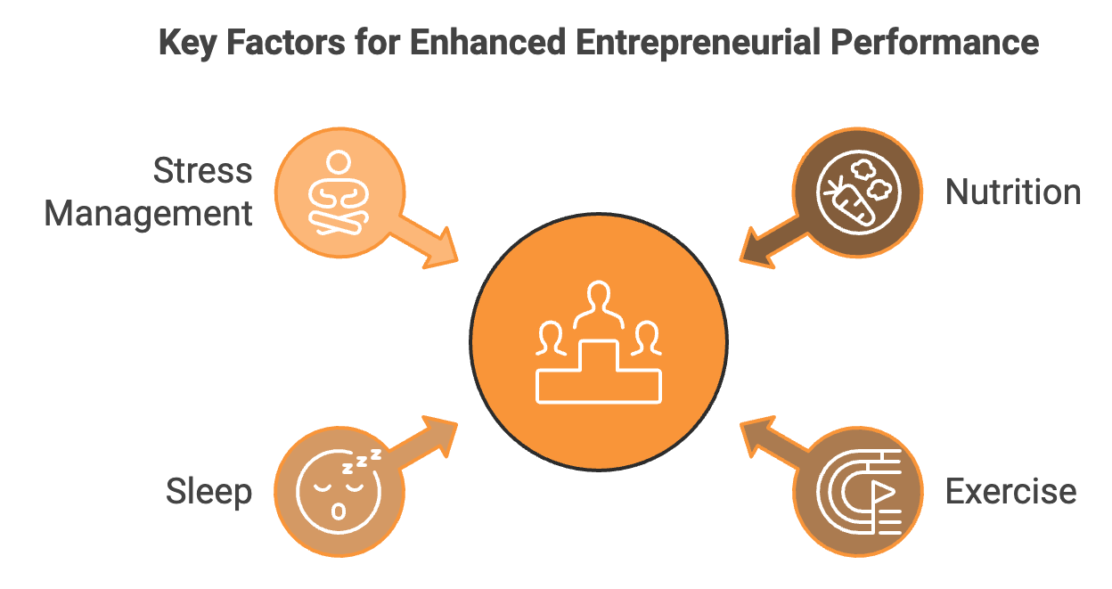

Nutrition: Fueling Your Entrepreneurial Engine
The food you eat directly impacts your energy levels, cognitive function, and overall health. Prioritize protein for maintaining energy levels and supporting cognitive function. Include lean protein sources like chicken, fish, lean beef, eggs, or plant-based options in each meal. Embrace healthy fats, particularly omega-3 fatty acids found in fatty fish, walnuts, and flaxseeds, which are beneficial for cognitive function and mood regulation. Choose complex carbohydrates like whole grains, sweet potatoes, and quinoa for sustained energy and stable blood sugar levels. Hydration is crucial; even mild dehydration can impact cognitive function, so aim for at least 8 glasses of water a day.
Practice mindful eating by taking dedicated meal breaks instead of eating on the go or while working. This can improve digestion and help you tune into your body's hunger and fullness cues. Meal prep can help you maintain a healthy diet during busy periods. Dedicate a few hours each week to prepare meals in advance. Keep healthy snacks like nuts, fruit, or Greek yogurt on hand to avoid reaching for less nutritious options when hunger strikes.
Remember, nutrition isn't about perfection. It's about making consistent, healthy choices that fuel your body and mind for peak performance. By incorporating these strategies into your daily routine, you'll be providing your body with the premium fuel it needs to drive your entrepreneurial success.

Exercise: Boosting Your Physical and Mental Strength
Regular physical activity enhances cognitive function, reduces stress, and boosts energy levels. For time-strapped entrepreneurs, High-Intensity Interval Training (HIIT) workouts can provide significant benefits in just 20-30 minutes. A study published in the Journal of Physiology in 2023 found that just three 20-minute HIIT sessions per week improved cognitive function and reduced stress levels in participants.
Strength training improves bone density, boosts metabolism, and enhances overall functional fitness. Aim for at least two strength training sessions per week. Yoga or Pilates combine physical activity with mindfulness, offering dual benefits for body and mind. They can improve flexibility, core strength, and stress management.
Consider active commuting by biking or walking to work to boost your mood and energy levels before starting your workday. Invest in a standing desk or a desk converter and set reminders to stand and move every hour. Try "exercise snacking" - short bursts of activity throughout the day, like doing a set of push-ups between meetings or taking a brisk 5-minute walk after lunch.
Most importantly, find activities you enjoy. Exercise shouldn't feel like a chore. Experiment with different activities until you find something you genuinely enjoy, whether it's dance classes, rock climbing, or team sports. Remember, consistency is key. It's better to do shorter workouts regularly than to have sporadic long sessions. Find a routine that works for you and stick to it.

Sleep: The Entrepreneur's Secret Weapon
Quality sleep is not a luxury; it's a crucial component of peak performance. Sleep is essential for memory consolidation, problem-solving, and creativity. A study published in Nature Neuroscience in 2023 found that individuals who got 7-9 hours of sleep per night showed a 32% improvement in creative problem-solving compared to those who slept less than 6 hours. Sleep also plays a vital role in emotional regulation, physical recovery, and decision-making.
To optimize your sleep, stick to a consistent sleep schedule, even on weekends. Create a sleep-friendly environment by keeping your bedroom dark, quiet, and cool. Invest in a comfortable mattress and pillows. Develop a relaxing pre-sleep routine, which could include reading, light stretching, or meditation. Limit screen time at least an hour before bed, as the blue light emitted by electronic devices can interfere with your body's production of melatonin, a sleep-inducing hormone.
Watch your diet by avoiding heavy meals, caffeine, and alcohol close to bedtime. Regular physical activity can improve sleep quality, but avoid intense exercise close to bedtime as it can be stimulating. Use relaxation techniques like deep breathing or progressive muscle relaxation to calm your mind before sleep.
Remember, sleep is not a waste of time. It's an investment in your productivity, creativity, and overall well-being. By prioritizing sleep, you're ensuring that you'll be at your best during your waking hours, ready to tackle the challenges and seize the opportunities that come with entrepreneurship.

Stress Management: The Physical Aspect
Chronic stress can have serious physical consequences, including weakened immune function, increased risk of heart disease, and accelerated aging. Regular exercise is one of the most effective stress reducers, releasing endorphins, improving mood, and providing a mental break from work-related stress. Deep breathing exercises, such as diaphragmatic breathing or the 4-7-8 method, can activate your body's relaxation response, reducing the physical symptoms of stress.
Progressive muscle relaxation, which involves tensing and then relaxing different muscle groups in your body, can help reduce physical tension associated with stress. Consider incorporating regular massages into your self-care routine to relieve muscle tension and promote relaxation. Some entrepreneurs find acupuncture helpful for stress relief and overall well-being.
Spending time in nature can significantly reduce stress and improve mood. Try to incorporate outdoor time into your routine, even if it's just a short walk in a local park. By addressing the physical aspects of stress management, you're not only improving your mental state but also protecting your body from the harmful effects of chronic stress.
Stress Management Technique | Benefits
Regular Exercise | Releases endorphins, improves mood, provides mental break
Deep Breathing Exercises | Activates relaxation response, reduces physical stress symptoms
Progressive Muscle Relaxation | Reduces physical tension
Massage | Relieves muscle tension, promotes relaxation
Acupuncture | May help with stress relief and overall well-being
Time in Nature | Reduces stress, improves mood

Maintaining physical health as an entrepreneur isn't about adhering to a rigid set of rules. It's about creating a lifestyle that supports your physical well-being while allowing you to pursue your business goals. Schedule health like you schedule business, putting exercise, meal prep, and sleep in your calendar with the same importance as your business commitments. Lead by example, modeling good health behaviors for your employees. Use technology wisely, finding apps and devices that help you track and improve your health.
Build a health support network, surrounding yourself with people who support your health goals, such as a personal trainer, nutritionist, or fellow health-conscious entrepreneurs. Structure your environment to support healthy habits by keeping healthy snacks in your office and a water bottle always within reach. Practice mindful indulgence, savoring treats consciously and in moderation. Don't neglect regular medical check-ups, as prevention is always better than cure.
Remember, the goal is progress, not perfection. There will be days when you don't eat as well as you'd like or miss a workout. That's okay. What matters is your overall pattern of behavior. As an entrepreneur, your physical health is intrinsically linked to your business success. By prioritizing nutrition, exercise, sleep, and stress management, you're not just investing in your personal well-being - you're investing in the long-term success of your business. A healthy entrepreneur is a resilient entrepreneur, one who has the energy, focus, and stamina to weather the challenges of business ownership and seize opportunities for growth.
Your body is the vehicle that will carry you through your entrepreneurial journey. Fuel it well, maintain it regularly, and it will serve you faithfully as you pursue your business dreams. Remember, taking care of your physical health isn't selfish or indulgent - it's a crucial part of your role as a business leader. By prioritizing your health, you're ensuring that you'll be able to show up fully for your business, your team, and your customers for years to come.

