Disclaimer

This eBook has been written for information purposes only. Every effort has been made to make this eBook as complete and accurate as possible. However, there may be mistakes in typography or content. Also, this eBook provides information only up to the publishing date. Therefore, this eBook should be used as a guide - not as the ultimate source.

The purpose of this eBook is to educate. The author and the publisher do not warrant that the information contained in this eBook is fully complete and shall not be responsible for any errors or omissions. The author and publisher shall have neither liability nor responsibility to any person or entity with respect to any loss or damage caused or alleged to be caused directly or indirectly by this ebook.

This eBook offers information and is designed for educational purposes only. You should not rely on this information as a substitute, nor does it replace professional medical advice, diagnosis, or treatment.
Table of Contents

Introduction 5
Chapter 1: What Is The Creator Economy? 10
Chapter 2: How To Get Started As A Creator 21
Find Your Niche 21
Choose A Platform 23
Chapter 3: 6 Ways To Make Money As A Creator 32
Sell A Membership For Exclusive Content 33
Sponsorships 33
Ad Monetization 34
Sell Merch 35
Sell Digital Products 36
Sell Consultation/Coaching 36
Chapter 4: Content Ideas 43
Chapter 5: Content Strategy 48
Conclusion 54

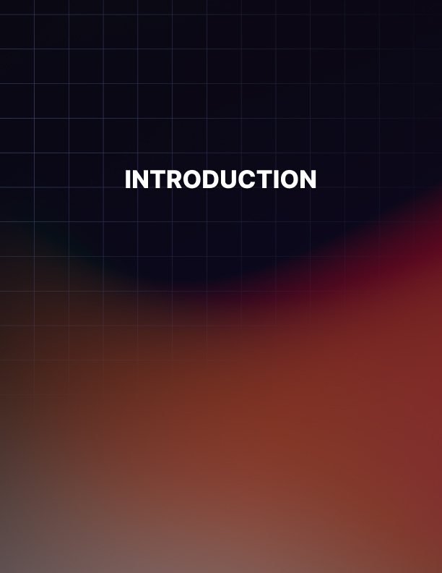

Introduction

The internet has changed everything.

Just a couple of decades ago, there was a certain way that things were done and nothing ever deviated from that time-tested, age-old approach to business and entertainment. The people were entertained and educated by mountains of content but there was little independence from the system that had existed for generations.

And then the world wide web came onto the scene and things started to change. Slowly but surely, the way that we consume and create has been democratized and now we live in a wildly transformed landscape that looks remarkably different from the one that previous generations knew.

The internet has done so much for the way that people communicate, share information, start businesses, research and develop concepts and plans, and any other aspect of daily life that you can think of. And, through the last decade, the internet has done so much for how people create content.

Today, a content creator is one of the most coveted and influential jobs on the internet. A successful content creator can impact entire industries and can also change their own lives for the better. They are a voice for the people and a way for businesses to connect with customers. They are also trail blazers when it comes to how everyday people express themselves, find others like them, and build communities.

What is a content creator and why are they so special? And what is the creator economy that they have manufactured, built up, and revolutionized again and again through the years? You need to know what these things are because, whether you know it or not, they all influence your daily life in many massive ways.

A content creator is someone or a group of people who produce engaging, instructive, or entertaining content for digital distribution. These people usually provide a unique viewpoint or voice. Fans cling to their distinctive viewpoints and over time develop strong bonds with them. These are the people who find a way to voice their opinions about all sorts of things, from instructional videos about makeup to products and businesses to world events and lifestyle choices. Content creators speak directly to their audiences, often without the help of big studios or large websites.

You have likely seen a content creator because they exist just about everywhere on the web now. They populate the pages of TikTok, YouTube, Twitter, Instagram, Facebook, and practically any social media app online.

But they also have their own websites - and even apps - that cater directly to the audiences they have built over the years. Blogs and podcasts are also home to some of the most popular content creators around.

Over the years, the idea of a content creator has blossomed from someone who likes to discuss things that they enjoy to people who run entire small businesses and hold influence over millions. Content creators are able to sway people to buy products and change their lives. The audiences have grown to trust these creators and hang on nearly every word they say.

The concept of content creators has grown in leaps and bounds over the years. Just a decade ago, it wasn’t something that existed and now creators like his bring in millions of dollars every year, both to themselves and to the companies they work with. And the number of content creators has ballooned in major ways recently, with more than 50 million people describing themselves as such in 2022.

The power of content creators will only grow, as will the number of people ascribing to be one. Through their hard work and their dedication to the cause, content creators have crafted their very own business models and an entire economy that revolves around them. That economy, the creator economy, is one that has thrived through good times and bad and will continue to do so in the years to come. It is still young, it is still evolving, and it holds great promise for anyone who takes it seriously and wants to dedicate their life to it.

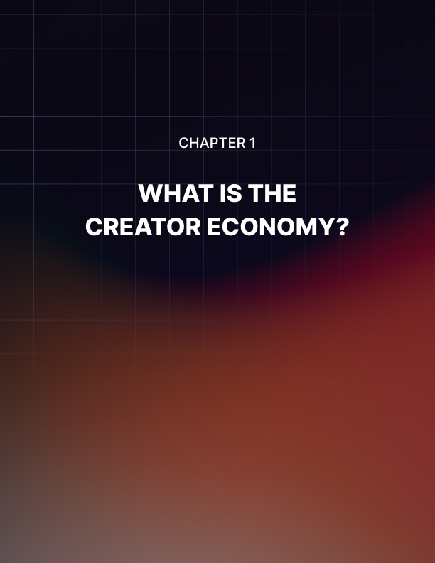

Chapter 1: What Is The Creator Economy?

You have probably heard the phrases “content creators” and “creator economy” again and again over the last few years, especially recently with the boom of TikTok and Instagram burning up the app stores since the start of the 2020s. But even if you have heard it talked about on your own news feeds or in the news, you still might not be 100% sure what it is. So, before we can really talk about the creator economy and the power it holds, we need to summarize it correctly so we know exactly what we are talking about.

Simply put, the creator economy is one that was generated by and still caters to creators. And, by the most basic definition, creators are people who produce millions of hours of content for their fans about many different subjects and are the ones who built and exist inside the creator economy. The creator economy is a world that financially rewards those who are committed to the idea of creating content consistently, via blogs, vlogs, tweets, postings on social media, and any way to connect with their fanbases.

Content creators don’t just blog or make videos though. There are many who make hand-crafted items or write books or even create audio programs about a number of things such as politics, history, meditation, self-are, lifestyle changes, home furnishings, and more.

Much like other creative economies, the creator economy is one where people are able to make whatever is they’re passionate about and then distribute that directly to the people who want it. It cuts out the middleman. The creator economy doesn’t rely on big companies, studios, networks, or publishers. Instead it is by the people and for the people. All of that makes every aspect of the creator economy, from creation to distribution, much more intimate and personal.

Let’s take a look back at the beginning of another game- changer that altered the way we are entertained and educated: the television. Back when the TV first came to the public in the 1950s, it started with very few channels. In fact, for many decades, most Americans could only watch three networks. But over time, there became more and more channels for people to enjoy and more and more programs on those channels.
Still, it was relegated to a very structured and strict system that didn’t allow for people to break away from the format put in place. With more freedom came more variety and different types of audiences were able to find content that they felt spoke directly to them.

Much like the start of television, the creator economy got off to a slow start where there were limited ways for people to express themselves. In the beginning of this new economy, there were limited outlets for people to post their creations and find their audiences. However, that isn’t the case anymore. Content creators were mostly stuck with YouTube for videos, Etsy for their own creations, and blog platforms such as WordPress for the written word.

But that didn’t last long, as other companies saw the value in letting people express themselves, more options became available to content creators and the creator economy was born. Now there are dozens of video sites, blogging platforms, social media apps, and marketplaces that allow people to make their content and distribute it to their fans.

There are now numerous options for innovative people to make money online thanks to the internet. A supportive audience is available for writers, singers, filmmakers, and other content creators to share their artistic ambitions with. Additionally, there are brand-new markets, such podcasting and gaming live streams.

In the past, if you wanted to make a living off of your artistic pursuits, you often had to partner with conventional publishing houses, film studios, or record labels. The need for managers or lengthy, binding contracts with "Big Media" is no longer necessary because creators may now support themselves.

Nowadays, there are many internet markets where you can offer your artistic skills. There are well-known websites like eBay, Etsy, and Amazon Publishing. Other platforms, such as Tumblr and WordPress for bloggers, Twitch for video game streamers, Instagram and Pinterest for photography fans, YouTube and TikTok for video creators, can also be advantageous.

Online producers can make money in a variety of ways, but the most common is revenue sharing with the platform they use.

Therefore, if you are a well-known Medium blogger, for instance, you can get money from subscription fees that Medium receives. You distribute that cash around Medium and the other well-known blogs.

The creator economy has benefited from social networks, offering markets where artists can earn a living. A loyal fanbase is also developed on social media by successful creators, who subsequently share their most recent works with them.

The typical American adult uses Facebook for about 38 minutes per day. In fact, 16 to 24 year olds spend an average of 3 hours every day on social media. In 2019, social networking took up about 2 hours and 20 minutes a day for internet users. That is a huge amount of time devoted to social media, and it provides many options for creators to market their work to pertinent, specific demographics of users.

A limited handful of platforms, including Facebook, YouTube, Twitter, Instagram, TikTok, and a few others, have a significant impact on social media. These platforms employ algorithms that effectively control what each user will view. When compared to those that take an organic approach, individuals who choose to promote on these platforms have a greater audience.

Social media, however, needs content. People must upload posts, images, videos, and other content to the sites. As a result, they make it simple for the top content providers to profit from their work, typically using the revenue-sharing model mentioned above.

The first step in becoming a successful creator is to publish excellent material and establish a following. To obtain a percentage of advertising money, content creators can submit their work to social media platforms. They can also receive money on creator-first platforms or commercialize their own site directly.

Podcasting
Sponsorship deals are the most popular source of income for podcasters. This entails making an advertisement to advertise an affiliate deal or incorporating a reference of a good or service into ordinary content. Brands provide an influencer a tracking link or promo code so they can be credited for any purchases they help to drive. Podcasters can take donations and crowdfunding through podcast hosting services.

Influential podcasters may charge a membership fee for premium material like more interviews, behind-the-scenes information, or ad-free episodes.

Blogging
Ads, affiliate marketing, sponsored content, and the sale of additional services are all viable revenue streams for bloggers.

Bloggers who have a big audience can post advertisements on their website by joining an ad network. The majority of these networks employ targeted advertising, which means that the ad changes in response to the viewer's most recent site behavior, which is monitored by cookies. A tracking link can be used by bloggers to advertise a business's goods by joining affiliate networks. When a customer purchases something using the blogger's link, they get paid a commission. Professional authors can also provide newsletters that are behind a paywall on their own websites or via content aggregators like Substack.

Videos
Uploading videos to YouTube is one of the most popular ways to monetize video content. To be eligible for the YouTube Partner Program, which enables creators to commercialize their channels through adverts, subscriptions, and channel memberships, applicants must have at least 1,000 followers and 4,000 view hours in the previous year. The creator receives the remaining 45% after YouTube takes its cut. By placing their videos behind a paywall on their website, video artists that specialize in tutorials or video courses can effectively monetize their work.

Influencers
Influencers are online personas that have the authority to influence the purchasing decisions of their followers. Influencers are employed by brands to produce sponsored content or act as brand ambassadors. In place of promoting a brand through a single sponsored post, brand ambassadors frequently talk about the company's products to raise brand recognition, typically in exchange for a monthly salary.

Design & Art
Creators can sell digital artwork, photography, and video on stock image websites and marketplaces that accept NFT (Non- Fungible Tokens) in return for royalties or commissions.

As you can see, the creator economy offers an awful lot to an awful lot of people. From designing and producing art to blogging or blogging, to podcasting and beyond, the creator economy has opened the door for quite literally millions of people - and millions of eager fans desperate for something that feels genuine and from the heart.

That is the thing about this new world of content creators: they are all genuine. Their passion comes from the things they create, the things they discuss, and the creative endeavors that drive them. The most successful content creators are the ones who have found the thing that really drives them, the topic that fires them up and gets them moving and excited. They have been able to take that passion and convert into their creations.

The fans pick up on those feelings. They truly know and believe that the person creating their content really believes in what they are saying and is truly fascinated and engaged in the subject matter. That is why the millions of people who subscribe to numerous content creators across multiple platforms keep coming back for more. They were sick and tired of the world of entertainment and creation that was flat and uninspired and so they are now following, loyally, the people who really mean what they say.

Content creators and the creator economy offer great opportunities to so many people. But it only offers that to people who are willing to work hard and truly willing and eager to follow the things that they are passionate about.

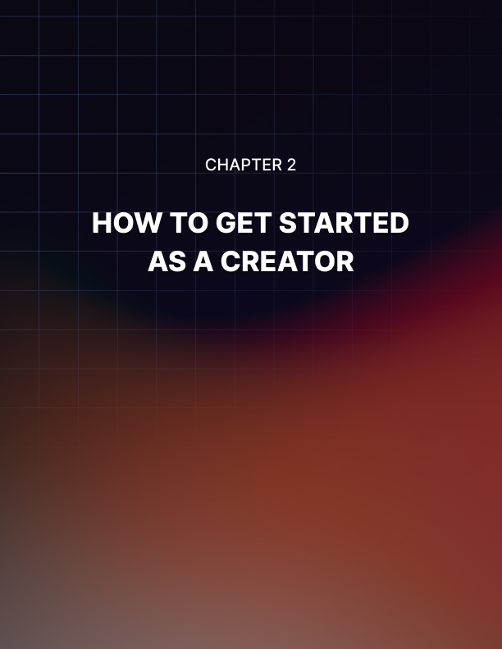

Chapter 2: How To Get Started As A Creator

Obviously, being a part of the creator economy can bring great things to our life beyond just financial fortune. By being involved in this up-and-coming, constantly-growing world, you are able to really make content about the things that make you happy, from music to movies to books to makeup and more. If you are passionate about something, you can quite literally create content about it.

But you need to have more than just a passion to make it in this world. Indeed, like any other economy and industry, you have to know certain things and follow particular steps in order to find success. You can’t just blindly start making your content and expect to find success right away. In fact, it may take some time before you find any sort of success at all!

The truth is that breaking into the creator economy isn’t easy and there will be many bumps in the road that present themselves to you. While, yes, there will be challenges, these challenges will be easier to get through if you follow a simple set of steps and rules and keep certain tips in mind at all times. Like any sort of industry, you can break into it - even with no prior experience. But if you are not smart about it and don't follow steps that others have found great success with, you are simply setting yourself up for a letdown and a disappointment that will waste your time, energy, and even money.

So, you want to get started as a creator. What are the first things you should do as you take the first steps into this long journey?

Find Your Niche
The first step in this process might end up being the most important one for many creators. It’s all about finding your little corner of the content creator economy and sticking with it. It’s about looking into yourself, honestly evaluating what you’re best at, and then figuring out how to turn that into some great, premium content.

Think about something that you believe you could make content about. Maybe you love books and you think you could run a book review TikTok account. Or maybe you’re great at cross-sticking and believe that you could start an Etsy store that sells your creations. Perhaps you love movies and know their history and would love to start a podcast that is all about the famous stories of Hollywood from yesteryear.

Those are all great ideas, aren’t they? But the truth is that they are already taken. That’s right, each of those ideas has already been taken by someone and success has already been found with each of them. That is how populous and busy the creator economy is. Every great idea has already been capitalized and anything you think of, no matter how great or genuine or original it feels, has already been touched upon by someone else.

Now, this shouldn’t scare you away from finding something you are passionate about and following it. Instead, you simply need to always keep in mind that you are not alone in the creator economy, not by a long shot. There are quite literally millions of others who are doing the same things that you want to do. The field is very crowded.

But you can break through.

The trick here is to find that niche that is as particular as possible. Do not just come up with the idea of “a podcast about politics.” Give that some thought, expand upon it, make it more unique. Niche means something that is very particular and limited, but in a good way. That is what you want to do. You want to find a certain something that you can provide to the creator economy that no one else does. There may be other creators so make things similar to yours. But if you do your job right and you take this seriously, you will find the thing that no one else does exactly like you.

This means you should find something that plays to your interests, your skills, your expertise, your knowledge, your passion, your hobbies. You have to think that whatever your niche is, it will be your only one. You will not be following several passions, you will be sticking with just one. Therefore, you need to find one that you will be comfortable sticking with forever. You need to find that one thing that makes you passionate, that one thing that you have a unique perspective on, that one thing that no one is quite doing. Once you have figured that out, you are on your way to creating content.

Choose A Platform
Okay, so you know what you want to talk about and what content you want to create but you are not quite at the stage of actually creating and finding your audience, monetizing it, and reaping the benefits.

The next thing you need to do is settle upon a platform that is best tailor-made for your skills and your content and your passion. There are so many options here that it’s really hard to choose the one that is completely perfect. But there are ways to start narrowing down the road you should be going down.

For example, are you going to be producing videos? Videos are easily the most popular form of content creation today so there is a good chance that you will be filming something for your creations. If that’s the case, you have a couple of options. Do you want to make short, quirky videos with the expressed purpose of going viral to find fans? If so, TikTok is for you.

TikTok has been growing in popularity over the last few years and now millions of people use the app daily to find the latest trends, memes, and up-to-date current events. If you want to be the hippest of hip, you want to use TikTok.

But maybe you want to rely upon a social media app that is part of a larger universe. That is when you would use Instagram Reels. The Reels feature in Instagram is an awful lot like TikTok and will allow you to create short videos that can be seen and shared by millions. However, it is part of the umbrella parent company of Meta, the owners of Facebook. Therefore, integration with Facebook is a total breeze with Instagram. This is a huge plus for anyone who is hoping to run a Facebook page for their content or a storefront via FB.

Finally, you can of course use YouTube. This is the original video site and honestly still holds many benefits that TikTok and Instagram simply don’t have. For starters, it’s best for long-term content. Therefore, if you are planning to make a video that is more than a couple of minutes, YouTube could be right for you. It will let you explore more, really dig into your content, and not worry about time constraints. If you aren’t looking to “viral” then YouTube might be right up your alley. Just keep in mind that it’s sometimes harder to share via YouTube and views are harder to come by too.

If you are looking to create photographic content, then Instagram is definitely going to be the avenue you want to go through. Instagram is now considered the go-to app for anything related to photography so you know that will be the one you use if you are snapping pictures and expressing yourself through your photography.

When it comes to text, you have a lot of options for your content. It depends on the sort of writing that you want to invest in. Are you looking for full, long-form, well-thought-out blogs? If that’s the case, you have quite a few options laid before you.

You could use Wordpress or Blogger or multiple other blogging platforms. Each of these providers will make setting up your blog as easy as can be and you’ll be able to get your blog up and running in no time at all. In fact, you can have an idea for a blog in the morning and be publishing your first piece just hours later.

But, maybe you are looking to create shorter forms of writing. You’re not looking to write a novel or even a blog but just share your pithy, fun thoughts about the world. If that is the case, then you know Twitter is the place for you. Twitter lets you write, you can just do it at 240 characters at a time.

Although Twitter does have that character restraint, you can still find ways to share quite a lot. In fact, there are many people who have found millions of followers through Twitter. It requires that you are smart, passionate, and find clever ways to get your thoughts across. It also requires consistency, communication with others, and deep commitment to finding something clever and unique to say.

Of course, you can also use Instagram to post your written words too. In fact, there are many content creators who use Instagram to make text posts. It takes a little more work sometimes but it is worth the exposure you get.

Most content creators use a mix of all these social media apps and websites to build their own little online empire. The smartest and most successful ones are able to balance each app and site and allow them to all perform different tasks and come together for one overall goal: to get the word out about content.

The thing is if you are going to use all of them, from YouTube to Instagram to Twitter, TikTok, and beyond, you have to make sure that they all get a good amount of attention. The biggest mistake you can make is to simply put all of your eggs into a social media basket. Spread the wealth around, use each of them to your advantage!
No matter what platform you create for or what it is that you make, you need to ensure two majorly important things: you speak from the heart and you speak often. Do not agree to produce content about something you’re truly inspired, passionate, and fired up about. Do not just choose something because you think you can find a paycheck in it. Remember that the audience you will be speaking to is very particular, and they are also very good at sniffing out someone who isn’t sincere.

Therefore, you must ensure that you are only delivering content that really is heartfelt and genuine. People will be able to see right through you if it’s not and your viewer or reader count will drop like a huge stone.

You also need to always be creating. Stay consistent. In fact, you should always be working on your next project. Your next video or your next written piece or your next piece of art should always be on the burner, on the way to completion. Your audience has a lot of options. There are many people they can choose from and many content creators they can stay loyal to.

The internet is a wild, fast-paced place and if you don’t keep up with it, it’ll leave you behind. Perhaps one of the biggest mistakes that a new content creator makes is that they don’t create content consistently.

This is your art. This is the way you express yourself. This is if you portray your personality and desires and passions to the world. You should be proud to always be making something new. And you should always be creating. If you aren’t actively working on a new piece for the world to see, you should be spending that time communicating with your followers and building a strong online presence.

In other words, even if you are just starting out you should be treating this passion, this hobby, like a full time job. You need to devote yourself to it. It will require a lot of hours, a lot of passions, and a whole lot of energy. But if you stick with it, it’ll easily be well worth it.

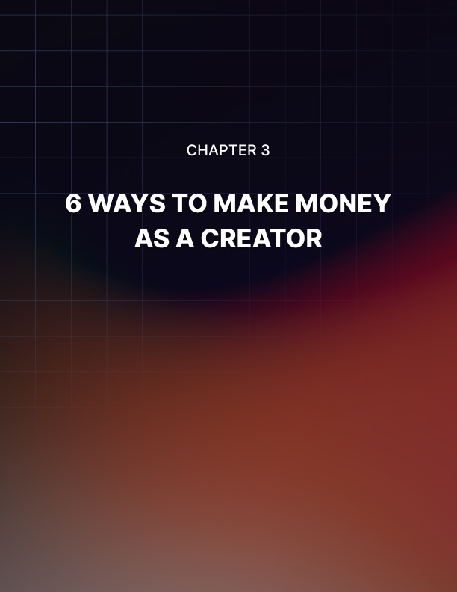

Chapter 3: 6 Ways To Make Money As A Creator

There are many people who get into content creation and the creator economy simply so they can express themselves.

Maybe you are one of those people. If that’s the case then you have an easy path ahead of you because the creation of your art is the reward!

However, there are plenty of other people who want to make money. There is no shame in that. And it’s actually a very smart move because there are now millions of people who make some form of their income via the creator economy.

But there are less people who make a steady, supportable amount of money via creation. It is possible, but it’s not as common as one would like. However, you can certainly start to add some money into your bank account via your new job as a content creator. But, again, you need to do things the right way, really understand what you’re doing and why you’re doing it, and follow some simple steps.

The good thing about making money as a content creator is that you have a lot of options to do so. As the creator economy has grown, the ways that people make money has also blossomed. Now there are multiple venues for you to add some extra cash to your wallet. And the best news of all is that you get to do that by being creative. You are literally going to get paid for doing something you are passionate about.

A warning, though: do not expect a storm of riches overnight. We have all heard the tales of content creators. But the truth is that those people are very rare. The vast majority of people who make money via their creations don’t make a whole lot. It won’t be enough to make rent, at least not at first. But it will be money you haven’t had before, so that’s good. Plus, the money you make - no matter the amount - will be definitive proof that you are connecting with people and finding an audience that likes what you have to say. That is sometimes an even bigger reward than the money itself.

What are the best, smartest, most sure-fire ways to make money when you are starting out as a content creator?

Sell A Membership For Exclusive Content
This is a big one that many, many content creators rely on to make some extra cash…but it’s not so easy.

Many content creators will ask for their followers to sign up for a membership to their site or their content. For an extra, monthly fee the followers are able to get certain perks that aren't allowed to non-paying people. Perhaps it’s an extra podcast. Perhaps it’s bonus pictures or blog posts that are typically hidden behind a paywall. Maybe it’s something as exclusive as a phone call with you. There are varying degrees of rewards that creators make for their paying followers.

But you need to be careful to not launch this idea right away. You definitely don’t want to even attempt this until you have a larger follower count. Otherwise you won’t get a lot of traction. And you also need to ensure that the perks you offer paying people are actually worth their time. If someone is literally paying you for something, it’s got to be worth more than something they could get for free.

Sponsorships
This is a step that many newer content creators take and it’s one that can really help you out and improve your bottom line.

There are a slew of companies out there looking for content creators to advertise on their behalf. In fact, there are entire networking websites that are all about hooking creators up with companies that need their help.

This is mostly ideal for people who make videos. Typically, at the beginning or end of a video, the creator throws in a little speech about the product or service they are advertising. It isn’t very long and it’s always obviously an ad but viewers are quite used to this and very comfortable with it too.

With sponsorships and partnerships, you are able to make a little extra money every time one of your followers clicks on a link. If this is a path you want to go down, there are a ton of services on Google that will list companies that are looking for people to pitch for them. You will need to have a consistent number of videos and a decent follower count before a company will want your help but you’d be surprised by how early in your creator career that you can start this process.

Getting paid for mentioning a brand is a great way for a new and up-and-coming content creator to get paid for doing what they love. But you have to do it with finesse and attention to detail and care. If you are heavy-handed about pitching products, it’ll come across as false and flat and shallow and it won’t sell a single product.

Ad Monetization
Yet another terrific way for a content creator to make money doing what they are passionate about is ad monetization.

You can make money from the official commercials that are played during your videos with this approach to getting paid for your content. If you have ever watched a YouTube video, you have surely seen the ads break when a short commercial for a movie or product pops up and you either sit through it or skip past it after a few seconds. These ads actually help pay the creator of the video you are watching.

This is a great approach because it really requires no work at all from you. All you have to do is keep making your videos and YouTube will do the rest. They will place the ads (although you are able to explicitly choose where they will go) which means you don’t have to spend some of your precious time on camera pitching a product like you have to with sponsorship or brand deals.

There are certain things to keep in mind here, however. You need to make sure that your channel follows the right policies and guiltiness of YouTube. If you are breaking the rules of the Community Guidelines, you can expect that you won't be approved to run ads. Your channel will go through a review process upon your request to have advertisements on it and you will be either approved or denied based upon this, and other factors.

And what are those other factors? Well, you need to have at least 1,000 subscribers and 4,000 valid public watch hours. That means that people will need to have watched 4,000 hours of your work. This is obviously no small task and it shows that you won’t be able to start getting paid for ads on your channel right away. You will need to build up your following. You will need to have loyal viewers who watch your stuff and you will need to make sure that they subscribe. Now you know why so many content creators on YouTube always ask you to “hit that subscribe button”.

Finally, you need to sign an agreement with YouTube. That signature doesn’t mean you are giving your content away, you still owe it to an extent. But now the website is free to insert ads of their choosing into your work.

TikTok also has a feature much like this too and you have to follow certain procedures. You also can sign up to pitch products via TikTok just like you do on YouTube. Of course, for both websites you need to follow each and every step to a T and you cannot deviate or break those rules, or else the websites will quickly pull ads from you and it’ll be all-but- impossible to get reinstated into monetization.

Sell Merch
Once you have a sizable following, a group of fans who stick by your side and watch all of your content through thick and thin, you can start to sell merchandise. And this is truly one of the best ways to make money via your content creations.

It doesn’t matter if you’re creating blogs, videos, artwork, audiobooks, podcasts, or more. Whatever it is that you’re making, there is a way for you to make merch about it. Maybe these items for sale carry an image from your work. Maybe it has a phrase that you say in your video or an original drawing that you shared with your fans. Whatever it is, you have multiple outlets to create. There are websites that instantly create shirts, bags, backpacks, mugs, and more for you. We no longer live in a world where you have to craft these things by hand and ship them out on your own. Instead, you can sign up with one of these sites, such as Custom Ink or Rush Order Tees or VistaPrint. When a product is ordered by your fans, the sites create the item and ship it off on your behalf.

This is great for many reasons. You will get a cut of every sale, of course, but selling merch will also spread the word about your content. That means that you should go to great lengths to ensure that whatever merch you make is something that is eye-catching, fun, and easily communicates a point. While inside jokes between you and your audience is all well and good, it won’t really bring in more fans. So you have to be open-minded about the merch you make and think of it as billboards for your work that are just used or worn by other people in the world.

Sell Digital Products
From eBooks to guides, courses, and more, you can sell a slew of digital products to your fans. Most of the time, these are usually eBooks, comic books, or limited-time audiobooks or podcasts.

The great thing about digital products is that you don’t have to literally ship them. You simply upload them onto a website of your choosing and then you let the fans download and pay when they choose. This is a great way for you to easily create an item that will make you money for a small amount of it .

Sell Consultation/Coaching
If you are in the business of life coaching or motivating or inspiring people, then you should consider selling your own consultation and coaching services. Maybe you are teaching people how to relax or how to do a better job at work or how to have a stronger personal life. You might even be teaching them how to knit or paint or even start a podcast or vlog of their own.

Whatever it is you’re good at, you can teach others to be good too. You should always offer these consultations and coaching on your channel.

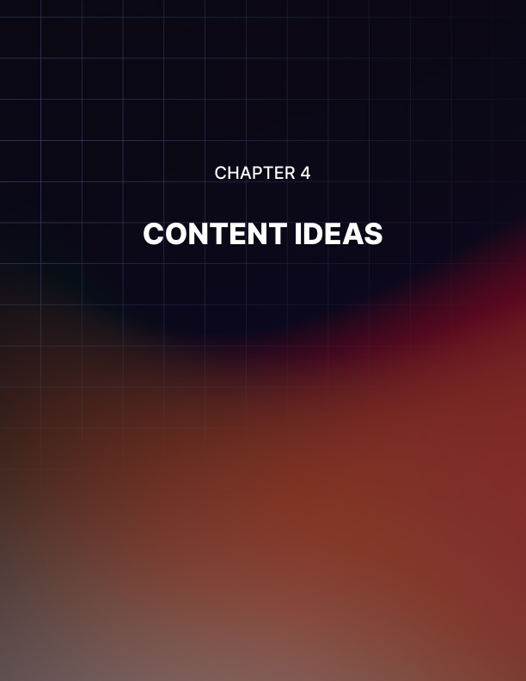

Chapter 4: Content Ideas

You know what sort of content you want to create and you know where to publish it. You know how to make some money and you know how to stick with it and allow it to find a loyal following.

But what about the actual content itself? What if you are suffering from writer’s block and you’re not sure what to publish? Sometimes content creators run out of ideas, it happens to nearly everyone. If that’s the case, you’re in luck because there are a few time-tested, easy-to-make ideas that are always popular and can keep your followers satisfied and happy.

For example…

How To/Tutorials
This is a great way to attract a large audience. How many times have you needed to do something and you weren’t sure how.

From changing your oil to installing a TV mount, there are tutorials for just about everything on the internet. And you can create one of those tutorials.

This is a great way to get easy views but you need to make sure that you are giving accurate information. When you are making a tutorial, no matter what it is about, you need to make it as an easy to follow, step by step guide that anyone will be able to follow, even if they have little-to-no experience with the subject at hand.

Day In The Life
Many people create content that is akin to a diary or journal. Their work just tells about the day in their lives. This is actually a very popular model that many content creators follow. Of course, you need to make sure you show a lot of personality and fun, unique moments in your “day in the life” digital journal. This is because you want people to stay engaged and if you’re simply filming yourself talking about your day, you’ll lose viewers. Instead, find something unique about your day or show off your personality in a special way.

Listicles
Now here is an idea that will always be popular and one that you can come back to again and again.

A listicle is a content creator who is, as you guessed it, listing certain things. Sometimes they are listing the best movies of the 1990s or the most stunning moments in sports history.

Whatever it is, a listicle should be informative with serious knowledge and expertise. Additionally, you need to show off your personality here as well. That is because you need to think of yourself as the host of the listicle and you should remain engaging and keep fans connected.

If you’re looking for a challenge, try to come up with a listicle that you can’t find anywhere else. When you create your idea, run it through Google and see if it’s been covered anywhere else. If you can think of something that really hasn’t been touched upon by another content creator then you’re really in luck.

When you are making listicles, you need to be careful about not using copyrighted material!

A listicle is going to cover things that will start debate and that’s why they are so great. They will get people talking and sharing and giving their own opinions. Don’t be afraid to upset people with your views if you are sharing an opinion. However, if you are creating tips about doing something, try to be as informative and insightful and detailed as possible.

The great thing about listicles is that there is always something that can be covered by them. They have been very popular on the internet for years now - and for good reason!

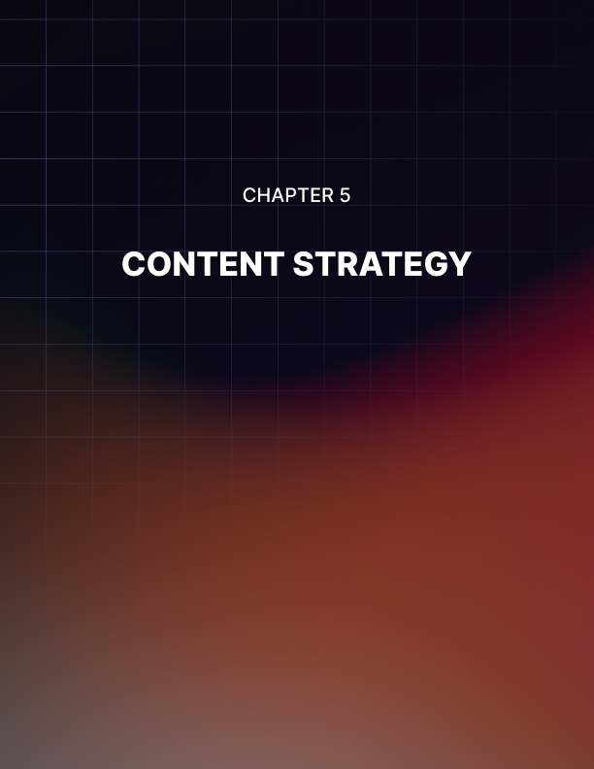

Chapter 5: Content Strategy

By this point, you hopefully have a good understanding of how to create content, how to find an audience, how to eventually make money, and how to always have new ideas that you can produce and turn into content.

You would think that maybe that’s it and you are ready to go and start your career as a content creator. The creator economy awaits you, you’re thinking, so it’s time to get out there and get going.

However, there is one more very important step that you simply have to follow before you are able to create the sort of career that has so many other successes. You need to develop a strategy for yourself and your channel, website, blog, Etsy store, etc.

What is a content strategy? Essentially, it is a plan that will give you a sort of path forward to achieve the sort of success you want. It will help you come up with ideas, it will help you find a loyal following, it will hold you accountable. More than anything, it will keep you consistent and will ensure that your fans are happy with the number of creations that you release and the speed that you put them into the world.

The most important thing about any strategy is that you stick with it. You need to remember that life is going to get in the way at times. Your side hustle as a content creator will not be your only source of income, at least for a very long time. Therefore, you need to make sure that your day job doesn’t take up all your time and leave you drained of energy to pursue this passion.

There will be times when you won’t feel up to creating anything. There will be times when you just feel ready to take some time off, throw in the towel, and focus on something else. But you have to always stick to your strategy!

Your content strategy should always revolve around this: you need to find a schedule and you need to stick to it.

If you watch a lot of video content creators, you have probably heard them say something like “And remember, I release a new video on Tuesdays and Thursdays.” This is a great way to keep the audience coming back again and again. They know that you will always have something new on those days and they will tune in to see what it is. If they have no idea about when your latest creation is hitting the web, they are less likely to come back to find it.

Consistency is key in the creator economy because, honestly, there are so many people competing for fans that consistency will give you an advantage over those who don’t use it. If you are always releasing new content and you build trust between you and your audience, they will start to rely on your schedule and even start looking forward to it.

Imagine if your favorite TV show didn’t tell you when it was airing. Would you keep watching it or will you give up on it? No one wants to work hard to find content, they want the entire process to be as easy as possible. Consistency helps them with that.

You can keep a tight schedule in many ways. Practically every smartphone or computer has a scheduling app built right into it. As well, most have reminder apps too. Therefore, you need to plug your schedule into your phone and have it remind you so you never get off track. You can also use apps like Notion or Google Calendar to remind you too. Soon, creating content will become a habit that is second nature and you will never drop the ball and leave your audience waiting.

Before you start your career as a content creator, you need to have multiple creations queued up and ready to go. If you are a video creator, that means that you should have multiple videos edited and ready to be published. If you are a writer, you need to have multiple blogs completely done. The same is true if you are making your own products or if you are creating podcasts or audiobooks. Whatever it is that you’re making, you should have quite a few up your sleeve, waiting for your official launch into the creator economy. Yes, this will take more work and it means it’ll take more time before you can launch but it’ll be worth it.

To audiences, it’ll look like you are releasing a bunch of new creations into the world. But it’ll actually be the result of weeks of planning and hard work. This will keep you consistent and it will start your relationship off with followers on a good foot.

You should spend at least several minutes every single day planning as well. While most of your time creating content will be spent actually, well, creating content, you should also spend a lot of time planning ahead and coming up with ideas. You should be thinking of pieces of art you want to create, or videos you want to film, or lists you desire to think about and compose. This planning ahead is a very important part of your content strategy. It will make sure that you don’t get writer’s block because you will always have a pot of ideas to pull from.

Your strategy should be focused on always keeping you working and always coming up with new ideas. The idea here is that your well never runs dry and you always have a new project to start working on. With this strategy followed, your channel or website or blog will continue to thrive and your fanbase will only grow.

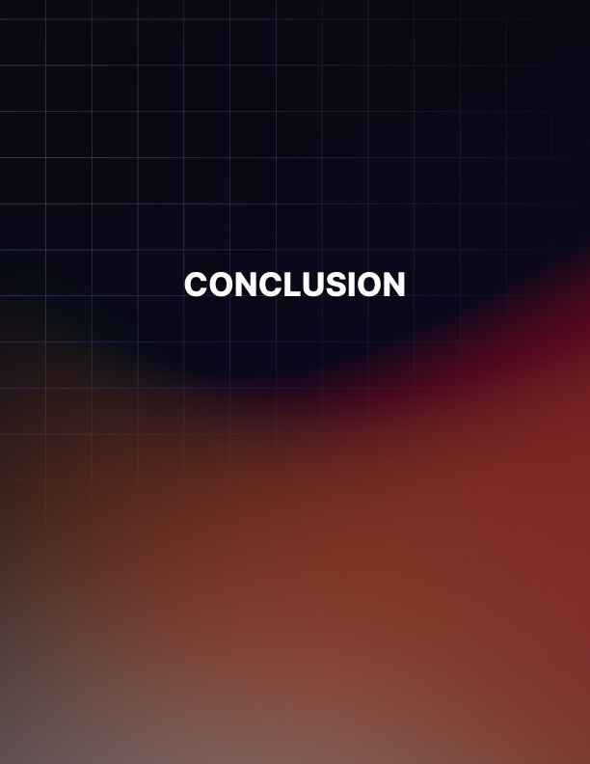

Conclusion

Entering the creator economy is so exciting. It feels like being a part of something very modern, very unique, and very promising.

There are now millions of people who have found some sort of success in the creator economy but it didn’t come easily to them. It might look painless and simple to those who enjoy their content but those who are most successful in this world have spent countless hours figuring out what they are passionate about and how to create content with it.

After reading so much about it, you might feel eager to get started and create your own content, find your audience, and build your own corner of the web. However, you need to do this the right way. You need to be smart and create your strategy, come up with new ideas about how to handle your social media, have a backlog of concepts that you can turn to whenever writer’s block arises, and start to plan on how to monetize your work.

See, there is a lot of work to be done! But if you follow the steps laid out before you and do things the right way, you will find that creating content for the web is one of the most rewarding, fun, and authentic ways to make money. Treat it like a real job that deserves your respect and attention and time. Eventually, you may find that there are plenty of other people who share the passion you have.

The creator economy is waiting for you.

