Disclaimer

This eBook has been written for information purposes only. Every effort has been made to make this eBook as complete and accurate as possible. However, there may be mistakes in typography or content. Also, this eBook provides information only up to the publishing date. Therefore, this eBook should be used as a guide - not as the ultimate source.

The purpose of this eBook is to educate. The author and the publisher do not warrant that the information contained in this eBook is fully complete and shall not be responsible for any errors or omissions. The author and publisher shall have neither liability nor responsibility to any person or entity with respect to any loss or damage caused or alleged to be caused directly or indirectly by this ebook.

This eBook offers information and is designed for educational purposes only. You should not rely on this information as a substitute, nor does it replace professional medical advice, diagnosis, or treatment.
Table of Contents

Introduction 7
What will this book cover? 8
What’s next? 10
Chapter 1: The Difference Between Fixed and Growth Mindsets 15
Understanding the Two Mindsets 15
Recognizing the Impact of Each Mindset on Your Life 15
Nurturing a Growth Mindset 16
Chapter 2: The Science of Learning and Growth 22
Understanding the Brain’s Ability to Change and Adapt 22
Learning About Neuroplasticity and Its Implications for Growth 23
Embracing the Potential for Lifelong Learning 23
Cultivating Neuroplasticity Through the Growth Mindset 24
Chapter 3: Embracing Challenges and Overcoming Obstacles 29
Learning to Approach Challenges with a Growth Mindset 29
Developing Resilience and Persistence 30
The Path of Persistence 30
Cultivate a Growth-Oriented Approach to Challenges 31
Chapter 4: Cultivating a Positive Mindset 36
The Power of Positive Thinking 36
The Psychological Benefits of Positivity 37
Developing a Positive Mindset to Foster Growth 37
Chapter 5: Developing Self-Awareness and Self-Reflection 42
Understanding Yourself and Your Goals 42
The Role of Self-Reflection in Personal Growth 43
Practical Strategies for Developing Self-Awareness 43
The Symbiosis of Self-Awareness and the Growth Mindset 44
Chapter 6: Setting Goals and Taking Action 48
Setting Meaningful and Achievable Goals 48
Developing Strategies for Achieving Your Goals 48
The Growth Mindset in Action: Goal Achievement 49
Chapter 7: Learning from Failure and Mistakes 54
Understanding the Importance of Failure 54
Learning from Failure: The Growth Mindset Approach 55
Embracing a Positive Attitude Toward Mistakes 55
Chapter 8: Celebrating Progress and Maintaining Momentum 60
The Importance of Celebrating Successes 60
Cultivating a Culture of Celebration 60
Maintaining Momentum for Continued Growth 61
Conclusion 66
A Recap of Our Journey 66
Embracing the Essence of the Growth Mindset 66
The Ongoing Adventure of Growth Continues 67



Introduction

In a world filled with opportunities and challenges, the way we perceive ourselves and our abilities can make all the difference in our pursuit of success and happiness. That’s why this book was put together so you can be able to achieve that with clear, well-thought instructions. This should not be seen as any ordinary book.

Instead, it should be a roadmap of what to expect. A lot of what you’ll learn will be actionable information. We provide you the details and the kind of action you need to take in order to make it all come together.

It won’t work if you don’t take action. If you’re taking action and nothing seems to work, then there may be a step you could have overlooked or missed. Either way, we encourage you to read through this book thoroughly (and yes, take notes if you like).

It is the mission of this book to get you to adopt a growth mindset. This way, you’ll be able to shed the limiting beliefs you have been living with. The reason those limiting beliefs exist may be due to many factors.

For example, you may be reading something that may instill deep-seated limiting beliefs into your subconscious. Someone may be complaining that you have to have a certain background in order to be successful. Or you have to act a certain way in order to fit in.

Here’s a classic, “failure is final”. Ever heard of that phrase? Well, it turns out that it can be true under the condition that you allow it.

There are so many different factors that can create limiting beliefs. And this will lead to more inaction than action. In turn, it will also keep people imprisoned in a fixed mindset as opposed to a growth mindset.

Simply put, you have the power to continue to feed your limiting beliefs. It is you that has the ability to keep it alive. However, these are not the best choices to live with.

This book will give you the power to steer clear of the limiting beliefs. To self-impose a mindset that is the complete opposite. Granted, this is something that can’t be done overnight.

Building a growth mindset will take time and effort. Nothing more or less. Yet, you’re going to need an informative roadmap to get there.

Without it, how will you build a growth mindset from scratch? That’s like trying to cook something without the ingredients or the recipe. If anything, this will be a reference guide that you’ll go back to again and again to ensure that you build that growth mindset from the ground up.

What will this book cover?
Now, we’re going to go over a list of each chapter in the book. We’ll provide you a brief synopsis so you know what you can expect reading each of the chapters. Let’s cut to the chase and dive right in:

The Difference Between Fixed and Growth Mindsets
Imagine two individuals facing the same setback. One throws in the towel, convinced that they lack the abilities to overcome such hurdles. The other sees it as an opportunity for growth and learning.

These two distinct approaches reflect the core of fixed and growth mindsets. This chapter will go into the origins and implications of these mindsets. By understanding their impact on various aspects of life, from relationships to career choices, you will gain a foundation for the transformative journey ahead.

The Science of Learning and Growth
Have you ever marveled at the brain’s remarkable capacity to adapt and evolve? This chapter will discuss neuroplasticity and its role in creating the growth mindset. You will learn the science behind this phenomenon so you can approach challenges with a renewed amount of enthusiasm and understanding - with the knowledge that learning is a lifelong adventure.

Embracing Challenges and Overcoming Obstacles
Adversity often strikes fear into our hearts, prompting us to retreat to our comfort zones. However, within the realm of challenges lies the secret to personal growth. You will learn how to reframe challenges as stepping stones rather than stumbling blocks.

By equipping themselves with the tools of resilience, adaptability, and persistence, they can emerge stronger from every trial, fostering a growth mindset that thrives on overcoming obstacles.

Cultivating a Positive Mindset
The power of positive thinking is no mere cliche. It is a psychological force that can shape the course of our lives. You will learn about the profound impact of maintaining a positive mindset on personal growth. You will explore the science behind optimism and practical strategies for cultivating positivity (which will allow you to uncover the potential of the thoughts and beliefs associated with them).

Developing Self-Awareness and Self-Reflection
To embark on a journey of growth, one must first understand their starting point. This chapter will help you start it. You’ll go on a voyage that involves understanding your strengths, weaknesses, and aspirations. By embracing self-awareness and engaging in regular self-reflection, individuals can align their growth efforts with their authentic selves, ensuring a path that resonates deeply with their aspirations.

Setting Goals and Taking Action
Goals are the signposts that guide us along our growth journey. However, setting the right goals and taking effective action toward them require a strategic approach. You’ll learn the entire process of crafting meaningful and achievable goals.

You will be armed with actionable strategies for breaking down goals into manageable steps. This will help you become better equipped in order to navigate your growth journey with purpose and direction.

Learning from Failure and Mistakes
The word failure can trigger discomfort and apprehension. At the same time, it’s also a misnomer. What do we mean by this?

People call setbacks “failures”. In reality, failure happens when you throw in the towel and choose not to continue. Therefore, setbacks and failures are not the same (contrary to popular belief).
Therefore, you will learn about setbacks and mistakes. By shifting your perspective that setbacks are not final but stepping stones, you will be able to learn the hidden lessons you’ll learn through them and use them to move forward in your journey.

Celebrating Progress and Maintaining Momentum
In a world where achievement is often emphasized over progress, it’s crucial to celebrate the small wins that create the bigger picture. You will learn about the importance of acknowledging and celebrating one’s success, regardless of their magnitude.

Furthermore, you will have practical strategies for maintaining motivation and momentum, ensuring that the growth journey remains engaging and fulfilling.

What’s next?
Now, it’s time to get the journey started. Before moving further, let’s cover a few things. This is a book for people who are serious about making a change.

If this is you, we encourage you to read on. We recommend that you treat this like a class on changing your mindset for the better. There are actionable materials in the book that will allow you to build your growth mindset from the ground up.

If you believe it’s easy to have a fixed mindset and a good idea to listen to your limiting beliefs, then this won’t be a good book for you to follow.

At this point, the choice is obvious. And a no-brainer at that. If you are willing to travel down the path that will lead you towards a growth mindset that will pave the way for something better in your life, the first chapter is just a page turn away.
As a final reminder, taking notes should be recommended. Especially if you’re going to learn every actionable step that will help you turn your fixed mindset into one that promotes growth.
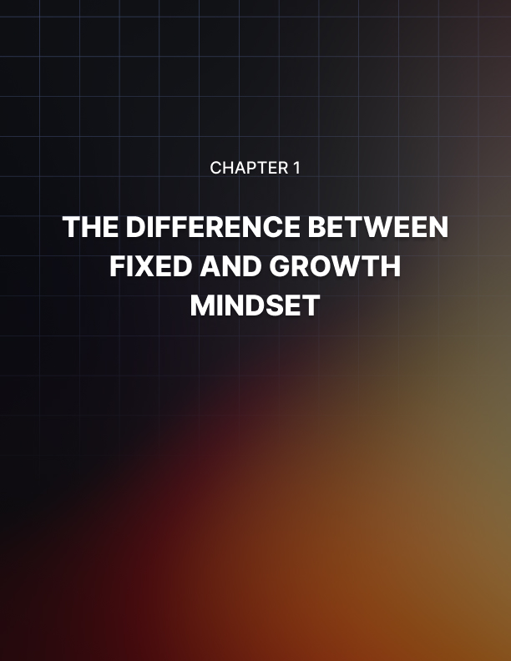

Chapter 1: The Difference Between Fixed and Growth Mindsets

At the core of our beliefs lie the blueprint for how we navigate the world, make choices, and respond to challenges. Imagine a spectrum that ranges from a rigid, fixed perspective to an open, adaptable one. This forms the basis of the two mindsets that shape our lives: the fixed mindset and the growth mindset.

This chapter will help you understand the fundamental differences between these mindsets and explore how they impact every facet of our existence. So let’s dive right in and talk more about fixed and growth mindsets and which components comprise each one.

Understanding the Two Mindsets
The fixed mindset and the growth mindset are not mere labels but rather lenses through which we perceive ourselves and the world. Individuals with a fixed mindset tend to believe that their abilities and intelligence are static traits. They perceive themselves as having a certain amount of talent, which they must protect and prove to others.

This mindset often leads to fear of failure, a reluctance to take risks, and a tendency to avoid challenges that might expose their perceived shortcomings. Conversely, the growth mindset is characterized by the belief that abilities and intelligence can be developed through effort, learning, and perseverance.

Those with a growth mindset see challenges as opportunities for growth, setbacks as stepping stones to success, and effort as the path to mastery. This mindset fosters resilience, a love for learning, and a willingness to embrace these setbacks as part of the journey toward improvement.

Recognizing the Impact of Each Mindset on Your Life
The mindsets we adopt are not inconsequential. They have a profound influence on our thoughts, behaviors, and outcomes. Let’s consider the two individuals in this following example:

Alex and Taylor are facing the same challenge. They are also learning a new skill. Alex possesses a fixed mindset, in which they approach the situation with anxiety. Meanwhile, they are worried that their initial struggles will indicate a lack of natural talent.

This can lead to them giving up prematurely, afraid that one setback would expose their inadequacy.

On the other hand, Taylor possesses a growth mindset. They would view the challenge as an exciting opportunity to learn and improve. While they accept that the difficulties that lie ahead exist, Taylor seeks guidance and practices diligently until mastery is achieved.

As you can see, the impact of these mindsets extend beyond skill acquisition. In academics, relationships, and personal development, mindsets play a pivotal role. Someone with a fixed mindset might avoid pursuing new subjects or career paths because they fear not being naturally adept.

In relationships, they might avoid difficult conversations to prevent admitting they’re wrong. In contrast, a person with a growth mindset would relish the chance to learn new subjects, would value feedback in relationships, and would approach challenges as learning experiences.

Nurturing a Growth Mindset
The exciting news is that mindsets are not fixed traits determined at birth. They can be nurtured and transformed over time. Recognizing the mindset you are currently old is the first step toward cultivating a growth mindset.

It’s crucial to listen to your inner dialogue, notice when you doubt your abilities, and challenge those thoughts by reminding yourself that growth is possible through effort and learning.

To shift toward a growth mindset, consider the following strategies:

- Embrace Challenges: Instead of shying away from challenges, welcome them as opportunities to learn and improve. Each challenge you overcome contributes to your growth.

- View Effort as a Path to Mastery: Effort is not a sign of inadequacy. It is a stepping stone to mastery. Celebrate your commitment to improvement, even when faced with setbacks.
- Learn from Criticism: Instead of feeling threatened by criticism, see it as valuable feedback that can guide your development. Constructive criticism helps you refine your skills and knowledge.

- Celebrate Others’ Successes: A growth mindset involves being genuinely happy for others’ achievements. Their success doesn’t diminish your potential ; it inspires you to reach new heights.

- Embrace Setbacks: Failure is not an endpoint but a stepping stone. Analyze setbacks, extract lessons, and use them to propel yourself forward.

By actively adopting these strategies and consistently challenging the beliefs that hold you back, you can gradually shift from a fixed mindset to a growth mindset. Remember, this transformation takes time and effort. But the rewards are immeasurable.

Final Thoughts
As you embark on this journey of self-discovery and empowerment, you’ll find yourself approaching challenges with newfound courage, embracing failures as stepping stones, and unlocking your boundless potential for growth.

Throughout the rest of the book, you’ll be learning the science behind the growth mindset. All while you explore the brain’s remarkable ability to change and adapt. We will provide you with the practical tools that will allow you to embrace challenges while cultivating a positive mindset.

You can achieve personal and professional success beyond your own beliefs and limits. It’s important to break free from the limitations while being able to live your best life. The best way to get there is with a growth mindset.

It’s time for you to ditch the fixed mindset for good. It’s time to say goodbye to not being able to move around as much. You’re about to enter wide open spaces with just one open door. Don’t trap yourself into a growth mindset any longer. Turn to the next page to see what’s next on your journey.
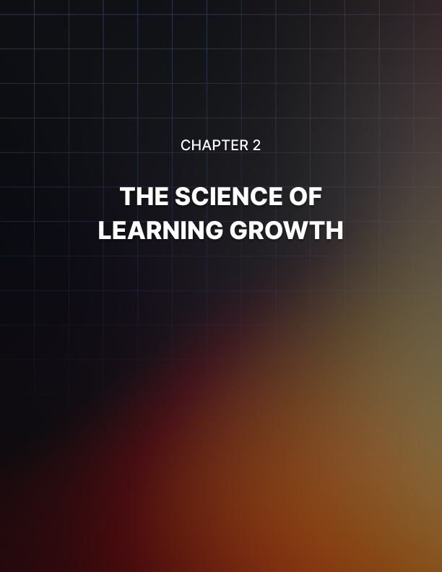

Chapter 2: The Science of Learning and Growth

In the vast landscape of personal development, few concepts are as exhilarating as the notion that our brains possess the remarkable ability to change and adapt throughout our lives. In this chapter, you’re going to learn about neuroplasticity - which is a concept that underpins the growth mindset.

You will learn about the inner workings of the brain and how it substantiates our capacity for learning, growth, and transformation. If you’re ever wondering about the science behind how people create a positive growth mindset, you’re about to
learn something cool in this chapter.

Without further ado, let’s dive right in and get started.

Understanding the Brain’s Ability to Change and Adapt
For centuries, it was widely believed that the brain’s structure and functions remained fixed after a certain age. However, modern neuroscience has unveiled a groundbreaking truth: the brain is not a static entity. But rather it is an ever-evolving organ capable of restructuring itself in response to experiences, learning, and environmental changes.

Thus, we look at the phenomenon known as neuroplasticity. Imagine your brain as a vast network of pathways and connections. It’s like a bustling city with plenty of intricate roads and bridges.

Whenever you learn something new, these neural pathways are formed or strengthened. Similarly, when you neglect your certain skills or knowledge, these connections can weaken over time.

Neuroplasticity, therefore, forms the very basis of our ability to adapt, learn, and grow.

Learning About Neuroplasticity and Its Implications for Growth
Neuroplasticity defies the conventional notion that our brains have a fixed capacity for growth. It’s a dynamic process that occurs at various levels - ranging from microscopic changes in individual neurons to macroscopic shifts in brain regions. Understanding neuroplasticity is crucial because it shatters the boundaries that we might have placed on our potential for growth.

Consider this following example:

A pianist is striving to master a complex musical piece. Initially, the brain might struggle to coordinate the precise movements required to play the piece flawlessly. However, with consistent practice, new neural connections are formed.
Over time, these connections strengthen, leading to improved coordination and fluency. This process exemplifies neuroplasticity in action - the brain adapting to new challenges and optimizing its functions.

As you can see, complex challenges can seem intimidating to the brain at first. Especially when there seems to be little or no room for potential error. The reality is consistent practice can allow you to make those errors so you can learn from them so you can execute the tasks in the best way possible.

Your neural connections will be stronger than ever before. What appeared to be a challenge from the start will seem like second nature later on. It will be to you “easy as pie”.

Embracing the Potential for Lifelong Learning
One of the most empowering aspects of neuroplasticity is its support of lifelong learning. As we age, our brains retain the capacity to learn new skills, absorb knowledge, and adapt to changing circumstances. This contradicts the age-old adage that you can’t teach an old dog new tricks.

In reality, our brains remain malleable throughout our lives, awaiting the stimulus of new experiences and challenges. By embracing the potential of neuroplasticity, you’re not limited by your age or current abilities. Whether you’re picking up a musical instrument in your retirement years, learning a new language, or mastering a technical skill, your brain is primed to forge new neural connections. The key lies in consistent practice, focused attention, and a willingness to step out of your comfort zone. Being able to do this will set you a head about shoulders over others that choose to stay stuck in a fixed mindset.

Cultivating Neuroplasticity Through the Growth Mindset
Neuroplasticity and the growth mindset share a symbiotic relationship. The growth mindset propels you to engage in activities that stimulate neuroplasticity. When you approach challenges with a growth mindset, you’re essentially encouraging your brain to forge new pathways and optimize existing ones.

This synergy creates a powerful loop of continuous improvements. Thus, your mindset fuels neuroplasticity. And neuroplasticity itself reinforces your growth mindset.

For example, let’s say someone is transitioning into a new career. With a growth mindset, they perceive the challenges of acquiring new skills and knowledge as opportunities for growth. As they persistently engage in learning and skill development, their brain’s neural pathways adapt, becoming more efficient at processing new information.

His adaptive process is neuroplasticity at work, aligning with the individual’s growth-oriented mindset. Furthermore, it is important to remember that you can be able to take advantage of this scientific wonder just by making a vital decision to better yourself.

As you immerse yourself into the world of neuroplasticity, you’ll recognize that your brain is not a fixed entity. Instead it’s a dynamic masterpiece that responds to your actions, thoughts, and intentions.

Final Thoughts
By embracing a growth mindset, you’re actively harnessing the potential of neuroplasticity to transform your life. Each time you approach a new challenge, learn a new skill, or strive for personal growth, your brain undergoes remarkable changes. It also solidifies the foundation for your journey toward a more fulfilling and enriched existence.

Now that you know about the science behind a growth mindset, we have to ask - is that impressive or what? You can have the science of neuroplasticity working for you, not against. This is only the beginning of something better - so continue on to the next chapter where we talk about the challenges and obstacles that lay ahead with your goals.


Chapter 3: Embracing Challenges and Overcoming Obstacles

Life is filled with challenges and triumphs. How we approach the challenges can define our journey toward growth and success.

This chapter will discuss the heart of resilience, persistence, and the transformative power of embracing challenges.

You’re about to learn how you can navigate through the landscapes of adversity. Along the way, you’ll acquire plenty of tools and the proper mindset to overcome these obstacles. All while you can be able to flourish in the abundance of rewards you can get out of the entire deal.

With that said, let’s get started with everything you need to know about challenges and obstacles.

Learning to Approach Challenges with a Growth Mindset
In the realm of personal development, challenges are not roadblocks but pathways to progress. They present opportunities for learning, adaptation, and growth. However, the manner in which we approach challenges determines whether they hinder or propel us forward.

With a growth mindset as our compass, we’re equipped to embrace challenges as vehicles for self-improvement. Without that ability, we’ll be stuck in an endless but vicious cycle of stagnation.

Imagine a student facing a complex math problem. A fixed mindset might lead them to believe that their initial struggle reflects their inability to comprehend the subject. This perception could trigger feelings of frustration, anxiety, and even avoidance.

On the other hand, a growth mindset would encourage the student to see the problem as a puzzle waiting to be solved. Each attempt, even if it results in a setback, is a step toward understanding. This perspective fosters resilience, tenacity, and a sense of empowerment.

That’s why rather than say that “it’s too hard”, you can say “yes, this is challenging. But I’ll take the necessary steps possible to solve it.”

Think about that for a minute. A growth mindset accepts the challenge knowing there is a way to conquer it. Meanwhile, the fixed mindset will worry about it being too challenging without putting much effort into solving it.

Developing Resilience and Persistence
Resilience is the art of bouncing back from setbacks with renewed determination. It’s the quality that enables individuals to weather the storms of life and emerge stronger on the other side. Resilience isn’t an innate trait - but a skill that can be cultivated and honed through practice.

The growth mindset forms the foundation of resilience. When we believe that effort and learning lead to improvement, we’re more likely to persist through these challenges. Each setback becomes an opportunity to learn, adapt, and refine our strategies.

By viewing setbacks as stepping stones rather than as indicators of inadequacy, we navigate challenges with a sense of purpose, knowing that growth is on the horizon.

The Path of Persistence
Persistence is the unwavering commitment to achieving our goals, even when faced with adversity. It’s the trait that propels us forward when obstacles appear insurmountable. With a growth mindset, persistence becomes a natural companion, fueled by their belief that every effort contributes to progress.

Let’s take a look at this one example from the lens of an entrepreneur. They’re launching a new business. Of course, they will encounter various obstacles.

They include financial constraints, market fluctuations, and unforeseen challenges. A fixed mindset might lead them to question their abilities and give in to doubt. In contrast, a growth mindset encourages the entrepreneur to see these obstacles as opportunities for learning and adaptation.
With each setback, they pivot, innovate, and refine their strategies. They know that the journey towards success is marked by resilience and persistence.

Cultivate a Growth-Oriented Approach to Challenges
Cultivating a growth-oriented approach to challenges involves a deliberate shift in perspective. Instead of avoiding challenges or fearing setbacks, you step forward with the belief that challenges are gateways to growth. This shift requires self-awareness and a commitment to your internal dialogue.

With that in mind, let’s take a look at the five tips you can take to heart while cultivating a growth-oriented approach to challenges:

- Embrace Discomfort: Challenges often push us out of our comfort zones. Embrace the discomfort, knowing that growth occurs when you challenge the boundaries of what you know.

- See Failure as Feedback: Failure is not an end but a valuable piece of feedback. Analyze what went wrong, learn from it, and use it to refine your approach.

- Focus on the Process: Instead of fixating solely on the outcome, focus on the journey. Every step you take, even if it’s a small one, will contribute to your growth.

- Seek Support and Learning: Challenges are opportunities to seek guidance, learn new skills, and expand your knowledge. Don’t hesitate to ask for help or invest in your development.

- Celebrate Effort and Progress: Shift your focus from solely celebrating final achievements to celebrating your efforts, persistence, and progress along the way. Again, small or large wins - you can still celebrate.

Final Thoughts
As you navigate through the challenges, remember that your mindset is the guiding light. With a growth mindset as your foundation, challenges become the gateways to growth rather than barriers to success. The journey of embracing challenges and overcoming obstacles is not always easy, but it’s the very essence of personal development. Each challenge you conquer and every setback you navigate will contribute to the story of your growth and resilience.

Challenges exist for a reason. And so do obstacles. Anyone who tells you they have been successful without them will clearly be lying to you.
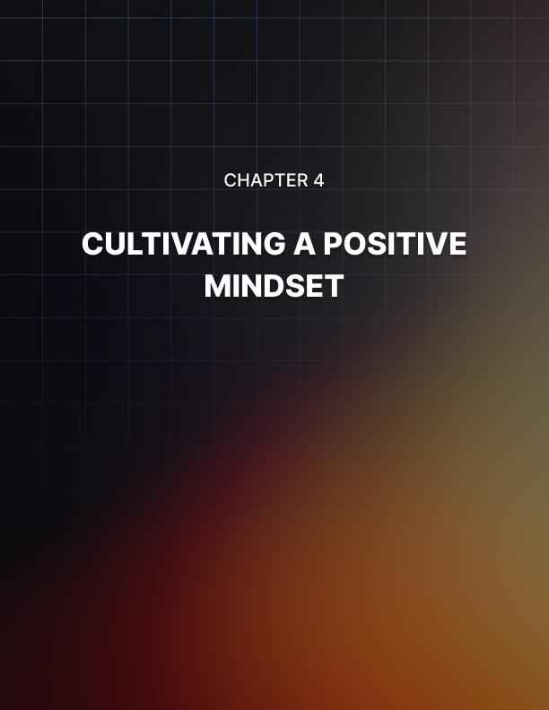

Chapter 4: Cultivating a Positive Mindset

The mind is a powerful tool that shapes our perceptions, attitudes, and responses to the world around us. You’ll learn how to cultivate a positive mindset in this chapter. You’ll be able to amplify the transformative effects of the growth mindset that you are developing.

We’ll discuss the science, psychology, and practical strategies that will help contribute to a positive outlook. It will foster an environment conducive to growth and personal development. We’re about halfway home - but we still have plenty of ground to cover in this guide.

Ready to move forward? Here we go.

The Power of Positive Thinking
The idea that our thoughts influence our reality is not merely philosophical. It’s backed by scientific research. Positive thinking isn’t about denying challenges or adopting an unrealistic outlook.

It’s about approaching situations with optimism, resilience, and a proactive attitude. Positivity enables us to perceive opportunities amidst difficulties and encourages us to seek solutions rather than dwelling on problems.

Think about the setbacks you’ve experienced in your personal or professional life. A fixed mindset might lead to negative self-talk, convincing you that you’re incapable of overcoming the obstacle. This negativity can hinder your motivation and creativity.

In contrast, a positive mindset empowers you to view the setback as a temporary challenge, motivating you to seek solutions and learn from experience. That’s why you’ll want to once again view setbacks as what they are.

People may say that setbacks (or in their term “failure”) are final. As in there are no second chances. This is not the case no matter how much you hear about it from other people.

It’s important that you take a step back whenever you sense a negative thought or feeling popping up. Be mindful of them as you are trying to stay the course of positive thinking. You’ll want to flip the script.

For example, instead of saying “I’m not good enough”, you can flip it into “I’m not really good at this. But with practice, I can get better.”

See the difference? In fact, flipping the script on negativity will be commonplace as you continue your journey of building a positive mindset.

The Psychological Benefits of Positivity
The benefits of a positive mindset extend beyond momentary shifts in attitude. Numerous studies in psychology and neuroscience highlight the profound impact of positivity on our well-being, resilience, and cognitive functions. A positive mindset is linked to reduced stress, improved immune function, and enhanced emotional regulation.

When we cultivate a positive mindset, we experience greater emotional balance. We’re better equipped to manage stressors, navigate setbacks, and maintain a sense of equanimity. This emotional resilience stems from our ability to reframe challenges as learning opportunities and setbacks as stepping stones toward growth.

Developing a Positive Mindset to Foster Growth
Cultivating a positive mindset involves adopting habits and practices that reshape our thought patterns over time. It’s not a mere exercise in wishful thinking. It’s a conscious effort to train our minds to perceive the world with greater optimism and open-mindness.

Let’s take a look now at the following five tips that will help you on
this path towards growth:

- Practice Gratitude: Regularly reflecting on what you’re grateful for shifts your focus from what’s lacking to what’s abundant in your life. This practice nurtures positivity and enhances your overall outlook.

- Challenge Negative Thoughts: When negative thoughts arise, challenge them with evidence of positive experiences or counterarguments. Over time, this practice helps rewire your brain to default positive interpretations.

- Surround Yourself with Positivity: Your environment influences your mindset. Surround yourself with uplifting people, read inspirational literature, and engage in activities that bring you joy.

- Visualize Success: Visualization is a powerful tool that primes your mind for success. Imagine yourself overcoming challenges and achieving your goal in vivid detail.

- Practice Self-Compassion: Treat yourself with kindness and understanding, just as you would a close friend. Self- compassion fosters a positive self-image and resilience in the face of setbacks.

Final Thoughts
As you embark on the path of cultivating a positive mindset, remember that your thoughts are not passive observers but active architects of your reality. With each positive thought, you’re creating a ripple effect that influences your emotions, behaviors, and outcomes. The journey of embracing positivity is not a one-time endeavor.

It’s a lifelong commitment to fostering an environment of growth and well-being. Positivity is one of the pillars that will strengthen and support a growth mindset. The stronger it is, the better your growth mindset will hold up over the course of time.
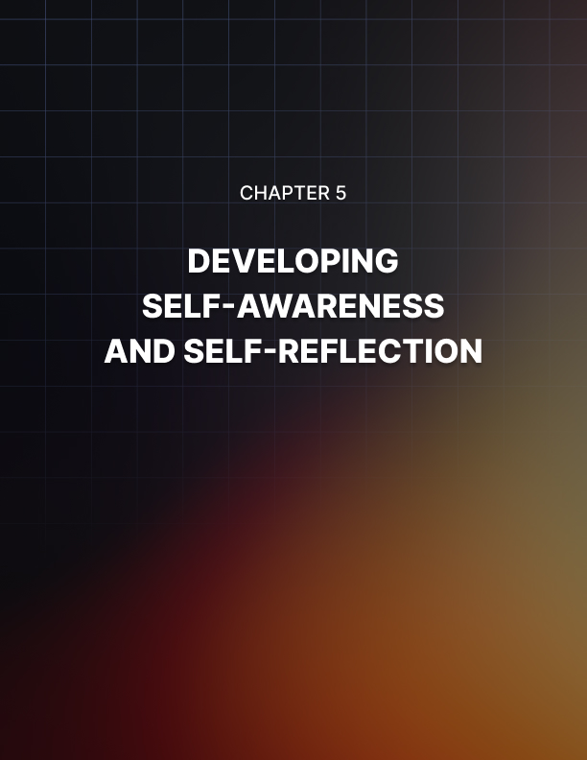

Chapter 5: Developing Self-Awareness and Self-Reflection

The world is filled with distractions and noise. Being able to turn inward to understand oneself deeply while living in it becomes a precious skill. The realm of self-awareness and self-reflection is where the journey toward personal growth begins.

Further, you will be exploring your own inner landscape. This chapter will discuss how you can get to know yourself. You’ll also learn the benefits of self-reflection, and practical strategies to cultivate self-awareness as a cornerstone of the growth mindset.

It’s always a good idea to make sure you know your true self. When you do this, it will be easier for you to develop the growth mindset you can achieve. Let’s dive further into this chapter now.

Understanding Yourself and Your Goals
Imagine embarking on a cross-country journey without a map or a destination in mind. Similarly, navigating life without a clear understanding of your values, strengths, weaknesses, and aspirations can lead to aimlessness and unfulfillment. Self- awareness is the compass that guides you through this journey, helping you make informed decisions aligned with your authentic self.

Through introspection and self-exploration, you unearth your core values - the principles that define what matters most to you.

These values act as beacons, illuminating your path and aiding you in making choices that resonate with your true essence.

Additionally, self-awareness enables you to identify your strengths, fostering a sense of confidence and empowerment as you leverage them to overcome challenges.

The Role of Self-Reflection in Personal Growth
Self-reflection is the process of examining your thoughts, emotions, and experiences to gain insight into your motivations and behaviors. It’s a journey of self-discovery that uncovers patterns, beliefs, and perspectives that might have been hidden in the depths of your mind. Through self-reflection, you gain a clearer understanding of why you think, feel, and act the way you do.

Think back to a day when you reacted strongly to a certain situation. Self-reflection invites you to pause and ask yourself why you responded the way you did. Was it triggered by a past experience?

Was it aligned with your values? This inquiry leads to self- awareness, allowing you to make conscious choices rather than reacting on autopilot. By regularly engaging in self-reflection, you develop the ability to navigate challenges with intention and authenticity.

Practical Strategies for Developing Self-Awareness
Cultivating self-awareness requires intentional effort and consistent practice. Here are practical strategies to help you embark on this transformative journey:

- Journaling: Dedicate time to write down your thoughts, emotions, and experiences. Regular journaling offers a window into your inner world, allowing you to identify patterns and insights.

- Mindfulness and Meditation: Engage in mindfulness practices that encourage present-moment awareness. Meditation helps quiet the mind, creating space for self-reflection and introspection.

- Seek Feedback: Encourage honest feedback from friends, family, and colleagues. External perspectives can provide valuable insights into your strengths, blind spots, and areas for growth.

- Ask Meaningful Questions: Pose open-ended questions to yourself, such as “what truly brings me joy?” or “What values guide my decisions?” Delve into these inquiries to uncover deeper layers of self-awareness.

- Practice Active Listening: When engaged in conversations, listen attentively to others. Reflect on their words and consider how they resonate with your own thoughts and feelings.

The Symbiosis of Self-Awareness and the Growth Mindset
Self-awareness and the growth mindset form a symbiotic relationship, each enhancing the effects of others. When you’re self-aware, you’re attuned to your thought patterns and beliefs, enabling you to identify when a fixed mindset is influencing your perception. This awareness empowers you to challenge these limiting beliefs and adopt a growth-oriented perspective.

Conversely, the growth mindset fuels self-awareness by fostering curiosity about your own potential. When you approach challenges with a growth mindset, you naturally seek opportunities for self-improvement and self-discovery. This proactive attitude drives you to engage in self-reflection to understand how you can overcome obstacles and achieve your goals.

Final Thoughts
As you embark on the journey of developing self-awareness and practicing self-reflection, remember that this path is not about judgment or criticism. It’s a journey of self-acceptance, curiosity, and growth. By exploring your inner landscape, you equip yourself with the insights necessary to navigate challenges, make meaningful choices, and align your actions with your authentic self.


Chapter 6: Setting Goals and Taking Action

Goals are the compass points that guide us toward our desired destinations. They provide purpose, direction, and a sense of accomplishment on our journey toward growth. The following chapter will discuss the art of setting meaningful goals and the strategic actions required to bring them to fruition.

You will learn how to harness the power of intention, planning, and perseverance as you explore how goal setting aligns seamlessly with the growth mindset. Soon, setting goals and taking action will be a lot easier than you think. Let’s get started with the following down below.

Setting Meaningful and Achievable Goals
The process of goal setting is more than scribbling a wish list. It’s about crafting a roadmap that leads you from where you are to where you want to be. A growth mindset aligns perfectly with this process as it encourages you to believe in your ability to learn, adapt, and achieve new heights.

When setting goals, ensure that they are specific, measurable, achievable, relevant, and time-bound (or SMART). Specific goals provide clarity, measurable goals allow you to track progress, achievable goals ensure feasibility, relevant goals align with your values, and time-bound goals create a sense of urgency.

Each element of the SMART framework integrates seamlessly with the growth mindset, reinforcing the belief that with effort and learning, you can achieve your aspirations.

Developing Strategies for Achieving Your Goals
Setting goals is the first step. Taking strategic action is where the magic happens. A growth mindset infuses your actions with purpose and resilience, propelling you forward even in the face of challenges. Here’s a step-by-step guide to help you develop strategies for achieving your goals:
- Break Down Goals: Divide larger goals into smaller, manageable steps. This approach not only prevents overwhelm but also allows you to track progress more effectively. The smaller you can be able to break them down, the better.

- Prioritize and Plan: Identify which steps are most critical and prioritize them. Create a plan that outlines the actions you need to take and the timeline for each step. It’s important to make sure that you perform the most critical and time- sensitive tasks first before moving onto the other task.

- Stay Adaptable: The path to achieving goals is rarely linear. Embrace flexibility and be prepared to adjust your strategies as circumstances evolve. Yes, things can happen and you’ll have no control over them. Therefore, if there are changes that occur, being adaptable will give you the chance to make quick decisions on the fly. Even when you are dealing with unexpected setbacks, adaptability will allow you the opportunity to make changes within your control.

- Celebrate Small Wins: Acknowledge and celebrate your progress along the way. Small victories provide motivation and momentum to keep moving forward. Over time, these will snowball into the bigger picture. It’s always a good idea to celebrate these wins no matter what. It will give you the motivation and the confidence to keep going forward.

- Learn from Setbacks: Challenges are an inherent part of any journey. When setbacks occur, approach them as learning opportunities and adjust your strategies accordingly.

The Growth Mindset in Action: Goal Achievement
Imagine an aspiring writer aiming to complete their first novel. With a fixed mindset, they might doubt their ability to produce a compelling story. Self-doubt could lead to procrastination and avoidance.

On the other hand, a growth mindset propels them to approach the challenge with determination. They recognize that writing skills can be developed through practice and learning. They set a SMART goal to write a certain number of words each day, seek feedback, and revise their work based on constructive criticism.

Through persistence and a growth-oriented approach, they achieve their goal of completing a novel. The growth mindset infuses every step of this journey with intention, purpose, and the belief that the effort and learning lead to improvement.

Final Thoughts
Setting and achieving goals is a testament to the transformative power of a growth mindset. When you combine a belief in your ability to learn and adapt with intentional planning and strategic action, you’re well-equipped to conquer challenges and realize your aspirations.

Be sure to adapt to changes, celebrate the small wins, and use setbacks as a learning tool. Do these and you will ensure the best success possible for every goal you set out to do.


Chapter 7: Learning from Failure and Mistakes

In a world often fixated on success and achievement, the concept of failure can evoke discomfort and fear. However, within the realm of the growth mindset, failure is not a verdict but a vital component of the journey toward personal development. The following chapter will explore the power of embracing failure and mistakes as opportunities for learning growth, and resilience.

Keep in mind that not all setbacks should be labeled failures. A failure happens when you voluntarily give up on something. That can be a setback of itself, even if you decide to do something different that will take you to the ultimate goal that you want to achieve.

With that said, let’s take a deeper look now at failures and mistakes. Here we go.

Understanding the Importance of Failure
Failure is not the opposite of success. It is a stepping stone toward it. The growth mindset reframes failure from an endpoint to a pivot point. It’s an acknowledgement that setbacks, mistakes, and challenges are integral parts of the journey toward improvement. Without failure, there can be no growth, since growth involves pushing the boundaries of what we know and discovering the unknown.

Think about the process of learning to ride a bicycle. As a child, you likely experienced falls and missteps before achieving balance and mastery. Each stumble was not a sign of inadequacy but a necessary part of the learning process.

Similarly, in all areas of life, failure is a natural part of the journey toward mastery. Keep in mind that setbacks and failures will not mean the end of the world. That’s what a fixed mindset wants you to think.

When in reality, you can sit back, zoom out and figure out how it all happened in the first place. This way, you can try and be able to avoid such setbacks and failures in the future.

Learning from Failure: The Growth Mindset Approach
A fixed mindset often interprets failure as a reflection of inherent inadequacy. This perspective can lead to avoidance, fear of taking risks, and a reluctance to step out of the comfort zone. In contrast, the growth mindset embraces failure as a springboard for growth.

It views failure as an opportunity to learn, adapt, and refine strategies. When you experience failure, approach it with curiosity rather than judgment. Reflect on what went wrong, identify areas for improvement, and consider how you can apply these insights to future endeavors.

This growth-oriented approach transforms failure into a powerful teacher, guiding you toward greater resilience, creativity, and adaptability.

Embracing a Positive Attitude Toward Mistakes
Mistakes are the footprints of progress, evidence that you’re stepping beyond your known limits. A growth mindset cultivates a positive attitude toward mistakes, recognizing that they are not indicative of your worth but indicative of your willingness to explore uncharted territories.

The next time you make a mistake, observe your inner dialogue. A fixed mindset might lead to self-blame and self-criticism. A growth mindset, however, encourages you to reframe the situation. Instead of saying “I failed,” say, “I learned.” This simple shift acknowledges the value of the experience and positions you for greater growth.

Final Thoughts
As you traverse the landscape of failure and mistakes, remember that each stumble is a stepping stone. The growth mindset reframes setbacks as opportunities to learn, adapt, and thrive. By embracing failure with a growth-oriented perspective, you’re not just building resilience, you’re building a foundation for success that’s grounded in experience, knowledge, and a deep understanding of yourself. Remember, if you can’t fail or make mistakes - you won’t grow nor learn anything valuable.
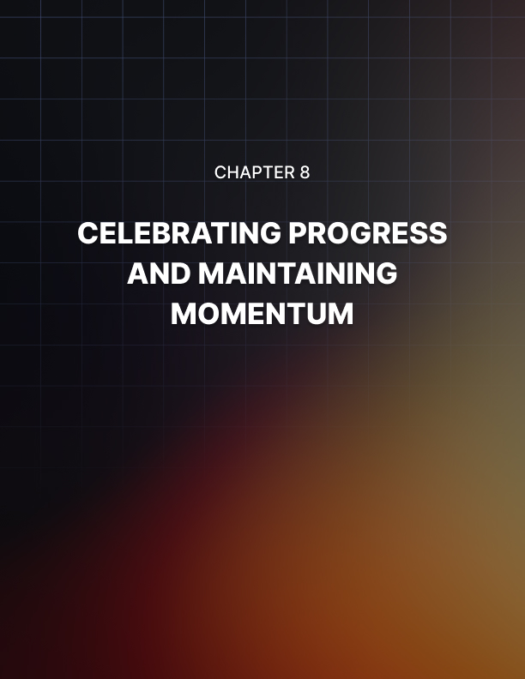

Chapter 8: Celebrating Progress and Maintaining Momentum

Celebrating progress is part of personal growth. And there is no doubt that whether it’s a small movement or a large one, it’s always a good idea to take a moment and be happy for it. This chapter is a testament to the importance of acknowledging your accomplishments, no matter how small, and maintaining the momentum that propels you toward continued growth.

We will explore how the art of celebration is excellent for your achievements while being able to fuel your journey forward.

We’re just getting down to the last chapter - so let’s celebrate this achievement by learning more about…well, you know…celebrating.

The Importance of Celebrating Successes
Celebrating success is not just a moment of fleeting joy. It’s a powerful tool for reinforcing positive behaviors, boosting motivation, and nurturing a growth mindset. While the journey toward your ultimate goals might be long, the path is marked by milestones - moments when you achieve a desired outcome, overcome a challenge, or demonstrate growth.

Acknowledging and celebrating these milestones creates a positive feedback loop. Your brain releases dopamine, a neurotransmitter associated with pleasure, when you achieve a goal. By intentionally celebrating, you’re amplifying this rewarding sensation, making it more likely that you’ll continue pursuing your goal with enthusiasm and dedication.

Cultivating a Culture of Celebration
Creating a culture of celebration in your life involves shifting your focus from what’s yet to be achieved to what you’ve already accomplished. This shift in perspective doesn’t diminish the importance of your long-term goals. Rather, it infuses your journey with positivity and gratitude.
You’ll want to consider the idea of implementing these strategies to cultivate a culture of celebration. Let’s take a look at what they are:

- Set Milestones: Break your larger goals into smaller milestones. Each time you achieve a milestone, take a moment to recognize and celebrate the progress you’ve made.

- Reflect on Progress: Regularly review your journey and reflect on the progress you’ve made. This reflection fosters a sense of accomplishment and motivates you to continue.

- Visual Reminders: Use visual cues, such as a vision board or a journal, to document and celebrate your achievements. Seeing your progress tangibly reinforces your growth mindset.

- Share Your Wins: Share your accomplishments with supportive friends, family, or mentors. Their enthusiasm and encouragement add to the joy of your achievements.

Maintaining Momentum for Continued Growth
While celebrating progress is vital, maintaining momentum is equally important. It’s the force that propels you toward your goals, even when challenges arise. The growth mindset fuels momentum by instilling in you a belief in your ability to learn, adapt, and overcome obstacles.

As you celebrate your achievements, remember that your journey doesn’t end with a single success. Each milestone is a stepping stone toward greater accomplishments. Here’s what you need to do to maintain momentum:

- Set New Goals: Once you achieve a milestone, set new goals that build upon your success. This progression keeps your journey dynamic and exciting.

- Learn from Setbacks: When setbacks occur, view them as opportunities to learn and adapt. Use failures as stepping stones rather than barriers.

- Practice Consistency: Consistency is the foundation of momentum. Consistently engage in actions aligned with your goals to maintain your progress.

- Review and Adjust: Regularly review your goals, strategies, and progress. Adjust your approach as needed to ensure you’re staying on track.

Final Thoughts
As you celebrate progress and maintain momentum, remember that your journey of personal growth is not a static destination but an unfolding symphony of experiences, achievements, and growth. The growth mindset serves as the conductor, guiding you through the harmonious interplay of celebration and perseverance.


Conclusion

As we draw the final curtain on this journey through the landscape of the growth mindset, we find ourselves standing at the threshold of a profound transformation. The path we’ve traversed has brought to light all the ideas of embracing challenges, cultivating resilience, and fostering a mindset that nurtures personal growth and fulfillment.

As we conclude this book, we’ll recap the entire journey that you have just traveled. So let’s finish this up so you can get started with continuing to grow a mindset that is for the better.

A Recap of Our Journey
From understanding the difference between fixed and growth mindsets to exploring the science of learning, from embracing challenges to developing a positive mindset, from cultivating self- awareness to setting meaningful goals, and from learning from failure to celebrating progress - each chapter of this book has been a step on the transformative journey toward breaking free from limiting beliefs and embracing the limitless potential of the growth mindset.

We’ve discovered that a growth mindset is not just a philosophy but a way of life. It’s a perspective that shapes our thoughts, actions, and reactions. It’s a lens through which we perceive challenges as opportunities, setbacks as stepping stones, and failures, as lessons.

It is the compass that guides us toward continuous improvement, resilience, and the pursuit of our highest aspirations.

Embracing the Essence of the Growth Mindset
At its core, the growth mindset encapsulates the belief in human potential - the idea that we are not bound by fixed capabilities but are instead empowered to learn, adapt, and evolve. It’s the recognition that effort, learning, and perseverance are the keys to progress.

The growth mindset invites us to shed the shackles of self- imposed limitations and step into a realm where possibilities know no bounds.

The important thing to remember is that you’ll need to continue practicing the key principles of maintaining a growth mindset. To recap, let’s go over what you’ll need to do on a regular basis:

- Embrace challenges: Rather fearing challenges, embrace them as an opportunity for growth. Approach difficulties with curiosity and a belief that you can learn from every experience.

- Cultivate Resilience: Develop the ability to bounce back from setbacks with renewed determination. Resilience is not an absence of struggle but the capacity to navigate it with strength and adaptability.

- Nurture curiosity: Cultivate a sense of curiosity that drives you to explore new ideas, skills, and experiences. A growth mindset thrives on a hunger for knowledge and an openness to learning.

- Learn failure: Embrace failure as a teacher, not as an end. Analyze mistakes, learn from them, and use them as stepping stones toward improvement.

- Celebrate Progress: Acknowledge and celebrate your achievements, no matter how small. Each milestone is a testament to your growth and dedication.

- Maintain Momentum: Stay committed to your journey of growth by setting new goals, learning from setbacks, and consistently taking action.

The Ongoing Adventure of Growth Continues
As you close this chapter, remember that your journey of growth is far from over. It’s an ongoing adventure, a canvas waiting to be painted with your unique experiences, triumphs, and growth. The growth mindset you’ve cultivated will be your guiding star, illuminating the path to living a life rich with purpose, fulfillment, and continuous progress.

May you embrace challenges with courage, view failures with curiosity, and celebrate successes with gratitude. We hope this book has been helpful as you build and maintain a growth mindset going forward.

If you have any questions, comments, or concerns regarding the book - do feel free to reach out to us. All the best in your journey.

