Disclaimer

This ebook has been written for information purposes only. Every effort has been made to make this ebook as complete and accurate as possible. However, there may be mistakes in typography or content. Also, this ebook provides information only up to the publishing date. Therefore, this ebook should be used as a guide - not as the ultimate source.

The purpose of this ebook is to educate. The author and the publisher do not warrant that the information contained in this ebook is fully complete and shall not be responsible for any errors or omissions. The author and publisher shall have neither liability nor responsibility to any person or entity with respect to any loss or damage caused or alleged to be caused directly or indirectly by this ebook
Table of Contents

Chapter 1: Who Should Be a Leader? 6
Leadership is a Life Skill 6
Leadership is a Superpower 6
Leadership Outside of Work Environments 7
Chapter 2: What Makes a Good Leader? 9
Chapter 3: Communication Skills 12
How to Give Instructions Without Sounding Demanding 12
Explain the Why 13
Chapter 4: How to Command Respect and Speak So Others Will Listen 16
Speak So Others Will Listen 17
Chapter 5: The Crucial Importance of Emotional Intelligence 21
What is EQ? 22
Tools 24
For Parents 25
In a Crisis 25
Chapter 6: Why It’s Important to Know Your Team 27
Be Genuinely Interested in Knowing Your Team 27
Putting Your Team Together 28
Chapter 7: Getting the Most Out of Your Team 31
Motivating Your Team 31
Protection 32
For Parents 33
Chapter 8: The Power of Ownership 35
Give Others Freedom To Work On What They Want 35
Don’t Force Someone To Do What They Don’t Enjoy 35
In a Crisis 36
For Parents 36
Chapter 9: How To Deal With Difficult Decisions 38
How To Stay Calm As a Leader 38
How to Handle Difficult Team Members 39
Chapter 10: Challenges for Modern Leaders 41

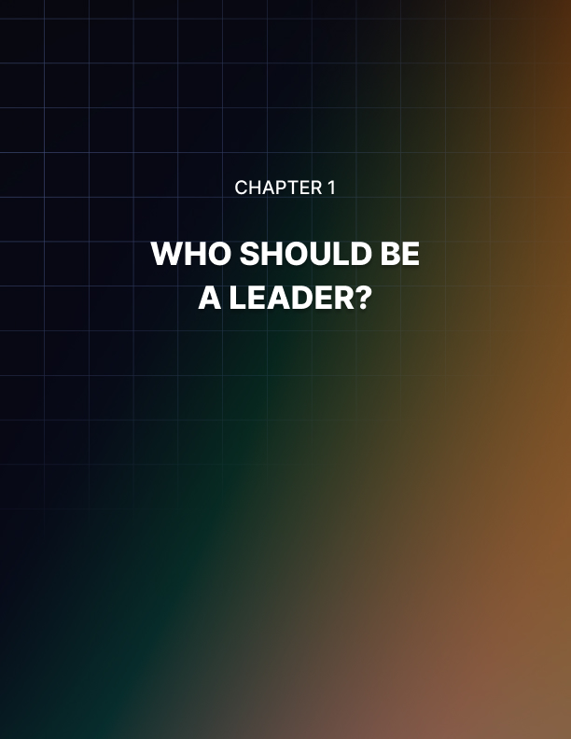

Chapter 1: Who Should Be a Leader?

Leadership is a topic that will typically interest businesses, managers, and CEOs. It is certainly very true that these are people who should try to understand what makes a good leader, and who can benefit from following leadership tips and advice.

In this book, we will be addressing the concept of leadership primarily from this angle. Most examples will pertain to leaders within organizations – whether those are charitable organizations, or whether they are massive corporations.

Leadership is a Life Skill
That said though, leadership is a life skill that should appeal to many more people than that!

That’s because leadership is something that we are all called upon to provide at some point. One of the most common examples given is the parent-as-leader. If you are a parent, then you are required to provide guidance, tutelage, mentorship, and discipline for your children.

There will be times when you must inspire your children to be the greatest versions of themselves. But there will also be times when you need to provide strict and stern instructions that could save their lives!

And of course, there will be battles when trying to send them to bed!

An influential leader will know how to listen and make the child feel heard, while at the same time giving them the space and the protection they need to grow.

Leadership is a Superpower
Then there is the leader who emerges in a crisis. In this situation, leadership is a superpower.

Imagine that you’re in a public space when suddenly the place collapses. You are trapped beneath the rubble and everyone is panicking, trampling one another. You need to work together in order to get help, and then to ration food and look after the injured.

In this situation, the person who rises to become the leader will be the person who is the most informed, and the person who is the most confident. If no one takes that mantle, then the situation could go south very quickly.

Being an influential leader is something that everyone should be capable of, so that they can rise to the occasion when it arises.

Leadership Outside of Work Environments
Finally, leadership is something that can make your social life and even your dating life that much more enjoyable. In every relationship and certainly every group dynamic, there is a power structure. Being the leader means being the one who gets to call the shots, who decides the activity, and who takes responsibility.

If you can be that person, then you’ll find it does wonders for every aspect of your career.

So while leadership largely pertains to businesses, this is something we all should strive to cultivate. That’s why throughout the book, we’ll also be looking at how lessons and examples apply to those that are not working within an organizational hierarchy.

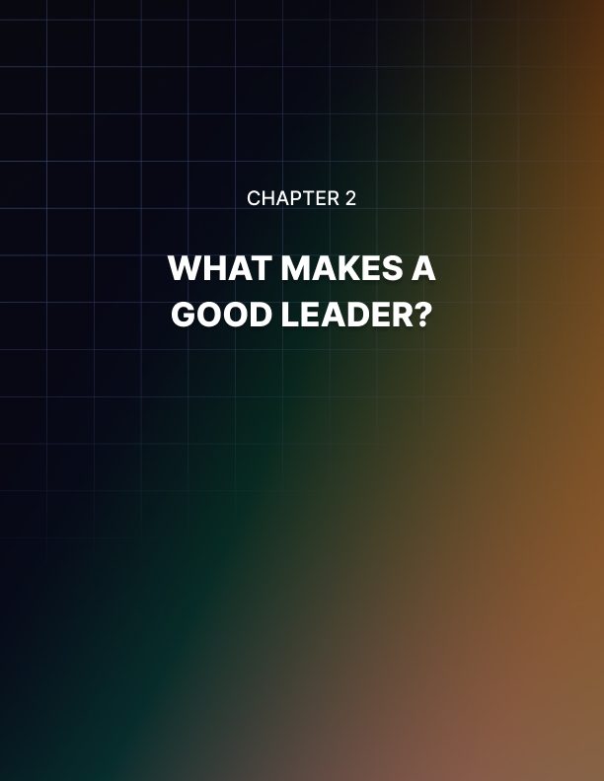

Chapter 2: What Makes a Good Leader?

Leadership is incredibly valuable then, but unfortunately, it is not simple and easy. In fact, to demonstrate just how challenging leadership can be, keep in mind that a lot of people – including those who are in leadership roles – actually have no idea how to be a leader!

We have an image of what leadership means, and we often think of it as being “in charge.” That means we need to micromanage our staff, and it means that if they do something wrong, we need to shout at them. Right?

This couldn’t be further from what a good leader is.

Many leaders make the mistake here of thinking that they should act almost like a parent – where their team are the children. That means shouting when someone does something wrong, it means setting strict rules, and it means taking a “what I say goes” approach.

This is entirely the wrong attitude! When you approach your leadership role in this manner, you effectively smother the creativity and free thinking out of your team. That in turn means they are far less likely to do their best work. It also means they’re very likely to spend a lot of their time feeling extremely stressed and not doing their best work. In fact, this could eventually leave them quitting!

Many offices have slowly crumbled as a result of staff being literally driven out of their organizations.

Apart from anything else, it is not your place to shout at or reprimand your staff. You simply have no right to do so. If someone fails to hand work in on time, or if they are repeatedly late, and you then admonish them like a child in front of the entire team… What kind of message does this send?

Do you really think they are going to be at all likely to do their best work the next day?

And what about their colleagues and friends?

You are not their Mother or Father. They are free people who can act as they wish. You don’t have any real authority over them, and you certainly aren’t superior to them.

Of course, if their behavior isn’t congruent with what you need from your team, then you can politely end the agreement between you. But that is not the same as yelling at someone until they run out of the office crying. You are equals who have made an agreement and they have simply chosen to terminate the agreement. Understand this.

Likewise, don’t make idle threats about their employment or their position. Some managers will literally tell their staff that they “have the power to fire them, you know.” Again, do you really think this is going to encourage an optimum performance?

Don’t you think they will end up just leaving the office entirely?

So how do you go about motivating a team that isn’t working its best? We’ll get to that more in future chapters, but the idea is to guide and not force. Your team was selected because they each should bring important new skills to the table. Your job is to create an environment where they feel comfortable to flex that muscle and employ those skills.

At the same time, you must inspire them to want to work, and to help place the right person on the right task so that they feel enthusiastic and excited to get to work. You need to provide clear and concise instructions, but then also step back and let your team’s skills come to the forefront.

Being an influential leader is about nurturing, protecting, inspiring, guiding, and sacrificing. This guide will explain all that.



Chapter 3: Communication Skills

One of the most important skills for any influential leader to cultivate is communication. Your ability to write and speak will greatly impact the way that people treat you, and the way that they respond to your instructions.

In the next chapter we’ll talk about how to command respect, but this chapter is about simply putting across your point of view and your goals in a way that your colleagues understand.

How to Give Instructions Without Sounding Demanding
One of the most common ways that a leader will communicate is by giving instructions. In other words, you will provide either verbal or written steps and tips that can help someone to know what you need from them.

If you do this well, then you can ensure that everyone you speak with is providing the best possible work. But if you fail to provide concise and clear instructions, then you’ll find that people end up doing the wrong kind of work – even when they mean well and have the best of intentions!

In future chapters, we’re going to discuss the importance of allowing staff some element of control when choosing how they go about their work. While that’s important, you will still of course have some factors that are not a matter of choice. You might have a specific deadline, you might have a particular budget, and there might be crucial points that need to be ticked off your list.

This is what you need to communicate in order for your team to operate as a well-oiled machine.

Consider these tips for providing clearer instructions:

- Provide all instructions right from the start. “Need to know basis” does not apply here.

- Don’t assume anything. This is related to the above point. But if you have a strict requirement, you cannot assume that your recipient will know that and plan their work around it. Don’t wait until they’ve wasted hours doing something unnecessary to point out the precise specification!

- Be clear and concise. You can write a more detailed instruction if you want, but make sure that the key specifications are written in a bulleted list that is extremely simple to follow. A long paragraph runs the risk of being overlooked or ignored. People just want to get on with their work and “detailed” instructions are actually counterproductive!

- Demonstrate where possible. This is a very useful tip as it will help to show exactly what it is you’re looking for. If you can’t demonstrate, then finding a useful example or analogue of what you’re looking for is also a good option. When asking a team to design a website for instance, it is a good idea to provide an example of the kind of thing you are looking for.

- Ask questions. If you ask questions then you will also be able to see if the person understands what you’re saying. Likewise, give them the opportunity to ask questions if they have any.

- Make sure you have their full attention!

If you are in a crisis situation, or a parent, then providing a written checklist for your followers to read through is likely not an option!

In this case though, you can still list off a bulleted list of things that need to be done and your requirements. Again, it’s about being concise and making sure it sticks in the mind:

“Call the police. Tell them that we’re at X address. Then get back here as quickly as possible. Do you understand?”

Explain the Why
Another very big and important tip when providing instructions as a leader is to explain the “why.” In other words, don’t just tell your team what to do… tell them why they need to do it.

That means you should be explaining to your team why it is that what they are doing is important, and what the “end goal” is. Instead of saying: do X, Y, and Z, you should say “We need to accomplish N, so do X, Y, and Z.”

This does a few things. Firstly, it shows you trust the individual, and that trust can have a hugely positive impact on their willingness and enthusiasm. Likewise, knowing why what they are doing is important, can also provide a lot of additional motivation.

Secondly, it empowers the individual to think of their feet. If you provide clear instructions but the person doesn’t understand the “why,” then they won’t be able to adapt if situations change. If they understand what needs to happen, then they can work around those problems to ensure that the outcome is still the one that you are looking for.

We’ll see this idea come up time and again in this book: the idea that you must trust your team.

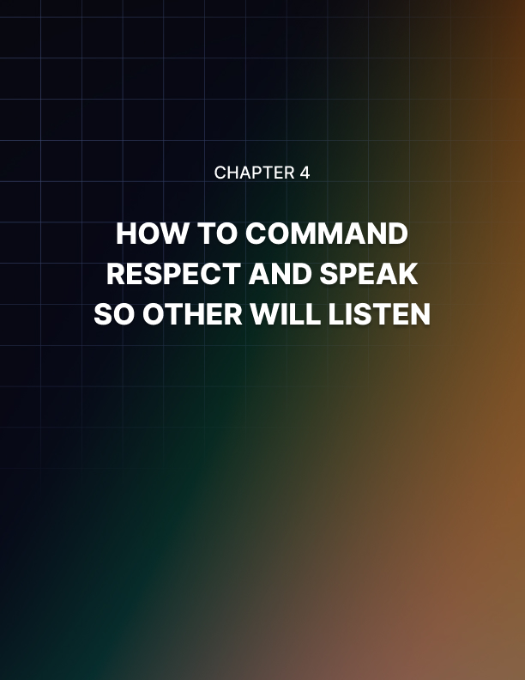

Chapter 4: How to Command Respect and Speak So Others Will Listen

One of the most common questions in regards to leadership is this: should you be feared or liked?

Some leaders are effective because they frighten their team into submission. When you are a strict leader who has been known to reprimand the team, this can gain you a reputation for being no- nonsense. People therefore don’t want to upset you, and thus they will do precisely what you instruct.

That’s one approach anyway.

The other approach is to try and be liked. The idea here is that you become someone that people enjoy spending time with, and who can actually enjoy socializing as a part of the team. You are a friend to your team, which means that they will want to please you out of respect and out of kindness. Thus, when you ask them to do something, they do it!

So which is better?

Ultimately, neither. Your aim should be neither to terrify your staff into obedience – which simply creates ill feeling. Likewise, it shouldn’t be to try and be the class clown, which will undermine respect.

Instead, be yourself. At the same time, be somewhat detached from the goings on of the office, such that you can take an impartial view when helping to settle disputes or help with personal issues.

Think of your role as “friendly guardian” or “kindly magician” more than “disciplinarian dictator” or “everyone’s mate.”

By doing this, you can command more respect by maintaining that slight air of separation, while at the same time giving your staff every reason to like you and no reason to think less of you.

The other reason to maintain a little more detachment from the rest of the team is so that they can feel more relaxed and free to enjoy work. From that point, when you do step in, it will be more of a novelty to hear you getting involved. That in turn means that people will listen because it’s so uncommon for you to speak in the first place!

From that point, it’s all about the way you speak.

Speak So Others Will Listen
You’ve been in your office allowing your team to talk among themselves outside, checking in every now and then to ensure everyone is okay.

Now it is time to talk and to provide some strategy or direction. How do you do this so that people will listen and take what you have to say to heart?

Being able to speak in a commanding manner is actually one of the most important aspects of leadership outside of the office too.

If you want your children to pay attention to you, or if you want to rise to the occasion during a crisis, you need to know how to command attention.

Here are some of the most important tips.

Speak More Slowly
Tip number one is to speak more slowly. Doing this will make you seem calmer, which in turn will make you seem more confident in what you have to say. At the same time, speaking more slowly makes your voice sound lower, and it makes you appear more intelligent. You’ll also be less likely to stumble over your words this way.

Think of pretty much any heroic leader from fiction, and they will normally have a measured, deep, booming voice. You can accomplish this by simply speaking more slowly.

Leave Silence
Another tip is to recognize the power of silence. Don’t be afraid to ask a rhetorical question and then let it hang. Don’t be afraid to build some suspense for what you’re about to say next!
Too many of us feel a constant urge to rush everything we have to say out at once. In fact though, it is often the silence between the individual statements that really has the most impact. It shows poise, control, patience, and confidence.

Speak With and To Emotion

Another extremely powerful tip is to speak to and from emotion. What do we mean by this?

In sales, when trying to sell something, you are told to focus on the “value proposition.” That means thinking about what it is that people gain from the product. Does your product make them happier? Healthier? Richer?

This will create an emotional hook, and emotion is what dictates behavior.

Well, attention is a type of behavior. And if you want people to listen, then you need to address something that seems pertinent to them – you need to appeal to their emotions. That means speaking about pride, about challenge, about success… it doesn’t mean talking about numbers, or strategy.

Find the emotional hook and use this to elaborate and bring your point to life.

Likewise, you should try to channel that emotion yourself. How does this make you feel? Whether you’re extremely happy, extremely confident, or something else… let that inform your choice of vocabulary.

Gesticulate
When you feel strongly about what you are saying, you will naturally gesticulate more and use bigger gestures. This unconscious signal makes us appear more congruent – it means our bodies and faces match our feelings.

That in turn means that people will be more engaged and more trusting in what we say. Look at anyone that you typically think of as charismatic, and you’ll find that they all use these kinds of large gesticulations as they talk.

But Know When to be Still
When you aren’t talking and getting your point across though, learn to be entirely still. This again will help you to evoke confidence and calm, which will create a powerful aura around you that makes other people want to listen.

As you continue to read this book, you’ll see that many of these strategies go hand-in-hand with techniques that make a better leader. These body language and language tips are indicative and they correlate with the traits that you are trying to cultivate.



Chapter 5: The Crucial Importance of Emotional Intelligence

We’ve discussed a few examples of bad leadership in this book so far, and unfortunately these examples are not uncommon. There are a huge number of very bad leaders out there, and in fact it’s seemingly quite rare these days to find someone who is happy with their management!

Why is this?

A big part of the problem is that many organizations don’t look at leadership as a quality that needs to be trained, or even that is innate. They don’t see leadership as a quality at all in fact – rather just a position!

This perspective is apparent in hiring and promotion activities. An organization might have a team of data analysts, ad managers, sales representatives, and accountants. They’ve all been working there for years beneath a successful manager.

Then one day, that manager leaves, and thus a power vacuum is created. Either that, or the organization offers the manager some meaningless promotion…

Whatever the case, the company now needs a new manager, and so what they will end up doing is looking at their existing staff and then finding a member who they think deserves the position – that will be someone who has been working there for a long time, or who has been doing a good job. Let’s say data analyst Jeff.

But data analyst Jeff is not a leader, and now suddenly he is in charge of 20 people. He has neither learned the skills necessary to be a leader, nor been blessed with them naturally.

He lacks emotional intelligence.

This also tends to happen when someone is put in an unknowing leadership role. For example, let’s say you have a team of writers on a magazine, and suddenly a new copy checker is brought in. Their job is to make sure there are no mistakes, and when they find one, they need to hand it back to the member of the team so that they can fix it (not a great set-up, but it works in this situation).

That copy checker is not just fulfilling a role, but they’re also calling out team members, and they’re giving them work. In other words, they are leaders – even though it might not immediately be apparent that this is the nature of their job. Again, this means that they are more likely to lack the inherent leadership skills that they really need in order to be successful.

What is EQ?
Emotional intelligence refers to our ability to recognize and identify emotions in ourselves, and in others. That means being able to spot when someone is unhappy but also understanding why they might be unhappy. It means being able to prevent making someone angry, by empathizing with them and understanding how best to handle their current situation.

Emotional intelligence can make a drastic difference to your success in a leadership role, and to the happiness and productivity of the team.

Imagine that you’ve spent all day working on something, and you’re extremely proud of what you have accomplished. You submit the work and then you get the following response:

“Please fix the error on page 3.”

Or worse:

“Thank you for this work. A good effort overall, but this does NOT conform to the style guidelines set out in the last meeting. Were you even listening? In addition, there are three mistakes right toward the end. Please be careful to pay attention when working as it creates more work for everyone else when you don’t.”

Oh and for added good measure, these responses were placed in a public forum where everyone could see the feedback.

So, what is wrong with these responses? Clearly you made mistakes, and you’re just being called out on them! Moreover, the manager/colleague has used polite language (please and thank you). They even said “good effort.”
Of course, that’s not how you’re going to react to someone critiquing work that you spent time and effort on however. And that approach is hardly going to make you want to quickly fix the problem.

A far better approach would be to start by acknowledging the hard work, and saying something positive about the final product. This acknowledgement immediately wins the favor of the person receiving the feedback, and shows them that you value the effort they’ve already put in.

You might then follow this up with a complement or two. This can help to balance out the negative feedback, again so as to keep morale high and to demonstrate that you do respect their work and effort. You can then include the negative feedback in a subtle way – while being sure to show understanding for what led to the issues – before following it up with something more positive. This is often referred to as the “sandwich” approach to giving feedback. For obvious reasons!

This now leaves that person far more likely to make the change, all without feeling insulted or overlooked by their management. Add to this a knowledge of the person you are speaking to and what helps them to work their best, and you can respond in a way that will be motivating, encouraging, but practical.

There are countless interactions every day that will require this kind of sensitivity.

Consider that top response too. This is seemingly innocuous but a simple fix could make all the difference (leaving aside for a moment the failure to acknowledge all the hard work):

“Please could you fix the error on page 3?”

The only change here is that the “please” has been moved to the front of the sentence. But while that might seem small, it creates a hugely different impression. Placing the “please” up front shows the reader that you are genuinely asking them to do something and you are grateful.

But when the start of the sentence is “fix this” it sounds like an absolute command. The “please” now becomes an afterthought that just so happens to be there.

If you are trying to get someone to do something and that person isn’t strictly someone that you have authority over, then this will become even more frustrating for them. Now it looks like you think you can boss them around. It comes across as curt, arrogant, and presumptuous.

Again, it might not seem like a big deal, but moving one word a few places can make a huge difference.

Now imagine countless interactions with hundreds of people in a single day, and hopefully you can recognize the crucial role of emotional intelligence.

Tools
Ultimately, the best improvements in emotional intelligence will come from life experience and knowing yourself.

Life experience is important because it teaches you sensitivity, and it teaches you never to assume what is going on in someone’s life.

Consider for a minute that someone comes into work looking scruffy and untidy, so you tell them that it isn’t good enough and they need to do better if they want to keep working with you. They promptly burst into tears.

Why? Turns out a parent died last night, and the only reason they still came into work was because they were so behind and they’re so conscientious.

You can never know what is going on in someone’s life, which is why you should always give them the benefit of the doubt. By having richer life experiences, you can experience this reality first hand, and gain a better understanding of what someone might be going through. Spending time with a wider range and variety of people can also help a great deal.

Listen with open ears, don’t jump to conclusions, and give people space to explain what is going on with them. But this kind of life experience and understanding takes a long time to cultivate. That’s why you should also focus on learning to know your own thoughts and feelings better. By understanding what makes you tick, you’ll be better able to understand and help manage the emotions of others.

One way to do this is by practicing CBT and mindfulness. That means spending time reflecting on your own thoughts and motivations, and being more consciously aware of where your attention is, what you’re thinking about, and how you’re feeling.

Managing your own emotions is also an important aspect of leadership so that is a great added bonus, as we will discuss in a later chapter.

For Parents
This is one of the tips in this book with the most obvious payoffs for parents. When trying to help your children to learn and grow, understanding their emotions is absolutely key. In particular, it is critical that you understand the importance of letting them feel “heard.”

When a child is very upset or angry, a parent can often attempt to try and “calm them down” by telling them not to be. This unfortunately will not usually help, as it basically tells them not to feel the way they are feeling – which often just makes them more angry and upset!

Instead, show first that you understand their emotions: say “that must have made you really angry, right?” or “I understand why you’re upset.”

In a Crisis
In a crisis, your job is to keep the mood of everyone in the situation calm. You are now managing the emotions of everyone present, to try and ensure the very best outcomes.

This means making sure that you stay calm yourself, and that you instruct clearly and recognize the role that panic and stress can play in the efficiency with which tasks get carried out.

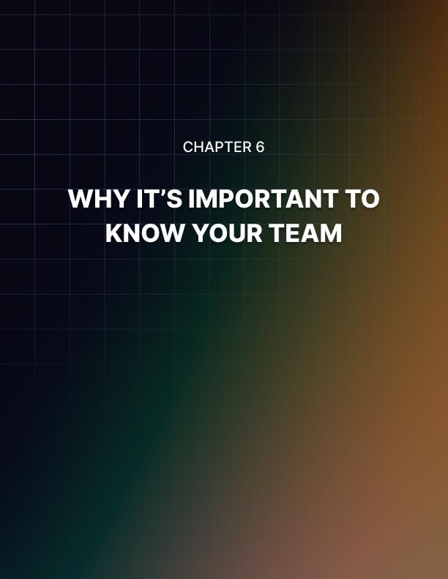

Chapter 6: Why It’s Important to Know Your Team

As a leader, your job is to achieve some kind of goal, or reach some kind of target, all by encouraging your team to do their best work. Again, it is not your job to micromanage that team or to do the work for them. Rather, you are simply encouraging them and giving them a safe place to exercise their inherent abilities.

Be Genuinely Interested in Knowing Your Team
One of the most important aspects of getting the most out of a team is to know them well. That means taking a personal interest in them as people, as well as having a solid understanding of what it is they do for your organization and how they work best.

This then allows you to anticipate how a team member is likely to react, and it allows you to put them in the best place at the best time, to put them on the most appropriate projects, and to generally help them to perform at their best level.

One of the most fundamental aspects of this, is to recognize what the key skills of each member of your team are, and then how you can put them to the best use. If you have a member of your team and you’re failing to maximize their potential, then you are simply wasting money.

Let’s consider an example. Imagine for a moment that you run a website on a complex topic such as programming. You have hired some technical writers and you’re paying them a lot in order to write in-depth tutorials and articles, and to stay up-to-date with the latest information.

But you also have those same writers uploading their own articles to the site. And you’re incredibly strict about formatting. You want them to make sure that they use the right fonts, that they are using the right sizes for images, and that they add the right meta tags.

To make things more complicated, your formatting guidelines change every few weeks. You then have the writers jump back into their work in order to add those updated changes.

And when they miss some formatting? Then all hell breaks loose and you yell at them until they change their ways.

That sounds rather destructive right? But it’s how a lot of teams will handle this kind of situation. In fact, this example is taken from a real-life experience.

The worst thing is that this means the programmer is now being paid a LOT of money in order to do work that anyone could do for a fraction of the price. Why have a top writer spend all day changing image sizes?

Instead, you could hire someone for a tiny amount of the price, and you could then use your best talent to generate meaningful work. You’d double your output, keep everyone happier, and end up with a much better end result.

What’s more, is that your staff will soon become miserable if they are spending all of their time doing work that doesn’t engage, challenge, or reward them in any way. And we’ll explore more about why this matters in a moment.

Putting Your Team Together
Another important reason to know your team well, is so that you can know who works best with who, and then make sure that they are paired according to that information.

This is more complex than simply putting people together if they get on! That’s because people who get on can often end up actually distracting one-another, meaning it might even make more sense to pair people together who challenge and improve each other.

Think as well about when to mix up your team, or how staying together could ultimately hurt performance. We’ve all heard how Steve Jobs introduced open plan offices to Pixar in order to encourage chance encounters between animators, script writers, actors, and the rest of the team.

Likewise, consider factors like “convergence and divergence.” This tells us how people placed in groups will typically grow more alike over time, while also becoming more different from those around them. This process can result in a “tribe-like” attitude, which might ultimately create problems within the office.



Chapter 7: Getting the Most Out of Your Team

Finding ways to get the most out of staff is a constant struggle for business owners and managers who are constantly told different things and given different information. One minute it's a good idea to incentivise staff with potential bonuses, perks and rewards, the next that same advice is apparently wrong. How do you know what to believe and what do you do for the best? And why is there so much disagreement in the first place?

Motivating Your Team
Well as it happens, the question really comes down to how you define motivation. There is of course more than one type of motivation and as the needs of the organization vary, so the best ways to get more out of staff change too. It turns out that when you're trying to encourage creativity and out-of-the-box thinking specifically, then incentives are more damaging than helpful.

And to understand why this is the case we need to break things down further and examine exactly what we mean by creativity. How do you define creativity? How do you measure problem solving ability?

While opinions vary on this matter, one aspect that is generally agreed to be indicative of wider creativity and problem-solving skill is what's known as 'functional fixedness'. This term refers to the ability or inability that we have to think of objects in ways other than their intended use. So if you were to take a hammer for instance, functional fixedness would be the 'cognitive bias' that prevented you from thinking of using it to scratch your back. It's a hammer, not a back scratcher.

A great demonstration of this flaw in our thinking is something called 'the candle box experiment'. Here participants are given a box of tacks and a candle and they're asked to attach the candle to the wall in such a way that it can burn while being poised there. Most people will try to tack the candle to the wall which will of course meet with disaster, but after a while they will start to think of alternative solutions at which point they get over their functional fixedness, realize that the box itself is a useful resource, and then tack that to the wall to stand the candle in.

The reason this is relevant to this particular discussion is that incentives and external motivation have actually been shown to make participants slower to come up with the solution.

The reason for this is that motivation can actually create some stress as you feel the need to amp yourself up to work towards the reward. This in turn can result in a kind of 'tunnel vision' as you approach your work – focussed hard on the task at hand.

Conversely creativity it appears is most likely to occur when we step back and relax. This in turn helps us to allow our minds to wander and enables us to see more connections between disparate ideas. And many believe that this is what creativity really is: the ability to combine unconnected ideas and combine them in unique new ways. Other studies show that a sense of ownership and pride in their work can also help to encourage staff to be more creative and original with their thinking, while allowing discourse between team members has been shown to incubate the generation of new ideas too.

So if you want your staff to provide data entry then you can help them to do this by providing incentives and rewards. Because this kind of role does not require creativity, that will be a suitable method! For other more creative tasks however it may be better to help them to relax, to let them take a step back and to provide a safe space to work their very best.

Protection
If stress can dampen creativity and prevent your team from producing their best work, the logical alternative is to reduce stress for your team as much as you possibly can.

That in turn means you need to take the flack. And that’s a huge part of what it really means to be a leader. What being a leader really means, is taking responsibility.

The bad leader will shout at their staff when things are going badly and blame them – failure to take responsibility.
This is despite the fact that the bad leader will micromanage every tiny decision and leave the team with no freedom of their own.

But the good leader will let the team work in the way they do best, and will then take the flack from upper management when things don’t go to plan. Why? Because when your staff feel as though they are protected and safe, that’s when they are able to do their best work. We’ve already seen how this can improve creative problem solving… but of course it also helps to improve work satisfaction, and to generally ensure that your team are happy working away.

Being a leader ultimately means taking the hit, and being willing to sacrifice your own sanity for theirs!

For Parents
Parents can benefit the most of all from this tip. One of the most important things to do as a parent, is to provide a source of unconditional love, as well as physical safety.

By meeting your child’s most basic needs like this, you give them the confidence they need to explore, learn, and make their own mistakes. A child who receives nothing but love and encouragement will have the confidence to venture out, to try new things, and to express themselves. This will ultimately lead to a far more even development that makes them into fully functioning adults some day!

In many ways, you can consider the role of a manager as something similar. You provide the “unconditional love” by creating a warm, team environment that protects the staff from the outside harsh realities of your organization.



Chapter 8: The Power of Ownership

At this point, you have a team that is happy to work and that feels safe and protected doing so. But we still haven’t honed in on precisely how you motivate them to actually get down to it.

Give Others Freedom To Work On What They Want
The answer to that little puzzle then, is to give your team ownership over the work that they do. That means to let your team make decisions about how they’re going to work, what they’re going to focus on, and even what it might end up looking like. You can even let them create their own projects.

This means giving them the freedom to experiment and a sense of ownership. There's a reason that Google give their staff free time to work on their own projects… and happen to be one of the largest and most transformative businesses in the world!

When you do this, you make someone innately and inherently invested in the project, and you ensure that they love what they are doing.

Don’t Force Someone To Do What They Don’t Enjoy
Here’s the stark reality: you can’t really force someone to do what they don’t enjoy to the best of their ability. If you force someone to work on a project they find dull, then of course they will work on that project. But they won’t give it their all, and much of the work will be sub-par.

Conversely, if you get someone to work on their passion project and this project has their name on it, suddenly they become far more invested and they actually want to go to work. They’ll work harder at the project because it has their name on it, and because it makes them feel alive. This could improve their career, and it’s something they can be proud of at the end of the day.

When you micromanage someone and control every small decision that someone makes, they are given zero control or ownership over that thing. This in turn means that they won’t be at all invested or interested in it.

Likewise, if you refuse to listen to their point of view, or if you know they have big problems with the way that the work is being approached, again you shouldn’t be surprised if they lack motivation and don’t do their best work.

This is why the job of the leader is to take on a lot of responsibility for what happens to protect their team, while at the same time giving the team more creative control. That’s why it takes a lot of bravery to be a true leader.

This is another reason it is so important to explain to people why they should do something.

In a Crisis
In a crisis this same approach applies. That’s because you will likely be yelling out roles for people: asking someone to call for help, while another person stops the bleeding for example.

Again, you can’t be everywhere and do everything. Your job is to give the instructions to the person attempting to do the job, and then to let them make the key decisions about how to do it.

For Parents
This is another tip that is very important and useful for parents! Young children always want to feel involved and they want to feel ownership over what they’re doing.

Try and feed your child their vegetables and they will often refuse. You might take this as a sign that they don’t want those vegetables. So what do you do? Promise them sweets if they eat their vegetables? (Remember: rewards can actually harm productivity!) Or do you fight them to try and get them to eat?

The solution often is to let them hold the spoon, or to let them choose which vegetables they want. You’re still guiding their behavior, but by letting them learn and feel involved, they will be much happier to acquiesce.



Chapter 9: How To Deal With Difficult Decisions

Sometimes being a leader means making the hard call. In fact, this is very often what it means.

Remember, the job of the captain is to go down with the ship. You are trying to protect your team so that they feel confident to do their best work. And that sometimes means taking a serious hit.

Here is how to deal with things when the going gets rough.

How To Stay Calm As a Leader
What do you do when you lose your biggest client and you think that your company is going to no longer be able to afford to employ everyone? What do you do when your family is in debt and you need to tell them that you have to downsize your home?

The single and most important job as a leader is to remain calm. Remember: you are protecting your team and taking the hits so that they can do their best work in a safe environment. That extends to remaining calm in a crisis so that they don’t have to panic.

If your team is worrying about lay-offs, then how are they supposed to focus and do their best work? This can ultimately become a self-fulfilling prophecy if allowed to escalate.

Consider that your team will look to you to set the tone. If you seem panicked, then they will panic. If you seem calm, then they will see that you have it under control.

Not only that, but you’ll also be able to appear more confident in your leadership, and ultimately it is only by being confident in yourself that you can inspire confidence in others!

This is not the same as hiding the truth from your team. One of the worst things you can do for a team from a communication standpoint is to lie and tell them everything is okay when it really isn’t. While this might seem as though it would further the cause of helping your team to stay focussed on their work, the truth is that it will eventually come out in the wash. This means you’ll then lose the trust of your team, and that they won’t know how best to prepare themselves for the coming event. Be truthful, reassuring, transparent, and calm.

How to Handle Difficult Team Members
Another issue that you will find yourself struggling with is the occasional mutinous individual. Whether you are the captain of a ship, or you are a team leader on the meat aisle, you will find there are always people who don’t want to do as you say.
So what do you do in this situation?

As before, you are not to reprimand, threaten, or punish the individual. Once more, this is not only morally a dubious position to take – it is also simply a bad strategy! This is because isolating, alienating, and aggravating someone who already intends on disrupting your leadership is a bad idea. Doing this will only cause that person to recruit more of your team to their cause, and to spend their time thinking about how wrong your style of leadership is!

Ever heard the saying “keep your friends close, and your enemies closer”? This is a saying that Italian autocrat Mussolini believed in strongly, which is why he coined the phrase “Transformismo” to describe the way he would deal with dissidents. This basically meant giving that vocal opponent a position of authority within his organization.

This strategy can often work wonders, as it turns that critic into someone who is now working with you to improve your leadership. They can see first-hand the challenges you face, and that perhaps life isn’t quite as simple as they believed it to be. Not only that, but it ensures they feel valued and cherished by the organization, rather than ostracized. AND it lets you keep a close eye on them…



Chapter 10: Challenges for Modern Leaders

Being a leader today is different than it ever has been before, and this is particularly true within organizations.

If you are a leader within an organization, then there is a high chance that you will find yourself dealing with a range of new situations and tools that alter the way that you lead.

For instance, you might today need to lead from afar. That means in other words, that you are going to be using collaboration tools to work with distributed teams all around the world. This can make life much more difficult, as you won’t be able to know precisely what your staff are doing, or whether they’re really carrying out the work you set for them!

Likewise, parents now need to deal with new challenges – which include such things as mobile phones and the internet. Again, this prevents them from knowing everything that is going on in their children’s lives, making it harder than ever for them to protect them and guide them.

There are several ways that we can react to these changes. One of the most common, is to try and reign in our followers even more – to place even stricter and more controlling rules and restrictions on them. The hope is that we can get a better idea of what they are doing and thus control their actions.

But the truth is that doing this actually often has the opposite effect. Again, the most powerful way to motivate someone who is miles away from you, is to make sure that the tasks you give them are inherently motivating. That is to say they should be rewarding in their own right – because they offer a sense of ownership to the person completing them, and a sense of being highly involved.

If you notice that someone is falling behind, don’t assume it is because they are lazy! Instead, ask why they aren’t motivated enough to complete the work you have set for them?

Likewise, many parents understand that telling their children they can’t drink alcohol will often force them to act out and drink even more without telling their parents! Giving them that bit of freedom – allowing them to have some drinks in a controlled and safe environment – can often help to avoid them feeling the need to completely rebel.

And so it is with the internet: try and block or restrict your child’s internet access and they will only find a way around it. But give them that access and tell them that you are doing so because you trust them, and you might find they are less likely to betray that trust.

Your job as a leader is to protect, to inspire, and to guide. It is NOT to control. This is true even when you are dealing with the modern, complex challenges of leadership. In fact, that only makes this approach even more vital.

