Guide

THE MULTI-BUCKET SAVINGS SYSTEM
____

The multi-bucket savings system represents a revolutionary approach to organizing your finances, moving beyond the traditional single savings account model to create a structured framework that aligns with your various financial goals and time horizons. Successful savers typically operate several accounts aligned with specific purposes, preventing the common mistake of commingling different types of savings.
This guide will walk you through the exact process of establishing and automating your multi-bucket savings system, helping you create a robust financial infrastructure that supports your short-term needs while building long-term wealth.

Part 1: Understanding the Multi-Bucket System Foundation

Why Traditional Savings Accounts Fail
Single-account savings strategies often fail because they:
- Mix emergency funds with long-term savings.
- Create confusion about how much is available for different purposes.
- Lead to dipping into long-term savings for short-term needs.
- Make it difficult to track progress toward specific goals.

The Five Essential Savings Buckets
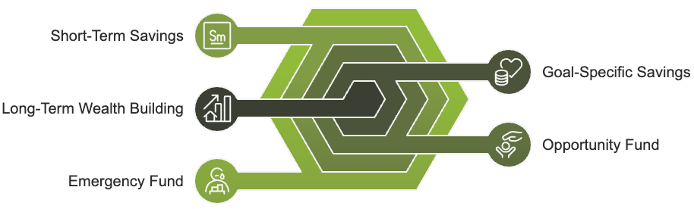
- Emergency Fund Bucket
- Purpose: Unexpected life events
- Target: 3-6 months of essential expenses
- Accessibility: High liquidity required
- Short-Term Savings Bucket
- Purpose: Planned expenses within 12 months
- Target: Based on specific upcoming needs
- Accessibility: Regular access needed
- Opportunity Fund Bucket
- Purpose: Unexpected investment or business opportunities
- Target: 1-2% of annual income
- Accessibility: Medium liquidity
- Goal-Specific Bucket
- Purpose: Dedicated savings for specific objectives
- Target: Based on individual goals
- Accessibility: Varies by goal timeline
- Long-Term Wealth Building Bucket
- Purpose: Future financial independence
- Target: 15-20% of income
- Accessibility: Low (designed for long-term growth)

Part 2: Setting Up Your Bucket System

Step 1: Account Selection and Setup
For each bucket, choose the appropriate account type:
Emergency Fund:
- High-yield savings account
- FDIC-insured
- No minimum balance requirements
- Easy access without penalties
Short-Term Savings:
- Traditional savings account
- Linked to checking account
- Online banking access
- No withdrawal limits
Opportunity Fund:
- Money market account
- Higher interest rates
- Check-writing capabilities
- Limited monthly transactions
Goal-Specific:
- Multiple savings accounts
- Nickname capability for different goals
- No monthly fees
- Online transfer capabilities
Long-Term Wealth:
- Investment accounts
- Tax-advantaged options where possible
- Diversification capabilities
- Professional management options

Step 2: Initial Funding Strategy
- Assess Current Savings
- Review all existing savings accounts
- Calculate total liquid assets
- Identify current emergency fund level
- Prioritize Bucket Funding
First Priority: Emergency Fund
- Begin with $1,000 quick-start emergency fund
- Build to one month of expenses
- Gradually increase to 3-6 months
Second Priority: Short-Term Savings
- Calculate upcoming known expenses
- Set aside initial buffer of $500
- Plan for regular contributions
Third Priority: Remaining Buckets
- Allocate remaining current savings
- Set up automatic contribution plans
- Adjust based on goals and timeline

Part 3: Automation Implementation

Setting Up Automatic Transfers
- Primary Paycheck Distribution
Create automatic transfers that trigger on payday:
- 50% to essential expenses account
- 30% to short-term savings
- 20% to long-term wealth building
- Secondary Distribution Rules
Configure secondary transfers:
- Emergency fund: 10% of income until funded
- Goal-specific: 5-10% based on timeline
- Opportunity fund: 1-2% of monthly income
- Technology Integration
Utilize available banking features:
- Direct deposit splitting
- Automatic transfer scheduling
- Round-up savings programs
- Goal tracking tools

Sample Automation Schedule
For bi-weekly pay periods:
Day 1 (Payday):
- Emergency Fund: $200
- Short-Term Savings: $300
- Goal-Specific: $150
Day 15:
- Emergency Fund: $200
- Long-Term Wealth: $400
- Opportunity Fund: $50

Part 4: Monitoring and Maintenance

Monthly Review Protocol
- Account Balance Check
- Review all bucket balances
- Compare against targets
- Identify any unusual activity
- Progress Assessment
- Track emergency fund growth
- Monitor goal-specific savings progress
- Evaluate wealth-building momentum
- Adjustment Opportunities
- Rebalance allocations if needed
- Increase automatic transfers when possible
- Optimize interest rates across accounts

Quarterly Deep Dive
Conduct comprehensive review:
- Interest Rate Analysis
- Compare current rates across institutions
- Identify better savings vehicles
- Calculate potential benefits of switching
- Goal Progress Evaluation
- Review timeline-based goals
- Adjust contributions as needed
- Update targets based on life changes
- System Optimization
- Evaluate automation effectiveness
- Fine-tune transfer timing
- Update bucket allocations

Part 5: Scaling Your System

Growth Strategies
- Income Increases
When receiving raises or bonuses:
- Maintain current lifestyle
- Increase bucket contributions proportionally
- Prioritize underfunded buckets
- Windfall Management
For unexpected money:
- Allocate 50% to pressing needs
- Distribute 30% to long-term growth
- Reserve 20% for immediate joy
- System Expansion
As wealth grows:
- Add sub-buckets for specific goals
- Introduce investment components
- Integrate tax optimization strategies

Implementation Challenges and Solutions

Common Obstacles
- Insufficient Income
Solution:
- Start with smaller percentages
- Focus on emergency fund first
- Increase gradually with income
- Technical Difficulties
Solution:
- Use multiple banks if needed
- Leverage financial apps
- Maintain manual tracking as backup
- Emotional Resistance
Solution:
- Start with one bucket
- Celebrate small wins
- Visualize long-term benefits

Action Plan: Next Steps

Immediate Actions (Week 1)
- List all current savings accounts
- Calculate total savings amount
- Choose banks/accounts for each bucket
- Open new accounts as needed

Week 2
- Set up automatic transfers
- Configure online banking access
- Download tracking apps
- Create monitoring spreadsheet

Week 3
- Begin first round of transfers
- Review automation success
- Adjust as needed
- Document process

Week 4
- Conduct first weekly review
- Make necessary adjustments
- Plan first monthly assessment
- Set quarterly review date
Final Words

CONCLUSION
____

The multi-bucket savings system represents a powerful framework for organizing your finances and building lasting wealth. By implementing this system, you create a structured approach to saving that aligns with your various financial needs and goals.
Success comes from taking immediate action. Start today by opening your first dedicated savings bucket and setting up one automatic transfer. Remember, your financial security architecture grows stronger with each small step you take toward implementation.
Don't wait for the perfect moment – begin building your multi-bucket savings system now. Your future financial security depends on the actions you take today.

