TABLE OF CONTENTS
____
INTRODUCTION 4
UNDERSTANDING PAID ADVERTISING PLATFORMS 8
Building Your Advertising Foundation 8
Measuring Success Across Platforms 10
Platform Selection and Management 12
MASTERING META ADS 17
The Foundation of Meta Advertising Success 18
Building Your Targeting Strategy 19
Advanced Audience Building Techniques 22
Measuring Success and Optimizing Performance 23
LEVERAGING GOOGLE ADS 27
Understanding Search Psychology 27
Creating Intent-Driven Campaigns 29
Maximizing Campaign Performance 31
UNLOCKING THE POTENTIAL OF TIKTOK ADS 35
Understanding TikTok's Unique Ecosystem 36
Creating Content That Converts 38
Maximizing Campaign Performance 40
SCALING WITH LINKEDIN ADS 44
The Professional Advertising Advantage 44
Strategic Targeting for Professional Audiences 46
Advanced Audience Development and Optimization 48
CHOOSING THE RIGHT PLATFORM FOR YOUR BUSINESS 53
Making Strategic Platform Decisions 53
Building Your Multi-Platform Strategy 56
Implementing Your Platform Strategy 59
Future-Proofing Your Advertising Strategy 60
DISCLAIMER
____
The information provided in this ebook is intended solely for educational and informational purposes. The author does not accept any responsibility for the outcomes that may arise from the application of the material within. While efforts have been made to ensure the accuracy and relevance of the content, the author cannot be held accountable for any errors or omissions, or for any consequences resulting from the use or misuse of the information provided. The responsibility for any actions taken based on the information in this ebook lies solely with the reader.


INTRODUCTION
____
If you’re staring at your screen, pondering where to spend your advertising budget, you're not alone.
The world of paid advertising can feel like a complex maze with countless paths, each promising to lead you to marketing success. Yet, as platforms multiply and algorithms evolve, making the right choice becomes increasingly challenging.
Successful advertising isn't about being everywhere… It's about being in the right place with the right message.

Should you focus on Meta's vast reach, tap into Google's intent-driven searches, capture TikTok's vibrant youth culture, or build professional connections through LinkedIn? These questions represent just the beginning of a critical decision-making process that can significantly impact your business growth.
The reality is that successful paid advertising isn't about following trends or copying competitors. It's about making informed decisions based on your unique business needs, target audience, and marketing objectives.
As you navigate through various advertising platforms, you'll discover that each has its distinct advantages and specialized use cases.
Meta excels at precise audience targeting and community building, while Google Ads captures high-intent traffic ready to take action.
TikTok dominates the attention of younger audiences with its creative, short-form content, and LinkedIn provides unparalleled access to professional decision-makers.
This book serves as your practical guide through the labyrinth of paid advertising platforms. You'll gain clarity on which platforms align with your business goals and learn how to leverage their unique strengths.
Rather than spreading your budget thin across multiple channels, you'll discover how to make strategic choices that maximize your return on investment. The insights shared here come from years of hands-on experience and data-driven research, distilled into actionable strategies you can apply immediately.
What makes this book different is its focus on practical application rather than theoretical concepts. You'll learn how to analyze your business needs, understand platform capabilities, and make confident decisions about where to invest your advertising budget.
Whether you're a small business owner looking to grow your customer base or a marketing professional aiming to optimize campaign performance, this guide will help you navigate the complexities of paid advertising with confidence and precision.
Successful advertising isn't about being everywhere—it's about being in the right place with the right message. Let's begin this journey together and transform the overwhelming world of paid advertising into a clear path toward your business success.
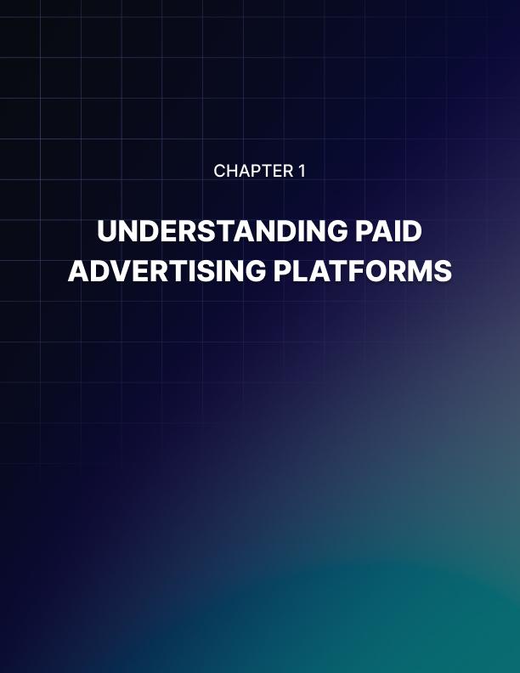

UNDERSTANDING PAID ADVERTISING PLATFORMS
____
Money flows where attention goes. As businesses worldwide pour billions into online advertising, projected to reach $785.1 billion by 2025 according to the Forbes Agency Council, your success hinges on choosing the right platforms to reach your audience.
Whether you're targeting professionals through LinkedIn or capturing Gen Z's attention on TikTok, each advertising channel offers unique opportunities and challenges. Understanding these platforms' strengths, audience demographics, and ad formats is crucial for maximizing your return on investment (ROI).

Building Your Advertising Foundation
Before you spend a single dollar on ads, you need to lay the groundwork that will multiply your chances of success. Many businesses rush into advertising without this essential preparation, leading to wasted budgets and disappointing results. Let's explore how to build this foundation properly.
Your ideal customer profile serves as the compass for all advertising decisions. Think beyond basic age and location demographics and understand the personality traits, interests, and behaviors that drive your customers.
Where do they hang out online? What content catches their eye? When are they most likely to engage with ads? What pushes them to make a purchase decision?
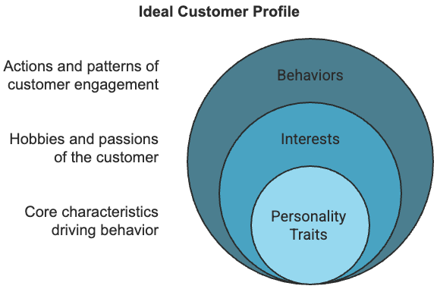
Consider how different platforms align with your audience's characteristics. If you're selling enterprise software to C-suite executives, LinkedIn's professional environment will likely deliver better results than TikTok's youth-oriented platform. However, if you're marketing trendy fashion to college students, TikTok and Instagram should be your primary focus.
Your marketing objectives should guide platform selection with laser precision, because each platform excels at different goals.
For brand awareness, Meta's extensive reach and visual storytelling capabilities can introduce your brand to millions of potential customers. When it comes to lead generation, LinkedIn's professional audience and targeting options excel at reaching decision-makers.
Google Ads captures people actively searching for solutions like yours. For driving direct sales, platforms with robust conversion tracking and optimization tools like Google Ads and Meta can help you optimize campaigns for purchases.
Budget planning extends far beyond just ad spend. You must account for content creation; video production for TikTok or YouTube ads typically costs more than static images for Meta ads.
Factor in management time, as some platforms demand more frequent monitoring and optimization. Always set aside a testing budget to experiment with different ad formats, audiences, and messages before scaling what works.

Measuring Success Across Platforms
Understanding performance metrics helps you optimize campaigns and justify your advertising investment. While vanity metrics like impressions or clicks might look impressive in reports, focus on metrics that directly impact your bottom line.
Return on ad spend (ROAS) measures the revenue generated for every advertising dollar spent. This fundamental metric varies significantly across platforms based on their audience quality and targeting capabilities.
For example, Google Ads often delivers higher ROAS for businesses selling products people actively search for, while awareness-focused platforms like TikTok might show lower initial ROAS but build valuable brand recognition.
Cost per lead (CPL) helps you evaluate lead generation efficiency. While LinkedIn typically shows higher CPL than other platforms, it often delivers higher-quality B2B leads that justify the increased cost. Track lead quality through your CRM to understand the true value of leads from different platforms.
Here's how key metrics typically perform across major advertising platforms:
Platform | Average CTR | Typical CPC | Best For
Google Ads | 2–3% | $1–$2 | High-intent traffic
Meta Ads | 0.5–1.6% | $0.50–$1.50 | Brand awareness
LinkedIn Ads | 0.3–0.5% | $5–$8 | B2B leads
TikTok Ads | 1–3% | $1–$2 | Youth engagement

Click-through rate (CTR) and cost per click (CPC) are fundamental metrics in paid online advertising that help measure campaign performance and cost-effectiveness.
CTR represents the percentage of people who click on your ad after seeing it, calculated by dividing the number of clicks by the number of impressions (views) and multiplying by 100. For example, if your ad receives 100 impressions and 5 clicks, your CTR would be 5%.
CPC, on the other hand, is the actual amount you pay when someone clicks on your ad. This can be either a fixed rate you set (maximum CPC bid) or determined through an auction system where you compete with other advertisers for ad placement.
Together, these metrics help advertisers understand both how compelling their ads are to their target audience (CTR) and how efficiently they're spending their ad budget (CPC).
A high CTR with a reasonable CPC generally indicates an effective ad campaign, though ultimate success depends on whether those clicks convert into meaningful actions like purchases or sign-ups.

Platform Selection and Management
Each advertising platform offers distinct advantages that can amplify your marketing efforts when properly leveraged.
Google Ads excels at capturing high-intent traffic through search advertising. When someone actively searches for products or services like yours, they're often closer to making a purchase decision.
The platform's extensive reach across search and display networks, combined with advanced targeting based on search intent, makes it particularly effective for businesses with clear product-market fit. Google's various ad formats, from text ads to shopping campaigns, let you match your message to user intent at different stages of the buying journey.
Meta's advertising platform provides unparalleled audience targeting capabilities through Facebook and Instagram. The platform's sophisticated algorithm can identify patterns in user behavior and interests that you might never uncover manually.
This makes Meta particularly effective for businesses that understand their target audience's interests and behaviors but need help reaching similar people at scale. Meta's diverse ad formats, from story ads to carousel posts, let you experiment with different ways to capture attention and drive engagement.
LinkedIn stands out for B2B marketing due to its professional user base and detailed targeting options. You can zero in on decision-makers by job title, company size, industry, and even specific companies.
This precision targeting, combined with LinkedIn's professional environment, helps establish credibility for B2B brands. While the platform's higher costs might deter some advertisers, the quality of leads often justifies the investment for B2B companies with higher customer lifetime values.
TikTok's rapid growth and unique content style present both opportunities and challenges for advertisers. The platform's AI-driven content distribution can help your ads reach highly engaged audiences, but success requires understanding platform-specific content trends and user behavior.
Traditional advertising approaches often fall flat on TikTok. To succeed, you need to create content that feels native to the platform while still achieving your marketing objectives.
Managing these platforms effectively requires different skills and resources. Each platform has its own learning curve, interface, and best practices that marketers need to master.
Google Ads demands technical expertise in keyword research, bidding strategies, and quality score optimization, while Meta Ads success hinges on audience targeting and creative optimization skills.
LinkedIn Ads require an understanding of B2B marketing principles and professional content standards, whereas TikTok Ads emphasize creative storytelling and trend awareness over technical complexity.
Your ongoing success relies on consistent monitoring and optimization. Schedule daily check-ins to track campaign performance and adjust bids. Plan weekly creative refreshes to combat ad fatigue. Conduct monthly strategic reviews to analyze broader trends and adjust your approach accordingly.
By understanding these platform-specific requirements and allocating resources appropriately, you can build a sustainable advertising program that delivers consistent results.
Choose platforms that align with your business objectives, audience preferences, and available resources. Start focused with one or two platforms, master them completely, and expand your presence as you prove ROI and build expertise.
Moving forward, stay adaptable as platforms evolve and new advertising opportunities emerge. The most successful advertisers maintain flexibility in their approach while staying true to their core business objectives and audience needs.


MASTERING META ADS
____
Every business owner dreams of reaching the perfect customer at the exact moment they're ready to buy. With Meta's advertising ecosystem reaching over 900 million daily active users across Facebook, Instagram, and Messenger (data from LeadsBridge), you now have the power to turn that dream into reality.
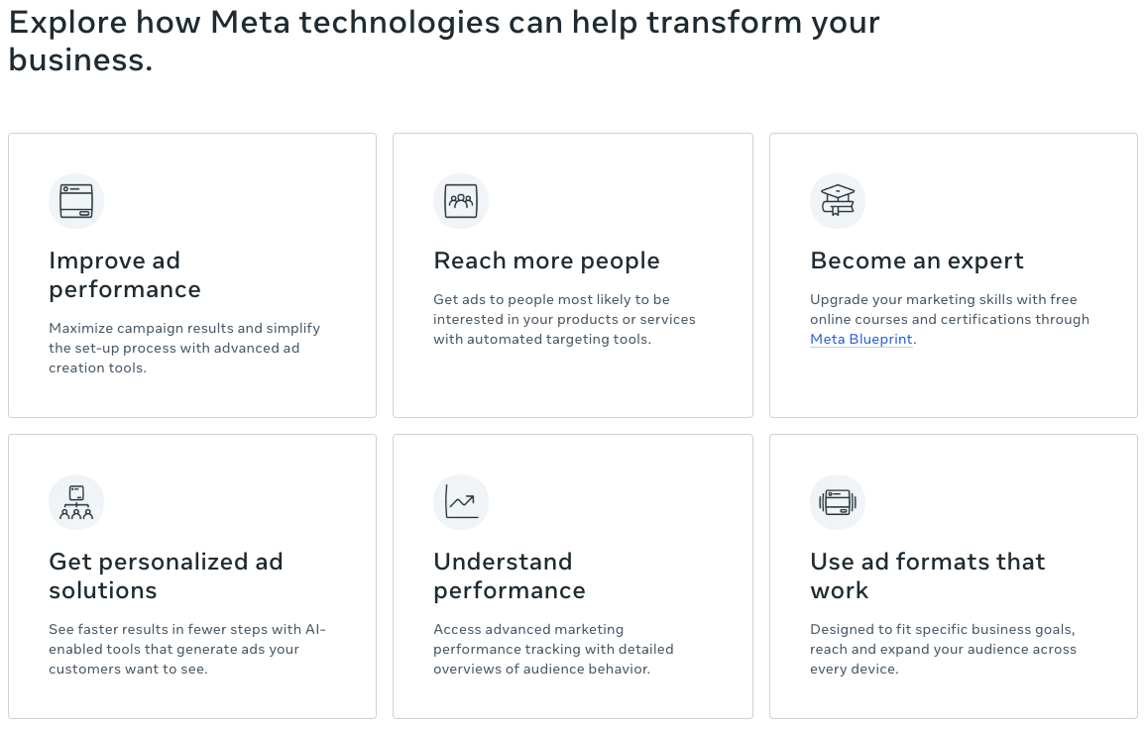
But here's the catch: simply showing ads to this massive audience isn't enough. Your success depends on mastering Meta's smart technology to connect with the right people at precisely the right time.

The Foundation of Meta Advertising Success
Meta's advertising system works differently than traditional platforms because it learns from every interaction across its network.
When someone likes a post, watches a video, or clicks an ad, the platform's technology captures these signals to build detailed audience profiles. This creates opportunities for you to reach people based on their actual behaviors and interests, not just basic demographics.
Think of Meta's targeting system as a smart matchmaker for your business. Instead of manually hunting for customers, you're tapping into a system that analyzes billions of data points to find people most likely to care about your products.
This precise matching capability translates directly into measurable results, as the platform achieves engagement rates of up to 3.7%—significantly higher than the industry average of less than 1%, based on research from Impulse Analytics.
Before diving into advanced tactics, you need to understand how Meta protects user privacy while delivering targeted ads. The platform prioritizes user confidentiality by using aggregated data rather than individual profiles.
This means that rather than exposing individual user data, the platform uses pattern recognition to group similar users together. This means you can reach highly specific audiences without compromising personal information.
For example, instead of targeting "John Smith who likes running," you're reaching "active lifestyle enthusiasts aged 25–34 who regularly engage with fitness content."
Here's a practical example of how this works. Imagine you run a local gym. Meta's system can help you target people who:
- Recently moved to your area
- Follow fitness influencers
- Engage with workout videos
- Browse athletic wear online
- Visit locations near your gym
This layered targeting creates a powerful way to reach potential customers who match your ideal client profile without invading their privacy.

Building Your Targeting Strategy
Your success with Meta Ads starts with understanding the three core targeting components: demographics, behaviors, and interests. But the real power comes from combining these elements strategically.

Demographic targeting
Demographic targeting goes far beyond basic age and location filters. You can reach people based on:
- Life events (recently engaged, new job, moved homes)
- Education level and field of study
- Career path and job role
- Relationship status
- Parental status
- Income level (in select countries)
While these options are powerful, avoid the common mistake of over-relying on demographics alone. The most successful advertisers use demographics as a foundation, then layer on behavioral and interest targeting to refine their audience.

Behavioral targeting
Behavioral targeting analyzes how people interact across Meta's platforms. This includes:
- Purchase patterns
- Device usage
- Travel frequency
- Content consumption habits
- Gaming preferences
- Charitable giving
- Political engagement
Consider how this deeper understanding can improve your targeting. Instead of simply targeting "women aged 25–34," you could reach "professional women who regularly purchase business attire online and attend networking events."

Interest-based targeting
Interest-based targeting connects you with people based on their demonstrated passions and preferences. Meta builds these interest profiles through:
- Pages liked
- Groups joined
- Ads clicked
- Content shared
- Events attended
- Apps used
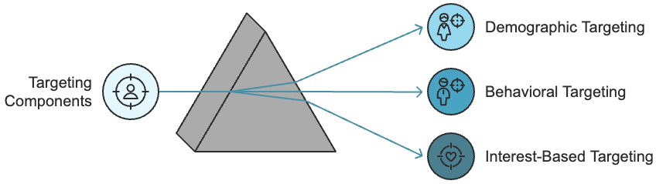
The key to success is combining these targeting options in ways that match your customer journey. For example, a wedding photographer might target:
- Recently engaged individuals (demographic)
- Who actively plan their wedding (behavior)
- And follow wedding inspiration accounts (interest)
This layered approach typically delivers better results than broader targeting because you're reaching people at the perfect intersection of readiness and interest.

Advanced Audience Building Techniques
Your most powerful targeting tool is Custom Audiences. These are groups of people who already know your brand, including:
- Your email list subscribers
- Website visitors
- App users
- Social media engagers
- Past customers
Consider this real-world example: an e-commerce retailer used Custom Audiences to segment their past customers based on purchase history and shopping frequency. By creating tailored campaigns for each segment, they achieved a 47% higher conversion rate compared to their standard demographic targeting.
To build effective Custom Audiences:
- Start with your best customers.
- Analyze their common characteristics.
- Create segments based on value and behavior.
- Develop targeted messages for each segment.
- Test and refine your approach.
Lookalike Audiences amplify your success by finding people similar to your best customers. Meta's technology analyzes thousands of characteristics to identify patterns among your existing customers, and then finds new users who match these patterns. Think of it as asking Meta to find more people like your most valuable customers.
When building Lookalike Audiences, remember:
- That smaller source audiences (1,000–5,000 people) often create more precise matches
- To test different percentage matches (1%, 5%, 10%) to find the sweet spot between reach and relevance
- To update your source audiences regularly to maintain accuracy

Measuring Success and Optimizing Performance
Your ability to measure and improve campaign performance separates successful advertisers from those who waste money on ineffective ads. Focus on these key metrics:
Return on ad spend (ROAS) tells you how much revenue you generate for every dollar spent on ads. Calculate it by dividing total revenue by ad spend. A ROAS of 2.0 means you're making $2 for every $1 spent.
Cost per acquisition (CPA) measures how much you spend to acquire each customer. Track this against your customer lifetime value to ensure profitability. For example, if your average customer spends $500 over time, a $50 CPA might be acceptable.
Engagement rate shows how many people interact with your ads compared to how many see them. Calculate it by dividing total engagements (likes, comments, shares, clicks) by total impressions.
The most successful Meta advertisers balance automated optimization with manual oversight. While Meta's smart technology can efficiently allocate your budget, you should:
- Review performance data daily.
- Adjust budgets based on ROAS.
- Test new audiences regularly.
- Update creative elements weekly.
- Monitor competitor activity.
Your success on Meta Ads ultimately depends on creating a systematic approach to testing, measuring, and improving your campaigns. By focusing on these fundamentals while staying current with platform changes, you'll build campaigns that consistently deliver results for your business.
Meta's advertising platform continues to evolve with new features and capabilities. Your success depends on mastering the fundamentals while adapting to changes in technology and user behavior.
Remember that behind every metric and targeting option is a real person you're trying to reach. Focus on creating value for your audience, and the results will follow.
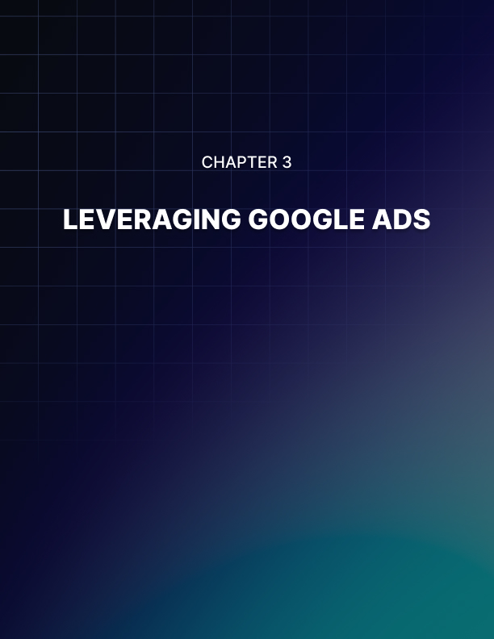

LEVERAGING GOOGLE ADS
____
When someone types a search query into Google, they're telling you exactly what they want. This golden opportunity to connect with eager customers has transformed Google Ads into a powerhouse for businesses worldwide. Let's explore how you can harness this opportunity to capture high-converting traffic and transform searching browsers into paying customers.
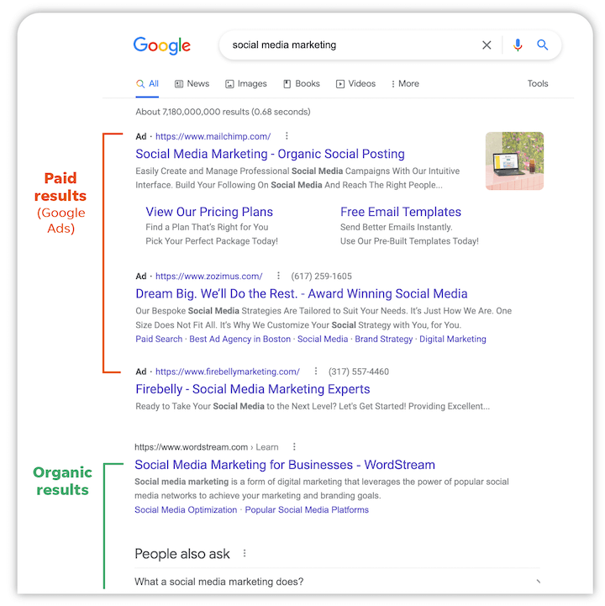

Understanding Search Psychology
Gone are the days when people typed fragmented keywords into search engines. Today's users express their needs naturally, giving you rich insights into their intentions.
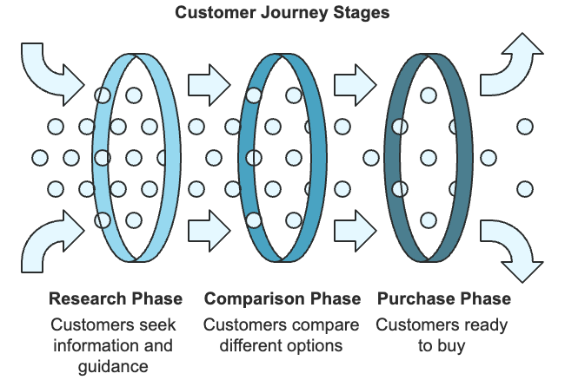
Instead of searching "electric SUV," someone might type "best electric SUV for a family of five under $50,000." This transformation reveals not just what they want, but their budget, family situation, and stage in the buying journey.
Google's sophisticated artificial intelligence analyzes hundreds of signals to understand the psychology behind each search. These signals reveal crucial patterns in user behavior and intent, helping advertisers craft and deliver perfectly timed messages.
When someone searches at 2 AM for "emergency plumber near me," they need immediate help. But when that same person searches "bathroom remodel ideas" on a Sunday afternoon, they're likely in research mode. Understanding these differences helps you create ads that match exactly what your potential customers need at that moment.
Think about how you search for information yourself. Your search patterns change based on your goals. You might start with broad educational queries like "how to start investing" before moving to specific searches like "best Roth IRA accounts 2025" as you get closer to making a decision. Google tracks this journey, allowing advertisers to meet potential customers at each step with relevant information.
The search engine processes various contextual signals that shape user intent:
- Previous searches in the same session
- Time and day of the search
- Device used (mobile searches often indicate more immediate needs)
- Geographic location and movement patterns
- Seasonal trends and current events
- Historical interaction patterns with similar searches
A practical example shows how this works. Imagine someone searches "pizza" on their phone at 7 PM while walking around downtown. Google understands they likely want to order dinner nearby.
However, if that same person searches "pizza" on their desktop at 10 AM, they might be looking for recipes or nutritional information. This context helps you deliver more relevant ads and achieve better conversion rates.

Creating Intent-Driven Campaigns
Successful Google Ads campaigns start by aligning your advertising strategy with three main types of search intent. Each type requires a different approach to messaging, bidding, and conversion optimization.
Informational Intent makes up about 80% of all searches based on a study conducted by Penn State’s College of Information Sciences and Technology. These searches often begin with phrases like "how to," "what is," or "why."
While these users might not buy immediately, they present valuable opportunities to build trust and awareness. For example, someone searching "how to fix a leaky faucet" might not need a plumber today, but they're showing early signs of plumbing problems. Your ads can offer helpful advice while positioning your service as a backup if their DIY attempt fails.
Navigational Intent reveals users searching for specific brands, websites, or locations. These searches indicate familiarity but might present opportunities for competitor advertising.
When someone searches "Nike running shoes website," they show clear brand preference. However, well-crafted ads from competing brands might capture their attention with compelling offers or unique features.
Transactional Intent signals readiness to take action. These searches convert at rates higher than informational queries. Users often include terms like "buy," "price," "near me," or specific product models.
For example, someone searching "buy iPhone 15 Pro Max 256GB black" shows clear purchase intent and specific preferences, making them an ideal target for immediate conversion-focused advertising.
Your campaign structure should mirror these intent patterns. Create separate campaigns or ad groups for each intent type, with messaging and bidding strategies aligned accordingly.
For informational searches, focus on educational content and slower-burning conversion paths. For transactional searches, emphasize immediate action and purchase benefits.

Maximizing Campaign Performance
Google's Smart Bidding technology transforms how you optimize for different user intents. Instead of manually adjusting bids based on limited data, Smart Bidding analyzes thousands of signals in real time to optimize your advertising spend. The system learns from every interaction, continuously improving its ability to predict which users are most likely to convert.
Here's how this works in practice: imagine you run a fitness equipment store. Smart Bidding might automatically increase your bids for searches like "buy treadmill online" when they come from:
- Users who previously visited your website
- Locations with historically higher conversion rates
- Times of day when purchases typically spike
- Devices that usually lead to more sales
- Weather conditions that drive indoor exercise equipment searches
Performance Max campaigns take this automation further by combining intent signals across Google's entire network. These campaigns use AI to identify and target high-intent users across Search, Display, YouTube, Gmail, and Maps. The system automatically adjusts creative elements and bidding strategies to maximize your conversion potential.
A particularly powerful feature of Google Ads is Dynamic Search Ads (DSA). Think of DSAs as your automated prospector, constantly discovering new opportunities based on your website's content and user search behavior.
When someone searches for something relevant to your business that you haven't specifically targeted with keywords, DSAs can automatically generate an ad that matches their query. This ensures you never miss out on relevant traffic, even for long-tail searches you might not have considered.
Custom intent audiences allow you to reach people based on their search patterns and online behavior. For instance, a luxury car dealer might target users who have:
- Searched for specific high-end vehicle models
- Visited automotive review sites
- Researched financing options
- Shown interest in competitor brands
- Engaged with luxury lifestyle content
This targeted approach helps ensure your ads reach users with demonstrated interest and purchase intent, improving your conversion rates and return on ad spend.
To optimize your campaigns for intent-based conversion, focus on creating seamless alignment between search queries, ad messaging, and landing page experience. Your ad copy should mirror the language and intent signals in user searches.
For transactional searches, emphasize immediate benefits, pricing, and clear calls-to-action. For informational searches, focus on educational value while maintaining clear paths to conversion.
By mastering these techniques and continuously adapting to changes in search behavior, you'll build campaigns that consistently deliver results.
Behind every search is a person with specific needs and intentions. Your success depends on understanding and serving these intentions effectively, creating better experiences for your potential customers while achieving your business objectives.
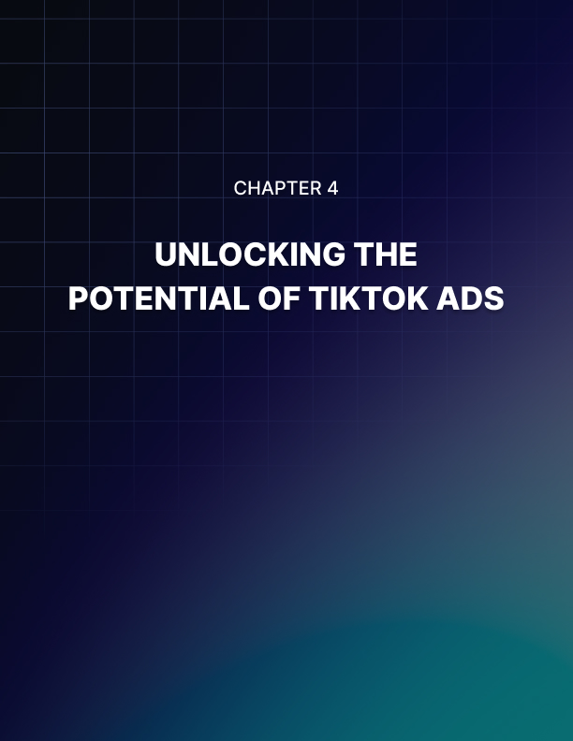

UNLOCKING THE POTENTIAL OF TIKTOK ADS
____
Every second, millions of thumbs scroll through short videos on TikTok, each swipe potentially worth thousands in advertising revenue. This entertainment powerhouse has transformed how Generation Z and young Millennials consume content, creating an advertising ecosystem unlike anything that came before.
With users spending an average of 95 minutes daily exploring an endless stream of engaging content according to Sensor Tower Consumer Intelligence, TikTok offers unprecedented opportunities to capture attention in ways traditional advertising never could.
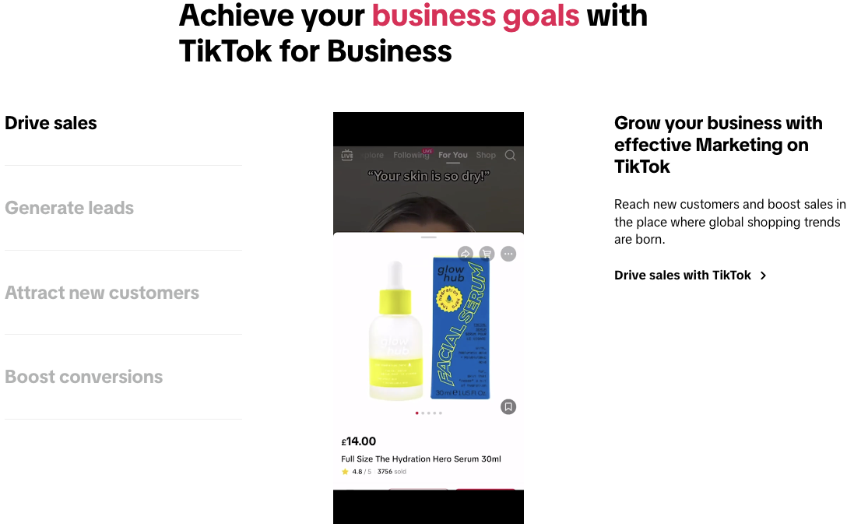

Understanding TikTok's Unique Ecosystem
TikTok stands apart from traditional social platforms through its foundation in short-form video content and its revolutionary approach to content distribution. While Instagram evolved from photos to videos and Facebook began with text updates, TikTok's DNA is built on quick, engaging video snippets that keep viewers hooked through a sophisticated content recommendation system.
The platform's smart content matching system, known as the For You Page (FYP), works differently than traditional social media algorithms.
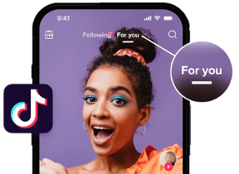
Instead of primarily showing content from accounts users follow, TikTok's system evaluates each piece of content independently. This creates an equal opportunity for visibility where a video from a newcomer can reach millions of viewers just as easily as content from established creators.
Understanding how TikTok's algorithm works reveals why traditional advertising approaches often fail on the platform.
The system analyzes hundreds of signals including:
- How long viewers watch each video
- Whether they finish watching or scroll past
- The speed of their scrolling
- If they share, comment, or create using the same sound
- The content of comments and captions
- Time of day and location of engagement
- Device settings and user preferences
- Historical patterns of interaction with similar content
This complex web of signals helps TikTok understand not just what content users like, but why they like it. For advertisers, this means moving beyond demographic targeting to create content that resonates with specific interest communities.
A fitness brand, for example, might find success not just by targeting young adults interested in health, but by understanding and participating in specific fitness challenges or trends that are currently capturing the community's attention.
TikTok's young user base approaches content differently than previous generations. Having grown up surrounded by traditional advertising, they've developed sophisticated filters for promotional content. These users value:
- Authenticity over perfection
- Creativity over production value
- Participation over passive consumption
- Community over broadcast messaging
- Entertainment over direct selling
This shift in values requires advertisers to fundamentally rethink their approach. A slightly imperfect, genuine video often outperforms highly produced commercial content because it matches the platform's natural environment.
For instance, a small beauty brand might achieve better results with a candid "get ready with me" video showing real product application than with a glossy traditional beauty ad.

Creating Content That Converts
Success on TikTok demands a different creative strategy than other platforms. While Meta rewards polished content and Google Ads focus on clear commercial intent, TikTok's environment requires a more nuanced approach that balances entertainment with marketing objectives.
The foundation of effective TikTok advertising lies in understanding the platform's unique content styles. Unlike traditional social media where users might scroll through content silently, 93% of TikTok users watch videos with sound on (source: TikTok Marketing Science).
This creates opportunities for more immersive storytelling through:

- Sound design
Music and audio trends often drive content virality. Successful advertisers maintain libraries of trending sounds and create content that naturally incorporates these elements. For example, a food delivery service might create a video showing their delivery process timed perfectly to a trending song, making the ad feel like entertainment rather than promotion.
- Visual storytelling
TikTok's vertical format and quick-cutting style require a different approach to visual composition.
Effective videos often:
- Hook viewers in the first second.
- Use rapid scene changes to maintain interest.
- Incorporate text overlays strategically.
- Feature close-up shots that work well on mobile.
- End with clear calls to action.
- Native integration
The most successful TikTok ads don't disrupt the user experience; they enhance it. This means creating content that could stand alone as entertainment while subtly incorporating brand messages. For instance, a clothing brand might participate in a trending dance challenge while showcasing their products naturally within the performance.
Here's how TikTok's primary advertising formats align with different marketing objectives:
Ad Format | Optimal Use Case | Key Benefits | Best Practices
In-feed ads | Product showcase, brand awareness | Natural integration, lower cost | Keep under 15 seconds, focus on entertainment
Spark ads | Amplifying organic content | Higher engagement, authentic feel | Partner with creators, boost top performers
TopView ads | Maximum visibility campaigns | Guaranteed impressions, premium placement | High-impact visuals, clear messaging
Hashtag challenges | Community engagement, user-generated content (UGC) generation | Viral potential,  user participation | Simple, achievable challenge concept

Maximizing Campaign Performance
The key to sustainable success on TikTok lies in building a systematic approach to content creation and optimization. This requires understanding how different elements work together to capture and maintain viewer attention while driving desired actions.
Your content strategy should focus on creating what TikTok calls "thumb-stopping moments"—elements that interrupt the natural scrolling behavior and compel viewers to watch. These might include:
- Unexpected opening scenes
- Intriguing questions or statements
- Visual pattern interrupts
- Compelling sound design
- Emotional hooks
When measuring campaign performance, look beyond traditional metrics like views and likes. TikTok's analytics provide deeper insights into how users interact with your content. Key metrics to track include:
- Watch time
This indicates how engaging your content is and helps predict its potential reach. Videos with higher average watch times typically receive more distribution through the FYP.
- Engagement rate
Calculate this by combining likes, comments, shares, and saves, then dividing by total views. Higher engagement rates often correlate with better algorithm performance.
- Click-through rate
For action-oriented campaigns, monitor how effectively your content drives viewers to take desired actions like visiting your website or making purchases.
Building momentum on TikTok requires consistent testing and optimization. Create variations of successful content to identify what specific elements drive performance. Test different:
- Opening hooks
- Video lengths
- Call-to-action placements
- Sound combinations
- Text overlay styles
- Posting times
Remember that TikTok's advertising ecosystem rewards creativity and authenticity above all else. Your best-performing content will likely be the pieces that feel most natural to the platform while still achieving your marketing objectives.
As TikTok continues to evolve, maintaining flexibility in your advertising approach while staying true to the platform's core principles of authenticity and entertainment will help ensure sustainable success. Focus on creating value for viewers first, and the business results will follow.
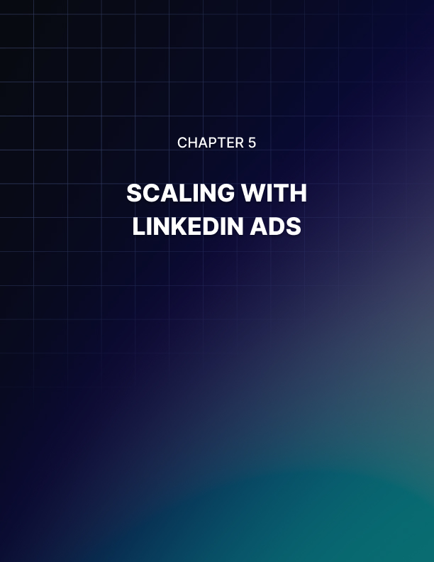

SCALING WITH LINKEDIN ADS
____
Every business dreams of reaching decision-makers who control million-dollar budgets. LinkedIn transforms this dream into reality by connecting you with 180 million senior-level influencers and 63 million decision-makers who actively engage on the platform.
While other advertising channels fight for distracted attention, LinkedIn offers you direct access to professionals when they're focused on business growth and career advancement.
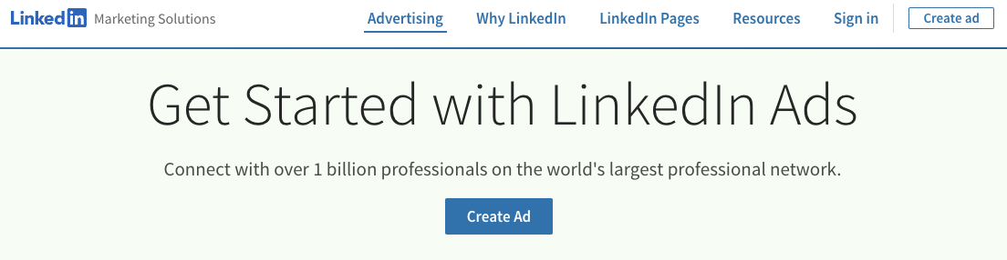

The Professional Advertising Advantage
LinkedIn's unique position in the advertising landscape stems from its foundation in verified professional data.
Unlike platforms that piece together user profiles from likes and shares, LinkedIn builds on concrete professional information that users actively maintain. When professionals update their work history, skills, or achievements, they're helping you create more precise targeting opportunities.
The platform's business-focused environment creates a distinct advantage for your advertising efforts. When professionals log into LinkedIn, they're not seeking entertainment or casual browsing—they're pursuing business opportunities, industry insights, and professional connections. This mindset shift means your ads appear when your audience is most receptive to business propositions and professional development opportunities.
Consider how this professional context influences engagement. A marketing executive browsing LinkedIn at 10 AM on Tuesday approaches content differently than when they're scrolling through Instagram during their evening commute. They're more likely to download your white paper, register for your webinar, or consider your enterprise solution because it aligns with their current professional objectives.
This alignment between user intent and advertising content produces remarkable results. LinkedIn advertisements generate leads with a 277% higher conversion rate compared to Facebook ads, according to HubSpot’s study. The platform's environment encourages meaningful professional interactions, allowing you to build credibility while generating high-quality leads for your B2B offerings.
Understanding LinkedIn's professional ecosystem helps you create more effective advertising strategies. The platform segments its audience based on verified professional attributes, creating natural targeting opportunities across industries, functions, and seniority levels. For example, when targeting IT decision-makers, you can reach them based on their actual role and responsibilities rather than assumed interests or behaviors.

Strategic Targeting for Professional Audiences
LinkedIn's targeting capabilities transform how you reach professional audiences. Instead of relying on broad demographic approximations, you can build sophisticated audience profiles based on professional attributes that directly impact purchasing decisions. This precision helps ensure your advertising budget reaches exactly the right decision-makers within your target organizations.
Your targeting strategy on LinkedIn should start with understanding the platform's unique professional identity layers. These layers are building blocks that combine to create highly specific audience segments. The foundation begins with basic professional attributes like job titles and company information, but the real power comes from combining multiple layers to reach exactly the right audience.
An extensive targeting approach on LinkedIn integrates three key dimensions:
- Professional identity forms your targeting foundation. This includes current job titles, functions, and industries, but extends beyond basic classifications to include skills, certifications, and educational background.
For example, when targeting IT decision-makers, you might combine technical skills in cloud computing with senior IT management titles to reach professionals who both understand and can approve your solution.
- Company context adds organizational perspective to your targeting. This layer considers company size, industry, growth rate, and technological maturity.
You can target organizations based on their LinkedIn page followers, technology stack, or recent hiring patterns. This helps ensure you're reaching professionals at companies that match your ideal customer profile.
- Behavioral signals refine your targeting based on how professionals engage with LinkedIn's ecosystem. This includes group memberships, content engagement patterns, and professional development activities. These signals help identify professionals actively seeking solutions or insights in your area of expertise.
The power of LinkedIn's targeting becomes clear when you combine these dimensions strategically. For example, a cloud security solution provider might target:
- Senior IT managers and directors (professional identity)
- At companies with 1000+ employees (company context)
- Who engage with content about digital transformation (behavioral signals)
- In regulated industries like healthcare or finance (industry focus)
- Located in specific geographic markets (location)
This multi-dimensional targeting helps ensure your ads reach professionals who have both the authority to make purchasing decisions and the context to understand your solution's value. According to LinkedIn's own data, advertisers who combine three or more targeting criteria see up to 37% higher conversion rates compared to those using basic.
Your targeting strategy should evolve based on campaign performance data. LinkedIn's Campaign Manager provides detailed insights into which professional attributes and combinations drive the best results. This allows you to refine your targeting over time, focusing your budget on the most responsive audience segments.

Advanced Audience Development and Optimization
LinkedIn's advanced audience development capabilities help you move beyond basic targeting to create sophisticated, high-converting audience segments. The platform's Matched Audiences feature allows you to integrate your existing customer data with LinkedIn's professional network, creating powerful opportunities for account-based marketing (ABM) and customer journey optimization.
Website retargeting on LinkedIn works differently than other platforms because it captures professional context. When someone visits your website, LinkedIn matches them with their professional profile, providing insights into their role and company.
This enables you to create retargeting campaigns based on both website behavior and professional characteristics. For example, you might create different retargeting messages for C-level executives versus technical evaluators, even if they viewed the same product page.
ABM becomes more effective on LinkedIn because you can target specific companies and job functions within those organizations. This allows you to create coordinated campaigns that reach different stakeholders within your target accounts.
For example, a software company might develop separate message tracks for:
- Technical evaluators focusing on features and implementation.
- Financial decision-makers emphasizing ROI and cost savings.
- Executive sponsors highlighting strategic benefits and competitive advantage.
LinkedIn's progressive profiling capabilities help you build a deeper understanding of your audience over time. As professionals engage with your content, you gather additional insights about their interests and needs. This data helps you create more relevant and personalized advertising experiences, leading to higher conversion rates and better ROI.
To maximize the impact of your LinkedIn advertising, focus on these audience development best practices:
Start with broader targeting parameters and refine based on performance data. This allows you to discover unexpected audience segments that respond well to your message. Monitor key metrics like engagement rate, conversion rate, and cost per lead to identify your most valuable audience segments.
Test different combinations of targeting criteria to find the optimal balance between reach and relevance. While narrow targeting can improve conversion rates, you need sufficient audience size to achieve your campaign objectives. LinkedIn recommends audience sizes of at least 50,000 for most campaign types.
Use LinkedIn's audience expansion features strategically to reach professionals similar to your best-performing segments. This helps you scale successful campaigns while maintaining targeting precision. The platform's algorithm identifies professionals who share key characteristics with your core audience, helping you discover new potential customers.
Your success with LinkedIn advertising ultimately depends on finding the right balance between targeting precision and campaign scale. Focus on creating value for your professional audience while continuously optimizing your targeting strategy based on performance data.
Remember that behind every targeting option is a real professional making important business decisions. Create campaigns that respect their professional context while helping them achieve their objectives.
By mastering LinkedIn's unique targeting capabilities and focusing on delivering value to professional audiences, you'll build campaigns that consistently generate high-quality leads and drive meaningful business results.


CHOOSING THE RIGHT PLATFORM FOR YOUR BUSINESS
____
Every minute you spend advertising on the wrong platform costs you more than just money—it drains resources that could drive real growth elsewhere.
Choosing the wrong platform wastes advertising dollars and misses opportunities to connect with ideal customers.

Businesses using strategically selected advertising platforms often achieve a higher return on ad spend compared to those spreading themselves too thin. Your success hinges not on being everywhere, but on making calculated choices that align with your business DNA.

Making Strategic Platform Decisions
Picture yourself as an investor building a portfolio. Just as you wouldn't invest your life savings based on trending stocks, you shouldn't choose advertising platforms based solely on popularity or current buzz.
Your selection process needs to mirror the methodical approach of a seasoned investor: careful analysis, risk assessment, and strategic allocation of resources. By focusing on platforms that genuinely resonate with your target audience, you'll maximize both impact and efficiency in your marketing efforts.
The stakes couldn't be higher. When you choose the wrong platform, you're not just wasting advertising dollars; you're missing opportunities to connect with ideal customers actively looking for solutions like yours.
Think about how your customers make buying decisions.
A senior executive researching enterprise software solutions brings different expectations and behaviors than a teenager shopping for trendy clothes. Your platform choice must reflect these fundamental differences in buyer behavior.
Consider this example that illustrates the importance of strategic platform selection. A professional services firm initially poured $50,000 into Meta ads because "everyone was doing it." After three months of lackluster results, they analyzed their target audience's behavior and shifted 80% of their budget to LinkedIn.
The result? Their cost per qualified lead dropped by 62%, while conversion rates jumped 285%.
Your platform selection journey starts with brutal honesty about your business capabilities. You need to evaluate your resources across three critical dimensions:
- Technical resources
Different platforms demand varying levels of technical sophistication.
- Google Ads requires a deep understanding of tracking implementation and conversion optimization.
- Meta needs expertise in pixel deployment and audience building.
- LinkedIn demands seamless CRM integration for lead tracking.
Therefore, assess your team's technical capabilities honestly. Having a great product means nothing if you can't properly track and optimize your campaigns.
- Content creation capabilities
Each platform speaks its own content language.
- Meta thrives on visual storytelling through images and short videos.
- LinkedIn demands thoughtful long-form content that demonstrates expertise.
- TikTok requires authentic, trend-aware video content that feels native to the platform.
Your content creation resources must align with your chosen platform's demands.
- Management bandwidth
Running successful ad campaigns requires consistent attention. You need to monitor performance, adjust bids, refresh creative assets, and optimize based on results.
Be realistic about how much time your team can dedicate to platform management. It's better to excel on one platform than to perform poorly across many.

Building Your Multi-Platform Strategy
Think of advertising platforms as instruments in an orchestra. Each plays a unique role, but their true power emerges when they work in harmony.
Your multi-platform strategy needs to leverage each platform's strengths while compensating for individual weaknesses. This requires a deep understanding of how different platforms complement each other throughout the customer journey.
Imagine you're selling high-end consulting services. LinkedIn ads build professional credibility through thought leadership content. Google Ads capture potential clients actively searching for solutions, while Meta ads keep your brand visible through retargeting while nurturing leads with educational content. Each platform serves a specific purpose in moving prospects toward conversion.
Your budget allocation strategy demands careful consideration of both immediate returns and long-term brand building.
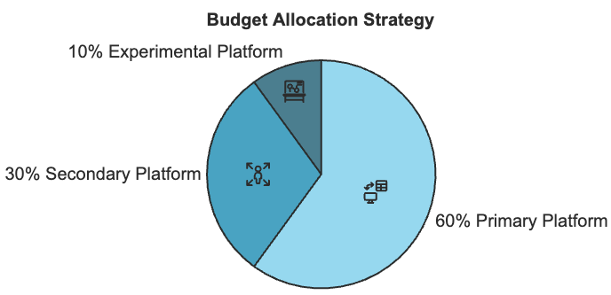
A weighted investment approach often works best:
- Primary platform (60% of budget):
Choose based on where your ideal customers spend most of their professional time and where you're most likely to capture high-intent prospects. This platform gets the lion's share of resources because it drives your core business objectives.
- Secondary platform (30% of budget):
Select a complementary platform that fills gaps in your primary platform's reach or capabilities. If LinkedIn is your primary platform for B2B leads, Google Ads might be your secondary platform for capturing active solution seekers.
- Experimental platform (10% of budget):
Allocate a small portion of your budget to testing new opportunities or emerging platforms. This keeps you ahead of market trends while managing risk.
This allocation isn't static. It should evolve based on performance data and changing business needs. Monitor these key performance indicators across platforms:
- Return on ad spend
- Cost per acquisition
- Lead quality score
- Customer lifetime value
- Brand awareness metrics
Understanding these metrics is crucial for optimizing your advertising strategy.
Lead quality score measures how likely a lead is to convert based on factors like engagement level, company size, and budget fit. For example, a CEO from a Fortune 500 company might score higher than an entry-level employee from a small business.
Customer lifetime value calculates the total revenue you can expect from a customer throughout your entire relationship, including repeat purchases and referrals—like a consulting client who starts with a $5,000 project but eventually brings $50,000 in business over three years.
Lastly, brand awareness metrics help gauge how well people know and recognize your brand, measured through indicators like:
- Brand recall (can people remember your brand when prompted?)
- Brand recognition (do they recognize your logo or name when shown?)
- Social media mentions
- Branded search volume (how often people search specifically for your company name)
- Share of voice (how often your brand is mentioned compared to competitors in your industry)

Implementing Your Platform Strategy
Success requires more than just selecting the right platforms. You need a systematic approach to implementation and optimization.
Start by creating a detailed roadmap that covers technical setup, content creation workflows, and performance monitoring systems. Your technical implementation should follow this sequence:
- Set up robust tracking systems across all platforms.
- Implement conversion tracking and attribution modeling.
- Create a centralized dashboard for cross-platform analysis.
- Establish automated reporting for key metrics.
- Configure integration with your CRM and marketing automation tools.
Content creation demands a platform-specific approach while maintaining brand consistency. For example, a customer success story might be presented differently across platforms:
- LinkedIn: In-depth case study with industry insights and professional analysis
- Google: Landing page optimized for specific search intent
- Meta: Emotional video highlighting customer transformation
- TikTok: Behind-the-scenes glimpse of project implementation
Your optimization strategy should operate on three time horizons:
- Daily optimization
Monitor and adjust basic campaign parameters like bids, budgets, and targeting. React quickly to performance changes and technical issues.
- Weekly reviews
Analyze broader trends, test new creative elements, and adjust audience targeting based on performance data. Schedule regular creative refreshes to combat ad fatigue.
- Monthly strategic assessment
Evaluate platform performance against business objectives, analyze competitor activity, and make major strategic adjustments as needed.

Future-Proofing Your Advertising Strategy
The advertising wor;d evolves constantly with new platforms emerging and existing ones transforming. Build flexibility into your strategy by maintaining awareness of industry trends and emerging opportunities. Stay informed about:
- Platform evolution: Major platforms regularly introduce new features and targeting capabilities. Understanding these changes helps you maintain a competitive advantage.
- Privacy changes: Data protection regulations and platform policies continue to impact advertising capabilities. Build first-party data strategies to reduce reliance on platform-provided targeting.
- Emerging technologies: AI and automation tools increasingly influence campaign management and optimization. Invest in understanding how these technologies can enhance your advertising efforts.
Your platform strategy should grow with your business. Regularly reassess your platform mix as your business objectives evolve and market conditions change. Success in modern advertising requires balancing proven techniques with strategic innovation.
Choosing the right advertising platforms is an ongoing process of analysis, testing, and refinement. Focus on platforms that align with your business objectives and resource capabilities while remaining flexible enough to adapt to new opportunities. Your success depends not on following trends, but on building a sustainable strategy that delivers consistent results for your unique business needs.

