Table of Contents
____

Introduction 4
How Your Brain Handles Focus 7
The Neural Networks of Attention 8
The Battle Between Bottom-Up and Top-Down Processing 10
The Cognitive Cost of Modern Life 12
The Hidden Costs of Cognitive Overload 14
The Distraction Dilemma 18
The Attention Merchants 19
The Architecture of Distraction 21
Reclaiming Your Attention 23
Strengthening Your Focus 25
The Physical Foundation of Focus 26
Engineering Your Focus Environment 28
The Deep Work Protocol 29
Advanced Focus Training 33
The Business of Attention 36
The New Economics of Attention 36
Engineering Attention Systems 39
The Attention Loop Framework 40
The Evolution of Attention Markets 42
The Attention Advantage 45
The Focus Multiplier Effect 46
The Strategic Attention Portfolio 50
The Compounding Power of Deep Attention 52
Mastering Attention 55
The Integration Framework 56
The Acceleration Effect 57
Your Next Steps 59

Disclaimer
____

The information provided in this ebook is intended solely for educational and informational purposes. The author does not accept any responsibility for the outcomes that may arise from the application of the material within. While efforts have been made to ensure the accuracy and relevance of the content, the author cannot be held accountable for any errors or omissions, or for any consequences resulting from the use or misuse of the information provided. The responsibility for any actions taken based on the information in this ebook lies solely with the reader.



Introduction
____
Y
our attention is under constant assault. Every notification, headline, and advertisement fights for a slice of your mental energy—the most precious resource you possess. This relentless competition for your focus isn't just a minor distraction. It shapes how you think, work, and live.
While money can be earned and time can be managed, your attention remains finite. Once spent, it's gone forever. This reality makes your ability to direct and protect your focus more valuable than ever before.
The average professional switches tasks every three minutes and requires nearly half an hour to regain deep focus after each interruption. Meanwhile, tech companies employ thousands of engineers and psychologists whose sole purpose is to capture and hold your attention through increasingly sophisticated methods.
The result? A world where maintaining sustained concentration has become an extraordinary challenge, and an extraordinary advantage for those who master it.
What separates highly successful individuals from others isn't just their talent or work ethic—it's their ability to direct their attention with laser-like precision toward their most important goals.
They understand that attention management supersedes time management in importance. While everyone has the same 24 hours, those who can maintain unwavering focus on critical tasks consistently outperform those who allow their attention to scatter across countless distractions.
This book offers a practical framework for taking control of your attention in a world designed to fragment it. You'll discover how your brain processes focus, why modern technology poses unique challenges to concentration, and most importantly, how to strengthen your attention muscle through proven techniques and strategies. Whether you're an entrepreneur building a business, a professional advancing your career, or a creator developing your platform, you'll learn how to transform your attention from a vulnerability into your greatest competitive advantage.
The skills you'll gain extend far beyond productivity enhancement. By mastering your attention, you'll experience deeper relationships, more meaningful work, and greater clarity in decision-making. You'll learn to filter out the noise that clouds your judgment and zero in on opportunities others miss.
This isn't just about doing more. It's about doing what matters with unprecedented intensity and purpose.
The battle for your attention is real, but you don't have to be a passive participant. Through the principles and practices shared in these pages, you'll develop the focus required to thrive in an increasingly distracted world. Your success story begins with a simple choice: deciding where to direct your attention right now.

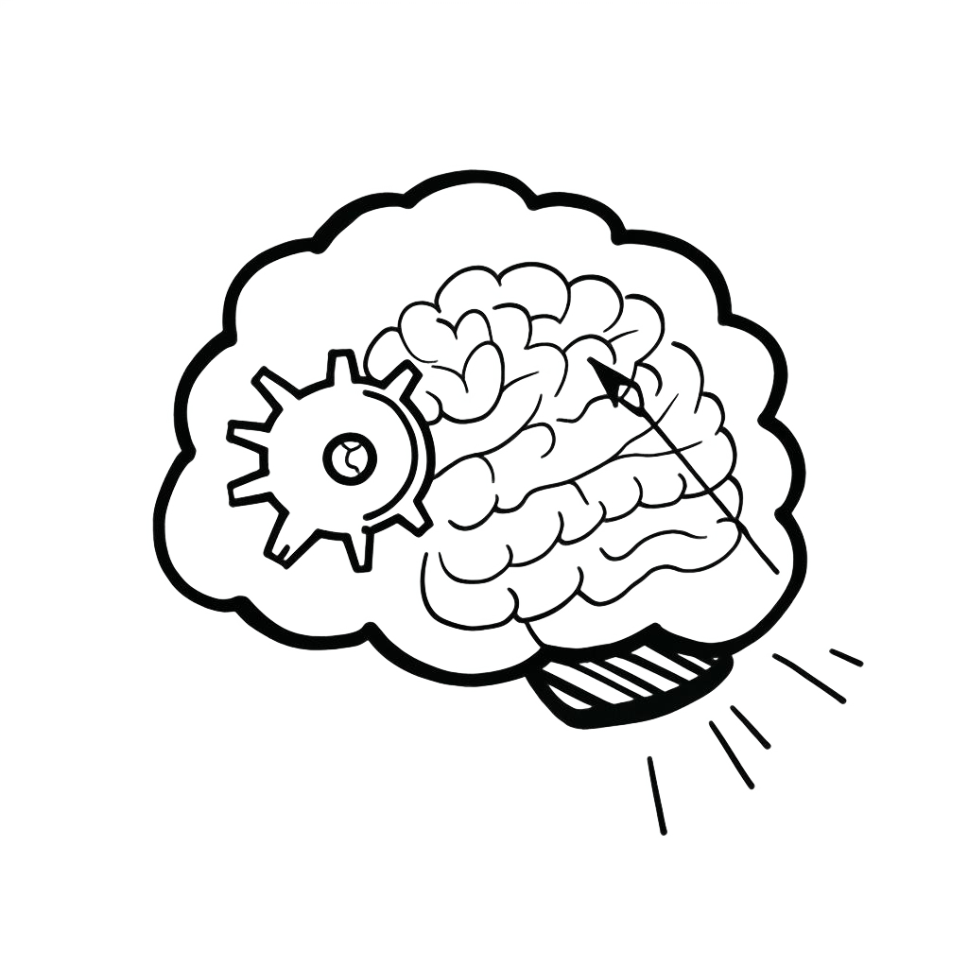

How Your Brain Handles Focus
____
Y
our brain processes an astounding 11 million bits of information every second, yet your conscious mind can only handle about 50 bits, according to an article from Britannica. This remarkable disparity reveals the sophisticated filtering system your brain employs to manage the constant stream of information bombarding your senses.
Recent studies show that the average attention span has decreased from 12 seconds in 2000 to just 5 seconds in 2022 according to a study from Microsoft, making it more critical than ever to understand how your attention works.

The Neural Networks of Attention
Your brain's attention system operates through three distinct but interconnected networks, each playing a vital role in how you process and respond to the world around you. Understanding these networks is crucial for mastering your focus in an increasingly distracting environment.
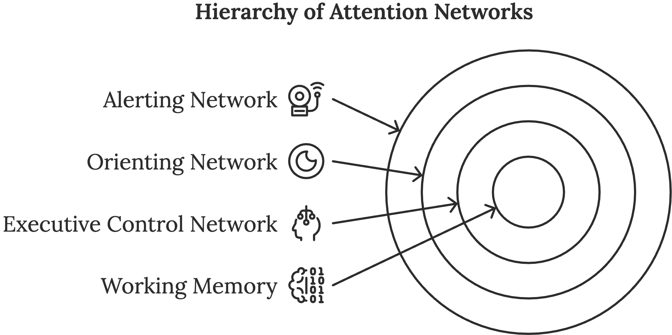
The alerting network functions as your brain's vigilance system, maintaining your readiness to process incoming information. Picture it as an always-on security system, monitoring your environment for potential threats or opportunities. This network becomes particularly active during tasks requiring sustained attention, such as driving on a long highway or listening to an extended lecture. The alerting network relies heavily on norepinephrine, a neurotransmitter that regulates alertness and attention.
The orienting network serves as your brain's spotlight operator, directing your attention to specific sensory inputs. When you're reading a book in a café and suddenly hear someone call your name, it's your orienting network that shifts your attention from the text to the voice. This network involves several brain regions, including the superior parietal lobe and the temporal-parietal junction, working together to help you prioritize and process sensory information effectively.
The executive control network, residing primarily in your prefrontal cortex, acts as your brain's CEO. This sophisticated system manages complex attention tasks, including decision-making, planning, and conflict resolution.
When you're trying to focus on writing an important email while ignoring the temptation to check social media, your executive control network is hard at work. This network relies on dopamine and other neurotransmitters to function optimally.
Your working memory operates in close conjunction with these attention networks, serving as a temporary mental workspace. Think of it as your brain's RAM, holding and manipulating information you're currently processing.
However, this workspace has strict limitations. Most people can only hold about four to seven items in their working memory at once. Understanding these limitations is crucial for managing your cognitive load effectively.

The Battle Between Bottom-Up and Top-Down Processing
Your attention system employs two main processing mechanisms that constantly compete for control over your focus. Understanding this battle helps you recognize why certain distractions are so powerful and how you can better manage them.
Bottom-up processing represents your brain's automatic response to sudden or striking stimuli. This evolutionary mechanism kept your ancestors alive by instantly alerting them to potential threats or opportunities.
When your phone vibrates in your pocket or a flash of movement catches your eye, that's bottom-up processing in action. This system operates through several key characteristics, including automaticity, sensory primacy, and the ability to override conscious attention for survival-relevant information.
Your bottom-up attention system is:
- Automatically triggered by external stimuli
- Processed through the amygdala and other primitive brain regions
- Lightning-fast in response time
- Difficult to suppress or ignore
- Heavily influenced by contrast and change in your environment
In modern environments, this ancient survival mechanism often works against you. The ping of a notification triggers the same automatic response that once helped spot predators, making it extremely difficult to maintain focus in technology-rich environments. Understanding this biological vulnerability helps explain why digital distractions are so powerful: they're essentially hijacking a system designed for survival.
Top-down processing represents your conscious control over attention, operating through your prefrontal cortex and other higher-order brain regions. This system is goal-directed and influenced by your knowledge, expectations, and current objectives. When you're actively searching for your keys or focusing on a specific conversation in a noisy restaurant, you're engaging in top-down processing.
Your top-down attention system is:
- Voluntarily controlled and directed
- Guided by your goals and intentions
- More cognitively demanding
- Crucial for learning and complex tasks
- Susceptible to fatigue and depletion
The reticular activating system (RAS) acts as a mediator between these two processing systems. Located in your brainstem, the RAS functions as a gatekeeper, determining which information reaches your conscious awareness. When you're looking to buy a new car and suddenly notice every vehicle matching your desired model, that's your RAS at work, prioritizing information relevant to your current goals and interests.

The Cognitive Cost of Modern Life
The myth of multitasking continues to persist despite overwhelming evidence that the human brain cannot effectively perform multiple attention-demanding tasks simultaneously. What we perceive as multitasking is actually task-switching, and this constant shifting of attention comes with significant cognitive costs.
When you switch between tasks, your brain must:
- Disengage from the current task
- Store relevant information in working memory
- Activate new task-relevant neural networks
- Recall and apply different rules or parameters
- Begin processing the new task
This switching process creates what neuroscientists call "attention residue"—the lingering thoughts and mental energy devoted to previous tasks that impair your performance on current ones.
Research from the University of California, Irvine, shows that it takes an average of 23 minutes to fully regain focus after an interruption, and can dramatically increase your error rate during this recovery period.
Environmental factors play a crucial role in your ability to maintain focus. Your brain's attention systems are heavily influenced by:
- Physical environment (noise levels, lighting, temperature)
- Digital environment (notification frequency, screen exposure)
- Social environment (presence of others, social expectations)
- Physiological state (hunger, fatigue, stress levels)
- Time of day (circadian rhythms)
The dopamine-attention connection represents another crucial aspect of modern attention challenges. Your brain's reward system, primarily driven by dopamine, has been expertly exploited by technology companies to create addictive engagement patterns. Every notification, like, or share triggers a small dopamine release, creating a pleasure response that makes you want to repeat the behavior.
This dopamine loop functions through:
- Anticipation of reward (notification)
- Action (checking device)
- Variable reward delivery (which may or may not be important)
- Temporary satisfaction
- Return to anticipation state
Understanding how this dopamine cycle affects your attention is crucial for developing effective focus strategies. When you receive a notification, your brain releases dopamine in anticipation of a potential reward. This creates a powerful urge to check your device, even when you're engaged in important work. The variable nature of these rewards (sometimes the notification is important, sometimes it's not) makes the cycle particularly addictive, similar to how slot machines keep players engaged.
These days, people check their phones up to hundreds of times per day, or once every few minutes during waking hours. Each check initiates this dopamine cycle, creating a constant state of partial attention that significantly impacts your cognitive performance.

The Hidden Costs of Cognitive Overload
Your brain's processing capacity follows specific patterns and limitations that, when exceeded, can lead to significant decreases in performance. Understanding these patterns helps you optimize your mental resources and maintain peak cognitive function.
Cognitive load theory explains how your mental resources are distributed across three distinct types of demands:
The intrinsic load represents the inherent difficulty of the task you're performing. Complex problems, like solving mathematical equations or analyzing financial data, create a higher intrinsic load than simple tasks like checking email.
The extraneous load comes from unnecessary mental effort caused by poor task design or environmental distractions. This might include trying to read a poorly formatted document or working in a noisy office space.
The germane load involves the mental effort required for learning and creating lasting memories. This type of cognitive load is essential for skill development and knowledge retention.
When these combined loads exceed your brain's processing capacity, you experience cognitive overload, leading to:
- Decreased decision-making ability
- Reduced creativity
- Increased error rates
- Slower processing speed
- Impaired memory formation
Your focus threshold represents the point at which your ability to maintain attention begins to deteriorate. This threshold varies throughout the day based on multiple factors:
- Circadian rhythms influence your natural energy and attention patterns. Most people experience peak cognitive performance in the morning, followed by an afternoon dip and a smaller evening peak.
- Physical state significantly impacts your attention capacity. Hunger, fatigue, and stress can all lower your focus threshold.
- Previous cognitive demands affect your current attention abilities. Just as physical exercise depletes your muscles, mental effort depletes your cognitive resources.
- Environmental conditions play a crucial role. Temperature, noise levels, and lighting can all impact your ability to focus.
Understanding these limitations helps you recognize when you're approaching your focus threshold. Key warning signs include:
- Increased error rates in simple tasks
- Difficulty remembering recent information
- Physical restlessness or fidgeting
- Heightened distractibility
- Physical symptoms like headaches or eye strain
The modern workplace often ignores these biological limitations, expecting constant high performance without accounting for natural attention cycles. Your brain naturally operates in roughly 90-minute cycles of high-to-low attention, known as ultradian rhythms. Working with these rhythms, rather than against them, can significantly improve your cognitive performance.
Your brain's attention networks are also heavily influenced by your physical environment. Even brief exposure to nature can restore attention capacity and reduce mental fatigue. A study published in the Journal of Environmental Psychology found that just 40 seconds of looking at a green roof improved focus compared to viewing a concrete roof.
Screen exposure presents another significant challenge to your attention systems. The blue light emitted by digital devices can disrupt your circadian rhythms, affecting sleep patterns and next-day cognitive performance. Additionally, how you consume digital content (often in short, fragmented bursts) may be reducing your capacity for sustained attention.
The solution isn't to abandon technology but to use it more intentionally. Understanding how your attention systems work allows you to create environments and habits that support rather than undermine your focus. By recognizing the biological basis of attention, you can develop strategies that work with your brain's natural tendencies instead of fighting against them.
Your attention is not just about willpower. It's also about understanding and working with your brain's sophisticated but limited processing systems.



The Distraction Dilemma
____
E
ach time you unlock your smartphone, you enter a battlefield where thousands of the world's brightest minds compete for your attention. Your average day might involve processing thousands of advertisements, responding to more than a hundred emails, and checking your phone hundreds of times. Behind these seemingly innocent interactions lies an intricate system engineered to capture and monetize every moment of your conscious awareness.
As you read this sentence, algorithms could be analyzing your behavior, predicting your next move, and adjusting their strategies to keep you engaged. Your attention has become the most valuable commodity in a $500 billion attention economy, traded like oil or gold between technology companies and advertisers.

The Attention Merchants
The modern attention economy operates on a deceptively simple premise: your time and mental focus are valuable resources that can be harvested and sold. However, unlike traditional commodities, attention merchants have developed increasingly sophisticated methods to extract this resource without you noticing the transaction.
Today's attention merchants employ a three-tiered approach to capture and monetize your focus:
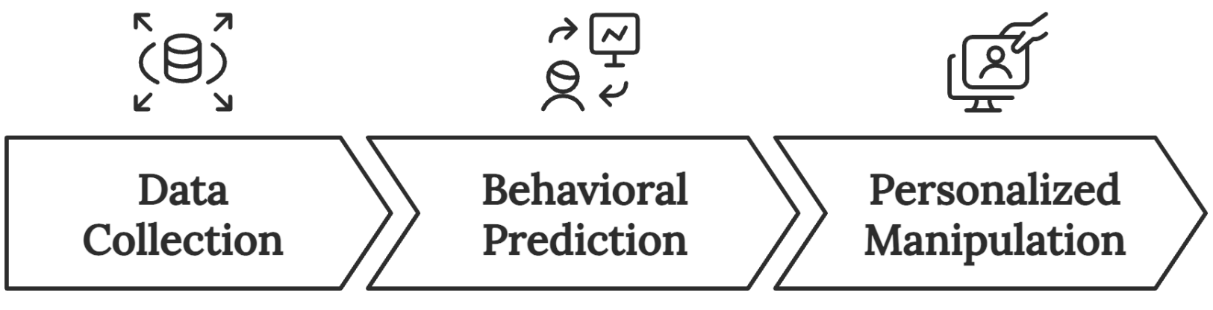
- Data Collection
Every interaction you have with digital platforms generates data points that create detailed psychological profiles. When you pause while scrolling, hover over an image, or click a link, these micro-behaviors are recorded and analyzed to understand your preferences and vulnerabilities.
- Behavioral Prediction
Advanced machine learning algorithms process this data to predict your future behavior with startling accuracy. These systems can anticipate when you're most likely to make a purchase, feel emotionally vulnerable, or be susceptible to certain types of content.
- Personalized Manipulation
Armed with these insights, platforms deliver precisely targeted content and experiences designed to maximize your engagement. This manipulation occurs through what former Mozilla and Jawbone designer James Williams calls "persuasive technology"—systems engineered to change how you think and behave.
The economics of attention capture have created a market where your focus is bought and sold in real-time auctions. Major platforms like Facebook and Google don't just sell advertising space; they sell guaranteed attention, backed by sophisticated targeting capabilities that can reach you at your most vulnerable moments.
These revenue figures per user demonstrate the varying monetization capabilities across major social media platforms:
- Facebook - $50.00 per user annually
- YouTube - $15.15 per user annually
- TikTok - $19.00 per user annually
- Twitter - $12.89 per user annually
These numbers represent the minimum value these platforms extract from your attention. The actual cost to your productivity, well-being, and cognitive capacity is far higher.

The Architecture of Distraction
Modern technology platforms employ persuasive design, a combination of psychological triggers, user interface elements, and algorithmic optimization that creates powerful engagement loops. These systems are built on decades of research in behavioral psychology and neuroscience, refined through constant A/B testing and real-time data analysis.
The core components of persuasive design include:
Variable Reward Systems - Just as slot machines use unpredictable payouts to create addiction, social media platforms implement variable reward schedules through likes, comments, and notifications. This unpredictability triggers dopamine releases that create powerful psychological dependencies.
Social Validation Loops - Platforms exploit your fundamental need for social acceptance by creating metrics that quantify your social worth. Every like, share, or follower becomes a measure of your value, creating an endless cycle of seeking validation through platform engagement.
Infinite Content Streams - The removal of natural stopping points through features like infinite scroll eliminates decision points where you might choose to disengage. This creates a ludic loop (aka doom scrolling), a trance-like state where you continue consuming content without conscious decision-making.
Time Pressure and Scarcity - Platforms create artificial urgency through features like disappearing content, limited-time offers, and "trending" indicators. These triggers exploit your fear of missing out (FOMO) and create compulsive checking behaviors.
The effectiveness of these techniques is enhanced by sophisticated AI systems that learn from your behavior in real time. These algorithms don't just predict what content you'll engage with; they actively shape your preferences and behaviors through carefully curated content delivery.
The core mechanism behind this manipulation is the dopamine feedback loop:
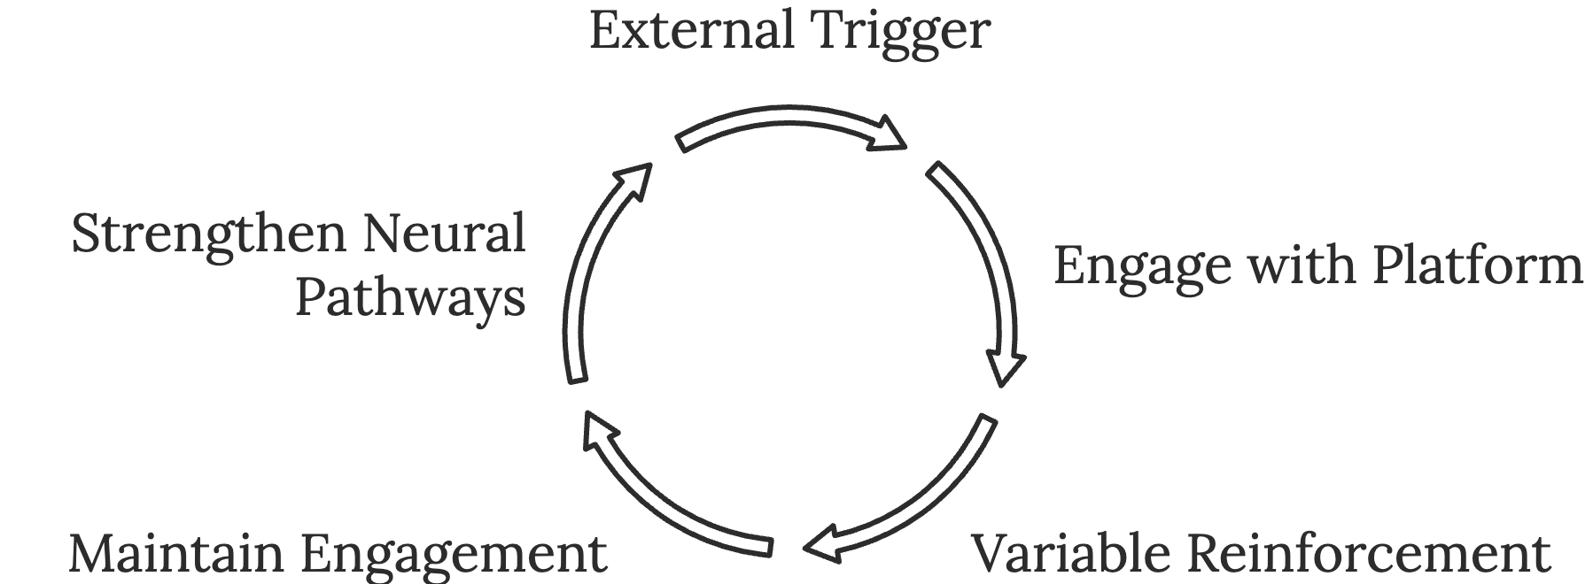
- An external trigger (notification, email, or alert) captures your attention.
- You engage with the platform, seeking a reward.
- Variable reinforcement creates uncertainty about when the next reward will come.
- This uncertainty maintains engagement through anticipation.
- The cycle repeats, strengthening neural pathways associated with the behavior.

Reclaiming Your Attention
Understanding how attention capture works is the first step toward regaining control. The next step involves developing practical strategies for maintaining agency in an environment designed to hijack your focus.
Recognition is your first line of defense. Learn to identify manipulation attempts by watching for these warning signs:
- Feeling anxious when separated from your device
- Losing track of time while using platforms
- Checking notifications compulsively
- Comparing your life to others' online presentations
- Feeling the need to document experiences for social media
Digital boundaries help create space between you and attention-capturing systems. Implement these protective measures:
- Designate device-free zones in your home.
- Set specific times for checking email and social media.
- Use screen time tracking apps to monitor your usage.
- Implement website blockers during focused work periods.
- Create morning and evening routines that don't involve screens.
Alternative activities reduce your dependence on digital stimulation. Build a repertoire of engaging offline activities:
- Reading physical books
- Practicing mindfulness or meditation
- Engaging in creative hobbies
- Spending time in nature
- Cultivating face-to-face relationships
The future of attention management will require increased vigilance as technology becomes more sophisticated. Virtual and augmented reality (AR), artificial intelligence (AI), and new forms of social pressure will create novel challenges for maintaining cognitive autonomy.
Your attention is too valuable to surrender to systems designed to exploit it. By understanding the mechanisms of attention capture and implementing strategic defenses, you can use technology's benefits while avoiding its pitfalls.
Every moment of focus you protect is an investment in your productivity, well-being, and personal growth. The secret lies not in complete abstinence but in developing a mindful, intentional relationship with digital tools.

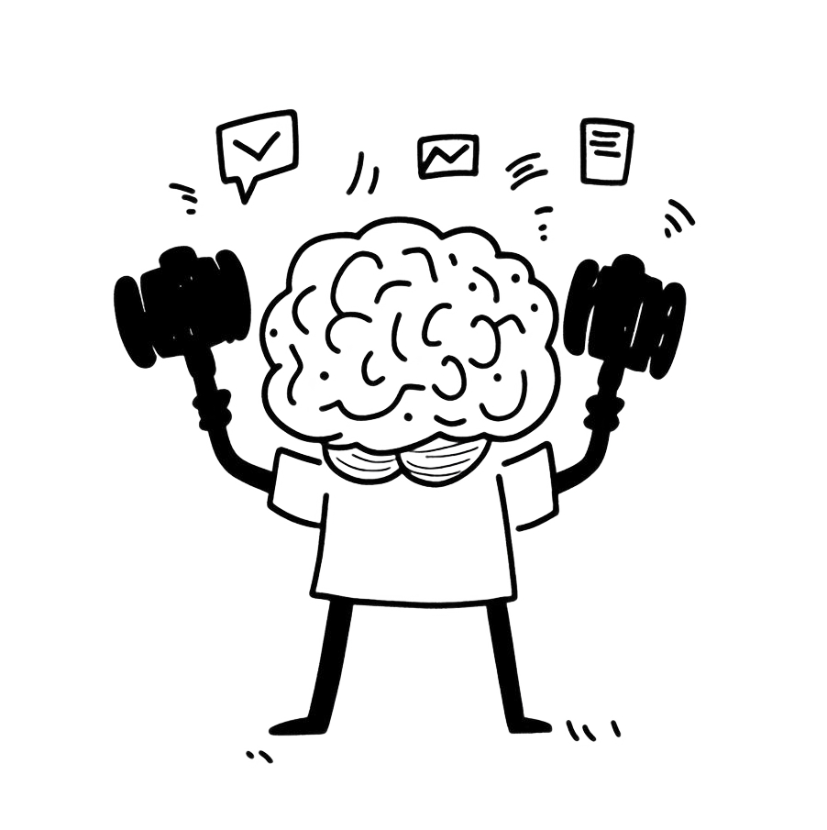

Strengthening Your Focus
____
Y
ou’re in the middle of an important presentation. Your mind wanders to an unfinished email, your afternoon meeting, and that argument you had at breakfast. Suddenly, you realize your audience is staring expectantly, waiting for an answer to a question you didn't hear.
Now contrast this with another scenario: You're deeply immersed in crafting that same presentation, ideas flowing effortlessly, each point building naturally on the last, completely absorbed in the task at hand.
The difference between these two experiences isn't luck or natural talent. It's the result of deliberately trained attention.

The Physical Foundation of Focus
Your brain operates like a high-performance sports car. It requires premium fuel, regular maintenance, and optimal conditions to perform at its peak.
Before diving into mental techniques, you must first establish the physical infrastructure that supports sustained attention. Individuals who optimize these fundamental elements tend to experience significant improvement in their ability to maintain focus over extended periods.
See your attention as a powerful spotlight that illuminates whatever it touches. Just as a spotlight requires stable power and proper maintenance to function effectively, your brain's attention system depends on specific physical conditions. The foundation of focus begins with three critical elements: sleep, nutrition, and movement.
Your brain's ability to maintain focus directly correlates with sleep quality. During deep sleep phases, your brain performs essential maintenance tasks, consolidating memories and clearing out neural waste products that accumulate during waking hours. This cleaning process, known as the glymphatic system, works ten times more effectively during sleep than while awake.
Without adequate sleep, your attention system operates like a spotlight with a flickering bulb—unstable and unreliable. To optimize your sleep for maximum focus:
- Maintain consistent sleep and wake times, even on weekends, to regulate your circadian rhythm.
- Create a gradual wind-down routine starting 90 minutes before bed.
- Keep your bedroom temperature between 65–68°F (18–20°C) for optimal sleep conditions
- Eliminate all sources of blue light exposure in the hour before sleep.
- Use white noise or nature sounds to mask disruptive ambient noise.
- Invest in a high-quality mattress and pillows that support proper sleep posture.
Your brain's energy requirements are extraordinarily high, consuming approximately 20% of your body's total energy despite representing only 2% of your body weight. This disproportionate energy consumption means that proper nutrition plays a crucial role in maintaining focus. A review published in the Journal of the American College of Nutrition shows that even dehydration by just 2% can impair attention and cognitive performance.
Strategic eating can significantly impact your attention span. Start your day with protein-rich foods to stabilize blood sugar levels and provide sustained energy. Include omega-3 fatty acids through sources like fatty fish, walnuts, or supplements, as these essential fats support neural communication and reduce inflammation. Maintain consistent hydration throughout the day, aiming for clear or light yellow urine as an indicator of proper hydration status.
Movement serves as the third pillar of focus foundation. Regular physical activity enhances attention through multiple mechanisms:
- Increased cerebral blood flow, delivering more oxygen and nutrients to brain cells
- Enhanced production of BDNF (brain-derived neurotrophic factor), which supports neural growth and plasticity
- Reduced levels of stress hormones that can interfere with attention
- Improved sleep quality, creating a positive feedback loop for cognitive performance
- Better oxygen utilization at the cellular level

Engineering Your Focus Environment
Your workspace exerts a powerful influence on your ability to maintain attention. Workers in optimized environments tend to be more productive and experience less mental fatigue compared to those in standard office settings. The key lies in understanding and controlling four critical environmental dimensions: visual, auditory, thermal, and air quality.
Start with your visual environment. Your brain constantly processes visual information, even when you're not consciously aware of it. A cluttered workspace forces your brain to continuously filter out irrelevant visual information, depleting cognitive resources that could be better used for focused work. Create a clean, organized workspace with only essential items visible. Position your primary work surface to take advantage of natural light while avoiding glare on screens.
The acoustic environment plays an equally crucial role in supporting or undermining focus. While complete silence works best for some people, others find that a moderate level of ambient noise (around 40–50 decibels) actually enhances concentration. This phenomenon, known as stochastic resonance, occurs when a specific level of background noise helps to stabilize neural firing patterns related to attention.
Temperature and air quality, often overlooked, significantly impact cognitive performance. Research from Harvard University found that cognitive function scores were significantly higher in green building conditions with enhanced ventilation compared to conventional building conditions. Maintain room temperature between 70–72°F (21–22°C), and ensure regular air circulation to keep CO2 levels below 1000 parts per million.

The Deep Work Protocol
Deep work is like mental weight lifting; it requires proper form, progressive overload, and strategic recovery periods. Just as athletes don't start with maximum weights, you'll build your focus capacity gradually through structured practice.
Your deep work journey begins with selecting the appropriate protocol for your situation. Try to implement these four approaches, each designed for different work contexts and lifestyle demands:
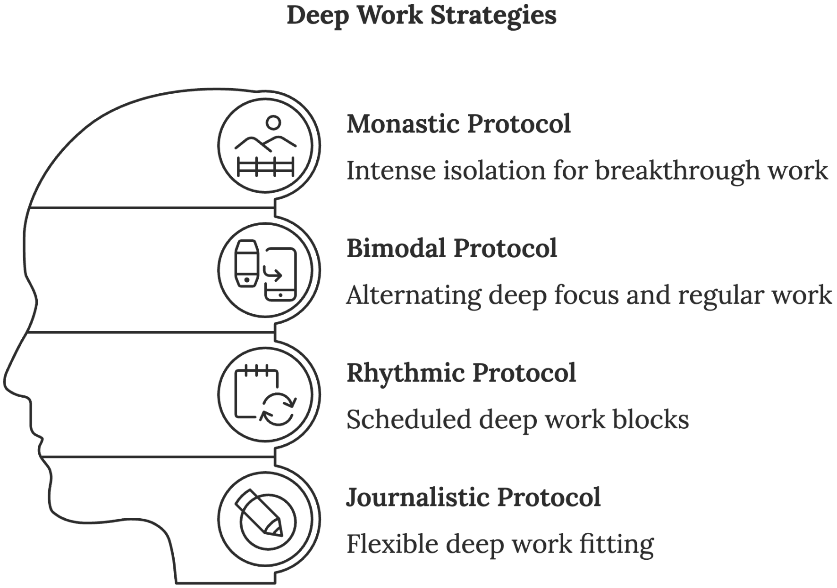
The monastic protocol represents the most intense form of deep work, involving extended periods of complete isolation from distractions. This approach suits projects requiring breakthrough thinking or complex problem-solving. Picture a writer retreating to a cabin to complete a novel or a researcher dedicating several weeks to solving a mathematical proof. While extreme, this protocol produces extraordinary results for those who can implement it.
To implement the monastic protocol:
- Identify a specific high-value project that justifies intense focus.
- Schedule extended blocks of complete isolation (days or weeks).
- Arrange for all routine responsibilities to be handled by others.
- Create clear boundaries and expectations with stakeholders.
- Establish specific success metrics to measure progress.
- Prepare your environment for sustained deep work.
The bimodal protocol offers a more practical approach for professionals who can't completely disconnect from their regular responsibilities. This method alternates between periods of deep focus and regular work, creating a rhythm that accommodates both intense concentration and necessary shallow work. Think of it as interval training for your attention—periods of high-intensity focus followed by recovery periods of routine tasks.
Implementing the bimodal protocol requires careful planning:
- Block out specific days or half-days dedicated solely to deep work.
- Create distinct transitions between deep and shallow work modes.
- Maintain separate workspaces for different types of work.
- Develop different communication protocols for each mode.
- Track and analyze your productivity patterns to optimize the timing and duration of each mode.
The rhythmic protocol represents the most accessible approach for most knowledge workers. It involves scheduling regular, shorter blocks of deep work (typically 90 minutes to 4 hours) at consistent times each day. This method builds on your brain's natural ultradian rhythm—the 90-minute cycles of high-to-low energy that occur throughout the day.
Successful implementation of the rhythmic protocol involves:
- Scheduling deep work blocks at the same time each day to establish a routine
- Using time-blocking to protect these periods from interruptions
- Creating clear start and end rituals to signal your brain when to shift modes
- Tracking your deep work hours to build momentum and maintain accountability
- Adjusting block duration based on your energy patterns and work requirements
The journalistic protocol provides flexibility for those with unpredictable schedules. Named after journalists who must write thoughtfully on tight deadlines, this approach involves fitting deep work into whatever time becomes available. While challenging, it can be highly effective when combined with proper preparation and rapid transition techniques.

Advanced Focus Training
Beyond basic protocols, advanced focus training involves systematically developing your attention capacity through progressive challenges and strategic recovery. It’s akin to building your mental endurance. Just as a marathon runner follows a structured training plan, you'll develop your focus through systematic practice.
Start with progressive loading, a technique borrowed from athletic training. Begin with manageable focus periods and gradually increase duration while maintaining quality:
Week 1–2
- Structure work into 25-minute focused sessions with 5-minute breaks.
- Track completion rate and quality metrics.
- Practice transition techniques between tasks.
- Build awareness of attention patterns.
Week 3–4
- Extend sessions to 45 minutes.
- Introduce more complex tasks.
- Begin combining different types of work.
- Monitor energy levels throughout.

Week 5–6
- Advance to 60-minute sessions.
- Add cognitive challenges during focus periods.
- Practice recovering from interruptions.
- Refine environment and protocols.
Week 7–8
- Target 90-minute sustained focus periods.
- Integrate multiple projects within sessions.
- Develop personalized optimization techniques.
- Create sustainable long-term practices.
The advanced practitioner employs attention anchoring, which entails creating stable reference points that help maintain focus during challenging work. This technique involves selecting specific environmental, physical, or mental cues that signal your brain to enter and maintain a focused state. For example, a particular piece of music, a specific seated position, or a pre-work ritual can serve as powerful anchors for attention.
Focus stacking combines multiple techniques to create compound benefits. Like a master chef layering flavors in a complex dish, you'll combine physical optimization, environmental control, and mental techniques to achieve peak performance.

A comprehensive focus stack might include:
- Morning movement practice to activate the body
- Strategic caffeine timing for optimal alertness
- Environmental customization for peak focus
- Deep breathing techniques during transitions
- Attention anchoring through consistent cues
- Progressive loading of task complexity
- Strategic recovery periods between sessions
Mastering these techniques requires patience and consistent practice. You're not just learning skills; you're rewiring neural pathways and establishing new patterns of behavior. Track your progress, adjust your approach based on results, and celebrate small improvements along the way. With dedicated practice, you'll develop the ability to direct your attention with precision and maintain focus with remarkable endurance.



The Business of Attention
____
E
very second, five hundred hours of video content are uploaded to YouTube, seventeen thousand tweets fly across Twitter, and two million emails flood inboxes worldwide. You have exactly 8 seconds to break through this noise before your potential customers shift their focus elsewhere. This relentless competition for attention shapes modern business success more powerfully than any other factor—even product quality or price point.

The New Economics of Attention
Think of attention as the new oil of the information age. Just as petroleum powered the industrial revolution, human focus drives today's knowledge economy. But attention differs from traditional resources in fascinating ways.
While everyone receives a fresh supply each morning, it depletes throughout the day and can't be stored or saved. This unique characteristic transforms attention into arguably the most precious—and challenging to manage—business resource.
When customers give you their attention, they make an investment more valuable than money. They trade their limited cognitive bandwidth for the promise of value in return.
Research from the Nielsen Norman Group reveals that businesses capturing just 30 additional seconds of user attention per session typically see a 23% increase in customer lifetime value. E-commerce platforms that extend visitor focus by one minute experience 4.7% higher conversion rates on average. These metrics illuminate the direct pathway from attention to revenue.
The relationship between sustained attention and brand building operates through multiple psychological mechanisms. When people consistently direct their focus toward your brand, it triggers the mere exposure effect, or the tendency to develop preferences for things simply because they're familiar. This explains why brands that successfully capture and maintain attention often experience exponential rather than linear growth in market share.
Calm transformed from a small meditation app startup into a billion-dollar company by mastering attention management. Their success didn't stem from having superior meditation content, because plenty of free alternatives exist.
Instead, they excelled at capturing and directing attention through strategic content delivery and experience design. By understanding that attention functions as currency in the modern economy, they built their entire business model around optimizing this crucial resource.
Your business must treat attention as a portfolio requiring careful management and strategic allocation. Just as financial investors diversify across assets, you need to balance different types of focus across various business activities. This might mean spending 30% of your attention capital on product development, 40% on customer relationships, 20% on team coordination, and 10% on market research. The exact ratios depend on your business model and growth stage, but the principle remains: conscious attention allocation drives better outcomes than reactive distribution.
The concept of attention arbitrage presents unique opportunities in modern markets. Just as financial arbitrageurs profit from price differences across markets, attention arbitrageurs identify and exploit gaps between where attention currently flows and where it generates maximum value. This might mean entering neglected market niches, utilizing undervalued communication channels, or addressing overlooked customer pain points.
LinkedIn provides a perfect example of attention arbitrage in action. While most businesses fight for attention on oversaturated platforms like Instagram and Facebook, companies focusing on LinkedIn's B2B ecosystem often find dramatically higher engagement rates and conversion opportunities. The platform's organic reach remains significantly higher than other social networks, yet many businesses overlook its potential for attention capture.

Engineering Attention Systems
Creating scalable attention management systems represents the next frontier in business optimization. These systems should automate routine decisions, streamline communication flows, and establish clear protocols for attention allocation.
Amazon exemplifies this approach through its famous "two-pizza team" rule. If a team requires more than two pizzas to feed, it's too large to effectively coordinate attention and communication.
The science of sticky brand experiences has evolved significantly in recent years. Creating memorable brand interactions requires orchestrating attention residue, the lingering mental effects that continue after initial exposure. This explains why some brands maintain mindshare even when they're not actively engaging with customers.
Your attention architecture must consider both psychological principles and engagement mechanics. It’s like designing a building: you need strong foundations (core value proposition) and carefully planned pathways (user journey) that guide people where you want them to go. This requires understanding the fundamental drivers of human attention:
- Pattern Interruption - Breaking expected sequences captures immediate focus
- Story Architecture - Narrative structures maintain engagement over time
- Value Layering - Multiple benefit levels within single content pieces
- Curiosity Gaps - Strategic information asymmetries drive continued interest
- Social Proof - Collective attention validates individual focus decisions
TikTok's algorithmic content delivery system showcases masterful attention architecture. The platform doesn't simply display content—it learns from your attention patterns, continuously refining its understanding of what captures and holds your focus. This creates a powerful feedback loop that makes the platform increasingly engaging over time. Their success offers valuable lessons for any business seeking to architect attention-driven experiences.

The Attention Loop Framework
Creating sustainable business growth requires moving beyond simple attention capture to engineering attention loops, or self-reinforcing cycles of engagement that generate increasing returns over time. These loops transform one-time attention into ongoing engagement, creating compound returns on initial attention investments.
Take Tesla's attention loop as an example. Their product innovations capture initial interest, which drives social media discussion, leading to media coverage, sparking more public curiosity, driving further innovation investments. Each cycle strengthens the company's ability to capture and maintain attention in the future. This self-reinforcing system means Tesla spends far less on traditional advertising than competitors while maintaining superior mindshare.
The key components of effective attention loops include:
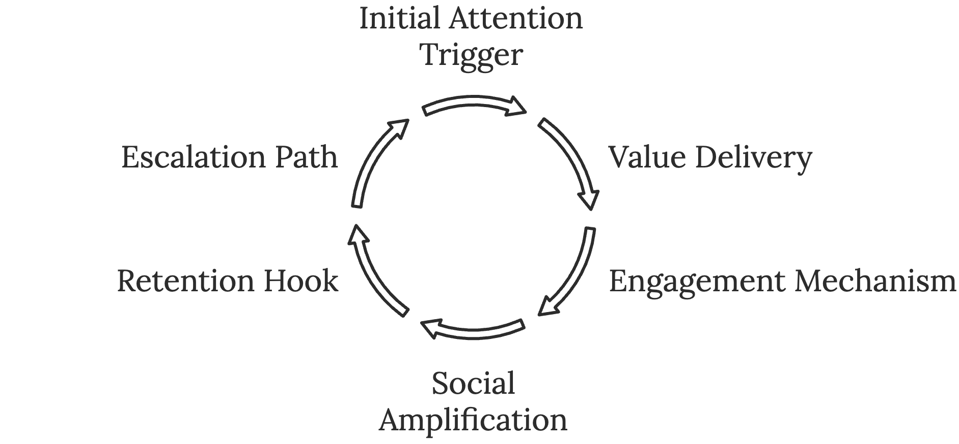
- Initial Attention Trigger - A compelling reason for people to first engage
- Value Delivery - Immediate benefit that justifies the attention investment
- Engagement Mechanism - A way for people to deepen their involvement
- Social Amplification - Features that encourage sharing and discussion
- Retention Hook - A reason to return and continue engaging
- Escalation Path - Opportunities for increasing engagement over time
Understanding how to measure and optimize attention requires sophisticated analytics systems that transcend traditional engagement metrics. While page views and click-through rates provide basic insights, truly understanding attention demands analysis of multiple engagement layers:
- Depth of Engagement - How thoroughly people interact with content
- Attention Quality - The level of focus during interactions
- Retention Patterns - How attention changes over time
- Cross-Channel Attribution - How attention flows between platforms
- Conversion Efficiency - How effectively attention translates to desired outcomes

The Evolution of Attention Markets
As technology advances, several emerging trends reshape how businesses compete for and leverage attention. AI increasingly mediates attention through sophisticated algorithms matching content with receptive audiences. This requires developing new strategies for working with AI attention gatekeepers while maintaining authentic human connections.
The rise of the creator economy democratizes attention capture, allowing individuals and small businesses to compete with larger organizations for audience focus. This trend forces businesses to rethink their approach to content creation and community building. Success now depends less on marketing budgets and more on creating genuine value that earns and rewards attention.
Augmented reality creates new opportunities for capturing attention by blending digital and physical experiences. This enables businesses to create more immersive and engaging customer interactions. Early adopters already use AR for everything from virtual product try-ons to interactive training experiences, showing how attention capture can become more experiential and contextual.
Voice and ambient computing change how people interact with digital content, requiring new approaches to attention capture that don't rely on visual interfaces. As smart speakers and Internet of Things (IoT) devices proliferate, businesses must adapt their attention strategies to work in an environment where screens don't dominate the interaction.
The businesses that thrive in tomorrow's attention economy will master both the art and science of attention, not just capturing it momentarily, but building lasting relationships through thoughtful attention architecture and strategic engagement design. When you treat attention as your most precious resource and develop systematic approaches to its management, you create sustainable competitive advantages that drive long-term success.
Your ability to understand, capture, and direct attention will increasingly determine your business success. Start by auditing your current attention systems, identifying opportunities for optimization, and building strategic frameworks that align with both your business goals and your customers' needs. Remember that in the attention economy, being seen isn't enough—you must be remembered, valued, and chosen repeatedly.

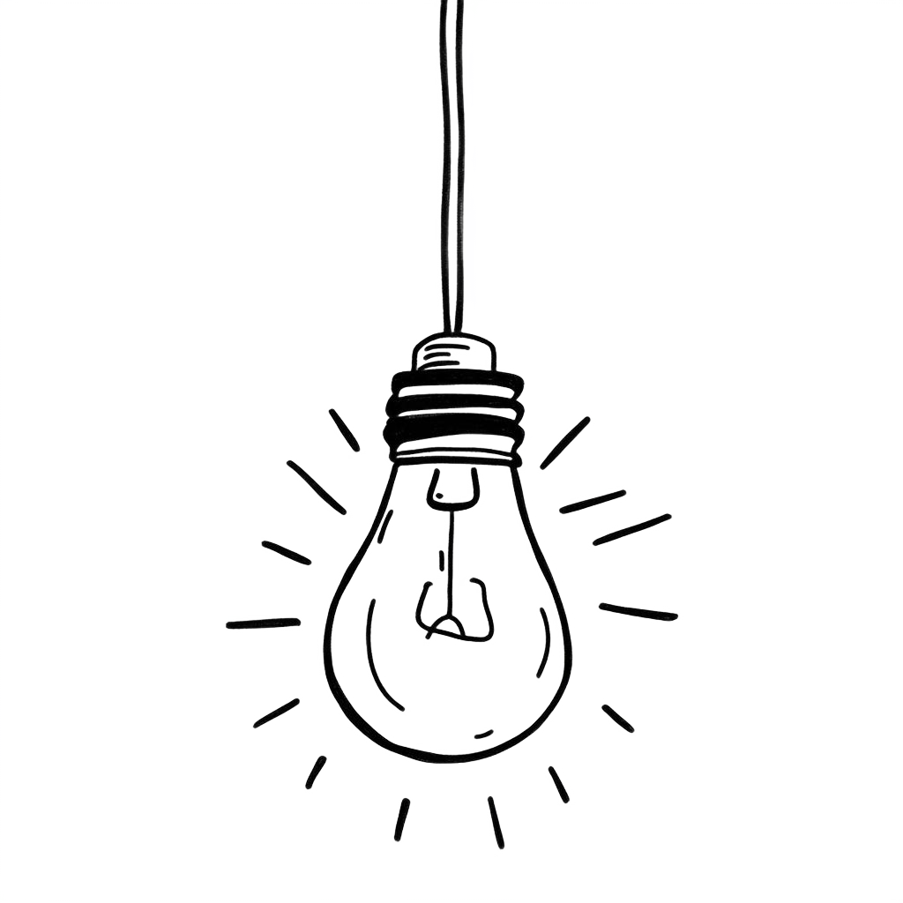

The Attention Advantage
____
I
n a world of endless distractions competing for our mental bandwidth, the ability to direct and sustain our attention has become an increasingly valuable asset. Like an experienced captain navigating treacherous waters, those who can steer their focus through the daily barrage of interruptions gain a powerful advantage that extends far beyond simple productivity.
The hidden power of attention isn’t merely a skill to be developed, but a strategic resource to be invested wisely. The quality of your attention shapes the quality of your work, relationships, and ultimately your life. Understanding how to harness this finite resource may be the most important meta-skill of our time.

The Focus Multiplier Effect
Observe what happens when you drop a stone into a still pond. The initial impact creates ripples that expand outward, growing in reach while maintaining their connection to that first point of contact.
This is precisely how focused attention works in your professional life: one point of deliberate focus generates expanding waves of impact across multiple domains.
The focus multiplier effect operates through a fascinating interplay of cognitive and practical mechanics. When you direct sustained attention to a specific domain, you trigger a cascade of compound benefits that accelerate over time. This multiplication of impact occurs because focused attention doesn't just improve your performance linearly; it creates exponential returns through multiple reinforcing mechanisms.
A landmark study from Stanford University's High Performance Psychology Lab demonstrates this multiplication in action. Researchers tracked two groups of knowledge workers over 18 months. The first group maintained 90-minute blocks of uninterrupted focus on key objectives, while the second worked in typical 30-minute fragmented intervals. By the study's end, the focused group didn't just perform better—they achieved their goals much faster while producing work that received consistently higher quality ratings from peers and supervisors.
This multiplier effect becomes even more powerful when you examine how it operates across different domains simultaneously. When you develop deep focus in one area, you cultivate neural patterns and mental models that transfer to other domains. A software engineer who develops sustained focus while coding often finds their problem-solving abilities enhanced in other areas of life. A writer who masters deep attention while crafting stories frequently discovers improved analytical capabilities in seemingly unrelated fields.
The Tesla story perfectly illustrates how this multiplier effect operates at an organizational level. While traditional automakers divided their attention between electric and combustion technologies, Tesla maintained an unwavering focus on electric vehicles. This concentrated attention multiplied their advantages across multiple domains:
- Their battery technology advanced faster because engineers could focus exclusively on electric power solutions.
- Software integration improved more rapidly because developers weren't juggling multiple systems.
- Brand perception strengthened as customers recognized their singular commitment.
- Supply chain efficiencies multiplied as they optimized everything around one technology.
- Talent acquisition became easier as the best minds in electric vehicles gravitated to their focused mission.
By 2023, this multiplied focus helped Tesla achieve a market value exceeding the combined worth of the next five largest automakers. More importantly, their focused attention created compound advantages that continue accelerating, making it increasingly difficult for competitors to catch up.
The multiplier effect of focused attention operates through several key mechanisms that reinforce each other over time:
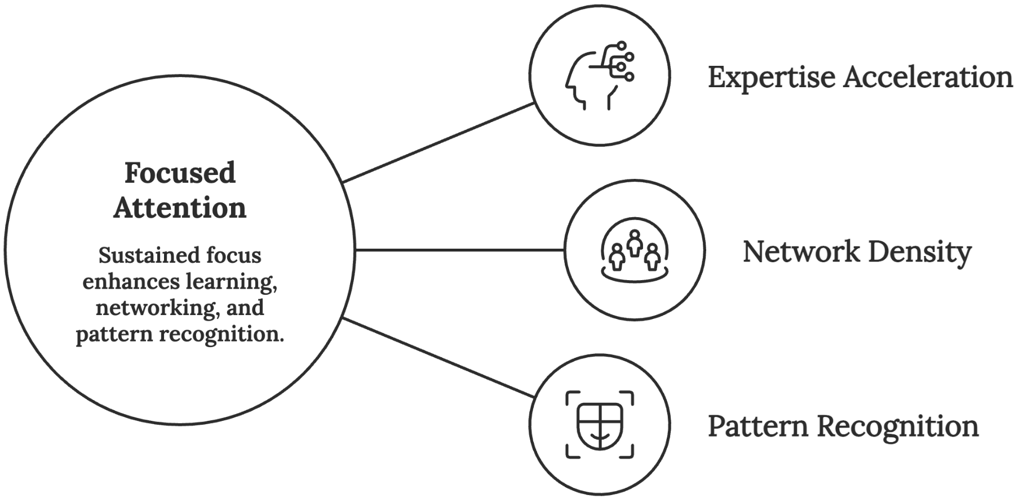

Expertise Acceleration
When you direct sustained attention to a specific domain, you don't just learn faster. You also learn differently.
Your brain forms denser neural networks around that subject area, creating "expert architecture." This enhanced neural structure allows you to recognize patterns, make connections, and solve problems with increasing sophistication. Malcolm Gladwell posits that to be an expert in any field requires approximately 10,000 hours of deliberate, focused practice to achieve mastery. However, these must be truly focused hours, as fragmented attention can actually extend this timeline significantly and undermine the quality of skill development.

Network Density
Focused attention doesn't just build your individual capabilities; it attracts and strengthens connections with others who share your interests.
When you consistently direct attention to a specific domain, you develop "high-density clusters"—interconnected groups of relationships that multiply your influence and access to opportunities. These networks create compound returns through shared knowledge, mutual support, and collaborative innovation.

Pattern Recognition
Perhaps the most powerful aspect of the focus multiplier effect is how it enhances your ability to recognize meaningful patterns. When you maintain sustained attention in any domain, your brain becomes increasingly sophisticated at detecting subtle signals and connections that remain invisible to casual observers. This enhanced pattern recognition creates a compound advantage that accelerates over time. The more patterns you recognize, the better you become at spotting new ones.

The Strategic Attention Portfolio
Just as a skilled investor carefully allocates capital across different assets, you must develop a strategic portfolio approach to managing your attention. This isn't about rigid time-blocking or simplistic productivity hacks. Instead, it's about understanding attention as your most valuable resource and deploying it with the same sophistication you'd apply to financial investments.
Think of your attention as investment capital. Different types of attention (deep focus, rapid switching, creative exploration, relationship building) represent different asset classes, each with its own risk-reward profile and optimal allocation strategy. Your goal is to build a portfolio that maximizes returns while managing risks and maintaining flexibility for future opportunities.
Microsoft's transformation under Satya Nadella provides a masterclass in strategic attention portfolio management. When he became CEO in 2014, Microsoft was struggling with scattered focus across dozens of initiatives. Nadella implemented what he called "focused intensity," a deliberate reallocation of organizational attention across three key domains:
- Cloud Computing - 60% of organizational attention
- Artificial Intelligence - 25% of attention resources
- Enterprise Solutions - 15% of strategic focus
This wasn't just about time allocation; it was about directing the company's collective attention, from research and development to marketing and customer engagement. The results were extraordinary: Microsoft's market value increased by 500% over seven years, demonstrating the power of strategic attention allocation at scale.
Your personal attention portfolio requires similar strategic thinking. Based on extensive research in cognitive psychology and professional performance, an optimal attention portfolio typically includes:
Deep Focus Zone (50–60% of attention resources)
- Complex problem-solving
- Skill development and mastery
- Strategic planning and analysis
- Creative work requiring sustained concentration
Growth Investment Zone (20–25%)
- Learning new skills aligned with core objectives
- Exploring adjacent opportunities
- Building strategic relationships
- Market research and trend analysis
Maintenance Zone (15–20%):
- Routine tasks requiring attention but not deep focus
- Relationship maintenance and networking
- System optimization and refinement
- Regular review and planning
Recovery Zone (10–15%)
- Deliberate rest and reflection
- Unstructured exploration and creativity
- Physical activity and movement
- Meditation and mindfulness practices

The Compounding Power of Deep Attention
While the costs of distraction are immediately apparent (i.e., missed deadlines, errors, reduced productivity), the returns on deep attention often remain hidden, emerging only over time through powerful compound effects. Understanding these hidden returns helps justify the significant investment required to develop and maintain focused attention.
Take a look at the case of Stripe, the payment processing company valued at over $95 billion. Their extraordinary success didn't come from superior technology, as payment processing was already a crowded field. Instead, it came from their deep attention to developer experience. While competitors scattered their focus across multiple user groups, Stripe maintained laser focus on making their API extraordinarily easy for developers to implement.
This focused attention created compound returns far beyond immediate market share:
Brand Premium - Companies practicing deep attention command premium pricing. Stripe's transaction fees exceed industry averages, yet developers choose them specifically because of the attention to detail in their implementation. This premium compounds over time as reputation strengthens and network effects accelerate.
Referral Velocity - Deep attention creates evangelical customers who actively promote your solutions. Stripe's growth came largely through developer word-of-mouth, reducing customer acquisition costs while building a more loyal user base. This organic growth compounds as each satisfied user becomes a brand ambassador.
Innovation Advantage - Focused attention reveals opportunities for innovation that remain invisible to casual observers. Stripe's rapid expansion into adjacent services stemmed from deeply understanding of developer needs gained through sustained attention. Each innovation builds on previous insights, creating compound returns through expanded capabilities.
The ROI of deep attention becomes particularly evident in knowledge work, where quality differences create exponential outcome variations. More importantly, these advantages compound over time as better code leads to fewer maintenance issues, happier clients, and stronger professional reputations.
Your ability to maintain and direct deep attention will increasingly determine your professional success. As artificial intelligence handles routine tasks, human value increasingly comes from the kind of complex problem-solving and creative work that only focused attention can deliver. By understanding and leveraging these principles, you create compound advantages that accelerate over time, transforming your career trajectory through the power of sustained, strategic focus.

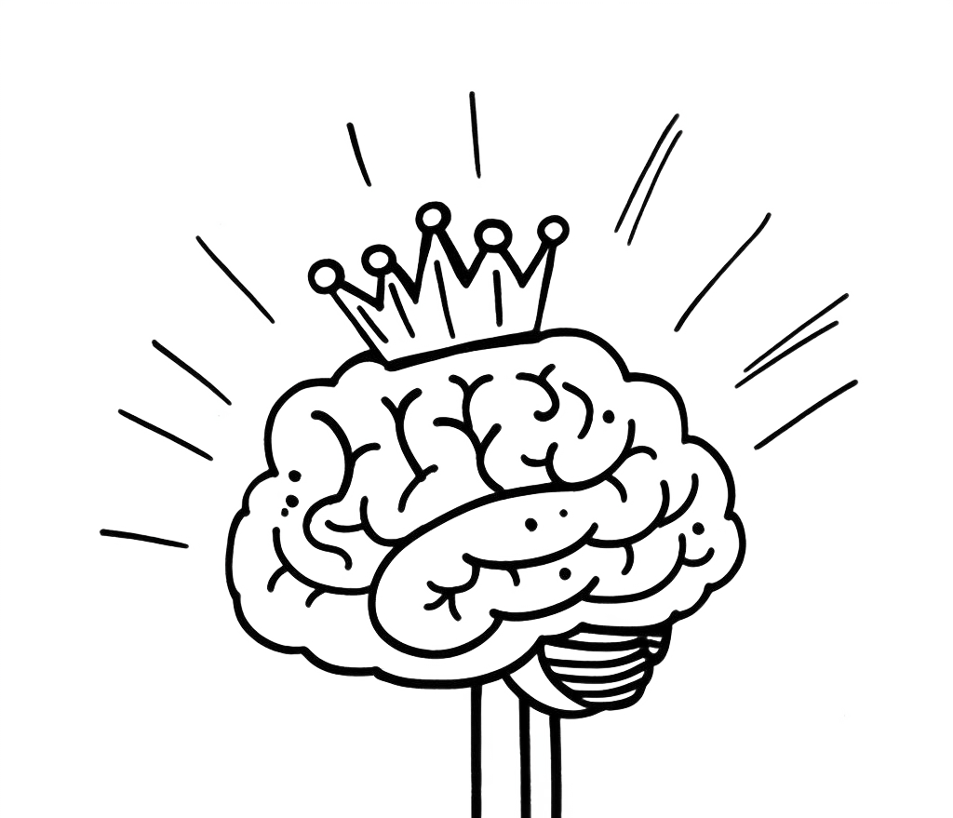

Mastering Attention
____
A
s AI reshapes entire industries, your capacity for sustained, purposeful attention has become the defining factor in professional success. This critical skill separates those whose careers will thrive from those who may struggle to remain relevant in tomorrow's workplace.
A recent McKinsey study projects that by 2030, roles requiring sophisticated attention management will see a 40% surge in demand, while positions centered on routine tasks face increasing automation. This means your journey toward attention mastery isn't just about improving productivity, but about securing your place in an economy where human focus represents the ultimate competitive advantage.

The Integration Framework
Your attention is like a sophisticated musical instrument. Just as a violin produces beautiful music only when all its components work in harmony, your attention system achieves peak performance when multiple elements align perfectly. The attention mastery pyramid represents this integrated approach, building from fundamental capabilities to advanced applications.
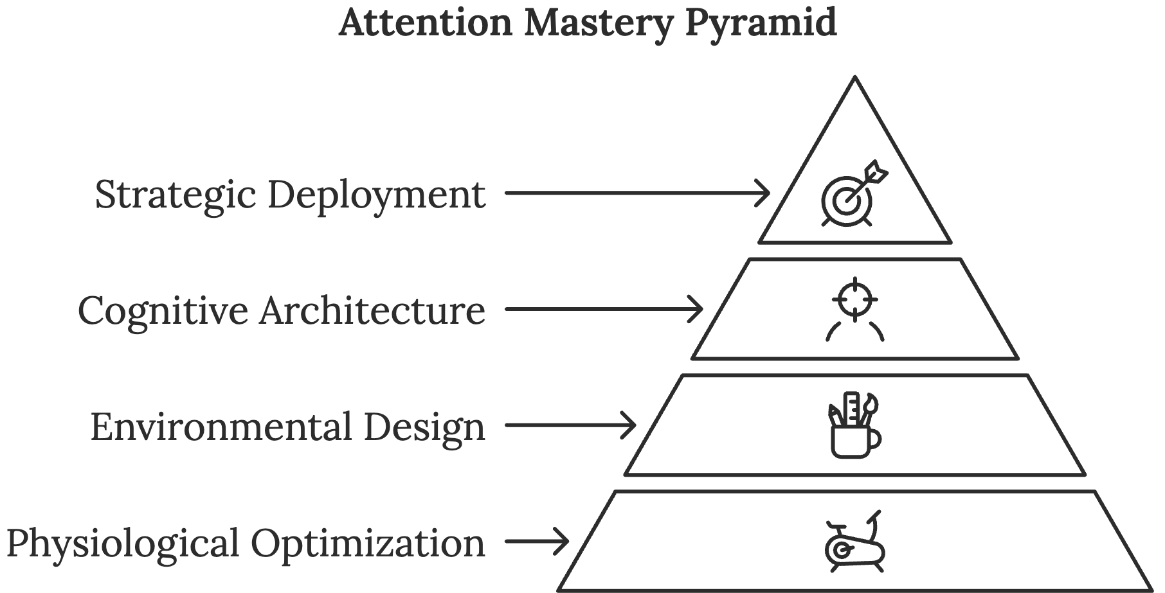
At the base of the pyramid lies physiological optimization, the foundation of all attention mastery. This includes sleep quality, nutrition, movement patterns, and stress management.
The second level comprises environmental design, or the intentional structuring of your physical and digital spaces to support focused work. This goes beyond simple decluttering. Research from the Harvard Business School shows that professionals working in optimized environments demonstrate much higher sustained attention spans compared to those in standard office settings.
The third level involves cognitive architecture, the mental frameworks and systems you use to process information and maintain focus. This includes techniques for managing mental load, strategies for task switching, and protocols for deep work sessions.
At the peak of the pyramid sits strategic deployment, or the ability to direct your attention with precision toward activities with the highest value. This mastery level allows you to create compound returns on your attention investment, dramatically amplifying your impact across all areas of life.
Try to understand how these elements work together in practice. When preparing for an important presentation, your physiological foundation ensures optimal brain function, your environment eliminates unnecessary distractions, your cognitive architecture helps you process and organize information efficiently, and your strategic deployment ensures you focus on the most impactful aspects of the preparation.

The Acceleration Effect
Imagine rolling a snowball down a hill. As it moves, it not only gains speed but also accumulates mass, creating a powerful force of momentum. This is the acceleration effect in attention mastery, the phenomenon where focused attention creates compound returns that accelerate your progress over time.
The path to attention mastery unfolds through five distinct stages, each building upon the previous while introducing new capabilities.

Stage 1: Awareness
You begin recognizing how attention shapes your results, identifying patterns in your focus, and understanding how different environments affect your concentration. This awakening often emerges through crises—missed deadlines, failed projects, or competitive setbacks that highlight the cost of scattered attention.

Stage 2: Control
Moving beyond awareness, you develop basic control over your attention through boundaries, routines, and resistance to immediate distractions. You start experiencing extended periods of focused work and seeing tangible improvements in your output. However, this control requires constant conscious effort and can be fragile under stress.

Stage 3: Optimization
At this stage, you're not just controlling attention but optimizing it. You understand your unique attention patterns and design your work around them. You develop sophisticated systems for managing energy, eliminating friction, and maximizing mental performance. Your attention control becomes more automatic, requiring less conscious effort.

Stage 4: Integration
Here, attention mastery becomes integrated into every aspect of your work and life. You naturally align activities with attention states, effortlessly switch between focus modes, and maintain clarity even in chaotic environments. Your systems become robust enough to handle increasing complexity while maintaining peak performance.

Stage 5: Innovation
The final stage represents true mastery, where you begin innovating new approaches to attention management. You develop novel solutions to attention challenges, create frameworks that benefit others, and contribute to the broader understanding of human focus. Your mastery becomes a platform for leading and teaching others.

Your Next Steps
The journey to attention mastery requires systematic action aligned with long-term objectives. Your transformation pathway should include immediate steps, medium-term strategies, and long-term vision development. Consider this structured approach your roadmap to attention mastery.
Begin with the daily attention mastery protocol:
- Morning Optimization (6:00–8:00 AM)
- Movement practice to activate neural pathways
- Nutritional strategy for sustained mental energy
- Environment preparation for peak focus
- Mindfulness practice for mental clarity
- Peak Focus Period (8:00 AM–12:00 PM)
- Strategic task alignment with energy peaks
- Communication boundary enforcement
- Environment control maintenance
- Progress tracking and adjustment
- Attention Recovery (12:00–2:00 PM)
- Strategic breaks aligned with ultradian rhythms
- Physical movement and nature exposure
- Social connection and collaboration
- Creative exploration
- Evening Reset (6:00–8:00 PM)
- Daily review and learning capture
- Next-day preparation
- Environment reset
- Digital sunset implementation
Your medium-term strategy should focus on developing more sophisticated attention capabilities through systematic skill building. This includes mastering advanced focus techniques, developing attention-positive leadership skills, and creating systems that support sustained high performance.
Looking toward the future, attention mastery will increasingly involve understanding and leveraging emerging technologies. Artificial Intelligence, virtual reality, and biometric monitoring will create new challenges and opportunities for attention management. Your long-term vision should consider how these trends will affect your field and position you to leverage emerging opportunities.
The future of attention mastery extends beyond individual productivity to collective intelligence. True masters will not only excel at personal focus but will also contribute to better team coordination, more effective organizations, and healthier social systems. Your journey toward mastery represents an investment not just in your success, but in the broader evolution of human attention capabilities.
You stand at the threshold of a profound transformation. Your attention represents your most precious resource in an increasingly complex world. By committing to mastery, you position yourself to create extraordinary value while helping others navigate the challenges of modern life. The future belongs to those who master attention, and your journey begins now.

