TABLE OF CONTENTS
____
INTRODUCTION 5
UNDERSTANDING THE POWER OF PROTOTYPING 8
The Multifaceted Role of Prototypes 8
Types of Prototypes 10
Prototyping: A Roadmap to Success 12
DESIGNING PROTOTYPES FOR DEMONSTRATION 16
The Art of Prototype Design 16
Guide to Creating Effective Prototypes 18
Tools and Techniques for Rapid Prototyping 19
Case Study: Dropbox's MVP 21
Avoiding Common Prototyping Pitfalls 22
UTILIZING PROTOTYPES TO TEST FUNCTIONALITY 25
The Importance of Functional Testing 25
Methodologies for Functional Testing 26
Setting Up Experiments for Insights 27
Real-World Scenarios and User Testing 28
Common Pitfalls and Iterative Development 29
GATHERING FEEDBACK AND ITERATING ON PROTOTYPES 33
Feedback's Power in Prototyping 33
Collecting Constructive Feedback Strategies 33
Interpreting and Prioritizing Feedback 35
Implementing Changes and Iterating 35
Case Study: Spotify's Use of Feedback to Refine Its Product 36
Overcoming Feedback & Iteration Challenges 37
THE CONTINUOUS JOURNEY OF PROTOTYPING 40
The Prototyping Mindset 40
Key Takeaways: Your Prototyping Toolkit 41
Prototyping Beyond Product Development 41
The Future of Prototyping 42
Encouraging a Culture of Prototyping 43
The Ethical Dimensions of Prototyping 44

DISCLAIMER
____
The information provided in this ebook is intended solely for educational and informational purposes. The author does not accept any responsibility for the outcomes that may arise from the application of the material within. While efforts have been made to ensure the accuracy and relevance of the content, the author cannot be held accountable for any errors or omissions, or for any consequences resulting from the use or misuse of the information provided. The responsibility for any actions taken based on the information in this ebook lies solely with the reader.


INTRODUCTION
____
Bringing a groundbreaking idea to life can be daunting, especially when faced with the unknown. Many innovators reach a point where they hesitate to take the next step, unsure of how to validate their concept without taking on significant risk. Prototyping offers a powerful solution—a way to test and refine your idea before full-scale development, providing a clear path to entrepreneurial success.
In this book, you'll learn how to transform abstract ideas into tangible realities through the power of prototypes. It's not about endless PowerPoint slides or wordy business plans; it's about creating something that brings your concept to life, allowing stakeholders to touch, see, and experience your vision. This isn't just about building a model—it's about crafting a compelling story that resonates with your audience and moves your idea from the drawing board to the marketplace.
You'll discover insider strategies that have propelled startups from obscurity to leadership. Learn to create prototypes that not only showcase your idea but also captivate even the most skeptical investors. Imagine presenting a room of potential backers with a living representation of your innovation, not just words on paper. That’s the power you'll unlock.
But this book goes beyond persuasion. You'll dive into functionality testing, using your prototypes as diagnostic tools to reveal hidden flaws and refine your design. This isn’t just about avoiding mistakes; it’s about perfecting your product to meet market demands before committing to full-scale development.
Prepare to rethink how you gather feedback. You'll learn to turn criticism into a catalyst for innovation, with each iteration making your prototype more refined, compelling, and aligned with your target audience. As you apply the principles in this book, you'll start to see innovation differently. You'll develop a sharp eye for opportunity, an ability to solve problems creatively, and the confidence to face challenges head-on.
This guide is not just about creating prototypes—it's about fostering a mindset of experimentation, adaptation, and the pursuit of excellence.

Whether you're a seasoned entrepreneur or just starting, this book will equip you with the tools and techniques to turn your ideas into reality. You'll learn to communicate your vision clearly and think visually, setting yourself apart in the competitive world of business.
Ready to change the way you validate ideas? Prototyping has helped many entrepreneurs launch world-changing products, and it can help you too. The road ahead is challenging but exciting. Turn the page to master prototyping and bring your ideas to life.
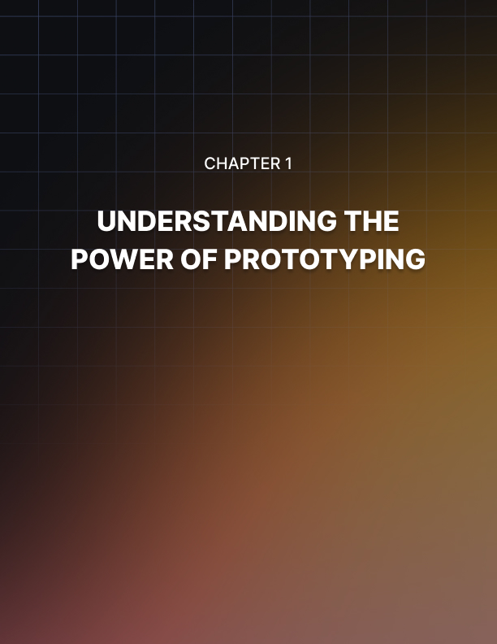

UNDERSTANDING THE POWER OF PROTOTYPING
____
The spark of an idea can ignite a revolutionary business venture, but transforming that spark into a roaring flame requires more than just passion and determination. You need a concrete way to validate your concept, demonstrate its potential, and convince others of its value. This is where prototyping steps in as your most powerful ally.
Prototyping is not merely about creating a miniature version of your product or a rough sketch of your service. It's a dynamic process that breathes life into your ideas, allowing you to test, refine, and perfect them before investing significant time and resources. As an entrepreneur, you'll find that prototypes are invaluable tools that can make the difference between a concept that fizzles out and one that takes flight.

The Multifaceted Role of Prototypes
Prototypes serve multiple purposes in your entrepreneurial journey. They transform abstract ideas into tangible representations, making it easier for you and others to grasp the concept's potential. Prototypes allow you to test assumptions and validate the feasibility of your idea in real-world scenarios. Through prototyping, you can quickly iterate on your design, making improvements based on feedback and observations. They serve as powerful communication tools, helping you articulate your vision to team members, investors, and potential customers. By identifying potential issues early in the development process, prototypes help you mitigate risks and avoid costly mistakes down the line.
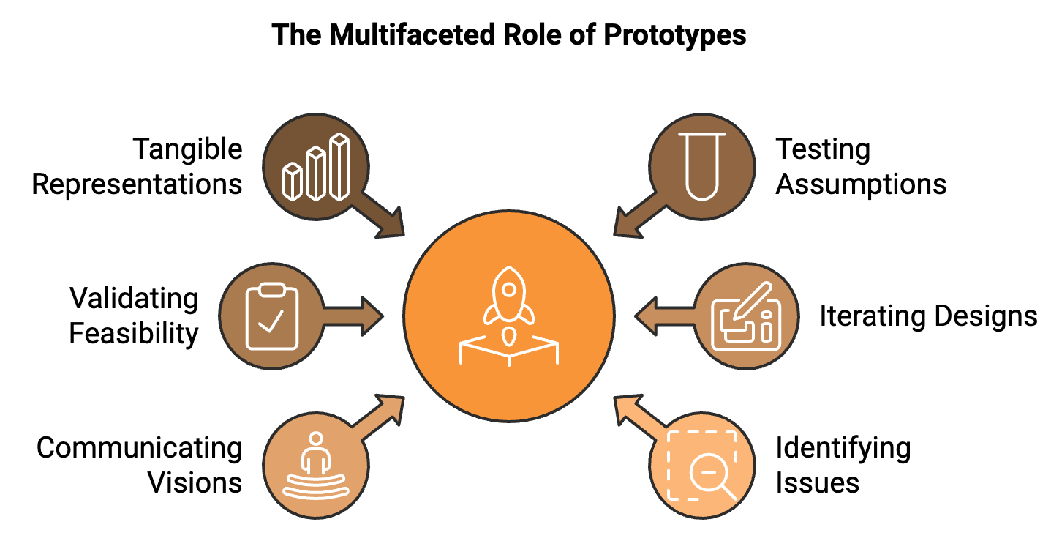
To truly appreciate the impact of effective prototyping, let's examine some real-world examples where it has turned abstract ideas into compelling pitches, leading to successful product launches.

Drew Houston, the founder of Dropbox, faced a common challenge when pitching his idea for a cloud storage service: how to demonstrate a complex, technical concept in a way that investors and potential users could easily understand. His solution? A simple, yet effective video prototype. Houston created a 3-minute screencast that showed how Dropbox would work, demonstrating the ease of file syncing across devices. This video prototype went viral, increasing signups from 5,000 to 75,000 overnight. It not only validated the market demand but also attracted investors, leading to Dropbox's successful launch and eventual growth into a multibillion-dollar company.
When Airbnb founders Brian Chesky and Joe Gebbia were struggling to pay their rent in San Francisco, they came up with the idea of renting out air mattresses in their apartment to conference attendees. To test this concept, they created a basic website prototype showcasing their apartment and the air mattresses they were offering. This simple prototype allowed them to validate their idea quickly. They hosted three guests during a design conference, proving that people were willing to pay for this unique accommodation option. This early success gave them the confidence to pursue their idea further, eventually leading to the creation of the global hospitality platform we know today.

Types of Prototypes
As you begin your prototyping journey, it's crucial to understand that not all prototypes are created equal. Different stages of your project and various audiences may require different types of prototypes. Let's explore the spectrum of prototyping options available to you:
- Low-Fidelity Prototypes
These are quick, rough representations of your idea, often created using simple materials or basic digital tools. They're excellent for early-stage ideation and concept testing. Examples include paper sketches, wireframes, and storyboards. Use these early in the development process when you're still exploring different concepts and need to quickly visualize ideas.
- Medium-Fidelity Prototypes
These prototypes offer more detail and functionality than low-fidelity versions but are still not fully polished. They're useful for demonstrating core features and user flows. Examples include digital mockups, click-through prototypes, and 3D-printed models. Use these when you've narrowed down your concept and need to test specific features or user interactions.
- High-Fidelity Prototypes
These are the most refined and realistic prototypes, often closely resembling the final product in look and functionality. Examples include fully interactive digital prototypes, functional physical prototypes, and beta versions of software. Use these in later stages of development when you need to conduct detailed user testing or present to stakeholders for final approval.
Selecting the appropriate type of prototype depends on several factors: project stage, audience, time and resources, feedback goals, and complexity of the idea. Early-stage ideas benefit from low-fidelity prototypes, while more developed concepts may require higher fidelity. Consider who will be interacting with your prototype. Potential users might engage better with a high-fidelity prototype, while team members can often work effectively with lower-fidelity versions. High-fidelity prototypes typically require more time and resources to create. Assess whether the potential benefits justify the investment. If you're seeking feedback on the general concept, a low-fidelity prototype might suffice. For detailed usability testing, you'll likely need a higher-fidelity version. More complex concepts may require higher-fidelity prototypes to adequately demonstrate their value and functionality.

Prototyping: A Roadmap to Success
Now that you understand the importance and types of prototypes, let's outline a general process you can follow to create effective prototypes:
- Define Your Goals
Clearly articulate what you want to achieve with your prototype. Are you testing functionality, exploring design options, or pitching to investors?
- Identify Key Features
Determine the core features or aspects of your idea that need to be represented in the prototype.
- Choose Your Prototype Type
Based on your goals, audience, and resources, select the appropriate fidelity level for your prototype.
- Create the Prototype
Use the appropriate tools and techniques to build your prototype. Remember, it doesn't need to be perfect – the goal is to create a representative model of your idea.
- Test and Gather Feedback
Put your prototype in front of users, stakeholders, or team members to gather insights and identify areas for improvement.
- Iterate and Refine
Use the feedback you've received to improve your prototype. This may involve creating multiple versions as you refine your idea.
- Document Learnings
Keep track of the insights you gain throughout the prototyping process. These learnings will be invaluable as you move forward with your project.
While prototyping is a powerful tool, there are some common mistakes you should be aware of. Don't get caught up in creating a perfect prototype. The goal is to test and validate your idea, not to build the final product. Stay open to criticism and be willing to make changes based on the feedback you receive. Your prototype is a means to an end, not the end itself, so be prepared to discard or significantly modify it if necessary. Even in early prototypes, consider how users will interact with your product or service. Prototyping is an iterative process. Don't expect to get it right on the first try.
As you move forward in your entrepreneurial journey, remember that prototyping is not a one-time event but an ongoing process. It's a powerful tool that can help you refine your ideas, validate your assumptions, and ultimately create products and services that truly resonate with your target audience. By embracing the power of prototyping, you're equipping yourself with a vital skill that can significantly increase your chances of success. So roll up your sleeves, gather your tools, and start bringing your ideas to life through the art and science of prototyping.
Prototype Fidelity | Characteristics | Best Used For | Examples
Low-Fidelity | Quick, rough, basic | Early ideation, concept testing | Paper sketches, wireframes
Medium-Fidelity | More detailed, semi-functional | Feature testing, user flow demonstration | Digital mockups, click-through prototypes
High-Fidelity | Refined, realistic, fully functional | Detailed user testing, final presentations | Interactive digital prototypes, beta versions

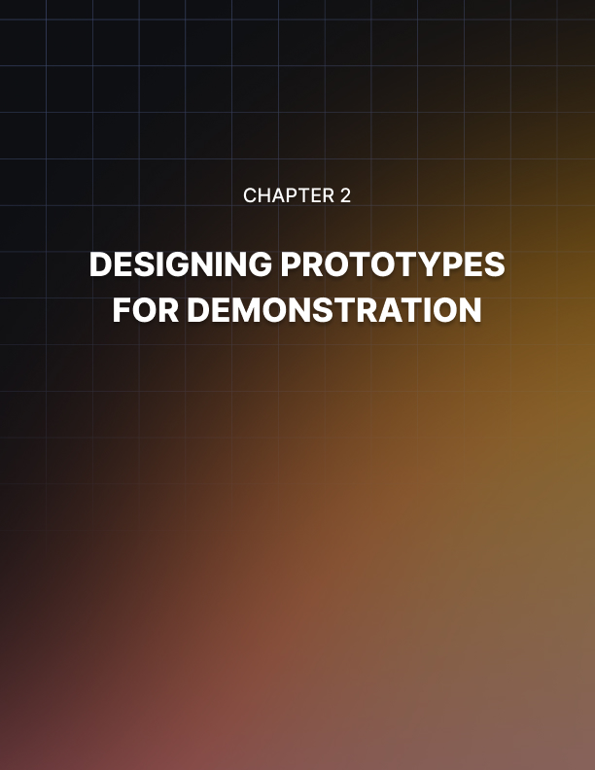

DESIGNING PROTOTYPES FOR DEMONSTRATION
____
In the world of entrepreneurship, your ability to transform abstract ideas into tangible, compelling demonstrations can make or break your success. This chapter will equip you with the knowledge and tools to design prototypes that not only showcase your concept's core functionality but also captivate stakeholders and potential customers.

The Art of Prototype Design
Prototype design is more than just creating a rough model of your product or service. It's about crafting a narrative that clearly communicates your unique value proposition. Your prototype should tell a story - the story of how your innovation solves a problem, fills a gap in the market, or improves lives.
To design an effective prototype, you need to focus on three key elements: clarity of concept, user-centric design, and visual appeal. Your prototype must clearly demonstrate the core functionality and unique selling points of your idea. Strip away any unnecessary features or complexities that might distract from your main message. Ask yourself: "What is the one thing I want my audience to understand about my concept?" This should be the focal point of your prototype. For example, when Jeff Bezos first conceptualized Amazon, he didn't try to prototype a vast online marketplace selling everything from books to electronics. Instead, he focused on a simple website that allowed users to order books online. This clear, focused prototype effectively demonstrated the core concept of e-commerce and paved the way for Amazon's eventual expansion.
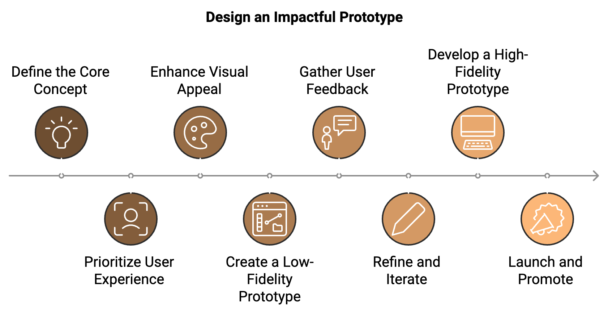

Your prototype should prioritize the user experience. Even if you're creating a low-fidelity prototype, consider how your target users will interact with your product or service. This user-centric approach will not only make your prototype more engaging but also demonstrate that you've thought deeply about your audience's needs and preferences. Airbnb's founders, for instance, initially created a simple website prototype that focused on the user experience of booking a stay. They emphasized ease of use and clear communication between hosts and guests, which are still core principles of Airbnb's platform today.
While functionality is crucial, don't underestimate the power of aesthetics. A visually appealing prototype can capture attention and leave a lasting impression. This doesn't mean your prototype needs to be a work of art, but it should be clean, organized, and professional-looking. Consider the success of Apple products. Their prototypes, even in early stages, often feature sleek designs that capture the essence of their brand. This attention to visual appeal has been a key factor in Apple's ability to generate excitement around new product launches.

Guide to Creating Effective Prototypes
Now that you understand the key elements of effective prototype design, let's walk through a step-by-step process for creating prototypes that effectively communicate your unique value proposition. First, define your prototype's purpose. Before you start designing, clearly define what you want to achieve with your prototype. Are you trying to demonstrate functionality, test user interaction, or pitch to investors? Your purpose will guide your design decisions throughout the process. Next, identify key features. List the core features that best represent your concept's unique value. Prioritize these features based on their importance to your overall vision and the specific goals of your prototype.
Choose your prototyping method that aligns with your purpose, timeline, and resources. Options include paper prototypes (quick, low-cost, and ideal for early-stage ideation), digital wireframes (useful for demonstrating user flow and basic layout), interactive digital prototypes (excellent for showcasing functionality and user experience), and physical models (necessary for tangible products to demonstrate form and feel). Start with rough sketches to visualize different aspects of your prototype. This low-stakes approach allows you to explore multiple ideas quickly and identify the most promising directions.
Using your chosen method, build your prototype. Focus on clarity, user-centricity, and visual appeal. Don't strive for perfection—your goal is to create a representative model that effectively communicates your concept. Finally, test and refine. Put your prototype in front of potential users or stakeholders. Gather feedback and use these insights to refine your design. This iterative process is crucial for creating a prototype that resonates with your target audience.

Tools and Techniques for Rapid Prototyping
Today's fast business environment demands the ability to create prototypes quickly, giving you a significant advantage. Here are some tools and techniques to help you prototype rapidly and effectively:
Digital Wireframing Tools | Physical Prototyping Techniques | Rapid Prototyping Methodologies
Sketch | 3D Printing | Design Sprints
Figma | LEGO Prototyping | Lean Prototyping
Adobe XD | Paper Prototyping

These digital wireframing tools allow you to create clickable prototypes quickly, demonstrating user flow and basic functionality without the need for coding. For physical products, 3D printing offers a quick way to create tangible prototypes. It's particularly useful for demonstrating form and ergonomics. Using LEGO bricks to create physical prototypes can be a quick and cost-effective method, especially for mechanical concepts. Don't underestimate the power of paper. Folded paper models or cardboard mockups can be incredibly effective for demonstrating physical product concepts.
The Design Sprints methodology, developed by Google Ventures, takes you from problem definition to tested prototype in just one work week. The Lean Prototyping approach emphasizes creating the simplest possible prototype to test a specific hypothesis, then iterating based on feedback.
One of the most challenging aspects of prototyping is deciding which features to include and which to leave out. Focus on your Unique Value Proposition (UVP). Your prototype should clearly demonstrate what sets your idea apart from existing solutions. Prioritize features that directly support your UVP. Consider your audience. Different features may be more important depending on who you're presenting to. Investors might be more interested in features that demonstrate market potential, while end-users might care more about ease of use. Demonstrate core functionality. Ensure your prototype clearly shows how your product or service works at a fundamental level. Avoid feature overload. It's tempting to showcase every feature you've thought of, but this can overwhelm your audience and dilute your main message. Stick to the essentials. Think about the user journey. Include features that demonstrate the key steps a user would take when interacting with your product or service. Your prototype doesn't need to be feature-complete. It's often more effective to focus on doing a few things well rather than trying to showcase everything at once.

Case Study: Dropbox's MVP
Dropbox's journey from concept to billion-dollar company offers valuable lessons in effective prototyping. When founder Drew Houston was ready to demonstrate his idea for a seamless file-syncing service, he faced a challenge. Building a fully functional product would have been time-consuming and expensive, with no guarantee of market interest. Instead, Houston created a simple video prototype. The three-minute video demonstrated how Dropbox would work, showing files being dragged into a folder and automatically syncing across devices. This video prototype allowed Houston to clearly communicate Dropbox's core functionality, demonstrate the user experience without building the actual product, and generate interest and gather valuable feedback from potential users.
The video prototype was a huge success, increasing Dropbox's waitlist from 5,000 to 75,000 overnight. It validated the market demand for the product and helped secure initial funding. Key takeaways from Dropbox's approach include focusing on core functionality (the video demonstrated Dropbox's key feature - seamless file syncing - without getting bogged down in details), keeping it simple (the prototype was easy to understand, even for non-technical users), and showing, not telling (by visually demonstrating how Dropbox would work, Houston made the concept tangible and exciting).

Avoiding Common Prototyping Pitfalls
When starting your prototyping process, watch out for these common mistakes: over-engineering, ignoring feedback, failing to set clear goals, neglecting user experience, and getting too attached.
Don't get caught up in creating a perfect, fully-functional prototype. The goal is to demonstrate your concept, not build the final product. Stay open to criticism and be willing to iterate based on the feedback you receive. Your first prototype is unlikely to be your last. Without clear objectives, you risk creating a prototype that doesn't effectively address your key questions or demonstrate your core value proposition. Even in early prototypes, consider how users will interact with your product or service. A prototype that's confusing or frustrating to use won't effectively showcase your idea. Your prototype is a means to an end, not the end itself. Be prepared to discard or significantly modify it if necessary.
By avoiding these pitfalls and following the guidelines outlined in this chapter, you'll be well-equipped to create prototypes that effectively demonstrate your concepts, engage your audience, and drive your entrepreneurial journey forward. Moving forward with your prototyping efforts, keep in mind that practice makes perfect. Each prototype you create will teach valuable lessons and sharpen your skills.
Embrace the iterative nature of the process, and don't be afraid to experiment with different approaches. Your ability to quickly and effectively prototype your ideas will be a powerful asset in your entrepreneurial toolkit, helping you bring your innovative concepts to life and turn your vision into reality.



UTILIZING PROTOTYPES TO TEST FUNCTIONALITY
____

The Importance of Functional Testing
Functional testing is a critical process that can make or break your product's success. When you test functionality using prototypes, you're essentially putting your idea through its paces in a controlled, low-risk environment. This allows you to identify potential issues, validate your solutions, and refine your concept before investing significant time and resources into full development. Consider the cautionary tale of Juicero, a startup that raised over $120 million in funding for its high-tech juicing machine. The company spent years developing a sleek, Wi-Fi-connected device that promised to revolutionize home juicing. However, when the product finally launched, it quickly became apparent that its core functionality was flawed. Users discovered that they could squeeze the juice packs by hand just as effectively as the $400 machine. Had Juicero invested more time in functional prototyping and testing, they might have identified this fundamental issue early on and pivoted their concept before it was too late. On the flip side, successful companies like Airbnb have used functional prototyping to great effect. Before building out their full platform, Airbnb's founders created a simple website to test the core functionality of their idea. This early prototype allowed them to validate the concept of peer-to-peer home sharing and iterate based on real user feedback.

Methodologies for Functional Testing
To effectively test the functionality of your prototype, you'll need to employ a variety of methodologies. Task-Based Testing involves creating a list of specific tasks that users should be able to complete with your product. For example, if you're prototyping a new e-commerce app, tasks might include searching for a product, adding it to the cart, and completing the checkout process. By observing users as they attempt these tasks, you can identify pain points and areas for improvement in your prototype's functionality. User Flow Analysis focuses on mapping out the various paths users might take through your product. By analyzing these flows, you can ensure that your prototype's functionality supports a smooth and intuitive user experience. Look for bottlenecks, dead ends, or confusing transitions that might impede user progress. A/B Testing can be invaluable when you have multiple ideas for how a particular feature should function. Create two versions of your prototype with different implementations of the feature, then test both versions with users to see which performs better. Edge Case Testing considers how your prototype will handle unusual or extreme scenarios. Think about potential edge cases specific to your product and test how your prototype handles them. Load Testing is crucial if your product will need to handle multiple users or process large amounts of data. While a full-scale load test might not be feasible with a prototype, you can often simulate increased load to get a sense of how your product will perform.

Setting Up Experiments for Insights
To get the most out of your functional testing, you need to set up experiments that will provide clear, actionable insights.
Start by clearly articulating what you want to learn from your testing.

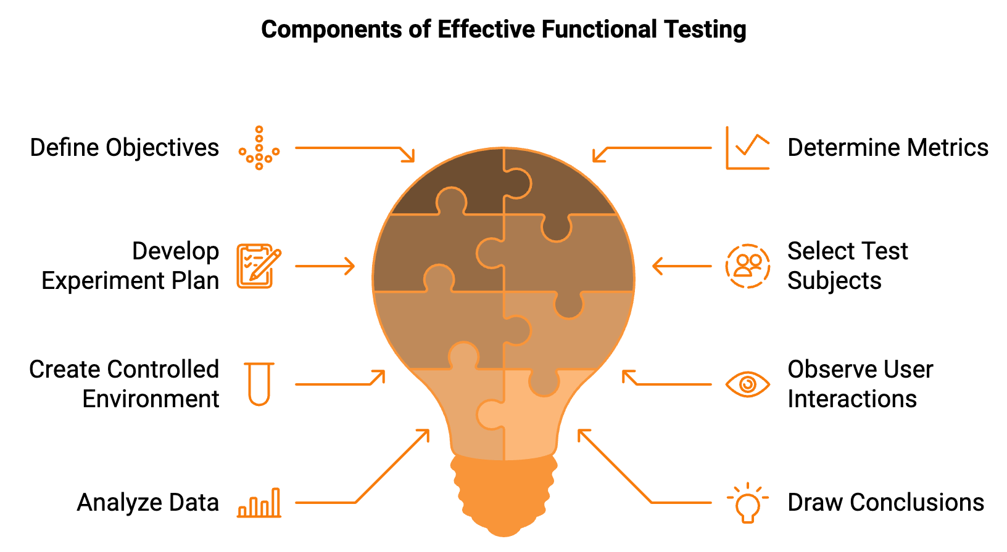
Are you trying to validate a specific feature? Improve user flow? Identify performance bottlenecks? Your objectives will guide the rest of your experimental design. Based on your objectives, determine which metrics you'll use to measure success. These might include task completion rates, time spent on specific actions, error rates, or user satisfaction scores. Develop a detailed plan for your experiment. This should include the specific tasks users will perform, the data you'll collect, and how you'll analyze the results. Your test subjects should be representative of your target user base. Consider factors like age, technical proficiency, and familiarity with similar products when selecting participants. Set up a controlled environment for your testing. This might be a physical space for testing physical prototypes or a digital environment for software prototypes. Ensure that you have all necessary equipment and that your prototype is fully prepared for testing. As users interact with your prototype, observe their behavior closely. Take notes on any difficulties they encounter, questions they ask, or unexpected ways they use the product. If possible, record the sessions for later review. Once you've completed your testing, analyze the data you've collected. Look for patterns, common issues, and areas where the prototype's functionality met or failed to meet your expectations. Based on your analysis, draw conclusions about your prototype's functionality. Use these insights to plan your next steps, whether that's refining certain features, rethinking your approach, or moving forward with development.

Real-World Scenarios and User Testing
While controlled experiments are valuable, there's no substitute for testing your prototype in real-world scenarios with actual users. This approach can uncover issues and insights that might not be apparent in a more artificial testing environment. One effective method is the "Wizard of Oz" technique, where users interact with what they believe to be a fully functional product, but in reality, some or all of the functionality is being simulated behind the scenes by a human operator. This allows you to test complex functionalities without having to fully develop them. Another powerful approach is beta testing, where you release a limited version of your product to a select group of real users. This can provide invaluable insights into how your product functions in the wild and help you identify issues that might not have surfaced in more controlled testing environments. When conducting real-world testing, it's crucial to create a feedback loop that allows you to quickly iterate on your prototype based on user input. This might involve regular check-ins with beta testers, in-app feedback mechanisms, or follow-up interviews to dig deeper into user experiences.

Common Pitfalls and Iterative Development
In functionality testing, watch out for common pitfalls such as over-engineering prototypes, ignoring negative feedback, testing with biased users, failing to document results, misinterpreting user input, neglecting accessibility, and focusing only on ideal scenarios.
Functional testing is not a one-and-done process. It's an iterative journey that requires continuous refinement based on the insights you gather. Each round of testing should inform improvements to your prototype, which you can then test again to validate your changes. This iterative approach allows you to progressively refine your product's functionality, ensuring that each version is an improvement over the last. It also helps you build confidence in your product, as you'll have concrete evidence of how it has evolved and improved over time. To maximize the benefits of functional testing, it's crucial to integrate it seamlessly into your overall development process. This means conducting functional tests at various stages of development, not just at the end. Consider adopting a development methodology like Agile or Lean, which emphasize iterative development and continuous testing. These approaches align well with the iterative nature of functional prototyping and testing. You might also consider implementing continuous integration and continuous delivery (CI/CD) practices, which can automate some aspects of functional testing. While these practices are more commonly associated with software development, the principles can be applied to other types of product development as well.

Testing Method | Description | Benefits
Task-Based Testing | Users complete specific tasks with the prototype | Identifies usability issues and pain points
User Flow Analysis | Mapping and analyzing user paths through the product | Ensures smooth and intuitive user experience
A/B Testing | Comparing two versions of a feature | Determines the most effective implementation
Edge Case Testing | Testing unusual or extreme scenarios | Ensures product reliability in all situations
Load Testing | Simulating high user or data loads | Validates performanceunder stress

Functional testing through prototyping is a powerful tool in your entrepreneurial toolkit. By rigorously testing your ideas before full-scale development, you can save time and resources, reduce risk, and ultimately create products that truly resonate with your users. Remember, the goal is not to create a perfect prototype, but to learn, iterate, and improve. Embrace the process, be open to feedback, and use the insights you gain to refine your product and increase your chances of success in the market.

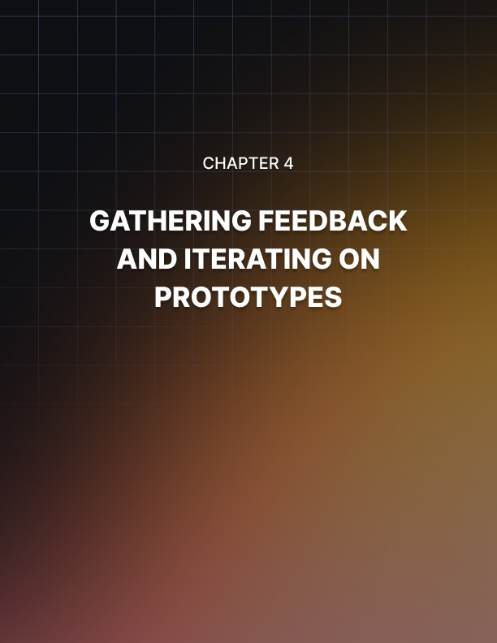

GATHERING FEEDBACK AND ITERATING ON PROTOTYPES
____

Feedback's Power in Prototyping
Feedback is the lifeblood of innovation. It provides fresh perspectives, uncovers blind spots, and challenges assumptions. When you open your prototype to feedback, you're essentially crowdsourcing insights that can dramatically improve your product's chances of success. Consider the story of Slack, the popular workplace communication tool. Slack began as an internal tool for a game development company. The founders recognized its potential and decided to develop it into a standalone product. By releasing an early version to a small group of users and actively seeking their feedback, Slack was able to identify key features that users loved and areas that needed improvement. This approach allowed them to create a product that resonated strongly with users, leading to its rapid adoption and success.

Collecting Constructive Feedback Strategies
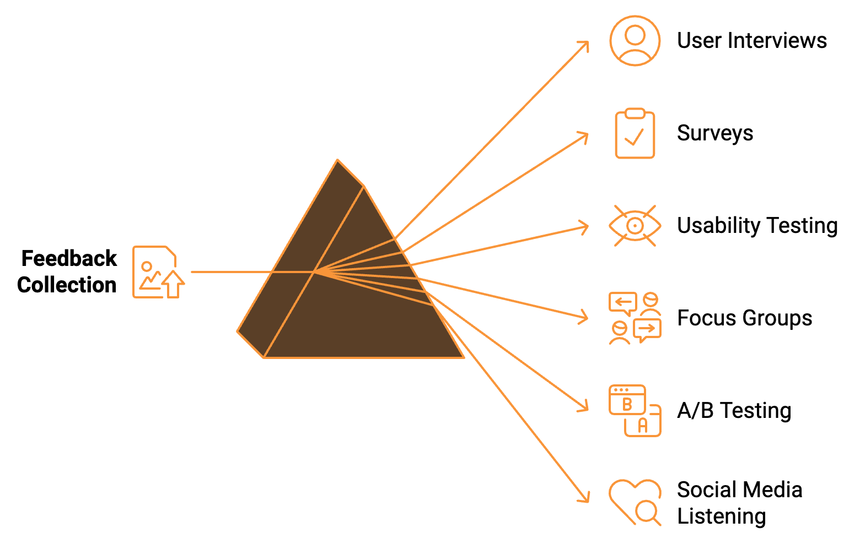
Gathering feedback is an art as much as it is a science. You need to create an environment where people feel comfortable sharing their honest opinions, and you need to ask the right questions to elicit useful insights. Some effective strategies for collecting constructive feedback include user interviews, surveys, usability testing, focus groups, A/B testing, social media listening, and beta testing. User interviews provide deep, qualitative insights into how people interact with your prototype. Surveys allow you to collect feedback from a larger number of people relatively quickly. Usability testing involves observing users as they interact with your prototype to complete specific tasks, revealing pain points and areas of confusion. Focus groups allow you to observe how people discuss and interact with your prototype in a social setting. A/B testing is particularly useful for refining specific aspects of your prototype. Social media listening can provide unsolicited, honest feedback. Beta testing can provide valuable real-world feedback from a select group of users.

Interpreting and Prioritizing Feedback
Collecting feedback is only half the battle. The real challenge lies in interpreting this feedback and deciding which insights to act on. Some strategies to help you make sense of the feedback you receive include looking for patterns, considering the source, quantifying where possible, balancing qualitative and quantitative insights, separating symptoms from root causes, prioritizing based on impact and effort, and not ignoring positive feedback. While gathering feedback from multiple sources, look for recurring themes or issues. Prioritize input from individuals who closely match your ideal user profile. Use metrics to quantify feedback where you can. Use both quantitative and qualitative data to build a complete picture. Try to dig beneath the surface to identify the root causes of the feedback you're receiving. Prioritize changes based on their potential impact on user satisfaction and the effort required to implement them. Understanding what users already like about your prototype can help you build on your strengths.

Implementing Changes and Iterating
Once you've collected and interpreted feedback, it's time to put those insights into action. Create an action plan based on your prioritized feedback, breaking down larger changes into smaller, manageable tasks. Start by implementing changes that are relatively easy to make but have a significant impact. When implementing changes, test them to ensure they genuinely improve the user experience. Stay open to pivoting your concept if the evidence suggests it's necessary. Keep a record of the changes you make and the reasoning behind them. Maintain clear version control as you iterate on your prototype. If you're working with beta testers or early adopters, keep them informed about the changes you're making based on their feedback.

Case Study: Spotify's Use of Feedback to Refine Its Product
Spotify's journey from startup to music streaming giant provides an excellent example of how to effectively use feedback to iterate and improve a product. When Spotify first launched, it faced several challenges, including a cluttered interface and difficulties in music discovery. The company actively sought user feedback through various channels, including user surveys, social media monitoring, and analysis of user behavior data. Based on this feedback, Spotify developed and iterated on several features, including Discover Weekly, Daily Mix, improved radio feature, collaborative playlists, and user interface refinements.
Spotify's approach demonstrates several key principles of effective feedback gathering and iteration: maintaining a continuous feedback loop, making data-driven decisions, implementing incremental improvements, focusing on personalization, and balancing innovation with familiarity.

Overcoming Feedback & Iteration Challenges
While gathering feedback and iterating on your prototype is crucial, it's not without its challenges. Some common obstacles you might face include conflicting feedback, feature creep, analysis paralysis, losing sight of the big picture, burnout, resistance to change, and limited resources. To overcome these challenges, look for underlying needs driving conflicting opinions, stay true to your core value proposition, set clear criteria for prioritizing feedback, regularly revisit your product strategy, build in time for reflection and celebration of milestones, foster a culture that values user feedback, and be strategic about which changes you prioritize based on potential impact and available resources. The process of gathering feedback and iterating on your prototype isn't about achieving perfection. It's about continuous improvement and creating a product that truly meets user needs.
It's about continuous improvement and creating a product that truly meets user needs.

Embrace the journey of discovery and refinement, and you'll be well on your way to creating a successful product that resonates with your target audience.

Feedback Collection Method | Strengths | Weaknesses
User Interviews | Deep, qualitative insights | Time-consuming, small sample size
Surveys | Large sample size, quantifiable data | May lack depth, potential for response bias
Usability Testing | Direct observation of user behavior | Can be resource-intensive
Focus Groups | Group dynamics, diverse perspectives | Potential for groupthink
A/B Testing | Direct comparison of options | Limited to testing specific elements
Social Media Listening | Unsolicited, honest feedback | May not be representative of all users
Beta Testing | Real-world usage data | Limited to early adopters

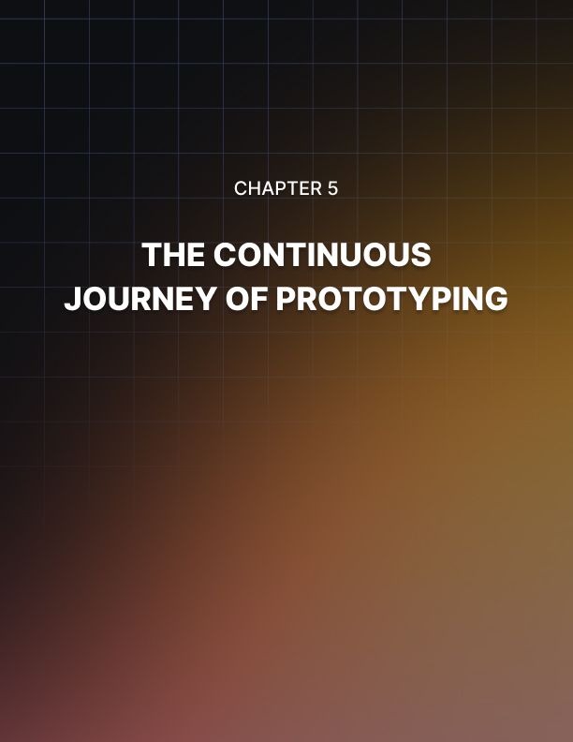

THE CONTINUOUS JOURNEY OF PROTOTYPING
____
Your experience in the world of prototyping has equipped you with a powerful set of tools and strategies. Standing at the threshold of putting these concepts into practice, it's crucial to recognize that prototyping isn't a destination—it's an ongoing process of discovery, refinement, and innovation.

The Prototyping Mindset
Adopting a prototyping mindset means embracing uncertainty and viewing every challenge as an opportunity for learning and improvement. This mindset is characterized by curiosity, resilience, and a willingness to fail fast and learn faster. You'll find that as you internalize this approach, it permeates not just your product development process, but your entire entrepreneurial journey.
Consider the story of James Dyson, the inventor of the bagless vacuum cleaner. Dyson didn't just create one prototype—he built 5,127 prototypes over 15 years before he finally had a product he was satisfied with. This relentless commitment to iteration and improvement ultimately led to a revolutionary product that disrupted an entire industry. Dyson's experience underscores a critical truth: prototyping is not a linear process with a clear endpoint, but a cyclical journey of continuous improvement.

Key Takeaways: Your Prototyping Toolkit
As you move forward in your entrepreneurial journey, keep these essential points at the forefront of your mind: Understanding different types of prototypes, from low-fidelity sketches to high-fidelity models that closely resemble the final product; designing with the end-user in mind, always keeping your target audience at the center of your prototyping process; rigorous functionality testing, employing a variety of methodologies to ensure your prototype functions as intended; effective feedback gathering, using a mix of qualitative and quantitative methods to collect insights; and embracing iterative development, where each round of testing and feedback informs improvements to your prototype. This cyclical process of build-test-learn-improve is at the heart of successful product development.

Prototyping Beyond Product Development
The principles you've learned about prototyping have applications far beyond product development. They can be applied to various aspects of your business and even your personal life. In business strategy, you can use prototyping principles to test new ideas before fully committing to them. For example, before launching a new marketing campaign, you could create a small-scale prototype by running a limited test campaign. This allows you to gather data and feedback, helping you refine your approach before a full-scale launch. In team management, you can apply prototyping principles to organizational structures or work processes. Instead of implementing sweeping changes all at once, you can prototype new approaches on a small scale, gather feedback, and iterate before rolling out company-wide. Even in personal development, prototyping principles can be invaluable. Whether you're considering a career change or picking up a new skill, you can use rapid prototyping techniques to test different options and gather feedback before making major commitments.
Continuing your prototyping journey, you'll likely encounter some common challenges. Being prepared for these obstacles can help you navigate them more effectively: Analysis paralysis, where you get stuck in endless analysis of feedback and data; feature creep, the temptation to add more features that can bloat your prototype; perfectionism, remembering that a prototype doesn't need to be perfect—it needs to be good enough to test your hypotheses; resistance to change, where you or your team may become attached to certain aspects of your prototype; and resource constraints, where prototyping can be resource-intensive, requiring creativity in your approach.

The Future of Prototyping
As technology continues to advance, the tools and methods available for prototyping are evolving rapidly. Stay abreast of these developments to ensure your prototyping toolkit remains cutting-edge:
Technology | Application in Prototyping
Virtual and Augmented Reality | Immersive prototyping in simulated environments
Artificial Intelligence | Generating design variations, predicting user behavior
3D Printing | Rapid physical prototyping
No-Code Platforms | Functional digital prototypes for non-technical team members
Remote Collaboration Tools | Facilitating remote prototyping and user testing

Encouraging a Culture of Prototyping
As an entrepreneur or business leader, one of your key roles is to foster a culture that embraces prototyping and iterative development. Here are some strategies to help you create such an environment: Celebrate learning, not just success, by recognizing and rewarding teams for insights gained through prototyping and testing; allocate resources for experimentation, dedicating time, budget, and tools specifically for prototyping; lead by example, engaging in prototyping yourself and sharing your experiences with your team; encourage cross-functional collaboration, creating opportunities for team members from different departments to work together on prototyping projects; and provide training and support, offering workshops or training sessions on prototyping techniques and tools to ensure your team has the skills they need to prototype effectively.

The Ethical Dimensions of Prototyping
Throughout your prototyping journey, it's important to consider the ethical implications of your work. Prototyping often involves testing with real users and can impact people's lives in various ways. Keep these ethical considerations in mind: Informed consent, ensuring that anyone participating in your prototype testing is fully informed and has given their consent; data privacy, being transparent about what data you're collecting and how it will be used; inclusivity, striving to include a diverse range of users in your prototype testing; environmental impact, considering the implications of your prototyping process, especially for physical prototypes; and honesty, being truthful about the state of your prototype and making sure users understand if it's not a finished product.
As we conclude this exploration of prototyping, remember that the skills and mindset you've developed are invaluable assets in your entrepreneurial toolkit. Prototyping is more than just a phase in product development—it's a powerful approach to problem-solving and innovation that can be applied across various aspects of your business and life. Embrace the iterative nature of prototyping, stay curious, and never stop learning from your users and your experiments. The path from idea to successful product is rarely straight, but with prototyping as your guide, you're well-equipped to navigate the twists and turns along the way.

