TABLE OF CONTENTS
____
TABLE OF CONTENTS 1
DISCLAIMER 3
INTRODUCTION 5
THE PSYCHOLOGY OF CONVERSIONS 8
The Power of Emotions in Decision-Making 9
Leveraging Scarcity and Simplicity 10
The Art of Storytelling and Visual Appeal 10
Personalization and Loss Aversion 12
EMOTIONAL TRIGGERS AND THEIR IMPACT ON DECISIONS 16
The Hidden Influences on Decision-Making 16
Harnessing Loss Aversion and Social Proof 18
The Psychology of Color and Design in Conversion 19
Storytelling and Cognitive Load in Conversion 20
TRUST THROUGH SOCIAL PROOF AND CREDIBILITY 24
The Foundation of Trust in the Digital Marketplace 24
The Art of Gathering and Displaying Social Proof 26
Building Credibility Beyond Social Proof 27
Overcoming Skepticism and Negative Feedback 28
SCARCITY AND URGENCY AS CONVERSION CATALYSTS 32
Understanding the Psychology of Scarcity 33
Implementing Scarcity in Your Marketing 34
The Power of Urgency in Driving Action 34
Balancing Scarcity and Urgency 36
Leveraging Technology for Scarcity and Urgency 37
The Future of Scarcity and Urgency in Marketing 39
PSYCHOLOGY-DRIVEN WEBSITE EXPERIENCES 42
The Psychology of First Impressions 42
The Power of Visual Hierarchy 44
The Role of Color in Persuasion 45
The Persuasive Power of Typography 46
Leveraging the Power of Whitespace 47
INTEGRATING THEORY INTO PRACTICE 50
The Holistic Approach to Psychological Marketing 50
Creating Your Psychological Marketing Toolkit 51
Implementing Psychological Principles 52
Ethical Considerations in Psychological Marketing 54
Conclusion 55

DISCLAIMER
____
The information provided in this ebook is intended solely for educational and informational purposes. The author does not accept any responsibility for the outcomes that may arise from the application of the material within. While efforts have been made to ensure the accuracy and relevance of the content, the author cannot be held accountable for any errors or omissions, or for any consequences resulting from the use or misuse of the information provided. The responsibility for any actions taken based on the information in this ebook lies solely with the reader.
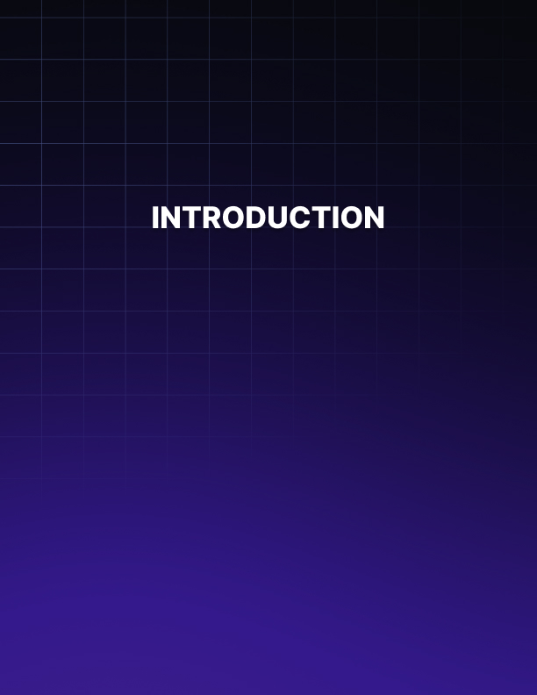

INTRODUCTION
____
Why do some websites easily convert visitors into customers while others struggle? The answer lies in understanding human psychology. This ebook reveals how consumer behavior influences conversions and how you can use these insights to transform your digital presence.
Imagine having a clear understanding of your customers' desires, fears, and motivations, and using that insight to guide them toward action.

This ebook equips you with ethical, research-based strategies that respect your customers while significantly boosting conversion rates.
This isn’t just another marketing “guide”—it’s all about understanding the psychology behind online behavior. You’ll learn how to leverage cognitive triggers that influence actions like clicking, scrolling, and purchasing. You’ll walk away knowing how to craft persuasive marketing messages, design effective websites, and create offers that truly connect with your audience.
You'll explore cognitive biases, emotional triggers, and the power of social proof. Beyond theory, you'll get practical, actionable steps to implement right away—whether it's creating urgency, building trust, or optimizing your website for conversions.
Each chapter will shift your perspective and give you tools to level up your marketing. Ready to tap into the full potential of your online business? Turn the page and start mastering conversion psychology for success.

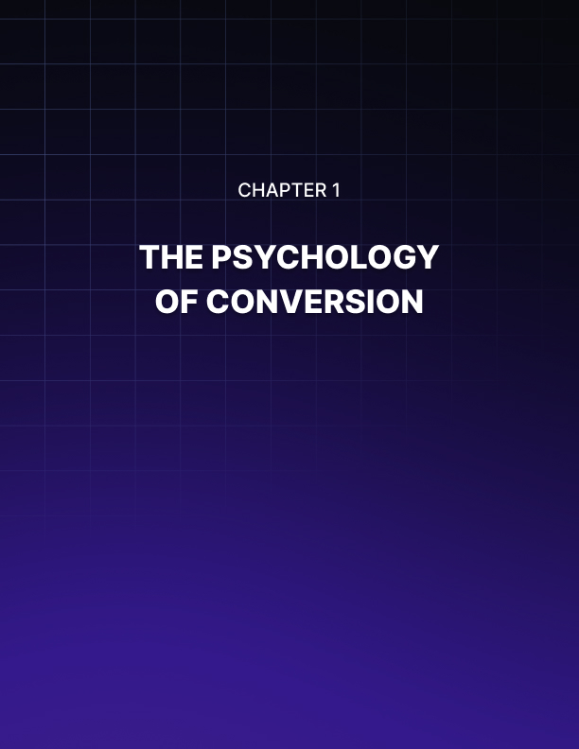

THE PSYCHOLOGY OF CONVERSIONS
____
Welcome to the fascinating world of conversion psychology. In this chapter, we'll uncover the secrets behind why people make the choices they do online and how to tap into the subconscious motivations that drive consumer behavior to dramatically boost your conversion rates.
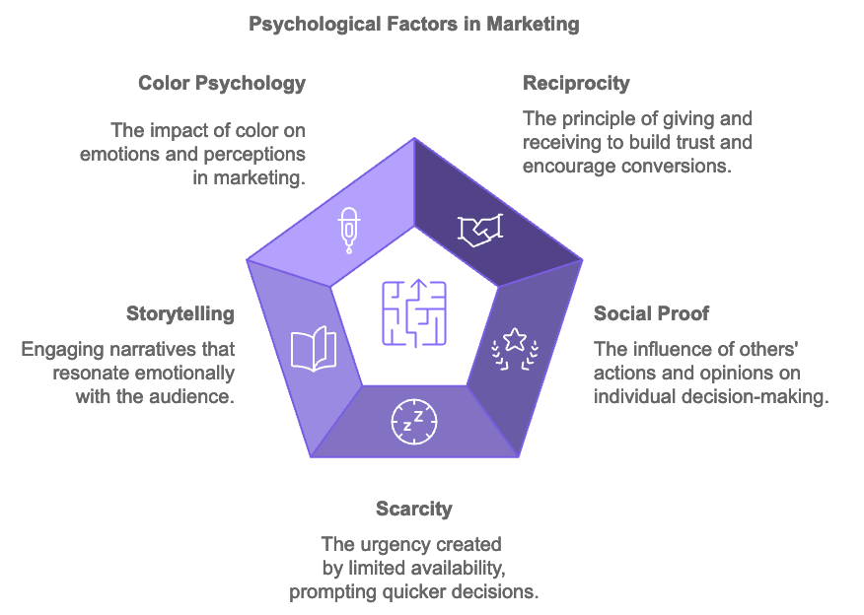

The Power of Emotions in Decision-Making
Humans are not as rational as we like to think we are. Our decisions are often driven by emotions, instincts, and subconscious biases rather than pure logic. This is where the power of psychology in marketing comes into play. According to a 2024 study by the Nielsen Norman Group, users typically spend less than 15 seconds on a webpage before deciding whether to stay or leave. In that brief window, your marketing must connect emotionally, build trust, and motivate action.
One of the most powerful psychological principles in marketing is the concept of reciprocity. This is the idea that when someone does something for us, we feel compelled to return the favor. You can leverage this by offering something of value to your potential customers before asking for anything in return. For example, you might offer a free ebook, a helpful video tutorial, or a valuable piece of content. When users receive this gift, they're more likely to feel a sense of obligation to your brand, increasing the likelihood of a conversion.
Another crucial psychological factor is social proof. Humans are inherently social creatures, and we often look to others to guide our behavior, especially in uncertain situations. This is why customer reviews, testimonials, and user-generated content can be so powerful in driving conversions. A 2024 survey by BrightLocal found that 91% of consumers read online reviews before making a purchase decision. Showcasing positive feedback from satisfied customers taps into the psychological need for social validation, helping potential customers feel more confident in their decision to convert.

Leveraging Scarcity and Simplicity
The principle of scarcity is another potent tool in your psychological arsenal. People tend to place a higher value on things that are rare or in limited supply. You can use this principle by creating a sense of urgency or exclusivity around your offers. For instance, you might offer a limited-time discount or highlight that only a few items remain in stock. This creates a fear of missing out (FOMO) that can prompt users to take action quickly rather than putting off the decision.
Understanding the concept of cognitive load is also crucial for optimizing conversions. Cognitive load refers to the amount of mental effort required to process information. When faced with too many choices or complex information, people often experience decision paralysis, leading to lower conversion rates. To combat this, you should strive to simplify your user experience. This might mean reducing the number of form fields on a signup page, streamlining your checkout process, or presenting information in easily digestible chunks. Reducing cognitive load makes it easier for users to take the desired action.

The Art of Storytelling and Visual Appeal
The power of storytelling is another psychological tool that can significantly impact conversions. Humans are wired to respond to narratives; we remember stories far better than we remember facts and figures. Weaving a compelling story around your product or service helps create an emotional connection with your audience, driving them to take action.
For example, instead of simply listing the features of your product, you could tell the story of how it was developed to solve a specific problem. Or you could share customer success stories that illustrate the real-world impact of your offering. These narratives help potential customers envision themselves benefiting from your product, making them more likely to convert.
Color psychology is another fascinating area that can influence conversions. Different colors evoke different emotions and associations, and savvy marketers use this to their advantage.
For instance, blue is often associated with trust and security, which is why it's commonly used by financial institutions. Red, on the other hand, can create a sense of urgency or excitement, making it effective for sale announcements or call-to-action buttons.
A study published in the Journal of Consumer Research in 2024 found that the perceived appropriateness of a color's application to a particular product influenced purchase intentions. This underscores the importance of choosing colors that not only align with your brand but also resonate with your audience's expectations and preferences.

Personalization and Loss Aversion
Personalization is another key psychological factor in driving conversions. People are more likely to respond positively to messages and offers that feel tailored to their individual needs and preferences. With the wealth of data available today, you can create highly personalized experiences that resonate with your audience.
A 2024 report by Epsilon found that 80% of consumers are more likely to make a purchase when brands offer personalized experiences. This could involve using a customer's name in email communications, recommending products based on their browsing history, or tailoring content to their specific interests or demographics.
The concept of loss aversion is also worth considering in your conversion strategy. Studies have shown that people generally feel the pain of losing something more acutely than the pleasure of gaining something of equal value. You can leverage this by framing your offers in terms of what customers stand to lose by not taking action, rather than focusing solely on what they'll gain.
For example, instead of saying "Save $50 when you buy now," you might say "Don't miss out on $50 in savings." The latter formulation taps into the fear of loss, potentially creating a stronger motivation to act.
Psychological Principle | Description | Application in Marketing
Reciprocity | People feel obligated to return favors | Offer free valuable content or resources
Social Proof | People look to others for guidance | Display customer reviews and testimonials
Scarcity | People value rare or  limited items more | Create limited-time offers or highlight low-stock
Cognitive Load | Too much information leads to decision paralysis | Simplify user experience and information presentation
Storytelling | People remember and connect with narratives | Use storytelling in product descriptions and marketing
Color Psychology | Colors evoke emotions and associations | Choose colors that align with brand and product
Personalization | People respond to tailored experiences | Use data to create personalized recommendations
Loss Aversion | People fear losing more than they value gaining | Frame offers in terms of potential losses

When applying these psychological principles, it's crucial to remember the importance of ethical marketing. While understanding psychology gives you powerful tools to influence behavior, it's your responsibility to use these tools in ways that genuinely benefit your customers. Transparency, honesty, and respect for your audience should always be at the forefront of your conversion strategies. Not only is this the right thing to do, but it also builds long-term trust and loyalty, which are invaluable for sustainable business success.
Tapping into the power of psychology in your marketing efforts does more than increase conversions – it helps you create meaningful connections with your audience. You're designing experiences that resonate on a deeper level, addressing real needs and desires in ways that feel natural and compelling. As you move forward, remember that understanding psychology is an ongoing process. Human behavior is complex and ever-changing, influenced by cultural shifts, technological advancements, and individual experiences. Stay curious, keep learning, and always be willing to test and refine your approach.
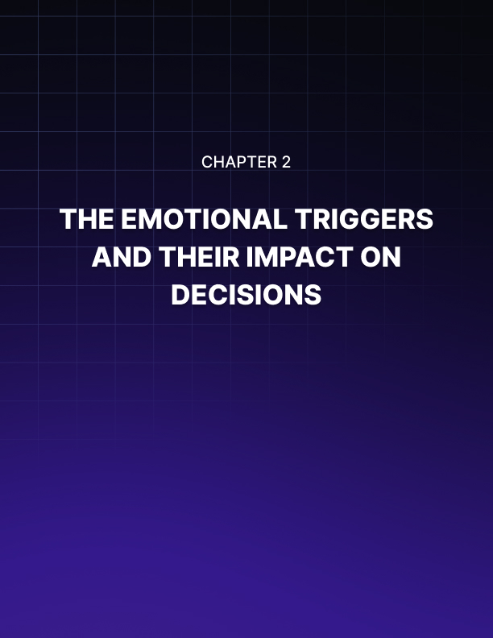

EMOTIONAL TRIGGERS AND THEIR IMPACT ON DECISIONS
____
Understanding cognitive biases and emotional triggers in marketing and conversion optimization is like holding a magic wand that influences consumer behavior. These powerful psychological phenomena shape how people perceive information, make decisions, and ultimately, take action. Grasping these concepts equips you to create marketing strategies that resonate deeply with your audience, driving conversions and fostering lasting customer relationships.

The Hidden Influences on Decision-Making
Your brain is a marvel of efficiency, constantly looking for shortcuts to process the overwhelming amount of information it encounters daily. These mental shortcuts, known as cognitive biases, help you make quick decisions but can also lead to errors in judgment.
For marketers, understanding these biases is crucial. They're not flaws to be exploited, but rather natural tendencies that, when recognized, can help you communicate more effectively with your audience.
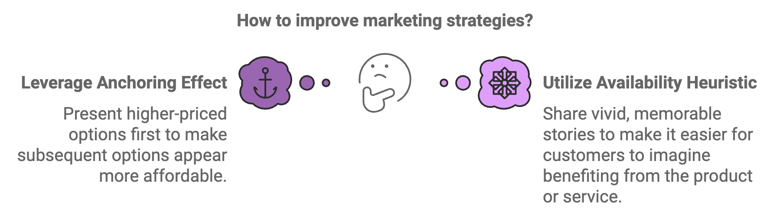
One of the most influential biases in marketing is the anchoring effect. This bias causes people to rely heavily on the first piece of information they receive when making decisions. In pricing strategies, for example, you can use this to your advantage. Presenting a higher-priced option first makes subsequent options appear more affordable by comparison. A 2024 study published in the Journal of Consumer Psychology found that when presented with a range of prices, consumers were 28% more likely to choose a mid-range option when it was preceded by a premium option.
Another powerful bias is the availability heuristic, where people judge the probability of an event based on how easily they can recall examples of it. This is why storytelling is so effective in marketing. Sharing vivid, memorable stories about your product or service helps potential customers easily imagine themselves benefiting from it. For instance, a fitness app that shares regular success stories of users who've achieved their health goals makes it easier for prospects to envision their own success, increasing the likelihood of conversion.

Harnessing Loss Aversion and Social Proof
Loss aversion, the tendency for people to prefer avoiding losses over acquiring equivalent gains, is a particularly potent force in decision-making. Research has consistently shown that the pain of losing is psychologically about twice as powerful as the pleasure of gaining. You can leverage this in your marketing by framing your offers in terms of what customers might lose by not taking action. For example, instead of saying "Sign up now to gain access to exclusive content," you might say "Don't miss out on exclusive content – sign up now." This subtle shift in language taps into the fear of missing out (FOMO), a powerful motivator driven by loss aversion.
A 2024 survey by the American Marketing Association found that marketing messages framed in terms of potential losses were 21% more effective at driving action than those focused on potential gains. But be cautious – overusing loss aversion tactics can backfire if your audience feels manipulated. The key is to strike a balance, using this principle judiciously and always in conjunction with genuine value for your customers.
Humans are inherently social creatures, and we often look to others to guide our behavior, especially in uncertain situations. This is the essence of social proof, a psychological phenomenon that can be a powerful tool in your conversion toolkit. When potential customers see that others have had positive experiences with your product or service, they're more likely to feel confident in their decision to convert. There are several ways to incorporate social proof into your marketing: customer reviews and ratings, testimonials, social media mentions, expert endorsements, and usage statistics. According to a 2024 survey by BrightLocal, 95% of consumers read online reviews before making a purchase. Displaying authentic customer reviews prominently can significantly boost trust and conversions. Remember, the most effective social proof is authentic and relevant to your target audience. Fake reviews or inflated numbers will likely be spotted and can severely damage trust in your brand.

The Psychology of Color and Design in Conversion
The visual elements of your marketing materials, including your website, ads, and product packaging, play a crucial role in triggering emotional responses and influencing decisions. Color psychology, in particular, can have a significant impact on how people perceive your brand and offerings. Different colors evoke different emotions and associations: blue often conveys trust, stability, and professionalism; green is associated with nature, growth, and health; red can create a sense of urgency or excitement; and yellow tends to evoke feelings of optimism and youth. A 2024 study published in the Journal of Marketing Research found that the perceived appropriateness of a color for a particular brand or product category influenced purchase intentions by up to 24%. This underscores the importance of choosing colors that not only align with your brand identity but also resonate with your audience's expectations and preferences.
Beyond color, other design elements can also trigger emotional responses and influence decision-making. For example, symmetry and balance in design can create a sense of harmony and professionalism, the use of white space can improve readability and focus attention on key elements, and images of people, especially those making eye contact, can create a sense of connection and trust. By thoughtfully considering these design elements, you can create a visual experience that not only looks appealing but also subtly guides your audience towards conversion.
Color | Emotional Association | Common Usage
Blue | Trust, Stability | Financial institutions, Tech
Green | Nature, Health | Eco-friendly brands, Health
Red | Urgency, Excitement | Sales, Call-to-action buttons
Yellow | Optimism, Youth | Brands targeting younger audience

Storytelling and Cognitive Load in Conversion
Humans are wired for stories. We've been sharing them since the dawn of language, using narratives to make sense of the world and connect with others. In marketing, storytelling can be a powerful tool for creating emotional connections and driving conversions. A well-crafted story can make your brand more memorable, help customers envision themselves using your product or service, create an emotional connection that goes beyond features and benefits, and simplify complex information and make it more digestible. When crafting stories for your marketing, consider the classic elements of storytelling:
- Character: Who is the hero of your story?
- Conflict: What problem or challenge does the hero face?
- Resolution: How does your product or service help resolve the conflict?
A 2024 study by the Content Marketing Institute found that brands using storytelling in their marketing saw a 32% increase in customer engagement compared to those using more traditional, feature-focused approaches.
Cognitive load refers to the amount of mental effort required to process information. When faced with too much information or complex choices, people often experience decision paralysis, leading to lower conversion rates. To optimize for conversions, it's crucial to minimize cognitive load and make the decision-making process as smooth as possible. Some strategies to reduce cognitive load include simplifying choices, using clear and concise language, breaking information into digestible chunks, using visuals, and streamlining forms.
The famous "jam study" by psychologists Sheena Iyengar and Mark Lepper found that when presented with fewer options, people were actually more likely to make a purchase. Reducing cognitive load makes it easier for potential customers to understand your offering and take the desired action.
As you apply these psychological principles to your marketing efforts, remember that the goal is not to manipulate but to communicate more effectively and provide genuine value to your audience. By understanding the cognitive biases and emotional triggers that influence decision-making, you can create marketing experiences that resonate deeply with your potential customers, driving conversions and building lasting relationships.

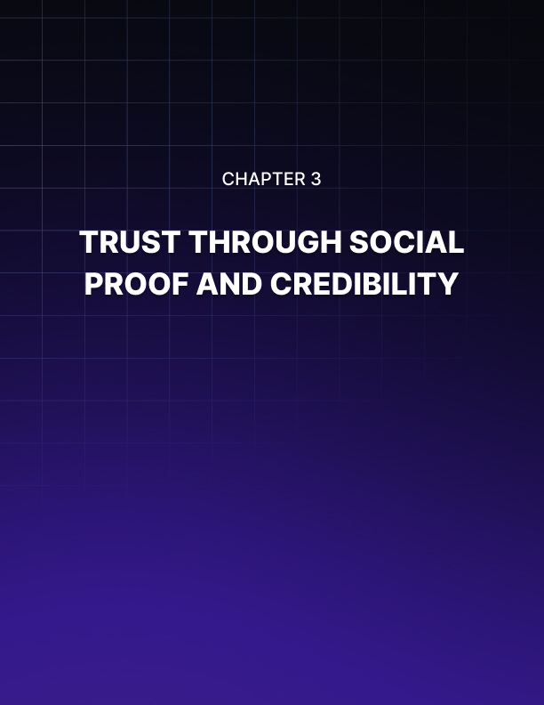

TRUST THROUGH SOCIAL PROOF AND CREDIBILITY
____
Trust is the cornerstone of any successful business relationship. With face-to-face interactions often replaced by screen-to-screen connections, building trust becomes even more crucial—and challenging. This chapter explores how you can leverage social proof and credibility to create a bridge of trust between your brand and your potential customers, ultimately leading to higher conversion rates and long-term customer loyalty.

The Foundation of Trust in the Digital Marketplace
Customers in the digital marketplace can't touch your products or look you in the eye, making it crucial to establish trust through your online presence. They rely heavily on the experiences and opinions of others to guide their decisions. A 2024 survey by TrustPilot revealed that 89% of consumers read reviews before making a purchase, and 49% trust online reviews as much as personal recommendations from friends and family. This highlights the critical role that social proof plays in building trust and driving conversions. Social proof comes in many forms, each with its own strengths and applications. Understanding these different types allows you to strategically incorporate them into your marketing efforts for maximum impact. User social proof includes customer reviews, ratings, and testimonials. It's one of the most powerful forms of social proof because it comes directly from people who have used your product or service.
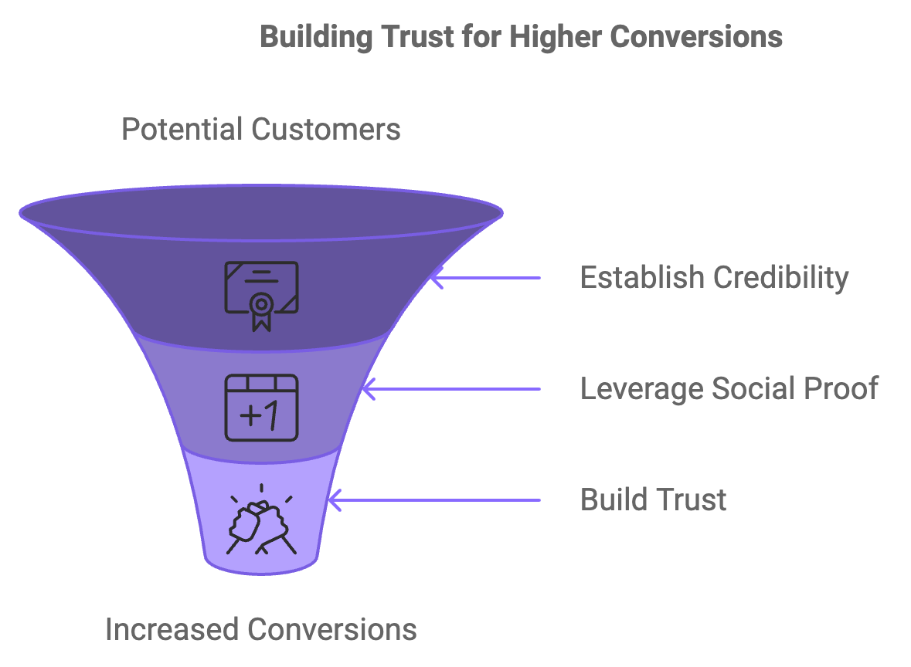
A 2024 study by the Spiegel Research Center found that displaying reviews can increase conversion rates by up to 270%, with the impact being even higher for higher-priced or more complex products. Expert social proof, such as endorsements or recommendations from industry experts or thought leaders, can significantly boost your credibility. Celebrity social proof, while not always applicable, can be powerful for certain products or services. However, it's crucial that the celebrity aligns well with your brand values and target audience.
The wisdom of the crowd leverages the idea that if a large number of people are doing something, it must be good. Displaying customer counts, download numbers, or subscriber totals can tap into this psychological principle. The wisdom of friends relies on the fact that people trust recommendations from those they know. Integrating social media connections to show which friends have purchased or used your product can be highly effective. Lastly, certification social proof, such as official certifications, awards, or accreditations from recognized institutions, can boost your credibility, especially in industries where expertise and reliability are crucial.

The Art of Gathering and Displaying Social Proof
To effectively use social proof, you need to strategically integrate it into your marketing materials and customer journey. Actively seek customer feedback by implementing a system to request feedback from customers after their purchase or experience with your product. A 2024 study by BrightLocal found that 76% of consumers who are asked to leave reviews go on to do so.
Tools like Yotpo or Trustpilot can automate this process, making it easier to collect a steady stream of reviews. Leverage user-generated content by encouraging customers to share photos or videos of themselves using your product. This not only provides social proof but also creates a sense of community around your brand. Showcase real-time statistics if you have impressive numbers.
Tools like UseProof or Fomo allow you to display real-time notifications of purchases or sign-ups, creating a sense of activity and popularity around your product. Create case studies for B2B companies or those offering more complex products or services. They allow potential customers to see detailed examples of how your offering has helped others in similar situations. Integrate social media by embedding social media feeds or testimonials on your website to show real-time, unfiltered feedback from customers. Use video testimonials to add an extra layer of authenticity to testimonials. Seeing and hearing a real person talk about their positive experience with your product can be incredibly persuasive.
The key to effective social proof is authenticity. Fake reviews or inflated numbers will likely be spotted and can severely damage trust in your brand. Always prioritize genuine, honest feedback over quantity.

Building Credibility Beyond Social Proof
While social proof is a powerful tool, it's not the only way to build credibility. Here are some additional strategies to enhance your brand's trustworthiness:
- Transparent Business Practices
- Expert Content Creation
- Professional Design and User Experience
Be open about your processes, pricing, and policies. A 2024 study by Label Insight found that 94% of consumers are likely to be loyal to a brand that offers complete transparency. Demonstrate your expertise by creating high-quality, informative content related to your industry. This could include blog posts, whitepapers, webinars, or podcasts. A well-designed, easy-to-use website or app signals professionalism and attention to detail, boosting credibility. Ensure your website has proper security measures in place, and display security badges prominently, especially on pages where users input sensitive information. Provide quick, helpful responses to customer inquiries, whether through email, social media, or live chat, to significantly enhance your credibility. If your brand has been featured in reputable media outlets, showcase these mentions on your website. If you work with well-known brands or have impressive clients, displaying their logos can lend you credibility by association.

Overcoming Skepticism and Negative Feedback
With the rise of fake news and online scams, consumers are becoming more skeptical of the information they find online. Address negative reviews professionally and constructively. This shows that you value all customer feedback and are committed to improving. Be transparent about your product's limitations. No product is perfect for everyone. Being upfront about who your product is and isn't for can actually increase trust. Provide detailed product information. The more information you provide about your product or service, the less room there is for skepticism. Include specifications, use cases, and even potential drawbacks. Offer strong guarantees like money-back guarantees or free trials to help overcome initial skepticism by reducing the perceived risk of trying your product. Use third-party review platforms like Trustpilot or Google Reviews to add an extra layer of credibility.
Ethical Guidelines for Social Proof
Never buy fake reviews or followers
Be transparent about sponsored content
Respect privacy when showcasing customer stories
Don't overstate your credentials
Update your social proof regularly

Adhering to these ethical guidelines helps protect your brand from potential backlash while building genuine, long-lasting trust with your audience. To ensure your efforts are effective, measure the impact of your social proof and credibility-building strategies. Key metrics to track include conversion rate, time on site, bounce rate, customer acquisition cost, customer lifetime value, and Net Promoter Score (NPS). Regularly analyzing these metrics allows you to refine your strategies and maximize the impact of your social proof and credibility-building efforts.
In conclusion, building trust through social proof and credibility is not a one-time task but an ongoing process. It requires consistent effort, authenticity, and a genuine commitment to providing value to your customers. Effectively leveraging these strategies helps create a strong foundation of trust that drives conversions and fosters long-term customer relationships and brand advocacy. Trust is your most valuable currency—invest in it wisely.
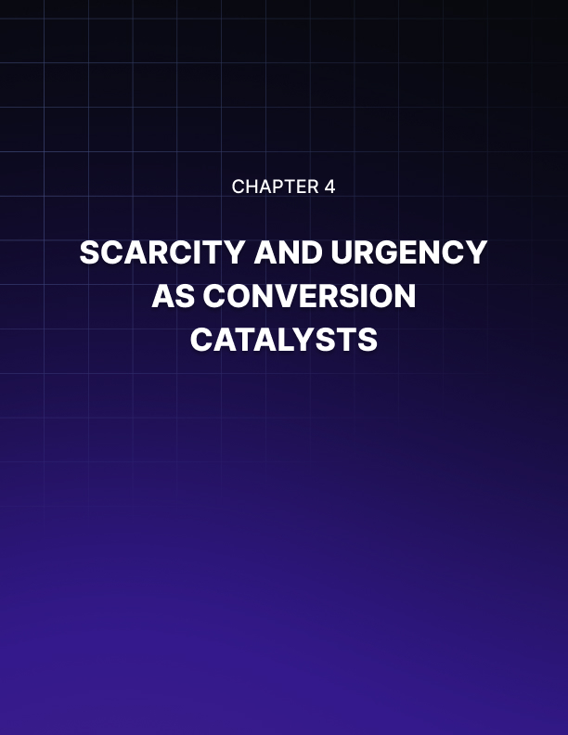

SCARCITY AND URGENCY AS CONVERSION CATALYSTS
____
Capturing and maintaining consumer attention is a constant challenge in digital marketing. Two powerful psychological triggers that can significantly boost your conversion rates are scarcity and urgency.
These principles tap into fundamental human motivations, prompting quick decision-making and action. In this chapter, you'll discover how to effectively harness these catalysts to drive conversions, increase sales, and create a sense of excitement around your offerings.
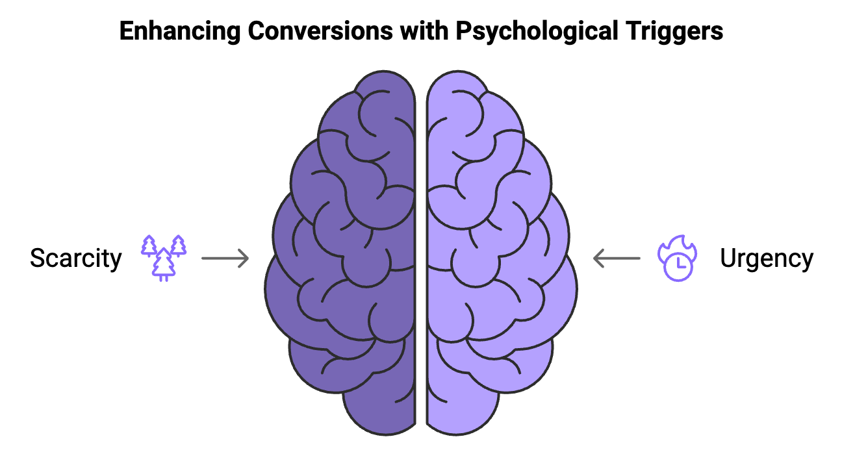

Understanding the Psychology of Scarcity
Scarcity is a powerful motivator in human psychology. When something is perceived as rare or limited, its perceived value often increases. This principle is deeply rooted in our evolutionary past, where resources were often scarce and competition for them was fierce. In modern marketing, you can leverage this innate response to scarcity to make your products or services more desirable. A 2024 study published in the Journal of Consumer Research found that products presented as scarce were perceived as 26% more valuable than identical products presented as abundant. This perception of increased value can lead to higher conversion rates and even allow for premium pricing.
There are several types of scarcity you can use in your marketing efforts:
- Quantity-Based Scarcity
Limiting the number of items available.
- Time-Based Scarcity
Offering deals for a limited time.
- Access-Based Scarcity
Restricting who can purchase or access your product.
- Feature-Based Scarcity
Offering limited edition versions with unique features.
Each type of scarcity can be effective, but it's crucial to choose the one that aligns best with your product and target audience. For example, luxury brands often use access-based scarcity to maintain exclusivity, while e-commerce sites might lean more heavily on quantity-based scarcity during sales events.

Implementing Scarcity in Your Marketing
To effectively use scarcity in your marketing, you need to be strategic and authentic. Here are some practical ways to incorporate scarcity:
- Create limited-time offers with flash sales or time-limited discounts.
- Display limited quantity alerts showing the number of items left in stock.
- Offer exclusive access to sales or new products for loyal customers or email subscribers.
- Create seasonal or holiday-themed products that are only available during specific times of the year.
- Use visual countdown timers on your website or in emails to create a sense of urgency around time-limited offers.
Remember, the key to using scarcity effectively is authenticity. False scarcity can backfire, damaging trust and credibility. Always ensure that your scarcity claims are genuine and transparent.

The Power of Urgency in Driving Action
Urgency is closely related to scarcity but focuses more on the time-sensitive nature of an offer or opportunity. Creating a sense of urgency motivates potential customers to take immediate action rather than delaying their decision. A 2024 study by the University of Nebraska-Lincoln found that adding urgency to marketing messages increased conversion rates by an average of 32%. This significant boost in conversions demonstrates the power of urgency as a motivational force.
Urgency works by tapping into the fear of missing out (FOMO) and loss aversion. People are more motivated by the thought of losing something than by the prospect of gaining something of equal value. Framing your offers around what customers might miss out on if they don't act quickly creates a powerful incentive for immediate action.
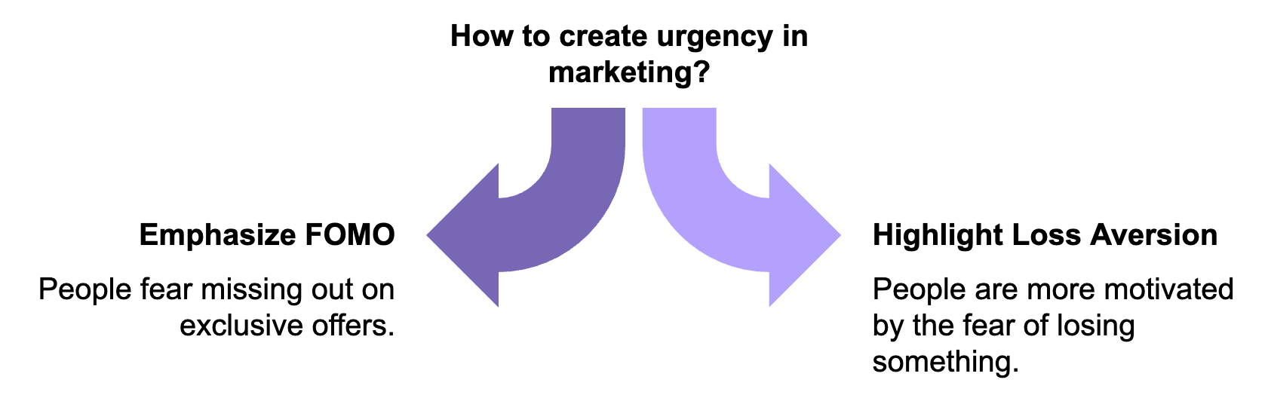
Here are some effective strategies for incorporating urgency into your marketing:
- Offer limited-time free shipping.
- Hold flash sales with steep discounts
- Notify customers when popular items are running low
- Issue coupons with expiration dates.
- Offer special bonuses or discounts for customers who pre-order new products.
- Send last-chance reminders for expiring offers or items in their cart.
When implementing these strategies, it's crucial to strike a balance. Overusing urgency tactics can lead to fatigue and skepticism among your audience. Use them judiciously and always in conjunction with genuine value for your customers.

Balancing Scarcity and Urgency
While scarcity and urgency can be powerful conversion tools, it's essential to balance them with a positive customer experience. Aggressive or manipulative use of these tactics can backfire, leading to customer frustration and damaging your brand reputation. Here are some guidelines for using scarcity and urgency ethically and effectively:
- Be transparent about the reasons for scarcity or time limits.
- Ensure that your offers provide genuine value to customers.
- Allow customers to opt-out of urgent messaging if they prefer.
- Maintain product or service quality.
- Follow through on your limited-time offers.
Constantly extending "limited time" erodes trust. The holiday shopping season, particularly Black Friday and Cyber Monday, provides an excellent example of how scarcity and urgency can drive massive sales. In 2024, online sales during these events reached a record $29.7 billion in the United States alone, according to Adobe Analytics.
These shopping events leverage both scarcity (limited stock of popular items) and urgency (time-limited deals) to create a frenzy of consumer activity. Retailers use countdown timers, limited-quantity alerts, and "doorbuster" deals to motivate quick purchases. However, the success of these events also highlights the potential pitfalls of overusing scarcity and urgency tactics. In recent years, some consumers have become fatigued by the constant pressure to buy during this period, leading to a backlash against "Black Friday culture." This underscores the importance of using these tactics judiciously and always in service of providing genuine value to your customers.

Leveraging Technology for Scarcity and Urgency
Modern technology offers numerous tools to implement scarcity and urgency tactics effectively. Dynamic pricing software can automatically adjust prices based on supply and demand, creating natural scarcity for popular items. Inventory management systems can display real-time stock levels to customers, creating authentic quantity-based scarcity. Email marketing automation allows for sending targeted, time-sensitive offers to customers based on their behavior and preferences. Retargeting ads can remind customers of items they've viewed or left in their cart, with time-limited incentives to complete the purchase. Mobile push notifications can send real-time alerts about limited-time offers or low stock to app users. Social media "flash" events can be used to host short, exclusive sales events on platforms like Instagram or Facebook. When implementing these technologies, always prioritize the customer experience. Ensure that your systems are reliable and that your messaging is consistent across all channels.
To refine your use of scarcity and urgency, it's crucial to measure their impact on your conversion rates and overall business performance.
Here are some key metrics to track:
Metric | Description
Conversion rate | Percentage of visitors who take the desired action
Average order value | Average amount spent per transaction
Click-through rate | Percentage of people who click on a specific link or call-to-action
Time to purchase | How long it takes for a customer to make a decision after encountering an offer
Cart abandonment rate | Percentage of users who add items to their cart but don't complete the purchase
Customer lifetime value | Total worth of a customer over the whole period of their relationship
Net Promoter Score (NPS) | Measure of customer satisfaction and loyalty

Regularly analyzing these metrics allows you to identify the most effective scarcity and urgency tactics for your business and refine your strategies accordingly.

The Future of Scarcity and Urgency in Marketing
With consumers becoming more sophisticated and digital marketing evolving, the use of scarcity and urgency tactics is likely to adapt over time. Some trends to watch include:
- Personalized Scarcity
Using data analytics to create tailored, time-sensitive offers for individual customers.
- Ethical Scarcity
A move towards more transparent and authentic scarcity tactics.
- Gamification
Incorporating game-like elements into shopping experiences.
- Ai-Driven Urgency
Using artificial intelligence to determine optimal timing and messaging.
- Virtual And Augmented Reality
Creating immersive, time-limited shopping experiences.
As these trends emerge, the key to success will be maintaining a balance between leveraging the power of scarcity and urgency and respecting your customers' intelligence and autonomy.
Scarcity and urgency are powerful catalysts for driving conversions when applied strategically and ethically. Understanding the psychology behind these principles, implementing them thoughtfully, and continually measuring their impact allows you to create compelling reasons for customers to choose your products or services.
The goal is not just to make a quick sale, but to build long-term relationships with satisfied customers who trust your brand. Use scarcity and urgency as tools to highlight the genuine value you offer, and you'll see not just increased conversions, but also greater customer loyalty and brand advocacy.
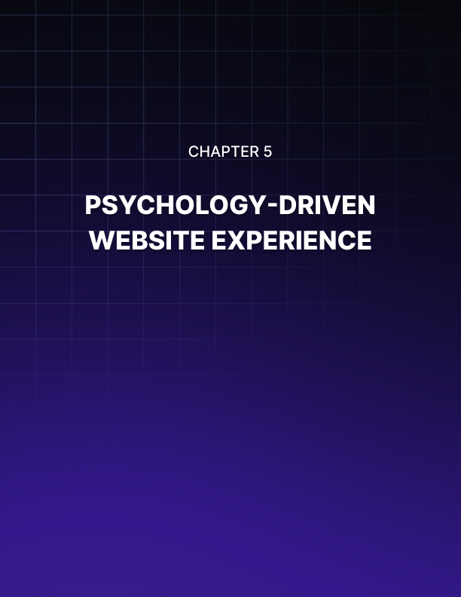

PSYCHOLOGY-DRIVEN WEBSITE EXPERIENCES
____
Your website is the gateway to your business, serving as a powerful tool in the ever-evolving online space. In this chapter, you'll discover how to harness the power of psychology to create website experiences that not only captivate visitors but also guide them smoothly towards conversion.
Understanding the intricate connection between design elements and human behavior enables you to craft a website that resonates with your audience's subconscious, influencing their decisions and actions in a way that benefits both them and your business.

The Psychology of First Impressions
Your website has mere seconds to make a lasting impression. Research from Google in 2024 shows that users form their first impression of a website in just 50 milliseconds. This split-second judgment can determine whether a visitor stays to explore or bounces away, never to return.
To make those crucial milliseconds count, you need to understand the psychological principles that govern first impressions.
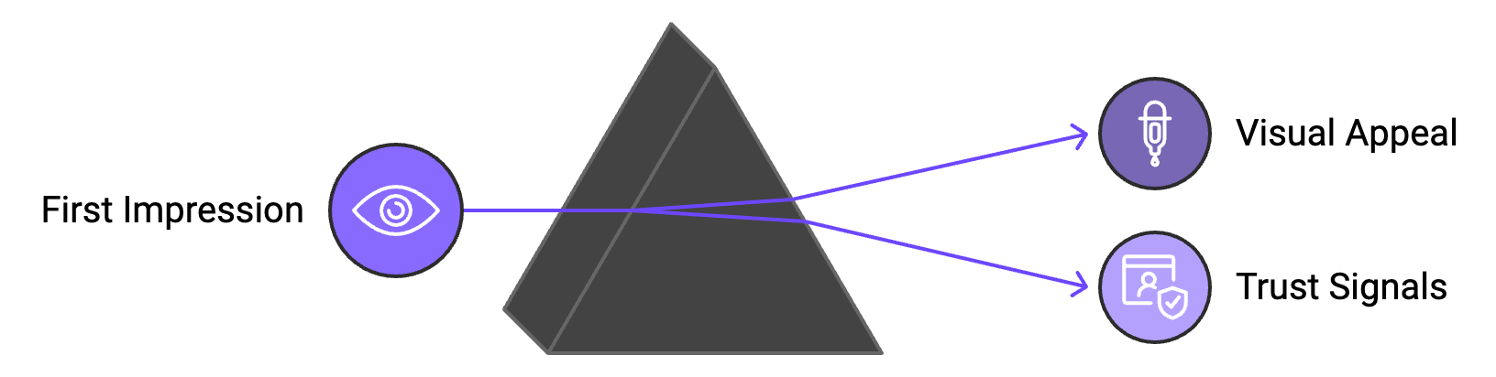
One key factor is visual appeal. The human brain processes images 60,000 times faster than text, making your website's visual design crucial. A study published in the Journal of Behavior and Information Technology found that the visual appeal of a website was the main driver of people's first impressions.
To capitalize on this, use high-quality, relevant images that resonate with your target audience, employ a color scheme that aligns with your brand and evokes the right emotions, and ensure your layout is clean, organized, and easy to navigate at a glance.
Another critical element is trust. The Stanford Web Credibility Project found that 75% of users make judgments about a company's credibility based on their website design. To build trust quickly, display trust signals prominently, such as security badges, client logos, or industry certifications, use professional, high-quality design elements that reflect your brand's values, and ensure your website loads quickly – slow loading times can erode trust and increase bounce rates.

The Power of Visual Hierarchy
Visual hierarchy is the arrangement of elements on your website in order of importance. It guides the user's eye to what you want them to see first, second, and so on. This is crucial for directing attention to key information and calls-to-action (CTAs).
The Gutenberg Diagram is a useful tool for understanding how users typically scan a webpage. It divides the page into four quadrants:
- Primary optical area (top left)
- Strong fallow area (top right)
- Weak fallow area (bottom left)
- Terminal area (bottom right)
Users tend to start in the primary optical area and end in the terminal area, following a Z-shaped pattern. You can use this knowledge to place your most important elements, like your value proposition or main CTA, in the primary optical area.
Other techniques for creating effective visual hierarchy include size and scale, color and contrast, white space, and typography. A 2024 eye-tracking study by the Nielsen Norman Group found that users spend 57% of their viewing time above the fold (the part of the web page visible without scrolling). This underscores the importance of placing your most crucial elements in this prime real estate.

The Role of Color in Persuasion
Color psychology plays a significant role in how users perceive and interact with your website. Different colors can evoke different emotions and associations, influencing user behavior in subtle but powerful ways. Here's a quick guide to color associations:
- Blue represents trust, stability, and professionalism.
- Green signifies growth, nature, and health.
- Red evokes excitement, urgency, and passion.
- Yellow symbolizes optimism, clarity, and warmth.
- Purple denotes luxury, creativity, and wisdom.
- Orange conveys confidence, cheerfulness, and friendliness.
- Black represents sophistication, luxury, and strength.
- White signifies purity, cleanliness, and simplicity.
A 2024 study in the Journal of Consumer Research found that the perceived appropriateness of a color for a particular brand or product category influenced purchase intentions by up to 24%. This means it's crucial to choose colors that not only align with your brand identity but also resonate with your audience's expectations and preferences. When using color in your website design, choose a dominant color that aligns with your brand personality and the emotions you want to evoke, use accent colors strategically to highlight important elements like CTAs, ensure sufficient contrast for readability and accessibility, and consider cultural differences in color perception if you have a global audience.

The Persuasive Power of Typography
Typography is more than just choosing a pretty font. It's a powerful tool for conveying your brand's personality, guiding user attention, and enhancing readability. Here are some key considerations:
- Font choice
Sans-serif fonts are generally easier to read on screens and convey a modern feel, while serif fonts can add a touch of tradition or sophistication.
- Font size
Ensure your text is large enough to be easily readable on all devices. A minimum of 16px for body text is a good rule of thumb.
- Line length
Aim for 50-75 characters per line for optimal readability.
- Line spacing
Use ample line spacing to improve readability and reduce eye strain.
- Contrast
Ensure there's sufficient contrast between your text and background colors.
- Hierarchy
Use different font sizes, weights, and styles to create a clear hierarchy of information
A study published in the Journal of Usability Studies found that proper use of typography could increase reading speed by up to 35% and improve comprehension by up to 20%. This demonstrates the significant impact that thoughtful typography can have on user experience and, ultimately, conversions.

Leveraging the Power of Whitespace
Whitespace, also known as negative space, is the empty space between elements in your design. Far from being wasted space, whitespace is a crucial tool for creating a clean, organized, and user-friendly website. The benefits of effective use of whitespace include improved readability, enhanced focus, perceived elegance, and better comprehension. A study by Human Factors International found that the proper use of whitespace between paragraphs and in the left and right margins increases comprehension by almost 20%.
When using whitespace in your design, don't be afraid of empty space – it's not wasted space, use whitespace to group related elements and separate unrelated ones, be consistent with your spacing to create a sense of rhythm and order, and consider using more whitespace around your most important elements to make them stand out.
Color | Emotion/Association
Blue | Trust, stability, professionalism
Green | Growth, nature, health
Red | Excitement, urgency, passion
Yellow | Optimism, clarity, warmth
Purple | Luxury, creativity, wisdom
Orange | Confidence, cheerfulness, friendliness
Black | Sophistication, luxury, strength
White | Purity, cleanliness, simplicity

In conclusion, designing a website that persuades and converts is a delicate balance of art and science. Understanding and applying these psychological principles allows you to create a website that not only looks great but also guides users effortlessly towards conversion. Remember, the key is to always put your users first. By creating a website experience that truly meets their needs and expectations, you'll not only boost your conversions but also build lasting relationships with your customers.


INTEGRATING THEORY INTO PRACTICE
____
You've journeyed through the fascinating world of conversion psychology, exploring the intricacies of human behavior and decision-making. Now, it's time to bring it all together and create a complete blueprint for integrating these powerful psychological principles into your marketing strategy. This chapter will guide you through the process of applying what you've learned, helping you craft compelling, persuasive marketing that drives sustained success.

The Holistic Approach to Psychological Marketing
To truly harness the power of psychology in your marketing efforts, you need to adopt a holistic approach. This means looking at your entire customer journey through a psychological lens, from the first point of contact to post-purchase interactions. By doing so, you'll create a seamless, psychologically-informed experience that guides potential customers towards conversion and fosters long-term loyalty.
Start by mapping out your customer journey, identifying key touchpoints where psychological principles can be applied. For example, use storytelling techniques to create an emotional connection with your brand during the awareness stage, leverage social proof to build trust and credibility in the consideration stage, apply scarcity and urgency tactics to prompt action in the decision stage, and utilize reciprocity to encourage repeat business and referrals in the post-purchase stage.
The goal isn't to manipulate but to create experiences that resonate with your audience's natural decision-making processes.A 2024 study published in the Journal of Consumer Psychology found that marketing strategies aligned with psychological principles resulted in a 27% increase in customer satisfaction and a 35% boost in brand loyalty.

Creating Your Psychological Marketing Toolkit
Now that you understand the importance of a holistic approach, it's time to build your psychological marketing toolkit. This toolkit will contain the various psychological principles and techniques you've learned, ready to be deployed strategically across your marketing efforts. Identify the key emotions that resonate with your target audience. A 2024 survey by the Advertising Research Foundation found that emotionally resonant ads were twice as likely to drive purchase intent compared to purely rational appeals.
List the most relevant cognitive biases for your product or service. For example, the anchoring effect could be particularly useful for pricing strategies, while the bandwagon effect might be leveraged in social media campaigns.
Compile a variety of social proof elements, such as customer testimonials, expert endorsements, and usage statistics. A 2024 study by BrightLocal found that 91% of consumers read online reviews before making a purchase, highlighting the continued importance of social proof in decision-making.
Develop a range of scarcity and urgency techniques, from limited-time offers to low-stock alerts. Be sure to use these judiciously to maintain authenticity. Create templates for different types of brand and customer stories that can be used across various marketing channels. Compile trust-building elements such as security badges, certifications, and transparent policies to be displayed prominently on your website and marketing materials. Develop methods for tailoring your marketing messages to individual preferences and behaviors, as personalized experiences have been shown to increase conversion rates by up to 20% according to a 2024 report by Epsilon.
With this toolkit at your disposal, you'll be well-equipped to infuse psychological principles into every aspect of your marketing strategy.

Implementing Psychological Principles
To maximize the impact of your psychological marketing efforts, you need to implement these principles consistently across all your marketing channels. Here's how you can apply psychological insights to some key marketing areas:
- Website Design
Your website is often the first point of contact between your brand and potential customers. Use principles of visual hierarchy to guide attention to key elements, leverage color psychology to evoke desired emotions, and incorporate trust signals to build credibility. A study by the Nielsen Norman Group found that users form their first impression of a website in just 50 milliseconds, underscoring the importance of psychologically-informed design.
- Content Marketing
Use storytelling techniques to create emotional connections with your audience. Structure your content to leverage the serial position effect, placing key information at the beginning and end where it's most likely to be remembered. A 2024 Content Marketing Institute report found that brands using storytelling in their content marketing saw a 30% increase in engagement compared to those using more traditional approaches.
- Email Marketing
Apply principles of reciprocity by offering valuable content before asking for a purchase. Use scarcity and urgency tactics in subject lines and body copy to encourage opens and clicks. Personalize emails based on user behavior and preferences to increase relevance and engagement.
Consistently applying these principles across all your marketing channels creates a cohesive, psychologically-informed brand experience that guides customers toward conversion and fosters long-term loyalty. To ensure your psychological marketing efforts are effective, you need to measure their impact consistently. Here are some key metrics to track:
- Conversion Rate
- Average Order Value
- Customer Lifetime Value
- Bounce Rate
- Time on Site
- Click-Through Rate (CTR)
- Net Promoter Score (NPS)
Regularly analyzing these metrics helps identify the most effective psychological tactics for your audience, allowing you to refine your strategies accordingly. Remember, the goal is continuous improvement and adaptation to your audience's evolving needs and preferences.

Ethical Considerations in Psychological Marketing
While psychological marketing can be incredibly powerful, it's crucial to use these techniques ethically. The line between persuasion and manipulation can sometimes be thin, and crossing it can damage your brand reputation and erode customer trust. Here are some guidelines to ensure your psychological marketing remains ethical:
- Be transparent about your marketing tactics.
- Ensure that your offers provide genuine value to customers.
- Respect privacy when using personalization tactics.
- Avoid exploiting vulnerable groups or individuals.
- Ensure all claims in your marketing are truthful and can be substantiated.
- Allow customers to opt-out of certain marketing tactics if they choose.
Adhering to these ethical guidelines protects your brand from potential backlash and helps build genuine, long-lasting trust with your audience. A 2024 Edelman Trust Barometer report found that 81% of consumers said they need to be able to trust a brand to buy from them, highlighting the importance of ethical marketing practices.

Conclusion
In this ebook, you've explored how to tap into psychology to make your marketing more impactful. From using emotional triggers and social proof to creating urgency, each section gave you practical strategies for connecting with your audience on a deeper level.
The key takeaways include understanding the role of emotional triggers, building trust through credibility and authenticity, and using cognitive principles to enhance user experience. By weaving these insights into your marketing approach, you're not just optimizing for conversions but building genuine connections with your audience.
As you apply these strategies, focus on creating a balanced and honest approach that earns loyalty. Consumer behavior keeps changing, so stay curious, keep adapting, and prioritize adding value. This way, you'll keep your audience engaged and your conversions growing.

