Disclaimer

This eBook has been written for information purposes only. Every effort has been made to make this eBook as complete and accurate as possible. However, there may be mistakes in typography or content. Also, this eBook provides information only up to the publishing date. Therefore, this eBook should be used as a guide - not as the ultimate source.

The purpose of this eBook is to educate. The author and the publisher do not warrant that the information contained in this eBook is fully complete and shall not be responsible for any errors or omissions. The author and publisher shall have neither liability nor responsibility to any person or entity with respect to any loss or damage caused or alleged to be caused directly or indirectly by this ebook.

This eBook offers information and is designed for educational purposes only. You should not rely on this information as a substitute, nor does it replace professional medical advice, diagnosis, or treatment.
Table of Contents

Introduction 5
Chapter 1: Embracing The Side Hustler Mindset 7
Discovering the Benefits of Side Hustling 7
Cultivating the Right Attitude for Success 8
Overcoming Common Side Hustle Challenges 8
Chapter 2: Identifying Profitable Side Hustle Opportunities 12
Assessing Your Skills, Interests, and Passions 12
Researching Lucrative Market Niches 13
Evaluating the Viability of Your Ideas 14
Chapter 3: Planning Your Side Hustle For Success 17
Defining Your Side Hustle Goals and Objectives 17
Creating a Solid Business Plan 18
Setting Realistic Expectations and Milestones 19
Chapter 4: Building A Strong Brand And Online Presence 22
Developing Your Personal Brand 22
Establishing a Professional Online Presence 24
Leveraging Social Media for Marketing and Promotion 26
Chapter 5: Marketing Strategies For Your Side Hustle 28
Identifying and Targeting Your Ideal Customers 28
Crafting Effective Marketing Messages 29
Utilizing Online and Offline Marketing Channels 31
Chapter 6: Managing Your Time and Resources 34
Effective Time Management Techniques 34
Maximizing Productivity in Your Spare Time 35
Managing Finances and Resources Wisely 37
Chapter 7: Scaling And Growing Your Side Hustle 39
Strategies for Scaling Your Business 39
Expanding Your Product or Service Offerings 40
Building Customer Loyalty and Retention 41
Chapter 8: Overcoming Challenges and Sustaining Success 44
Dealing with Setbacks and Obstacles 44
Balancing Your Side Hustle with Other Commitments 45
Maintaining Long-Term Success and Growth 46
Conclusion 49



Introduction

Did you know that you can turn any hobby you have into a business with no trouble whatsoever? You can make just about any business a side hustle where you can make some serious money doing what you love, and if you take the time to work really hard at it, it could become your main hustle. Or it could at least become a massive part of your income.

However, so many prospective side hustlers don’t know where to start and have no idea how to turn their business from an idea in their head to something that can actually make them some money when they need it. That’s actually what this book is for and likely why you picked it up in the first place, because you are sure you could get your side hustle working if you only had a blueprint for success. Well, thankfully with this blueprint book, you do!

In these pages we are going to break down some of the tips and tricks to get yourself inside of a side hustler’s mindset, and what you need to do to make sure that you are fully ready to get your side hustle off the ground and into the space of being very profitable.

Look, you have some amazing idea in your head for some side hustle that will change your life, provide value to your customers, and maybe even change the world. That can be good or bad, because you could either be extremely excited to show your side hustle to the world or you might just be convinced that it will never work. But no matter your thoughts on side hustling or what your side hustle is, you need to ensure that you read this blueprint book.

Because every single side hustle (no matter what it is) and every single person who wants to own a side hustle business (no matter who they are), has had to follow the same basic steps to prepare themselves for the success that they have had. This book is going to share those steps, and if you follow them, you will be 100% primed for your own brand of success.

Here’s what you need to know in order to take your side hustle out of your head and into a field of serious success.


Chapter 1: Embracing The Side Hustler Mindset

Whether you are a firm believer in the Law of Attraction/Assumption, believe that like attracts like, or have no interest in any of that at all, you still need to understand that owning a side hustle takes some serious mindset work. While you might be champing at the bit to work on taking action and building your business from the ground up, you need to stop and do some inner work first. If you approach the outer action with a serious mindset, then you will get a lot more done than if you try to take action while sabotaging yourself with your inner talk.

First, you need to get excited about your side hustle. Far too many people see side hustling as a massive mountain that they need to climb. Much like a real mountain, you might start off with some serious enthusiasm, but about halfway up you will start to get tired and want to go back down. This can cause some serious problems if you have invested a lot of money into your side hustle, but then want to quit when the going gets tough.

The fastest way to overcome this problem is to continually get excited about your side hustle, and the best way to get excited is to focus on the benefits. Side hustling can bring a lot of benefits to your life and it is important to not just remind yourself of them at the start of your business journey, but also during the journey so you can keep pushing ahead.

Discovering the Benefits of Side Hustling
Obviously, the first benefit is that you get to do something you love, and you get to work with your passion. Whether your side hustle is baking cookies for people, writing custom code for business, or providing coaching about something that you really care about, you should be extremely excited and passionate about the topic you are working with. Working with your passion, and working on your side hustle, should bring you some serious joy and excitement in your life.

You should be extremely excited every single time you sit down to work on your side hustle because it is something you are very excited about. That’s one of the biggest benefits, and it can really make you feel good after a long and hard day to come home and work on your side hustle.

Another big benefit of having a side hustle is that you can make some extra money sharing what you love with the world. Whether you are making money by sharing a product or service or performing commissions for a fee, getting a little extra income never harms anyone.

Additionally, you will be able to watch your customers benefit directly from what you are doing and selling. Being able to watch your products, services, or talents make someone else smile can be a massive benefit that just makes you feel good.

Cultivating the Right Attitude for Success
Once you have all of the benefits laid out in front of you, you need to focus on having the correct attitude. A side hustle should, at its core, not feel like work and not drive you crazy. You don’t want your side hustle to become a source of stress for you and your family, you want it to keep feeling fun and exciting because that is going to keep you motivated in the face of some of the challenges that will pop up.

So don’t get discouraged when challenges and obstacles pop up that threaten to stop your progress in its tracks. Instead do your best to have some fun with it and see each challenge as just that. It is a challenge that you are going to do your best to fully overcome.

Overcoming Common Side Hustle Challenges
Persistence is going to be the hardest thing to do, because it is one thing to get the mindset when things are easy and you are eager to keep on working. But it is another whenever life is grinding you down and the side hustle isn’t doing what it should to make you money. So make sure to have strategies in place to get you into that mindset of excitement where everything is possible, even if the world is falling apart around you.

You will feel much better if you can do that on command, because developing the right mindset and attitude is very tricky when working with a side hustle. Persisting in it is going to be even harder whenever the road gets rocky.


Chapter 2: Identifying Profitable Side Hustle Opportunities

Now I know that ‘following your passions’ is the first piece of advice that was really given in this book, and for a successful side hustle you need to have some serious passion to be able to stick with whatever your side hustle is. However, how do we make sure that passion equals eventual profit?

Assessing Your Skills, Interests, and Passions
First, you need to make a list of all your passions and see if any of them can be turned into good side hustles. For example, if you love making art and working with your hands, there are countless ways you can turn that into a business, as well as countless resources you can use.

Additionally, ask yourself what are you interested in? What do you want to know more about to grow in? Because even a successful side hustle can get very boring if you are simply doing the same thing every single day and not challenging yourself at all. You should pick a side hustle opportunity that leaves you with a lot of room to grow and improve your skills.

Not only will you constantly be learning new methods of the elements of your side hustle, but you can channel all of that extra knowledge into some serious passion for your business. As you learn more, you will be able to improve your products and services as well, and that will give you the ability to share more value with your customers. The more value you can provide for them, the happier they will be whenever they interact with your side hustle!

So don’t be afraid to write down some of your passions and then write three to five potential side hustles for each. It is okay if you have a very long list or a very short one, because now you need to step back and really chew on the list. Take a few days and just think of some of the side hustle ideas that you have. Are there any that might be a little easier than others to pull off? Does one excite you and give you more drive to complete it than the other? Is one idea really unique or does a market exist for some of these already?

Researching Lucrative Market Niches
Taking the time to mull over all of the ideas you have created can really help you figure out some of the better ideas that stand out or are more exciting than the rest. Once you have a collection of side hustle ideas that you might want to seriously pursue, you should attempt to do research on each one to see which one is the most profitable.

Of course, profit isn’t everything. Mainstream side hustles fail just as often as the non mainstream ones do, and some of the most unlikely ideas manage to become a massive profit machine. But you should still try to get an idea of how your ideas will fare in the real business world.

So do some research and try to see what ideas you have would make the most profit. Because it might be easier to set up a side hustle that other people are already doing, because that means you have a lot of potential mentors to pick from as well as a lot of resources to use. Plus, you can even attempt to figure out some of the biggest pitfalls and problems that those businesses suffered and then do your best to avoid them.

Evaluating the Viability of Your Ideas
Once you have some ideas that can turn a profit, you should also take a look at the mainstream side hustles in your field, the trend for the market, and what the people in your business niche really want. For example, if you want to have a side hustle making clay sculptures, it can be worthwhile to look at what people want out of their clay sculptures.

Do they want humanoid figures? Animal shapes? Big and massive sculptures or small ones that they can put on a bookshelf or side table? Are they focused on realistic sculptures or more abstract styles? Answer these questions and see if there is any way to turn the trends to your advantage. While you don’t want to bend to the will of the masses or spend hours and hours constantly working on projects that are mainstream and not what you really want to do, you should at least be aware of what the world wants out of a side hustle in your niche.

Taking what’s popular and mainstream now into consideration is going to give you more knowledge that you can use for your side hustle, and maybe once you get popular and noticed with your mainstream works of art, you can focus on creating what you really want.

At that point, you already have an audience who might just buy, share, and talk about everything you will put out there! While it can be hard to stomach doing some of the mainstream stuff for a side hustle that is supposed to be fun and filled with passion for you, you might as well try to have fun while doing it, because it is only going to get you closer to doing what you really want to do with your side hustle.

And if you do the mainstream stuff well enough, you will get an audience who loves your work enough to keep talking with you and they will be very receptive whenever you try something brand new.


Chapter 3: Planning Your Side Hustle For Success

Alright, so now you have the correct mindset to run a side hustle as well as a pretty good and well researched idea that has a pretty good chance of turning some type of profit. However, you don’t want to start work on your side hustle just yet. Because you need a plan, and it needs to be a really good one.

You can’t just throw stuff at the wall and then try to see what sticks, because that is going to knock your traction towards success into a serious ditch! Having a plan (or a blueprint) is going to give you targets to reach, goals to check off, and something strong to fall back on whenever you need some support. But how do you make a side hustle plan that will work on ensuring that your business goals are met? Well, here’s how to get started.

Defining Your Side Hustle Goals and Objectives
First, no plan can start without some clear objectives and a clear goal. For your side hustle, you need to ask, what do you want this side hustle to accomplish? Do you want your side hustle to hit
$10,000 in sales? To reach 500 people? To motivate people to change something about themselves? Do you want to make one sale and then you will be happy?

You need to answer that question, and don’t be afraid to have an answer that is big or seems impossible. Maybe you want to hit one million in sales or you want to help 4,000 people with your services. Having a huge and (what seems like) an unreasonable goal, can be something that will keep you and your side hustle striving as you keep working towards it. And if it seems too big of something to accomplish, then that is what the objectives are for.

For example, if you want to hit a certain number in sales, then we can break that goal down into some objectives that you can tackle one after the other. For example, to hit 10,000 dollars in sales, then how many of your products and services do you need to sell? How many customers would you need to have? What would your marketing need to look like to reach those customers? What would your budget need to be if you wanted all of that
$10,000 to be pure profit?

Creating a Solid Business Plan
All of the answers to these questions are going to be your objectives, and now you’ve got some smaller targets to hit as you move towards your goal. Now, don’t worry if your objectives change or you add some new ones as your business goes on.
For example, you might introduce some new products and services that will make you some more cash, so your ‘number of products sold’ might change. Or you might introduce a new objective because your situation changed. Heck, you might even upgrade your goal and move the goalpost!

Once you have your big goals, and a solid business plan for what you need to do in order to achieve them, then you need to think smaller and get very realistic. For example, if you want to make 10,000 dollars in sales, you first need to make one sale for 10 dollars.

What goes into making a sale for your side hustle? Do you need to market your business to your niche? Go door to door and market that way? Do you need to focus on making your product the best it can be before you go to market? Set some milestones around these questions and their answers, and that is going to help drive you towards your realistic goal of making a sale.

You can even make a business plan just for the completion of your small goal, just like the one you have for your big overarching goal. Again, having a strong plan with steps and milestones you can check off during the process of heading towards the goal is a fantastic idea, and it is going to help to keep you motivated.

Setting Realistic Expectations and Milestones
Finally, don’t be afraid to be realistic. Before you can make 100 sales, you need to make one, and that can be a little discouraging as you focus on how to make that one sale, find the right customer, and persuade them to buy your product or service. If even the smallest goal seems impossible for you, you need to make sure that you are focusing on celebrating the small wins when they do come.
There are a lot of small reasons to celebrate whenever it comes to opening up a side hustle. You might get your business website open and up, you might purchase a storefront, or you might send out your first advertisement on social media. Don’t be afraid to celebrate with yourself or your team and give yourself some time to be happy for these small goals. It might seem a bit silly, but if you can have some fun with celebrating the small goals, you will be able to better benefit from the big goals.

Making a business plan and all of these goals should take up quite a lot of time for you, no matter what your side hustle is or how profitable you think the side hustle will wind up being. The more time, energy, and detail you put into having a good plan that will meet all your needs, the more successful your business will be whenever you eventually follow that plan.
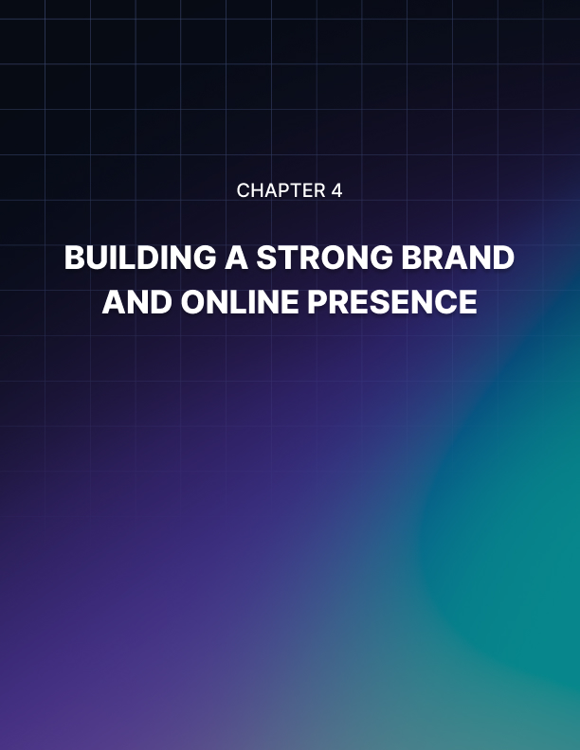

Chapter 4: Building A Strong Brand And Online Presence

Nearly every single business has a brand. It could be their logo, a saying that is said, a certain song or jingle, or someone else that just clicks in your brain and makes you go ‘yep, that is that business!’ In order for your business to be both attractive and successful with the people in your niche, you need to develop a personal brand.

Developing Your Personal Brand
But that doesn’t just mean logos and jingles and a colorful font, but also your personal brand. A personal brand is going to set the tone for what people will come to expect whenever they work with your business, and a personal brand is extremely important. In fact, if you do not have a good personal brand, your business will suffer. No question about it.

For an example of this, let’s take two restaurants. Restaurant A has terrible food, a rough environment, and it is too loud, cramped, and hard to eat in. However, the service is top notch. Your every need at the restaurant is fulfilled eagerly and the waiters and servers make the best attempt to get to know you and make you feel welcome even if the rest of the restaurant is falling down around your ears.

Now Restaurant B has five star food, a fantastic atmosphere and ambiance, and it is a perfect place to sit and just have some fun. However, the service is nonexistent and when you do get a waiter or server to come see you, they are rude and the requests you have take way too long to get filled properly.

While you might not go back to restaurant A again, you will always look back and remember the fine service you got, and if you go back to restaurant B you will find that you can’t stop thinking about how terrible the service was and how much you wish you hadn’t gone.

Your side hustle is a business, and while you wear many hats inside of that business, when you interact with the customer you are one of the servers. How you treat them and how they interact with you is going to determine what they feel about your business. You might have the best side hustle ever that runs like clockwork and gets perfect products to your customers on time, but if you don’t treat your customers right and break the promises of service that you have given them, they won’t come back.

Likewise you might have a side hustle that is still experiencing those growing pains and making a few mistakes, but if you get to know your customer, treat them like a king, and make sure that their needs are heard and met, they will keep coming back to you.

So what do you want the personal brand of your side hustle to be? Do you want a business that is all smiles and happiness? Do you want a business that gets your clients the products and services they want right away? Do you want a reliable business that every single person who walks in the door can depend on? If you take the time to really think about what you want your personal brand to be, then you can answer the much more important question of how to seep every part of your business in your personal brand. Then you can get back to providing the best experience you can for the customer.

Once you have your personal brand, then it is time to get technical with the professional stuff. Your side hustle is going to need to be online in some capacity, whether it is fully online or you have an online business that will promote your physical storefront. In order to make sure that your customers come to your website and want to stay on the website to make their purchases, you need to have a professional online presence.

Establishing a Professional Online Presence
This means that your website needs to be up to date, polished, and not filled with things that will take your customer’s attention away from the funnel you want them to go down. The funnel that starts with them on your website and ends with them buying all of your stuff.

So make sure that every aspect of your business website is easy to navigate, and that your customers have many different ways to get to your storefront and to click purchase. If something is wrong with your business website, such as a code error or an unresponsive link or webpage, then you need to get it fixed right away. A professional website is going to be the cornerstone of your online presence, and if you don’t know how to build a website or don’t want to learn from one of the dozens of website builders out there, then you can easily hire a professional to complete the work for you.

But of course, a professional website only works if you can get your customers to it. This is where marketing comes in. For this, you are going to need to go on social media and give your business some type of page. Of course, you shouldn’t try to be active on ten different social media accounts at the same time, but should focus on where your customers are.

Look at your customer niche. Are they all watching videos? Are they found on Twitter? Are they posting on Facebook? If you can figure out where and when your prospective customers are on social media, you can start to market to them. Also, pick a social media strategy you are comfortable with. If you aren’t comfortable showing up on video to make a TikTok about your business, then don’t. If you don’t want to write a long Facebook post, then don’t.

Leveraging Social Media for Marketing and Promotion
Try to strike a balance between the type of social media you are going to produce as well as what social media your prospective customers would like to see. Additionally, don’t be discouraged if this process takes some time, because despite what everyone thinks, no one goes viral overnight on social media. Your business might have to post a lot before you start to gain some traction, and even more before your social media followers migrate to your website.

Keep on building your online brand and presence, and then you will find yourself swimming in customers and having to deal with the abundance of success.
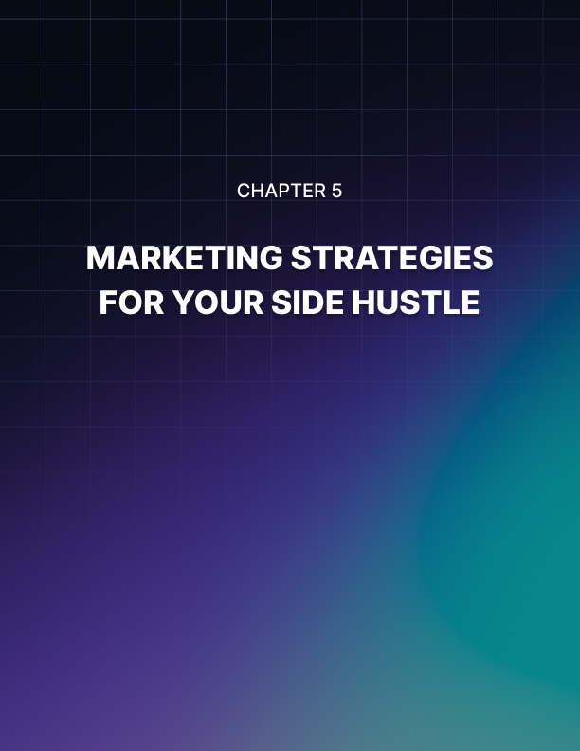

Chapter 5: Marketing Strategies For Your Side Hustle

Alright, so you’ve got your brand figured out, your social media pages up, and your website is ready for people to go down the funnel and buy your products. The only thing missing is all the people, and this is where a lot of side hustle owners start to really hit the middle of the mountain. Where you aren’t making much progress and you feel like turning back and giving up.

It can be hard, especially if you are working so hard and have invested your time and money into all of this and then your marketing doesn’t produce the customers you want. But do you even know what customers you want to attract into your business? Well, most side hustles and even the majority of businesses don’t! They are confident and comfortable accepting anyone with a pulse and an open wallet, but this is often a bad business practice, because if you are trying to market your product to everyone you will likely get nowhere and sell to no one. So it is much better to reach out and focus on finding some of the ideal customers you can bring to your website.

Identifying and Targeting Your Ideal Customers
Think about your side hustle and the products or services you want to sell. Who do you want to target in your marketing campaign? Do you want to target people with pets? People who love to cook? People over 30 years of age? Is your product suited for teenagers? Young adults? The elderly?

Write down who your ideal customer would be. Give them a name, talk about their family, and flesh out their life a bit. Make them be the perfect customer that you would give your arm to have walked in the door. Once you have your perfect customer in front of you, try to find them. Where would they hang out? What would they be doing? How would you get their attention?

Finally, and this is the most important question that you need to ask yourself whenever you focus on your ideal customer, how will they be helped by my product or service? What problem do they have that I am in a position to solve? How will my product or service make their life easier or better?

Crafting Effective Marketing Messages
This will help you start to focus on your marketing campaign. If your ideal customer is 25 years old and spends a lot of time on social media, then you can market to that on social media. The questions above: how will they be helped by my product or service? What problem do they have that I am in a position to solve? How will my product or service make their life easier or better? These are the questions that your marketing needs to answer.

Because no matter where, when, or how you market your products or services to someone, you need to ensure that you are letting them know the answer to the questions above. Your customer wants to look at your marketing advertisement, post, or campaign and get that question answered. Because they want to be helped and they want to know why and how you can help them before they spend their money on you.

So if your side hustle is baking cookies, talk about how your ideal candidate doesn’t have time to bake their own homemade cookies, but also doesn’t have the money to risk a gamble on store bought stuff. Instead, they need a baked good that is going to hit the spot every time and is made with some of the best ingredients ever… and wouldn’t they know it, that is what your product is!

No matter what your side business is, you are trying to solve a problem or provide a benefit in another person’s life, and your customers need to connect to that if you want them to give you their business. So make sure that all of your marketing messages bring everyone back to the fact that a problem needs to be solved and you are the only one capable of solving that problem.

Finally, while your entire business might be online and you might be putting a lot of work into your social media posts, websites, and email list emails, don’t forget about the world of offline marketing too. Sure it might not be as glamorous or as impactful as it once was, but it still holds a lot of power and weight that you can take advantage of.

Utilizing Online and Offline Marketing Channels

Don’t be afraid to host local gatherings or events at your storefront to drum up business and make some physical connections. For example, if your side hustle is all about art, you might want to host an art gallery or some type of gathering where you can share your pieces and show your work off, while also getting to know some of the other artists in the area.

Also, don’t underestimate going door to door and trying to drum up customers the old fashioned way, or hang up some flyers around town to try and get people’s attention. Again, the offline ways of doing things might not be as beneficial as the online ways of doing things for attracting your perfect client or drumming up some amazing business, but they can be helpful and you might as well give them a try.

Marketing can be a very hard and discouraging part of any side hustle, even if you are a naturally good marketer and you enjoy talking to people and telling them all about what you do and why you do it. However, don’t be afraid to keep on marketing and putting yourself out there, even if it seems like no one cares or no one is paying attention.

If you have been marketing for a while and haven’t seen any real success, you should try to look at the data behind your business. How many people are looking at your website every single day? What pages are they spending the most time on? How many people did your social media posts bring to your website? While this might not get you any sales, understanding what your business marketing efforts look like on the data end can be very important for your overall marketing plan.

You can even hire or work with an expert in order to interpret the data and come up with a serious plan of action.
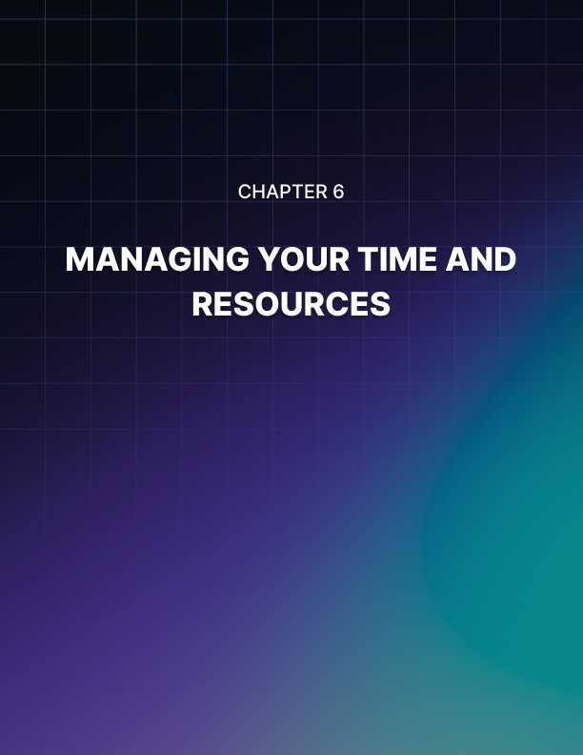

Chapter 6: Managing Your Time and Resources

Whether your side hustle has experienced some small successes, some large successes, or even a few failures along the road by this point, you might have realized something. Time is the biggest resource you have, and there often isn’t enough of it during the day. Most side hustles are just that, side hustles that are complimenting a main job that a person has.

If you are working during the day for your main job and then coming home at night for your side hustle, it can get quite taxing on the body and the mind, and you might find that you are running out of time to get things done for one or both obligations.

Additionally, if you have a family, other hobbies or obligations, or emergencies seem to pop up around every single corner, then soon it might seem that you have no time whatsoever to make anything other than incremental progress on your side hustle.

Even if you don’t expect your side hustle to be anything more than something fun to do, and not a replacement for your main business, it can still be discouraging to never have the time.

Effective Time Management Techniques
If you want to add a side hustle into your life, then you need to follow some time management tips in order to make sure you give your side hustle the respect it deserves. For example, guard your side hustle time. If you are serious about wanting to advance your side hustle, then you need to treat it like your main job. Just like your main job has hours that you need to be working there, you need to give your side hustle hours too.

So maybe for two hours during the evening you sit and work on your side hustle without any interruptions, and you make it clear to family and friends that you need to focus and won’t be available for them. Or maybe you get up early and work on your side hustle over breakfast.

Regardless, try to set a block of time and attempt to stick with it every single day. Another tip is to write down all the progress you made as well with each day you worked. This can give you some serious motivation whenever you need it and it can also make sure that you are keeping yourself on track and aren’t wasting a ton of time.

Additionally, try to take a look at your schedule and see if there are any areas where you have spare time. Now, it can be very easy to look at the lack of time you already are dealing with and focus on that, while bemoaning that you don’t have any spare time, but you might have some.

Maximizing Productivity in Your Spare Time
Be honest with yourself. Do you really need to watch two hours of the same TV shows every night? Do you have to take an hour long lunch every day? Do you need to spend those extra 30 minutes in bed looking at your phone every morning and night? It will take some sacrifices and a bit of getting used to, but you will soon find that you might be able to squeeze a bit more spare time out of your day than you thought. Don’t be afraid to use that time to be very productive and work on your side hustle. Even if you only get one or two things checked off your list every day, that is still progress, and slow progress is much better than no progress at all!

Finally, you shouldn’t just focus on managing your time, but also your resources. It doesn’t matter if you are trying to run a side hustle on a shoestring budget, if you have a few more resources, or if you already have some resources to call upon and things to put in place. All that really matters isn’t the number of resources you have, but how you choose to manage them.

So make sure to manage your resources wisely and ensure that you are always asking yourself what your business needs. While it might be easy to buy a brand new website with more bits and bobs than you know what to do with, or to get the premium email list plan so you can send more emails per day, don’t get so caught up in what your business might need that you forget all about what your business does need.

Managing Finances and Resources Wisely
As we will see in the next chapter, it is much easier to scale your business when you need to scale it, rather than trying to manage a scaled business that you don’t have enough customers to sustain. So make sure to always ask yourself what the business needs, and don’t be afraid to be a little frugal even if you have some more resources to play with.

Additionally, and this isn’t mentioned nearly enough in the circles of people who do side hustles, don’t be afraid to ask for help. If you need a logo designed and have someone in your corner who is a kickass artist, ask them to help. Same if you know a coder, a writer, or a marketing expert. While it can be a little scary to share a side hustle idea with people in your circle, especially if that idea isn’t 100% perfect or finished yet, by asking for help you will save time, money, and the frustration of having to figure things out by yourself.

Plus, by the time your business scales you will be outsourcing jobs and delegating tasks anyway, so you might as well get good at it now! Don’t be afraid to really focus on making both your time and your resources work for you and your needs, because that is going to help you succeed with your side hustle.


Chapter 7: Scaling And Growing Your Side Hustle

It will take more time than you imagined, probably more effort than you were prepared to give, and also will push your emotions to the limit, but finally everything will pay off! Your side hustle has grown to a point where you have customers, you are making money, and you are tearing at the seams trying to run it all.

Maybe there are too many things to do and you can’t find the time to do them all without sacrificing something non negotiable, maybe the structures you have built on your social media or website worked fine when you had 10 customers, but can’t work when you have 100. Or maybe you are starting to go stir crazy remembering all the orders and addresses you need to send your products to.

Strategies for Scaling Your Business
If your side hustle is starting to feel less like a very fun activity and more like a second job, you need to reach out and start to scale your business in a way that makes sense, and while it can seem rather daunting to scale your business, it really isn’t that hard and often you don’t need to overhaul all of the systems you are using. Instead, you can just focus on scaling the systems you have.

As mentioned in the last chapter, you can often buy or upgrade your website, your email list software, and your social media accounts to higher tiers. These higher tiers allow you to expand your software to take on more people, handle more orders, and wrangle more traffic to your website.

If you are having problems with the physical side of things, you might want to invest in hiring and training up some help. For example, if your business is a coaching business, you might be able to coach or group coach a number of clients, but eventually you just won’t have the time or energy to help any more people. At that time, it might be a good idea to hire some additional coaches and train them in your methods, so you can help more people, the coaches can get some experience, and you can make some more money.

Scaling and delegating tasks can be very scary at first, because as a business owner, you often want to have full control over your business. But having help will free you up to take on larger tasks.

Expanding Your Product or Service Offerings
One of these larger tasks might be to expand the products or services you offer. This is where things get fun, because you are given license to do what you really want to do. You might start charging for different types of commissions, open up a VIP program for customers willing to pay more, or start offering a new product or service for your business. Heck, you might even choose to open an entirely new side hustle that the audiences of the first one might be interested in.

Additionally, if your business is growing, you will want to start keeping the customers around that you’ve already got. While getting new customers is always going to be important for a business, it’s really majorly important whenever the business is new. However, if you have an already established side hustle, then you will want to retain the customers you have and keep them coming back.

Building Customer Loyalty and Retention
Customer loyalty and retention get a rap for being overly complicated in the world of marketing and business, but really you just need to do a good job, provide some amazing services, and then make sure to keep in touch with those customers and give them a reason to come back. Discounts, extra services, first look at the new stuff you are releasing. Make your customers start to feel really valued and they will keep coming back and begging you for more.

Now, not every customer is going to be a loyal one, and not every customer is going to want to come back… all for their own reasons. However, if you put the effort into customer retention it is going to really pay off.

Plus, one of the biggest benefits of retaining customers is that you might build a friendship with them. There’s nothing like making a new friend because you treated them well within the context of a business relationship, and if they own a side hustle of their own or have some talents you could use, then you can make further connections.
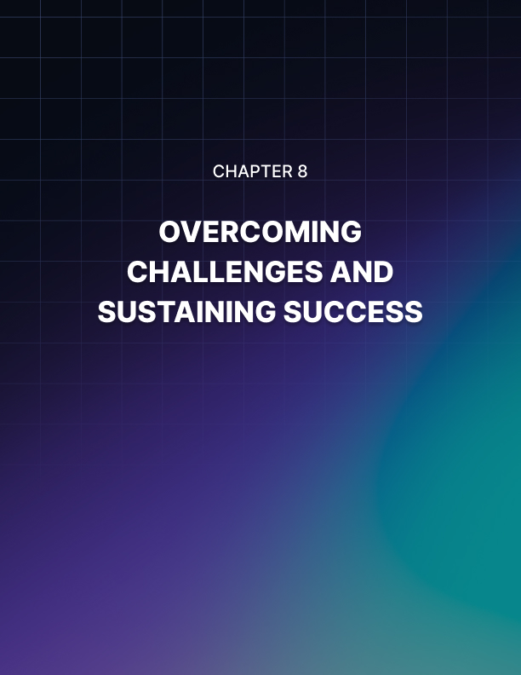

Chapter 8: Overcoming Challenges and Sustaining Success

Now, no matter what stage your side hustle is in, you need to know that you are going to face challenges and obstacles, and as your side hustle grows these are going to grow too. No matter what the obstacle or the challenge is, there are often a few different ways to overcome them and focus on getting back on track to success.

Dealing with Setbacks and Obstacles
First, always take a step back from the problem. It can be extremely easy to fall into a knee jerk reaction whenever someone comes in late, an unexpected bill is due, or an angry customer leaves a one star review. However, the knee jerk response to the first answer is never the correct answer, and the best thing to do is put some space between you and the problem in order to approach it rationally and peacefully.

Next, instead of getting angry at the problem and feeling stress, anxiety, or worry about what happened, try to turn your mind towards a solution. It can get very easy to ruminate and moan about the problem and become a victim to your circumstances, but as a side hustle business owner you need to be able to stand up and become a leader and make your circumstances obey you and all your needs.

Often, if you take the time to think about your problems and give yourself time to find an answer, you will be able to get some traction on finding a massive solution that will get you moving past the problem.

Balancing Your Side Hustle with Other Commitments
Still, one problem that might be a bit harder than others to solve is the fact that a growing side hustle (especially if you have other employees and people handling delegated tasks for you) can take up a lot of time to the point where it becomes a second job. Now if you aren’t one of those people who dreams of making enough with their side hustle to be able to quit their day job and do it full time, that’s fine, but you still need to balance your time.

So make sure to have an updated schedule of what your side hustle is going to take from you and how much time and energy you need to give it. Now if you are delegating and stepping away from the grunt work and day to day main tasks of your business, then it shouldn’t require as much time as if you were doing that and the leadership work. But it can still take up a lot of time.

Don’t be afraid to restructure your day and maybe make some sacrifices in order to give yourself time to have everything done for your side hustle. It will be a balancing act to manage a side hustle, another job, and the various commitments of your family and your life, but you will find a way to do it.

Maintaining Long-Term Success and Growth
Now, it doesn’t get any easier if you are one of those people who dreams of making enough with their side hustle to be able to quit their day job and do it full time. Even if you leave your old job, now you’ve got quite a lot riding on the side hustle, and no matter your financial situation you will still need to put in a lot of work to keep the side hustle going.

The best way to handle the juggling of all these time commitments is to make sure that you are clear on how much time you have each day, what spare time you can shuffle around, and what you need to sacrifice to make it happen. Getting your schedule written down and focusing on having it laid out in front of you will be very beneficial.

Finally, you need to make sure you have a way to maintain this long term growth. This often means investing the time into your business to keep it running, but you don’t want to get complacent. No matter what you do for a side hustle, you are going to have some competition and other people doing the same thing. If you continue innovating, growing new products, testing them out, and working harder on making sure your side hustle is the best option, then you will continue to stay in the game.

So make sure that you don’t take your foot off the gas and continue to push yourself to become the best you can be. While
you can celebrate your successes, rest on your laurels for a bit, and have some fun and get some rest, don’t ever stop trying to push your business to being the best it can be.

There might be a point in your business where you feel like you have hit a ceiling, or where it feels uncomfortable to grow. Maybe you have all the money and stability you want, maybe you feel like you are starting to reach your limit, or maybe further growth just doesn’t seem appealing to you.

It’s something to think about if you reach this point, because you can be perfectly content in your business, but if you want to keep growing you will need to do your best to push past the discomfort and try to keep on growing. Because who knows what heights your business will get to if you don’t stop.


Conclusion

Building a side hustle, any side hustle, is extremely hard work. It’s tough, it will demand a lot of you, and even if you could see yourself doing your side hustle for the rest of your life, you will still find some struggle with it at the end of the day. But don’t give up at all!

You have the blueprint, you have the skills, and you have all the resources and help you could ever want if you just ask for it. So don’t be afraid to start building a side hustle, whether you want to build something that will eventually replace your main job and be one of the key things that support your family, or you just want something to do with your evenings and a skill you have a passion for, a side hustle can be something that gives you real benefits.

Plus, at the end of the day building a side hustle about something you are passionate about is fun! And you can really get into having fun with the process and enjoying the process of building the business, which will not only make you more motivated to do it, but will also make you more motivated to see some real success.

If you want to build a side hustle, the only thing that will ever stop you is you. And to leave you at the end of this blueprint book, there is something that you need to remember and should probably repeat to yourself whenever you run into problems with your business.

“Doubt has killed more dreams than failure ever will”

