Disclaimer
This work may not be copied, sold, used as content in any manner or your name put on it until you buy sufficient rights to sell it or distribute it as your own from us and the authorized reseller/distributor.
Every effort has been made to be accurate in this publication. The publisher does not assume any responsibility for errors, omissions or contrary interpretation. We do our best to provide the best information on the subject, but just reading it does not guarantee success. You will need to apply every step of the process in order to get the results you are looking for.
This publication is not intended for use as a source of any legal, medical or accounting advice. The information contained in this guide may be subject to laws in the United States and other jurisdictions. We suggest carefully reading the necessary terms of the services/products used before applying it to any activity which is, or may be, regulated. We do not assume any responsibility for what you choose to do with this information. Use your own judgment.
Any perceived slight of specific people or organizations, and any resemblance to characters living, dead or otherwise, real or fictitious, is purely unintentional.
Some examples of past results are used in this publication; they are intended to be for example purposes only and do not guarantee you will get the same results. Your results may differ from ours. Your results from the use of this information will depend on you, your skills and effort, and other different unpredictable factors.
It is important for you to clearly understand that all marketing activities carry the possibility of loss of investment for testing purposes. Use this information wisely and at your own risk.
Table of Contents
Introduction 5
Chapter 1: What Is TikTok all about? 7
What Is TikTok? 7
How Can Brands Benefit From TikTok? 8
How Can I Get Started With TikTok? 9
Chapter 2: Signing Up For TikTok 11
Downloading TikTok 11
Using TikTok After Installation 11
Signing Up For TikTok 11
Chapter 3: TikTok Walkthrough 14
Chapter 4: Switching Your TikTok Personal Account Into a TikTok Pro Account 18
Switching Into A Pro Account 18
Chapter 5: Branding Your TikTok Profile For Business 21
Customizing The Profile 21
Adding More Social Profiles To Your TikTok Profile 22
Chapter 6: Creating Your First TikTok Video 24
Creating The Video 24
Chapter 7: Using “Discover” as a Powerful Marketing Tool 28
Using Discover 28
Chapter 8: Creating A Hashtag Challenge 32
Creating The Challenge 32
Chapter 9: Increasing Reach By Cross Promoting Your TikTok Content On Other Social Platforms 35
Sharing Your Videos 35
Sharing On Facebook 35
Sharing On Twitter (X) 36
Sharing On Other Platforms 36
Chapter 10: How Businesses Use TikTok In the Real World 38
Finding Other Businesses On TikTok 38
Analyzing A TikTok Profile For A Business 38
Chapter 11: TikTok Web 41
Chapter 12: Tips For Setting Up A Profitable Influencer Marketing Campaign For TikTok 45
What is influencer marketing? 45
Promotion of User Interaction 45
Create fun, unique and creative content 46
Chapter 13: Best TikTok Video Ideas to Boost Your Brand 48
Chapter 14: Encouraging TikTok Users To Generate Content For Your Brand 52
What Is And How User Generated Content Works? 52
The DIY Strategy 52
More Ways To Take Advantage Of UserGenerated Content With TikTok 53
Chapter 15: Running a Contest or Sweepstake On TikTok The Right Way 56
Incorporate official rules 56
Chapter 16: Best TikTok Marketing Strategies To Increase Followers 60
Carry Out Your Own Research 60
Create Content That Is Useful And Creative 60
Improve The Participation Of Your Followers 61
Chapter 17: TikTok Marketing Do’s And Don’ts 64
Do’s 64
Don’ts 65
Chapter 18: TikTok Marketing Premium Tools and Services to Consider 69
Chapter 19: TikTok Marketing FAQs 73
Conclusion 79



Introduction
This “TikTok Marketing” Training is designed to take you by the hand and walk you through the process of getting the most out of TikTok on behalf of your business.
I’m very excited to have you here, and I know that this will be very helpful for you.
This exclusive training will show you step-by-step, topic by topic, and tool by tool, what you need to know to dominate TikTok Marketing, in the easiest way possible, using the most effective tools and in the shortest time ever.
This training consists of 19 training chapters, ready to show you the latest TikTok Marketing strategies.
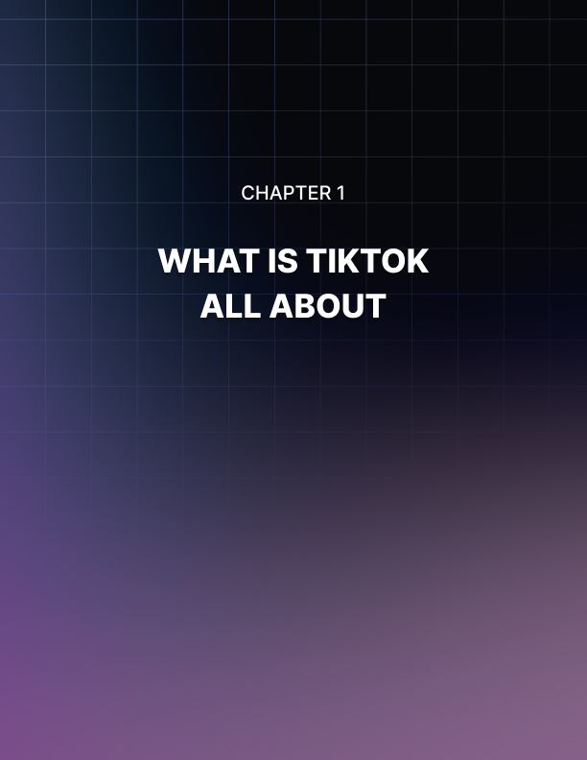

Chapter 1: What Is TikTok all about?

What Is TikTok?
TikTok is an application that came out of nowhere, was created in China where it is known as DOUYIN and for the rest of the world it is known as TikTok.
When TikTok was created it caused great euphoria among Chinese youth and teenagers because it was an application of video exchanges and for young people that was very fun.
TikTok joined musical.ly where young people could upload music videos where they could synchronize the movements of their lips with the music which was sensational.
Then the young people who had more experience technically uploaded original videos which caused them to become influential on the platform. For young people it is very fun since they can upload videos with durations of 15 seconds and can also share these videos in their stories and these videos have a duration of 60 seconds. TikTok and music.ly are addressed to the same audience.
Are People Caring About TikTok?
First of all, we may say that one of the large impediments that TikTok has had to making its marketing successful is that most of the sellers and business managers over 30 do not know the platform or have not even heard of it.
Secondly, the Ministry of Electronics and Information Technology of India ordered that the application of electronic stores in India be withdrawn. There was great concern because it was not known if the application was safe for young people. Madras superior court said that pornography and other illicit things were encouraged with this application.
The measure lasted a short time and was lifted on April 22, after TikTok reviewed its content well by removing more than 6 million videos that were believed to violate the terms of use.
Despite all the inconveniences TikTok has been the most downloaded application during the year 2018 and the first quarter of 2019.
Who Uses TikTok?
First, we will start with music.ly which is an application that points to the z generation and with a female bias, even though this application is still favored by young people, with 66% of its users under 30.
The Douyin application as it is known in China began to be used in 2017 by young people. And 55% of their users were under 24 years old.
It is important to note that the first users of Douyin stayed on the platform as they got older. This means that the average age of Douyin users has gradually gone up.
In February of 2018, about 31.8% of people using Douyin were under 24 years old, with 23.4% of users aged 25 to 30, and another 23.4% of users aged 31 to 35.
We can only wait to see if the growth of users of the TikTok application will be equal to that of Douyin over the years.

How Can Brands Benefit From TikTok?
For the marketing of brands using the TikTok application there are three ways:
First, the user can create their own channel and upload videos that they consider to be relevant.
Second, the user can work with influential people to help their content be disseminated more widely.
Third, the user can pay to advertise on TikTok although TikTok does not have the same scope as YouTube. However, it can become more popular and stable over time.
Generally, many brands combine their own channels and work with influential people so that the content of their products are directed to a larger audience.
They can also try some of the ideas on their own channels like hashtag challenges, user generated content and TikTok advertising.
The user can also suggest to their influencers to share this type of content in their networks.

How Can I Get Started With TikTok?
From my point of view, to start using the TikTok application we must first know what it is and what it is for. Then see how it works and what its scope is and what benefits we can have using this application.
When knowing everything about this application and having downloaded it to our cell phone then we follow these steps:
- First, we create a user profile with our email address or a Facebook account.
- From there we configure our account with a photograph and our data is included as our YouTube account or other social networks.
- Every time you open the TikTok application it shows us the videos that other users have uploaded.
- It also allows us to apply different recording modes to our videos.
- It is a very fun application that gives the user many tools to share their ideas.
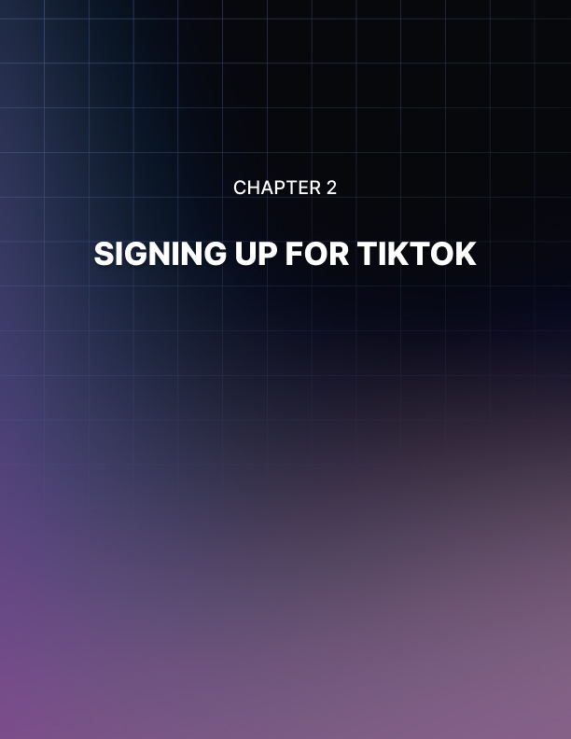

Chapter 2: Signing Up For TikTok
We have designed this training as a step by step guide to TikTok marketing, so we’ll kick-start it off from the very beginning: joining the TikTok network and using the app for the first time.
And because TikTok is a brand new platform, it is important that you learn how to familiarize with it from scratch. Are you ready? Yes? Awesome, then let’s get started!

Downloading TikTok
TikTok is primarily a mobile app much like Instagram, so you have to start by pulling out your smartphone or tablet, and then opening the app store corresponding to your platform. TikTok is available for Android devices as well as iOS, and you can also download it from the Amazon app store.
Ok, let’s continue. Start on the app store, and search for “TikTok”. Now locate the “TikTok” app in the results. Tap on the result in the list, and then tap on the “install” button on the next page.

Using TikTok After Installation
Unlike most apps, TikTok allows you to search, browse, and discover content on the platform without actually signing up first, so let’s take a quick look at it.
Start by opening the app. When you open TikTok, you’ll be immediately shown the video feed. You can swipe up to tune into another video, and so on. You can tap on the profile icon on the right to see who uploaded the picture, and back on the video feed you can like, comment, or share the video, but you can’t use these features until you sign up as a TikTok user. You can also tap on the “discover” icon to watch the hottest videos and find trending hashtags.

Signing Up For TikTok
Once you are ready to become a TikTok user, tap on the “me” icon at the bottom of the screen. You will be prompted to sign up with a phone number, an email address or with a profile from another platform such as Facebook, Google, or Twitter.
For this example, we’ll show you how to sign up with an email address. Tap on the “sign up with phone or email” button. Next, select your birthday, using the date selection function on this page, and then tap on the “continue” icon.
On the following page, tap on the “email” icon. Next, enter your email address in the “email address” field, and tap on the “continue” icon. Now enter your new account’s password into the “password” field, and tap on the “confirmation” icon.
Lastly, you have to do a verification to let the app know that you are not a bot. Simply drag the slider to fit the on-screen puzzle piece in place, and wait for the verification confirmation message.
And that’s it! You are now a TikTok user, and you can fully interact and engage with content and other users on the platform. You can tap on the “me” icon to go to your profile page.
And as you can see here, there’s still a lot to do, including becoming a Pro member and branding your profile, but we’ll take care of that in a couple of upcoming lessons.
But get ready! Because in the following lesson we’ll be giving you a full walkthrough of the TikTok app and its features!
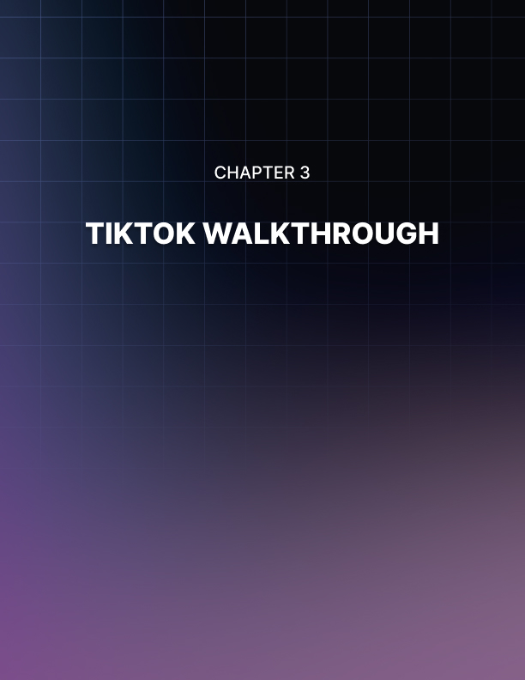

Chapter 3: TikTok Walkthrough
As you could see in the previous chapter, TikTok is an easy to join, easy to use platform for discovering amazing visual content.
Now, what you just saw in the previous lesson was a mere teaser of all the awesome stuff that TikTok lets you see and do, so in this lesson we are going to give you a complete walkthrough of the app.
Start by opening the app. Are you there already? Good, let’s get started.
When you open the app, you’ll start on the video feed right away, which also functions as the TikTok home screen.
At the bottom of the screen you will find all the shortcut icons. Let’s take a look at them, from left to right, starting with the “home” icon, which simply let’s you go back to the home screen from anywhere on the app when you tap on it.
Next is the “discover” icon. This shortcut will take you to the “discover” screen, where you can search, browse, and find the latest trending videos and hashtags.
Here you can use the “search” bar to search videos and trending hashtags by keyword.
You can tap on the “scan” icon to generate or scan custom TikTok QR Codes that make it easy to follow or be followed.
Back on the “discover” screen, you will find promoted topics in the top banner, and trending content in the bottom.
Alright, let’s now tap on the “plus” icon. This will take you to the recording screen, which is TikTok’s main feature. This screen is simple enough.
You can use the “sounds” icon to find the perfect sound or track for your recording, the camera icon on the top right to switch cameras, the drop-down icon to display more recording tools, the “upload” icon to upload an image or video from your device to your recording, and the “effects” icon to add effects such as stickers or animations to your recording.
Once you are ready to start recording, you will simply have to tap on the “record” icon button in the bottom center of the screen to start recording. You can tap on the “x” icon to close the recording screen.
Let’s now tap on the “inbox” icon. This shortcut will take you to the notifications screen, where you’ll find notifications about your account. You can tap on the “selection” tab on the top center of the screen to select what type of notification you want to see, including likes, comments, mentions, followers, and notifications from TikTok.
Here you can also tap on the “message” icon to go to the “direct messages” screen, where you can compose messages for your TikTok friends simply by tapping on the “plus” icon in the top left corner.
Let’s now tap on the “me” icon. This shortcut will take you to the account screen. Here you will be able to customize your account profile picture, to check the number of videos you have uploaded, the number of users you are following, the number of followers you have, and your number of likes.
You can tap on the menu icon on the top right corner of this screen to go the account options screen, where you can manage all your account settings and access other options and test features available on the platform.
Back on the account screen, you can tap on the “edit profile” button to customize your channel. Here you can personalize your profile picture and video, your name, username, and bio. Here you can also add your Instagram and YouTube profiles.
On the account screen you’ll also find a bookmarks icon shortcut that will take you to the “favorites” section.
Here you’ll find all the videos, hashtags, sounds, and effects that you have saved to your account.
TikTok makes it easy for you to find your friends on the platform. All you have to do is to tap on the “find friends” icon on the top left corner of this screen to go to the “find friends” screen. Here you can tap on “invite friends” to send custom TikTok invites to your friends, on “find contacts” to locate TikTok friends by their phone numbers, and on “find Facebook friends” to locate TikTok users on your Facebook friends list.
Finally, let’s tap on the “home” icon shortcut to check what you’ll find on the video feed. Let’s start on the top of the screen. You can control the content you’ll see in your video feed by tapping on “following” to only see videos from people you follow, or on “for you” to see videos recommended by the TikTok algorithm.
When watching a video, you will see information about it in the bottom left, right above the “home” icon. Information you’ll find here include the username of the user who uploaded the video, the title of the video, and the name of the track or sound used in the video.
To the right, you’ll find buttons to interact with the video and the content creator. From top to bottom, you’ll find a shortcut to the channel that uploaded the video, a “like” button, a “comment” button, a download button, and a thumbnail that you can tap on to see information about the track or sound used in the video.
And this is it my friend! TikTok in a nutshell. Now that you know how to use TikTok, are you ready to take the next step? We hope you are, because in our following lesson we’ll be showing you how to switch your new TikTok account into a Pro account that will be perfect for marketing.
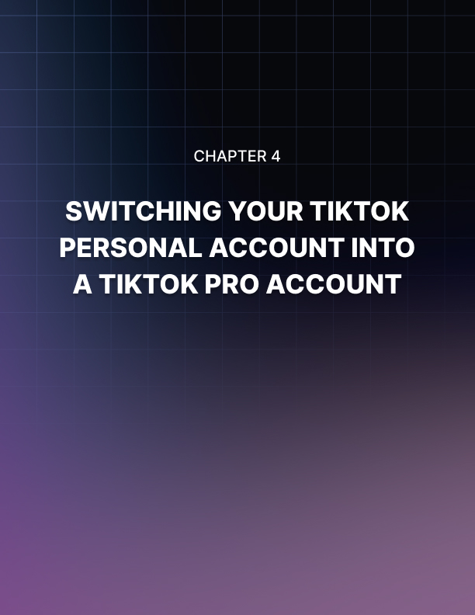

Chapter 4: Switching Your TikTok Personal Account Into a TikTok Pro Account
Are you ready to continue your TikTok marketing journey? We hope you are, because we’re about to show you how to use TikTok to grow your business to the next level.
In the previous lessons we showed you the basics about joining and using the TikTok platform, and now we’re going to take it all one step further by showing you how to switch your new TikTok account into a Pro account that’ll let you take advantage of all that TikTok has to offer.
Doing this is simple enough, and you can start on the TikTok home screen while logged in to your account.
From there, tap on the “me” shortcut icon to go to the account screen. Next, tap on the menu icon on the top right corner to go to the account settings screen. Now tap on the “manage my account” option located under the “account” section.

Switching Into A Pro Account
Once in the “manage my account” screen, tap on the “switch to Pro account” link. Ok, now that you’re about to make the switch, you might be wondering, what’s a Pro account all about?
A Pro account is simply a free account upgrade that will give you access to the necessary tools to grow and track your performance.
With a Pro account you can also view analytics, which will let you find out how your videos perform, and to learn more about your followers.
Alright, now continue by tapping on the “ continue” button. Next, choose a category. This will allow you to get customized analytics. You can tap on “ next” after you select your account category.
On the following screen, enter your phone number into the “phone number” field and then tap on “next”. You’ll receive an SMS code to your phone that you’ll have to enter on the next screen, right into the “4-digit phone code” field.
Enter the code, and then tap on “done” to continue. Awesome job! Now you have a Pro TikTok account.
Let’s tap on “ok” to finish. After you switch to Pro, an “analytics” tab will be added to our account settings screen, right under the “account” section. Tap on this tab to go to the “analytics” screen, where you will see a detailed overview of your account performance, which can help you to make decisions and optimize your content according to the results you’re getting here.
Switching to a Pro account is not permanent, and you can go back to a personal account if you want to, with just a few simple steps.
All you would have to do is to go to the account settings page, and tap on the “manage my account” tab under the “account” section, and then tap on the “switch back to personal account” link.
And this is it my friends! Now you can fully take advantage of all the marketing features that TikTok offers. Next up we’ll be showing you how to customize your TikTok business profile the right way.

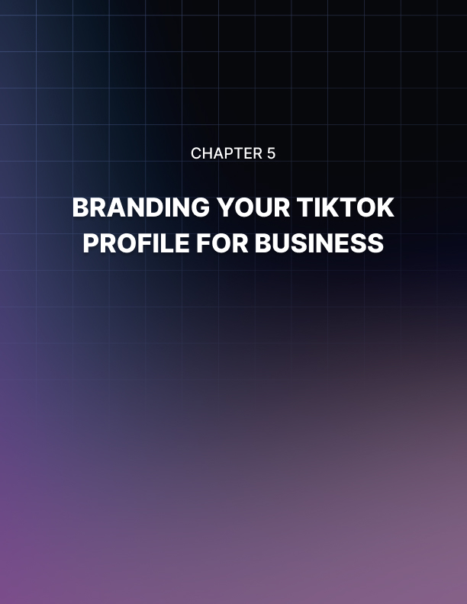

Chapter 5: Branding Your TikTok Profile For Business
You joined TikTok, you learned to navigate it, and you also switched to a Pro account to make the most out of TikTok marketing. There is only one thing left to do before you actually start running your marketing campaigns on the platform, and that is to brand your TikTok profile for business.
In this lesson, we are going to show you how to customize your Pro TikTok profile in a way that will increase your brand’s exposure for potential customers in your niche, step by step, the right way.

Customizing The Profile
Let’s start on the home screen. Tap on the “me” shortcut icon to go to your profile screen. Once there, tap on the “edit profile” button.
When editing a TikTok profile, you’ll have the options to customize the profile photo, the profile video, the name, username, bio, and links to profiles in other social platforms.
Let’s start by customizing the profile photo. Tap on the “change photo” icon. You can tap on “take a photo” to shoot a pic to upload, or on “select from gallery” to upload your new profile picture from your device’s media gallery.
In this case, we are going to tap on “select from gallery” to upload the profile image from the gallery. Before you upload the image, make sure that it is attention-grabbing, that it relates to your audience and niche, and that it reflects the values of your target customers.
Ok, let’s now customize the profile video. Tap on the “change video” icon. Next, select a video from your device’s gallery and tap on it to upload it to your profile.
On the next screen, drag the video frames in the bottom of the screen to use a 6 second segment for your profile. Then tap on “save”.
Let’s now customize the profile name. First, tap on the “name” tab. Now enter the name of your brand or business into the “name” field, and then tap on “ save”.
Now the username. Tap on the “username” tab. Next, enter your new username into the “username” field. Here we recommend you enter the same username that you use on your other social media channels. Usernames can only contain letters, numbers, underscores, and periods. You can tap on “save” when you are done composing the username.
Let’s now tap on the “bio” tab to add a description to your profile. Use the “ bio” field on the following screen to enter a brief description of your brand or business. It is highly recommended that you include hashtags as keywords in the description, to make it easier for users to find your profile when looking for content in your target niche. You can tap on “save” after you finish.

Adding More Social Profiles To Your TikTok Profile
Ok, now it is time to add the final touches, by adding your branded Instagram and YouTube profiles to your branded TikTok profile. First, tap on the “Instagram” tab. This will open the Instagram sign on the screen. Enter your Instagram sign in info here, tap on the “login” button, and confirm to allow TikTok access to your Instagram profile.
To add your branded YouTube profile, tap on the “YouTube” tab. You will be prompted to log in with your Google account. Select the account with which you’ll sign in with, enter your sign in information if prompted to, review the permissions on the following page, and then tap on “allow”.
And that is it! As you can see, customizing a TikTok profile for your business is easy if you follow these steps. Next up we’ll be showing you how to create your first TikTok marketing video, so get ready!
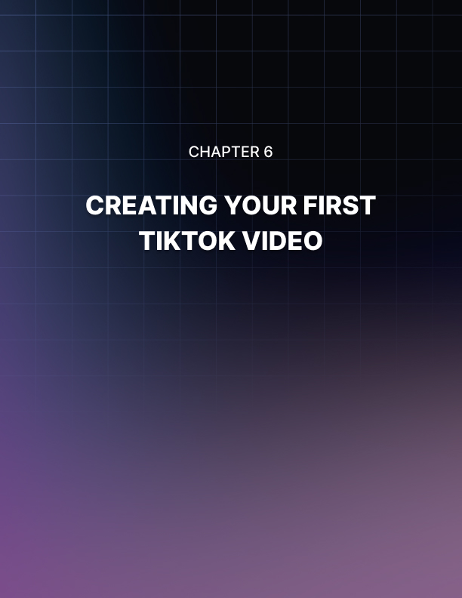

Chapter 6: Creating Your First TikTok Video
Let’s continue your journey into the new, awesome world of TikTok marketing.
You just completed your Pro TikTok profile for business, and now you are ready to start posting your content on the platform. That means that in this lesson, we will be showing you how to create and upload your first TikTok video, step by step.
You can access the TikTok video creator from anywhere on the app. All you have to do is to tap on the “create” shortcut icon in the bottom center of the screen.

Creating The Video
You can start creating a video right after you open the video creator. This is an easy to use tool that will let you add lots of funny elements that increase awareness and engagement.
Let’s start from the top to bottom. The first feature you have to use is “sounds”. When you tap on “sounds”, you will be taken to the sounds gallery screen. Here you can choose which sound or music track you will use in your video.
On the “discover” tab you will find the most popular sounds first. You can tap on the “discover a sound” button to try the featured sound. You can then either tap on “use this sound” to use that clip in your video, or on “try another” to discover other clips.
On the “playlist” section you can discover sounds and clips by categories, such as “trending”, “viral”, “global hits”, “latin hits”, “comedy”, “challenge”, “news”, and “spooky”.
You can check the most popular sounds in each category by scrolling down this screen. You can try each sound by tapping on the “play” icon in the sound’s thumbnail, and to add a sound to your “favorites” list by tapping on the “bookmarks” icon corresponding to a sound clip.

You can also search for specific sounds or clips by entering a keyword in the search bar. To select a clip from the results, simply tap on the clip you want to use, and then tap on the “confirmation” icon to load it into your video.
Now it is time to select which camera you’ll choose to record your video. You can do this by tapping on “flip”, which will switch between the front and rear cameras until you select one.
When you tap on “speed”, you can select the speed at which you’ll record your video. When you tap on “beauty”, you’ll activate “beauty mode”, which is a filter that cleans up faces featured in your video. You can tap on it again to turn it off!
When you tap on “filters”, you will be able to choose from a variety of filters. Please consider that, if you are creating videos for a brand or business, it is important that you choose a consistent look for your videos.
Selecting a fixed set of customizations on this menu will be a vital aspect of branding your marketing videos on TikTok, because it will help your audience associate your videos with a distinctive look and feel!
Lastly, when you tap on “timer”, you can select a stopping point for the sound clip that you’ll use in your video, using the slider function in the sound clip graph.
Alright, let’s now look at the functions in the bottom of the screen. Let’s tap on the “effects” icon first. Here you can select a crazy variety of effects for your marketing videos. These effects can help you to make your videos funnier and more engaging, and all you have to do is to tap on an icon to select it. It will immediately appear on screen!
Ok, let’s now tap on the “upload” icon. This function will allow you to upload a video or image from your device’s gallery into your TikTok video.
Now that you have fully customized the video, it is time to record. To record a video, you simply have to select the length of the video first. You can select between 60 seconds or 15 seconds. For marketing videos, it is recommended that you create 15 second videos.

After selecting your preferred length, tap on the “record button” icon. Your video will start recording, and you can start performing right away. Once the video stops recording, you’ll just have to tap on the “confirmation” icon.
You will be able to make some edits in your video after it is processed. You can tap on “filters” to add or change the filter, you can tap on “trim” to cut the sound clip you selected. You can tap on “volume” to control the volume of the sound clip. You can also tap on “sounds” to change the sound that you already selected if you want.
There are additional visual edits you can make to your video. For example, you can tap on “effects” to apply effects such as transitions and splits.
You can tap on “character” to add on- screen text to your videos. Finally, you can tap on “stickers” to add stickers or emojis to your video.
Now that you are done editing your new, awesome TikTok video, all you have to do is to tap on “next” to go to the “post” screen.
Here you have to enter a description for your video in the “describe” field. Here we recommend you tap on the “hashtag” button before typing a keyword or search term. This will help you expand your reach.
Now review the permissions that you’ll allow for users that interact with your video, and then tap on “post”. And that is it! Your new video will start uploading, and all you have to do now is to wait until it starts getting a ton of views and interactions!
But this isn’t it! Stay tuned, because we’ll be showing you how to use these videos to go viral to expand your reach beyond your usual audience in the upcoming lessons!
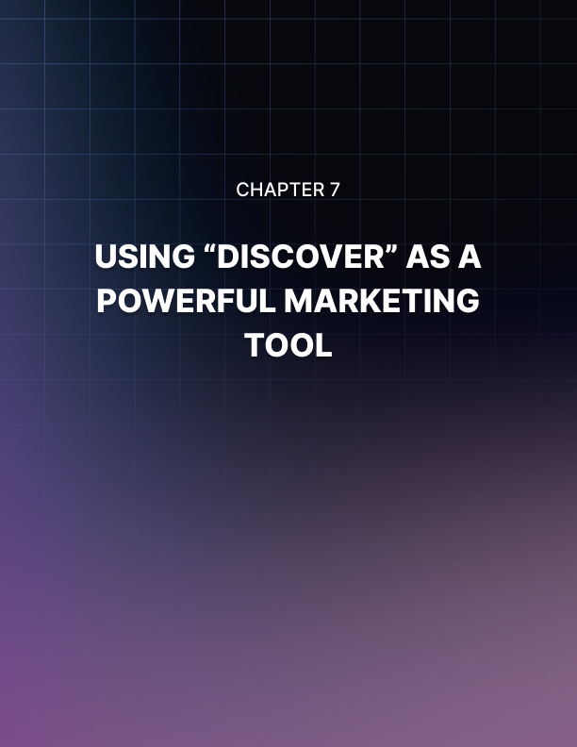

Chapter 7: Using “Discover” as a Powerful Marketing Tool
Now that you learned how to create engaging TikTok videos for your brand, it is time for you to start learning how to use the platform for marketing.
And all good marketing starts with research. Knowing who is in your target audience, and knowing the latest trends in your niche are vital.
That is why in this lesson we will be teaching you how to use TikTok’s “discover” feature, a powerful marketing research tool that comes built-in with the app, and that lets you find the best content for your next big marketing campaign.
Using this “discover” feature is easy enough, and you can access it from anywhere on the app simply by tapping on the “discover” shortcut icon located in the bottom of the screen.
This shortcut will take you to the “discover” screen, where you’ll be able to find featured trends, viral hashtags, and much more!

Using Discover
So how do you exactly use this “discover” feature? Well, it’s easy enough, let’s take a look. The easiest way to find content on this screen is by checking the featured trends on top. By tapping on a featured trend on this banner, you will find all videos using the featured hashtag.
You can leverage the information you find here to expand your reach by adding these featured hashtags, but only as long as it makes sense for your brand!
Let’s now go back to the “discover” screen to look at the content posted under the featured trends banner.
Here you’ll find the hashtags that are trending at any given moment. One thing you’ll notice is that these hashtags are getting millions of views, which means that they’ve gone viral.
The good news is that you can use these trending hashtags to increase your brand’s exposure like crazy, and we’ll show you how.
First, scroll down through this screen to browse all trending hashtags. You’ll do this to find a hashtag that you can use to produce content for your brand. It is important that the hashtag that you select makes sense to your audience.
Once you find a hashtag, check the number of views it is getting. The larger the number of views, the larger the audience you will reach. This also means that the hashtag is very engaging!
Ok, now tap on the hashtag to go to the hashtag screen. Here you will find the hashtag’s thumbnail, the number of views it is getting, and a description of the hashtag. In this description you will find what the hashtag is all about, and how to use it. For example, if the hashtag is about performing a challenge, you will find how to participate in this description.
Now, the most important part is to actually watch some of the videos on top to see what type of content using that hashtag is performing the best.
What you’ll do then is to take notes about the most engaging elements in these videos so you can reverse engineer them for your branded videos. Elements we recommend you to watch out for include lettering, sounds, and effects.
The “discover” feature also allows you to make personalized searches. Let’s go back to the “discover” screen now to show you how.
To do personalized searches, you have to use the “search” bar on top.
Here you’ll simply have to enter a keyword into the “search” bar, and then tap on “search”.
After you do, you’ll see all content related to your search. You can filter your results too, for a more effective search. For example, under the “top” tab you’ll find the top performing content related to your keyword or search term.
Under the “users” tab you’ll find users that have included your keyword into their profiles. Here we recommend that you check the profile of top users, and to follow them so they can follow you back. You can then engage with them so they interact back with you, which will help you to increase the relevance of your account.
Under the “videos” tab you’ll find only top performing videos related to your search. Under “sounds” you’ll find which sounds match your keyword, and under “hashtags” you will find which hashtags include your keyword. Here we recommend that you save related hashtags with over 1 million views!
And that is it my friends! This is how you can use “discover”, and as you can see, this feature is a powerful marketing tool that will help you to stay on top of your marketing game!


Chapter 8: Creating A Hashtag Challenge
You’ve learned how to optimize your TikTok profile, you’ve learned how to create compelling content for TikTok users, and you’ve learned the easiest way to discover what’s hot on the platform.
Now it is time to master it all by learning how to create a hashtag challenge. Challenges are nothing new for social media users, but TikTok found a way to make them unique for its audience.
In this lesson, we are going to show you how to easily set up a hashtag challenge from start to finish, step by step.
When you create a hashtag challenge on TikTok, the very first step is to come up with a cool challenge idea. It can be something funny, such as encouraging users to roll up on the floor or dancing, or it can be something more serious, but relatable, such as coming out with a trending issue on video.
You can find inspiration for your challenges in the “discover” screen.
You’ll simply have to look at the videos posted in the “trending hashtags” section. Pay attention to hashtags that have the “challenge” keyword at the end, to see what type of challenges are trending on TikTok.

Creating The Challenge
Once you come up with a cool challenge idea, you can start creating it by tapping on the “create” shortcut icon.
First, customize the video. Tap on “sounds” to select a sound from the TikTok sounds library. Make sure to select a sound clip that fits the topic of your challenge.
Next, tap on the “more” icon to set the “speed” of the video, to turn on or off “beauty” mode, to select a “filter”, and to make a cut to the audio clip if you need to using the “timer”.
Now tap on the “effects” icon to select an effect for your recording. Remember that you can also upload a video or image to your recording by tapping on “upload”.
Alright, now select the length of your video. Because this is a challenge, it is best to record a 15 second video. Now tap on the “record button” icon to start recording.
Because this is a challenge that you want your viewers to imitate, we highly recommend that you rehearse what you’ll do on camera before you record.
Once you complete the recording, tap on the “confirmation” icon to process the video. Now that you are on the preview screen, you can make additional edits to the video, such as adding more visual effects, adding text, and adding stickers, by tapping on the available icons. You can tap on “next” to continue after making your last edits.
Alright, now it is time to personalize the hashtag challenge for the video.
Start by adding a description of the challenge into the “describe your video” field. Tap on “hashtags” to add your challenge keyword. Here you simply have to enter the keyword right after the hashtag symbol, and then to add the word “challenge” at the end.
To maximize the reach and engagement you’ll get, and to make sure that you go viral, allow all permissions for your challenge video. Now tap on “post” to finish.
And that’s it! Now your new hashtag challenge will spread, and you will go viral in less time than you’d expect. That right there is the power of TikTok marketing!
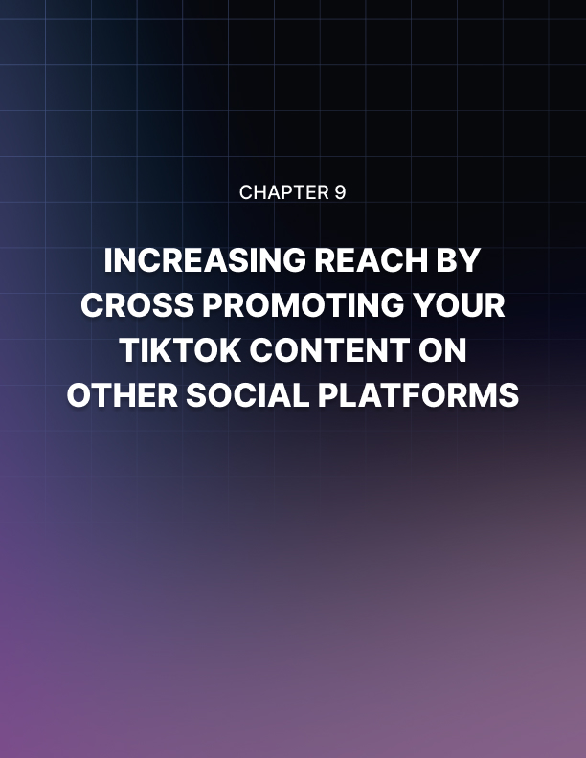

Chapter 9: Increasing Reach By Cross Promoting Your TikTok Content On Other Social Platforms
By this stage, you’ve learned the most powerful marketing tricks that you can apply on TikTok, which is the next big thing in social media.
But that doesn’t mean that you should limit your reach to the TikTok network, so in this chapter we are going to show you how to cross promote your TikTok content on other social platforms.
Let’s start on the TikTok home screen, but know that you can do this from anywhere on the app. Tap on the “me” shortcut icon to go to your profile, where you will find your videos. Make sure that your profile is set on the video grid tab.

Sharing Your Videos
Alright, now it is time to select a video to promote. To do this, simply tap on any of the videos in your profile to open the video view.
Now tap on the menu icon to the right. This will open a menu where you’ll see all platforms where you can cross promote your video, under the “share to” section.
Platforms and services available to promote your TikTok videos include instant messaging, Facebook, SMS, Twitter, Facebook Messenger, Email, Web URL, and QR code. Let’s see how to easily cross promote this video on the social platforms available on this menu.

Sharing On Facebook
Let’s share it on Facebook first. Start by tapping on the “Facebook” icon. Next, enter your login info, and tap on “log in”. A “share to Facebook” window will appear so you can post the video without leaving TikTok. Enter a caption to describe the video into the “say something about this” field. As you can see here, there is already a link preview of your video and a link to watch it on TikTok. This is a great way to funnel your Facebook followers to your TikTok account!
Next, select where you’ll post the video, set the privacy settings, and then tap on “share now”. And that’s it!

Sharing On Twitter (X)
Let’s now share this on Twitter. Start by tapping on the menu icon, and then tap on the Twitter icon in the “share to” menu.
A Twitter window with your TikTok video will appear. This window has a pre-built message that includes your TikTok username, a TikTok hashtag for people looking for TikTok content on Twitter, and a link to your video on TikTok.
You can personalize this message by editing the message and adding your own hashtags, yet we recommend that you leave the TikTok hashtag, because it will help you to reach other TikTok users that can follow you from Twitter to your TikTok profile! Once you have edited your message, tap on the “tweet” button.
And that’s it!

Sharing On Other Platforms
Although there are now other social buttons that allow you to post directly to other social platforms, there is an easy way to do it.
All you have to do is to download the video that you want to share, so you can upload it from your device to other visual discovery platforms, such as Instagram. To do this, simply tap on the menu icon in the video view screen. Next, tap on the “save video” option. Your video will save, and now you can share it on your most active social media channels!
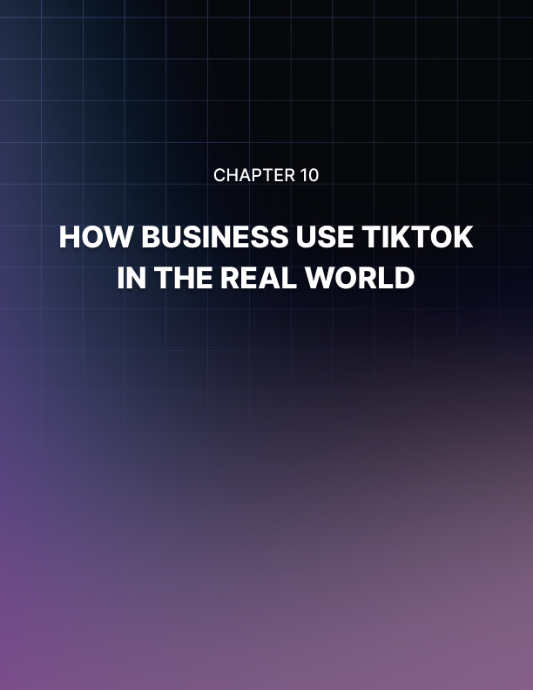

Chapter 10: How Businesses Use TikTok In the Real World
Now that your TikTok account is up and running, and now that you know how to create engaging content to generate buzz around your brand, it is time for you to learn how other businesses in your niche are using TikTok for their campaigns.
This will allow you to study their own marketing tactics, which you can reverse-engineer, as well as to discover who is following them.
Checking out how your competitors and other businesses use TikTok, you have to start by finding them. To do this, you have to use the “discover” feature. So first, tap on the “discover” shortcut icon to go to the “discover” screen.

Finding Other Businesses On TikTok
Ok, let’s now look for other business accounts on TikTok. The easiest way to do this is simply by typing a niche keyword into the search bar. Type your keyword, and then tap on “search”. Once in the results screen, tap on the “users” tab.
Now, to identify business accounts in the niche you are searching on, you have to look for accounts that are clearly branded. This means accounts that have the name of a brand, company, or business, that have a branded profile image or video, and that have a sizable audience.
Optionally, you can use the name of a brand or business as the keyword when you do your search. This will make your search easier if you are already looking for a specific brand or business. Now tap on the profile of a business account in the results.

Analyzing A TikTok Profile For A Business
Ok, now it is time to take a closer look at the details on a business account.
These details, as well as the type of content you’ll find in them, will vary from niche to niche, but there’s still useful information that you can measure to optimize your account.
Start by identifying which additional profiles they add to their TikTok profiles. In general, most businesses on TikTok include their Instagram profiles. This is because Instagram is also a visual discovery platform for younger users, and they know that it is important to cross promote.
Next, look at their profile bio. Businesses use this field to target niche keywords and search terms in their industry. This makes it easier for them to be discovered by potential customers. To grab the attention of profile visitors, they include emojis in their bio. This enhances the visual appeal of their bio, and of their profile in general.
Lastly, you have to take a look at their videos. Businesses use TikTok to showcase their products or services. They make their products or services as prominent as possible in their video thumbnails.
When you watch one of these videos, you’ll notice that businesses use them to show the process behind creating a product, or make them about using a product, or about the results of using a product or services. This helps them increase buying intent in the viewer, and moves them down the sales funnel!
Finally, we recommend you to follow these accounts if they’re a business in your niche. This will help you to network with similar businesses on TikTok, as well as to reach the audiences of these businesses!


Chapter 11: TikTok Web
TikTok is primarily a mobile app, and its features are intended for users on the go. But if you are also a marketer, you’ll be glad to know that there’s a lot you can learn about using the app, right on its official website.
In this lesson, we’ll be taking a look at the TikTok website. With this, we aim to provide you with a detailed overview of all the information you can find there, for general use as well as for your business.
You can go to the TikTok website by visiting “tiktok.com” on your browser of choice. The homepage will show you a visual teaser of the type of content and posts that users upload to the platform. This can help you to get great ideas to create your next big marketing posts!
Let’s take a look at the links in the header bar. As you’d suppose, the “home” link takes you to the homepage, so let’s start by clicking on the “about” link.
This will take you to the “about” page, where you’ll find information about the app and the company.
Let’s now click on the “trending” link. This will take you to the “trending” page, where you’ll find a live feed of the videos and hashtags that are trending on TikTok right at that moment.
Here you can watch these videos as well as the number of interactions these videos are getting. Here you’ll also find trending hashtags on TikTok. You’ll find the hottest hashtags on top, and you can see the number of views each hashtag is generating, live!
You can use the information on this page to find the perfect hashtag for your next marketing post or challenge while you are away from the app!
Let’s now click on the hamburger menu icon. On this menu you’ll find access to four sections: “company”, “programs”, “support”, and “legal”. Let’s take a quick look at each of these sections.
The “company” section has links to the “about” page, to the “newsroom”, and to the contact page. Here we recommend you to visit the “newsroom”, where you’ll find vital information about updates, about upcoming features, and about all the cool stuff happening on the app and the company!
Alright, let’s now look at the “programs” section. Here you’ll find a link to the “TikTok for good” program, which is intended to teach users how to use TikTok to raise awareness and get active about causes and issues around the world, and a link to the “advertise on TikTok” program.
As a marketer, this is a program you might want to keep an eye on, because this is TikTok’s upcoming advertising program that’ll be rolling out for users and businesses sometime soon.
This advertising program will give you access to TikTok’s very engaged, young, active, and very diverse global audience, as well as access to innovative ad products that’ll help you reach the right audience for your business and clients.
Currently, this is not an open advertising platform, but you can sign up to participate in the program by clicking on the “create an ad” button on this page to create an advertiser account. You’ll simply have to select the location of your company, what type of product or entity you will promote, and to submit your contact info.
Let’s now look at the “support” section. Here you’ll find links to the “help center”, to the “safety center”, and to the “community guidelines” page. We strongly recommend you to take the time to check the content on these pages.
This will help you to get familiar with TikTok’s rules.
Other content you have to read to further familiarize yourself with TikTok can be accessed from the “legal” section. Here you’ll find links to the “cookies policy”, “intellectual property policy”, “law enforcement”, “privacy policy”, and “terms of service” pages.
You’ll also find useful features on the footer of the site, so let’s scroll down.
Here you’ll find download links from every app store, and a sign up box that you can use to create a TikTok account from the website.
All you have to do is to enter your phone number in the field under “text yourself a link to download TikTok”, and then to hit “send”. You’ll receive a
TikTok download link directly to your smartphone via SMS.
And this is it my friends. Take the time to familiarize with the TikTok website, and to stay alert on news, updates, and upcoming features!
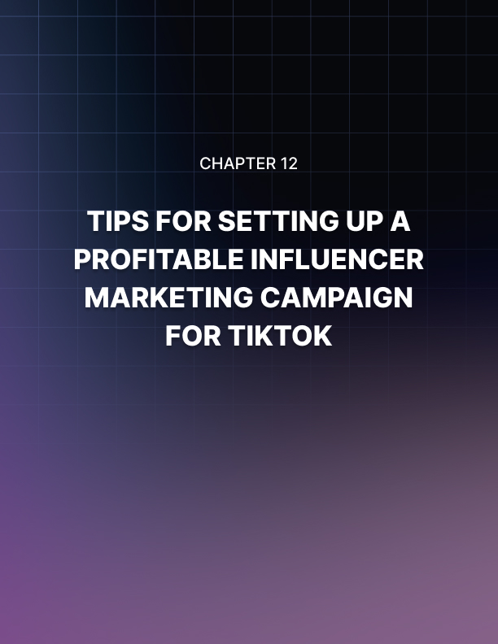

Chapter 12: Tips For Setting Up A Profitable Influencer Marketing Campaign For TikTok

What is influencer marketing?
Nowadays people can communicate more easily using social networks, which have had great growth in recent years.
One of the things that has had a lot of boom is the use of social networks by commercial brands because it allows them to advertise their products.
But what does it take for these products to reach their future buyers, and who are the people who help boost brands on the networks?
These people are known as influencers, and are people who claim to have a great influence on social networks and who have the ability to capture the attention of other people to influence it.
But how do brands reach their millions of customers and convince them to buy their products and follow them on their networks?
Influencer marketing is when a brand or product involves the influencer to promote their brands or products to their followers with the intention of raising awareness or increasing their sales.

Promotion of User Interaction
One of the most important aspects of using the TikTok application as a successful influencer marketing campaign is that the user can participate and interact with its content.
How can the user interact with your content? Very easy. The user can challenge other users to join a hashtag challenge such as who makes the highest jump.
The success of TikTok is that it creates a unique perspective that allows users to interact with its content without issuing a forced perspective.

Create fun, unique and creative content
One of the things that makes the TikTok application a unique tool for influencer marketing is that TikTok does not need high quality content to achieve the required impact.
The originality in this case should be seen as important as the quality since the users of this application seem to appreciate the more cheesy and silly promotions of the lateral content.
Use of the hashtag challenge
Hashtag challenges are an important and essential part of the TikTok platform and community.
Anytime the user is experiencing or navigating the waters of this application, they will realize that there are a lot of challenges in which he can participate at any time. Hashtag challenges have to do with recreation and video interactions with some new ideas.
The TikTok application has proven to be a very important tool in influencer marketing for a great majority of brands.
With all the previous tips, you don't have to miss the big move. The user can choose to use the paid promotion to promote their brand. When the user chooses this option, they will work with certified influential people, which will ensure that their product or brand is more successful.


Chapter 13: Best TikTok Video Ideas to Boost Your Brand
Since its launch, TikTok promoted a brief viewing of videos, which made the application very popular among young people.
According to statistics, they show that 500 million young people have become fans of watching 15 seconds of TikTok.
No matter whether your reason is to have fun or gain followers, what we do know is that, TikTok, with its millions of fans, is the right platform for them to see you or to boost your brand.
Here we present the best ideas of TikTok so that your brand has great and excellent momentum.
Lip sync video
Music is a source of inspiration throughout the world, music transports us, elevates our mood and makes us dream.
A song is also inspiring and drives you to create, use your creativity, experiment with lip sync videos and let others see your performance.
Video Duet
Duet videos are very popular and are very popular among YouTubers, knowing this we invite you to try this excellent idea.
To create duet videos we just have to open the video from where you want to create the duet, touch the share icon and select duet and now you can make the video you want and as you wish.
Pet video
Who doesn’t love pets; most people have a pet, a little bird, a beautiful cat or dog. If you have a beautiful pet and you are a person who loves to make videos with them or promote the sale of pets, use this tool, which will help you capture the best and most beautiful moments with them.
Imitating other popular videos
On social networks we can watch a lot of videos on a daily basis, which for some reason becomes very popular; if we want our videos to be popular too then we choose the same theme or a similar performance.
Keep up with the trend
A great idea for our video to be in trend is to do it about an important event that is happening or that will happen.
For example, if the film festival is celebrated in your city, then make a video about this event, how it was developed and what was the most relevant thing that happened in it. Or if you saw a video that got thousands of views, make one similar to that.
Show your skills
Another excellent idea to show what makes you so unique and special is to show your skills.
For example, if you know how to cook, then make a video where you show yourself preparing a delicious cake.

Improvised videos
It’s happened to us that we are in a place and we see something very funny happen or we see something incredible but we can’t capture the moment because we didn’t have a camera ready.
Then always have your camera ready for when you encounter these unrepeatable moments as you will surely stumble upon one of them.
Travels
Millions of people travel around the world and others travel through videos, then record the panoramic views of the people you know. These will be loved by all your followers.
Additional Tips To Make Your Videos More Popular On TikTok
- Publish regularly and give strength to your publications. You can publish your videos on TikTok once or twice a week.
- Connect with other influencers as they can help you improve your posts and get more followers.
- Always share your videos on social networks you have, this will increase your views; you can also mention your TikTok profile link or your nickname on other social networks so you will get more followers.
- Try to show positive things in your videos since the public does not like negative videos. The public likes things that will brighten their day.
- Comment on the videos of others, by doing so your videos will also receive more comments.
- Respond to each comment made by your followers and in doing so, do it generously, respectfully, be interesting and fun when responding.
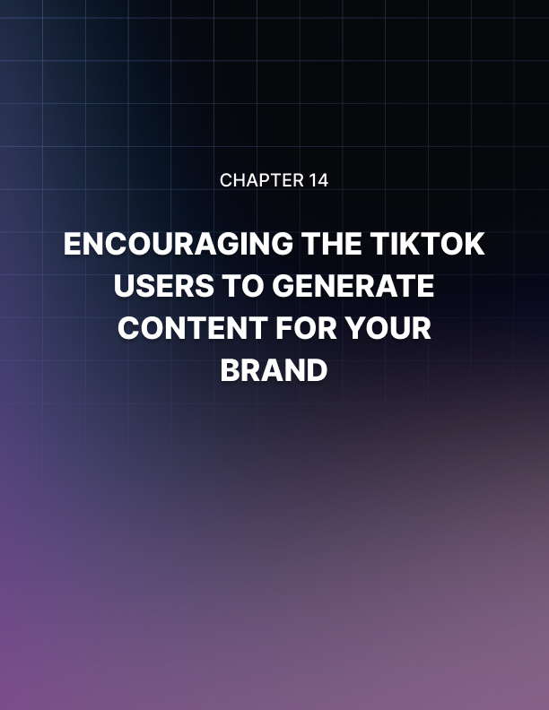

Chapter 14: Encouraging TikTok Users To Generate Content For Your Brand

What Is And How User Generated Content Works?
User Generated Content (UGC) is a type of marketing in which brands can rely on their own TikTok channel or work with influencers and thus encourage their followers to create user-generated content.
The Z generation (which are the people who have used digital technology since a young age and are comfortable with the Internet and social media) loves to immerse themselves completely in new experiences, for that reason they are not the ones who sit at home watching traditional TV, they seek to live daily experiences that raise them to the highest.
For this reason, social networks have had such acceptance within this generation and the TikTok application has fallen from the sky as it allows them to do and see fun things that circulate throughout the networks.
This application also has the great advantage that if you work with products or have a brand you can promote with it, you can obtain excellent results. Generation Z does not like passive experiences, and that is why this generation prefers to get involved in the experience which is why they love TikTok because this application allows them to do that.
If you can find a way to encourage customers using videos of them interacting with their products in some way, it is likely to have very good acceptance.

The DIY Strategy
To give an example of the advantages of this application in China, the Haidilao restaurant discovered this with a DIY option on the menu.
Customers who made the selection of the DIY menu item were able to create their own dishes outside the menu and then the clients filmed their experience.
The Chinese restaurant Haidilao encouraged its customers to share this experience by uploading their videos in Douyin.
After customers shared this experience with their Douyin followers, many people went to the restaurant so they could also create their food and video.
With this example we realize that the TikTok application is a great help when it comes to promoting a brand or a product, after this more than 15 thousand people requested the DIY option; 2000 videos uploaded from their creations and were watched by 50 million people.

More Ways To Take Advantage Of UserGenerated Content With TikTok
User-generated content is one of the simplest and most powerful ways to get closer to establishing a real connection with the audience.
Most brands want their users to share the content of their products or to talk about them but fail to use it correctly.
By using the TikTok application as a tool for user-generated content, the client will obtain excellent results. Since this application is one of the most installed in the year 2019.
An excellent way to take advantage of user-generated content on TikTok is to create videos with images of your audience which will be seen millions of times since this application has millions of users.
Another way is that TikTok allows you to create publications with images to which you can add fun music and share with your users in videos from 9 to 15 seconds, this makes your brand more viewed by users.
Another advantage offered by the TikTok application is that the customer will comment on your products in their stories.
When the user mentions your brand in their stories that gives you the opportunity to ask if you can share their content in your stories.
This means that by adding this content to your stories you have more opportunity for your followers to keep you in mind.
Creating featured stories with user-generated content allows you to extend the lifetime of your stories by doing this you take advantage of sharing UGC.
You can also create contests which are excellent because they allow you to attract new content and get more users to share their content with you.
By creating contests you get closer to your audience, create ties with them and this increases your followers too.
We must take advantage of using UGC as a marketing tool and all the good we can get from it. Our world is very globalized, and these applications allow us to get closer to people, especially young people who sometimes feel apart. TikTok gives the opportunity to many people who have great talent and are very creative to show what they know how to do in the freshest and funniest way.


Chapter 15: Running a Contest or Sweepstake On TikTok The Right Way
Currently, TikTok does not have published guidelines for doing a contest, but that does not mean that there are no rules for doing so.
For the TikTok contest or raffle, it is legal to comply with these 7 basic recommendations to carry out a promotion on a social platform.
Use an exclusive hashtag to explore tickets. One of the best ways to explore tickets for a TikTok contest is through the use of an exclusive hashtag.
Any publication that is made during the published time period of the promotion that has the default hashtag is considered an entry.

Incorporate official rules
The official rules are those that protect you in court if something does not go well and you need to defend yourself.
A clear set of rules will detail who can enter, how to enter, what the prizes will be and when the promotion ends.
You can also provide a way to enter without requiring a purchase. You must also incorporate in your rules an acknowledgment that the promotion has no sponsorship or support from TikTok or anything linked to it.
The rules should be published in a relevant manner as a link wherever you post about your TikTok contest including your own video about the contest, the video subtitle, the social announcement or a link in your social biography.
Be cautious of copyright infringement
You cannot claim or accept that a participant in your TikTok contest uses music, logos or any other copyrighted material to participate.

Give wonderful prizes
Before holding a TikTok contest or raffle, think about what kind of prizes your fans would like. Incredible prizes always generate more appeal.
But you should keep in mind that in the US; Prizes worth more than $600 have IRS presentation requirements for the winners.
Follow laws and social guidelines
Each state and social platform has exclusive laws and guidelines for raffles and gifts. It also has federal laws and strict FTC guidelines related to the use of the word "contest", "raffle" or "announcement" in its notice of action and in the program's own hashtag.
Laws to give gifts in other countries could be even more severe. Expressing that "he was not aware of that" or "the others do so" will not save him from an FTC investigation or a lawsuit or fines. So follow the rules.
Keep reasonable entry dates
To increase the number of tickets you receive, the period of entry for your promotion should not be too short, nor should it be very long.
For an uncomplicated contest with some prizes, a week should be long enough. If you have a lot of prizes and different degrees of winners, you could analyze the possibility of making a promotion for the period of a month. You should also make sure you have enough time to judge the entries for the contest.
Reduce the duration of each video for your contest
When users watch videos they don't like to watch such a long video because it is usually very boring, you don't want to watch 200 videos of sixty minutes. 3 minutes is more than enough time to assess the quality of a contestant.
The best way to be sure to make the best possible raffle is to use an accredited promotional agency to help you write official rules, and make sure you are not breaking any laws. And in this way work with you to comply with the guidelines of the TikTok community.
TikTok is a site where you can express your creativity. It is also a global community of people who are looking for fun and welcoming experiences. The guidelines of the TikTok community, which are periodically updated, are an important code of conduct for a safe and cordial environment.
If these guidelines are violated this would result in the deletion of your account or its content. Users must also follow local laws. TikTok reserves the right to monitor and report the content to the relevant authorities, as allowed by applicable law.
Your policies and guidelines should be created to promote and build trust, respect and a positive environment for everyone in this community. TikTok is confident that its users will give respect to the community and keep TikTok fun and enjoyable for everyone.
TikTok is not a place to post content that could harm other users or encourage them to harm themselves, either by physical or emotional damage.
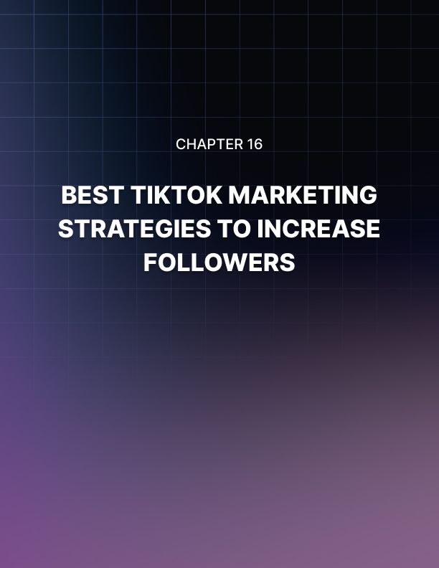

Chapter 16: Best TikTok Marketing Strategies To Increase Followers
As the days go by, TikTok becomes increasingly popular in the world, and a large number of vendors are now receiving traffic from TikTok.
It is not difficult to obtain traffic from a platform that is in an inaugural period. Because of this it is necessary to have excellent TikTok marketing strategies for each seller to gain more followers and traffic.

Carry Out Your Own Research
Without hesitation, researching and obtaining remarkable information from your own niche remains the most important factor for success.
The first thing to do is to learn all that you can about your closest competitors. You must know the content they are creating; you must know the specifics about the success they obtain from their videos.
This may be difficult, but it is worth taking calculated measures. It is when you investigate them that you are able to recognize some mistakes that they might be making. By filling the void and doing things differently you can stand out.

Create Content That Is Useful And Creative
One of the most entertaining ways to see what we like in social networks is through the videos that have become super popular today.
But to be able to attract our audience and promote our products successfully we must create videos that have content with a high degree of utility and that are very creative. In this way we can keep our followers interested.
Our video has to look highly interesting so that our content gets their attention and can add value to our users.
Use your creativity. Remember, people use different social networks to entertain themselves, so don't upload videos that bore the viewer.
Have Partners
In fact, if you are dedicated to doing your business without partners, there will be times when partnering with others is inevitable. If you find someone in the same industry as you, you can share ideas with each other.
You could change one thing you have never done that could transform your traffic completely. They can also learn something from you that could be useful.
Be Consistent
TikTok takes the prize when it comes to entertainment so do what it takes to ensure a regular update of your TikTok videos and be consistent just as you would if you were creating a blog.

Improve The Participation Of Your Followers
How do you do it? Here are 5 great tips:
- Ask A Question
It's simple to ask questions where you worry about your fans for example.
How does the cold weather make you feel? This type of question will make them feel committed and loved and this will make them follow your videos faithfully.
That is the kind of marketing that is needed. So ask open questions regularly.
- Ask Your Followers To Choose
Involve your audience in providing them with options to choose from, when they respond you will have already committed them.
Have them choose their position on some controversial issues of life, this is very useful because a debate will be generated.
Do not put yourself on the side of any of your followers. Allow them to discuss on their own, while you play the role of moderator.
- Make Your Posts When Your Fans Are Online
Research and identify the time your fans are online. In this way, by publishing your videos at that time you will gain more viewers.
- Interact With Other Brands
This is very beneficial because when interacting with other brands, it allows you to publicize your brand to an audience that it could not reach and part of the traffic generated will result in sales.
You should keep in mind here that you must share content that is useful.
- Crowdsource Comments
You need to have comments to remain notable for your audience, that's when you know if they love your content or not. One of the advantages is that people have no problem testing the comments. You just have to ask them in a good way.
You should ask questions where they can give sincere answers. For example, where should you specifically improve on your next contest, your audience will be quick to provide meaningful input.
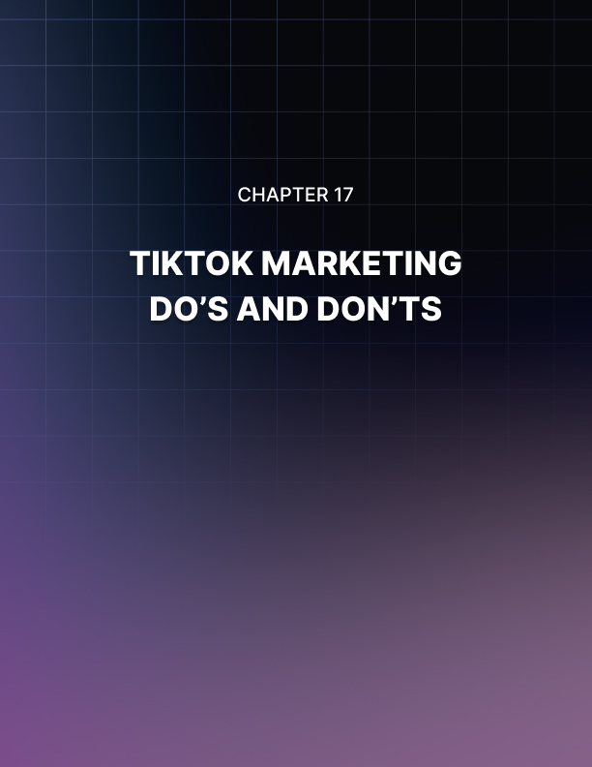

Chapter 17: TikTok Marketing Do’s And Don’ts

Do’s
Create a profile that looks fascinating
This is a transcendent detail since the information you provide can leave a great impression on the people who look and visit your profile.
Be original
Discover your own style, do not imitate the content that is created by others. Be original, enjoy creating your videos since the viewers of your videos can see if you enjoyed making the video or not.
Understand your followers
First, ask yourself why people would want to follow you. What does your account offer that others do not? Are you a good dancer or actor? All these questions will help you get to know your audience, remember that you are not making videos for yourself.
Follow the instructions when uploading videos
You must ensure that you do not violate TikTok guidelines. Your videos should be useful content for your followers, for example videos where you give tips to improve your physical training.
Participate in viral videos
By following the latest trends in social networks lets you know that other types of content are popular right now. For example, the challenges involved in singing a popular song are an excellent option.
Make your content consistent
Build a consistent pattern so that your audience knows what to expect from you. If your audience already knows what kind of video they expect from you every Monday and every Thursday, they will start waiting for you and return to TikTok on those days to watch their videos.
Relate to your audience
Connect with your viewers, don't forget to answer the comments that they put in your videos. When responding to your followers be kind, give intelligent answers and they will feel that you care and that you look at their comments.
Spread your videos on other social networks
Make a promotion of your videos on other social networks such as Facebook, Instagram and also in a blog if you have one. The greater the number of people who see and know your content, the more they will see and like it.
Make your production values improve over time
Most people who start on TikTok do so with limited budgets, equipment and skills. By spending time practicing they will develop their skills and once they can generate money they will improve their equipment and budget.
Make your TikTok account grow
One of the most successful ways to make your TikTok account grow is to work TikTok together with another network. The primary influencers of TikTok work great on YouTube. So take into account these tips to increase your followers.

Don’ts
Don’t create boring videos or videos without any utility
Remember that you are not making videos for yourself but for an audience, you should not make a wide range of videos trying to keep everyone happy.
Don’t reveal much personal information in your profile
Some people misuse TikTok so it is not convenient for you to reveal a lot of information about yourself, you must be careful. Do not upload videos and images that people can use to abuse.

Don’t upload videos that generate violence
Users of social networks use this medium to have fun, meet people and learn things. You want to grow your network of followers on TikTok, so if your videos are full of violence, your followers will stop following you.
Don’t choose a long username
If you want to make an impact when creating your TikTok account don’t choose a long and complicated username, choose an easy and attractive name that hooks your followers.
Don’t be generic when creating your profile
If you talk about many things at once your followers will not understand what your page is about.
Don’t forget to follow the latest trends
If you don't follow the latest trends in other easy networks you will not have the opportunity to see and know that other types of content are popular at the moment.
Don’t use a single account
If you want to have a large audience, then don’t limit yourself to a single account on the social network. By doing so, you will not be able to reach users on social networks such as Instagram, Facebook, YouTube, etc.
Don’t copy videos from others
Don't try to imitate the content of others' videos. If you do, you will never find a style that distinguishes you from others. Be original and unique.
Don’t follow people who are not famous on the network
If you want more followers you should not follow people who have no influence on the network, if you want these people to follow you, it is very easy, follow them and stop following them until they follow you.

Don't use your TikTok videos to promote weapons
This social network is widely used by young people who use it to spend fun moments creating videos or just enjoying the content. So on this platform you cannot publish content that encourages its users to buy weapons or use them.
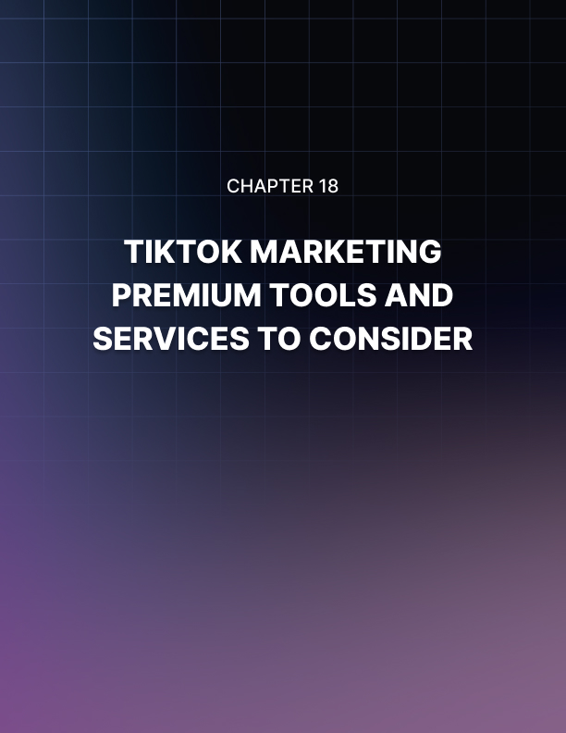

Chapter 18: TikTok Marketing Premium Tools and Services to Consider
Fanbytes
Fanbytes, being the largest TikTok influencers network in the world, has helped brands like Warner, Atlantic and
Universal to reach a younger demographic on TikTok. And with a staff of Millenials and Gen Z, they fit perfectly.
Fanbytes took this self-described "advertising" approach to marketing with the more refined offer obtained through TikTok.
This approach allows brands to work with influential users of TikTok to create thematic challenges which makes the public participate with a comment or a like.
What is refreshing about the Fanbytes’ pricing model is that there are no wasted expenses.
They charge a cost per completed visit model. If the user leaves the ad halfway, there is no charge. And an announcement better than this is the company's history with campaigns that average about a 90% completion rate.
And what if you have more views than you had budgeted? Don’t worry, because you will only be charged to your limit, anything beyond that will be a bonus.
Pentos
Pentos is a TikTok analysis platform, which provides services like helping to locate influential people, explore their content, monitor hashtags and songs, etc.
Also with this service you can enter the data of any TikTok influencer. This allows you to obtain important information about influencers.
With this service you can analyze the performance of your content, having a more complete and detailed understanding of your performance on TikTok.
LightMV
LightMv is a creator of free online device presentations which allows you to create high quality photos in minutes.
It offers you a variety of theme templates that are unique and super cool that you can use to create a magnificent photo video for any occasion.
The use of this tool differs from the other free online tools in that it will not add an annoying watermark on the output video.
InShot
InShot is a tool well known in the world of video editors, because it offers a wide range of features which include options to speed up or slow down videos. This is fascinating for users, who can also add music, filters and more to their videos.
It has a simple interface and almost everything is self-explanatory, you can also find all the basic functions for video editing on the home page.
With the use of this tool we can add texts, frames to our videos and make them look different from the rest.
Funimate
Funimate is another of the great applications that is on the popularity list, since it has extravagant effects and wonderful transitions, perhaps this is the best editor for TikTok.
With this tool we can play with many effects and sounds, we can also apply custom stickers to your videos.
Unlike the other applications, we can find the interface somewhat messy, but despite this, you can be sure that you will master the application in just a few minutes.
What you will like most about this editor is its incredible collection of effects. It has more than two dozen effects that will help you turn your videos into extraordinary videos.
Beecut
Beecut is an excellent video editing tool, it has almost all the features that are required to make a quality video. With this tool you can cut, trim, merge, accelerate, zoom, add a mosaic, flip and freeze among other things.
It has hundreds of text templates, filters, overlays, transitions and many other beautiful and cool elements.
Timbre
The strength and key of Timbre is in its ability to chain multiple videos. The interface is simple and easily understood. All you have to do is open the application, select the highlighted option and the application will do the rest of the work for you.
It also lets you play with the audio settings in case you want to change the audio of a particular song.
The only negative thing about Timbre is that it doesn't allow you to preview the files before downloading them.
Vizmato
If you are looking for an application that combines the ingenious features of Inshoot and the beautiful and incredible effects of Fulminate then Vizmato is the best for you.
This application allows you to cut and trim your existing videos and you can join several clips together.
And the most incredible of all this is that the clips can be trimmed after having added them to the main video. You just have to add the clips and adjust the end and the beginning of each clip according to your needs.
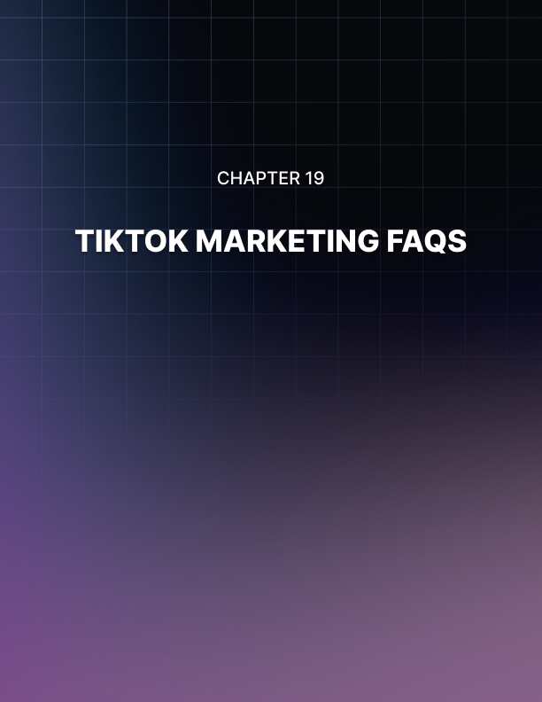

Chapter 19: TikTok Marketing FAQs
How can TikTok adapt to your digital strategy?
TikTok has a very young clientele unlike other platforms. If you can create videos that are captivating for TikTok followers, it could be a very valuable tool for your business.
TikTok is advertised as a social media platform where users can show their true colors. And being authentic is a great marketing strategy. With the highly sophisticated TikTok editing tool system, you could really shine.
TikTok lately has been testing native video ads that point to websites, this is very big news for marketers.
Should brands pay attention to TikTok?
Before answering this question let us tell you a little about the Z generation which are the most fanatical users of TikTok. You need to keep this in mind when asking why a brand should pay attention to TikTok.
The Gen Zers are today's teenagers and the fastest growing group of tomorrow's trendsetters. Knowing that Gen Z is an objective population group, and if a popular Gen Z brand is not on TikTok, their brand could be missing out.
How much does it cost to advertise on TikTok? (available in beta in the U.S.)
The brands that advertise on TikTok are, for the most part, companies with applications, and therefore, encourage downloads. Advertisers incorporate photo editing applications such as Facetune, Enlight and Facetify among others, also the GruBhub food delivery application continues to advertise on this platform.
The ads themselves are very basic, like one that was made for Go Keyboard which is not even formatted for vertical video.
But what is the cost of ads on TikTok? according to a February rate card seen by Digiday. Feed ads are sold at a cost of $10 per impression, with an insignificant campaign expense of $6,000.
Brand acquisition ads have a daily value of $50,000 with a guarantee of 5 million impressions...
Who uses TikTok more?
According to official TikTok data, the number of users that are active daily exceeds 150 million and the monthly assets are more than 300 million.
During the spring festival held in China, the number of users increased impressively from 40 million users to 70 million.
The average age of users has also increased, users between the ages of 24 and 30 accounted for 40% of the total number, that is, the majority of users of the TikTok platform according to these statistics is Gen Z.
Who has the most followers on TikTok?
The person who has the most followers on TikTok in 2019 is 17 year old Loren Gray.
At some point she presented her program on snapchat called "Glow Up", she also obtained nominations for presenting herself on social networks for which she was nominated for the Teen Choice Awards and People's Choice Awards.
This girl has also been producing music since 2017 and in May of this year she released her single “Can’t do it”.
In 2024, the person with the most followers on TikTok is 24 year old Khaby Lame, with over 162 million followers.
How to go live on TikTok?
Launching live on TikTok is an innovative feature of the application where users can make live videos for their followers to see what they are doing today.
To launch these videos live using the application on an iPhone or an android, Follow these steps:
- You must install the application on your phone. Which is obtained from the app store or Google Play.
- Start the application. Open it on your cell phone and be sure to log in to your account where you want to broadcast live. When you have started, touch the + button at the bottom center of the program.
- Start recording. Look at the "Live" button next to the "Record" button.
- Touch the "Live" button to start making your live broadcast.
How Do You Get A Verification Badge On TikTok?
The TikTok platform only gives verification badges to its most genuine users who have popularity and who are very influential on the network.
Although the official verification statements of this platform are not disclosed, we will show you how to get a foundation of faithful followers.
Follow these steps:
- Videos that you share are of excellent quality and that are always recorded vertically.
- Research popular videos to see what is popular and try to imitate how users with featured videos advertise their own content.
- Try to entertain. This you do by being fun and exciting, act lively and interact with the music and your environment in an innovative way.
What Content Is Prohibited On TikTok?
The following list includes services and products that cannot be advertised on TikTok.
- Drugs: Ads that show and encourage drug use.
- Alcohol: Ads that show or encourage people to consume alcohol.
- Cigarette and tobacco: Ads that promote the use of cigarettes or any of their derivatives.
- Sexual content: Ads that show naked or any sexual content.
- Illegal products, services or illegal activities.
- Lottery or Random games: Ads that promote gambling or online lottery.
- Talk about hate or violence: Ads that promote hate and violence.
- Weapons: Ads that promote the use of weapons.
What type of content is restricted on TikTok?
- The following is a list of content that TikTok may allow at its discretion if the content complies with all applicable rules, laws and regulations.
- Content that promotes financial services such as administration or investment of funds.
- Food and drinks: Ads that promote drinks or food with a high level of sugar, fat or salt that are identified under the nutrient profile, may be subject to restrictions.
- Medical care, medications and pharmaceutical products cannot have misleading or inaccurate statements.
What practices are prohibited on TikTok?
- Misleading Claims: The ads should not promise exaggerated results, nor should they make claims that cannot be justified.
- Misleading functionality: Ads should not include items that can trick the user into relating to the ad.
- Silenced or immobile ads: Advertised ads must contain videos with quality audio, ads that do not comply with this will be rejected.
- Lack of brand: Ads must accurately represent the product or service by clearly marking the ad within the title.
- Data collection: If you have a request for data, they should appear only on links outside the application.



Conclusion
In conclusion, TikTok is not just a place to share creative content; it's also packed with user-friendly tools that make promoting brands super enjoyable. It's especially popular among young people who favor simple, fun experiences and products. This young audience is a big reason why influencers and brands flock to TikTok—they know it's where they can connect with users looking for something fresh and easy.
Moreover, TikTok is committed to keeping its community safe and welcoming. It regularly updates its guidelines to ensure everyone acts responsibly and respectfully. If someone breaks these rules, they might see their content or even their entire account deleted. TikTok also keeps an eye on local laws and won’t hesitate to step in if needed. These efforts help build a platform where everyone can feel respected and have a good time.
By sticking to these community norms and embracing its efficient promotional features, TikTok ensures it remains a place where fun, creativity, and safety all thrive together, making it an ideal spot for both users and marketers.

