TABLE OF CONTENTS
____
INTRODUCTION 5
DISCOVERING YOUR MARKET 8
Understanding Your Target Audience 8
Identifying Customer Needs, Problems, and Desires 9
Gathering Quantitative Data and Analyzing Competition 10
Finding Market Gaps and Avoiding Common Pitfalls 11
VALIDATING ASSUMPTIONS 15
The Importance of Assumption Validation 15
Designing Effective Validation Experiments 17
Advanced Validation Techniques 17
Leveraging Validation Results 19
BUILDING A MINIMUM VIABLE PRODUCT 22
Understanding the MVP Concept 22
Defining Your MVP's Scope 23
Choosing the MVP Type and Creating a Roadmap 24
Agile MVP Development with Simplicity 24
Gathering and Interpreting User Feedback 26
Moving from MVP to Full Product 27
CUSTOMER FEEDBACK LOOP 30
The Power of Customer Feedback 30
Establishing a Robust Feedback System 31
Advanced Survey Techniques 33
Avoiding Confirmation Bias and Implementing Changes 34
Leveraging Customer Feedback for Innovation 35
FROM VALIDATION TO EXECUTION 37
The Power of Market Research 37
The Iterative Nature of Assumption Validation 37
From MVP to Scale 38
Leveraging Customer Feedback for Improvement 39
Financial Management and Fundraising 39
Embracing Agility and Adaptability 40

DISCLAIMER
____
The information provided in this ebook is intended solely for educational and informational purposes. The author does not accept any responsibility for the outcomes that may arise from the application of the material within. While efforts have been made to ensure the accuracy and relevance of the content, the author cannot be held accountable for any errors or omissions, or for any consequences resulting from the use or misuse of the information provided. The responsibility for any actions taken based on the information in this ebook lies solely with the reader.


INTRODUCTION
____
Your startup idea is full of potential, but doubts linger. What if it doesn’t resonate with the market? What if you invest your time, energy, and savings into something that doesn’t work?
This book is your guide to overcoming those fears. It offers a proven system for validating your startup idea before you commit significant resources.

Do you want to ensure your idea is viable and market-ready?

Within these pages, you’ll discover how to conduct focused market research, test assumptions, and gather valuable customer feedback. You’ll learn how to refine your idea, making sure it meets real-world needs and resonates with your audience. This isn't about theory—it's about equipping you with data-driven strategies and actionable techniques that separate successful startups from those that don’t make it.
By the time you finish, you'll have transitioned from an aspiring entrepreneur with a spark of an idea to a confident innovator with a market-tested, validated concept. You'll know how to spot true opportunities, avoid costly mistakes, and understand what makes customers tick, all while saving time and resources.
This book isn’t just about preventing failure—it’s about setting you up for extraordinary success. You’ll gain insights from the experiences of other entrepreneurs and use their lessons as your competitive advantage.
So, are you ready to validate your way to startup success? Turn the page, and let’s get started on turning your idea into a market-approved reality.



DISCOVERING YOUR MARKET
____
The journey to startup success begins with a crucial step: uncovering your market. This chapter equips you with sophisticated tools and methodologies to gather both qualitative and quantitative data, ensuring you have a crystal-clear picture of your potential market. You'll gain insights on analyzing competition and identifying market gaps that your startup can uniquely fill.

Understanding Your Target Audience
Before you can create a product or service that resonates with your audience, you need to know who they are. Start by creating detailed buyer personas – fictional representations of your ideal customers.
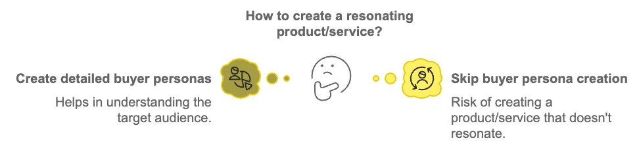
These personas should include demographic information such as age, gender, income, education level, and occupation. But don't stop there. Dive deeper into psychographic details like values, interests, lifestyle, and pain points.
To build these personas, you'll need to gather data from various sources:
- Surveys
- Interviews
- Social Media Analytics
- Customer Data
- Industry Reports
Your goal is to create a vivid picture of your ideal customer.The more detailed your personas, the better you can tailor your product and marketing efforts to meet their specific needs.

Identifying Customer Needs, Problems, and Desires
Once you've defined your target audience, it's time to uncover their needs, problems, and desires. This step is crucial because your startup's success hinges on solving a real problem or fulfilling a genuine desire.
Start by asking yourself these questions:
- What challenges does my target audience face in their daily lives or businesses?
- What goals are they trying to achieve?
- What solutions are they currently using, and how satisfied are they with these solutions?
- What improvements or features do they wish existed in current solutions?
To answer these questions, employ a mix of research methods: observational research, focus groups, online forums and social media monitoring, customer reviews analysis, and trend analysis. Combining these methods gives you a thorough understanding of what drives your potential customers. This knowledge forms the foundation for developing a product or service that truly resonates with your market.

Gathering Quantitative Data and Analyzing Competition
While qualitative data provides depth, quantitative data offers breadth and statistical validity. Here are some methods to gather quantitative data:
- Online Surveys
- A/B Testing
- Market Size Analysis
- Competitor Analysis
- Web Analytics
When analyzing quantitative data, look for patterns and correlations. For example, you might discover that a certain age group is more likely to have the problem your product solves, or that people in specific geographic areas are more interested in your offering.
Understanding your competition is crucial for identifying your unique value proposition and finding gaps in the market. Here's how to conduct a thorough competitive analysis:
- Identify Your Competitors
List both direct competitors (offering similar products/services) and indirect competitors (offering alternative solutions to the same problem).
- Analyze Their Offerings
Study their products or services, pricing strategies, and target markets.
- Evaluate Their Marketing
Examine their websites, social media presence, advertising, and content marketing strategies.
Thoroughly understanding your competition allows you to position your startup to fill market gaps and offer unique value to customers.

Finding Market Gaps and Avoiding Common Pitfalls
Market gaps represent unmet needs or underserved segments within your industry. These gaps often present the most promising opportunities for startups. Here's how to identify them:
- Look for Underserved Demographics
- Identify Unaddressed Pain Points
- Consider Technological Advancements
- Analyze Market Trends
- Look for Integration Opportunities
- Consider Price Points
- Explore Niche Markets
Remember, a market gap isn't always obvious. It might require combining insights from various sources and thinking creatively about how to meet customer needs in new ways.
As you navigate the market research process, be aware of these common pitfalls: confirmation bias, over-reliance on secondary data, ignoring negative feedback, assuming your experience is universal, focusing too narrowly, neglecting cultural factors, and misinterpreting data. Avoiding these pitfalls ensures that your market research provides a reliable and valuable foundation for your startup.
Research Method | Advantages | Disadvantages
Surveys | Reach large audience quickly, quantifiable results | Limited depth, potential for biased responses
Interviews | In-depth insights, ability to probe further | Time-consuming, smaller sample size
Focus Groups | Group dynamics can generate new ideas | Potential for groupthink, not representative of larger population
Observational Research | Reveals unconscious behaviors | Time-intensive, potential for observer bias
Social Media Analysis | Access to real-time data, large sample size | May not represent entire target market, privacy concerns

Keep in mind that discovering your market is an ongoing process as you conclude this chapter. Markets evolve, customer needs change, and new competitors emerge. Regularly revisiting and updating your market research will help keep your startup aligned with current market demands and opportunities. With a clear understanding of your target audience, their needs, and the competitive landscape, you're well-equipped to move forward with validating your assumptions and developing your minimum viable product.



VALIDATING ASSUMPTIONS
____
The foundation of your startup idea rests on a series of assumptions. These beliefs about your market, customers, and product form the bedrock of your business model. However, assumptions, no matter how well-informed, remain unproven until tested. This chapter equips you with advanced methods to rigorously validate your core assumptions, minimizing risks and maximizing your chances of success.

The Importance of Assumption Validation
Your startup's success hinges on the accuracy of your assumptions. Untested assumptions can lead to wasted resources, misaligned products, and ultimately, business failure. Systematically validating your assumptions helps you reduce risk, save resources, gain insights, and build confidence.
Reducing risk involves identifying and addressing potential issues early in the development process. Saving resources means avoiding investing time and money in ideas that don't resonate with your target market. Gaining insights allows you to discover valuable information about your customers and market that can inform your strategy. Building confidence helps you accumulate evidence to support your decisions and attract potential investors.
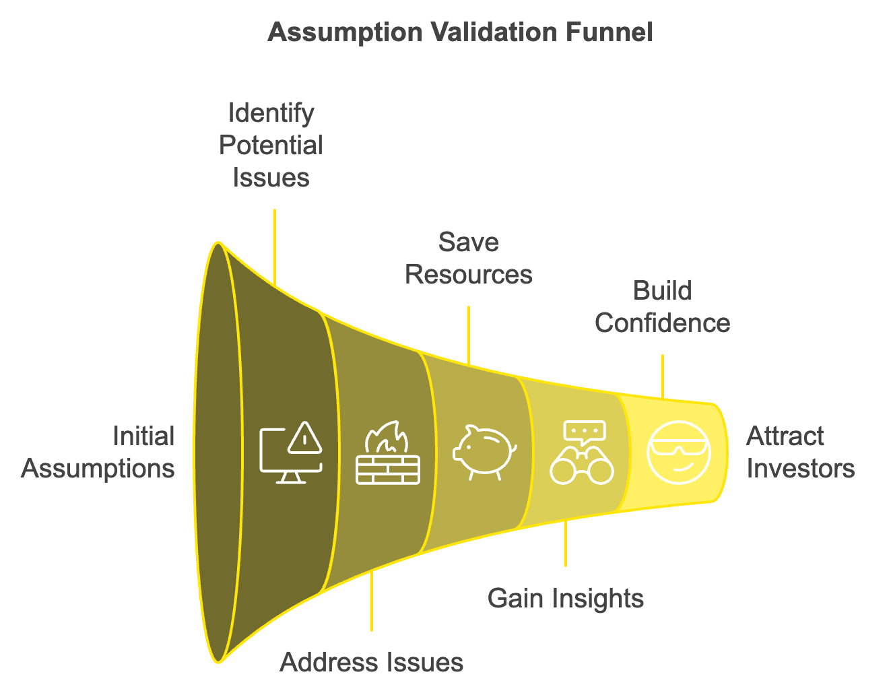
Before you can test your assumptions, you need to identify them. Start by listing all the beliefs underlying your startup idea. These might include market assumptions, customer assumptions, product assumptions, and business model assumptions. Market assumptions encompass the size of your target market, growth potential, and competitive landscape. Customer assumptions involve who your customers are, their needs, behaviors, and willingness to pay. Product assumptions include the features your customers value most, how they'll use your product, and its competitive advantage. Business model assumptions cover your revenue streams, cost structure, and distribution channels. Once you've compiled your list, prioritize your assumptions based on their potential impact and uncertainty. Focus on testing the most critical assumptions first – those that, if proven wrong, would significantly alter your business model.

Designing Effective Validation Experiments
With your core assumptions identified, it's time to design experiments to test them. Each experiment should follow these steps:
- Define the Hypothesis
- Set Success Criteria
- Choose Your Method
- Execute the Experiment
- Analyze Results
- Draw Conclusions
Defining the hypothesis involves transforming your assumption into a testable statement. Setting success criteria means determining what results would confirm or refute your hypothesis. Choosing your method involves selecting the most appropriate validation technique for your hypothesis. Executing the experiment means conducting your test while minimizing bias and external factors. Analyzing results involves evaluating your findings against your success criteria. Drawing conclusions means deciding whether to pivot, persevere, or conduct further tests.

Advanced Validation Techniques
A/B Testing
A/B testing, also known as split testing, involves comparing two versions of a webpage, app interface, or marketing message to see which performs better. This method is particularly effective for validating assumptions about user preferences and behavior. To conduct an A/B test, create two versions of your product or message, changing only one element. Randomly divide your audience into two groups. Present each group with a different version. Measure the performance of each version using predetermined metrics. Use statistical analysis to determine if the difference is significant.
Version | Button Color | Click-through Rate | Conversion Rate
A | Blue | 3.2% | 1.8%
B | Green | 2.9% | 1.5%

Pilot Programs
Pilot programs involve launching a small-scale version of your product or service to a limited audience. This technique allows you to test multiple assumptions simultaneously in a practical setting. To run an effective pilot program, define clear objectives and success metrics. Select a representative sample of your target market. Develop a minimal version of your product with core features. Launch the pilot and gather data on usage, feedback, and performance. Analyze results and use insights to refine your product and strategy. Pilot programs are particularly valuable for B2B startups or complex products.
Smoke Tests
Smoke tests gauge market interest before investing in product development. These tests involve creating a landing page or advertisement for your product idea and measuring audience response. To conduct a smoke test, create a compelling landing page describing your product concept. Set up a call-to-action, such as an email sign-up or pre-order button. Drive traffic to your page through targeted ads or social media. Measure engagement metrics like click-through rates and sign-ups. Survey interested individuals to gather more detailed feedback. Smoke tests are excellent for validating market demand quickly and cost-effectively.

Leveraging Validation Results
Once you've conducted your validation experiments, it's crucial to effectively leverage the results. Document everything by keeping detailed records of your experiments, results, and insights. Share findings to ensure all team members are aware of validation results to inform decision-making across the organization. Iterate rapidly by using insights to quickly refine your product or business model. Build a validation culture by encouraging ongoing testing and learning throughout your startup's lifecycle. Communicate with stakeholders by using validation results to build confidence with investors, partners, and team members.
Assumption validation is an ongoing process, not a one-time event, as you conclude this chapter. Markets evolve, customer needs shift, and new competitors emerge. Continually testing and validating your assumptions positions your startup to adapt and thrive in a dynamic business environment. Armed with these rigorous testing techniques, you're well-equipped to minimize risks and maximize your chances of building a successful, market-aligned startup. The journey of assumption validation requires persistence, creativity, and a willingness to challenge your own beliefs. Take on this process as an integral part of your startup's growth, and you'll find yourself building not just a product, but a resilient, customer-focused business that can handle market uncertainties and come out stronger with each iteration.


BUILDING A MINIMUM VIABLE PRODUCT
____
The concept of a Minimum Viable Product (MVP) stands at the core of modern startup methodology. It's the embodiment of your validated assumptions, the first tangible iteration of your idea that you'll present to the world. This chapter guides you through the strategic development of an MVP that effectively tests your value proposition while conserving precious resources.

Understanding the MVP Concept
An MVP is not simply a stripped-down version of your final product. It's a strategic tool designed to test your core value proposition with real users while minimizing development time and resources. The goal is to learn as much as possible about your target market and the viability of your solution with the least effort. Key characteristics of an effective MVP include focusing on core functionality, addressing the primary problem you've identified, delivering value to early adopters, and facilitating rapid learning and iteration. Remember, "minimum" doesn't mean low quality or sloppy. Your MVP should be polished enough to effectively demonstrate your value proposition and gather meaningful feedback.

Defining Your MVP's Scope
Before you start building, you need to clearly define the scope of your MVP. This involves identifying the essential features that will allow you to test your core assumptions and deliver value to your early adopters.
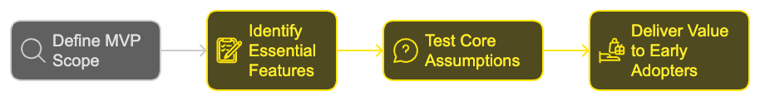
Start by revisiting the key assumptions you validated in the previous chapter. What is the primary problem you're solving? What is the core value you're providing? Use these insights to guide your MVP definition. Next, create a list of all potential features for your product. Categorize these features into three groups:
- Must-Have
Features essential to solving the core problem.
- Nice-To-Have
Features that add value but aren't critical.
- Can Wait
Features that can be added in future iterations.
Focus solely on the must-have features for your MVP. This approach allows you to launch quickly and start gathering real-world feedback.

Choosing the MVP Type and Creating a Roadmap
There are several types of MVPs, each suited to different situations and goals. Some common types include:
- Concierge MVP
- Wizard of Oz MVP
- Landing Page MVP
- Single-Feature MVP
- Piecemeal MVP
Choose the MVP type that best aligns with your goals, resources, and the nature of your product. Consider factors like development time, cost, and the kind of feedback you need to gather. With your MVP scope defined and type chosen, it's time to create a detailed roadmap for development. This roadmap will guide your team through the MVP creation process, ensuring everyone stays aligned and focused on the core objectives. Your roadmap should include a prioritized feature list, timeline, milestones, resource allocation, and testing plan. Remember to build in flexibility. As you progress, you may need to adjust your plans based on new insights or challenges.

Agile MVP Development with Simplicity
Agile methodologies are particularly well-suited for MVP development. They emphasize flexibility, rapid iteration, and continuous feedback - all crucial elements in the MVP process. Key agile principles to apply in your MVP development include iterative development, continuous integration, daily stand-ups, user stories, and regular reviews. By adopting these agile practices, you can maintain flexibility and responsiveness throughout the MVP development process.
One of the challenges in MVP development is striking the right balance between simplicity and sophistication. Your MVP needs to be simple enough to build quickly and cheaply, yet sophisticated enough to effectively test your value proposition. Here are some strategies to achieve this balance: focus on core value, embrace imperfection, use existing solutions, design for scalability, and prioritize user experience. Sophistication in an MVP comes from its ability to solve a real problem effectively, not from having numerous features or complex technology.
MVP Type | Description | Best For
Concierge | Manually deliver service to small user group | Testing value proposition before building tech
Wizard of Oz | Create product facade with manual backend | Testing user interaction and demand
Landing Page | Website describing product to measure interest | Gauging market demand with minimal development
Single-Feature | Product with one core problem-solving feature | Focusing on primary user need
Piecemeal | Utilize existing tools to deliver solution | Minimizing custom development

Gathering and Interpreting User Feedback
The primary purpose of an MVP is to gather user feedback. This feedback will guide your future development efforts and help you refine your product to better meet market needs. Some effective methods for gathering user feedback include in-app surveys, user interviews, usage analytics, A/B testing, and social media monitoring. When interpreting feedback, look for patterns and trends rather than focusing on individual comments. Quantify feedback where possible to identify the most pressing issues or popular feature requests. Be wary of the "loud minority" - a small group of vocal users whose opinions may not represent your broader user base. Always cross-reference qualitative feedback with quantitative data from usage analytics.
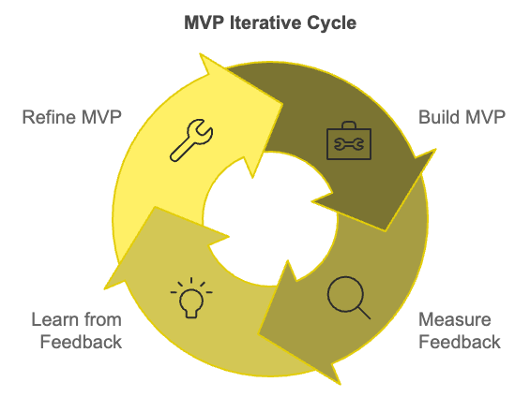
The MVP process doesn't end with the initial launch. It's an iterative cycle of building, measuring, and learning. Once you've gathered sufficient feedback, it's time to refine your MVP. Follow these steps in your iteration process: analyze feedback, brainstorm solutions, prioritize changes, implement updates, and re-test. Iteration doesn't always mean adding features. Sometimes, the best improvement is simplifying or even removing features that aren't delivering value.

Moving from MVP to Full Product
As you iterate on your MVP, you'll reach a critical decision point: Should you continue on your current path (persevere) or make a fundamental change to your business model (pivot)?
Signs you should persevere include users engaging with your core features as intended, key metrics showing positive trends, and feedback being generally positive with suggestions for incremental improvements.
Signs you should consider pivoting include low user engagement or high churn rates, feedback indicating you're not solving a significant problem, and your MVP not being scalable or economically viable.
Remember, pivoting isn't failure - it's a natural part of the startup process. Many successful companies, including Slack, Instagram, and Twitter, underwent significant pivots based on MVP feedback.
Eventually, if your MVP validates your core assumptions and gains traction, you'll need to transition from MVP to a full-fledged product. This transition requires careful planning and execution. Steps in this transition include solidifying your product roadmap based on MVP learnings, scaling your technology infrastructure to handle increased usage, expanding your team to support full product development, implementing a more comprehensive marketing strategy, and developing customer support processes. Throughout this transition, maintain the agile, user-focused approach that guided your MVP development. Continue to gather feedback and iterate, even as you expand your product's scope and user base.
Building an MVP isn’t about creating a perfect product; it’s about learning, adapting, and gradually refining your solution to meet real market needs as you wrap up this chapter. By following a strategic approach to MVP development, you position your startup to create a product that truly resonates with users and stands out in the market. The MVP process requires patience, flexibility, and a willingness to challenge your own assumptions. Embrace this process, and you'll find yourself building not just a product, but a deep understanding of your market and a foundation for sustainable growth.
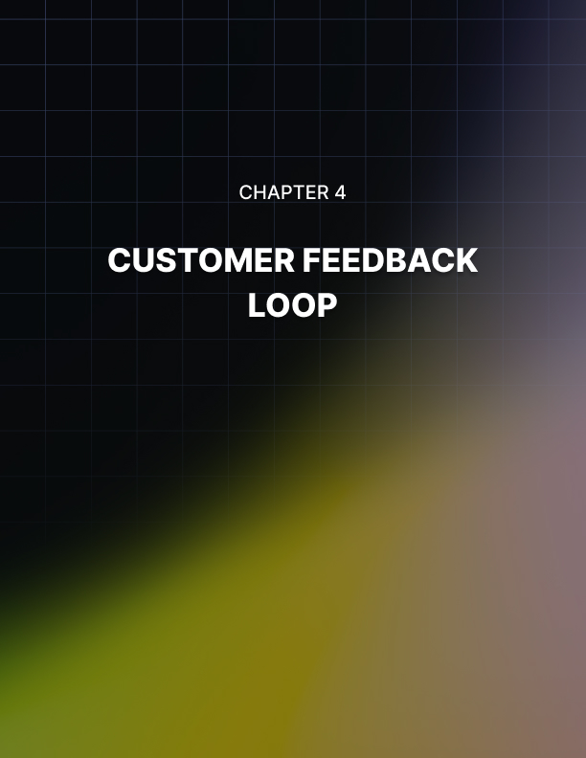

CUSTOMER FEEDBACK LOOP
____
Your ability to listen to and act on customer feedback can be the deciding factor between success and failure in the startup world. This chapter explores the critical process of establishing a robust customer feedback loop, a system that not only gathers insights but also translates them into actionable improvements for your product or service.

The Power of Customer Feedback
Customer feedback is the lifeblood of product development and business growth. It provides invaluable insights into user experiences, preferences, and pain points that you might not have anticipated. Actively seeking and analyzing feedback gives you a competitive edge, helping you refine your offering, enhance customer satisfaction, and drive business success. The benefits of a well-implemented customer feedback loop are numerous:
- Improved Product-Market Fit
- Enhanced Customer Loyalty
- Reduced Churn
- Informed Decision Making
- Innovation Opportunities
- Cost Efficiency
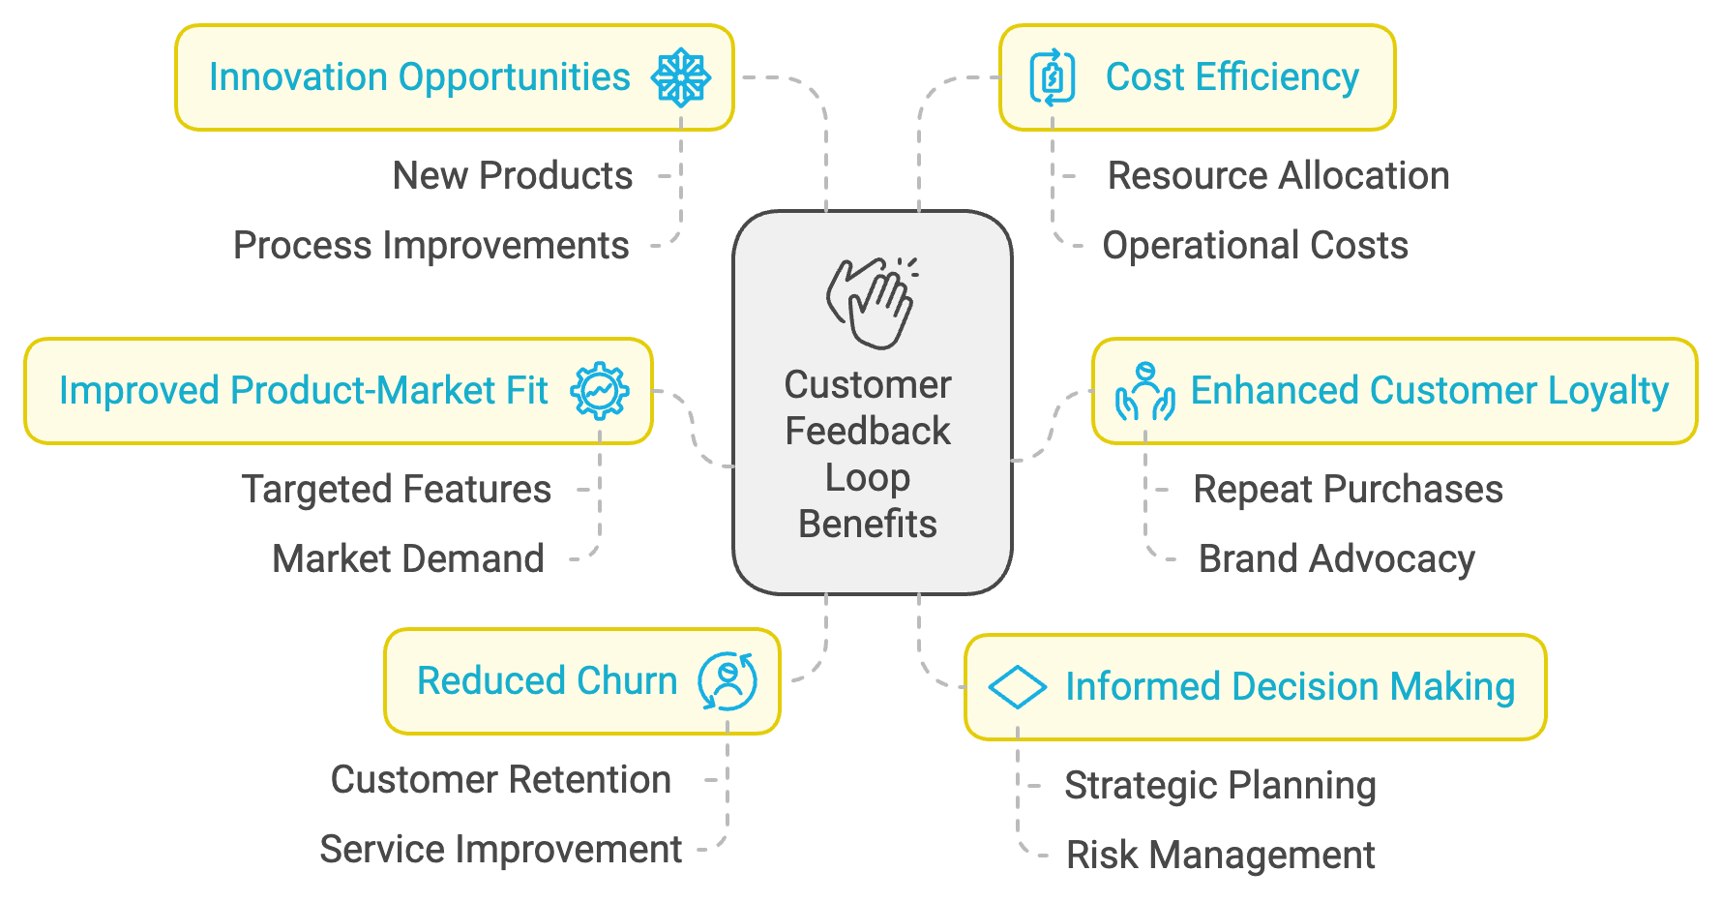
Understanding your customers' needs and preferences allows you to tailor your product to better serve your target market. When customers feel heard and see their feedback implemented, they're more likely to remain loyal to your brand. Identifying and addressing pain points quickly can prevent customer attrition. Customer insights can guide strategic decisions across various aspects of your business, from product development to marketing strategies. Customer feedback often reveals unmet needs or new use cases, sparking ideas for product improvements or new offerings. By focusing on features and improvements that customers actually want, you can allocate resources more effectively.

Establishing a Robust Feedback System
Creating an effective customer feedback loop involves more than just collecting opinions. It requires a systematic approach to gathering, analyzing, and acting on customer insights. Here's how you can establish a robust feedback system:
- Define Clear Objectives
Before you start collecting feedback, clearly define what you want to learn. Are you looking to improve a specific feature? Understand overall customer satisfaction? Identify new product opportunities? Having clear objectives will guide your feedback collection methods and ensure you're gathering relevant insights. Clarity in objectives is crucial for the success of your feedback system.
- Choose the Right Feedback Channels
Different feedback channels are suited to different types of insights. Some effective methods to consider include surveys, interviews, focus groups, user testing, social media monitoring, in-app feedback, and customer support interactions. Each channel has its strengths and can provide unique insights into your customers' experiences and preferences.
- Implement Feedback Collection
Once you've chosen your feedback channels, it's time to implement them. Best practices include timing your feedback requests appropriately, keeping the process simple for customers, incentivizing participation, and ensuring accessibility for all customers. Timing is key when asking for feedback, as you want to catch customers at the right moment in their journey with your product.
- Analyze and Interpret Feedback
Collecting feedback is only half the battle. The real value comes from analyzing and interpreting this data to extract actionable insights. This process involves categorizing feedback, quantifying qualitative data, looking for trends over time, cross-referencing with other data, and using data visualization techniques. By employing these methods, you can turn raw feedback into valuable insights that drive decision-making.
- Act on Insights
The most crucial step in the feedback loop is taking action based on the insights you've gathered. This might involve prioritizing product improvements, addressing customer concerns, updating marketing strategies, or training staff. Actionable insights are the ultimate goal of any feedback system, as they lead to tangible improvements in your product and customer experience.

Advanced Survey Techniques
Surveys are a powerful tool for gathering customer feedback, but their effectiveness depends on how well they're designed and implemented.
To improve your survey strategy, consider using the right question types, implementing skip logic, optimizing for mobile devices, A/B testing your surveys, and using micro-surveys.
These advanced techniques can significantly improve the quality and quantity of feedback you receive.

Survey Technique | Description | Benefits
Likert Scale Questions | Measure attitudes on a scale | Quantifiable data, easy to analyze
Skip Logic | Show/hide questions based on previous answers | Personalized experience, relevant data
Mobile Optimization | Design surveys for mobile devices | Higher completion rates, better user experience
A/B Testing | Test different survey versions | Optimized response rates and data quality
Micro-Surveys | Short, focused questionnaires | Higher response rates, contextual feedback

Avoiding Confirmation Bias and Implementing Changes
Confirmation bias can significantly skew your interpretation of customer feedback. To mitigate this, seek disconfirming evidence, involve diverse perspectives, use blind analysis, quantify feedback, and consider alternative explanations.
When implementing changes based on feedback, prioritize the feedback, create an action plan, test before full implementation, monitor the impact, and communicate changes to your customers. This structured approach ensures that you're making data-driven decisions and closing the feedback loop effectively.

Leveraging Customer Feedback for Innovation
While customer feedback is invaluable for improving existing products and services, it can also be a powerful driver of innovation. To leverage feedback for new product development, identify unmet needs, analyze feature requests, explore edge cases, combine insights from different customer segments, and encourage ideation within your team. By systematically gathering, analyzing, and acting on customer feedback, you position your startup to build products that truly resonate with users, foster customer loyalty, and drive sustainable growth. Take the voice of your customers as a guiding force in your startup journey, and you’ll find yourself not just meeting their needs, but anticipating and exceeding them in ways that set your business apart in the competitive startup landscape.


FROM VALIDATION TO EXECUTION
____

The Power of Market Research
Market research is the foundation of your startup's success. Continuous market monitoring is essential to stay ahead in a dynamic business environment. This involves regular industry analysis, competitor tracking, customer sentiment analysis, and trend forecasting. Maintaining a pulse on your market positions you to make proactive decisions rather than reactive ones.
Refining your target audience is a natural part of startup evolution. Analyze user data, conduct segmentation studies, create dynamic personas, and explore adjacent markets. A well-defined target audience is the cornerstone of effective marketing and product development strategies.

The Iterative Nature of Assumption Validation
Validation is an ongoing process that should be integrated into your startup's DNA. Establish a culture of hypothesis testing by framing assumptions as hypotheses, setting clear success metrics, engaging in rapid experimentation, and learning from failures. As your startup matures, employ more sophisticated testing methodologies such as multivariate testing, cohort analysis, predictive modeling, and user journey mapping.

From MVP to Scale
Transitioning from your Minimum Viable Product (MVP) to a full-fledged, scalable product brings new challenges and opportunities. Scaling your technology infrastructure becomes crucial during this phase. Leverage cloud scalability, focus on performance optimization, enhance security measures, and implement automation wherever possible.

Your product strategy should evolve based on user feedback and market demands.

Prioritize features that provide the most value to your users and align with your business goals. Continuously refine your user interface and experience, consider expanding to new platforms or devices, and look for opportunities to personalize the user experience.
Scaling your team is equally important. Establish and communicate clear company values, develop a comprehensive onboarding process, implement knowledge management systems, and focus on leadership development to support your scaling efforts.

Leveraging Customer Feedback for Improvement
Scaling your business requires making your customer feedback loop more sophisticated. Employ advanced feedback analysis techniques such as:
- Natural Language Processing
- Predictive Analytics
- Integration of Multiple Data Sources
- Real-Time Feedback Systems
Ensure that your customers see the impact of their feedback by implementing transparent communication, beta testing programs, customer advisory boards, and personalized follow-ups.

Financial Management and Fundraising
Sound financial management becomes increasingly critical as you move from validation to execution. Track key financial metrics such as:
- Customer Acquisition Cost (CAC)
- Lifetime Value (LTV)
- Burn Rate
- Runway
- Unit Economics
If you decide to seek external funding, perfect your pitch, build relationships with potential investors early, choose the right investors who bring more than just money, understand investment terms, and be prepared for the rigorous due diligence process.

Embracing Agility and Adaptability
Your ability to adapt quickly to changing circumstances can be your greatest asset in the startup scene. Cultivate an agile mindset by taking on uncertainty, encouraging experimentation, learning from failures, and staying close to your customers. Adapt to market changes through scenario planning, flexible goal setting, cross-functional collaboration, and continuous learning. Standing at the cusp of executing your validated startup idea, keep in mind that the journey ahead is not a straight path but a winding road of continuous learning, adaptation, and growth. Your success will depend not just on the strength of your initial idea, but on your ability to continuously refine and evolve that idea in response to market feedback and changing conditions.
Key Success Factors | Description
Market Research | Continuous monitoring, audience refinement
Assumption Validation | Hypothesis testing, advanced methodologies
Scalability | Infrastructure, product strategy, team growth
Customer Feedback | Advanced analysis, closing the feedback loop
Financial Management | Metric tracking, fundraising strategies
Agility | Adaptive mindset, market responsiveness
The startup journey is demanding, but it's also incredibly rewarding. Moving forward, carry the spirit of innovation and commitment to creating value that originally inspired you to start this journey. With thorough validation, strategic execution, and unwavering persistence, you have the tools to turn your startup vision into a thriving reality.

Every successful company you admire today started exactly where you are now.

They faced the same uncertainties, overcame similar challenges, and learned invaluable lessons along the way. Your startup has the potential to join their ranks, to disrupt industries, and to make a lasting impact on the world.
So take a deep breath, review your validated assumptions, rally your team, and step confidently into the execution phase of your startup journey. The road ahead may be challenging, but armed with the knowledge and strategies you've acquired, you're well-equipped to navigate whatever comes your way. Your startup's success story begins now – embrace the journey, learn from every experience, and keep pushing forward. The world is waiting for the unique value that only your startup can provide.

