Disclaimer

This eBook has been written for information purposes only. Every effort has been made to make this eBook as complete and accurate as possible. However, there may be mistakes in typography or content. Also, this eBook provides information only up to the publishing date. Therefore, this eBook should be used as a guide - not as the ultimate source.

The purpose of this eBook is to educate. The author and the publisher do not warrant that the information contained in this eBook is fully complete and shall not be responsible for any errors or omissions. The author and publisher shall have neither liability nor responsibility to any person or entity with respect to any loss or damage caused or alleged to be caused directly or indirectly by this ebook.

This eBook offers information and is designed for educational purposes only. You should not rely on this information as a substitute, nor does it replace professional medical advice, diagnosis, or treatment.
Table of Contents

Introduction 6
Chapter 1: It’s Who You Know 10
Chapter 2: Nurturing The Connections You Already Have Virtually 15
Chapter 3: How To Make New Virtual Connections 20
LinkedIn 20
Facebook Groups 20
Google Forums 21
Online Webinars 22
Chapter 4: Virtual Networking Tools For Success 27
Zoom 27
GoToWebinar 27
Slack 28
Eventify 28
Brella 28
Arena 29
UPStage 29
Chapter 5: Mastering Virtual Etiquette 35
Chapter 6: Tips For Virtual Networking As An Introvert 42
Have Reasonable Expectations 42
Listen More Than You Talk 42
Prepare With Icebreakers 43
Have a Follow-Up Plan 43
Know When You Need to Say No 44
Chapter 7: Up Your Virtual Networking Strategy With Social Media 46
Best Social Media Sites 46
Connect Your Social Media To Your Invites 47
Keep It Professional 47
Chapter 8: How To Get Found On Social Media And Other Content Marketing Sites? 54
Use Relevant Hashtags 54
Optimize Your Bio 54
Engage With Other Accounts 55
Conclusion 57


Introduction

When you work in an office, the idea of networking can be simple. You may spend time at meetings, going to the break room, or even a ride in the elevator and you are able to meet other professionals who will help you to reach some of your goals. You may have to do a little work to go to conferences and more in order to make the connections that grow your network, but you can still get the work done.

Things get a little harder when you work from home. You still need to form some of these important connections, to meet others and work hard, in order to finally get ahead and reach for success. Networking when you are not in the office can be hard, but it may be one of the best ways to grow your business and make sure that you meet new people.

Virtual networking allows this to happen, whether you are in the office or work from anywhere. Through virtual networking, you will be able to take advantage of online platforms, social media, and even online webinars and conferences in order to form connections with others, even when you are not able to meet them in-person. Virtual networking allows the individual who works remotely a chance to network that they may not have had in the past.

There are different ways that you are able to do virtual networking and the one you choose can depend on your personal preferences and what works the best for you. You will need to attend virtual events. You can make some of your own or go to one that is sponsored by another organization. Learn something new and meet others who want to work through this as well.

Your current colleagues are good options as well. If you just started to work remotely, you have the advantage of already knowing a lot of your colleagues. Building up those relationships and maintaining those with the current colleagues can make a difference in how well you can network as well. If you leave your current job to start working remotely, then make sure that you stay in touch with some of the former colleagues too. This will help you to still have those connections that you can utilize later if you need.

There are so many benefits that you will be able to enjoy when it comes to virtual networking, but it basically comes down to some of the relationships that you are able to form along the way. This guidebook will take a closer look at virtual networking to help you see how great this can be for you to utilize too. Let’s get started!



Chapter 1: It’s Who You Know

When it comes to virtual networking, you need to focus on the relationships that you want to form. It is all about who you know. There is a lot of give and take that comes within this kind of networking and you may need to focus on some different rules that you will need to follow along the way to make sure that you are able to do things properly online. But it is really about the relationships that you form.

The more people you know in the right places, the easier networking will be. You can call on those connections later on, and they will be able to call on you later on if they need to. With the shift of many workers going from in-person work to remote work, traditional ways of building up a network is going out the window. Because of this, the culture of many companies is changing as well and the individuals and leaders will need to find some of the best ways to communicate and maintain the relationships that they need along the way.

Proper communication is going to be important when it comes to making the right connections. Think about how you can communicate in a thorough and thoughtful manner. Learn how to do active listening, and show that you care. Finding ways in your business endeavors to gather virtually can make it easier for everyone to work on building up some of the networks that they would like along the way.

As you start to work through your new networking ideas, whether you are a remote worker or not, you will need to think about who you already know and how you can utilize some of those different connections along the way. Everyone already has some connections that they are able to utilize, whether they realize it or not. And the connections do not always need to eb the people that you know from work or in your own industry.

Think about the people you went to school with. Have you maintained some of those relationships over the years and can utilize them now to bring in more clients or more customers or to help with a job? Is there a professor who has some good connections that they could introduce you to along the way?

What about one of your friends? They may not be a professional connection, but many of the friends you have maintained through the years may also have some connections that you can utilize as well. Or even colleagues from some of the past jobs. You can even look to different family members and some of the people that they know to see if there are some valuable connections that will serve you well over the years.

Keep in mind that you will need to focus on forming relationships. These people are not just there to serve you and then go away.

You need to form a relationship and maintain it. It could be years of maintaining that relationship before you are able to utilize it.

But you will be glad when you do need it.

There is also a lot of give and take in these relationships. There are times when you will be able to call on some of your connections for a favor or to help, and there are times when they will need to call on you for help. This is part of the networking process and will benefit both parties along the way. Be prepared to step in and help out when you can, even when you do virtual networking.

The goal is to build up some good relationships that will serve both parties well through the years. Virtual networking makes it possible to do this, even when you work remotely or when you do not spend as much time in the office as other coworkers. With a bit of help and some of the steps that we will talk about through this guidebook, you will see how efficient and successful virtual networking can be and how it is part of the future for most people who are looking to network from home or out of the office.

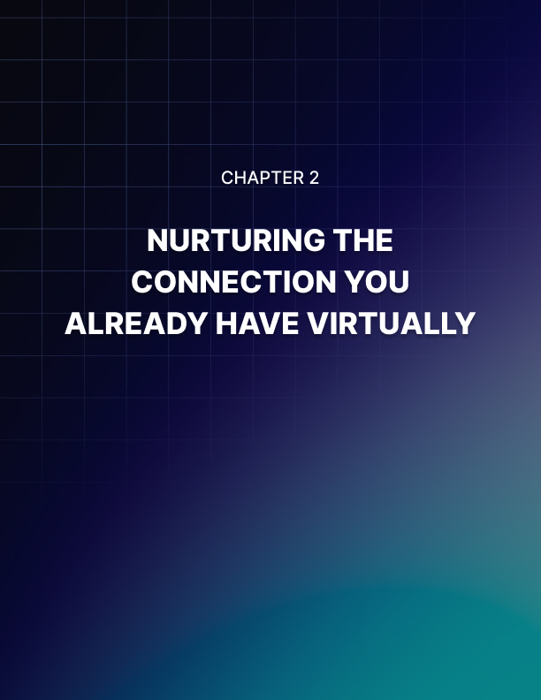

Chapter 2: Nurturing The Connections You Already Have Virtually

You already have some connections. Whether you have done a few internships or worked at several jobs in your career, you have a few connections that you can work with at any time. This is great news because you already have a good source of connections that you can utilize the way that you want. You will be able to grow that a little bit more in the future, but for now, we need to focus on the people we already know.

How can you connect with this group of people virtually? In our fast-paced world, it is not always possible to keep up with this network face to face, but that does not mean you want to lose them as an important connection, or that they want to lose you either. There are different ways that you are able to work with these connections and still reach them, even if you are not in the same location and can’t meet them in-person as often as you would like. Some of these options include:

Make Sure You Have Their Social Media?
Social media is going to be your friend when it comes to virtual networking. This is the perfect place to keep in touch with some of your connections, learn new things about that connection, and even send quick messages when you want to keep in touch with them. Make sure that you are utilizing social media, especially some of the big ones like Facebook, Twitter, and Instagram, so that you can reach your connections and keep in touch. This provides a personal touch to them and will make it more likely that they will be available for a favor later on.

Check Up With A Text Or Email
Let the connection know that you are thinking about them, even if you have not run into them for a long time. You do not have to spend a lot of time doing this. A few minutes here or there on occasion can help. Set some reminders or put it down on your calendar, especially if there are important dates that you want to remember to congratulate or think about a connection for on that day.
When it is time to reach out to the connection, you can just check in through email or a text. This only takes a few minutes, but just a few heartfelt words will be enough to show the other person that you care about them and are thinking about them. This will go a long way in helping you to get ahead and really reach your goals, even when you can’t stop in and see the connection that often.

Invite To Networking Events With New Connections
If you have a new networking event that is going to happen soon, invite some of those connections to that event. You do not need to invite them to each event and you do not need to invite every connection to the event either. The point is to know your connections well enough that you know when one particular networking event will entice them or help them reach some goals.

It is even better if you are able to entice them with an event that has new connections for them to meet. Everyone loves a good networking event that has new connections, ones that they have not been able to form on their own yet. This can be a good way for you to reconnect with them, show them something of value to themselves, and to keep that connection nearby if you need them later on. And all it takes is a quick invitation and a few seconds of your time.

Life is busy and it is not always possible to meet people in- person all the time. This does not make it an excuse to ignore some of your past connections and only focus on a few people you can see right now. With the right networking in place, you will be able to still connect with those people who are valuable to your success, even through virtual means.
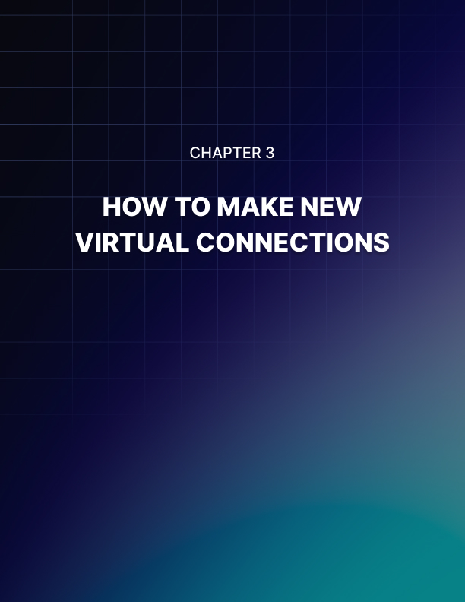

Chapter 3: How To Make New Virtual Connections

Now it is time to take a look at some of the different options that you can use in order to make some new virtual connections. As we talked about before, you may already have some connections and you can utilize different virtual means in order to make those connections and get ahead along the way. But if you want to really make a good network and lots of connections, you will need to find some good ways to make new virtual connections that you never had before.

LinkedIn
LinkedIn is one of the top places that you are able to build up the virtual network that you are looking for, especially in the professional field. There are a ton of professionals who are already online on this social media site and many are looking for connections already. This makes it a great opportunity to form some of the connections that you want.

Make sure that you have a LinkedIn profile to get started. You need to have it completed with some of the most important information about yourself, ensuring that you are able to get the most views. Take some time to form good connections too. Look for the commonalities with others when you send a connection request to make it more likely that you are going to meet someone and form that connection. Also consider adding some of the connections that you need to ensure that you will see the best results.

Facebook Groups
Facebook groups are a place where you are able to connect with others who share some of the same interests as you. It is possible to create your own group and then connect it back to your page to get the community started. Or you can look for groups in your industry or in your interests and join that to start participating.

There are different steps that you can take in order to help connect to a community, whether you are making your own group or connecting with others in a different group. These ideas include:

- Be authentic and visible: You need to build up trust through some of your posts and comments. Make it easy for people to talk to you, talk about things that provide value, and more to be authentic on the page.
- Be active: Do not just sit back and assume that others are going to connect with you through this. You need to be an active participant to make sure that others are able to see you and will work with you as well. Give positive feedback with reactions and comments, engage in some good conversations, and create a good environment where people want to participate.
- Use Facebook live: When it is your own group, make sure to utilize Facebook Live. This allows you to engage with the members and make a splash along the way. Make all of the Facebook Live options unique and creative to ensure that your members will want to be part of it.

There are a lot of ways that you can utilize Facebook groups to help you make virtual connections. Take a look at some of the tips above to make sure that you will get the best results.

Google Forums
Google is a name that you know and trust, one that is going to allow you to work with a lot of different people from all over the world. Just by taking a few minutes to sign up for your own Google account, you will be able to search around the forums and meet a lot of people, as well as use all of the other tools that are available through Google.

Once you have set up your own account, you will be able to start searching for some of the great groups that you want to utilize.

Search around and see if there are some that are in your industry or whether there are some of your current connections that are in a group who can get you in it as well. Once you are in the forum, follow up on some of the rules that are there and then start talking and interacting and becoming a major part of the group, ensuring that you are able to get a few connections from each one.

Online Webinars
There are a lot of online webinars that you are able to join and you should take advantage of this as well. Find something that interests you and then utilize it as a way to meet other people too. There are so many benefits of attending these online webinars so it is worth your time in order to learn something new and meet other people.

Take some time to learn which webinars are out there. You may feel overwhelmed in the beginning, trying to figure out which one is right for you. Think about what would help propel your career and get you ahead, what would be the most valuable to you. It can be something new and unique as well so that you can learn something that is brand new.

Once you find a webinar or two that seem interesting to you, it is time for you to attend and participate. While some webinars allow others to sit back and just listen and learn, this makes it hard for you to really focus on making new connections. You need to get right in there and learn how to participate and have a lot of fun.

When you are able to do that, you increase your chances of meeting others and really making a difference along the way with how many connections you have.

Making new virtual connections is one of the best ways for you to get ahead and make a difference in how big your network is going to grow. Find the right webinars online and learn how to reach out to others and you will find that you can make great virtual networking is the right thing for you.

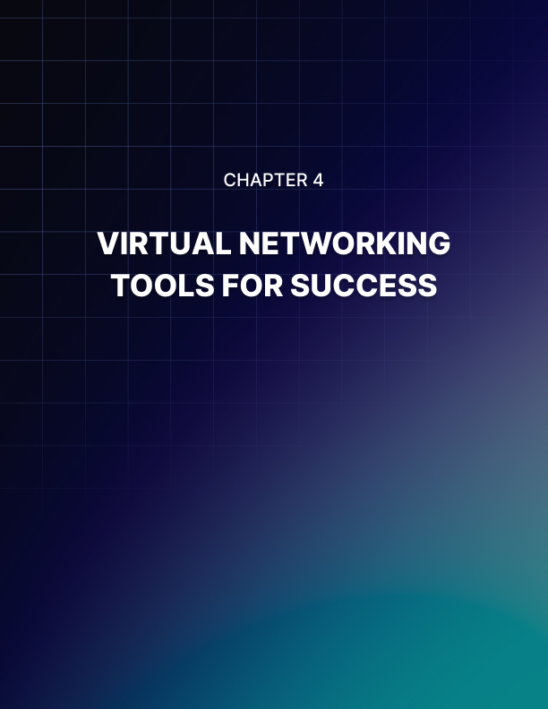

Chapter 4: Virtual Networking Tools For Success

When it is time to work with your virtual networking to meet others and get ahead, you want to make sure that you are reaching your people as efficiently as possible. There are a lot of great virtual networking tools that you are able to use, you will just need to make your plans and see which tool will provide you with the most benefits in the process. Some of the best virtual networking tools that you can use include:

Zoom
One of the first places that you can look when it is time to work with your virtual networking is Zoom. Almost everyone has an account with Zoom and it is really easy to set up and use, even without downloading something onto your computer. Choose to talk to one person or multiple and see what all this site can do.

While Zoom may not have all of the same features that some of the other options on our list do, it does provide a lot of benefits compared to utilizing them. It is simple to work with, whether you would like to talk to just one person or a lot, Zoom is going to provide you with all of the services that you need to set up that virtual meeting and make lasting connections.

GoToWebinar
GoToWebinar is a great option to choose when it is time to have a flexible webinar that will work for all of the virtual networks that you would like to expand all of the things that you are able to do with those who come to your events.

This is similar to what you can see with Zoom, but it also provides a lot of other great choices that will give you interaction, insightful analytics, powerful integrations, and so much more. This makes it useful for paying attention to some of the different things that you need to really get your virtual meeting off the ground. You can also use it for basic talking and communicating if you would like too.

Slack
Those who are trying to put together a virtual event will find that Slack is a great option that they are able to utilize. There are a ton of great features that the individual or the group is able to use in order to help them to get the most engagement, with as little onboarding as possible. This is great for some of the last minute meetings that you would like to set up or for things that happen but do not have a ton of planning with them.

One thing that a lot of organizers like about Slack is that it allows them and other attendees to just jump right on whenever they would like, engaging in a real-time conversation without all of the friction that some of the other options are going to have. This makes it easier for the organizer to ignite a community and even direct their attention better than before.

Eventify
If you would like a chance to mix up some of the formatting that you do for your virtual event, then you can take the time to work on Eventify in order to create your very own event app. This is possible with Eventify, which is designed to help you create a completely personalized, cross-platform app for your event so that you can take some of the networking that you do to the next level.

Eventify works on the idea of tag technology, which is going to work to match attendees together. At the registration, an attendee is able to pick a maximum of 20 tags that are meant to match their interests, which range from fintech to food technology based on your event. They can then connect up with others according to their interests. It is also possible for an attendee to send out invites to others, get and receive some private messages, and set up meetings one on one if they would like.

Brella
Next on the list is Brella. This is an aesthetically pleasing event platform that is sure to provide one of the best virtual event platforms on the list. And networking is going to be one of the specialties that you like the most.

This one is unique because it is going to utilize artificial intelligence to help connect the attendees together. All of those who join will be able to get with the right people, can utilize some of the live chat features to converse with other sponsors, and even book one on one video meanings to bring in professional conversations when it is needed. There are no limits and you are sure to love everything that this one has to offer.

Arena
You can also choose to work with Arena. This is a great tool to use for all of your needs with hybrid and virtual events. It was originally designed by event organizers for other event organizers. This means that it is going to have all of the things that you need in order to get the work done. You will love that this is a simple, customizable, scalable, robust, and affordable option to help you get ahead with all of your virtual networking needs.

One of the things that a lot of professionals like about this option is that it is made for networking. Things like the video and audio are above the rest and allow all of the people who attend your events a way to choose how they would like to interact and network. Some of your attendees may prefer to do the work without the video tool, and this is allowed on Arena.

It is even possible to use other streams to have discussions like a chat stream or engagement tools that allow the participant a chance to raise their hand when they have a question to ask. It is even possible for attendees to watch what is going on if they do not want to join in on this at all.

UPStage
Upstage by Hire Space is a great place to start when you need to get a virtual or hybrid conference off the ground. They offer some of the best when it comes to all of the networking capabilities that you need to foster some of those connections that are so important to your company.

How does this one work though? Attendees are able to join this network and enjoy real-time discussions, do networking sessions that are similar to the speed dating we have seen in the past, and even join in with a focus group thanks to some of the smart features that are provided to the customer based on their goals and interest. There are many great reporting features to see how many of the attendees were able to interact with one another and even set up some 1 on 1 meetings if you need.

All of these virtual networking tools are going to help your company get set up for success. Determining which one is right for you will make a world of difference in your overall success and will ensure that you are able to get ahead and make virtual networking work well for you.



Chapter 5: Mastering Virtual Etiquette

When it is time to do some of the virtual networking that you want, you need to make sure that you are able to follow some of the necessary etiquette that is required. Everyone has certain expectations when it comes to the way that you behave in the world, and you need to find ways to master the techniques, or
you will turn off those connections and have them running for the hills. Some of the ways that you can master your virtual etiquette includes:

Don’t Expect A Reply
Do not always expect a reply from someone to one of your meetings. While it would be nice to get your whole email list to show up and work with you, this is not always going to be the case. And bugging the other person all the time is never a good idea either. You need to send out some of the standard stuff and then let it alone if it seems that the other person is not all that interested in working with you along the way. You will get some replies, but you do not need to turn this into harassment along the way.

Make Sure You Have Reliable Wi-Fi
Your Wi-Fi is going to be so important when it comes to these virtual networking events. You do not want to have static on either side or worry about losing the other person along the way. You want it all to be smooth and simple to work with the whole time. And having the internet that is going to work the whole time is a bit part of having this work your way.

Check the Wi-Fi connection before you get started. See whether there are any issues that could pop up later and figure out ways to fix these if they do show up. You may need to talk with your internet provider or IT personnel to see what you are able to do to prevent potential issues later on as well.

Test Out Sound
It is a good idea to test out the sound and audio on Zoom and other tools before you get started. You want to make sure that you are able to hear everyone else and that they are able to hear you along the way too. You may need to enlist another person to do this with you. have them sit in another room and discuss whether you both are able to hear one another or not. If there is a problem with the sound, you will have time to fix it and make it sound better before the meeting starts.

It looks very unprofessional to have the sound not work on your device when it is time to get the whole process started. No one wants to wait to see whether the sound is going to work or not.

But when you test it out on your own ahead of time, you will find that you can get all of the issues worked out ahead of time.

Arrive On Time
Never show up late. Just like with an in person meeting, showing up late shows that you do not really value the time of the other person and you are not willing to spend that time with them. You need to be on time, if not early, to ensure that no one is kept waiting and that they don’t wonder whether you are going to show up or not in the first place. Do whatever you need to do to make sure that you will arrive on time to the meeting. Set an alarm, have the computer near you during the time, and clear up all of the time around that scheduled event to make sure that you are not going to be late.

Introduce Yourself
Before you get anything else started, you need to take some time to introduce yourself to the other person. Whether you are talking with one person or many, it is a good idea to introduce who you are and anything else that is important for the other side to know about you. As part of the icebreakers, you can continue to work through the group and let everyone introduce themselves and say something about themselves too, helping to open up the room and get others talking, and not just yourself.

Be Authentic
Your main goal through all of this is to be authentic. When you try to fake who you are, others are going to see right through it and will judge you instantly. This is a big turnoff for a lot of people and they will instantly not want to do anything that you ask them to or be open to anything that you want. But when you are authentic and your true self, people will warm up to you and may even forgive some of the mistakes that come up along the way.

There are different ways to be authentic. Do not try to hide anything, talk in a tone that seems natural to you, and put on a smile. Nothing puts people at ease quite like showing off a nice smile for all to see. When you are able to do this, you will find that it is easier to interact with others and make a big impression.

Don’t Pitch
Do not spend all that time pitching your ideas to others and trying to get them to pay attention. No one wants to get on a meeting and just hear you pitching the whole time. That is boring and it instantly puts their defenses up against you. You want them to feel comfortable and calm around you. You want them to feel like it is a conversation with an old friend when they get on. This will take some time to master, but remember that this is a conversation, not a pitch meeting, and you will find that this is going to be a good way to get started.

Offer Something In Return
This is not all about you. If the other person just feels like you are asking and asking, but you have no want to give them something in return, then this is not going to go well for you. Networking is all about the give and the take. You may want to get something out of the relationship, but so does someone else. You need to be willing and able to offer the other side something in return.

The exact thing that you are going to offer to them will depend on the information about that networking meeting. But there needs to be more giving than taking on your end. This sweetens the deal for the other side and makes it feel less like you are begging and more like you trying to look out for the other person and give them what they need.

Mastering virtual etiquette is going to be an important part of the whole process, providing you with some of the best in meeting others. There are certain rules that you will need to follow along the way, ensuring that the whole thing goes off without a hitch.

Follow some of the guidelines above and you will be off to a good start.
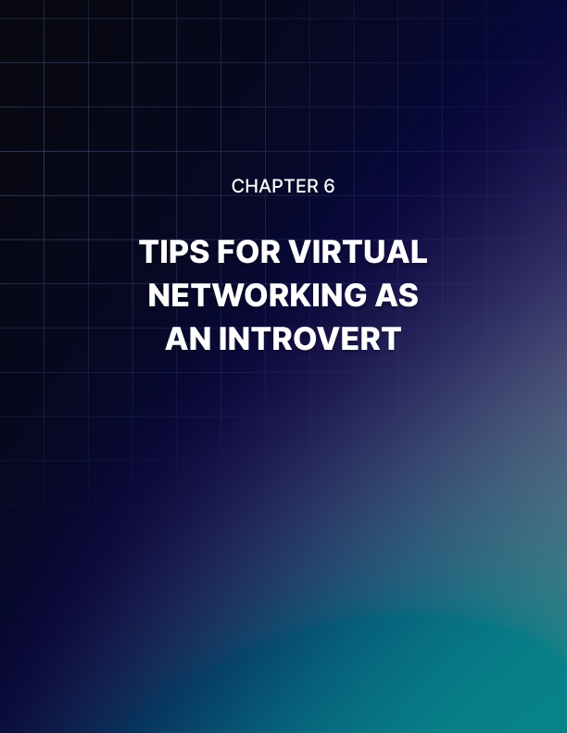

Chapter 6: Tips For Virtual Networking As An Introvert

As an introvert, you may worry that you are not able to do any of this virtual networking in the first place. It is hard for some introverts to get out there and make a splash, to get themselves noticed, but all is not lost. In fact, working with virtual networking could actually be beneficial to someone who is an introvert. You get many of the same benefits, without having to attend many of the same in-person events.

An introvert is able to work with virtual networking as well to see success with growing their connections and making sure they get success. Some of the tips that an introvert is able to use to help with virtual networking includes:

Have Reasonable Expectations
Be reasonable about your expectations when you get started with virtual networking. While it would be amazing to talk to someone for five minutes and be instant best friends and have that person open twenty doors for you, that is a lot of pressure to put on any meeting that you plan to do and it is not a good idea to start with.

Be reasonable about what you expect out of all the conversations that you have with the other person. Think about how you can help them. Keep it all simple too. If some doors do open, even better, but for right now you are just working through a conversation. If you just see this as a conversation to meet someone new, rather than something that will instantly change your life, a lot of the pressure will fall off and you will find that the conversation flows more naturally and goes better than before.

Listen More Than You Talk
While making new connections, one thing that you should focus on is learning how to listen more than you talk. You learn once when you talk, you learn twice when you listen. Many people get nervous when it is time to make new connections and meet new people.

They assume that they have to carry the whole conversation and talk the whole time, and this can make them nervous. However, while you do need to say something and bring up questions and show that you are listening, you may find that it is more successful when you are able to listen more than you talk.

By letting the other person talk more and express their opinion, you will be able to learn more about them. You can find some new connections, bring up new topics to talk about, and discuss things in a new way. This just does not happen if you are spending all the time dominating the conversation and not letting the other person talk at all, you are going to end up with a bored connection who does not want to talk to you again.

Everyone likes to talk about themselves. It makes them feel good. And when you respond and show that you are interested in what they try to tell you, this can form a really good connection as well. And all of this is only possible if you take the time to really listen to the other person along the way.

Prepare With Icebreakers
Getting a conversation up and running can be one of the hardest parts of virtual networking, or any other type of networking that you would like to do. Once you can make everyone feel comfortable, you will be able to get the ball rolling and can ensure that everyone is going to have a good time while connecting.

You may want to consider some of the best icebreakers that you are able to use along the way. These can help put everyone at ease and will set the mood as you go through some of the steps to opening them up and getting ready for the rest of the presentation. You can look up a few different icebreakers so you are ready to take on the rest of the connection and see the best results in the process.

Have a Follow-Up Plan
It is important to have a good follow-up plan for all of your customers or new clients. This is a chance for you to reiterate what was discussed online together and to see if you are able to provide further assistance. There are different types of follow-up plans that you are able to work with depending on your goals and your product, but create the type of follow-up plan that you would like to use from the very beginning.

Maybe you send out an email thanking the other person for meeting with you right away. Maybe you wait a few days to let things settle and then follow up to see if they had any more questions or were still interested in the product or meeting up. You can decide the way to do this, but a good follow-up plan helps to maintain that connection and can prove useful later on with that person too.

Know When You Need to Say No
One thing that can be hard for an introvert to do is learn when to say no to something. They want to make others happy and worry about disappointing someone else. They want to be everything to everyone all the time, and this may lead them to taking on more than they are able to handle.

It is good to be motivated and ready to lend a hand. This makes you stand out from the crowd and introverts are often really good at managing time and can make themselves stick out this way rather than focusing on being loud or as talkative as others. But introverts may struggle with the word no and will take on too much, draining their own energy and losing some of the quality that they can provide.

It is important to know where your limits are and then stick with them. This can be hard in the beginning. You want everyone to like you and you may not like telling someone no because you think it will disappoint them. But saying no is good for you and for the other person. It helps you to have limits and others to respect them and ensures that you are rested enough to be able to give the best each time.

Virtual networking is something that anyone is able to do, regardless of their talents, time, or personality. With the tips above, an introvert or an extrovert will be able to create some of the virtual networking that they desire.
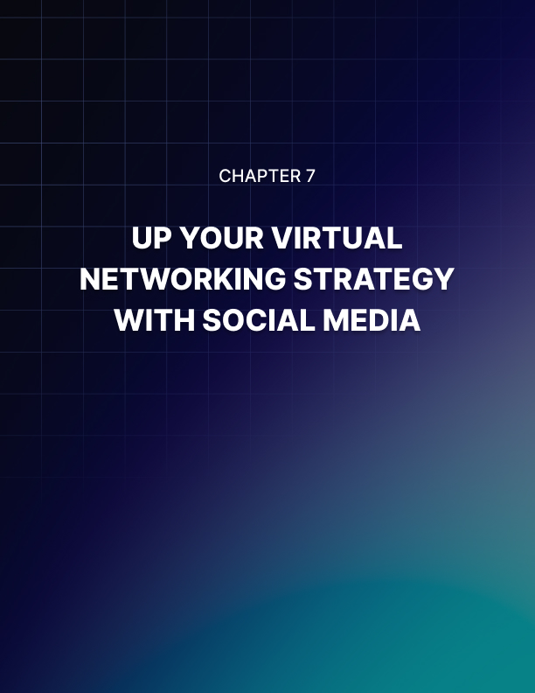

Chapter 7: Up Your Virtual Networking Strategy With Social Media

Social media is one of the best places for you to form some good connections that you are not able to get anywhere else. Knowing how to work with social media campaigns and figuring out the best way to speak to others who are looking to reach out to you as well. There is so much that you can do with your social media that will make virtual networking go out of this world. Some of the ways that you can step up your own virtual networking strategy with social media includes:

Best Social Media Sites
You do not need to work with every social media site in order to create some of the virtual networking connections that you want. But you do need to work with the right ones. Professionals who are willing to work with some of the best in social media sites will find that this is a great way to work through and reach the connections that they want on all levels. Some of the best options to choose when picking a good social media site include:

- YouTube: YouTube is a great visual social media site where you can interact with a lot of people. Share videos, webinars, and other important information that you would like to share with others. Make sure that you present high-quality videos that are certain to impress and do not sound the same as all the others. This will give you a lot of chances to interact with the viewers and you can lead them to your website or other options for connection.
- Instagram: Instagram is great for forming a connection through visuals and showcasing some of your work. If you work in an industry that values pictures and images, then you need to spend some time on Instagram to form some of your connections.
- Twitter: Short and sweet and to the point is the name of the game when it comes to Twitter. This is a great place to share some of your information in a small package to make sure that you are getting the best results to your connections.
- LinkedIn: This is a business social media site, a good one to form some of the bonds that you need with other like minded professionals in the same industry. Look into the connections of those you already connect with, share useful information on the industry, and find other ways to connect with those who matter the most to you.

Connect Your Social Media To Your Invites
Any time you invite connections to a webinar, a time to meet, or anything else, take the time to attach your social media to this as well. They may not choose to use it, but it can provide you with a good way to get in connection with them and will allow them more time to search you out and learn more about you too.

You should only focus on a couple of social media sites at once. This will help save a lot of confusion and can keep the invites to a minimum. Three is usually pretty good unless you have a large reach and need more. Any emails or other options that you send out to others should have information about the social media you use to help out here.

Keep It Professional
No matter what you do with your social media, you need to make sure that you act in a professional manner all the time. No one wants to come to your profile to make a connection and then find out that you are unprofessional or that you say and do things that offend them. If you are using your social media as a way to reach others and form more business connections, then the page needs to be professional the whole time.

This means that it is time to clean up the social media page as much as possible. Have pictures that go along with the message that you want to share and posts that are relevant. Clean up your current social media site if it is not matching with the new message that you want to send to other people either. Little things can turn customers away from you and connections, so take the time to clean up the social media to make it look amazing.
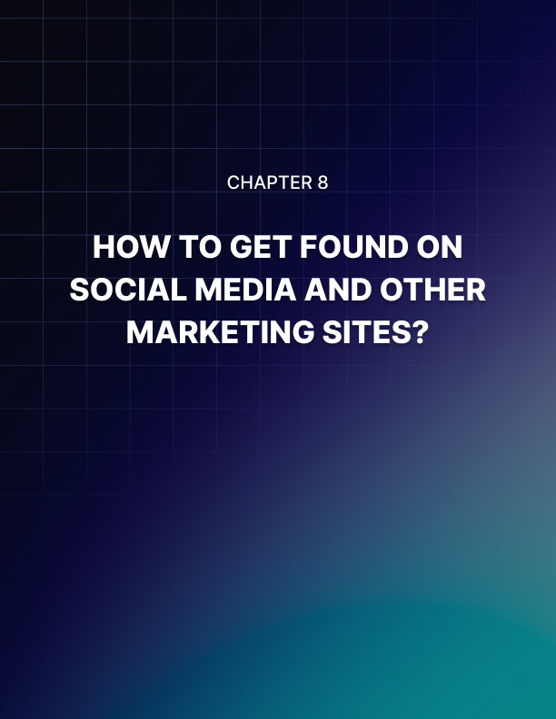

Chapter 8: How To Get Found On Social Media And Other Content Marketing Sites?

One goal that you need to work towards when it comes to your social media presence is to make sure that other people are able to find you through searching. With the right tools, like an optimized bio and some good hashtags, you can have others find you and start that connection first. Some of the ways that you can make sure you are found on social media and other content marketing sites includes:

Use Relevant Hashtags
One of the first things that you should consider doing when it comes to your social media and content marketing sites is to use the right hashtag. This makes It easier for your connections to just type in the hashtag and find you. When you utilize a unique hashtag that is relevant to your industry, it can also help new connections find you when they search online.

Research some of the top hashtags in your industry and find ways to add them naturally into the posts and comments that you write on social media. This will help others to find you when they search for that information. Another option is to make a unique hashtag, one that is special to your business. You can always promote that later on and utilize that buzz to bring more connections into your site.

Optimize Your Bio
The next thing to work on is optimizing your bio. You need to have a strong bio that tells the reader who you are quickly and will not make it hard to learn who you are. You can add more than one line, but it also should not be a novel of information either. A few of the things that you can remember when creating the bio that you want on your content marketing and social media include:

- Be consistent on all digital platforms. Choose a bio that works for all social media platforms and your website. Each one has their own limits on the characters that you can use, but try to be as consistent as. You can.
- Be clear and concise: You will be limited on space that you can use on some social media, like Twitter and Instagram, while others allow more characters. No matter the amount of space you have, find ways to explain who you are with impactful and useful information.
- Include the right keywords: You need to use some good keywords that will make the profile easier to search. You can include things like your primary skill sets, services, or even products in the bio to make it easier to search.

When you optimize your bio, it is easier to maintain consistency from one area to the next. And you will have the benefit of making it easier for your viewers and connections to find you when they need to.

Engage With Other Accounts
It is not enough to just write a few posts and then ignore the social media in between these posts. That is one way to make it hard for your account to be found by others you wish to connect with. You need to be active on social media and interact with as many people as possible, without looking like spam, to help make yourself more visible.

The first interactions that you do need to be with those who come to the page and comment. When someone comments on a post, asks a question, or messages you, make sure that you respond back. This does not have to be instant so do not worry if you can’t be on the page all day long. But it does need to be done in a reasonable amount of time so the viewer feels like they are important.

You also need to interact with others who have similar interests with you. Follow and like other pages that are inspirational to you, that share a good message, or who are in the same industry as you. Then comment, provide advice, and otherwise interact with that page. This may get the owners of that page to comment or follow you back. But more importantly, this is a great way for the followers of that other page to see your information and perhaps make a jump over to being your follower as well.


Conclusion

In our modern world, we need to network more than ever. But it is not always possible to do the networking face to face like we have in the past. Thanks to all of the neat technology that is going on around us, it is possible to do a virtual networking event, either individually or in a big group, to make sure that we are able to reach those important connections that will bring us to success.

There are so many reasons to network with those around us. Whether you want to look to break into a new field, reach new clients to grow your own business, or have connections available in case something changes later on, virtual networking opens up more doors than ever before. With the right techniques and following some of the tips above, you will be able to open up your net of connections and see some of the great networking that you need.

