TABLE OF CONTENTS
____
INTRODUCTION 5
SPOTTING OPPORTUNITIES IN THE MARKET 8
Understanding Customer Needs Through Research 8
Finding and Acting on Market Gaps 9
LEVERAGING TRENDS FOR FUTURE GROWTH 12
Using Advanced Analytics to Spot Future Opportunities 12
Taking Action on Tomorrow's Trends 13
UNDERSTANDING WHO YOU SERVE 16
Building Deep Customer Understanding 17
Gathering Rich Customer Insights 19
Making Profiles Actionable 21
Keeping Profiles Current 23
Practical Application Steps 24
Strategic Profile Usage 25
EVALUATING MARKET COMPETITION 28
Understanding Your Competition 28
Taking Action on Competitive Insights 30
MASTERING KEYWORD AND DEMAND RESEARCH 34
Understanding Search Patterns and Consumer Intent 34
Using Keyword Research Tools Effectively 36
TESTING AND VALIDATING YOUR IDEAS 39
Starting with Simple Tests 39
Avoiding Common Testing Mistakes 40
INDUSTRY-SPECIFIC RESEARCH TECHNIQUES 43
Navigating Different Industry Domains 43
Tailoring Your Research Methods 45
YOUR NEXT STEPS TO SUCCESS 48
Building Your Research Foundation 48
Measuring Impact and Driving Growth 49
Your 90-Day Action Plan 50

DISCLAIMER
____
The information provided in this ebook is intended solely for educational and informational purposes. The author does not accept any responsibility for the outcomes that may arise from the application of the material within. While efforts have been made to ensure the accuracy and relevance of the content, the author cannot be held accountable for any errors or omissions, or for any consequences resulting from the use or misuse of the information provided. The responsibility for any actions taken based on the information in this ebook lies solely with the reader.


INTRODUCTION
____
Ever wonder why some products become instant hits while others struggle to gain traction? The difference isn’t always in quality or marketing—it’s in the research and strategy behind them.
Guesswork is the biggest threat to any business. Every year, thousands of entrepreneurs invest time, money, and effort into products that never find their audience. According to Harvard Business School Professor Clayton Christensen, 95% of new products fail within their first year.
But you don’t have to be part of that statistic.
Think about the last time you spotted a successful product and thought, "I could have done that!" The reality is, you probably could have.
The entrepreneurs behind today's winning products aren't necessarily smarter or more talented; they simply mastered the art of research and validation before rushing to market. They learned to read the signs, interpret the data, and test their ideas before investing their resources.
And now, you're about to learn exactly how they did it.
The most successful entrepreneurs combine passion with strategy, recognizing that research and validation are the foundation of success.

This book hands you the keys to unlock opportunities others miss. You'll discover how to spot rising trends before they peak, identify gaps in crowded markets, and validate your ideas without spending a fortune.
Imagine launching a product with complete confidence, knowing exactly who your customers are, what they want, and how much they’re willing to pay—before you invest a single dollar in development. This isn’t just about avoiding failure; it’s about increasing your chances of long-term success.
What makes this book different is its laser focus on actionable techniques that work in today's market. You’ll learn step-by-step methods for leveraging social media insights, conducting competitor analysis, and using modern tools to validate your ideas. Whether you’re a first-time entrepreneur or a business owner looking to expand, you’ll develop the mindset and skills to identify and seize opportunities with precision.
Successful entrepreneurs don’t just rely on passion – they rely on strategy. Thorough research and validation aren’t obstacles to success, they are the foundation of it. Now it's your turn to join their ranks and master the art of finding winning products and services.


SPOTTING OPPORTUNITIES IN THE MARKET
____
Finding untapped business opportunities can set you apart from competitors in today's crowded marketplace. By understanding what customers truly need and spotting gaps in the market, you can develop products and services that solve real problems.

Understanding Customer Needs Through Research
To find promising opportunities, you need to look at your market from different angles. Start by grouping your potential customers into distinct segments based on their unique challenges and preferences.
For example, if you notice eco-conscious parents struggling to find sustainable toys for their children, you've spotted a potential opportunity. High search volumes for terms like "handmade wooden toys for toddlers" with limited product listings can signal an untapped market.
Your research should combine different approaches to get a complete picture. Watch how people use existing products. You'll often spot workarounds they create or hear complaints about current solutions. Talk directly to potential customers through surveys and interviews, asking open-ended questions about their challenges and wishes. According to LinkedIn, these conversations provide valuable insights into what customers really want.
Don't forget to tap into social media conversations. People often share their frustrations, feature requests, and discussions about ideal solutions online. These platforms can reveal trending topics and emerging needs in your industry. Modern tools can help you analyze this data efficiently, from customer reviews to changing consumer behaviors.

Finding and Acting on Market Gaps
Instead of focusing on product features, think about what jobs customers are trying to get done. Harvard Business School's Jobs to Be Done framework suggests looking at the broader goal. When someone uses a meal delivery service, they're not just buying food—they're buying convenience and stress reduction.
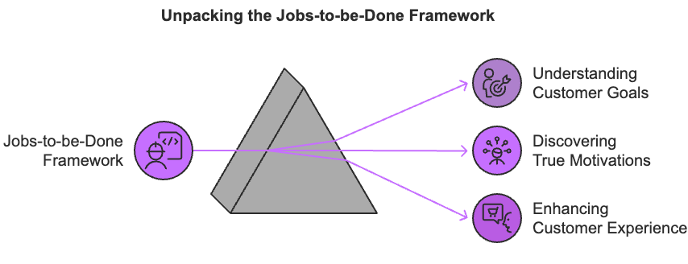
To spot gaps between what customers want and what's available, consider these key areas:
- New technologies create fresh possibilities.
- Changes in regulations leading to new requirements.
- Shifting social values affecting consumer demands.
- Economic conditions influence buying habits.
According to AMZScout, a product generating over 300 sales monthly on platforms like Amazon shows strong market potential. However, be careful not to fall into common traps:
Watch out for confirmation bias. Don't just look for data that supports your existing beliefs. Balance hard numbers with real customer insights, and don't ignore smaller markets that might be underserved. Most importantly, avoid getting stuck in endless research. When you spot a promising opportunity, take action.
Start by testing your idea on a small scale. Create a simple test product to validate your solution before making major investments. Make sure the market is large enough to be profitable, and understand why existing companies haven't addressed this need yet. Successful companies are increasingly using flexible approaches to product development, allowing them to respond quickly to market changes.
Finding untapped opportunities combines careful research with practical action. Keep watching for genuine customer problems you can solve, and you'll be well-positioned to create successful products and services that stand out in the market.


LEVERAGING TRENDS FOR FUTURE GROWTH
____
Success in business isn't just about understanding today's market—it's about anticipating tomorrow's opportunities. When you stay ahead of market trends, you can develop products and services that meet emerging customer needs before your competitors do.

Using Advanced Analytics to Spot Future Opportunities
Modern technology has transformed how you can analyze and predict market trends. AI-powered tools now process vast amounts of customer data, revealing hidden patterns in buying behaviors and preferences. These tools excel at analyzing unstructured feedback from reviews and social media posts to identify emerging trends before they become mainstream.
Predictive analytics has become particularly valuable for forward-looking businesses. Straive reports that this technology market will reach $28.1 billion by 2026, growing at nearly 22% annually. You can use predictive analytics to forecast demand patterns, identify seasonal trends, and optimize your inventory management. This data-driven approach helps you make smarter decisions about which products or services to develop next.
Social media platforms offer another window into emerging trends. Through social listening tools, you can track real-time conversations about consumer needs and preferences.
Tools like ProAI emphasize that this approach helps you spot trends in their early stages, giving you time to position your business ahead of demand. By combining social media insights with traditional market research methods like customer interviews and surveys, you'll build a more complete picture of where your market is heading.

Taking Action on Tomorrow's Trends
When you identify promising trends, careful validation becomes crucial. Start with small-scale tests to verify market acceptance before making major investments. Successful companies increasingly use flexible development approaches that let them adapt quickly to market feedback.
Consider exploring emerging markets, where untapped opportunities often hide. Technorely advises examining local consumer needs, cultural preferences, and economic conditions in these markets. Pay attention to infrastructure challenges and regulations that might affect your entry strategy.
While analyzing trends, watch for common pitfalls that can derail your efforts. Don't rely too heavily on historical data. Tomorrow's market won't necessarily follow yesterday's patterns.
Keep your focus global, as trends increasingly cross borders and industries. Most importantly, always validate your findings against real customer needs through direct feedback and pilot testing.
Modern trend research requires both technological tools and human insight. Using advanced analytics while maintaining close contact with your target market helps ensure your products stay relevant in a rapidly changing marketplace.
Don’t forget to regularly monitor trends and adjust your strategy based on new data and customer feedback. This balanced approach will help you spot and capitalize on opportunities that drive sustainable growth for your business.


UNDERSTANDING WHO YOU SERVE
____
The foundation of any successful business lies in deeply understanding your customers. While many entrepreneurs rush to develop products based on assumptions, those who invest in creating detailed customer profiles often achieve greater market success.
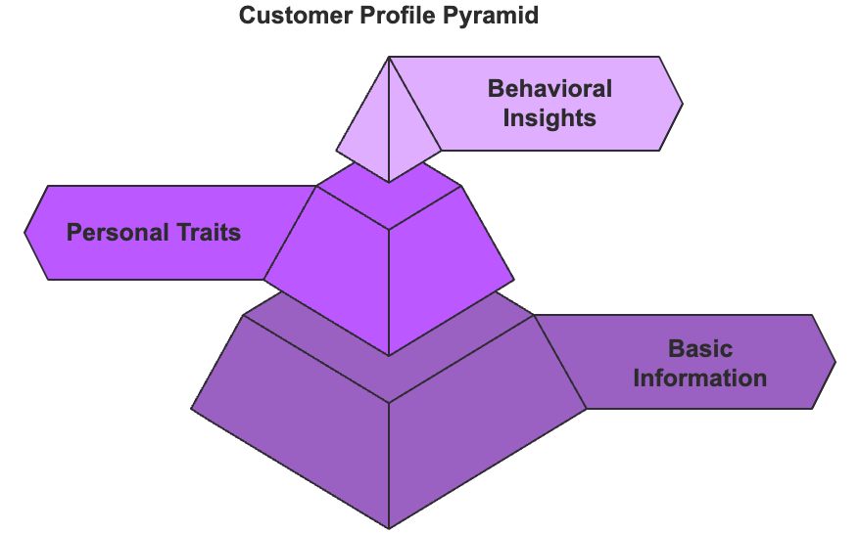
Let’s explore how developing extensive customer profiles can transform your product research strategy and drive better business outcomes.

Building Deep Customer Understanding
Understanding your customers goes far beyond basic information collection. It's about developing insights into their world that drive meaningful product decisions. According to research by Salesforce, businesses prioritizing deep customer understanding consistently outperform those relying on surface-level analysis.

Essential Profile Components
A complete customer profile combines several key elements:

Basic Customer Information
Understanding basic customer information is essential for conducting effective product research. Demographic factors such as age, gender, location, and income help segment your audience and tailor products to meet the specific needs and preferences of different groups. A customer’s professional background offers insights into career-related needs, while family status sheds light on purchasing behavior related to home life and children.
Education level is also important because it helps determine the types of products or content that resonate with customers based on their knowledge, and analyzing spending patterns reveals how much customers are willing to invest in particular products, guiding pricing strategies. Collectively, these factors enable businesses to create targeted, relevant offerings that align with customer expectations.

Personal Characteristics and Motivations
Personal characteristics and motivations are key to understanding the deeper drivers behind customer behavior. Values and core beliefs reveal what customers prioritize, helping businesses align their products with their customers' ethical standards and preferences. Lifestyle choices and preferences offer insights into how customers live and what products will best complement their daily routines or interests.
Knowing personal goals and challenges also enables businesses to design solutions that address specific obstacles customers face, making products more relevant and impactful. Additionally, social influences and aspirations provide context on how peer groups and societal trends affect customer choices, while understanding decision-making patterns helps predict how customers will evaluate and choose products, allowing businesses to optimize their offerings for maximum appeal.
Collectively, these elements help shape products that resonate on a deeper emotional level, fostering stronger customer loyalty.

Behavioral Insights
Behavioral insights are crucial in product research because they provide a deeper understanding of how customers interact with products and make purchasing decisions. By examining factors described below, businesses can predict customer behavior, identify trends, and optimize their offerings to align with consumer desires.
Purchasing habits highlight the frequency and type of products customers buy, allowing businesses to predict future behaviors and adjust marketing efforts accordingly. Brand relationships reveal the strength of customer loyalty and attachment to specific brands, guiding how to build stronger brand affinity.
Shopping preferences (online/offline) help businesses optimize their sales channels, whether focusing on e-commerce or brick-and-mortar experiences. Price sensitivity indicates how much customers are willing to pay for a product, helping businesses fine-tune their pricing strategies.
Lastly, technology adoption patterns show how quickly customers are adopting new technologies, assisting businesses in determining the timing of product launches or upgrades. Together, these insights help companies understand customer behavior and make data-driven decisions to meet customer needs.

Gathering Rich Customer Insights
To truly understand your customers and develop products that meet their needs, gathering rich, detailed insights is crucial. By engaging directly with customers and utilizing advanced analysis methods, you can uncover deeper layers of customer behavior, preferences, and pain points.
Direct interactions, such as interviews, focus groups, and surveys, offer valuable, real-time feedback, while advanced tools enable businesses to analyze patterns and predict future trends. Combining both approaches ensures a well-rounded understanding of your customer base, allowing for more informed, strategic product decisions.

Direct Customer Engagement
The most valuable insights often come from direct interaction with customers. One-on-one interviews allow businesses to hear personal stories and deeper motivations, offering rich, qualitative data.
Focused group discussions are another type of customer engagement. These bring together diverse perspectives, helping identify common challenges and pain points shared by customers. Structured surveys are also helpful, as they’re an effective way to validate assumptions and gather quantitative data that can support decision-making.
Additionally, online community engagement enables continuous, real-time feedback from a broad customer base, providing ongoing insights into customer preferences and needs. Together, these methods offer a thorough understanding of your audience, empowering businesses to create more tailored, customer-centric products.

Advanced Analysis Methods
Advanced analysis methods help businesses refine product research by leveraging technology to uncover valuable insights.
Pattern recognition in customer behavior allows companies to identify recurring actions and preferences, revealing what drives purchasing decisions. Predictive analysis of future needs enables businesses to anticipate customer demands, helping them stay ahead of market shifts.
Cross-channel interaction tracking provides a comprehensive view of how customers engage with products across multiple platforms, ensuring a seamless experience. Lastly, trend identification and analysis help businesses spot emerging developments and adapt their offerings to stay relevant in a dynamic market.
Together, these methods provide a data-driven approach to product development, improving the alignment of products with customer expectations.

Making Profiles Actionable
Actionable customer profiles are crucial for turning insights into tangible product improvements. By integrating customer understanding into product development, you can prioritize solutions that address specific pain points and align offerings with real customer needs.
Cross-team implementation ensures that customer insights are shared across the organization, fostering collaboration and maintaining a consistent focus on customer satisfaction. This approach helps create products that not only meet but exceed customer expectations, driving long-term success.

Product Development Integration
Transform customer insights into product decisions by:
- Identifying specific pain points that need solving will enable you to focus on solving the most pressing issues.
- Prioritizing features based on customer importance ensures that the most valuable elements are addressed first, maximizing product relevance.
- Aligning development roadmaps with customer needs guarantees that the product evolves in a way that resonates with the target audience.
- Testing solutions against profile expectations allows businesses to validate that the product truly meets customer expectations before launch, reducing the risk of misalignment and increasing the chance of success.

Cross-Team Implementation
Cross-team implementation ensures that customer insights are integrated into every part of the organization. Enabling all teams to access and use customer profiles ensures that decisions across departments are grounded in real, up-to-date information. And creating collaborative decision-making processes encourages diverse perspectives and allows teams to align on strategies that best meet customer needs.
Maintaining consistent customer focus across departments ensures that every function, from marketing to product development, stays aligned with customer expectations. Finally, regular profile updates and sharing sessions keep everyone informed of any changes in customer behavior, ensuring the organization remains responsive to evolving needs and continuously delivers relevant products and experiences.

Keeping Profiles Current
Updating profiles is crucial in product research because it ensures your understanding of customer needs remains accurate and relevant as markets evolve. Regular updates and continuous learning allow businesses to adapt their strategies based on fresh insights, ensuring that product development stays aligned with changing customer behavior and external trends.

Regular Update Process
Constantly updating customer profiles is essential for product research, as it ensures your understanding of customer needs remains up to date.
Scheduled review periods allow businesses to systematically assess and refresh customer profiles at regular intervals, ensuring the information remains relevant. Incorporating new data helps businesses stay informed of emerging trends and customer behaviors, providing a solid foundation for product decisions.
Additionally, validating assumptions ensures that previous insights still hold true and prevents outdated strategies from influencing development. Monitoring market changes allows businesses to adapt their products to shifts in industry conditions, ensuring offerings remain competitive and aligned with customer expectations.

Continuous Learning
Build a system for ongoing insight gathering by:
- Monitoring changing customer needs
- Tracking evolving market conditions
- Updating profiles with new learnings
- Sharing insights across teams

Practical Application Steps
At this point, you already know how essential customer profiles are for turning insights into actionable strategies. By following structured steps for development, implementation, and maintenance, businesses can ensure their customer profiles remain effective and continuously drive product improvements. Through this approach, you can foster a deeper understanding of your audience and create products that truly align with your market.
- Initial Profile Development
- Gather existing customer data
- Conduct primary research
- Analyze market patterns
- Create comprehensive profiles

- Implementation
- Train teams on profile usage
- Integrate insights into decisions
- Monitor effectiveness
- Gather feedback

- Maintenance
- Regular profile reviews
- Update based on new information
- Refine understanding
- Share updates organization-wide

Strategic Profile Usage
Effective use of customer profiles enables businesses to leverage insights as powerful tools for growth and innovation. By incorporating customer profiles into product development, marketing strategies, and customer experience improvements, companies can create offerings closely aligned with customer needs and expectations. This approach helps drive informed decisions across the organization, ultimately leading to stronger market positioning and sustainable business growth.
Turning customer profiles into strategic assets enables businesses to use insights to drive key decisions and long-term success. By using customer profiles to guide product innovation, you can develop offerings that directly address customer pain points and desires, ensuring relevance in the market. These profiles also inform marketing strategies and messages, helping you craft personalized and compelling communications that resonate with target audiences.
Shaping customer experience improvements based on profile data allows companies to enhance every touchpoint, fostering greater satisfaction and loyalty. Finally, integrating customer insights into business growth decisions enables organizations to allocate resources and prioritize initiatives that correspond to evolving customer needs, driving sustainable growth and competitive advantage.
Creating and maintaining detailed customer profiles is fundamental to effective product research and development. When you understand your customers deeply, you make better decisions about product features, marketing approaches, and growth strategies. Remember that customer profiling is an ongoing journey that requires regular attention and refinement to remain valuable.


EVALUATING MARKET COMPETITION
____
You can't create winning products without understanding who you're up against in the market. By analyzing your competitors thoroughly, you'll spot opportunities they've missed and position your offerings more effectively. Let's examine how to turn competitive research into actionable insights that drive product success.

Understanding Your Competition
Start by identifying who truly competes for your customers' attention and budget. Direct competitors offer similar products, but don't overlook indirect competitors who solve the same problems differently. Companies that conduct thorough competitive analysis consistently make better decisions about features and pricing that help them stand out in the market.
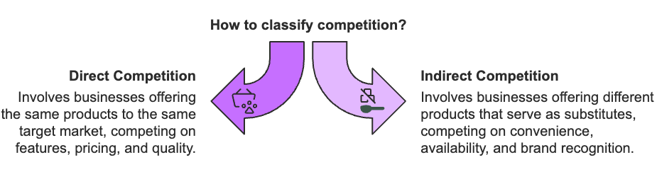
When analyzing competitors, look beyond surface-level features to understand their overall approach. Examine their target audience, brand positioning, and distribution channels.
Pay special attention to their pricing strategies and how they communicate value to customers. Dovetail suggests that understanding competitors' strengths and limitations helps you refine your product strategy to bring something meaningfully better to market.
Create a detailed feature comparison matrix to track how different solutions stack up. This helps you identify gaps in the market and opportunities for differentiation. Include categories like core features, pricing tiers, support options, and user experience elements. Use this matrix to prioritize which differentiating features will matter most to your target customers.
 | Product 1 | Product 2 | Product 3 | Product 4
Feature 1
Feature 2
Feature 3
Feature 4
Price
Customer Satisfaction
Primary Sales Channel
Positioning
Don't just rely on public information. Analyze customer feedback about your competitors. Study online reviews, social media conversations, and complaint patterns.
LinkedIn highlights how this research reveals where competitors excel or fall short in meeting customer needs. These insights often point to opportunities you can capitalize on with your product development.

Taking Action on Competitive Insights
Transform your competitive research into concrete actions that improve your product strategy. Use your findings to forecast market trends and ensure your products stay relevant as the market evolves. Focus on areas where you can meaningfully differentiate your offering.
Watch for signs that competitors are struggling to serve certain market segments. For example, if you notice that sustainable packaging companies focus mainly on large businesses, you might discover an opportunity to serve small businesses with eco-friendly solutions. These market gaps often indicate unmet customer needs you can address.
Set up a regular monitoring system to track competitive changes. Review competitor activities weekly, conduct monthly strategic assessments, and perform comprehensive market analysis annually. This helps you stay ahead of shifts in the competitive marketplace.
To stay competitive, it's essential to monitor key metrics such as market share changes, customer acquisition costs, feature adoption rates, and customer satisfaction scores. Tracking shifts in market share helps identify trends and potential threats, while analyzing customer acquisition costs allows you to evaluate competitors' efficiency and optimize your own approach.
By observing feature adoption rates, you can understand which innovations are resonating with the market, and measuring customer satisfaction scores provides insights into your competitors' strengths and weaknesses, helping you identify opportunities to offer superior experiences. Together, these metrics enable you to stay ahead of market trends and make informed decisions for your product strategy.
Develop a structured approach to gathering competitive intelligence through public financial reports, industry publications, customer feedback channels, and market research reports. Ensure insights flow to all relevant teams through regular strategy meetings and cross-functional collaboration.
Be mindful of common competitive analysis pitfalls. Don't focus solely on matching features. Consider the broader competitive environment, including market trends and industry developments.
Look beyond feature parity to understand the complete customer experience. Remember that competition is dynamic, requiring regular monitoring and strategy adjustments.
Make competitive analysis an ongoing process rather than a one-time effort. Regular monitoring and strategy refinement will help you develop products that truly stand out in your market.
Turning competitive insights into actionable strategies is essential for staying ahead in a dynamic market. If you continuously monitor competitors, identify market gaps, and focus on areas of differentiation, your business can create products that better meet customer needs.
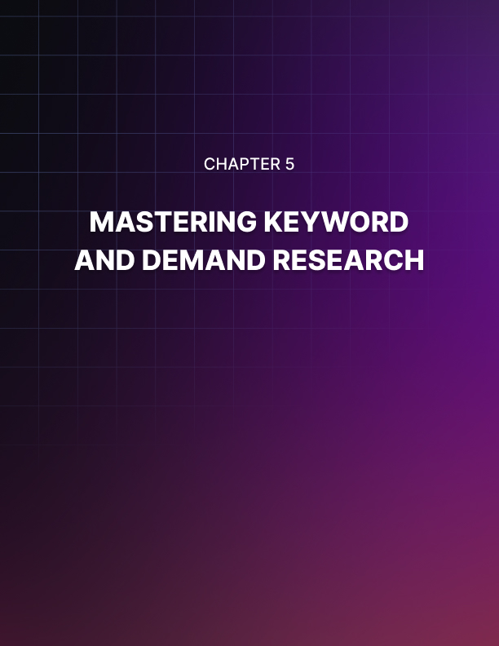

MASTERING KEYWORD AND DEMAND RESEARCH
____
Understanding what people search for online can reveal powerful insights into consumer demand and market opportunities. While traditional market research helps you understand your customers, keyword research shows you exactly what they're looking for right now. By mastering this research approach, you'll spot opportunities that others miss.

Understanding Search Patterns and Consumer Intent
When people search online, they tell you their needs, desires, and pain points.
Looking at search patterns helps you understand not just what products people want, but why they want them. You'll want to pay attention to both search volume (how many people are looking) and search intent (why they're looking).
High search volumes can signal strong demand, but numbers alone don't tell the whole story. Look for seasonal patterns that might affect your product's success throughout the year.
For example, beach accessories might show high searches in summer but drop significantly in winter. Tools like Google Trends can help you spot these patterns and plan accordingly.
Search intent falls into different categories that reveal where customers are in their buying journey. When someone searches for "how to choose running shoes," they're gathering information. But a search for "Nike Air Zoom size 10 best price" shows they're ready to buy. Focus on searches that show clear buying intent, as these often lead to faster sales.
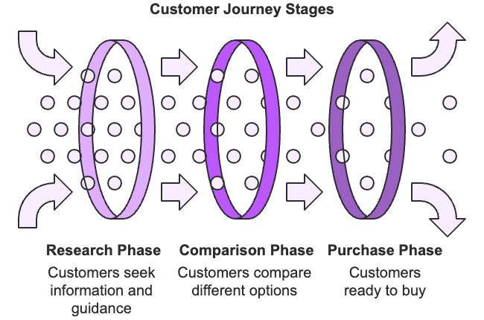
Long-tail keywords (specific phrases like "eco-friendly yoga mats for beginners") often signal stronger purchase intent than general terms like "yoga mats." While these specific phrases might have lower search volumes, they typically face less competition and convert better. According to Copy Machines, businesses focusing on long-tail keywords often find it easier to stand out in niche markets.

Using Keyword Research Tools Effectively
You don't need expensive tools to start your keyword research. Google's free tools provide valuable insights to get you started. Google Trends helps you track interest over time and spot seasonal patterns. And the Keyword Planner shows you search volumes and helps you find related terms people are searching for.
For deeper insights, paid tools can be worth the investment. Ahrefs and Helium 10 provide extensive data about keywords, competition levels, and market opportunities. AMZScout specializes in Amazon marketplace research, helping you estimate potential sales volumes.
Combining data from multiple tools gives you a more complete picture of market opportunities. When using these tools, look for keywords that show:
- Consistent or growing search interest
- Clear purchase intent
- Manageable competition levels
- Sufficient profit potential
A local bakery successfully used this approach by researching terms like "best cupcakes in [city]" and "custom birthday cakes near me." They discovered strong local demand with limited competition, leading to a 50% increase in customers within three months of optimizing their business around these keywords.
Avoid common research mistakes that can lead you astray. Don't focus solely on search volumes; high numbers might mean fierce competition.
Consider profit margins, market saturation, and customer acquisition costs. Pay attention to seasonal changes that could affect your business, and don't overlook opportunities in local markets where competition might be lower.
Start your keyword research by listing potential product ideas and gathering initial search data. Test your findings with small marketing campaigns before making major investments.
Additionally, keep monitoring market changes and updating your research regularly. Consumer interests evolve quickly in today's digital marketplace.
Remember to validate any opportunities you discover through keyword research with real customer feedback before launching products. By continuously refining your keyword strategy and staying agile in response to shifting trends, you can ensure that your business remains aligned with consumer needs and competitive dynamics.


TESTING AND VALIDATING YOUR IDEAS
____
You've found what looks like a promising market opportunity, and you're eager to start building your product. But launching without proper testing is like building a house without checking the foundation. Before investing significant time and money, you need to validate that customers actually want what you plan to create.

Starting with Simple Tests
Begin by writing down what you believe about your potential customers and product. For example, you might think "small business owners will pay $50 monthly for an automated bookkeeping solution" or "remote workers need a better way to collaborate on creative projects." These clear statements give you something concrete to test.
The easiest way to start testing is through conversations with potential customers. Talk to them about their current challenges and solutions, but focus on listening rather than pitching your idea.
According to Shno.co, these early conversations often reveal critical insights you wouldn't discover through surveys alone. Pay attention to patterns in what people say about their problems and needs.
Once you understand the problem better, you can test your solution. Create a simple website describing your product and measure interest through email signups or pre-order commitments. Airbnb used this approach before building their platform, helping them validate demand for their unique hospitality concept.
You can also build basic prototypes using tools like Figma for digital products or physical mockups for tangible goods. Keep these early versions focused on core features. You just need enough detail to get meaningful feedback.
Pre-sales campaigns offer another powerful way to validate market interest. Consider offering early-bird pricing or exclusive features through platforms like Kickstarter.
Setting clear minimum sales goals helps you gauge real market demand before major investments. Modern tools like UserTesting.com and PickFu can also help you gather quick feedback from potential customers.

Avoiding Common Testing Mistakes
When testing your ideas, watch out for confirmation bias, or the tendency to look for feedback that supports what you already believe. Successful validation requires embracing negative feedback as valuable input for improvement. Don't ignore comments that challenge your assumptions.
Keep your testing methods simple and focused. Complex validation processes often delay valuable feedback and increase costs unnecessarily. While numbers and metrics matter, don't overlook the value of detailed customer comments. These qualitative insights often reveal a deeper understanding of customer needs and preferences.
Research from CBS Insights shows that 42% of new SaaS products fail due to insufficient market demand. To avoid this fate, set clear success criteria before you start testing. Define specific goals like minimum pre-orders, target feedback scores, or user engagement metrics. Create a realistic timeline and budget for your validation process, allowing for multiple rounds of testing and adjustment.
Document everything as you test: customer feedback, testing results, and market insights. This information helps you make better decisions about moving forward or adjusting your concept, because the most successful products often evolve significantly during validation as entrepreneurs learn what customers truly want.
Testing isn't a one-off task—it's an ongoing process throughout your product's life. When results show promise, move forward decisively while continuing to gather feedback. If tests reveal problems, be ready to adjust your concept. By following this approach, you'll dramatically increase your chances of launching a product that truly meets customer needs.


INDUSTRY-SPECIFIC RESEARCH TECHNIQUES
____
Every industry beats to its own rhythm when it comes to product research. What works brilliantly for consumer tech might fall flat in healthcare, where safety standards and regulations dominate decision-making. You'll need to adapt your research approach to match the unique demands of your specific sector.

Navigating Different Industry Domains
Whichever fast-paced tech sector you’re in, you'll need to move quickly while maintaining quality.
Remote research platforms will help you gather user feedback efficiently, and rapid prototyping lets you test ideas before competitors catch up. Staying adaptable and embracing innovation will allow you to stay ahead of trends and effectively respond to shifting market demands.
Your focus should stay firmly on user experience. This is a crucial strategy if you’re a techpreneur, as tech products live or die by their usability. Keep a close eye on both established players and emerging startups, as the competitive environment can shift overnight.
Healthcare research demands a different approach entirely. Before diving in, you must understand the regulatory framework that will shape your product development.
Your research should also consider multiple user groups, from patients and healthcare providers to administrators and insurers. Each brings distinct needs and influences purchasing decisions. Clinical validation often requires formal studies or trials, so build these requirements into your timeline and budget from the start.
The food and beverage industry is a different arena, combining sensory experience with strict safety standards. You'll need to conduct thorough taste tests and texture analysis while ensuring compliance with food safety regulations.
Understanding eating habits and cultural preferences becomes crucial. Successful companies like Curion Insights combine detailed sensory testing with deep consumer insights to perfect their formulations.
Manufacturing and industrial products require yet another mindset. Here, technical specifications and compatibility with existing systems take center stage.
Your research timeline needs to account for longer sales cycles typical in B2B environments. Don't forget to investigate the entire supply chain, from materials availability to production capabilities and distribution networks.

Tailoring Your Research Methods
Each industry requires specific tools and approaches to uncover meaningful insights.
In healthcare, you might focus on patient outcomes and compliance rates, while tech companies track user engagement and retention metrics. Manufacturing prioritizes performance specifications and durability testing, and food companies measure taste scores and nutritional content.
Cross-functional collaboration becomes essential across all industries. Involve subject matter experts when designing your research, work closely with technical teams on feasibility studies, and leverage your sales team's direct customer insights. If you're in a regulated industry, ensure compliance officers review your research plans early.
Recognize the unique challenges each sector presents. In technology, you're racing against rapid market changes and short product lifecycles. Healthcare projects face strict regulations and complex stakeholder networks. Manufacturing deals with technical complexity and high investment requirements.
When you understand these challenges upfront, you can adapt your research approach accordingly. Tailoring your strategies to each sector's specific demands will help you streamline your processes and minimize potential risks.
Focus on metrics that matter in your sector. For consumer products, track brand awareness and purchase intent. In healthcare, prioritize patient outcomes and safety metrics. Technology companies should monitor user engagement and retention rates, while manufacturing focuses on performance specifications and reliability.
The key to successful industry-specific research lies in staying flexible while maintaining rigor. Keep up with changing regulations, embrace new research tools that fit your sector, and build processes that can scale with your business. Remember to validate your findings through the lens of your industry's unique requirements and standards.
Your research methods should evolve like your industry. Stay informed about sector trends, adopt relevant new tools, and maintain the flexibility to adjust your approach when needed. This combination of industry-specific expertise and adaptability will help you develop products that truly resonate with your market.


YOUR NEXT STEPS TO SUCCESS
____
Turning research insights into action separates successful products from those that never reach their potential. You've learned powerful strategies for understanding markets, customers, and competitors. Now it's time to put that knowledge to work through focused implementation.

Building Your Research Foundation
Start by establishing clear objectives for your product research efforts.
Your goals should specifically outline what you want to achieve and by when. For example, instead of saying "understand the market better," set a target like "identify three underserved customer segments within our market by the end of Q1." According to Survicate, businesses with clear research objectives are 72% more likely to develop successful products.
You'll need the right tools to support your research efforts. While advanced AI-powered platforms can provide valuable insights, don't feel pressured to invest in expensive technology right away.
Begin with essential tools that match your current needs and budget. Start with basic analytics software and customer feedback systems, then expand your toolkit as your research operations grow.
Create consistent rhythms for your research activities. Make it a daily habit to monitor competitor updates and track customer feedback. Schedule weekly sessions to analyze market trends and monthly meetings to review your research objectives. This structured approach helps ensure nothing falls through the cracks while keeping your team aligned on priorities.

Measuring Impact and Driving Growth
Tracking the right metrics helps you understand if your research efforts are paying off. Focus on both process metrics (like research completion rates and data quality) and outcome metrics (such as product-market fit scores and revenue impact).
And don't just collect numbers. Regularly review these indicators to identify areas for improvement and adjust your approach accordingly.
Building a research-driven culture requires more than just collecting data. Invest in your team's capabilities through training programs and knowledge-sharing sessions. Create opportunities for cross-functional collaboration so insights flow freely between departments. According to Hoick, successful research implementation depends heavily on strong stakeholder engagement, so keep decision-makers involved and informed throughout the process.
As you scale your research operations, prepare for common challenges. Create systems for managing data effectively while maintaining security and quality. Build flexible processes that can grow with your business. If you're planning to expand internationally, consider cultural differences and local market variations in your research approach.

Your 90-Day Action Plan
Transform these concepts into reality by following a structured implementation timeline:
- Days 1–30: Foundation Building
Start with an honest assessment of your current research capabilities. Choose essential tools that fit your budget and establish basic processes for collecting and analyzing data. Train your core team on research fundamentals and set up regular check-in meetings.
- Days 31–60: Implementation and Testing
Launch small pilot projects to test your research processes. Begin collecting data systematically and establish regular monitoring systems. Pay special attention to how insights flow between teams and adjust your communication channels as needed.
- Days 31–90: Optimization and Scaling
Review your initial results and refine your approach based on what's working. Scale successful methods while phasing out ineffective practices. Create plans for the next growth phase, including additional tool investments or team expansion.
Remember that building effective research practices is a lifelong commitment. Start small, measure your progress, and adjust your approach based on results. Focus on creating sustainable systems that can grow with your business. Most importantly, take action today—even small steps toward better research practices will help you develop products that truly resonate with your market.
The knowledge you've gained through this book provides a strong foundation for success. Your next step is to put these ideas into practice and start building products that make a real difference in your customers' lives.

