TABLE OF CONTENTS
____
INTRODUCTION 2
DEFINING YOUR PURPOSE 5
The Importance of Purpose in Writing 5
Crafting an Emotional Connection 6
Techniques for Setting Clear Intentions 7
Understanding Your Audience 9
Practical Application 10
TECHNIQUES FOR CAPTURING ATTENTION 12
First Impressions and the Curiosity Gap 12
Don't Bury the Lead & Craft Compelling Headlines 13
Storytelling: The Key to Engagement 14
Using Cliffhangers Effectively 16
MASTERING WORD RHYTHM FOR FLOW AND STYLE 19
The Power of Copywork 19
Building Your Swipe File 20
Balancing Sentence Variety 21
The Art of Transitions 22
The Power of Active Voice 22
THE PSYCHOLOGY OF READER ENGAGEMENT 26
The Power of Conversational Writing 26
Stripping Away Jargon and Fluff 27
Killing Your Darlings and Harnessing Story Power 28
The Psychology of Persuasion and Emotion 29
CREATING YOUR PATH TO MASTERY 33
The Foundation: Purpose-Driven Writing 33
Capturing Attention: The Art of the Hook 34
The Psychology of Connection: Writing with Empathy 35
Continuous Improvement: Your Journey to Writing Mastery 36
DISCLAIMER
____
The information provided in this ebook is intended solely for educational and informational purposes. The author does not accept any responsibility for the outcomes that may arise from the application of the material within. While efforts have been made to ensure the accuracy and relevance of the content, the author cannot be held accountable for any errors or omissions, or for any consequences resulting from the use or misuse of the information provided. The responsibility for any actions taken based on the information in this ebook lies solely with the reader.



INTRODUCTION
____
In a world overflowing with content, capturing and keeping attention has become one of the greatest challenges in communication. Standing out requires more than just well-chosen words; it demands writing that engages, resonates, and leaves a lasting impact.
This book is here to show you how to refine your writing into something truly memorable. It’s not just about crafting words—it’s about creating connections, sparking curiosity, and inspiring readers to take action. You’ll find practical techniques and insights to make your writing magnetic, from instantly grabbing attention to weaving narratives that hold interest to the very last word.
Through proven strategies and actionable exercises, you’ll learn how to simplify complex ideas, cut out unnecessary jargon, and build a style that feels clear, conversational, and powerful. This book will also introduce you to tools like “copywork” and “swipe files” to refine your unique voice, helping you write with confidence and purpose.
Alongside skill-building, you’ll explore advanced techniques that draw on psychology and proven principles in communication. Discover the art of balancing sentence structures for a natural flow, and understand how to structure your writing to create a rhythm that’s both engaging and enjoyable to read.
Standing out takes more than good words; it requires writing that resonates and leaves a lasting impact.

By the time you finish this book, you’ll have a toolkit of techniques for crafting words that influence, inspire, and drive results. It’s more than following guidelines—it’s about finding your voice, creating messages that resonate deeply, and writing in a way that feels authentic and compelling.
Ready to move beyond ordinary writing and create words that truly stick with readers? This book will show you how to make your words matter, spark ideas, inspire action, and leave a lasting impression. Here’s your chance to make every word count and stand out in a busy world.

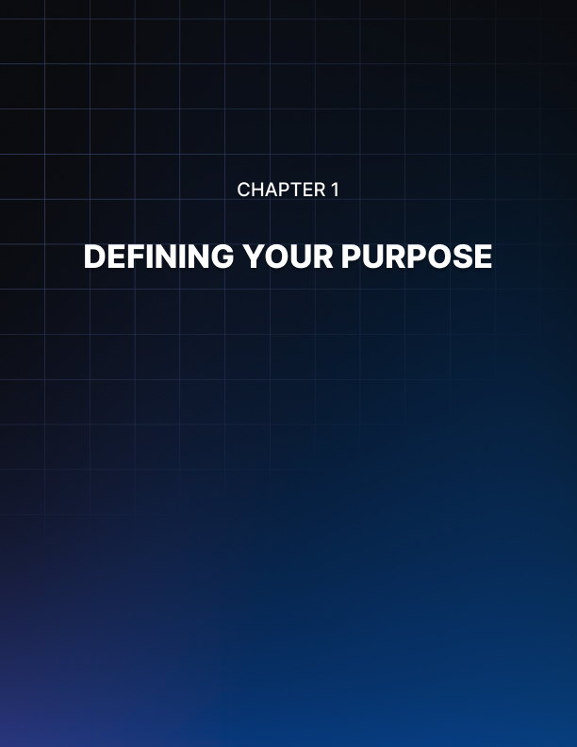

DEFINING YOUR PURPOSE
____
You’re about to learn the key to writing that truly connects. It all begins with a clear purpose. Think of your purpose as the foundation for your writing. Without it, you’re simply drifting, hoping to make an impact. But with a defined purpose, every word you write becomes an intentional step toward your goal.

The Importance of Purpose in Writing
Defining your purpose before you write serves several key functions: it provides focus and direction, helps you choose the right tone and style, guides your content selection, ensures consistency throughout your piece, and makes editing and revising more efficient. When you sit down to write, whether it's a blog post, a sales letter, or a company-wide memo, you're not just stringing words together. You're crafting a message that should inspire, inform, or incite action. But how can you achieve this if you're not clear on what you want to accomplish?
Let's dive into how you can effectively define your purpose and set the stage for impactful writing. At the heart of your writing purpose is your core message. This is the main idea you want your readers to walk away with. To identify your core message, ask yourself: What's the one thing I want my readers to remember? If I had to sum up my entire piece in one sentence, what would it be? What's the most important takeaway for my audience? For example, if you're writing a piece about time management for entrepreneurs, your core message might be: "Effective time management is the key to scaling your business without burning out."
Your purpose isn't just about what you want to say; it's about who you're saying it to. Understanding your audience is crucial for tailoring your message effectively. Consider who your ideal reader is, what their pain points and challenges are, what level of knowledge they already have on the topic, and what motivates them. Create a detailed persona of your target reader. This will help you craft a message that speaks directly to their needs and interests.

Crafting an Emotional Connection
Effective writing evokes emotion. What do you want your readers to feel after reading your piece? Do you want them to feel inspired to take action, confident in their abilities, curious to learn more, or relieved to have found a solution? Identifying the desired emotional response will guide your word choice, tone, and overall approach.
What do you want your readers to do after they finish reading? Your call-to-action (CTA) is a crucial part of your writing purpose. It might be to sign up for a newsletter, purchase a product, implement a new strategy, share the content with others, or change a behavior or habit. Be specific about the action you want readers to take. This will help you craft a more persuasive piece that guides readers towards that action.
Your writing should always support your broader business or personal objectives. Ask yourself: How does this piece of writing fit into my larger strategy? What long-term goal does it support? How will I measure its success? Ensuring alignment between your writing purpose and your overall goals will make your content more strategic and impactful.

Techniques for Setting Clear Intentions
Now that you understand the components of a well-defined purpose, let's look at some techniques for setting clear intentions that will guide your writing process. One powerful technique is the "5 Whys" Method. This technique, originally developed by Sakichi Toyoda for the Toyota Production System, can be adapted for writing. Start with your initial purpose statement and ask "why?" five times to dig deeper into your true intentions.
For example:
- Initial purpose
To write a blog post about social media marketing.
- Why?
To share tips on effective social media strategies.
- Why?
To help businesses improve their online presence.
- Why?
To increase their customer engagement and sales.
- Why?
To contribute to their business growth.
- Why?
To establish myself as an expert in digital marketing and attract more clients.
By the fifth "why," you've revealed a much more specific and meaningful purpose that will guide your writing more effectively.
Another useful technique is the Elevator Pitch. Imagine you have just 30 seconds to explain the purpose of your writing to someone. What would you say? This exercise forces you to distill your purpose down to its essence. Your elevator pitch should include who your audience is, what problem you're addressing, how your writing will help solve that problem, and what makes your approach unique.
The Reverse Outline technique involves creating an outline working backwards from your desired outcome. Start with your call-to-action and work your way back to your opening, considering what information the reader needs to take this action, what objections they might have and how you can address them, and what emotional journey you need to take them on. This technique ensures that every part of your writing serves your ultimate purpose.

Understanding Your Audience
An Empathy Map is a powerful tool for understanding your audience and aligning your purpose with their needs. Create a quadrant with the following sections:
Think and Feel (What are your readers' worries, aspirations, and thoughts?), See (What environmental factors might influence your readers?), Say and Do (How do your readers behave and communicate?), and Hear (What influences are your readers exposed to?).
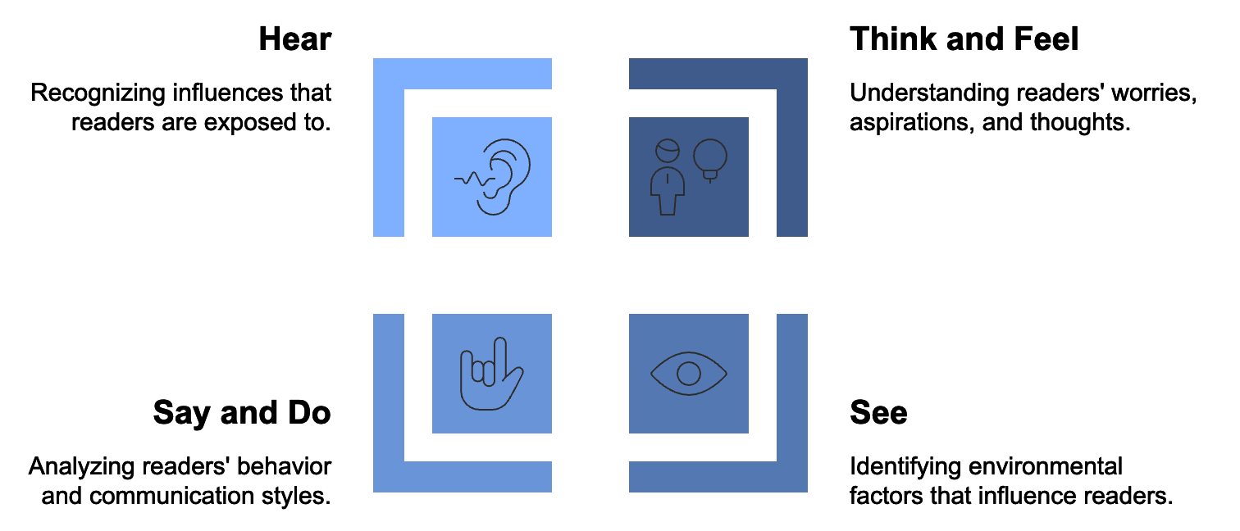
Fill in each quadrant based on your understanding of your audience. This exercise will help you craft a purpose that truly resonates with your readers.

Finally, you can adapt the SMART goal-setting framework to define your writing purpose. Your purpose should be Specific (clearly defined and unambiguous), Measurable (include criteria for measuring success), Achievable (realistic given your resources and constraints), Relevant (aligned with your broader goals and objectives), and Time-bound (include a deadline or timeframe). For example: "To write a 1500-word blog post on time management techniques for entrepreneurs, aiming to increase newsletter sign-ups by 20% within two weeks of publication."
By applying these techniques, you'll create a clear, focused purpose that will guide every aspect of your writing process. Remember, defining your purpose is not a one-time event. While you write and receive feedback, you may need to refine and adjust your purpose. Stay flexible and open to evolution, but always keep your core intentions in mind.

Practical Application
To help you put these concepts into practice, here's a worksheet you can use for your next writing project:
- Core Message
In one sentence, what's the main idea you want to convey?
- Target Audience
Describe your ideal reader in detail.
- Desired Emotional Response
How do you want your readers to feel?
- Call-to-Action
What specific action do you want readers to take?

- Alignment with Goals
How does this piece support your broader objectives?
- Success Metrics
How will you measure the impact of your writing?
Answer these questions before you start writing, and refer back to them throughout your writing process. It will serve as your compass, keeping you on track and focused on your ultimate purpose.
By prioritizing purpose definition, you're setting yourself up for writing success. You'll find that your words flow more easily, your message resonates more strongly, and your impact grows exponentially. So before you write your next piece, take the time to clearly define your purpose. Your readers - and your results - will thank you for it.
As you move forward in your writing journey, keep in mind that purpose is just the foundation. In the next chapter, we'll explore how to capture your readers' attention from the very first word, turning that well-defined purpose into irresistible content that keeps your audience hooked from start to finish.

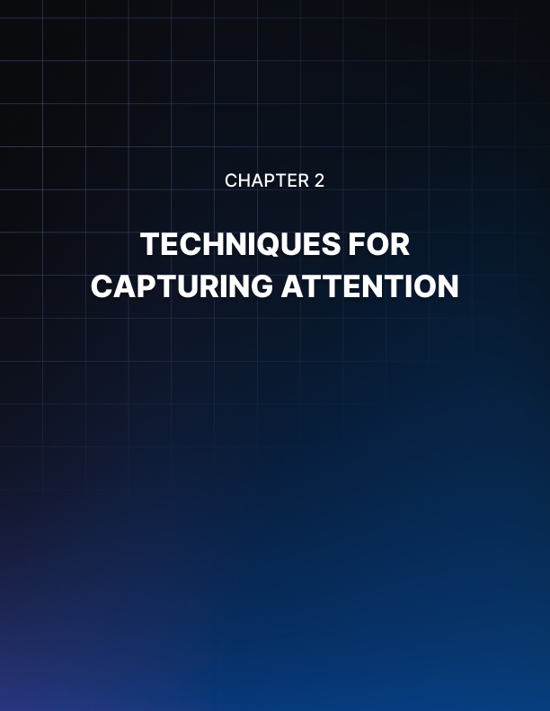

TECHNIQUES FOR CAPTURING ATTENTION
____
You’re at the starting point of your writing, armed with a clear purpose. Now it’s time to grab your readers’ attention right from the start. With only seconds to make an impression, this chapter will provide powerful strategies to create hooks that draw readers in and keep them engaged.

First Impressions and the Curiosity Gap
Think about the last time a piece of writing truly grabbed your attention from the first sentence. What made it so compelling? Chances are, it tapped into your curiosity, emotions, or a pressing need. That's the magic of a well-crafted hook. A hook is your opening gambit, the literary equivalent of a firm handshake and a winning smile. It's your chance to make readers sit up and take notice, to convince them that your words are worth their precious time and attention. But here's the catch: you can't just rely on a catchy first line. You need to maintain that intrigue throughout your piece, creating what we call a "curiosity gap" - a state of tension between what the reader knows and what they want to know.
The curiosity gap is a powerful psychological tool. It plays on the human need for closure and our innate desire to fill in missing information. When you create a curiosity gap, you're essentially opening a loop in the reader's mind that they feel compelled to close. You can create and maintain a curiosity gap by asking a thought-provoking question, making a bold statement, using the 'imagine' technique, teasing with partial information, or creating contrast. For example, you could start with a question that challenges assumptions or promises an interesting answer, like "What if everything you knew about productivity was wrong?" Or you could grab attention with a surprising claim: "The secret to business success isn't what you think - it's how well you fail." The key is to open these loops early in your writing and keep them open long enough to maintain interest, but not so long that readers become frustrated.

Don't Bury the Lead & Craft Compelling Headlines
In journalism, there's a cardinal rule: never bury the lead. This means putting your most newsworthy information right at the top. In business writing, this translates to presenting your most engaging points early on. You can apply this principle by starting with your conclusion, using the inverted pyramid structure, making promises early, and addressing pain points immediately. For instance, you could let readers know what they'll gain from reading your piece right from the start: "In the next five minutes, you'll learn three strategies that could transform your business."
Your headline is often the first (and sometimes only) thing readers see. It's your first chance to hook them, so it needs to pack a punch. Some tried-and-true formulas for attention-grabbing headlines include:
- The How-To
("How to Triple Your Productivity in 30 Days")
- The List
("7 Habits of Highly Successful Entrepreneurs")
- The Question
("Are You Making These Common Leadership Mistakes?")
- The Secret
("The Hidden Key to Business Growth You're Probably Overlooking")
- The Negative
("Stop Wasting Time on These 5 'Productivity' Hacks")
- The Challenge
("Can You Build a Six-Figure Business in Just One Year?")
Make sure your headline fulfills its promise. Prioritize accuracy over sensationalism.

Storytelling: The Key to Engagement
Humans are hardwired for stories. We've been telling them around campfires for millennia, and they remain one of the most powerful tools in a writer's toolkit. You can use storytelling elements to make your writing irresistible by creating a hero, establishing conflict, building suspense, providing resolution, and ending with a lesson. For example: "Meet Sarah. Like many entrepreneurs, she was working 80-hour weeks but barely keeping her head above water. Her business was stagnating, and her personal life was in shambles. Then she discovered a time management technique that changed everything. Within three months, she had doubled her revenue while cutting her work hours in half. Want to know her secret?" This short story creates a relatable hero, establishes a conflict, builds suspense, hints at a resolution, and promises a valuable lesson - all in just a few sentences.
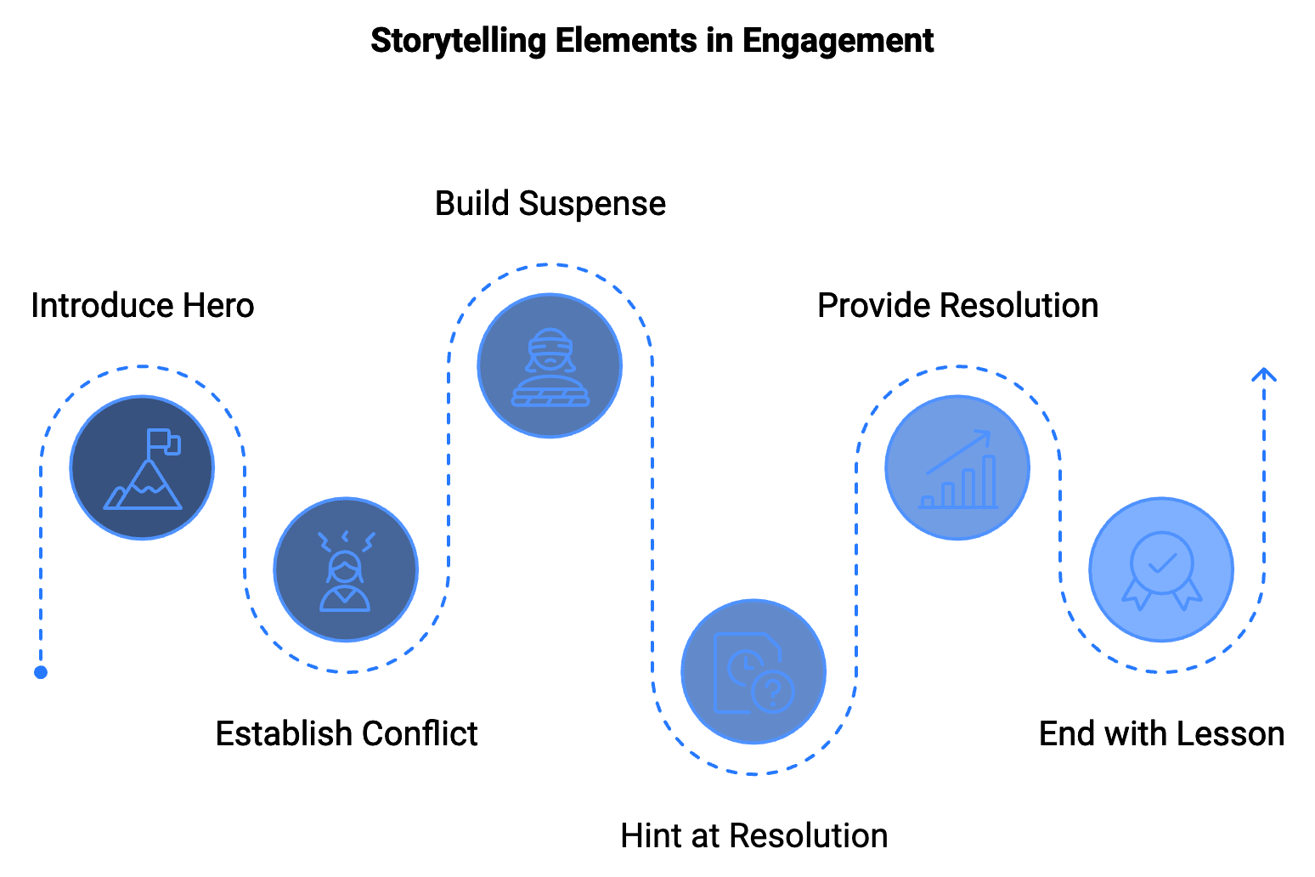

Creating a strong hook is crucial, but it's equally important to maintain that engagement throughout your piece. You can keep readers hooked by using subheadings, employing the "bucket brigade" technique, sprinkling in surprises, asking questions, using analogies and metaphors, and varying your sentence structure. For instance, you could use transitional phrases like "But wait, there's more," "Here's the interesting part," or "You might be wondering..." to keep readers moving through your text. Don't let your writing become predictable. Throw in unexpected facts, contrarian viewpoints, or novel ideas to keep readers on their toes. Engage readers by asking them questions throughout your piece. This keeps them actively involved in the content. Use analogies and metaphors to help explain complex ideas in relatable terms and add interest to your writing. Mix short, punchy sentences with longer, more detailed ones to create rhythm and maintain interest.

Using Cliffhangers Effectively
Television writers have long used cliffhangers to keep viewers coming back episode after episode. You can use the same technique in your writing to keep readers engaged from section to section or even from one piece of content to the next. Some ways to create effective cliffhangers include ending sections with a question ("But what if there was a way to achieve all this in half the time?"), hinting at what's coming next ("In the next section, I'll reveal the one tool that made all of this possible"), creating anticipation ("What happened next shocked even the most seasoned industry experts"), and using the 'Zeigarnik effect'. This psychological principle states that people remember uncompleted tasks better than completed ones. You can use this by intentionally leaving things unresolved at key points in your writing. Keep in mind, the goal is to build anticipation that draws the reader to continue.
To help you put these concepts into practice, here's an exercise you can try:
- Choose a topic you want to write about.
- Write five different headlines for your piece using the formulas provided earlier.
- Craft three different opening lines using the techniques discussed.
- Write a short story (3-5 sentences) related to your topic, incorporating the storytelling elements we covered.
- Create a cliffhanger ending for one of your sections.
By practicing these techniques, you'll develop a toolkit of strategies to capture and maintain your readers' attention.
Hook Type | Example | Purpose
Question | "Are you tired of working harder but not smarter?" | Engages reader directly, prompts self-reflection
Statistic | "Did you know that 90% of startups fail within the first year?" | Provides shocking or interesting fact to grab attention
Story | "When Sarah started her business, she had no idea she'd be working 80-hour weeks..." | Creates emotional connection, provides relatable context
Challenge | "Can you double your productivity in just one week?" | Sparks curiosity, encourages engagement
Controversial Statement | "Everything you've been told about time management is wrong." | Challenges assumptions, provokes thought

Perfecting the hook is a game-changer in business writing. It’s the difference between content that’s skimmed and forgotten, and writing that engages, persuades, and drives action. With these techniques at your disposal, you're well on your way to creating content that not only captures attention but holds it from start to finish. Moving forward, remember that grabbing attention is just the first step. In the next chapter, we’ll explore how to maintain that engagement by mastering the rhythm and flow of your words, ensuring your writing not only hooks readers but keeps them coming back for more.

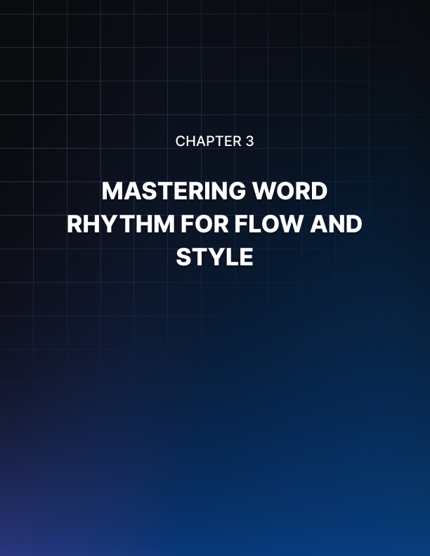

MASTERING WORD RHYTHM FOR FLOW AND STYLE
____
The melody of your words can be just as powerful as their meaning. You've hooked your readers, but now you need to keep them engaged. This chapter will teach you how to create a rhythm in your writing that's as captivating as a well-composed symphony.

The Power of Copywork
One of the most effective ways to improve your writing flow and style is through a technique called "copywork." This method, used by famous writers for centuries, involves hand-copying sentences and passages from admired texts. By doing so, you internalize the rhythm, structure, and tone of great writing.
To start with copywork, choose a piece of writing you admire. It could be a blog post, a book chapter, or even a sales letter. Spend 15-20 minutes each day hand-copying a portion of this text. When you write, focus on sentence structure, word choice, and punctuation. Observe how the author builds rhythm and flow. For example, let's look at a passage from Warren Buffett's annual letter to Berkshire Hathaway shareholders: "Charlie and I view the marketable common stocks that Berkshire owns as interests in businesses, not as ticker symbols to be bought or sold based on their 'chart' patterns, the 'target' prices of analysts or the opinions of media pundits. Instead, we simply believe that if the businesses of the investees are successful (as we believe most will be) our investments will be successful as well." Notice the clarity and conversational tone. Buffett uses simple language to explain complex concepts. He creates rhythm through sentence variation, mixing shorter phrases with longer explanations. By regularly practicing copywork, you'll start to absorb these techniques into your own writing. You might find yourself naturally varying sentence length, using more precise vocabulary, or structuring your paragraphs more effectively.

Building Your Swipe File
A swipe file is a collection of writing samples that inspire you or that you might want to reference in the future. It's like a personal library of great writing that you can turn to whenever you need inspiration. Your swipe file might include compelling opening lines, effective calls-to-action, well-crafted metaphors or analogies, powerful closing statements, clever turns of phrases, and effective transitions between ideas. To start building your swipe file, create a system that works for you. This could be a physical folder, a digital document, or a tool like Evernote or Pinterest. Whenever you come across a piece of writing that impresses you, add it to your swipe file. For instance, you might save this opening line from a Seth Godin blog post: "The shortcut is a lie." It's short, punchy, and immediately intriguing. Or you might save this call-to-action from a marketing email: "Don't let another day go by without the tools you need to succeed. Click here to get started now." Keep in mind, the purpose isn’t to copy these examples exactly. Use them as a starting point to inspire your own unique phrasing and style.

Balancing Sentence Variety
Imagine reading a piece where every sentence is the same length and structure. It would quickly become monotonous, right? That's why sentence variety is crucial for maintaining reader engagement. Mix short, punchy sentences with longer, more complex ones. Use this variety to create rhythm and emphasize key points. Here's an example: "Success isn't easy. It requires dedication, hard work, and often, a bit of luck. But with the right mindset and tools, you can stack the odds in your favor. Are you ready to take the first step?" Notice how the sentence lengths vary. The first sentence is short and direct. The second provides more detail. The third bridges ideas, and the final sentence is a short question that engages the reader directly.
To practice this, try the "sentence length" exercise:
- Write a paragraph about your topic.
- Count the words in each sentence.
- Aim for a mix of lengths: very short (1-5 words), short (6-10 words), medium (11-20 words), and long (20+ words).
- Rewrite your paragraph, varying sentence lengths to create better flow.

The Art of Transitions
Smooth transitions are like the crossfades in a well-produced album. They guide your reader from one idea to the next, creating a seamless reading experience. Here are some effective transition techniques: Use transitional phrases like "On the other hand," "Similarly," "In contrast," "As a result." Ask questions such as "But what does this mean for your business?" Use pronouns to refer back to previous ideas, like "This approach..." Create a bridge sentence that connects two ideas. For example: "Effective time management can dramatically increase your productivity. However, many entrepreneurs struggle to implement good time management practices. This is where the Pomodoro Technique comes in." The transition "However" signals a contrast, while "This is where" bridges to the new idea.

The Power of Active Voice
Active voice makes your writing more dynamic and engaging. It puts the subject of the sentence in the driver's seat, performing the action rather than receiving it. Compare these sentences: Passive: "The report was submitted by the team." Active: "The team submitted the report." The active version is more direct and energetic. It also tends to be more concise. To practice using active voice, try this exercise: Write a paragraph about a business process. Highlight all instances of "was," "were," "by," and "have been." Rewrite these sentences in active voice. Remember, there are times when passive voice is appropriate, especially when the actor is unknown or unimportant. But in general, aim for active voice to keep your writing lively and engaging.
The "Rule of Three" is a writing principle suggesting that ideas presented in threes are more memorable and satisfying to readers. This creates a pleasing rhythm in your writing. For example: "This product will save you time, increase your productivity, and boost your profits." You can use the Rule of Three in various ways: in a list of items or ideas, in repetition of a word or phrase, or in the structure of your entire piece (introduction, body, conclusion). To practice, try writing a product description or service offering using the Rule of Three. See how it adds rhythm and emphasis to your writing.
Metaphors and analogies can breathe life into your writing, making complex ideas more understandable and memorable. They create a mental image that resonates with your readers. For instance, instead of saying "Our software simplifies project management," you could say "Our software is like a GPS for your projects, guiding you efficiently from start to finish." To develop your metaphor skills, choose a concept you want to explain, list its key characteristics, brainstorm everyday objects or experiences that share these characteristics, and craft a metaphor linking your concept to one of these familiar ideas.
One of the best ways to check the flow and rhythm of your writing is to read it aloud. This technique helps you catch awkward phrasing, run-on sentences, and areas where the rhythm falters. Here's how to do it: Print out your writing or display it on a screen. Read it aloud at a normal pace. Mark any spots where you stumble, run out of breath, or feel the rhythm is off. Revise these sections, then read aloud again. Pay attention to how your writing sounds. Does it flow smoothly? Are there any jarring transitions? Does the rhythm match the tone and purpose of your piece?
In the quest for rhythm and flow, don't forget the power of white space. Short paragraphs and occasional one-sentence paragraphs can create visual rhythm on the page and give readers' eyes a break. Like this. Use white space strategically to emphasize key points, create pauses for reflection, or signal a shift in topic.
Improving your writing flow and style isn't something that happens overnight. It requires consistent practice and reflection. Here are some exercises to help you on your journey:
- Daily writing: Spend 15-30 minutes each day writing about anything. Focus on creating flow and rhythm.
- Imitation exercise: Choose a piece of writing you admire. Try to write a paragraph in the same style, paying attention to sentence structure and rhythm.
- Rewrite challenge: Take a piece of your own writing from a few months ago. Rewrite it, focusing on improving flow and style.
- Read widely: Expose yourself to different writing styles by reading a variety of genres and authors.
The goal is progress, not perfection. With each piece you write, you’re honing your skills and shaping your unique voice.
With continued practice, you’ll find that creating engaging, rhythmic writing becomes more natural. Your words will flow more smoothly, your ideas will connect more seamlessly, and your readers will find themselves effortlessly gliding through your content. In the next chapter, we'll explore how to use psychological principles to create an even deeper connection with your readers, ensuring that your well-crafted words not only flow beautifully but also resonate powerfully with your audience.
Technique | Purpose | Example
Copywork | Learn from masters | Hand-copy passages from admired texts
Swipe File | Collect inspiration | Save compelling opening lines, CTAs, etc.
Sentence Variety | Create rhythm | Mix short and long sentences
Active Voice | Energize writing | "The team submitted the report"
Rule of Three | Enhance memorability | "Save time, increase productivity, boost profits"
Metaphors | Simplify complex ideas | "Software is like a GPS for your projects"
Read Aloud | Check flow and rhythm | Read your writing out loud to catch issues
White Space | Create visual rhythm | Use short paragraphs and line breaks

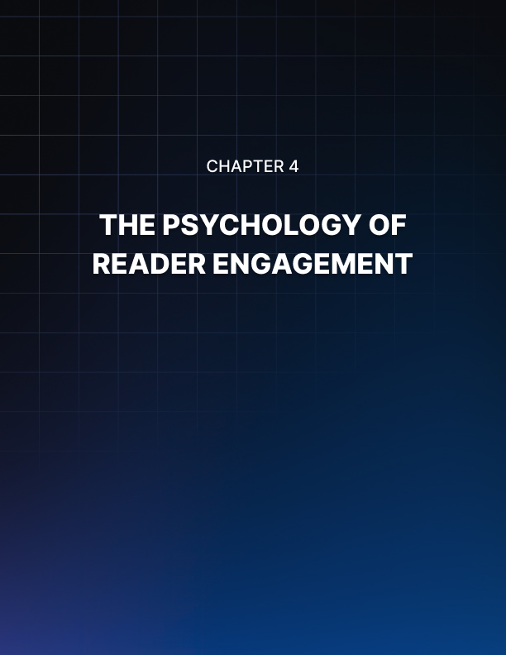

THE PSYCHOLOGY OF READER ENGAGEMENT
____

The Power of Conversational Writing
When you write like you talk, you create an instant connection with your reader. It's as if you're having a one-on-one conversation, breaking down the barriers between writer and reader. This approach, often called "conversational writing," is a powerful tool in your arsenal. To write conversationally, imagine you're explaining your topic to a friend over coffee. Use contractions, ask questions, and don't shy away from personal pronouns. For example, instead of writing "It is advisable to implement this strategy," try "You should give this strategy a try." The second version feels more personal and engaging. Some key techniques to make your writing more conversational include using "you" and "I" to create a direct dialogue with your reader, asking questions to engage your reader's mind, using contractions to make your writing feel less formal and more natural, employing short sentences and paragraphs to mimic natural speech patterns, and including anecdotes to make your writing relatable and memorable. Conversational doesn’t mean unprofessional. Aim for a balance between approachability and authority, like being the friendly expert at a networking event rather than a lecturer at a formal symposium.

Stripping Away Jargon and Fluff
Nothing kills engagement faster than dense, jargon-filled prose. Your goal is to communicate clearly, not to impress with big words or industry-specific terms. This doesn't mean dumbing down your content; it means making it accessible to a wider audience. Start by identifying jargon in your writing. These are terms that might be common in your industry but unfamiliar to your general audience. For each piece of jargon, ask yourself: Is there a simpler way to express this concept? If you must use a technical term, provide a clear, concise explanation. Next, hunt for "fluff" - unnecessary words or phrases that don't add value. Common culprits include redundant phrases (e.g., "repeat again," "plan ahead"), overuse of adverbs (e.g., "very," "really," "extremely"), and filler words (e.g., "basically," "actually," "in order to"). Here's an example of how to strip away jargon and fluff:
Before: "In order to optimize your digital footprint, it's imperative to leverage a multi-channel approach to content dissemination."
After: "To boost your online presence, share your content across different platforms."
The revised version is clearer, more concise, and more likely to engage your reader.

Killing Your Darlings and Harnessing Story Power
William Faulkner famously advised writers to "kill your darlings" - to eliminate any element of your writing that doesn't serve the overall purpose, no matter how much you love it. This advice is crucial for creating engaging, focused content. To apply this principle, start by identifying your main message or goal for the piece. Then, review each paragraph, sentence, and word, asking yourself: Does this element support the main message? If not, cut it. Be especially wary of tangents, no matter how interesting. Every word should earn its place in your writing. If it doesn’t support your main goal, it’s likely distracting the reader and weakening your message.
Humans are hardwired for stories. We've been sharing them around campfires for millennia, and they remain one of the most effective ways to engage an audience and make information memorable. To incorporate storytelling into your business writing, use anecdotes to illustrate points, frame data and statistics within a narrative, create case studies that follow a story arc (challenge, solution, result), and use metaphors to explain complex concepts. For example, instead of simply stating "Our software increased productivity by 25%," you could tell the story of a specific customer: "Sarah, a small business owner, was working 80-hour weeks and still falling behind. After implementing our software, she cut her work week to 50 hours and saw her revenue increase by 30%. Here's how she did it..."

The Psychology of Persuasion and Emotion
Understanding the principles of persuasion can dramatically increase the impact of your writing. Robert Cialdini's six principles of influence are particularly relevant: Reciprocity, Consistency, Social Proof, Liking, Authority, and Scarcity. People tend to return favors, so offer value in your writing, and readers will be more likely to take the action you suggest. They also like to be consistent with their past actions, so remind readers of their values or past commitments that align with your message. People look to others for guidance on how to behave, so use testimonials, case studies, and statistics to show that others have benefited from your ideas or products. Build rapport through your writing by showing your personality and finding common ground with your readers, as people are more likely to be influenced by those they like. Establish your credentials and expertise early in your writing to leverage the principle of authority. Finally, highlight the unique benefits of your offering or create a sense of urgency to tap into the scarcity principle. Incorporate these principles into your writing to make it more persuasive and engaging.
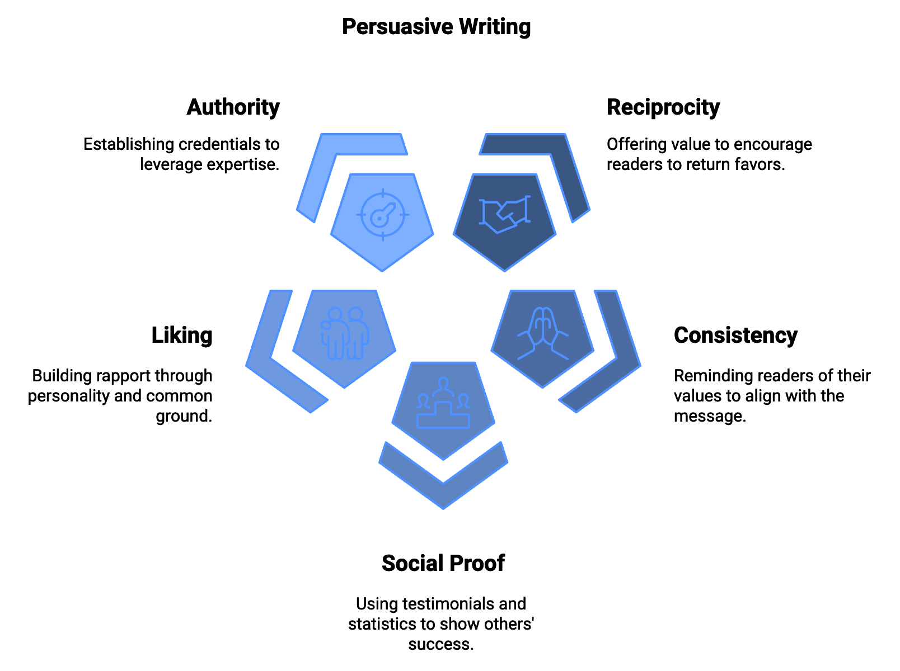
While facts and logic are important, emotion is what truly drives human decision-making and behavior. To engage your readers on an emotional level, use vivid language that appeals to the senses, share personal experiences that your readers can relate to, highlight the emotional benefits of your ideas or products, not just the practical ones, and use power words that evoke emotion (e.g., "transform," "breakthrough," "revolutionary"). For example, instead of writing "Our course will teach you marketing skills," try "Imagine the confidence you'll feel as you watch your business grow, knowing you have the marketing skills to succeed in any economy."

The way you structure your writing can significantly impact its psychological effect on the reader. A well-structured piece guides the reader's attention and maintains their engagement. Consider these structural elements: use headings and subheadings to break up text and guide the reader, vary paragraph length to create rhythm and emphasis, use bullet points or numbered lists for easy scanning, and include "pattern interrupts" - unexpected elements like quotes, images, or callout boxes - to maintain interest. Pacing is equally important. Mix longer, more detailed sections with shorter, punchier ones. This variety keeps the reader engaged and allows for both in-depth exploration and quick takeaways.
Principle | Description | Example
Reciprocity | People tend to return favors | Offer valuable content for free
Consistency | People like to be consistent with past actions | Remind readers of their values
Social Proof | People look to others for guidance | Use testimonials and case studies
Liking | People are influenced by those they like | Show personality in your writing
Authority | People respect authority | Establish your credentials early
Scarcity | People want what's rare | Create a sense of urgency

The end of your piece is just as important as the beginning. It's your last chance to make an impression and motivate action. Psychology tells us that people tend to remember beginnings and endings more than middles (the serial position effect), and that the last thing we experience colors our perception of the entire experience (the recency effect). To create a powerful ending, recap your main points, but don't simply repeat them. Synthesize them into a cohesive takeaway. Circle back to your opening to create a sense of closure. End with a strong call-to-action that ties into the reader's emotions and motivations. Consider ending with a provocative question or statement that lingers in the reader's mind.
By understanding and applying these psychological principles, you can create writing that doesn't just inform your readers, but truly engages them, resonates with them, and motivates them to take action. Effective writing isn’t just about what you say—it’s about how you make your readers think, feel, and act.

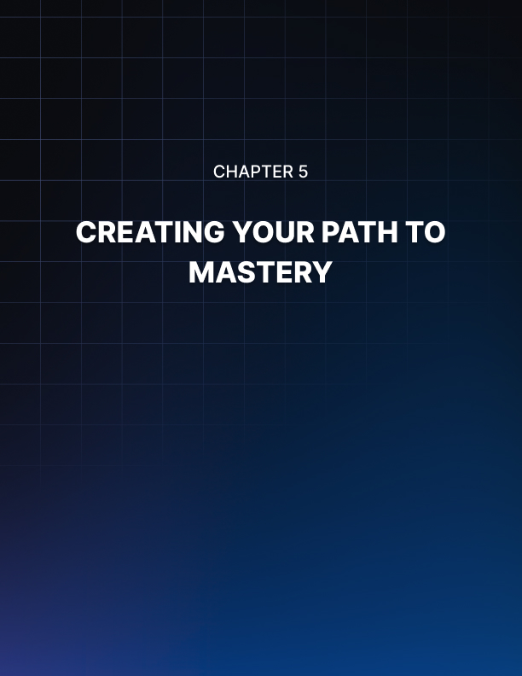

CREATING YOUR PATH TO MASTERY
____
You've navigated the world of effective writing, exploring the key elements that turn ordinary text into compelling content. Now, it's time to reflect on what you've learned and chart your course toward writing mastery. This final chapter will recap the essential insights and methods we've covered, emphasizing their importance in your writing toolkit. More importantly, it will guide you on how to integrate these techniques into your unique writing style, helping you develop a voice that's authentically yours while being powerfully effective.

The Foundation: Purpose-Driven Writing
Every piece of writing begins with a clear purpose, serving as your compass to guide each word you choose and every technique you apply. Without a well-defined purpose, your writing risks becoming unfocused and ineffective. Take a moment to reflect on how you've been defining your writing purpose. Have you been clear about your core message, your target audience, and the action you want readers to take? If not, it's time to make this a non-negotiable first step in your writing process.
Consider creating a purpose statement template for yourself. Before you start writing, fill in the blanks: "I am writing this [type of content] for [specific audience] to [desired outcome]. After reading this, they should feel [emotion] and be motivated to [action]." This simple exercise forces you to clarify your intentions and sets the stage for more focused, impactful writing. Your purpose isn’t just about what you want to say—it’s about what you want your readers to think, feel, and do after experiencing your content.

Capturing Attention: The Art of the Hook
In an information-saturated world, capturing and maintaining attention is more crucial than ever. You've learned about the power of strong headlines, compelling opening lines, and creating curiosity gaps. But have you been consistently applying these techniques in your writing? Challenge yourself to write at least five different headlines for each piece of content you create. This exercise not only helps you find the most compelling angle for your topic but also trains your brain to think in terms of hooks and attention-grabbers. Keep a swipe file of headlines that catch your eye in your daily reading. Analyze why they work and how you can adapt similar techniques in your own writing.
Remember the importance of maintaining engagement throughout your piece. The "bucket brigade" technique, where you use transitional phrases to keep readers moving through your text, is a powerful tool. Try incorporating phrases like "But here's the interesting part..." or "Now, you might be wondering..." into your writing. These act as mini-hooks, reigniting curiosity and pushing readers to continue.

The Rhythm of Words: Developing Your Unique Voice
Mastering the rhythm and flow of your writing is what will set you apart as a skilled communicator. The techniques of copywork and maintaining a swipe file are not just exercises—they're ongoing practices that will continually refine your writing style. Make it a habit to spend at least 15 minutes a day on copywork, hand-copying passages from writers you admire. Pay attention to their sentence structure, word choice, and overall flow. Through practice, you'll begin to develop your own unique voice. This voice is the culmination of your experiences, personality, and writing skills. It’s what makes your writing distinctively yours. To nurture this voice, try the following exercise: Write a short paragraph about a topic you're passionate about. Now, rewrite that same paragraph imagining you're having a conversation with a friend. Compare the two versions. Which one sounds more authentic? Which one is more engaging? Often, the conversational version will feel more natural and compelling. This is your authentic voice shining through. Developing your voice is an ongoing journey. It evolves as you grow both as a writer and as a person. Embrace this growth, and don’t hesitate to experiment with different styles and tones.

The Psychology of Connection: Writing with Empathy
At its core, effective writing is about making a connection with your reader. The psychological principles we've discussed—from the power of storytelling to the importance of emotional appeals—all serve to strengthen this connection. As you write, constantly ask yourself: How will my reader feel about this? What questions might they have at this point? What objections might they raise? Empathy is your most powerful tool in creating this connection. Try this exercise to enhance your empathetic writing: Choose a topic you want to write about. Before you start writing, create three distinct reader personas. For each persona, describe their background, their current challenges, and their aspirations related to your topic. Now, write a short piece addressing each of these personas. Notice how your language, examples, and even your main points might shift depending on who you're writing for. This exercise not only improves your ability to write with empathy but also highlights the importance of understanding your audience. The more you can put yourself in your readers' shoes, the more effectively you can address their needs and concerns.

Continuous Improvement: Your Journey to Writing Mastery
Applying the techniques and principles we’ve discussed, keep in mind that becoming a master writer is a continuous journey, not a destination. Every piece you write is an opportunity to hone your skills. Here are some strategies to ensure you're continuously improving:
- Set Writing Goals
Establish both short-term and long-term writing goals. These could be quantitative (like writing 500 words a day) or qualitative (like mastering a new writing technique each month).
- Seek Feedback
Don't write in a vacuum. Share your writing with trusted colleagues, join a writing group, or consider working with a writing coach. Constructive feedback is invaluable for growth.
- Read Widely
The best writers are often voracious readers. Read outside your comfort zone. Analyze what makes different types of writing effective.
When integrating these techniques into your writing, consider developing a personal workflow. This could look something like this: Purpose Definition, Research and Outline, First Draft, Rest, Revision, Feedback, Final Polish, and Publish. This workflow should remain flexible. Adapt it to fit your personal style and the unique requirements of each writing project.
Writing Stage | Key Actions
Purpose Definition | Define audience, message, desired outcome
Research and Outline | Gather information, create rough structure
First Draft | Focus on getting ideas down
Rest | Let draft sit for a day if possible
Revision | Systematic review and improvement
Feedback | Share with trusted reader for input
Final Polish | Make adjustments based on feedback
Publish | Share work with the world

As we conclude this book, it's important to recognize that you're not just learning techniques—you're embarking on a journey of continuous growth and improvement. Writing is both an art and a craft. It requires creativity and technical skill, intuition and learned techniques. The principles and methods we've discussed are your toolkit, but how you use these tools is up to you. Face the challenges in your writing journey with determination. Each difficult sentence, each complex idea to explain, and each piece of critical feedback is an opportunity to grow. Celebrate your successes, no matter how small. Did you write a particularly compelling headline? Did you explain a complex idea with clarity? Did a reader tell you your article helped them? These are all victories worth acknowledging.
Keep in mind that writing is not just about communication; it’s about creating a connection. Through your words, you have the power to inform, persuade, inspire, and move people. That's an incredible responsibility and an amazing opportunity. Use it wisely and use it well. As you move forward, keep pushing yourself to improve. Set ambitious goals, but be patient with yourself as you work towards them. Writing mastery is not achieved overnight but through consistent effort and practice. Every word you write is a step on this journey. Finally, never lose sight of the joy of writing. Amidst deadlines, word counts, and SEO considerations, remember why you started writing in the first place. Whether it's to share your ideas, to help others, to express yourself, or simply for the love of crafting with words, let that passion fuel your continued growth. You have all the tools you need to become a masterful writer. Now, it's time to put them into practice. Your unique voice, your important ideas, and your powerful words are needed in the world. So go forth, write boldly, and make your mark. The page is waiting for you.

