Disclaimer

This work may not be copied, sold, used as content in any manner or your name put on it until you buy sufficient rights to sell it or distribute it as your own from us and the authorized reseller/distributor.

Every effort has been made to be accurate in this publication. The publisher does not assume any responsibility for errors, omissions or contrary interpretation. We do our best to provide the best information on the subject, but just reading it does not guarantee success. You will need to apply every step of the process in order to get the results you are looking for.

This publication is not intended for use as a source of any legal, medical or accounting advice. The information contained in this guide may be subject to laws in the United States and other jurisdictions. We suggest carefully reading the necessary terms of the services/products used before applying it to any activity which is, or may be, regulated. We do not assume any responsibility for what you choose to do with this information. Use your own judgment.

Any perceived slight of specific people or organizations, and any resemblance to characters living, dead or otherwise, real or fictitious, is purely unintentional.

Some examples of past results are used in this publication; they are intended to be for example purposes only and do not guarantee you will get the same results. Your results may differ from ours. Your results from the use of this information will depend on you, your skills and effort, and other different unpredictable factors.

It is important for you to clearly understand that all marketing activities carry the possibility of loss of investment for testing purposes. Use this information wisely and at your own risk.
Table of Contents

Introduction 5
Chapter 1: What Is YouTube Marketing All About? 7
What is YouTube? 7
How Does It Work? 8
Why Should You Consider YouTube For Business? 8
What’s The Future For YouTube Business? 9
Chapter 2: Researching And Picking A Profitable Niche 11
Step 1 – Researching And Picking A Niche On Top Online Marketplaces 11
Step 2 – Researching Related Search Terms 12
Chapter 3: Creating And Optimizing A Business YouTube Channel 15
Creating Your Channel 15
Customizing And Optimizing Your Channel 15
Chapter 4: Setting Up A Sales Oriented YouTube Video 18
Getting Started 18
Customizing The Video 18
Chapter 5: Embedding Your YouTube Sales Video On A Blog Post 22
Getting Your Video Embed Code 22
Creating A Blog Post To Insert Your Video Onto Your Site 22
Embedding Your Video 23
Publishing Your Post 24
Chapter 6: Cross-Posting Your Sales Video To Your Business’ Social Channels 26
Start By Shortening Your Shareable Link 26
Cross-Posting Your Video On Facebook 26
Cross-Posting Your Video On Twitter 27
Chapter 7: Starting A Live Stream To Promote A Product Launch URL 30
Going Live On YouTube 30
Setting Up The Stream 30
Starting Or Scheduling The Stream 31
Chapter 8: How To Send Your Product Video To The First Page Of Search Results 33
Step 1 - Upload Your Video 33
Step 2- Optimize For The Top Ranking And Publish Your Video 33
Step 3 - Verify Your Ranking 35
Chapter 9: Promoting Your Sales Video With A Custom YouTube Ad Campaign 37
Getting Started 37
Creating The Campaign 37
Setting Up The Video Ad And Launching The Campaign 39
Chapter 10: Creating A Product Consideration Video Ad For YouTube 41
Creating And Customizing The Campaign 41
Creating The Product Consideration Ad And Launching The Campaign 42
Chapter 11: Creating A Customer Retargeting Campaign On YouTube 44
Getting Started 44
Creating The Retargeting List And Launching The Campaign 44
Chapter 12: Outlining Your Perfect YouTube Sales Funnel For 2024 47
Step 1 – Identify Goals And Set Stages 47
Step 2 – Make A Content Audit 48
Step 3 – Plan Your Content Mix For Each Stage Of The Funnel 48
Chapter 13: Enabling Monetization On YouTube Easily In 2024 51
How Does Monetization Work? 51
Things To Know Before Enabling Monetization 51
Enabling Monetization 52
Chapter 14: Top YouTube Marketing Tips To Increase Sales in 2024 55
Create Short Videos 55
Brand Your Channel 56
Be Consistent 56
Use Annotations As Calls To Action And Links 57
Chapter 15: The More Profitable Types Of YouTube Videos In 2024 59
Educational Videos 59
Explainer Videos 59
Product Videos 60
Tutorials And Demos 60
Testimonials 61
Chapter 16: Alternative Monetization Strategies For Businesses On YouTube 63
Patreon 63
Dailymotion 63
Brid TV 64
Mixer 64
Facebook and Facebook for Creators 64
Chapter 17: YouTube Business Do’s And Don’ts 67
Do’s 67
Don'ts 68
Chapter 18: YouTube Business Tools And Services To Consider 71
Chapter 19: YouTube Business Frequently Asked Questions 75



Introduction

Welcome to our YouTube Business Training, designed to take you by the hand and walk you through the process of getting the most out of YouTube on behalf of your business.

I’m very excited to have you here, and I know that this will be very helpful for you.
This exclusive training will show you step-by-step, topic by topic, and tool by tool, what you need to know to dominate YouTube, in the easiest way possible, using the most effective tools and in the shortest time ever.

This training consists of 19 training chapters, ready to show you the latest YouTube Business strategies.

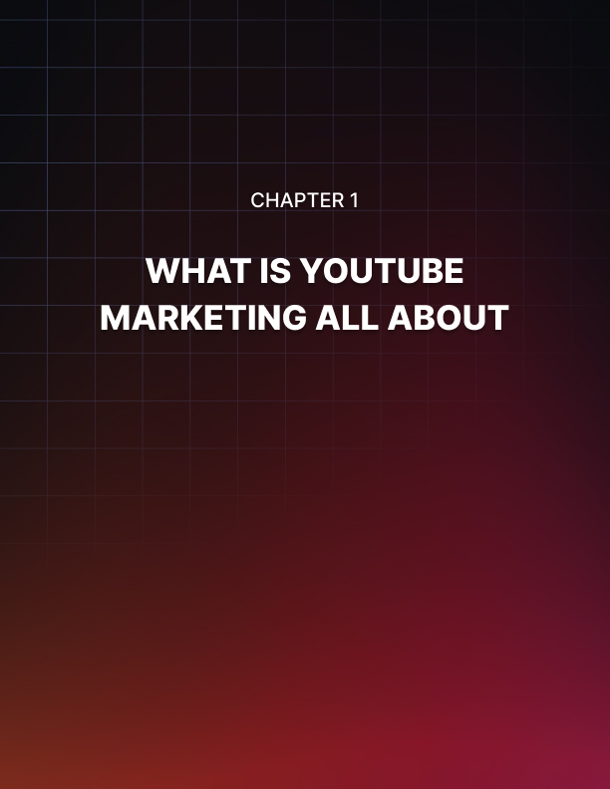

Chapter 1: What Is YouTube Marketing All About?

We’d like to congratulate you on your decision to take up this course, and to thank you for choosing us as your guide.

This is an immense opportunity for you to learn the ultimate strategies that’ll help you scale your online marketing efforts and grow your business on YouTube, the most popular video streaming platform on the internet.

We’ve created this course to help you discover all the ways in which you can use YouTube to make more money. We’ve spent a lot of time on the platform, and we’ve uncovered the best, proven methods to monetize it beyond ad revenue.
To kickstart your journey, we’d like to start with the basics.

What is YouTube?
YouTube is, on the surface, an entertainment-centric platform. It is designed to make it easy for common people to find the type of video content that they enjoy, and to stream it seamlessly from any device, wherever they go.

This entertainment model is a modernized spin of the traditional TV format, and it is always online. This means that YouTube provides people from all around the world with 24/7 access to plenty of video content, for free.

Yet, this unlimited access to free video content 24/7 is fueled by brands, businesses, creators, and personalities that are benefiting from uploading their video content to YouTube.

That’s right folks, the YouTube platform is open for creators that are willing to feed the platform with quality content in exchange to access an always-online global audience for their products and services.

How Does It Work?
YouTube works because the platform provides an open window for consumers to find quality content and for brands and businesses to find the right audience to promote their offers.

The methods to monetize these audiences are varied and extraordinarily effective, but the business model works like this:

- YouTube lets people and brands join and use the platform for free.
- Brands, business, creators, and personalities produce quality content and upload it to the platform.
- People look for content they like, find the videos produced by brands in their niche, and start getting familiar with those brands. The higher the quality of the content, the more people start considering those brands.
- Brands output videos on a consistent basis, and start growing their audience.
- Once those brands grow an engaged audience and build trust, they start to use monetization strategies that encourage people to spend money on products sold or promoted by those brands.
- Brands start making money, and can scale their efforts.

Why Should You Consider YouTube For Business?
Many people don’t think of YouTube as a platform for business, but you can see results and profits pretty quickly if you do it right, and you don’t have to be famous or to have a large budget for that.

The main advantage of YouTube for business is that it lets you leverage all your efforts from a single platform. For starters, it lets you show and build your brand’s personality through videos. Long gone are the days of building awareness one image at a time!

On YouTube you can demonstrate your expertise in your niche. This means that you can produce videos to educate potential customers about the problems they face, using your products or services as assistance.

This in turn allows you to also showcase your products and services, their benefits, their features, and everything that makes them different from what’s offered by the competition, all without being salesy!

On YouTube you also have a platform to broadcast special occasions, such as in-store events, conferences, and much more. You can also use it to run webinar style presentations, and to interact with your audience in real time.

YouTube also has a self-serve advertising solution that allows you to promote your content and offers. It has some of the best rates around and gives you hyper-targeting features that will help you reach and convert the perfect customer.

Additionally, YouTube helps you reduce overhead costs and the complexity of running an online business by providing you with a platform where you can host your video content for free.

What’s The Future For YouTube Business?
Businesses on YouTube can look to a bright future because the number of active users on the platform is increasing year by year.

Technologies such as 360 video, augmented reality, and virtual reality are going to enhance the user experience, and businesses can leverage that to better showcase their products and services.

Also, content marketing and brand sponsorship are becoming the most effective strategies to drive sales, and YouTube is the perfect environment to develop and run them.

Are you ready to learn what it takes to get the most out of YouTube Business in 2020? Yes? We’re glad you are, because we’re going to get started in the following lesson!



Chapter 2: Researching And Picking A Profitable Niche

Are you ready to get started? Because this lesson is all about the first step that you have to take before you go onto YouTube.

That’s right friends, there’s homework to do before you go upload your first business video, but don’t worry! It’ll only take a bit of your time, and will help you stay in line once you start doing YouTube business.

This first step is to research and find a profitable niche to build your YouTube business. A niche is simply the category of product or service that you want to promote and sell.

So let’s suppose that you are familiar with healthy living and medical stuff, and you want to dedicate your business to that. That’s a good starting point! Now you have to select your niche by narrowing down the exact type of healthy living stuff that you want to promote. That will be your niche!

Let’s also suppose that you are not sure what to promote yet, and that you don’t know where to start. In this case, you have to start by learning where to find top-selling niches, how to identify one, and then picking one. This guide will help you regardless of your situation, so let’s do it from the beginning.

Step 1 – Researching And Picking A Niche On Top Online Marketplaces
You don’t have to try your luck by promoting random offers to see if a niche is profitable or not. You can find this information easily, simply by looking at top selling categories in popular online marketplaces.

While there are a ton of marketplaces you can do your research around, including amazon, we have found the ones that make it easier to research, find,
and pick a niche. These are ClickBank, and JVZoo. Let’s see how easy it is to do it!

On ClickBank
Start by visiting “clickbank.com”. You’ll have an idea of what type of products and niches perform well by checking the featured offers on the homepage.
But the best way to find the best niches is to go to the marketplace by clicking on the “affiliate marketplace” tab, then clicking on the “search” icon on the following page.

Next, click on the drop-down menu below “sort results by” and select “gravity” to position best-selling offers on top. This is how you can identify the most profitable niches on this site, but be aware that you’ll get similar results in other marketplaces.

To identify the niche of an offer by name, look at the “cat” or “category” section in the offer’s card. Notice how some of the top selling niches are health and fitness, self-help, E-business, online marketing, and cooking. There you have it, some of the niches you can pick from!

Searching On JVZoo Market
JVZoo is an affiliate platform that is similar to ClickBank. To find what niches are hot and trending there, simply visit “jvzoomarket.com” to go the website’s marketplace. Now scroll
down to the “today’s top sellers” section. There you’ll see the type of products that are currently making the most money. And to find top selling niches, check under “top categories”.

Step 2 – Researching Related Search Terms
Now that you have picked your niche, it is time that you find the search terms related to that niche.

Search terms are long-tail keywords that potential customers use to find content in your niche, and also when they are researching products before making a purchase decision.

It is important that you collect these search terms before you start your YouTube Business because you can use them to optimize your videos for maximum reach.
On Google
Let’s start this research on Google. This is the search engine we’ll use because a large majority of potential customers will use it.

What you’ll do is type your niche keyword into the search bar, and wait for the autocomplete suggestions.

These are the most popular search terms that your audience is using on Google, and the good news is that by using these terms you can rank your videos on top of the search results pages! We’ll be teaching you how to do that in an upcoming lesson, so let’s continue with what we have at hand.

On YouTube
Alright, let’s take this search to YouTube. Although you’ll be targeting the same audiences on both platforms, it could happen that you’ll find different segments of the same audience using different search terms on YouTube.

So simply go to YouTube, and type your niche keyword in the search bar. Then, wait for the autocomplete suggestions. And there you have the results. As you can see, although the results are very similar, they can include more specific keywords that give you ideas about what type of videos you can create to funnel those searches.

Wrapping Up
You can finalize by saving the search terms you found by adding them to an Excel spreadsheet. This will help you to have them handy every time that you create content for your channel!

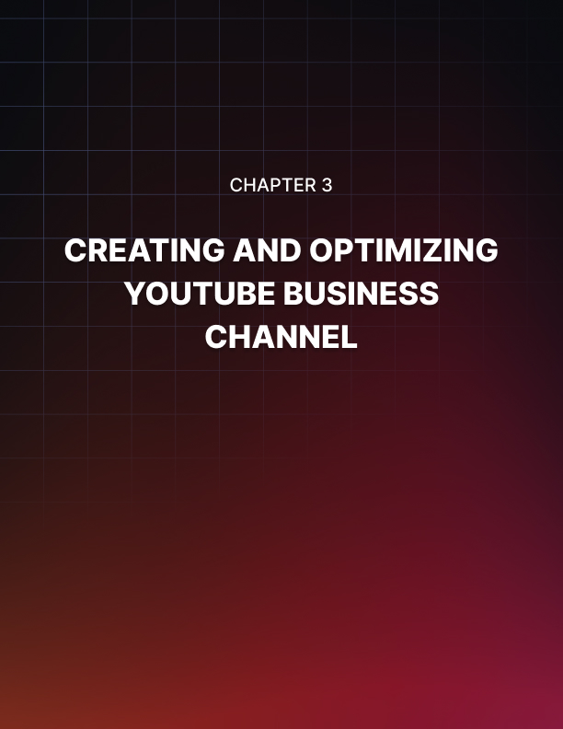

Chapter 3: Creating And Optimizing A Business YouTube Channel

You just did a great job researching and picking a niche to start off on the right foot, and now it is time to go on YouTube.

Your job now is to establish a presence, and for that you have to create a YouTube channel for your business.

In this lesson we are going to show you how to create a branded YouTube channel that is optimized to reach the right viewers and customers, step by step, the right way.

Creating Your Channel
To create a YouTube channel, you have to start by going to the YouTube website while logged in to your Google account.

Once there, click on the profile icon to open the YouTube menu, and then click on the “settings” tab. On the following page, click on the “add or manage your channels” link.

On the following page, click on “create new channel”. Now you are going to enter the name of your brand or business into the “brand account name” field.
Next, click on the “create” button.

Customizing And Optimizing Your Channel
Great job! Now that you created a branded channel, it is time for you to customize it, and to optimize it.

Start by clicking on the “customize channel” button. This will take you to the channel customization page, where you are going to add your channel icon, your channel art, your channel description, and more.

Let’s start with the channel icon. For this, click on the edit button inside the icon placement. Next, click on the “edit” button. On the following page, click on “upload photo”, and upload your company logo. Awesome job! Now go back where you left on YouTube to add your channel art.

This is a cover image that will appear on your channel page. First, click on the “add channel art” button. Next, click on “select photo from your computer”, then locate and upload your cover image. Lastly, click on “select”.

Now it is time to optimize the channel. For this, click on the “about” tab, and then on “channel description” on the following page.

What you’ll do now is to compose a description of your brand and a summary of the content that viewers will find on the channel. Here you are going to include keywords and search terms, so your channel appears on searches that target those same keywords and terms in YouTube searches. You can click on “done” when you finish.

And that is it folks! As you can see, creating a branded YouTube channel for your business is a piece of cake, you just need to apply the right optimizations to make it really attractive and search-friendly from the get go!

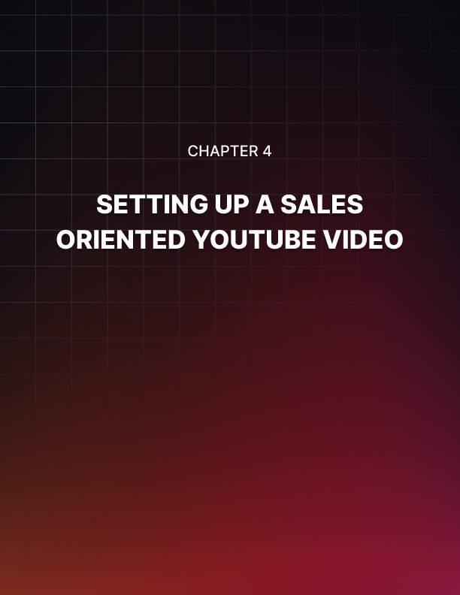

Chapter 4: Setting Up A Sales Oriented YouTube Video

We just walked you through the steps necessary to create and optimize a high-converting YouTube channel for your business, and now we are ready to move to the next step.

That’s right, we’re about to show you how to set up a sales-oriented video. We know you’ve been anticipating this lesson because video is where the meat is, and your expectations are right, because we are going to show you not only how to upload the video, but also how to apply the optimizations that will help you attract viewers and convert.

Getting Started
Let’s start off by uploading your video. By this point you should have a video ready to publish.

So go to the YouTube homepage while logged in to your channel, and click on the profile menu button. Next, click on the “YouTube studio” option in the menu.

Once on the YouTube studio dashboard, click on the “create” button. Then, click on the “upload video” option. Now you are going to click on “select file”.

Locate the video file that you are going to upload from your computer, and double-click on it to start the upload.

The video will start uploading, and you can continue the job by customizing it and adding your optimizations.

Customizing The Video
Ok, let’s start by composing the video title in the “title” field. Here you are going to type the title of your video. Don’t try to be too original. Simply describe the content of the video and add the keywords or search terms that best describe that content well, like we’re doing in this example.

As you can see, we added one of the top search terms we found during our keyword research, and we added the name of our business at the end of the title to differentiate it from the rest of the videos on the results page.

Alright, now it is time to compose the video description in the “description” field below. Again, the secret here is to add a brief summary of the content in your video filled with keywords and search terms. Here you are not as restricted by space, so we recommend you add from 3 to 5 keywords and search terms, the ones that are most relevant to the video.

It is also important that you add an action URL with a call to action at the end of the description. That way, you can instruct viewers to click on the URL to discover a product or offer at a given point during the video, and they’ll simply have to scroll down a bit and click while they’re still engaged.

Now click on “upload thumbnail” to upload a custom thumbnail for your video. Always add custom thumbnails to your videos instead of using a segment of your video as a thumbnail.

Alright, now select the “no, it’s not made for kids” option under “audience”, and click on “more options”. Here are the additional configurations that you are going to do.

First, insert your keywords and search terms in the “tags” field. Next, select the language of your video. Now click on the “category” menu button and select the correct category of your video. Done? Ok, then let’s click on “next” to move to the next step.

Now it is time to add “video elements” to your video. There are two types of video elements you can add. “End screen” are elements that you can add at the end of the video, and “cards” are elements that you can add during the video.

These elements are on-screen buttons that you can use as CTAs to encourage viewers to complete an action during or at the end of the video.

Let’s show you a quick example
Let’s add a “subscribe” CTA and a recommended video card at the end of the video. For this, click on the “add” button corresponding to “add an end screen”.
Once on the “end screens” window, click on “plus element”. Next, click on the “subscribe” option. The editor will insert the “subscribe” card at a point near the end of your video, but you can select a different time.

Now click again on “plus element”, and select “video”. Now select the “best for viewer” option, and click on “save”.

Awesome job! Once you are done adding your video elements, click on “next” to continue. In the following window, select the “public” option. Then click on the “publish” button.

And that’ll be it! You can copy the video link provided by YouTube to share your video on your other social channels, but you can hold on to this for a bit, because we’ll be showing you how to share and embed your video in a couple of upcoming lessons. Stay tuned!

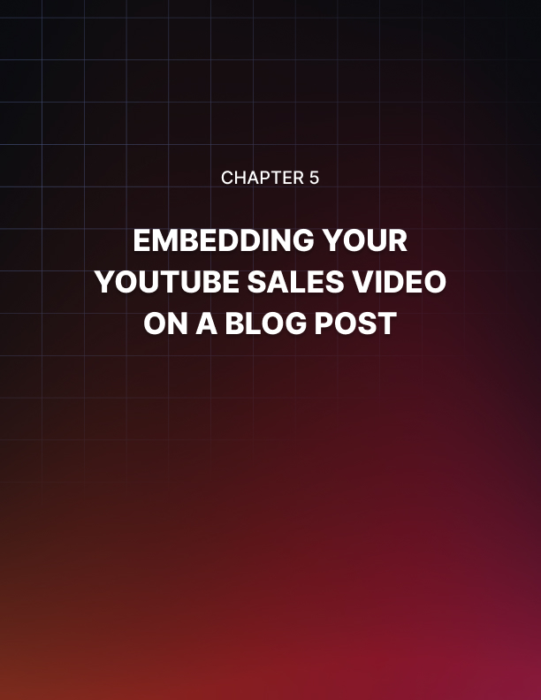

Chapter 5: Embedding Your YouTube Sales Video On A Blog Post

You just uploaded your sales-oriented video to YouTube, where you are guaranteed a steady stream of views and clicks, and now it is time to expand that reach to other channels!

There are a variety of channels where you can promote your video, and we’ll start by showing you how to add it on a blog post. This will expose your video to web visitors that reach your blog content through search, and it is easy to do.
Let’s do this!

Getting Your Video Embed Code
You have to start by getting the video embed code. This is a code that you can use to insert your video on a blog post page, and you can get it straight from your channel dashboard.

So let’s go to the dashboard first. Start on the YouTube homepage, and click on the profile menu button. Next, click on the “YouTube studio” option in the menu.

Once on the channel dashboard, click on the “videos” tab on the left sidebar menu. Now locate the video that you are going to insert into the blog post, and
click on the “options” icon. Now click on “get shareable link”.

Creating A Blog Post To Insert Your Video Onto Your Site
Alright folks, now it is time to create the blog post where you’ll insert your video. This not only has the benefit of expanding your reach, it also helps you create a backlink that increases the ranking and relevance of the video.

For this example, we are going to create a blog post for our WordPress website. If you are using a different content management system, you might have to take slightly different steps, but the basic implementation applies.

If you’re using WordPress like us, follow these steps. Start on your site’s dashboard, and move to the “posts” tab on the left sidebar menu. Now click on the “add new” option.

This will open the post editor, where you’ll compose your new blog post. This should be a blog post optimized to drive traffic to your video, so people watch and convert.

Ok, so you are going to start by composing the article title in the “add title” field. Make sure to add the main keyword or search term that you want to target, and an actionable phrase or hook. You can use the same title of your YouTube video here, minus the name of your business at the end.

Now you are going to compose your blog post below. A blog post to embed your video should be a maximum of 500 words to simply summarize the points in your video. Close the post with a call to action letting readers know that they can watch the rest of the content by playing the video below.

Embedding Your Video
Now to open a space, click on the “plus” icon. Now scroll down the blocks menu, locate the “embeds” tab, and click on it. Next, click on the YouTube icon. Now you are going to paste the embed URL you got from your channel dashboard into the YouTube URL field. Then, click on the “embed” button.

Awesome job! As you can see, the video is embedded at the bottom of the blog post. This is a great strategy to funnel website visitors to your videos because some of them will find the blog post by using the keywords you are targeting, but might simply end watching the video instead of reading the blog post.

A little trick you can use to send the viewer from the blog post page to YouTube is to use the caption field to insert a CTA. Simply click on the “write a caption” field, and then type “watch on YouTube. Next, highlight this text and click on the “link” icon. Now paste the embed URL into the “paste URL” field, and then click on “apply”.

Let’s now optimize this post with tags and a featured image before you publish it. For this, click on the “document” tab in the editor menu on the right. Now click on the “tags” tab, and insert your keywords and search terms into the “tags” field, just like you did on YouTube.
Now click on the “featured image” tab. Click on “set featured image”, then click on the “upload files” tab, then on “select files”, and locate the image that you’ll use as a feature image on your computer. Double-click on it, and then click on “set featured image”.

Publishing Your Post
Now that you are all set and done, click on the “publish” button, and confirm. And that’s it! You can always repurpose your YouTube videos for your website this way, which will help you to create backlinks for your YouTube video and to add more content for your website!

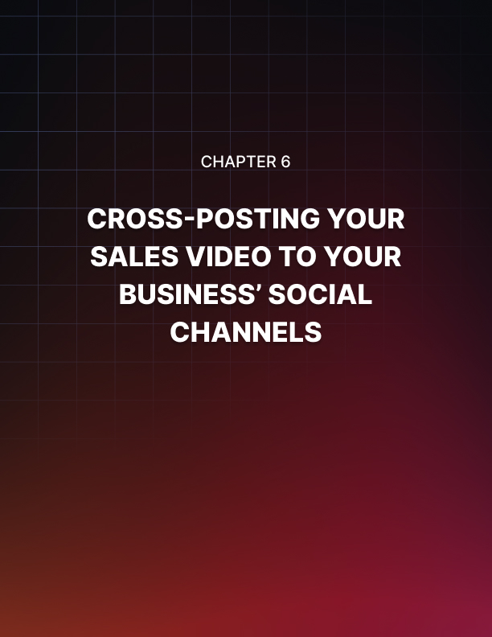

Chapter 6: Cross-Posting Your Sales Video To Your Business’ Social Channels

You have just given a good boost to your YouTube business video by uploading it to your website, and now it is time to boost it through your business social channels too.

Now, you just can’t drop a link to your video on Facebook and call it a day, so in this lesson we are going to show you how to cross-post your videos the right way.
Here we are going to show you how to use Facebook and Twitter, the best places to share external URLs and generate conversions out of it.

Start By Shortening Your Shareable Link
The first thing that you have to do is to shorten your video link. This is an important step for two reasons.

For one thing, shareable links don’t look good on social posts because they’re not customized and are long.

Second, social media sites decrease the relevance of posts with YouTube URLs because they would rather that you upload videos directly to their platforms.

The best service to shorten URLs is bit.ly. To use it, simply visit bit.ly on your browser, paste your shareable URL into the “shorten your link” field. Now click on the “shorten” button and copy the shortened link. Save this link somewhere handy so you can share it easily.

Cross-Posting Your Video On Facebook
All right folks, Let’s start by crossposting the video on Facebook. This is going to be easy. First, log in to your Facebook account and go to your business page.

Once on your business page, click on the “write a post” field. What you’ll do now is compose a Facebook post to promote your video. Start by adding the video title as the post headline on top. Now in the space, compose a brief description of the video. Make sure to use your keywords and search terms, and to add a call to action to ask users to click on the link to watch the video.

Alright, now you are going to paste your shortened video URL below this text. Facebook will fetch a link preview, so click on the “close” icon to cut it out of the post.

What you’ll do instead is to insert the video thumbnail as the post image. For this, click on the “photo/video” button, locate the thumbnail image, and then double click on it to upload it.

Now spell check your copy, check that the URL is correct, that the image looks good in the preview, and then click on the “post” button.

And that’s it! The post looks incredible, and users simply have to click on the link to watch the video directly on YouTube!

Cross-Posting Your Video On Twitter
Now you are going to cross-post your video on Twitter. For this, go to your Twitter business account.

Once there, click on the “tweet” button.

When composing your post on Twitter the strategy is similar to Facebook. Open the post by adding the video title first. Now compose a brief description of the video below the headline, making sure to use your keywords and search terms, and to add a call to action.

What you’ll do now is to make your keywords into hashtags. Simply identify a keyword and type a hash symbol before it. In the case of search terms, simply put each keyword in the term together and place the hash symbol. This will rank your post on searches for those terms and keywords.

Now paste your shortened video URL below the text. Now click on the “gallery” icon to upload your thumbnail image to the post. Now spell check your post text, make sure that the link and image are correctly inserted into the post, and then click on “tweet”.
And that’s it! Now your post will benefit from exposure on twitter too, which is one of the best places to drop external URLs!

As you can see, cross-posting your videos on social media is easy, and we highly recommend that you build a strong social media audience to push your content there with these very easy steps!

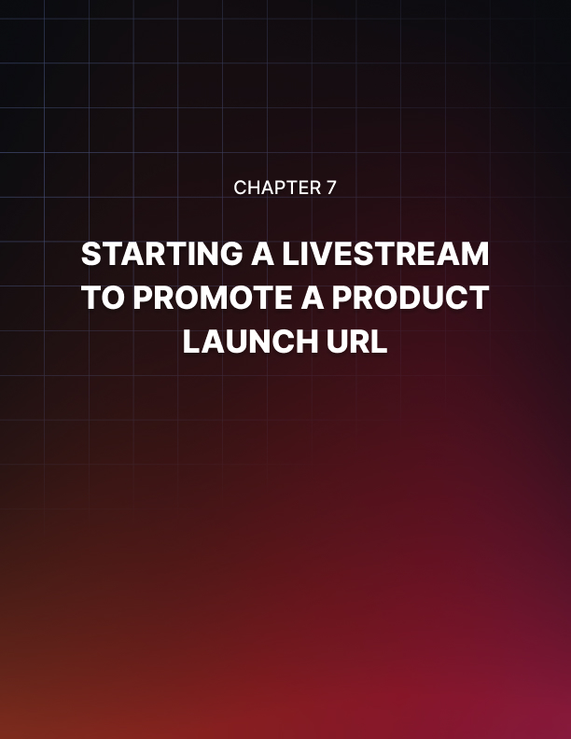

Chapter 7: Starting A Live Stream To Promote A Product Launch URL

Live streaming is all the rage now, although the majority of people are not using it to make money. You’ll find people using live streams to chat and play video games, and only a few using it for its money-making potential.

In this lesson we are going to show you how to set up a YouTube live stream where you can go live for your business, interact with potential customers, and make money in real time!

Going Live On YouTube
Going live on YouTube is really easy, and in this lesson we are going to show you how to go live to promote a product launch URL to present your product and generate early bird sales.

Start on the YouTube homepage while logged in to your channel, and from there go to your YouTube studio dashboard by clicking on the profile menu button, and then on the “YouTube studio” option.

Once on the dashboard page, click on the “create” button on the top bar menu. Then, click on the “go live” option from the display menu. This will take you to the live streaming page.

Setting Up The Stream
Now it is time to start setting up the live stream. First, make sure to allow YouTube access to your camera and microphone so the live stream runs.

Now click on the “stream” tab. Here you are going to add your live stream information. Enter the name of your live stream into the “create a title” field.

Here you are going to enter the name of your product launch.

Now you are going to add the product launch description into the “description” field. Here you are going to add a summary of the product launch. Make sure to include your target keywords and search terms for maximum exposure.

The next step is key. You are going to insert your product launch URL at the end of the description. You will entice viewers to take action during the live stream to encourage them to learn more about the product by clicking on the URL in the description. This is how you are going to drive conversions during the live stream!
Now make sure that the stream is set as “public”, and then click on the category menu button to select the correct category for the stream.

Now click on the “upload custom thumbnail” and upload a thumbnail image that you consider to be a good fit for this stream. You can use the product cover or an asset from the product launch kit as the thumbnail. Lastly, select the “no, it’s not made for kids” option in the “audience” section.

Starting Or Scheduling The Stream
You will have the options to broadcast the stream right away, or to schedule the stream for a later date.

Now, your best bet is to leverage buzz for the product launch to promote your live stream, so you have to make sure to either schedule the live stream to make time to promote the broadcast, or to promote it heavily on social media before you go live.

In case you want to schedule the live stream, simply enable the “schedule for later” option, then click on the date field and use the calendar function to pick a date, and then click on the time field to select the time of the broadcast. Once you schedule the broadcast, click on “create stream”.

On the other hand, if you are going live right away, simply disable the “schedule for later” option, and then click on “stream”. In this case, we just posted a reminder to our Facebook and Twitter accounts, so we expect viewers coming in the moment we start the stream, so make sure to post your reminders before you go live too!

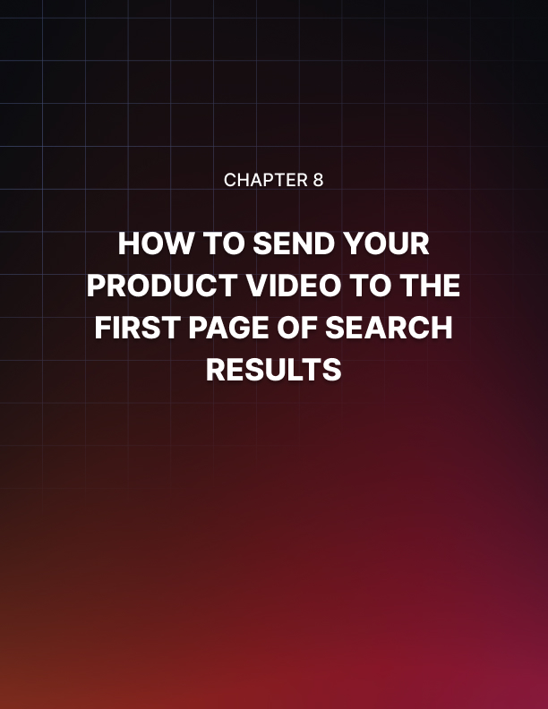

Chapter 8: How To Send Your Product Video To The First Page Of Search Results

One of the hardest things to achieve on YouTube is ranking a video on top of the search results pages. In fact, this is the reason why most aspiring YouTube businesses and creators quit.

And while it can certainly be discouraging to try to compete and rank in a platform as saturated as YouTube, you’ll be glad to know that there is actually a way to rank your video on top, right from the moment you publish it.

In this lesson we are going to show you that trick, so you can send your videos to the first page of search results the easy and fast way, step by step!

Step 1 - Upload Your Video
Start by uploading your video to YouTube. Let’s do it from the homepage this time. For this, simply click on the camera icon on the top bar menu, and then click on the “upload video” option.

Now click on “select file”, locate your video file and double-click on it so your video starts uploading.

Step 2- Optimize For The Top Ranking And Publish Your Video
Now that your video is uploading, you can start optimizing it. The optimizations we’re about to show you differ from the optimizations we applied when we set up the first sales video because the goal now is to compete for the top ranking on the top page by laser-targeting some search terms.

Let’s start with the video title. This video title should be at least five words long, and it has to include your target keywords, search terms, the name of your brand or of the product that you are going to promote, and video keywords.

If you are unfamiliar with video keywords, allow us to explain them real quick. Video keywords are keywords that the YouTube and Google algorithms identify as keywords related to videos with high traffic. In other words, these are keywords targeted by the most popular videos on the platform.

Interestingly, these are very general keywords that when combined with your niche keywords can help you compete for the top spot on search results.

These keywords include “Review”, “How To”, “Tips”, “Tutorial”, “Funny” as well as keywords related to the fitness, sports, health, and lifestyle niches.

By adding the name of your product or brand in the mix, the algorithm differentiates the title from the rest because it makes it unique, and places it on top. It is then your job to keep the top place by sending viewers to the video.

For this example, we are going to use the “Tutorial” keyword as our video keyword. We are going to combine this keyword with a high-traffic search term and the name of our business at the end of the title.

Let’s now optimize the description. The strategy here is simple: compose a description that is 250 characters long. Include all of your target keywords and search terms on this description and your product URL at the end.

Now click on “upload thumbnail” to upload your thumbnail image. Then select the “no, it’s not made for kids” option in the “audience” section.

Now click on “more options”. Scroll down to the “tags” section and insert your keywords and search terms into the “tags” field. This is crucial, because tags are going to help you to index your video faster.

Now select the language of your video, then click on the “category” menu button and select the correct category of your video. Then click on “next”.

For this example we are going to skip adding elements to this video, so we’ll simply click on “next” to continue.

Finally, you are going to select “public” in the “visibility” section, and then you’re going to click on the “publish” button.

Step 3 - Verify Your Ranking
YouTube videos are ranked immediately, and you’ll be able to check your spot in the search results page right away. For this, go to the YouTube homepage, enter the search term in your title, and then click on the “search” icon. And there you go! As you can see, our video is on the top spot of the search results page.

Let’s now visit google.com to check the ranking over there. Here you’ll apply the same steps: type your target search term in the search bar, and press enter to start the search. Then click on the “videos” tab. And there you have it again, our video is right there on the results for video! It doesn’t get any easier than this to send your videos to the first page of search results!

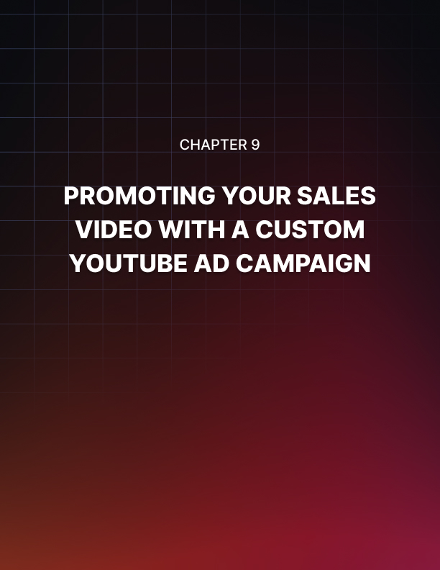

Chapter 9: Promoting Your Sales Video With A Custom YouTube Ad Campaign

We’ve come through all the right strategies that top YouTube businesses and marketers apply to grow their channels, so now we are going to take this training to the next level.

If you want to get more results, and get them fast, then you have to invest some money in ads. In the upcoming lessons we are going to show you how to set up paid advertising campaigns to boost your YouTube business videos, starting with this lesson, where we are going to show you how to promote your video with a custom YouTube Ad campaign.

Getting Started
To create a custom YouTube Ad campaign to promote your video, go to your YouTube studio dashboard by clicking on the profile menu button, and then on the “YouTube studio” option.

Next, click on the “videos” tab. Locate the video that you want to promote, click on the “options” icon, and then click on the “promote” option from the display menu.

On the following page, click on the “get started” button. This will take you to the Google Ads dashboard, from where you can create your custom YouTube Ad campaign.

Creating The Campaign
Start by clicking on “new campaign”. On the following page you are going to select your campaign goal. To create a custom campaign, select the “create a campaign without a goal’s assistance” option. Now select “video” as the campaign type. Then select “custom video campaign” as the campaign subtype, and click on “continue”.

Now you are going to customize the campaign. Start by entering the name of your new campaign into the “campaign name” field.

As you can see here, “maximum cost per view” is selected by default in the “bidding strategy” section. This means that you will only pay when someone views your video ad. This is the optimum strategy for this campaign, so let’s skip to the “budget and dates” section.

Here you are going to enter your ad spend and your schedules. Start by clicking on the budget type menu button and select “daily”. Now enter the amount you want to spend daily on ads. You can start with a low number, such as $5 or $10, and can scale it from there.

By default, your campaign is set to “start as soon as ads approved” with no end date, but you can edit this schedule if you prefer to launch this campaign on a later date.

Now click on the “languages” tab. Click on the “enter language” field, and select your target language from the display menu. It is always better to select the language of your video, but you can select additional languages if you added captions to the video that you’ll promote.

Now click on the “locations” tab and select your target locations. Here you are going to select locations where people speak your target language, and where people are more likely to purchase your products after watching your video ad.

Now scroll down, and enter the ad group name into the “ad group” field. This is where Google Ads will save the ads that you create in this campaign.

Now click on the “demographics” tab. Here you are going to check the demographic attributes that best describe your perfect customer.

Now click on the “audiences” tab. Here you are going to select attributes that define your audience. It can be an interest, an industry, or a customer lifecycle stage. The easiest way to use this feature is to enter a related keyword into the search box, and to select one or more attributes from the results.

Once you are done here, move to the “content” section and click on the “keywords” tab. Here you are simply going to enter your keywords and search terms into the keywords field.
Now click on the “topics” tab. Here you are going to select the topic that you want to target. The easiest way to make your selections is to simply locate and select your topic or topics from the menu.

Now click on the “placements” tab. Here you can select specific placements to show your video ads. Use this feature ONLY if your plan is to target a very specific audience on a very specific placement, such as subscribers and viewers of a YouTube channel, or visitors of a specific website.

All you have to do here is to enter a keyword into the search box, and to select placements from the results. In this example we don’t want to narrow down our reach to specific placements, so we will skip this selection.

Now in the “bidding” section you are going to enter the maximum bid that you are willing to place for each unique view.

Setting Up The Video Ad And Launching The Campaign
Alright friends, now it is time to set up the video ad. Start by adding your video ad to the creative. You can do this by typing the name of your video in the “search for a video” bar, or simply by entering your video URL into this same search bar.

Now you have to select the ad format. For this example we are going to select “skippable in-stream ad” to show our video ad when viewers are watching other videos.

Now enter your product or sales page URL into the “final URL” field, then click on the “display URL” field to generate the display URL for the ad.

Now enter the name of this new ad into the “ad name” field, and then click on the “create campaign” button. And now that your campaign is set, review your campaign settings and click on “continue to campaign”. And that’s it!

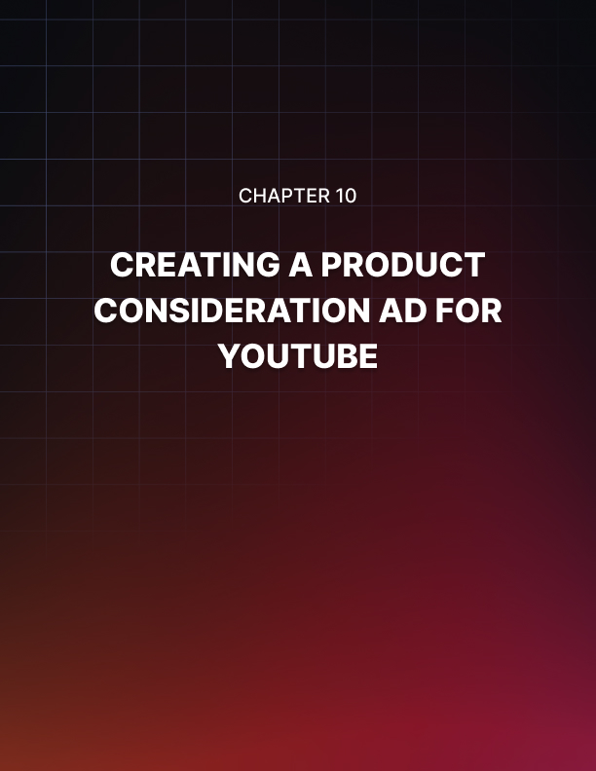

Chapter 10: Creating A Product Consideration Video Ad For YouTube

Time to continue boosting your YouTube business video with ads, this time through a campaign that is optimized with settings that encourage product consideration.

In other words, we’re about to show you how to create a YouTube ad that will convince buyers that your product is their best choice!

Let’s start off this lesson right from the Google Ads dashboard, where you can access by visiting the “ads.google.com” URL while logged in to your Google account.

Creating And Customizing The Campaign
From there, click on the “new campaign” button. Now select “product and brand consideration” as the campaign goal. Then select “video” as the campaign type. Now select “influence consideration” as the campaign sub-type, and then click on “continue”. Now you are going to customize the campaign. Start by entering the name of this new campaign into the “campaign name” field.

The rest of the campaign configurations will be similar to the configurations we made when we created the previous campaign.

First, click on the budget type menu button and select “daily”. Next, enter your daily ad spend into the amount field. We are going to launch the campaign as soon as the ads are approved, so we’ll skip the schedule in this example.

Ok, now click on the “languages” tab to select your target languages. Next, click on the “locations” tab to select your target locations. Now move to the “ad group name” column and enter the name of your new ad group.

Now you are going to move to the “people” section. Click on the “demographics” tab to check your audience demographic attributes.

Then, click on the “audiences” tab and add your audience's attributes. Here we strongly recommend that you select “inmarket” attributes. This will help you to target viewers that are active online buyers, which are more likely to make a purchasing decision after watching your video ad.

Next, move to the “content” section and click on the “keywords” tab. Enter your keywords and search terms into the keywords field. Then click on the “topics” tab and select the topics that you want to target with your ad.

In case you want to target specific website visitors or viewers of a specific channel, click on the “placements” tab. We are not going to pick specific placements, so we will skip this configuration. Lastly, enter your maximum “cost per view” bid into the “bidding” field.

Creating The Product Consideration Ad And Launching The Campaign
Alright folks, time to set up the ad. Start by pasting your video URL into the “search for a video” field.

For this type of campaign we recommend you select “video discovery ad” as the ad format. This will show your ad on more than one placement, including the YouTube homepage, on search results pages, and on recommended video feeds. That way, you’ll avoid people skipping your video ad, while also giving them more time to consider clicking on the video.

Now you are going to customize the ad and compose the ad copy. Start by selecting a thumbnail. Next, compose the ad headline in the “headline” field. Next, compose a description into the “description 1” field. You can add a description extension into the “description 2” below, but this is optional.

Then, enter the ad name into the “ad name” field, and click on the “create campaign” button. On the following page, review your campaign settings, and click on “continue to campaign”. And that’s it!

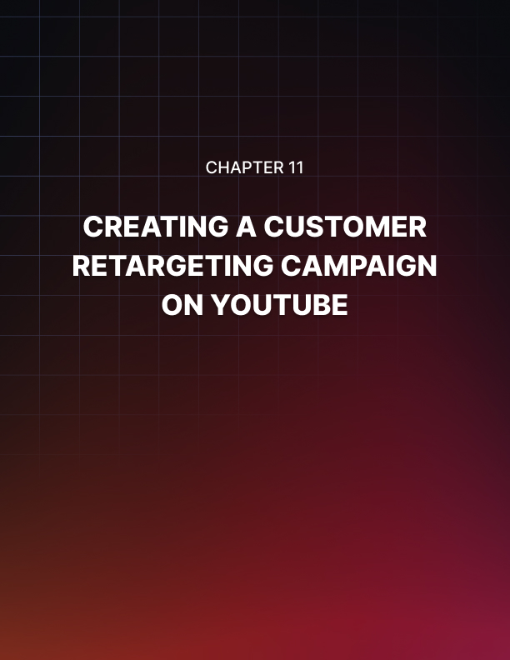

Chapter 11: Creating A Customer Retargeting Campaign On YouTube

Alright folks, we’re nearing the end of this journey, so we’ve saved a big strategy for last. In this lesson we are going to show you how to retarget potential customers that have interacted with your videos and your channel on YouTube!

Getting Started
You can create a customer retargeting campaign on YouTube by adding viewers that have shown interest in your product and sales videos to a retargeting list. This way you can retarget them with more content from your channel until they convert!

For this, start on your Google Ads dashboard, and from there click on the “tools and settings option” in the top bar menu. Then, click on the “audience manager” option.

Creating The Retargeting List And Launching The Campaign
This will take you to the “remarketing” section of the audience manager, where you can create your retargeting list.

Start by clicking on the “plus” icon. Next, click on the “YouTube users” option from the display menu.

Now you can start setting up the list. First, enter the name of your new list into the “audience name” field.

Now click on the “list members” menu button. Here you can select which users to retarget according to how they interact with your videos or your channel.

You can retarget people that viewed any or certain videos from your channel, people who viewed any or certain videos as ads, people who subscribed or visited your channel page, people who have liked your videos, people who have added videos from your channel to a playlist, and people who have shared a video from your channel.

The best strategy here is to select “viewed any video as an ad from a channel”. This retargeting strategy allows you to retarget viewers who have completed viewing one of your video ads. This is a signal of interest and sometimes of purchasing intent, so retargeting these viewers will lead to a conversion after 5 or more retargeted videos.

Next, click on the “YouTube channel” menu button and select your YouTube Business channel from the list.

The default “pre-fill options” and “membership duration” settings are optimal, so you can skip these settings for now. Our recommendation is for you to track the behavior of YouTube leads to reconfigure these settings later on. For example, if you find the majority of your leads convert after 15 days, then you can set your “membership duration” at 15 days, but you have to do this after several days of running your retargeting campaign.

And now that you are done customizing the retargeting list, click on the “create” button. And that’s it! Now YouTube will add viewers that match your retargeting criteria to this list, and will show them more of your content to increase your sales!



Chapter 12: Outlining Your Perfect YouTube Sales Funnel For 2024

These past training lessons have walked you through the manual strategies that are going to get you started on the right foot, and now we’re about to get into the brainy stuff, the strategies that will help you plan, improve, optimize, and scale.

And we are going to start by teaching you how to outline the perfect YouTube sales funnel for 2024. In this lesson you’ll learn how to develop a funnel according to your current efforts, and what type of videos you’ll have to produce to move each viewer into your funnel.

Step 1 – Identify Goals And Set Stages
It is important to identify what the goals of a sales funnel are and to set them in order before you set up the stages in your funnel.

In this training we’re focusing on driving sales and making profit, yet the majority of your business leads won’t move right into the bottom of the funnel, ready to make a purchase. That is why it is vital to establish different goals to capture leads at different stages.

You have to see the sales funnel as an inverse pyramid that goes from top to bottom. On top are the leads that are less likely to convert, the leads that may not even be aware of your brand, and that you have to “suck in”. In the middle are the leads that are aware of your brand and are interested in your offer. And at the bottom are the leads that are ready to get their hands on your product.

Let’s establish goals for each stage in the funnel:

- At the top of the funnel your goal is to drive awareness. that is, awareness about your brand, or your product, or your service. The intention is for the user to become aware that you exist, regardless of their desire to consume what you offer.
- At the middle of the funnel your goal is to drive interest and consideration. Once a lead sees you as a trustworthy authority, they’ll keep hanging around, watching your videos, either because you are a trusted source of information, or because your products offer a real way to solve an issue or need in their life.

Notice that at this point you can also drive desire. This means that a lead is not only considering your product, but is actively desiring your product, yet there is an objection stopping the lead from taking action, such as price, or maybe they need to learn more about the product before making a purchase.

- Finally, at the bottom of the funnel the goal is to drive action. This is when a lead is ready to convert by signing up for a trial or making a purchase.

Step 2 – Make A Content Audit
The next step is to audit your channel to make a content inventory. What you’ll do at this point is to check the content that you have in your channel and to take notes about the different types of videos that you have produced. And, you are going to analyze how each video can help a lead move from one stage to another.

Doing this will help you to better identify at what point of the YouTube content lifecycle you are in. For example, you might find that you have more videos that are simply optimized to help people find your videos on YouTube, but that don’t push your brand or products too much.

Or, you may find that you have lots of videos that are centered on your products, and that are designed to put viewers in the mood for purchasing.

By taking inventory of the different videos you have, you can fine tune your content strategy to match the goals you need to achieve at each stage of the funnel. In other words, you can find out how many videos you have to create to have an equal number of videos for each stage. This is especially helpful if you’re just getting started.

Step 3 – Plan Your Content Mix For Each Stage Of The Funnel
By this point you know the mindset that will push viewers into each stage in a YouTube sales funnel, and you have a clearer idea of the type of content that you need to produce to balance things out.
But to properly balance your content mix, you have to apply a content split for each stage in the funnel, and we’ve found out this to be the perfect content split for your mix:

- 40% of content for the top of the funnel. This means that 40% of your content has to be intended to reach leads. In other words, search-friendly videos that are not necessarily about your brand, but about entertaining things that your audience likes.
- 40% of content for the middle of the funnel. This means that another 40% of your content will be intended to showcase your products in a context that is familiar to your audience, using storytelling techniques.
- 20% of content for the bottom of the funnel. This means that the last 20% of your content will be intended to encourage your viewers to take action, or at the very least to find your product videos if they’re actively researching them.

And that’s it folks! You can design an agency-level sales funnel for your YouTube business in three simple steps, guaranteed. Are you curious about what types of videos work best for YouTube business, and which ones perform best for each stage in the funnel? Then tune in to the following lessons!

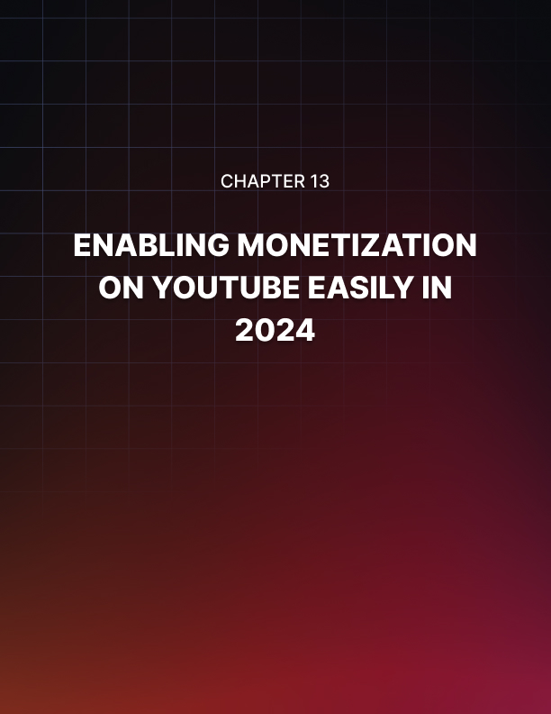

Chapter 13: Enabling Monetization On YouTube Easily In 2024

We’ve been talking about using YouTube to do business the easy way by applying monetization strategies that help you to turn viewership into profits from sales driven through the YouTube platform.

But let’s not forget about channel monetization, the main income strategy offered by YouTube to content creators, which you can leverage to generate an additional income stream from ads that run on the videos that you upload to your channel.

How Does Monetization Work?
Channel monetization is a revenue sharing model implemented by YouTube to encourage creators to upload the highest quality content possible to the platform. The more a creator is able to engage viewers and increase watch time, the more money they can make.

And it works like this: You follow a series of simple steps to apply for monetization, and once your channel is approved, ads will start running on your videos. Each time a viewer completes watching an ad for a certain period of time, the advertiser pays YouTube for the ad, and you get a cut from that payment.

Things To Know Before Enabling Monetization
Enabling monetization is a great way to supplement your YouTube business income, but YouTube is going to review your channel before enabling you for monetization.

These are some things you need to know in order to prepare your channel for the review process if you want to start earning ad revenue as soon as possible:

- Create videos that encourage prolonged watch times. This is, videos that are entertaining and that keep the viewer watching until the end. In general, you have to make videos that are between 6 to 25 minutes long, depending on the topic.
- If you’re using stock footage and audio, make sure to have your licenses up to date, and to know exactly where you are getting your stock assets from. This will help you avoid duplication claims as a reason for non approval.
- Your channel needs to have at least 4,000 combined view hours and a minimum of 1,000 subscribers to get monetized. These numbers aren’t difficult to achieve if you produce quality content. It is also necessary to do an SEO audit on your published videos so you can optimize your content for maximum visibility, which will help you reach those numbers more easily.
- Avoid encouraging viewers to do a “sub for sub”. YouTube will deny your application if you use “sub for sub” as an engagement strategy. Instead, call viewers to subscribe, like, and turn on notifications.
- Make sure to review all guidelines on the “YouTube channel monetization policies document” that you’ll find at support.google.com/youtube/answer/1311392.

Enabling Monetization
Alright folks, now that you’ve prepared to apply for monetization, here is what you’ll do, step by step:

Set up an AdSense account if you haven’t already. AdSense is the ad revenue share program for publishers and creators, and that’s the platform where YouTube will process your payments. You can create an AdSense account at google.com/adsense/start/.

- Sign in to your YouTube account and channel that you want to monetize, click on the profile menu button, and then click on the “creator studio” button.
- Click on the “monetization” tab, which you’ll find on the left sidebar menu.
- If you’re eligible to apply for the monetization program, click on the “start” button inside the “review partner program terms” card, then confirm that you agree to the terms and conditions.
- Click on the “start” button inside the “sign up for Google AdSense” card and sign in to your approved AdSense account.

Now all you have to do is to wait for approval, which can take 30 days or less. In that time, keep uploading awesome content and engaging with your audience.
What If I’m Not Approved?
There’s a certain number of applications that don’t get approved for one reason or another, but you don’t have to worry!

If you’re not approved at first, simply examine the reasons the company gives you for non-approval, take the necessary steps to fix them, and wait for an additional 30 days from the day of non-approval to submit a new application.

Once You Get Approved
Celebrate! Post a “thank you” video and give a shout out to your most active and most engaged viewers, and keep creating awesome videos!



Chapter 14: Top YouTube Marketing Tips To Increase Sales in 2024

When your objective is to drive sales and generate profits, you have to go above and beyond the strategies that you would normally use to simply increase traffic and boost awareness, and that’s where YouTube Business Made Easy comes in.

Yet you can’t underestimate the power of applying proven YouTube marketing tactics when it comes to increasing your chances of driving more sales simply by pushing the right buttons. In this lesson we are going to discuss the best YouTube marketing tips that will help you to increase sales in 2024.

Create Short Videos
We have talked about the importance of creating videos that promote lengthier watch times.

These are videos that are on average between 6 to 25 minutes long, and the intention is to boost retention. But it so happens that the contrary can work as well, if not better, in some instances.

That’s why it is important to include short videos into your mix. Videos that last less than 2 minutes can generate over 50% of your views, and they’re more effective to deliver your message to certain leads at certain stages of your sales funnel.

While a single short video won’t help you to drive an immediate sale, or to show more than one ad, adding several short videos to your channel can help you to increase watch times because more people will be able to watch your videos in short bursts.

This will also help you to capture attention and increase consideration of people short on time, such as people at their jobs. These people are more likely to make urgent decisions, and if you create a video series to showcase your products, then you’re more likely to drive a sale from those prospects!

Brand Your Channel
The look of your channel has to match your vision and the way that you want your audience to perceive your products. You have to think of your channel as an extension of your overall online presence, or as another page on your business website.

This means that every element of your channel has to be customized in a way that is recognizable for people who have visited your other channels, such as your website, and your social media profiles.

This means that you have to use the same logo that you use on your other channels as your channel icon, to use your header images as your channel cover, and to match the colors and design of cards and CTAs in your channel and videos with the design on your website.

Be Consistent
A primer marketing strategy is to be consistent with content. This means that you have to publish content at the right time, and when your audience expects it.

The starting point is to establish a content schedule. You can, for example, study when your viewers are more active, and at what times and on which days you get the most views, and to publish your videos at those times. You can look at the analytics section of your channel to get this information.

You can then plan a content schedule based on those results. For example, if you get peak views and engagements on Tuesdays at 8 PM, then you have to upload your videos on those days and at that time.

You have to also plan the build-up. You can create teasers to post on your other social media channels, and you can set up reminders for your subscribers and followers.

Lastly, it is recommended that you automate your content calendar. You can do this by uploading your video when it’s done, and scheduling the launch for the right time.

Use Annotations As Calls To Action And Links
YouTube allows you to include annotations in your videos. Annotations are pop-up elements that appear during play time, and that you can use to encourage viewers to take certain actions by clicking on them, such as watching another video, visiting someone else’s channel, or visiting a landing page.

You can add annotations through the video editor!

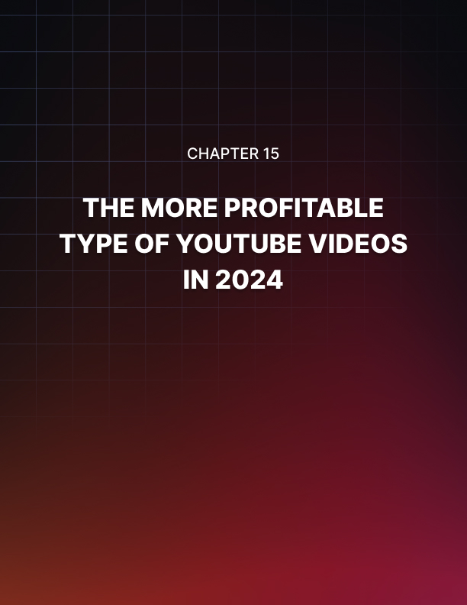

Chapter 15: The More Profitable Types Of YouTube Videos In 2024

There is an almost unlimited number of videos that you can create and have success with on YouTube. As long as you create helpful content that is entertaining, you’re set to make it big on YouTube.

The thing is that not every type of video is going to be profitable, regardless of how many views they get you. What you want is to learn what type of videos are profitable, so let’s talk about them!

Educational Videos
These are videos where you educate leads that are looking for information. This can be information about anything in your niche, about things that can help them find an answer to a question. You can use infographics and whiteboard animations for your educational videos, where your brand becomes the guide to the answer or “class” that you are providing.

These videos are great for capturing leads that are at the top of the funnel, people that are simply researching stuff way before they’re aware of your product.
One strategy that you might want to apply, is to not give out your whole content in one video; instead, use your educational videos as intros to a larger content series that you can use to move viewers into the bottom of your funnel. For example, you can create a video as the first part of your series, and invite viewers to download an eBook where you provide the rest of the info.

Explainer Videos
These are videos where you explain the solution to a problem. They’re similar to educational videos, but they’re more specific about explaining a means to an end, such as explaining how a product helps people to solve a problem, or how a tool helps people make more money.

These videos can help you to catch leads at the top and in the middle of the funnel, because they can spark awareness among people at the top, and create interest among people in the middle. The trick is to create videos that explain how the products or services that you sell can solve a given problem, to explain it quickly and in simple terms.

Product Videos
These are videos where you showcase your products or services. Most commonly, they are short videos that work as an introduction to your products,
where brands explain what the product is all about.

Please note that these are not adverts and you shouldn’t use them to focus on selling the product. What you’ll do is to simply create a video where you clearly explain what your product or service is, how it works, and what type of problems it solves.

You can use these videos to engage leads in the middle. While they won’t necessarily help you to drive an immediate sale, they will help you to create interest and consideration, leading to a conversion down the line.

Tutorials And Demos
Video tutorials are videos where you explain to viewers how to do something, from how to use an online tool, to how to create a birdhouse. These “How To” videos are incredibly effective when it comes to driving conversions, because they encourage the user to learn how to complete a task or achieve an objective if they use the tool or product in the tutorial.

Because of that, these are the types of videos that you are going to use to convert people in the last stages of your funnel.

For example, you can create a tutorial video to teach people how to use a tool that you are promoting to create a website with an integrated shopping cart in just a few minutes. Because you are providing a quick, easy solution to a problem that lots of people want to solve, you can drive lots of conversions from that video simply by inserting your affiliate link in the video description!

Testimonials
In these videos you are going to feature testimonials of people providing feedback about your product. Normally, these are recordings of clients that have had a good experience with a brand, product, or service.

What you have to do is to ask some of your customers to rate your product on camera and talk about how it has helped them to achieve results.

Testimonial videos are the equivalent to reviews on a website, and they can help leads at the bottom of your funnel to make the final purchasing decision.
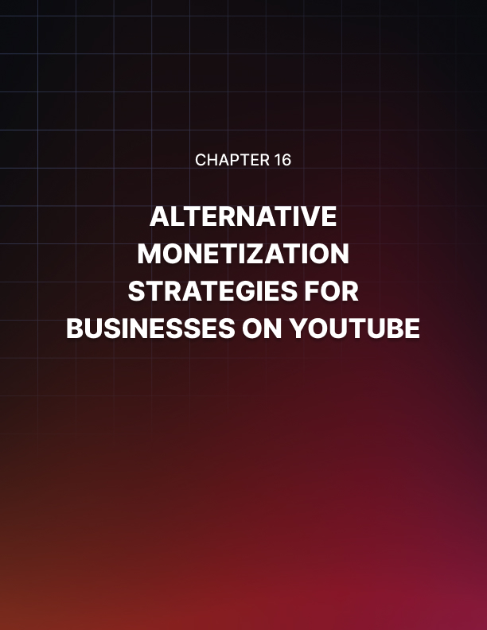

Chapter 16: Alternative Monetization Strategies For Businesses On YouTube

One of the things you’ll hear from every successful hustler when you ask them what their secret is, they’ll say diversification. Diversification means to create additional income streams to supplement your main hustle.

In this case, your main hustle is YouTube, and it is a good idea to supplement your YouTube Business strategies with additional streams. The following is a list of our favorites.

Patreon
Patreon is a membership platform that allows creators to set up a membership program so they can monetize their content, and it is a favorite among creators on YouTube. With it, you can create a membership business through which your biggest fans are able to pay a fee to get access to your premium content.

What this means is that you can use Patreon to set up a paywall for your best content. For example, you can create a premium video course that is not available on YouTube, and that only Patreon subscribers can get.
And in case you’re not monetizing your YouTube content, you can create a subscription service where you send subscribers a different product monthly for a fee, and you can funnel viewers from YouTube to sign up to this service.

Dailymotion
Dailymotion is a video streaming service that is similar to YouTube in look, and feel, but that offers more relaxed guidelines and
access to an international audience that you won’t find on YouTube.

Dailymotion has a partner program that lets you monetize your video content, and it’s easy to apply. This means that you can join Dailymotion, join the partner program, and monetize your videos there too!

Brid TV
Brid TV is a scalable YouTube alternative with a great monetization solution and white label service for content creators.

What makes Brid TV special is that it is a dedicated online video player platform. This means that it lets you host your videos on their platform, so you can then embed them on your site or anywhere else, and you can monetize your videos with different ad formats in those placements.
Twitch

Twitch is a live streaming platform. Perhaps the most popular streaming site of all, it has attracted former YouTube live streamers, who have
ended up moving their business there.

Twitch is a great platform to stream live events, product demonstrations, and services live. It gives you a great opportunity to show what you do in real time, and it has a great partner program that lets you monetize your streams once you build a sizable follower count.

Mixer
Mixer is an interactive live streaming platform that offers a similar experience to that of Twitch.

Held as the best Twitch alternative, it offers juicy monetization options such as membership programs, a partnership program, and access to verified channels for businesses that’ll help you take monetization to a new level!

Facebook and Facebook for Creators
There’s no doubt that Facebook is still the king of social media platforms, and one of the most active, most profitable sites on the planet.
It is also a great platform to post your video content and make money off it. It works similar to YouTube in that you have to upload your videos and add your action URLs.

But be careful! On Facebook, you have to directly upload the videos to the platform instead of sharing the YouTube video URL.

The only bad news is that video content on Facebook doesn’t have the same evergreen potential as on YouTube, so what you have to do is to create shorter videos and to share them on a more regular but equally consistent frequency.

On the other hand, Facebook for Creators is a Facebook program that you can join to monetize your video content on Facebook, which is possible through ads, brand collaborations, and other built-in monetization tools.

You can join the Facebook for Creators program at facebook.com/creators.

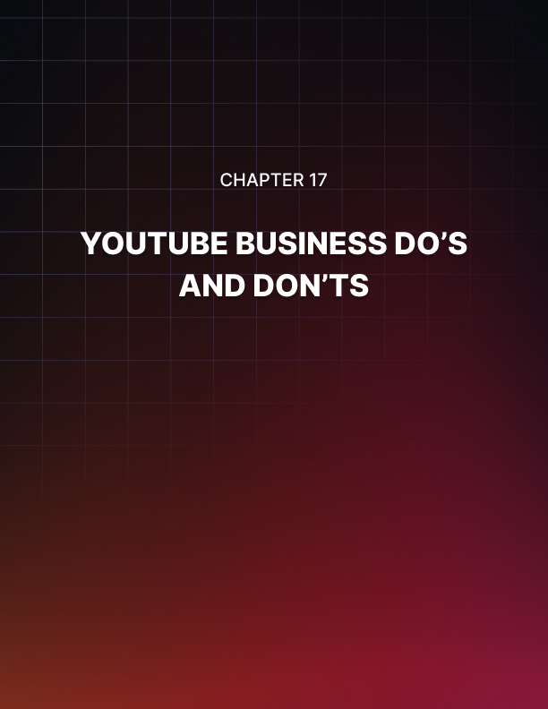

Chapter 17: YouTube Business Do’s And Don’ts

Do’s
Plan Everything
It is crucial that you plan everything you’ll do with your YouTube business. From your next video to your upcoming product launch video campaign, it is important that you think about the results that you want to get before you execute.

Be Customer-Centric
Your YouTube business content has to be customer-centric. This means that you have to create videos that make the viewer aware that you are selling a product or service, and that help them make faster purchasing decisions.

Be Entertaining
Your message is going to resonate more with your audience if you entertain and educate at the same time. This ensures that viewers will remember your brand down the road.

Be Original
You have to work on creating a voice and feel that is unique for your brand. Something that helps new viewers differentiate you from the competition, and that cues repeat viewers into recognizing your unique brand identity.

Be Consistent
Make sure to stick to a content schedule. Release videos when people expect them, share relevant stuff with your social media followers at specific times every day, and so on.

Engage With Your Audience
Engaging with your audience is as important as creating quality content. Simply reply to comments, like interactions, and give shout outs to active viewers and subscribers and you’ll keep your prospects happy.

Engage With Other YouTube Businesses
It is highly recommended that you interact with other brands on YouTube. Find similar businesses to yours, and comment on their videos. This will expose your brand to an untapped audience.

Be Visually Attractive
Maintaining a clean, professional image and neat production values will help you attract more viewers and keep existing ones coming back. A well- designed channel and videos are great for growth.

Use Calls To Action
Always make clear what action you want a user to complete at any point in all of your videos. Be it to visit a website, to watch an upcoming video, or to submit their info, always ask your viewers to take action.

Monitor Your Performance
Keep an eye on your performance by tracking the metrics that are relevant to your goals, such as view times, click-through rates, and conversions.

Don'ts
Don’t Steal Content
It is OK to reverse-engineer and repurpose content by giving it a different angle. However, copying content from another creator or business and reusing it as your own will get you in trouble and damage your reputation.

Don’t Mislead
Always create content that is consistent with your keywords. Never use keywords to attract traffic to the wrong type of video just because it adds more viewers to your counter.

Don’t Spam
Never over-promote your offers, and never spam your subscribers with notifications. Users won’t buy anything just because you publish a product video every day!

Don’t Try To Go Viral
At least not all the time. Going viral is sometimes a matter of luck, and failed attempts can look desperate to your viewers. So if you plan to make a video go viral, plan well and find assistance if possible.

Don’t try To Become Famous
Becoming a famous YouTuber is not the job of a YouTube business. To have a very large viewership you have to create entertainment-centric videos with a very mainstream appeal. Instead, focus on growing your own limited, niche audience. That’s where your customers are at!

Don’t Force “Sub 4 Sub”
There is no point in following random accounts if you run a YouTube business, so offering to subscribe to other channels if they subscribe to yours is a surefire way to grow a fake audience that’ll never buy from you.

Don’t Disappear
If you have to take a break from YouTube for any reason, tell your subscribers and announce it on your channel. This way people will know that you’ll be back, and won’t think that you became inactive.

Don’t Publish Corporate Stuff
Don’t publish videos about your business or about very technical details of your service unless you do it in an entertaining way, for example by publishing a “behind the scenes” or production bloopers video.

Don’t Argue With others
Don’t take criticism personally and never argue with users in the comments. Always reply with professionalism, and ignore, even block, overtly toxic interactions.

Don’t Over Publish
Avoid posting too many videos, and avoid publishing and creating every video that pops into your mind. Simply keep your intended content schedule consistent and your YouTube business will be alright!

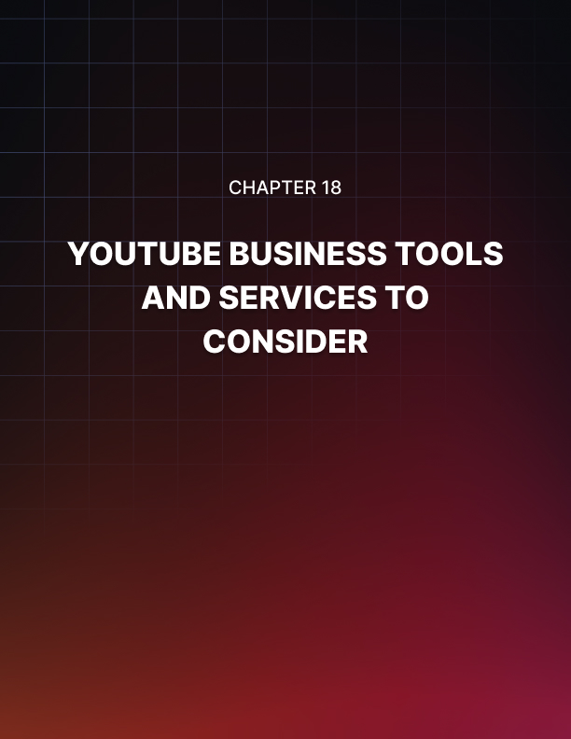

Chapter 18: YouTube Business Tools And Services To Consider

VidIQ
VidIQ is a video marketing tool designed for YouTube Businesses and creators that are serious about getting profitable results. It is a certified YouTube platform that will help you analyze your existing content and will provide you with insights that you can use to improve your output. It offers powerful analytics features that monitor keyword scores, views, search term metrics, engagement metrics, and much more.

You can also add it as an extension on Chrome for easier access!

TubeBuddy
TubeBuddy is an all-in-one productivity tool for your YouTube business. It can help you organize all your YouTube activities under a single dashboard, and it helps you understand your audience, to optimize your content, and to improve your SEO strategy.

TubeBuddy offers you features that include advanced keyword research, timesaving templates and publishing tools, search engine optimization resources, built-in promotional tools, as well as analytics and split testing tools.

Social Blade
Social Blade is a top analytics tool and a favorite among successful YouTubers running their businesses on the platform. It has a powerful monitoring engine that helps you track user statistics and provides a deeper understanding of the user growth and trends that matter most to your YouTube business.

Social Blade is powerful, but not complicated. It provides you with a simplified analytics technology that is easy to understand for any creator. It allows you to see your subscribers, your video views, and your estimated earnings by date, and it makes it easier than ever for you to rank your videos, find influencers, and grow your channels.

Woobox
Woobox is an all-in-one online marketing platform that has a dedicated suite for YouTube creators and businesses, which is designed to help you promote your YouTube channel and your content on Facebook the easy way.

With Woobox you’ll be able to display your videos on a Facebook page tab, with just a few clicks. It is easy, it allows you to feature your best videos, it adds a “subscribe” button so viewers can subscribe without leaving your YouTube tab, and exposes your YouTube business to the Facebook audience!

Pixlr
Pixlr is a next generation image editing tool that is designed for YouTube Businesses and online marketers. Pixlr provides you with next level, intuitive image editing tools that are powered by artificial intelligence.

It is easy to use, and it makes editing your YouTube thumbnails seamless, fun, and fast. You can use it to edit stuff carefully on your desktop, or to edit stuff such as special effects and stickers for your videos on the go.

Tubular Insights
Tubular Insights is, just as the name implies, a video marketing insights platform that is designed to give YouTube businesses the latest and most popular insights on the video marketing industry.

More specifically, it is a network of video marketing experts that monitor, analyze, and collect the latest, most relevant information from every corner of the video marketing industry.

With Tubular Insights you’ll get the latest trends, tips, and analysis for your YouTube Business strategy, from these experts, right to your inbox.

Camtasia
Camtasia is a video editing and screen recording tool that might just be the perfect solution for your growing YouTube business because it offers you an all-in-one suite for all your screencasting and video editing needs.

With Camtasia you can mark up videos, make edits, add effects, capture and customize the movements of your mouse on the screen, show keystrokes, add notes, annotations, highlights, captions, and much more.

Camtasia is perfect for creating tutorials, video lessons, explainers, How-To videos, demos, training videos, and the like.

Hootsuite
Hootsuite is an awesome social media management tool with great YouTube Business features. It offers brands and creators on the platform a
simpler way to manage their YouTube business, and it unlocks new ways to save time and grow your video views. Hootsuite will help you to schedule videos on your own terms, to share your YouTube videos across social media, and to automatically search, find, and share videos from your custom search stream when you don’t have videos to publish!

SEMrush
SEMrush is a social media analytics tool that will help you with your YouTube Business SEO, competitive search, and content strategies.

You can use SEMrush to do keyword analysis in your niche, to run a channel audit, to track your performance and backlinks, and to get organic traffic insights.

HEADLINER
HEADLINER is an amazing video creation tool for YouTube Businesses and creators.

It helps you get your content ideas more easily and faster, because it offers you a canvas where you can insert your videos, images, and audio, then add animations, captions, gifs, and more, until you get the perfect video. Then it makes it easy to export and share your video on YouTube and across all your channels.

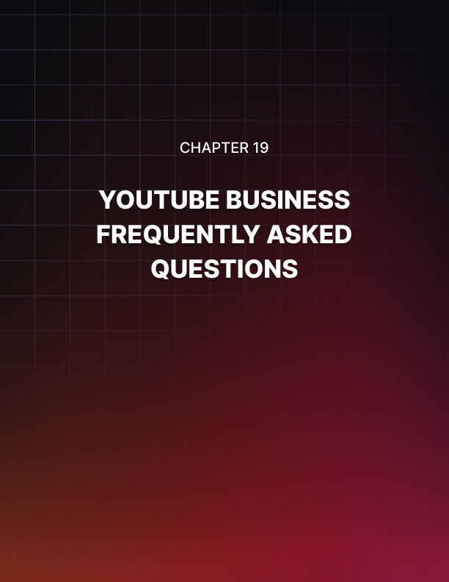

Chapter 19: YouTube Business Frequently Asked Questions

Is YouTube Business Different From YouTube Marketing?
YouTube business is a more holistic approach to YouTube than YouTube marketing because the goal of YouTube business is to build a presence for your business on the platform AND to bring business-specific results.

That is, to attract customers, make sales, and keep the profits. To that end, a YouTube business has to learn how to do YouTube marketing. This means that YouTube marketing is essentially part of doing YouTube business.

And What Is The Difference Between A YouTube Business And A YouTube Creator?
As a YouTube business, your goal is to represent your business on the platform, to attract customers on the platform, and to generate sales, yet your focus is not on the platform.
A YouTube creator is someone, or a brand, that creates video content specifically to grow as a YouTube content creator, and to profit from the platform.

Is It Necessary To Do YouTube Business If You Are Already Promoting Elsewhere?
YouTube is an excellent platform to diversify your content and your reach. It is one thing to favor one social media site over another because every social media site offers something different and caters to a different type of customer, and you could be missing out if you ignore YouTube simply because you are promoting elsewhere.

On YouTube you can find a very valuable segment of your audience that is not active on other social platforms. Besides, YouTube is one of the top most active websites that exists. Lastly, YouTube is the place to drive real business results.

Does Your Business Need More Than One Channel?
It depends on how many different types of products you sell. If you sell vastly different products under the same business, then it is a good idea to create more than one channel. Again, only if it makes sense.

You might also want to create more than one channel if you plan to execute more than one type of content strategy. For example, you can create a channel for training and educational content, and one for showcasing your offers.

Is It A Good Idea To Upload Video Commercials?
Of course! But you have to do it with the intention of advertising them. In fact, creating short commercial videos to advertise your products can be the quickest way to make money on YouTube.

Now, be careful about uploading commercials as content for your audience. Instead, focus on quality content that guides them through your funnel until they decide on a purchase. The commercials will help you to convert users that are not your subscribers yet.

Can You Organize Content On Your Channel Like On A Website?
Organization is crucial when it comes to the image of your business and branding, and that includes the presentation of your YouTube channel.

Thankfully, you can create playlists to organize your videos into categories, and you can do it right from your channel dashboard. This will help you to keep your channel nice and tidy, and it will make it easier for viewers to browse your content.

Is It Better To Produce Your Own Videos Or To Outsource Them?
In general, it is a better idea to outsource your videos to dedicated video creators and in fact, to automate most of the non-business tasks and to delegate the creative output down the line.

Now, it may be that creating your videos is your passion and your business, so as long as you know how to create awesome, quality videos, then you can go this route. Otherwise, it is more productive to dedicate your energy to the business strategies.

Do You Need A Large Budget To Start A YouTube Business?
No! In fact, starting a YouTube business offers you a very low-entry to making money online, and you can always scale. You are going to need some money though, depending on what you can afford to create by yourself and the things that you’ll need to outsource. For example, if you have graphic design skills, you can create your own thumbnails and graphics, which means that you can cut that out from your budget.
On the other hand, there are going to be things like ads that will require you to invest some money, but again, it all comes down to scaling. This means you can start investing as low as $5 a day on ads, and to scale once you’re able to reinvest your earnings.

Are Views And Subscribers Important To A YouTube Business?
As baffling as this may sound, they’re not that important. Thousands of views and subscribers won’t tell you the whole picture, and won’t tell you anything about the results that you want for your business.

The metrics you want to look at are the metrics that signal intent. These include watch times and click-throughs.

Is There A Way To Know Whether A YouTube Lead Is Considering Your Products?
One easy way to determine this is to scan intent after the user clicks-through from one of your videos to your website.

The first thing you have to take note of is what type of video the viewer comes from: a video from the top of the funnel, from the middle, or from the bottom.

Next, you are going to analyze their behavior on your website. Things you can learn about a visitor are session times, clicks, pages visited, whether they converted or submitted a form, and abandoned carts. You can check that information on your analytics tool of choice.

