Table of Contents

Introduction 5
Step 1: Channel Focus 7
Step 2: Creating a Keyword Strategy 12
Step 3: Branding Mastery 16
Step 4: Creating Share Worthy Content 19
Step 5: Build Your Subscriber Base 23
Conclusion 27

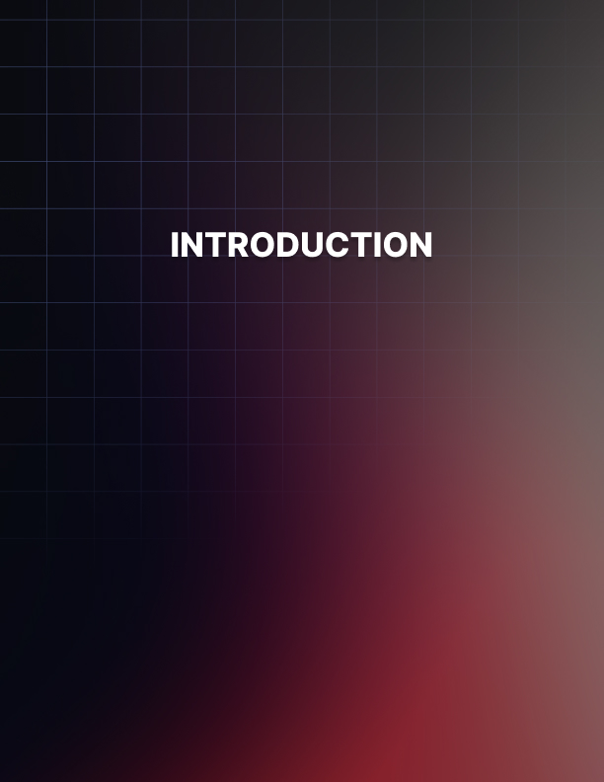

Introduction

There’s a good reason that YouTube is the leading video platform online, especially for businesses.

It’s easy to use, allows for maximum exposure in the search engines and the audience is readily available. In fact, YouTube has over a billion registered users, which means it’s clearly a great way to build a business, maximize outreach and develop an outstanding brand.

But we don’t have to tell you about the incredible possibilities that creating a YouTube channel has to offer. You likely already know this. What you may not know is exactly how to get started.

This includes things like:

- How to choose a theme for your channel.
- How to effectively brand your channel.
- How to optimize your channel for maximum exposure.
- How to choose the best content formats for your channel.
- How to grow your subscriber base.

Well, you’ll no longer be left wondering because all of this is covered in this special report: YouTube in 5 Easy Steps.

We’ll guide you through all the important elements of creating a winning channel.

From how to set up your channel so that it’s designed to attract the most loyal subscribers, to how to plan and produce the highest quality content possible, we’ve got you covered.

Let’s begin!

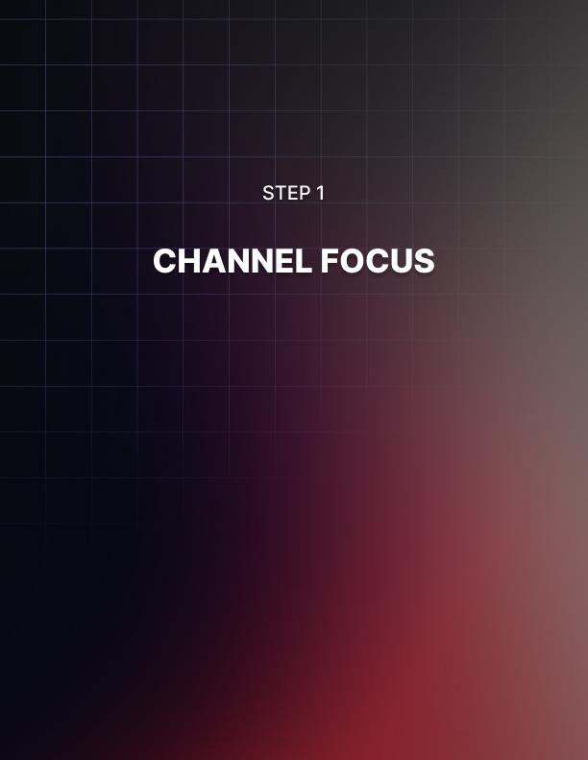

Step 1: Channel Focus

When it comes to setting up your YouTube account, there are many tutorials online that will guide you through the actual sign- up process, so we won’t cover that in this report.

Instead, we’ll kick things off by talking about what really matters:

The focus of your channel.

The truth is, laying the groundwork for your channel early on is key to your success. In fact, the one thing that often separates successful channels from flops is in careful planning.

First, you want to make sure you have decided on one main topic for your channel. Coming up with a strong theme will make it easier for you to grow your audience.

And while you aren’t stuck creating content for only one niche, when you’re just starting out it’s always best to focus on one specific topic rather than trying to cater to multiple audiences.

You can scale your business later by creating additional content that will attract other segments of your market.

The key is to create a channel that is focused and delivers content that is relevant to one main niche.

So, begin by jotting down ideas and notes about the kind of content you want to create.

Research your market in order to better understand what kind of information they’re looking for, what style of content and overall tone are they most likely going to be attracted to and what can you do differently from other channels in your market?

Quite often, the most successful channels are created based on topics you are personally interested in and passionate about. And of course, you want to tie your content in with your existing products, websites or blogs.

The idea is to create one seamless brand where you’re visible on all major platforms, so connecting your YouTube channel with a blog that offers a text-based component will reach a wider audience and help you maximize exposure.

If you aren’t sure what your channel will be about you’ll want to spend some time figuring it out before you go any further. Again, this goes back to researching your market so you can find areas that are lacking in content.

Fulfilling a need in your niche with content that is in-demand but not widely available, will be the easiest way to launch your channel with little marketing needed.

If you need extra help coming up with a focus and theme, here are a few popular themes used in many successful YouTube channels:

How-To/Tutorials/DIY
These channels are always popular because they teach specific skills. Whether your channel will provide tutorials for things like software, marketing, website building or making money – OR – you create content based on home improvements, interior design or saving money with renovations, this type of channel is always in demand.

Best of Clips
Think of these videos as round-ups of popular videos. It could include content like “Funniest Home Videos”, or “Top 10 Vacation Spots”. The possibilities are endless. Just make sure you aren’t infringing on anyone’s content and that you have the right to include segments of videos.

Travel Channels
People are always looking for reviews on places to vacation and what type of activities are available in these areas. You can easily monetize a travel channel with sponsorships later once your audience grows.

Tech Videos
Always a popular topic, tech videos simplify technology. You could feature reviews of products such as computers, mobile devices and other gadgets or cover tech news.

Crafting
These channels cover everything from creating crafts, selling crafts and everything in between. Many of the popular channels teach people how to create handmade crafts but there are dozens of ever-growing channels that show people how to create digital- based products to sell on sites like Etsy or Shopify.

There are so many other channel themes that are in-demand and profitable, including gaming channels, podcast-style channels, story-time videos, fitness and health based channels, cooking channels and even channels dedicated to exposing online scams.

The idea is to research your market, analyze the top 10 YouTube channels in your niche and create a plan for your channel before you even begin to create content. That way you have a clear blueprint in place that will guide you with clear direction and a strong focus.

Regarding Channel Names
If you haven’t yet decided on a name for your channel, you’ll want to consider this very carefully. Your name represents your brand, your business and tells potential subscribers what to expect from your channel.

This means you don’t want to choose something generic or vague that people won’t instantly associate with a topic.

While there are countless examples of successful Vloggers who created a channel in their personal name, it’s often much easier to launch a channel and connect to your target audience if you choose a channel name that represents the type of content you’ll be offering. In other words, your theme.

This means that you first need to ensure that you understand your market and what kind of content they’d be interested in.

Creating a successful YouTube channel requires a strong focus on specific content formats. Creating a random channel that tries to be all things to everyone will make it hard, if not impossible, to build a recognized brand and to stand out.

Instead, you want your content to be geared towards one main niche. At least when you’re just starting out.

Again, while you aren’t restricted to creating content in just one niche, by deciding to focus the initial phase of your channel on one segment of your market, you’ll be able to launch faster, grow a following easier and solidify your brand.

Plus, it’ll be easier to create a content plan and schedule if you take a laser-focused approach to launching your channel.

Tip: You also want to make sure that the name you choose has an available domain, or closely related one. You’ll want to register that domain in advance, before you even launch your channel.

Acquiring the domain as well as the username on all popular social media platforms will help you protect your business because it puts you in full control of your brand. Plus, it’s a great place to sell merch later on!

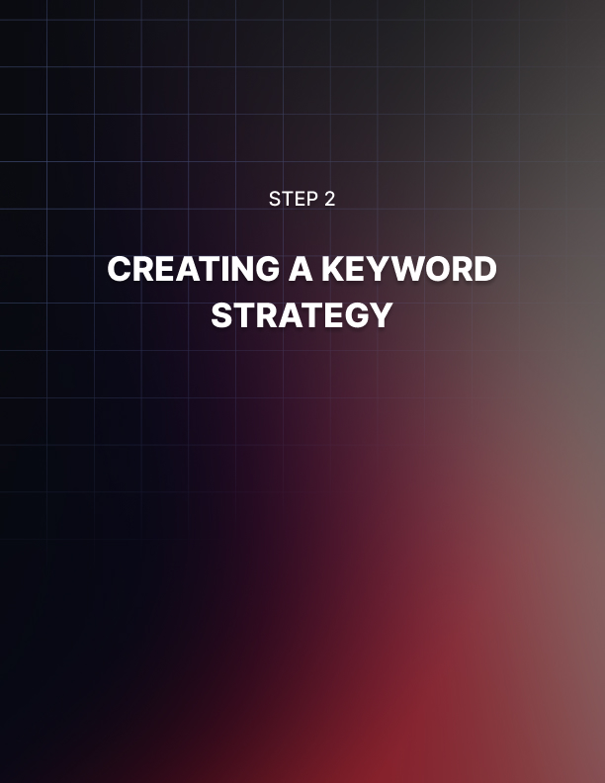

Step 2: Creating a Keyword Strategy

Keywords help people find your channel. They serve as signals in the major search engines that will connect your audience to the content they’re looking for.

In fact, just by optimizing your channel so it includes relevant and highly-targeted keywords may be all you need to do to drive in traffic, especially if your content caters to a hungry market.

This means, you’ll want to add relevant keywords in the “About Section” of your channel.

Doing this will help you rank organically in the search engines and make sure your channel appears when someone enters search terms directly into the YouTube search bar.

Try to come up with 10-15 relevant, long-tail keywords that best describe your content.

You can use them throughout the different areas of your channel as well as within the description of each video.

You’ll also want to optimize your video descriptions so that they are focused on both your audience and search engines. This means that instead of writing a long description for each video, focus on including your primary keywords early in the text but make sure they read smoothly.

You don’t want to keyword stuff to where a subscriber reads your description and it doesn’t make any sense to them.

Your most important keywords should always appear in the first line of your description otherwise it’ll be truncated with a “Show More” link, but again, make sure your description isn’t just a series of keywords – it needs to provide your audience with important information about your content.

In addition, you’ll want to include relevant keywords in your video titles as well, especially your focus keyword (the main keyword you’re hoping to rank for).

Keep your video titles short and focused on engagement. You want them to be exciting and to immediately capture attention.

Always take advantage of any opportunity to include keywords in your content. In addition, vary the keywords used so that you’re able to rank for a variety of long-tail keyword phrases.

Here are a few ways to leverage free YouTube keyword tools:

HyperSuggest: https://www.hypersuggest.com/
There’s a free version of this keyword tool that will allow you to search by country while providing important data, such as potential search volume.

WordTracker: https://www.wordtracker.com/
This tool will provide search volume, overall competition and other information that will help you optimize your channel such as the number of times keywords appear in the anchor and title of popular YouTube channels.

This tool makes it easy to uncover relevant, high-traffic keywords while being able to reverse-engineer popular channels in your niche.

And finally, you’ll want to create a secondary keyword list that focuses on tags.

Tags function the exact same way keywords do and so they’ll become a very important part of your channel.

Unfortunately, tags aren’t displayed by default in video descriptions so you won’t be able to uncover them just by browsing popular videos in your niche. However, there are a handful of free tools that will solve this problem.

These include:

TubeBuddy:
https://www.tubebuddy.com/

Tags for YouTube:
https://chrome.google.com/webstore/detail/tags-for- youtube/dggphokdgjikekfiakjcpidcclbmkfga?hl=en-US

Once you install these Chrome plugins, whenever you visit a YouTube channel and look through the description, you’ll be able to see what tags are being used by the creator. This spy tactic is invaluable because it’ll show you exactly what others are using successfully.

And while tags aren’t the only way to optimize your videos and overall channel, they’re important when it comes to signaling to YouTube search and Google what your video is about.

Tags will also help your videos populate in search as well as in related video views.

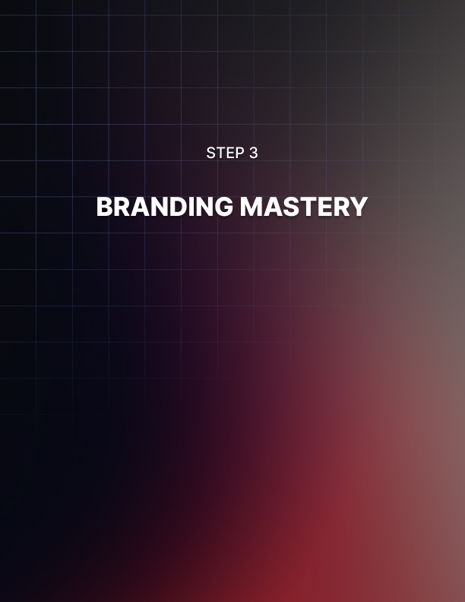

Step 3: Branding Mastery

We’ve discussed the importance of choosing a theme for your channel but now it’s time to connect that theme to your brand.

Branded videos always outperform unbranded videos and there's a good reason for it: People begin to recognize your content just because your brand is prominent and memorable. They’ll share your content with others (if it’s entertaining), and in turn, your brand will gain even more exposure.

This includes creating stand-out channel artwork. Consider hiring a professional designer to create a logo, banner and thumbnail templates that you can repurpose.

You’ll find qualified designers on websites like

- https://www.Upwork.com
- https://99designs.com

What you’re looking to do is highlight your brand in every way possible. You should choose one main color scheme or design style and stick to it. Always look for ways to include your logo or another brand-identifying element into your videos and other
content. The more often people see it, the faster they’ll begin to
recognize it.

If you have a great tagline, you should include that on your artwork. If you produce a lot of videos (a new video every week, or every other day, for example), then include that in your channel banner so that people know what to expect.

Remember that YouTube can be viewed on many devices, from a smartphone to a television. On a larger television screen, the channel art will appear in the background, behind your content. On a desktop or mobile device, the channel artwork appears as a banner across the top of the content.

You can also create your channel artwork from scratch if you’re on a tight budget using a free image creator like Canva. This free tool includes ready-to-go YouTube templates that you can quickly and easily customize for your channel.

Link: https://www.Canva.com

Important Note: As you design your channel artwork, keep in mind that “safe area” in the center of the template. That’s the area that will be displayed on nearly every device. You want to keep your text and graphics within that area.

Make sure any important information like your website URL, taglines, and images are inside of this space so they’ll show up on the device and not be cut off or covered up.

Another thing to think about is your linking text. YouTube lets you display links to your channel – they show up in the bottom right corner, on top of your channel artwork. Make sure you don’t have text, logos, or important images in that area of your artwork.

Pro Tip: You could also create a hat, mug or t-shirt with your channel logo and include it in every video. The more you can highlight your brand throughout your content, the better.

Then later, as your channel grows in popularity, you’ll be able to sell these items to your subscribers who want to support your business.

It’s easy to create a custom merch at places like:

- https://www.Printful.com
- https://www.RedBubble.com



Step 4: Creating Share Worthy Content

Your first video will probably not be everything you were hoping for. That’s fine – practice makes perfect! The more you create content, the faster and easier it will be and the quality will improve as will your skills.

What you want to do is practice making and uploading videos until you’re familiar and comfortable with the way the platform works.

Watch a lot of videos in your market and see what channel owners are offering. Pay attention to their format and overall structure, along with their pacing. Take plenty of notes!

Then, create a content schedule and stick to it and upload them (you don’t have to actually publish everything you upload). The more you practice, the better you’ll become, just like every other skill you’ve learned.

The post production process is very important as well, especially when it comes to creating engaging content free of lag and poor pacing.

The main thing to pay attention to during the editing process is to remove any unnecessary pauses, lags and to ensure that you keep a steady pace so that your content flows smoothly and keeps your viewers’ attention.

You can also save a lot of money by learning how to edit your own videos. Popular Vloggers like Jake Paul and Felix Kjellberg use Adobe Premiere to edit their videos. You’ll pay just over $20 a month to use it, but it’s very intuitive and comes with everything you’ll need to get started.

You can check it out here: https://www.adobe.com/creativecloud/plans.html

If you want to follow the lead of popular vlogger Casey Neistat, you can use the Final Cut Pro app.

Final Cut Pro is easier to use than Adobe Premiere and comes packed with useful features that’ll help you create stunning videos. It also includes outstanding organizational tools that will make project planning easier.

There’s free editing software available as well, including iMovie which has a minimal learning curve and comes pre-installed on Mac-based operating systems.

It’s a great tool for starting out, and will help you learn the basics of video editing quickly and easily.

YouTube isn’t a difficult platform to learn. In fact, its popularity is mostly due to how easy it is to use. You can upload videos in a range of formats and YouTube converts them into Adobe Flash for you (this gives you a file extension of .FLV).

Doing this allows YouTube to play your videos on its flash player (which anyone can upload for free and use).

Another great benefit of this is that you can embed your video into a website just by copying the HTML code and pasting it into your site. This lets any of your website visitors watch the video on your site using the YouTube player.

This way, you don’t have to host the videos on your own site and use up a ton of bandwidth.

Bandwidth is the range of signal frequencies you need to transmit data over the internet – and you have to pay for what you use. Let YouTube carry the bandwidth burden for you!

Of course, most people will likely find your video by searching Google or YouTube’s on-site search for relevant content. In order to help connect viewers with the videos they’re looking for, YouTube utilizes a complex algorithm that’s made up of over a million lines of code.

One of the main factors they use to figure out which videos to show is video metadata.

Metadata is the title, description, thumbnail, and tags you give your video when you upload it. That means you need to make sure your tags are relevant to the video content (and that they match the keywords viewers would use to search for your content).

YouTube also measures video quality by measuring the length of time it’s being watched. If a lot of viewers leave the channel before your video is over, this suggests that your video had a misleading title (or thumbnail), or that it didn’t give viewers what they were looking for.

If they stay until the end, your video is likely appropriate for the search terms used, and it will be given a higher ranking than videos left unfinished.

Tips: Spend some time watching videos from your favorite channels, especially from creators in your niche.

Pay attention to their overall style, how they create transitions, what their pace is and branding style.

- What kind of voice and tone do they take when creating videos?
- Do they create head-talker type video content more often than other formats?

Take notes! We’ve mentioned this already but it’s important, especially when you are doing market research in order to create a plan for your own channel. You’ll want to reflect on this later.

And finally, give yourself the freedom to make mistakes. You’ll learn a lot throughout the process and the kind of video content you create today will likely look a lot different from what you create a year from now when you’ve had the time and experience needed.

The important thing is to stay consistent, follow a content schedule that your subscribers come to rely on and stay true to your brand.

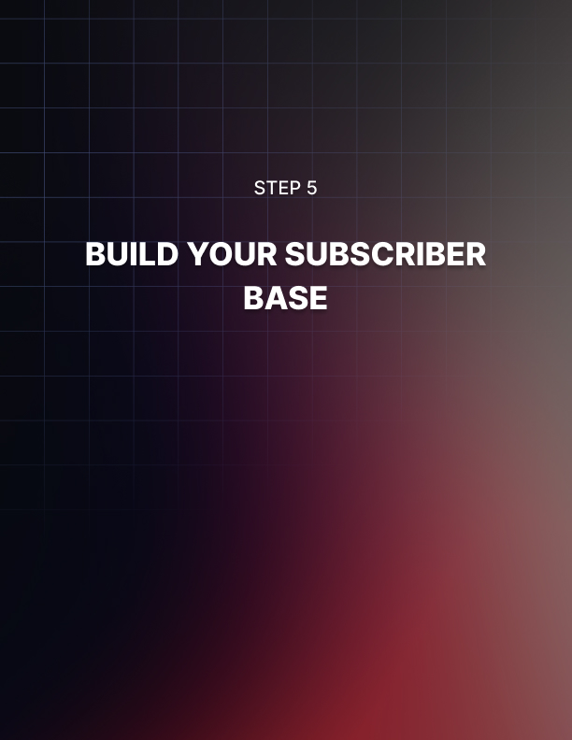

Step 5: Build Your Subscriber Base

When it comes to growing an audience, there are a few easy things you can do to give your channel the best chance at being successful.

First, you’ll want to consistently work on creating a strong backend. This means that the more video content you can publish, the better.

Providing subscribers with a ton of content to consume will keep them on your channel longer and will work towards facilitating the process of converting a visitor into a loyal subscriber.

So, work on building up your library of content. This is why creating a content schedule is so important. Decide on whether you plan to create one video a week, every other week or once a month – the choice is yours. But keep in mind that when you’re in the initial stages of creating a channel, you’ll need to put more time and energy into creating more content just so your audience has enough to engage with.

So, consider spending a few weeks (maybe even months) creating content for your channel before you publish. That way you can provide enough upfront to keep people engaged.

Tip: Subscribers prefer channels that provide fresh, new content on a regular basis. You can set yourself up for long-term success without becoming overwhelmed by creating content in batches and then stock-piling it for future release.

That way, you’re able to take breaks in between to recharge while still having fresh content to upload.

You should also include a direct call-to-action in both your video content itself as well as in the description. Don’t be afraid to ask viewers to subscribe, like and turn on notifications for your channel. Not everyone will understand how YouTube works so remind them that they need to subscribe in order to be notified when new content is available.

In addition, people like to support new channels so if you directly ask people to subscribe, comment and like your video because it helps your channel grow, chances are they’ll do it!

You could also end your video with a question or request for feedback. This will encourage people to leave comments which will signal to YouTube that your channel is growing and that it should be shown more frequently. The more activity a channel gets, the more often it’ll appear in search results.

You can also organize your channel’s content in order to help people find what they’re looking for. Consider setting up playlist style arrangements that organize your content based on topic or style. Your subscribers will appreciate it and chances are they’ll binge a lot more content if they run through video playlists.

You should also be on the lookout for ways to network and cross- promote with other channel owners.

Give a shout-out to another channel or consider providing links in your video content to other channels. This will get you on the radar of established channels who may be open to networking! Just the same, look for opportunities to be a guest on relevant channels.

This can be done a few different ways including by collaborating on just one video, two separate videos that are pieced together (where you create one part of the video and someone else creates another part of it), or by creating content exclusively for another channel as a way of introducing your brand to their audience while giving the creator fresh content to publish.

When it comes to reaching out to other channel creators when looking for possible collaborations, you can easily connect with them through their social media accounts, through email, or directly through their video comments or blog.

Just be careful when approaching channel owners so that you’re highlighting what’s in it for them (free content, etc.).

In addition, you should spend some time engaging with their content, following their channel and studying what it is that they do.

That way, when you reach out to them you can show that you’re familiar with their content and brand and explain why you believe a collaboration would be mutually beneficial.



Conclusion

Creating a successful YouTube channel isn’t rocket science, but it does require time, commitment and focus. In the early months, you’ll likely be creating more content than you will later, to build up your backend inventory and cultivate a following quickly.

Later, you’ll be able to ease back and produce fewer videos with a longer lifespan. So, create a content schedule that you feel you can stick to. Condition subscribers to expect content at certain times each month as it’ll keep them coming back.

Remember, on YouTube watch time is very important. The longer that new viewers remain engaged with your content, the more likely they’ll turn into a subscriber and when it comes to viewer retention, by analyzing the data that YouTube provides you, you’ll know with certainty what content is among your top performing videos so that you can create more of them!

Plus, the longer a viewer stays engaged with your videos, the better the chances are that they’ll interact with it – by subscribing, commenting and liking your content.

This is where playlists come into play. By segmenting your content, especially after you’ve uploaded a large amount, you’ll be able to keep people glued to your channel longer as they consume the different available playlists.

Make sure you focus on optimization as part of your weekly business plan. You want to ensure that every title includes relevant keywords to boost visibility.

Remember to add keywords into video descriptions, avoiding duplicates! Make the space count.

And finally, always look for ways to create off-site (external) links. One of the easiest ways to do this is by auto-syncing your YouTube channel with your other social media accounts, such as twitter, Instagram and Facebook.

That way every time you post new content, it will automatically appear on all your social media profiles. These social signals are important when it comes to maximizing exposure and successfully growing a channel.

